出國報告（出國類別：國際會議與論文發表）

參加第21屆ISSAT RQD 國際會議

服務機關：國立高雄應用科技大學
姓名職稱：戴貞德國際長
派赴國家：美國
出國期間：2015.8.4-2015.8-8
報告日期：2015.10.15

摘要
本出國目的為拜訪University of Kansas及University of Missouri洽談國際交流合作與招生事宜及參加ISSAT國際研討會並洽談國際交流事宜。拜訪KU Kansas大學討論姊妹校合約合作內容包括3＋1學程等實質內涵，相談甚歡，副校長當場簽MOU。
第21屆ISSAT_RQD信任度及品質設計國際會議發表研究新成果與研究發展。會議中囊括個案研究、實驗結果與信度及品質設計理論應用。

目次
摘要
一、目的 4
二、過程 4
三、過程剪影.................................................................................................................9
四、心得及建議事項 11

目的
  - 計畫目的

第21屆ISSAT_RQD信任度及品質設計國際會議發表研究新成果與研究發展。會議中囊括個案研究、實驗結果與信度及品質設計理論應用。另外，拜訪KU Kansas大學討論姊妹校合約合作內容包括3＋1學程等實質內涵，相談甚歡，副校長當場簽Mou。
- 拜訪University of Kansas及University of Missouri洽談國際交流合作與招生事宜。
- 參加ISSAT國際研討會並洽談國際交流事宜。

- 過程

8/4(二) 拜訪University of Kansas
8/5(三) 拜訪University of Missouri
8/6(四)參加ISSAT-RQD國際研討會
8/7(五)參加ISSAT-RQD國際研討會
8/8(六)參加ISSAT-RQD國際研討會

拜訪KU Kansas大學討論姊妹校合約合作內容包括3＋1學程等實質內涵，相談甚歡，副校長當場簽Mou。(如照片3-6)。
本校與美國 University of Missouri-Kansas City(UMKC)洽談2＋2學程承認及雙聯學制合約，2＋2與3＋1學程承認，將有助於本校四技和研究所招生。

第21屆ISSAT_RQD信任度及品質設計國際會議發表研究新成果與研究發展。會議中囊括個案研究、實驗結果與信度及品質設計理論應用。(如照片1與2)

發表論文摘要及會議議程如下:

ISSAT-RQD 國際研討會發表論文摘要

Combinatorial Algorithm of Wordlength Pattern for Two-level Fractional Factorial Designs
Author | Jen-der Day
Co-Author(s)
Abstract | A wordlength pattern (WLP) is used to determine the resolution or minimum aberration for choosing a good fractional factorial 2k-p design. Based on the aliased structure between left-right half parts for the two-level geometrical designs, the proposed combinatorial algorithm of WLP can be applied to all lengths of word and to the general cases of two-level fractional factorial designs. This algorithm is useful particularly for saturated right-half designs since the closed form formulae and recursive property are involved. Besides, it can be easily extended to the cases of large scale designs.
Keywords | Geometrical Design, Hadamard matrix, Wordlength pattern, Resolution, Minimum Aberration

RQD 2015
Conference Program 會議議程
THURSDAY, AUGUST 6, 2015
8:00 am - 9:00 am | Registration  Continental Breakfast
9:00 am - 9:15 am | Welcome Awards Presentation
9:20 am - 10:35 am | SESSION 1: Statistical Reliability Modeling & Its Applications  Chair: Prof. D. Gary Harlow (Lehigh University, USA)
9:20 am - 10:35 am | SESSION 2: Quality Engineering in Design  Chair: Prof. Gordon Savage (University of Waterloo, Canada)
10:50 am - 12:05 pm | SESSION 3: Maintenance and Reliability Modeling & Optimization  Chair: Dr. Mitsutaka Kimura (Gifu City Women’s College, Japan)
10:50 am - 12:05 pm | SESSION 4: Security Analytics & Modeling  Chair: Prof. Taghi M. Khoshgoftaar (Florida Atlantic University, USA)
1:15 pm - 2:45 pm | SESSION 5: Multistate Network Reliability & Process Improvement  Chair: Dr. Ping-Chen Chang (National Taiwan University of Science & Technology, Taiwan)
1:15 pm - 2:45 pm | SESSION 6: Software Reliability Modeling and Its Applications  Chair: Dr. Yoshinobu Tamura (Yamaguchi University, Japan)
3:00 pm - 5:00 pm | SESSIONS 7 & 8: Challenges and Opportunities in Reliability  Chair: Dr. Feng-Bin Sun (Tesla Motors, USA)

FRIDAY, AUGUST 7, 2015
8:00 am - 8:15 am | Registration  Continental Breakfast
8:15 am - 9:30 am | SESSION 9: Software Quality & Reliability Modeling  Chair: Dr. Kehan Gao (Eastern Connecticut State University, USA)
8:15 am - 9:30 am | SESSION 10: System Reliability, Safety and Failure Analysis  Chair: Prof. B.S. Dhillon (University of Ottawa, Canada)
A SHELF – Swiss Cheese Model for Aviation Safety
Po Chung Tong (The Hong Kong Polytechnic University, Hong Kong)
Hei Tung Chau (The Hong Kong Polytechnic University, Hong Kong)
Tsun Tai Wong (The Hong Kong Polytechnic University, Hong Kong)
Combinatorial Algorithm of Wordlength Pattern for Two-level Fractional Factorial
Designs
Jen-der Day (National Kaohsiung University of Applied Sciences, Taiwan)
Transportation System Failures: An Investigative Study
B.S. Dhillon (University of Ottawa, Canada)
9:30 am - 9:45 am | Coffee Break
9:45 am - 11:45 am | SESSIONS 11 & 12: Tutorial Session  Chair: Prof. Hoang Pham (Rutgers University, USA)
12:00 pm - 1:00 pm | Conference Luncheon
1:15 pm - 2:45 pm | SESSION 13: Multi-State System Reliability Modeling & Its Applications  Chair: Prof. Yao Hsu (Kainan University, Taiwan)
1:15 pm - 2:45 pm | SESSION 14: Security Analytics & Applications  Chair: Prof. Taghi M. Khoshgoftaar (Florida Atlantic University, USA)
3:00 pm - 5:00 pm | SESSION 15: Mechanical Reliability Modeling & Prediction  Chair: Prof. Liyang Xie (Northeastern University, China)  SESSION 16: Software Quality and Reliability Assessment and Applications  Chair: Dr. Shinji Inoue (Tottori University, Japan)

SATURDAY, AUGUST 8, 2015
8:15 am - 8:30 am | Registration  Continental Breakfast
8:30 am - 10:00 am | SESSION 17: Automotive Reliability Modeling & Distribution Networks  Chair: Prof. Songlin Zheng (University of Shanghai for Science and Technology, China)
8:30 am - 10:00 am | SESSION 18: Maintenance Optimization & Its Applications  Chair: Prof. Syouji Nakamura (Kinjo Gakuin University, Japan)
10:15 am - 12:15 pm | SESSION 19: Reliability and Maintenance Modeling & Applications  Chair: Dr. Elsayed Elsayed (Rutgers University, USA)
10:15 am - 12:15 pm | SESSION 20: System Modeling & Simulation & Its Applications  Chair: Prof. Antonio C. Caputo (University of Roma Tre, Italy)
12:15pm | Adjourn!

三、過程剪影《續》

活 動 花 絮
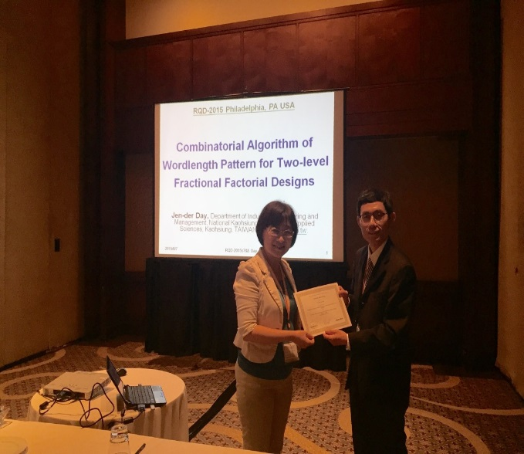 | 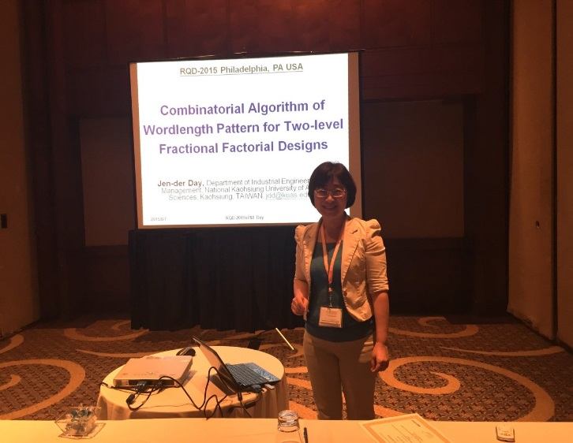
照片1：ISSAT,RQD,2015 | 照片2: ISSAT, RQD ,2015論文發表
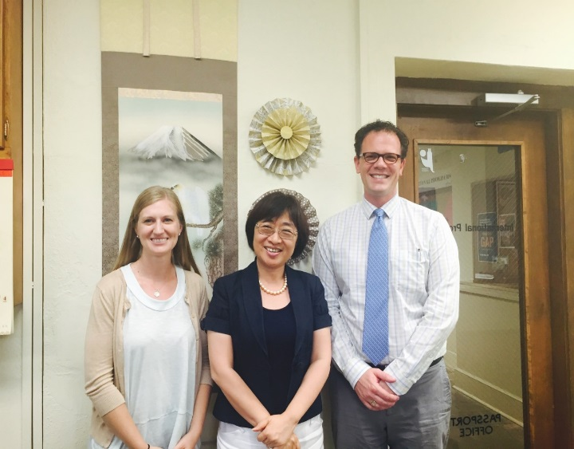 | 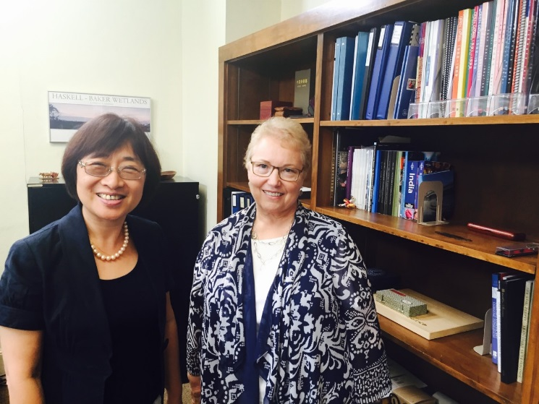
照片3:KU Kansas大學國際長合照 | 照片4：KU Kana副校長合照
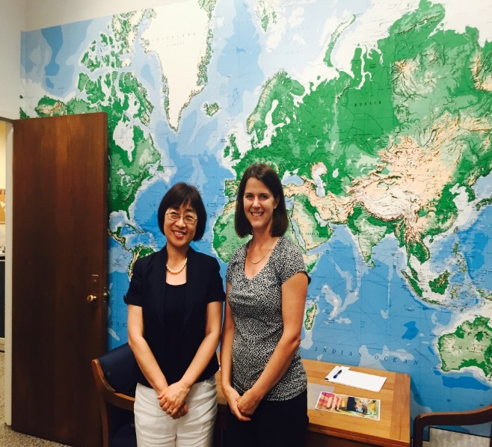 | 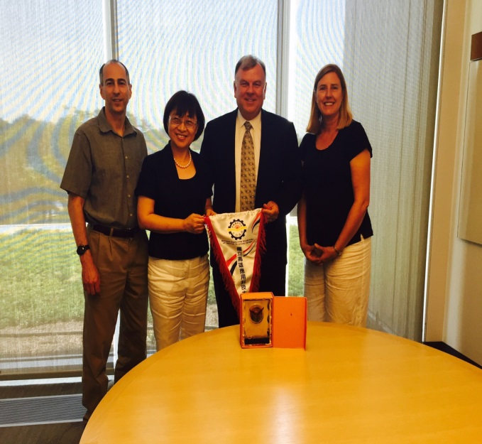
照片5:密西西里語文中心主任合照 | 照片6:UMKC 教務長，工學院院長，文學院教授代表合照
四、心得及建議事項
◎ 心得及建議事項撰寫說明
姊妹校拜訪成果

(一). 拜訪KU Kanas大學討論姊妹校合約合作內容包括3＋1學程等實質內

涵，相談甚歡，副校長當場簽署兩校MOU，並拜訪密西西里語文中心主
任論暑期營會等實質交流活動。
104年11月10日美國University of Kansas, Dr. Potts(Assistant Vice Provost, International Programs)來訪本校洽談3+1課程。

(二).拜訪UMKC University of Missouri-Kansas City(UMKC)大學洽談2＋2學程承
認及雙聯學制合約，2＋2學程及雙聯學制將有助於本校四技和研究所招
生。目前進度:國企系已與該校談細節。
(三).本校與美國UMKC工學院/電資學院洽談3＋1學程承認，3＋1學程將有
助於本校四技和研究所招生。
(四).本校與美國KU(University of Kansas)洽談3＋1學程承認，3＋1學程將
有助於本校四技和研究所招生。目前進度:工學院與電機學院談正與
該校談細節。
(五).此次赴美國參加ISSAT-RQD進行論文發表增加高應大國際知名度對QS排
名有助益。

