壹、目的

The World Travel & Tourism Council世界旅遊業理事會（WTTC）是最具權威性之非政府國際旅遊組織，以「提升政府、公眾認識旅遊、旅行對經濟和社會的影響力」為核心任務，通過與各國政府通力合作，推動旅遊資源的開發，拓展國際旅遊市場。自2000年起，每年4月或5月在世界不同城市召開一次世界旅遊旅行大會，因會議規模龐大、規格高，堪稱「旅遊界的奧林匹克。」
WTTC 為旅遊及旅行業商業領袖的論壇，其成員包含全球領先旅遊及旅行企業近100位董事長及首席執行官。該理事會對所有的旅遊及旅行業相關問題每年辦理論壇共聚討論，並於會中舉辦頒獎典禮，鼓勵發展永續觀光推動之目的地，本局所屬東北角暨宜蘭海岸國家風景區管理處以「舊草嶺自行車隧道」從參賽57個國家中，入圍「明日旅業大獎-目的地類」，並受邀參加頒獎典禮及大會活動，出席大會可彰顯我國在永續觀光經營之努力，亦有助於提升國際形象。
本次出席成員有3人，包括東北角暨宜蘭海岸國家風景區管理處方正光處長、該處遊憩課金保樑課長及本局國際組林毓珊科員，於104年4月12日出發前往西班牙馬德里，4月18日返國。除參加Tourism for Tomorrow Award頒獎典禮外，另也參加世界高峰論壇(Global Summit)及小組研討會，藉由與國際觀光單位之交流互動，學習國際經驗，並增加臺灣之國際能見度。

貳、行程表

- Tourism for Tomorrow Day of Learning Schedule明日旅業大獎學習行程
- 日期：104年4月14日
- 時間：09:50-22:00(包含入圍者上台簡報、分享、城市導覽及歡迎酒會)
- 地點：MediaLab Prado, Calle Alameda, 15 28014 Madrd.

- Global Summit 世界高峰會
- 日期：104年4月15-16日
- 時間: 4/15 14:00-18:45 4/16 09:30-19:00(包含開幕、頒獎典禮、論壇)
- 地點：North Convention and Congress Centre, IFEMA, Madrid
4. 內容：
- Drivers of Disruption-藉由非觀光旅遊產業界領導者之外部觀點，探討政治安全與風險、全球氣候變遷及投資環境的變動。(與談人：Richard Fenning, CEO, Control Risks, Julie Meyer, CEO, Ariadne Capital)
- Leaders Perspective – Disruption-WTTC會員對於觀光旅遊產業分裂的觀點(與談人：Doug Anderson, President & CEO, Carlson Wagonlit Travel, Gary Chapman, President Group Services & DNATA, Emirates Group, Luis Maroto, President & CEO, Amadeus IT Group, Chen Feng, Chairman of the Board, HNA Group, Jeff Rutledge, CEO, AIG Travel)
- Travel & Tourism - Powering Growth in Europe-WTTC歐洲會員談目前觀光旅遊在歐洲的發展。(與談人:Darren Huston, President & CEO, The Priceline Group, Temel Kotil, President & CEO, Turkish Airlines, Michael O’Leary, CEO, Ryanair)
- Madrid - Linking Spain with the World-會程第2天以主辦國西班牙的觀光發展為論壇主題，包含馬德里發展觀光的挑戰和未來機會，及今日馬德里如何發展成符合觀光需求的城市?那些因素會未來會影響馬德里發展觀光等議題，共分為2Panel討論
  - Panel 1: Ana Botella, Mayor of Madrid, Emilio Butragueño, Institutional Relations Director, Real Madrid C.F., David Muñoz, Chef and Owner, DiverXOand StreetXO, José Pedro Pérez-Llorca, President of the Royal Board of Trustees, useo Nacional del Prado
  - Panel 2: Simón Pedro Barceló, Co-Chairman, Barceló Grupo, José Luis Bonet, Chairman, Leading Brands of Spain Forum, Luis Gallego, CEO, Iberia, Alberto Duran, President, ILUNION and Vice President, Fundación ONCE, Andrés Pan de Soraluce, Chairman & CEO, OHL Desarrollos.
- Focus on Cities - reinvention, differentiation and inspiration城市扮演驅動觀光旅遊產業發展，在過去20年間已經顯著改變，低成本航空的出現和消費者習慣之改變，都已影響觀光產業發展，因此，此時段由城市觀點探討對於觀光產業之短、中、長投資如何布局? 居民與觀光客如何平衡，如何營運及避免競爭在城市內的境內與境外旅客等議題。(與談人: Desirée Bollier, CEO, Value Retail Plc, Isabel Borrego, Secretary of State for Tourism, Spain, Roger Dow, President & CEO, U.S. Travel Association, Howard Eng, President & CEO, Greater Toronto Airports Authority, Paul Griffiths, CEO, Dubai Airports, Hiromi Tagawa, Chairman of the Board, JTB Corp.)
- Shockwaves – disruption and reinvention through technology藉由科技所帶來的破壞和重塑已經驅動了20世紀觀光產業的發展，然而，不只是科技的進化改變的產業，觀光也正面臨著商業模式的改變，本時段藉由觀光產業界新舊成員的辯論來探討科技、顧客期望與商業模式的重塑。(與談人: Chip Conley, Head of Global Hospitality & Strategy, Airbnb, Dara Khosrowshahi, President & CEO, Expedia Inc, Federico J. González Tejera, CEO, NH Hotel Group, Michel Taride, President, The Hertz Corporation, Rob Torres, Managing Director, Travel, Google)

- 明日旅業大獎(Tourism for Tomorrow Award)說明
- 明日旅業大獎由「世界旅遊觀光委員會」所舉辦，旨在表揚全世界對旅遊業永續經營的組織及理念者。獎項包括：目的獎(Destination Award)、社群獎(Community Award)、環境獎(Environment Award)、人才獎(People Award)、創新獎(Innovation Award)。
- 本局東北角暨宜蘭海岸國家風景區管理處，在全球57個國家及地區計158件申請案中脫穎而出，以「舊草嶺自行車隧道及環狀線」入圍「目的獎(Destination Award)」，是臺灣第一個也是唯一一個入圍此一獎項的單位 【其他2名入圍者分別為斯洛維尼亞及保加利亞】。
- 參賽單位需填妥大會準備之相關表格，遞送後由大會進行第一輪評估，並選出入圍者，接後大會指定裁判親臨現場審查，本次進行現場審查裁判為日本Spirit of Japan Travel 總裁Masaru Takayama先生。現場評估完成後，再將資料送回WTTC總部，由所有裁判開會決定最後贏家，並於頒獎典禮時公布。入圍者皆能獲得主辦單位提供之1名商務艙機票及住宿接待，WTTC大會每年均在旅遊業界募得多家觀光企業贊助。
- 「舊草嶺自行車隧道及環狀線」入圍原因：全長2,167公尺的「舊草嶺隧道」於1924年貫通，原為日據時期之鐵道，後因鐵路電氣化及單線通車不敷使用，於1986另建新草嶺隧道，舊隧道於是封閉閒置近20年。本局東北角暨宜蘭海岸國家風景區管理處歷經多年的努力，將舊草嶺隧道修繕及規劃為結合歷史、文化、觀光的「自行車隧道」，並在2009年正式開放，讓遊客體驗它的原始風貌。同時也將沒落、地處偏僻的小鎮及福隆火車站活化，並結合舊草嶺隧道（二級古蹟）的復舊，連接環狀線的自行車道，與本區特殊的海洋地質景觀、漁村文化、臺灣的極東點（San Diego）等景點與公路結合，成功推動遊客對當地的自然生態及人文古蹟有更深入的認識與瞭解，創造福隆小鎮興盛繁華。福隆火車站1984年遊客人次約為8萬人次，至2014年遊客人次激增至49萬7,624人次；並以自行車帶動低碳觀光風潮，因而促使地方經濟活絡及創造就業機會，達到永續發展觀光資源的多元價值。

四、T4T 小組研討會
- 主辦單位於4月14日上午安排各獎項之入圍者，以報告、分享及互相研討的方式，供入圍者互相學習。研討會中每位入圍者需上台以英文報告10分鐘(無投影片及其他視覺輔助)，隨後開放Q&A討論。本次研討會由筆者上台報告，報告分享內容包含舊草嶺隧道簡介、改建為自行車隧道之緣由，及如何藉由維護管理，推廣行銷並串連周邊景點達到永續觀光之成效。
- Q&A由東北角風管處方正光處長回覆，新加坡媒體詢問在隧道整建過程中，所遇到之困難點與需溝通協調的單位有哪些？方處長以內部及外部所必須克服之事項統籌回應。
- 由於東北角之舊草嶺自行車隧道近年來搭配臺灣好行-黃金福隆線推出套票及套裝行程，本次亦藉由參與會議，將相關文宣品及套票發送與會貴賓 ，並進一步邀請貴賓有機會訪臺。
- 明日旅業大獎-目的地類最後由保加利亞首都Ljubljana以綠色城市脫穎而出，於4月15日在Tourism for Tomorrow Awards Ceremony中頒獎，臺灣「東北角舊草嶺隧道環狀線」此次參加雖未成為Winner，但入圍已是一種肯定，相信藉由此次參賽經驗，將有助於東北角風管處後續營運管理與永續觀光之發展。

叁、結論與建議

近年全球觀光發展大致呈現三大趨勢，即新興觀光據點（new destinations）不斷竄起、觀光商品多樣化（diversification of tourism）及觀光據點競爭白熱化（increasing competition between destinations）。面對多變的觀光場域，觀光管理者如何提昇或維持競爭力、發展合乎時宜的觀光活動、市場運作的公平機制等；以及觀光客如何擁有更多選擇、並藉由組織運作使觀光行為更為便捷、以最有利於個人、團體、國家的方式從事觀光活動，都可顯示出國際觀光組織的存在和運作對觀光產業的發展、創新及推廣有極大幫助和影響。本次前往參加2015年WTTC年度大會，為臺灣首度入圍明日旅業大獎，實屬不易，為能增加臺灣之國際能見度，讓國際了解臺灣在觀光產業之發展情形，以下建議，提供參考。
- 積極參與國際觀光組織
針對世界上觀光旅遊活動，有關全球的、區域的國際觀光組織之會員國、非會員國，或者政府間、非政府間組織、民間團體，在環境永續發展思潮澎湃影響下，陸陸續續簽署問世的法令規章和行為規範，再次說明臺灣不應該在國際觀光組織中缺席。在全球性思維的架構影響之下，世界各國對於參與國際組織與事務的意願趨向積極，相對亦投入更多的時間、精力與資源，對於觀光領域更是如此。
在與會過程中，與亞洲鄰近國家如韓國及日本代表交流，日本政府觀光局(Japan National Tourism Organization)代表村井友利乃表示，此次日本由觀光局海外事業務部長領隊出席，帶領日本國籍航空及各大旅行社業者及飯店代表計12位出席高峰會，除業界國際交流外，也是透過共同出席此次會議，研討日本觀光產業未來發展方向。
另外，韓國樂天集團出席代表也表示，此次出席主要為爭取2017年WTTC在韓國首爾舉辦，韓國透過民間業者與官方力量，共同爭取國際會議在韓舉辦。另外透過觀察，此次中國大陸與會之觀光業界人士比例也相當高，臺灣應透過積極參與國際觀光組織的過程中，獲得更多行使會員權利與義務的機會，也得以促使本身對於其他國家之觀光發展有所了解，同時有利於爭取籌辦國際性活動，並可避免在國際觀光領域中遭到邊緣化。

- 深耕基層，積極培育國際人才
相較於與國際組織直接進行業務往來而言，容易忽略對於培育國際事務的人才之重要性，而人才為影響國際競爭力的重要關鍵因素之一。在過去的概念裡，往往認為國際人才不外乎是具備優秀的外語能力，但事實上對於參與國際觀光組織，以及從事國際觀光行銷宣傳而言，語文能力僅僅是工具，是國際人才的基礎，其本身對於觀光國際事務的素養及國際關係敏感度才是關鍵。
從國際報告評比角度與人力資源需求角度歸納來看，國際事務能力可以化約成三種能力：溝通力、移動力與跨文化認知能力，因此，目前除了加強本局人員對於觀光產業的專業度外，若有國際組織所舉辦的人才培訓課程，亦應儘可能的提供相關資源，協助前往參與，以便增加其對於國際事務的敏銳度，同時與整體國際組織的運作模式接軌。

- 邀請學術或教育單位共同參與國際組織
根據外交部網站揭露的資料，我在28個政府間國際組織及其下屬機構擁有正式會籍，並以「觀察員」等身分參與22個政府間國際組織及其下屬機構。然而台灣參加的政府間國際組織除了APEC等少數組織較為重要外，其餘大部份組織活動不多，影響也不大。中共在加入聯合國後，挾其聯合國會員及安理會常任理事國身份，在政府間國際組織杯葛我方參與。但在民間性國際組織，則有較大的迴旋空間。建議可先從參加非營利組織如全球永續旅遊推動聯盟(Global Sustainable Tourism Council)等，加入會員並參與年會活動，可由本局各管理處分年度派員出席，除能與國際永續觀光組織交流互動外，也藉由擔任會員，了解他國永續觀光推動情形。
另外，也可協請大專院校相關科系教授或熟稔國際事務之觀光科系教授併同出席，以彌補目前管理處人才多偏向地方領域管理而缺乏國際經驗之不足。大專院校教授更可藉由出席國際觀光非營利組織活動機會，增加實務與國際經驗，於日後發表國際期刊論文時，將本局或本處之管理實務經驗以例證或學術科學方式呈現，在各種不同管道增加國際能見度，並讓國際了解臺灣觀光發展情形。

附錄 相關照片
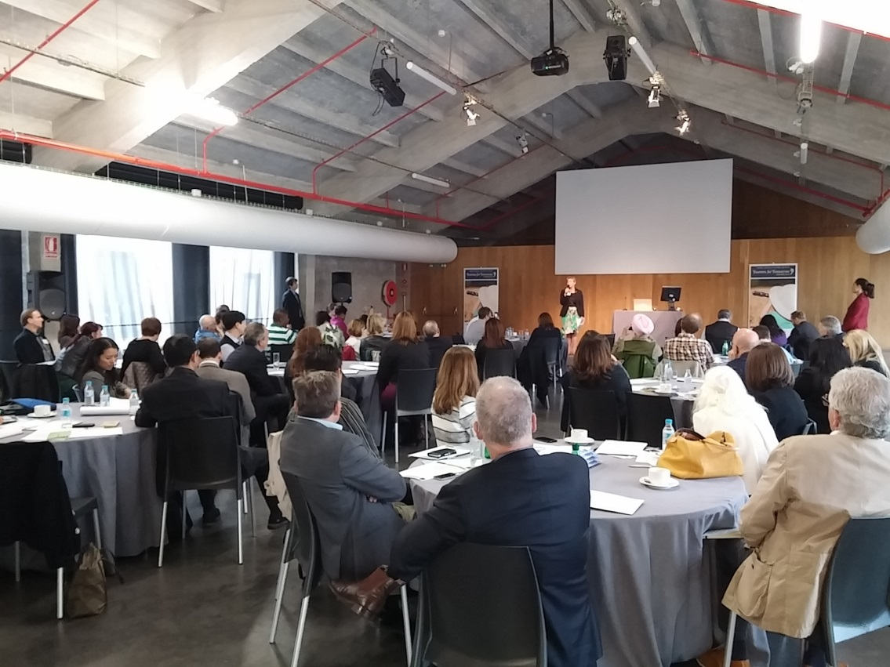
Tourism for Tomorrow Award入圍者分享學習研討會
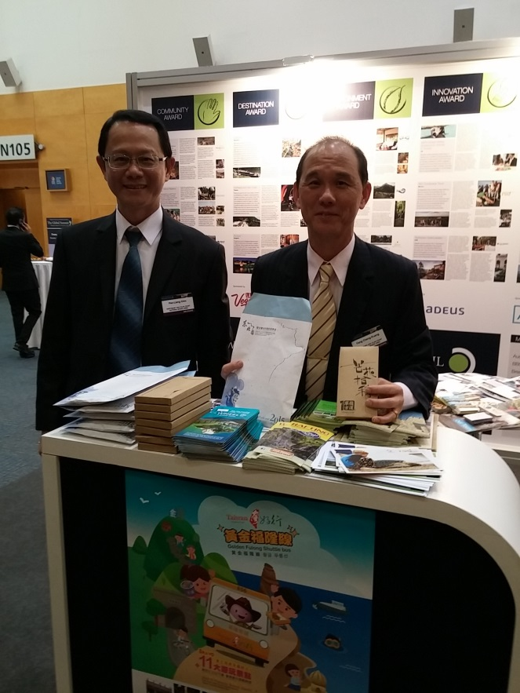
Global Summit會場外設攤推廣東北角周邊景點(左-遊憩課金保樑課長、右-東北角風管處方正光處長)

開幕儀式-WTTC主席Michale Frenzel致歡迎詞
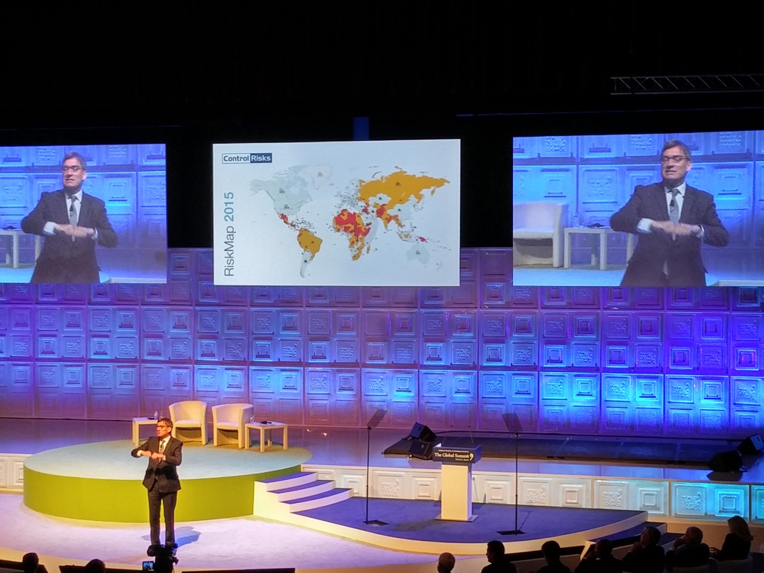
論壇-Drivers of Disruption 與談者Richard Fenning, CEO Control Risks
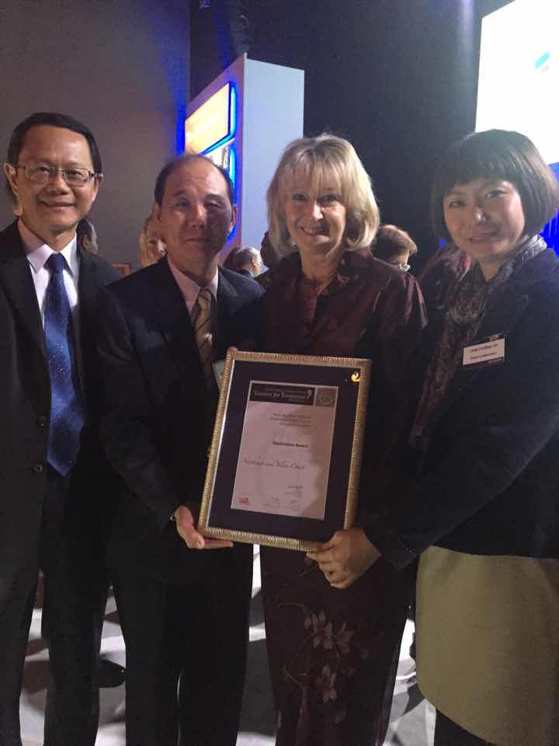
與明日旅業大獎典禮主席Fiona Jeffer(右2)合影。
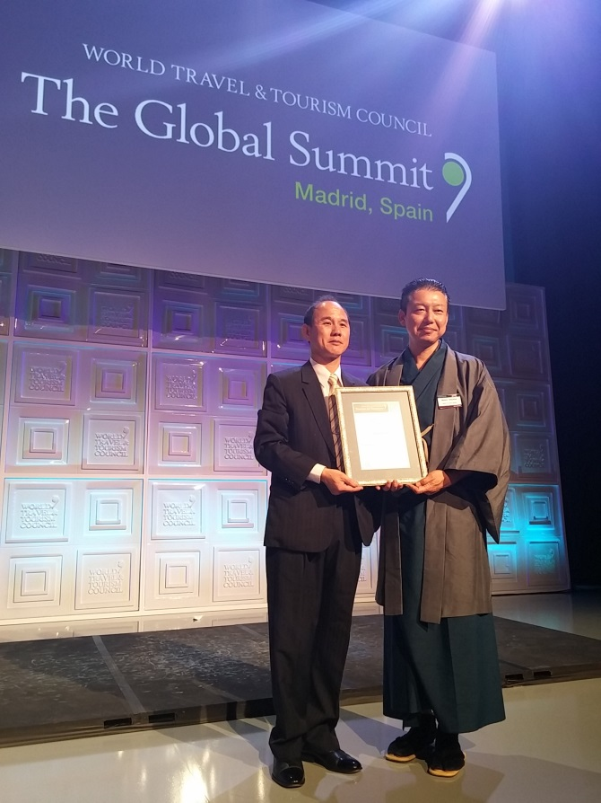
東北角風管處與現場評判評審日本Spirit of Japan Travel 總裁Masaru Takayama先生合影。
參賽資料簡要說明
Ministry of Transportation and Communications Tourism Bureau Northeast and Yilan Coast Scenic Area Administration
A Brief Introduction of the Old Caoling Tunnel and Circle-Line Bikeway

The revival of the declining rural train station in conjunction with the repurposing of Old Caoling Tunnel (a grade two historic site) and the design of a circular biking route gave birth to a new era of glory and prosperity to the small township of Fulong. In 1984, the number of visitors to Fulong Railway Station totaled around 80,000. In 2014, these numbers grew exponentially to reach a total of 497,624, successfully invigorating local business activity and the tourism industry.
The Old Caoling Tunnel Circle-Line Bikeway is a trail that incorporates historic value and is a symbol of the economic development in the Northeastern Coast. The route also includes a viewing of refurbished forts located along the coast line that serve as reminders of the bygone Martial Law Era, as well as the spectacular geological landscapes that are unique to this region, the vibrant fishing village culture, Taiwan's easternmost tip (San Diego) and numerous other scenic locations and coastal highways. This destination and activity has attracted countless visitors eager for the chance to immerse themselves in both ecological treasures and historic culture, while bicycling provides a low-carbon, environmentally friendly method of transportation. This has enabled local businesses to flourish, created many opportunities for employment, and is a realization of the many values brought by sustainable tourism.
I. An environment for preserving historic sites and culture
Old Caoling Tunnel, a historic site of vast importance, has undergone proper preservation and is currently being well maintained, crucial steps that ensure all visitors have the opportunity to fully understand and experience firsthand the value of this cultural heritage. Old Caoling Tunnel's symbolic meaning and importance lie in the following dimensions:
(I) A fully preserved representation of local culture.
Old Caoling Tunnel was completed in the year of Taishō 13 (1924) and is available today to the public after the Northeast and Yilan Coast National Scenic Area Administration actively intervened in its preservation and maintenance. Visitors are now able to fully experience the tunnel's rustic qualities and feelings of respect for the historic monument, allowing the tunnel to become the carrier of culture and human wisdom.
(II) A testimonial to the importance of economic benefit and transportation during the period of Japanese occupation.
Old Caoling Tunnel was once an important transportation route between Taipei and Yilan. It was a substantial influence on economic development in the period of Japanese occupation and was also an important asset for national defense and communication. After the tunnel was built, the Yilan railway line became connected to the Northeastern railway network and was key to development in Yilan's industries as well as industries along the entire eastern regions of Taiwan.
(III) A token of gratitude towards tunnel engineer Syongjhennanyan.
At the time of its construction, Old Caoling Tunnel was the longest lasting tunnel construction project in Taiwan, taking more than three years to fully complete and become operational. During its construction, project on-site supervising engineer Syongjhennanyan unfortunately contracted black-water fever and passed away at the age of only 34. When the tunnel was completed, Japanese technician Niimoto Shikanosuke inscribed the plaque reading "Conquering Dangers Given by God" etched over the north exit of the tunnel, and Sagataro Kaku inscribed the plaque reading "Where White Clouds Fly" over the tunnel's south exit. The Japanese also erected a monument near the north exit in memory of the great engineer who perished on duty.


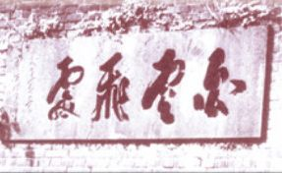

The "Conquering Dangers Given by God" plaque etched over the north exit of the tunnel
The "Where White Clouds Fly" plaque etched over the south exit of the tunnel over the north exit of the tunnel

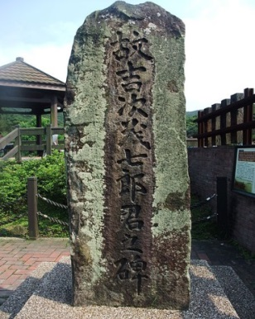
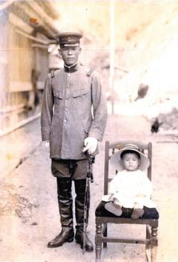

Syongjhennanyan monument Portrait of Syongjhennanyan
(IV) The inspiration for popular Taiwanese folk song "Diudiutung".
In 1787 (Year 52 of the Qianlong Era in the Qing Dynasty), Yilan people began claiming the Lanyang Plains under the leadership of Wu Sha. In those early days, the Yilan people needed to travel back and forth by crossing the many hills that separate Yilan from Taipei, and "Caoling Ancestral Trail" stands witness to those days of hardship. During the period of Japanese occupation, the government began laying down railways all across Taiwan, and in 1924 (Taishō 13) the Yilan Line became operational, greatly facilitating travel between the rural regions of Yilan with the metropolis. Due to the excessive number of water veins in the Xueshan Range, even after tunnels were carved out of the mountains, water continued to seep through the enclosing walls. When trains passed through the tunnels, drops of water inevitably fell onto the carriage roofs. The sounds of droplets coupled with churning wheels and rumbling tracks and the feeling of pleasure as villagers embarked on their journeys sparked the creation of renowned Taiwanese folk song "Diudiutung", a tune that aptly portrays the vivid images of "trains passing through the tunnels."

丟丟銅歌詞
火車行到伊都，阿末伊都丟，唉唷磅空內。
磅空的水伊都，丟丟銅仔伊都，阿末伊都，丟仔伊都滴落來
雙腳踏到伊都，阿末伊都丟，唉唷台北市。
看見電燈伊都，丟丟銅仔伊都，阿末伊都，丟仔伊都寫紅字。
人地生疏伊都，阿末伊都丟，唉唷來擱去。
險給黑頭伊都，丟丟銅仔伊都，阿末伊都，丟仔伊都撞半死。
借問公園伊都，阿末伊都丟，唉唷對都去。
問著客人伊都，丟丟銅仔伊都，阿末伊都，丟仔伊都我不知。
拖車走到伊都，阿末伊都丟，唉唷拖我去。
去到公園伊都，丟丟銅仔伊都，阿末伊都，丟仔伊都摸無錢。
拖車大哥伊都，阿末伊都丟，唉唷免生氣。
明年還你伊都，丟丟銅仔伊都，阿末伊都，丟仔伊都有甲利。
II. Connecting and revitalizing coastal scenic spots
(I) Fulong Railway Station
Fulong Railway Station is located in New Taipei City's Gongliao District and is currently administrated by the Taiwan Railway Administration Yilan Line. The successful integration of Old Caoling Tunnel with the Circle-Line Bikeway engendered an effective tourism development model that enabled the revitalization of the local tourism industry. The railway station is famous among cyclists as well as for its specialty bento boxes, the latter of which are sold by vendors whose cries can be heard all along the platforms whenever trains stop at the station. A multitude of bento shops, bicycle stores and beach ware shops are accessible right outside the station. Visitors may rent bikes, buy their lunches, dine and embark on their rides for an environmentally friendly, low-carbon travel experience.
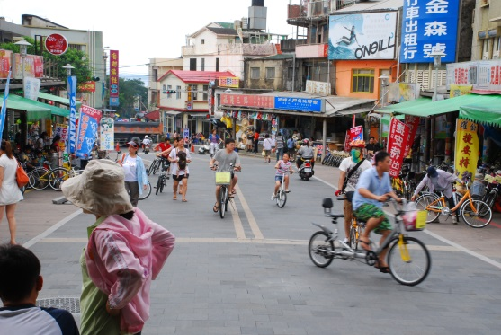
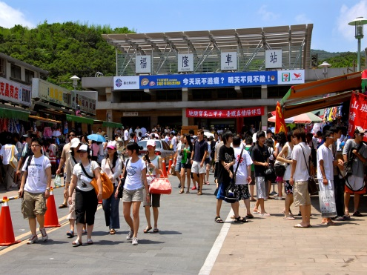

Cyclists in front of the railway station
Crowds of visitors before the railway station

(II) Old Caoling Tunnel
Old Caoling Tunnel connects New Taipei City and Yilan County, and was constructed between Taishō 10-13 (1921-24). The tunnel has a length of 2,167 meters and was the longest railway tunnel in Taiwan at that time. In 1986, Old Caoling Tunnel was closed down when a new railway tunnel was built (it remained disused for as long as 22 years) and was designated as a County Historic Monument in 2004. The tunnel was reopened to the public in 2008 as part of a biking trail.
Old Caoling is a horseshoe shaped single line arched tunnel with exits on the north and south sides built out of ascending layers of thick 4B bricks, creating a tunnel that is both grand in design and imposing in structure. The tunnel roof is supported by heavy pieces of stone. The arches framing the tunnel's exits are constructed from red brick and reach a height of 5 meters that allow one-way railroad passage. The arches are built in the 5 layer arching style (5 layers of red brick), one of the most notable characteristics of the entire structure.

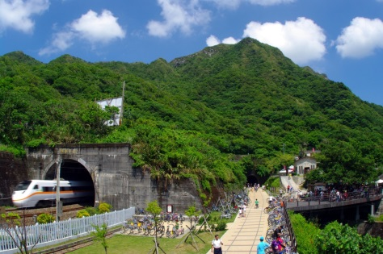
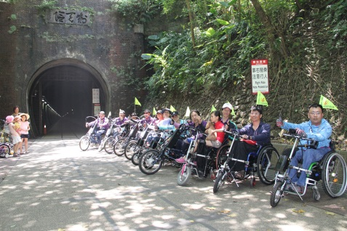

The tunnel's north exit The tunnel's south exit
(III) Shicheng
The saying goes that this location was named Shicheng, or "Stone City," when the "red-headed Dutch" built walls of defense out of huge rocks along the shoreline over three centuries ago. It is the perfect spot from which Turtle Island and stationary fishing can be seen and attracts many visitors who on weekends and holidays are drawn to the incredible views of the Pacific Ocean. In 1626, Year 6 of the Tienchi Era during the Ming Dynasty, the Spanish and the Dutch were in fierce contention for right of ownership over Northern Taiwan, and it is said that Shicheng was part of the coastal defenses built during that period of colonial expansion.
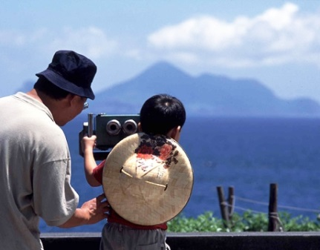
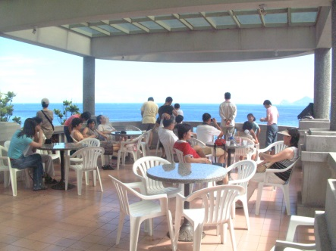

Distant view of Turtle Island View from Shicheng Service Area
(IV) Lailai Geological Area
Lailai Shore is the region along the entire Northeast coast with the most pronounced abrasion platforms. It is fended on the north by Sandiaojiao, flanked on the east by the Kuroshio Current of the Pacific Ocean and is the perfect environment for nurturing algae and plankton, which in turn cultivate massive numbers of fish and other oceanic creatures. The shore encompasses imposing walls of volcanic rock that are almost perpendicular to the ground, sea grooves, and geometric rock patterns that highly resemble washing boards. All these geological formations are the outcomes of orogenesis and natural erosions. People have always liked to name places after geological forms, therefore it is only natural that the continuous waves of undulating black rock should be referred to as the "Devil's Washing Board." The platform is also a perfect location for gazing at the distant Turtle Island.
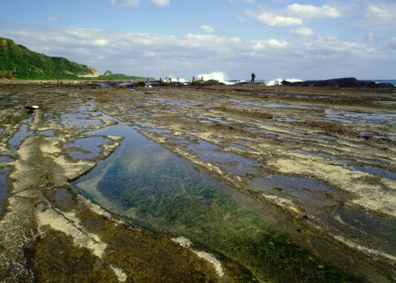
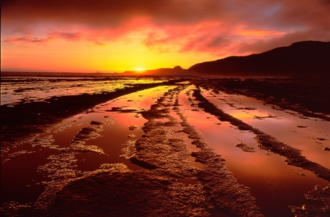

Abrasion Platform View of Sunrise
(V) Oceanic Resource Ecological Restoration Park
The Park is primarily dedicated to the cultivation of baby abalone and paradise fish population. The institution also offers guided tours to tourists and elementary or junior high school students for purposes of advocating aquatic preservation educating the public in the region's indigenous marine species, and is an integral of regional tourism.
(VI) Sandiaojiao
According to local legend, it is said that in Year 6 of the Tienchi Era during the Ming Dynasty (1626 AD), the Spanish fleet arrived at Taiwan's northeastern seas from the Philippines, and recorded this previously unknown location in their ship's log with the Latin name of San Diego. This is the earliest record of Taiwan's northeast cape and easternmost tip in Western history. The early residents of this region therefore pronounced and translated the western name as "Sandiao," which later evolved into "Sandiaojiao" or Sandiao Cape. The scenic spot includes a lighthouse and has been created into a picturesque hotspot for taking wedding photos.
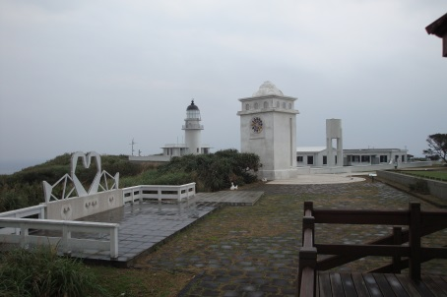
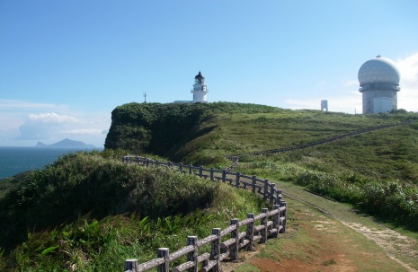

Sandiaojiao Lighthouse
View of Turtle Island from Sandiaojiao Lighthouse

(VII) Mao’ao Fishing Village
A visit to Mao’ao Fishing Village is like entering a forgotten forest path and leaving behind the bustle of the modern city. Within the village grounds are century-old banyan trees whose gnarled roots are woven into the earth, ducks that swim along the bubbling creeks, and stone slab houses constructed from local materials. All these elements emphasize the idyllic qualities of the sleepy little town as gentle waves break up along the shore. There may be no majestic mountain views or awe-inspiring coastal landscapes, but the very artlessness and authenticity of village life clears the mind and lightens the heart.
Backed by sloping mountains and facing the Pacific Ocean, Mao’ao is located west of Sandiaojiao and is flanked by a natural harbor, while three mountain streams flow into the bay and provide residents with abundant sources of fresh water. Mao’ao is one of the few tiny fishing villages within the Northeast Cape and Yilan Coast National Scenic Area that have retained their traditional simplicity, and it has been said that the village acquired its name from the shape of its harbor, which resembles the Chinese character for "Mao" when viewed from high above.
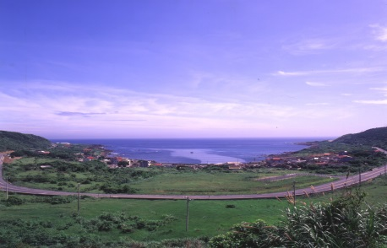
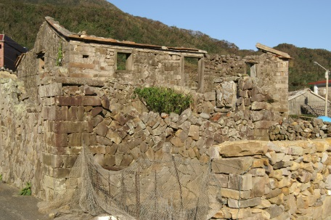

Bird's eye view of Mao’ao Mao’ao stone slab houses
(VIII) Fulong Tourist Center
The white walled and red tiled structure immediately neighboring the Fulong Bathing Beach is the Northeast Cape and Yilan Coast National Scenic Area Administration Building and Fulong Tourist Center. Fulong Tourist Center was built around the concept of "green architecture," and features transom windows on all four sides of the building that are guarded by wave-inspired wrought iron fencing that evoke images of the winding coastline. This form of architecture well-lit and naturally airy, and at the same time ensures complete privacy and security. The Center is used primarily for displaying information on the Northeast Coast's ecological features, historical culture, and travel destinations. The Center is also equipped with a multi-media room, a bicycle trial riding area, a repurposed timber wood sculpture exhibition hall, a Northeast coast scenic spot and activity treasure map, Northeast travel guides, sand sculpture creative modeling area, and a comprehensive service area. All visitors to Fulong are sure to stop by the Tourist Center for its abundant resources and information.
In 2001, Taiwan was struck consecutively by typhoons Toraji, Nari, and Haiyan. Massive volumes of driftwood washed up upon the Northeastern shores and were collected and sorted by the Administration. It was then that the agency discovered that the piles of timber contained many precious native Taiwanese species, a discovery that inspired the repurposing of driftwood. To awaken public consciousness of environmental conservation and renewal, to advocate and realize development in the tourism industry, and at the same time to cultivate local artistic talent, the Administration commissioned Sanyi wood sculptors and the Taiwan Wood-Carving Association to instill new life artistic value into the masses of driftwood through their unique perspectives and intricate techniques. The Administration placed these works of art into a collection and established the Repurposed Timber Wood Sculpture Exhibition Hall. Exhibited pieces are carved mainly out of Taiwan red cypress, stout camphor, Taiwan incense cedar, and other precious woods. They fully embody the spirit of environmental protection and regeneration, and also represent the perfect integration of tourism with artistic culture. These wood sculptures have now become one the Northeast Coast's most unique and irreplaceable cultural tourism asset.

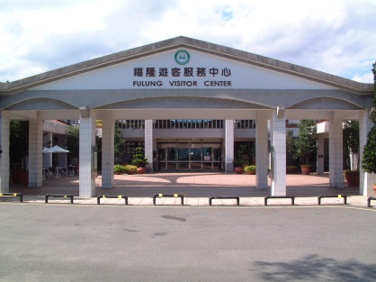
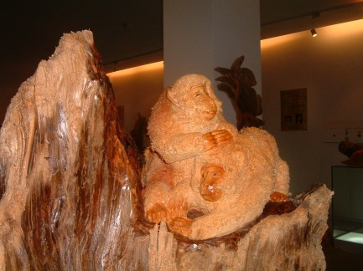

Fulong Tourist Center Wood Sculptures
III. Neighboring Scenic Locations
(I) Jioufen
Jioufen of Reifang District was once at the heart of the gold mining industry in Taiwan. It is gently embraced by rolling mountains and faces a deep bay curling just below. The small mountain town, with its variety of landscapes and ocean scenery, has fully retained the simple lifestyle once led by people of bygone eras. In Year 9 of the Guangshu Era of the Qing Dynasty (1893), gold deposits were discovered in the Jioufen area. Crowds living the gold rush dream swarmed into the small town as Jioufen's gold rush history officially commenced. After World War II ended and Taiwan was released from Japanese occupation, the gold rush fever also died, leaving behind increasing fewer numbers of workers and residents. Excavations were finally terminated in 1971.
Due to the increasing growth of the tourism industry, Jioufen is now experiencing an economic comeback, and its historic streets are teeming again with crowds of vendors and visitors. This is a place where busy city dwellers come for respite and relaxation from their daily hustle and bustle. Jioufen is nestled on hills that are flanked by mountains all around with an open bay deep down below, and the tiny mountain town's streets and structures meander along the irregular heights of the sprawling hills. Its local residents have retained their simple lifestyles, and because houses have always been packed tightly together due to lack of open space, the locals have maintained close relationships with their neighbors, creating an atmosphere of friendliness and sociability that is rarely found elsewhere in this modern world. The changing seasons alter the tones and colors of the mountain scenery, imbuing it with distinctively different moods and spirits. Jioufen was once the land of dreams for gold rush seekers, but today, it's the land of opportunity for artists seeking to make their names.
(II) Yilan
Yilan was once called the indigenous name of Kavalan and is located on the Lanyang Plains of Taiwan's northeast region. Three major rivers irrigate these plains, Yilan River, Lanyang Stream, and Dongshan River.
The areas north of Lanyang Stream are commonly divided into two regions: North Stream, which includes Toucheng, Jiaosi, Zhuangwei, Yuanshan, Yilan City, and Tatung, a total of six townships. The areas south of Lanyang Stream are referred to as: South Stream, which is composed of six remaining townships including Wujie, Dongshan, Lotung, Suao, and Nanao.
The people of the Lanyang region are simple-minded, highly acculturated, and for hundreds of years have been dedicated to the reclusive activities of either concentrated studies or simple farming.
The mountains, oceans, rivers, lakes, hot springs, cold springs, streams and waterfalls of this region provide endless opportunities for appreciation and contemplation. The poetic beauty of the surrounding sceneries is a boundless source of inspiration for artistic and poets like as well as the ultimate destination for traveling and sightseeing.
In 2006, after HsuehShan Tunnel became fully operational, Yilan became a veritable "garden of Taipei." Visitor numbers grew exponentially, enabling the region to become an international tourism hotspot.

The eight destinations that are connected by the Old Caoling Tunnel Circle-Line Bikeway has successfully engendered development in sustainable ecological tourism and drawn more than 1.85 million visitors to the region since 2008. The tourism industry has created economic benefits of over NTD 300 million per year, and bicycle vendors in particular have grown from 0 to more than 30. Visitor satisfaction are as high as 98.96%, and intentions of revisiting are even higher a 99.22%. Public consciousness of eco-travel, green tourism and environmental conservation has grown hand in hand, which has in turn led to substantial growths in local bicycle businesses as well as the hospitality and food and beverage industries. This has become the driving force for the virtuous cycle between environmental protection, economic expansion, and social development by providing returning youths with opportunities of employment, alleviating population loss, and effectively rejuvenating local business activity. The project has furthermore won the participation and identification of local residents, as well as the trust of other government agencies and authorities.

