（出國類別：參加國際研討會）

參加香港比較教育學會2015年度學術年會

服務機關：國立暨南大學
姓名與職稱 ：國際文教與比較教育學系
蔡玉萍博士生
派赴國家：中國香港
出國期間：104年2月5日~2月7日
報告日期：104年2月7日

摘要
2015年2月6日至7日，比較教育學會在香港大學舉行為期兩天的學術年會
(Comparative Education Society of Hong Kong Annual Conference 2015)。來自世界各國對於教育有熱誠的學者和研究生都來參與此盛會。開幕典禮在2月6日下午1:30開始，並在14:30開始第一場的研討會。此年會於2月7日下午五點半圓滿落幕。
香港比較教育學會2015年度學術年會的主題是”Developing Scholarship in Comparative Education”。我本人，題目為” Multicultural Education Policy in the Secondary Schools of Malaysia”。在這些議題中，我更了解各國的教育制度，以及為何這些發表人想要研究問題的動機，其主要目標都是希望改善自己本國的教育制度。
我的報告內容主要是根據馬來西亞現有的多元文化制度來做探討包括其教科書，課綱和語言政策此三方面作分析。現場的發表人都是以提問題方式做交流，主要集中在詢問發表人本國現有教育制度的細節、研究方法的設計和更仔細釐清發表人研究的動機。現場與會人員對我提的問題是關於我研究動機並詢問為何馬來西亞的多元文化為何可以作為臺灣的借鏡。根據問題，我也一一解釋，之後現場與會人員對發表人的文章都有或多或少的建議，以做為將來繼續研究的依據。

目次
本文
目的 1
過程 1
會議議程 1
議場主題 2
報告議題及其內容重點摘述 2
心得及建議 3
附件 4

本文
一、目的：本人參與香港所舉行的比較教育學會的年度國際研討會之目的是希望藉由參與這研討會能吸收目前此相關領域的學者們新的想法並給予本人更多相關的學術研究方向，此外也希望和與會人員一起分享和討論本人所發表的文章，並能給予意見以幫助本人改進自己的文章。
二、過程:
(一)會議議程
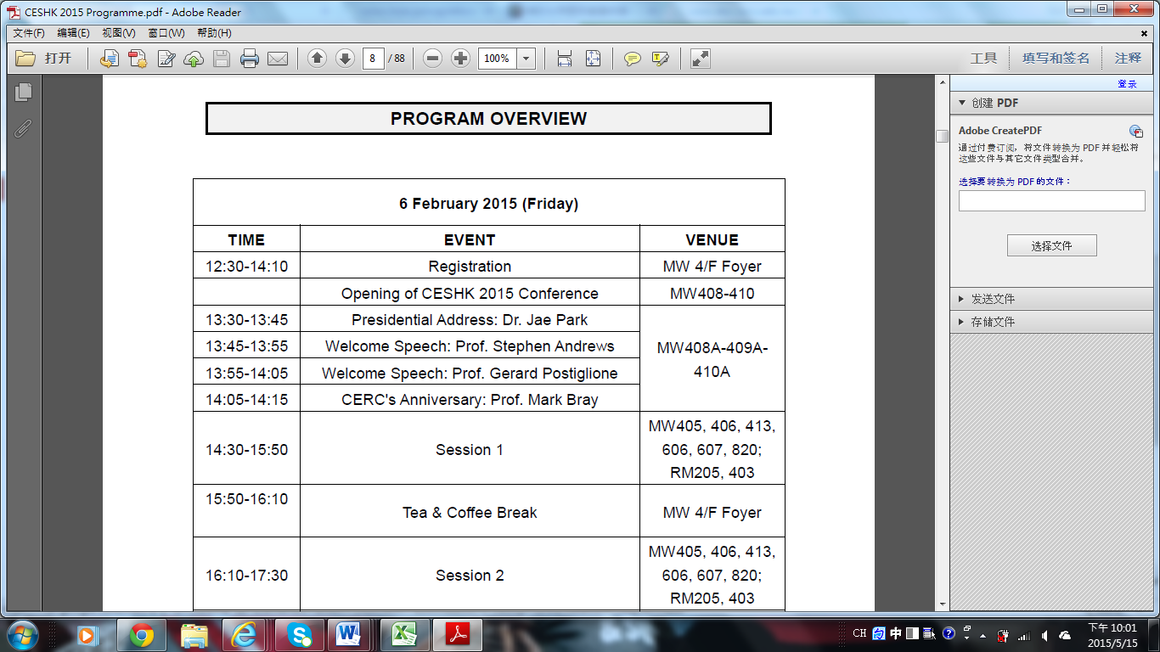
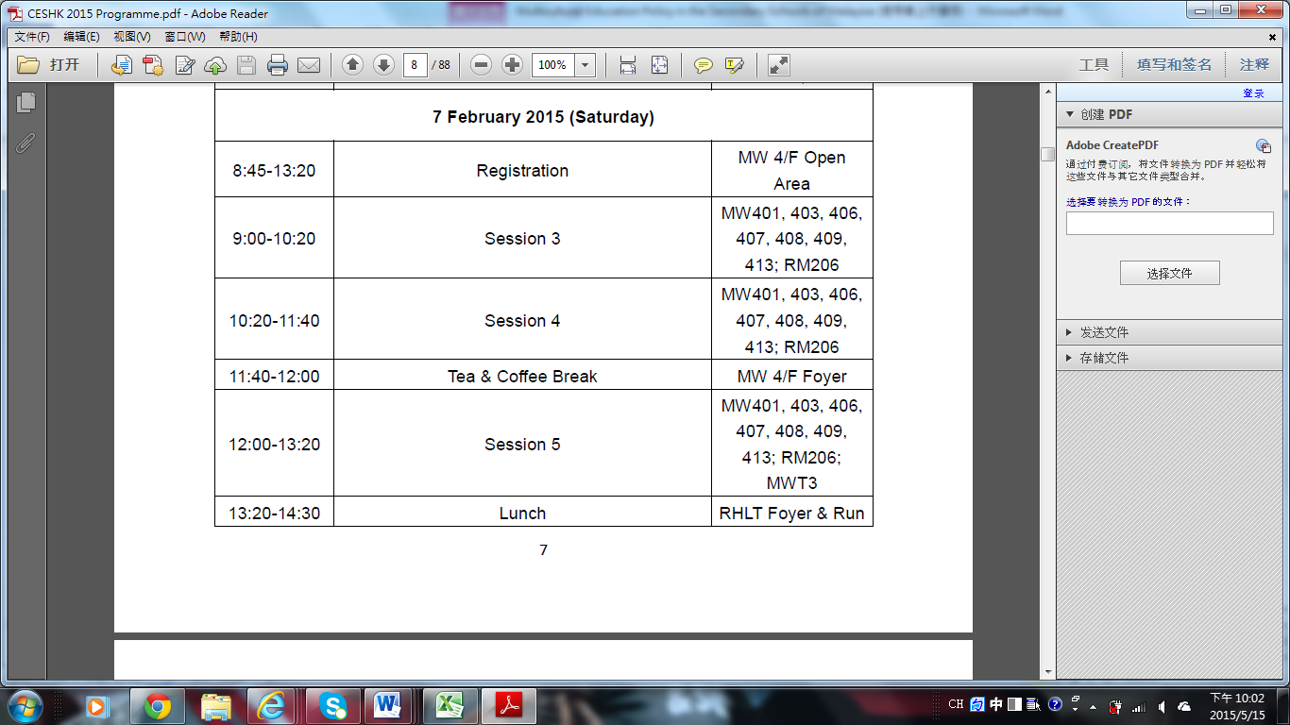
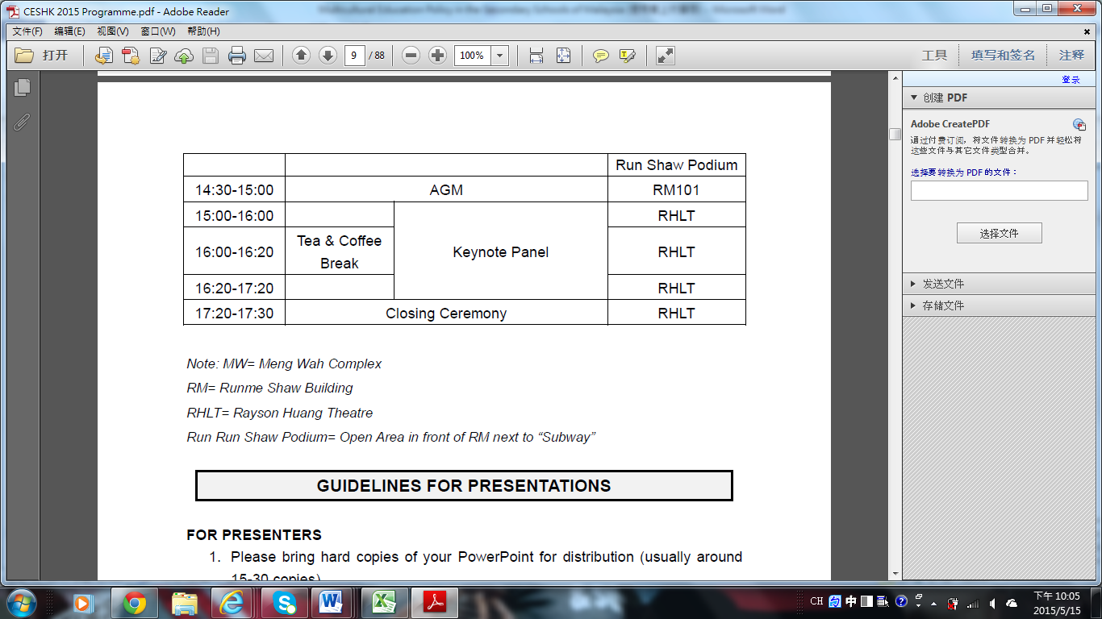
(二) 議場主題
國際研討會主題:
Developing Scholarshi in Comparative Education
本人報告的議題: 馬來西亞中等教育多元文化政策
(Multicultural Education Policy in the Secondary Schools of Malaysia)
(三) 報告議題及其內容重點摘述
以下是本人發表文章的題目及中英文摘要:
Multicultural Education Policy in the Secondary Schools of Malaysia
(馬來西亞中等教育多元文化政策 )
Abstract(英文摘要)
Malaysia is a nation diverse in its ethnicity, culture, and religion. Its multiethnic
and multi-religious nature poses unique challenges to the government in keeping the Malaysian people united. In Malaysia, the multicultural society is typified by three magor enthnic groups, namely Malays, Chinese and Indians. Education system is the best tool for these three major of ethnic groups which will work together. Therefore, it is a goal of Malaysian education to enhance social integration among these various ethnic groups beyond mere physical integration, and intends to eliminate social prejudices and discrimination. This study discusses how the Government of Malaysia has been managing its complex cultural and religious nation with different ethnicities as a nation by its multicultural education policy foucsed on junior high school phase of the secondary schools. According to the results, the researcher discussed them mainaly based on James Bank’s multicultural education viewpoints.The conclusion might provide other multiethnic countries with unique opportunity to learn the related experience from Malaysia.
中文摘要
馬來西亞是一個多元民族在種族，文化和宗教。它的多種族
和多宗教特質想要使馬來西亞人民團結的馬來西亞政府是個挑戰。在馬來西亞，多元文化的社會主要是由三個種族組合，即馬來人，中國人和印度人代表。而教育幫助這三個主要族群將一起工作團結一起的最佳工具。因此，整合這些不同民族社會融合一起並打算消除彼此的社會偏見和歧視是馬來西亞教育的目標。本研究討論馬來西亞政府如何處理國內複雜的文化、宗教、不同種族團結成為一個國家的議題。此報告的多元文化的教育政策焦點放在中等教育階段。根據研究結果，研究者主要根據詹姆斯˙班克斯的多元文化教育觀點來探究。此研究結論可以提供其他的多民族的國家相關的啟示和建議。

三、心得及建議
此研討會使我感受到學術自由及開放的一面。每人都可參與任何一場他們所想要聆聽的報告，也都能和報告人員有所互動和交流。更難能可貴的是此年會參與人員是來自世界各地，大家齊聚一場共同為教育盡一份心力，不論是哪方面的議題更不論是討論哪個國家的教育。此過程中，本人受益良多也受感動。在發表完之後，與會人士建議我可以再多加著墨馬來西亞多元文化教育政策產生的背景，且若能訪問到馬國相關人士如教育人員等或給予問卷應會更完善。這些建議我會虛心接受，對我未來的研究也會更有利。
至於我也聽取其他國家研究生的文章包括來自大陸、香港、韓國等。聽完之後對於其他國家的教育現況其他們將來的願景有更清楚的了解，如有不錯的想法並適用於我國的話，我們來自臺灣的研究生可以提供給我們教育部或者應用在我們教學上，不同國家對教育的想法激發彼此對本國教育改善的方向。參加此研討會不僅可以在研討會上發比自己對教育的看法理念，更可以激盪出自己未來的研究方向。
至於建議方面，可能是香港大學的內在校園動線較為複雜，因此當天報到時本人迷路了。但是其指引路線不是很清楚，所以花了一些時間尋找研討會舉行地點，在這方面希望以後要舉辦的學校能夠在動線指引方面能更清楚。

四、附件
附上本人參加此國際研討會發表文章的全文。
附件:
Contents
I. Introduction 4
1. Background and Motivation 4

1.1 The importance of multicultural education 4
1.2 Why Malaysia is chosen 5
1.3 The Purposes of the Study 6
1.4 Research Method 6
1.5 Limitation of the Study 7
II. Literature Review 7
2.1 Multicultural Education 7
2.1.1 What Multicultural Education Is 7
2.1.2 The Goals of Multicultural Education 8
2.1.3 James Banks on Multicultural Education 10
2.1.4 Other Proponents of Multicultural Education 12
2.2 The Multicultural Education Policy in the secondary schools of
Malaysia 14
2.2.1 The multicultural background of Malaysia 14
2.2.2 The Multicultural education of Malaysia 17
III. Results abd Discussions 22
3.1 Textbook 22
3.2 Curriculum 23
3.3 Language policy 23
IV. Suggestions 23
References 24

I. INTRODUCTION
1. Background and Motivation
Multicultural education relates to education and instruction designed for the cultures of several different races in an educational system. This approach to teaching and learning is based upon consensus building, respect, and fostering cultural pluralism within racial societies. Multicultural education acknowledges and incorporates positive racial idiosyncrasies into classroom atmospheres.
What’s more, multiculturalism education concentrates on the need of including notions of race, class, and diversity while teaching. Multiculturalism supports the idea that students and their backgrounds and experiences should be the center of their education and that learning should occur in a familiar context that attends to multiple ways of thinking (Banks and Banks, 2013).

1.1 The importance of multicultural education
As the world seems to be getting smaller and smaller with the widespread use of technology, the importance of multicultural education in K-12 classrooms grows exponentially. Students who have access via the internet to international gaming, shopping and social media sites need an even better understanding of the similarities and differences between their own cultures and those of the world around them. Likewise, the ever-present reality of conflicts between nations reinforces the importance of multicultural education as the need for people of varying backgrounds to have a better understanding of one another has international implications for future generations. A sound multicultural education model manifests an acceptance of a respect for all cultures in our pluralistic society. It fosters positive self-regard in one’s own culture and positive attitudes toward the culture of others (Parks, 2012 ). While exploring similarities and differences among cultures, it develops an understanding and appreciation of one’s own cultural heritage as well as that of other cultures. It fosters the ability to function harmoniously and productively in a multicultural society.
The principles of multicultural education promote close working relationships among the school, home, and community in order to provide consistent expectations and mutual support. The use of positive role models from the community is an integral and valuable component for promoting multicultural education in the schools. It is important to note the diversity of cultures, ethnic backgrounds, and races of children in schools (McCracken, 1993). “Multicultural education incorporates the idea that all students – regardless of their gender; sexual orientation; social class; and ethnic, racial, or cultural characteristics – should have an equal opportunity to learn in school” (Banks and Banks, 2013). If done correctly, students will develop a positive perception of themselves by demonstrating knowledge about the culture, history, and contributions of diverse groups. This way, multiculturalism is a tool for instilling students with pride and confidence in their unique and special backgrounds (Banks and Banks, 2013).
1.2 Why Malaysia is chosen
The resarcher has some reasons as follows to explain why Malaysia is chosen:
Malaysia is a nation diverse in its ethnicity, culture, and religion. Its multiethnic and multi- religious nature poses unique challenges to the government in keeping the Malaysian people united. However, the 13 May 1969 Incident happened (Andaya & Andaya, 1982). After that, Malaysia government wanted to establish related policies to avoid such accidents and make sure the unity of Malaysia. From then on, the governement has tried to develop the multicultural education because education plays an important role in multicultural communities.
It is a goal of Malaysian education to enhance social integration among these various ethnic groups beyond only physical integration, and intends to eliminate social prejudices and discrimination. Now, Malaysia has become a trade nation. One of the reasons is its stable situation within the country. That means its development of the multicultural education is effective and successful. So to explore its multicultural education is necessary and useful for other countries with multi-cultures. In this study, the researcher chose the phase of junior high school, excluding that of senior high school. The reasons are as follows. First, compulsory education in Malaysia includes elementary and junior high school. Compulsory education is important for the development of a nation. In a nation, it is not only a basement but also a tool to develop the government’s policies. Second, because of the time limitation, the researcher only chose the phase of junior high school to study.
1.3 The Purposes of the Study
The aim of the study is to explore the multicultural education policy in the secondary schools of Malaysia. Specifically, this study highlights the four topics as follows:
(1) the theories and viewpoints on multicultural education,
(2) the multicultural background of Malaysia,
(3) the multicultural education policy in the secondary schools of Malaysia,including its textbooks, curriculum and language policies.
(4) the conclusion, implication and suggestion according to the findings of this study.
1.4 Research Method
The researcher adopted Document analysis. Document analysis is a social research method and is an important research tool in its own right and is an invaluable part of most schemes of triangulation. Documentary work involves reading lots of written material including public records, the media, private papers, biography and visual documents. A document is something that we can read and which relates to some aspect of the social world. Official documents are intended to be read as objective statements of fact but they are themselves socially produced (retrived from :http://www.drcath.net/toolkit/document.html).
1.5 Limitation of the Study
There are two limitations in this study. First, because of large amount of related references and the insufficient time, the researcher cannot present complete findings. Second, because of the limitation of the researcher’s language ability, just English and Chinese references were read excluding Malay references.
II. Literature Review
A review of the literature aims to give some academic support for the present study. To achieve these purposes, the review of the literature in this study highlights two topics: 1) the theories on multicultural education including its identifications and its goals, 2) the multicultural education of Malaysia including its multicultural background, its multicultural education policy in the secondary schools of Malaysia. Besides, the second part includes the textbooks, the language policy and the curriculum of the secondary schools of Malaysia.
2.1 Multicultural Education
2.1.1 What Multicultural Education Is
Multicultural education developed from the Civil Rights Movement of the 1960s. Initially, schools hastily made classes where students would be able to learn about different ethnic groups, a majority of the information learned in these classes were about holidays and other celebrations. These classes were considered to be electives and were typically only taken by students of the ethnic groups the classes were focused on. (Banks and Banks, 2013)
Multicultural education is a field of study based on the idea that students from diverse backgrounds should have equal opportunities to education. It draws on insights from a number of different fields, including ethnic studies and women studies, but also reinterprets content from related academic disciplines (Banks & Banks,1995).
Multicultural education, also viewed as a way of teaching, promotes principles such as inclusion, diversity, democracy, skill acquisition, inquiry, critical thought, value of perspectives, and self-reflection. It encourages students to bring aspects of their home lives into the classroom and thus, allows teachers to support the child’s intellectual and social/emotional growth ( O’Donnell, 2015).
Multicultural education is also attributed to the reform movement behind the transformation of schools. Transformation in this context requires all variables of the school to be changed, including policies, teachers' attitudes, instructional materials, assessment methods, counseling, and teaching styles (Banks, 1997). Besides, multicultural education is concerned with the contribution of students towards effective social action. It therefore necessitates children from all backgrounds to acquire “democratic skills and knowledge” (Banks &Michelle, 1998) in order to become effective citizens in a democratic society. In this process, the experience of oppressed groups is valued and a commitment to mutual respect and tolerance is developed (Gutmann, 2003).
2.1.2 The Goals of Multicultural Education
Supporters of multicultural education (e.g., Banks, 2008;Sleeter & Grant, 2003) claim that, at the social level, its major goals are to reduce prejudice and discrimination against oppressed groups, to work toward equal opportunity and social justice for all groups, and to effect an equitable distribution of power among members of different cultural groups (Sleeter, 1996).
Within the field of education, Banks (1993) views the primary goal of multicultural education as transforming schools so that “all students will acquire the knowledge, attitudes, and skills needed to function in an ethnically and racially diverse nation and world” (p. 28) . While multicultural education can be conceptualized in many different ways, some of the leaders in the field (for example: Banks, 1997; Nieto, 1996, 1999; Sleeter, 1996; Sleeter & Grant, 1994), define the goals and ideals of multicultural education similarly.
The primary goal of multicultural education is not merely to promote human relations, to help students feel good about themselves, or to preserve students' native languages and cultures. While these outcomes may be by-products, the primary goal of multicultural education is to promote the education and achievement of all students, particularly those who are traditionally dismissed and underserved in the education system (see Table 1). Sonia Nieto (1996) defines multicultural education as antiracist basic education for all students that permeates all areas of schooling, characterized by a commitment to social justice and critical approaches to learning. Furthermore, multicultural education challenges and rejects racism and other forms of discrimination in schools and society. It accepts and affirms differences in race, ethnicity, religion, language, economics, sexual orientation, gender, and other differences that students, communities, and teachers encompass. It should permeate the curriculum and instructional strategies used in schools, as well as interactions among teachers, students, and families in school and outside of it (Nieto, 1999). v
Table 1 The Goals of Multicultural Education
- Analyzes ways in which schools and the education system as institutions in our society work to maintain and perpetuate racism (Banks, 1997)
- Examines the history and underlying causes of racism, sexism, and other forms of institutional oppression (Banks, 1997)
- Encourages academic excellence (Nieto, 1999)
- Is for all students, not just students of color (Nieto, 1996)
- Requires the authentic examination of white privilege and the legacy of white dominance (McIntosh, 1989; Howard, 1999)
- Teaches how racism hurts not only people of color but also whites, and how it keeps us from being allies (Howard, 1999)
- Demonstrates how people have worked together in history to fight against all forms of oppression (Howard, 1999)
- Teaches about the shared aspects of racism and other forms of oppression (Gorski, 2002)
- Helps students, families, teachers, and administrators understand and relate to the histories, cultures, and languages of people different from themselves (Sleeter & Grant, 1994)
- Provides opportunities to envision a better world: a just and fair society with equitable opportunities for all
- Inspires and empowers us to work to make those visions come true.

2.1.3 James Banks on Multicultural Education
James Banks, a lifetime leader in multicultural education and a former president of both the National Council for the Social Studies and the American Educational Research Association, describes the balancing forces in (Banks, 2008) “Citizenship education must be transformed in the 21st Century because of the deepening racial, ethnic, cultural, language and religious diversity in nation-states around the world. Citizens in a diverse democratic society should be able to maintain attachments to their cultural communities as well as participate effectively in the shared national culture. Unity without diversity results in cultural repression and hegemony. Diversity without unity leads to Balkanization and the fracturing of the nation-state. Diversity and unity should coexist in a delicate balance in democratic multicultural nation-states” (Gorski, 2012). Planning curriculum for schools in a multicultural democracy involves making some value choices. Schools are not neutral. The schools were established and funded to promote democracy and citizenship. A pro-democracy position is not neutral; teachers should help schools promote diversity. The myth of school neutrality comes from a poor understanding of the philosophy of positivism. Rather than neutrality, schools should plan and teach cooperation, mutual respect, the dignity of individuals and related democratic values. Schools, particularly integrated schools, provide a rich site where students can meet one another, learn to work together, and be deliberative about decision making. In addition to democratic values, deliberative strategies and teaching decision making provide core procedures for multicultural education (Campbell, D., 2010).
According to Banks, multicultural education is an idea, an educational reform movement, and a process (Banks, 1997). As an idea, multicultural education seeks to create equal educational opportunities for all students, including those from different racial, ethnic, and social-class groups. Multicultural education tries to create equal educational opportunities for all students by changing the total school environment so that it will reflect the diverse cultures and groups within a society and within the nation's classrooms. Multicultural education is a process because its goals are ideals that teachers and administrators should constantly strive to achieve.
Besides, he formulated the five specific dimensions as content integration, knowledge construction process, prejudice reduction, equity pedagogy, and empowering school culture and social structure (1998).
Figure 1 Banks’ Five Dimensions of Multicultural Education
Content integration deals with the infusion of various cultures, ethnicities, and other identities to be represented in the curriculum. The knowledge construction process involves students in critiquing the social positioning of groups through the ways that knowledge is presented, for example in scientific racism or the Eurocentric view of the “discovery” of America. Prejudice reduction describes lessons and activities that teachers implement to assert positive images of ethnic groups and to improve intergroup relations. Equity pedagogy concerns modifying teaching styles and approaches with the intent of facilitating academic achievement for all students. Empowering school culture describes the examination of the school culture and organization by all members of school staff with the intent to restructure institutional practices to create access for all groups (Banks, 2004). While highlighting the interrelatedness of the five dimensions Banks promotes deliberate attention to each.
2.1.4 Other Proponents of Multicultural Education
A variety of even more educational philosophers and theorists have written about their views on multicultural education, and their beliefs are many and varied. Here, the researcher chose some of them to discuss their beliefs about multicultural education.
(1) Meira Levinson on Multicultural Education
According to Levinson, three distinct groups present different conceptions of “multicultural education.” These groups are: political and educational philosophers, educational theorists, and educational practitioners. In the minds of the members of these groups, multicultural education has different, and sometimes conflicting, aims within schools. Philosophers see multicultural education as a method of response to minorities within a society who advocate for their own group’s rights or who advocate for special considerations for members of that group, as a means for developing a child’s sense of autonomy, and as a function of the civic good. Educational theorists differ from philosophers in that theorists seek to restructure schools and curriculum to enact “social justice and real equality” (Levinson, 2009, p. 433). By restructuring schools in this way, educational theorists hope that society will thus be restructured as students who received a multicultural education become contributing members of the political landscape. The third and final group, educational practitioners, holds the view that multicultural education increases the self-esteem of students from minority cultures and prepares them to become successful in the global marketplace. Though there are overlaps in these aims, Levinson notes that one goal, cited by of all three prominent groups within the field of education, is that of “righting the historical record” (p. 435).
(2) Joe Kincheloe and Shirley Steinberg on Multicultural Education
Kincheloe and Steinberg in Changing Multiculturalism (1997) described confusion in the use of the terms "multiculturalism" and "multicultural education". In an effort to clarify the conversation about the topic, they developed a taxonomy of the diverse ways the term was used. The authors warn their readers that they overtly advocate a critical multicultural position and that readers should take this into account as they consider their taxonomy. Within their taxonomy, Kincheloe and Steinberg break down multiculturalism into five categories: conservative multiculturalism, liberal multiculturalism, pluralist multiculturalism, left-essentialist multiculturalism, and critical multiculturalism. These categories are named based on beliefs held by the two largest schools of political thought (liberalism and conservatism) within American society, and they reflect the tenets of each strand of political thought. In terms of Levinson’s (2009) ideas, conservative multiculturalism, liberal multiculturalism, and pluralist multiculturalism view multicultural education as an additive to existing curriculum, while left-essentialist multiculturalism and critical multiculturalism see to restructure education, and thus, society.
(3) Labaree on Multicultural Education
Labaree's Democratic Equality ideology, which is defined in Labaree's article, Public Goods, Private Goods: The American Struggle Over Educational Goals is a perfect example of different aspects of Multicultural Education. A teacher using Labaree's Democratic Equality, would have students who are able to feel like they belong in the classroom, which teaches students equal treatment, and gives support to multiculturalism, non-academic curriculum options, and cooperative learning (Labaree,1997). Labaree use of Democratic Equality supports a multicultural education because “in the democratic political arena, we are all considered equal (according to the rule of one person, one vote), but this political equality can be undermined if the social inequality of citizens grows too great” (Labaree, 1997, p. 42). By providing opportunities to engaged and enrich children with different cultures, abilities, and ethnicities we allow children to become more familiar with people that are different from them, hoping to allow a greater acceptance in society. Also by representing a variety of cultures reflected by the students in your classroom, children will feel like they have a voice or a place at school.
Although every expert or philosopher has his/her viewpoints about multicultural education, their points basically emphasize the mutual respect and understanding.
2.2 The Multicultural Education Policy in the secondary schools of Malaysia
2.2.1 The multicultural background of Malaysia
Modern Malaysian pluralism has been shaped by migration, and has impacted post-independence nationbuilding and society-making in many ways. Malaysian contemporary ethnic diversity is not only characterized by the existence of the various ethnic groups—Malay, Chinese, Indian, Iban, Kadazan, and ethnic minorities such as the Orang Asli and the Siamese—but also of recent migrants (mostly Indonesians) who play an important role in shaping Malaysian history and social participation in citizen-making. However, the variety of ethnic groups, with their own distinctive lifestyles and value systems is living together. Schools are challenged to address the needs of students from many backgrounds (Andaya & Andaya, 1982) .
Reflecting the contradictory processes of convergence and divergence, Malaysian diversity has been a source of tension and conflict in the society, as manifested by the May 1969 ethnic riots in Kuala Lumpur and other parts of the country (Andaya & Andaya, 1982). More than three decades down the road, however, Malaysian society has changed, and ethnic relations have improved tremendously, with reasonably strong tendencies toward convergence and new solidarities. Nevertheless, the constant contestation and even tension are also present and their implications for ethno-religious relations cannot be overlooked.
The Malaysian government defined Malaysian culture through the issuance of the "1971 National Culture Policy". It defines three principles as guidelines for Malaysian culture: that it is based on the cultures of indigenous people; that if elements from other cultures are judged suitable and reasonable they may be considered Malaysian culture; and that Islam will be an important part of national culture (Campbell, 2010).
At a national conference organized by Malaysia’s Ministry of Culture, Youth and Sports in 1971, the Malaysian government formulated what was to become a national cultural policy based on the following principles:
i). The national culture of Malaysia must henceforth be based on the cultures of the people indigenous to the region
ii). Elements from other cultures which are judged suitable and reasonable may be incorporated into Malaysia’s national culture
iii). Islam will be an important element in the national culture
In the period since its implementation, Malaysia’s national culture policy has become one important point of vigorous debate and political conflict. In the years since the formulation of a National Cultural Policy, and particularly in the late 1980’s, the Malaysian government has been concerned to implement its basic principles by intervening directly and across the board in the cultural field. Not surprisingly, and perhaps because it has not been altogether clear and efficient about its task, government intervention in the cultural field has produced a response on the part of a variety of non-Malay groups who feel that their cultural freedom has been curtailed. For example, at a meeting of the Chinese guild and associations of Malaysia held in March, 1983, delegates passed a series of resolutions that were compiled in a joint memorandum to the Ministry of Culture, Youth and Sports. In April 1984, a group of the best-known Indian cultural, social and religious organizations submitted a similar memorandum. Both memoranda accused the government of having formulated a cultural policy which was Malay-centric and undemocratic, and requested that a new policy on national culture be established which was more clearly multi-ethnic and democratic (Kahn & Loh, 1992).
The legal foundations of the Malaysian cultural policy are derived from the following acts and regulations:
i). Antiquities Act 1976 (Act 168)
ii). National Art Gallery Act, 1958
iii). Legal Deposit of Library Material Act, 1986 (Act A667)
iv). National Library Act, 1972; The National Library (Amendment) Act, 1987
v). National Archive Act, 1966 (Act 44), (Revised 1971), (Act A85), (Revised 1993), (Act 511)
vi). Tourist Development Corporation of Malaysia Act 1972 (Act 1972)
vii). Broadcasting Act 1988 (Act 338), Broadcasting (Amendment) Act, 1997 (Act A977)
viii). Cinematography Film - Hire Duty Act 1965 (Revised 1990), (Act 434)
ix). (Perbadanan Kemajuan Filem Nasional Malaysia Act 1981 (Act 244), Perbadanan Kemajuan Filem Nasional Malaysia (Amendment) Act, 1984 (Act 589)
x). Perbadanan Kemajuan Kraftangan Malaysia Act 1979 (Act 222)
xi). Theatres & Places of Public Amusement (Federal Territory) Act 1988 (Act 182)
xii). Bernama Act, 1967 (Revised 1990), (Act 449)
xiii). Entertainment Duty Act 1953 (Revised 1973) (Act 103)
2.2.2 The Multicultural education of Malaysia
The policy about multicultural education has many perspectives we can discuss. The researcher chose three of them to explore multicultural education of Malaysia including its textbooks, curriculum, and language policies.
(1) Textbooks
Textbooks are edited according to the following principles (Badrul Isa, 2015).
Being a plural country, there is the urgency of inculcating the spirit of multiculturalism from the early age as possible. This realization has led to the formation of unique policy of multiculturalism in the educational sector. Though two types of schooling exist (national school and vernacular school), the same policy is applied to all types of schools.
A. Rukun Negara (National Principles)
The aim of the Rukun Negara is to create harmony and unity among the various races in Malaysia. The Malaysian Educational Policy Since independence, education has always been given first priority and essential in developing skilful and sufficient manpower needed in building the nation. The designing and crafting of any educational policy will finally depend on the type of society we wish to develop. The future of nation does depend greatly on the education system of the country. It should begin with strong foundation of primary level of education and to be followed by systematic secondary education, supported by competitive but flexible tertiary system. Education bring changes to civilization of a nation, thus it should be viewed in a more complete and holistic approach. Thus, Malaysian educational system is designed to suit the country’s aspiration in realizing a better working structure and to meet future challenges globally. To achieve this, the major goals of any educational programme and activities are:
1. Equip students with the essential skills in a holistic and integrated manner, in order to produce individuals who are intellectually, spiritually, emotionally and physically balanced; as well as functionally literate;
2. Inculcate and nurture national consciousness by promoting common ideals, values, aspirations and loyalties to foster national unity and national identity;
3. Produce skilled manpower for economic and national development; Instill desired moral values in students so that they can contribute effectively towards nation towards building (Badrul Isa, 2015) .
B. National Ideology (The Rukunegara Any policy)
The Rukunegara Any policy designed has to conform the National Ideology or commonly referred to as the ‘Rukunegara’. It is a country’s common principle, developed to address Malaysia’s aspiration of unity and development, to unite Malaysians and to crease a sense of responsibility within each citizen. The principles of Rukunegara are outilined below:
• Belief in God
• Loyalty to King and Country
• Up holding the Constitution
• Rule of Law
• Good Behavior and Morality The underlying objectives of Rukunegara are
• To develop a united n nation within a plural society
• To develop a democratic society through a constitutionally elected parliament
• To develop a just society with equal opportunities for all
• To develop a liberal society of diverse cultural traditions
• To develop a progressive society oriented towards science and modern technology Rukunegara stipulates that: “To develop a liberal society of diverse cultural traditions” Malaysian government with the collaboration of non-governmental organizations is working hard towards developing a liberal society. This is a matter of importance, as liberal society can help maintain the stability of the country. One of the ways to achieve this is through the equality in learning. The educational system is designed to promote a united, democratic, just, liberal and progressive society (Badrul Isa, 2015).
C. The National Philosophy of Education (Falsafah Oendidikan Kebangsaan)
It is a basic education that have been implemented in the country of Malaysia by FPN, every educational activities organized to achieve the balance in terms of physical , emotional, spiritual and intellectual.
The National Philosophy of Education emphasizes the development of quality individual who will later contribute to the development of nation and society. National Philosophy of Education states: “Education in Malaysia is on going effort toward further developing the potential individuals who are intellectually, spiritually, emotionally and physically balanced and harmonious, based on a firm belief and devotion to god. Such an effort is designed to produced Malaysian citizen who are knowledgeable and competent, who possess high moral standards and who are responsible and capable achieving a high level of personal wellbeing as well as being able to contribute to the betterment of the society and the nation at large” Art education in Malaysia has undergone a tremendous change since the independence. In 1980`s, a new national curriculum was introduced in primary and secondary levels.
D. The implication of “one outline, multiple textbook edition" policy
Because of the multiethnic groups in Malaysia, the textbooks are translated into different langguages, mainly Malay, Chinese and Tamil.
(2) Curriculum
The New Curriculum for Primary School was introduced in 1982 and the Integrated Curriculum for Secondary School was introduced in 1988. These new curricula are in line with several government policies, aims and objectives in education that were reviewed as early as 1970`s and various education reforms that were introduced ever since.
According to Malaysia Education ministry, their textbooks are basec on the idea:
Integrated Secondary School Curriculum (KBSM). The design of KBSM is for the continuity from the primary education, integration of intellectual, spiritual, emotional noble values and physical elements. It also stresses on the lifelong education and the further usage of the national language. Table 2 shows Malaysis curriculum (KBSM, 1997).

Table 2 Lower secondary Level (Form I – Form III) of Curriculum in Malaysia
Subjects | Total time per week (minutes)
Malay Language | 240
English language | 200
Mathematics | 200
Islamic Education＊ | 160
Moral Education＋ | 120
Science | 200
Integrated living Skills | 160

Subjects | Total time per week (minutes)
Geography | 120
History | 120
Health Education | 40
Physical Education | 40
Art Education/Music | 80
Chinese/Tamil Language＋＋ | 120
Arabic Language ＋＋(Communication) | 240

For Muslim students , they have to study Islamic education; however, if non-Muslim students, they have to study moral education. So we will know how Malaysia stresses moral education is.
Besides, every student has to study Malay and English. As for Chinese and Indian students, they can study their mother languages as an optional subject. Most important of all, every student has the equal opportunity to study in junior high school. Besides, if more than 15 parents in a class want to learn other languages excluding Chinese/Tamil/Arabic language, the schools have to open the foreign language classes.
(3) Language policy
The Malay language, formally called Bahasa Malaysia, was established as the official language of Malaysia after its independence from the British in 1957 ; English was used as a second language. In 1971, Bahasa Malaysia was made the medium of instruction in all national schools, supplanting English medium ones. After three decades of the Malay-only policy, Malaysia, a largely trading nation, realized that the proficiency level of English among Malaysians has deteriorated to the point of almost halting its globalization policy. This was considered a huge setback in the push towards becoming a fully developed country by the year 2020 (Pennycook, 1994). Under the Malay-only policy, Malaysia government highlights Malaysia and English. Now, in the secondary school, Malay and English are compulsory subjects; Chinese and Tamil are optional subjects.
III. Results abd Discussions
This part presented the results of the multicultural education policy in the secondary schools of Malaysia based on three perspectives: testbook, curriculum and language policy. The results and discussion are addressed in terms of the related references.
3.1 Textbook
First, one of the aims of editing the textbooks is to create harmony and unity among the various races in Malaysia. However, the unity is based on the principle “one Malay”. Second, one of the aims of the textbooks is to respect diverse cultural traditions. However, how is the proportion of the presentations of diverse cultures in the textbooks of Malaysia? Third, Malaysia’s textbooks are based on the policy: “one outline, multiple textbook edition" policy. However, the truth of multiple textbooks editions is that the textbooks are written in three languages, not in different editions. The aim of the editing Malaysia’s textbooks accords with Banks’ ideas: content integration, prejudice reduce, and an equity pedagogy. However, the item of empowering school culture is excluded.
3.2 Curriculum
According to KBSM, the curriculum is “destined to produce Malaysian citizens who are knowledgeable, who possess high moral standards, and who are responsible and capable of achieving a high level of personal well being as well as able to contribute to the harmony and betterment of the nation at large”(Ministry of Education). Besides, the curriculum highlights the moral education and harmony of the nation. Next, the government gives everyone equal opportunity to study no matter which ethic groups the person belongs to. So in that part, Malaysia governement emphsaizes the equal learning opportunity for every citizen in Malaysia. Last, the time of learning Malay Language and even English is longer than that of learning Chinese and Tamil. Learning a language is learning a culture. So when students learn their own languages, they also learn their own cultures. However, the time of learning Malay or English distributed is not the same as that of learning Chinese or Tamil.
3.3 Language policy
Because of globalization and one-Malay policy, English and Malaysia are emphasized. Now in the secondary school, Malay and English are compulsory subjects; Chinese and Tamil are optional subjects. Basically, the multicultural education policy of Malaysia is based on one-Malay policy because of achieving to the unity of Malaysia. Besides, to avoid the conflicts and develop Malaysia, the government offers equal opportunities to every student. Malaysia government should continue striving its effort to achieve the real equity.
IV. Suggestions
This study investigates the multicultural education policy in the secondary schools of Malaysia. Based on the study findings, it also provides Taiwan with related suggestions about multicultural education policy. According to the results, the researcher provided some suggestions.
- In respect of the content of the curriculum, it is necessary to get rid of the advantaged groups’ dominance and emphasize the development of the students’ multicultural literacy.
- It is necessary to emphasize students’ abilities of putting multi-cultures into practice and the development of multicultural literacy.
- It is important to hold meetings regularly in order to examine the insufficiencies or faults about the multicultural education policy.
- It is essential to develop pre-job teachers ’knowledge and literacy and encourage in-job teachers to help their students be involved in a multicultural classroom.
References
Andaya, B. W., and Andaya, L. Y (1982). A History of Malaysia. London: Macmillan.
Banks, J. A.1993). Approaches to multicultural curriculum reform. In J. Banks and C.
Banks, J.A. & Banks, C.A.M. (Eds). (1995). Handbook of research on multicultural education. New York: Macmillan.
Banks, J. A. (1997). Educating Citizens in a Multicultural Society. New York: Teachers College Press.
Banks, J.A. and Michelle T. (1998). “Multiculturalism’s Five Dimensions.” NEA Today Online. Retrieved fromhttp://www.learner.org/workshops/socialstudies/pdf/session3/3.Multiculturalism.pdf
Banks, J. A. (1998). Approaches to multicultural curricular reform. In Lee, E.
Banks, J. A., & Banks, C. A. M. (2004). Handbook of research on multicultural education. San Francisco: Jossey-Bass.
Banks, J. A. (2008). An introduction to multicultural education (4th ed.). Boston: Pearson Education.
Banks and Banks.(Eds). (2013). Characteristics and Goals. Multicultural Education. (John Wiley & Sons).
Badrul Isa (2002). Multiculturalism in art education: a Malaysian perspective.
Faculty of Education, Universiti Teknologi MARA MALAYSIA. Retrived from http://portal.unesco.org/culture/es/files/29700/11376859351isa_badrul.pdf/isa_badrul.pdf
Campbell, D. (2010). Choosing Democracy: a practical guide to Multicultural Education. 4th. edition. Pearson, Allyn /Bacon.
Gorski, P. C.(2002). Rerrived from http://www.mhhe.com/socscience/education/multi.
Gorski, P.C (2012). A Brief History of Multicultural Education. Hamline University. Retrieved from http://red.pucp.edu.pe/ridei/files/2012/11/121111.pdf
Gutmann, A. (2003). The Authority and Responsibility to Educate. In A Companion to the Philosophy of Education. Randall Curren, ed. (Malden, MA: Blackwell), pp. 397-411.
Howard, G. (1999). We Can't Teach What We Don't Know: White Teachers, Multiracial Schools. New York: Teachers College Press.
Kahn, J. S. & Loh,F. eds (1992). Fragmented vision: Culture and Politics in Contemporary Malaysia. Syndey: Allen & Unwin.
Kincheloe, J. and Steinberg, S. (1997). Changing Multiculturalism, London: Open University Press.
Labaree, D. (1997). Public Goods, Private Goods. The American Struggle Over Educational Goals. American Educational Research Journal, 34, 39-81. Retrieved September 10, 2014.
Lee, E. Menkart, D., & Okazawa-Rey, M. (1998). Beyond Heroes and Holidays: A Practical Guide to K-12 Antiracist, Multicultural Education and Staff Development. Washington, DC: Network of Educators on the Americas.
Levinson, M. (2009) Ch. 23. Mapping Multicultural Education' in Harvey Seigel, ed. The Oxford Handbook of Philosophy of Education (Oxford University Press).
McCracken, J. B. (1993). Valuing diversity. The primary years. Washington, DC: National Association for the Education of Young Children.
McIntosh, P. (1989). White privilege: Unpacking the invisible knapsack. Peace and Freedom, 1(1), 10-12.
Nieto, S. (1996). Affirming Diversity: The Sociopolitical Context of Multicultural Education (2nd ed.). White Plains, New York: Longman.
Nieto, S. (1999). The Light in their Eyes: Creating Multicultural Learning Communities. New York: Teachers College Press.
O’Donnell, C. Commentary (2015). [Web log comment]. Retrieved from http://www.learner.org/workshops/tml/workshop1/commentary.htm
Parks, J. (2012). Tips for Integrating Multiculturalism and diversity into the preschool classroom. Retrieved May 17, 2014. from http://hatchearlylearning.com/integrating-multiculturalism-diversity/
Pausat Perkembangan Kurukulum (KBSM, 1997). Pembelajaran Masteri- Konsep dan Pelaksaan dalam KBSR dan KBSM, Kuala Lumpur.
Pennycook, A. (1994). The worldliness of English in Malaysia. The cultural politics of English as an international language. London & New York.
Sleeter, C.E., & Grant, C. (1994). Making Choices for Multicultural Education: Five Approaches to Race, Class and Gender. Englewood Cliffs, NJ: Prentice Hall.
Sleeter, C. (1996). Multicultural Education as Social Activism. Albany, NY: SUNY Press.
Sleeter, C.E.&Grant (2003). Making choices for multicultural education. Five appraoches of race, class and gender. Boston:Jossey-Bass.

