蒙特婁議定出締約國名單Status of Ratification

Ratification of: | Vienna Convention | Montreal Protocol | London Amendment | Copenhagen Amendment | Montreal Amendment | Beijing Amendment
Total number of countries | 197 | 197 | 197 | 197 | 197 | 197
The table below shows the status of Ratification, Accession, or Approval of the agreements on the protection of the stratospheric ozone layer as provided by the Depositary, the United Nations Office of Legal Affairs, New York.

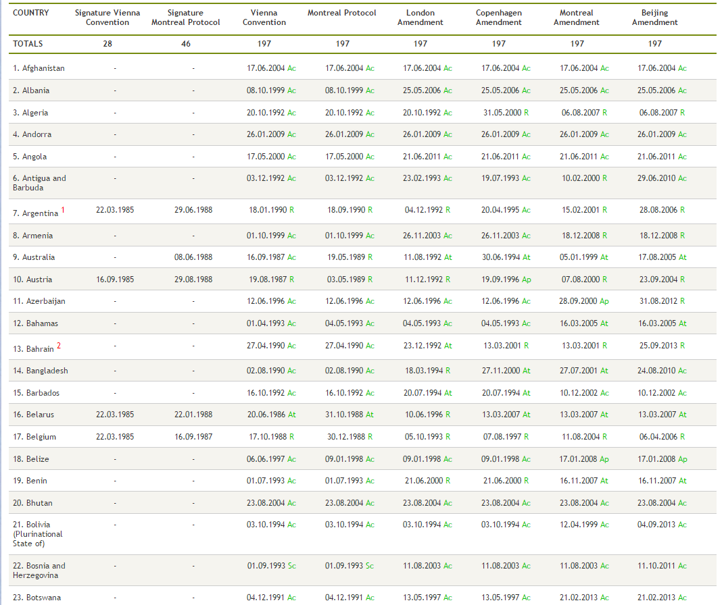
As of 04 December 2014, the status of ratification is as follows:
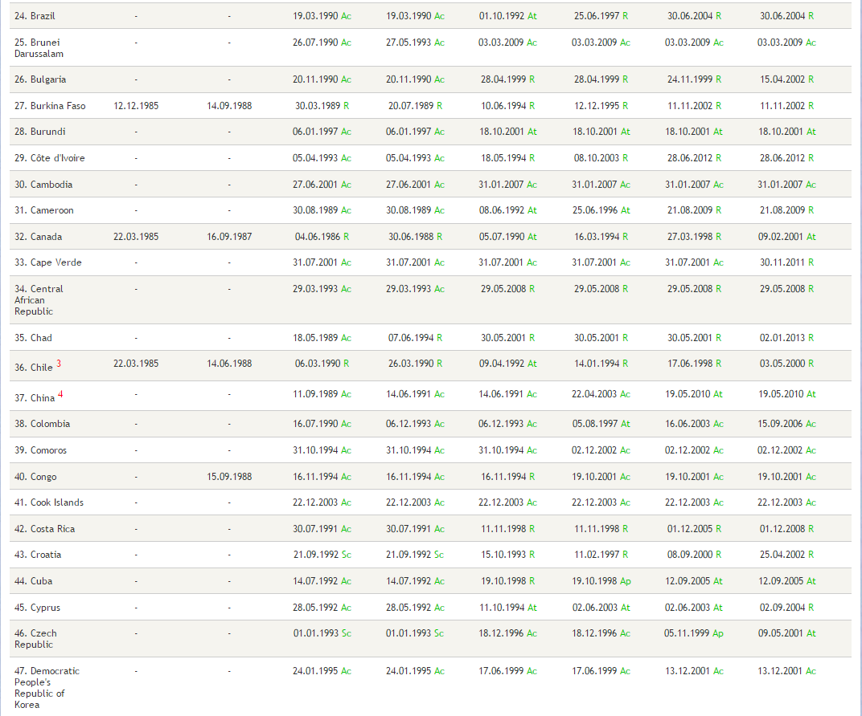
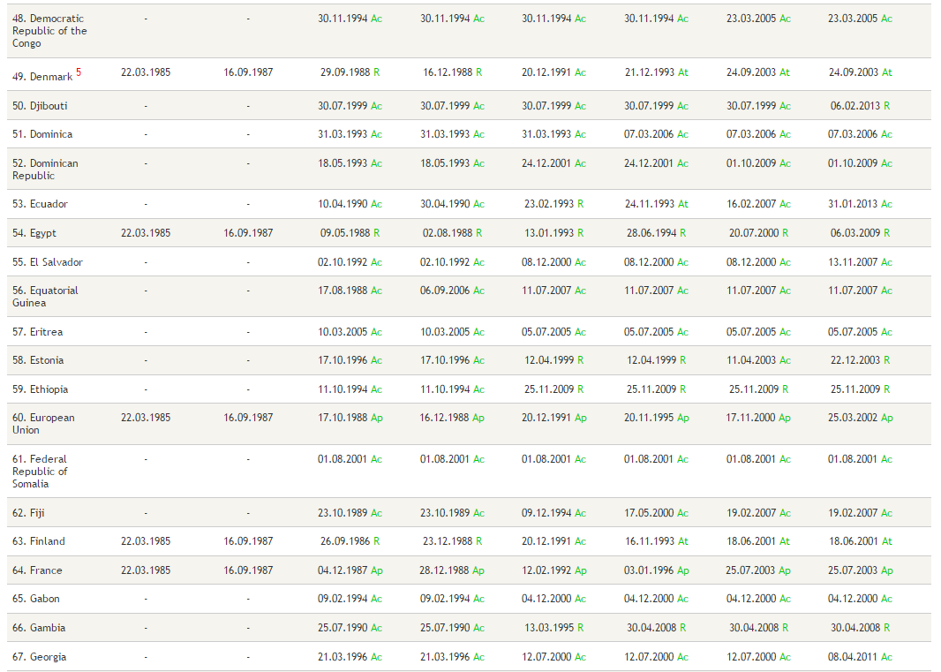
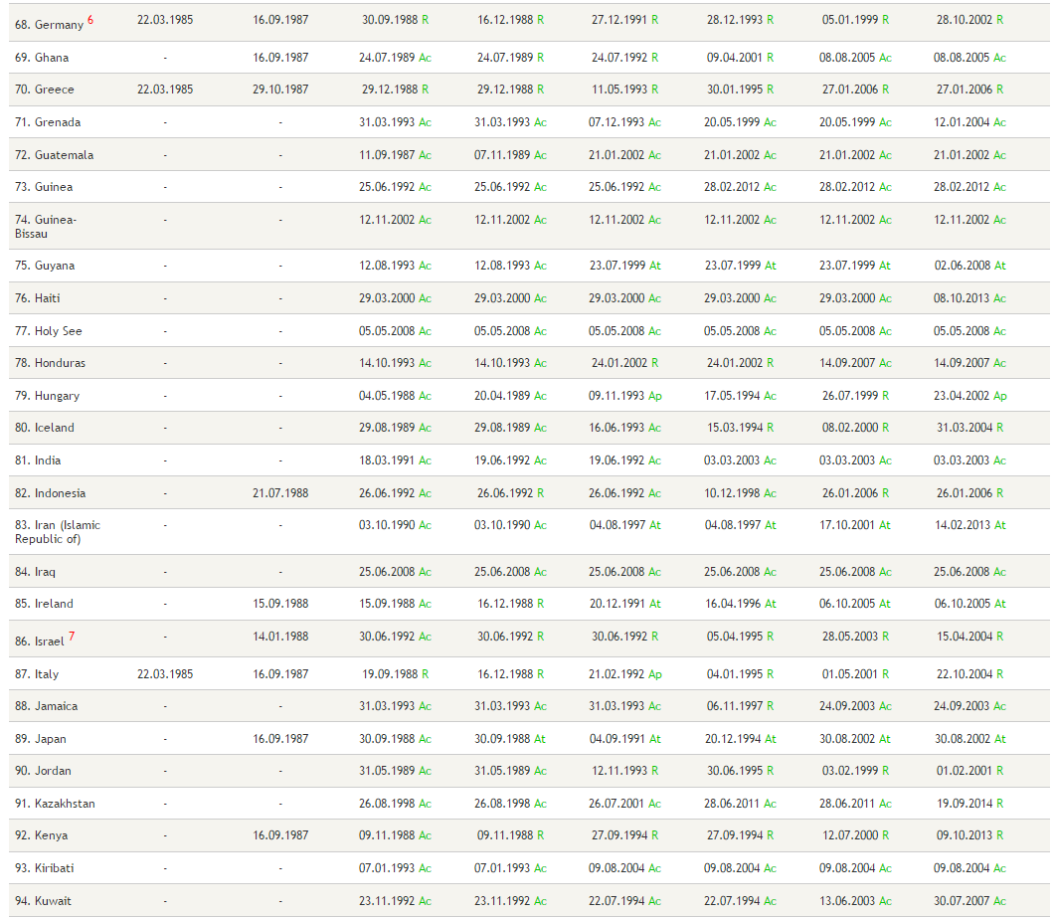
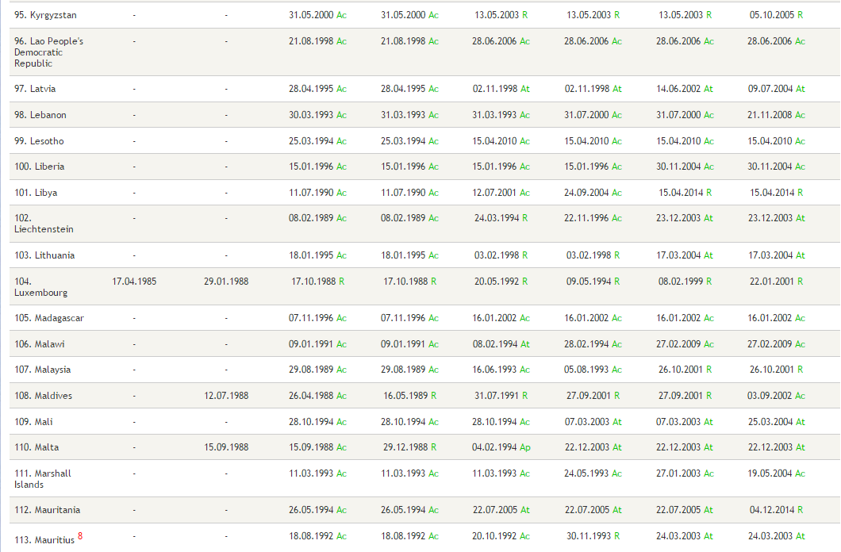
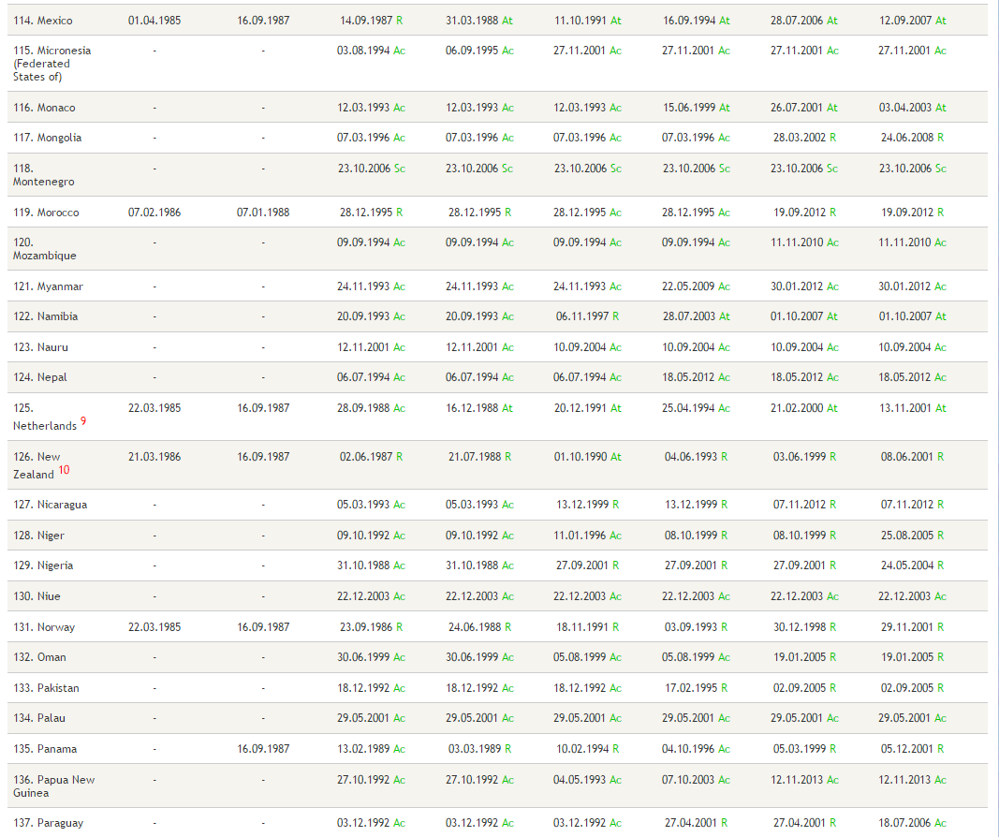
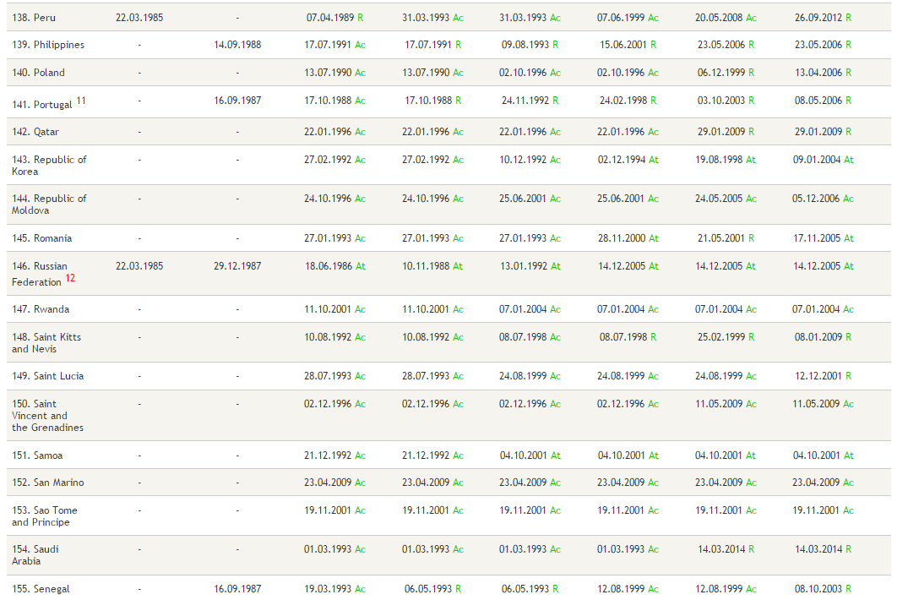
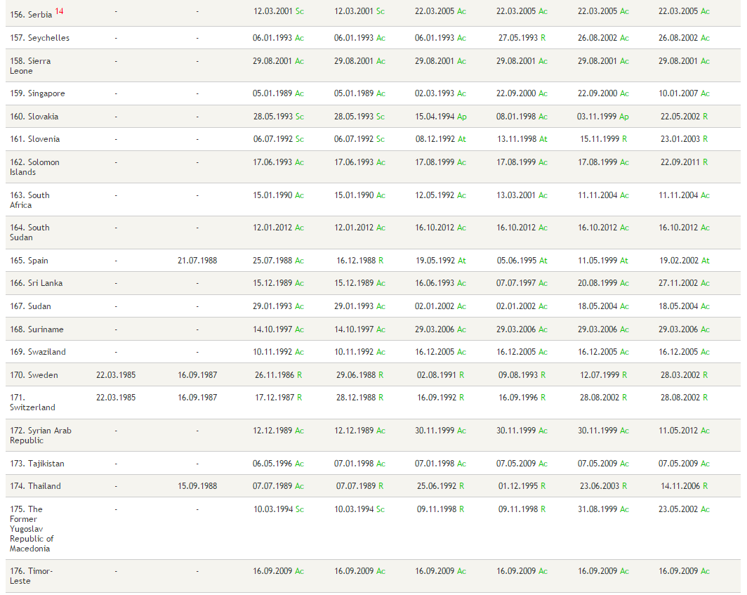
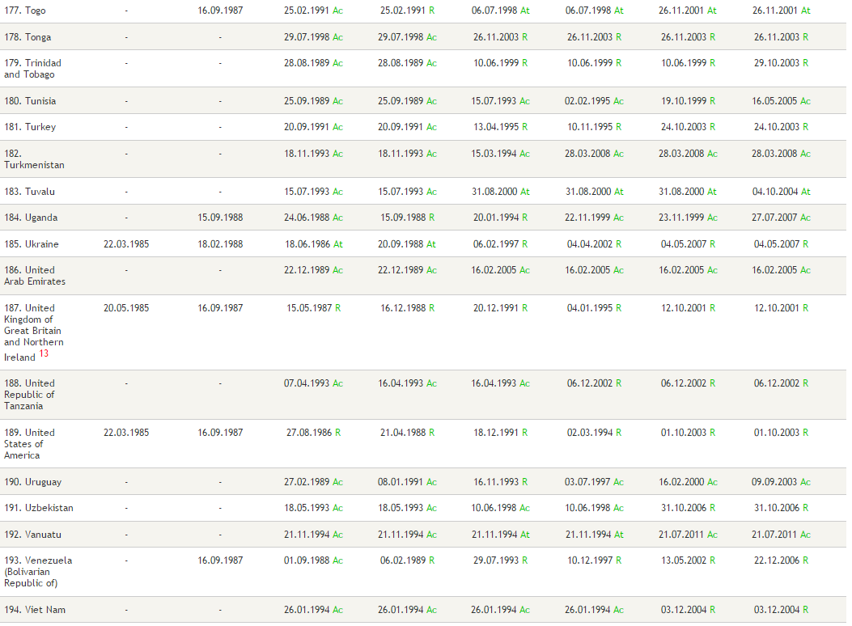
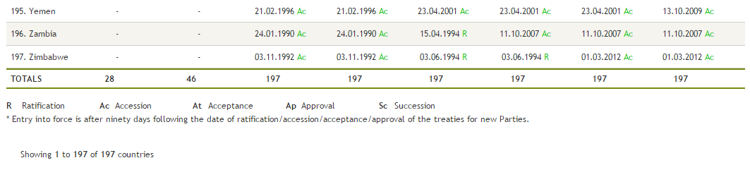

Notes
R Ratification Ac Accession At Acceptance Ap Approval Sc Succession
* Entry into force is after ninety days following the date of ratification/accession/acceptance/approval of the treaties for new Parties.
Vienna Convention (22.9.1988)
Montreal Protocol (1.1.1989)
London Amendment (8.10. 1992)
Copenhagen Amendment (14.6.1994)
Montreal Amendment (10.11.1999);
Beijing Amendment (25.2.2002)

