出國報告（出國類別：國際會議）

參加第十屆摩擦攪拌銲接國際研討會 The 10F TWI FSW Symposium之報告

服務機關：中正大學機械工程學系
姓名職稱：敖仲寧教授
派赴國家：中國北京
出國期間：2014.05.19-2014.05.24
報告日期：2014.07.01

摘 要
敖仲寧教授至北京參加由英國銲接研究所TWI舉辦之2012第十屆摩擦攪拌銲接國際會議(Friction Stir Welding Symposium, FSW 2014)該會議是針對應用先進製造科技--摩擦攪拌銲接製程的專業國際會議。該會議由發明摩擦攪拌銲接製程的英國銲接研究中心主辦，共舉行了十屆，此次自2014年5月20日至101年5月23日在北京國家會議中心舉行四天。敖仲寧與林派臣教授共同發表論文Mechanical Properties and Failure Modes of Friction Stir Clinch Joints Between 6061-T6 Aluminum and S45C Steel Sheets (鋁合金6061-T6與中碳鋼S45C板料異種材料摩擦攪拌扣接銲點的機械性質與斷裂模式) 。藉與國際上摩擦攪拌銲接研究學者之切磋了解摩擦攪拌銲接技術之最新發展，也更清楚中正大學機械系與前瞻製造中心在摩擦攪拌銲接技術與國際最新技術之接軌情形，並結識各國學者與工業界人士。在本實驗室以及疲勞實驗室針對此次會議所發表的論文所用之技術背景已通過不同國家包含我國、大陸與美國專利。並藉由參觀大陸之北京賽福特公司(FSW China)了解摩擦攪拌銲接技術在大陸深入以及工業化之程度。
目次
項目 頁次
壹、目的 4
貳、參觀訪問過程 4
参、參訪心得與建議 7
肆、附錄攜回資料 8
伍、論文全文 9
陸、北京賽福特公司參觀 24
柒、附件 26

壹、會議目的
摩擦攪拌銲接製程 (Friction Stir Welding Process, FSW )是一項顛覆傳統電弧銲接的製程，利用及類似銑床的攪拌機台，將金屬板料利用極大之塑性變形直接在固相攪拌接合。該技術是再1991年由英國銲接研究中心(The Welding Institute, TWI)所發明並申請專利。摩擦攪拌銲接自發明至今，不論在技術、工具、材料以及應用上都發展出了許多衍生的技術。TWI自1994年以來每兩年舉行一次技術專業密集的Symposium，集合世界各地之學者與應用工業界，探討摩擦攪拌銲接製程的先進製造議題。目前共已舉行了十屆，此次自2014年5月20日至2014年5月23日在北京國家會議中心舉行四天。藉與國際上摩擦攪拌銲接研究學者之切磋了解摩擦攪拌銲接技術之最新發展，並藉由參觀大陸之北京賽福特公司(FSW China)了解摩擦攪拌銲接技術在大陸深入以及工業化之程度，也讓國際學者與工業界更清楚中國大陸目前在摩擦攪拌銲接技術上的迅速進展，以及英國英國銲接研究中心(The Welding Institute, TWI)在中國大陸就摩擦攪拌銲接技術授權合作上的重大進展。中正大學機械系與前瞻製造中心敖仲寧教授與林派臣教授共同在摩擦攪拌銲接與摩擦攪拌點銲技術發展多年，藉此會議可進一步了解與國際最新技術之接軌情形。並與各國學者與工業界人士舊識敘舊談新技術，並結識新一代的學者。

貳、參觀訪問過程
103年五月20日(一) 搭中國國際航空13:00班機由桃園機場前往北京，於下午16:30抵達北京首都機場後搭車前往此次會議下榻之北京國際會議中心酒店。住宿就在北京國際會議中心旁十分便利。隨即前往會場註冊台報到。北京國際會議中心就在面積非常廣大的奧運公園內，鳥巢與水立方遙遙可見，但距離都還在一公里以上。北京國際會議中心原是奧運時的新聞中心，奧運後成功轉型成為國際會議中心，其規模比台北世貿要大得多，同時可以容納多項大型展覽，以及同時可容納二十項中大規模國際之國際會議舉行。此一國際會議是非常專業的symposium，僅針對摩擦攪拌銲接的議題與論文，故可謂是一個"小眾"的研討會，雖然佔兩個很大的會場，比起同時在北京國際會議中心舉行的中國全國雲計算會議則顯得小巫見大巫了。



2014FSW國際研討會議Plenary會場 北京國家會議中心外觀

會議參加人數約350人，參加者超過20個國家地區。共有口頭發表論文100篇。包含摩擦攪拌銲接基礎機理研究、製程數值模擬分析、製程技術與機具刀具開發研究、製程技術應用研究以及工業發展現況報告等。包括英國銲接研究中心(The Welding Institute, TWI) 的執行長Christoph Wiesner, FSW技術主持人M. Russell, 國際知名學者包括美國Rockwell Scientific Dr. M. Mahoney， Univ. Missouri Rolla Prof. R. Mishra，Brigham Young University Prof. T. Nelson，德國Helmholtz Zentrum Geesthacht 的Dr. dos Santos、大陸中國科學院金屬研究所馬宗義教授，以及日本大阪大學銲接研究所Prof. Fujii以及大陣容的教授與學者學生研究團隊等摩擦攪拌銲接重量級學者。藉地利之便大陸從事FSW研究之教授相當多，如清華大學史清玉，吳愛萍，山東大學武傳松，燕山大學傅瑞東，哈工大劉會杰，江蘇科技大盧笙，東北大學丁樺等教授皆帶研究生團隊參加，陣容龐大。

會議排程如下 :
1. 新的FSW以及FSP製程發展與控制方法
2. 創新的FSW攪拌刀具設計以及機構
3. 高溫材料的FSW製程
4. FSW摩擦攪拌銲接基礎機理研究以及數值模型
5. FSW 金相及材料微觀特性
6. FSW銲道機械性質
7. 異種材料的FSW接合製程
8. FSW工業應用實例
9. 摩擦攪拌點銲製程

此次發表論文是林派臣教授與本人之共同著作，共同作者有研究生廖鵬翔與博士生蘇政明。於大會第一日5月20日下午14:35-14:55發表:題目為Mechanical Properties and Failure Modes of Friction Stir Clinch Joints Between 6061-T6 Aluminum and S45C Steel Sheets (鋁合金6061-T6與中碳鋼S45C板料異種材料摩擦攪拌扣接銲點的機械性質與斷裂模式)，由林派臣教授報告。此篇是國科會研究計畫以及中正大學前瞻中心AIM-HI支持之研究項目之研究結果。
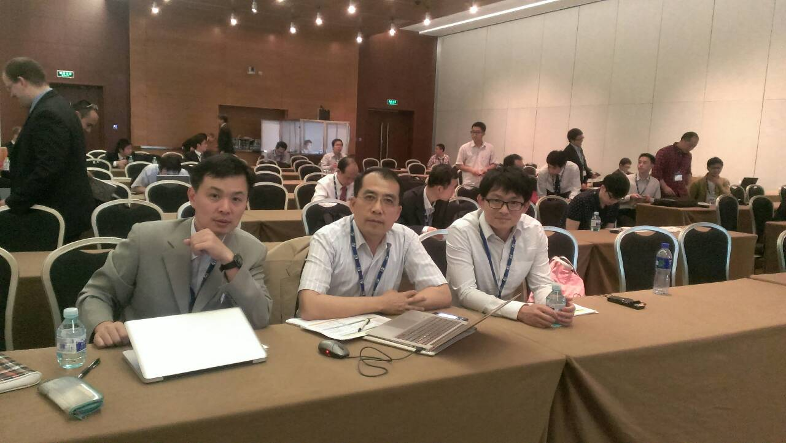

林派臣教授、作者、博士生蘇政明於 10th FSW會場

摩擦攪拌扣接點銲是一種較新的FSW製程，特點在利用攪拌及搭接過程上下板扣接的方式接合，在異種材料銲接有其特定之優點，汽車工業鈑金製程的銲接接合上最具應用潛力。。本研究利用精密銑床及自行開發兩種攪拌扣接刀具對無法利用傳統銲接製程接合之鋁材Al 6061及中碳鋼S45C板料成功以摩擦攪拌點銲扣接銲合。第一種扣接刀具為圓柱型，第二種為楔行目的在增加扣接程度。本研究之擴孔式(sweeping)摩擦攪拌配合兩種刀具是一種全新的嘗試。機械性質之研究則利用搭接剪力試片與十字型拉力試片進行測試。準靜態剪力測試結果顯示圓柱刀具銲點斷裂負荷高於楔型刀具銲點，但在準靜態開口測試及週期負荷疲勞條件下楔型刀具銲點的斷裂負荷有較佳表現。兩種攪拌扣接刀具產生之攪拌區以及扣接區宏觀截面顯示最大之差異在於倒鉤及凹槽之型態。圓柱刀具銲點在準靜態剪力測試中之斷裂位置起源於倒鉤之尖端，而楔型刀具銲點在準靜態剪力測試中之斷裂位置則起源於上下板材扣接內緣之頸縮位置。至於週期負荷疲勞條件下兩種刀具銲點的斷裂接起源於倒鉤之尖端或附近。研究結果顯示攪拌扣接後銲點的幾何型態攪拌區域內材料流動之幾何型態微控制銲點機械強度之主要因素。本研究之製程參數可達高複現性，研究結果清楚闡釋銲點強度之機理。會後多位在汽車業界之專家對本研究表達高度之興趣，其中 HITACHI USA之袁偉博士與作者有更深入之討論壇及實施細節。HITACHI USA是第一家製作出機械手設備將不留凹痕的摩擦攪拌點銲應用在汽車鈑金接合的公司，在歷次的FSW會議中皆有展出攤位展示其技術進展。

台灣遊艇造船工業引進TWI摩擦攪拌銲接技術分享
在大會最後一場演講活動是由TWI之摩擦攪拌銲技術經理Mike Russell介紹台灣遊艇造船工業引進TWI摩擦攪拌銲接技術。給現場來賓帶來驚喜亦使來自台灣的我們與有榮焉，不過在此之前我們自己竟然不知道台灣工具機業以及遊艇業在TWI的直接指導下參與了這項秘密行動，直至今方始曝光。由於無任何書面資料，也不允許照相，故全憑筆者紀錄內容。這項技術轉移是透過經濟部工業局，FSW製程設備其實就是銑床或綜合加工機，參與設備提供的是亞崴機電股份有限公司(程泰工具機集團)，成立於1986年，為台灣最具規模的專業CNC加工中心機製造廠商之一；其產品行程分佈從610 mm 到 20 米，包括立式加工機、臥式加工機、龍門加工機、五軸加工機、高速機..等等。針對大型造船甲板之FSW需求開發專用之天車式龍門型加工機。參與FSW造船技術技轉的是台灣最大的私人造船廠高雄的慶富造船公司以及多次參與國艦國造的宜蘭龍德造船公司。遊艇甲板銲道利用FSW可銲6米長之擠型鋁板，銲接時間僅20分鐘。已經運用在這兩家公司的全鋁遊艇甲板上。Mike Russell尤其稱在台灣工業之infrastructure的配套完全，綜合加工機之衛星工業與協力廠完備，亞崴機電的技術能力極高，因此機具開發非常順利。造船用的擠型鋁板亦完全由台灣在地鋁擠型業供應，從設計試做修改到定案極有效率。更值得稱讚的是台灣的經理人雖不一定具有技術背景，但是能迅速掌握技術要點有效率的協調與掌控進度，使得技轉非常成功。而台灣技術人員與工程師的技術背景紮實與吸收能力強更不在話下。

參觀活動
本次會議參訪活動是參觀位於北京市郊的中航工業北京賽福特技術公司通州產業化生產基地。該公司成立於2002年是中國航空工業集團公司北京航空製造研究所(625所)旗下之子公司，也稱中國摩擦攪拌銲中心，自2006年在工程院關橋院士(大陸銲接界大老)推動下全面引進TWI 之FSW技術與專利全力開發技術與生產設備，已發展成為中國最大之FSW公司，並向全世界輸出設備。東亞地區之TWI 之FSW技術授權亦由該公司代理。我國則由高雄金屬研發中心向北京賽福特公司輾轉取得TWI 之FSW技術授權。此次參觀由該公司總經理欒國紅帶領參觀，詳細介紹技術及機具，並開放自由攝影。該公司不但輸出技術，也製造系列設備產品，更可以客製化設備，也研發銷售FSW的各種攪拌刀具。使與會各國學者專家大開眼界一睽大陸FSW之實力。據知大陸的探空火箭燃料節、高鐵的車廂、殲機的鋁合金結構等早都已經使用此技術生產，從現長展示的一小截全鋁客車廂可以以小見大。

参、會議心得與建議
本次藉參加2014第十屆摩擦攪拌銲接國際會議(Friction Stir Welding Symposium, FSW 2014)了解摩擦攪拌銲研究之最新發展，摩擦攪拌銲過程之固相材料流動性為相當困難及亟需探究之議題，近年來在流動性數值模型已大有突破。適切之材料在固相時之物理係數、流變曲線等資訊漸完備，因此數值模擬準確性大為提高。此外在鋼鐵以及高熔點之鈦合金之FSW因著刀具材料的突破而大有進展。 另外在衍生的摩擦攪拌製程FSP上也越來越多樣化。作者在FSW的另一研究議題就是製作局部顆粒強化複材及其基礎研究。再者從工業化應用進展上如大陸航空工業，德國汽車工業，日本軌道車輛工業與汽車工業，以及台灣造船工業都可以看出此技術實在潛力無窮。
大陸近年的各項進展亦令人刮目相看，從參觀北京賽福特可看出其端倪。此外大陸學者帶領學生積極參與，許多學生皆能以英語在研討會上侃侃而談，信心十足。台灣的學生倘不自我檢討迎頭趕上，恐怕只能窩在小島上自我感覺良好了!

肆、附錄攜回資料
大會手冊一份，光碟則將於七月份補寄達
伍、論文全文

MECHANICAL PROPERTIES AND FAILURE MODES OF FRICTION STIR CLINCH JOINTS BETWEEN 6061-T6 ALUMINUM AND S45C STEEL SHEETS

Pai-Chen Lin*
Advanced Institute of Manufacturing with High-tech Innovations & Department of Mechanical Engineering, National Chung-Cheng University, Chia-Yi, Taiwan

Peng-Xiang Liao, Zheng-Ming Su, Jong-Ning Aoh
Advanced Institute of Manufacturing with High-tech Innovations & Department of Mechanical Engineering, National Chung-Cheng University, Chia-Yi, Taiwan

April 3, 2014

SYNOPSIS

The mechanical properties and failure modes of friction stir clinch (FSC) joints between aluminum 6061-T4 and steel S45C sheetswere investigated through experimental approaches. Two types of tools were used to make FSC joints. Lap-shear and cross-tension specimens were considered. Under quasi-static shear conditions, the failure load of joints made by Type I tool was higher than that of joints made by Type II tool. However, under quasi-static opening and cyclic shear conditions, the performance of joints made by Type I was worse than that of joints made by Type II tool. Micrographs of the FSC joints before and after failure were examined. The main geometric difference between the two joints was the shapes of the hook and groove. Under quasi-static loading conditions,the failureof joints made by Type I tool was initiated from the hook tip. The failureof joints made by Type II tool was initiated from the inner button neck. Under cyclic shear conditions,the failure of both joints was initiated near/from the hook tip. The results indicated the joint geometry significantly affected the mechanical properties and failure modes of FSC joints investigated here.

INTRODUCTION

In order to improve the fuel efficiency and performance of vehicles, material substitution from steels to aluminum alloys was considered in the automotive industry. Recently, vehicles made of hybrid body structures, which combine steel and aluminum parts, have been produced [1,2]. In order to join different components made of aluminum and steel sheets, many joining processes, such as friction stir spot welding (FSSW) [3-5], ultrasonic spot welding (USW) [6,7], clinching [8,9], friction bit joining (FBJ) [10], and self-piercing riveting (SPR) [11,12], were considered.In contrast to the conventional welding processes, these joining processes make joints without melting the base metals to avoid the deficiency of the brittle intermetallic compound layer at the aluminum and steel interface [13].

Among the aforementioned processes, the FSSW process developed by Mazda Motor Corporation and Kawasaki Heavy Industrywas originally used for joining similar and dissimilar aluminum sheets [14,15]. ForFSSWs between aluminum and steel sheets (Al/Fe FSSWs), one of the challenges was the strength and melting point of steels, whichwere much higherthanthose of aluminum alloys. Recently, MazdaMotor Corporation modified the FSSWprocess to join aluminum sheets to zinc coated steel sheets[16,17].In this study, the tool was not indented into the lower steel sheet. Only the upper aluminum sheet was stirred. It was interesting that the zinc layer couldinteract with the aluminum sheet to form a discontinuous intermetallic layer, which provided goodbonding strength for Al/Fe FSSWs.Note that nearly no mechanical interlock existed at the interface since the interface was nearly flat. Bozzi et al. [18] made Al/Fe FSSWs byusing tungsten rhenium alloy (W25Re) tools, which could plunge though the upper aluminum layer and directlyinto the lower steel sheet. They showed that the strength of Al/Fe FSSWs strongly depends on the thickness of intermetallic compounds at the interface,not the size of the hook. This indicated that the mechanical interlock of their Al/Fe FSSWs appeared to be limited. Mechanical properties and failure modes ofAl/Fe FSSWs under quasi-static loading conditions were studied by many researchersas well [3,4,19,20]. Their results showed that Al/Fe FSSWs could provide sufficient failure loads under shear dominant loading conditions, but poor failure loads under opening dominant loading conditions. This phenomenon was probably due to the characteristics of the intermetallic compound layer at the interface.

Here, a new joining process, friction stir clinching (FSC), was proposed to join aluminum sheets to steel sheets.The FSC process in factwas a combination of the swept-friction stir spot welding (Swept-FSSW) and clinching processes. Note that the Swept-FSSW process wasa variation of the FSSW process developed by Buffa et al. [21] and Tweedy et al. [22]. The key point of this process was the tool sweeping motion, which could make larger stir zones and provide better mechanical properties for Swept-FSSWs. On the other hand, the clinching process was one of the traditional mechanical fastening processes. Sheet metals were punched by a tool into a die and deformed as two button structures, which could provide good mechanical interlock between them [23].

A schematic illustration of the FSC process used to join an aluminum sheet to a steel sheet is shown in Fig. 1. In this figure, a rotating tool with a probe is first indented into the upper aluminum sheet until a pre-set indentation depth larger than the total sheet thickness is achieved. An anvil with a circular cavity beneath the lower steel sheet is used as a die. The tool rotational speed is maintained for the whole joining process to generate frictional heat. The heated and soften sheets are then punched into the die to form two shallow button structures.Next, the rotating tool is moved outward for a distance and then swept counterclockwise along a circular path to form two deepbutton structures. Note that the toolsweeping motionhere is used for expanding the size of the outer button. Consequently, the inner and outer button structures can provide a strong mechanical interlock between two sheets. Finally, the tool is moved backward to the initial location,plunged a little more to fill the remaining cavities or holes in the inner button, and then retracted from the surface. AnAl/Fe FSC jointis made. Note that unlike the aforementioned FSSW process, the zinc coated steel sheet is not necessary in this process.

In this paper, the mechanical properties and failure modes of FSC joints aluminum 6061-T4 and steel S45C sheetsare investigated through experimental approaches. Two types of tools are used to make FSC joints under different processing parameters. Lap-shear and cross-tension specimens are used to evaluate the mechanical properties of FSC joints under different loading conditions. Pictures and optical micrographs of the FSC joints before and after failure under quasi-static and cyclic loading conditions are examined. Failure behaviors of FSC joints made by Type I and Type II tools under quasi-static shear, quasi-static opening, and cyclicshear conditions are investigated and discussed.

EXPERIMENTS

Aluminum 6061-T4 sheets with a thickness of 1.6 mm and bare steel S45C sheets with a thickness of 1.0 mm were used. Two types of tools were used to make specimens, as shown in Fig.2. Type I tool had a flat tool shoulder with a smooth probe. The diameter of the tool shoulder was 12 mm. The diameter and length of the probe were 6 mm and 2.8 mm, respectively. Type II tool had a flat tool shoulder with a notched probe. Most of the dimensions of Type II toolwere identical to those of Type I tool. Only the probe length was 3.8 mm. A die with a circularcavityat the center was used to make the button structure of FSC joints, as shown in Fig.3. The depth and diameter of the cavitywere 2 mm and 10 mm, respectively. The joints were made by aCNC milling machinefrom MAZAK Corporation, as shown inFig.4.

Lap-shearspecimens were made by using two 25.4 mm by 101.6 mm sheets with a 25.4 mm by 25.4 mm overlap area. Two doublers were made by folding two square parts of the sheets near the ends (25.4 mm × 25.4 mm). The doublers can align the applied load to avoid the initial realignment of the specimen under lap-shear loading conditions. Cross-tension specimens were made by using two 50.8 mm by 152.4 mm sheets with a 50.8 mm by 50.8 mm overlap area. Note that the aluminum 6061-T4 and steel S45C sheets were taken as the upper and lower sheets of both specimens, respectively.

Lap-shear and cross-tension specimens were tested by using a MTS servo-hydraulic testing machine at a monotonic displacement rate of 5.0 mm/min. The tests were terminated when specimens were separated. The loads and displacements were simultaneously recorded during the tests. The average failure load obtained from three tested specimens was then used as the reference load to determine the load ranges applied in the fatigue test. Lap-shear specimens were then tested with a load ratio R of 0.1. The test frequency was 10 Hz. The tests were terminated when the specimens were separated or the displacement of the two grips exceeded 5 mm.

Fig.5(a) shows a FSCjoint in a lap-shear specimen made by Type I tool. Fig.5(b) shows a FSCjoint in a cross-tension specimen made by Type I tool. Fig.5(c) shows aclose-up top view of the FSC joint on the uppersheet. As shown in the top view, the top surface of theweld looks like a button with a central hole. Theflash squeezed from the upper (aluminum) sheet is accumulated along the outercircumference of the joint. Fig.5(d)shows a close-up back view of the FSC joint onthe lower sheet. In the back view, a circular bulgeof the steel sheet caused by the tool anddie can be seen.In the following section, the details of the failure modes of FSC joints under different loading conditions will be presented and discussed.

FRICTION STIR CLINCH (FSC) JOINTS

In this paper, aluminum6061-T4 sheets with a thickness of 1.6 mm and steel S45C sheets with a thickness of 1.0 mm were used for the upper and lower sheets of specimens, respectively. Two types of tools, Type I and Type II, was usedto make the joints investigated here. For Type I tool, a rotational speed of 500 rpm, an initial indentation depth of 2.8 mm, and an indentation rate of 120 mm/min were applied for indenting. Next, a feed rate of 30 mm/min and a path radius of 1.5 mm were applied for sweeping. Finally, a final depth of 3.3 mm was applied for filling. For Type II tool, most of the processing parameters were identical to those of Type I tool, exceptthe initial and final indentation depthswere3.4 and 3.9 mm, respectively. The indentation depth of Type I tool is shorter than that of Type II tool since the probe length of the former is shorter than that of the latter. Note that these processing parameters were determined by the design of experiments (DOE) for the maximum failure loads of FSC joints in lap-shear specimens.

Fig.6(a) shows an optical micrograph of the cross section along the symmetry plane of a FSC joint made by Type I tool before testing. Only the first portion of theFSC process is used. Note that this joint is used as a reference to see the effects of the tool sweeping motion shown in the following. In this figure, the upper and lower sheets are punched by a rotating tool into a die and deformed as two shallow button-shape structures. As shown in Fig.6(a), the profile of the upper sheet reflects the general shape of the tool; however, that of the lower sheet does not reflect the general shape of the die. In addition, the inner button (upper sheet) only protrudes a little into the outer one (lower sheet). This indicates that the mechanical interlock between these two shallow buttons appears to beweak. The possible reason is that the strength and melting point of steel are high compared to aluminum. Therefore, the lower (steel) sheet cannot be softened and deformedby the tool and die during the traditional FSSW process.

Fig.6(b) shows an optical micrograph of the cross section along the symmetry plane of a FSC joint made by Type I tool before testing. The fullFSC process is used. As shown inFig. 6(b), the inner and outer buttonsbecomewider and deepercompared to those in Fig. 6(a). Hooks (marked by small arrows) and grooves(marked by circles) can be seen on the circumference of the outer button. The hooks in fact are the flashes formed by thesweeping motion of the probe. The grooves are the toolmarks graved/formed by the probe. As shown in Fig. 6(b), the inner button (upper sheet) protrudes a lot into the outer one (lower sheet) compared to those in Fig.6(a). This indicates that the mechanical interlock between these two buttons can be improvedbythe tool sweeping motion.

Fig.6(c) shows an optical micrograph of the cross section along the symmetry plane of a FSC joint made by Type II tool before testing. The full FSC process is used as well. In this figure, the general shape of the FSC made by Type II tool is similar to that made by Type I tool. However, the interface between inner and outer buttons is different. Due to the notch of the probe, the hooks (marked by small arrows) are folded and the grooves (marked by circles) are graved/formed as a notch shape. In addition, the outer button here is bulged more than thatmade by Type I tool probably due to the longer probe length. This indicates that the FSC joint made by Type II toolcan provide good strength in both shear and opening directions. In contrast, the FSC joint made by Type I tool can only provide good strength in the shear direction since the inner button does not protrude sideways into the outer button as shown in Fig. 6(b). Furthermore, the stress concentration effect, which is important to the fatigue performance, caused by the hooks can be eliminated since they are folded.

FAILURE MODES OF FSC JOINTS

QUASI-STATIC SHEAR CONDITIONS

Fig. 7(a) shows a micrograph of the symmetry cross section of a failed FSC joint made by Type I tool under quasi-static shear conditions. The bold arrows in Fig. 7(a) schematically show the direction of the applied load. The applied load stretches the upper left sheet (marked as Leg 1) and the lower right sheet (marked as Leg 2). As shown in Fig. 7(a), near the upper left portion of the joint, a necking failure is initiated from the hook tip (marked by F1). The failure then propagates along the circumference of the inner button. When the applied load continues to increase, the upper sheet is torn off at the location S2 and the inner button is separated from the outer button at the location F2.

Fig. 7(b) shows a micrograph of the symmetry cross section of a failed FSC joint made by Type II tool under quasi-static shear conditions. As shown in Fig. 7(b), near the left portion of the joint, a shear failure is initiated from the neck of the inner button (marked by F1 and F2). The failure then propagates along the circumference of the inner button. When the applied load continues to increase, the upper sheet is shear off.

QUASI-STATIC OPENING CONDITIONS

Fig. 8(a) shows a micrograph of the symmetry cross section of a failed FSC joint made by Type I tool under quasi-static opening conditions. The bold arrows in Fig. 8(a) schematically present the directions of applied loads at the ends of the sheets. The applied loads stretch the ends of the upper sheet (marked as Leg 1 and Leg 2) and those of the lower sheet. Note that only one arrow on the lower sheet can be seen since these two arrows are overlapped in this cross-section. As shown in Fig. 8(a), two necking/shear failures (marked by F1 and F2) can be seen at the tips of the right and left hooks.Finally, the failed FSC joint is separated.

Fig. 8(b) shows a micrograph of the symmetry cross section of a failed FSC joint made by Type II tool under quasi-static opening conditions. As shown in Fig. 8(b), two necking failures (marked by F1 and F2) can be seen near the right and left necks of the inner button. Finally, the failed FSC joint is separated.

CYCLIC SHEAR CONDITIONS

Fig. 9(a) shows a micrograph of the cross section along the symmetry plane of a failed FSC jointmade by Type I tool at the fatigue life of 8585 cycles under a load range of 2.8 kN. As shown in Fig. 9(a), two fatigue cracks can be seen. One fatigue crack (marked as crack 1) appears to emanate near the left hook (marked by point CT1) and propagates into the upper sheet. The other fatigue crack (marked as crack 2) appears to emanate near the righthook (marked by point CT2) and then propagates downward along the interfacial surface between inner and outer buttons. Fig. 9(a) shows that fatigue crack 1 propagates through the upper sheet thickness and then becomesa circumferential crack. Fatigue crack 2 propagates through the bottom of the inner button and becomes a circumferential crack as well. Finally, fatigue cracks 1 and 2 meet together and the upper sheet is torn off. Note that the right hook tip in the lower sheet is nearly sheared off by the upper sheet.In this case, fatigue crack 1 can be considered as the kinked crack emanating near the hook tip of the joint. As suggested by Fig. 9(a), fatigue crack 1 appears to be the dominant crack to cause the final failure of the FSC jointmade by Type I tool under cyclicshear conditions.

Fig. 9(b) shows a micrograph of the cross section along the symmetry plane of a failed FSC jointmade by Type II tool at the fatigue life of 40020 cycles under a load range of 2.8 kN. As shown in Fig. 9(b), two fatigue cracks can be seen. One fatigue crack (marked as crack 1) appears to emanate near the left hook tip(marked by point CT1) and the other fatigue crack (marked as crack 2) appears to emanate from the righthook tip (marked by point CT2). The following fatigue behavior of this joint is similar to that of the joint made by Type I tool, as shown in Fig. 9(a). Note that the hook tips are severely deformed by the grooved probe of Type II tool. In this case, fatigue crack 1 can be considered as the kinked crack emanating near the hook tip of the joint. As suggested by Fig. 9(a), fatigue crack 1 appears to be the dominant crack to cause the final failure of the FSC jointmade by Type II tool under cyclicshear conditions.

MECHANICAL PROPERTIES OF FSC JOINTS

Table 1 lists the mechanical properties of FSC joints made by Type I and Type II tools. Note that, the processing parameter for each tool is obtained based on design of experiments (DOE) for the maximum failure load under quasi-static shear conditions. As listed in Table 1, under quasi-static shear conditions, the average failure load of joints made by Type I tool is higher than that of joints made by Type II tool. The possible reason is that the hook made by Type I tool provides additional mechanical interlock in the shear direction, as shown in Figs. 6(b) and 7(a). However, under quasi-static opening conditions, the average failure load of joints made by Type I is worse than that of joints made by Type II tool. The possiblereason is that the groove shape made by Type II tool provides additional mechanical interlock in the opening direction, as shown in Figs. 6(c) and 7(b). Under cyclic shear conditions, the average fatigue live of joints made by Type II tool is much higher than that of joints made by Type I tool.

CONCLUSIONS

The mechanical properties and failure modes of friction stir clinch (FSC) joints between aluminum and steel sheetswere investigated through experimental approaches. Two types of tools were used to make FSC joints under different processing parameters. Type I tool has a flat shoulder and a smooth probe. Type II tool has a flat shoulder and a grooved probe. Lap-shear and cross-tension specimens are used to evaluate the mechanical properties of FSC joints under different loading conditions.

Mechanical properties of FSC joints under different loading conditions were first obtained. Under quasi-static shear conditions, the failure load of joints made by Type I tool was higher than those of joints made by Type II tool. However, under quasi-static opening and cyclic shear conditions, the performance of joints made by Type I was worse than that of joints made by Type II tool. Pictures and optical micrographs of the FSC joints before and after failure under quasi-static and cyclic loading conditions were examined. The micrographs showed that the main geometric difference between the two joints was the shapes of the hook and groove. Under quasi-static shear and opening conditions,the failure modes of the two joints were different. For Type I tool, the failure was initiated from the hook tip in the upper aluminum sheet. For Type II tool, the failure was initiated from the inner button neck. Under cyclic shear conditions,the failure modes of the two joints were similar. The failure was initiated near/from the hook tip in the upper aluminum sheet. The results indicated that the joint geometry has significant effects on the mechanical properties and failure modes of FSC joints investigated here.

ACKNOWLEDGEMENTS

The support of this work by the National Science Council (NSC) under Grant No. 101-2221-E-194-MY3 and 101-2917-I-194-001 is greatly appreciated. The partially support of this work by the Ministry of Economic Affairs (MOEA) and National Science Council (NSC) of Taiwan, Republic of China under Contract No. 100-EC-17-A-05-S1-189 is also greatly appreciated.

REFERENCES

[1] Carle, D., Blount, G., 1999. The suitability of aluminium as an alternative material for car bodies. Mater. Des. 20, 267-72.
[2] Sakurai, T., 2008. The latest trends in aluminum alloy sheets for automotive body panels. Kobelco Technol. Rev., No. 28, October, 2008.
[3] Tran, V.-X., Pan, J., 2010. Fatigue behavior of dissimilar spot friction welds in lap-shear and cross-tension specimens of aluminum and steel sheets. Int. J. Fatigue, 32, 1167-1179.
[4] Tanaka, K., Kumagai, M., Yoshida, H., 2006. Dissimilar joining of aluminum alloy and steel sheets by friction stir spot welding. J. Jpn. Inst. Light Met. 56, 317-322.
[5] Miyagawa, K., Matsumura, H., Tsubaki, M., Yasui, T., Fukumoto, M., 2008. Spot welding between aluminum alloy and Zn coated steel by friction stirring. Quart. J. Jpn. Weld. Soc. 26, 131-136.
[6] Abdel-Aleem, H., Katoh, M., Nishio, K., Yamaguchi, T., Tsue Y., 2005. Evaluation by ultrasonic testing and TEM observation of bond interface for ultrasonic bonds of 5052/SUS304 and 5052/SPCC. Quart. J. Jp. Weld. So. 23,194-202.
[7] Watanabe, T., Sakuyama, H., Yanagisawa, A., 2007. Ultrasonic Welding between Mild Steel Sheet and Al-Mg Alloy Sheet. Quart. J. Jpn. Weld. Soc. 25,239-244.
[8] Lee, C.-J., Kim, J.-Y., Lee, S.-K., Ko, D.-C., Kim, B.-M., 2010. Parametric study on mechanical clinching process for joining aluminum alloy and high-strength steel sheets. J. Mech. Sci. Technol. 24,123~126.
[9] Abe, Y., Mori, K., Kato, T., 2012. Joining of high strength steel and aluminium alloy sheets by mechanical clinching with dies for control of metal flow. J. Mater. Process. Technol. 212, 884-889.
[10] Miles, M.P., Kohkonen, K., Packer, S., Steel, R., Siemssen, B., Sato, Y.S., 2009. Solid state spot joining of sheet materials using consumable bit. Sci. Technol. Weld. Join. 14, 72-77.
[11] Sun, X., Khaleel, M.A., 2005. Performance optimization of self-piercing rivets through analytical rivet strength estimation. J. Manu. Process. 7, 83-93.
[12] Sun, X., Stephens, E.V., Khaleel, M.A., 2007. Fatigue behaviors of self-piercing rivets joining similar and dissimilar sheet metals. Int. J. Fatigue 29, 370-386.
[13] Zhang, W., Sun, D., Han, L., Gao, W., Qiu, X., 2011. Characterization of intermetallic compounds in dissimilar material resistance spot welded joint of high strength steel and aluminum alloy. ISIJ Int. 51, 1870-1877.
[14] Sakano, R., Murakami, K., Yamashita, K., Hyoe, T., Fujimoto, M., Inuzuka, M., 2001. Development of spot FSW robot system for automobile body members. In:Proceedings of the 3rd international symposium of friction stir welding, Kobe,Japan, September 27–28; 2001.
[15] Iwashita, T., 2003 Method and apparatus for joining. US patent 6601751 B2, August 5, 2003.
[16] Mazda Motor Corporation, 2005. Mazda develops world’s first steel and aluminum joining technology using friction heat. Mazda Press Release, June 2, 2005.
[17] Gendo, T., Nishiguchi., K., Asakawa, M., Tanioka, S., 2007. Spot friction welding of aluminum to steel. Warrendale (PA): Society of Automotive Engineers, SAE Technical Paper No. 2007-01-1703.
[18] Bozzi, S., Helbert-Etter, A.L., Baudin, T., Criqui, B., Kerbiguet, J.G., 2010, Intermetallic compounds in Al 6016/IF-steel friction stir spot welds. Mater. Sci. Eng. A 527, 4505-4509.
[19] Sun, Y.F., Fujii, H., Takaki, N., Okitsu, Y., 2013. Microstructure and mechanical properties of dissimilar Al alloy/steel joints prepared by a flat spot friction stir welding technique. Mater. Des. 47, 350-357.
[20] Miyagawa, K., Matsumura, H., Tsubaki, M., Yasui, T., Fukumoto, M., 2008. Spot welding between aluminum alloy and low carbon steel by friction stirring. Quart. J. Jpn. Weld. Soc. 26, 42-47.
[21] Buffa, G., Fratini, L., Piacentini, M., 2008. On the influence of tool path in friction stir spot welding of aluminum alloys. J. Mater. Process. Technol. 208, 309-317.
[22] Tweedy, B., Widener, C., Burford, D., 2007. The effect of surface treatments on the faying surface of friction stir spot welds. In: Rajiv SM, Murray WM, Thomas JL, Kumar VJ, editors. Friction stir welding and processing IV, Warrendale (PA), TMS, 2007. p. 333-340.
[23] Su, Z.-M., Lin, P.-C., Lai, W.-J., Pan, J., 2014. Fatigue analyses of self-piercing rivets and clinch joints in lap-shear specimens of aluminum sheets. Int. J. Fatigue. Under review.

Table 1. Mechanical properties of FSC joints made by Type I and Type II tools.

 | Failure Load  (Lap-Shear) | Failure Load  (Cross-Tension) | Fatigue Life  (Lap-Shear)
Type I Tool | 5131 N | 2353 N | 10,438 cycles
Type II Tool | 4645 N | 3099 N | 48,648 cycles

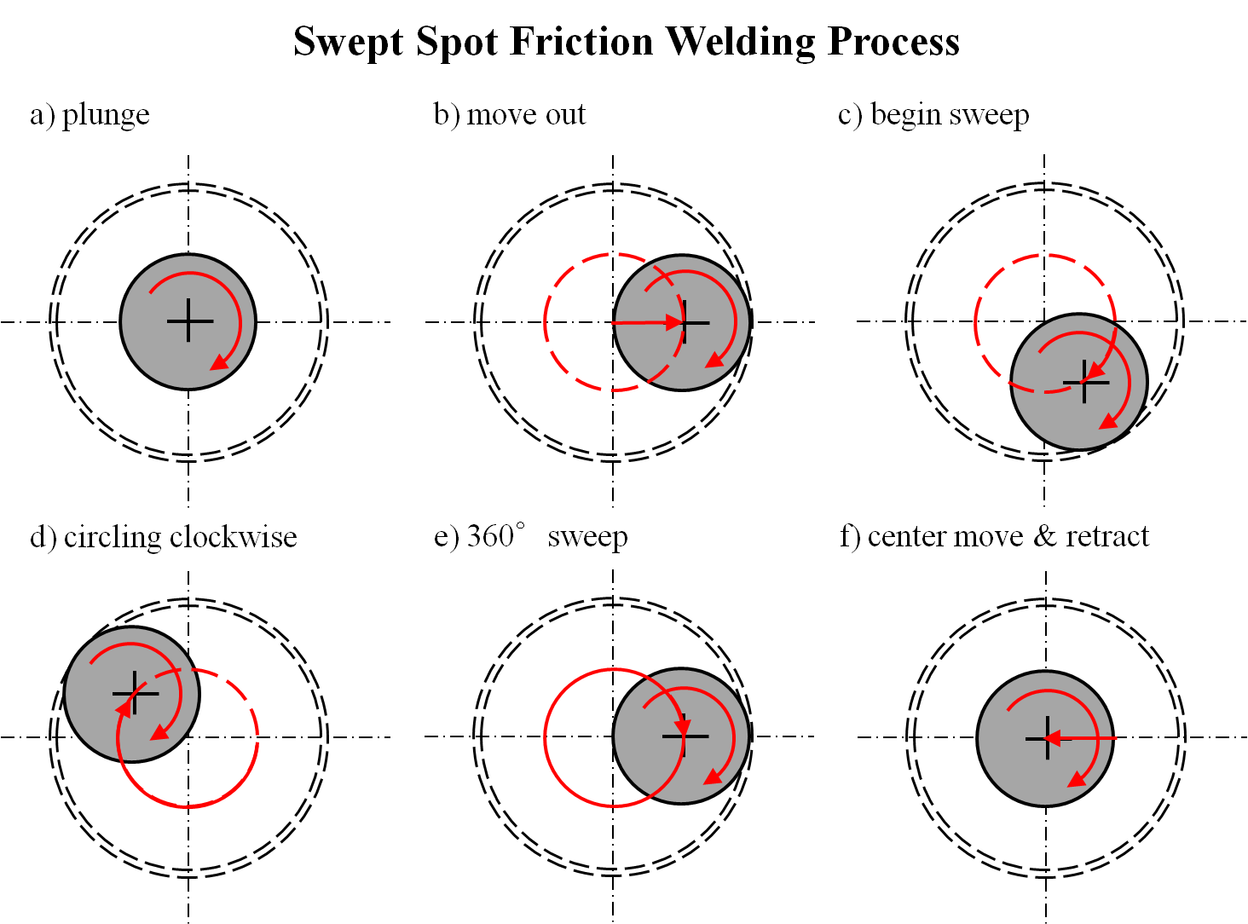

Fig. 1. Schematics of the friction stir clinching (FSC) process.

Fig. 2. Schematics of Type I and Type II tools for FSC.

Fig. 3. A die with a circular cavity at the center used for FSC.

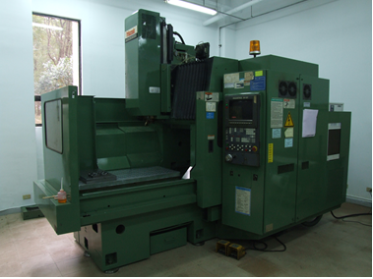

Fig. 4. A CNC milling machine from MAZAK Corporation used for FSC.

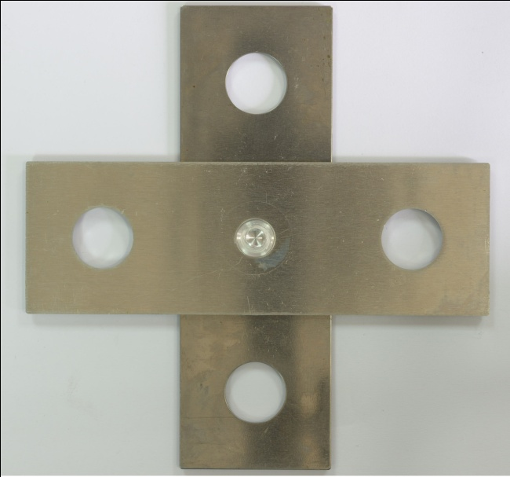 | 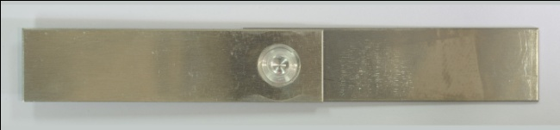
(a) | (b)
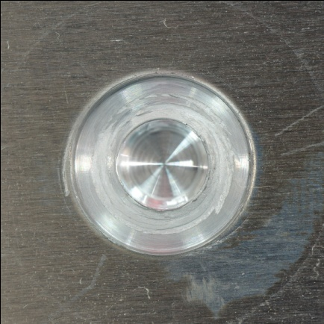 | 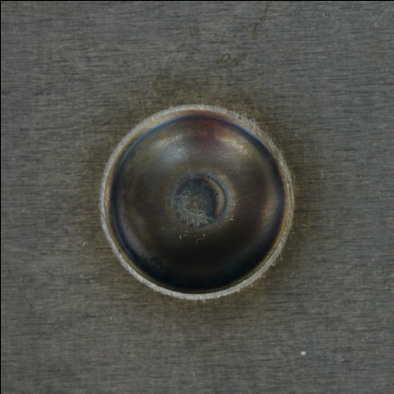
(c) | (d)

Fig. 5. (a) A lap-shear specimen and (b) a cross-tension specimen with FSC joints made by Type I tool. Close-up (c) top and (d) back views of a FSC joint made by Type I tool.

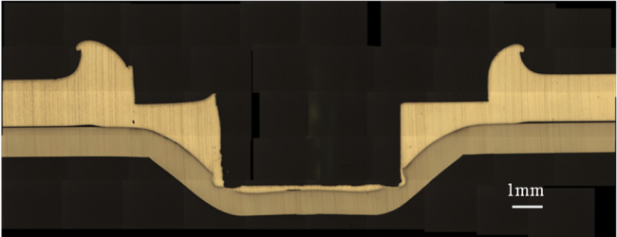
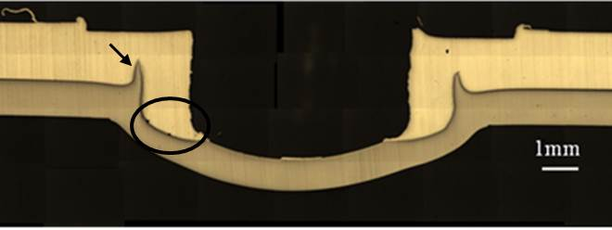
(a)
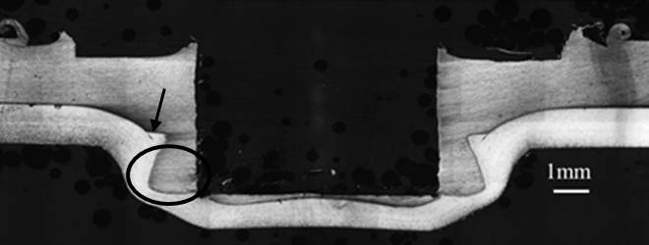
(b) (c)
Fig. 6. Micrographs of the cross sections of Al/Fe FSC joints made by (a)(b) Type I and (c) Type II tools.

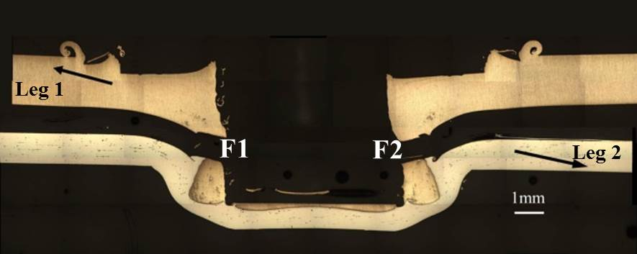
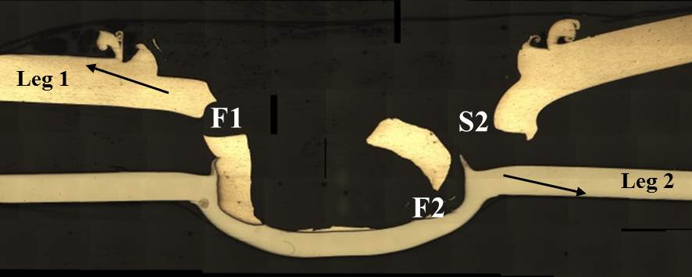
(a) (b)
Fig. 7. Micrographs of the cross sections of Al/Fe FSC joints made by (a) Type I and (b) Type II tools in failed lap-shear specimens under quasi-static loading conditions.

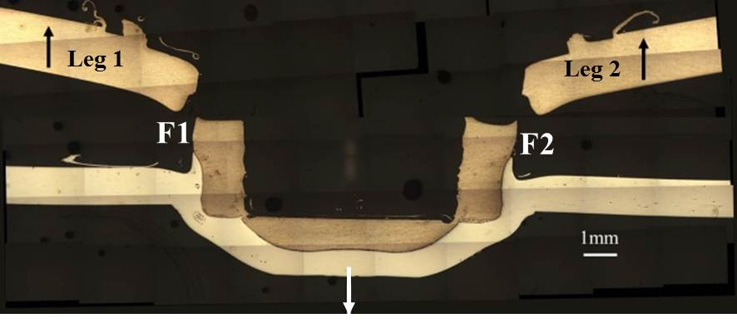
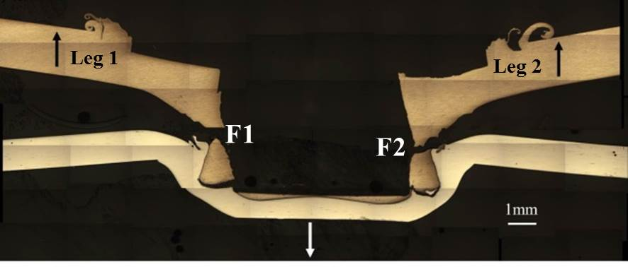
(a) (b)
Fig. 8. Micrographs of the cross sections of Al/Fe FSC joints in cross-tension specimens made by (a) Type I and (b) Type II tools in failed cross-tension specimens under quasi-static loading conditions.

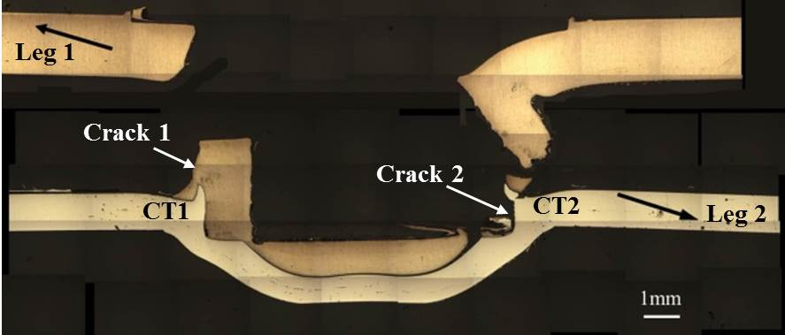
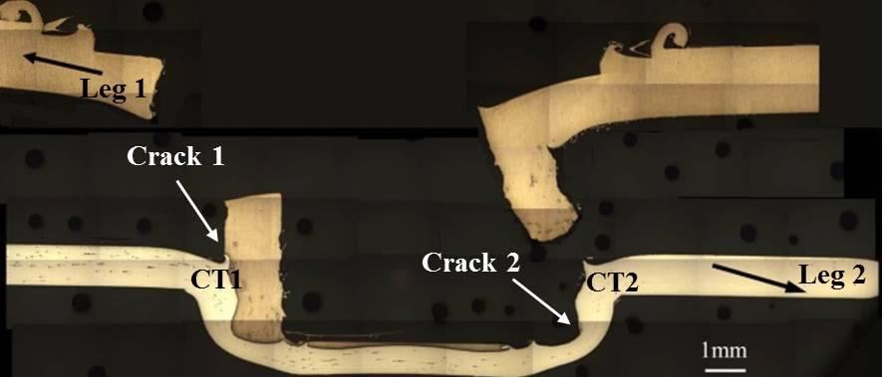
(a) (b)
Fig. 9.Micrographs of the cross sections of Al/Fe FSC joints in cross-tension specimens made by (a) Type I and (b) Type II tools in failed lap-shear specimens under cyclic loading conditions.

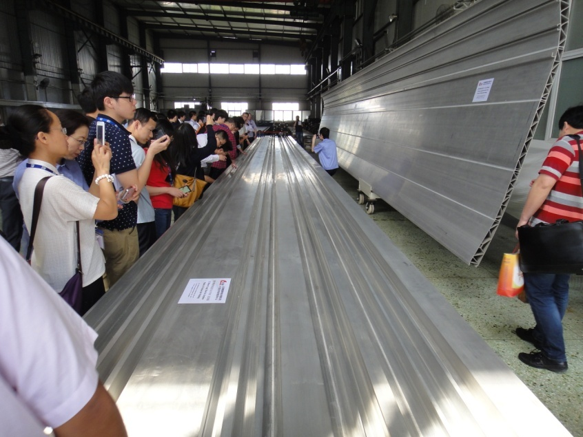
陸、北京賽福特公司參觀
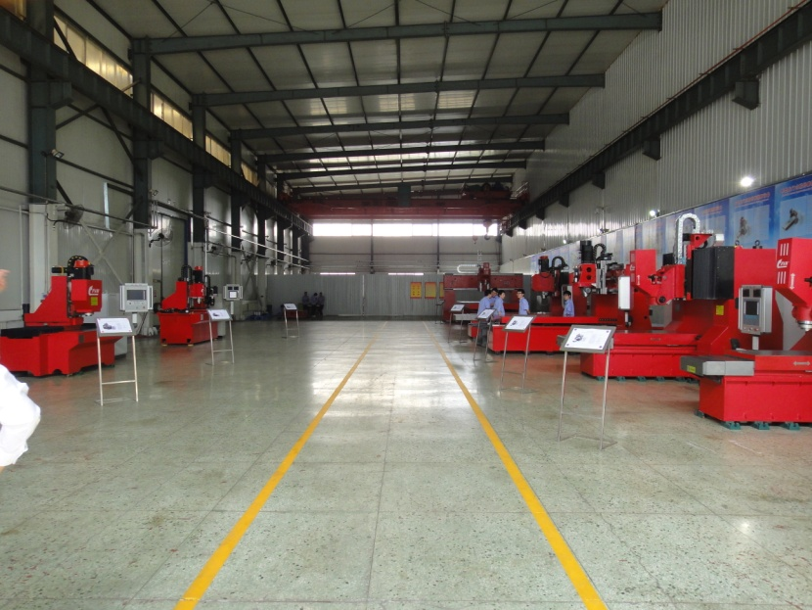
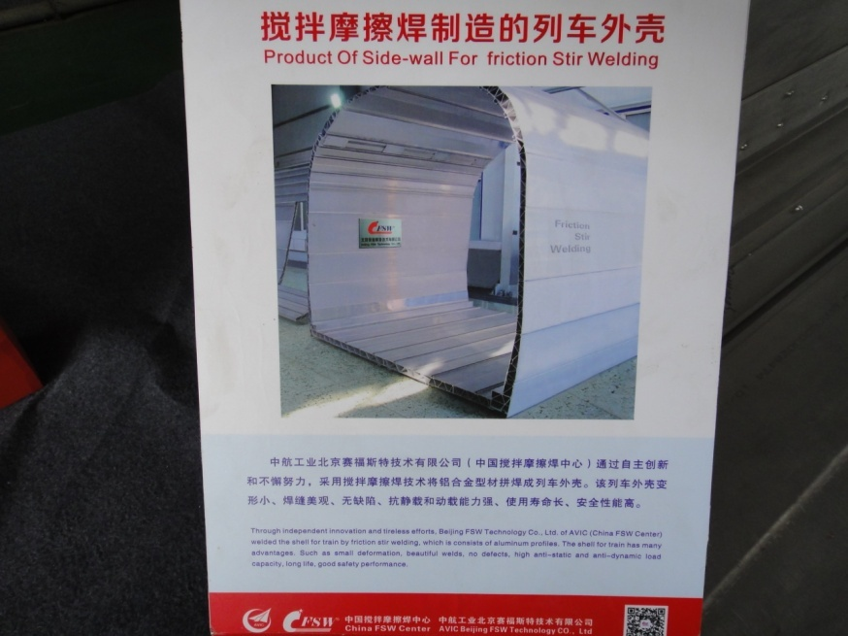
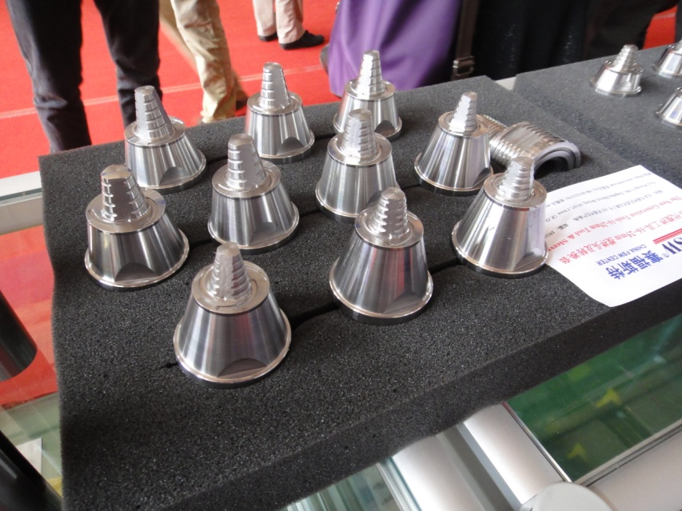
北京賽福特公司參觀 廠房 FSW銲接之飛機機艙地板
摩擦攪拌銲接製造之列車外殼(一)(二)

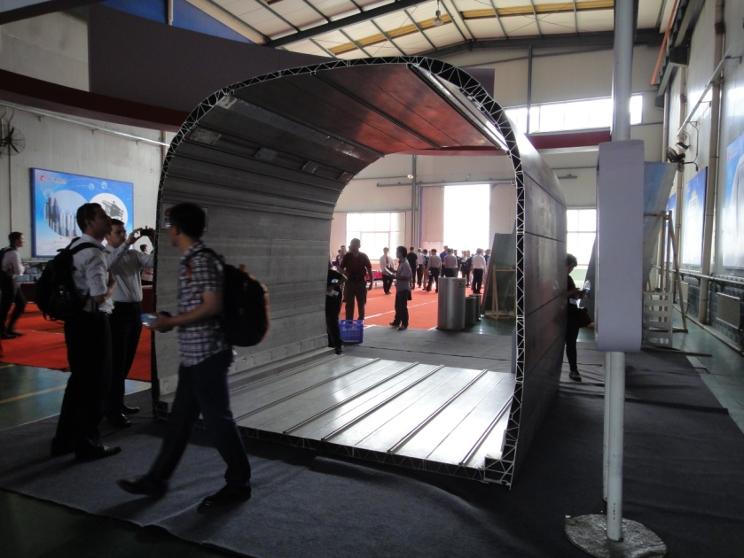
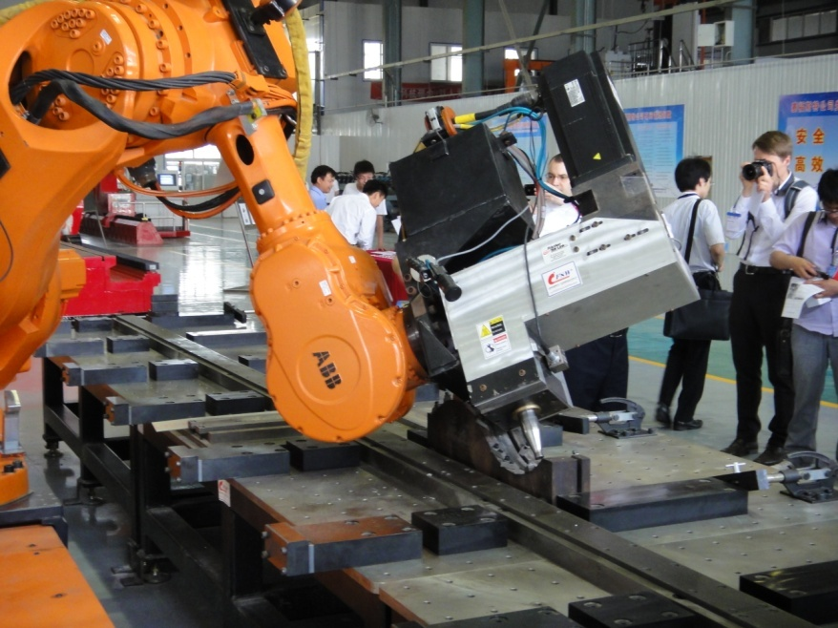

摩擦攪拌銲接刀具 摩擦攪拌銲接機械手臂

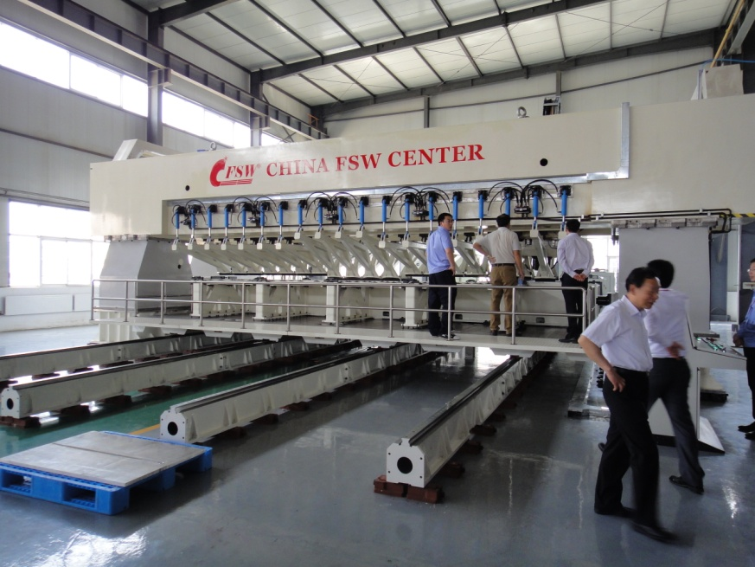
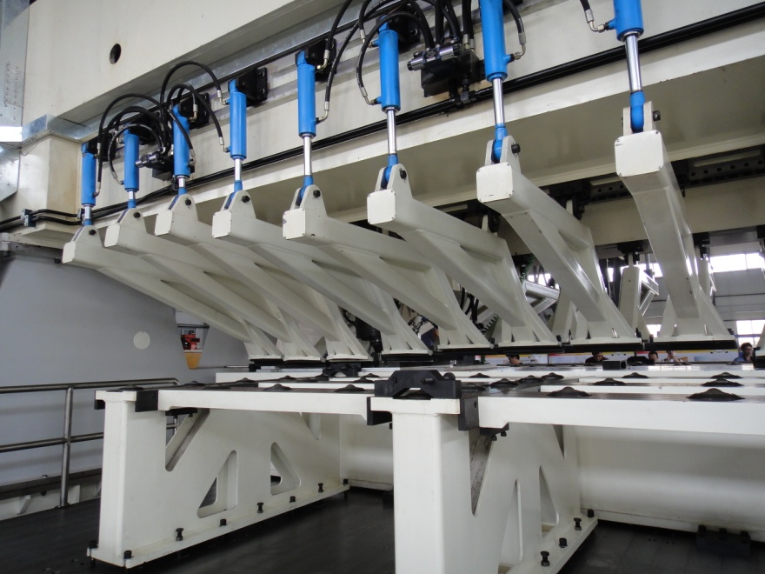

大型摩擦攪拌銲接機夾具系統 大型摩擦攪拌銲接機

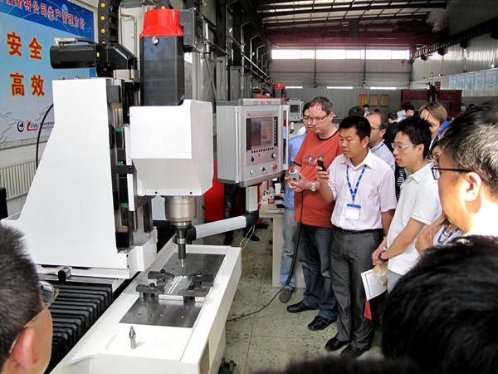
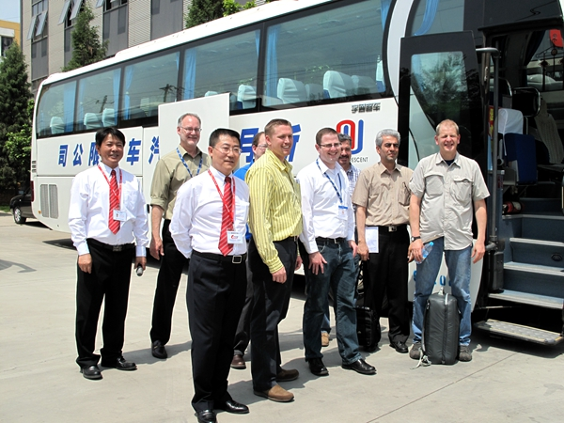

參觀過程(一) 參觀過程(二)

柒、附件
大會議程(一)
大會議程(二)

大會議程(三)

大會議程(四)

(五)大會議程

大會議程(六)

