行政院所屬各機關因公出國人員出國報告
(出國類別：其他-國際會議)

參加2014年世界水產養殖學會
（World Aquaculture Society）
年度會議

服務機關： | 行政院農業委員會漁業署
姓名職稱： | 繆自昌組長
派赴國家： | 澳洲
出國期間： | 103年6月5日至13日
報告日期： | 103年8月 22 日

參加2014年世界水產養殖學會（World Aquaculture Society）年度會議出國報告

目 錄

壹、摘要……………………………………………………………………… | 2
貳、目的……………………………………………………………………… | 3
參、過程……………………………………………………………………… | 3
肆、心得與建議……………………………………………………………… | 9
附件一：分組會議重要講者發表題目及摘要……………………………… | 10
附件二：活動照片…………………………………………………………… | 45

參加2014年世界水產養殖學會（World Aquaculture Society）年度會議出國報告

壹、摘 要
世界水產養殖學會成立於1969年，迄今會員已含括100多國，該會致力於國際交流，期望在兼顧生態環境資源及持續性生產前提下，透過創新的養殖觀念、生產技術、養殖系統，提供養殖水產品作為人類未來蛋白質來源的重要管道，引導養殖產業的永續發展。
2014年會於6月7～11日在澳洲阿德萊德（Adelaide）召開，主題為「創造、營養、成長」，除透過73個議題於12個會議室分組簡報及討論外，另有展覽會提供136家廠商參展，展覽內容主要為養殖所需水質處理設備、循環水過濾系統、新式單體牡蠣養殖籃等。漁業署由繆自昌組長代表參加，因相同時段分組討論議題甚多，優先選擇參與與國內養殖發展政策相關之議題分組會議。
會中介紹多種新型養殖科技，Ms. Julie Delabbio 介紹應用LED照明設備於水產養殖，調控光的波長、光亮度及光週期，以影響魚類生理反應與習性，提昇飼料有效利用。
日本Mr. Manabu Seoka介紹黑鮪人工繁養殖情形，指出日本從1994年開始研究人工繁養殖黑鮪，直至近3年有初步成果及推廣民間箱網養殖，未來將改進初期人工飼料成分及光線刺激等功能性實驗，以持續提升幼魚活存率。
臺灣農業工程研究中心梁榮元研究員與海洋大學陳瑤湖教授共同發表循環水養殖發展現況與未來趨勢，並以位於屏東農業生物科技園區的養殖企業應用魚菜共生系統於淡水養殖，並運用於海水大規模室內養殖場，結合海葡萄淨化養殖海水石斑池排放水，達到商業化量產情形為實例說明台灣魚菜共生應用情形。
Ms.Katherine Hawes簡介目前國際上養殖水產品認驗證制度（如GLOBAL GAP、GAA、ASC等），均屬於業者自願性並非強制，多由第三方驗證單位進行驗證，可能面臨欠缺政府公權力，建議各國政府部門在進出口養殖水產品時，可透過立法要求養殖水產品須取得認驗證。另Mr.Peter Cook 簡介ASC制度始於2010年，目前全球計有吳郭魚、白蝦、鮑魚、鮭魚等8種養殖種類、37國、76家養殖場、1,053項養殖水產品取得ASC驗證標章（臺灣有10家臺灣鯛養殖場）。
觀察本次參與會議者以企業、生產業者居多，養殖業者熱中追求水產養殖技術新知、氣候變遷與養殖管理策略等議題，對於新型牡蠣養殖藍、生物製劑與生技方式處理技術非常熱絡。養殖所需用電佔生產成本三成以上，應用LED照明設備，除可有效降低生產成本，並能提升關聯生產效能。
國際上水產養殖認驗證甚多，我國目前仍以推動產銷履歷制度為主，但因國內消費客群主要仍偏向低價取向而非驗證取向，仍需透過教育及推廣消費者認識產銷履歷產品，期使制度得以永續。

貳、目 的
世界水產養殖學會成立於1969年，迄今會員已含括100多國，該會致力於國際交流，期望在兼顧生態環境資源及持續性生產前提下，透過創新的養殖觀念、生產技術、養殖系統，提供養殖水產品作為人類未來蛋白質來源的重要管道，引導養殖產業的永續發展。透過參加世界水產養殖學會年度會議，瞭解國際水產養殖公、私部門研究發展趨勢及現階段面臨問題，掌握全世界各國政府、非政府組織、國際社會、學術研究機構與民間團體所提出可能解決方案或建議，並將相關決議內容適時轉化為國內法規與制度，作為國內水產養殖產業輔導政策工具。

參、過 程
參加世界水產養殖學會2014年會會議日程表
日期 | 行 程
103/6/6~7  (星期五、六) | 1.啟程:自桃園機場搭乘中華航空公司班機至澳洲雪梨機場，轉澳洲航空公司班機前往阿德雷德機場。  2.飯店報到與入住：由阿德雷德機場搭車入住Breakfree Directors Studio旅館。
103/6/8~11  (星期日至三) | 1.出席人員報到、大會開幕。  2.大會主席報告。  3.頒發WAS年度優秀論文獎。  4.依73個主題於12個會議室參加各分組專題報告。  5.參觀136家廠商文宣.實體展覽(如循環過濾機、牡蠣採收機等)。  6.參加大會舉辦歡迎酒會。
103/6/12~13  (星期四、五) | 返程：自阿德雷德機場搭乘澳洲航空公司班機至雪梨機場，轉中華航空公司班機返台。

6月8日：
(一)大會開幕：
Mr. Graham Mair宣布開會並致歡迎詞，說明本次會議主軸為「創造、營養、成長」，期望在兼顧生態環境資源及持續性生產前提下，透過創新的養殖觀念、生產技術、養殖系統，提供養殖水產品作為人類未來蛋白質來源的重要管道。另邀請Mr.Richard Colbeck、Mr.Jose R.Villalon 及Mr.Charlie Arnot 分別發表專題演講，提出水產養殖發展相關趨勢與觀點。
（二）LED照明設備於水產養殖：Ms. Julie Delabbio （附件一.1）指出調控光的波長、光亮度及光週期，可以影響魚類生理反應與習性，提昇飼料有效利用。研究顯示斑馬魚(Zebra fish)在暖水與冷水環境分別可見到不同色光，美國淡水梭魚(Walleye)則可見到橘光與綠光。透過LED應用於水產養殖，可以依據人類需求刺激養殖魚類改變習性，如光線陰暗影響箱網魚類習性--白天下沉，晚上上升。Mr. Frode Oppedal（附件一.2）指出LED應用於箱網養殖鮭魚可改變幼生與成魚不同體型鮭魚生長所需深度，以利飼料有效利用減少流失。
(三) 直流微電流於魚類柵欄（fish barrier）技術：Mr. Carl Burger（附件一.3）指出透過指出全球已成功應用此技術設置60餘處魚類柵欄，包括：有效引導鮭魚洄游至正確上游母川產卵、阻絕養殖引水時雜魚進入、養殖草魚及鱷魚等電子防逃裝置、魚類不同階段分養隔離設備。
（四）養殖漁業與環境、氣候變遷：Mr. Malcolm Beveridge（附件一.4）透過養殖漁業優劣勢機會威脅(SWOT)分析，指出養殖漁業在碳足跡及飼料轉換率(FCR)均優於牛羊豬，且對漁村經濟成長及人口就業助益甚多，驗證及便利型魚片商品越來越受到消費者喜好等市場趨勢。講者並提出1.養殖漁業是否真能協助貧窮國家人口脫貧? (如非洲國家) 2.近年養殖水產品產量增加，產值卻下降趨勢? (如Tilapia、鯰魚、鮭魚) 3.小型魚類價格越來越低，是否可作為貧窮國家人口消費水產品主要來源? (如中國養殖小格規tilapia 賣給尚比亞) ；講者指出答案是肯定的，只要養殖產業鏈間均能注意生產環節，就可做到。
（五）環境監控與貝類藻類養殖管理：Ms. Luis Henriquez（附件一.5） 及Ms.Ana Rubio （附件一.6）分別透過海域、河域相關水質長期監測調查與研究，可以判定南澳洲沿岸箱網養殖、河口營養鹽與海上娛樂活動、大型藻類(昆布、石蓴)生長之間關聯性；另透過數據可預測牡蠣養殖期、育肥期、異地輪養地點選擇與採收期。

6月9日：
（一）日本Mr. Manabu Seoka介紹鮪魚人工繁養殖情形，指出日本從1994年開始研究人工繁養殖鮪魚，直至近3年有初步成果及推廣民間箱網養殖，未來將改進初期人工飼料成分及光線刺激等功能性實驗，以持續提升幼魚活存率。會中簡報者特別提出今年5月日本近畿大學魚類研究中心成功讓鮪魚在陸上魚塭自然產卵，且沒有利用賀爾蒙人工催熟。
（二）鮪魚人工飼料開發－日本Mr. Tsuyoshi Goto（附件一.7）研究，指出經過雙層包埋技術，將魚粉、魚油及維生素等作成長條狀彈性飼料(類似熱狗)飼養箱網鮪魚，並與直接飼養生餌(bait fish)實驗對照，效果相當，且FCR<4，具市場競爭力。Mr. Ben nan Chen（附件一.8） 研究指出EPA、DHA等脂肪酸添加於輪蟲－透過餵食已滋養輪蟲作為提升黑鮪稚魚存活率技術，作為黑鮪初期餌料生物攜帶者，經半年餵養後可有效提升黑鮪稚魚存活率。
（三）南方黑鮪精母細胞移植技術—澳洲Mr. Ande Smith （附件一9）提出鮪魚精母細胞移植技術架構，未來可透過該作業模式，包括:從鏡檢黑鮪精巢成熟度後，將精母細胞取出與冷凍技術保存，可確保黑鮪精子活性。
（四）應用分子標示技術檢視牡蠣是否受到海水酸化影響— Ms. Priscila Goncalves （附件一.10）透過分子標示(Molecular Marker) 及螢光檢測技術，檢視不同酸鹼值環境下所養殖牡蠣細胞內粒線體中已標示特殊分子活性，證實未來可運用於氣候變遷下海域是否酸化指標。
（五）利用大豆取代魚粉進行白蝦養殖試驗— Mr. Walter Quadros Seiffert（附件一.11） 研究顯示白蝦人工飼料中運用大豆蛋白可取代魚粉蛋白含量約32%，其開發人工飼料FCR為2.08，白蝦成長良好。
（六）海參與牡蠣整合養殖模式建立—紐西蘭 Mr.Leonardo N. Zamora （附件一.12）針對兩種生物進行2年養殖試驗，放養牡蠣攝食海中微細藻類及海參用來攝食海域底層有機質，結論為:澳洲海參怕熱(水溫不能超過20°C)故養殖地點選擇很重要、海參與牡蠣可高密度養殖。

6月10日：
（一）魚菜共生系統－臺灣農業工程研究中心梁榮元（附件一.13）研究員與海洋大學陳瑤湖教授共同發表循環水養殖發展現況與未來趨勢，並以位於屏東農業生物科技園區的養殖企業應用魚菜共生系統於淡水養殖，並運用於海水大規模室內養殖場，結合海葡萄淨化養殖海水石斑池排放水，達到商業化量產情形為實例。
（二）循環水養殖系統－Mr. Rodney Missen （附件一.14）指出循環水養殖系統(Recirculation Aquacultur System, RAS) ，具有可控養殖條件、可保障種魚不受外來病原影響、及高生物安全性等條件，且設施與技術成熟，目前已可多方應用於養殖三大階段:受精卵孵化期(Hatchery)、魚苗中間育成期(Nusery)，與養成期(Grow up)。如廣泛應用於鮭魚、SPF白蝦、與室內石斑魚苗養殖場。惟設施成本高，未來在推廣上仍須應用科技(如LED、魚菜共生系統)與結合生物安全、魚病預防觀念，以確保品質及提升高價值水產品養殖產量。
（三）Mr. German Merino （附件一.15）實驗證實以RAS進行海水魚類循環水養殖系統設計時，首須考量海水引水設備效能—以在10年為基本使用年限前提下，效率值較高幫浦(以提高5%為例)，長期而言將能節省為數可觀電費支出，尤其在未來各國電價上揚趨勢下，養殖業者應有使用高效率、低汙染設備之長期比較及計算成本概念。
（四）循環水養殖大菱鮃Mr. Yong Li （附件一.16）以RAS在8公噸水槽養殖大菱鮃實驗，研究指出水流速度控制在625L/Hr為最佳生態養殖環境流速(Ecology based flow rate)；在480L/Hr流速為經濟養殖流速(Economy based flow rate)。
（五）WAS舉辦歡迎酒會邀請各出席會員參加，會場約有800至1000人參加，會中遇見台灣長期在美國農業部工作Dr.Cheng-Sheng Lee(音譯李承新博士)負責美國亞太地區水產養殖事務，目前主要從事夏威夷SPF白蝦繁養殖。經交談其與本會前副主委李健全博士相當熟識，渠建議本會應指派同仁積極參與類似國際會議及與國際人士互動交流，讓國際社會看見台灣的主動參與；另會中渠引見與其同行之美國奧本大學退休教授Dr.Claude E. Boyd(國際水產養殖池塘水質管理大師)，並與Dr. Boyd寒暄提及其同事Dr. Lovershine，說明1994年間因職奉派赴美國奧本大學4個月參加國際水產養殖訓練班進修期間，參加其講授養殖池塘管理上課情形，喚起其記憶，交談甚歡。並與統一企業水產飼料研究部門馬進添經理、亞太區水產總監吳明勳(現任世界水產養殖學會理事)，共同分享此行收獲水產新知。

6月11日：
（一）海洋水產品與人體健康—Mr.Martin Bowerman（附件一.17）調查全球188國家人口肥胖情形，指出1980年起各國人口均有肥胖趨勢，歐洲及中南洲國家特別嚴重(台灣僅成長25%)，其主要原因在於所攝取食物與紅色肉類有關(尤其是牛肉)，其他諸如癌症、心臟病、糖尿病、高血壓等亦與飲食有關。而養殖水產品具有高FCR效率、最少碳足跡、高品質蛋白、微量元素及人類必須脂肪酸，鼓勵大家推廣食用。
（二）養殖水產品認驗證制度－Ms.Katherine Hawes （附件一.18）指出養殖水產品雖是目前生產者與產品供應連鏈趨勢，惟提出另類思考--在市場上販賣如此多標示及驗證水產品中，消費大眾要的是什麼形式養殖水產品? 新鮮(Fresh)? 自然(Nature)? 生態標示(Ecology Labeling)? 環境標示(Environmental Labeling)? 社會標示(Social Labeling)? 還是永續(Sustainability)? 講者提出--是否生產過程透明、可追蹤及符合規範，不太需要注重品質，即是消費大眾的基本要求。然而誰來把關呢? 獨立第三方驗證單位並非政府單位，其認驗證是否具有政府公權力? David O'Sullivan（附件一.19）指出目前國際上養殖水產品認驗證制度(如GLOBAL GAP、GAA、ASC等)，均屬於業者自願性並非強制，僅日本及冰島有透過立法強制實施養殖水產品認驗證制度，建議各國政府部門在進出口養殖水產品時，可透過立法要求養殖水產品須取得認驗證。
（三）ASC制度－Mr.Peter Cook（附件一.20） 簡介ASC制度始於2010年，目前全球計有吳郭魚、白蝦、鮑魚、鮭魚等8種養殖種類、37國、76家養殖場、1,053項養殖水產品取得ASC驗證標章（其中含臺灣10家臺灣鯛養殖場）。

肆、心得與建議
一、觀察會議中企業、生產業者居多，透過其發言及提問瞭解業者較偏重於實務操作及獲利問題，演講者(多為學者)則偏向數字研究與發表。養殖業者熱中追求水產養殖技術新知、氣候變遷與養殖管理策略等議題，較漠視社區管理等議題(如Social License to operate)。。
二、觀察展覽會場中養殖業者(人潮)對於傳統水質處理設備較少關心與投入洽談，然而對於新型牡蠣養殖藍、生物製劑(益生菌)與生技方式處理技術非常熱絡。。
三、養殖所需用電佔生產成本三成以上，應用LED照明設備及技術於水產養殖生物，除可有效降低生產成本，刺激水族生理反應(如性腺成熟、性轉換等)，提升關聯生產效能。。
四、直流微電流應用於魚類柵欄(fish barrier)技術倘可應用於國內水產養殖場，結合自動化設備將可作為養殖水生生物防逃裝置，或分級養殖設備，可有效降低人力成本支出。。
五、國際上水產養殖認驗證甚多，我國目前仍以推動產銷履歷制度為主，惟因國內消費客群主要仍偏向低價取向而非驗證取向、取得驗證產銷履歷產品並無市場價差且通路及銷售量有限、生產業者追求短利於通過產銷履歷及補助後即退出等因素，致使近年產銷履歷驗證產品無法大幅提升，仍需透過教育及推廣消費者多購買產銷履歷產品，期使制度得以永續。
附件一分組會議重要講者及摘要目錄
- Julie Delabbio -NEW TOOLS FOR THE FUTURE: MANIPULATING LIGHT INTENSITY AND LIGHT COLOR IN AQUACULTURE ENVIRONMENTS
- Frode Oppedal - Responses of Caged Salmon to farm environment
- Carl Burger -GRADUATED FIELD, ELECTRIC FISH BARRIER AND GUIDANCE TECHNOLOGY: EXISTING AND POTENTIAL APPLICATIONS FOR AQUACULTURE
- Malcolm Beveridge - AQUACULTURE: ENVIRONMENT, BIODIVERSITY AND CLIMATE CHANGE
- Catriona Macleod - DEFINING THE NATURAL AND ANTHROPOGENIC DRIVERS BEHIND “eutrophication HOTSPOTS” IN MACROALGAL COMMUNITIES
- Ana Rubio - Improving oyster industry’s resilience through estuarine monitoring across a range of time scales
- Tsuyoshi Goto -ARTIFICIAL FEED DEVELOPMENT FOR FARMED BLUEFIN TUNA, THUNNUS ORIENTALIS
- Bennan Chen -EFFECT OF ROTIFER ENRICHMENT ON SURIVAL OF SOUTHERN BLUEFIN TUNA Thunnus maccoyii DURING EARLY LARVAL REARING
- Andre Smith -TOWARDS DEVELOPING A GERM CELL TRANSPLANTATION FRAMEWORK FOR SOUTHERN BLUEFIN TUNA (Thunnus maccoyii)
- Priscila Goncalves -ADAPTING TO CLIMATE CHANGE: IDENTIFICATION OF MOLECULAR MARKERS ASSOCIATED WITH OCEAN ACIDIFICATION IN OYSTERS
- Walter Quadros Seiffert- SUBSTITUITION OF FISH MEAL BY A SOYBEAN PROTEIN CONCENTRATE FOR Litopenaeus vannamei CULTIVATED IN A BFT SYSTEM
- Leonardo N. Zamora - TWO FOR THE PRICE OF ONE: CO-CULTURE OF PACIFIC OYSTERS AND AUSTRALASIAN SEA CUCUMBERS.
- Jung-Yuan Liang - EFFECTS OF PHOTOSYNTHETIC PHOTON FLUX DENSITY AND PHOTOPERIOD ON WATER QUALITY AND CROP PRODUCTION IN A LOACH (Misgurnus anguillicandatus) - NEST FERN (Asplenium nidus) RAFT AQUAPONICS SYSTEM
- Rodney Missen - THE CURRENT UTILISATION OF RECIRCULATING AQUACULTURE TECHNOLOGY IN INCREASING GLOBAL AQUACULTURE PRODUCTION.
- German Merino - Pressure drop due to biofouling roughness under turbulent seawater flow in pipes systems
- Yong Li - EFFECTS OF FLOW RATE ON THE GROWTH, FEED INTAKE, IMMUNITY AND WATER NITROGEN IN A CLOSED RECIRCULATION AQUACULTURE SYSTEM OF TURBOTS (Scophthatmus maximus L.)
- Martin Bowerman - SEAFOOD & HEALTH - LEAN FOREVER
- Katherine Hawes - What’s in a Label? The legal implications of sustainability certification for aquaculture products
- David O'Sullivan - MULTI-STANDARD INTEGRATED AUDITS - ARE WE THERE YET?
- Peter Cook - THE AQUACULTURE STEWARDSHIP COUNCIL: A GUIDE TO THE CERTIFICATION PROCESS
NEW TOOLS FOR THE FUTURE: MANIPULATING LIGHT INTENSITY AND LIGHT COLOR IN
AQUACULTURE ENVIRONMENTS
Dr. Julie Delabbio Once Innovations, Inc. Plymouth, MN

Light cycle is the entraining signal for most circadian systems. In aquaculture, researchers in the past have examined photoperiodicity as a tool to manipulate physiological processes and enhance desirable characteristics both in both finfish and shellfish. Today, strict photoperiod regimes for different life stages are common practice in many sectors of aquaculture. However, photoperiod is only one aspect of lighting. There are two other elements of lighting, spectral composition (color) and degree of illumination (intensity) that are rarely considered in lighting systems for aquaculture. Yet, both of these elements have been found to be highly significant in other sectors of animal farming.
Now, with the advancement of LED lighting, research on the other two elements of lighting is possible. This presentation will look at the various components of LED lighting, examine the research-to-date on spectral composition of light and its effect on fish, and consider the potential for future research given the availability now of narrow-band wavelength, submersible LED lamps.
Responses of Caged Salmon to farm
environment
Frode Oppedal , David Johansson, Frida Laursen, Mette Remen, Ole Folkedal, Jonatan Nilsson, Lars Gansel, Øyvind Korsøen, Tim Dempster and Lars Stien frodeo@imr.no Institute of Marine Research, NO-5984 Matredal,

Norway Salmon sense, respond and cope with a range of environmental variables within sea-cages. Groups of and individual fish display active trade-offs through preferred swimming depths and densities during large fluctuations in space and time. With increased concern about production efficiency and animal welfare of caged salmon, research on relations between behaviour, physiology and cage environments have intensified. Results from recent trials on behavioural and physiological response of farmed salmon to cage environment will be presented. Hypoxia avoidance seems to be overruled by temperature preference potentially leading to poorer appetite and growth with physiological disturbances of homeostasis in extreme cases. Submerged artificial lights of different levels of intensity and colour spectra emerge as a promising environmental management tool to lead salmon away from potential harmful environments. Water currents appear to be an important directing factor for swimming behaviour and above thresholds impaired production performance and physiology are present. Swimming depth of individual salmon depend on fish size. Deeper swimming of salmon through changes in environments such as attracting lights, reduced feeding motivation and reduced surface availability has created mismatches with the infective stage of the salmon lice parasite. Multiple management practices are emerging to reduce levels of lice within the cage farming.
GRADUATED FIELD, ELECTRIC FISH BARRIER AND GUIDANCE TECHNOLOGY: EXISTING AND
POTENTIAL APPLICATIONS FOR AQUACULTURE
Carl Burger* and Les Ohlbach Smith-Root, Inc. 14014 NE Salmon Creek Avenue Vancouver WA 98686 USA cvburger@smith-root.com; lohlbach@smith-root.com

Electric guidance and deterrence technologies have been used for various fisheries management-related needs for the past few decades. To date, over 50 Graduated Field Fish Barriers (GFFBs) have been sited around the world to block the upstream migrations of invasive species, guide fish into fishways, and/or prevent movements into areas (e.g. hydropower tailraces) where fish presence is not wanted.
This paper focuses on existing uses of GFFB technology in aquaculture applications, such as those to guide salmon from home streams into production-scale hatchery ponds in the U.S. (four examples; see Fig. 1). We also highlight deployments to prevent the escape of desirable species from retention ponds and reservoirs (three examples).
We will discuss the technology's potential in other fish farming applications to minimize the entrance of predator
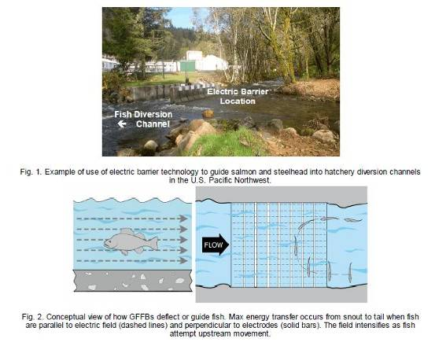
AQUACULTURE: ENVIRONMENT, BIODIVERSITY AND CLIMATE CHANGE
Malcolm C M Beveridge*, Michael Phillips, Doug Beare, Max Troell and Sarah Castine
WorldFish, Jalan Batu Maung Batu Maung, 11960 Bayan Lepas, Penang, Malaysia M.Beveridge@cgiar.org

Global demand for seafood, growing wealth, and growing human populations are driving the growth of aquaculture, as a source of fish for food, nutrition and income. Aquaculture is already the world's fastest growing animal food producing sector, but its future contribution to global food supplies and food security is far from certain, particularly for some of the poorest and hungriest most food and nutrition insecure people on our planet. The presentation focuses on challenges for aquaculture in developing countries, within the context of ever more globalized food production industries.
The growth of aquaculture has often caused undesirable ecological impacts such as loss of wetlands, water and sediment pollution and decreases in biodiversity. Additionally, aquaculture has also not always either provided food or increased the incomes of the poor and marginalised. Aquaculture can be an ecologically efficient means of producing animal products, as conversion efficiencies, and even water use efficiencies, are often far greater than for the production of other animal foods. Future growth, as for all food production systems, will need to address the challenges of access to essential inputs such as land, water, seed, feed, and energy and the release of greenhouse gases and other by-products. The consumption of ecosystem services clearly affects ecosystem structure and function, which in turn generates feedback loops that affect entire aquaculture value chains, and the livelihoods of those who depend on them. These complex interactions and ultimate impacts are mediated by many externalities, including trade, energy and environmental policies and the state of the economy, operating at a range of scales from local to global.
The presentation considers how aquaculture can better contribute to reducing poverty and hunger in developing countries. It summarizes the complex interactions between aquaculture and the environment and the options available to minimize impacts on biodiversity and climate change. It also considers the role of aquaculture in climate change mitigation and the options for adaptation, as well as opportunities for collaborative research to address the challenges posed.
DEFINING THE NATURAL AND
ANTHROPOGENIC DRIVERS BEHIND
"eutrophication HOTSPOTS" IN MACROALGAL COMMUNITIES
Luis A. Henríquez, Catriona Macleod, Jeff Ross & Neville Barrett
Luis.HenriquezAntipa@utas.edu.au Institute for Marine & Antarctic Studies, Fisheries, Aquaculture & Coasts (IMAS - FAC). University of Tasmania. 20 Castray Esplanade, Battery Point,

Estuaries and coastal embayments have often been shown to be vulnerable to anthropogenic sources of nutrients. Nitrogen and phosphorus loads can affect reef ecology favouring opportunists, altering community structure and physiological responses of key species. The vulnerability of any given reef system to impact is determined by both the prevailing abiotic conditions and the community's ability to assimilate nutrient loads. In this study, we provided a nutrient source within three reefs and followed the successional response on both existing and colonizing (cleared) macroalgae. We assessed the influence of prevailing abiotic factors (i.e. exposure, light, salinity, nutrients availability) on macroalgal community attributes (abundance, diversity, dominance, colonizing capabilities, N:P ratios). The main goal was to identify to what extent these conditions modulate the effects of elevated nutrient loads.
Caulerpa and Fucoids dominated in sheltered conditions (Community 1). Kelps and Encrusting algae were the main groups as exposure level increased, (Community 3); an intermediate community (Community 2) was identified as sitting between these two extremes (Figure 1). Nutrients were significantly higher near the artificial source, but diminished rapidly with distance such that levels were consistent over most of the reef. The exposure regime appears to be a key factor affecting macrophyte response to nutrients however; this relationship was not straightforward as exposure and light level are inherently linked. As might be expected opportunist's abundance increased where light levels were higher, but seemed to be moderated by exposure as maximum abundance occurred at intermediate exposure levels in the community 2. In contrast, these factors didn't influence the abundance of perennial species or the colonizing community. Location and exposure also appear to influence N:P ratios and nutrient content of the key species, with greater nutrient content observed at sites with low/intermediate levels of exposure.
These results suggest that local physical differences and community attributes may be critical for discerning potentially vulnerable habitats, i.e., "hotspots". Consequently, to address the coastal eutrophication problem information on both the natural attributes of the communities and the physical drivers in habitats under eutrophication pressure is needed to really inform coastal planning processes and underpin modelling of response
gradients.
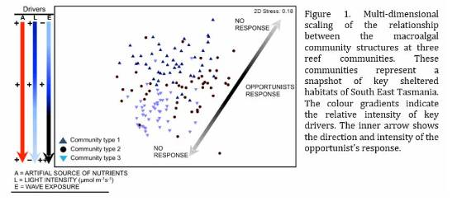
Improving oyster industry's resilience through estuarine monitoring across a range of time scales
Ana Rubio*, Peter Coad, Roman Kadluczka, Bruce Alford
Hornsby Shire Council PO Box 37, Hornsby NSW 1630, Australia arubio@hornsby.nsw.gov.au

Oyster farming in New South Wales (NSW, Australia) requires optimal estuarine water quality conditions. Water quality can vary in response to land-based catchment activities, oceanic currents and weather conditions. Shortterm variations in declining water quality, usually in response to rainfall events and algal activity, can impact the oyster industry with harvest are closure when problematic levels are reached. In NSW there is a lack of long-term high-frequency monitoring of the estuarine environment to assist management responses to short term declines in water quality. This information is critical for estuarine management including recreational and commercial fishing industries. In almost every estuary in NSW there is a vibrant oyster industry that requires good water quality and a
healthy catchment to thrive.
Climate change is one of the many long-term threats to the oyster industry. There is considerable uncertainty regarding when, where and how this threat will affect the oyster industry. Long-term monitoring of the estuary will assist in managing this threat by improved understanding of current estuarine processes and how future climate change scenarios will alter these processes.
The Hawkesbury River supports the cultivation of two species of oysters and a prawn fishery. Hornsby Shire Council and Manly Hydraulics Lab have pioneered in real-time estuary monitoring. This initiative started in 2004 at one monitoring station measuring water temperature and salinity and has now expanded to six stations monitoring a wider range of parameters that include a thermistor chain, chlorophyll-a and turbidity. Real-time environmental data benefits the oyster industry on different time scales: 1) short time scales: real-time data access assists daily farming management decisions (e.g. growers monitor declines in salinity following rain events and can respond by moving oyster stock to areas with favourable salinities; 2) medium time scales: eight years of high frequency environmental data exists allowing for a better understanding of the relationships between local environmental variability and oyster performance. This data can be compared to climate indices and may ultimately allow the development of seasonal forecasting systems; 3) long time scales: real-time data contributes to the understanding of baseline conditions, quantifying change by identifying long-term trends and potentially attributing changes to a cause.
Reliable environmental information can help the oyster industry plan for adverse and beneficial climate events, allocate resources, adapt to climate change and ensure its long-term sustainability. Healthy estuaries offer greater resilience to the oyster and seafood industries that rely on them.
ARTIFICIAL FEED DEVELOPMENT FOR FARMED BLUEFIN TUNA, THUNNUS ORIENTALIS
Tsuyoshi Goto*, Itaru Shioya, Kazushi Harada, Hiromi Ito
Central Research Laboratory, Nippon Suisan Kaisha, Ltd., Tokyo Innovation Center,
32-3 Nanakuni 1 chome, Hachioji, Tokyo 192-0991, Japan tsuyoshi@nissui.co.jp

We have developed an effective and practical artificial feed for farmed bluefin tuna, Thunnus orientalis. Compared with the conventional feed, the artificial feed was manufactured using a completely different process. The longshape feed enables easier recognition for fish, and has high nutritional quality. The double concentric feed with 8- 10% of moisture content is composed of two parts: an inner feed (filling mass) and a highly palatable outer shell.
The filling mass made mainly from fish meal and fish oil is highly nutritious, and the outer shell made mainly from fish meal and plant-derived ingredient offers high digestibility. In addition, the feed can be stored at room temperature.
To investigate the effect of the artificial feed on growth and feed conversion ratio (FCR), we fed farmed bluefin tuna a mackerel diet (control) or the artificial feed to satiation 6 days a week for 6 months from summer to autumn.
The water temperature during the experimental period was between 18 to 30 C. The growth of the artificial feed group was equivalent to that of the control group which had initial and final body weight approximately 16 and 32 kg, respectively. Compared with the control group (approximately 11), the FCR of the artificial feed group was lower (approximately 4).
Taking into consideration of the cost for labor and logistics, our feed was demonstrated to be superior in practical use in tuna aquaculture.
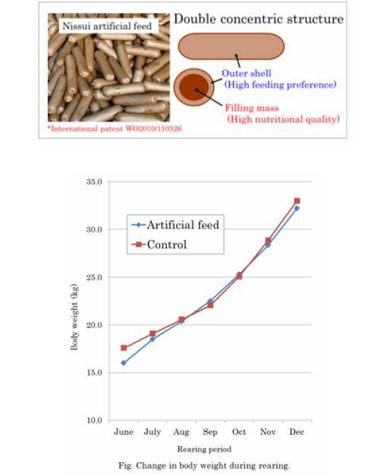
EFFECT OF ROTIFER ENRICHMENT ON SURIVAL OF SOUTHERN BLUEFIN TUNA Thunnus maccoyii DURING EARLY LARVAL REARING
Ben Nan Chen*, Wayne Hutchinson, David Poppi, Craig Foster, Graham Mair
Clean Seas Tuna Ltd PO Box 80, Arno Bay, SA 5603, Australia
Email: bennan@cleanseas.com.au

High mortality of southern bluefin tuna (SBT) larvae in the early life stage is still a major bottleneck which hinders the development of SBT hatchery propagation. In the hatchery, SBT larval survival rate is usually below 1% after the first two weeks of larval rearing. Inappropriate environmental conditions and poor nutritional profile of the live feeds used during the larval rearing period are implicated in this poor survival rate. Previous trials showed that SBT larval survival could be improved using an efficient upwelling system in the larval rearing tank from the beginning of first feeding, however larval survival remained low at the end of the 2 week post hatch. This study focused on improving the nutrition of live feeds (i.e. rotifers) to determine if a higher DHA content in the enrichment diets could
improve SBT larval survival until the end of the 2 week of hatchery production.
This experiment was conducted in a 9 x 3000-L tank system stocked with SBT eggs obtained from broodstock held in the on-shore facility at the Clean Seas Tuna Ltd hatchery in Arno Bay, South Australia. Three live feed enrichment solutions using two commercial enrichment products, AlgaMac 3050™, S.Presso™ and a mixture of
both enrichment products (Mix) were evaluated. At 13 days post hatch (dph), SBT larvae fed with rotifers enriched with AlgaMac 3050™ had significantly (P < 0.05) higher survival (22.4 ± 3.1%) compared to survival of the larvae fed with rotifers enriched with S.Presso™ (12.8 ± 4.3%) or a mixture of both enrichment products (8.4 ± 2.8%, Fig. 1.). No significant difference in growth of SBT larvae was detected among treatments. Swimbladder inflation was poor in all treatments ranging between 7.2% and 15.0% and was not significantly different between treatments. Fatty acid analyses of DHA and EPA of the rotifers and SBT larvae from different treatments were also carried out. The results indicated that live feeds with high DHA content materials significantly improve SBT larval survival during the live feed feeding stage. High DHA content enrichment product such as AlgaMac 3050™ should be used to enrich live feeds during SBT first feeding stage. Further, the low swimbladder inflation rate of the SBT larvae in the larval rearing tanks should be addressed in future SBT larval rearing trials.
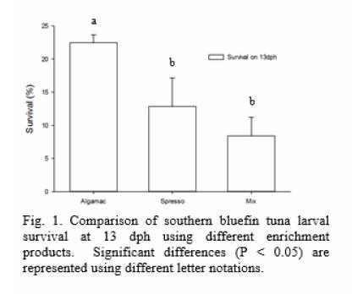
TOWARDS DEVELOPING A GERM CELL TRANSPLANTATION FRAMEWORK FOR SOUTHERN BLUEFIN TUNA (Thunnus maccoyii)
Andre Smith*, Abigail Elizur, Yutaka Takeuchi, Goro Yoshizaki, Ido Bar, Erin Bubner
University of the Sunshine Coast Locked Bag 4, Maroochydore DC, Queensland, 4558, Australia ondy.smith@gmail.com

Germ cell transplantation technology could be an important tool in the successful closed life-cycle aquaculture of southern bluefin tuna (Thunnus maccoyii) (SBT), to ease the fishing pressure on the wild stocks and develop a selfsustained industry. Currently, there are issues surrounding the care and maintenance of SBT broodstock, as they are large animals (up to 160kg) and reach sexual maturity at a late age (10 - 12 years). Germ cell transplantation has the potential to overcome the difficulties in maintaining large bodied broodstock, such as SBT, by transplanting donor-derived germ cells (SBT) into a smaller bodied surrogate species such as yellowtail kingfish (Seriola lalandi) (YTK). YTK has been selected as a prospective surrogate host, as YTK larval development and spawning occurs at a similar temperature as YTK, and it reaches sexual maturity at a younger size (3kg) and age (3 - 4 years) than SBT. Another reason why YTK has been selected as a potential surrogate for SBT is that they are a commercially important species and therefore the aquaculture of this species is already well developed.
The current study has laid the framework for a germ cell transplantation protocol for SBT by establishing some of the prerequisite knowledge required for this technology to progress. Firstly, an effective protocol to collect and dissociate SBT testis material to obtain a high number of viable germ cells for transplantation was developed. The current study also confirmed an effective method to cryopreserve SBT testis material to ensure that SBT germ cells were readily available year-round for germ cell transplantation. The current study also developed a method to successfully transplant SBT germ cells into YTK larvae, and then rear those transplanted larvae in low density, to assess the suitability of YTK as a surrogate host for SBT. We have demonstrated that YTK can successfully support the migration and colonisation of transplanted SBT germ cells, and are currently examining the proliferation of these cells to establish whether YTK may have the potential to be used as a surrogate for SBT.
ADAPTING TO CLIMATE CHANGE:
IDENTIFICATION OF MOLECULAR MARKERS ASSOCIATED WITH OCEAN ACIDIFICATION IN OYSTERS
Priscila Goncalves*, Emma L. Thompson, Kelli Anderson, David A. Raftos
Department of Biological Sciences, Macquarie University, NSW 2109, Australia & Sydney Institute of Marine Science, Chowder Bay, NSW 2088, Australia. priscila.goncalves@mq.edu.au

Marine environments are facing changes in both water acidity and temperature over this century. Elevated atmospheric CO concentrations are predicted to cause a reduction in the pH of the oceans from 8.1 to 7.7 by 2100. As a consequence of this ocean acidification, carbonate ion concentrations will be reduced leaving bivalve molluscs particularly susceptible due to their reliance on calcium carbonate for shell formation and integrity.
Environmental stressors associated with climate change have also been shown to have negative impacts on the metabolism, calcification, immune responses, reproduction, development and growth rate of oysters. However, these impacts can vary depending on the species, and even between populations within species. For instance, the deleterious effects of climate change have been shown to be far less severe in Sydney rock oyster Saccostrea glomerata produced through selective breeding than in wild type oyster. The aim of our study was to compare the response of two populations of Sydney rock oysters to elevated levels of CO (856 μatm, average pH 7.75) at both cellular and molecular levels, in order to identify the molecular basis for adaptation to climate change. At the cellular level, the impacts of elevated CO levels were tested on the cytoskeleton, mitochondrial membrane potential and oxidative stress of selected and wild type populations. Selectively bred oyster blood cells showed a lower mitochondrial membrane potential in relation to the wild population at ambient conditions and their mitochondrial activity was further decreased after exposure to elevated CO . Although the same scenario was found in the production of reactive oxygen species (ROS) at ambient control condition, ROS production increased (up to 3.4-fold) in the selected population after CO exposure. At the molecular level, selectively bred and wild oysters displayed differential gene expression profiling through Real-Time PCR for genes involved in oxidative stress, mitochondrial energy metabolism and cytoskeleton. Selectively bred oysters showed a different molecular response compared to the wild population under ambient control conditions (contrasting basal levels). Moreover, under high levels of CO , a set of genes was differentially regulated in both populations in comparison to the control condition. Based on our findings, we conclude that selectively bred Sydney rock oysters respond differently to CO stress at both cellular and molecular levels when compared to non-selected oysters. This behavior might be related to the ability of this population to better withstand ocean acidification. This suggests that we may have identified intracellular processes and physiological systems that might provide inherited protection against climate change.
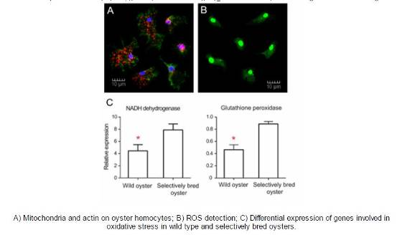
SUBSTITUITION OF FISH MEAL BY A SOYBEAN PROTEIN CONCENTRATE FOR Litopenaeus vannamei CULTIVATED IN A BFT SYSTEM
Walter Quadros Seiffert¹, Adolfo Jatobá¹ ²; Bruno Corrêa da Silva¹, Felipe do Nascimento Vieira¹; Mariana Soares¹; Jose Luiz Pedreira Mouriño¹; Federal University at Santa Catarina (UFSC), Department of Aquiculture, Brazil; Aquicultura Laboratory, Araquari Campus, Instituto Federal Catarinense (IFC).

Alternative protein sources to substitute fishmeal is necessary to increase the sustainability of marine shrimp production in a biofloc system . Currently nutritional studies focus on finding a renewable ingredient with a high protein concentration, good essential amino acid profile and lower cost than fishmeal. The purpose of this study was to evaluate the zootechnical performance of marine shrimp (Litopenaeus vannamei), cultivated in a superintensive biofloc system fed with diets containing different levels of substitution of fishmeal by soybean protein concentrate.
Four different isoenenergetic diets were formulated with different levels of substitution of fish meal by soybean protein concentrate (0, 33, 66 and 100%). The diets were formulated with 270 g.kg of estimated digestible protein and similar quantities of marine origin fat (fish oil + fish meal fat) guaranteeing a similar fatty acids profile. The study used 2,400 marine shrimp (L. vannamei) with average weight of 3,96 ± 0,04 g, reproduced from a Specific Pathogen Free line from the company Genearch Aquaculture LTDA (Rio Grande do Norte, Brazil).
The 12 experimental units with 800 L of useful water had a surface of 4 m² (depth and side) and another 2 m² offered in artificial substrate to increase the animals' comfort. An initial density of 250 shrimp.m was maintained. Throughout the experiment the dissolved oxygen, temperature, volume of settleable solids, transparency, pH, total dissolved ammonia, nitrite, nitrate, alkalinity, total suspended solids, dissolved ortophosphase and salinity were monitored weekly.
At the end of the experiment, the centesimal and aminogram composition of the shrimps was evaluated and of the sludge generated as well as zootechnical indicators. Table 1.
The treatments were no interference (P>0,05) in the results of water quality, centesimal composition of the shrimp and of the sludge generated. The substitution of 33% of fish meal by the soybean protein concentrate in the diet did not interfere in the zootechnical performance of the marine shrimp cultivated in a biofloc system, and did not change the water quality parameter of the culture.
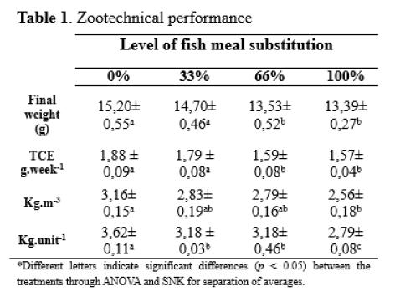
TWO FOR THE PRICE OF ONE: CO-CULTURE OF PACIFIC OYSTERS AND AUSTRALASIAN SEA CUCUMBERS.
Leonardo Zamora* and Andrew Jeffs. Institute of Marine Science, Leigh Marine Laboratory University of Auckland P.O. Box 349, Warkworth 0941, New Zealand
lzam004@aucklanduni.ac.nz

The Australasian sea cucumber, Australostichopus mollis, has attracted commercial attention for aquaculture development due to its high market value (USD 275 kg dried weight) and its potential for co-culture with shellfish. Most of the current research has been focused on growing this sea cucumber species together with mussels, for which there is a significant existing aquaculture industry in New Zealand and southern Australia. Minimal attention has been given to the possibility of growing these sea cucumbers with other species such as finfish and oysters. Therefore, in the current study we evaluated the long term growth and survival of juvenile A. mollis placed under oyster farms located in a shallow harbour in north-eastern New Zealand. Juvenile sea cucumbers (36 g mean wet weight) were grown in eighteen plastic cages (1.0 × 0.5 × 0.15 m, L × W × H) fixed to the seafloor beneath three Pacific oyster farms in the Mahurangi Harbour; Dyers, Brownes Bay and Te Kapa. The cages were subtidal, directly below oysters being cultured on an intertidal wooden "rack and rail" system. Culture started at the end of the summer, and after 304 days the sea cucumbers had doubled in size, however, their subsequent growth appeared to be constrained by seawater temperature and the overstocking of the cages (Fig. 1). It was not possible to determine survival as sea cucumber losses (52% in Dyers, 38% in Brownes Bay and 33% in Te Kapa) could be due to mortality, or escapes from the cages and loss of entire cages due to adverse weather conditions.
Overall, the results of this study indicate that the aquaculture of sea cucumbers with Pacific oysters is feasible, however, it will be important to manage stocking times, sizes and densities to maintain adequate growth rates and reduce escapes.
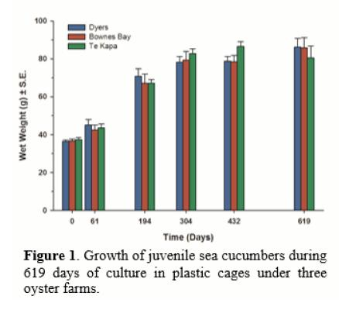
EFFECTS OF PHOTOSYNTHETIC PHOTON FLUX DENSITY AND PHOTOPERIOD ON WATER QUALITY AND CROP PRODUCTION IN A LOACH (Misgurnus anguillicandatus) – NEST FERN (Asplenium nidus) RAFT AQUAPONICS SYSTEM
Jung-Yuan Liang and Yew-Hu Chien Department of Aquaculture, National Taiwan Ocean University, Keelung, Taiwan 202 Agricultural Engineering Research Center, Chung-Li City, Tauyuan, Taiwan 320

A previous study showed that a Loach Misgurnus anguillicandatus - Chinese Chive (Allium tuberosum) raft aquaponics system was effective in water and cost saving, nutrient conservation and fish and plant production. Increased PPFD favored stable and good water quality and concomitantly, fastened fish growth and plant growth. Two photoperiods (16-h or 24-hight per day) did not make differences in water quality and both fish and plant production with full-time sunshine plant. This study focused on effects of photoperiod and light intensity on production of high value fish and half-time sunshine plant. A factorial arrangement of 6 treatments, 2 photoperiods (3-h or 9-h light per day) X 3 PPFD (photosynthetic photon flux density: 14, 28, 56μmol/sec.m with T5 tube) for loach and Nest fern Asplenium nidus Linn. were assigned to 12 tanks. Each tank was an aquaponics system containing fish and raft-supporting plant. In 4 weeks' rearing, water quality remained safe and stable. No fish died. Overall average weight gain was 45.0% for fish and 36.0% for plant. Water loss was 3.5%, due to leaf transpiration mainly and evaporation. Increased photoperiods and PPFD favored stable and good water quality and concomitantly, fastened fish growth and plant growth.
THE CURRENT UTILISATION OF
RECIRCULATING AQUACULTURE TECHNOLOGY IN INCREASING GLOBAL AQUACULTURE PRODUCTION.
Rodney Missen , Gerard Adam and Wil Conn RADAQUA P/L Glenview, Qld, Australia, 4556 rod@radaqua.com.au

What are the future opportunities for RAS to play a role in a global marketplace with a voracious appetite for protein? The world's population is projected to reach 9 billion by 2050, a statement that is normally followed by the term 'Food Security'. What does this growing protein demand coupled with greater awareness of the need by individual countries to feed their people into the future mean for RAS technology?
RADAQUA presents an overview on the advancement of modern RAS approaches, incorporating insight into the major change drivers that are serving to transform the way RAS has historically been by adopted within global aquaculture industries.
Pressure drop due to biofouling roughness under turbulent seawater flow in pipes systems
Germán Merino1,3, Joel Barraza1, Carlos Basulto2, Alejandro Segura2 and Guido Drago4 1Universidad Católica del Norte, Departamento de Acuicultura, Coquimbo, P.O. Box 117. Chile. (+56 51 209927), jbarraza@ucn.cl 2Universidad Católica del Norte, Unidad de Ingenieria, Coquimbo, P.O. Box 117. Chile. (+56 51 209757), ingenieria@cultivosucn.cl 3 Centro de Estudios Avanzados en Zonas Aridas (CEAZA), Unidad Regional de Desarrollo Científico & Tecnológico (CONICYT), Chile. 4 Condominio San Francisco. Edificio Costanera, Departamento 401, Avenida Alemania, Valparaíso.
guido.drago@gmail.cl

One of the main criteria when designing hydraulic piping systems is defining the head loss faced by the fluid within the conduits. Head loss is the energy lost by friction between particles of water and conduits walls, and in this case will be the internal pipe wall. The amount of energy lost or dissipated is a multi-parametric function and hence all together will affect the level of incidence. Some of the parameters involved are flow pattern (laminar or turbulent), water path trajectory, viscosity, and pipe surface roughness. Surface roughness becomes a particular issue faced only in hydraulic systems working with natural seawater. The abundant biological life in marine natural water plus the high water flow within the hydraulic pipe system generates a mass flow condition that promotes settling and colonization of life forms (also known as biofouling) on the internal pipe surface. These problems increase when intake seawater system is too close to the water surface or when a twister cone appears at the suction zone.
The amount of dissipated energy (or head loss) has to be known and it is quite relevant for aquacultural piping designs since it estimation are up to the boundary conditions established by the designing engineer. Usually marine piping systems will develop an important growth of biofouling in the internal pipe surfaces, and therefore an under-
estimation of the biofouling growth will maximize the head loss term meaning a dramatic reduction in the water flow and/or an increase in the electrical energy required to supply water to an aquacultural project. The second most relevant variable production cost in a flow through aquacultural farm is due to the electrical energy required by water pumping. Hence an adequate analysis has to be performed to evaluate the interaction between biological variables and boundary conditions established for hydraulic marine designs. The impact of the biological variables on the hydraulic system design is farm site-specific which highly varies along world coast-line. Chile has one of the most productive plankton zones which sustain an important fishery industry and therefore the variety of life-forms and their spatial distribution represent a serious issue as potential biofouling.
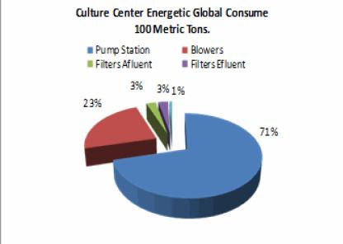
EFFECTS OF FLOW RATE ON THE GROWTH, FEED INTAKE, IMMUNITY AND WATER NITROGEN IN A CLOSED RECIRCULATION AQUACULTURE SYSTEM OF TURBOTS (Scophthatmus maximus L.)
Li Yong*, Wang Xiao-chen, Zhou Bang-wei, Sun Guo-xiang, Zhao Ning-ning, Liu Ying
Institute of Oceanology, Chinese Academy of Sciences Qingdao 266071, China liyong@qdio.ac.cn

Introduction:
Based on the view of Eco-nutrition and Water environmental control, the study aimed to explore the effects of flow rate on the feed intake, growth, water quality and immunity of turbot in a closed recirculation aquaculture system, looking for the optimum flow rate.
Materials & Methods:
Effects of flow rate on feed intake, growth and water quality of turbot were investigated in closed recirculation aquaculture system. Fishes with a mean initial weight of 200.3±7.6g were reared at four different flow rates (200L/h, 400 L/h, 600L/h, 800L/h), equaling 0.5, 1.0, 1.5, 2.0 tank volumes/h in 400L tanks during 42 days. Six hundred and sixty fishes were randomly allotted in four treatments with three replicates for each treatment at a stocking density of 14.1±0.51kg/m .
Results:
(1) Feed intake, specific growth rate and weight gain rate increased rapidly first and then slowly with flow rate increasing, while food conversion rate showed a reverse pattern. The specific growth rate of group B,C,D were significantly higher than group A by 30.77%〜52.31%, while feed conversion rate was lower than group A by 13.83%〜22.34%. (2) Concentrations of total ammonia nitrogen (TAN), unionized ammonia nitrogen (UIA-N) and nitrite (NO -N) in water decreased rapidly first and then slowly with flow rate increasing. The ammonia nitrogen of group B,C,D were significantly higher than that of group A by 53.70%〜79.07%. (3) The flow rates had significant influence on the blood Na+, K+, CI-, glutamic-pyruvic transaminase (GPT), SOD, lysozyme (LZM), glutamicoxaloacetic transaminase (GOT) of turbot: the GPT and SOD increased first and then decreased with flow rate increasing, while GOT showed a reverse tendency and LZM showed a tendency of growing. Compared with group A, the SOD activity significantly (P <0.05) increased by 14.25% ~ 21.25%; LZM activity by 22.16% ~ 57.53%; ALP activity by17.88% ~ 73.74%; GPT activity by 35.68% ~ 71.65% in group B,C, D. There were no significant difference (P> 0.05) in serum sodium, potassium, chloride content of blood among these four groups. (4) The optimal growth and ecological flow rate were calculated as 625L/h (1.56 tank volumes/h), combining the specific growth rate with total ammonia nitrogen in water. Another optimal growth and ecological-economical flow rate were calculated as 480L/h (1.20 tank volumes/h), combining specific growth rate with power consumption and TAN in water.
SEAFOOD & HEALTH - LEAN FOREVER
Martin Bowerman* PO Box 6822 Gold Coast Mail Centre QLD 9726 Australia
mobo2@bigpond.com

A pathway to challenge and overcome the body's physiology, supported by the latest science from the fields of nutrition and weight loss. "Whilst it may seem that the world is getting smaller, we - humans - are getting bigger. At least that's the case in wealthy nations like Australia, where obesity is a significant problem for an increasing number of people.
The grim reality of this is that being overweight can lead to all sorts of health problems - diabetes, heart disease, high blood pressure and even a higher risk of some types of cancer. Most people realise being overweight is not good for health but once gained, excess weight is very difficult to lose - and keep off.
Why is this so difficult? Humans evolved in environments with very uncertain food supplies and through this experience we seem to have become physiologically programmed to retain fat in times of plenty. Move forward to the obesogenic environment of the 21st Century, where there is now too much food whenever we want it. To lose excess weight successfully involves battles on two fronts: negotiating the modern obesogenic food environment, and - here is the key - challenging the body's own physiological messages.
What's in a Label? The legal implications of sustainability certification for aquaculture products
Katherine Hawes - Aquarius Lawyers - khawes@aquariuslawyers.com.au

This paper will outline the current international regulatory frameworks for certification of aquaculture. The paper will consider whether the soft law developed by international bodies are a legal basis for private third party seafood certification and outline the problems with third party certification from a legal perspective. The paper will discuss whether certification should move from third parties, including non government organisations, and shift towards international or State regulation.
According to the recent OCED figures Capture fisheries' output is projected to rise by only 5% by 2022 with aquaculture increasing by 35%, despite a slowing growth rate due to higher feed costs and more limited availability of production locations. Aquaculture is projected to surpass capture fisheries as the main source for human consumption by 2015.
In order to satisfy this increasing demand and to avoid any environmental disturbance, the aquaculture industry needs to develop in a sustainable manner. Therefore, standards and practices for farming, processing and selling of aquaculture products should be adapting to meet those new demanding criterion-that of sustainability. As a response to these global awareness new approaches to improving the environmental sustainability of aquaculture farms, processing plants and distributors have been established, including an increasing number of ecolabelling and certification schemes for fish and fishery products from both capture fisheries and aquaculture.
The ecolabelling schemes have emerged in reference to national, regional and international measures for fisheries and aquaculture sustainability at the early 1980s, which are: 1.The United Nations Convention on the law of the Sea (UNCLOS) (1982);
2.The FAO Code of Conduct for Responsible Fisheries(CCRF)(1995); 3.The United Nations Fish Stocks Agreement(UNFSA) (1995);4.Various regional fisheries management organizations(RFMO's) i.e. ICCAT. 5.The FAO Guidelines for the Ecolabelling of Fish and Fishery Products from Marine capture Fisheries.6.The FEAP Code of Conduct for European Aquaculture (FEAP 2006)
Ecolabelling was first recognized at an international level in 1992, during the United Nations Conference on Environment which was held in Rio de Janeiro. This type of certification, originally defined simply as "making relevant environmental information available to appropriate consumers" (USEPA 1993)
Although certification process can be carried out by public or government organisations, at present certification is currently carried out by private organisations and non government organisations. The Global Aquaculture Alliance (GAA) is the primary global trade association that certifies aquaculture production and processing facilities with the label 'The Best Aquaculture Practices Certified (BAP Certified)'. However, these schemes can only be seen as a starting point since they require improved elaboration to meet all concerns related to the negative impacts of aquaculture.
MULTI-STANDARD INTEGRATED AUDITS – ARE WE THERE YET?
David O'Sullivan, Dosaqua Pty Ltd, Australia, dos@dosaqua.com.au

Third-party or independent certification is becoming a vital part of market access. Here is just a brief list of some of the standards on offer that are applicable to aquaculture:
1.Environmental - ISO 14001, EMAS, Ecomapping
2.Food Safety - ISO22000, HACCP, GFSI recognised schemes - GAA Seafood Processing, GlobalG.A.P., IFA, FSSC 22000, SQF Code, BRC & IFS
3.Quality - ISO 9001
4.Workplace Safety - OHSAS 18001
5.Traceability - MSC/ASC Chain of Custody
6.Multi-focus - ASC (various species), GAA BAP (Hatcheries & Farms for various species & groups), Global GAP (Farms and Aquaculture)
7.Feed Mills - GAA BAP, Global GAP, Feedsafe
8.Plus an ever increasing range of Supermarket specific codes, standards, guidelines.
There is no doubt that many end consumers are confused with all the different certification schemes that are being offered. The next 5-10 years will be an interesting time as the owners of the Standards lobby/threaten/promote their particular scheme and buyers decide which ones offer them the best 'comfort' options.
Although they are voluntary, certification against these Standards is becoming an accepted part of the seafood industry wanting to prove its social responsibility, environmental, animal welfare, food safety and traceability credentials. However, whilst there is financial and advisory assistance for growers in some developing countries, most industry members selling to a range of markets are finding that they need to comply with a wide range of certifications. This adds to the operating costs of the business which they must either bear themselves (further reduce profit margin) or pass onto the customer and risk losing some market share to another company whose prices may be lower.
Fortunately there has been some recognition of the overlap of these schemes such as the GFSI benchmarking work for recognition, also the ASC, GlobalG.A.P. and GAA Memorandum of Understanding, many growers have to deal with different audit teams from different Certifying Bodies.
Some Certifying Bodies who handle several standards can offer an "integrated audit" which provides reductions in auditor time and hence savings to the aquaculture company. The maths is simple, rather than having 2 or 3 visits by different auditors who often ask the 'same' question, appropriately trained audits can be onsite for less time as they can overcome duplication. An integrated report also provides a much better representation of the whole system in place, rather than just focussing on certain issues.
However problems arise when different certifying bodies are involved, especially with the need for different reports to be completed and in the division of the time (and hence cost) involved. Case studies from around the world are used to provide some context to the problems being experienced and to call for a collaborative approach from the Certifying Bodies, the Standards Owners, the auditors and industry for mutual recognition, equivalency or harmonisation of the Standards.
THE AQUACULTURE STEWARDSHIP COUNCIL:
A GUIDE TO THE CERTIFICATION PROCESS
Peter Cook
Centre of Excellence in Natural Resource Management, University of Western Australia.' Albany WA 6330. Peter.cook@uwa.edu.au

The Aquaculture Stewardship Council's mission is to transform aquaculture towards environmental sustainability and social responsibility, using efficient market mechanisms that create value across the chain. The overarching strategy of the ASC is to use market forces to transform aquaculture. This will be done by reducing the key negative social and environmental impacts of aquaculture through compliance with standards at the farm level. Jointly established by WWF and IDH in 2010, the ASC is an independent, not for profit organisation, designed to recognise and reward responsible fish farming, to support purchasing of certified seafood, and to move aquaculture towards sustainability and social responsibility. In partnership with the MSC, the ASC ensures a "farm to fork" chain of custody process.
Despite several of the ASC standards (e.g. Tilapia and Pangasius) already being in operation, and many farms already being certified, considerable confusion still exists concerning how farms can become certified, who can us the ASC logo, and the cost of the certification process and logo use. The objective of this presentation will be to present the latest information on the certification process, the accreditation of certification bodies, and the costs associated with various aspects of ASC certification.
附件二：活動照片
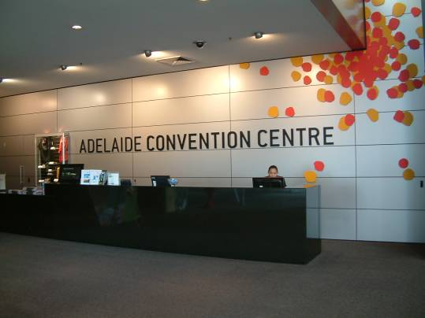
上圖-2014WAS會場；下圖-WAS報到櫃檯
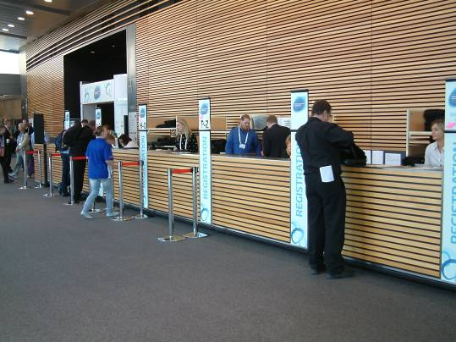
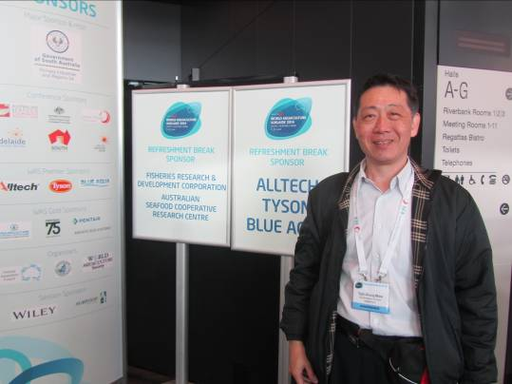
上圖-筆者出席WAS報到情形；下圖-大會開幕式
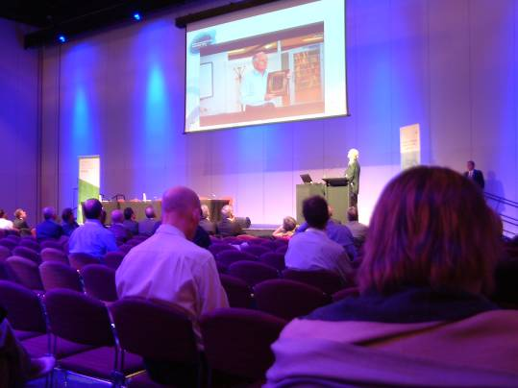
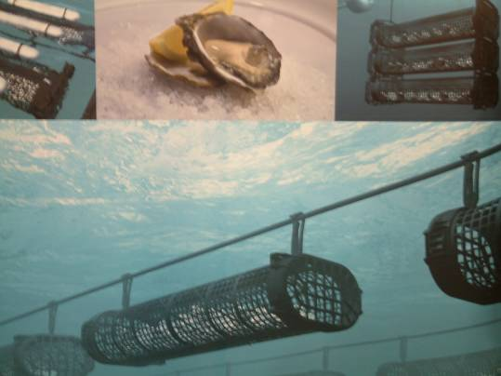
上圖-牡蠣籠具養殖展示；下圖-大型養殖抽水機展示
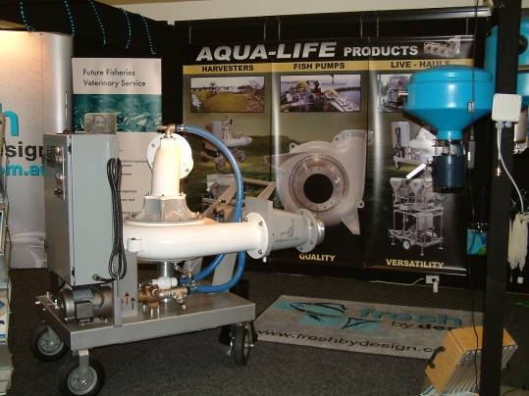
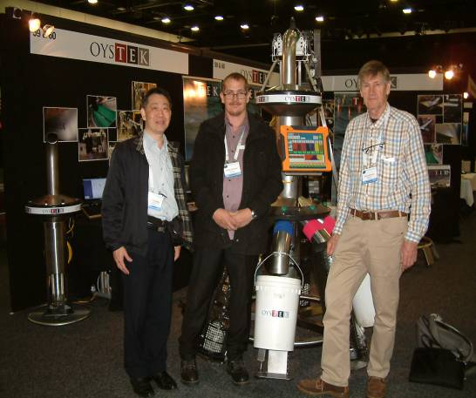
上圖：筆者與牡蠣分級處理機製造廠商合影
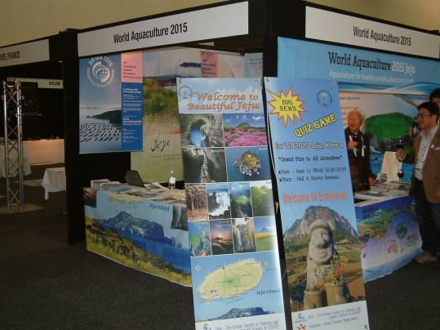
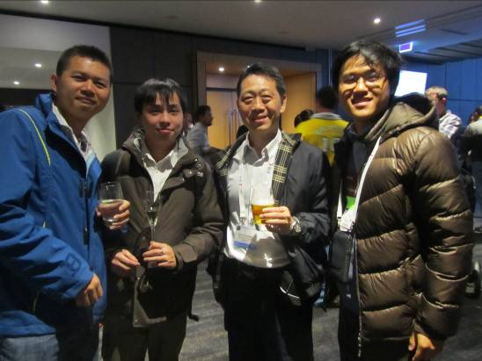
上圖： WAS歡迎酒會上筆者與來自臺灣學者業者合影；
下圖：筆者與農工中心梁榮元(左)、Cheng-Sheng Lee博士(中)合影
