出國報告（出國類別: 其他: 國際會議）

2014第三屆土木、材料與環境科學
亞洲學術研討會
3rd Asian Conference on Civil, Material and Environmental Sciences 2014
出國報告

服務機關：國立雲林科技大學 環境與安全衛生工程系
姓名職稱：郭昭吟 副教授

派赴國家：日本
報告日期： 2014/8/10
出國時間：2014年07月21−25日

摘要
本人於民國 103 年 07 月 21–25 日出國，參加2014第三屆土木、材料與環境科學亞洲學術研討會(3rd Asian Conference on Civil, Material and Environmental Sciences 2014)，會議日期為103 年 07 月 21–24 日。此行程主要為發表文章及學術交流。發表之文章為製備氧化亞銅與二氧化鈦降解氣相1,2-二氯乙烷之研究Preparation of hybrid catalyst with cuprous oxide and titanium dioxide to photodegrade gaseous 1,2-dichloroethane。主要內容為以溶膠凝膠法製備450ºC氧化鉍(Bi₂O₃)並混合商用氧化亞銅(Cu₂O)，製備不同比例(25、50、75 wt%)Bi₂O₃/Cu₂O之混成觸媒(25BC、50BC、75BC)，分析觸媒之晶相結構、能隙等物化特性分析，並分別放置不同波長光源(紫外光模擬太陽光)下，探討批次光催化降解氣相1,2-二氯乙烷(1,2-DCE)之可行性。本研究之Bi₂O₃/Cu₂O複合式觸媒具有良好光催化降解污染物之能力且能有效將污染物轉化成低毒害性物質。該關鍵技術已發表於該研討會，充分與國外學者交換相關學術研討並獲得精進之思想。
該土木、材料與環境科學亞洲學術研討會為亞洲學術之國際會議，今年於日本北海道舉行，其匯集了各專家、學者，透過此研討會平台進行學術、實際應用之交流以及經驗分享。對本人及本人所領導實驗室之研究深度、廣度具有相當之啟發，將有助於未來之學術發展。
目次
一、 目的 1
二、 過程 1
三、 心得 2
四、 建議事項 2
五、附錄 3
附件一：發表全文(含海報) 3
附件二：照片 12
附件三：發表論文清單 13

- 目的
參加2014第三屆土木、材料與環境科學亞洲學術研討會(3rd Asian Conference on Civil, Material and Environmental Sciences 2014)，此行程主要為發表文章及學術交流。發表之文章為製備氧化亞銅與二氧化鈦降解氣相1,2-二氯乙烷之研究Preparation of hybrid catalyst with cuprous oxide and titanium dioxide to photodegrade gaseous 1,2-dichloroethane。主要內容為以溶膠凝膠法製備450ºC氧化鉍(Bi₂O₃)並混合商用氧化亞銅(Cu₂O)，製備不同比例(25、50、75 wt%)Bi₂O₃/Cu₂O之混成觸媒(25BC、50BC、75BC)，分析觸媒之晶相結構、能隙等物化特性分析，並分別放置不同波長光源(紫外光模擬太陽光)下，探討批次光催化降解氣相1,2-二氯乙烷(1,2-DCE)之可行性。本研究之Bi₂O₃/Cu₂O複合式觸媒具有良好光催化降解污染物之能力且能有效將污染物轉化成低毒害性物質。

- 過程
研討會報到時間在7/21-7/22下午5：30，本人抵達報到時間為7/21下午。論文發表的時間安排於7/23下午14：00-15：00，本次發表之文章為編號10，ACCMES-1372。是製備氧化亞銅與二氧化鈦降解氣相1,2-二氯乙烷之研究。
其過程與國際學者探討之重點如下
  - 揮發性有機化合物 (Volatile Organic Compounds, VOCs)長期廣泛應用於石化工業、塑料業、半導體產業等工業製程，具有高滲透、脂溶、揮發性等特性，因此並被認為是致癌、致突變或致畸的有害物質(Guengerich et al, 1980) 。其中，1,2-二氯乙烷(1,2-DCE)為常見之含氯揮發有機物質(Cl-VOCs)之一，在空氣、水和土壤中都可被發現，屬氯代脂族烴(CHAs)，主要作為乙烯製品的生產及工業用溶劑之用途(Liu et al, 2014)。此外，1,2-DCE為害有空氣污染物之重要組成之一，會引發肝、腎功能、呼吸系統、中樞神經系統的危害，產生噁心、嘔吐、中毒、昏迷等症狀，長期暴露甚至導致基因和染色體畸變(Syed et al., 2014)，且因在環境中轉化消減甚慢，殘留期長(Vogel et al., 1987)，此點，與會之國際學者均表贊同也給予更多他國之學術數據加以討論。
  - 發表之文章使用三氧化二鉍(Bismuth trioxide, Bi₂O₃)為稀土族金屬氧化物之p型半導體材料，能隙為2.8 eV，容易被激發於紫外光及可見光波長下而光催化降解污染物，但導電帶的電子不易被激發，使氧分子之還原反應受侷限，造成超氧陰離子自由基產量減少，而導致光催化效果不佳(Hu et al., 2013)。氧化亞銅(Cuprous oxide, Cu₂O)為p型半導體材料之一，能隙約2.17 eV，不具毒性、高穩定性、無二次污染等優點，且具其獨特的光學和電學性質，僅需要較小之光源即可激發電子跳躍，但因電子電洞對再結合率高，而影響光催化效能。為了增加Bi₂O₃及Cu₂O觸媒的光催化活性，有研究指出，兩種不同能隙、電位之半導體材料的結合，因電位上的差異，產生內電子傳遞效應，同時降低能隙及電子電洞對再結合，而增加光源波長的利用性。此外，因粉體光觸媒不利於使用與回收，易造成環境二次污染問題，若將觸媒塗覆於載體上，同時能減少觸媒使用量及增加光催化反應面積。此項研究應用為本篇文章之創新研究技術，發表期間獲得學者之肯定與認同，並且學者們也提供了他們的見解及原理探討以及未來可做研究之方向，收益頗多。亦有學者非常感到興趣，提出了邀約至他校進行學術交流、短期研究之議題。
  - 其中本研究提出之最終產物分析獲得其他學者之認可，及確認本研究之貢獻為本次發表重點。由發表之結果中吸收波長之分析，氧化鉍/氧化亞銅混成觸媒有兩種能隙，有利於同時在紫外光及可見光下激發自由基以降解污染物。於紫外光及模擬太陽光下光催化反應120分鐘時，單一觸媒氧化鉍與75 wt%氧化鉍和25 wt%氧化亞銅之混成觸媒降解氣相1,2-二氯乙烷之效率，可分別由61%、49%提昇至92%、83%。研究結果證實製備之氧化鉍/氧化亞銅混成觸媒，可運用觸媒不同能隙的轉換，延長電子電洞對再結合並提高光催化效率，故本研究製備之氧化鉍/氧化亞銅混成光觸媒未來將有運用自然太陽光進行難分解有機污染物之可行性。

總之，該文章於研討會期間有許多專家學者均對其感到興趣進而進行相關問題交流。本次學術研討會匯集了各專家、學者，透過此研討會平台進行學術、實際應用之交流以及經驗分享，共計有上百篇之學術論文於此發表交流，他人之研究成果亦有許多值得學習之處，交流之效果良好。其相關內容詳如五、附錄之附件一。

- 心得
    - 數場之學術發表均發現發表人相當之學術深度，許多研究議題都值得再深入研究。
    - 本次研討會與其他專家學者當面研析相關研究內容，對學術上有實質交流且有顯著幫助。
    - 此次學術發表及聆聽其他學術發表及交流，激發許多學術思想。特別與日本學者共同進行學術上之探討，奠定未來進一步實質交流之良好契機。
- 建議事項
    - 建議未來學校仍能提供多元的補助管道，讓老師以及學生能在學校的幫助下，至國外展現學術成果。
    - 建議未來學校可進一步與日本優秀大學如北海道大學進行相關學術交流， 展開更多創新性的學術成果。

五、附錄

附件一：發表全文(含海報)
- 論文全文
Preparation of hybrid catalyst with cuprous oxide and titanium dioxide to photodegrade gaseous 1,2-dichloroethane

Wei-Jhen Huang
Department of Safety Health and Environmental Engineering, National Yunlin University of Science and Technology, 123 University Rd., Sec. 3, Douliou, Yunlin 640, Taiwan
happy111279@gmail.com

Jyun-Siang Syu
Department of Safety Health and Environmental Engineering, National Yunlin University of Science and Technology, 123 University Rd., Sec. 3, Douliou, Yunlin 640, Taiwan
Flystudent6@gmail.com

Chao-Yin Kuo
Department of Safety Health and Environmental Engineering, National Yunlin University of Science and Technology, 123 University Rd., Sec. 3, Douliou, Yunlin 640, Taiwan
kuocy@yuntech.edu.tw

The corresponding author: Tel.:+886 5 534 2601x4423; fax: +886 5 531 2069
E-mail address: kuocy@yuntech.edu.tw (C.Y. Kuo)

Abstract
Hybrid catalysts of cuprous oxide and titanium dioxide with different oxygen concentrations (3%, 21%) were prepared and used to catalyze the photodegradation of gaseous 1,2-dichloroethane (1,2-DCE) by red light and ultraviolet light. The degrees of photodegradation of 1,2-DCE using red and ultraviolet light were 41 and 86%, respectively, and these photodegradation results were better than those obtained using a non-hybrid catalyst. A hybrid catalyst 30 wt% cuprous oxide and the balance titanium oxide inhibited electron-hole pair recombination and enhanced the electronic response in the catalyst surface improving the photocatalytic degradation.
Keyword: cuprous oxide, titanium dioxide, 1,2-dichloroethane, photocatalysis

- Introduction
Volatile organic compounds (VOCs) have been extensively used long-term in a wide range of industrial processes in, for example, the petrochemical, plastic, polymer, and semiconductor industries. However VOCs are carcinogenic, mutagenic, and can acutely harm the central nervous system. 1,2-Dichloroethane (1,2-DCE) is a common chlorinated volatile organic compound (Cl-VOC), which is mainly used in the manufacture of vinyl chloride, as a solvent in industry, for cleaning textiles and equipment, and in pesticides and pharmaceuticals [1, 2]. Additionally, 1,2-DCE is an important hazardous air pollutant, which decomposes slowly and so remains for a long period in the environment [3]. Long-term exposure to 1,2-DCE under conditions can mutate genes and chromosomes [4].

Cuprous oxide (Cu₂O) is a p-type semiconductor with a direct band gap of 1.9–2.2 eV; it has been used in conductor materials [5], solar cells [6], anode materials [7], biosensors [8] and catalysts [9]. Cu₂O is weakly toxic, inexpensive, highly stable, readily available, and environmentally acceptable; it also has a high optical absorption coefficient [10, 11]. Cu₂O can adsorb oxygen molecules, which can inhibit the recombination of electrons and holes in photocatalysts, and so can improve photocatalytic activity [12].

Titanium dioxide (TiO₂) is an n-type semiconductor, which is non-toxic, chemically stable, highly photocatalytically active, highly photostable and cheap [13]; it also efficiently degrades toxic chlorinated organic compounds under strong illumination at ambient temperature and pressure, to yield non-toxic CO₂ and H₂O or HCl following [14, 15]. However, TiO₂ has a large band gap of 3.2 eV, and so cannot be easily excited by visible light. To solve this problem, the Cu₂O/TiO₂ composite catalyst was developed to reduce the rate of recombination of electron-hole pairs, and thereby improve the efficiency of use of solar energy by TiO₂ and increase the stability of Cu₂O [16]. Moreover, recovering a powdered catalyst is difficult, and this problem can result in secondary pollution. Hence, in this work, hybrid catalysts of Cu₂O and TiO₂ in different ratios were immobilized and granulated into cylindrical shapes and a batch reactor with various concentrations of oxygen was used to determine their effect on the degradation of gaseous 1,2-dichloroethane degradation under irradiation at various wavelengths between red and ultraviolet.

- Experimental Method

- Preparation of photocatalyst
Commercial Cu₂O and TiO₂ were used to prepare a Cu₂O/TiO₂ hybrid catalyst by the immobile method. First, to 45 g of TiO₂ were adding various masses of Cu₂O, such that the Cu₂O represented 0, 1, and 30 wt% of the catalyst. Second, deionized water was added which uniformly mixed and then the mixing materials was squeezed to form a strip. Third, the hybrid Cu₂O/TiO₂ catalysts were freeze-dried at –50°C for 12 hr. Finally, each strip was cut into lengths of 1.5–2.5 cm. The catalysts this formed are denoted as TiO₂, 1CT, and 30CT, respectively.

- Experimental apparatus and method
The reaction tank that was used in the photocatalytic experiment was made from reinforced glass and had inner and outer layer and it is as the same with the literature [9]. Before the experiment was performed, a pump was used to discharge air from the reactor and gaseous 1,2-DCE was extracted using a gasification device. A bag was connected to a nitrogen source to set the initial concentration of 1,2-DCE from the gasification device. The contaminant was then injected into the reaction vessel. The initial concentration of gaseous 12-DCE in the reactor was 40±10 ppm; the relative humidity and oxygen concentration were monitored and maintained at 45±5% and 21% or 3% using a temperature-humidity detector and oxygen analyzer, respectively. A magnetic stirrer was installed at the bottom of the reactor, and operated at a rotational speed of 800 rpm to ensure the uniformity of the gas. 1,2-DCE was adsorbed by Cu₂O/TiO₂ 30 min before irradiation; it was then degraded under irradiation at a wavelength between red and ultraviolet for 300 min. Finally, the concentration of 1,2-DCE was determined by sampling at intervals and GC-ECD analysis.

- Results and discussion

- UV-vis spectra analysis of catalyst
Figure 1 presents the diffuse UV-vis reflectance spectra of TiO₂, Cu₂O and Cu₂O/TiO₂ hybrid catalysts with different concentrations of Cu₂O at wavelengths in the range 200-800 nm. The wavelengths at which the photocatalysts were effective are obtained from the tangent of the curve in the figure, and the energy gaps were determined using formula (1). The absorption wavelengths of TiO₂, Cu₂O, 30CT and 1CT were 382, 641, 382, and 641 nm. In addition, The energy gaps of TiO₂, Cu₂O, 30CT and 1CT were 3.24, 1.94, 3.24, 1.94 eV. These results demonstrate that adding Cu₂O yielded two absorption wavelengths and band gaps, which increased the utilization of irradiation.

Fig. 1 UV-visible absorbance spectra of different hybrid Cu₂O/TiO₂ photocatalysts.

$E=hv=\frac{hc}{λ}=\frac{6.626×{10}^{−34}\left(J∙S\right)×3×{10}^{−8}\left(m∙s\right)×{10}^{−9}\left(nm\right)}{λ×1.602×{10}^{−19}\left(J/{eV}\right)}=\frac{1240.8}{λ}$,
(1)
where E is band gap (eV), and h is Planck’s constant (6.626×10⁻³⁴ J．S) ; 1 eV= 1.602×10⁻¹⁹ J.

- Photodegradation efficiency of catalyst
Figure 2 presents the photodegradation efficiencies of Cu₂O/TiO₂ hybrid catalysts in the degradation of gaseous 1,2-DCE under various irradiations and 3% oxygen. Clearly the adsorption efficiency was 10–20% at period of adsorption equilibrium 30 min before irradiation. These results suggest that the degradation of 1,2-DCE by light with was substantially photocatalyzed by Cu₂O/TiO₂ hybrid catalysts. As shown in Fig. 2 (a), the photodegradation efficiencies achieved using photocatalysts under red irradiation for 300 min followed the order 1CT＞30CT＞TiO₂; those under UV irradiation for 300 min followed the order 1CT＞TiO₂＞30CT, as shown in Fig. 2 (b). Table 1 presents the calculated reaction rate constants of 1,2-DCE degradation. The reaction rate constant under UV light (0.0059) over the 1CT catalyst clearly exceeds that (0.0013) over red light over the 1CT catalyst. These results demonstrate that the efficiency of photocatalytic degradation by irradiation with UV light exceeded that by irradiation with red light.
Fig. 2 Photodegradation efficiencies of 1,2-DCE with different hybrid Cu₂O/TiO₂ photocatalysts under 3% oxygen concentration and irradiation by (a) red light, and (b) UV light. (C₀= 45±15 ppm, RH= 45±7%, T= 27ºC, red light λ= 620-625 nm, I= 36.6 mW/cm² and UV light λ= 365 nm, I= 8.1 mW/cm² )

Figure 3 presents the efficiencies of photodegradation of gaseous 1,2-DCE under different irradiations in 21% oxygen using Cu₂O/TiO₂ hybrid catalysts on. Before the light was turned on, the adsorption rate was 10–20% at adsorption equilibrium at 30 min. As shown in Fig. 3 (a), the order of photodegradation efficiencies was 1CT＞30CT＞TiO₂ under red light at 300 min; the order under UV light was 1CT＞TiO₂＞30CT, as shown in Fig. 3 (b). Table 1 shows that the reaction rate constant of 1,2-DCE degradation under UV light using commercial was only 0.006, whereas the 1CT had a higher photocatalytic activity, as it yielded reaction rate constants of 0.0075.
Table 1 Pseudo first order reaction rate estimate with various irradiations at 3% and 21% oxygen concentration.
Oxygen | 3% |  |  |  | 21%
Light source | UV light |  | Red light |  |  | UV light |  | Red light
Catalyst | k×10⁻³  (min⁻¹) | R² | k×10⁻³  (min⁻¹) | R² |  | k×10⁻³  (min⁻¹) | R² | k×10⁻³  (min⁻¹) | R²
TiO₂ | 4.90 | 0.9904 | 1.10 | 0.8269 |  | 6.00 | 0.9927 | 1.50 | 0.9874
30CT | 3.30 | 0.9831 | 1.00 | 0.8331 |  | 4.00 | 0.9832 | 1.80 | 0.8542
1CT | 5.90 | 0.9730 | 1.30 | 0.9576 |  | 7.50 | 0.9932 | 2.10 | 0.8236

Fig. 3 Photodegradation efficiencies of 1,2-DCE with different hybrid Cu₂O/TiO₂
photocatalysts under 21% oxygen concentration and irradiation by (a) red light,
and (b) UV light. (C₀= 41±7 ppm, RH= 50±8%, T= 27ºC, red light λ= 620-625
nm, I= 36.6 mW/cm² and UV light λ= 365 nm, I= 8.1 mW/cm²)
- Conclusions
In this study, the hybrid catalysts of Cu₂O/TiO₂ were prepared to degrade gaseous 1,2-DCE by red light and ultraviolet light with different oxygen concentration (3%, 21%) were investigated. The results are shown as follows:
- Adding Cu₂O can get two absorption wavelength and band gaps were confirmed, which could efficiently enhance the utilization of irradiation .
- In this study, high photocatalytic activity of 1CT hybrid catalyst may attributed to the higher specific surface area, suitable light source (UV light), 21% oxygen concentration and separation rate of electron-hole pairs.

- Acknowledgments
The authors would like to thank the National Science Council of the Republic of China, Taiwan, for financially supporting this research under Contract No. NSC 101-2221-E-151-038- MY3.

- References
- Gold L S, Human exposures to ethylene dichloride. Banbury Report no. 5 – Ethylene Dichloride: A Potential Health Risk (Ames B eds.), Cold Spring Harbor Laboratory, California, 1980, pp. 209–226.
- Westrick J J, Mello J W, Thomas R F. The groundwater supply survey. J. Am. Water Resour. Assoc., 1984, 76(5): 52–59.
- Vogel T M, Criddle C S, McCarty P L. Transformation of halogenated aliphatic compounds, Environ. Sci. Technol., 1987, 21(8): 722–736.
- Gwinn M R, Johns D O, Bateson T F, Guyton K Z. A review of the genotoxicity of 1, 2-dichloroethane (EDC), Mutat. Res., 2011, 727(1–2): 42–53.
- Bohannan E W, Shumsky M G, Switzer J A. Epitaxial Electrodeposition of Copper (I) Oxide on Single-Crystal Gold (100). Chem. Mater., 1999, 11(9): 2289–2291.
- Hussain S, Cao C, Usman Z, Chen Z, Nabi G, Khan W S. Fabrication and photovoltaic characteristics of Cu₂O/TiO₂ thin film heterojunction solar cell. Thin Solid Films, 2012, 522: 430–434.
- Poizot P, Laruelle S, Grugeon S, Dupront L, Taracon J M. Nano-sized transition-metal oxides as negative-electrode materials for lithium-ion batteries. Nature, 2000, 407: 496–499.
- Chang Y, Teo J J, Zeng H C. Formation of colloidal CuO nanocrystallites and their spherical aggregation and reductive transformation to hollow Cu₂O nanospheres. Langmuir, 2005, 21(3): 1047–1079.
- Lin J H, Wu S W, Kuo C Y. Degradation of gaseous 1,2-dichloroethane using a hybrid cuprous oxide catalyst. Process Saf. Environ. Prot., 2014.(in press)
- Siripala W, Ivanovskaya A, Jaramillo T F, Baeck S H, McFarland E W. A Cu₂O/TiO₂ heterojunction thin film cathode for photoelectrocatalysis. Sol. Energ. Mater. Sol. Cell., 2003, 77(3): 229–237.
- Yu Y, Du F P, Yu J C, Zhuang Y Y, Wong P K. One-dimensional shape-controlled preparation of porous Cu₂O nano-whiskers by using CTAB as a template. J. Solid State Chem. 2004, 177(12): 4640–4647.
- Li J L, Liu L, Yu Y, Tang Y W, Li H L, Du F P. Preparation of highly photocatalytic active nano-size TiO₂/Cu₂O particle composites with a novel electrochemical method. Electrochem. Commun., 2004, 6(9): 940–943.
- Abdelaal M Y, Mohamed R M. Novel Pd/TiO₂ nanocomposite prepared by modified sol–gel method for photocatalytic degradation of methylene blue dye under visible light irradiation. J. Alloys Compd., 2013, 576: 201–207.
- Alberici R M, Jardim W E. Photocatalytic destruction of VOCs in the gas-phase using titanium dioxide. Appl. Catal., B: Environ., 1997, 14(1–2): 55–68.
- Chen X B, Mao S S. Titanium dioxide nanomaterials: synthesis, properties, modifications, and applications. Chem. Rev., 2007, 107: 2891–2959.
- Huang L, Peng F, Wang H, Yu H, Li Z. Preparation and characterization of Cu₂O/TiO₂ nano–nano heterostructure photocatalysts. Catal. Commun., 2009, 10(14): 1839–1843.

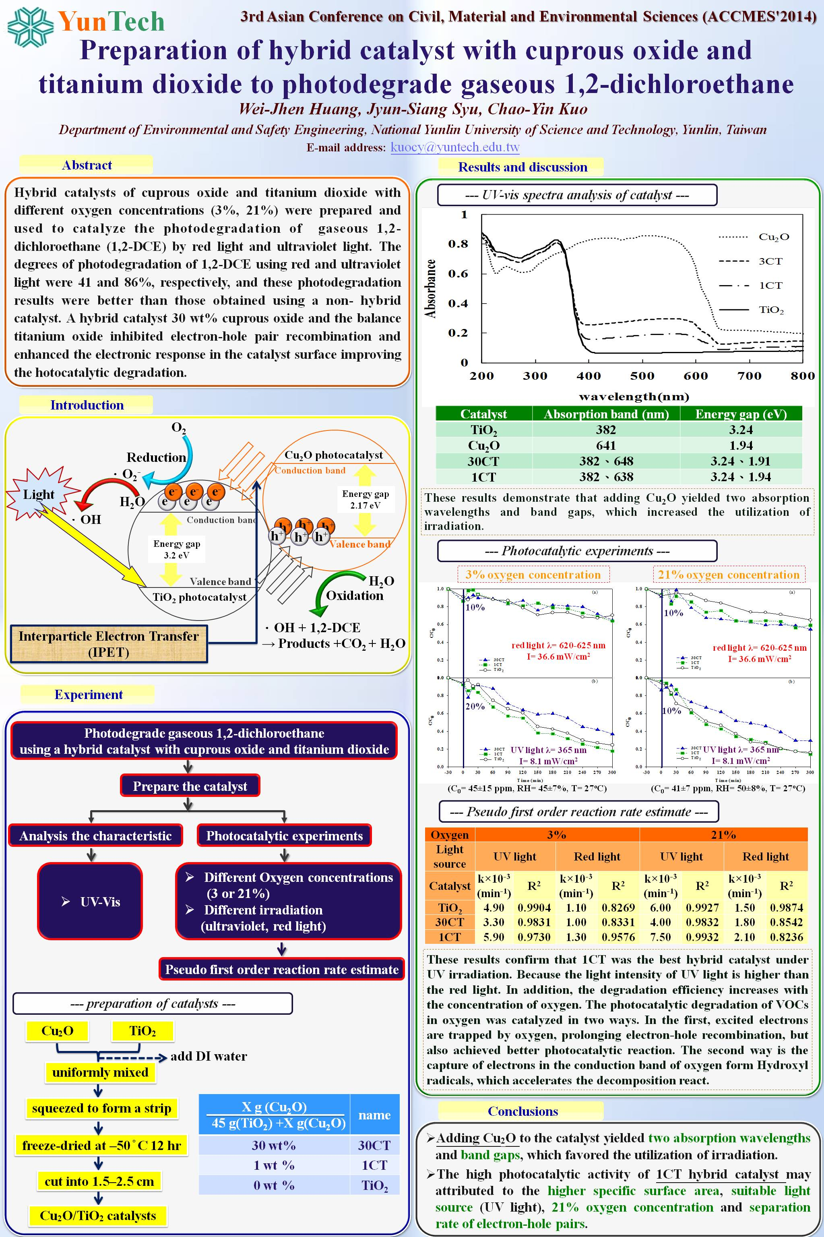
- 海報

附件二：照片
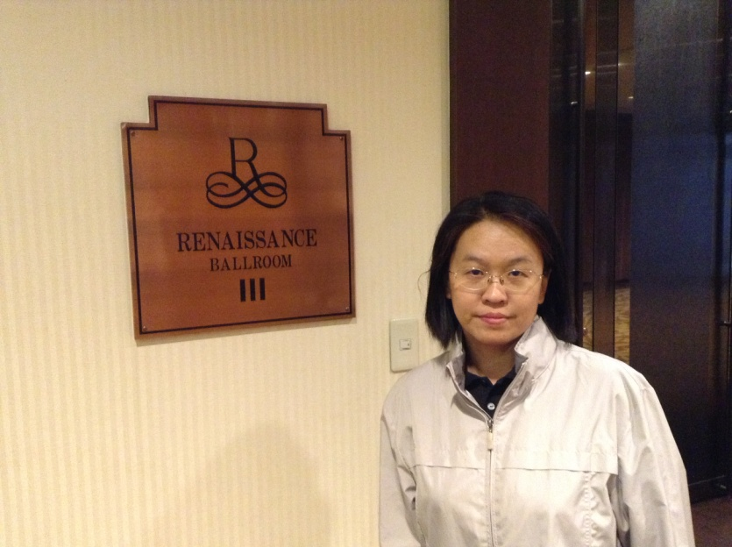
說明：研討會地點

說明：研討會會場布置
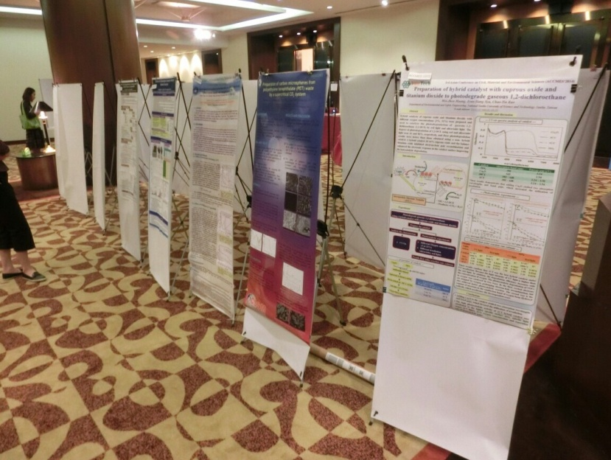
說明：海報成果發表情形

附件三：發表論文清單
本次研討會有關領域之發表清單如下所示：
No. | Manuscript No. | Title | Authors
1 | ACCMES-1396 | Environmental forensic study on chlorinated solvents using compound-specific isotope  analysis | Yu-Min Chang  Kuo-Sheng Tsai  Hung-Teh Tsai  Wen-Yao Liu
2 | ACCMES-1311 | IAQ index for assessing air-conditioned offices | Kwok Wai Mui  Ling-tim Wong
3 | ACCMES-1315 | Kinetics of adsorption of C.I. Reactive Red 2 by TiO2-In2O3 composites | Chung-Hsin Wu  Chao-Yin Kuo  Chih-Hao Lai  Wei-Yang Chung
4 | ACCMES-1333 | Development of Greener Fuel by Emulsification of Hydrous Short-Chain Alcohols and Diesel: Heavy-Duty Diesel Engine Performance and Emissions | Sheng-Lun Lin  Jen-Hao Tsai  Yu-Chen Chang  Wen-Jhy Lee  Guo-Ping Chang-Chien
5 | ACCMES-1361 | CdIn2S4 microsphere as an efficient visible-light-driven photocatalyst for bacterial inactivation: Synthesis, characterizations and photocatalytic inactivation mechanisms | Wing Kei Ho
6 | ACCMES-1335 | A Cost-Benefit Analysis of Groundwater in Korea | Sun G. Kim
7 | ACCMES-1356 | An Assessment Framework of Metropolitan Park Development | Liang-kong Lin  Walter Den  Ying-Chyi Chou  Hsin-Yi Yen  Ching-Hua Lu
8 | ACCMES-1618 | Lead recovery from aqueous solutions by tobermorites synthesized from desulfurization slag | Ying-Liang Chen  Juu-En Chang  Yi-Chieh Lai  Ming-Sheng Ko
9 | ACCMES-1486 | Evaluating Internal Corrosion Control for Water Distribution System Using Liquid Lime | Dal-Sik Woo  Byung-Gi Hwang  Young-Wha Kim
10 | ACCMES-1372 | Preparation of hybrid catalyst with cuprous oxide and titanium dioxide to photodegrade gaseous 1,2-dichloroethane | Huang Wei Jhen  Syu Jyun Siang  Kuo Chao Yin
11 | ACCMES-1616 | Preparation of carbon microspheres from polyethylene terephthalate (PET) waste by a supercritical CO2 system | Yi-Chieh Lai  Cheng‐Hsien Tsai  Ying-Liang Chen  Sheng-Lun Lin
12 | ACCMES-1399 | Anodic Degradation of Tetracycline Hydrochloride on a BDD Electrode: Effect of current density and sample matrix | Te-San Chen  Kuo-Lin Huang  Yu-Syuan Chen  Ren-Wei Tsai.  Shui-Jen Chen
13 | ACCMES-1379 | Enrichment of a Hydrogen-Producing Consortium without Methane Production | Kyung-Suk Cho  Jeonghee Yun  Tae Gwan Kim
14 | ACCMES-1382 | Effects of Proton Exchange Membrane on Electricity Generation and Bacterial Community in Air-Cathode MFC | Yun-Yeong LeeKyung-Suk Cho  Tae Gwan Kim
15 | ACCMES-1391 | Degradation of acetaminophen by Ce(IV) oxidation | Kuo-Lin Huang  Te-San Chen  Shui-Jen Chen  Tzu-Ying Tang
16 | ACCMES-1646 | Vehicular indoor air pollution involving the use of air fresheners and cleaning agents | Chih-Chi Lin  Der-Jen Hsu
17 | ACCMES-1378 | Characterization of Odor Emission and Microbial Community Structure during  Composting of Pig Carcasses | Hee Wook Ryu  Bo Min Ki  Tae Gwan Kim  Kyung-Suk Cho
18 | ACCMES-1524 | Preparation and Efficacy Evaluation of a Forcipomyia taiwana Repellent | Chao-Tsang Lu  Hsien-Ming Lee  Ching-Wen Lou  Jia-Horng Lin
19 | ACCMES-1324 | The feasibility of recycling sulfuric acid containing Fe and Pb by ion diffusion film process | Tsung-Yueh Tsai  He-Shin Lo  Shiou-Yu Chen  Ji-Wei Zheng  Wei-Ting Kao
20 | ACCMES-1487 | Evaluation of Long-term Behavior of the Standing Column Well | Duhee Park  Jeong-Seon Park
21 | ACCMES-1632 | Response of RC Beams Strengthened with Curtailed FRP Composite Plates | Yung-Chih Wang  Chung-Kai Wu
22 | ACCMES-1374 | Cyclic Behavior of Marine Silty Sand Subjected to Long Term Loading | Jin Man Kim  Su Won Son  Muhammad Safdar
23 | ACCMES-1735 | Effect of Prestress Force on the Strength of Dapped-End Reinforced Concrete Beams | Shatha D. Mohammed  Thamir K. Mahmoud
24 | ACCMES-1484 | Studies on the Basic Properties of Bagasse-Gypsum Composites and Hollow Blocks Application | Han-Hsi Liang  Kuo-Tsang Huang  Kevin Fong-Rey Liu
25 | ACCMES-1588 | A Study of Liquid System Dimensionally Stable Anode Electrocatalytic Reactions to  Remove Ammonia Nitrogen | Shu Wan Chang  Jung Jie Huang  Ching Wei Chang  Chin Yuan Hsu  Po Yu Hu
26 | ACCMES-1357 | Bio-friendly Synthesis of Complex ZnO Nanostructures | Yu-Cheng Chang
27 | ACCMES-1395 | Surface Modification of Reverse Osmosis Membranes Using PEG-Based Hydrogels to Enhance Membrane Properties | YiChun Che  Yeu-Ding Chen  Hsun-Tien Li
28 | ACCMES-1529 | Pattern Designs and Applications of Functional Complex Hosiery Products-Taking Tao Tribe in Taiwan for example | C.-M. LIN  Jia-Horng LIN  P.-C. Hsiao
29 | ACCMES-1332 | Triphenylamine-Styryl-Based Dyes Applied to Electrochromic Devices with Similar Structure of Dye-Sensitized Solar Cells | Yuan-Tsen Su
出國報告審核表
出國報告名稱： 2014第三屆土木、材料與環境科學亞洲學術研討會
出國人姓名（2人以上，以1人為代表） |  |  | 職稱 |  |  |  | 服務單位
郭昭吟 |  |  | 副教授 |  |  |  | 環境與安全衛生工程學系
出國類別 | □考察 □進修 □研究 □實習  其他 國際會議  （例如國際會議、國際比賽、業務接洽等） |  |  | 報告書是否涉及公務或商業機密，應予限閱，上傳後不對外公開報告書內容(擇一勾選) 否(上傳後即公開)□是(應予限閱)（勾選本項者須填寫限閱原因）＿＿＿＿＿＿＿＿＿＿
出國期間：103年7月21日至103年7月25日 |  |  |  |  |  | 報告繳交日期：103年8月10日
審 核 項 目 |  |  |  |  |  | 出國人員自我檢核（勾選） |  | 審核單位  （勾選） |  | 審核單位
1.依限繳交出國報告 |  |  |  |  |  | ■ |  | □ |  | 二級主管、系所主管  (核章)
2.格式完整（本文必須具備「目的」、「過程」、「心得及建議事項」） |  |  |  |  |  | ■ |  | □ |  | 二級主管、系所主管  (核章)
3.無抄襲相關資料 |  |  |  |  |  | ■ |  | □
4.內容充實完備 |  |  |  |  |  | ■ |  | □
5.建議具參考價值 |  |  |  |  |  | ■ |  | □
6.送本機關參考或研辦 |  |  |  |  |  | ■ |  | □
7.送上級機關參考 |  |  |  |  |  | □ |  | □
8.退回補正，原因：  （1）內容空洞簡略或未涵蓋規定要項  （2）抄襲相關資料之全部或部分內容  （3）引用相關資料未註明資料來源 |  |  |  |  |  | □  □  □  □ |  | □  □  □  □
一級主管、院長
(核章)
9.本報告除上傳至出國報告資訊網外，將採行之公開發表：  （1）辦理本機關出國報告座談會（說明會），與同仁進行知識分享。  （2）於本機關業務會報提出報告  （3）其他 |  |  |  |  |  | □  □  □  □ |  | □  □  □  □
10.其他處理意見及方式： |  |  |  |  |  | □ |  | □
11.符合原核定出國計畫 |  |  |  |  |  | ■ |  | □ |  | 人事室(核章)
12.符合出國報告書撰寫規格  (含「封面」、摘要(【200-300字】、目次、本文、【附錄】） |  |  |  |  |  | ■ |  | □
13.退回補正，原因：以外文撰寫或僅以所蒐集外文資料為內容 |  |  |  |  |  | □ |  | □
出國人簽章（2人以上，得以1人為代表） |  | 國際事務處 |  |  | 秘書室核稿 |  |  |  | 校長或授權人員

