出國報告（出國類別：參加國際研討會）

參加於日本名古屋舉辦的MLB2013國際研討會報告

服務機關：國立高雄應用科技大學
姓名職稱：李曉青 助理教授
派赴國家：日本名古屋
出國期間：2013/09/24-2013/09/26
報告日期：2013/10/09

摘要
本次的國際研討會，2013年International Symposium on Marketing, Logistics, and Business (MLB 2013)於102年9月24日至102年9月27日在日本的名古屋的ANA Crowne Plaza Hotel Grand Court飯店舉行。個人參與的場次是屬於行銷的場次，發表的論文名稱為THE NEGATIVE IMPACT OF RESTRICTVE SALES PROMOTION (RSP) ON BRAND ATTITUDES FROM THE PERSECEPTIVE OF PERCEIVED PROMOTION UNFAIRNESS。透過此次的研討會對於許多的相關行銷的研究領域有更多的想法和研究方向，且在研究方法上也有新的見解與學習，未來可進一步的應用於個人的研究中。對於自己所發表的論文也獲得許多的建議與回饋。同時，在與會的過程中也認識了許多的學者專家，並向他們請益，收獲良多。
目次
摘要………………………………………………………………………………………………1
目次………………………………………………………………………………………………2
出國報告本文……………………………………………………………………………………3
附錄………………………………………………………………………………………………7

出國報告本文
- 目的
本次出國參加研討會的目的是發表論文於國際研討會，與國際學者互相交流與討論，同時也可瞭解個人研究領域的相關訊息與發展方向。

- 過程
2013年International Symposium on Marketing, Logistics, and Business (MLB 2013)訂於102年9月24日至102年9月27日在日本的名古屋的ANA Crowne Plaza Hotel Grand Court飯店舉行(如圖1)。此研討會共有兩個部份，一為International Conference on Information and Social Science (ISS 2013)，另一為我所參加的International Symposium on Marketing, Logistics, and Business (MLB 2013)。本次會議研討內容，共有3個主題，分別為Marketing, Logistics, and Business，研討會會議主要主題包含如下：
- Information Management
- Information Society
- Information Technology
- Information Communication
- Management Information System
- The related topics in Information
- Economics
- Management
- Finance
- Sociology
- Psychology
- The related topics in Social Science

本次參加2013 International Symposium on Marketing, Logistics, and Business，活動行程如下：
- 102年9月24日
參加2013 MLB研討會開幕式，並由Professor Kaoru Endo演講The Great East Japan Earthquake and Social Media。

- 102年9月25日
參與研討會10:30-12:00有關行銷方面的論文發表演說，本日的相關主題有討論到跨文化品牌建立、B2C行銷的文化議題、創新產業中口碑的應用、數量折扣的負面效果等有趣的發表主題。個人參與了此場次的論文發表(如圖2)，收獲頗多，且相關議題亦和個人的研究領域相似，因為未來可進一步採用與學習。尤其當天在看學者Poster的發表部份(如圖3)，看到一篇醫學方面的研究，但亦是採用實驗設計的方式，與個人的研究方法相似，且此篇研究是採用長期的實驗研究方法，是個人未來在研究時可以參考使用的方法。此種長期的實驗設計方法，是目前行銷學術界主要訴求的重點之一，因為透過長期的研究可以看到一些趨勢是短期研究無法看到的，因此收穫很多。

- 102年9月26日
■ 此日參加研討會論文發表，此次於本會議所發表的論文名稱為「THE NEGATIVE IMPACT OF RESTRICTVE SALES PROMOTION (RSP) ON BRAND ATTITUDES FROM THE PERSECEPTIVE OF PERCEIVED PROMOTION UNFAIRNESS」，是屬於Poster的場次。本研究結果於此次研討會發表上獲得學者門的熱烈詢問與討論，得到相當多的寶貴意見，如圖4。
同時在本日也參加了行銷發表的場次(如圖5)，在此場次中相關討論的議題有綠色E-BOOK購買意願的探討、新科技產品購買前因之探討、有機食品負面資訊的影響、電子口碑的影響探討等議題，這些亦都和個人的研究相関，因此收獲許多。更另人開心的是在此次會議中更遇到了以前博班的老師和學長，過程中和他們請益許多研究的方法和心得，並探討相関的研究議題，在未來應受益頗多(如圖6)。



圖1 2013年International Symposium on Marketing, Logistics, and Business (MLB 2013) 於102年9月24日至102年9月27日在日本的名古屋的ANA Crowne Plaza Hotel Grand Court飯店舉行。

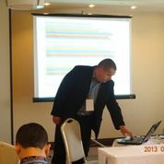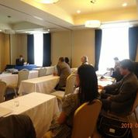
圖2 2013年9月25日參加研討會的行銷發表場次

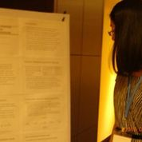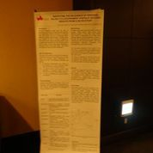
圖3 2013年9月25日參加研討會的Poster場次

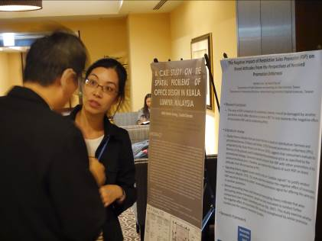
圖4 2013年9月26日發表的Poster場次

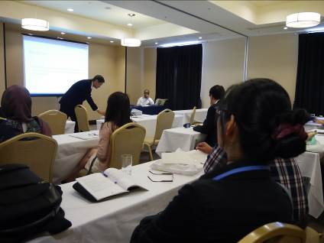
圖5 2013年9月26日參加研討會的行銷發表場次


圖6 向老師和學長交流請益

- 心得及建議
此次非常高興能夠到日本名古屋參加2013年International Symposium on Marketing, Logistics, and Business (MLB 2013)，並在此國際級會議中發表論文，獲得相當多的討論與學習機會，藉由此機會吸取許多寶貴的研究知識，得知目前最新的研究趨勢，並認識許多從事相關研究的人士。
此次論文發表中，在與來自世界各地，包含法國、波蘭、土耳其、澳洲、澳門台灣、香港、日本、馬來西亞及新加坡等知名大學的專家學者們討論彼此研究成果，個人收獲頗豐。然而，本次活動的參與對我而言是一次難得的寶貴經驗，將就此次參加研討會所獲得之心得整理如下：
(1) 本次所發表的論文「THE NEGATIVE IMPACT OF RESTRICTVE SALES PROMOTION (RSP) ON BRAND ATTITUDES FROM THE PERSECEPTIVE OF PERCEIVED PROMOTION UNFAIRNESS」，藉由參與此研討會論文發表下，與國際專家學者互動交流激發研究新方向和更清楚本論文可能的限制，並展示研究成果及促進國際交流。
(2) 在參加MLB2013研討會過程中，除了參與行銷方面的論文發表，透過多位專家學者們的發表，也讓我更深入了解到國外在相關領域上的發展現況。此外，在長期實驗設計的研究上，更是擴展了我另一個未來可以應用的研究方法，可使自己的研有更突破性的發展。
整體而言，參加完此研討會發表後，個人獲得相當大的收穫，除了研究方向外，在研究的方法上更是得到許多啟發。

附錄
THE NEGATIVE IMPACT OF RESTRICTVE SALES PROMOTION (RSP) ON BRAND ATTITUDES FROM THE PERSECEPTIVE OF PERCEIVED PROMOTION UNFAIRNESS

WeiWei Chen
Department of Public Relations and Advertising, Kun Shan University, Taiwan
chenwei@mail.ksu.edu.tw

Hsiao-Ching Lee
Department of International Business, National Kaohsiung University of Applied Sciences, Taiwan
hclee@cc.kuas.edu.tw

ABSTRACT

Restrictive sales promotion (RSP) is a promotional strategy where restrictions in quantity or in time are placed on a promotion. RSP has been shown as an effective tool for increasing perceived values and sales volumes. However, the long-term effectiveness of RSP is questionable. For example, consumers may go to great lengths to acquire the RSP product by waiting for a long time. However, if consumers realize they can still pay the promotional price after the promotion has ended, negative effects may be observed in their attitudes, often transmitted through word-of-mouth (ETV, 2010). It is possible that companies that offer RSPs might frequently be doing so as a type of promotional strategy, rather than to take advantage of the unique value of RSP. The restriction advertised in the RSP may not be the actual restriction in time or volume, which could be regarded as information-behavior inconsistency. Such inconsistency may negatively influence consumer attitudes toward a brand.
Equity theory indicates that perceived fairness is based on distribution fairness and procedural fairness (Thibaut and Walker, 1975). Distribution fairness is based on the perceived ratio of what is received relative to what is sacrificed, and procedural fairness pertains to judgments of the fairness of a process, based on societal norms and behavior (Adams, 1965; Thibaut and Walker, 1975). Regarding sales promotions, although consumers may perceive distribution fairness because they make an equivalent monetary sacrifice (i.e., the promotional price) as others, they may still perceive procedural unfairness because they make more non-monetary sacrifices (e.g., time, effort, search cost) than others. Perceived promotion unfairness (PPU), proposed by Xia, Kular-Kinney and Monroe (2010), suggests that consumers evaluate the fairness of the process used to determine the promotional price as specified by the promotional strategy. For vendors who offer RSP frequently, consumers evaluate not only price fairness but also promotion unfairness, and compare their non-monetary sacrifice with that made by other consumers who obtained the same product with the same promotional price. Therefore, in this study, we examine the impact of information-behavior inconsistency of RSP on brand attitudes from the perspective of PPU.
Previous studies about signaling theory suggest that sellers usually have more information than buyers; therefore, buyers tend to rely on “credible signals” to distinguish between sellers (Akerlof, 1970). For example, if a vendor offers another RSP, accompanied by credible signals, such as providing the reason for the sale (e.g., anniversary sale), consumers are motivated to justify the vendor’s behavior. The impact of information-behavior inconsistency of RSP on PPU would be different. Thus, the moderating effect of a credible promotional signal would be examined in this study. Furthermore, based on mental accounting theory and transaction decoupling theory, when decoupling various transactions, people are less motivated to conduct further comparisons (van Putten, Zeelenberg and van Dijk, 2007). In contrast, if people couple subsequent events into the same mental accounts, they strongly link two events (Prelec and Loewenstein, 1998). Regarding the information-behavior inconsistency of RSP, consumers are likely to link similar promotions and make comparisons. The impact of inconsistency on perceived promotional unfairness is affected by the degree to which promotional bundles are comparable. Therefore, the moderating effect of comparable promotional bundles would be examined.
This study review related literature to develop the research hypotheses and framework. By conducting 3 experiments, this study collects data and uses ANOVA to analyze the hypotheses. This study finds that the information-behavior inconsistency decreases brand attitudes directly and indirectly through the PPU. In addition, the negative affect is lessened by credible promotional signal of subsequent promotion and inferior promotion bundle. Based on the findings, this research broadens previous RSP research which explores one-time RSP promotion to examine the negative effects of multiple RSP. In addition, this study extends previous studies on fairness by applying Xia et al. (2010) perceived promotion fairness. The finding indicates several managerial implications about developing effective RSP strategies.

Keyword：restrictive sales promotion, information-behavior inconsistency, perceived promotion fairness, brand attitude, signaling theory, promotion bundle

REFERENCES

Adams, J.S. (1965). Inequity in social exchange. in Advances in Experimental Social Psychology, Vol. 2, L. Berkowitz, ed. New York: Academic Press, 267-99.
Akerlof (1970), The market for “lemons: quality uncertainty and the market mechanism. The Quarterly Journal of Economics, 83(3), 488-500.
ETV (2010), “Where is restrictive?” Retrieved from http://tw.news.yahoo. com/article/url/d/a/101209/142/2io07.html.
Prelec, D., & Loewenstein, G. (1998). The red and the black: Mental accounting of savings and debt. Marketing Science, 17(1), 4-28.
Thibaut, J. W. & Laurens, W. (1975). Procedural Justice: A Psychological Analysis, Hillsdale, NJ: Erlbaum Associates.
van Putten, M., Zeelenberg, M., & van Dijk, E. (2007). Decoupling the past from the present attenuates inaction inertia. Journal of Behavioral Decision Making, 20(1), 65-79.
Xia, L., Kukar-Kinney, M., & Monroe K. B. (2010). Effects of consumers’ efforts on price and promotion fairness perceptions. Journal of Retailing, 86(1), 1-10.

The Negative Impact of Restrictive Sales Promotion (RSP) on Brand Attitudes from the Perspectives of Perceived Promotion Unfairness

WeiWei Chen¹ and Hsiao-Ching Lee²
¹Department of Public Relations and Advertising, Kun Shan University, Taiwan
²Department of International Business, National Kaohsiung University of Applied Sciences, Taiwan

• Research purpose:
– The value of RSP is based on its uniqueness, however, it would be damaged by another promotion which offers the price as same as RSP. This study examines the negative effects of inconsistent RSP and its moderating effects.

• Literature review:
– Equity theory indicates that perceived fairness is based on distribution fairness and procedural fairness (Thibaut and Walker, 1975).Perceived promotion unfairness (PPU), proposed by Xia, Kular-Kinney and Monroe (2010), suggests that consumers evaluate the fairness of the process used to determine the promotional price as specified by the promotional strategy. Consumers would compare their RSP with other promotions at the same promotional price. Therefore, we examine the impacts of such RSP on brand attitudes from the perspective of PPU.
– Signaling theory suggests buyers tend to rely on “credible signals” to justify vendors’ behaviors (Akerlof, 1970). This study examines whether the negative effect of inconsistent RSP would be lessened by sellers’ reasonable promotion signal for offering the same price in another promotion.
– Mental accounting theory and transaction decoupling theory indicate that when decoupling various transactions, people are less motivated to conduct further comparisons (van Putten, Zeelenberg and van Dijk, 2007). This study examines whether the negative effect of inconsistent RSP would be strengthened by similar promotion bundles and the superior promotion bundles.

• Research Framework
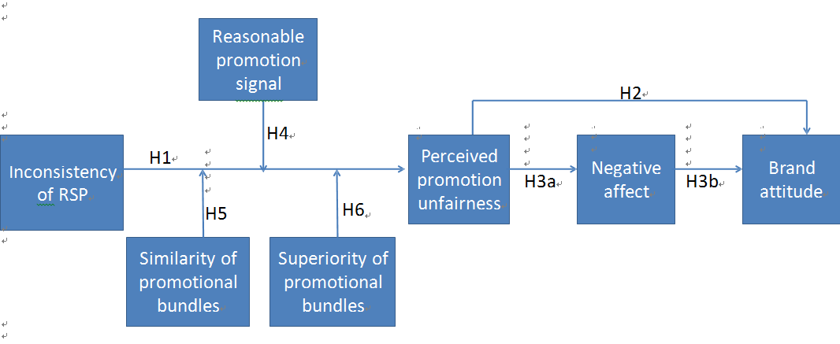
• Research Methodology: By conducting 3 experiments, this study collects data and uses ANOVAs and regressions to analyze the hypotheses.
– Study 1: 2(inconsistency : High vs Low) X 2 (Reasonable: High vs Low): 148 participants.
– Study 2: 2(inconsistency : High vs Low) X 2 (Similarity : High vs Low): 170 participants.
– Study 3: 2(inconsistency : High vs Low) X 2 (Superiority: High, Mid, Low): 285 participants.

• Research findings:
– Inconsistency of RSP has negative effects on brand attitudes directly and indirectly through the PPU.
– The negative affect is lessened by reasonable promotional signal, but is strengthened by similar promotion bundles, and even superior promotion bundles.

• Theoretical contributions:
– This research broadens previous RSP research to examine the negative effects of frequent promotions.
– By applying the concept of perceived promotion unfairness to promotion, this study shows that the evaluation of fairness would occur after purchasing.

• Managerial implications:
– Firms should notice the consumers responses when they offer the frequent promotions, particularly RSP.
– Firms should offer the reasonable signal to justify their frequent promotions.
– Firms should reduce the similarity of multiple promotions. Further, they should not offer the superior bundles than RSP.

全文完

