出國報告（出國類別：其他: 國際會議）

參加『2013 組織創新國際研討會』「2013 The International Conference on Organizational Innovation」

服務機關：國立暨南國際大學 國際企業學系
姓名職稱：林暉堯 博士生
派赴國家：泰國 華欣
出國期間：102 年 7 月1日至 102 年 7 月 6 日
報告日期：102 年 12 月 11 日

摘 要
參加由美國國際組織創新協會(International Association of Organizational Innovation; IAOI)在泰國華欣所舉辦之『2013 組織創新國際研討會（2013 The International Conference on Organizational Innovation）』，協辦單位為泰國International College at Suan Sunandha Rajabhat University ，此協會致力於組織創新知識之交流與分享，並定期舉辦研討會(ICOI)與出版期刊(IJOI)，在管理領域有著一定的學術地位。學生這次參與會議的目的是為了作知識的共享與創新，並聽取來自世界各地的專家學者分享他們的研成果和最佳實踐，透過口頭報告進行意見與看法的交換，希望在此過程中，學生可以從世界各地的專家與學者的意見交換中得到許多有用的資訊與未來的研究方向。在未來的研究方向中，可以融入相同領域的新觀點與在不同領域中對研究有幫助的觀點，藉此達到讓學生的研究議題上，有相輔相成的功效。最後，非常感謝學校在費用上的補助，讓學生可以無後顧之憂的參與國際性會議

目
錄
摘 要 II
一、 目的 1
二、 參加會議經過 1
三、 與會心得 4
四、 建議 4
附錄一
附錄二

目的
為了增進學識、拓展國際視野，並在研究上獲得一些國外學者的建議，遂參加美國國際組織創新協會 (International Association of Organizational Innovation; IAOI)在泰國華欣舉辦的『2013 組織創新國際研討會（2013 The International Conference on Organizational Innovation）』， ICOI在學術研討會中素有不錯的名聲，每年都有來自超過20個國家的學者參與會議討論，並定期出版國際期刊(IJOI)，此研討會在學術界也有著一定的地位，因此學生也以此研討會為目標，開始著手進行研究，期盼自己的研究成果能被ICOI所接受，而經過一番努力之後，學生的研究成果也很幸運的被研討會接受了，便滿懷期待的參與此次IAOI在泰國華欣所舉辦的國際研討會，希望藉由在會議中進行論文口頭報告、報告的過程中與會後的討論與交流，能得到一些建議，在組織領域創新的研究知識更臻成熟與豐沛，並期許自己在研究觀念上能有顯著的成長。

參加會議經過
學生因課堂學習之啟發，有了議題研究的想法，即著手研究撰寫，並得知美國國際組織創新協會 (International Association of Organizational Innovation; IAOI) 今年在泰國華欣舉辦『2013 組織創新國際研討會（2013 The International Conference on Organizational Innovation）』，此協會致力從事國際上創新的議題之推廣與交流，並定期舉辦研討會(ICOI)與出版期刊(IJOI)，有著一定的學術地位，相信能讓學生得到許多益處。學生在得知會議舉辦時間後便積極從事投稿的動作，也有幸得到了研討會的接受，便展開了出國與會發表論文的旅程。
7/1 : 啟程前往曼谷機場，並乘車三小時前往華欣，安頓之後即就寢。
7/2：
0830~0900 報到
0910~1200 聽取参場 keynote speakers 的專題演講
學生在會議中聽取了三場Keynote Speaker的主題演講，分別是Dr. René Pellissier的Innovation in A Complex Environment: Lessons Learnt From Developing Economies(在複雜的環境中創新：吸取來自發展中經濟體的經驗)、Dr. Sergey Ivanov的Innovation, Feararchy, and the Next Great Shift(創新，以及下一個重大的轉變)及Dr. Marius Potgieter的Innovation: A National Priority in South Africa(創新：在南非國家中的優先考量)，演講中談到了許多關於創新的議題與創新的方式、過去的經驗與未來的發展，以及在不同的環境與文化之下，對於創新所需考慮的作法與條件，在演講的過程與結束後的發問對談，學生聽取了許多不同的見解與想法，也刺激了自己的思考，讓學生在創新上學到了許多不同的思考方式。
7/3：
0900~1700 論文發表與聽取
0900~1020
聽取Thailand學者 Darma R. Khairiree的報告Thailand and New Technological Innovation: a Social Sciences Perspectives (從社會科學的角度來看泰國和新技術的創新)並與其討論交流。
泰國是一個充滿傳統文化與科技創新的國家，傳統的文化影響深遠著影響泰國人的生活，但是創新的科技設備影響著年輕一輩的泰國人，本作者主要是探討傳統的文化與新技術的創信兩者的衝擊下，對於年輕一輩泰國人的影響，如創新的平板電腦、智慧型手機、新一代的3D與4D的電影，所產生的影響，進而探討到經濟發展。
以傳統儒家思想為主的台灣，又是亞洲科技產品研發重鎮的台灣，也是同時面臨到這兩種因素的影響，過去的儒家思想主要強調人與人之間的聯結，但是科技設備(智慧型手機)，卻將人與人之間的距離，越拉越遠，與傳統的儒家思想相異，因此未來的研究，可以將台灣視為研究樣本，來進行研究與探討。
1030~1200
聽取來自Canada的學者Muhammad Mohiuddin的報告 Offshore Outsourcing of Manufacturing SMES and Developing Organizational Dynamic Capabilities (中小製造企業的離岸外包和發展組織動態能力)並與其討論交流。
主要探討過去可以進行離岸外包的企業，大多是屬於大型的多國籍企業，但是此作者採取中小企業為主要的研究樣本，該研究主要的貢獻是，發展一個理論架構來探討離岸外包，而離岸外包可以強化自身的競爭能力和降低企業的成本，主要的理論觀點是採用動態能力的觀點來探討。
從過去的文獻中，可以發現進行離岸外包的企業類型是屬於跨國企業，而跨國企業進行離岸外包的策略是降低生產成本，較少發現到以中小企業為研究的樣本，因此本文章可以視為一個借鏡，因為台灣的企業，大多數是以中小企業為主，來探討台灣中小企業進行離岸外包的決定因素，也可深入研究中小企業與大型企業離岸外包決定因素的差異。
而學生在報告過程中，有時會因為緊張及語言上口音的差異而在問題討論中有些溝通上的小問題，不過在場的會議主持人都十分有耐心的再次說明與傾聽，也給了學生許多在研究上的建議，對學生所提出之員工個人特質與主管的領導風格會影響到員工的績效、還有領導風格對兩者具有干擾效果這三方面，給予了學生相當的肯定，並建議學生多去了解相關的產業知識，希望學生能夠幫助這個台灣特有產業提升其整體的營運績效與顧客滿意度，在一來一往的討論中，學生的英文聽說能力也提升了不少，更勇於開口去說，在聽的時候也慢慢的部會因為緊張而聽不懂，與會報告一方面可以增加研究能力、學習新知識，另一方面又可以提升語文能力，實是一個非常好的經驗。
在會議的過程中也聽取了一篇學生非常感興趣的研究，它主要是在探討顧客忠誠度對消費行為的影響，作者提到了像是品牌資產、營銷工具和服務的質量都會影響到顧客對於品牌的忠誠度，還有提到一些關於品牌資產、品牌價值的概念，而他的研究樣本是連鎖的零售業，與學生所研究的檳榔產業兩者都是連鎖零售業，有著極為相似之處，而在與作者一番討論後，作者也建議學生可以把研究著重在檳榔業者所建立之品牌形象、銷售人員的服務態度和一些銷售相關的配套上，從內部管理進而發展到外部的銷售上，兩者做一個結合，相信能為檳榔業者的經營帶來更大的效益。
7/4 :
0900~1700 與國外學者進行交流研討暨華欣古城參觀巡禮
7/5~7/6 :
參訪當地觀光景點與名勝古蹟：華欣葡萄酒莊園、考皇宮、愛與希望之宮、華欣火車站、華欣老街、泰絲博物館。

與會心得
非常感謝學校讓學生申請到此次的補助，讓學生有這個機會可以到國外參加研討會，和國外學者進行交流並增進學生的國際觀。此次參加美國國際組織創新協會 (International Association of Organizational Innovation; IAOI) 在泰國華欣所舉辦的『2013 組織創新國際研討會（2013 The International Conference on Organizational Innovation）』，與會的過程中，學生透過報告與國外學者討論與交流$，$得到了許多學者的建議，不只是得到相同領域的新資訊，也接觸了不同領域的研究，和一些經驗的分享。在討論之中也了解到了自己研究上的不足之處，藉由一些國外學者的意見來加以改善與補強，這對學生來說實是一個難能可貴的經驗。而透過和一些國外學者的討論與思辨之後，也更確立了學生之研究結果，其一是個人特質對員工績效會有顯著正向影響，其二是領導風格對員工績效有顯著正向影響，其三是領導風格對個人特質與員工績效之間的關係具有干擾效果。國外學者也認為學生的研究結果可用在檳榔業者執行員工招募規劃上，來協助檳榔業者提昇整體的績效、顧客滿意度和檳榔產業之競爭力可更，並建議學生可以更加深入了解目前檳榔產業的現況，以及檳榔業者藉由領導風格改善員工績效，增長相關專業知識，有助於提昇檳榔業整體營運績效。這份研究受到國外學者的肯定，並得到許多建議與未來研究方向與發展的引導，讓學生信心倍增，大大的提高了未來做研究的動力，非常高興有這次出國報告的體驗與機會，讓學生了解國外學者做研究的方式及對研究上衣些不同的見解，也期許自己能夠更加的致力於研究上，為研究付出更多的努力，希望假以時日能邁入更高的研究境界。
而參加這次的國際研討會讓學生獲益良多，不論是在知識的增進、視野的拓展和語言的溝通技巧上，都得到了大大的幫助，希望能常有機會出國參與會議，藉以提升學識的深度與廣度。

建議
出國參與研討會議固然有滿滿的收穫，但交通的往來與外地住宿對於學生來說也是一筆相當可觀的費用，非常感謝學校讓學生有機會可以獲得費用上的補助，減輕學生的負擔，讓學生沒有後顧之憂，希望學校可以增加出國與會的補助，讓學生往後有更多的機會繼續出國參加研討會，以拓展學生的視野、提升研究的深度與廣度，相信在學生的研究與未來發展上會有很大的幫助，最後，再次感謝學校這次對學生所提供的補助，大大的減輕了學生在生活上的負擔，讓學生可以放心的繼續在研究上努力，感恩。

附錄一
研討會報到處 | 參與證明
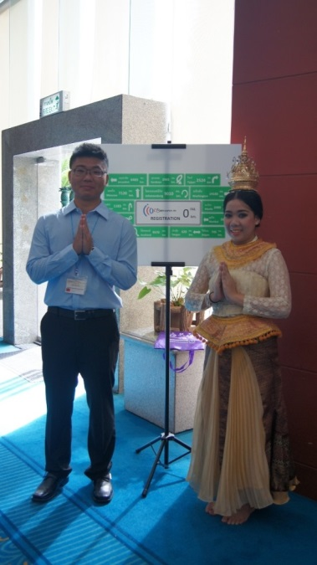 | 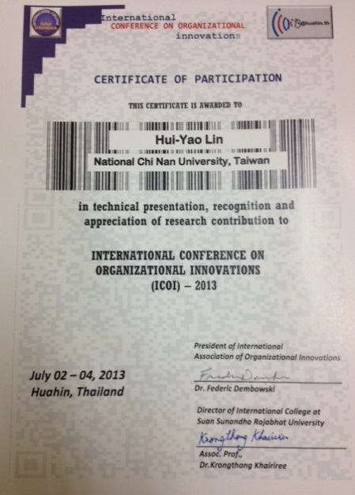
識別證 | 大會手冊
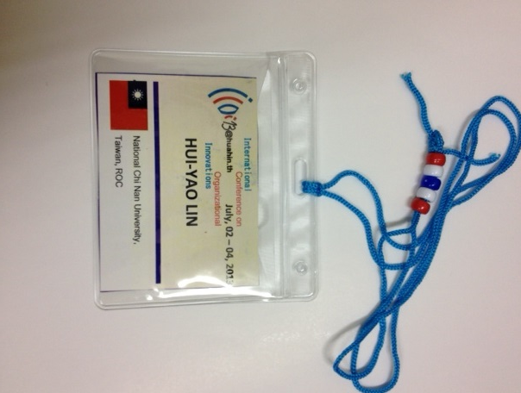
簽到處 | 主席演講
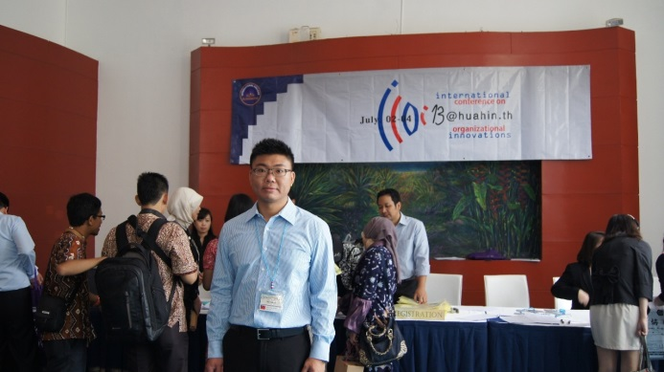 | 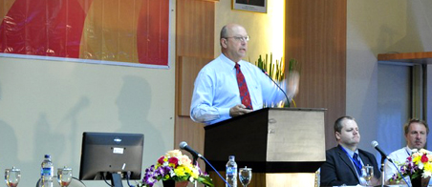

附錄二
檳榔業員工個人特質對員工績效影響之研究-以領導風格為干擾變數論文口頭報告
Effects of Personality Traits on Staff Performance of Employees in Betel Nut Industry - Leadership Style as the Moderator
Abstract
Chewing betel nuts is quite popular in Taiwan that the saturated betel nut industry has resulted in fierce competition. Besides, the government and the health organizations have largely propagated the negative effects of chewing betel nuts on human bodies and the environment. The businesses therefore have to attract new customers and retain the existing customers. The costs for developing new customers are much higher than retaining the existing customers that the effects of employees’ Personality Traits and Leadership Style on the promotion of Staff Performance in such a competitive environment is regarded as the research objective of this study.
The betel nut businesses and the service personnel in Yunlin County are the research subjects in the questionnaire survey. Total 500 copies are distributed. The predicted outcome shows 1.the significantly positive effects of Personality Traits on Staff Performance, 2.the remarkably positive effects of Leadership Style on Staff Performance, and 3.the moderating effects of Leadership Style on the relations between Personality Traits and Staff Performance.

Key words: Personality Traits, Leadership Style, Staff Performance, betel nut industry

Research background and motivation
Because of the rapid living pace in such a busy, competitive, nervous, and changeable society, modern people are suffering from psychological pressure which could result in psychological diseases. Under such living environment, a lot of people tend to addict to some indulgence, such as chewing betel nuts, to reduce the fatigue and stress. In this case, betel nuts, as one of the important produce in central and southern Taiwan, present high economic value. According to the statistics of Council of Agriculture in 2006, betel nuts were the second economic crops in Taiwan, next to paddies, and the planting area of betel nuts increased up to 56,500 hectare in 2000, more than 6.5％ planting areas in Taiwan. The annual value of betel nut production was about ten billion NT dollars; about three million people were chewing betel nuts in Taiwan; and, two million people engaged in betel nut industries (Council of Agriculture, 2005). Nevertheless, betel nuts are open for import after Taiwan joining in WTO that the benefits of betel nut-related industries have been affected. Besides, the change of consumption style and the competition of the same industry in such as a competitive market have resulted in the decrease of annual income of betel nut businesses. When the customers decrease, both products and people become the critical factors in maintaining continuous competitive advantages and core capabilities. Coming from everywhere, the employees in betel nut industry present the existing personality traits, which could directly affect the job performance and behaviors. In addition to Personality Traits, Leadership Style of the direct supervisors would also influence the employees’ Job Performance. Leadership is considered as a primary tool to achieve the objectives; invalid Leadership could result in bad Job Performance of employees (Wu, Lu & Wu, 2010).
- Personality Traits
Personality Traits are the specific and dynamic behaviors of an individual reacting to the situation. It also refers to the different durability of an individual from others. After being adults, Personality Traits, showing certain models and methods, are presented on individual working styles and interpersonal relationship. In this case, individual behaviors would reflect unique Personality Traits in various situations (Pervin & John, 1997). Chang (1986) mentioned that individual traits would be presented when adapting to other people, oneself, affairs, and the entire environment; such traits were consisted of physical and metal characters of an individual under the interaction among heredity, environment, and learning, and revealed integrity and durability. The early research on Structure of Personality tended to look for the durable characters which could describe individual behaviors. The more consistence of characters was shown, the higher frequency it would occur in various situations that describing individual behaviors with such characters became important (Robbin & Coulter, 2001).
Norman (1963) improved the factors of Agreeableness, Conscientiousness, Extraversion, Emotional stability, and Gentleness proposed by Fiske (1949) and Tupes & Christal (1961), by verifying the factorial structure. Five dimensions proposed by Costa & Mccrae (1997) for Personality Traits are mostly accepted presently. (1) Agreeableness refers to a person’s intention to follow the rules formulated by others that the higher conformity to the rules formulated by the supervisors, the higher Agreeableness is presented. (2) Conscientiousness refers to an individual’s concentration on pursuing objectives that the fewer objectives, the higher Conscientiousness is shown, as the objectives are better concentrated. (3) Extraversion refers to a person being comfortable to the relationship with others that the higher comfort, the more extraversion is revealed. (4) Emotional stability refers to the number or intensity of individual negative emotion. (5) Openness to Experience indicates the quantity and depth of individual interests that the more diverse, but shallow, interests, the higher openness is shown.

- Staff Performance
Schermerhorn (1999) regarded Job Performance as the value and volume of tasks achieved by an individual or a team, i.e. the value of employees contributed to the work, the work quality or quantity (Chang & Li, 2006), in other words, the productivity of employees. Individual behaviors of employees performed to achieve the organizational expectation, objectives, rules, and occupational requirements are the key to evaluate Job Performance (Campbell, 1990). That is, Job Performance could be evaluated by the contribution of an employee to the organizational objectives. Brouther (2002) considered Job Performance as the achievement of an individual on the work objectives, reflecting the completion of tasks, i.e. the degree of an employee implementing the work requirements. To sum up, Job Performance represents the behaviors in the work process in which an individual engages to contribute to the organizational objectives, and it could be further measured and evaluated. Lee, Lain & Chen (1999) divided Job Performance into the dimensions of Efficiency, referring to the production rate and the task completion in a period of time, Effectiveness, indicating the achievement of objectives, and Quality, regarding the error rate, complaint rate, and supervisor and customer satisfaction. With the example of electronic industry in Taiwan, Li (2009) definitely proposed that Staff Performance measurement should contain efficiency, effectiveness, and quality (Lee et al, 1999). (1) Efficiency refers to the production rate and the task completion in certain period of time. (2) Effectiveness indicates the achievement and the proposal of objectives. (3) Quality includes accuracy, complaint rate, supervisor satisfaction, customer satisfaction, and colleague satisfaction.

- Leadership Style
A good leader would encourage the potential of an employee to enhance the work efficiency, satisfy the demands, and automatically and actively work for the organizational objectives. Yang (2009) regarded leadership as a person influencing others or a group to achieve certain objectives. Robbins (2000) considered leadership as the capability of affecting a group to achieve the group objective.
Leadership Style is classified into the following categories. (1) Paternalistic Leadership exists in Chinese society. With the effects of Chinese culture, paternalistic culture value would appear on the management and operation of enterprises. Under the rule of man, a leader presents obvious and powerful Leadership Style similar to patriarchy, but would take care of, sympathize, and concern about the subordinates and include the behaviors of moral leadership. (2) Transactional Leadership, as a social exchange theory based on the interactive behaviors among people (Konovsky and Pugh, 1994), emphasizes the basic and external satisfaction. The relationship is built on contract, aiming to maintain the stability of an organization. (3)Transformational Leadership refers to the leader offering a vision which is meaningful to the members so that the members are willing to internalize the organizational objectives to individual objectives and strive for the achievement.

- Correlation research on Personality Traits and Leadership Style towards Staff Performance
A lot of empirical research indicated the effects of Personality Traits on Staff Performance (Tett et al., 1991; McDaniel, 1994; Caligiuri, 2000). Chou (2009) discovered the significant effects of Conscientiousness on Job Performance; Chiang (2010) pointed out the remarkable effects of Personality Traits on Job Performance; and, Chen (2009) found out the notable effects of Personality Traits on Job Performance of the marketing personnel in information and electronic industry in Taiwan, where Consciousness appeared the most significant contribution to Job Performance. Similar to the research results of Chiang (2010), Huang (2009) discovered the partially notable effects of Personality Traits on Job Performance. Wang (2009) indicated the positive correlations between Openness, Consciousness, Extraversion, and Friendliness in Personality Traits and Job Performance. Wu (2009) studied the employees in high-technology companies and concluded that the higher Openness and Consciousness in Personality Traits, the better Job Performance in the organization. Aiming at various industries, a lot of research on Transactional Leadership and Transformational Leadership was preceded. For instance, Chang (2009) mentioned the effects of Leadership Style on the capability of group members achieving the organizational objectives that a good leader would offer proper incentive to encourage the subordinates striving for achieving the organizational objectives; work morale of the employees could therefore be promoted by the encouragement of supervisors. Chung (2008) indicated that the employees in financial industry in Taiwan presented better Job Performance when they recognized Leadership Style of laissez-faire. Wei (2010) studied 209 production personnel in a glass substrate company and concluded that Inspiring Talent in Leadership Style revealed remarkably positive effects on Staff Performance. Chuan (2009) pointed out the positive effects of a library chief’s Leadership Style on the employees.

Based on the above literatures, the following hypotheses are proposed in this study.
H1: Personality Traits presents significantly positive effects on Staff Performance.

H2: Leadership Style reveals remarkably positive effects on Staff Performance

H3: Leadership Style appears moderating effects on the relations between Personality Traits and Staff Performance.

- Conceptual framework of this study
Personality Traits
Staff Performance
Leadership Style
H1
H2
H3
Fig. 1: Conceptual framework

Research method and design
- Research subjects
The study sample subjects betel nut industry operators and service personnel in Yunlin County, the questionnaire distributed objects, issued 500 questionnaires, 288 valid samples, the recovery rate of 58%.
- Analysis methods
In this study, structural equation modeling analysis using AMOS understand personal characteristics, leadership style influence on employee performance.
- Verify the reliability and validity analysis
In this study, the reliability value of all facets of 0.7 or more, said the study's dimensions are with high reliability and construct validity of the scale in this study using confirmatory factor analysis to analyze, it can be seen from the following table 1 in this study, convergent validity and construct validity scales very well.
Table 1: Confirmatory factor table
Research dimensions | Overall goodness of fit | The results
Personal qualities | X²=0(P<0.001)；DF=0；GFI=1.00；CFI=1.00 | Excellent fit of the overall model
Leadership style | X²=0(P<0.001)；DF=0；GFI=1.00；CFI=1.00 | Excellent fit of the overall model
Employee Performance | X²=0(P<0.001)；DF=0；GFI=1.00；CFI=1.00 | Excellent fit of the overall model

The results
- Theoretical Model
The figure is the overall presentation of the results of this study, this study was significant because of the path coefficients indicated by solid lines, the opposite path coefficients not significant in this study because of a dotted line, we can clearly see the path coefficients of the variables due , all to achieve significant, which means that these path coefficients due Individually reach convergent validity, can be said to meet the basic requirements analysis model, we then fit index by the theoretical model, that the research model fit is verified, which is also the research model is consistent with the theory with valid degrees.
- Explore the hypothesis

Efficiency
Performance Indicators
Agreeableness
Conscientiousness
Extraversion
Personal qualities
Employee Performance
Coefficient <0.01

P value <0.000
GFI > 0.9
AGFI > 0.9
RMSEA < 0.1
CFI > 0.9
Leadership style
Coefficient <0.01

Coefficient <0.01

Transactional leadership
Paternalistic leadership
Transformational
Neurotic
Openness to experience
Quality
Coefficient <0.05

Coefficient <0.01

Coefficient <0.05

Coefficient <0.01

Coefficient <0.05

Coefficient <0.05

Coefficient <0.05
Coefficient <0.01

Coefficient <0.05

Coefficient <0.05

Coefficient <0.01

The study hypothesis verification results see Table 3.
Hypothesis | Correlation | P Value | Result
H1 | + | 0.00 | support
H2 | + | 0.00 | support
H3 | + | 0.00 | support

Conclusion
The study released by a series of questionnaires and recycling, a comprehensive analysis of the results, assuming the completion of H1, H2, H3 of verification results of this study, 1 personal traits have a significant positive impact on employee performance. 2 leadership style has a significant positive impact on employee performance. 3 the relationship between leadership style and personal qualities of employee performance, with interference effects. In this study, personal qualities employees expect betel nut industry research on the impact of employee performance - in leadership style as a moderating variable, the results can be executed as a betel nut industry on staff recruitment plan to help improve the overall performance of the betel nut industry, improve customer satisfaction and industrial competitiveness. And more in-depth understanding of the current status of the betel nut industry, as well as betel nut industry by improving employee performance leadership style, growth-related expertise, contribute to the overall operating performance of betel nut industry.

Reference
Council of Agriculture, Executive Yuan. Yearly Report of Taiwan’s Agriculture, 2005.
Wu, Hsin-pei, Lu, Luo & Wu, Shan-ju (2010). High-Performing Employees’ Profiles and Competencies: A Listed Computer systems Company in Taiwan. Journal of Human Resource Management, 10(2), P1-26.
Chang, Chun-hsing (1986). Modern Psychology. Taipei City: Tunghua Books.
Li, Yuan-tun & Lan, Chun-wei (2009). A Study of the Relationship among Superiors'' Leadership Style, Employees'' Communication Satisfaction and Productivity. Labor Review Magazine, 130, 53-55.
Yang, Ming-hsien (2009). Introduction to Management. Taipei, Chung Hsing Management.
Chou, Hui-ying (2009). The effects of personality and organization tactics on organization Commitment for overseas assignments-Evidence from the expatriate of Mainland China. Sun Yat-Sen Management Review, 2(2), 24-41.
Chiang, Chin-hua (2010). Effects of Personality Traits and Organizational Culture Fit on Job Performance. Management Review, 21(3), 81-102.
Chen, Hui-mei (2009). RELATIONSHIPS BETWEEN PERSONALITY TRAITS AND JOB PERFORMANCE FOR SALES EXPATRIATES IN ELECTRONIC AND INFORMATION INDUSTRIES. Management Review, 18(1), 37-52.
Huang, Tsai-lin (2009). Research of the relationship among personality traits, job stress, job involvement, professional commitment and job performance of administrative staff in hospital. Journal of Nanhua University, 2(4), 63-74.
Wang, Lu-yi (2009). The Research of Relationship among Personality, Organization Structure , Job Satisfaction and Job Performance─A Case Study of the Administrative Staff of Taichung Export Processing Zone. Management Review, 16(3), 78-98.
Wu, Yu-fang (2009). Analysis of Performance on Personality Traits and EQ. Sun Yat-Sen Management Review, 4(3), 107-121.
Chang, Wei-liang (2009). Human Resource Management. Taipei: Yeh Yeh.
Chung, Hui-ru (2008). research the relationship among leadership style sense, personality traits, music preference, and performance. Journal of Human Resource Management, 8(3), 77-91.
Wei, Shih-liang (2010). A Research on the Relations among Leadership Style, Job Involvement and Job Performance-A Case of Production Department of One TFT-LCD Glass Substrates Company. Journal of Nanhua University, 1(3), 124-137.
Chuang, Yih-shin (2009). The Relationships Among the Cognitive Leadership Styles of the librarian Head, Job Satisfaction and Performance of Employee. Journal of National Defense Management, 22, 28-43.
Brouther K.D.（2002）, “Institutional,cultural and transaction cost influences on entry mode choice and performance”, Journal of International Business Studies, 33(2): 203-223.
Caligiuri, P. M. (2000). The Big Five personality characteristics as predictors of expatriate’s desire to terminate the assignment and supervisor-rated performance. Personnel Psychology, 53(1), 67-88.
Campbell, J.P.(1990), Modeling the Performance Prediction Problem in Industrial and Organization Psychology, No.1, p.687-732. Palo Alto, CA: Consultig Psychologists Press.
Costa, P. T., Jr. & McCrae, R. R., (1997). Personality trait structure as a human universal. American Psychologist, 52, 509-516.
Fiske, D.W(1949),‖Consistency of the factorial structure of personality ratings from different source: ,Journal of Abnormal and Social Psychology,Vol.44,329-344.
Konovsky M. A. & Pugh,S.D. 1994. Citizenship behavior and social exchange. Academy of Management Journal, 37, pp.656-669.
Lee, Y.D., Lain, J.W. and Chen, C.Y.(1999), A study on the measurement of productivity for white-collar employees: a case of electronic industry in Taiwan. The Chinese Military Academy Journal, pp.345-361.
McDaniel, E. (1994). Understanding educational measurement. Madison, Wisconsin: Brown & Benchmark Publishers.
NormanW .T.,(1963).Toward and adequate taxonomy of personality attributes: Replucated factor structure .Journal of Abnormal and Social Psychology,66:574-583.
Pervin, L.A. and Cervone, D. John, O.P.(2005), Personality: Theory and Research. (9th ed.). New York: John Wiley.
Robbins, S.P. (2000), Oranizational Behavior: Concepts, Controversies and Applications, 9th Edition. New York： Prentice Hall College.
Robbins, S.P & Coulter, M(2002).Management. New Jersey: Person Education.
Tett, Robert P., Douglas N. Jackson, and Michell Rothstein (1991) “Personality Measures as Predictors of Job Performance: A Meta-Analytic Review,” Personnel Psychology 44: 703–742.
Tupes, E.C & R.E. Christal(1961),‖Recurrent personality factors based on trait ratings(ASD-TR-61-97)‖,Lackland air force base, TX: Aeronautical systems division: ,Personnel Laboratory.

