出國報告（出國類別：其他: 國際會議）

參加「2013年第4屆電子商務、管理和經濟之國際研討會」「2013 4th International Conference on E-business, Management and Economics」

服務機關：國立暨南國際大學 國際企業學系
姓名職稱：林宜潔 博士候選人
派赴國家：南韓 濟州島
出國期間：102/10/18~102/10/23
報告日期：102/12/11

摘 要

筆者參加由國際經濟發展研究中心(International Economics Development and Research Center (IEDRC))在南韓濟州島所主辦的「2013第四屆電子商務、管理和經濟之國際研討會」(2013 4th International Conference on E-business, Management and Economics)。由於該組織在過去十餘年已在各地舉辦過多場國際性研討會且擁有一定之學術水準，因此吸引各國學者與專家來參與盛會。
此次參與研討會之目的除了累積再次以英文發表文章的自身經驗之外，更期望藉此機會能與來自不同國家的學者及專家進行學術性交流、溝通與意見交換。此外，為提升學術研究之廣度與深度，亦參與聆聽其他傑出學者的期刊發表，並參與互動式問答以提升學術涵養知識。再者，透過研討會的參與除了可以結識更多不同領域的國外學者之外，也可藉此提升跨國學術合作之機會以及研究成果之交流。
在會議結束後，自行在該區進行短暫視察，進一步瞭解該國歷史文化。透過此一短暫的觀察，體驗到「讀萬卷書不如行萬里路」，且體會自然環境所帶給這地區的無限商機。藉著此學術交流機會除可增廣見聞，還可開闊視野，真可謂一舉數得。
目 次
壹、 目 的 1
貳、過 程 1
一、 研討會投稿過程 1
二、 研討會會議行程 1
三、 研討會參與過程 2
參、心得與建議 3
一、 會後心得 3
二、 會後建議 3
肆、附錄一 4
肆、附錄二 17

壹、目 的
- 參加由國際經濟發展研究中心(IEDRC)所舉辦的『2013第四屆電子商務、管理和經濟之國際研討會(2013 4th International Conference on E-business, Management and Economics)』，並由林宜潔博士候選人針對林宜潔與張魁峯副教授所共同撰寫的「影響消費者行為之舊品處置因素之研究 (A Study to Explore How Disposing Old-Goods Factors Influence Consumer’s Behavior) 」之文章進行上台發表。
- 林宜潔博士候選人於上台發表後，與多位國際學者針對該研究進行研究成果討論與意見交流，並探討舊品處置這一議題尚未被完整地探索與發展。建議對行銷領域有深入鑽研的學者們，可以針對消費者購後處置這方面的議題作更深入的研究，以增加消費者行為之深度與廣度。

貳、過 程

研討會投稿過程
- 於2013年05月30日 查閱International Conference on E-business, Management and Economics(ICEME)徵稿事項。
- 於2013年07月23日 正式向ICEME提出欲發表之期刊-「影響消費者行為之舊品處置因素之研究 (A Study to Explore How Disposing Old-Goods Factors Influence Consumer’s Behavior) 」，並接受審查。
- 於2013年08月15日 收到由ICEME所發出的發表接受涵以及後續相關處理事項(如: 費用繳交、文章修改與上傳…等內容)。
- 於2013年09月08日 之前將缺乏的資料皆補充完畢並上傳至ICEME負責之專人。
- 於2013年10月18日~2013年10月23日至南韓濟州島，並於2013年10月19日~2013年10月20日在卡索萊克斯高爾夫別墅(Castlex Golf Club)進行期刊發表。

研討會會議行程
- 於2013年10月18日(五) 上午10:05在臺灣桃園國際機場搭乘GE0866班機飛往南韓濟州島，並於當天抵達東方飯店(Oriental Hotel)住宿。
- 於2013年10月19日(六) 上午10:00抵達卡索萊克斯高爾夫別墅(Castlex Golf Club)參與ICEME邀請的專家學者之演講聆聽。此外，並進行登記報到手續且帶回會議相關所需之資料。
- 於2013年10月20日(日) 上午11:00抵達卡索萊克斯高爾夫別墅(Castlex Golf Club)進行研討會之參與並與各國學者進行午餐餐敘，並於下午04:00~06:30至Club House Banquet Room進行期刊之發表。會後在同飯店進行晚餐餐敘並與各國學者進行交流。
- 於2013年10月23日(三) 大約13:00由南韓濟州島搭乘GE865班機返回臺灣桃園國際機場。

研討會參與過程
筆者於2013年10月20日(日) 下午04:00~06:30在南韓濟州島的卡索萊克斯高爾夫別墅(Castlex Golf Club)會場中的Club House Banquet Room進行期刊之發表。該場次主題為: 電子教育、電子商務、管理和經濟(E-education, E-business, Management and Economics)，該場次是由Dimiter Georgiev Velev這位學者所主持並開場。
筆者的期刊發表題目為: 「影響消費者行為之舊品處置因素之研究 (A Study to Explore How Disposing Old-Goods Factors Influence Consumer’s Behavior) 」，被安排在E-education, E-business, Management and Economics的主題項目內宣讀，該主題項目計有15篇期刊發表。筆者發表完內容之後，與現場各國學者進行成果討論與意見交流。其中，令筆者印象深刻的是，有多位學者認同筆者所探討議題之新穎性確實足夠，理論的運用也可行，但，影響變數的考慮，似乎尚有更多探索的空間。另外，有學者提出，變數中的「產品稀有性」是用資源基礎理論為理論基礎下去發展，該學者認為，資源基礎理論適用於討論企業競爭而用，在本文中，將他運用於產品稀有性是否合適?是否有更佳合適的理論可以衍伸? 再者，因發表該篇期刊時是以命題方式呈現，期待量化之後的結果是否能與預期有所符合。而在研究標的物方面，在本文的第三章是以國際精品包包為研究標的物，假設如果將研究標的物衍伸成成四個(如: 精品包包、手機、衣服、傢具)，是不是更能符合與衡量消費者購後處置之最終四個階段的結果呢? 最後，建議可將消費者購後處置模式明顯地勾勒出來，再另外發展其模型並探索。
遺憾的是，筆者在問答和討論之關鍵點仍無法精細地掌握，著實令人可惜，也告誡自己要在加強其研究之靈敏度並努力再次提升第二語言的精確度與流暢。
值得一提的是，筆者所參與的場次中，幾乎都與財經和企業績效相互融合議題為居多。當中有一位韓國教授 Ro J. Pak 的報告內容及宣讀效果相當具有水準，令人肯定。該位學者的期刊發表主題為: 「結合重要績效和層級分析法來提升滿意度(Combining Importance-Performance Analysis with Analysis Hierarchy Process for Enhancing Satisfaction)」，其主要是在解釋如何將重要績效分析(IPA)和層級分析法(AHP)作結合然後作出更好的決策。在此研究中，他們透過對績效分析(IPA)和層級分析法(AHP)這兩種研究方法的結合去對提升網路教育服務滿意度的相關屬性作一個調查。在各屬性間的成對比較之過程中，類神經網絡(back-propagation neural network)是被提及的。就如先前文獻所提，他們思考如何控管重要的屬性以提高網路教育服務的滿意度。該學者提及，重要績效分析(IPA)是一種簡單但有易用性的技巧，可被用來決定屬性的狀態，但那並未指出各個屬性應該如何提升管理目標。然而，重要績效分析(IPA)和層級分析法(AHP)的融合可以回答屬性如何達成目標得這個答案。重要績效分析(IPA)和層級分析法(AHP)這兩種方法都是強而有利的分析工具，但當他們融合再一起時，其分析效果又多了一倍多。因此，該研究最主要的目的在於，嘗試結合這兩個分析法其不只可以指出屬性現存狀態的結果，而且也可以引導出管理目標的方向。
筆者認為，該學者的整體概念也許亦可融合行銷管理議題作一個衍伸性的探討，可以以某一家企業為研究對象，整合出他們的服務管理流程屬性，然後使用重要績效分析(IPA)和層級分析法(AHP)這兩種方法來衡量這些屬性哪些是要改善、哪些是要持續等…，透過這方法來提升企業績效並衍伸一個新的研究議題。
另外，令筆者印象深刻的還有一位韓國的博士生同時發表三篇期刊，而且三篇的發表的議題內容有連續性與延續性的意味存在，是極具有深度與廣度的研究，且該年輕學者在研究討論的部分，面對各國學者的提問，也能一一迎刃而解，其著實令筆者忍不住讚嘆!!也令學者深覺自學尚有不足。可惜會後這位韓國學者提前離席，筆者來不及與其交談，實屬扼腕。

參、心得與建議

會後心得
此次參加由國際經濟發展研究中心(IEDRC) 在南韓濟州島所舉辦的『2013第四屆電子商務、管理和經濟之國際研討會(2013 4th International Conference on E-business, Management and Economics)』並發表文章，此次體驗收穫豐碩，也大開眼界(因筆者是第一次至國外參與研討會)。筆者除累積以英文發表文章的自身經驗之外，更藉此機會與來自不同國家的學者與專家進行學術性交流與溝通。筆者認為，語文能力的習得是很重要的，透過言語，我們可以不受地理文化上的限制與隔閡、與各國學者暢談彼此理念並相互切磋，且更進一步地有效學習。
其次，也透過此會議的過程，結交國際人士，並交換彼此的研究與教學經驗，如志同道合的話，有機會可以更進一步進行跨區的學術合作，進行腦力激盪。除此之外，該組織在舉辦國際研討會已舉辦多年，其不但促進各國學者在此會議的研究成果交流，更可帶動舉辦地區的觀光產業，帶動當地經濟發展。在會議結束後，筆者自行進行短暫的市區觀察，進一步瞭解該國人文歷史發展。此一短暫的觀察，更體驗到不只是「讀萬卷書不如行萬里路」，更能體會自然環境所帶給這地區的無工業的商機。所以藉著此學術交流機會除可增廣見聞，還可開闊視野，真可謂一舉數得。
總而言之，經過此次體驗之後，筆者認為機會難得，也感謝學校願意提供一部分補助，使其可以減輕一些經濟上的負擔。此外，透過海外研討會的參與，可以與更多有深度的學者做近距離交流、共同討論與學習的機會，使筆者對於相關領域也有所粗淺的了解和認識，且對今後的研究和學習上提供了很大的幫助。若未來還有機會能夠前往，筆者必當積極參與!

會後建議
透過此次的海外體驗，唯一深覺美中不足之地在於，該組織原定在A地點舉辦研討會，但在發表前兩週才臨時更換地點且交通不便，致使許多學者深感困擾，也有許多學者因此未能出席，實屬可惜。
其次，鼓勵國內學者可以多多參與海外學術研討會或是爭取在國內舉辦國際型研討會，以使我國聲望、研究能力之能見度更為提升，亦讓國際社會更瞭解我國在研究上的努力與國際社會的貢獻。
肆、附錄一

Abstract—It was a good choice for disposing the old-goods in a global economic growth slowdown years. Therefore, this study picked the pre-positive factors that affect disposal of old-goods out and then discussed the relationship between the factors and mental price premium. It will be provided 6 propositions in the study. Besides, this study will adopt SPSS18.0 and AMOS 18.0 to analyze the data. This study hopes to enrich the implications that sellers should make a disposition classification based on these factors in the future.
A Study to Explore How Disposing Old-Goods Factors Influence Consumer’s Behavior
I-Chieh Lin ¹, Kuei-Feng Chang ²

Index Terms—Perceived depreciation, product scarcity, mental price premium, disposal

INTRODUCTION
In the situation of salary reduction but still want to buy something as the popularity of, with the rise of global Internet usage, it created a sharp increase of on-line shoppers in worldwide. Today, the electronic commerce (e-commerce) has become an important tool for enterprising to improve their reputation and provides their new product information also. In general, e-commerce combines the business activities of buying, selling, product information, and services together through Web. By this way, it can satisfy the demands of corporations, commodities, and consumers, and then achieve the needs of costs reduction [1]. The e-commerce through on-line transactions, it not only can reduce corporations’ operating costs and promotes corporations’ name brand, but the consumers can get the benefits from this way also, such as: resale, rental, exchange and etc. Consumers can get lots of information by using Internet to help them to make a better decision.
It is worth to notice, although there are many literatures in purchased products, the discussions in disposition behavior after purchasing is much less. All of the disposition intentions in old-goods, is gathered from various factors, it is a series of interactive behaviors. Most of the consumers seem to focus on the process of products purchased, but less on the disposal way of old-goods. When sellers are making a decision of old-goods disposition, that is a series of complex process, it included the result of people’s psychological factors, products’ internal factors, external factors of environment changed, and etc. Based on this view, sellers begin to consider, “you will choose what types of disposition in what situations (e.g., resale intention, rental intention, exchange intention, and giving away intention)”. So, this study picked the pre-positive factors that affect disposal of old-goods out and then discussed the relationship between the factors and mental price premium.

Literature Review

Disposition research
As described by Jacoby et al. [2], consumer behavior can be defined as “acquisition, consumption, and disposition of goods, services, time and ideas by decision-making units”. As described elsewhere, different disciplines typically focus on different portions of this behavioral process. Nevertheless, for a long time, the research of consumer behavior pays more attention to the decision-making process of products purchased and the consumption style, it is relatively less for the research of disposition behavior after purchasing [3]-[6]. Therefore, Jacoby, Berning, and Dietvorst had ever developed disposition decision taxonomy in 1977 [2], in order to discuss the disposition decision of old-goods. In this study, Jacoby et al. set up a conceptual model for consumer’s disposition behavior, it included three types of disposal: (1) keep the product, (2) permanently dispose of it, (3) temporarily dispose of it.
Accordingly, Burke, Conn, and Lutz [7] modified that taxonomy and related disposal behavior to demographic and psychographic profiles of different disposer types. These early studies tended to deal with specified products, such as small electrical appliances. Other models that describe the consumer disposition decision process tend to focus on a problem solving orientation [8]. And Hanson [9] looked at the process using three significant elements-situation, object, and person variables. Furthermore, Harrell and McConocha [8] acceded to variables of charitable donations, tax deductions, philanthropic behavior and gift giving.
This study investigated the rationales consumers use when selecting prevalent disposition options (keep, throw away, sell, donate with tax deduction, donate without tax deduction, and pass along). Besides, a field study was conducted with consumers to learn more about how their characteristics relate to the selection of several important disposition options, and provided more disposition options for consumers [8].
Unlike previous literatures, we suggest, when we disposal our old-goods, we should not only concentrate our attention on personal psychological factors, but also should focus on the possibility of finances which products brought.

Factors that affect disposal of decision-making
As stated above, when consumers dispose of the old-goods, they will consider a lot of factors. This study attempts to integrate the concept that factors which affects post-purchase disposition from other scholars:
(1)The internal factors of product
It included the depreciation, scarcity, volume size, brand characteristics, quality of commodity (major producers, e.g., Japan or China), a speed of drive out the old and bring in the new, and etc.
(2)The external factors of product (market factors)
It included, the transaction cost, market reference price, original purchase price, market size, and price promotion of commodity, and etc.
(3)The situational factors of product used
It is including transaction frequency, sustainable needs, temporary, convenience, experience that used, and warranty period of commodity, and etc.
(4)The psychological factors of person
Consumer’s mental price premium, perceived non-usefulness, investment returns, unused amounts for commodity, and etc.
As mentioned above, most of studies that discussed the reasons of affects purchase decision-making from a buyer standpoint, but there is relatively few from a seller standpoint. However, not only a buyer, but a seller is playing an important role in transaction process. Because of seller is making a decision, he considers other factors also, such as: scarcity, transaction cost, mental price premium, and etc. All of these elements will affect the final intention of disposition decision-making for seller. Consequently, this study plays a role of seller to explore consumer’s post-purchase disposition intentions, as well as dig out the reasons of disposal old-goods and the correlations between some certain variables.

Perceived depreciation
Depreciation means a curtate value by using. The Economics had ever mentioned, the goods a lot of wear and tear when we used in a long time, it will result in a phenomenon of value decreased, and this phenomenon we call “depreciation”. Besides, it also includes other factors, for instance: The cognition on seller’s perception, such as the psychological factors of seller will lead him to feel this goods is falling in price, or it should be eliminated for its functions, or the goods which we bought was too bad to be used, or even the lost on spiritual that spent too much time in repairing a goods, and etc. All of these factors will lead to depreciation. In other word, “when this product had been using a certain time by person and lost its original value, it led a seller to think this product was not newly anymore, the depreciation would occur”. Moreover, depreciation is mainly made from these three elements as follow. It included, physical deterioration, functional obsolescence, external obsolescence [10].
According to above we said, this study inferred five dimensions of perceived depreciation and organized it in Table 1:

TABLE 1 Five dimensions of perceived depreciation
Dimensions | Definition
Abrasion depreciation | The wear degrees of product, that is physical wear, including external and internal deterioration.
Time depreciation | The length of time will affect product’s value, even if there is no physical wear for product, but over time, it still has a depreciation generated, ex: expiration date is nearly.
Mental depreciation | It derived from consumers’ subjective consciousness, even though this product has been used with low frequency, but it has become an old-goods for consumers.
Performance depreciation | It means a elimination of function. For the same product, a new product is better than an old one, and its accessories also.
Market depreciation | The external factors of product. For example: this product is over-supply in market.

Product scarcity
Mentioned to scarcity, the first reaction we thought was “limited edition”. Scarcity tactics can be classified into two types: quantity limit and time limit.
However, does scarcity just limit on quantity and time only?
Saloner and Shepard [11] had ever suggested, a product which has an effect of network will increase itself value with the numbers who hold it, but not suit the product which has scarcity effect, the benefits of rarity products will decrease with the holder increased. Brock and Yoder [12] pointed out “Commodity Theory” and noted, “Any commodity will be valued to the extent that it is unavailable”, in other words, it claimed if the commodity has a feature of unavailability, it will increase its own value. According to Barney’s Resource-Based View, Barney [13] argued that sustained competitive advantage derives from the resources and capabilities a firm controls that are valuable, rare, imperfectly imitable, and not substitutable.
Hence, under the viewpoint of RBV, it argued, if a resource with produced valuable is more rarity, its competitive advantage is stronger. In other words, if you can utilize the scarcity well then create a great value for yourself [14].

Transaction reference price
While consumer is making a purchasing decision, the buying intention usually determines on a perceived acquisition value, that is consumer’s alternatives between perceived benefits and perceived sacrifices. When you feel this product’s perceived benefits is large than perceived sacrifices, then the probabilities of you chose this product will become higher [15]-[16]. Reference price is assumed to be “a benchmark when we do a price comparison”. The price which below the reference price are called low-price (it’s relatively inexpensively); and the others which above the reference price are called high-price (it’s relatively expensive). For a general market, reference price refers to a related information which people could recall from their memories when they purchased a commodity [17]. In a nutshell, reference price was defined as: “When people purchase a product, a related price information of product that he/she is acceptable” according to resources of price information, it can divide into internal reference price and external reference price. Furthermore, Chang and Chou argued, it is an adaptation of price after consumer assessing that appeared in their mind, it’s also called “adaptation level price” [18]-[19].
Simply, that is, “Reference price is a price which sellers made based on the internal or external information when he/she wants to sell old-goods; and this type of related price information of product that he/she recalled, will affect his/her price decision”.

The effect of perceived depreciation on transaction reference price
Stroker and Antonides [20] found that when consumer faces an uncertainty of purchasing, the price that they were willing to pay is obviously impacted by product’s lifespan or product’s fixed-price. Once the product had been used by people, the product would come into depreciation. So, if sellers wanna sell an old-goods, they will consider five dimensions of perceived depreciation, these dimensions have a great impact for sellers and buyers at the same time, and transaction reference price further. Besides, there is an economic life for assets, it means “Assets’ operation service life which could maintain effectiveness”. For this reason, if a product’s depreciation is high, there is no valuable to sell it. As well as, it will increase its depreciation again after sells it, such as a used car, its price is getting lower only. Thus, following the above arguments, we hypothesize that:
P1: Perceived depreciation provides a negative influence on transaction reference price.

The effect of product scarcity on transaction reference price
There was a scholar combined the scarcity with Need-For-Uniqueness Theory. Based on a standpoint of Need-For-Uniqueness Theory, people have a uniqueness demand [21]-[22]. There is a negative reflection for all of person get the same information, yet a way to enhance people owns their uniqueness, is holding a scarcity commodity [23]. Thus, we can find that there is a correlation to a certain extent between the Need-For-Uniqueness Theory and the scarcity of Commodity Theory.
Therefore, a thing that is more unique, is got more attention by people, and desires to get it. In this situation, the value of existence for this goods is higher than the others, and its reference price will enhance correspondingly; on the contrary, if sellers want to sell a goods which has no scarcity, the reference price is getting low for this goods. Thus, following the above arguments, we hypothesize that:
P2: Product scarcity provides a positive influence on transaction reference price.

Perceived transaction cost
A term of transaction cost came up from The Nature of The Firm by Coase in 1937 and claimed, in a transaction process, the transaction cost will increase because of a uncertainty of environment and bounded rationality (the operation system is imperfect) [24]. In 1975, Williamson integrated Coase’s concepts with his opinions, and proposed a complete theory of transaction cost [25]-[26]. Transaction cost can be regard as a time-cost, searching-cost and spiritual-cost they paid for completing the transaction [27].
However, for disposition of old-goods, sellers attempt to get returns by transacting. But old-goods are not a new product after all, it might has a same product exists in the market and renting or reselling. In this moment, a reference price of product not only affect buyers’ buy intention and sellers’ sell intention, but also affect how much monetary returns sellers received and the deal is success or not. Therefore, sellers have to price a reference price which is accepted by everyone and then bargain with buyers, so that accomplish a transaction.
In a series of processes, sellers might face various transaction costs in the market, such as: searching cost of ex-ante, bargaining cost of ex-middle and monitoring cost of ex-post.
(1)Searching cost of ex-ante: In order to set a price which is accepted by buyers (in the situation of protect their maximum of benefits), sellers set a reference price by searching the related-information about the goods on market (because it can prevent the reference is too high or too low). In particularly, if this product’s volume is rare and buyers do not realize its functions, sellers should put a lot of searching costs in the progress to illustrate its characteristics, so that support a rationality for the reference price.
(2)Bargaining cost of ex-middle: In a transaction, both of buyers and sellers don not know each other, there is a low trust between them, so sellers have to spend a lot of time to communication with buyers. Furthermore, if this goods has been used by someone, buyers have a query about its efficiency and quality, for this reason, sellers should try their hard to negotiate with buyers and convince them of its value. But, there is a failure outcome for two parties stand in the information asymmetry or do not reach an agreement on price.
(3)Monitoring cost of ex-post: After two parties have signed a contract (sellers do not get a payment and buyers do not get a commodity), in order to prevent each other to break a contract (ex: buyer turned to doing a transaction with other seller whose price is much cheaper) and lead to large of bargaining costs, sellers will spend a lot of monitoring costs to observe this contract’s progress and quality while executing it.
In short, transaction cost will be different with commodity’s scarcity or uncertainty of efficiency. Therefore, the transaction cost that we mentioned above will be incorporated in a consideration by sellers when they price a reference price.

The effect of perceived depreciation and perceived transaction cost
In brief, there is a high degree of depreciation for product, it represents consumers are familiar with this product already and are accepted by everyone, hence, sellers could spend lower costs (such as searching cost) doing a transaction. Both of buyers and sellers are deeply affected by five dimensions of perceived depreciation (ex: the risks of time, mental, performance), so if sellers think this product has high depreciation, it influences the transaction costs in turn. In a nutshell, when sellers want to sell this goods, he/she must be consider that buyers have copious knowledge about this goods, so sellers do not waste their time on searching, bargaining and monitoring. Thus, following the above arguments, we hypothesize that:
P3: Perceived depreciation provides a negative influence on transaction cost.

The effect of product scarcity and perceived transaction cost
Moreover, we thought there is a positive relationship between product scarcity and transaction cost. As Brock noted in Commodity Theory, “Any commodity will be valued to the extent that it is unavailable”[12]. On the whole, product scarcity represents the volume is few or there is a limitation on acquirement (limited editions). However, while sellers sell a goods which is scarcity and uniqueness, they are afraid that buyers would negotiate the price with sellers or break the contract, all of these would the bargaining costs and monitoring costs to increase. In other words, if sellers perceive this commodity is much scarcity, it means the non-monetary cost is getting higher for this commodity. Thus, following the above arguments, we hypothesize that:
P4: Product scarcity provides a positive influence on transaction cost.

Mental price premium
The economics literature defines price premiums as price that above-average profits [28]-[29]. Ba and Pavlou [30] had ever noted a price premium as the monetary amount above the average price received by multiple sellers for a certain matching product. It is crucial to clarify that price premiums do not imply that action sellers receive higher price than from other selling channels. Besides, Rao and Bergen [31] explained, a price premium can be thought of as the excess price paid, over and above the “fair” price that is justified by the “true” value of the product. This excess price has typically been view as the amount paid over and above all economic costs of manufacture.
In fact, Kauffman and Wood [32] showed that price in Internet actions are significantly lower than standard retail value. A major reason for the existence of price premiums is the need to compensate the seller for reducing transaction risks [33]. Therefore, in an efficient market with dynamic pricing, we argue that buyers are willing to compensate reputable sellers with price premiums to assure safe transactions.
As above mentioned, no matter whether seller/buyer experiences or searches this goods or not, if only they still thought of its quality or functions were larger than the original price prior to purchase, both of them have high mental price premiums for goods, in turn, there will be a rise in success rate. Thus, we develop the mental price premium in our study, and means: “In certain conditions and influences of external environmental changes, it would make commodity’s value higher than the original value when we resold. If there is higher valuable, the transaction price is getting higher also”.

The effect of reference price and mental price premium
In a transaction process, if seller/buyer perceives there is a great avtivating unused amounts to use, then both of them will think of this goods is valuable for selling/buying, in turn enhances the transaction reference price of this goods. Shafir and Thaler [34] demonstrated, consumer would open a mental accounting in their mind when they are purchasing, and consider that the money which they paid for goods is seen as a “loss”, the benefits which they continually to use for goods is regarded as a “gain”. When they think “loss” is larger than “gain”, they are unwilling to buy this goods because it will cause the utilization of goods to loss; on the contract, while seller perceives the transaction reference price (deal with buyer) is larger than he/she paid for goods, then seller will consider that he/she could get a monetary return because of this goods, therefore, it not only enhance the perceived value, but enhance the transaction intention for goods also. Thus, following the above arguments, we hypothesize that:
P5: Transaction reference price provides a positive influence on mental price premium.

The effect of transaction cost and mental price premium
Douma and Schreuder [35] mentioned the concept of researching cost and means: Both of buyers and sellers should bear the transaction costs in a transaction process. Hence, for consumers, if they want to buy a specific commodity, they are more willing to spend their time searching the information about the goods or negotiating with sellers, such as: price comparison, store reputation, product quality, and etc. In a process, ex-ante costs and ex-post costs would accumulate with time. People wouldn’t buy goods when they found the value of goods is lower than an accumulation of costs and an uncertainty of status. Similarly, because sellers perceive the occurrence of buyers’ mindset, sellers will consider that whether it bring large benefits for him/her or not before they disposal it. If sellers perceived that there were a lot of negotiations at the first time as well as felt troublesome, and then they would consider that goods was no valuable to them, in turn caused this transaction failure.
P6: Transaction cost provides a negative influence on mental price premium.

Methodology
The conceptual model of this study as shown in Figure 1:
In the study, we will totally develop 22 question items according to our 5 variables, and adopt an international luxury bag to be an object. The ages of the population of the study is all above 20 years old, and live in Taiwan. We will send 500 questionnaires out in total; the respondents will answer questions regarding their experiences using seven-point scales ranging from “strongly disagree” to “strongly agree”. Besides, the study will adopt SPSS18.0 to acquire the reliabilities and validities of questionnaire; moreover, the measurements and structural models were tested by using AMOS 7.0 program.

Perceived depreciation
Product scarcity
Transaction reference price
Transaction cost
Mental price premium

Fig. 1.Conceptual model

Conclusions
It not similarly with previous studies, this study picked the pre-positive factors that affect disposal of old-goods out and then discussed the relationship between the factors and mental price premium, and adopted TCE and RBV to be based. This study hopes to provide some implications to explore: 1. Do transaction reference price and transaction cost are influenced by perceived depreciation and product scarcity, and in turn influence on the mental price premium? 2. This study hopes to clarify that does consumer is influenced by these pre-positive factors before they want to dispose of their old-goods. 3. If the 6 propositions that we mentioned above was confirmed, does it influence consumer ‘s decisions that what disposal intentions(resale, rental, bartering, giving away or throw it out) they would choose? We hope not only to enrich consumer behavior but also enhance the concept of eco-life, but also could keep the faith of 3R in the study.

Acknowledgment
We appreciate helpful and constructive comments from anonymous reviewers.

References
- R. Kalakota, and A. B. Whinston, “Frontiers of electronic commerce”, Addison Wesley Longman Publishing Co., Inc., 1996.
- J. Jacoby, C. K. Berning, and T. F. Dietvorst, “What about disposition?” The journal of marketing, vol. 41, pp. 22-28, April, 1977.
- K. M. Rassuli, and G. D. Harrell, “A new perspective on choice” Advances in Consumer Research Volume, vol. 17, pp. 737-744, 1990.
- J. C. Mowen, “Consumer behavior”,4th ed, N. J.: Prentice-Hall, 1995.
- J. Lastovicka, and K. V. Fernandez, “Three paths to disposition: The movement of meaningful possession to strangers”, Journal of consumer research, vol. 31, pp. 813-823, 2005.
- H. Chu, and S. Liao, “Conceptualizing the influence of consumer online C2C resale behavior on purchase decisions”, Ph. D. Working paper, Yuan-Ze Univ., Taiwan , 2007.
- M. Burke, W. D. Conn, and R. J. Lutz, “Using psychographic variables to investigate product disposition behaviors”, in Proceedings of the American Marketing Association Educator’s Conference, 1978, vol. 43, pp. 321-326.
- G. D. Harrell, and D. M. McConocha, “Personal factors related to consumer product disposal tendencies”, The journal of consumer affairs, vol. 26 , pp. 397-417, 1992.
- J. W. Hanson, “A proposed paradigm for consumer product disposition processes”, The journal of consumer affairs, vol. 14, pp. 49-67, 1980.
- C. Shilling, “The body and social theory”, 2nd ed., SAGE publications Inc., 2003.
- G. Saloner, and A. Shepard, “Adoption of technologies with network effects: An empirical examination of the adoption of teller machines”, The RAND Journal of economics, vol. 26, pp. 19-35, 1995.
- T. C. Brock, and R. M. Yoder, “Commodity theory of selective communication and opinion change”, Unpublished manuscript, The Ohio State University, 1968.
- L. A. Brannon, and A. E. McCabe, “Time-restricted sales appeals: The importance of offering real value”, The Cornell hotel and restaurant administration quarterly, vol. 42, pp. 47-52, August, 2002.
- J. Barney, M. Wright, and D. J. Ketchen, “The resource-based view of the firm: Ten years after 1991”, Journal of management, vol. 27, pp. 625-641, Sep. , 2001.
- P. R. Dickson, and A. G. Sawyer, “The price knowledge and search of supermarket shoppers”, Journal of marketing, vol. 42, pp. 42-53, July, 1990.
- H. Chu, and S. Liao, “Exploring consumer resale behavior in C2C online auctions: Taxonomy and influences on consumer decisions”, Academy of marketing science review, vol. 11, pp. 1-27, 2007.
- C. Lin, “The Effects of Reference Price, Semantic Cues on Consumer’s Purchase Behavior”, M.S. thesis, Dept. of Information Management, National Central Univ., Taiwan, 2002.
- H. C. Kuo, “The Effects of Discount Magnitude, External reference Price on Consumer’s Behavior”, M.S. thesis, Dept. of Business administration, National Central Univ., Taiwan, 2007.
- C. C. Chang, and Y. J. Chou, “The Effects of Perceived Quality and Reference Price on Consumers’ Perceived Value and Willingness to buy”, Journal of Business Adiministration, vol. 45, pp. 1-36, 1999.
- N. E. Stroeker, and G. Antonides, “The process of reaching an agreement in second-hand markets for consumer durables”, Journal of economic pshchology, vol. 18, pp. 341-367, 1997.
- M. Lynn, and P. Bogert, ”The effect of scarcity on anticipated price appreciation”, Journal of applied social psychology, vol. 13, pp. 67-78, 1996.
- S. Swami, and P. J. Khairnar, “Diffusion of products with limited supply and known expiration date”, Marketing Letters, vol. 14, pp. 33-46, 2003.
- K. T. Tian, W. O. Bearden, and G. L. Hunter, “Consumers’ need for uniqueness: Scale development and validation”, Journal of consumer research, vol. 28, pp. 50-66, June, 2001.
- R. H Coase, “The nature of the firm”, Economica, 4, pp. 386-405, 1937.
- O. E. Williamson, “Strategizing, economizing, and economic organization”, Strategic management journal, vol. 12, pp. 75-94, 1991.
- O. E. Williamson, “Transaction cost Economics”, Handbook of new institutional economics, Springer US, pp. 41-65, 2005.
- V. A. Zeithaml, “Consumer perceptions of price, quality and value: A means-end model and synthesis of evidence”, Journal of marketing, vol. 52, pp. 2-22, July, 1988.
- B. Klein, and K. B. Leffler, “The role of market forces in assuring contractual performance”, Journal of political economy, vol. 89, pp. 615-641, 1981.
- C. Shapiro, “Premiums for high quality products as returns to reputations”, The Quarterly journal of economics, pp. 659-679, 1983.
- S. Ba, and P. A. Pavlou, “Evidence of the effect of trust building technology in electronic market: Price premiums and buyer behavior”, MIS quarterly, vol. 26, pp. 243-268, Sep. , 2002.
- A. R. Rao, and M. E. Bergen, “Price premium variations as a consequence of buyers’ lack of information”, Journal of consumer research, vol. 19, pp. 412-423, Dec., 1992.
- R. J. Kauffman, and C. A. Wood, “Running up the bid: Modeling supplier opportunism in Internet auctions”, Proceedings of the Sixth Americas Conference in Information Systems, Long Beach, CA, 2002, pp. 929-936.
- A. R. Rao, and K. B. Monroe, “Causes and consequences of price premiums”, Journal of business, pp. 511-535, 1996.
- E. Shafir, and R. H. Thaler, “Invest now, drink later, spend never: On the ental accounting of delayed consumption”, Journal of economic psychology, vol. 27, pp. 694-712, 2006.
- S. Douma, and H. Schreuder, “Economic approaches to organization”, New York: Prentice Hall, 1992.

I-Chieh Lin is a Ph.D Candidate at the Department of International Business Studies, National Chi Nan University. 1 University Rd., Puli, Natou 54561,Taiwan, R. O. C.. Her current research focuses on international business management, consumer behavior, marketing management. Email addresses: s101212904@ncnu.edu.tw

Author’s formal photo
Kuei-Feng Chang is an Assistant Professor at the Department of International Business Management, Da Yeh University, 168 University Rd., Dacun, Changhua, 51591, Taiwan, R. O. C.. He holds a PhD in management from National Kaohsiung First University of Science and Technology. His research has focuses on consumer behavior, marketing research, service management, and project management. Email addresses: kfchang@mail.dyu.edu.tw

肆、附錄二
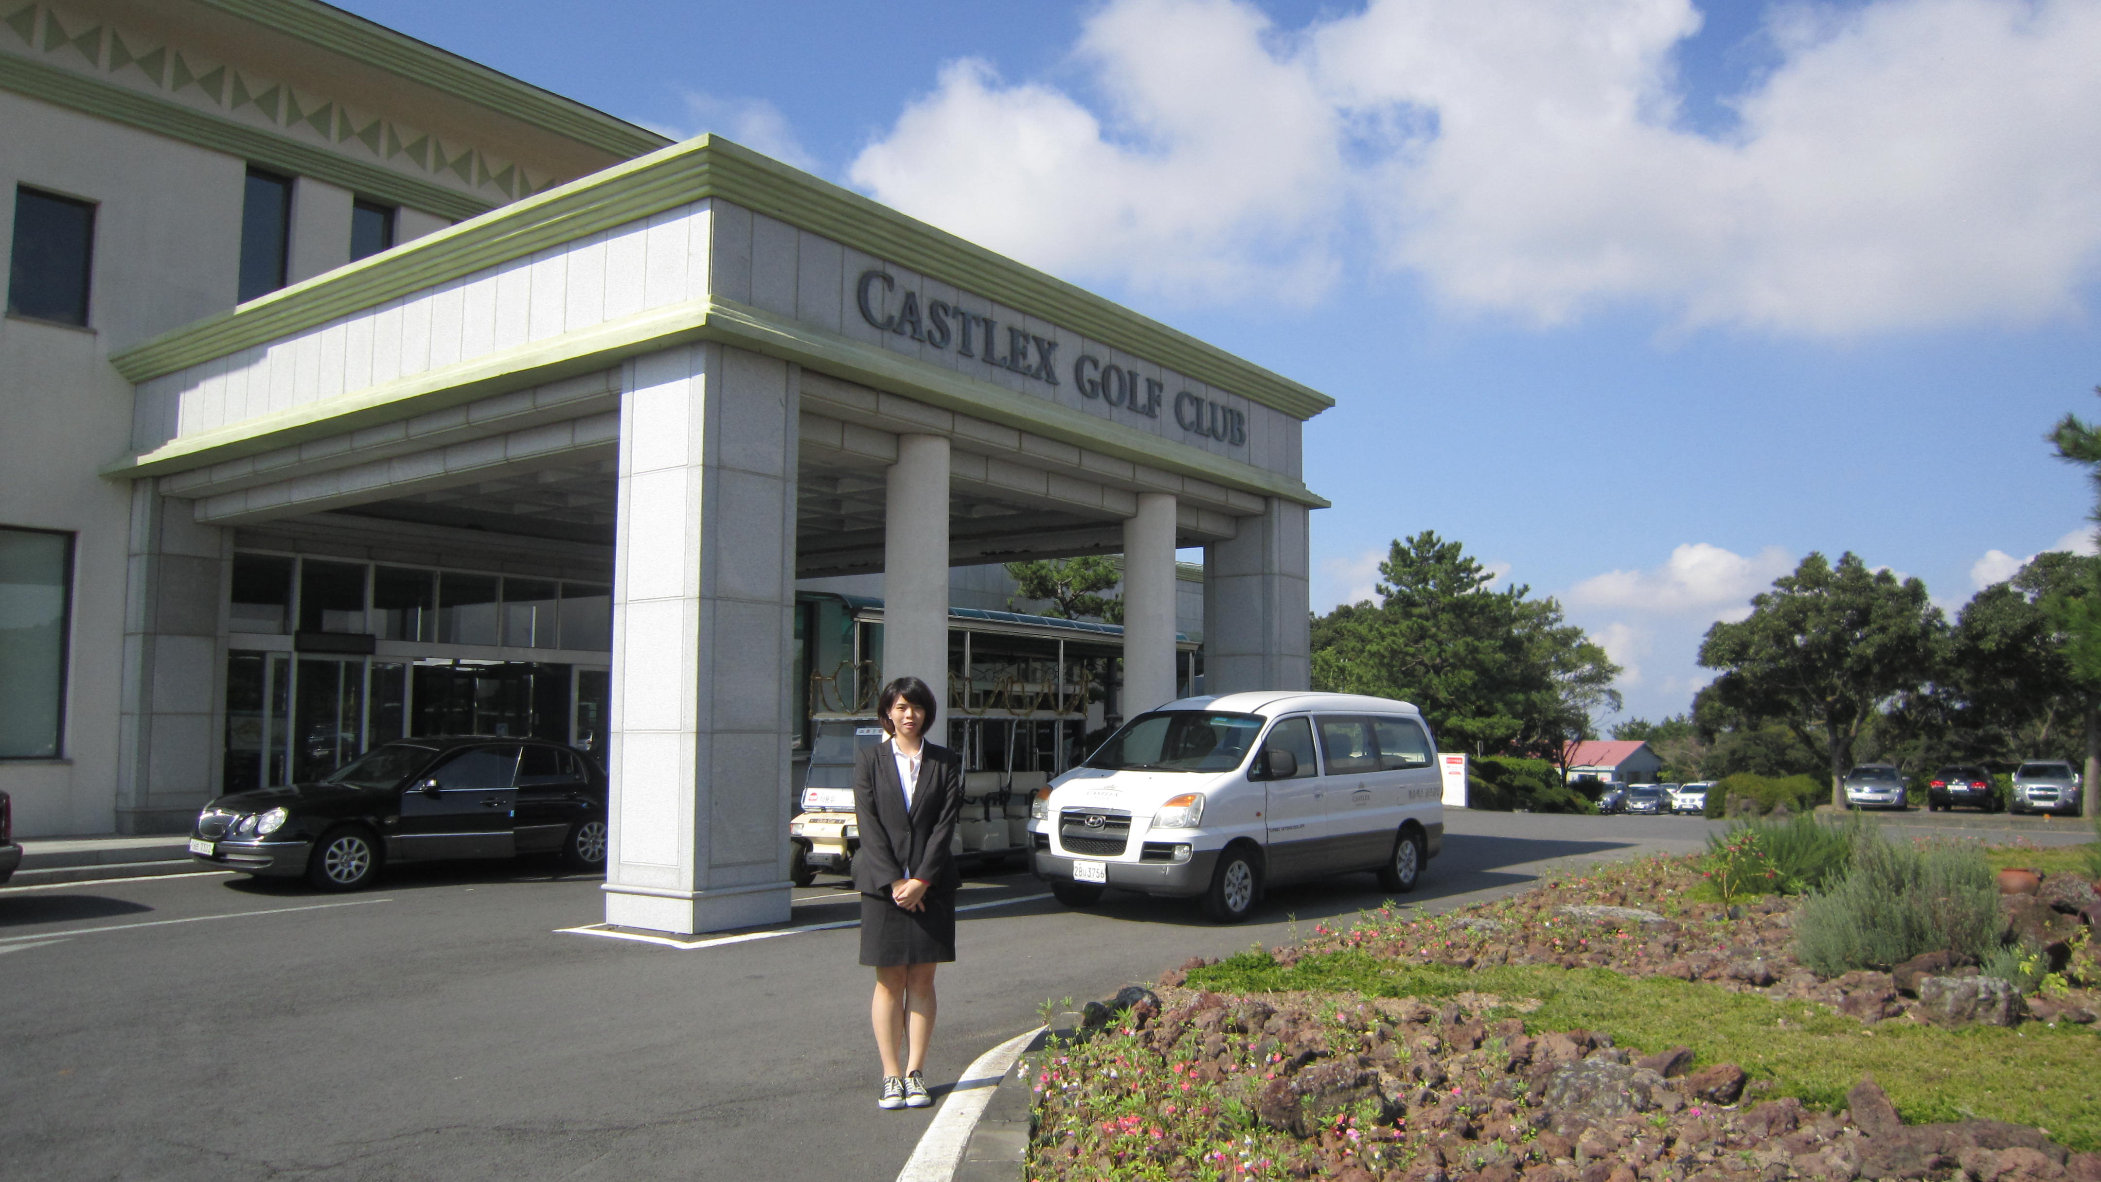  南韓濟州島國際研討會會場 |   研討會會場地點名稱標示
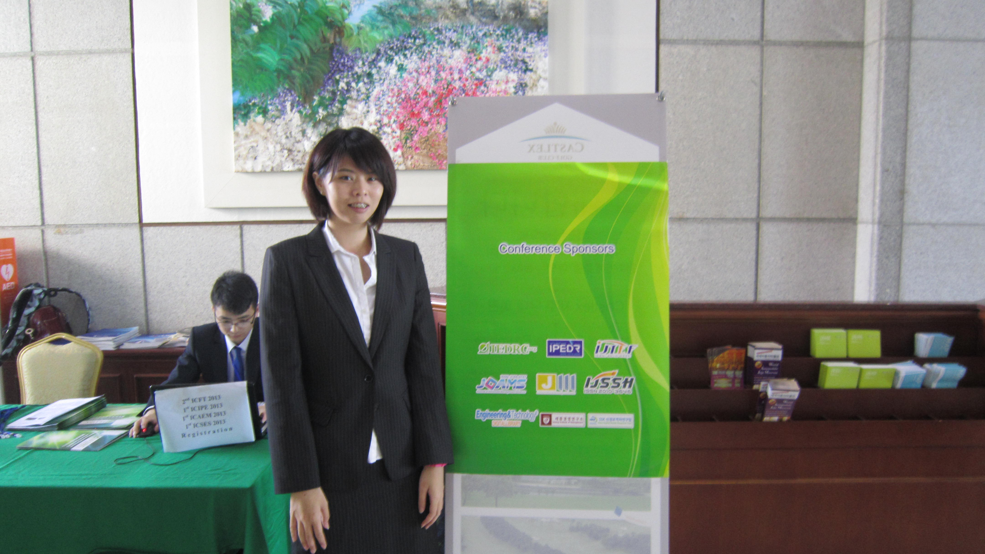  研討會標示立牌 | 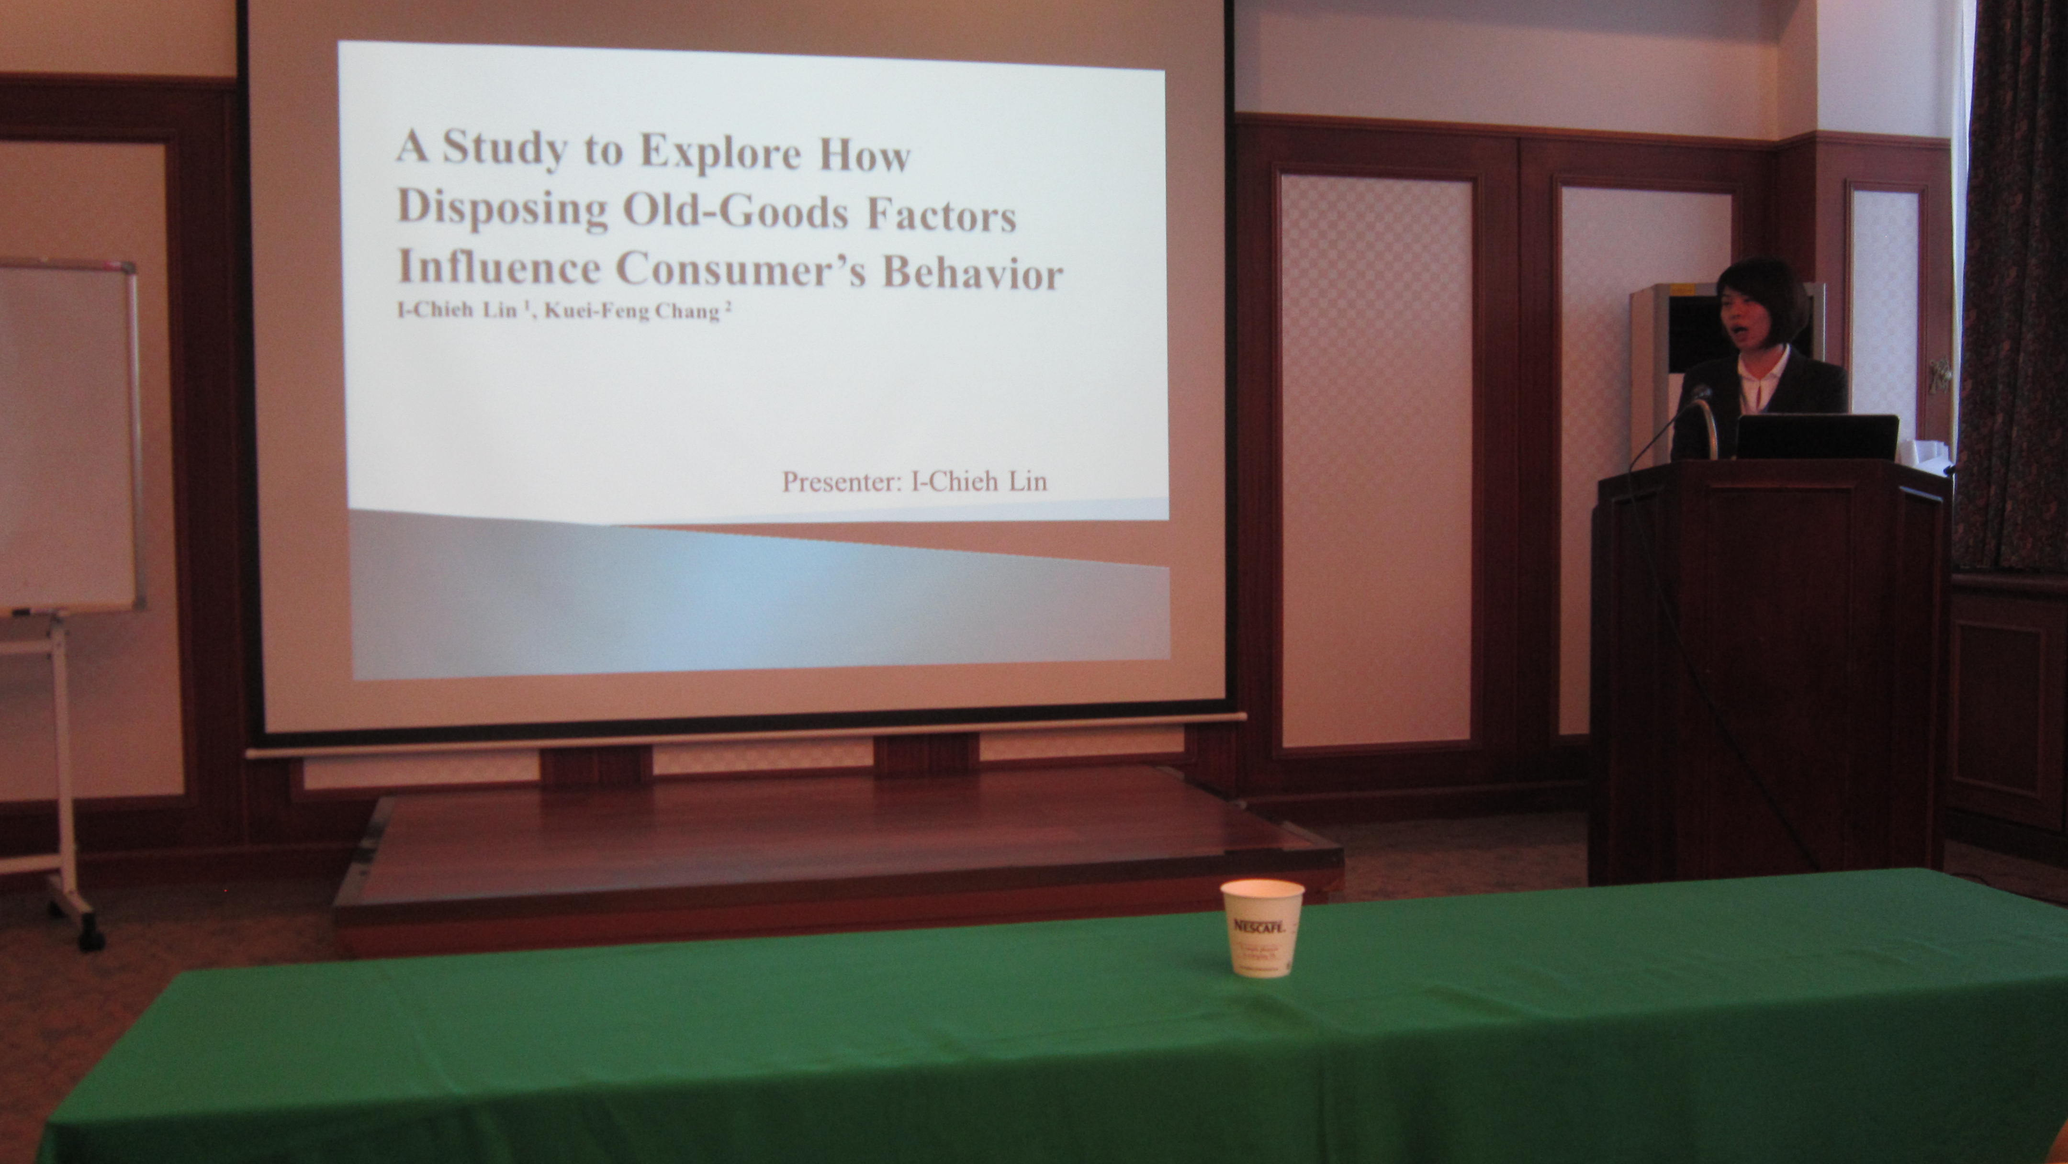  研討會英語口頭報告
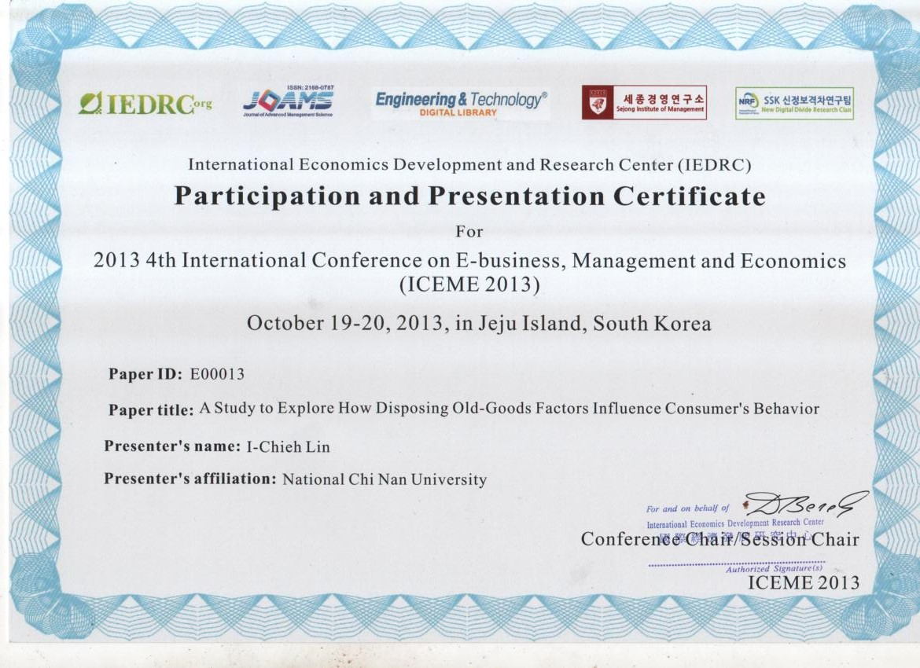  研討會發表證明書 | 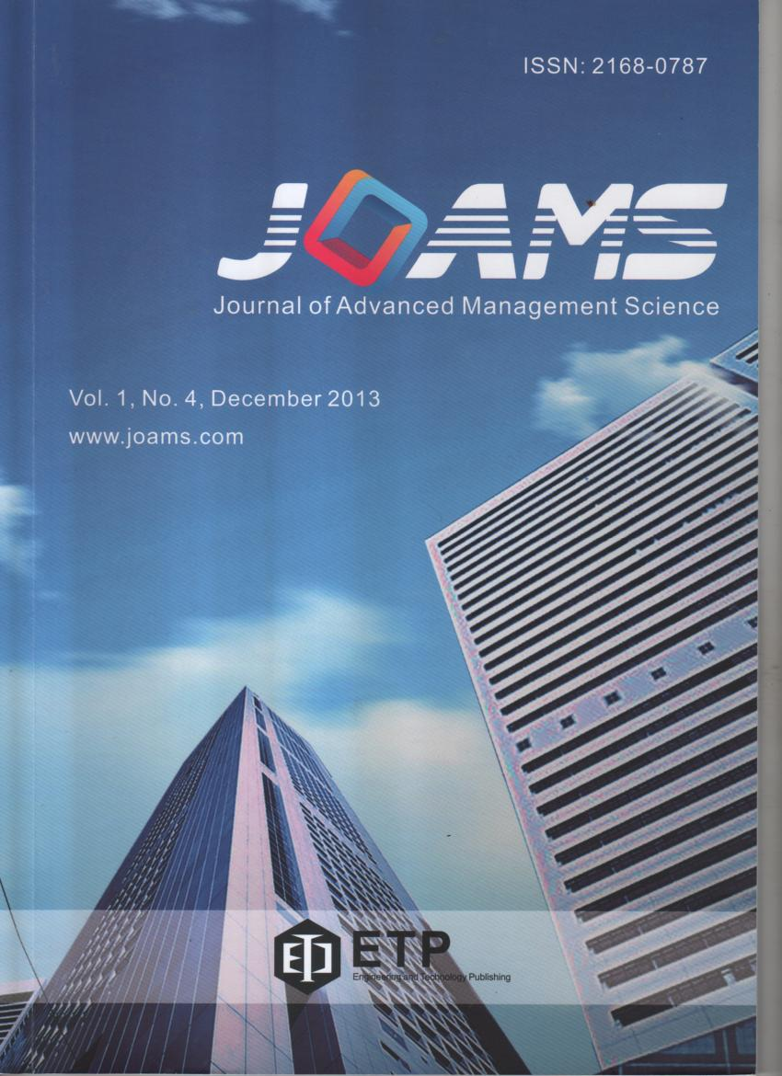  研討會期刊刊登之書籍

