出國報告（出國類別：其他）

出席國際學術會議心得報告

服務機關：國立高雄第一科技大學
姓名職稱：羅維 教授
派赴國家：土耳其
出國期間：102/6/18~102/6/25
報告日期： 102/8/15

摘要

本次出國係為參加營建工程與管理國際研討會ICCEM 2012, International Conference on Construction Engineering and Management 2013 (World Academy of Science, Engineering and Technology)發表論文(中文題目)時間與成本互異時專案完成時程之最佳化(英文題目)Optimizing the Project Delivery Time with Time Cost Trade-offs。
本次2013年營建工程與管理國際研討會係由科學、工程及技術世界學院所主辦。 地點於土耳其第一大城伊士坦堡。時間為2012年6月20日及21日兩日，本人之發表論文(被安排於21日。由於會期遇當地反政府民眾之示威行動，是以參加研討會人數不理想，以至於現場口頭發表( oral presentation)實際到場發表人數較少。
本次研討會參與發表者與營建管理相關之論文甚少，且由於大會安排場地不理想，與會者間互動甚少。本人此次行程雖順利完成，惟研討會逢當地之示威行動加上大會未及時應變，使得研討會不如預期，所得資料有限。日後當避免參加會場地區有政治及治安不穩定情形，及主題過於廣泛、不夠明確之研討會。同時若承辦大型之研討會應考慮可能發生之風險，並設有應變之機制。

I
目次
摘要………………………………………………………………..I
目的………………………………………………………………..1
過程………………………………………………………………..2
心得及建議………………………………………………………..3
附件………………………………………………………………..16
目的

參加營建工程與管理國際研討會ICCEM 2012, International Conference on Construction Engineering and Management 2013 (World Academy of Science, Engineering and Technology)發表論文(中文題目)時間與成本互異時專案完成時程之最佳化(英文題目)Optimizing the Project Delivery Time with Time Cost Trade-offs。

1
過程
- 本次2013年營建工程與管理國際研討會係由科學、工程及技術世界學院所主辦。 地點於土耳其第一大城伊士坦堡。時間為2012年6月20日及21日兩日。本人於十八日搭機赴土國首都於十九日抵達後。二十日起參加為期兩天之研討會，研討會分別於三個會場進行，研討會發表分為兩類型；現場口頭發表( oral presentation) 及e-海報發表 (e-poster presentation)。現場口頭發表( oral presentation)自早晨八點半至下午一點，中間十一點休息十五分鐘至十一點十五分。下午則為e-poster presentations。本次研討會大會無特別安排大會開始儀式，也並沒安排知名人士之演講，現場發表壓縮至僅有兩個半天。而會後亦無一形式上之閉幕儀式，即草草結束此研討會。 而本人於會後即自行參觀Istanbul University及Istanbul 之建築與公共設施。
- 由於會期遇當地反政府民眾之示威行動，是以參加研討會人數不理想，以至於現場口頭發表( oral presentation)實際到場發表人數較少，且由於大會將不同領域參雜於同一session中，使得與會聽眾多有半途離席，聽眾甚少，多無討論發言之情形。整個會期口頭發表為上半天。下午會場幾乎空無一人。
- 本次研討會參與發表者與營建管理相關之論文只有三篇，其中兩篇與公司經營績效與成長相關，作者為大陸學者。另一篇為風險管理電腦軟體使用之問卷調查分析。並無特殊之學術創新及價值。由於大會安排場地不理想，並無足夠交誼空間，與者間互動甚少。
- 大會議程如下:

2


3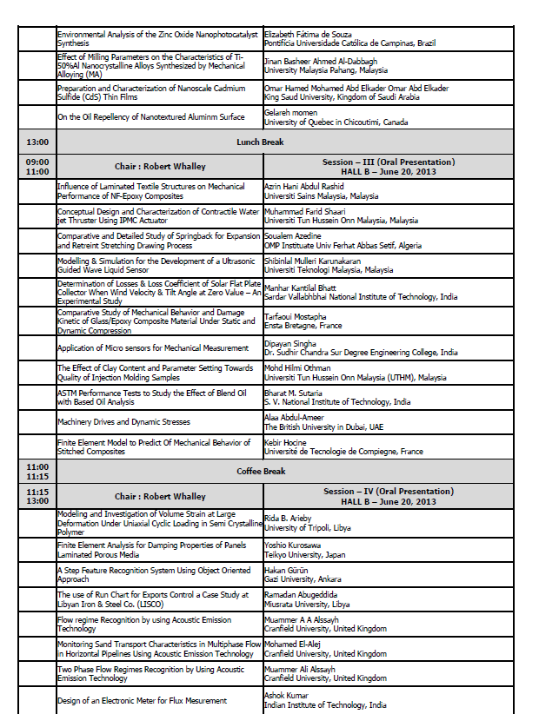

4
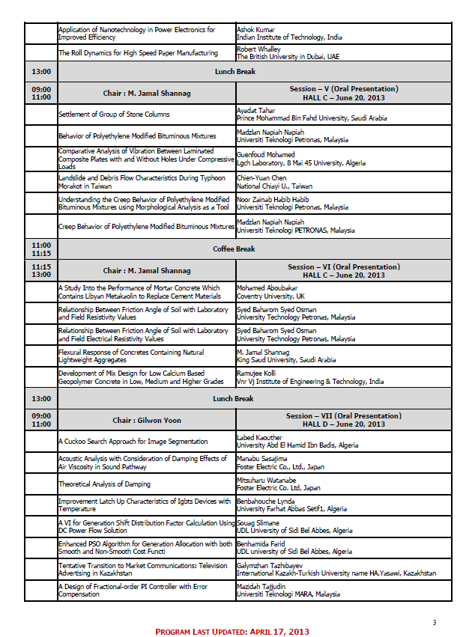

5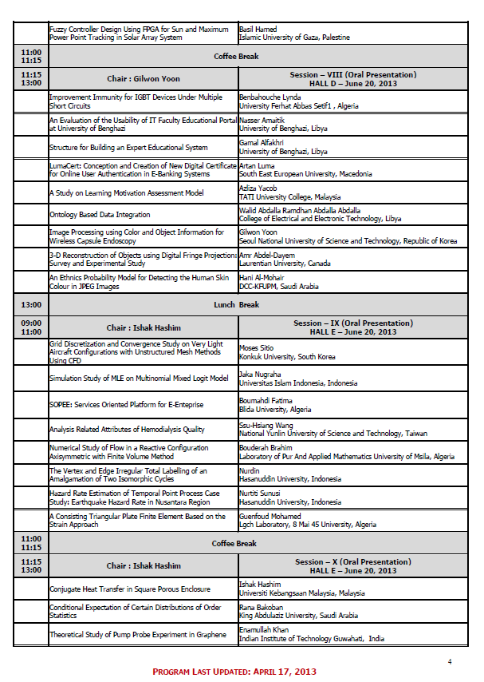6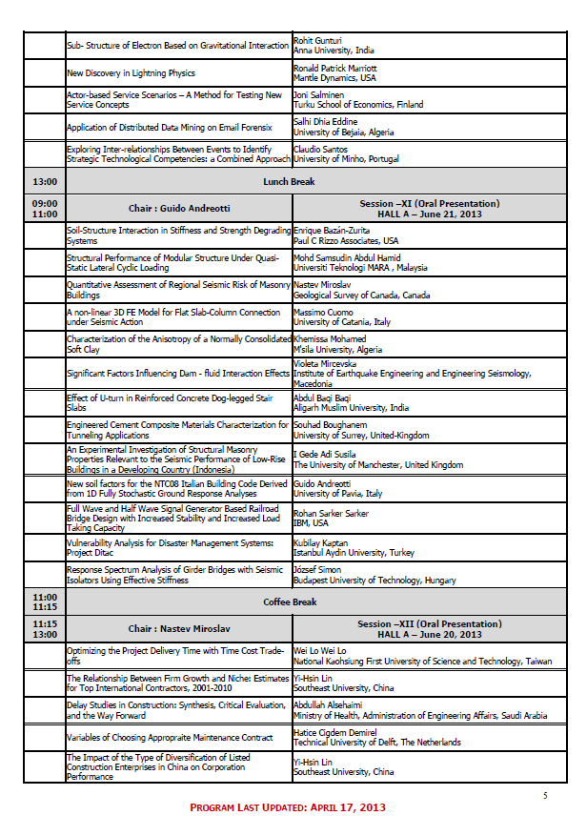7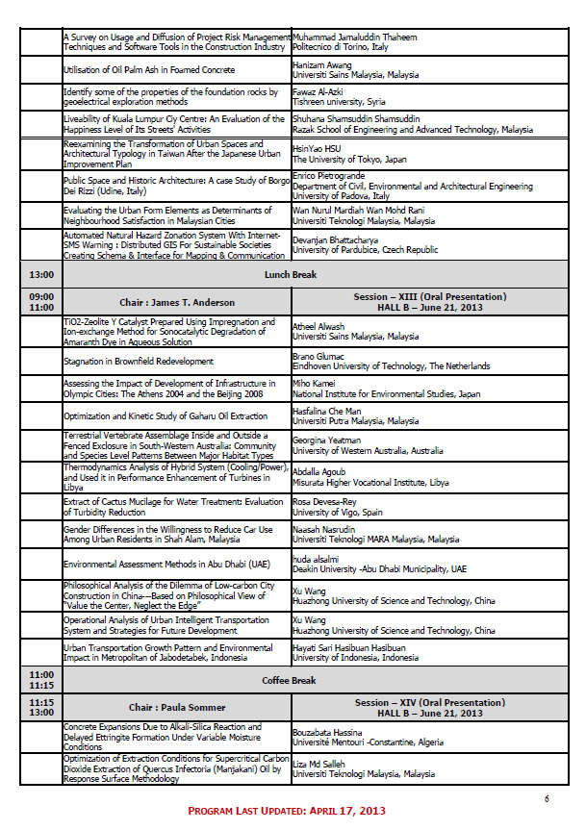8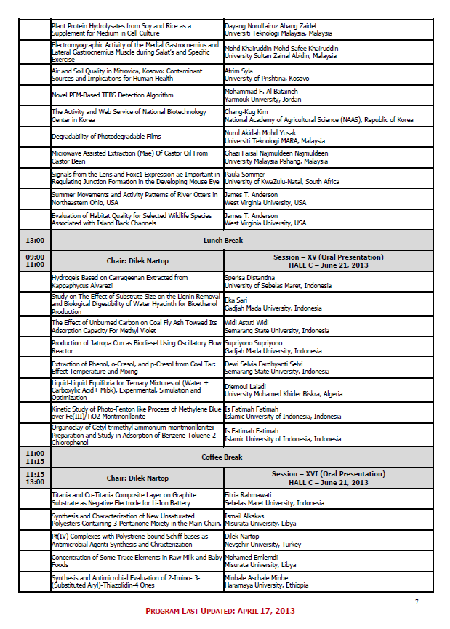910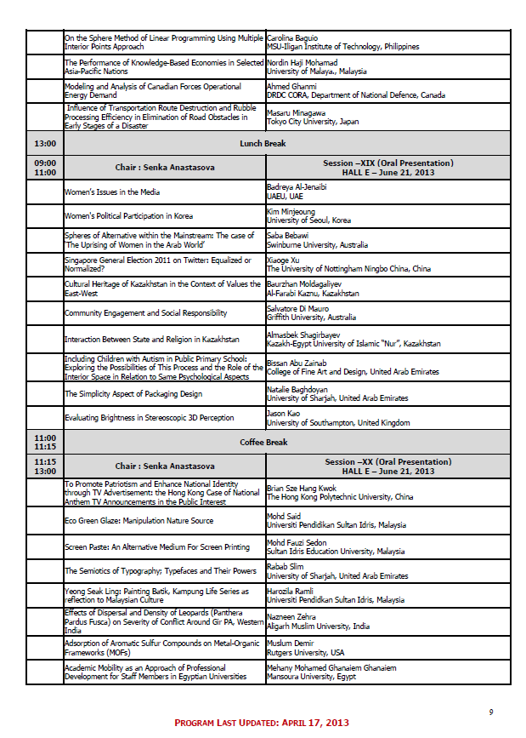11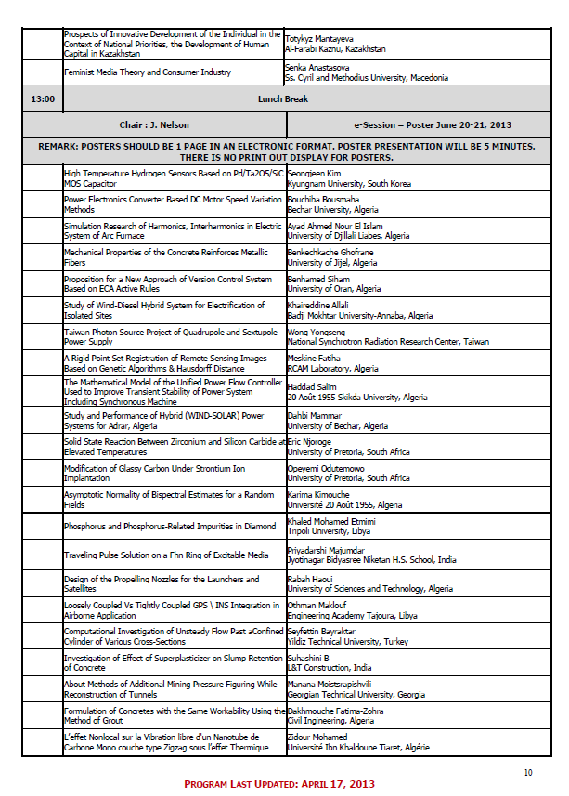12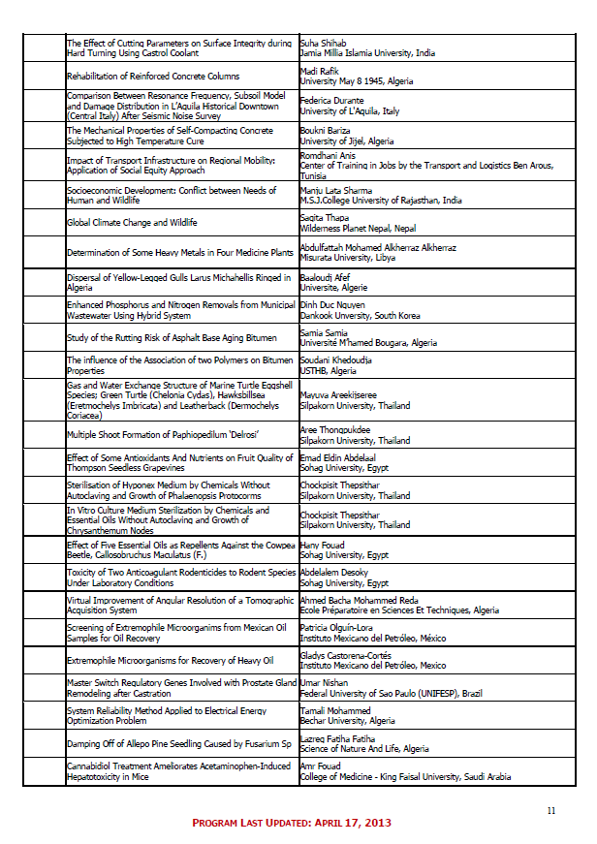13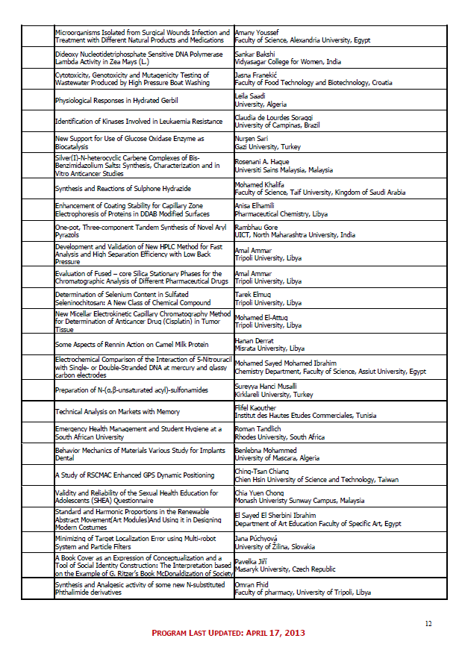

14

15

心得及建議
二、與會心得
- 主辦單位缺乏應變能力:
本次研討會地點於土耳其伊士坦堡 Taksim廣場附近之NIKKO Hotel，Taksim廣場由於土耳其政府計畫拆除Taksim廣場邊綠地公園(The Gezi Park)，將之改建成商場，以至於於五月起引起大規模反政府之示威遊行，後因政府強力鎮壓導致多人死亡、受傷，甚而引起西方社會之關注。由於此次安排之會場即在Taksim Square周邊，盤據Taksim Square反政府之民眾之示威行動，已嚴重影響交通及安全，甚至有些國家已發出旅遊警戒。據了解同時間在當地有醫療相關研討會，因之將會場改往較不受影之地區，然而本研討會主辦單位並未有任何反應。

- 研討會之流程及會場安排不佳:
本次研討會為期兩天，研討會分別於三個會場進行，研討會分為兩類型；現場口頭發表( oral presentation) 及e-海報發表 (e-poster presentation)。現場口頭發表( oral presentation)安排於上午。下午則為e-poster presentations。或許由於反政府民眾之示威行動，是以參加研討會人數不理想，以至於現場口頭發表( oral presentation)場次較少，整個會期只有兩個半天。下午會場幾乎空無一人。而且大會亦因參加研討會人數不理想，將不同領域之研究合併於一場次發表。大會原邀請本人擔任一場次之Chair，在看完大會之 programme，於會前即予以回絕了。另外會場安排於地下室，地方狹隘，不但通風不佳，各方條件都相當不理想。整體而言就發表論文質與量以及研討會場硬體之安排，本次研討會相當不理想。

- 不同領域之研究儘量避免於一場次發表，避免造成人員移動及冷場之場面。

建議
- 避免參加會場之地區有政治及治安不安之情形。
- 避免參加主題過於廣泛、不夠明確之研討會。
- 日後若承辦大型之研討會應考慮可能之風險，並設有應變之機制。

16

附錄

發表論文全文
Optimizing the Project Delivery Time with Time Cost Trade-offs

Abstract— While to minimize the overall project cost is always one of the objectives of construction managers, to obtain the maximum economic return is definitely one the ultimate goals of the project investors. As there is a trade-off relationship between the project time and cost, and the project delivery time directly affects the timing of economic recovery of an investment project, to provide a method that can quantify the relationship between the project delivery time and cost, and identify the optimal delivery time to maximize economic return has always been the focus of researchers and industrial practitioners. Using genetic algorithms, this study introduces an optimization model that can quantify the relationship between the project delivery time and cost and furthermore, determine the optimal delivery time to maximize the economic return of the project. The results provide objective quantification for accurately evaluating the project delivery time and cost, and facilitate the analysis of the economic return of a project.

Keywords—Time-Cost Trade-Off, Genetic Algorithms, Resource Integration, Economic return

INTRODUCTION
Although to minimize the construction cost following a pre-planned schedule is important for both the owner and contractors in the course of investment, it is more important to select a construction duration, which produces the highest economic return on the total investment plan. In real-world situations, unpredictable events often affect the schedules of construction projects, forcing contractors to alter and re-allocate the durations of activities. Therefore, evaluating the benefit of the investment cannot produce meaningful results unless the trade-offs between the times and costs of activities for a construction project are considered [1]. As such, there is a need to develop a practical technique which incorporates the time-cost trade-off of activities and can assess the optimal construction duration in an investment plan. This paper first introduces a Genetic Algorithms (GAs) optimization model and then, uses a project case to demonstrate that the proposed algorithms can quantify the relationship between project time and cost, and subsequently, identify the optimal project delivery time with the maximum economic return.

METHOD
By using genetic algorithms (GAs), an optimization model was developed to assess the optimal delivery time of a construction project. Owing to the work of Professor John Holland in 1970s, GAs in particular became popular and has been widely adopted to find a near optimal solution to a problem with many solutions. There are three basic operators in GAs (Reproduction, Crossover, and Mutation) [2] which are used to reproduce a subsequent generation that is more suitable to the current environment. GAs simulate the natural ‘‘survival of the fittest’’ process, as best genes exchange information to produce offspring that are evaluated in turn and can be retained only if they are fitter than the others in the population. Usually the process is continued for a large number of generations until an optimal gene is obtained. Using genetic algorithms to solve optimization problems with an enormous range of possible solutions has proved to be a very effective and feasible approach.

PROJECT COSTS AND RESOURCE-USE EFFICIENCY
Project costs include direct and indirect costs. Indirect cost is composed of the expenditure on management during project implementation and usually increases linearly with project duration and is represented as a single cost per time period, thus it depends heavily upon the project duration, the longer the duration, the higher the indirect cost, and can be calculated as follows:

$\text{IC}=T×U_{d}$ (1)

where IC=total indirect cost of a project; and U_{d}= daily cost rate for indirect cost in $/day.
The direct cost (DC) includes the costs required to execute activities directly (TC_{d}) and the resource handling cost caused by the mobilization/demobilization (TC_{m}). For a feasible project duration, there always is a set of time and cost arrangement for each activity that will produce the project duration with the lowest total project cost. Moreover, each activity has its own time-cost trade-off curve, which is defined by a minimum cost point, also known as normal point, and a minimum time point, also known as crash point, and estimated based on the relationships between the time and cost and the resource arrangements. Previous studies have suggested nonlinear resource-time relationships for an activity [3], [4] and a quadratic efficient model has been proposed to examine this [5]. The proposed model supposes that there always is an optimal crew combination for a specific activity, which can complete the activity in an optimal duration with the highest efficiency and lowest cost. When the assigned work duration deviates from the optimal duration, the efficiency will decline and the cost will increase. The relationship between efficiency and duration with regard to the resources needed for an activity is shown in Fig. 1, when the activity duration changes, the efficiency of each activity will change and affect the cost. The efficiency of the activity can be calculated as follows:

$E_{i}=\frac{1}{a_{i}×{\left(T_{i}−{\text{Tn}}_{i}\right)}^{2}+1}$ (2)

where E_{i}= the efficiency of activity i; T_{i} = the duration of activity i; Tn_{i} = the normal duration of activity i; a_{i} = a positive constant.
Therefore, project direct costs required to execute activities are the sum of all activity costs, and can be expressed as follows:

${\text{TC}}_{d}=\sum_{i=1}^{M}{\frac{C_{i}}{E_{i}}}$ (3)

where TC_{d} = the total direct costs of construction project with M activities, and C_{i} = cost of activity i.

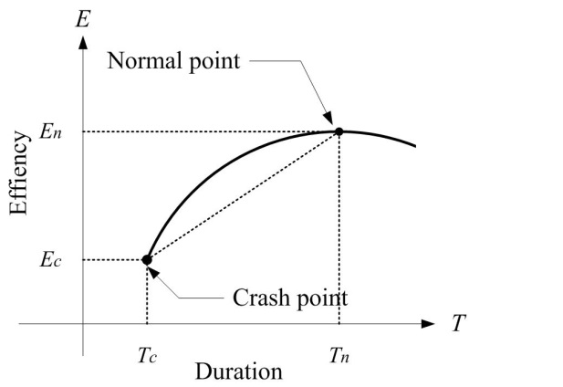
Fig. 1 Efficiency-duration curve

Besides, because of the variations of daily resource usage, the project would be mobilized and demobilized to re-allocate resources and the mobilization/ demobilization cost of resources can be expressed as follows:

${\text{TC}}_{m}=\sum_{i=1}^{M}{\sum_{t=1}^{T+1}{\left|Q_{\text{it}}−Q_{i(t−1)}\right|×U_{i}×P_{i}}}$ (4)

where Q_{it} and Q_{i(t-1)} = the quantity of resource usage of activity i on day t and day t-1 respectively; U_{i}= unit cost of activity i; P_{i}= the ratio of mobilization/ demobilization unit cost over the cost for activity i.
Accordingly, the total cost of a project (TC) can be derived from (1) to (4) and expressed as follows:

$\text{TC}=\text{DC}+\text{IC}={\text{TC}}_{d}+{\text{TC}}_{m}+\text{IC}$ (5)

OBJECTIVE FUNCTION
Implementing the GA technique involves five main steps: (1) Setting the gene structure; (2) deciding the gene evaluation criteria (objective function); (3) generating an initial population of genes; (4) selecting an offspring generation mechanism; and (5) coding the procedure in a computer program. Using genetic algorithms to solve optimization problems with an enormous range of possible solutions has proved to be a very effective and feasible approach.
The objective function in genetic algorithms is used to determine the suitability of the evolution of the chromosomes retained. By using the objective function the proposed model will eliminate inferior chromosomes through competition until the optimization process cannot evolve a better solution and all populations converge to a stable condition.
The objective function is a measure of the performance of the design variables and is used to determine the suitability of the evolution of the chromosomes retained in genetic algorithms. The objective function in this research is designed to obtain the maximum net present value (NPV) for an investment plan as follows:

$F=\text{Max}\left\{−\text{TC}(T_{i},r)+\sum_{k=1}^{K}{\frac{I_{k}}{(1+r)^{k}}}\right\}$ (5)

where TC= the total project cost which will be calculated with various activity durations; K = a positive integer, the total number of periods K; I_{k}= income of period k; r= discount rate of the investment; and F= the objective function value.

CASE
The assumptions of the project are as follows:
- The life cycle of the invested project is expected to be 50 years (period number = 200 quarters) after the construction is completed.
- The income for each quarter is $75,000 after the construction project is completed.
- The annual discount rate of the investment plan is assumed to be 2% (0.5%/ quarter), 5% (1.25%/ quarter) and 8% (2%/ quarter) to examine the simulation results.
- The construction operation consists of seven activities (Activities A to G).
The details of the activity durations and costs are shown in Table I. The network schedule with the critical path B-E-G is as shown in Fig. 2. The indirect cost of the project was assumed to be $10,000 per day, and the project duration was assumed to be 2 years (8 quarters, 24 months) based on the normal duration provided for each activity. The total cost of the project calculated from the early-start schedule was $2,802,560. To simulate real-world projects while simplifying the complexities of the model, it is assumed that (a) project operations are assumed to be the best procedure, and will not change in the simulation process, (b) the relationship between work duration and the efficiency of resources for an activity is a quadratic function, (c) the working duration of each activity is adjustable within the range of (0.5 - 1.1) × Tn_{i}

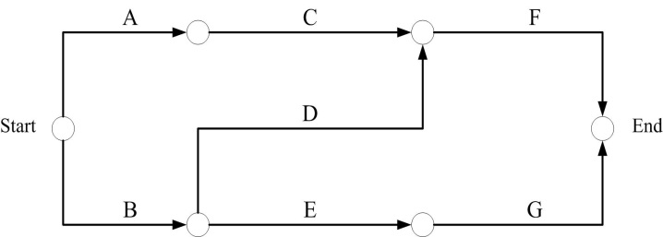
Fig. 2 Precedence network for the example project

Table I
Project information
Activity | Successors | Normal duration | Total float | Activity  cost
Activity | Successors | (days) | (days) | Activity  cost
A | C | 6 | 8 | 119,400
B | D,E | 9 | 0 | 192,000
C | F | 5 | 8 | 309,000
D | F | 5 | 5 | 548,100
E | G | 8 | 0 | 142,000
F |  | 5 | 5 | 525,600
G |  | 7 | 0 | 43,200

First, the proposed algorithms successfully quantify the project delivery time and the construction cost as shown in Table II and the relationship is depicted as Fig. 3. Subsequently, the net present values (NPV) of the project at various delivery times are identified as shown in Table III and the relationships between the project delivery time and NPV is depicted as in Fig. 4. The results suggest that the optimal delivery time is compressed to 21 months instead of the original 24 months after the optimization and the value of the discount rate significantly affects the economic return of the project. It is logic to infer that as there is a trade-off relationship between the project time and cost, the optimal project delivery time may vary at different discount rate.

Table II
Construction cost versus project delivery time
Delivery time | Construction cost
(Months)
12 | 3,094,947
15 | 2,733,372
18 | 2,642,653
21 | 2,543,844
24 | 2,560,520
27 | 2,594,638

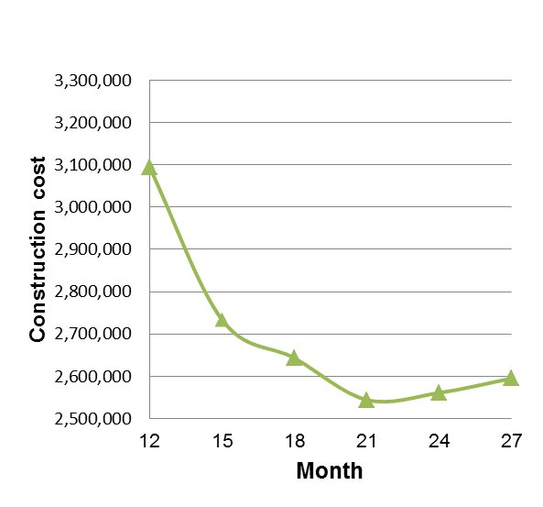
Fig.3 Construction cost versus project delivery time

Table III
NPV versus project delivery time
Delivery  time | Net present values
Delivery  time | 8%* | 5% | 2%
12 | 455,818 | 2,234,877 | 6,225,309
15 | 762,790 | 2,539,739 | 6,544,024
18 | 814,584 | 2,583,798 | 6,595,929
21 | 881,081 | 2,630,083 | 6,657,650
24 | 827,934 | 2,572,749 | 6,579,206
27 | 782,773 | 2,486,332 | 6,516,592
* Annual discount rate

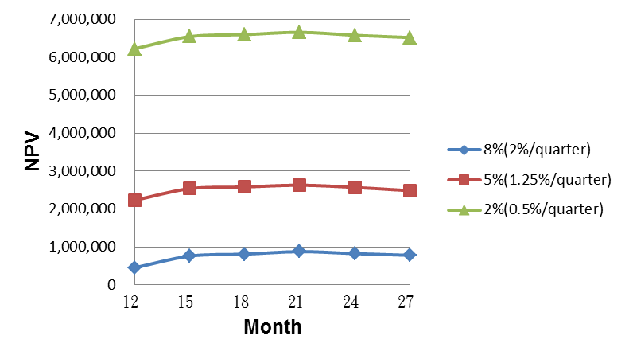
Fig.4 NPV versus project delivery time

Conclusions
To evaluate an investment project without considering the time cost trade-offs of its construction works is unrealistic and deviates from real-world practices. The proposed algorithm that incorporates the adjustable durations of activities and can analyze the trade-offs between the project deliver time and cost and subsequently, identify the optimal delivery time of an investment project. In addition, our research results indicate that the cost impact of float loss can be reduced through the effective integration of project resources. The proposed method provides an objective approach in which the project delivery time and overall project cost can be evaluated accurately and facilitate the analysis of the economic returns of the project with various delivery times.

Acknowledgment
This work was financially supported by the Taiwan National Science Council.

References
- C. W. Feng, L. Liu, and S. A. Burns, “Using genetic algorithms to solve construction time-cost trade-off problems,” J. Comput. Civ. Eng., vol. 11, no. 3, pp. 184-189, 1997.
- A. B. Senouci, and N. N. Eldin, “Use of genetic algorithms in resource scheduling of construction projects,” J. Constr. Eng. Manage. , vol. 130, no. 6, pp. 869-877, 2004.
- J. E. Kelly, “Critical-path planning and scheduling: Mathematical basis,” Operational Res., pp. 296-320, 1961.
- R. Reda, and R. I. Carr, “Time-cost trade-off among related activities,” J. Constr. Eng. Manage., vol. 115, no. 3, pp. 475-486, 1989.
- B. Holt, L. M. Fu, “Rule generation from neural networks,” IEEE Trans. on Sys., Man and Cybernetics, vol. 8, no. 3, pp. 54-63, 1955.

