出國報告（出國類別：國際會議）

The 34th International Association
for Human Caring Conference
第34屆國際人類關懷研討會

服務機關：國立臺北護理健康大學
醫護教育研究所
姓名職稱：李皎正教授
派赴國家：美國
出國期間：2013.05.28~2013.06.04
報告日期：2013.06.28
摘要
本次「第34屆國際人類關懷研討會」在美國奧蘭多舉行，會期自2013年5月29日至6月1日，會議主題為「關懷的奧秘和奇蹟：融滲關懷於護理實務、教育及研究(Magic Mystery, and Miracles – Embracing the Difference Caring Makes in Nursing Practice, Education and Research)」，各場次分為三個議題進行：教育、臨床實踐及研究。
筆者的論文｢發展我國臨床關懷照護之e化學習課程---從病人、家屬及護理人員觀點(Developing caring content of an e‐learning program from the patient and nurse point of view)｣分屬在臨床實踐的組別，內容主要說明護理專業起源於對人類的關懷(caring)，但研究顯示，護理人員對病人的關懷照護能力並未隨著醫療水準的進步而提昇。因此本研究旨在研發「關懷病人e化課程」，結合角色楷模學習及數位教學等創新方法，運用於臨床護理人員之繼續教育，期望本研究計畫能建立我國護理界推展關懷教育的模式，並幫助護理教育者掌握護病互動行為的教學策略與技巧，研究結果最終可作為護理界推展臨床護理關懷教育之依據。

目次

摘要……………………………………………………………………………………………2
目次……………………………………………………………………………………………3
本文
目的…………………………………………………………………………………………4
過程…………………………………………………………………………………………5
心得及建議…………………………………………………………………………………9
附錄
一、 研討會議程..…………………………………………………………………………10
二、 發表之論文摘要..……………………………………………………………………19
三、 研究者和與會學者合照…..…………………………………………………………20
四、 會議照片..……………………………………………………………………………20

壹、目的
一、參加「第34屆國際關懷照護研討會（IAHC Conference）」，筆者分別以口頭論文的方式發表「發展我國臨床關懷照護之e化學習課程---從病人、家屬及護理人員觀點（Developing caring content of an e‐learning program from the patient and nurse point of view）」，並與博士班學生以壁報論文發表「護理人員關懷行為評估驗證性因素分析（Testing and verifying Nurses Caring Behavior Assessment (NCBA) by confirmatory factor analysis）」等二項專題報告。
二、與IAHC各國成員討論當今關懷照護的推展及成效等，並就各團體發展及實施情形，交換彼此意見，以及針對未來相互合作或支援的可能性進行探討，促進各成員及團體彼此間之交流關係，筆者更藉此在IAHC的會議過程中展現臺灣在護理臨床關懷照護之研究成果與貢獻。
貳、過程
5月28日：
筆者於上午9時在桃園國際機場搭乘達美DL276班機，先飛日本東京，轉機至美國底特律，再轉奧蘭多，並於當地時間21時抵達奧蘭多國際機場，自行前往至下榻的「迪士尼世界渡假村（Walt Disney World Swan and Dolphin Resort）」進住。
5月29日：
完成報到手續，並於晚間6時參加研討會之歡迎開幕式。典禮中由IAHC主席介紹國際關懷照護協會於西元1978年由護理理論家Dr. Madeleine Leininger創立之後，每年分別於世界各地舉辦年度國際關懷照護研討會。本次第34屆國際關懷照護研討會（IAHC Conference）於102年5月29日至6月1日在美國奧蘭多舉行，與會人員除了地主國（美國）學者外，尚有加拿大、英國、冰島、澳洲、泰國、日本及中華民國等國家的代表約200多人參加。此次研討會的主題為關懷的奧秘和奇蹟：融滲關懷於護理實務、教育及研究 (Magic Mystery, and Miracles – Embracing the Difference Caring Makes in Nursing Practice, Education and Research)。本次研討會的主要目的有三項：一、提供專注於關懷領域的學術研究者和臨床工作者機會，分享其關懷的研究、實踐和教育；二、瞭解目前在研究、實踐和教育等方面運用關懷架構的策略；三、促進學術之間對於關懷相關研究、實踐和教育工作間的聯繫。
5月30日：
研討會於上午8時30分在迪士尼世界渡假村（Walt Disney World Swan and Dolphin Resort）正式展開。此次IAHC開幕儀式由Marian Turkel, Marlaine Smith, & Gail Williams一同致歡迎詞，隨後即由Dr. Anne Boykin進行專題演講，其主題為關懷的奇蹟（The Miracle of Caring），主講人從其小時候感受到的關懷經驗講起，認為具備熱忱才能讓人感受到關懷，而在案例分享的過程中，可以感受到主講人也是身體力行的貫徹這個想法，並且在關懷照護病人的過程中，也從病人、家屬的身上學習到愛的真諦。
分組論壇（Concurrent Session）可區分為教育、臨床實踐及研究等三方面，依論文主題的性質分別在三個不同的場地報告。筆者被分配在臨床實踐的組別，並發表「發展我國臨床關懷照護之e化學習課程---從病人、家屬及護理人員觀點（Developing caring content of an e‐learning program from the patient and nurse point of view）」專題報告。內容主要說明護理專業起源於對人類的關懷(caring)，但研究顯示，護理人員對病人的關懷照護能力並未隨著醫療水準的進步而提昇。因此本研究旨在研發「關懷病人e化課程」，結合角色楷模學習及數位教學等創新方法，運用於臨床護理人員之繼續教育，藉此加強護理人員的關懷照護能力。研究方法為：（1）採深入訪談及焦點團體訪談法確立病人、家屬及護理人員對於關懷照護之具體行為，並將訪談資料以內容分析法進行分析。（2）拍攝錄製優良護理人員於不同臨床情境與病人互動之教學影片。（3）將訪談內容及護病教學影片融入課程中，成為以SHARE關懷理念為核心的護理人員繼續教育課程「關懷病人e化課程」。執行成果包括（1）初步分析11位病人、3位家屬及19位護理楷模，瞭解其對護病互動的關懷/不關懷照護經驗的訪談資料，並歸類於合作研究醫院的SHARE理念中，S：感受病人的需求、H：幫忙病人、A：感同身受、R：尊重病人的隱私及尊嚴、及E：主動告知或解釋。（2）完成初步的「關懷病人e化課程」，並經由專家會議來審視本課程之學習目標、課程大綱、單元內容、課程教材、教學影片及反思試題的適用性。（3）將完成修訂之「關懷病人e化課程」，放置於醫院Moss系統的電子化學習（e-learning）平臺，檢視本課程介入後參與前趨測試的護理人員關懷照護行為之成效。期望本研究計畫能建立我國護理界推展關懷教育的模式，並幫助護理教育者掌握護病互動行為的教學策略與技巧，研究結果最終可作為護理界推展臨床護理關懷教育之依據。報告過程並播放病人分享照護經驗的聲音檔及護病互動的影片，皆得到與會聽眾的肯定與鼓勵，並建議將此e化教育課程翻譯成英文，嘉惠更多國際護理人員。
另外由Jane Sumner, & William Fisher 所發表的論文Caring in Nursing as Communicative Action: Applying Strong Theory in Survey Research。從其論文發表的內容可看出量表的發展過程，且參與口頭報告的學者在結尾大多會留下自己的聯絡方式，如：mail信箱等，可看出其歡迎對該議題有興趣之與會者一同交流的心意。
5月31日：
研討會於上午8時開始。第一場專題演講的開場者為Marilyn Ray，演講主題為Honoring 35 Years of Caring Scholarship: Reflectionsfrom1978。而讓筆者比較關注的議題為Gail Williams, Mark Soucy, & Maureen Rubin 所發表的 Interprofessional Education: Embracing the Difference Caring Makes in Nursing Education and Practice。由於跨領域的團隊合作在今日的護理界顯得相當重要，護理師除了自己的專業外，常常需要結合營養師、復健師、醫師等等的團隊力量一同來照護病人，而此篇論文中即點明跨領域的團隊需要著重於病人為中心，並且感激團隊中每一位成員所扮演的角色，這也讓筆者想到財團法人醫院評鑑暨醫療品質策進會於2012年制訂｢師資培育制度認證辦法｣，將跨領域團隊合作照護教學列為臨床教師訓練課程的範圍之一，可見跨領域團隊合作的議題是現今醫護界重要的一項課題。
此外，Sandra Cadena 學者所研究的主題 Transcultural Caring: Nursing Faculty and Students Immersed in International Clinical Experiences and the Effects on Compassion, Cultural Competence and Relationship-Building 也相當具有意義，帶領從小生長於北美地區的護理學生實際走訪南美進行田野調查，讓學生藉由實際接觸當地的文化，和當地人面對面的溝通交流，以消除原先對不同地區及文化的刻板印象。另外由Carol Wilson 學者所研究的主題 Making a Difference in Graduate Education: Implementing Online Caring Groups，改變過去認為關懷團體必須在課室教學時才可運用，現在則進一步運用於遠距的網路教學中，Carol Wilson 在D2L建立起非同步的關懷團體空間，並運用Google hangout的平台建立同步，讓學生們即使分隔N地仍可彼此面對面的關懷團體空間等。從多位學者的口頭報告中皆汲取相當不同的經驗，期望未來也能在我國的護理教育界中實際運用。
而今日除了口頭論文的報告外，還有壁報論文的展出，此展出時間亦充分讓與會者能夠互相交流，在會場中，筆者即認識了Florida Atlantic University的Lenny Chiang-Hanisko副教授，其為華裔美籍，由於美國現在許多研究所的課程皆為網路教學，因此在網路遠距教學上有所專精，在筆者極力邀請下，將於明年年中來筆者所任職的學校擔任研討會的主講者。
此外，由於第35屆IAHC的研討會將於日本京都舉辦，因此主辦人Naohiro Hohashi教授也在會場中介紹了明年舉辦IAHC的團隊，除了其自身所任教的神戶大學外，還有同樣任職於該校的Junko Honda副教授，以及東京慈惠會醫科大學的Junko Ishikawa講師，並邀請同在亞洲地區的筆者務必一同參與明年IAHC的盛會。
在壁報論文展出的部分，除了筆者與博士班學生徐紫娟一同發表的壁報「護理人員關懷行為評估驗證性因素分析（Testing and verifying Nurses Caring Behavior Assessment (NCBA) by confirmatory factor analysis）」外，筆者尤其注意到其中有五篇是來自加拿大的Dr. Colleen Maykut指導護理系大四學生的作品，看到年輕學生展現自信的發表自己的文章，此舉令筆者也想向我國護理界的老師建議，可以嘗試指導大學部的學生先於國際研討會中以壁報的形式發表文章，以鼓勵學生並激發其潛能，進而拓展學生的國際觀。
6月1日：
本日為本屆IAHC研討會的最後一天，第一場專題演講於上午8時開始，開場者為Sharon Cumbie, Wendy Miller, & Dana Brackney，演講主題為Narrative Pedagogy and the Caring Professions: Theory, Education, Research & Practice。結束後則由Dr. Jean Watson進行閉幕演講，其主題是Embracing the Sacred Unknowns of Human Caring：Opening to Mystery and Miracles，說明關懷的核心是心中有愛，唯有真心的關懷才能撫慰人心，並見證用愛及關懷照護所展現的奇蹟。整體研討會活動及閉幕式於中午結束，總計四天的研討會共有63篇口頭論文、46篇壁報論文及6場專題座談會。
6月2日：
筆者原預計參訪一間佛羅里達州基督復臨安息日會的醫院，然而由於當日適逢假日，因此在聯繫的過程中醫院表示無法開放參觀，故筆者改與其他位IAHC研討會與會者同行參觀迪士尼世界。
6月3~4日：
筆者於6月3日上午8時搭車前往奧蘭多國際機場，搭乘中午12時達美DL252班機回臺，中途分別於底特律及東京轉機，6月4日21時30分返抵桃園。

參、心得及建議
一、心得
此次研討會的主題為關懷的奧秘和奇蹟：融滲關懷於護理實務、教育及研究，5月30日專題演講的主講者為Dr. Anne Boykin，其主題為關懷的奇蹟（The Miracle of Caring），主講人從其小時候感受到的關懷經驗講起，認為具備熱忱才能讓人感受到關懷，而在案例分享的過程中，可以感受到主講人也是身體力行的貫徹這個想法，並且在關懷照護病人的過程中，也從病人、家屬的身上學習到愛的真諦。
而6月1日閉幕演講的主講者為Dr. Jean Watson，其主題是Embracing the Sacred Unknowns of Human Caring：Opening to Mystery and Miracles，關懷的核心是心中有愛，唯有真心的關懷才能撫慰人心，並見證用愛及關懷照護所展現的奇蹟。
筆者的論文｢發展我國臨床關懷照護之e化學習課程---從病人、家屬及護理人員觀點(Developing caring content of an e‐learning program from the patient and nurse point of view)｣安排在5月30日分組論壇（Concurrent Session）的臨床實踐組中發表，報告過程並播放二段共2分多鐘以中文發音，附有英文字幕，由病人分享照護經驗的聲音檔，還有一段4分多鐘中文發音，附有英文字幕的護病互動影片，得到與會聽眾的肯定與鼓勵，並建議筆者將此套e化教育課程翻譯成英文，嘉惠更多國際護理人員。
最後感謝國科會的經費補助，此行不僅有助於筆者日後從事關懷相關研究，更能建構推動關懷教育的基石於護理學術及臨床實務界。

二、建議
在觀看壁報論文時，令筆者特別留意到其中有五篇是來自加拿大的Dr. Colleen Maykut指導護理系大學四年級學生的作品，看到年輕學生展現自信的發表自己的文章，並分享要以關懷為核心的理念，繼續學習護理，成為具有關懷特質的護理人員。此舉令筆者省思，也想向我國護理界的教師提出建議，是否可以指導學生先能於國際研討會中以海報發表文章，以鼓勵學生並激發其潛能，進而拓展學生的國際觀。

附錄
一、研討會議程資料
本屆研討會為了響應綠色環保，僅提供網路連結http://nursing.uthscsa.edu/iahc/index.asp 下載相關資料。
WEDNESDAY, MAY 29, 2013
8:00 AM 4:00 PM Dove | IAHC BOARD MEETING
2:00 PM - 6:00 PM Swan Foyer | REGISTRATION & CHECK-IN
6:00 PM - 8:00 PM Osprey Ballroom | 34TH ANNUAL IAHC CONFERENCE WELCOME AND IAHC PAST PRESIDENTS' RECEPTION W/HORS D'OEUVRES SERVED

THURSDAY, MAY 30, 2013
7:30 AM - 5:00 PM Swan Foyer | REGISTRATION & CHECK IN
7:30 AM - 8:30 AM Swan Foyer | BREAKFAST PROVIDED & EXHIBIT TIME
8:30 AM - 8:45 AM Swan 3&4 Ballrooms | WELCOME | Marian Turkel, PhD, RN, NEA-BC, FAAN, Director Professional Nursing Practice and Research, Einstein Healthcare Network; Marlaine Smith, RN, PhD, AHN-BC, FAAN, Dean and Helen K. Persson Eminent Scholar, Christine E. Lynn College of Nursing, Florida Atlantic University; Gail B. Williams, PhD, RN, PMHCNS-BC, Professor, UT Health Science Center at San Antonio School of Nursing
8:45 AM - 9:45 AM Swan 3&4 | KEYNOTE | The Miracle of Caring |  | Anne Boykin, PhD, MN, BSN, Professor Emeritus, Florida Atlantic University
9:45 AM - 10:15 AM Swan Foyer | BREAK & EXHIBIT TIME
10:15 AM-11:30 AM Swan 3&4 | 1-A FIRST | EDUCATION | Listening to the Cellist, the Dressmaker, and the Chef: Knowing Caring through Literature and other Arts | Mary O'Connor, PhD, RN, FACHE
10:15 AM-11:30 AM Swan 3&4 | 1-A SECOND | EDUCATION | Caring Connections in Doctoral Education: Embracing the Magic Along the Way | Cynthia J. Brown DNS, RN, AHN-BC, Priscilla Dunson Bartolone, DNS, RN; Judith Drumm DNS, RN, CPN; Laureen M. Fleck, PhD, FNP-BC, CDE; Debra Hain, PhD, APRN, ANP, GNP-BC; Florence Keane, DNSc, MBA, MSN, PMHNP, ANP-C; M. Christopher Saslo, DNS, ARNP-BC, FAANP; Georgann V. Weissman DNP, ARNP, CNE; Marilyn A. Ray, RN, PhD, CTN-A
10:15 AM-11:30 AM Swan 3&4 | 1-A THIRD | EDUCATION | Creation of a Caring Science Elective for Freshmen and Sophomore Students | Gayle L. Casterline, PhD, RN, CNE
10:15 AM-11:30 AM Macaw | 1-B FIRST | PRACTICE CLINICAL | The Journey Home: Caring with Urban Appalachian Families as They Transition from Homelessness | Rebecca Lee, PhD, RN, PHCNS-BC, CTN-A; Angela Clark, MSN, RN
10:15 AM-11:30 AM Macaw | 1-B SECOND | PRACTICE CLINICAL | Unraveling the Mystery Behind the Diagnosis: Using Story Inquiry to Inform Caring Practice | Mary Ann Leavitt, RN, BSN, CCRN, (PhD student)
10:15 AM-11:30 AM Macaw | 1-B THIRD | PRACTICE CLINICAL | Caring for the Nurse in the Hospital Environment | Elizabeth Clerico, RN, MSN, CGRN; Tanya Lott, MSN, RN-BC; Raquel “Kelly” Walker, MSN, RNC-MNN; Erin Kosak, BSN, RN
10:15 AM-11:30 AM Parrot | 1-C FIRST | RESEARCH | Reengaging Mature Nurses: The Impact of a Caring Based Intervention | Mary Bishop DNP RN NEA BC FACHE
10:15 AM-11:30 AM Parrot | 1-C SECOND | RESEARCH | Caring Parents: Relations between the Youth Developmental Assets Model and Dosage of Case Management Visits on Parenting Scores in Project MAS | Andrea E. Berndt, PhD; Gail B. Williams, PhD, RN
10:15 AM-11:30 AM Parrot | 1-C THIRD | RESEARCH | Embracing the Difference Caring Makes: Implementing Caring Groups in a New Graduate Orientation Program | Carol B. Wilson, PhD, RN; Carolyn M. "Kenzie" Martin, MSN, RN-BC; Janice L Esposito, MS, BSN, RNC-OB, C-EFM
11:30 AM-12:30 PM Swan 1&2 | IAHC BUSINESS MEETING & LUNCH PROVIDED
12:30 PM - 1:45 PM Swan 3&4 | 2-A FIRST | EDUCATION | Calling the Hermeneutic Circle: Being and Longing with Pre-Nursing Students | Mary T. Packard, PhD, RN, Jenna K. Forte, MS
12:30 PM - 1:45 PM Swan 3&4 | 2-A SECOND | EDUCATION | Compassion in Nursing Students | Holly Diesel, PhD, RN; Donna Taliaferro, PhD, RN
12:30 PM - 1:45 PM Swan 3&4 | 2-A THIRD | EDUCATION | Magic, Mystery, and Miracles in Oaxaca, Mexico: Ritual and Healing Among Indigenous People | Joyce Miller, RN, DNP, RMT-P; Katherine Baumgartner, RN, DNP
12:30 PM - 1:45 PM Macaw | 2-B FIRST | PRACTICE CLINICAL | Using Caring Science to Design a Healing Environment for Radial Cath Recovery | Megan Wilson, MSN, RN, BA
12:30 PM - 1:45 PM Macaw | 2-B SECOND | PRACTICE CLINICAL | The Application of Caring Concepts as Strategies for Recovery Success | Ross A. Stewart, RPN, RN, MHSc
12:30 PM - 1:45 PM Macaw | 2-B THIRD | PRACTICE CLINICAL | Developing caring content of an e-learning program from the patient and nurse point of view | Jane Lee-Hsieh, RN, MSN, Professor; Tzu-chuan Hsu, RN, MSN; Michael A. Turton, MA; Su-Fen Cheng, RN, PhD
12:30 PM - 1:45 PM Parrot | 2-C FIRST | RESEARCH | Tapping the Magic of Verbatim Theatre to Move from Field to Forum: Translating Peace-Promoting Research Findings | Patricia Liehr PhD RN; Kate Morris, MA; Mary Ann Leavitt RN BSN CCRN; Ryutaro Takahashi MD PhD
12:30 PM - 1:45 PM Parrot | 2-C SECOND | RESEARCH | Reflective Dialogue on Caring: A Research Practicum Experience | Shelley J. Greif, RN, BSN, MPH, PhD Candidate; Bernadette Lange, PhD, RN; AHN-BC
12:30 PM - 1:45 PM Parrot | 2-C THIRD | RESEARCH | Caring Protocols and Programs: Elements and Patterns in Interventional and Correlational Research | Zane Robinson Wolf, PhD, RN, FAAN; Denise Nagle Bailey, EdD, MEd, MSN, CSN
1:50 PM - 3:05 PM Swan 3&4 | 3-A FIRST | EDUCATION | Nursing Situations: Teaching, Learning and Living Caring in Nursing | Charlotte D. Barry, PhD, RN, NCSN; Shirley C. Gordon, PhD, RN, NCSN; Beth King, RN, PhD, PMHCNS-BC
1:50 PM - 3:05 PM Swan 3&4 | 3-A SECOND | EDUCATION | Nursing Curriculum and the Science of Caring | Gail Sullivan MSN, ARNP-BC, CCRN
1:50 PM - 3:05 PM Swan 3&4 | 3-A THIRD | EDUCATION | Confessions of a caring convert: How my faculty led me back to myself | Katharine C. Cook, PhD, RN, CNE
1:50 PM - 3:05 PM Macaw | 3-B FIRST | PRACTICE CLINICAL | Nursing “Caring” During Catastrophic Events: Theoretical, Research and Clinical Insights | Yvonne M. Sterling, PhD, RN, AE-C
1:50 PM - 3:05 PM Macaw | 3-B SECOND | PRACTICE CLINICAL | Transforming Practice through Embracing Caring In Nurse Managed Centers | Kathleen Valentine, RN, MS, PhD; Eugenia Millender PhD(c), RN, MS & Maria Ordonez DNP, ARNP-BC
1:50 PM - 3:05 PM Macaw | 3-B THIRD | PRACTICE CLINICAL | Enhancing Holistic Healing at the Workplace | Lalitha Mathew, RN, BSN, CRRN
1:50 PM - 3:05 PM Parrot | 3-C FIRST | RESEARCH | Nursing Presence: Process, Openness, and Transformation Within the Context of Swanson’s Caring Theory | Susan Driscoll MPH, MSN, ANP-BC, WHCNP-BC
1:50 PM - 3:05 PM Parrot | 3-C SECOND | RESEARCH | The Lived Experience of Nursing Faculty Who Receive Caring from their Students | Susan Welch, Ed.D, RN, CCRN, CNE
1:50 PM - 3:05 PM Parrot | 3-C THIRD | RESEARCH | Caring as Evidenced in the Lived Experience of Registered Nurse Reiki Practitioners | Wendy J. Robb, PhD, RN
3:05 PM - 3:10 PM Swan Foyer | BREAK & EXHIBIT TIME
3:10 PM - 4:10 PM Swan 3&4 | SYMPOSIUM |  | Caring in Nursing as Communicative Action: Applying Strong Theory in Survey Research | Jane F. Sumner, Ph.D, RN, APRN, BC; William P. Fisher, Jr, PhD
3:10 PM - 4:10 PM Swan 3&4 |  |  | Caring in Nursing: Toward a Problem-Focused Methodological Pluralism | William P. Fisher, Jr, PhD; Jane F. Sumner, PhD, RN, APRN, BC
3:10 PM - 4:10 PM Swan 3&4 |  |  | The Role of Care in Bringing Human and Social Capital to Life in Nursing | William P. Fisher, Jr, PhD; Jane F. Sumner, Ph.D, RN, APRN, BC
4:10 PM -5:10 PM Swan 3&4 | AESTHETIC PRESENTATION |  | Vulnerability as Transformative Potential: A Model for Caritas Social Action | A. Lynne Wagner, EdD, RN; Sharon Ann Cumbie, PhD, RN, CS; Susan Hagedorn, PhD, RN, PNP, WHNP, FAANP
5:15 PM - 6:15 PM Osprey Ballroom | CARITAS COACHES & STUDENT POSTERS (AUTHORS PRESENT) & REFRESHMENTS SERVED

FRIDAY, MAY 31, 2013
7:30 AM - 8:00 AM Swan Foyer | BREAKFAST PROVIDED & EXHIBIT TIME
8:00 AM-8:05 AM | Scholarship Awardees (Dr. Barry & Dr. Ray) in Swan 3 & 4
8:05 AM - 9:05 AM Swan 3&4 | PRESENTATION |  | Honoring 35 Years of Caring Scholarship: Reflections from 1978 | Marilyn A. (Dee) Ray, RN, PhD, CTN-A
9:05 AM - 9:30 AM Swan Foyer | BREAK & EXHIBIT TIME
9:30 AM - 10:45 AM Swan 3&4 | 4-A FIRST | EDUCATION | Interprofessional Education: Embracing the Difference Caring Makes in Nursing Education and Practice | Gail B. Williams, PhD, RN, PMHCNS-BC; Mark D. Soucy, PhD, RN, PMHCNS-BC, FPMHNP-BC & Maureen Rubin, PhD
9:30 AM - 10:45 AM Swan 3&4 | 4-A SECOND | EDUCATION | Transcultural Caring: Nursing Faculty and Students Immersed in International Clinical Experiences and the Effects on Compassion, Cultural Competence and Relationship-Building | Sandra. J. Cadena, PhD, APRN
9:30 AM - 10:45 AM Swan 3&4 | 4-A THIRD | EDUCATION | A Native American Transcultural Caring Immersion Experience for Nursing Students | Rose M. Cirilo, RN, BSN-PhD-Student; John Lowe, RN, PhD, FAAN
9:30 AM - 10:45 AM Macaw | 4-B FIRST | PRACTICE CLINICAL | Metaphors of Contemporary Caring Concepts | Susan Driscoll MPH, MSN, ANP-BC, WHCNP-BC; Kathi Voege Harvey MSN, FNP-BC; Alina Miracle MSN, FNP-BC
9:30 AM - 10:45 AM Macaw | 4-B SECOND | PRACTICE CLINICAL | The ART of Reaffirming Purpose in Health Care Practice | Vidette Todaro-Franceschi, RN, PhD, FT
9:30 AM - 10:45 AM Macaw | 4-B THIRD | PRACTICE CLINICAL | Managing Delirium in Acute Care: The Mystery Can be Solved through Caring | Candice Hickman, MSN, RN; Meg Scheaffel, BSN, RN, MBA-MHA; Taren Ruggiero, MSN, RN; Adrienne Wolfson MSN, RN, CCRN-CSC
9:30 AM - 10:45 AM Parrot | 4-C FIRST | RESEARCH | Spouse Caregiving Viewed through the Lens of Watson’s Theory of Human Caring | Christine L. Williams, RN, DNSc, PMHCNS-BC
9:30 AM - 10:45 AM Parrot | 4-C SECOND | RESEARCH | Embodied Being: A Model of Nurse Caring for Individuals who have Undergone Organ Transplantation | Valarie S. Grumme MSN RN CCRN, PhD Student
9:30 AM - 10:45 AM Parrot | 4-C THIRD | RESEARCH | Enhancing care for cardiac patients with diabetes through telehealth: Development of a cross cultural intervention | Chiung-Jung (Jo) Wu, RN DrHlthSc; Huei-Chuan (Christina) Sung, RN PhD; Anne M Chang, RN PhD; Mary Courtney, RN PhD; Marilyn Ray, RN PhD CTN-A
10:50 AM-12:05 PM Swan 3&4 | 5-A FIRST | EDUCATION | From Midwife/ PhD candidate to Midwifery Lecturer – the practical application of lessons learned and transferred from attending previous IAHC conferences | Tina South, RM, PhD (c)
10:50 AM-12:05 PM Swan 3&4 | 5-A SECOND | EDUCATION | Making a Difference in Graduate Education: Implementing Online Caring Groups | Carol B. Wilson, PhD, RN
10:50 AM-12:05 PM Swan 3&4 | 5-A THIRD | EDUCATION | Unraveling the Mystery of the Magical Mechanisms to Portray Human Caring via the Miraculous Internet | Robin E. Pattillo PhD, RN, CNL
10:50 AM-12:05 PM Macaw | 5-B FIRST | PRACTICE CLINICAL | Creating and Sustaining Peace Within for the Journey of Self Care for Nurses An Experiential Podium Presentation | Cynthia J. Brown DNS, RN, AHN-BC; Mary Bishop DNP, RN, NEA- BC, FACHE; Bonnie B. Bar MS, RN, AHN-BC
10:50 AM-12:05 PM Macaw | 5-B SECOND | PRACTICE CLINICAL | Family Caregivers of Wounded Warriors | Denise Miner-Williams, RN, PhD, CHPN; Sharon Lewis, RN, PhD, FAAN; Denise Kirmse, MS; Jennifer Kretzschmar, BS; Martha Loomis, MA
10:50 AM-12:05 PM Macaw | 5-B THIRD | PRACTICE CLINICAL | Use of Ray’s Transcultural Caring Dynamics in Nursing and Health Care Model as Guide to Understand the Well-Being of Muslims in the United States | Mary Brigid Martin PhD (C), RN-BC, CTN-A
10:50 AM-12:05 PM Parrot | 5-C FIRST | RESEARCH | To Establish Rapport is to Live Communion in a Caring Relationship- a Hermeneutic Semantic Exploration of the Concept ‘Rapport’ | Anne Kasén, RN, PhD
10:50 AM-12:05 PM Parrot | 5-C SECOND | RESEARCH | Tapping the Power of the Hermeneutical Mystery of “Evidence” in Developing Caring Knowledge | Laurie Abbott MSN, RN
10:50 AM-12:05 PM Parrot | 5-C THIRD | RESEARCH | Creating Learning Practice Communities to Improve the Patient’s Experience | Andrea E. Berndt, PhD; Clarice Golightly-Jenkins, PhD RN BSN MSN CNS; Mickey L. Parsons, PhD MHA RN FAAN
12:05 PM - 1:00 PM Swan 1&2 | LUNCH PROVIDED & EXHIBIT TIME
1:00 PM - 2:00 PM Swan 3&4 | SYMPOSIUM |  | The Magic of Innovation in Simulation: Novel Ways to Embrace Caring Science | Kathryn B. Keller, PhD, RN, CNE; Terry L. Eggenberger, PhD, RN, CNE; Susan K. Chase, EdD, FNP-BC, FNAP; Jill Winland-Brown, EdD, FNP-BC; Josie Weiss, PhD, FNP-BC, FAANP, Susan Garnett, MSN, FNP-BC, David Newman, PhD
2:00 PM - 2:15 PM Swan Foyer | BREAK & EXHIBITS (LAST TIME)
2:15 PM - 3:30 PM Swan 3&4 | 6-A FIRST | EDUCATION | Teaching the Core Values of Caring Leadership | Judy B. McDowell, RN, MSN, CCRN; Donald D. Kautz, RN, PhD, CRRN, CNE, and Randy L. Williams, RN, MSN, MBA
2:15 PM - 3:30 PM Swan 3&4 | 6-A SECOND | EDUCATION | The integration of Caring Science within nursing simulations as an effective teaching strategy in an End-of-Life Course at a Registered Nurse- Baccalaureate Program | Janet Sopcheck, RN, MA, CCRN, CEN, CAN; Dr Linda Washington-Brown; Dr. Arman Davis; Dr. Angela Russell; Dr. Christine Williams
2:15 PM - 3:30 PM Swan 3&4 | 6-A THIRD | EDUCATION | Sacred Acts and Human Needs: Foundations for a Caring Science Curriculum | Bethany Correlli, MSN, RN
2:15 PM - 3:30 PM Macaw | 6-B FIRST | PRACTICE CLINICAL | Using the National HCAHPS Survey to Evaluate Caring for Patients | Beth Koon, LCSW, DCSW, CPHQ
2:15 PM - 3:30 PM Macaw | 6-B SECOND | PRACTICE CLINICAL | Nurse as Artist in Artistic Caring | Shirley Conrad-Eckes BSN, RN, CCRN
2:15 PM - 3:30 PM Macaw | 6-B THIRD | PRACTICE CLINICAL | Finding the Light From Within | Debra Wolf, MSN, ARNP, BC; Iris Lawrence, BS, RN, CCRN
2:15 PM - 3:30 PM Parrot | 6-C FIRST | RESEARCH | Caring and uncaring behaviors from perspective of patient: a qualitative study | Xiao Peng, MSNc, RN; Yilan Liu, PhD,RN
2:15 PM - 3:30 PM Parrot | 6-C SECOND | RESEARCH | The Experience of Unpaid Caregivers at Diagnostic Disclosure of Mild Dementia | Dorothy J. Dunn PhD, RN, APN-C, FNP-BC, AHN-BC
2:15 PM - 3:30 PM Parrot | 6-C THIRD | RESEARCH | Native American Adolescent Stress Intervention Strategies Guided by the Nursing as Caring Theory | Melessa Kelley, RN, MSN, PhD-C; Dr. John Lowe, RN, PhD, FAAN
3:35 PM - 4:50 PM Swan 3&4 | 7-A FIRST | EDUCATION | The Effect of a Curriculum Based on Caring on Levels of Empowerment and Decision-Making in Senior BSN Students | Karen Johnson, PhD, RN
3:35 PM - 4:50 PM Swan 3&4 | 7-A SECOND | EDUCATION | The Student’s Experience of Learning Caring | Judith Drumm DNS, RN, CPN
3:35 PM - 4:50 PM Swan 3&4 | 7-A THIRD | EDUCATION | Breaking the Cycle of Incivility: Invitational Interactions and Caring Behaviors within Nursing Education | Terri P. Worthey MSN, RN; Sharon Grason MS, RN
3:35 PM - 4:50 PM Macaw | 7-B FIRST | PRACTICE CLINICAL | CANCELLED: See The Beauty of the Dancer | Carol Picard PhD RN
3:35 PM - 4:50 PM Macaw | 7-B SECOND | PRACTICE CLINICAL | Caring to Lead: A Study of Clinical Nurse Council Leaders in Shared Governance | Susan R. Allen, PhD(c), RN-BC; Edith J. Morris, PhD, RN, APRN-BC
3:35 PM - 4:50 PM Macaw | 7-B THIRD | PRACTICE CLINICAL | The Role of Caring in The Human Health Experience: Magic, Medicine, and Healing. | Joyce B. Perkins PhD, MS, MA, RN, AHN-BC, CHTP, RMT-P
3:35 PM - 4:50 PM Parrot | 7-C FIRST | RESEARCH | The Adaptation of New Registered Nurses | Kathleen S. Ashton, Candidate for PhD, RN
3:35 PM - 4:50 PM Parrot | 7-C SECOND | RESEARCH | Unstructured diaries in caring science research-possibilities and pitfalls | CANCELLED - Tina Nordman, PhD (caring science), RN
3:35 PM - 4:50 PM Parrot | 7-C THIRD | RESEARCH | Cultural Impact with Reflective Journaling | Donna Taliaferro, RN, PhD; Holly Diesel, RN, PhD
5:00 PM - 6:30 PM Osprey Ballroom | POSTER PRESENTATIONS (AUTHORS PRESENT) & RECEPTION W/HORS D'OEUVRES SERVED

SATURDAY, JUNE 1, 2013
7:30 PM - 8:00 AM Swan Foyer | BREAKFAST PROVIDED
8:00 AM - 9:00 AM Swan 3&4 | SYMPOSIUM | Narrative Pedagogy and the Caring Professions: Theory, Education, Research & Practice | Sharon Ann Cumbie, PhD, RN, CS; Chris Osmond, PhD; Wendy E. Miller, DNP, RN, CNE; Dana E. Brackney, PhD, RN, CDE, BC-ADM
9:00 AM - 9:15 AM Swan Foyer | BREAK
9:15 AM - 10:15 AM Swan 3&4 | SYMPOSIUM | Caring: Honoring the Past, Co-Creating the Present and Envisioning the Future | Marian Turkel, PhD, RN, AHN-BC, FAAN; Marlaine Smith, RN, PhD, AHN-BC, FAAN; Zane Robinson Wolf, PhD, RN, FAAN
10:15 AM-11:30 AM Swan 3&4 | ENDNOTE | Embracing the Sacred Unknowns of Human Caring: Opening to Mystery and Miracles | Jean Watson, PhD, RN, AHN, BC, FAAN
11:30 AM-12:00 PM Swan 3&4 | CLOSING CEREMONY: 35th Annual IAHC Conference Announcement; Marian Turkel, PhD, RN, AHN, FAAN, Director Professional Nursing Practice and Research, Einstein Healthcare Network and Noahiro Hohashi, PhD, RN, PHN, LSN Professor of Family Health Care Nursing, Kobe University, Japan

二、發表之論文摘要：
Developing caring content of an e-learning program
from the patient and nurse point of view

Jane Lee-Hsieh*, RN, MSN, Professor
Tzu-chuan Hsu, RN, MSN; Michael A. Turton, MA; Su-Fen Cheng, RN, PhD.
School of Nursing, National Taipei University of Nursing and Health Science
No. 365, Ming-te Road, Peitou District, Taipei, 11219 Taiwan, ROC
E-mail address: hsiehjane@ntunhs.edu.tw

Background: To promote the quality of nursing care, a Taiwan Hospital committed to implementing its SHARE ("S: Sense people’s needs before they ask", "H: Help each other out", "A: Acknowledge people’s feelings", "R: Respect the dignity and privacy of others", "E: Explain what’s happing") framework in clinical practice. This research is the second stage of a three-year research project.
Purposes: (1) To explore patient experiences of caring as demonstrated by nurses in this hospital; (2)To incorporate patients’ perceptions in this study and the results of the previous research, the creation of videos of exemplary nurses role modeling caring to produce an online continuing education program in order to promote the quality of nursing care at the hospital.
Methods: This study used qualitative methods to conduct semi-structured in-depth interviews with 11 hospitalized patients. A constant comparative method was used to extract caring themes which were integrated into the five components of SHARE.
Results: Results showed that while nurses had a rich and multifaceted concept of caring, the patients focused on the physical aspects of caring. The patients also spontaneously gave many examples of uncaring behaviors. Seven themes clustered, encapsulating patient experiences and perceptions regarding caring in nursing: frequently check physical condition, provide skillful care to fulfill needs, resolve distress, give positive support, display an intimate attitude, respect privacy and autonomy, and explain current and coming intervention. Eight themes regarding uncaring in nursing were extracted: rote nursing care, neglect of physical care, refusal of patient requests, impatient appearance, insincere work attitude, not considerate of patient feelings, ignore privacy and dignity, and intervention without explanation. Based on these findings, this project combines the patient voice, presented in audio format online, with the videos of exemplary nurses, to create an online education program that exploits the potential of anywhere, anytime, streaming media.
Conclusion: These findings are used to develop caring content of an e-learning program for nursing continuing education in Taiwan.

Key words: caring, e-learning program, nursing continuing education, Taiwan
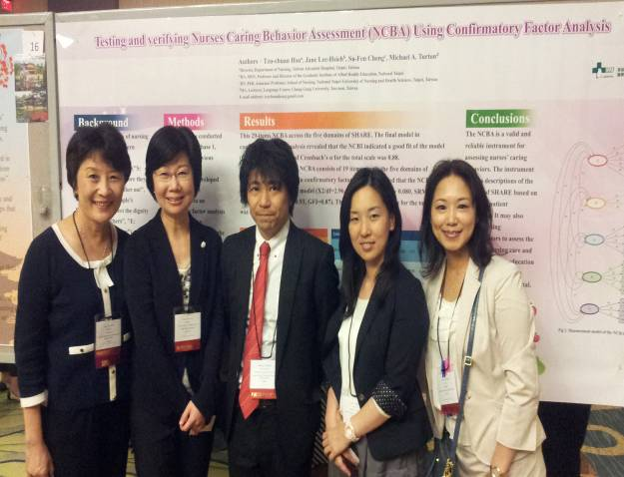
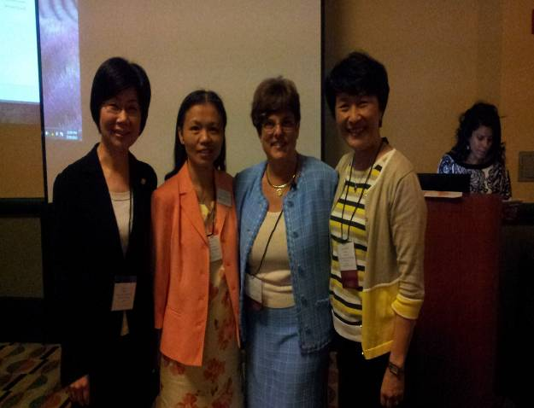
三、研究者和與會學者合照
口頭報告後與美國學者合影 壁報發表與日本學者合影
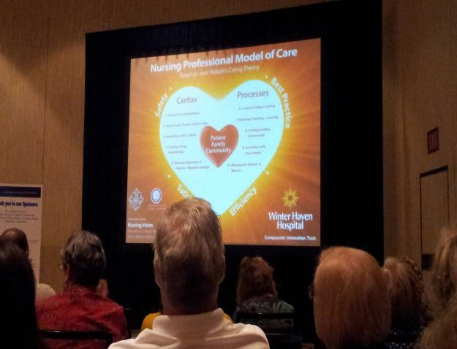
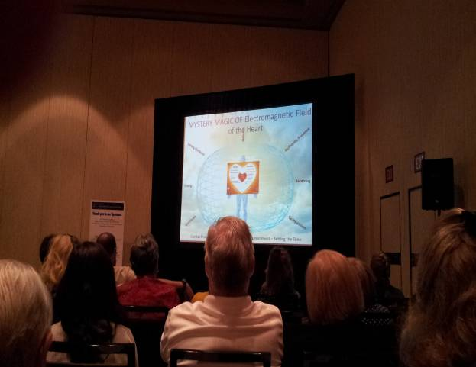
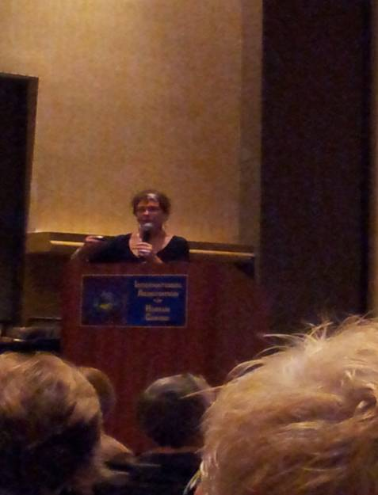
四、會議照片
