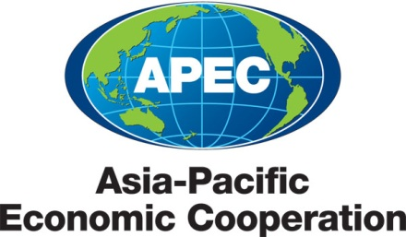
_________________________________________________________________________________
2013/SOM1/SCCP/001
Agenda Item: 3

Draft Agenda

Purpose: Consideration
Submitted by: SCCP Chair

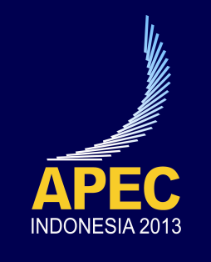 | First Sub-Committee on Customs Procedures Meeting  Jakarta, Indonesia  29-31 January 2013
Agenda

FIRST MEETING OF THE SUB-COMMITTEE ON CUSTOMS PROCEDURES
29-31 January 2013
Jakarta,Indonesia

Agenda Item #1: | Opening Remarks by the Director General of Indonesian Customs and Excise
1. The Director-General of Indonesian Customs and Excise will welcome delegates and deliver an opening remarks
Agenda Item #2: | SOM Chair’s Remarks
- The SOM Chair will be invited to deliver this remarks.
Agenda Item #3: | APEC SCCP Chair’s Remarks
3. The SCCP Chair will welcome delegates and provide opening remarks.
Agenda Item #4: | CTI Chair’s Remarks
4. The CTI Chair will be invited to address the SCCP members on the progress within CTI at SOM I, SOM II and SOM III (Russia) and the priorities for CTI for 2013.
Agenda Item #5: | Adoption of Agenda
5. The SCCP Chair will call upon the SCCP members to adopt the agenda for the 1st meeting of SCCP 2013.
Agenda Item #6: | Report of the 2012 Outcome
6. The APEC Secretariat will be invited to provide an overview of the outcomes of the APEC 2012 meetings hosted by the Russian Federation.
Agenda Item #7: | Supply-Chain Connectivity Framework
7. Chile will be invited to make a presentation on Chokepoint 8 suggested guideline
Agenda Item #8: | APEC Secretariat Communications and Public Affairs Unit (CPAU)
8. Communications and Public Affairs Unit (CPAU) of the APEC Secretariat will be invited to make a presentation
Agenda Item #9: | AEO and Partnership with Business Community
9. The US will be invited to make a presentation on the first AEO workshop that is scheduled on February 27-28, 2013
10. Indonesia will be invited to make a presentation on the development of its Authorized Economic Operator Program
11. Korea Customs will be invited to make a presentation onThe Status and Future Plan of the Study on AEO MRA Effects.
12. All SCCP members will be invited to engage in discussion on the next steps for AEO.
Agenda Item #10: | Intellectual Property Rights
13. The US will be invited to make a report on the second voluntary IPR mutual enforcement operation
14. Japan will be invited to present its proposal on holding Intellectual Property Right (IPR) border enforcement workshop
Agenda Item #11: | Collective Action Plan
15. Japan will be invited to present its proposal on progress reviews of Collective Action Plan (CAP) Items.
Agenda Item #12: | Economic Competitiveness
16. WCO will be invited to make a presentation on the WCO Economic Competitiveness Package (ECP)
Agenda Item #13: | Information Technology and Risk Management
17. Hong Kong, China will be invited to make a presentation on its efforts in deterring illegal shipments of "hazardous wastes" and "endangered species"
18. Indonesia will be invited to make a presentation on “Exchanging Outward Cargo Manifest through Single Web-based Application”
19. Indonesia will be invited to make a presentation on “Implementation of PNRGOV Standard Message for International Flights among Airlines of APEC Members”
Agenda Item #14: | Single Window
20. Japan and Chinese Taipeiwill be invited to make a report on the implementation of APEC Regional Workshop on Single Window in Malaysia, October 2012
21. Indonesia will be invited to make a presentation on National Single Window System in Indonesia
22. All SCCP members will be invited to engage in discussion on the next steps for Single Window.
Agenda Item #15: | Trade Recovery
23. Japan will be invited to make a brief presentation on matters related to Trade Recovery.
Agenda Item #16: | Other Business
24. US will be invited to make a report on VWG
Agenda Item #17: | Cross Fora Collaboration
25. Japan will be invited to present the updated SCCP Related Discussion Matrix
26. US will be invited to make a presentation on Travel Facilitation Initiative (TFI)
Agenda Item #18: | Adoption of the 2013 Work Program
27.The SCCP Chair will call upon the SCCP members to adopt the 2012 Work Program
Agenda Item #19: | Adoption of Report
28.The SCCP Chair will call upon the SCCP members to review and adopt the summary report of the 1st Meeting of SCCP 2013.
Agenda Item #20: | Closing Remark
29.The SCCP Chair will provide the final closing remarks to mark the conclusion of the SCCP2 Plenary session.

