出國報告審核表
出國報告名稱： 第六屆亞洲地區安全社區國際研討會
出國人姓名  （2人以上，以1人為代表） |  |  |  | 職稱 | 服務單位
羅文敏 |  |  |  | 專門委員 | 行政院原住民族委員會
出國類別 |  | □考察 □進修 □研究 □實習  ■其他 國際會議 （例如國際會議、國際比賽、業務接洽等）
出國期間：101年 11月 27至 101 年 12月 1日 |  |  |  |  | 報告繳交日期：102年 1月 17日
出國人員自我檢核 | 計畫主辦機關審核 |  | 審 核 項 目
■  ■  ■  ■  ■  ■  □  □  □  □  □  □  □  □  □  ■  □  ■  □  □ | □  □  □  □  □  □  □  □  □  □  □  □  □  □  □  □  □  □  □  □ |  | 1.依限繳交出國報告  2.格式完整（本文必須具備「目的」、「過程」、「心得及建議事項」）  3.無抄襲相關資料  4.內容充實完備  5.建議具參考價值  6.送本機關參考或研辦  7.送上級機關參考  8.退回補正，原因：  （1）不符原核定出國計畫  （2）以外文撰寫或僅以所蒐集外文資料為內容  （3）內容空洞簡略或未涵蓋規定要項  （4）抄襲相關資料之全部或部分內容  （5）引用其他資料未註明資料來源  （6）電子檔案未依格式辦理  （7）未於資訊網登錄提要資料及傳送出國報告電子檔  9.本報告除上傳至出國報告資訊網外，將採行之公開發表：  （1）辦理本機關出國報告座談會（說明會），與同仁進行知識分享。  （2）於本機關業務會報提出報告  （3）其他  10.其他處理意見及方式：
出國人簽章（2人以上，得以1人為代表） |  |  | 計畫主辦機關  審核人 | 一級單位主管簽章 |  | 機關首長或其授權人員簽章
說明：
一、各機關可依需要自行增列審核項目內容，出國報告審核完畢本表請自行保存。
二、審核作業應儘速完成，以不影響出國人員上傳出國報告至「公務出國報告資訊網」為原則。

出國報告（出國類別：其他-國際會議）

第六屆亞洲地區安全社區國際研討會

服務機關：行政院原住民族委員會
姓名職稱：羅文敏專門委員
派赴國家：日本（國際會議中心）
出國期間：101年11月27日至12月1日
報告日期：102年1月
目 錄
一、摘要 5
二、過程 6
（一）101年11月27日 6
（二）101年11月28日 6
（三）101年11月29-30日 7
（四）101年12月1日 8
三、會議心得及建議 9
四、附件目錄：
附錄一：研討會議程及日程 12
附錄二：活動照片 15
附錄三：其他國家相關文件或展示品 16
附錄四：本會發表及補助海報之摘要內容 17

一、摘要：
本會為積極參與國際安全社區交流，近3年均指派人員參加該國際會議，例如98年由前劉玉娟專員（轉調至衛生署）參加大陸主辦之「第5屆亞洲國際安全社區研討會」、99年由前陳淑敏副處長（已退休）參加韓國主辦之「第19屆國際安全社區研討會」、100年由衛生保健科張信良科長（現任）參加瑞典主辦之「2011年國際安全社區研討會」，今（101）年則由本人奉派參加日本主辦之「第6屆亞洲國際安全社區研討會」也藉由本次出國參訪的機會，學習日本在防災安全上的相關措施。
而「安全社區」國際研討會已成為每年常態式的辦理，藉由各國間成果報告逹到彼此間的觀摩及交流，而共同的目標即是於部落共識下，在地制宜整合資源，以減少各種意外或故意性的傷害、營造更安全的環境、促進人際和諧、增進每個人身體、心理與社會全面的安適而不斷努力的一種運動。而國際的重視，在於世界衛生組織（WHO）於 1989年在瑞典成立了「世界衛生組織社區安全推廣協進中心」，協助全世界社區從事安全促進的工作。並訂定了「安全社區」的六大指標，以公開認證的方式，推廣社區安全促進的理念，形成世界性的「安全社區網」，促進安全工作。
依據WHO國際安全社區準則第六項指標-「分享：安全社區必須持續性的參與國內和國際的安全社區組織」。因此，本會及辦理「安全社區」或「安全學校」的原住民部落社區，也展開積極國際交流活動，除將本國辦理經驗及過程與他國分享，也期透過國際會議中學習到不同的各項事故傷害防制工作創見，利用安全社區計畫工作有效分擔政府的負荷，建立一個賦能社區的雙向機制，透過政府、公民社會和私部門各自獨特的角色與責任，共同合作處理安全問題，讓部落發展為具有安全的健康社區，是本次參加會議最高願景及目的。

二、過程：

（一）第一天-101年11月27日
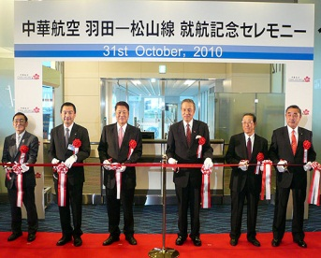
獨自出發前往日本，於99年10月31日開航的台北松山對飛東京羽田，舊稱「東京國際機場」，於1931年開放使用。1978年新建的成田機場(NRT)完工後，成田機場便接手了東京大部分的國際航空交通量，羽田機場便作為國內線航空交通之用。由車站前往辦理登機手續的櫃檯只需要幾十米，十分方便。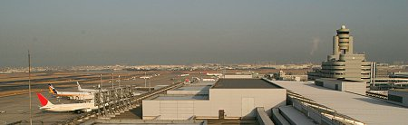
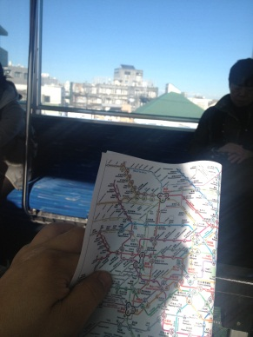
羽田機場位於東京市中心以南約30分鐘路程處。它含有三棟航站大廈：第一航廈主要由JAL及其附屬航空公司使用，第二航廈主要由ANA及其附屬航空公司使用，國際航廈則由20個航空公司使用。
一出機場後搭山手線地下鐵前往品川，轉搭JR到逹住宿目的地池袋車站。充分體驗東京密佈的地下鐵是極為便利及容易辨識的管理系統；手上看著東京都心路線圖，值得學習的是日本人以不同顏色及英文字母區隔各路線圖，各站間又以數字替代，以方便各國觀光客容易了解。所以本人便順利獨自搭地鐵到逹住宿飯店。

（二）第二天-101年11月28日
由於本日全日為報到日，晚上晚宴預計七點開始，由本會「101年健康原氣、安全部落－原住民事故傷害防制計畫之專案管理中心」計畫主持人郭憲文教授參加。為熟悉前往研討會會場的路線，及順道尋找日本防災新商品，特以步行方式，由住宿地點步行前往研討會地點，即太陽城五樓會議室。

（三）第三、四天-101年11月29-30日
29日議程分為上午海報展示及說明，及下午各國口頭報告，而場次講演議題共有「校園安全」、「兒童安全」、「交通安全」、「社區安全」、「老人安全」等議題，本次研討會台灣總共有21篇論文口頭發表，另外共有21篇海報發表，其中本團論文口頭發表為3篇，由台灣公共衛生學會郭憲文老師，發表承接本會計畫之成果，以充分與其他亞洲國家充流。海報發表為6篇，海報發表部分，備有本會簡介DVD及紀念品,故發問非常踴躍；29日下午及30日上午則因時間有限，故參加較有興趣之簡報來聆聴，計有：
- 高齡者及兒童的自行車事故預防（日本）
- 阿里山山地原住民鄉社區交通安全之推動（台灣）
- 文山地區之防災與管理（台灣）
- 獨居老人之生活支持(日本)
- 地震之防災-針對居家失能者之策略(日本)
- 2011年洪水危機分析未滿15歲少年之死亡及預防措施(泰國)
30日下午則前往日本豐田汽車展示場，由下圖可知日本在汽車製造上，充分考慮人性化的需求，尤其在日本超高齡化的人口狀況下，特別在老人及失能者，於汽車進出不便下，設計了便利輪椅上下及進出的汽車裝置，實在為之佩服。而在能源環保的設計上也可看出未來電動汽機車之充電站的建置，並且利用太陽能及風力來作充電的來源，亦在落實環保政策下，下了很大的功夫。日本製造業一向靠技術能力獨霸全球，本次的參觀，更能感受日本以技術能力為基礎的問題解決能力取勝。
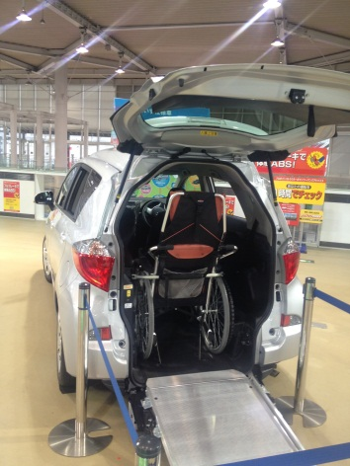
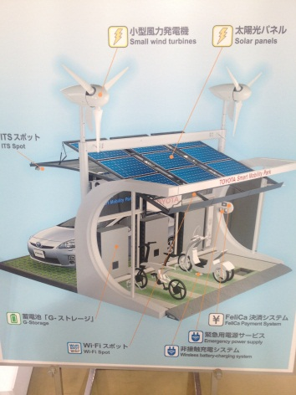
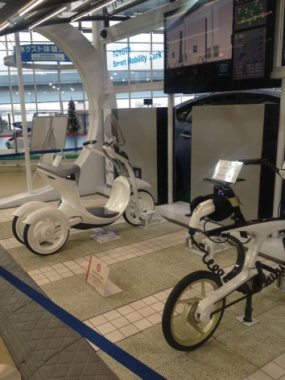
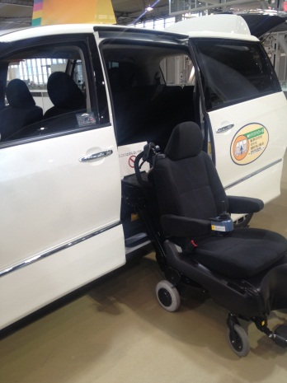
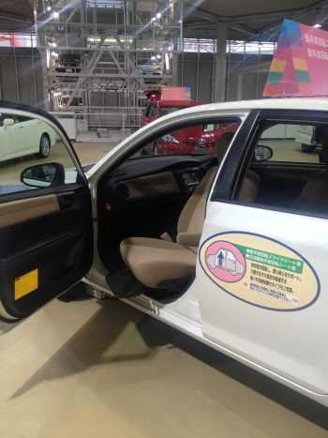
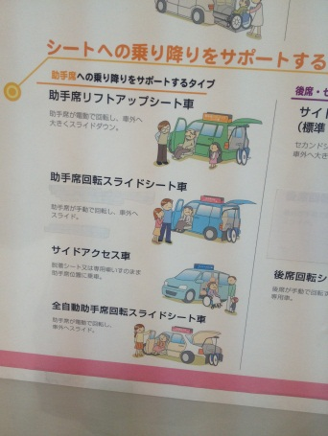

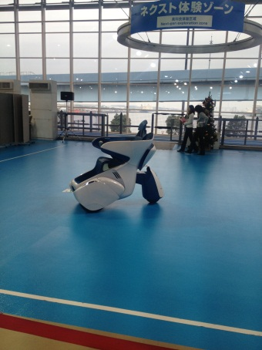
輪椅無障礙進出
無障礙自動進出
太陽能風力充電
電動汽機車實物
前座貼心進出
輪椅進出示意圖
多功能無障礙車
未來新電動車

（四）第四天-101年12月1日
本日為回程日，預定中午之回程機票，故一早收拾行李，便前往羽田機場。

三、會議心得及建議：
隨著全球暖化氣候變遷所衍生溫室效應，氣候異常及海平面上升，再加上日本地區多有地震及水災等，而形成常態化的現象。日本阪神大地震導致建築物倒塌，其中有46萬棟房屋遭受損壞，約有6000多名死者，約有9成是被塌毀的房子壓死，高逹8成之民眾是由當地居民救出。日本已而累積相當的防災經驗，例如大都巿擁擠，發生地震房子倒塌後，因彼此相連常會引起火災，故日本在後續重建時，會拓寛道路，並提高道路兩側建築物之耐震度。
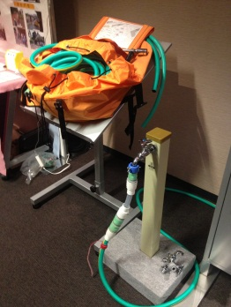
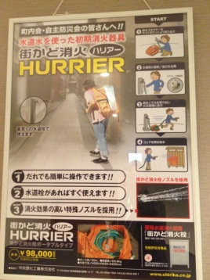
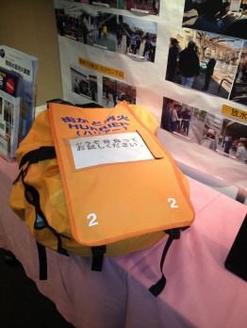
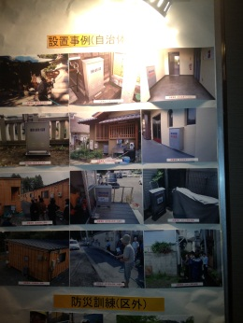

而其預防策略為自助及互助的地方社區以彌補政府支援之不足。故吸取日本防災的主要重點為加強初期滅火，故有簡易個人滅火設備（如上圖），平常需準備避難設施，做好避難生活管理體制，以致發明女性防災包、防寒溼塑膠包、生水過濾吸管等防災用品。（如下圖）

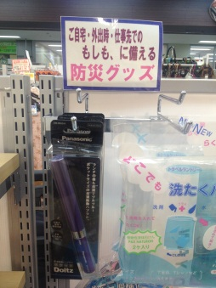
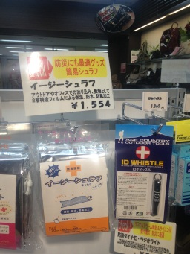
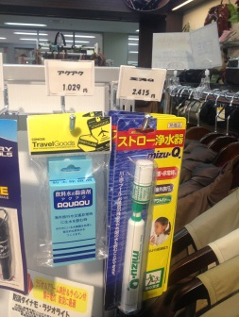

所幸在日本商店有參觀多種的防災用品，或許在建置原住民地區防災策略時，可加以應用並將原住民地區特殊需求的防災用品普及化。而本人亦將此建議於本會擴大會報提出建議，以作未來原住民防災規劃，以為本次出國一個重要的收獲。
經過本次出國感想，日本在於製造業技術的優勢，已經考慮到人性化、便利性及未來趨勢的問題，反觀本國，其台灣的優勢即是資訊技術的優勢，為亞洲第一，全球第三的能力，故在未來有關原住民政策上，應充分以資訊技術為基礎下，規劃出部落民眾有感的資本建設，故而建議本會規劃建置原鄉智慧防災戰情中心之提案，業於101年12月13日在本會第427次主管會報上，提出建議及簡報；其決議之二為「防救災Ｅ化是一項趨勢，如何運用現化科技，掌握資訊，整合資源作多元的運用，本會各處室應有跨單位的整併思考作為，請本會企劃處先洽內政部資訊中心瞭解救災體系與本會競合部分；別機關已建置的希望可以結合分享，其不足部分，且是本會不可或缺的，似可納入未來機制建置之研議」。故由此獲本會長官之支持及指導，亦是另一個重要的收獲。

附件：
附錄一：研討會議程及日程
附錄二：活動照片
附錄三：其他國家相關文件或展示品
附錄四：本會發表及補助海報之摘要內容
- 附錄一：第六屆亞洲地區社區安全國際會議議程研討會
- 議程
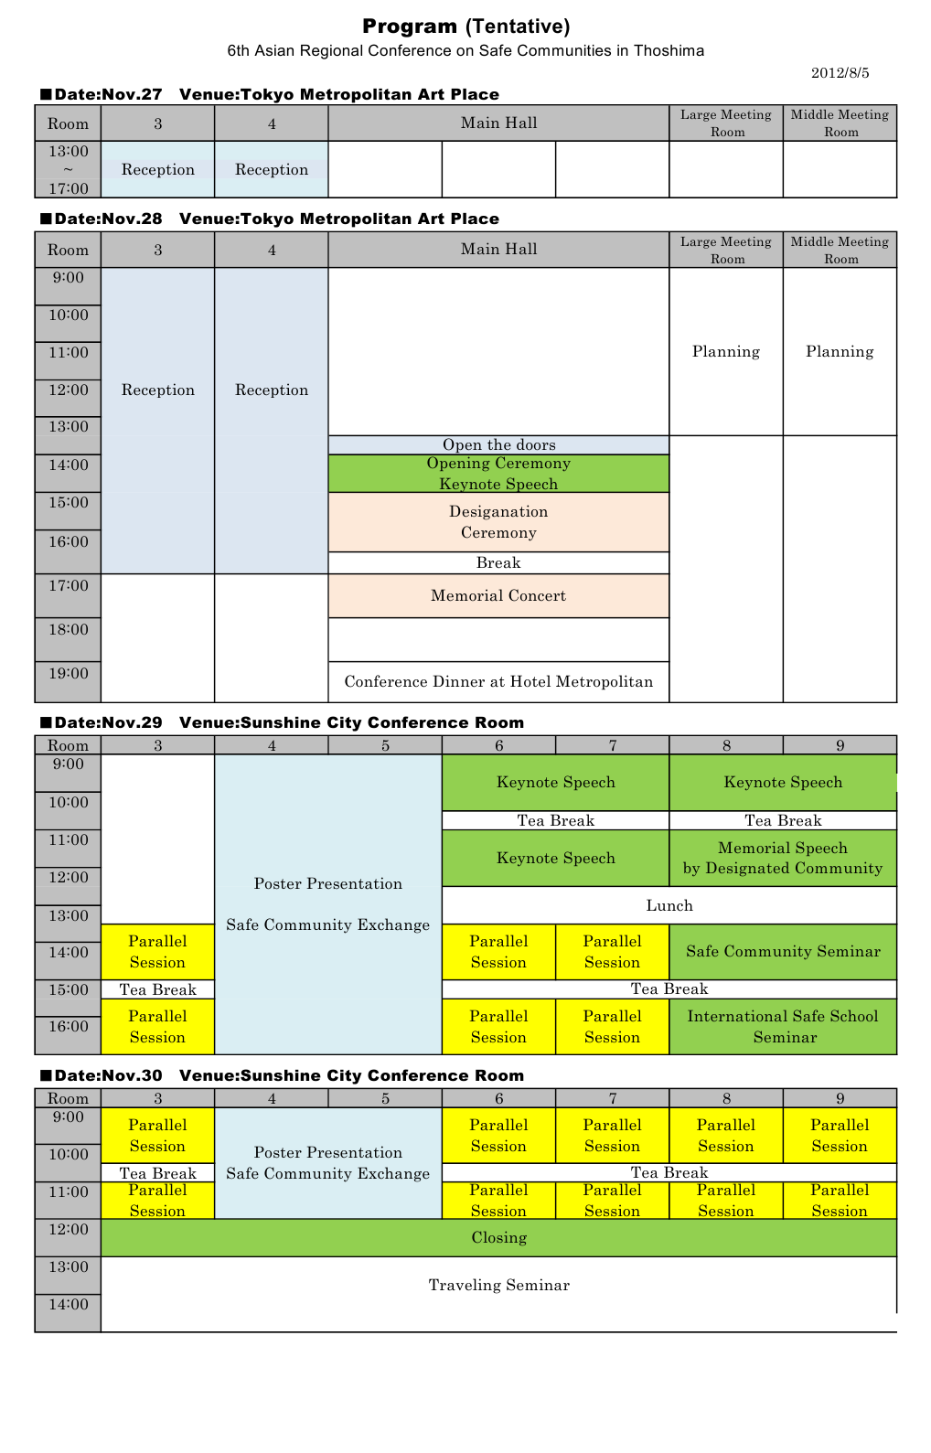
- 口頭報告及海報展示
編號 | 投稿單位 | 報告者 | 類別 | 題目
1 | 行政院原住民族委員會 | 郭憲文 | 口頭 | A successful strategy for the promotion of a reduction in alcohol use among indigenous peoples in Taiwan
2 | 專管中心 | 郭憲文 | 口頭 | Prevalence of habitual alcohol use amongindigenous Taiwanese: a national telephone-interview study in 2010 to 2011
3 | 國立臺灣師範大學 | 胡益進 | 口頭 | The Application of the Health Belief Model to the Related Factors Regarding the Playground Injuries Prevention Behavior among the Kindergarten Teachers
4 | 專管中心 | 郭憲文 | 海報 | An effective program for the promotion of strategies that reduce unintentional injuries in Taiwan ’ s indigenous communities
5 | 臺中市和平區健康促進推廣協會 | 詹美鳳 | 海報 | Hold on use right leg while motorcycle vehicles parking in cross-section road
6 | 花蓮縣秀林鄉加灣社區營造協會 | 鄭秀蓮 | 海報 | Effects of the reduction of alcohol drinking in an indigenous Truku tribe
7 | 花蓮縣秀林鄉秀林社區發展協會 | 郭憲文 | 海報 | A Vision of Safe, Healthy, and Happy Living in Shulin, Hualien County
8 | 宜蘭縣大同鄉部落健康促進會 | 郭憲文 | 海報 | The integration of public and private resources to promote a safe community in Datong Township
9 | 國立臺灣師範大學 | 胡益進 | 海報 | The Responsibility and Committment of International Safe School Movement

- 參與人員
編號 | 單位 | 職稱 | 中文姓名
1 | 花蓮縣秀林鄉加灣社區營造協會 | 執行人 | 鄭秀蓮
2 | 臺中市和平區健康促進推廣協會 | 執行長 | 詹美鳳
3 | 臺中市和平區健康促進推廣協會 | 居家安全召集人 | 陳素如
4 | 臺中市和平區健康促進推廣協會 | 主任委員 | 黃永生
5 | 臺中市和平區健康促進推廣協會 | 學童安全副召集人 | 張淑芬
6 | 臺中市和平區健康促進推廣協會 | 觀光水域副召集人 | 羅濟貴
7 | 臺中市和平區健康促進推廣協會 | 傷害資料監測組員 | 傅蘭美
8 | 臺中市和平區健康促進推廣協會 | 農事安全組員 | 傅黎葳
9 | 臺中市和平區健康促進推廣協會 | 蓄意性傷害防制組員 | 陳嘉淳
10 | 國立陽明大學 | 教授 | 郭憲文
11 | 國立陽明大學 | 助理 | 林筱淇
12 | 國立臺灣師範大學 | 教授 | 胡益進
13 | 行政院原住民族委員會 | 專門委員 | 羅文敏

- 附錄二：活動照片
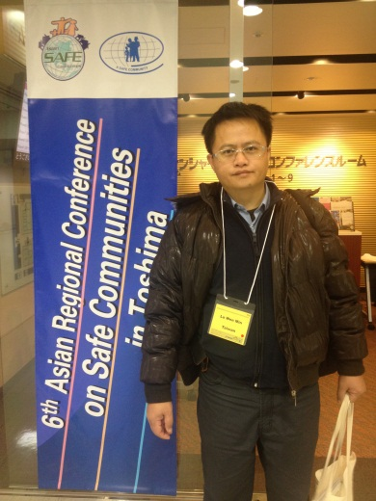
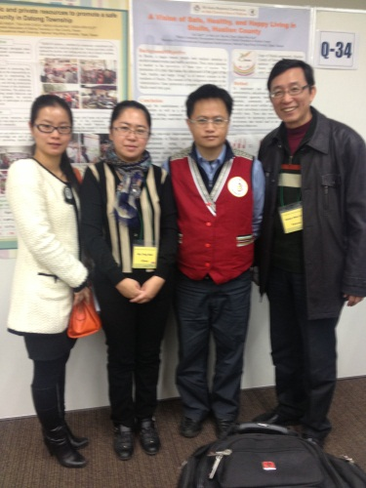
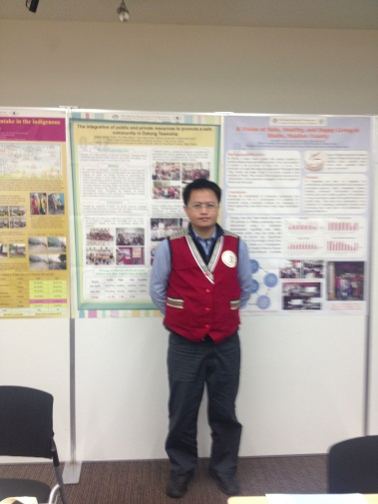
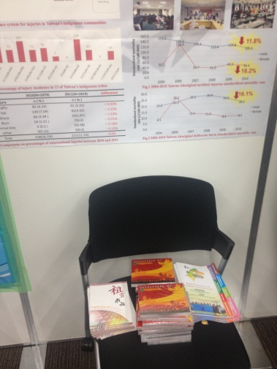
本會代表羅專委於報到會場
於本會海報成果前與大陸代表合影
本會代表羅專委於海報前留影
本會DVD簡介及14原住民族介紹贈品於海報前，免費贈送國外友人

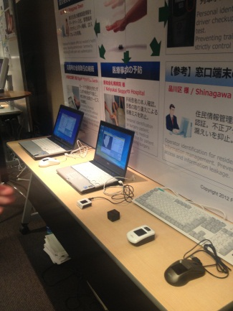
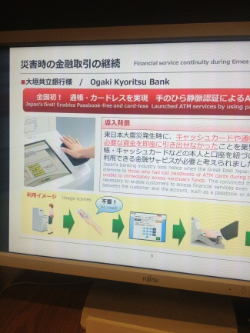
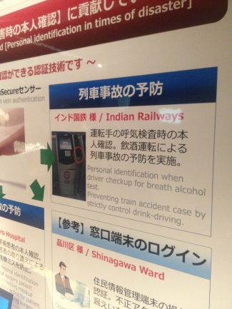
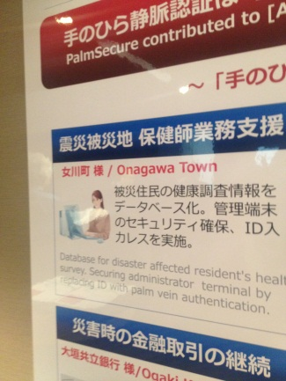
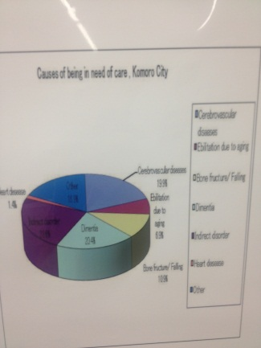
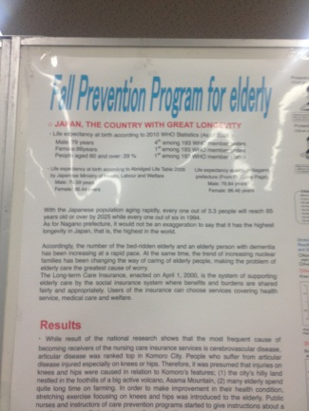
附錄三：其他國家安全社區相關文件或展示品
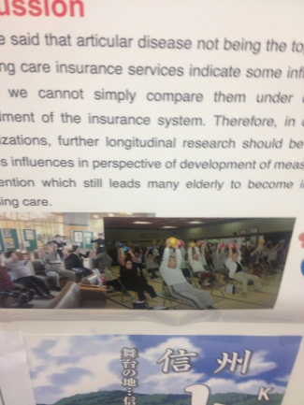
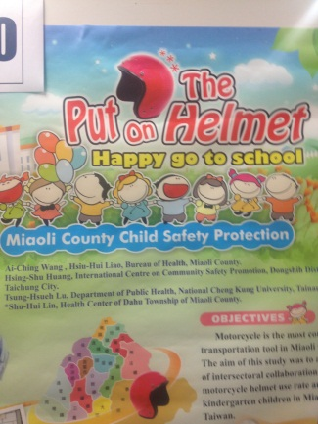
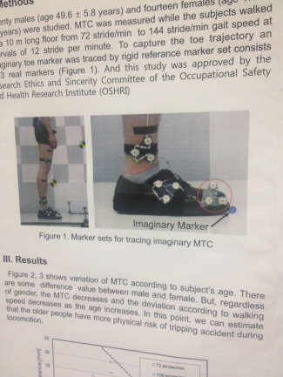
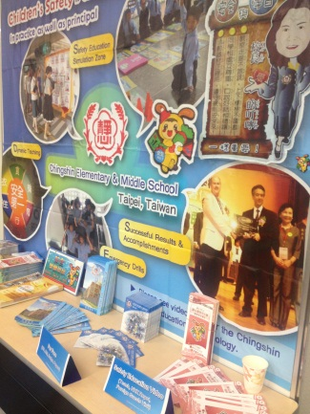
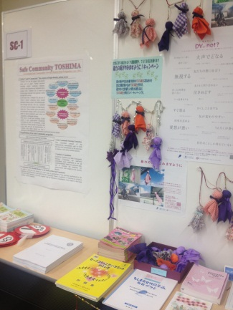
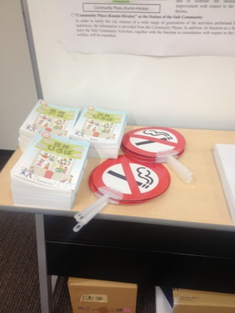
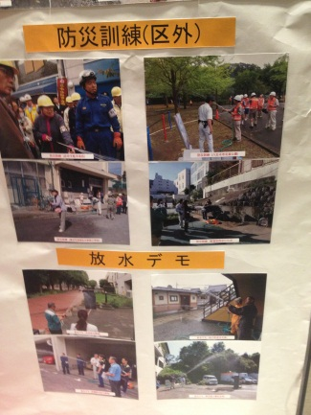
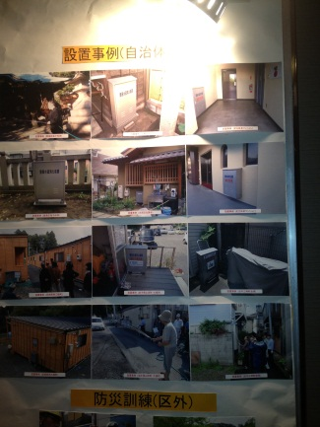
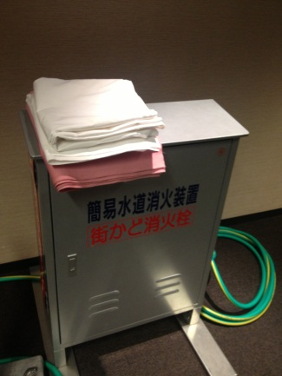
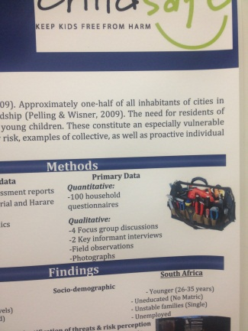
附錄四：本會發表及補助海報之摘要內容
  - 行政院原住民族委員會
A SUCCESSFUL STRATEGY FOR THE PROMOTION OF A REDUCTION IN ALCOHOL USE AMONG INDIGENOUS PEOPLES IN TAIWAN
Hsien-Wen Kuo¹, Ta-Chuan Sun², Shin-Liang Chang², Lih-Chen Ke², Chih-Fei Chen¹
¹Institute of Environmental and Occupational Health Sciences, National Yang-Ming University, Taipei, Taiwan; ² Taiwan’s Council of indigenous People, Executive Yuan, Taipei, Taiwan

Background/objective
The consumption of alcohol in the indigenous population significantly exceeded the average of the Taiwanese population, leading to findings of high mortality rates due to liver diseases. Under government sponsorship, we established a program in which we established managing centers for the supervision promotion of alcohol use reduction in indigenous communities. This sponsorship also covered the data analysis performed afterwards to investigate whether this program led to any significant results. The objective of this study is to develop a successful strategy for the promotion of alcohol drinking reduction among the indigenous population.
Methods
Twelve different communities of Taiwan’s indigenous peoples were included in this study. We trained members of these communities to promote the reduction of alcohol use within the community. The managing centers were then established to supervise these communities. In this program, we employed the use of a local expert who assisted us in organizing our team members. Volunteers were also recruited to help us in this project. This program also included encouraging members of the community to sign a contract of commitment to the program’s objective (namely, to reduce the amount of habitual drinking). Our team made efforts to use all available resources (health centers, churches, and so on) to optimize the effectiveness of this program.
Results
Our management centered collected data on community drinking habits via two means: face-to-face survey in the community and telephone survey over the whole indigenous population. The data shows that there was a significant reduction in drinking after the institution of our program. Comparing the results to the survey performed in 2004, 2011 showed a 15% reduction in alcohol use. Through these surveys, we also found that the members of this community displayed an increased knowledge of the (mainly adverse) effects of alcohol use as well as an increased motivation to reduce the amount of alcohol consumed.
Conclusions
Although our program was only employed in 12 indigenous communities, it is highly likely that this run of our program had a significant impact on the indigenous communities throughout Taiwan.
  - 「101年健康原氣、安全部落－原住民事故傷害防治計畫」專管中心
PREVALENCE OF HABITUAL ALCOHOL USE AMONG INDIGENOUS TAIWANESE: A NATIONAL TELEPHONE-INTERVIEW STUDY IN 2010 TO 2011
Hsien-Wen Kuo¹, Ta-Chuan Sun², Shin-Liang Chang², Lih-Chen Ke², Chun-Ping Tu¹
¹Institute of Environmental and Occupational Health Sciences, National Yang-Ming University, Taipei, Taiwan; ² Taiwan’s Council of indigenous People, Executive Yuan, Taipei, Taiwan

Background/objective
Because the consumption of alcohol is an important part of aboriginal culture, the mortality rate of unintentional injuries among indigenous peoples is higher than that of the rest of the population in Taiwan. The objective of this study is to investigate the prevalence of alcohol drinking in 2010 and 2011 among the indigenous Taiwanese, using a national telephone-interview survey.
Method
Because there is no database of indigenous peoples in Taiwan, we used a telephone-interview survey to randomly dial in indigenous area. A structured questionnaire modified from a WHO survey was used to interview to each indigenous person. We conducted the interview under a strict procedure of quality control and assurance.
Results
In 2010, it was found that the overall prevalence of drinking among the indigenous peoples interviewed was 44%. There was a difference in gender, with 53.4% of men having a drinking habit and 37.5% of women having one. In 2011 the results were lower. There was a 2% decrease in drinking for the overall sample, a 5% decrease for men, and a 1.6% decrease for women. The final measured rates for men and women were 48.4% (men) and 35.9% (women). Looking back to Dr. Ko’s study of the same population in 2004, we can find that from 2004 to 2011 there was a 15% overall decrease in habitual drinking.
Conclusions
The overall decrease in drinking is likely attributed to the results of a government anti-drinking program initiated after 2004. In this way, our study provides evidence that this program was effective in reducing the amount of drinking, thereby reducing the unintentional injuries of these indigenous peoples.
  - 「101年健康原氣、安全部落－原住民事故傷害防治計畫」專管中心
AN EFFECTIVE PROGRAM FOR THE PROMOTION OF STRATEGIES THAT REDUCE UNINTENTIONAL INJURIES IN TAIWAN’S INDIGENOUS COMMUNITIES
Hsien-Wen Kuo¹, Sheau-Chyi Lin¹, Ta-Chuan Sun², Shin-Liang Chang²,Lih-Chen Ke², Chen-Tz Wen¹
¹Institute of Environmental and Occupational Health Sciences, National Yang-Ming University, Taipei, Taiwan; ²Taiwan’s Council of Indigenous People, Executive Yuan, Taipei, Taiwan

Background/objective
Because the leading cause of death in indigenous communities is unintentional injury, it is vital to develop an effective program for the promotion of strategies that can reduce unintentional injury rates among indigenous populations.
Methods
We established management centers to supervise QA/QC and outcome as well as evaluate the performance of 15 NGO/NPOs in indigenous communities. The Taiwanese government provided this program with funding. The NGO/NPOs had three necessary tasks: organize the team, establish a surveillance system, and create a volunteer team. From the collection of information from each indigenous community, we determined the priorities of the strategies. These priorities included the reduction of the following: alcohol drinking, falling down, fires, intoxication, home injuries, agricultural injuries, and traffic injuries. The strategies developed were based on the 4Es (Engineer development, Education to modify unsafe behavior, Enforcement to supervise, and unsafe Environmental modification).
Results
Over the two-year span of the program, we saw changes in the rates of various unintentional injuries as per telephone interview data. An overall decrease of 4% was found (16.1 prior to the start of the program and 12.1 afterward). There were decreases in falling (from 7.04% to 4.50%--a change of 2.25%), cuts (from 3.34 to 1.81%--a change of 1.53%), and burns (from 1.21% to 0. 30%--a change of 0.91%). Unfortunately, an increase in injuries due to traffic accidents was found (up 0.9% from 4.15% at the beginning of the program—a total of 5.05%).
Conclusions
Due to a high incidence of injuries in indigenous communities, Taiwan’s government sponsored a program for the promotion strategies to reduce unintentional injuries. This program has shown an effective intervention for the reduction of unintentional injuries in indigenous communities.
  - 臺中市和平區健康促進推廣協會
HOLD ON USE RIGHT LEG WHILE MOTORCYCLE VEHICLES PARKING IN CROSS-SECTION ROAD
Mei-Feng Zhan¹, Yong-Sheng Huang¹, Wan-Zhi Huang¹, Zhu-Ru Chen¹, Mu-Sng Chen¹, Hsien-Wen Kuo²
¹Health Promotion Association of Heping Dist. in Taichung City, Taiwan; ²Institute of Environmental and Occupational Health Sciences, National Yang-Ming University, Taipei, Taiwan

Background/objective
Injuries surveillance system can be provided as the basis of the safe community through the encouragement and cohesion of community. We integrate various resources to collect data of injuries in detail, such as demographic information of injury victims, events of timing and place, severity and location of injuries. However, information of injuries should be analyzed and presented for taking as a reference of injury prevention.
Procedure
A victim from injury of motorcycle during medical care in clinic was reported the information regarding to the procedure of injuries occurrence. He rode locomotive when stops the traffic light, the toe and instep in their left foot was ran over by a car driving front wheel milling. However, the driver unexpectedly did not know the milling to my foot, I forcedly beat the automobile glass and notice this injury events.
Findings
This story of injury event was rewritten and analyzed by The Peace Community Safe Promotion Association (PCSPA) to disseminate residents in community. According to our habit of locomotive parking using left leg to step on when stop the traffic light. However, this situation will lead to danger for drivers of locomotive from nearby motor vehicles. We suggested that drivers of locomotive should be careful the danger situation from parking of locomotive when stops the traffic cross-road. Using realistic event of injury from locomotive can easily be understood and convinced residents to take preventive method in indigenous community. Furthermore, it is vital to take as a reference for designing various preventive strategies based on the surveillance system of injury.
Conclusions
Through realistic victim self-reported from procedure of traffic injury, it can heartily touch and inspired other residents in community to take action for prevention of traffic injury.
  - 花蓮縣秀林鄉加灣社區營造協會
EFFECTS OF THE REDUCTION OF ALCOHOL DRINKING IN AN INDIGENOUS TRUKU TRIBE
Shug-Lien Cheng¹, Mei-Jhih Syu¹, Qing-Sia Tang¹, Hsien-Wen Kuo²
¹Qowgan Community Building Association of Sioulin County in Huailen Country, Taiwan; ²Institute of Environmental and Occupational Health Sciences, National Yang-Ming University, Taipei, Taiwan

Background/objective
Youths in this Truku tribe have a high death rate stemming from cirrhosis and injuries due to related to the consumption of alcohol. The objective of this study is to promote an alcohol-reduction program in this indigenous Truku tribe.
Method
An alcohol-reduction program was conducted in 2009 in this community, integrating various resources from the domestic religion, nonprofit organizations and public sectors. Volunteers were enrolled and community participation was encouraged to establish supporting systems in the tribe such as public policy, employment training courses, tea-drinking groups as replacements to alcohol-drinking groups, information exchanges and strategies to reduce falling among elderly.
Results
A significant reduction of death from the overuse of alcohol was found after the implementation of the program during three-year period. Every person in the tribe recognized the serious problem of alcohol and also established a commitment to reduce alcohol drinking. The number of volunteers advocating alcohol reduction and encouraging alcoholics increased from 10 to 40 persons. Furthermore, the mortalities and incidence of injuries significantly decreased due to the changing climate of alcohol reduction in the tribe.
Conclusions
A practical intervention program in the indigenous Truku tribe was successfully conducted through the participation and commitment of the community as well as due to the integration of various resources in the reduction of alcohol drinking.
  - 花蓮縣秀林鄉秀林社區發展協會
A VISION OF SAFE, HEALTHY, AND HAPPY LIVING IN SHULIN,
HUALIEN COUNTY
Hsien-Wen Kuo¹ , Yuli Taki², Ai-Mei Lin², Shu-Ru Zhan²
¹Institute of Environmental and Occupational Health Sciences, National Yang-Ming University, Taipei, Taiwan; ²Shulin Community Development Association of Shulin Township in Hualien County, Taiwan

Background/objective
In Shulin, a major reason people seek medical attention is alcohol-related events and traffic accidents. Thus, more attention is needed in the prevention of these types of injuries. The promotion of a plan that seeks the attainment of the goal of the “safe, healthy and happy living” is of utmost concern to the residents of Shulin. The counsel of the indigenous peoples in the Administrative Yuan sponsored a program to help the people of Shulin reach their goal.
Method
To implement our plan, we integrated the administrative, educational and health care resources of government agencies, health management stations, hospitals, community development associations, churches and social welfare agencies. We established an injury surveillance system that reported injuries on a monthly basis. These data were disseminated to the community for increasing community awareness and involvement that would lead to the modification of dangerous behaviors.
Results
As a result of these efforts, there has been a 10 percent increase in the number of people willing to reduce or completely stop their drinking behavior. There has also been a 10 percent increase in the number of people willing to encourage and support the decision by a family member to reduce or completely stop their drinking behavior. Another positive effect is the transformation of individual volunteers to volunteer families, which has enabled a more effective follow-up, an analysis of factors, an allocation of resources and an elimination of factors related to alcohol-induced accidents.
Conclusions
Through the establishment of community mechanisms and partnerships as well as a development of a platform for interaction among community residents, the community of Shulin expects they reach their vision of safe, happy and healthy living.

  - 宜蘭縣大同鄉部落健康促進會
THE INTEGRATION OF PUBLIC AND PRIVATE RESOURCES TO PROMOTE A SAFE COMMUNITY IN DATONG TOWNSHIP
Hsien-Wen Kuo¹, Cheng-Kung Chen², Yu-Ying Hsieh², Tsai-Chin Chou², Meng-Hsuan Mu²
¹Institute of Environmental and Occupational Health Sciences, National Yang-Ming University, Taipei, Taiwan; ²Tribal Health Promotion Association of Datong Township in Yilan County, Taiwan

Background/objective
Because of a high incidence of injuries in Datong’s aboriginal areas stemming from alcohol-related behavior and unsafe environment, our program established a plan to reduce this incidence rate.
Method
We organized an aboriginal committee to assist in promoting this program. The chairman of this committee took on the responsibility to integrate the public and private resources in empowering the community’s people to avoid unsafe behaviors, such as consuming alcohol, administrating medicine improperly, and driving motorcycles without helmets. Volunteers investigated the houses in the community for unsafe situations, including designs and facilities. The police also periodically monitored the community, noting unsafe behaviors and environmental issues. Throughout this program, we actively encouraged the residents of this community to participate in actions that would reduce injuries due to such behavior.
Results
There were six main results of our project. 1) The knowledge and skill of the community’s residents in terms of preventing injuries was upgraded. 2) An injury surveillance system was established to track the data that could present the reasons for the injuries. 3) Residents of the community signed commitments to reduce the unsafe behaviors; these commitments included reducing the amount of alcohol drank and wearing helmets while riding motorcycles. 4) The monitoring of unsafe home environments, especially for the homes of the elderly and infants was established. 5) A prevention strategy for injury reduction was developed to control the incidence rate. 6) The program’s data and results were disseminated throughout the community. Conclusion: Through the integration of public and private resources, including residents of the community, we systemically took steps to move DaTong township toward its goal in becoming a safe community.

