出國報告（出國類別：其他）

東亞植物園網絡會議報告書

服務機關：行政院農業委員會林業試驗所
姓名職稱：董景生 副研究員
派赴國家：俄羅斯
出國期間：101/9/23～101/9/29
報告日期：101/10/20
摘要
東亞區中國、日本、俄羅斯、韓國、台灣等國家共同舉辦“the East Asian Flora”(東亞植物誌) 聯合學術研討會，並同步舉行三個研討會的桌邊國際會議，其中之一為“East Asian Botanic Garden Network”(東亞植物園網絡會議)。此東亞區植物園網絡提供一個有利場合，幫助東亞各國在共同平台上，一起朝著建立共識的研究與管理方向努力。臺灣自第一屆會議起即為東亞植物園網絡之成員，前三屆亦皆派員與會報告現況，以確保會籍並保持與國際社會之合作互動交流，本次俄羅斯為第四屆主辦國，因此派員代表台灣參與會員國會議，除了報告台灣植物園現況，並加強東亞區交流。會後選舉下屆東亞區植物園網絡主席，仍由中國代表黃宏文連任。

目次
一、出國目的 4
二、過程 4
三、心得及建議 7
四、附件一(邀請函) 9
五、附件二(報告全文) 10
六、活動照片 17

本文

一、出國目的
東亞植物區系，是全球最豐富且最古老的植物群，於一百多年前，中國、日本、韓國、俄羅斯等各研究學者的研究，已經漸漸累積東亞植物區系和植被的知識和經驗，但因其包含範圍廣泛，物種豐富，還有很多尚未探索的領域。然而，在此區域各國的條款和植物學相關的理論、文化政經上的差異，造成了諸多分歧。但歐亞植物地理學則相反，在植被區劃的概念和理論，皆已形成共識並進而建立起預測模型，而歐亞大陸的東部邊緣-東亞地區，仍有許多懸而未決的問題。
有鑑於此，俄羅斯、日本與中國等三個國家共同舉辦 “the East Asian Flora” (東亞植物誌) 聯合學術研討會，並同步舉行三個平行研討會附加會議，其中之一為“East Asian Botanic Garden Network”(東亞植物園網絡會議)。本此研討會將提供一個有利場合，幫助東亞各國在共同平台上，一起朝著建立共識的研究與管理方向努力。
臺灣自第一屆會議起即為東亞植物園網絡之成員，前三屆亦皆派員與會報告現況，以確保會籍並保持與國際社會之合作互動交流，本次俄羅斯為第四屆主辦國，因此派員代表台灣參與會員國會議。

二、過程
101年9月23日
由桃園機場至香港轉機，抵達俄羅斯海參崴機場時已11:30pm
101年9月24日
EABGN會議：主席為中國代表洪宏文、副主席為俄羅斯代表Victor Kuzevanov，研討會主辦人Pavel V. Krestov。
各國代表包括：大會秘書日本代表邑田 仁；日本代表菅原 敬、中村幸仁、田中信行；中國代表莊娛樂、吳宜亞；韓國代表Woo-Seok Kong等四位；俄羅斯代表Yuri N. Gorbunov等三位；以及台灣代表董景生。

會議中首先由日本的祕書進行前三次會議的結論與大綱報告。
接著由各國代表進行十分鐘現況報告(略，職報告內容如附件二，並將台北植物園英文摺頁贈送與會國家)。
討論議題為：
1.有關未來可能的跨國合作
2.科學家的互訪
3.網站的設計與功能
4.解說志工的可能性
以下件要紀錄各國代表的發言與討論：
大會主席
討論東亞區植物園網絡的下一步。
包括網路的公開化資料共享，以及因應BGCI的目標，與社區進行結合。
RIO+20(今年巴西CBD會議)的COP下有對種子權益、利益分享取得共識，因此各國植物園未來在收集種源時更要注意，種源的來源合法、與當地的互動。若由植物園將種子釋放出去，更應先簽定備忘錄，以免藥商得利後沒有回饋給產地國或在地社群。目前植物園衍生智慧財產利益的問題，通常就是在藥物開發上特別容易被注意，基本上亞洲各國的國科會或科研機構，都已經定了一些在地利益分享規章，所以在各國的國家簡報裡，未來會更加強這部分權利義務的規範與自主管理。

韓國代表
溫帶區域植物園能否進行較深化的合作？
案例分享(保育與植物園管理，並邀請WWF韓國的亞洲虎保育計畫報告)

俄羅斯代表
目前正在設置新的日本庭園，日本庭園對俄羅斯而言充滿異國情趣，藉著新的庭園希望能吸引到民眾對鄰近日本類似區的溫帶植物的興趣。
物種保育，正在進行幾種稀有物種的組織培養，域外保存，稍後並參觀該實驗室。
植群研究是否可以統一規格與形式。
(主席裁示於另一個side events會議中討論，職於三天後受邀此會議，詳述於後節)

日本代表
日本並未進行報告，僅針對前三次會議報告結論與執行現況，中國主席則當面指示進度執行不佳，例如網站、LOGO都應該重行設計。

台灣代表
主席指示由本人簡介台灣現有網頁、解說志工等都會區植物園的規模與形式，職就台北植物園現有的網站運作維護方式，平面出版型式，以及志工團的協助運作方式逐一說明。

綜合討論
經驗的分享
韓國：與保育團體的互動，利用WWF等國際保育組織的經費援助，進行植群保育。
台灣：台北植物園面積較小，但人口繁多，因此主要目標在於都會區域的植物園教育。俄羅斯代表提問台北植物園驚人的入園人數如何管理，經過詳細詢問後，職發現多數與會代表誤以為台北國際花卉博覽會在台北植物園舉辦，因此詳加解釋說明。
中國：有較充裕的維管預算，收費管理造就部分明星植物園崛起。
會後至晚間參訪俄羅斯植物園，並由俄羅斯作東邀宴，筵席間並與各國討論可能的未來合作機會。

101年9月25日-28日
東亞區植群研討會各項報告。
101年9月28日
東亞區植群研究桌邊會議：主席為韓國代表。
台灣代表為宜蘭大學陳子英，大多數成員與植物園會議成員相同，僅中國不願意加入植群會議，蒙古籍與芬蘭籍科學家皆有代表與會，但並未加入數日前的東亞區植物園會議。
本會首先由WWF組織派代表，進行專題演講東北虎的保育，由於東北虎棲地零散，破碎化的棲地造成族群數量的衰減，而WWF資助東北亞植群研究，目的即在保育東北虎的自然棲地。
本會議較為學術，與會各國科學家多為植群研究人員，討論重點在未來的交換學生、研究人員與合作研究方式。
101年9月29日
會議結束，因無返國飛機延至9月28日始搭晨間飛機返國。

三、心得及建議
本次參訪最重要的目的為國際交流，特別是與鄰近東亞地區國家代表的交流，以及對於台灣現存植物園系統的推廣與介紹。
數日與會的互動，發現每個國家在國家植物園的建立上採取不同的策略，俄羅斯比較由研究人員主導，因此植物園設置上，呈現較高的科學性，例如有系統的收集某生態系的植物展示，植物園的展示兼及當地學者的研究，例如植物園內的花圃，持續進行多項菊科授粉雜交實驗。
對於植物園的管理，俄羅斯採用研究人員領導專業的園丁，因此植物園到處都可以看到持續的造景工作，園丁辛勤的管理植物園的植栽，值得台灣做為借鏡。
俄羅斯植物園的範圍與形式與台灣的福山植物園類似，包含植物園的區域，大面積的花圃、鳥園、水池、網室、花廊、溫室…，以及後山的森林，以保護區形式進行大面積展示。
溫室栽植有各種熱帶常綠植物、沙漠植物，由一位主任率領八位園丁進行維護管理。由於俄羅斯有長達六個月的冰雪期，溫室必須靠燒煤度冬，因此每個月需要耗費大量的能源，這也是維護本園區最大的開銷，本植物園的收費大多數都投入在這部份，而員工則隸屬國科會的研究單位，編列有經常性預算。
後山的自然保護區，包含整條溪流以及原始森林，整個園區的步道都用最原始的方式呈現，除了大門以及玫瑰花園幾個主要景點外，園區多處的步道採用礫石甚至草皮、泥濘地，由於此處冬天雪封，步道維護不易，因此保留原始步道是省工省錢的作法。而低度的建設，使得植物園保存了海參威這個俄羅斯商業區裡的森林綠帶，或許台灣地區的植物園也應該以整個都市綠帶的角度去規劃思考。
此次會議中，更令人感到表現亮眼的是韓國的研究與行政人員，由於韓國國科會與林業單位的積極投入，韓國代表團不但資料準備齊全，各種相關摺頁，加上邀請保育NGO參與並進行西伯利亞虎保育專題演講，都展現出立足亞洲學術圈的氣勢，各種簡報工具，智慧型手機的華麗展示，不但使用手機作為簡報工具、操作介面、播放介面，成功行銷了韓國的3C產業。會議中並大手筆準備了韓式便當以饗與會各國代表，極具巧思，花小錢就做到很大的行銷效果。近年來，韓國、澳洲國科會在國際場合經常都有很積極的作為，值得臺灣仿效。
由於主席宣布以通訊方式票選明年會議場地，因此明年度尚未決定會議地點，台灣除了以採取書信積極爭取外，由於與會國家咸認為台灣的網站、志工系統在台北都會區操作的不錯，獲得不錯的口碑，因此建議未來台北植物園，加速進行解說資源的公開與整合，創造出英語化介面，應該能吸引到更多國際的關注。

四、附件一(邀請函)
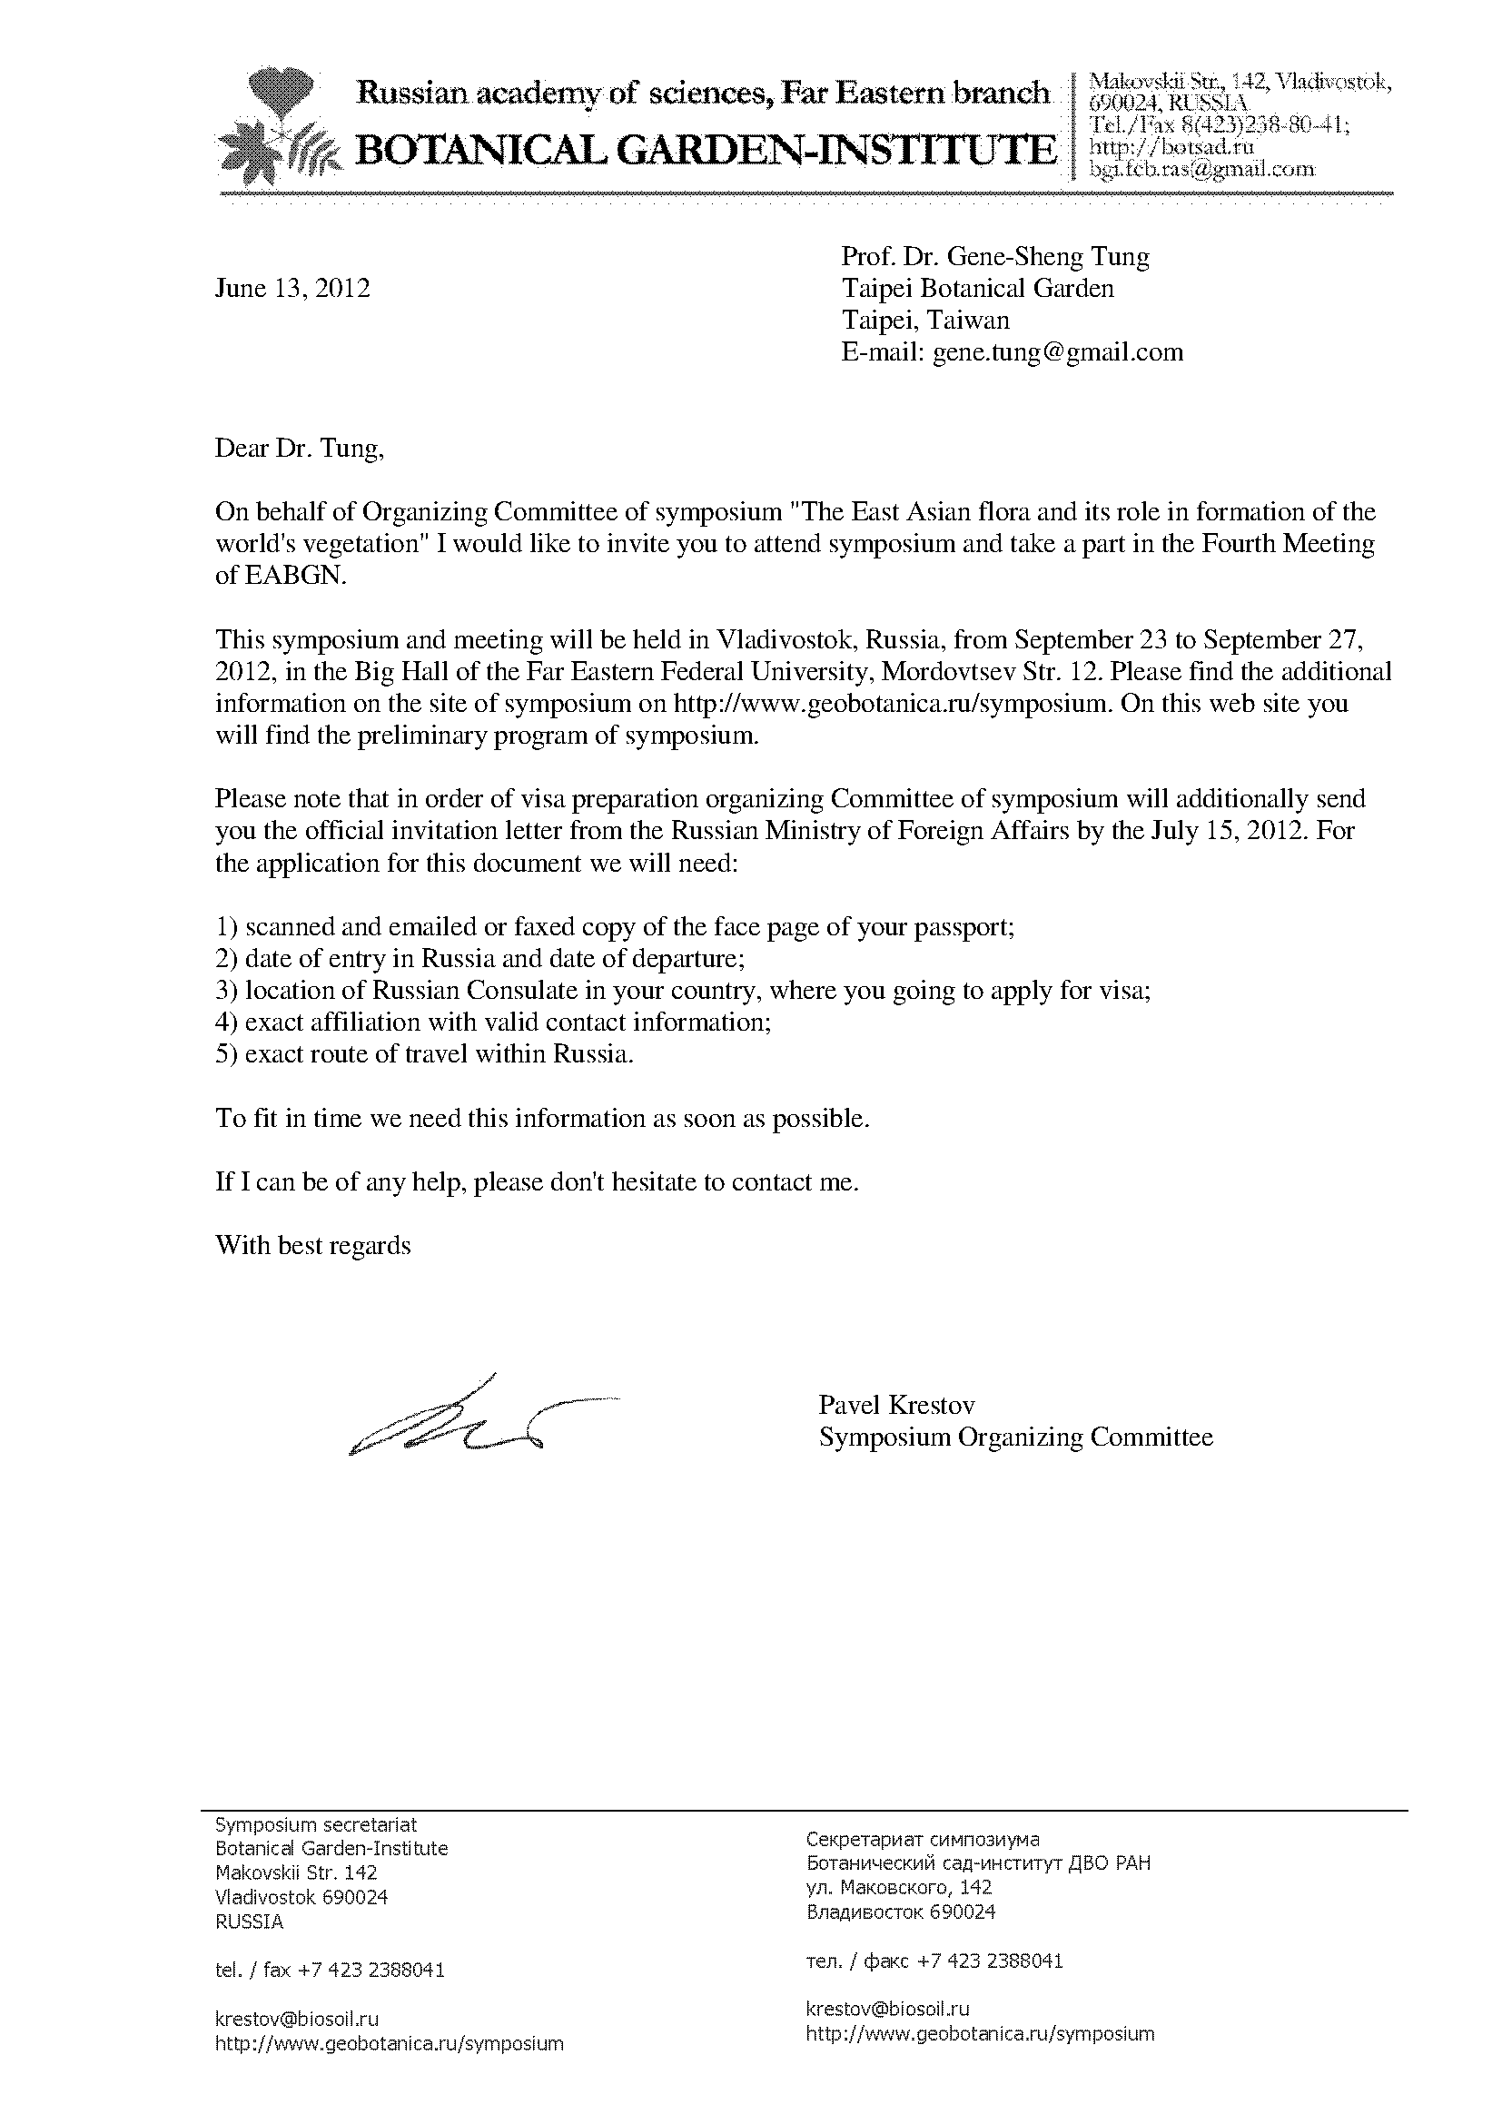

五、附件二(報告全文)
The Botanical gardens in Taiwan

Gene-Sheng Tung
Taiwan Forestry Research Institute, Taipei 10066, Taiwan

There are several botanical gardens with various sizes and at different locations in Taiwan. They are separately at Taipei, Heng-chun, Fushan, and National Museum of Natural Science in Taichung. In addition, they are members of Botanical gardens Conservation International (BGCI).Among them, the first three ones are associated with the Taiwan Forestry Research Institute (TFRI). It is worth mentioning that The Taipei Botanical Garden is the first one in Taiwan, and there is also some detailed information of conservation situation at current will also be presented herein.

- Botanical gardens in Taiwan

  - Heng-chun Tropical Botanical garden (HTBG)
The Heng-chun Tropical Botanical garden (HTBG) has a 72-hectare exhibition area and a 138-hectare nature reserve area. It was established in 1906 and located on Heng-chun Peninsula at the southern tip of Taiwan. It is a tropical, uplifted coral reef ecosystem, located at the elevation of ca. 150-300 m, the annual average temperature is 22ºC, and the annual precipitation is 2,500 mm. The planted region and the natural forest are included in the exhibition area. In display areas, there are about 1,200 species of vascular plants have been planted. Attractive landscape and exhibition as well as rich natural resources make it as an educational, research-worthy, and recreational botanical garden.
The mission of HTBG is to collect, conserve, and study tropical plants, and particularly to protect the rare and threatened species of Heng-chun peninsula and Botel Tobago Island (Lanyu) and the uplifted coral-reef forest ecosystem of the garden, by means of attractive horticultural exhibit, innovative site interpretation, high-quality environmental education, and a lively mixed of recreation at the botanical garden to promote public engagement, understanding, and appreciation for plant diversity.

  - Fushan Botanical garden (FBG)
The Fushan Botanical garden (FBG) was 1,097 hectares, located in northeastern Taiwan and established in 1990. In 1992, 30 hectares were opened to the public. The missions of FBG are conservation, research, and education. It is situated in the natural mountain with the elevation ranging from 400 to 1,400 meter. It has warm and humid weather with an annual average temperature of 18.6ºC, an annual precipitation of 3,500 mm, and an average relative humidity of 98%.
Three divisions, i. e., water resource reserve, Ha-pen nature reserve, and the garden, have been designed in approximately equal area. The garden division retains most of the natural forest for research and in situ conservation and opens 30 hectares for exhibiting the plant collection. In the display area, more than 3,000 plants belonging to 700 species of vascular plants have been planted for the public tourism and education.
The goals of FBG are to develop and maintain a diverse living collection of plants, especially indigenous plants of Taiwan, to support research and teaching in plant biology and ecology, further the conservation of plant diversity, and to promote the understanding and appreciation of plants as well as the natural environment to the public.

1.3. Taipei Botanical garden (TPBG)
The Taipei Botanical garden (TPBG) was first built in 1896 as a nursery (Taipei Nursery) during the Japanese colonial period. It was later expanded and renamed The Taipei Botanical garden in 1921 and became the first botanical Garden in Taiwan. It was reassigned to be under the management of Taiwan Forestry Research Institute after the WWII. It is located in the Taipei City and occupies 8.2 hectares which contains the garden of Gymnosperms, Ferns, Taxonomic Garden, Ethno-plants, Aquatic plants, Lotus pond, Taiwan Indigenous Plant Display Area and other theme exhibition sites with a collection of more than 2000 species. It also happens to be an unearthed cultural relic of the old Taipei Lake. Around 4,500 years ago, the lake became habitable land, and human activities started to take place in the area. The abundant cultural remnants left behind makes the botanical garden an important archeological site in Taiwan.
In addition to living species, there are two historical monuments in the garden- the Herbarium and Bu-Cheng-Shih-Sz Museum (formerly known as the Guest House of Imperial Envoys). The Herbarium was built in 1924 and was the first herbarium in Taiwan. The worldwide plant specimens collection dated back from the last century along with abundant living plants makes the garden a precious place in Taiwan. The Guest House of Imperial Envoys was built in 1888 at the location of the Taipei Zhongshan Hall. It was relocated to the current site in 1933 and renamed Bu-Cheng-Shih-Sz Museum. At present, it becomes one the most precious places in Taiwan, with the underground cultural remnants, historical buildings, abundant living plants, and worldwide plant specimens.
Taipei Botanical Garden is much more than a garden. It is also an institution holding documented collections of living plants for the purposes of scientific research, conservation, display and education. TPBG is dedicated to conduct scientific research to provide plant conservation data, collect and nurture plant species extensively for plant conservation, promote the understanding of conservation by the general public through exhibition and inspirational education, and collaborate with Botanical Gardens Conservation International to help conserve the plant diversity.
TPBG is also the first Botanical gardens Conservation International (BGCI) member in Taiwan, and the aim of this organization are to support and empower members and the wider conservation community so that their knowledge and expertise can be applied to reversing the threat of extinction crisis facing one third of plants. The mission is to collaborate with institutes worldwide for plant conservation and academic. (cited from BGCI website http://www.bgci.org/)

- Programs of Taipei Botanical garden
2.1. Ex situ conservation
In addition to the overall plant collection and cultivation in the botanical gardens to conserve the genetic resources, several specific conservation programs have been implemented.
Red book: “Rare and Endangered Plants; Vol. I~VI” have been issued from 1996-2001. The rarity of 450 vascular plants has been evaluated based on the criteria of IUCN 1994. Conservation policies are made by the useful references provided by Red Book. To understand the rare status of those plants and provide an overall reference for future biodiversity conservation, a comprehensive program is conducted. Researchers of the botanical gardens are collaborated with the Taiwan Society of Plant Systematics and Endemic Species Research Institute, using the criteria of IUCN 2001, to evaluate the rare status of all vascular plants in Taiwan.
Seed bank: The seed bank has been built in TPBG to store more genetic resources. Routinely, seed vitality therein is inspected. Seeds stored are also exchanged with other botanical gardens.
Research of the rare plants: Several rare species of their reproductive biology have been selected to study, i. e., Archangiopteris itoi, A. somai, Pteris wulaiensis, Aglamorpha meyenian, Diplazium megaphyllum, and Hemionitis arifolia. Those rare plants have been successfully silvicultured (Ko et al. 2004, Chiou et al. 2006a, Chou 2007). Among them, reproduced seedlings of Archangiopteris itoi, an endemic and critically endangered species, growing at only one location with less than 100 individual plants, have been repatriated to the original habitat (Chiou et al. 2006b).

2.2. The research development
Based on the platform of Botanical garden, TPBG established the management procedure for plants introduction and provenances record. It also corresponds to ISO criteria in 2012. From January to July 2012, there have been 677 plants introduced. For the management of plants introduction and provenances record, the first step is to apply into the nursery. After that, the movement of plants needs to be recorded by the prescript procedure. In addition, the dieback of plants should also follow the procedure and finally decide to remove.
According to Red book, the research center of Taiwan Forestry Research Institute has checked the conservation situation of field gene bank and seed bank for the relocation conservation of threatened plants. TPBG, FBG, Lianhuachih Research Center (LTER), Chaiyi Botanical garden (CBG), and Heng-chun Tropical Botanical garden (HTBG) are assigned to implement this project. The aims of this project are to check the resource of plants and the collection of relative resources, to increase the provenance collection of arbor and bush at least up to 90% of CR-VU arbor and 50% CR-VU bush, and to adopt relocation conservation for provenances which are not included in the protected area. At present, the collection statistics of botanical gardens and research centers are as the following. In TPBG, there are 15 CR, 13 EN, and 39 VU species collected, and the number is 67, which is 7.38% of our 206 collected species. In Taiwan, most of the collections are woody plants and the species of arbor accounts for 77% of Red Book. Relatively, herbaceous plants are exile. Although the collected species of arbor are more than others, there are no resource records. In addition, the individual number is less. Among them, there are only 25 species owns 30 individual plant. The amount is not enough for population conservation. The detailed collection statistics of different threatened species is as the following figure. The total collected number is 206, and the percentage of CR-VU species is 22.69%.
Threatened Level | Vine Corp | Herbaceous plant | Bush | Arbor | Total
CR | 1 | 11 | 6 | 15 | 33
EN | 4 | 16 | 4 | 32 | 56
VU | 10 | 30 | 24 | 53 | 117
Sum | 15 | 57 | 34 | 100 | 206
Percentage of CR-VU species (%) | 28.3 | 9.15 | 33.33 | 76.92 | 22.69
Figure. The collection statistics of threatened species in TPBG

FBG, LTER, and KTBG are near hot spot regions of CR-VU arbor species for the geographic advantages. The distribution of CR-VU herbaceous plants are mainly spread at the height of 1500m, but each research center is limited to reach and promote relocation conservation.

3. Conclusion
The three botanical gardens in Taiwan have different characteristics but all concern on biodiversity conservation and education for their diverse plant collection, colorful plant cultivation and display, and the attractive landscape. The future goals of botanical garden are developing innovative programs, building staff capacity, working on network among botanical gardens, and maintaining the current prescript procedure. Overseas academic research and worldwide plants conservation are our present endeavor.

Literature cited

Chiou W. L., K. C. Yang, Y. P. Yang, K. S. Hsu, S. Y. Chen. 2000. Type specimens in the herbarium of Taiwan Forestry Research Institute. I. Pteridophyta. Taiwan Forestry Research Institute Ext. 118: 1-92.
Chiou, W. L., Y. M. Huang, T. H. Shieh, S. Y. Hsu. 2006a. Diplazium megaphyllum (Bak.) Christ, a rare fern in Taiwan, reproduces by apogamy. Taiwan Journal of Forest Science 21(1): 39-47.
Chiou, W. L., Y. M. Huang, C. M. Chen. 2006b. Conservation of two endangered ferns, Archangiopteris simai and A. itoi (Marattiaceae: Pteridophyta), by propagation from stipules. Fern Gazette 17 (5): 271-278.
Chou, H. M., Y. M. Huang, S. L. Wong, T. H. Hsieh, S. Y. Hsu, W. L. Chiou. 2007. Observations on gametophytes and juvenile sporophytes of Archangiopteris somai Hayata (Marattiaceae), an endangered fern in Taiwan. Botanical Studies 48: 205-213.
Ko, J. W., Y. M. Huang, W. L. Chiou. 2004. Reproductive biology of Aglaomorpha meyeniana. BioFormosa 39: 83-91. [in Chinese with English summary]
Li, J. H., K. C. Yang, S. W. Chung, C. W. Chen, W. L. Chiou. 2004~2007. Type specimens in the herbarium of Taiwan Forestry Research Institute. II~V. Taiwan Forestry Research Institute Ext. 165: 1-230; 169: 1-219 pp; 172: 1-213 pp; 176: 1-204.

六、活動照片
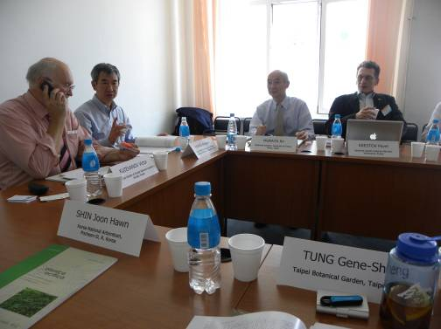
左邊為會議主席
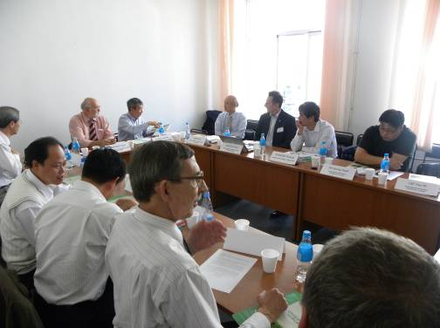
桌邊會議全貌
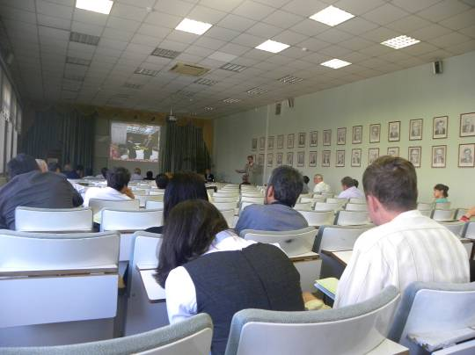
研討會與報告
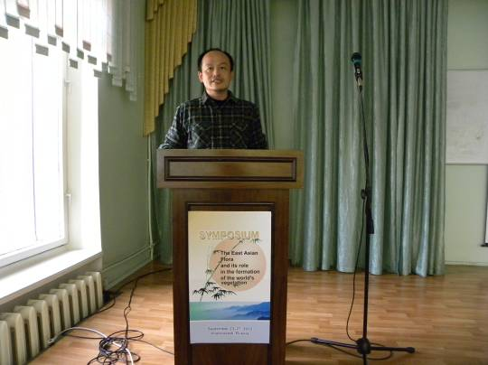
報告台灣植物園現況

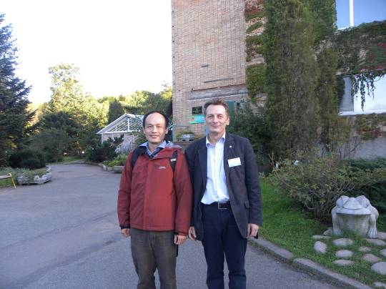
與會議主席於俄羅斯植物園合影
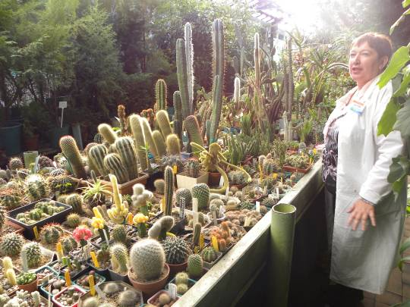
俄羅斯植物園溫室

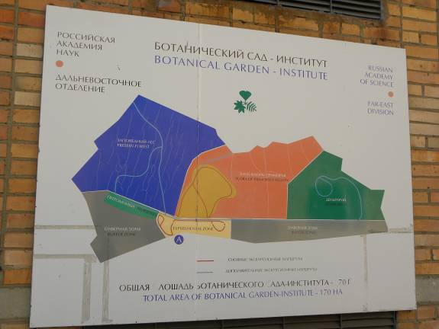
俄羅斯植物園地圖
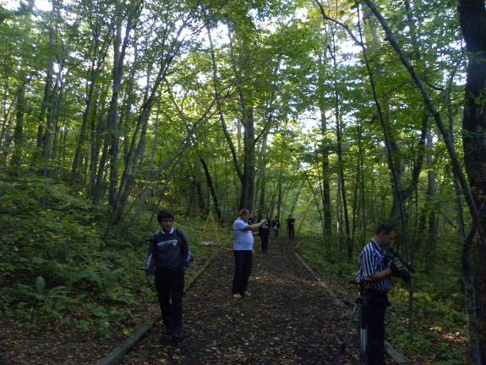
植物園後方的保護區

