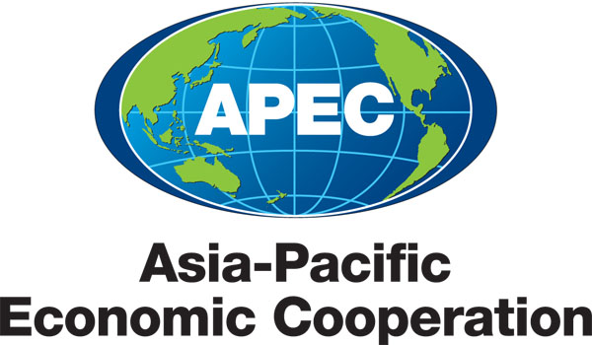
附件6
___________________________________________________________________________
2012/SOM2/ACT/014
Agenda Item: 8

Indonesia Priorities in 2013 - Strengthening Anti Corruption Bodies and International Cooperation Networks in Combating Corruption

Purpose: Information

Submitted by: Indonesia

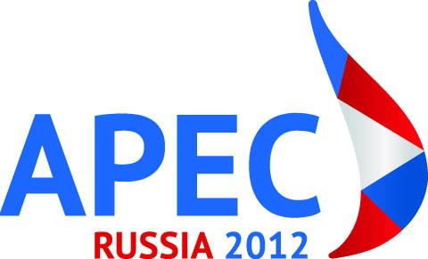 | 15th Anti-Corruption and Transparency Experts’ Working Group Meeting  Kazan, Russia  26 May 2012

INDONESIA APEC PRIORITIES IN 2013

Strengthening Anti Corruption Bodies and International Cooperation Networks in Combating Corruption

APEC Anti-Corruption and Transparency (ACT) Working Group
Kazan, Russia, May 26th 2012

International cooperation and partnerships are inevitably shaped by shifting international paradigm about corruption from traditional to modern. First, corruption is a global concern that is why corruption eradication has to be globalized. Globalization provides opportunities for increased international trade and investment as well as corruption. Second, corruption is not merely single jurisdiction but multi-jurisdiction issue. The perpetrators of corruption are aware that overseas jurisdictions are safe haven for them.

Third, global anti-corruption spirit has departed from conventional to a more sophisticated and globalized modus operandi. It used to be that corruption was treated as ordinary and conventional crime, ending only with the trial and conviction of the perpetrators. These days, it is not enough to tackle down the criminals and put them in jail. It is also important to track and recover the assets stolen and hidden all over the world. Asset recovery is paramount effort in the fight against corruption and money laundering. Furthermore, proceeds of corruption and money laundering will create another potential crime in fighting back the law enforcement process. The ill-gotten money will be source for another crimes in order to cover crime under investigation or to support obstruction of justice. The weaker and poorer corruptors, the easier the job of law enforcement.

Fourth, a transnational corruption requires swift and effective transnational law enforcement. The modus operandi often involves economies abroad as loci for transaction, safekeeping of stolen assets, hiding the evidences and sanctuary for fugitives. Today, corrupt officials and the bribers, ill gotten gains and evidence of the crime may all be in multi-jurisdiction. Therefore, it requires a better way to address corruption in modern-day. Having the facts that international cooperation have developed in recent years, there should be not safe haven for corruptors in this world to hide. Wherever and whenever they hide, they have to deal with international law enforcement networks.

Thus, fighting corruption today can no longer rely on conventional and traditional means. It must be done by modern, sophisticated means, involving international collaboration between law enforcement agencies and authorities from all over the world. These days, corruptors are using more sophisticated technology, social media and smart intermediaries as gatekeepers of the proceeds of crime. The means of communication shifted from wire telephony to internet protocol based communication such as Skype, Blackberry Messenger, WhatsUp, Facebook, Twitter, Gtalk, emails, etc. Law enforcement must have capacity and competence to use most advance technology used by criminals.

Ladies and Gentlemen,

Indonesia is honored and grateful to be the hosting economy and Chair for the ACT in 2013. SOM 1 will be held in Jakarta around late January till mid of February 2013 and SOM3 will be conducted in Bali, one of the most beautiful islands in the world.

In accordance with previous meetings and results, Indonesia wish to continue the good work of the ACT and will promote and strengthen the implementation of existing APEC commitments, UNCAC and other international standards and commitments. For 2013, Indonesia will focus its priority on:
- Strengthening Anti-Corruption Bodies or Other Law Enforcement Authorities.
- Promoting International Cooperation Networks amongst Member Economies

The 1st priority, Indonesia also has put its particular attention in how to strengthen the effective functioning anti-corruption bodies and enforcement authorities in carrying their duties to prevent and punish corruption acts by giving all available adequate commitments, resources and law. This priority is inline with UNCAC article 6 (Prevention) and 36 (Enforcement) and G20 Working Group on Anti-Corruption Action Plan (area 8) in which every Government of member economies are being encouraged to strengthen the effective function of its anti-corruption body(ies) or enforcement agency(ies) and the independency free from undue influence to carry out their powers and duties in the fights against corruption.

Secondly, in accordance with Chapter IV of the UNCAC on International Cooperation in which State Parties shall cooperate and assist each other in investigations and other proceedings relating to criminalisation of corrupt acts. Based on the provision, Indonesia calls every member economies to cooperate and to give assistance to each other in relation to the investigation and prosecution of corruption in these specific areas: MLA, Extradition, enforcement cooperation, joint investigations and etc.

in some cases, corruptors are united and has their own networks, can only be defeated by law enforcement networks. Criminal has their own syndicates in operating their modus operandi and require support of pertinent power and resources. Networks are the key strategy of winning the war. The best law enforcement agencies in the world put the cooperation strategy to create good and trusted networks. Good cooperation will create easy access of information, willingness to help the process, efficiency and effectiveness in getting the result, maintain cooperating witness, and expedite the process. We believe that the slogan “The most effective weapon against crime is cooperation” is important and valid to address the need of international cooperation to combat transboundaries corruption.

Therefore, we also would like to propose to have international cooperation networks within ACT WG by having a special taskforce in anti-corruption, INTER-ACT (interact-international anti-Corruption taskforce) as the platform of international cooperation in investigation and prosecution of transboundaries corruption cases and also to discuss best practices in handling corruption cases and prevention efforts.

Expected Deliverables in 2013:

- 2012 APEC ACT Working Group deliverables outcomes
- 2012-2013 APEC WG Projects
- To prepare 1-day workshop on “Challenge and Strategy of strengthening anti-corruption bodies and other enforcement agencies in combating corruption in modern world” back to back with SOM 1 (tbc).
- To conduct International conference on "Strengthening International Cooperation: The Good must Associate" back to back with SOM 3 (tbc);
- To Establish INTER-ACT (International Anti Corruption Taskforce) as part of ACT WG to discuss and cooperate for any international cooperation issues related with transnational crimes issues and legal assistance.

