出國報告（出國類別：會議）

赴美參加國際高科技犯罪調查相關技術訓練研討會心得報告

服務機關：法務部調查局
姓名職稱：鄭調查官健行
派赴國家：美國
出國期間：100年9月11日至9月16日
報告日期：100年11月28日

摘 要

國際高科技犯罪調查協會（HTCIA, High Technology Crime Investigation Association）2011年訓練研討會於2011年9月11日至9月14日假美國加州印地安威爾市舉行，本次會議探討的主題包含行動裝置、現場事件、電子郵件調查及雲端等熱門鑑識議題，主辦單位將研討會分為演講（Lecture）和實作（Lab）二類，同一時段各有8至11場次分別在不同的會場進行，與會者可針對其專長或興趣挑選適合之主題參加。
演講內容包含資訊安全、雲端調查、手機鑑識及網路犯罪等，從初階至高階皆有，適合執法人員或數位鑑識人員可依程度作選擇；實作部份則包含Black Bag、Access Data、Found Stone、Guidance Software及Micro Systemation等知名公司發展之各類數位鑑識工具，其新功能介紹與應用。
會議期間另有數十個數位鑑識軟硬體設備廠商參展，與會人員可於中場休息時間參觀，藉以了解各家廠商展示之新產品功能及發展趨勢，每天議程從早上8時30分至下午5時30分，需預先登記註冊欲參加之場次，本次會議議題種類雖多，但同時段內與會人員只能選擇1個演講或實作參加研討，難免有遺珠之憾，本局資安鑑識實驗室已創立迄今已有數年，已無須再參與基本概念類之課程，因此參與本次研討會之課程內容，主要以數位鑑識熱門之新議題如智慧型手機鑑識、雲端鑑識或新版本鑑識工具如EnCase v7、XRY等課程為主，期有助於擴展提升本實驗室之視野與能力。

目 次
壹、研討會目的 4
貳、研討會過程 4
參、心得與建議 9
附件1：HTCIA研討會會場之相關照片 9
附件2：研討會之議程 9

研討會目的
- 了解當前數位鑑識領域之趨勢發展，以提昇本局數位鑑識工作之能力與服務品質。
- 與會者包含各國之執法、數位鑑識及資安領域之人員，藉由相互交流可吸收各國數位鑑識及高科技犯罪防制等相關實務經驗，並建立國際合作管道。
- 認識各種新版數位鑑識軟體設備，尋得適合本局實驗室適用之工具。

研討會過程
國際高科技犯罪調查協會（HTCIA）之前為1981年成立之地方檢察官高科技反竊協會，後因高科技犯罪型態之不斷演進，不僅止於竊盜，該協會轉變為高科技犯罪調查協會，探討內容包含所有使用高科技犯罪的類型，而由於電腦與網路普及，因此網路犯罪及數位鑑識近年來已成為該協會研討重點。
2011年HTCIA研討會於美國加州印地安威爾市舉辦，9月11日報到，9月12至14日為正式之研討會課程，研討會之議程如附件2，個人參加之內容如下：
- 9月11日中午12時至下午7時30分，於舉辦研討會之飯店（Renaissance Esmeralda Indian Wells Resort & Spa）地下室會議廳舉行報到並領取相關議程之資料，主辦單位將會議之議程依照其技術領域分別於不同的會場舉行。由於課程種類繁多，參與本次研討會之各國人員達400餘人，因此報到後，個人先對未來三天要參加之課程先挑選註冊，熱門的課程通常很快就額滿，本次參加之課程以鑑識軟體新版EnCase v7功能介紹、智慧型手機相關鑑識設備及雲端鑑識等相關課程為主。
- 9月12日上午8時30分參加開幕儀式，開幕式後參與美國Guidance Software公司主辦之EnCase Forensic v7 Workflow、Leveraging EnCase Forensic v7 Evidence Processor及Email Investigation in EnCase Forensic v7等課程。 Guidance Software公司係發展整合式數位鑑識軟體之公司，其產品EnCase Forensic軟體工具為本局實驗室進行電腦鑑識時最常使用之工具，今年下半年EnCase Forensics軟體版本由v6.18升級至v7，使用方式及功能改變之幅度非常大，為使本局實驗室能順利銜接新版本，因此在研討會第一天全排定EnCase Forensic v7 相關課程。
- EnCase Forensic v7 Workflow 課程介紹EnCase軟體之工作流程，其案件管理方式較之前一版本改變許多，操作上較直觀簡明，畫面編排亦較舊版清爽有條理，而新版首次採用Web式之程式介面，以使用者的角度來看，若已習慣舊版的操作方式，在使用新版介面時需要較長的時間適應。
- Leveraging EnCase Forensic v7 Evidence Processor 課程介紹EnCase軟體新功能-- Evidence Processor，該功能整合舊版數個功能如Signature Analysis、Hash Analysis、Compond files structure View、及Data Index 等，將原本需在鑑定過程中分別執行的功能整合在案件開始時即可一次先執行，當然因此需要長時間進行，優點在於可利用下班時間先執行出結果，以利鑑識人員在隔日上班時進行分析。
- Email Investigation in EnCase Forensic v7課程介紹EnCase軟體在電子郵件分析功能之改善，舊版EnCase 軟體對於電子郵件鑑識功能很陽春，鑑識人員常須利用其他工具如R-Mail等對電子郵件再作進一步分析，而新版EnCase Forensic v7軟體針對這部分作了大幅的改進。
- 9月13日先繼續參加Guidance Software公司主辦之Using EnCase v7 Reporting Templates課程，以更全面了解新版EnCase Forensic v7軟體，接著選擇三場演講議程，題目分別為Geo-Location in iOS and Android Services and Apps: Finding, Processing and Validation、Trends in Cloud Forensics及Email and Metadata Investigations。
- Using EnCase v7 Reporting Templates課程介紹EnCase軟體在產生報表之新功能，亦大幅改進舊版之不足，使用者可利用結構化及程式化的方式設計報表版面樣式，以供日後常用報表套用。
- Geo-Location in iOS and Android Services and Apps: Finding, Processing and Validation：講者先介紹目前市佔率最高的兩種智慧型手機作業系統，美國Google公司的Android系統和Apple公司的iOS系統，再進一步講解該系統中，使用者地理位置的存放點，鑑識人員如何取證、處理及驗證，由於時間關係僅僅限於概述，無法深入說明。
- Trends in Cloud Forensics：演講介紹目前的雲端運用有哪些種類後，再闡述鑑識人員該如何去因應，但雲端運用日漸繁多，鑑識人員在此所面臨之挑戰也越來越大，而其中法律面的因應，亦為重要之課題。
- Email and Metadata Investigations：介紹各類Email檔頭及Metadata內容分析，調查人員如何在Email和Metadata中發現線索，以作進一步之調查。
- 9月14日上午參加瑞典Micro Systemation公司之iCloud Forensics及以色列CelleBrite公司之Deep Dive into iPhone and Android Using the Cellebrite UFED Physical Analyzer課程，下午參加NetWork Forensics – TCP/IP, Pactet Analysis and Investigation及iOS Forensics Analysis Using Open Source Tools二場演講。
- iCloud Forensics：瑞典Micro Systemation公司為手機鑑識工具XRY產品之開發廠商，此課程介紹如何利用其產品在iPhone手機上鑑識美國Apple公司目前正在發展之iCloud雲端應用，此課程包含了目前最熱門之雲端鑑識與手機鑑識，但討論範圍限縮在美國Apple公司的產品與服務。
- Deep Dive into iPhone and Android Using the Cellebrite UFED Physical Analyzer：以色列Cellebrite公司為手機鑑識工具UFED產品之開發廠商，此課程主要介紹利用UFED Physical Analyzer對美國Google公司的Android系統和Apple公司的iOS系統之資料作擷取及分析。
- NetWork Forensics – TCP/IP, Pactet Analysis and Investigation：此課程為網路封包鑑識，針對TCP/IP封包分析調查。
- iOS Forensics Analysis Using Open Source Tools：此課程介紹如何利用免費之Open Source Tools對美國Apple公司之iPhone作業系統iOS進行分析。

心得與建議
  - 本局資安鑑識實驗室使用之整合式電腦鑑識工具EnCase Forensic，已於今年下半年推出新版v7，其功能及操作方式皆作了大幅的變更，個人於此次研討會利用一天時間學習EnCase Forensic v7之課程，新版雖然尚有待改進之處，但功能確已比舊版加強許多，為使本局電腦鑑識人員可以順利接軌新版，本局應儘快辦理新版之教育訓練。
  - 智慧型手機日益普及，功能亦較以往傳統手機更加強大，幾乎涵蓋了以往手機、PDA、GPS、小筆電及數位相機等功能，是以儲存有關於使用者個人資訊也較以往多出很多，使得在各類案件中，智慧型手機的重要性也提升，因著技術門檻及品牌優勢，目前智慧型手機的種類已不似傳統手機般繁多，以作業系統分類，常見的有Android、iOS、RIM及Windows等，傳輸線介面也趨統一，這部分對數位鑑識人員而言是件好事，但因著智慧型手機功能變強變複雜，如儲存格式和加密機制，亦成為鑑識人員的新挑戰。
  - 此次研討會在手機鑑識的部分，個人選擇參加市面上常見的商用手機鑑識設備Cellebrite UFED及XRY等應用課程，使用此類商用設備可降低手機鑑識之難度，對於常見之手機可利用該設備直接萃取資料、分析並產生報表，但缺點在於採購及維護的價格昂貴，所以挑選了另一個Open source的手機鑑識課程，期待能更有效利用低價之非商用軟體進行手機鑑識。
  - 人們將資料儲存於雲端已日漸普及，數位證據可能不再儲存於本地端電腦的媒體中，而是存放在未知位置的伺服器群之中，這可能是未來數位鑑識領域所面臨最大的挑戰，就此次研討會而言，僅就個案或特殊的雲端服務（如iCloud及FaceBook等）技術面作切入，缺乏整體性的解決方案，若要建立雲端數位證據蒐集之機制，提出之方案須自法律面、管理面及技術面皆作深入思考，方能有所成效。
附件1

HTCIA研討會會場之相關照片
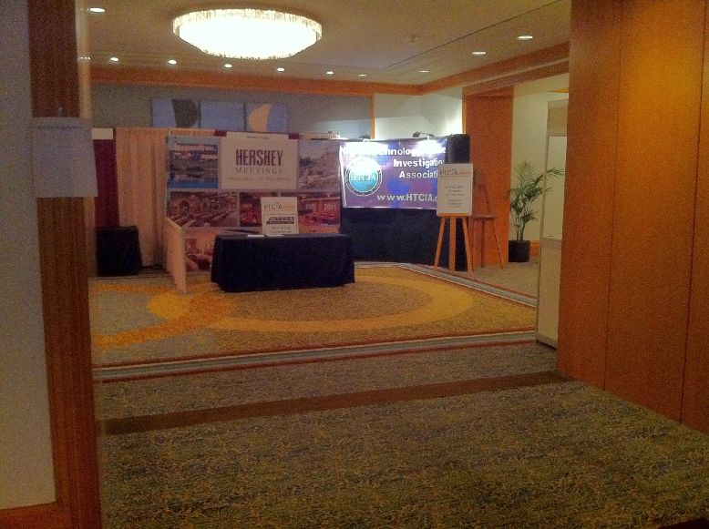
圖1 研討會報到處

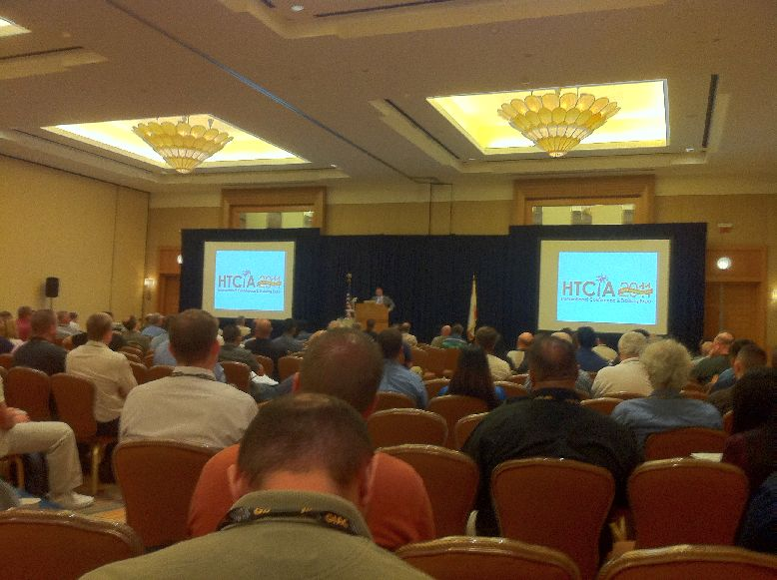
圖2 研討會開幕式
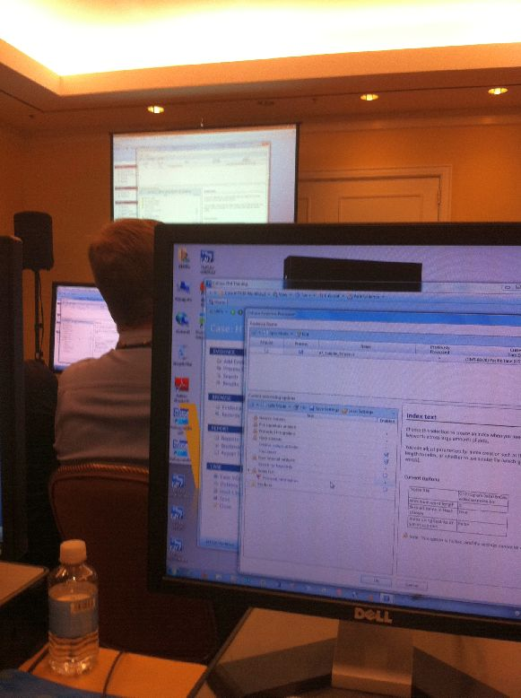
圖3 研討會上課情形
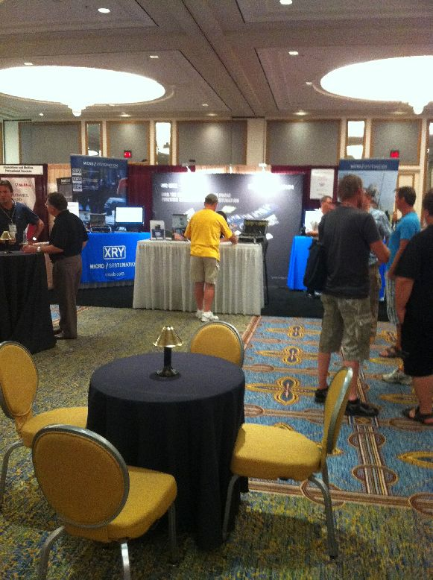
圖4 研討會展示廳1

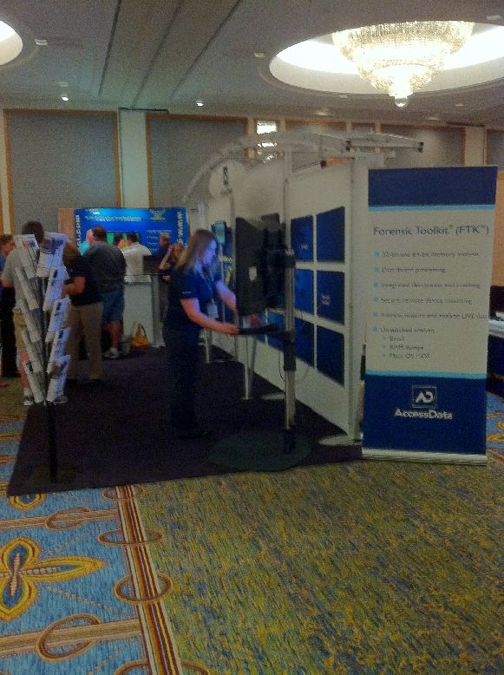
圖6 研討會展示廳2
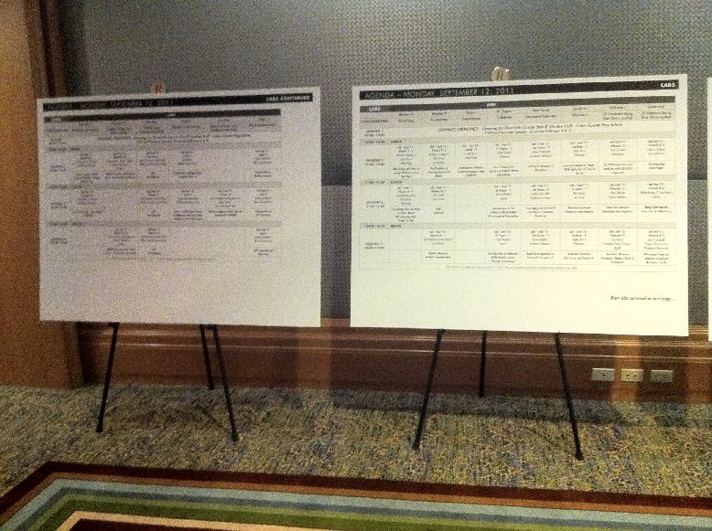
圖7 研討會課程表
附件2 研討會議程

Schedule of Events for September 12, 2011
Room | Emerald 1 | Emerald 2 | Emerald 3 | Emerald 6 | Emerald 7 | Emerald 8
Track | Intellectual Property Investigations | Child Exploitation | eDiscovery | Information Security | Cyber Investigations/  Forensics | eLegal
8:30 - 10:00 | Opening Keynote - Cliff Stoll / Greeting by Riverside County Sheriff Stanley Sniff - Color Guard Flag Salute
10:00 - 10:30 | Break
10:30 - 12:00 | BD Consulting and Investigations  Thomas Quilty  Introduction to IPR and Brand Investigations | L.A. District Attorney's Office  Marc Beaart  The Challenges of Investigating and Prosecuting Child Pornography Cases | Clearwell Systems Inc.  Dean Gonsowski Esq.  eDiscovery n the Cloud - Addressing Challenges for the new Paradigm | Network Conversions  Jeff Carrell  Networking 101 | CRU-DataPort/WiebeTech  James Wiebe  Solid State Storage for Forensic Investigators | L.A. District Attorney's Office  Jonathan Fairtlough  Investigation of Cyber Bullying
12:00 - 13:30 | Lunch
13:30 - 15:00 | Adobe  Chris Stickle  Working with Law Enforcement on IPR Cases | The Innocent Justice Foundation  Heather Steele  Child Pornography Evidence: the Ulitimate Tool to Rescue Children from Sexual Abuse | Institution Brand Protect, Inc.  Michael Kiefer  Utilization of Social Media Monitoring in Risk Mitigation & Investigations | Verizon Risk Team  Andrew Bonillo  2011 Data Breach Report Investigations | The Identity Theft Council  Neal O'Farrell & Anne Madrid  An Innovative National Model for Combating Identity Theft | VC-PISA/PolyU/Glamorgan  Chingwa (Daniel) Ng  Computer Monitoring for Pre-emptive Corporate Forensics
15:00 - 15:30 | Break
15:30 - 17:00 | Monster Cable  Camilla Herron  Realities of Doing Business in Red China: Why We Don't Belong There | L.A. District Attorney's Office  Marc Beaart  Legal Issues in Child Pornography Cases | Premier Customer Connections  Jim Cook  Cellular Phones the "New DNA" | Symantec Corporation  Auston H. Davis  Beyond Incident Response: Running the Investigation | Renato Blum & Cedric Laurant  Where Did You Go Last Summer? GeoLocations Data at Risk Abroad | HTCIA  Duncan Monkhouse  HTCIA Chapter Officer Training
17:30 - 18:30 | Showcase - Sept 12 - Emerald 4 - MSAB
18:30 - 19:30 | Showcase - Sept 12 - Emerald 5 - AccessData

Schedule of Events for September 13, 2011
Room | Emerald  1 | Emerald  2 | Emerald  3 | Emerald  4 | Emerald  5 | Emerald  6 | Emerald  7 | Emerald  8
Track | Intell.  Property Investig. | Hot  Topics | Cyber  Invest/  Forensics | Student  Poster  Present. | SANS  Leadership  Breakfast | Information  Security | Cyber  Invest/  Forensics | eLegal
7:30 - 8:30 |  |  |  |  | SANS  Institute  Rob Lee  COINS Chapter Leaders Breakfast
8:30  - 10:00 | Recording Industry Association of America  Marcus Cohen, Tom Rackleff & Jim Orr  Music Piracy-Identification and Investigation | McAfee  Michael Spohn  Incident Response-  A 12 Step Program | Cal DOJ-Medi-Cal Fraud & Elder Abuse  Luis Salazar & Chris Conception  Virtualization Forensics and What We Know | Cal Poly Pomona  Anna  Carlin  Student Poster Presentation of Work in Cyber Security and Computer Forensics |  | Bell Aliant  Peter Morin  Advanced Persistent Threat: The Battle to Own Your Network | Technology Pathways, LLC  Christopher L. T. Brown  Live System Triage of Windows Volume Shadow Copy | Southeastern Oklahoma State University  G. Stevenson Smith, Ph.D  How to Value $$ the Damages from Cyber Attacks
10:00- 10:30 | Break
10:30  - 12:00 | Motion Picture Association of America  Bob Brasich  Reverse Internet and HTTP Headers: Identifying Suspects, Associated Websites and Locating Source Files | Paraben  Amber Schroader  Get Down and Dirty with Your Mobile Data | FinalData  Eric Wahlberg & Akira Katanosaka  Examining Samsung Phones | Cal Poly Pomona  Anna  Carlin  Student Poster Presentation of Work in Cyber Security and Computer Forensics |  | Oxygen Forensics  Oleg Davydov & Oleg Fedorov  Geo-Location Data in iOS and Android Services and Apps: Finding, Processing, and Validations | My hard Drive Died, LLC  Scott A. Moulton  SSD: Solid State Drives & how They work for Data recovery and Forensics! | MaTTica  Cynthia Navarro & Andres Velazquez  Social Networking with an International Flare
12:00- 13:30 | Lunch
13:30  - 15:00 | Software Analysis and Forensic Engineering Corporation  Bob Zeidman  Detecting Software Intellectual Property Theft | Flying Penguin  LLC  Davi Ottenheimer  Trends in Cloud Forensics | Michael Menz & Mark Menz  Tips & Tricks | Cal Poly Pomona  Anna  Carlin  Student Poster Presentation of Work in Cyber Security and Computer Forensics |  | C-PISA/  PolyU/  Glamorgan  Chingwa (Daniel) Ng  Facebook Forensics | Michael Wilkinson & Brian Jones  8 Years of Triage. A Case Study of State Electronic Evidence Branch (SEEB) of the NSW Police Force | Absolute Software Corporation  Stephen Treglia & Tim Smail  Remotely Searching Mobile Devices - Is It Legal?
15:00- 15:30 | Break
15:30- 17:00 | Microsoft  Steve Studhalter  Software Piracy - Current Business Model & Emerging Threats | Vound Software  Peter  Mercer  Email and Metadata Investigations | AccessData  Rob Attoe  Internet Explorer 9 Artifacts and Inprivate Browsing & Travel Log Data |  |  | SRT Wireless, LLC  Vincent Costagliola & Ty Brevard  802.11 Exploitation & Tracking | ASR Data  Andy  Rosen  The Seven Deadly Sins of Data Forensics | Talion, LLC  Phillip Mahan  Privacy's Role in Forensics

Schedule of Events for September 14, 2011
Room | Emerald 1 | Emerald 2 | Emerald 3 | Emerald 6 | Emerald 7 | Emerald 8
Track | Intellectual Property Investigations | Child Exploitation | eDiscovery | Information Security | Cyber Investigations/  Forensics | eLegal
8:30 - 10:00 | Sideman & Bancroft, LLP  Jim Shore & Richard Nelson  The Good, The Bad and The Ugly-2011 Brand Protection Legal Update | FBI  Thomas Brenneis  Sextortion Defined | Digital Mountain, Inc.  Julie Lewis  Using Cloud computing In Computer Forensics And Electronic Discovery | NCI Information Systems  Dan VanBelleghem  Data Exfiltration: Detection and Response | Cal DOJ-Bureau of Medi-Cal Fraud and Elder Abuse  Kelli O'Neill  Preserving Evidence from the Cloud | San Francisco City Attorney's Office  Barron L. Fong  Internal Investigations and Computer Forensics
10:00 -10:30 | Break
10:30 - 12:00 | Entertainment Software Association  Daniel Seymour  Internet Piracy | FBI-RCFL Orange County  Jason Weiss, Jim Watkins & Baden Gardner  How to do More with Less in Laboratory Environment | Littler Mendelson, P.C.  Aaron Crews & Mark Menz  Depositions Without Pain | Cal Poly Pomona  Anna Carlin & Dan Manson  Building the Cyber Warriors of Tomorrow | High Tech Crime Institute  Tom Eskridge  Cell Phone (Portal Device) First Responder/Investigations | State of California-Department of Insurance-Fraud Division  Brian Farnsworth  Lock Picking and Bypassing Techniques
12:00 - 13:30 | Lunch
13:30 - 15:00 | FBI  Ken McGuire  Navigating intellectual Property Rights Investigations | Craig Ball  Computer Forensics Jeopardy | Digital Mountain, Inc.  Julie Lewis  Bridging The Gap Between Compute Forensics And Electronic Discovery | CBTS  Robert A. Andrews II & Michael C. Taylor  & Chris Simpson  Network Forensics-TCP/IP, Packet Analysis and Investigation | Forensic Audio  Kent Gibson  Curious Case Studies in Forensic Audio | L.A. District Attorney's Office  Donn Hoffman  Forensic Examiner Self-Defense, Part 1: How to Tame & Train Attorneys
15:00 - 15:30 | Break
15:30 - 17:00 | BD Consulting and Investigations  James Keith & Thomas Quilty  Data Breach Planning and Response | Berla Corporation  Andrew Russell  GPS Analysis and More | MaTTica  Andres Velazquez  Latin American Digital Forensics Perspective | Consultant  Chris Simpson  Knowledge Management for Incident Responders and Investigators | viaForensics  Katie Strzempka  iOS Forensic Analysis Using Open Source Tools | L.A. District Attorney's Office  Donn Hoffman  Forensic Examiner Self-Defense, Part 2: Courtroom Testimony Without Pit Stains

Lab Schedule for September 12, 2011
Room | Rhodes A | Rhodes B | Toulon | St. Tropez | San Remo | Sardinia | Valencia I
Track | Black Bag | AccessData | Foundstone | Cellebrite | Guidance  Software | Wetstone* | Various*
8:30  - 10:00 | Opening Keynote - Cliff Stoll / Greeting by Riverside County Sheriff Stanley Sniff - Color Guard Flag Salute
10:00  - 10:30 | Break
10:30  - 12:00 | Black Bag  Derrick Donnelly & Don Brister  Mac Triage and How to Image Without Loosing Your Nuts | AccessData  Nick Drehel & Michael J. Staggs  The Realities of Investigating Social Media | Foundstone  Israel Perez  Foundstone Ultimate Incident Response Lab (3 hours) | Cellebrite  Keith Daniels  Best Practices for Success in Mobile Device Extractions | Guidance Software  Ashley Stockdale  EnCase Forensic v7 Workflow | Wetstone  Matt Davis  Live Investigative Triage - FREE 4gb US-LATT device for law enforcement | Infinadyne  Paul Crowley  CD/DVD forensics and analysis with CD/DVD Inspector
12:00  - 13:30 | Lunch
13:30  - 15:00 | Black Bag  Derrick Donnelly & Don Brister  Everything That You Need to Know About iOS Forensics, But Forgot to Ask | AccessData  Chris Sanft  MAC Analysis |  | Sumuri  Steve Whalen  Introduction to the Cellebrite UFED Mobile Device Logical Extractions | Guidance Software  Ashley Stockdale  Leveraging the EnCase v7 Evidence Processor | Wetstone  Matt Davis  Malware evidence discovery and analysis | Vound Software  Peter Mercer  E-mail and Analyst Notebook Integration
15:00  - 15:30 | Break
15:30  - 17:00 |  | AccessData  Rob Andrews & Ken Warren  Infosec: Memory Analysis Fundamentals |  | Sumuri  Steve Whalen  Introduction to the Cellebrite UFED Mobile Device Physical Extractions | Guidance Software  James Habben  E-mail investigations in EnCase Forensic v7. | Wetstone  Matt Davis  Malware evidence discovery and analysis | Canadian Police College (RCMP)  Eric Rowe  Windows Memory Forensics: Theory, Tools & Techniques

Lab Schedule for September 12, 2011 (Continued)
Room | Valencia II | Valencia V | Valencia VI | Gibraltar | Corfu | Corsica | Capri
Track | Various* | Technology Pathways | Susteen* | NW3C ** | Mobile  Forensics Inc. ** | Search  Group ** | Micro Systemation
8:30  - 10:00 | Opening Keynote - Cliff Stoll / Greeting by Riverside County Sheriff Stanley Sniff - Color Guard Flag Salute
10:00  - 10:30 | Break
10:30  - 12:00 | Vere Software  Todd G. Shipley  Investigating web pages | Technology Pathways  Christopher L. T. Brown  Live & System at Rest Triage of Windows Volume Shadow Copy | Susteen  Sonny Farinas & James Cooksey  Mobile Forencis with Secure View - Beyond Data Extraction | NW3C **  Mark Bowser & Matt Williams  GPS investigation | Mobile Forensics Inc.  Lee Reiber  Introduction to Mobile Phone Examiner Plus (+) |  | Micro Systemation  Shaun Sutcliffe  Introduction to Mobile Forensics
12:00  - 13:30 | Lunch
13:30  - 15:00 | Catelas  Robert Levy & Scott Emery  Using Relationship Forensics for eDiscovery | Technology Pathways  Christopher L. T. Brown  Pro Discover Lab - Free License - 3 Hours |  | NW3C **  Mark Bowser & Matt Williams  GPS investigation | ASOTO Technology Group  Alvaro Alexander Soto  Intro to OSINT (Open source Intelligence) and Penetration Testing for Law Enforcement | Search Group **  Lauren Wagner & Elizabeth Tow  SNS Investigative Tools, Tips and Techniques - 3 Hours | Micro Systemation  James Eichbaum  Introduction to GPS Forensics
15:00  - 15:30 | Break
15:30  - 17:00 | Chappell University/Wireshark University  Laura Chappell  Wireshark Kung Fu - Analyze Suspicious Network Traffic |  | Susteen  Sonny Farinas & James Cooksey  Mobile Forencis with Secure View - Beyond Data Extraction | NW3C **  Mark Bowser & Matt Williams  GPS investigation |  |  | Micro Systemation  James Eichbaum  XRY Exporting and Reporting

Lab Schedule for September 13, 2011
Room | Rhodes A | Rhodes B | Toulon | St. Tropez | San Remo | Sardinia | Valencia I and II
Track | Black Bag | AccessData | Foundstone | Cellebrite | Guidance  Software | Wetstone | Various*
8:30  - 10:00 |  | AccessData  Nick Drehel, Jr.  Next Generation Decryption | Foundstone  Israel Perez  Foundstone Ultimate Incident Response Lab (3 Hours) | Cellebrite  Keith Daniels  Best Practices for Successful Mobile Device Extractions | Guidance Software  Rodney Smith  Using EnCase Forensic v7 Reporting Templates | Wetstone  Matt Davis  Conducting Steganography Investigations (3 Hours) | SANS Institute  Rob Lee  Super Timeline Analysis and Case Studies (3 Hours)
10:00  - 10:30 | Break
10:30  - 12:00 | Black Bag  Derrick Donnelly & Don Brister  Everything That You Need to Know About iOS Forensics, But Forgot to Ask | AccessData  David Speringo  eDiscovery - What every forensic investigator should know about eDiscovery and the process (Lecture only) |  | Sumuri  Steve Whalen  Introduction to the Cellebrite UFED Logical Extractions | Guidance Software  Steve Salinas  EnCase Portable - Forensic Triage and Collections in the Field
12:00  - 13:30 | Lunch
13:30  - 15:00 | Black Bag  Derrick Donnelly & Don Brister  Mac/iOS Forensics with Blacklight | AccessData  David Speringo  eDiscovery - Social media and ediscovery (Lecture only) | Foundstone  Israel Perez  Foundstone Ultimate Incident Response Lab (3 Hours) | Sumuri  Steve Whalen  Introduction to the Cellebrite UFED Physical Extractions | Guidance Software  Ashley Stockdale  EnCase Forensic v7 Workflow | Wetstone  Matt Davis  Live Investigative Triage - Free 4gb US-LATT device for LE | SANS Institute  Rob Lee  Intermediate Web Browser Analysis - Beyond History Analysis (3 Hours)
15:00  - 15:30 | Break
15:30  - 17:00 |  | AccessData  Rob Andrews & Ken Warren  InfoSec - Hands-on hacking investigation: Man in the middle attack |  | Cellebrite  Keith Daniels & Ronen Engler  Deep Dive into iPhone and Android Using the Cellebrite UFED Physical Analyzer | Guidance Software  Ashley Stockdale  Leveraging the EnCase Forensic v7 Evidence Processor | Wetstone  Matt Davis  Live Investigative Triage - Free 4gb US-LATT device for LE
17:30  - 18:30C |  | AccessData  Nick Drehel, Jr  FTK4 Transition Workshop - Happy Hour

Lab Schedule for September 13, 2011 (continued)
Room | Valencia V | Valencia VI | Gibraltar | Corfu | Corsica | Capri
Track | Pathway Technology | Susteen* | NW3C ** | Mobile Forensics Inc.** | Search Group ** | Micro Systemation
8:30  - 10:00 | Technology Pathways  Christopher L. T. Brown  Live and System at Rest Triage of Windows Volume Shadow Copy |  | NW3C **  Matt Williams & Mark Bowser  STOP - Secure Technique for On-Site Preview (1 Day Class) | ASOTO Technology Group  Alvaro Alexander Soto  Intro to OSINT (Open Source Intelligence) and Penetration Testing for Law Enforcement | Search Group **  Timothy Lott & Christopher Armstrong  Field Triage (3 Hours) | Micro Systemation  James Eichbaum  Android Forensics
10:00  - 10:30 | Break
10:30  - 12:00 |  | Susteen  Sonny Farinas & James Cooksey  Mobile Forensics with Secure View - Beyond Data Extraction |  | Mobile Forensics Inc.  Lee Reiber  Advanced Mobile Phone Analysis with MPE+ |  | Micro Systemation  Jim Cook  Cell Site Analysis
12:00  - 13:30 | Lunch
13:30  - 15:00 | Technology Pathways  Christopher L. T. Brown  Pro Discover Lab - Free License (3 Hours) |  |  |  | Search Group **  Lauren Wagner & Elizabeth Tow  Google and Firefox as Investigative Tools | Micro Systemation  Jansen Cohoon  Introduction to Python Scripting
15:00  - 15:30 | Break
15:30  - 17:00 |  | Susteen  Sonny Farinas & James Cooksey  Mobile Forensics with Secure View - Beyond Data Extraction |  | Fluke Networks  Carolyn Carter  Tracking Illegal Activity Through a Wireless Network | Search Group **  Lauren Wagner & Elizabeth Tow  USB Applications | Micro Systemation  Jansen Cohoon  Advanced Python Scripting

Lab Schedule for September 14, 2011
Room | Rhodes A | Rhodes B | Toulon | St. Tropez | San Remo | Sardinia | Valencia I
Track |  | AccessData |  | Cellebrite | Guidance  Software | Wetstone | Various*
8:30  - 10:00 |  | AccessData  Lee Reiber  Phone, iDevices, & Androids: Analysis with MPE+ and FTK |  |  | Guidance Software  James Habben  E-mail Investigations in EnCase Forensic v7 | Wetstone  Matt Davis  Malware Evidence Discovery and Analysis | Catelas  Robert Levy & Scott Emery  Using Relationship Forensics for eDiscovery
10:00  - 10:30 | Break
10:30  - 12:00 |  | AccessData  Michael J. Staggs & Tom Wong  Infosec: New Technology for the Improved Handling of Advanced Exploits  (Lecture Only) |  | Cellebrite  Keith Daniels & Ronen Engler  Deep Dive into iPhone and Android Using the Cellebrite UFED Physical Analyzer | Guidance Software  Rodney Smith  Using EnCase Forensic v7 Reporting Templates | Wetstone  Matt Davis  Malware Evidence Discovery and Analysis | Vere Software  Todd G. Shipley  Cloud Computing Investigations
12:00  - 13:30 | Lunch
13:30  - 15:00 |  | AccessData  David Speringo  eDiscovery - Early Data Assessment & Early Case Assessment |  |  | Guidance Software  Steve Salinas  EnCase Portable - Forensic Triage and Collections in the Field | Wetstone  Matt Davis  Conducting Steganography Investigations (3 Hours) | Vere Software  Todd G. Shipley  Investigating Web Pages
15:00  - 15:30 | Break
15:30  - 17:00 |  | AccessData  Chris Sanft  Windows 7 Forensics |  |  | Guidance Software  Ashley Stockdale  EnCase Forensic Workflow |  | Canadian Police College - RCMP  Eric Rowe  Windows Memory Forensics: Theory, Tools & Techniques

Lab Schedule for September 14, 2011 (continued)
Room | Valencia II | Valencia V | Valencia VI | Gibraltar | Corfu | Corsica | Capri
Track | Various* | Pathway Technology | Susteen* | NW3C ** | Mobile Forensics Inc.** | Search Group ** | Micro Systemation
8:30  - 10:00 | FBI  Eric Zimmerman  osTriage: A Next Generation On-Scene Preview Tool | Technology Pathways  Christopher L. T. Brown  Live and System at Rest Triage of Windows Volume Shadow Copy |  | NW3C **  Matt Williams & Mark Bowser  BCPI - Basic Cell Phone Investigations (1 Day Class) | Fluke Networks  Carolyn Carter  Tracking Illegal Activity Through a Wireless Network | Search Group **  Timothy Lott & Christopher Armstrong  Using Virtual Machines in an Investigative Capacity (3 Hours) | Micro Systemation  Jansen Cohoon  iDevices Forensics
10:00  - 10:30 | Break
10:30  - 12:00 | Chappell University/Wireshark University  Laura Chappell  TCP/IP King Fu: Analyze TCP/IP Communications |  | Susteen  Sonny Farinas & James Cooksey  Mobile Forensics with Secure View - Beyond Data Extraction |  |  |  | Micro Systemation  Jansen Cohoon  App Overtime
12:00  - 13:30 | Lunch
13:30  - 15:00 | Infinadyne  Paul Crowley  CD/DVD Forensics and Analysis with CD/DVD Inspector |  |  |  | Fluke Networks  Carolyn Carter  Tracking Illegal Activity Through a Wireless Network | Search Group **  Lauren Wagner & Elizabeth Tow  SNS Investigative Tools, Tips and Techniques (3 Hours) | Micro Systemation  James Eichbaum  iCloud Forensics</A< i>
15:00  - 15:30 | Break
15:30  - 17:00 | FBI  Eric Zimmerman  osTriage: A Next Generation On-Scene Preview Tool |  | Susteen  Sonny Farinas & James Cooksey  Mobile Forensics with Secure View - Beyond Data Extraction

