出國報告（出國類別：國際研討會）

亞太管理特刊研討會

服務機關：國立高雄應用科技大學企管系
姓名職稱：翁鶯娟助理教授
派赴國家：北京
出國期間：2011/ 7/ 8~7/ 10
報告日期：2011/ 7/ 9
摘要
承蒙學校補助，筆者得以參加「2011 亞太管理特刊研討會」，會議日期為2011年7月8日至10日，共3天。此次特刊研討會主要目的為讓投稿者與期刊主編有雙向交流機會，並讓投稿者清楚了解論文未來修改方向與第二輪審查時編輯之意見為何。
參與此次國際會議時，APJM幾位特刊的編輯均提出許多筆者論文未來修改方向之相關意見與建議，讓筆者可在第二輪投稿審查時，得以針對研討會中編輯所提意見，逐一修正論文內容，以強化本文之假設推論與實證結果，目前投稿論文內容已仔細修改完成，並已送出接受第二輪審查。感謝學校補助參加特刊會議，提昇教師研究能量。
目次
亞太管理特刊研討會 1
摘要 2
一、研討會報告 4
二、研討會照片 5
三、研討會議程 6

一、 研討會報告
目的：
承蒙學校補助，筆者得以參加「2011 Asia Pacific Journal of Management Special Issue Conference」，會議日期為2011年7月8日至10日，共3天。此次特刊研討會主要目的為讓投稿者與期刊主編有雙向交流機會，並讓投稿者清楚了解未來修改方向與第二輪審查時編輯之意見為何。

過程：
會議於北京人民大學舉行。特刊幾位編輯香港中文大學呂源教授(Yuan Lu, Chinese University of Hong Kong)、香港中文大學歐玉輝教授(Kevin Au, Chinese University of Hong Kong)、人民大學徐二明院長(Erming Xu， Renmin University of China)、達拉斯大學Mike Peng教授 (University of Texas at Dallas)與總編輯Michael Carney (Concordia University)不但全程參與，並給報告者許多寶貴意見。另大會議除安排Mike Peng教授在議程中指導與會者撰寫國際期刊應注意事項，也特別在議程最後一天中請Mike Peng教授演講關於大陸新興多國籍企業全球策略之相關議題。本次議程共有家族連結與治理關係、家族連結與社會網絡關係、私人及家族企業與環境關係，及私人及家族企業創新等四大報告議題。筆者報告論文主題為公司內部能耐對綠色創新之影響-以家族企業為干擾變數，屬私人及家族企業與環境關係場次。

心得及建議事項：
參與此次國際會議收獲最大的部分為筆者報告時，APJM幾位特刊的編輯均提出許多筆者論文未來修改方向之相關意見與建議，讓筆者得以在理論論述與實證結果有進一步改善空間。例如, 歐玉輝教授明確指出本文須再進一步做敏感性分析，以強化本文之實證結果。另此次特刊研討會，主要為針對家族企業策略管理之相關議題進行研討，也讓筆者對此一研究領域有更深入了解。其他與會報告者均為來自美國、香港、澳門、大陸與印度關於家族企業研究的優秀學者。筆者不但可將自己之研究與相關學者專家分享及討論，且此行另一收獲是因此次研討會為一相對小型會議，所以與會報告者與特刊編輯均有較多機會得以相互認識，交換研究心得與連絡方式，可作為日後互相討論的起點。個人覺得這是一個很好的意見交流與學習機會。建議學校可補助此類特刊會議，提昇教師研究能量。

二、研討會照片

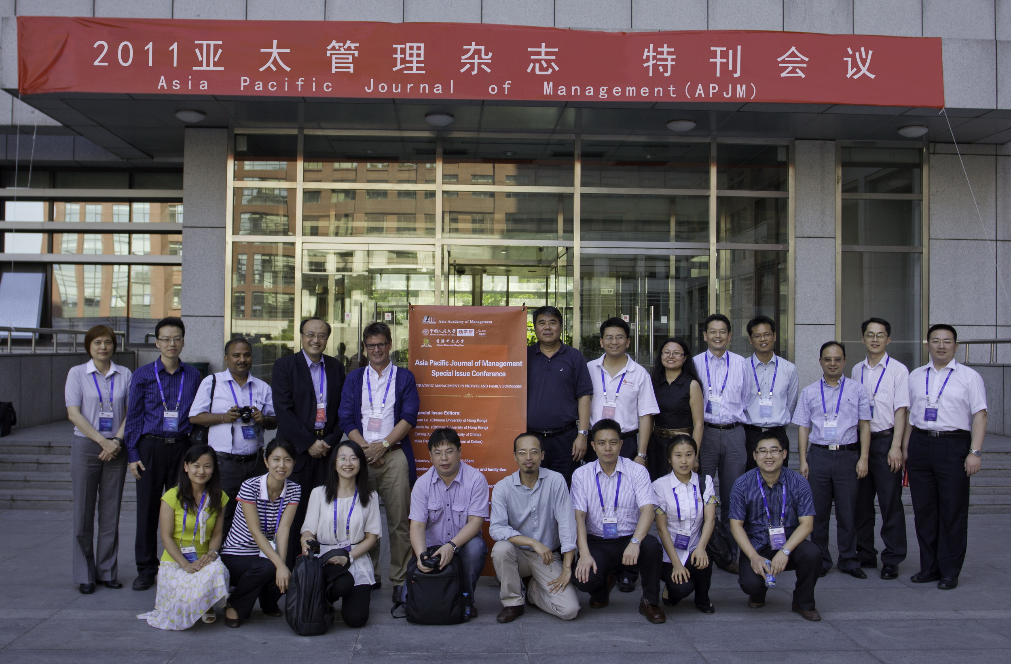

三、研討會議程

Asia Pacific Journal of Management

Special Issue Conference

STRATEGIC MANAGEMENT IN PRIVATE AND FAMILY BUSINESSES

Conference: Beijing, China, July 8-9, 2011

Targeted publication date for the Special Issue: 2013

Special Issue Editors:

Yuan Lu (Chinese University of Hong Kong), Kevin Au (Chinese University of Hong Kong),

Erming Xu (Renmin University of China), and Mike Peng (University of Texas at Dallas)

Conference Sponsors:
School of Business, Renmin University of China, Beijing, China
Faculty of Business Administration, Chinese University of Hong Kong
Asia Academy of Management

Friday, July 8, 2011
Conference Registration:

From 13:00 to 17:00, July 8, in the lobby of Beijing Friendship Hotel (友谊宾馆大厅)

Welcome Dinner: 18:30 to 20:30

Dinner shall be held at: restaurant of Beijing Friendship Hotel (友谊酒店餐厅)

Keynote Speaker: Professor Mike Peng

----------------------------------------------------------------------------------------------------------------

Conference Schedule

Date: July 9, 2011, Saturday Morning
Venue: Room 404, Mingde Business Building, Renmin University of China (明德商学楼404)
08:30 – 9:00 Opening Ceremony (开幕式)
Welcome speech by leaders 学校或学院领导致词
Welcome speech by conference chairman 会议主席致词

Session One: Corporate governance and family ties

Chair person: Erming Xu
Paper presentation

9:00 – 09:30: Weichieh Su (University of Texas at Dallas) & Cheng-Yu Lee (Southern Taiwan University)
Whether and when: effects of corporate governance on R&D in Taiwanese family businesses

9:30 – 10:00: Kevin Au (Chinese University of Hong Kong)
Incubating the next generation to venture: a case study of a family business in Hong Kong

10:00 – 10:30: Anand Saxena (University of Delhi)
Business groups in India: a study of transgenerational succession
10:30 – 10:45
Tea break

10:45 – 12:15
Session Two: Family ties and social networks

Chair person: Kevin Au

10:45 – 11:15: Hua Song (Renmin University of China) & Lan Wang (Renmin University of China)
The impact of private and family firms’ social network on financing performance in clusters

11:15 – 11:45: Xiaogang He (Shanghai University of Finance and Economics) & Yanling Lian (Shanghai University of Finance and Economics)
Family involvement and kinship effect: an exploratory comparison among family members in China
11:45 – 12:15: Nitin Pangarkar (National University of Singapore) & Jie Wu (University of Macau)
Alliance formation, partner diversity and the performance of start-up firms: evidence from Singapore
12:30 to 13:30
Lunch
Angel Restaurant
(天使食府)
Date: July 9, Saturday Afternoon
Venue: Room 404, Mingde Business Building, Renmin University of China (明德商学楼404)
13:45 – 15:15

Session Three: Private/family businesses and environments

Chair person: Mike Peng

13:45 – 14:15: Grace Fan (University of Leeds)
A political perspective of co-evolution between organizations and their environments: longitudinal studies of 3 large Chinese private enterprises, 1978-2009
14:15 – 14:45: Daphnie Yiu (Chinese University of Hong Kong) & Jun Su (Beijing Technology and Business University)
Informal institutions and private firm performance: examining the role of alternative financing in China

14:45 – 15:15: Shigeru Asaba (Gakushuin University)
Patient investment of family firms: a study on the behavior of the listed electric machinery manufacturers in Japan
15:15 – 15:30
Tea Break

15:30 – 17:30

Session Four: Innovation in private and family businesses
Chair person: Yuan Lu

15:30 – 16:00: Yi-Chun Huang (National Kaohsiung University of Applied Science) & Ying-Jiuan Wong (National Kaohsiung University of Applied Science)
The firm’s internal factors and adoption of green product innovation: comparing family and non-family firms
16:00 – 16:30: Ziliang Deng (Renmin University of China), Peter Hofman (University of Nottingham), & Alexander Newman (University of Nottingham)
Determinants of product innovation in Chinese private small and medium-sized enterprises
16:30 – 17:00: Qiang Liang (Sun Yat-Sen University), Xinchun Li (Sun Yat-Sen University), & Danhui Zheng (Sun Yat-Sen University)
The impact of family involvement on the innovation process: evidence from Chinese listed family firms

17:00 – 17: 30: Youyi Su (University of British Columbia) & Michael Carney (Concordia University)
Can China’s family firms create intellectual capital?

17:30 – 18:00
Summary and Suggestions

18:30 – 19:30
Dinner
Beijing Friendship Hotel

Date: July 10, Sunday Morning Venue: Room 404 (Business School of Renmin University)
10:00-12:00 Mike Peng: The global Strategy of emerging multinationals from China

APJM Conference Preparation Team

Please feel free to get in touch with the following team members

Name | E-mail | Telephone
Hai Guo （郭海） | haiguo@ruc.edu.cn | 15901021981
Nan Yao （姚楠） | yueque1986@hotmail.com | 18701503067

