2011 Economy Report - Australia

National Trade Measurement
- The new national trade measurement system is bedding down well.
  - The Uniform Test Procedures for the verification of trade measuring instruments are being revised and converted into National Instrument Test Procedures.
  - The national appointment of private licensee is progressing well.
  - New instructions for inspectors have been developed
  - New inspectors are being appointed to make up for those who did not transfer across from State and Territory authorities. The induction of the first 10 has been completed and their training is mentioned below.
- A regulatory Impact Statement is being prepared for new amendments to the National Trade Measurement Regulations to analyse:
  - Whether prescribed accuracy classes for instruments used for particular trade transactions should be introduced;
  - Whether prescribed number of scale intervals should be introduced for particular transactions;
  - Whether prescribed re-verification periods for trade measuring instruments should be introduced; and
  - Whether requirements should be introduced for wine sold by the glass.
- Recent legal advice has confirmed that fuel dispensers used for fuel tax rebates in the mining industry are in use for trade. Accordingly, the NMI will be introducing controls for these instruments.
- The NMI is investigating the introduction of controls for trade waste meters.
- With the introduction of a national system of trade measurement there is greater opportunity for cooperation with Customs to intercept substandard goods at the entry point to Australia.
- The NMI is in the process of liaising with State and Territory taxi meter regulators about the introduction of national metrological controls for taxi meters.

Utility Metering
- A very successful TC 12 meeting was held in London in June 2011. The issue has always been harmonisation of requirements across the Atlantic. This was achieved and a new draft of R46, incorporating the changes, is nearing completion.
- A Regulatory Impact Statement is being prepared for lifting the exemption for domestic electricity meters.
- Australia is in the process of adopting of R137 and publishing an Australian national standard for domestic gas meters.
- The NMI is taking part in the 3rd party (NATA) accreditation of testing facilities for large capacity irrigation meters. This testing requires access to large quantities of water such as are available at the Manly Dam.

NMI Type Approval Facilities
The EMC testing capability has recently been upgraded to 2.7GHz at 10V/m.

Conformity to Type
At the last CIML meeting in Florida, Australia has proposed that OIML begin formal work on conformity to type through a new technical committee. The meeting decided instead to hold a seminar on CTT and this was held in Utrecht in June this year. The outcome was a recommendation to CIML to establish a TC initially to prepare a guidance document. A second resolution was to hold a further seminar in association with the CIML meeting in Prague this year in order to further explore conformity systems used by other organisations, specifically the IEC.

Quality Measurements
- A combined meeting of TC17/SC1 (grain moisture) and TC17/SC8 (quality measurements of agricultural products – grain protein) was held in Orlando in the week after the 2010 CIML meeting. The next draft of the recommendation for grain protein measuring instruments is about to be distributed to the committee.
- Because of its climate, grain moisture measurements are of particular concern in Tasmania. The NMI has committed to adopting the R59 draft and issuing a national standard by the end of 2011. The NMI has also purchased NIR and reference grain moisture instruments so that moisture measurements at Tasmanian receival sites can be monitored during the coming harvest.

Regulatory measurements
- The NMI made presentations at a recent police conference at which the police agreed to consider the introduction of conformity-to-type testing of evidential breath analysers (EBAs). They also expressed concern about the lack of approval and requirements for breath screening devices, particularly as some of the lesser known brands were being used by companies to screen their employees and apply sanctions, including dismissal.
- In conjunction with traffic regulators, the NMI has developed a national approval standard for traffic speed cameras. The main provisions of the standard are now being circulated to manufacturers for a sanity check prior to publication. The NMI is also considering the calibration infrastructure needed to verify these instruments.

Medical measurements
With the circulation of the working draft for the revision of R16-2 on non-invasive automated sphygmomanometers, the NMI is in the process of establishing a “mirror” committee for consulting with medical practitioners. It is anticipated that this will provide the opportunity for a closer liaison with the medical community.

Training
Since the introduction of national trade measurement the NMI is requiring all verifiers and weighbridge operators who work under license to NMI to demonstrate that they are competent. We have developed a process whereby they complete a recognition kit which is then assessed by trade measurement inspectors who have undergone training as assessors. Industry is responding well to this process. To date around 500 of a possible 4000 verifiers have undergone the process. They have until July 1 2012 to complete the process free of charge so we are expecting the number of applications for assessment to increase rapidly as we approach the deadline. The number of training courses delivered in the past 12 months also increased dramatically. Licensees now recognise that their staff must follow the uniform test procedures when they verify measuring instruments in use for trade.

NMI will start the process of training 30 new inspectors before 1 July 2012. Ten trainee inspectors have already been hired and their training schedule has started. They are expected to have gained two qualifications by 30 June 2012 and be eligible to be appointed as fully operational inspectors.

Dr Grahame Harvey
August 2011
2011 ECONOMY REPORT - CANADA

Measurement Canada

Trade Sector Reviews - Defining the Desired Level of Metrological Controls and Government Intervention Required by Canadians

In 1999, Measurement Canada (MC) began the review of its intervention and programs through a major consultative exercise nationwide. Measurement Canada has divided the marketplace into 39 trade sectors where trade measurement is taking place.

After extensive consultations with industry, industrial customers, consumer associations, and other stakeholders, Measurement Canada has completed the review of the following 21 sectors and sub-sectors:
• Electricity (2001)
• Downstream Petroleum (2002)
• Natural Gas (2002)
• Retail Food (2003)
• Dairy (2003)
• Upstream Petroleum (2004)
• Retail Petroleum (2004)
• Water Distribution (2004)
• Forestry and Logging (2007)
• Fishing and Fish Products (2007)
• Grain and Field Crop (2008)
• Forestry and Logging (2008)
• Chemical Products (2009)
• Livestock and Poultry (2009)
• Food and Beverage Manufacturing (2009)
• Fruit and Vegetable Industry (2009)
• Textiles (2010)
• Steam and Thermal Energy (2010)
• Cryogenic Products Subsector (2011)
• De-icing Fluids Subsector (2011)
• Transportation (2011)

Presently, the review of one sector is being carried-out and recommendations are expected for April 2012:

• Waste Management

Page 1 of 4

In April 2011, Measurement Canada decided to discontinue trade sector reviews after 2012. With Bill C-14, An Act to Amend the Electricity and Gas Inspection Act and the Weights and Measures Act, having received Royal Assent, Measurement Canada’s efforts must be focused on the Bill’s implementation.

Measurement Canada will still conduct the Waste Management trade sector review, which will include waste collection, waste disposal, and the recycling and scrap metal sub-sectors. This will be the last sector review conducted for the foreseeable future.

Trade sector reviews have a rich history at Measurement Canada and have contributed valuable information to various policies. They have offered a vehicle to seek the input of industry sectors and consumers alike and have helped to increase Measurement Canada's profile. Their legacy is the role they have played in shaping the recent legislative amendments. Recommendations and decisions stemming from trade sector reviews provided the building blocks upon which the amendments were drafted and also provided data for the support of the amendments during the legislative process.

As a general outcome of these trade sector reviews, consumers have clearly expressed the need for government intervention to ensure accurate measurement. The mandatory inspection of measuring devices on an-going basis (e.g. every year or two years) has been requested and consumers have accepted that these inspections be performed by private organizations provided that they are recognized and monitored by Measurement Canada. Such mandatory inspections have also been requested by commercial and industrial customers. However, a lower level of intervention has been requested in some sectors for transactions involving large companies that have the expertise and resources to ensure accurate measurement (e.g. custody transfer of natural gas, petroleum, etc.). Marketplace monitoring programs are being developed or expanded in the above trade sectors.

Page 2 of 4

Legislative Changes

Bill C14 received royal assent in March 2011 and Measurement Canada is presently developing the associated regulations.

Bill C14 provides, under the Weights and Measures Act, the authority to create regulations
establishing mandatory inspection requirements and a legal obligation for device owners to comply with the requirements, and the authority for the Minister of Industry to designate non
government inspectors to perform these inspections and to suspend or revoke an inspector's designation.

The legislative changes will also increase penalties for offences under both the Weights and Measures Act and the Electricity and Gas Inspection Act to provide increased levels of deterrence against non-compliance. Maximum fines for each count would be increased from $1,000 up to $10,000 for minor offences (summary conviction) and from $5,000 up to $25,000 for major offences (indictment). New provisions for repeat offenders would also be created with fines up to $25,000 for summary convictions and fines up to $50,000 for indictable offences and/or imprisonment for a term not exceeding two years.

Bill C14 also introduces an Administrative Monetary Penalties System for strict liability offences in both the Weights and Measures Act and the Electricity and Gas Inspection Act. Monetary penalties would not exceed $2,000 per violation. There could be many infractions occurring simultaneously (e.g. if several measuring devices have not been inspected within the timelines set out in the Regulations, each measuring device would be in violation).

Participation in Type Approval MAA and MRA
Signatory to the OIML Mutual Acceptance Arrangement (MAA) for R76, R60 and R49 as utilizing participant, Canada continues to be an active participant in this program. Measurement Canada accepts the pattern approval evaluation test results from Issuing Authorities under the OIML MAA Program for non-automatic weighing instruments and related modules and will eventually do the same for load cells and water meters.
Measurement Canada continues to be both an issuing and utilizing participant in the Canada-US Mutual Recognition Agreement (MRA) of Type Evaluation Program for non-automatic weighing instruments, electronic indicators, and fuel dispensers. In July 2011, the MRA was renewed for a period of 5 years.

Page 3 of 4

Use of Authorized Service Providers for device inspections
As of June 30, 2011, there were 166 organizations authorized to perform inspections of mass, volume, electricity and natural gas measuring devices on behalf of Measurement Canada. The vast majority of these organizations are located across Canada but 10 are located in the United States and Mexico due to the North American Free Trade Agreement. All authorized organizations were closely monitored and subject to audits and follow up inspections.

Load Cell Requirements

In early 2011, MC began requiring approved load cells in most new installations of vehicle scales. This initial implementation was intended as a pilot to ensure that there were no unforeseen issues with our new requirements. Implementation of these new requirements has gone very well and MC now intends to expand the program to cover the vast majority of large capacity Non-Automatic Weighing Devices. These other device types will tentatively become subject to the requirements as of 01 Jan 2012.

MC will continue to allow either US (NTEP) or OIML (MAA) load cells in the affected devices. In all cases, the load cells must be compatible with the device they are intended to be used in. MC has developed and published criteria for ensuring compatibility and has developed a worksheet to assist scale technicians and inspectors in ensuring that compatibility requirements have been met.

This program is intended to supplement MC's ongoing efforts to improve compliance rates, especially in heavy capacity devices, and as part of MC’s ongoing commitment to harmonization with OIML.

Software Security Requirements for Electricity and Gas Meters

MC has established a joint work group with representatives from industry and has developed requirements based on OIML document D31 - General requirements for software controlled measuring instruments. These new requirements, published in August on MC’s internet site for public consultation, will establish, amongst other things, design requirements to allow electronic sealing of meters and remote access to non-metrological parameters. With the rapid deployment of smart meters in Canada, it is very important for electricity utilities to be able to reconfigure non-metrological parameters of meters remotely.

Page 4 of 4

2011 ECONOMY REPORT
P.R. China
- Reinforce energy metrology, focusing on energy conservation
- Approve three new energy measurement centers in province level
- Inspection on implementation of technical regulation for product energy label (e.g. energy-consuming products, air conditioners in room and magnetic stoves for household use etc.)
- Supervision and Management on heat meters
- Co-organization of Energy Metrology Symposium with US Energy Department

- Improvement of the metrology regulation and technical infrastructure
  - Initiate the draft of the catalogue of the measuring instruments subject to compulsory verification
  - Participated international comparison and organize comparison among local standards
  - Organized qualification examination for Certified Metrology Engineer
  - Technical regulations
- Reviewing 40 national technical regulations
- Drafting the technical practice for product energy label inspection
  - Assistance to improving the metrology system in enterprises

- Focus on metrology supervision and inspections in priority areas
  - Inspection in trade measuring instrument
  - Inspection on instruments for weighing road vehicles;
  - Inspection of prepackages goods
  - Inspection on the 73 national metrology station and substation

- Capacity building
- Develop 3 national laboratories for type approval
- Approve to establish 1 national petroleum substation and 4 national natural gas substation for high flow measurement, respectively

- International cooperation
- Actively participate in relevant OIML TCs’ activities (such as OIML TC9/SC2, OIML TC12) and CTT seminar
- Carry out 31 international comparison

Report for 18th APLMF Meeting

Economy | : | Indonesia
Head | : | Mr. Charles Sagala
Director of Directorate of Metrology
Directorate General of Standardisation and Consumer Protection
Ministry of Trade
The Republic of Indonesia
Address | : | Jalan Pasteur No.27 Bandung 40171 Indonesia
Contact Person | : | Rifan Ardianto  Head of Section of Cooperation  Directorate of Metrology  Directorate General of Standardisation and Consumer Protection  Ministry of Trade  The Republic of Indonesia
Phone | : | +62 22 420 3597
Fax | : | +62 22 420 7035
Website | : | www.depdag.go.id
Email | : | Charles Sagala  Rifan Ardianto : rifan.ardianto@depdag.go.id (rifan.ardianto@gmail.com)
Progress Report of Legal Metrology Activities in Indonesia
2010 - 2011

Directorate of Metrology (DoM) is one of Government organization who has a responsibility of the authority in conducting the legal metrology activities in the Republic of Indonesia. DoM has main effort on drafting and regulating the policy, standardization, technical assistance, supervision, and evaluation on legal metrology.

The vision of Dom is to establish the effective and efficiency of legal metrology system in order to increase the competitiveness of domestic products and services at global market and also consumer and producer protection.

Current Activities
- Legislation
In aiming to in line with international requirement in particular ASEAN community and in considering the national condition, some of technical regulations are being revised e.g. technical requirement for checking net quantity of prepackaged products as ASEAN Common Requirements for Pre-packaged Products and type evaluation of water meter.

- National Flagship “Promoting Public Awareness of Legal Metrology”
As a legal metrology activities was only focus on verification and supervision activities which are only done by government agencies, Directorate of Metrology tried another approach in promoting legal metrology which is must also come from bottom (bottom – up approach) so the awareness of public on legal metrology is expected built. This Flagship called “Promoting Public Awareness of Legal Metrology” is aimed to build make a culture of fair on measurement as an added value of life which will support economic strengthened, boost social image, and also increase national performance of legal metrology.

Three output of this flagship are “Fair Traditional Market”, “Fair City/Urban”, and “Metrological Prime Award”. “Fair Traditional Market” is given for a traditional market in each province which is all measuring instruments used in trade had been verified regularly. “Fair City/Urban” is given for a city/urban which is all measuring instruments had been verified in particular for NAWI, water meter, kWh meter, and Fuel Dispenser as a major measuring instruments. “Metrological prime award” is given for verification officers who have a contribution in giving a metrological service and also given for regional verification offices which give a good service to costumer.

As a pilot project, currently there were 56 traditional markets awarded “Fair Traditional Market” and a city as “Fair City/Urban”.

2011 ECONOMY REPORT
Japan
1. The Current State of Japan after the Great East Japan Earthquake
The first and foremost, in regard to the Great East Japan Earthquake on 11th March, we would like to express our sincere gratitude as the Japanese delegate to the APLMF economies and international organizations for giving us many encouraging messages, offering relief supplies and sending us rescue teams. The devastating tsunami, as high as 40 m, hit Northeastern Japan. It took more than 15,000 lives and 4,000 people are still missing in the disaster area.
In addition, the Fukushima Nuclear Power Stations were severely damaged due to the earthquake and some reactors were melted down. Through the utmost efforts of the experts, the reactors are almost cooled down and stable. Still there remain many difficulties we have to overcome in the medium and long terms.
Despite of these hardships, Japanese people have been helping each other with a slogan “Kizuna” which means strong tie among people. We believe we will recover again soon if each of us makes every single effort. While going through these ordeals, we would like to ask everyone to watch us with warm eyes and we would like to share our recovery experience with the world.
2. The Influence of the Great Earthquake on Legal Metrology in Japan
In regard to legal metrology, based on the “Act on Special Measures Concerning Preservation of Rights and Interests of Victims of Specified Disaster”, the validity periods for specified measuring instruments were extended until the end of August if expiration dates were after the day of the earthquake. Limiting in the disaster area, the expiration dates of 142 approvals, licenses and permissions were extended. These included verification of measuring instruments, registration of manufacturers, driver’s licenses, permissions to distribute medicines, permissions to operate restaurants and so forth. Now it is September. The facilities of verification institutes and manufactures for specified measuring instruments are almost restored to their former states. Therefore, with some exceptions, it is decided that validity periods of the specified measuring instruments will not be further extended.
3. Incorporating Technical Requirements of Measuring Instruments into JIS
Ministry of Economy, Trade and Industry (METI) is currently reviewing and revising all technical requirements on the specified measuring instruments presently described in the cabinet orders supplementing the Measurement Law. This revision aims to incorporate the technical requirements into the Japanese Industrial Standards (JIS). After the revision, the technical requirements on each specified measuring instrument would actually refer to the corresponding item in the JIS. This process, so-called “incorporating technical requirements into JIS,” would enable us to amend such technical requirements more timely and quickly, corresponding to the revision of international standard and technical innovation.
So far, technical requirements of the eight specified measuring instruments have been amended by incorporating the requirements into JIS and it has been in effect since March 2011 for Heat meters (R75) and Alcohol hydrometers (R-22) based on the OIML Recommendations. METI is currently revising liquefied petroleum gas meters (R117) and road tankers with volume scale level gauging (R80-1) in order to conform with the OIML Recommendations and METI plans to complete this project in regard to all other technical requirements of the specified measuring instrument.
4. Participation in the OIML Activities
In 2006, National Metrology Institute of Japan (NMIJ) signed DoMC (Declaration of Mutual Confidence) in the framework of the MAA (Mutual Acceptance Arrangement) as the Issuing Participant for OIML R60 (Load Cell) and R76 (Nonautomatic Weighing Instruments). MAA intends to realize mutual acceptance of the test report of type approval validated with the OIML Certificates of Conformity under the MAA, which enables ‘one-stop-testing’ for the manufacturers. Japan embraces the significance of MAA in order to facilitate the international harmonization in legal metrology, and NMIJ is engaged in the implementation of the MAA on R60 and R76 with respect to perspectives of the domestic manufacturers in this field.
5. Other News in NMIJ in 2011
As a result of the Great East Japan Earthquake on 11 March 2011, many facilities at NMIJ in Tsukuba were damaged although there were no serious injuries to the personnel. After the earthquake, NMIJ as well as AIST were closed for a while and we were forced to suspend all services of calibration and type approval. These services are gradually returning to the original state. In regard to the type approval in legal metrology, the service of issuing certificates almost restored to the former state. NMIJ greatly appreciate consideration of the member economies to our situation.
Although it is not related the earthquake, JICA Training Course in Legal Metrology has been suspended for 2011. We are therefore making an effort by proposing JICA the next program in 2012. In regard to the training program for grain moisture measurements, we are prepared for providing trainers in this field if it is requested by APLMF or a member economy.
Economy Report

Republic of Korea

- Measures Act

Under the Measures Act, the Korean Agency for Technology and Standards (KATS) is authorized to promote and enforce Korea’s legal metrology system.

The Act sets forth the following:

- The legal units of measurement to be used in commercial transactions
- Type approval and tests for measuring instruments
- Inspection requirements for measuring instruments
- Registration requirements for businesses that manufacture and repair measuring instruments, and businesses that certify the accuracy of measurements
- Which institutions are authorized to conduct inspections and confer type approval
- Proper management of technical regulations for measuring instruments

The Act was revised in 2011, making it unnecessary for businesses to renew type approval for measuring instruments and thus lifting an unnecessary cost burden. Previously, renewal was required every 10 years.

Clinical thermometers and blood pressure gauges were exempted from type approval requirements as these items fall under healthcare legislation. The revised Act also recognizes that technology has improved the quality of fuel dispensers and LPG dispensers, making it appropriate to extend the approval period to three years instead of two.

KATS is continually working to streamline Korea’s legal metrology system. To that end, we have established four technical committees: a committee to improve systems for the management of legal metrology, a committee to establish a more efficient surveillance system, a committee to establish a better measuring system, and a committee to improve the management of prepackaged goods.

- Use of SI Units

Korea joined the Metre Convention in 1959 and adopted the International System of Units (SI) in 1961. Though officially prohibited in commercial transactions, certain non-SI units such as geun (weight) and pyeong (area) are still sometimes used. KATS is working to promote the SI through public service announcements on the radio as well as through posters, websites and outdoor signboards.

KATS is cooperating with consumer groups to research the degree of SI compliance in various commercial fields this year. We are monitoring advertisements, real estate listings and other materials where non-SI units were widely used in the past.

- Prepackaged Products

KATS is authorized under the Measures Act to promote and enforce the use of SI units for 26 prepackaged products (detergents, beverages, etc.) and to verify that all quantities stated on product labels are accurate within a certain allowable margin. KATS continually works to raise awareness of SI units among stakeholders and industries, and regularly conducts inspections to verify the accuracy of the measurements stated on packaging.

Three years ago Korea moved to a new system allowing the manufacturers of designated prepackaged products to submit declarations of conformity in lieu of undergoing inspections. To date, this system applies to 196 food products, but KATS is considering whether to expand its scope to cover industrial products and consumer products as well. The ultimate objective of this system is to protect the rights and interests of consumers and ensure fair commercial transactions.

- Measurement Standards and Reference Materials

KATS has initiated a Measurement Standards Project in cooperation with the Korea Research Institute of Standards and Science (KRISS) to develop measurement standards and traceability systems for new growth engine industries. In 2010, KATS developed world-class measurement standards for AC voltage and radioactivity. In addition, KATS plans to establish traceability systems for radioactivity and to develop related reference materials and protocols.

To ensure the reliability of reference materials, KATS has accredited eight reference material producers (RMPs) since 2006 in accordance with international standards (ISO Guides 34, 35 and others). These include RMPs that produce reference materials for industrial gas and precision measuring instruments.

- Workshop on the National Standards System and Precision Measurement Technology

The Workshop on the National Standards System and Precision Measurement Technology took place at the Korea Research Institute of Standards and Science (KRISS) from March 17 to April 2, 2011. Sixteen experts representing Ethiopia, Indonesia, the Philippines, Jordan, Kazakhstan, Mongolia, Uzbekistan and Vietnam participated in the workshop, which included technical and general lectures as well as intensive laboratory work. Topics included gas analysis, organic and inorganic analysis, and measurement standards for length, mass, electricity, temperature, time and frequency.

- Training

To ensure the efficient and professional operation of Korea’s official metrology systems, KATS regularly organizes internal training programs to improve the capabilities of local government officials and personnel responsible for verifications and inspections. Training courses cover the Measures Act, type approval, the SI and verification procedures.

KATS also offers training courses for the staff of verification laboratories every year to enhance the overall precision and accuracy of measurements.
18th APLMF Meeting, 06-08 September 2011, Busan, Republic of Korea

NAME OF ECONOMY : MALAYSIA

Updates on Current Development/Activities in Legal Metrology

1. National Measurement System Act 2007

The National Measurement System Act (NMSA) 2007 came into operation on 15 February, 2008.

Under the Act the National Metrology Laboratory of SIRIM Berhad (NML-SIRIM) has been appointed as the National Measurement Standards Laboratory. A National Measurement Council (NMC) is established under the Act to advise the Minister on all matters concerning the national policy objectives for measurement system activities.

Briefings to various stakeholders such as the government regulatory agencies, industries, laboratory practitioners, academia and professional bodies on the important provisions and implications of the Act are still ongoing.

2. Regulations for the Control of Quantity of Product in Prepackages

The draft regulation for the control of pre-packaged products is still being finalized by the Ministry of Domestic Trade, Cooperative and Consumerism (formerly known as the Ministry of Domestic Trade and Consumer Affairs) where consultations with the main players in industry and the respective government agencies had been carried out to seek their views prior to the implementation of the regulation.

3. Review of Pattern & Specifications Order for Weighing and Measuring Instruments

A Weights and Measures Technical Committee consisting of members from the Ministry of Domestic Trade, Cooperative and Consumerism; National Measurement Standards Laboratory; and Metrology Corporation Sdn. Bhd. has recently finalised the 1st Draft of the Pattern and Specifications requirements for weighing and measuring instruments; volume measuring instruments; and also time recorders and time measuring instruments which are currently listed in the Pattern and Specifications Order under the Weights and Measures Act 1972.

The 1st Draft has been submitted to the Legal Advisory Office of the Ministry of Domestic Trade, Cooperative and Consumerism last month for their commments. The draft has taken into consideration relevant OIML recommendations and publications in updating the pattern and specifications requirements.

Dated : 25 August, 2011
ASIA – PACIFIC
LEGAL METROLOGY FORUM

New Zealand Economy Report 2011

1/ Restaurants Selling Live Seafood

MAPSS have been working on an investigation involving restaurants that sell live seafood and crayfish by weight to dining customers. The investigation was prompted after a complaint, alleging that some Chinese restaurants throughout the Auckland region were selling live seafood by advertising in imperial units and using non-trade weighing equipment.

The complaint was received in late May 2010 and in June 2010 MAPSS begun an investigation into the practices of 30 live seafood restaurants within the greater Auckland region. As a result of the investigation the following breaches were found:

Breach | Number Non-Compliant | Percentage Non-Compliant | Specific details of alleged offence
Selling by reference to weight in units other than the metric system  (30 restaurants) | 26 | 87% | Selling in pound / ounces and Chinese customary units of measurement
Advertising in units other than the metric system  (16 restaurants) | 14 | 87% | Advertising on the menu, display boards and in Asian newspapers in pounds / ounces and Chinese customary units of measurement
Had in possession for trade weighing equipment that was not approved and not stamped with the mark of verification  (30 restaurants) | 30 | 100% | Using non-trade weighing equipment to weigh and charge for live seafood and crayfish

A range of other technical breaches were also detected as a result of the investigation, including weighing equipment being out of level, weighing not commencing on zero and failing to deduct the tare weight of containers used to hold the product whilst being weighed.

The price charged in relation to the sale of live seafood and crayfish ranged considerably depending on the restaurant, seafood type, size, and quality;

Crayfish - $64.90/kg to $151.80/kg
Blue Cod - $61.60/kg to $129.80/kg
Paua - $105.60/kg to $215.60/kg

The potential for detriment to the consumers was high given the methods by which the restaurateurs were attempting to sell the seafood and the price that was being charged when converted back to kilograms.

As a result of the wide-scale non-compliance found and the fact that nearly all restaurateurs investigated:

- were of Chinese descent; and
- had limited English language skills; and
- were not aware of the regulatory requirements with respects to legal metrology in New Zealand; and
- had a genuine willingness to comply with the Weights and Measures regulatory requirements.

MAPSS decided to deal with the non-compliances by means of education and issuing letters of warning explaining the requirements under the Weights and Measures Act for conducting trade in New Zealand.

Since the initial visit, one subsequent follow up visit has been made to all of the 30 restaurants that were initially investigated. The majority of the restaurants are now fully compliant with Weights and Measures Act and regulations.

Many had purchased new metric weighing equipment and were now advertising and selling in metric units of measurement. Of those who were still not fully compliant, most were working towards purchasing new weighing equipment and were changing their method of advertising.

A series of third visits are currently underway to those restaurants who; after the second visit were still not fully compliant. If as a result of the third visit non-compliance is still found, infringement offence notices may be issued or prosecution may be instigated.

2/ Meeting with Importers of Seafood Products

In May 2010 MAPSS representatives met with the two of the main importers of seafood products into New Zealand. The meeting was organised in response to short weight imported seafood products being found in supermarket outlets. The detected non-compliance has resulted in the issuing of infringement offence notices and the prosecution of one of the importers. It is MAPSS intention to work with suppliers to facilitate long term industry compliance.

There were a number of issues raised by both importers that were centred around the interpretation of test methods used to determine the quantity of glazed and frozen seafood products including; shrimp, prawn and squid. Glazed and frozen seafood products are unique in that; the process used to preserve the product involves applying water spray prior to snap freezing, this process helps keep the seafood in a good condition and prevents freezer burn. An issue arises because this glaze is not deemed to be part of the product for determining the net quantity and therefore has to be removed in order to determine the quantity of the goods to be sold.

The two companies at the meeting questioned MAPSS test methodology for determining the net quantity of glazed / frozen seafood against their own laboratory test methods. The test methods used by the MAPSS are based on and consistent with ‘international best practice’, OIML Recommendation R87 and National Institute of Standards and Technology (NIST) U.S, NIST Handbook 133.

MAPSS has agreed to continue working with both companies concerned in order to help them develop and adopt the correct sampling programs and test methods for ensuring that product both imported and sold in New Zealand complies with the national metrology laws.

3/ Meeting with New Zealand Retailers Association

In June 2010 MAPSS representatives met with the NZ Retailers Association (NZRA) to discuss several issues concerning the monitoring and controlling of both in-house branded and third party supplied packaged goods. The main concern conveyed by the NZRA was that retailers (supermarkets in particular) did not have the resources or capability to monitor and control each individual package presented for sale. Many supermarkets carry over 30,000 product lines and it is not possible for individual traders to monitor or control this number of packages.

In the meeting it was clarified that although the weights and measures legislation can hold retailers, wholesalers, importers or manufacturers responsible for breaches of the legislation, where it is determined that the cause or fault of any alleged breach has not occurred as a direct result of the retailers actions or inaction, then MAPSS would not pursue action against the retailer but focus on suppliers.

Another concern raised by the NZRA was that suppliers and in particular packers of goods (third party suppliers) were using the Average Quantity System (AQS) as a ‘packing’ standard to determine the quantity in their packages. The AQS as prescribed in the legislation is an inspection tool for legal metrology enforcement authorities in order to determine compliance and could result in consumer detriment if used when packing goods.

In response to the points raised, MAPSS as agreed to several action points including:

- Develop guidelines that will clarify MAPSS processes and procedures around the investigation and enforcement of the current packaged goods legislation. These guidelines will also provide guidance in relation to the requirements for monitoring both in-house and also supplier branded products.

- Develop a guide on the application of the Average Quantity System (AQS) for packers, suppliers and manufactures (third party suppliers). This will be specific to those industry groups who are responsible for packaging goods that are of the same kind and in predetermined quantities.

4/ Trade Measurement Co-operative Arrangement with the Australian National Measurement Institute (NMI)

Over the past year MAPSS has been actively working with NMI to finalise an agreement that will provide a framework for ongoing co-operation between the two agencies. This arrangement is one of the Government’s agreed Single Economic Market outcomes and is scheduled to be signed in September 2011.

The arrangement will cover future communication, co-operation, information sharing, training, compliance strategies, enforcement activities, type approvals and laboratory services.

The close co-operative relationship between the two agencies was recently further strengthened with the two week secondment of MAPSS Type Approvals Advisor to NMI which resulted in significant exchanges of technical knowledge and experience.

5/ New Measurement and Product Safety Service Auckland Premise

MAPSS has regional offices in Christchurch, Petone and Auckland with laboratory and workshop facilities that support their operational activities in the product safety, trade measurement and fuel quality monitoring areas.

MAPSS’s current Auckland premise is no longer fit-for purpose and the expiry of its lease on 31 July 2011 has been used as an opportunity to locate, lease and fit out a new building that will meet their current and future needs. On May 1, 2011 a new premise was leased at 502 Rosebank Road, Avondale, Auckland.

The laboratory and workshop layout of the building has been planned to maximise operational efficiency, minimise health and safety risks and reflect international legal metrology best practice. It has taken into account knowledge gained from studying the Australian National Measurement Institute’s (NMI) new metrology laboratory in Brisbane and the depth of technical expertise and experience within the MAPSS team.

Capacity and laboratory systems capability will be expanded in the new premise to enable potential future closure of the Petone laboratory and consolidation of all North Island laboratory services into Auckland. Changing MAPSS to a service model consisting of two laboratories (Auckland and Christchurch) is seen as essential to reduce MAPSS’s ongoing operational expenditure and enable it to remain within tight budgetary constraints and its current fixed baseline.

The new Auckland office is planned to be officially opened in mid October 2011 and will be an opportunity to highlight MAPSS’s operational activities with consumers, traders, industry and stakeholders.
New Zealand assistance for Metrology in Pacific States

In December 2009 New Zealand hosted a workshop on developing metrology legislation for countries from the Pacific region. The workshop was sponsored by the PTB. Representatives from Fiji, Nauru, Papua New Guinea, Samoa, Solomon Islands and Tonga attended.

Samoa
Following that workshop Samoa obtained funding from the Commonwealth Secretariat in London to engage a consultant to develop new metrology legislation. John Barker of Barker Metrology Consultants Limited in New Zealand has been engaged for this project. Completion is due by September 2011.

John Barker reports that the model being used to develop the legislation is that developed by Dr De Silva for the UNIDO project for Cambodia and Laos PDR. Three important issues needed to be addressed for Samoa:
- compatibility with regional partners - particularly Australia, New Zealand and American territories,
- providing traceability of Samoa physical standards through national primary standards of countries that are signatories to the CIPM, Mutual Recognition Arrangement, and
- phase out of the use of customary/non metric units.

The contract also includes the supply of training on the draft legislation, supply of policy documents for approval (mostly a paper based system utilising international approvals) and verification processes particularly dealing with transition issues to the OIML requirements and supply of some test procedure documents.

Samoa will be seeking further funding for technical training particularly in regard to testing of non automatic weighing instruments, fuel pumps and pre-packaged goods to OIML international recommendation requirements.

Other states
To date we have received no requests to progress legislation for the other Pacific states that attended the December 2009 workshop.

Philippines Report for 18th APLMF Meeting
Economy | : | Philippines
Head | : | Dr. Nuna E. Almanzor  Director of Industrial Technology Development Institute  Department of Science and Technology  Bicutan, Taguig, Metro Manila
Address | : | ITDI, DOST Compound, General Santos Avenue, Bicutan, Taguig, Metro Manila, Philippines
Contact Person | : | Rodrigo B. Dacuyan  Representative of the ITDI to the National Metrology Board  Aurora V. Kimura  Chief, National Metrology Laboratory  ITDI, DOST
Phone | : | +63 2 8373167
Fax | : | +63 2 8373167
Website | : | www.itdibiz.com
Email | : | Dr. Nuna E. Almanzor : nea@dost.gov.ph  Rodrigo B. Dacuyan :rbdacuyan@gmail.com

I. The Economy Metrology Act

In the last quarter of 2003, the Philippine Congress enacted the Philippine National Metrology Act which established a National Measurement Infrastructure System for Standards and Measurements. The legislative measure was approved by the Philippine President on February 3, 2004.
Under the said law, it was declared as State policy to facilitate the development of scientific and technical knowledge and progress in the national economy by encouraging the standardization and modernization of units and standards of measurements to adapt to the needs of the times, thereby complying with international standards and protecting the health, interest and safety of every consumer and his environment from the harmful effects of inaccurate or false measurements.

II. The National Metrology Board
[With the Industrial Technology Development Institute (ITDI) as Secretariat and the National Metrology Laboratory (NML) as one of the implementing bodies]
***(Please see annexes for the organizational charts)

The National Metrology Law also paved the way for the creation of the National Metrology Board which is chaired by the Secretary of the Department of Science and Technology (DOST) and is composed of the Secretaries of the following agencies or their duly authorized representatives as ex officio members:

a) Department of Trade and Industry (DTI)
b) Department of Transportation and Communications (DOTC)
c) Department of Health (DOH);
d) Department of the Interior and Local Government (DILG);
e) Department of Justice (DOJ);
f) Department of Environment and Natural Resources (DENR); and
g) Department of Agriculture (DA)
In addition to those members from government agencies, there shall be appointed to the Board one (1) representative each from the business sector, the professional metrology association of national membership, and the academe, all of whom shall have a term of three (3) years to be appointed by the President upon recommendation of the Secretary of the DOST.
Under the Implementing Rules and Regulations (IRR) of the same law, the NMB is a policy making and implementing body which, in the exercise of its functions, duties, and responsibilities, has the power to delegate the authority concerned entities as deputized entities to implement the provisions of the Metrology Act. The ITDI, as the Secretariat of the NMB, shall recommend to the NMB the delegation of specific authority and functions of the NMB to other departments and agencies of the government and private institutions as deputized entities to assist in the implementation of the Act.
In addition, the ITDI shall form Technical Working Groups (TWGs) drawing members from the department and agencies of the government and private institutions, to draft technical and other guidelines needed to carry out the provisions of the IRR of the National Metrology Act (RA 9236). Among others, these shall include:
- Verification Procedures
- Type Approval Procedures
- Verification Intervals
- Tolerances for Measuring Equipment
- Fees and Charges Harmonization Guidelines
At present, the ITDI has invited technical representatives from the different sectors concerned to form the different TWGs. Initially, the TWG will cover ASEAN ASEAN Consultative Committee on Standards and Quality (ACCSQ) Harmonized Regulations and Procedures covering Non-Automatic Weighing Instruments (NAWI) and Pre-Packaged Goods.
The Draft Rules and Guidelines shall be submitted to the NMB for approval.

It is important to note that the law also includes important provisions on the following matters:
- The Industrial Technology and Development Institute (ITDI) is mandated to serve as the Board's Secretariat;
- The National Metrology Laboratory, the existing laboratory arm of the ITDI, was maintained and mandated to carry out the technical, calibration and laboratory functions to effectively implement the provisions of the National Metrology Act with the assistance of other departments and agencies of the government and private institutions
Thus, currently, the National Metrology Laboratory of the Philippines (NMLPHIL) which is under the Industrial Technology Development Institute-Department of Science and Technology (ITDI-DOST) is the organization responsible for establishing and maintaining national physical standards for basic and derived quantities such as mass, length, temperature, time interval, voltage and resistance. The NMLPHIL also performs the dissemination of standard values to users at the best uncertainty levels attainable, through the calibration and measurement services offered by the Laboratory.

III. Use of SI Units

The 2003 National Metrology Act also prescribed the system of unit based on the International System of Units (SI) as the mandatory system of measurement throughout the country in regulated areas of application. Under the law, the use of other units on meritorious cases may be allowed by the Board: Provided, That measuring equipment used for measuring quantities in regulated areas of application shall give results expressed in either SI or Board-Authorized Units: Provided finally, That all measurement standards and measuring equipment use in the regulated areas of application shall be subject to metrological control.

IV. Measurement Standards and Reference Materials

NML Philippines Standards

Parameter | Standard | Nominal Value
Mass | Stainless Steel Weight | 1 kg
Mass | Set of Weights | 1 mg to 20 kg
Length | Line Standard, nickel-steel | 1 m
Length | Set of Gage Blocks | 0.5 to 100 mm
Density | Silicon Density Standard | 2.329074 g/cm³
Density | Set of Standard Hydrometers | 0.6 to 2 g/cm³
Volume | Proving Tanks and Calibrating Buckets | 500 mL to 20 L
Viscosity | Master Viscometers | 1 to 10 000 cSf
Pressure/ Vacuum | Pneumatic Pressure Balance | 0 to 20 bar g
Pressure/ Vacuum | Hydraulic Pressure Balance | 0 to 5 000 bar g
Pressure/ Vacuum | Hydraulic Pressure Balance w/ Pressure Divider | 0.001 to 5 bar
Force | Standard Load Cells | 5 kN to 2 000 kN
DC Voltage | Electronic Voltage Standard Cell Bank | 1.018 V & 10 V
AC-DC Difference | AC-DC Thermal Transfer Standard | 0.5 to 1 000 V, 10 Hz to 1MHz
Single-Junction Difference | Single-Junction Thermal Transfer Standard | 4V, 5 mA
Resistance | Standard Resistors | 1 Ohm & 10 kiloOhm
Frequency | Cesium Beam Primary Frequency Standard | 10 MHz
 | Multi-Channel GPS Receiver
 | Kelvin-Varley Voltage Divider
Temperature | Fixed Point Temperature Standards | 0-1085°C
Temperature | Pt Resistance Thermometer | -183 - 660°C
Temperature | Mercury-in-glass Thermometers | -41.4 - 101.5°C
Temperature | Pt-Rh Thermocouples | 0-1100°C

The NML, ITDI is awaiting the arrival of new Mass Comparators.

The NML, ITDI has acquired some standards/equipment and/or trainings on different fields of metrology through collaborations with:

- NRLM/NMIJ, Japan
- AFNOR-CERLAB, France
- NML (NMIA), Australia
- GTZ Germany
- PTB, Germany
- KRISS, South Korea

Trainings were also availed of through:

- APLMF
- APMP
- APEC
- JICA, Japan
- KOICA, South Korea
- GTZ, Germany

There are ongoing collaborations with:
- PTB, Germany
- KRISS, South Korea

Other Linkages:
- Associate State Member, BIPM
- APMP
- APLMF
- ACCSQ (ASEAN Consultative Committee on Standards and Quality)

V. Metrology-Related Programs

The NML Philippines, ITDI conducts/provides:

- Inter-laboratory comparisons among local testing and/or calibration laboratories;

- Trainings (upon request) on verification/calibration/testing covering different areas like mass, length, volume, temperature, pressure, etc., to government as well as private testing/verification/calibration laboratories;

- Consultancy services to different sectors including the different DOST Regional Metrology Laboratories re: standards/equipment requirements appropriate to services required in their respective Philippine regions.###
Annex 1 of the Philippine Report:
Organizational Structure of Concerned Institutions

The National Metrology Board, created under the National Metrology Law is chaired by the Department of Science and Technology. The Industrial Technology Development Institute (ITDI) of DOST acts as the NMB’s Secretariat.
National Metrology Board Organizational Structure
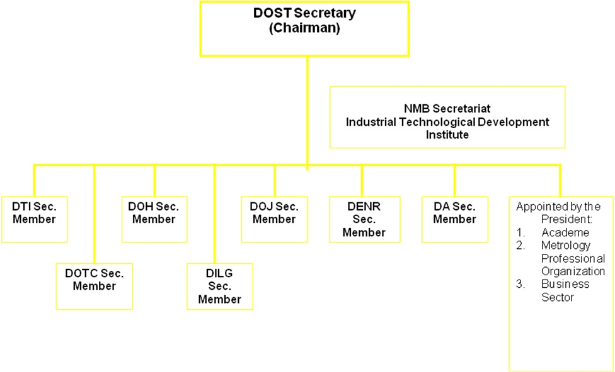
The office under the DOST which spearheads the implementation of the National Metrology Act is the Industrial Technology Development Institute (ITDI) as it serves the NMB’s Secretariat. The ITDI is one of the seven (7) Research & Development Groups under the DOST:
DOST Organizational Chart
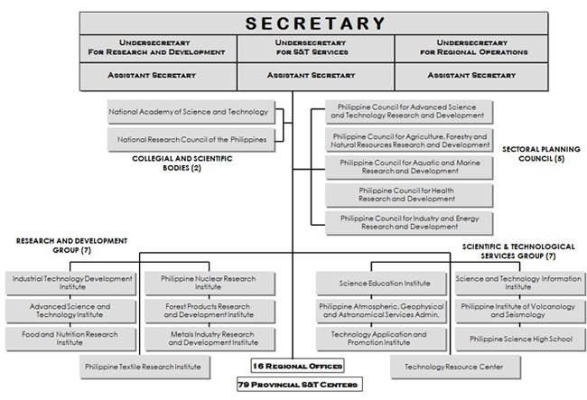
The office under the ITDI which is directly involved in the implementation of the National Metrology Act is the Metrology Department and thereunder, the National Metrology Laboratory operates.
Industrial Technology Development Institute Organizational Chart
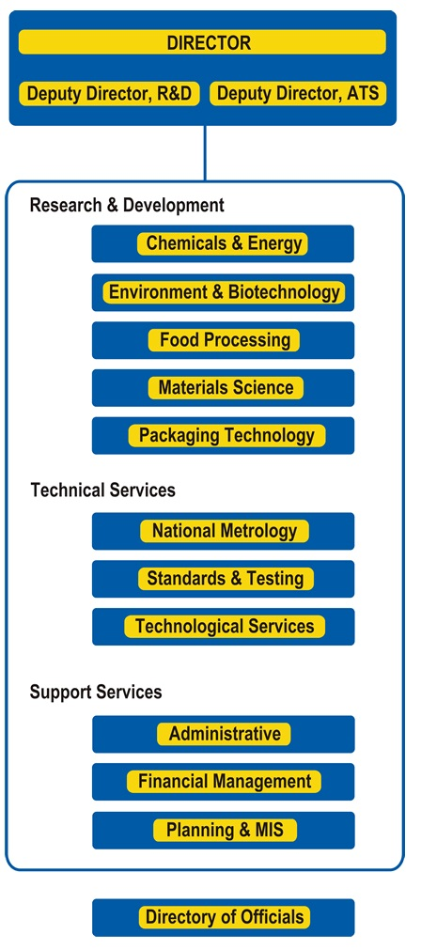
The National Metrology Laboratory is the national metrology institute which is under the ITDI; it is the body directly involved in establishing and maintaining national physical standards for basic and derived quantities such as mass, length, temperature, time interval, voltage and resistance.
The National Metrology Laboratory Organizational Chart
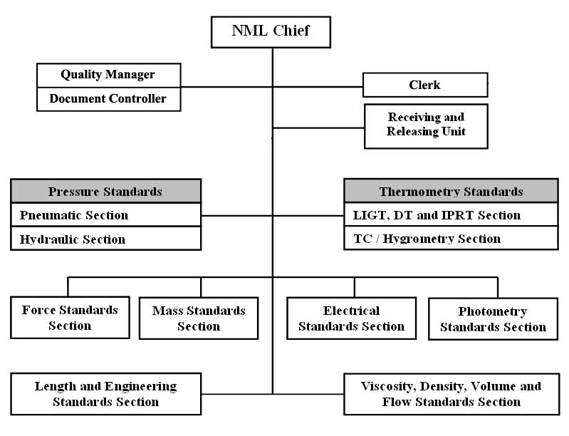
Below is an organizational chart which encapsulates the relations of all the institutions mentioned above which are involved in the implementation of the National Metrology Act:
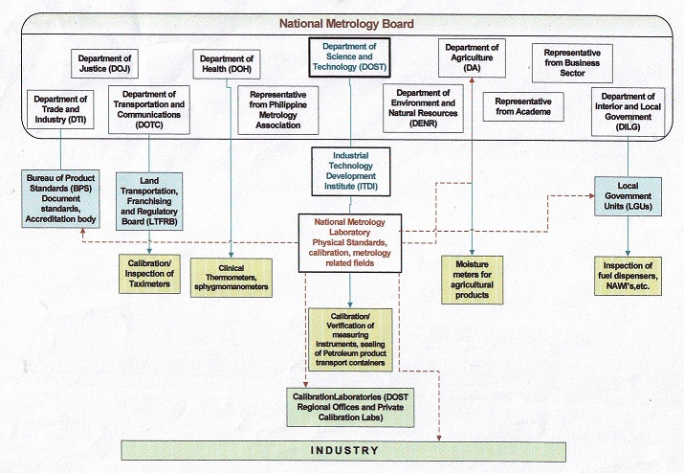

Economy Report
Singapore

I. Singapore Weights and Measures Programme

Weights and Measures Office (WMO) of SPRING Singapore plays an important role in protecting consumers and traders by regulating the use of weighing and measuring instruments used for trade and pre-packaged goods. SPRING ensures a uniform and accurate system of weights and measures is used in Singapore thereby ensuring fair trade and correct measurement for excise tax computation.

Since the revision of the Weights and Measures Act and Weights and Measures Regulations in 2006, WMO has made several initiatives to ensure that the Weights and Measures Programme remains relevant for consumers and businesses and aligned with international practices.

Key initiatives to the weights and measures programme include:

1. Authorised Verifier Scheme
Private sector companies designated by SPRING Singapore as AVs under the Authorised Verifier (AV) Scheme to handle the verification of weighing and measuring instruments for trade use. WMO has designated 22 AVs.

The designation scope of the AV Scheme has also been expanded to include the following:
- Verification of CNG dispensers
- Verification of working standards (weights and test measures)

An industry briefing on the verification of working standards was held on 28 July 2011 to enhance the knowledge and capability of the AVs.

2. Average Quantity System
SPRING continually shares with pre-packaging companies and ensures that they comply with the requirements of the AQS. It achieves this by conducting training courses to the industry and visiting packers/importers. Towards this end, WMO assisted the Agri-Food and Veterinary Authority of Singapore (AVA) to conduct sharing sessions for the food industry on the requirements of pre-packaged goods in accordance with OIML R87 in March 2011. During the sharing sessions, WMO’s pamphlets on the requirements of pre-packaged goods were also distributed to provide better understanding of the Average Quantity System (AQS).

3. Improving the Design of the Volume Measure

As part of WMO’s on-going effort to increase the convenience and efficiency of the fuel dispenser verifications, we collaborated on a project with a group of National University of Singapore’s (NUS) students.

The aim is to improve the design of the existing volume measure thereby overcoming the issues of verification personnel exposing to hazardous fumes of petrol. The new equipment also eases the difficulty of returning the petrol back to the station’s underground tank.

The final product, a metal trolley with height adjustable capability and a volume measure with fumes control capping was fabricated. Gas analysis test to determine the amount of fumes reduction during delivery was conducted with very encouraging results. The four common hazardous compounds found in petrol were effectively reduced to a very low and safe level with the use of the new volume measure equipment.

Taking it one step further, WMO would be sharing its new system’s designs to encourage innovation and improvement to the fuel dispenser verification process.

III. User Education and Outreach


SPRING Singapore organized the Quality & Standards (QS2011) on 29 June 2011 for the local enterprises, industry experts, industry associations, consumers, academia and government bodies to enhance awareness of the latest trends in standards, accreditation, consumer safety, weights and measures and technical regulations. Attended by some 400 participants, this year’s conference focused on “Building Trust in Products and Services”.

WMO recently published a pamphlet entitled, “Exact reading makes good business sense” to better educate the retail market on the various accuracy classes of weighing and measuring instruments. The pamphlet is written in both English and Chinese.

.

29 July 2011

August 2011

Name of Economy: United States of America

Current Developments in U.S. Legal Metrology:

Major issues on the Agenda of the National Conference on Weights and Measures (NCWM) as of August 2011 and related national initiatives of the National Institute of Standards and Technology (NIST).

- Development of a new ANSI standard for Gas Meters /
Harmonization with OIML Recommendations

The American National Standards Institute (ANSI) technical committee B109, responsible for gas metering standards is developing a new performance-based standard for gas meters that will cover all metering technologies. This new standard is based on the final draft of OIML R137 “Gas Meters,” and is being tentatively called “B109-point-zero.” The organization responsible for this technical committee is the American Gas Association (AGA), and a NIST engineer is leading this effort.

Manufacturers of gas meters are especially enthusiastic about improved harmonization because their products already must meet the requirements of international standards (mostly OIML) to be sold in overseas markets – and most manufacturers of these systems have significant overseas sales. Many members of the ANSI B109 committee are also very enthusiastic about creating an over-arching performance-based standard for gas meters that is performance-based and much less prescriptive. This should help create a much more “level playing-field” between competing metering technologies in the marketplace (diaphragm, rotary, turbine, mass-flow, ultrasonic, etc.). Some of these “newer” technologies are not currently covered by a domestic US standard – creating a significant problem for the purchasers of these systems. A single performance-based standard that covers all metering technologies will serve to alleviate this issue.

The United States is also continuing the effort to harmonize its requirements in other areas of legal metrology with those of the International Organization of Legal Metrology (OIML). Because our system splits responsibility between the national government and the state governments, the National Conference on Weights and Measures (NCWM) and National Institute of Standards and Technology (NIST) are working as a team to focus attention on the need to harmonize national and international legal metrology standards.

2. Development of Hydrogen Fuel Measurement Standards

The National Conference on Weights and Measures approved a tentative code of legal metrology requirements for commercial hydrogen gas refueling devices, filling a critical gap in the U.S. hydrogen economy infrastructure. The United States had its first modern hydrogen station open in 1993 in Riverside, California. While the use of hydrogen cars in the U.S. is still in the developmental stage, there are hopes that there will be approximately 50,000 “affordable” hydrogen cars on the road in the U.S. by 2015.

As part of a national effort to promote alternative fuels for vehicles, NIST established a U.S. National Work Group (USNWG) for the Development of Commercial Hydrogen Measurement Standards in 2007 to develop a comprehensive set of legal metrology standards for commercial measurement of hydrogen for vehicle and other refueling applications.

The tentative equipment code applies to hydrogen gas deliveries sold typically through service station dispensers for use as fuel in fuel cell and internal combustion engine vehicles. The approved method of sale stipulates that hydrogen fuel only be sold by the kilogram and that street sign pricing be shown in terms of whole cents (e.g., $3.49 per kg, not $3.499 per kg). The tentative code includes device design, accuracy, installation and use requirements, and test procedures. NIST published the tentative code in its 2011 edition of NIST Handbook 44 “Specifications, Tolerances, and Other Technical Requirements for Weighing and Measuring Devices.”

This USNWG plans to continue its work through 2012 to refine and finalize the hydrogen equipment and fuel quality codes and related test procedures, while continuing its training and educational outreach projects. Current discussions on fuel quality are converging on a requirement for 99.97% hydrogen purity.

3. Labeling Requirements for Printer Ink and Toner Cartridges:

Proposed new Method of Sale and Labeling Requirements:

- Method of Sale, printer ink cartridges. – All printer ink cartridges kept, offered, or exposed for sale or sold shall be sold in terms of the count of such cartridges and the fluid volume of ink in each cartridge stated in terms of milliliters or fluid ounces.
- Method of Sale, toner cartridges. – All toner cartridges kept, offered, or exposed for sale or sold shall be sold in terms of the count of such cartridges and the net weight of toner substance.

Over the past several years, there has been a change in the net content statements on inkjet and toner cartridges. Currently, there is little uniformity in the marketplace on this item, and many new labels have only a page yield count (e.g., prints 1000 pages). The NIST Weights and Measures Division believes that according to guidelines from the US Weights and Measures Law, “information required on packages,” these products are required to have the net contents of the ink (and toner) labeled. These are expensive items and the need exists to clarify the labeling requirements for industry, consumers, and weights and measures officials.

Many industry representatives do not believe that a net content statement should be required, and that a having a page yield statement is sufficient. Their main arguments are that 1) the ink associated with a cartridge is a small fraction of the total cost of the print cartridge mechanism; and 2) a page yield can provide a meaningful comparison to a consumer if all manufacturers employ the same estimating assumptions and techniques. According to manufacturers, the International Organization for Standardization (ISO) studied this issue for years and has rejected reliance on ink volume or quantity; instead ISO has developed a yield estimating and claiming methodology that permits cartridges to be compared using a consistent yardstick.

One large issue is that allowing the “contents” declaration only by yield will possibly open the door for other commodities to request to change their labeling (e.g., loads of laundry). One resolution being considered is for inkjet/toner cartridges to be sold by volume and weight – and adding page yield as a supplementary statement. This will allow for weights and measures inspectors to verify the net contents, and also provide information for consumers to make value comparisons.

4. Net Weight of Seafood

The U.S. Government Accountability Office (GAO) issued a report on a study that found deficiencies in how federal agencies enforce regulations for fraudulent practices in the seafood industry. One significant fraudulent practice mentioned in the report was short weighing.

Seafood industry leaders, through the National Fisheries Institute (NFI), have long recognized that fraudulent practices such as trans-shipping fish from one country to another to avoid certain duties and tariffs, misidentification of species, and short weighing creates consumer mistrust in the industry as well as unfair trade practices that harm companies who follow the rules. NFI formed the Better Seafood Board (BSB) in 2007 to address these issues. The mission of the BSB is to highlight NFI members as companies that provide honest seafood products and to provide a mechanism for partners in the supply chain to report suspected fraudulent practices.

Industry efforts to fight fraud were believed to not be sufficient by themselves. Government oversight and enforcement is essential to curtail certain fraudulent practices. Due to limited enforcement of the existing fraud-related regulations, changes are needed to protect the interests of the consumers and ethical businesses.

NIST has held two public forums on this issue, in May 2009 and in July 2010, to discuss the problem and solutions to short net weight fraud occurring in the Seafood industry. The two meetings were a collaborative effort and was attended by 70 participants representing: Federal Agencies from Customs and Border Protection (CBP), Food and Drug Administration (FDA), National Marine Fisheries Service (NMFS), NIST, and the U.S. Department of Agriculture (USDA), Weights and Measures Officials from individual states, Trade Associations from American Frozen Food Institute (AFFI), Better Seafood Board (BSB), International Food Distributors Association (IFDA), National Association of Attorney Generals (NAAG), and National Fisheries Institute (NFI), and individual companies.

Participants of the forums were in agreement that economic fraud is regularly occurring in the seafood industry and that a concerted effort must be taken to address this practice. It was also agreed that intentional short weighing of 10% to 35% is frequently found and creates a significant economic impact to consumers and the government (e.g. tax revenue) and threatens regulatory integrity and equity in the marketplace. Discussion centered around the need for clarity on interpretations of current laws, especially the issues concerning ice or “glazing” or “marinade” being counted in the net weight statements.

The CBP, FDA, and NMFS believed they do currently have the legislative authority to be effective against seafood fraud, but actual enforcement of the laws remains a significant issue. The FDA plans to publicize to industry that there will be greater enforcement activity in the area of short weighing of seafood. FDA also plans to investigate possibly publicizing cases where seafood fraud is found, with the intent of being a deterrent to future fraudulent activity. Forum participants agreed to closer collaboration in combating seafood fraud in the future.

- Sale of “Pelletized” Ice Cream and “Pelletized” Frozen Desserts

Packaged “pelletized” ice cream is a novel product that entered the U.S. retail market about three years ago. Pelletized ice cream is essentially “beads” of ice cream that are quickly frozen with liquid nitrogen.” The beads are relatively small, but can vary in shape and size. As with other types of ice cream, the pellets are produced in several flavors, and they are frequently mixed with pieces of cookies, brownies, candy, and other inclusions. A method of sale issue developed in the U.S. because at least two manufacturers are labeling their packages by net weight while the other manufacturers are labeling their packages in terms of fluid measure. The manufacturers that label their packages by fluid measure included the air surrounding the pellets in their net quantity of contents statement. Ice cream and other frozen dairy products are traditionally sold in the U.S by fluid volume while the product is in a frozen state.

In June 2008, NIST held a meeting in Gaithersburg, Maryland to discuss issues related to the sale of packaged Pelletized Ice Cream with all interested parties. The participants included representatives from the NCWM, officials from individual states, officials from the U.S Food and Drug Administration, manufacturers of pelletized ice cream, and a representative of the International Dairy Foods Association.

The U.S. Food and Drug Administration (FDA) made an announcement in April 2009 that the appropriate net quantity of contents declaration for pelletized ice cream would be net weight only. Manufacturers were given until April 2010 to revise their labels. In July 2010, the NCWM approved new language in HB 130 that fully defines pelletized ice cream and states that it shall only be kept, offered, or exposed for sale on the basis of net weight.

In August 2010, the FDA made a decision that the net quantity of content statement on pelletized frozen desserts (different from pelletized ice cream because they do not contain any dairy products) shall also only be declared in terms of net weight. FDA is expecting manufacturers of pelletized frozen desserts to have their labels reflect a net weight declaration in 2011.

6. Seed Count for Agricultural Seeds

The NCWM is working to adopt a test procedure for inspection of bulk agricultural seed (specifically corn seed, soybean seed, field bean seed, and wheat seed) labeled by “count” rather than weight.
There is a current standard adopted by the Association of Official Seed Analysts (AOSA) which is broadly accepted by industry. Currently, several states adopt both the AOSA standard and the NIST Handbook 133 regulation, which causes confusion due to conflicting Maximum Allowable Variations (MAV). The MAVs in HB 133 are not considered appropriate for seed counts in which counts can be as high as a 200,000.

NIST and the NCWM are in the process of amending HB 133 to provide for a uniform, practical, and accurate method for conducting inspections of specified agricultural seed varieties when labeled and/or sold by “count.” There is consensus among the seed industry, state seed control officials, and academics in support of the AOSA standard for seed counting.

Moisture Allowance – Pasta & Noodle Products

There is a controversial item that has been proposed in NCWM concerning a 3% “moisture allowance” for pasta and noodle products. These products are packaged in paper bags, paperboard cartons, and/or flexible plastic bags with a moisture content of 13 % or less at the time of pack.

Studies indicate that moisture loss for pasta products is reasonably predictable over time. Pasta exhibits consistent moisture loss when handled in a uniform manner. However, moisture loss can vary more than 4 % due to environmental and geographic conditions. Although it eventually reaches equilibrium with the surrounding atmosphere because it is hygroscopic, this balance does not occur until long after packaging and shipping. There is support from manufacturers on this item, but most regulators believe there is no need to offer the extra allowance. One potential problem is that manufacturers may possibly attempt to under-fill on purpose to take advantage of the allowance; correct net weight would need to be verified at time of packaging.

- Legal Metrology Issues concerning Electrical Vehicle Charging

One rapidly developing and significant legal metrology issue in the U.S. concerns the sale of electricity to charge electric vehicles. The U.S. government has set the target goal of one million electric vehicles in use by 2015.

Electric vehicles run on battery power, replenished through electrical connections. In the U.S., the primary charging locations are residences, businesses, and storage locations for fleet vehicles. There are minimal legal metrology issues in these locations because the electricity has already been metered and billed by the electrical utility. In these locations, with a standard charger, recharging a typical electric vehicle battery from near-total discharge to full charge usually takes 4-8 hours, with most vehicles charging overnight.

Public charging sites are still relatively uncommon in the U.S., although the number of these sites is rapidly increasing. These sites are usually located in city or store parking lots, and at hotels, airports, and various businesses. The installation of “DC Fast-Charging Stations” with high-speed charging capability can allow consumers to recharge a battery on their electric vehicle from 20% to 80% in about 10 minutes.

The legal metrology issues arise on how the public site is attempting to “sell” the electricity to consumers. Many sites currently favor a “time-of-connection” charge, but that is not very equitable because of the wide range of charging capabilities of the different types of stations/connections. The fairest way to sell electricity is by the kilowatt-hour, but this is more complicated, possibly confusing for consumers, and many jurisdictions have regulations that say that only “utilities” can sell electricity (with strict restrictions on the “price” of electricity). The key for the weights and measures officials is that the transaction involves a measurable finite quantity of energy so that nationally-standardized requirements for the method of sale can be developed.

Economy report of Vietnam for 2011 APLMF meeting

I – Current status and development of legal metrology
1. Law and regulations
- Law on Metrology will be summit to National Assembly for approval on October this year.
- Issued 20 biding technical specifications on metrology, based on OIML recommendations.
2. Organized the International Metrrology Day (20/5/2011).
II – In the year of 2012
- Submit the Government, the Minister of MOST to issue Degree, Cirlulars for implementing Law on Metrrology;
- Submit the Minister of MOST to issue Circular on metrological management for trade of gold.
- Issue ~20 biding technical specifications on metrology, based on OIML recommendations.

