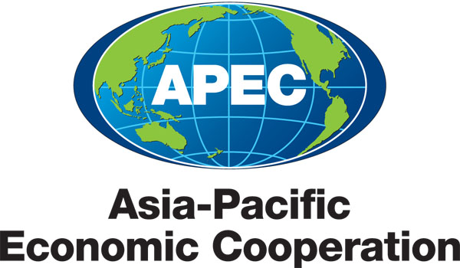
_____________________________________________________________________________
2011/SCSC/JRAC1/010
Agenda Item: 7

Economy Updates – Singapore

Purpose: Information

Submitted by: Singapore

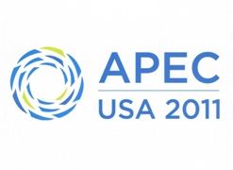 | Joint Regulatory Advisory Committee on Electrical and Electronic Equipment Meeting  Chicago, United States  24 May 2011

Singapore
Economy Updates for 16th APEC JRAC Meeting on 24 May 2011

Background on the Singapore Consumer Protection (Safety Requirements) Registration Scheme (CPS Scheme) and Consumer Protection (Consumer Goods Safety Requirements) Regulations 2011 (CGSR)

Both CPS Scheme and CGSR are administered by SPRING Singapore. SPRING Singapore is appointed the Safety Authority since 1991 by the Ministry of Trade and Industry (MTI) under the Consumer Protection (Safety Requirements) Regulations (CPSR) which undergone a major revision in 2002. One of the roles of the Safety Authority under the Regulations is to ensure compliance by industry on the registration of forty-five (45) categories of Controlled Goods.

CGSR comes into effective on 1 April 2011. It applies to consumer goods for private use or consumption as well as packaging in which the goods are supplied. It excludes goods that are currently regulated by other laws.

Economy Updates

Regulatory amendments/updates | - CPSR was last amended in 2002  - CGSR was implemented on 1 April 2011
Investigations | Conducted 12 investigations on possible infringement of the Regulations
Recalls | 1 recall
Fatalities or significant injuries: tradesperson/public | None
Standards amendments: | Minimum edition of safety standards for 25 categories of Controlled Goods harmonised with ASEAN Member States
Infrastructure upgrades / expansions / issues – remedial actions taken | - Energy Labelling Scheme for Air-conditioner, Refrigerator and Clothes Dryer known as Registrable Goods by the National Environment Agency (NEA)  - Since 1 January 2008, Registrable Goods must carry energy labels under the Environmental Protection and Management Act
Free Trade Agreements: | - JSEPA (Agreement between the Republic of Singapore and Japan for a new-age Economic Partnership)  - ASMRA (Mutual Recognition Agreement on Conformity Assessment between the Government of Australia and the Government of the Republic of Singapore)  - ANZSCEP (Agreement between New Zealand and Singapore on a Closer Economic Partnership)  - AHEEERR (ASEAN Sectoral Annex on Mutual Agreement for Electrical and Electronic Equipment)  - ASEAN Harmonised EEE Agreement (Agreement on the ASEAN harmonized Electrical and Electronic Equipment (EEE) regulatory regime)  - APEC EE MRA  - BSMI-SPRING EE MRA (Mutual Recognition Agreement on Conformity Assessment between the Bureau of Standards, Metrology and Inspection and the Standards, Productivity and Innovation Board)  - CECA (Comprehensive Economic Cooperation Agreement between the Republic of India and the Republic of Singapore)  - KSFTA (Free Trade Agreement between the Republic of Korea and the Republic of Singapore)
Safety Audits | - Technical File Audit on Registered Suppliers  - Conformity Assessment Body annual assessment  - Recognised Testing Laboratory annual assessment
Incidents and trends – remedial actions taken: | - 8 incident reports – damages confined to the products and mainly due to mishandling.  - Do’s and Don’ts handbook
Compliance actions: | 210 market surveillance conducted
Industry announcements: | - Circulars  - News update in the SPRING’s website www.spring.gov.sg/safety
Licensing updates: | None
Actions against importers / exporters / retailers / suppliers / industry | 30 warning letters issued and 4 compound fines
Industry/ public safety awareness campaigns: | - CGSR Seminar for Businesses and Consumers

Date: 18 May 2011
Version: 01
Submitted by: Daniel Ng, Singapore

