學習心得報告（出國類別：短期進修）

美國JOHNS HOPKINS醫學中心
泌尿科進修

服務機關：國軍花蓮總醫院
姓名職務：黃建銘泌尿科醫師
派赴國家：美國
出國期間：2009年9月1日至2009年8月31

目 次
- 前言……………………………………………………………………………… 2
- 進修主題與計劃 …………………………………… …………………… 2
一、進修主題 …………………………………………………………………… 2
二、進修計劃 …………………………………………………………………2-3
- 進修內容及結果 ……………………………………………………3-11
- 心得與建議……………………………………………………………………4-5

前言
此次能獲得美國第一名的泌尿科實驗室同意的進修，真是最好機會，它不僅是全美第一，也可說是全世界第一，尤其是機械人手術更是世界有名，它的學術第位不言可喻，我所找到的教授就是在這方面非常有研究的學者，我參與了有關機械手臂手術及前列腺影像重組技術，並進一步了解神經血管在觀察中所產生的人為錯誤。除此我也計劃參與若干相關的訓練，以期對本科能很大的助益，另外也專研於超音波影像，此影像學對我們臨床的應用非常重要。

進修主題與計劃

一、進修主題
我把主題放在機械手臂手術及前列腺影像重組技術，另外還有若干相關的主題我也有參與：

- 達文西機械手臂手術
- 先進的超音波前列腺影像重組技術
- 研究elastography超音波
- 超音波phantom的製作及其運用
- 泌尿科癌症機械人手術的技術及技巧訓練- 洛杉機醫學中心
- 超音波及各項泌尿科操作手術訓練- 舊金山美國泌尿科醫學會
- 超音波定位針刺切片的問題

二、進修計劃
由於泌尿科機械手臂實驗室有著最先進的儀器設備，使得在學習上能獲得充分的資源，我的計劃就是在實驗室運用現場的設備，計劃出很好的研究方向。不過首先我還是到醫院了解目前的臨床工作：

- 參與泌尿科開會及臨床工作
- 了解達文西機械手臂手術
- 開始了解並操作先進的超音波
- 認識超音波前列腺影像重組軟體
- 製作出符合超音波使用的假體超音波phantom及其運用
- 著手於研究elastography超音波
- 加入泌尿科醫學會
- 報名泌尿科癌症機械人手術的技術及技巧訓練- 洛杉機醫學中心
- 報名超音波及各項泌尿科操作手術訓練- 舊金山美國泌尿科醫學會
- 最後我又想出我的最後計劃：超音波定位針刺切片的問題，也就是利用這一年來所學的phantom技術，找出針刺的不準確原因。

叁、進修內容及結果
因為在醫院及實驗室長期努力的研究，終於有所成就，準備發表於醫學雜誌。

本研究利用機械手臂了解超音波影像在前列腺的立體重組情形。其中並使用假的前列腺進行重組模擬，發現的確有人為錯誤的產生，對於如何校正此項誤差有莫大的幫助。

此項研究同時與機械人手術同時進行，可以提供醫師即時的血管神經定位以避免傷害有一定程度的幫助，除此也可同步監控前列腺及相關臓器的位置及器械相對位置。

此結果發表於AUA 美國泌尿科年會中的 EUS 並且獲獎為OUTSTANDING
以下為其ABSTRACT:

PARTIAL-VOLUME ARTIFACT ON PROSTATE ULTRASOUND IMAGING
Chien Ming Huang, Chunwoo Kim, Doru Petrisor, Doohyun Lee, Misop Han, Dan Stoianovici
URobotics Lab, Urology Department, Johns Hopkins University, Baltimore, MD
http://urobotics.urology.jhu.edu/
Introduction: The TRUS Robot, a robot to manipulate a transrectal ultrasound probe (TRUS), has been developed and used in tandem robot-assisted laparoscopic radical prostatectomy (T-RALP) to better visualize the neurovascular bundles (NVBs) during surgery and to generate 3-D reconstruction images of the prostate and NVBs. The NVBs lie just outside of the prostatic fascia, adjacent to the prostate gland. We examined how the partial-volume effect of TRUS, a common cross-sectional imaging artifact, could influence NVB localization and 3-D reconstruction results.
Methods: During T-RALP, a side-fire TRUS probe was placed as usual along the cranial-caudal axis. It was rotated by the TRUS Robot so that the prostate can be scanned with variable angle coronal-sagittal views. Images were recorded together with positioning information given by the robot. Image-position pairs were then processed for 3-D reconstruction using Amira software (Visage Imaging, CA). The bladder, urethra, prostate, seminal vesicles, NVBs and rectal wall were segmented. TRUS scanning was also simulated by using a simple mockup in a water basin. The mockup was made of a chicken egg with a thin wire wrapped around it, simulating the prostate and NVBs, respectively.
Results: In the reconstruction of the images acquired in surgery, certain portions of the NVB were observed as if penetrating the prostate (Fig.1). This may be explained as a consequence of a partial-volume artifact. The schematic in Figure 2 shows that when the imaging plane is nearly tangential to the prostate, even though a NVB is represented outside the prostate (red dot outside green circle), in the Image Slice the NVB appears within the prostate (red within green). This artifact appears because partial volumes of adjacent structures within the Slice Thickness are collapsed to one Image Slice. This observation was confirmed in mockup experiments. Figure 3 shows the ultrasound image of a wire wrapped around the egg, when the image plane is nearly tangential to the eggshell. The image clearly shows the artifact, in which the wire appears to penetrate the shell. Therefore, while attempting to image NVBs, Doppler activity within the gland should not be immediately dismissed, especially when a partial-volume artifact is suspected. Doppler ultrasound may artificially show parts of NVBs to be located within the prostate.
Conclusion: Partial-volume artifact in TRUS may make structures adjacent to the prostate, such as NVBs, appear within the gland. This is only apparent when the slice of the image plane is nearly tangential to the capsule. The artifact may be avoided by using transverse imaging. Clinicians should be aware of this important artifact in interpreting prostate ultrasound images.
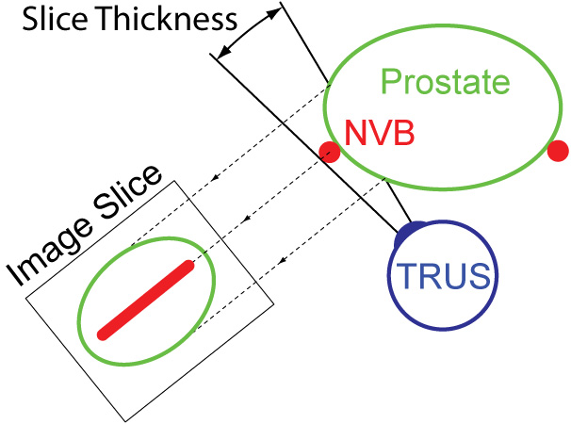
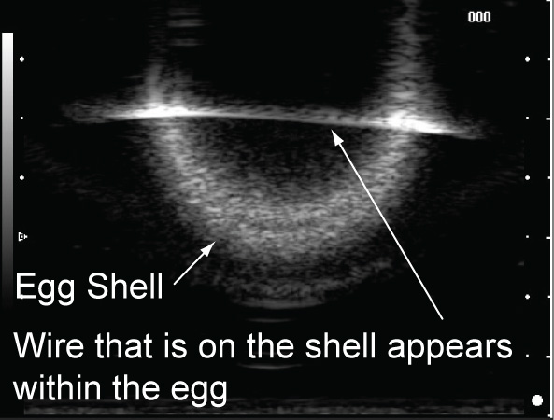
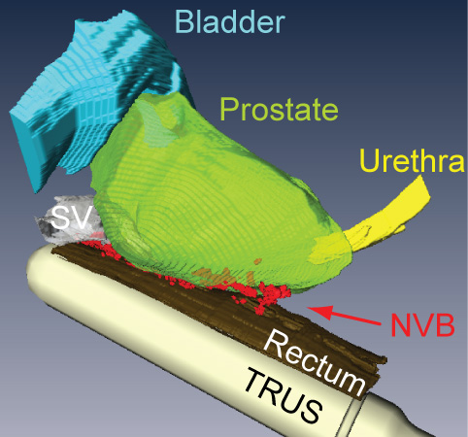
Acknowledgement: Partially supported by award R21CA141835 from the National Cancer Institute, the Sidney Kimmel Comprehensive Cancer Center at Johns Hopkins, and Hitachi Medical Systems America. The content is solely the responsibility of the authors and does not necessarily represent the official views of the NCI, JHU, or HMSA.
除此，當我在作此研究時，須校正其準確性，但總發現針穿刺時實在很不準確，於是著手於研究針的不準性以下為其準備發表的 ABSTRAT

穿刺切片時針的彎曲如何造成不準確性
黃建銘^{1*} ,Chunwoo Kim², Doru Petrisor², Doohyun Lee², Misop Han², Dan Stoianovici²
國軍花蓮總醫院 外科部 泌尿外科¹ ;Robotics Lab, Urology Department, Johns Hopkins Medicine, Baltimore, MD, USA²
How needle bending makes needle puncture biopsy inaccuracy?
Chien Ming Huang¹, Chunwoo Kim², Doru Petrisor², Doohyun Lee², Misop Han², Dan Stoianovici²
Division of Urology, Department of Surgery, Hualien Armed Forces General Hospital^{1;} Robotics Lab, Urology Department, Johns Hopkins Medicine, Baltimore, MD, USA²

Purpose:
Needle puncture is a popular procedure in clinics. Particularly, patients have tumor lesion need to differentiate malignant or benign. Physicians are trying to make their effort to reach the lesion by image-guided needle, such as ultrasound, CT and MRI. Although these images give us very good resolution, the inaccuracy is still high. As far as we know, needle bending while penetrating soft tissue is one of important reasons. We design a gelatin mockup to know how needle bending affects inaccuracy.
Materials and Methods:
We use a container which is transparency. In the container, we fill with gelatin. The gelatin mockup was made with gelatin, water, sorbitol and glycerin (12:100:6:6 by weight). This was well mixed and heated by microwave to reached 50-60 Centigrade degree. Remove the bubbles by some tissue paper and pour it into the container. It needs to be solidified in refrigerator for couple hours. We fixed the ultrasound by Robotic holder with needle adaptor. Visible Laser was used for calibration by through the needle adaptor (Figure 1). A puncture needle biopsy was used to penetrate mockup (Figure 2). We turned the needle 180 degree and made another puncture (Figure 3).
Results:
In Figure 3, these two punctures have a gap of 9.5mm in 5cm depth. Because this biopsy gun has a slot on the tip of needle, it made needle bending in different way. When we use diamond shape needle, it goes more straight.
Conclusion:
Slot tip needles do not go straight. That kinds of needle tip make needle bending. It is true that needle bending affect biopsy accuracy, which has 9.5mm away from the target in 5cm depth. Different needle tip design might have different bending degree. We believe diamond shape needle tip would be better than slot one.

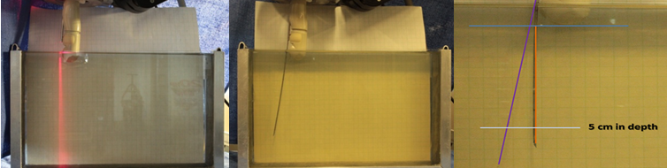
Figure 1 Figure 2 Figure 3

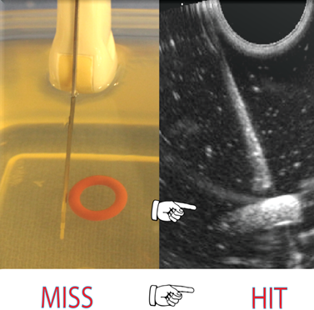
^ 此圖可發現實際上 針是沒刺到目標，但影像卻顯示刺入目標
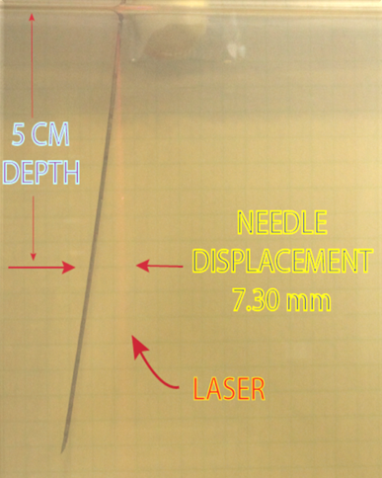
^此圖顯示針的確偏移了7.3mm

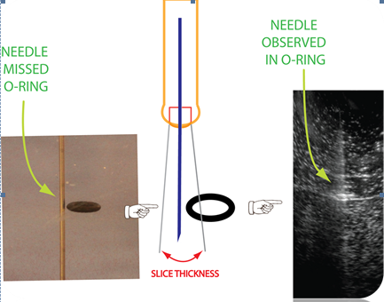
^此圖是用來示意針的影像是如何在超音波上顯現出錯誤
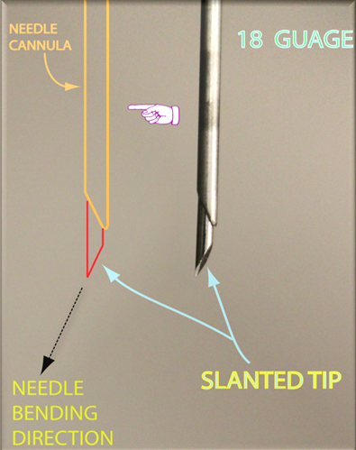
^此圖是表示針端的斜面是讓針偏移的主要原因

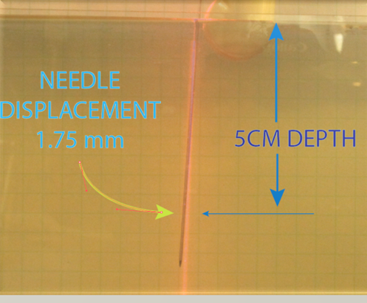
^使用鑽石頭的針偏移的很少 只有1.75mm

另外本人也參與兩項訓練
訓練1 泌尿科癌症機械人手術的技術及技巧訓練
本人有幸於0121, 2010參加由美國泌尿科醫學會所舉辦的泌尿科癌症機械人手術的技術及技巧訓練，藉由真實的手術現場即時轉播，使得我們學習到臨場的手術經驗，這是在國內所沒有的，更重要的是這三天的手術皆由機械人來完成。
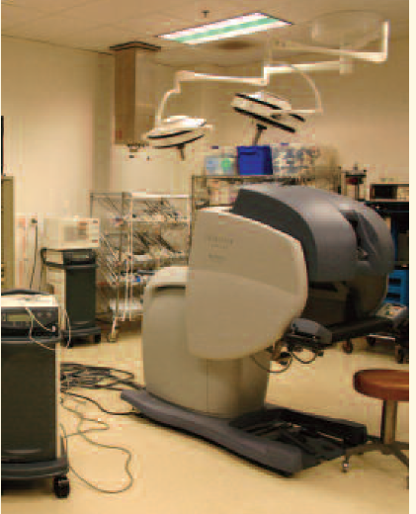
以下為其課表
Scientific Program Schedule - 26.25 AMA PRA Category 1 ™ Credits
Thursday, January 31, 2008
Bladder - Drs. Ornstein and Dash
6:30 – 7:00 a.m. Continental Breakfast, Registration and Sign In
7:00 – 7:10 a.m. Welcome and Introductions
7:10 – 7:40 a.m. Surgery Overview: Robotic Cystectomy and Diversion
7:40 – 10:40 a.m. Surgical Procedure – Live Case Broadcast
• Robotic Cystectomy and Pelvic Lymph Node Dissection
10:40 – 10:55 a.m. Break
10:55 – 11:15 a.m. Technique Panel: Diversion – Continent
11:15 a.m. – 12:00 p.m. Complications ofMinimally-invasive Cystectomy and
Diversion: Avoidance, Recognition and Recovery
12:00 – 1:00 p.m. Lunch
Laboratory Session
1:00 – 2:30 p.m. PorcineModel – Cystectomy
2:30 – 3:30 p.m. Video Session and Break
3:30 – 5:30 p.m. PorcineModel – Continent Diversion
Meeting Adjourns
Friday, February 1, 2008
Prostate - Dr. Ahlering
6:00 – 7:00 a.m. Continental Breakfast and Sign In
7:00 – 7:30 a.m. Surgery Overview: Step-by-Step Technique for Robotic
Radical Prostatectomy
7:30 – 10:30 a.m. Surgical Procedure – Live Case Broadcast
• Robotic Radical Prostatectomy
10:30 – 10:45 a.m. Break
10:45 – 11:05 a.m. Techniques Panel: Tips and Tricks on Potency and Nerve
Sparing
11:05 – 11:45 a.m. Complications ofMinimally-invasive Radical
Prostatectomy: Avoidance, Recognition and Recovery
11:45 a.m. – 1:00 p.m. Lunch
Laboratory Session
1:00 – 3:00 p.m. Video Session
CadaverModel – Robotic Prostatectomy Skills Training
3:00 – 3:30 p.m. Break
3:30 – 5:30 p.m. Video Session
CadaverModel – Robotic Prostatectomy Skills Training
Meeting Adjourns
Saturday, February 2, 2008
Kidney - Drs. Ornstein, Clayman and McDougall
6:00 – 7:00 a.m. Continental Breakfast and Sign In
7:00 – 7:30 a.m. Surgery Overview: Partial Nephrectomy: Robotic and
Standard
7:30 – 10:30 a.m. Surgical Procedure – Live Case Broadcast
• Robotic Partial Nephrectomy /Standard Partial
Nephrectomy
10:30 – 10:45 a.m. Break
10:45 – 11:05 a.m. Techniques Panel: Vessel Clamping and Tissue Cutting
11:05 – 11:45 a.m. Complications ofMinimally-invasive Nephrectomy and
Partial Nephrectomy: Avoidance, Recognition and
Recovery
11:45 a.m. – 1:00 p.m. Lunch
Laboratory Session
1:00 – 3:00 p.m. Video Session
PorcineModel – Partial Nephrectomy
3:00 – 3:30 p.m. Break
3:30 – 5:30 p.m. Video Session
PorcineModel – Partial Nephrectomy
Meeting Adjourns
Robotic and Advanced Laparoscopic Urologic Oncology: Curing Cancer Through Technology and Skill

經由此課程，讓我學習到機器人的手術流程，並經由現場醫師們的討論，獲得即時的解說，以下為課程的目標：

Target Audience
Urologists who have experience with laparoscopic techniques seeking
to enhance their abilities to perform advanced standard laparoscopic
oncological procedures and oncologic surgeons seeking to
expand their abilities into robotic laparoscopic surgery.
Course Description/Purpose/Need
Minimally-invasive urology has evolved into an integral part of the
treatment of urologic cancer. The modern management of prostate,
renal, adrenal and bladder cancer requires a working knowledge of
laparoscopic and robotic techniques. In order to perform advanced
minimally invasive urology procedures, open surgical principles must
be integrated with those of laparoscopy and robotic-assisted laparoscopy.
This course provides a structured approach to robotic and advanced
laparoscopic surgery for urologic oncology. The specific surgical
techniques will be outlined in a step-by-step operative outline. Issues
such as optimal positioning, port placement, dissection techniques
and methods to facilitate dissection and reconstruction will
be discussed. The procedure will then be demonstrated in a live case
surgery with expert faculty to provide commentary and offer specific
tips and tricks related to each technique. Attendees will then
practice the specific surgical skills in inanimate, animate and/or cadaveric
models for each of the surgical procedures. Panel discussions
with the expert faculty will address methods to recognize and
address complications and problems for each of the surgical procedures.
The course is designed to spend a full day concentrating on
each of the following areas: prostate cancer, bladder cancer and
renal cell cancer.
Learning Objectives
Upon completion of this course, participants should be able to:
_ demonstrate the surgical steps of robotic surgery procedures for
bladder, prostate and kidney cancer
_ analyze the robotic techniques unique to surgical management
of bladder and prostate cancer and the robotic and standard laparoscopic
techniques unique to surgical management of renal
cancer, specifically partial nephrectomy
_ discuss the key complications, and outline the intra-operative and
postoperative management related to robotic surgery procedures
for bladder and prostate surgery as well as robotic and standard
laparoscopic procedures for partial nephrectomy
_ apply the laparoscopic and robotic surgical skills of suturing and
knot-tying related to urethrovesical anastomosis,

訓練2 超音波及各項泌尿科操作手術訓練
這項多采多姿的訓練是全世界最大的泌尿科醫學會- 美國泌尿科醫學會所舉辦課程包含了前列腺肥大的雷射手術、男性超音波、腹部超音波、小兒超音波、腎臟細針燒除術、腎臟開動手術、女性骨盆腔手術及腹腔鏡手術的訓練，經由這次的訓練獲得許多的經驗，不管是在臨床或是教學上都有很大的助益，尤其是本院的腹腔手術及超音波的診治上的運用都會有長足的進步，另外還有前列腺的雷射治療，這已成為全世界最標準的手術治療，在這次的訓練中有幸可以手動來操作各個不同的雷射機器，可說是收獲不少，而且使用了豬的前列腺來讓我們學員學習更增加了真實性，相信對於本院在前列腺的治療上能提供進一步的提昇。

肆、心得與建議
一、心得
此次在美國第一名的泌尿科實驗室進修有關機械手臂手術及前列腺影像重組技術，並進一步了解神經血管在觀察中所產生的人為錯誤。此影像學對我們臨床的應用非常重用，除此也參與美國醫院教學的工作，對於學術上的研究有進一步的認識。
美國第一大醫學院的泌尿科果然是非常優秀的教學中心，我到實驗室時，他們還配給我最新進的電腦，使得我可以獨立的進行各項研究工作，實驗中有各種機械人可供運用於泌尿科手術，我也到了手術室參與研究工作，看到了他的手術室有著各項的先進工具，才知道醫師能作的事真多。
在實驗室裡我開始研究elastography超音波，這是最先進的超音波技術，它能鑑別腫塊的軟硬度，所以我開始制作各種腫塊的phantom能運用在特別的超音波上。
我也參與了影像的立體重組工作，使得我對於前列腺有更進一步的認識，也因此寫了論文 ，他們及老師的工作都非常真經常到了晚上八九點才回家，我也在這樣的氛圍中加油創造了論文，這真是非常充實的進修。
本人有幸能參與AUA 2010年會並有發表研究成果，可說是本院及軍醫體系的光榮。美國在泌尿醫療系統及人才培訓已有完整之訓練計畫及制度，對於各類疾病亦有完善處置流程，其豐富經驗，值得我們學習。此次美國短期進修可以提升本院醫療水準，並造福病患。

二、建議
- 回國後，我仍與老師在連絡，可以加強與國外教授的交流，建議我們醫療體系可以多鼓勵人員到國外做短期的進修。
- 可以做一到三個月的進修，不但能與世界接軌也不太會影響醫院整體的運作。
- 加強學術交流，軍醫大會可以多邀請學術上有研究成果學者來發表。
- 加強機械人手術的訓練，此項手術已成為標準的治療方式，不應因為健保不付而不做這方面的訓練。
- 提高參與國外學術發表的機會。
- 建議提供出國貸款，讓出國進修者無金錢上的後顧之憂。

