出國報告（出國類別：交流訪問）

首爾國立大學大學自主化訪問行報告

服務機關：國立成功大學
姓名職稱：賴明詔校長、馮達旋副長、
陳進成主任、李依蓁僱用辦事員
派赴國家：韓國
出國期間：99年1月27日至1月29日
報告日期：99年3月10 日

首爾國立大學
大學自主化(Corporatization)
訪問行報告摘要

本校今年1月27日至1月29日受邀前往韓國首爾國立大學(Seoul National University)進行亞洲大學自主化經驗考察及國際學術交流。此行由賴明詔校長領軍，馮達旋資深執行副校長、化工系陳進成主任、李依蓁雇用辦事員等人代表出訪。本參訪團前進首爾國立大學考察該校大學自主化之經驗及針對「自主、治理、職責」（Autonomy, Governance and Accountability）議題進行討論分析；目前該校已通過韓國國會並於民國100年正式邁入大學自主化時代，成為亞洲國家大學高等教育之前瞻及優良範例。故本參訪團遠赴首爾國立大學考察，以期探討該校自主化的過程、整體架構及相關行政業務之交替轉變。

目次、
一、 成員、日期、地點 4
二、 訪問目的與行程 4
三、 訪問大要及過程 4
四、 心得與建議 9

首爾國立大學
大學自主化(Corporatization)訪問行報告

- 成員、日期、地點
- 成大: 賴明詔 校長
馮達旋 副校長
陳進成 主任
李依蓁 助理

- 首爾國立大學: 李長茂 校長
朴杉沃 教授(校務會議主席)
李根寬 副院長(公關處)
姜大熙 副院長(研發處)
徐敬浩 院長(文學院)

- 日期:2010.1.27~1.29 首爾國立大學

- 訪問目的與行程
- 了解首爾國立大學大學自主化之原因、程序、目的、與架構。
- 拜會各教授了解其在大學自主化中扮演之角色及對大學自主化之看法、運作、與觀感。

  - 訪問大要及過程

三-1 朴杉沃教授(president of University senate)
- 為什麼要大學自主化:
在招募外籍優良教師上因制度限制;待遇低,65歲退休。
- 追求目標:自主化(Autonomy)
要求條件: a.教育部補助金額維持目前水準並隨其他國立大學調升而
調升。
b.所有要求列入大學自主化條文中,以得到保障。
- 大學自主化過程:
  - 10年前開始此議題之討論。
  - 5年前開始政府提出全國國立大學大學自主化構想,但遭拒絕。
  - 2年前針對首爾國立大學單獨大學自主化之構想提出討論並與政府討論。
iv. 校內廣泛討論。
v. 討論後經一年醞釀期接著李校長宣布首爾國立大學要大學自主化。
vi. 進行大規模溝通及討論,並著手進行大學自主化相關內容之規劃,成立67人委員會負責此事,成員包括教育部、地方政府、教師。
溝通次數與期間: 13次辯論會及一年的與校內成員面談。
85%之Senate成員同意大學自主化。
4. 大學自主化後權力結構:
Board of trustee為權力中心6-15人,1/2以上校外。
5.目前Senate之狀態:
i. 代表有50人,由各院依各院大小(教授人數)分配代表人數。
每月開會一次。
ii. 朴教授擔任之角色: 建議及審議
以學校長期利益為主要考量,並保障各院平衡發展。
6. 大學自主化後退休與權利變化:
教師:
現任教師保障其退休金不變。
新任教師以私校授退休金支付,其額度與公立教授同。
大學自主化後彈性薪資,但保障現任教師薪水不低於現制。
5年後必須決定公立與私立退休方式。
職員: 職員為公務員,20年為期,20年後轉為私立,支領私校退休金。

三-2 李長茂校長
1.為什麼要大學自主化:
僵化的制度
人員編制限制
2. 追求目標:
自由與自立
長期發展計劃
3. 目前教師(tenure)長聘情形:
過去約70~80%新聘教師可得到長職。
現在約50%新聘教師可得到長職。
未來視競爭力，維持適度通過率，以提昇競爭力。
4. 目前外籍教師情形:
人數:
共約200人，含訪問教授(visiting professors)。
其中可長聘制(tenure track)約60人。
70人為兼任教授或研究員。
制度:
Mentor：給每位新進外籍老師一位mentor。
助理：給研究生助理協助翻譯。
5. 國際化工作:
課程:
Intensive course：由國外大師組成教學團隊,每週密集上課。
每人上課1~2週。
雙學位計畫:
由過去4個近年增加至13個。
每個計畫約有2-3個學生參加。
6. 大學自主化之推動:
i. 釋出大學自主化訊息開始討論。
ii. 對此大學自主化議題暫時停止討論一年。
iii. 宣佈要進行大學自主化。
組成80人大學自主化工作團體，其中10人為校外人員。
其中10人為職工公會成員因全國公會意見而退出。

分5組
政府溝通，治理，人事與監督，經費，設備(Facility)

iv. 大學自主化法案擬訂方式:
溝通
政府 李校長
提出法案
v. 公聽會次數:
參加70場以上說明會、公聽會,以小團體方式進行深度說明與溝通。

三-3 姜大熙寬副院長
1. 研發建教窗口:
以研發處為單一窗口。
2. 經費來源:見資料
3. 任務: 協助專利申請,技轉及成立公司
4. 大學自主化議題:
i. 回收校內大學自主化問卷,大約略高50%教授回覆。
ii. 教授態度: 大多冷漠不表態,只要其權益不受影響及少管(leave them alone)即可。

三-4 李根寬副院長
1.日本大學自主化與SNU大學自主化之差別
i. 日本因政府赤字高達GDP 100%以上,為了減少赤字並緊縮政府公務員規模,預計縮減10萬人以上,因此提出國立大學大學自主化,以減小赤字及因應政府公務員人數之縮減。日本政府要求每年政府輔助減少1%。
ii. SNU法人人為追求自主與效能, 韓國政府赤字小於GDP 40%,因此,法人
化後並不縮減政府補助額度。
2. 大學自主化過程
i. 內部溝通及法案之草擬,同時與政府,媒體溝通說明。
ii. 提出草案給政府後提到國會,運用校友力量促成法案之支持。

四、 心得與建議

此次有關韓國首爾國立大學大學自主化(corporatization)的訪問所得之心得與建議如下:
1. 目前韓國大學運作方式接近我國未施行校務基金前之公務預算運作方式,比我們目前之校務基金運作方式僵硬沒彈性與效率.依其在國會待通過之法案,有機會比我們彈性有效率. 目前其公私立大學退休金差不多,但我國私立大學教師依新私校退休方法,一次退差不多,但月退休金約為公立5 或 6成,因此他們首爾國立大學大學自主化對一般新進教授影響不大.但在我國則影響很大. 其大學自主化後,校長權力不見得比目前成大實務運作上校長之權力大(如預算之分配與使用全並未經校務會議討論及審議)。

2. 充分溝通與立法保護是韓國首爾國立大學大學自主化過程之精華所在.首爾國立大學校長李長茂在首爾國立大學過程參加了70次以上之說明與討論會,並找外界兩家顧問公司,分別針對現狀及未來運作進行研究提出方案以為制度設計及立法條文之重要參考資料.除了校內溝通外,媒體,政府官員,及國會議員之遊說與溝通亦同時進行.所下的功夫非常大.目前其大學自主化條文中保障政府補助不減少(日本每年減1%),其他國立大學補助調升時亦跟著同比率調升.目前首爾國立大學大學自主化在校內已通過但仍有反對聲音。

3. 目前我國有校務基金運作方式,已給予公立大學較大自主空間,但仍有一些改善與放寬空間.由於大學自主化涉及的層面相當廣,整個配套措施及修法工作必須完備方能確保改制成效.所須投入心力非常可觀.

4. 建議只要把我國目前之校務基金運作方式稍加修改,將自籌款之運用方式在適當的內部控制及外部監督下,給予更大自主空間,即可達成韓國首爾國立大學大學自主化之目的。同時可在最小變動下,迅速有效提昇公立大學運作效率及競爭力。

5. 建議成立「校務監督委員會」監督學校行政及財務，而Faculty Senate維持對學校學務的監督。
附錄、馮副校長的信及參訪照片


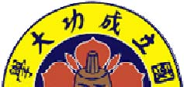

Office of the Senior Executive Vice President
National Cheng KungUniversity Tainan, Taiwan, ROC
Email: fengd@sevp.ncku.edu.tw

January 29, 2010
Professor Jang-Moo Lee
President, Seoul National University
leejm@snu.ac.kr
c.c. Professor Kyung-ho Suh
Professor and Dean of College of Liberal Studies, SNU

Professor Keun-Gwan Lee
Associate Professor, College of Law
Dr. Jung Uck Seo
The National Academy of Engineering of Korea

Re: Thank you for your gracious hospitality
Dear President Lee:
Thank you so much for your gracious hospitality!
In the past two days, President Lai, Professor C. C. Chen (Chairman of our Department of Chemical Engineering) and I had one of the most intensive learning experiences of understanding, under your palpable helmsmanship, the monumental transformation that may be taking place soon in Seoul National University. If SNU could be successful in this endeavor, and from everything we have seen and heard, especially conveyed via the body-language from all the individuals we have met, there is little doubt that it will be!
Last night, just before President Lai and us said goodbye to my good friend Dr. Jung Uck Seo, he said something that suddenly made us all realize that Korea is ripe for this transformation. Dr. Seo said that “some twenty years ago, if one were to ask which universities in Korea would be the top twenty in the country, you would probably find 15 national universities and 5 private ones. Today, the situation is reversed. This tells me (Dr. Seo) that Korea higher education has progressed!”
In my mind, this statement is profound in two levels.
First, the intellectual challenge of private universities on national universities in Korea is real and palpable. While the ascendancy of private universities in Korea may not be, and probably is not, challenging the absolute front-running position of SNU, it does imply that the Korean Government does not (and have not for a long period) meddle with the running of such universities. The strong ones gets stronger and the weak ones either diminishes in statue, or find alternative ways to survive, or simply shut down. Currently, whenever one thinks about any kind of transformation, private universities presence in higher education landscape in the country is to be taken seriously into account, either directly or indirectly!
Second, the fact that in your transformation to corportization, you have the opportunity to leverage private university retirement package as an alternative for SNU employees (presumably not only that applies to faculty, but staff as well,) shows that you have a powerful avenue to overcome one of the most thorny issues.
Still, the most important lesson my boss President Lai, Professor Chen and I learned from our two days are the following:
  - (1) You and your absolutely dedicated team, led by you of course, were relentless and laser-focused in your effort. The genesis as we could surmise began with the fundamental belief that without the
  - transformation would inherently and well articulated by you and your team. Once again, the body language from all shows that you and your team were passionate about SNU contributions to Korea in particular, the world in general.
- (2) The “incubation” period, where you and your team thought through all possible issues and challenges facing SNU in the transformation, and drawing comments from those who presumably were either mildly or vehemently against the idea, shows that you were methodical, systematic and strategic in your effort.
- (3) It is impressive that you have now a “constitution” for SNU after transformation. As I have written to Professor Sam Ock Park after we met, I said that “In this respect, I am sure one of the reasons for the success of the United States is the fact that it has one of the most complete and far reaching CONSTITUTION, developed by men more than 250 years ago. Even though there were, and still will be, amendments in the past 250 years and in the future, the fundamental principles thus far have not moved one bit!” With a strong and thoughtful constitution, I am sure it will guide SNU in the 21st century, as it ascends to global leadership in higher education.

After we return to NCKU, President Lai and us will examine everything we have learned in detail. We hope you and your team can continue to provide us with your wisdom and experiences.
Thank you again,
Warmest personal regards
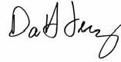
Da Hsuan Da Hsuan Feng Senior Executive Vice President National Cheng Kung University
c.c. President Michael M. C. Lai Senior Executive Vice President H. H. Hwung Vice President for Academic Affairs M. J. Tang Vice President for Research and Development C. C. Wang Vice President for International Affairs Jenny Su Vice President for Students Affairs B. C. Shu Vice President for General Affairs C. W. Chen General Secretary of the University W. S. Lee
Members of NCKU Presidential Blue Ribbon Panel
Professor C. C. Chen

Office of the Senior Executive Vice President
National Cheng Kung University Tainan, Taiwan, ROC
Email: fengd@sevp.ncku.edu.tw

January 28, 2010
Professor Sam Ock Park President, University Senate Seoul National University parkso@snu.ac.kr

Re: Thank you so much for your most enlightening and information-rich meeting with us yesterday in your office

Dear Sam:

I want to take this opportunity to thank you heartily for giving us ample time from your busy schedule to discuss the issue of autonomy, governance and accountability for higher education. Your information about the historical transition for Seoul National University will undoubtedly prove to be extraordinarily vital for us at the National Cheng Kung University.

First, I was deeply impressed by your office’s physical presence. I have never seen, in US or in Asia, where the President of the University Senate can have such an impressive, spacious, elegant yet not ostentatious office. I believe how the University Senate is viewed within the university communities, from administration to faculty, is fundamental between the two “factions.” It is transparent by the setting of your office that both communities within the university view the Faculty Senate as a vital part of the “whole,” and not a “part,” (administration or faculty.) I have not seen such a “mindset” before.

Second, I was deeply impressed by your palpable and profound interest of the future of higher education in Korea in general, Seoul National University in particular. In your capacity as the President of the University Senate, you have shown us a view that transcends beyond the position of purely representing the faculty, yet at the same time be the intellectual liaison between the faculty and the administration (especially the president of SNU) in ensuring difficult issues of the university, such as the ones we have been discussing, are aired, debated, and clearly communicated within the university communities. Such a role of the President of the University Senate is again not seen by me before, either in Asia or in the United States.

Third, I am sure I speak for my boss Academician Michael Lai and my colleague Professor C. C. Chen that we appreciated very much for your absolute candor in talking about the forthcoming “corportization” of Seoul National University. It was clear to us that the process was arduous, for all communities in SNU, which resulted in much understandable debates (I suspected that some of the debates must have been quite heated.) But in the end, logic, vision, developing a deep intellectual understanding and the absolute willingness to pay attention to all details no matter how unpleasant or cumbersome (as we say, devils are in the details,) seem to win the day. I am also sure that as you move into your new phase of university governance, you will continue to find new issues to content with. However, with a well documented CONSTITUTION, with sufficient detailed technical articles built-in, you may just be an example of real success in Asia Pacific. In this respect, I am sure one of the reasons for the success of the United States is the fact that it has one of the most complete and far reaching CONSTITUTION, developed by men more than 250 years ago. Even though there were, and still will be, amendments in the past 250 years and in the future, the fundamental principles thus far have not moved one bit!

Fourth, and perhaps the most important of all is that from your discussion, it made us clearly aware of the similarities and dissimilarities between Taiwan and Korea higher education systems. In particular the strong retirement system that is built into your private universities. This will be important for us as we contemplate a similar path of university reorganization in the coming years.
President Lai, Professor Chen and I would like to take this opportunity to invite you to visit NCKU so a much larger community in our university can benefit from your vast experience and wisdom.

We shall keep in close contact with you on this.

Thank you again,

Warmest personal regards
Da Hsuan
Da Hsuan Feng Senior Executive Vice President National Cheng Kung University
c.c. President Michael M. C. Lai Senior Executive Vice President H. H. Hwung Vice President for Academic Affairs M. J. Tang Vice President for Research and Development C. C. Wang Vice President for International Affairs Jenny Su Vice President for Students Affairs B. C. Shu Vice President for General Affairs C. W. Chen General Secretary of the University W. S. Lee
Members of NCKU Presidential Blue Ribbon Panel
Professor C. C. Chen

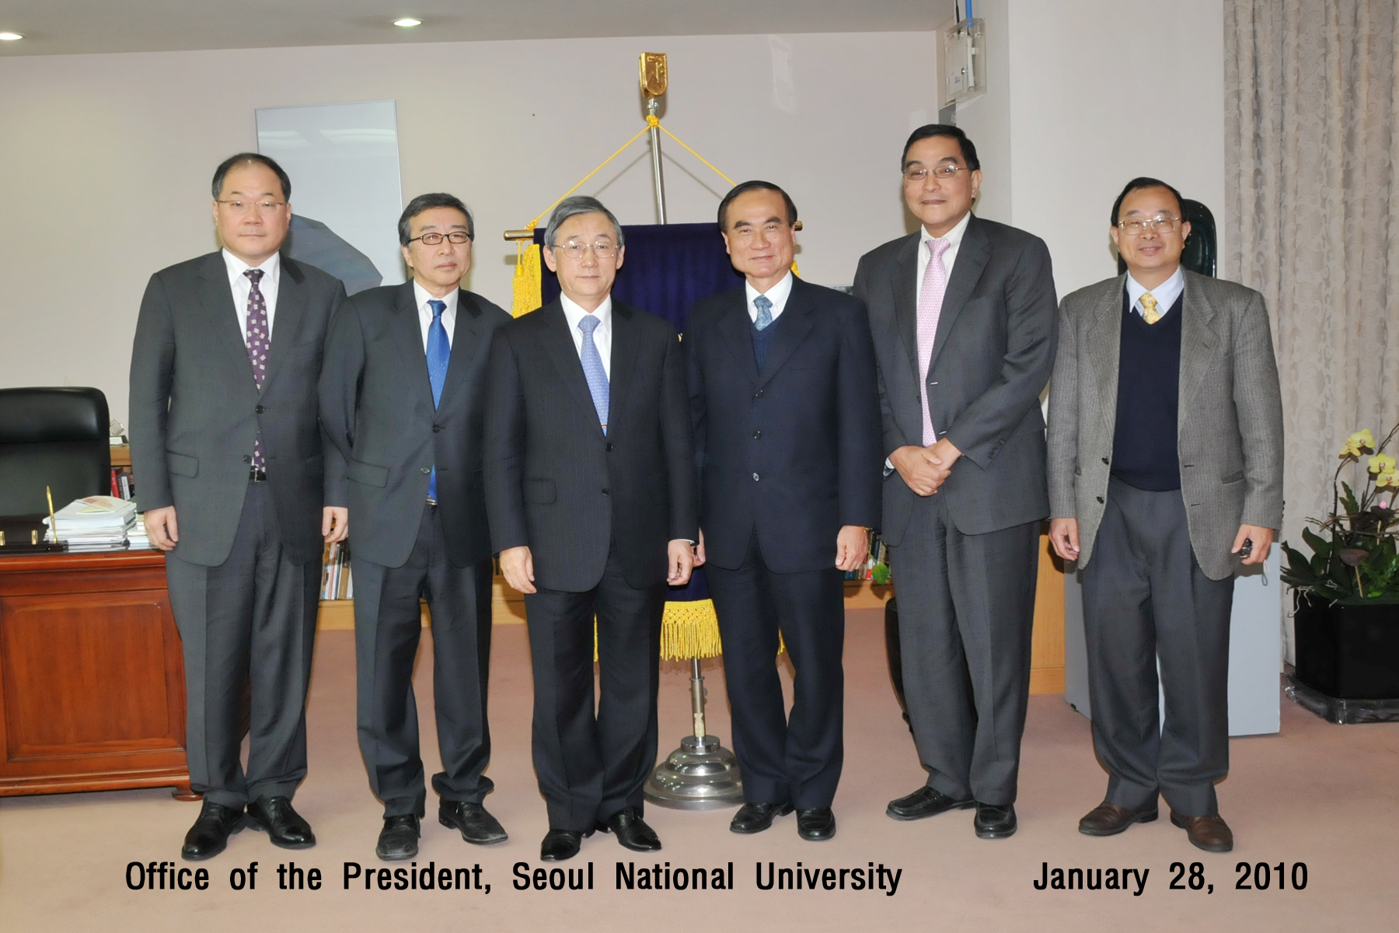
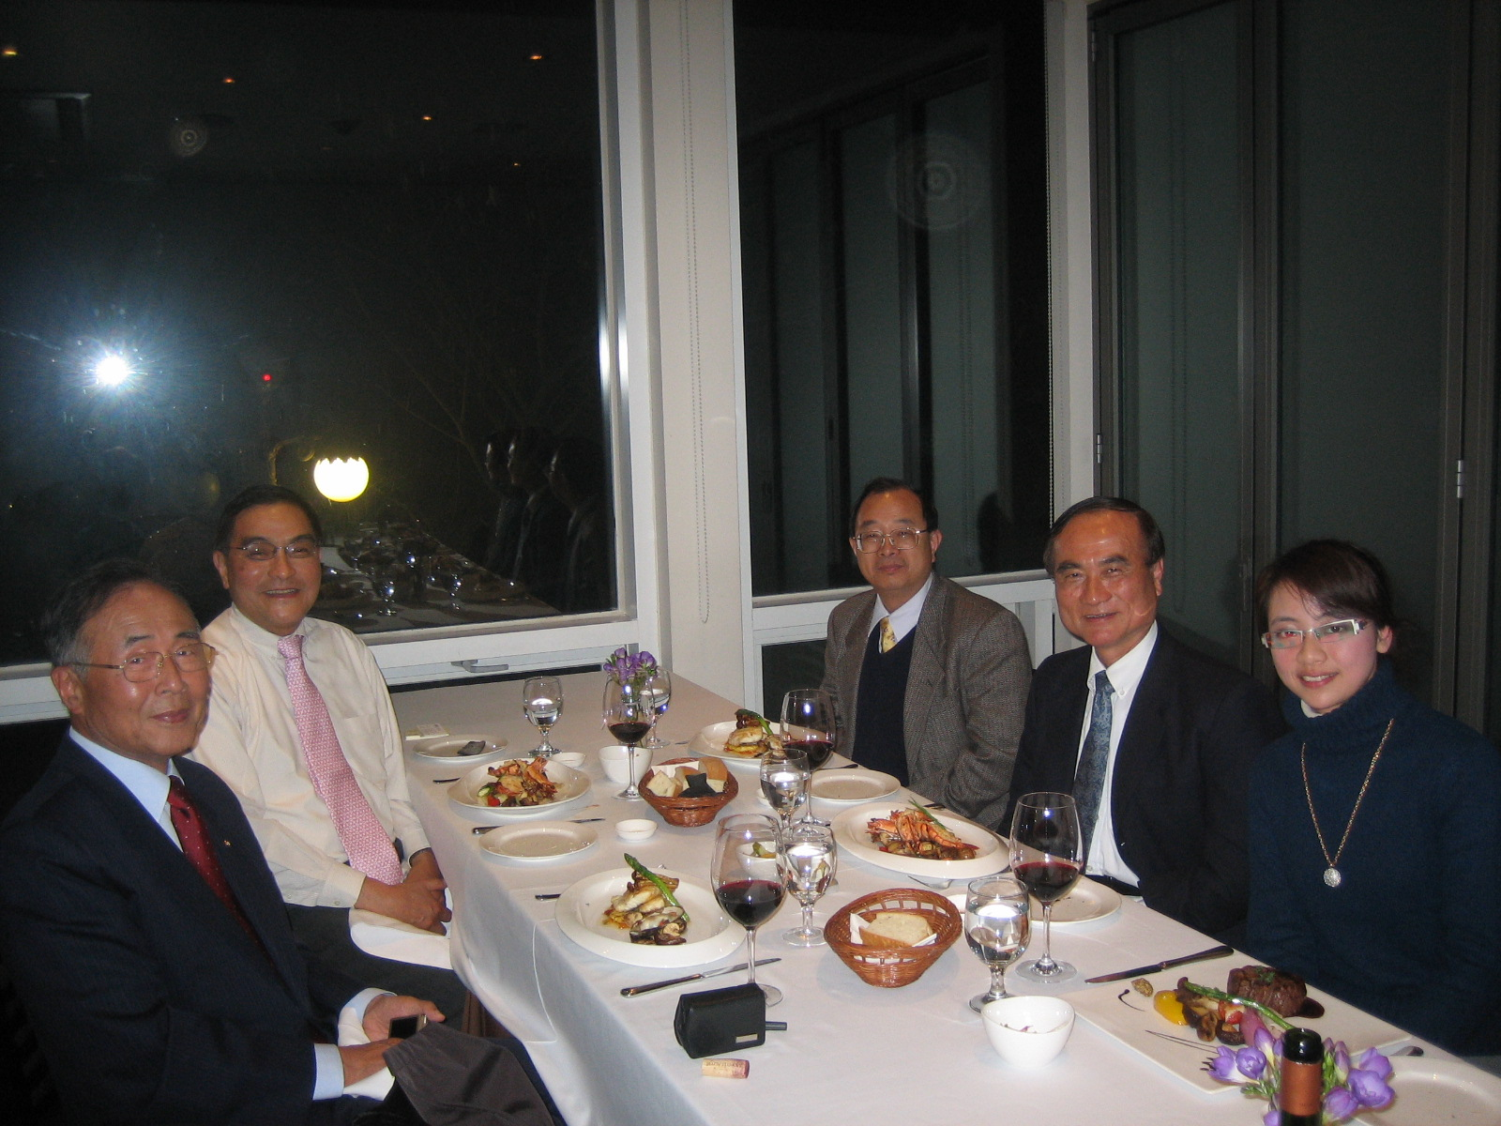
Dr. Jung Uck Seo,
Chairman of Korea e-trade Association & Chairman of the Korea Accreditation Boar

