出國報告(出國類別：其他(訪問))

公差赴美夏威夷大學自然能源研究所(HNEI)參訪與討論「車輛節能創新科專」合作研究

服務機關：國防部軍備局中山科學研究院
姓名職稱：聘用副總主持人 韓國璋
派赴國家：美國夏威夷
出國時間：98.09.14至98.09.18
報告日期：98.11.11

國防部軍備局中山科學研究院出國報告建議事項處理表
報告名稱 | 公差赴美夏威夷大學自然能源研究所(HNEI)參訪與討論「車輛節能創新科專」合作研究
出國單位 | 系發中心 | 出國人員級職/姓名 | 聘用副總主持人 / 韓國璋
公差地點 | 美國夏威夷 | 出/返國日期 | 98.09.14 / 98.09.18
建議事項 | - 本次赴美國夏威夷大學自然能源研究所拜訪廖伯彥教授，參觀其負責之電化學電力系統實驗室。該實驗室近六年的兩個主要研究方向─鋰離子電池測試與評估及各種電動和複合動力車輛測試的數據蒐集與分析，與本計畫研發需求密切相關，建議建立密切合作研發關係，藉助其豐富經驗與資源，俾利本計畫關鍵技術之開發。  - 運用再生能源(如太陽能、風力、海洋溫差等)或燃料電池發電，結合儲電裝置(如鋰離子電池堆)所構成的區域性先進電力系統，為標準之軍民通用科技。而基於能源安全與環保考量其發展亦屬必然。本院具備各相關技術領域專長，建議納入前瞻科技研發項目，持恆聚焦發展。
處理意見 | - 已於10月6日計畫工作檢討例會提出本案，討論確認延續98年合作研發成果， 99年合作研究議題，包括：(一) 基於98年電池芯量測數據所建立模式，提供精準之電池電量估測演算法；(二) 電池堆的模式建立，並協助提供電動車輛路試數據蒐集和分析方法。已納入99年細部計畫書，並已通過經濟部細部審查。  - CIGS薄膜太陽能電池與儲能系統技術發展均已納入為本院經濟部科專計畫執行項目。

國防部軍備局中山科學研究院
九十八年 度 出 國 報 告 審 查 表
出國單位 | 系發中心 | 出國人員  級職姓名 | 聘用副總主持人 / 韓國璋
單 位 | 審 查 意 見 |  |  | 簽 章
一級單位
計 品 會
保 防
安 全 處
企 劃 處
批 示
國外公差人員出國報告主官（管）審查意見表

- 本案為98年經濟部科技專案「車輛節能創新技術研發三年計畫」計畫出國公差。本計畫由四所負責，跨國計畫韓副總主持人參與計畫研發，負責以卡曼濾波器(Kalman Filter)演算法估測鋰電池堆之電量，被指派赴美國夏威夷大學自然能源研究所參訪並討論合作研究項目。雖係新增計畫，唯透過跨所中心協調與合作，順利完成報部核定作業，於98.09.14如期成行，完成考察任務，值得肯定。
- 本次出國目的除參訪夏威夷大學自然能源研究所與討論合作議題外，並實地瞭解夏威夷再生能源研發與應用現況，掌握未來發展趨勢。經韓副總主持人面報後，已責成其持續蒐集相關資訊，提供前瞻科技發展規劃參考，並逐步規劃建立太空電子裝備所需獨立自主之太陽能電力產生、不斷電儲電裝置、電力分配與管理等關鍵技術能量。
出國報告審核表
出國報告名稱：公差赴美夏威夷大學自然能源研究所(HNEI)參訪與討論「車輛節能創新科專」合作研究
出國人姓名 |  |  |  |  | 職稱 | 服務單位
韓國璋 |  |  |  |  | 聘用副總主持人 | 系發中心
出國類別 |  |  | □考察 □進修 □研究 □實習  ■其他 訪問
出國期間：98年9月14日至98年9月18日 |  |  |  |  |  | 報告繳交日期： 年 月 日
計  畫  主  辦  機  關  審  核  意  見 | □1.依限繳交出國報告  □2.格式完整  □3.無抄襲相關出國報告  □4.內容充實完備  □5.建議具參考價值  □6.送本機關參考或研辦  □7.送上級機關參考  □8.退回補正，原因：□不符原核定出國計畫 □以外文撰寫或僅以所蒐集外文資料為內容 □內容空洞簡略或未涵蓋規定要項 □抄襲相關出國報告之全部或部分內容 □電子檔案未依格式辦理 □未於資訊網登錄提要資料及傳送出國報告電子檔  □9.本報告除上傳至出國報告資訊網外，將採行之公開發表：  □辦理本機關出國報告座談會（說明會），與同仁進行知識分享。  □於本機關業務會報提出報告  敬會：保防官  □其他  □10.其他處理意見及方式：
審核人 |  | 出國人員 |  | 初審（業管主管） |  |  | 機關首長或其授權人員
說明：
- 各機關可依需要自行增列審核項目內容，出國報告審核完畢本表請自行保存。
- 審核作業應儘速完成，以不影響出國人員上傳出國報告至「政府出版資料回應網公務出國報告專區」為原則。

報 告 資 料 頁
1.報告編號： |  | 2.出國類別：  其他(訪問) |  | 3.完成日期：  981111 | 4.總頁數：30
5.報告名稱：公差赴美夏威夷大學自然能源研究所(HNEI)參訪與討論「車輛節能創新科專」合作研究

6.核准  文號 | 人令文號 |  | 98年8月28日國人管理字第0980012010號  98年8月21日國備科產字第0980011501號
6.核准  文號 | 部令文號
7.經 費 |  |  | 新台幣：82,910 元
8.出(返)國日期 |  |  | 98年9月14日至98年9月18日
9.公 差 地 點 |  |  | 美國夏威夷
10.公 差 機 構 |  |  | 夏威夷大學自然能源研究所(HNEI)
11.附 記

行政院及所屬各機關出國報告提要
出國報告名稱：公差赴美夏威夷大學自然能源研究所(HNEI)參訪與討論「車輛節能創新科專」合作研究
系統識別號
頁數 30 含附件：■是否
出國計畫主辦機關/聯絡人/電話
系發中心/韓國璋/329523
出國人員姓名/服務機關/單位/職稱/電話
韓國璋/系發中心/跨國計畫/副總主持人/329523
出國類別：□1考察□2進修□3研究□4實習■5其他
出國期間：98年9月14日至98年9月18日  報告日期：98年11月11日 | 出國地區：美國夏威夷
分類號/目

關鍵詞：
SOC (State of Charge)；
BMS (Battery Management System)；
HNEI (Hawaii Natural Energy Institute)

內容摘要：
本院自民國98年起執行經濟部科技專案「車輛節能創新技術研發三年計畫」電池能量偵測與管理技術之開發，基於合作研發需求，赴美考察。本次考察主要內容為：
- 赴美國夏威夷大學夏威夷自然能源研究所參觀其電化學電力系統實驗室，討論可能合作研究議題。
- 瞭解夏威夷氫能系統發展現況與未來之發展規劃。
- 赴夏威夷大島與茂依島實地參觀其利用再生能源發電研發與應用現況。

目 次
- 目的…………………………………………………（09）
- 過程…………………………………………………（10）
- 心得…………………………………………………（12）
- 建議事項……………………………………………（14）
附 件
- 夏威夷再生氫能計畫………………………………（15）
- 廖伯彥教授個人簡歷與電化學電力系統實驗室之
設備能量……………………………………………（23）
公差赴美夏威夷大學自然能源研究所(HNEI)參訪與討論「車輛節能創新科專」合作研究
- 目的
- 本院自民國98年起執行經濟部科技專案「車輛節能創新技術研發三年計畫」(以下簡稱本計畫)電池能量偵測與管理技術之開發，除系統架構之確認與設計外，電池充電狀態(State of Charge，SOC)的精確估測是電池管理系統(Battery Management Systems，BMS)的關鍵技術。電動汽車在使用過程由於電池電量與工作條件(如負載電流)及操作環境(如溫度)之間所顯現的高度非線性關係，使精確估測SOC為難度頗高之挑戰；其關鍵在於電池動態模式的建立與演算方法。
- 本計畫規劃自民國99年起以自行開發之電池管理系統執行實車(包括電動摩托車與電動汽車)驗證測試，期獲取路測數據與實驗室模擬數據交互驗證，並由分析路測數據以建立電動車的駕駛行為模式(Driving Schedule and Driving Cycle)，進一步做為實驗室模擬與設計之依據。因此，路試時的數據擷取規劃與後續的數據分析方法為達成前述目的之重要議題，希望藉由專家訪談與後續之合作研究以加速此一能量的發展與建立。
- 職奉核於9月14日啟程，17日完成任務返國，18日抵台。本次考察主要內容為：
- 赴美國夏威夷大學 (the University of Hawaii) 夏威夷自然能源研究所 (Hawaii Natural Energy Institute (HNEI)) 拜訪廖伯彥(Bor Yann Liaw)教授，參觀其電化學電力系統實驗室(EPSL) ，討論99年合作研究議題，包括電池電量估測與電動車路測之數據擷取與分析。
- 拜訪夏威夷氫能電力示範園區計畫專案經理Mitch Ewan先生，瞭解夏威夷氫能系統發展現況與未來之發展規劃。赴大島參觀夏威夷自然能源實驗室(NELHA)閘道計畫示範展示。
- 赴茂依島(Maui)參觀茂依電力公司(MECO)，瞭解其利用再生能源發電研發與應用現況。
- 過程
- 職9月14日08：00抵達夏威夷，於夏威夷機場與廖伯彥教授會合後，逕赴位於檀香山市區廖教授與夏威夷先進交通運輸技術中心(HCATT)合作設立的電動車(Electric Vehicle；EV)和複合動力汽車(Hybrid Electric Vehicle；HEV)評估測試及先進電池系統試驗研究計畫實驗室，該項研究計畫並長期接受美國空軍先進電源技術辦公室(Advanced Power Technology Office；APTO)的資助與委託合作。目前主要研究方向為：(一) 鋰離子電池測試和評估；(二) 各種電動和複合動力車輛測試的數據蒐集和分析，其中亦包括質子交換膜燃料電池複合動力汽車。
- 9月14日11：00抵達夏威夷大學夏威夷自然能源研究所(HNEI)拜會夏威夷氫能電力示範園區計畫專案經理Mitch Ewan先生，說明氫能電力示範園區的規劃、執行現況與未來發展。因夏威夷距離美國大陸達2,400浬，又不自產石油，其能源供應90%以上依賴進口石油，為美國各州之冠。夏威夷州政府於2009年6月宣示期於2030年達成其電力產生70%來自再生能源(如風力、太陽能、地熱、生質能等)的目標，在這樣的政策目標下，夏威夷自然能源研究所結合夏威夷先進交通運輸技術中心與民間創投(Kolohala Holdings與 Hawaii Angels)成立氫能系統發展計畫，並藉由示範園區向政府與民間(含來自各地的觀光客)展示其效能。Ewan先生提供夏威夷再生氫能計畫(Hawaii Renewable Hydrogen Program)簡報如附件一。
- 9月14日14：00於廖伯彥教授研究室討論本計畫99年度規劃合作研究項目，包括電池電量估測演算法、電動車路試數據擷取規劃與分析方法。會後並參觀其電化學電力系統實驗室設備，包括：電池測試站台(Arbin Instruments BT-2043 8-channel galvanostat/potentiostat computer-controlled battery test station)、電化學阻抗頻譜儀(Electrochemical impedance spectroscopy)、精準電源與量測單元、真空手套箱等，所有儀器均以電腦及網路連結，可透過線上接取資料與即時控制。廖教授個人簡歷與電化學電力系統實驗室之設備能量如附件二。
- 9月15日08：37搭機前往大島。首先赴夏威夷自然能源實驗室(NELHA)參觀，由執行長Ronald N. Baird接待。實驗室佔地322英畝，就在大島的Kona機場旁邊，其主要資源為土地與政府投資建設的深層海水(海面下3,000英呎攝氏6度的深冷海水)供應系統。感覺實驗室營運主軸比較像育成中心，利用其資源吸引民間的商業(以投資生產為主，如海水養殖、高冷蔬果種植)、研發(海洋溫差發電、聚光型太陽能發電、風力發電)與教育訓練團隊進駐。實驗室編制包括管理人員8人，操作人員11人，為非營利法人組織。進入園區參觀須簽署保密協議(NDA)，同時不准照相。Baird先生親自驅車帶職與廖教授參觀園區部分廠商的養殖廠與深層海水輸送設施。14：00參觀園區進駐廠商Sopogy公司，該公司佔地4英畝，正在興建聚光型太陽能發電系統並進行測試，容量500KW，預計年底完工。
- 9月16日06：43自大島搭機飛檀香山後轉往茂依島。首先赴夏威夷大學在茂依島的校區拜會校區負責人Harold Keyser博士，介紹該島電力現況與未來以風力發電為主的再生能源發展。為達成70%清淨能源發電的目標，歐胡島(檀香山所在)因人口稠密，可用土地不足，規劃布建海底電纜輸送茂依島的風力發電以補不足。接著參觀鄰近校區的太平洋生質柴油公司，該公司創立超過10年，專注生質柴油開發生產，擁有獨到的無水製程(Water-free Processing Technology)，可協助建廠生產生質柴油，提供區域販售。下午赴茂依電力公司(MECO)再生能源服務部拜訪，瞭解其對再生能源發電、輸配電與儲能規劃，其中尤以區域與社區儲能設施(Energy Storage Utilities)議題最受關注，尋求與學研單位合作。19：55搭機返檀香山，結束此次考察行程。
參、心得
- 美國夏威夷大學(the University of Hawaii)夏威夷自然能源研究所(Hawaii Natural Energy Institute(HNEI))電化學電力系統實驗室(EPSL)過去六年來一直在夏威夷先進交通運輸技術中心(HCATT)和美國空軍高級電源技術辦公室(APTO)的資助與合作下，從事電動和複合動力汽車評估測試及先進電池系統測試驗證研究計畫。由於鋰離子電池和燃料電池在電動和複合動力汽車應用上的巨大潛力與吸引力，目前在HCATT和APTO計畫下，該實驗室參與的兩個主要研究方向為：(一)鋰離子電池測試和評估；(二)各種電動和複合動力車輛測試的數據蒐集與分析，其中包括質子交換膜燃料電池複合動力汽車。
由廖伯彥教授負責的EPSL還與美國專家微系統公司(Expert Microsystems， Orangevale，CA)共同開發電池分析技術，以利電池診斷模型及診斷工具預測的應用開發。並已執行完成美國海軍STTR第一階段的研究，完成電池模型以及電池性能及剩餘壽命的預測工具箱設計。其建立之核心技術為：電勢微分電容量分析(Incremental Capacity Analysis；ICA) 和 電池電量 (State of Charge；SOC) 估測法則，用以確定電容量損失和失效模式，以便準確估計電池性能及預測剩餘壽命。此亦為本計畫研發項目的關鍵技術之一。此外，該實驗室也一直與位於德克薩斯州聖安東尼奧的美國西南研究所(Southwest Research Institute)合作，建立電池模型(包括鉛酸，鎳氫，鋰離子電池和超級電容器)，以利為美國國防部開發複合動力汽車模擬平台。
專注與持恆的研發，夏威夷州政府與美國國防部的支持，厚實了該實驗室在各類二次電池包括測試與評估，模式建立，先進電池電力系統開發及應用等領域的研發能量與成果累積(特別是其電池與電動及複合動力汽車測試數據庫)。由於電池的測試項目多且相當費時，這不是其他研發單位可以後發先至而迎頭趕上的。
- 夏威夷因距離美國大陸達2,400浬，又不自產石油，其能源供應90%以上依賴進口石油，為美國各州之冠。基於能源安全與環保的考量，夏威夷州政府於2009年6月宣示：期於2030年達成其電力產生70%來自再生能源(如風力、太陽能、地熱、生質能等)的嚴峻目標。在這樣的政策目標下，其產官學研各界都投入資源為此目標努力，這點在本次參訪的夏威夷大學自然能源研究所(HNEI)、夏威夷自然能源實驗室(NELHA)，進駐NELHA園區的廠商Sopogy公司、茂依電力公司(MECO)再生能源服務部等都可明顯看出。其中電力公司以提供服務為主，對再生能源的開發與應用相當程度必須仰賴學校及民間公司的研發團隊。再生能源研發成果與示範應用的展示與夏威夷觀光景點的整合則是夏威夷州推動再生能源計畫的另一特點。
肆、建議事項
- 本次赴美國夏威夷大學自然能源研究所拜訪廖伯彥教授，參觀其負責之電化學電力系統實驗室。該實驗室近六年的兩個主要研究方向─鋰離子電池測試與評估及各種電動和複合動力車輛測試的數據蒐集與分析，與本計畫研發需求密切相關，建議建立密切合作研發關係，藉助其豐富經驗與資源，俾利本計畫關鍵技術之開發。
- 運用再生能源(如太陽能、風力、海洋溫差等)或燃料電池發電，結合儲電裝置(如鋰離子電池堆)所構成的區域性先進電力系統，為標準之軍民通用科技。而基於能源安全與環保考量其發展亦屬必然。本院具備各相關技術領域專長，建議納入前瞻科技研發項目，持恆聚焦發展。

附件一 夏威夷再生氫能計畫(THE HAWAII RENEWABLE Hydrogen PROGRAM, by M. Ewan, R. RocheleauError: Reference source not found)
- Introduction
With over 90% of its energy system fueled by imported fossil fuels (Figure 1), isolated by over 2,400 miles of ocean from the nearest land mass, and with the highest energy costs in the nation (Figure 2), there is compelling motivation for Hawaii to harness its diverse renewable energy resources (Figure 3) to achieve energy self-sufficiency. Evolving towards a hydrogen economy is one of the potential paths to achieving that goal. Arguably, Hawaii has, of all the states, the nearest-term potential to evolve towards a renewable hydrogen economy. Hawaii’s political leadership is critically concerned with Hawaii's energy situation and has developed supportive policies, backed by funding, to advance a hydrogen economy. The initial focus of this effort is the Big Island that has significant wind, solar and geothermal resources.

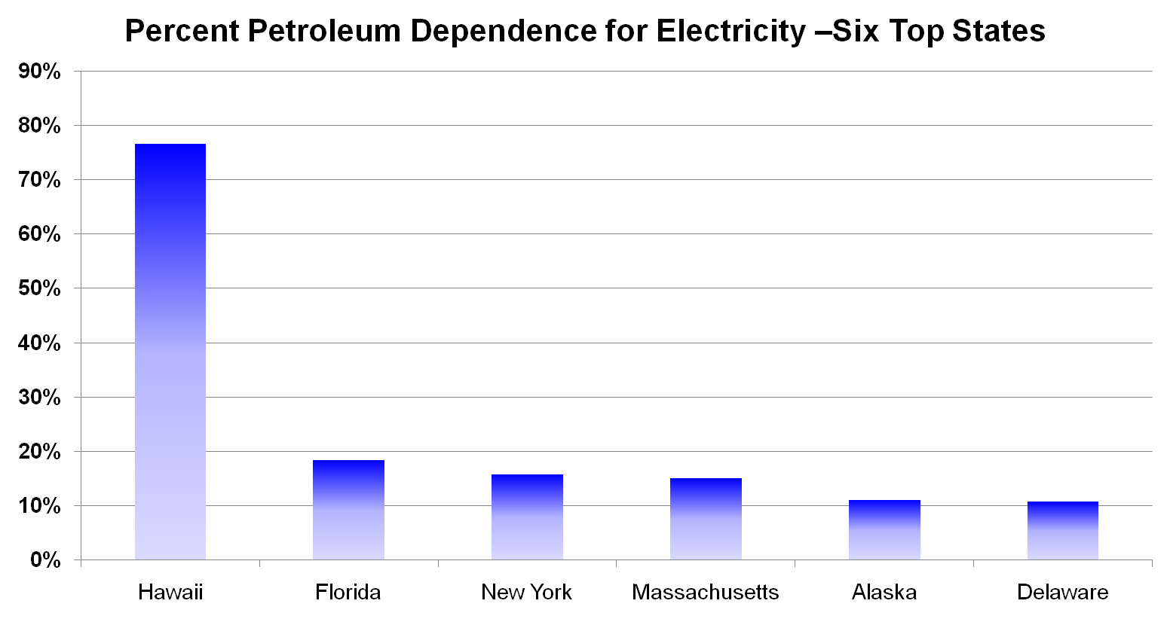
Figure 1: Petroleum dependence for electricity – top six states

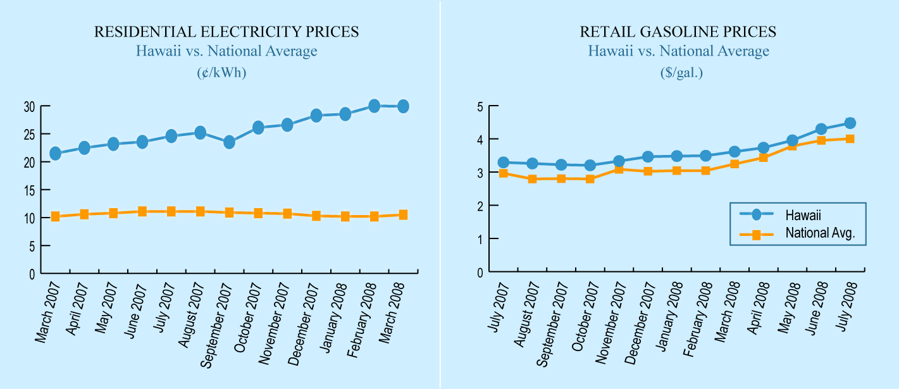
Figure 2: Hawaii - Highest Energy Costs in the U.S.

Figure 3: Hawaii Renewables Estimated at 150% of Current Installed Capacity

This paper describes the current status of the Hawaii Renewable Hydrogen Program, the development of a Hawaii Renewable Hydrogen Program Plan by Kolohala Holdings LLP and the Hawaii Natural Energy Institute (HNEI), and the first major project that has received cost-share funding - a fueling station to support a hydrogen fueled Plug-in Hybrid Electric Vehicle (PHEV) shuttle bus project at Hawaii Volcanoes National Park (HAVO), Hawaii’s largest tourist attraction with over 2 million visitors per year.

2. The Hawaii Renewable Hydrogen Program
Act 240, passed in 2006 by the Hawaii State legislature, established the Hawaii Renewable Hydrogen Program within the Department of Business, Economic Development and Tourism (DBEDT) to support the increased use of Hawaii’s indigenous renewable energy resources using hydrogen as an energy carrier. Act 240 also appropriated $10 million for a hydrogen investment capital special fund for program development and investment. It is intended that the fund will be deployed to:

- Develop a world-class renewable hydrogen program in Hawaii;
- Provide cost share for projects that will attract a significant amount of federal and private research and development activity to Hawaii;
- Provide seed capital and investment capital for emerging Hawaii-based advanced energy technologies and technology companies;
- Build hydrogen infrastructure on the Big Island of Hawaii; and
- Leverage over $100 million in additional sources of capital.
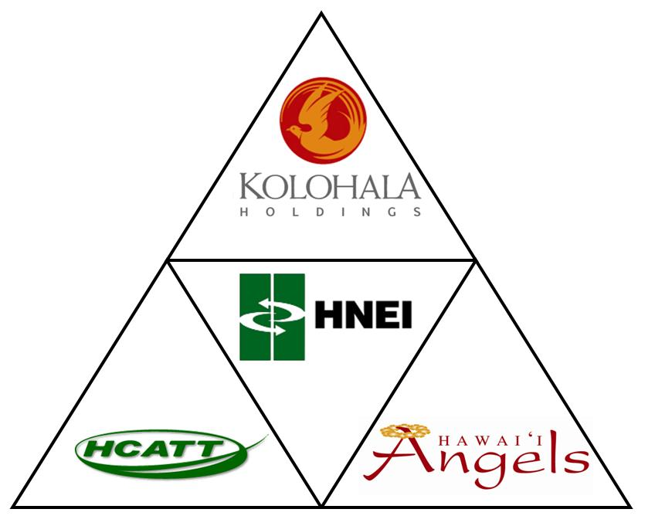
Figure 4: Hawaii Renewable Hydrogen Program Consortium

A consortium (Figure 4) lead by Kolohala Holdings LLP, a Hawaii-based early stage venture capital firm, was selected to manage the fund. Other members of the consortium include HNEI, the Hawaii Center for Advanced Transportation Technologies (HCATT), and the Hawaii Angels, a local angel financing investment group. Kolohala is responsible for strategic oversight, conducting hydrogen industry benchmark and market gap assessments, the identification of market needs, companies to target for fund investments, and the investment fund’s exit strategy implementation. HNEI is responsible for developing an overall state hydrogen program development plan, the technical evaluation of proposed investments, hydrogen infrastructure project management, and attracting cost share projects to the state.

Kolohala’s fund management strategy includes to multiply state funds by combining cost share and seed/venture investments. Investment allocations are planned as follows:

- Cost Share: $100,000 - $1 million per project for infrastructure or pre-commercial validation, and federal or private sources.
- Seed: $25,000 - $500,000 per idea to test or develop an idea taking it from bench scale to pilot plant scale.
- Venture: $500,000 to $2.5 million per company to grow the company from pilot scale to commercial scale.

Kolohala Holdings will help the portfolio company to achieve liquidity. Some methods include:

- Acquisition: Portfolio company purchased by a national firm;
- Initial Public Offering: A company could offer its shares to the general public; and
- Distribution: A company with positive cash flow can distribute free cash back to its investors.

Program Investment Focus
As illustrated in Figure 5, an integrated renewable hydrogen system is comprised of renewable energy resources, conversion technologies to produce hydrogen, storage and distribution technologies and infrastructure, and finally the end-use conversion technologies that use the hydrogen fuel to provide an energy service such as transportation. While the Hawaii Renewable Hydrogen Program legislation calls for activities to take place in all of these areas, the available resources are finite and so there must be a prioritized program that allocates resources to developing the overall Hawaii hydrogen energy system in areas that focus on Hawaii’s specific needs and unique resources. These are likely to be in the development of Hawaii’s renewable energy sources and the related conversion technologies that provide a pathway to producing hydrogen rather than the end-use applications technologies that are likely to be developed elsewhere.

Figure 5: Hydrogen Energy System

Program Timeline

Figure 6: Program Timeline

The hydrogen investment capital special fund will span 10 years (Figure 6) with the investment activity taking place in years 1 through 4. The “Program” timeline element refers to the development of a near-term (2007-2010) State of Hawaii Program Plan, and a longer-term plan for the period 2010 to 2020. The plans shall address the following:
- Strategic partnerships;
- Engineering and economic evaluation;
- Grid reliability;
- Hydrogen demonstration projects;
- Public education; and
- The promotion of Hawaii’s renewable hydrogen resources to potential partners and investors.
The plan shall include considerations of:
- Expanded installation of hydrogen production facilities;
- Development of integrated energy systems including hydrogen vehicles;
- Construction of additional hydrogen refueling stations; and
- Promotion of building design and construction that fully incorporates clean energy assets, including reliance on hydrogen-fueled energy generation.

3. Hawaii Hydrogen Power Park at Hawaii Volcanoes National Park
The Hawaii Hydrogen Power Park at Hawaii Volcanoes National Park (HAVO), the first cost share project to be funded under the Hawaii Renewable Hydrogen Program, was initiated in 2002 in support of US DOE’s Technology Validation Program, to conduct engineering and economic validation of pre-commercial hydrogen technologies. Due to lack of funds the program was put on hold for a number of years. In 2008 DOE reestablished funding for this program and cost share became available through the hydrogen fund. Power Park is funded by the US DOE through Hawaii's Department of Business, Economic Development and Tourism’s Strategic Industries Division (DBEDT) as part of the State Energy Partnership Program. HNEI serves as the implementing partner and is managing development and operation of Power Park activities.

The US DOE and the State of Hawaii have committed $1.2 million each for the development of hydrogen fueling infrastructure at HAVO under the Power Park program. This effort includes hydrogen production utilizing renewable electricity, compression, storage, delivery, and dispensing to hydrogen vehicles. Separately, HAVO has proposed to acquire from 2 to 5 battery-dominant fuel cell hybrid plug-in shuttle buses. These vehicles are expected to reduce congestion at the park, to provide a better (quieter and cleaner) visitor experience, and to support the National Park Service “Climate Friendly Parks” program to reduce HAVO’s carbon footprint. The Hawaii Center for Advanced Transportation Technologies (HCATT), which currently manages a hydrogen fueling station for the US Air Force at Hickam Air Force Base on Oahu, has converted several vehicles for fuel cell use and has been identified by HAVO to manage the vehicle conversion effort. It is planned to use the hydrogen infrastructure developed under Power Park to support HAVO’s hydrogen fueling requirements.

Hydrogen Supply
Hydrogen will be produced by an electrolyzer system powered by renewable electricity supplied from the Hawaii Electric Light Company (HELCO) at special research rate which has been applied for with the Hawaii Public Utilities Commission. Renewable electricity available on the island of Hawaii include geothermal power supplied from the Puna Geothermal Ventures plant which is located about 20 miles from HAVO. Power from this facility is currently curtailed during the night and could be a potential source of renewable energy for future expansion of the Power Park. The fueling station is to be supplied on a “turn-key” basis including hydrogen production, compression, storage, and dispensing. An RFP for supply of the system was released in March 2009 with a desired operational date of November/December 2009.

The fueling station will be located inside the park at the Kilauea Military Camp (KMC), an Army recreational facility (DOD) that already operates an existing fleet of shuttle buses for its military visitors.

Hydrogen Vehicles
Two vehicles will be provided by the Department of Transportation and the Department of Interior ($1 million) under Advanced Transportation for Parks and Public Lands program. The options for the supply of the vehicles include the originally planned option of converting existing internal combustion engine shuttle buses to a PHEV configuration utilizing a fuel cell as an auxiliary power range extender, and more recently, investigating the acquisition of an off-the-shelf purpose-built bus such as the Proterra fuel cell PHEV. While the latter option is attractive, it will require additional funding.

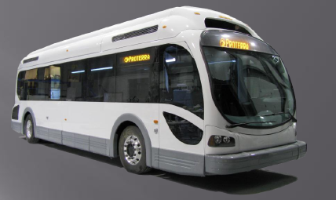
Figure 7: Proterra Bus Option

Shuttle Bus Operations
The buses will be used on a variety of routes inside HAVO to test operations on different grades, elevations, climatic, and atmospheric conditions. Figure 8 illustrates the first two planned routes. The Crater Rim Drive route is 10 miles long and is over relatively gentle terrain at an elevation of 4,000 feet.
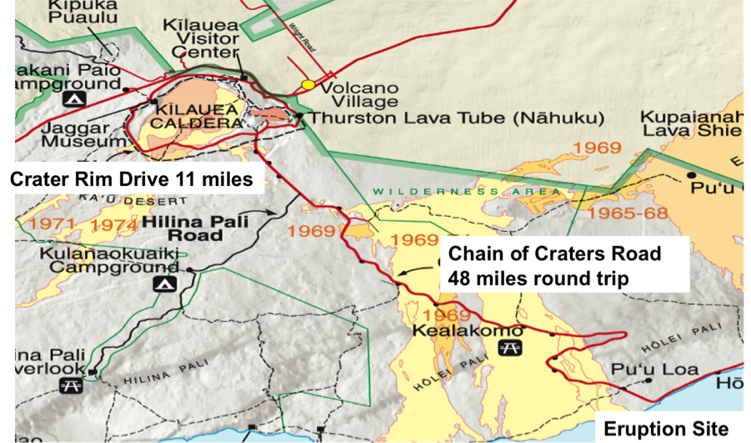
Figure 8: Shuttle Bus Preliminary Routes

The buses will be able to complete their planned daily operations under battery power but will be able to extend their operational time using the fuel cell generator. On the other hand, the trip to the eruption site will be challenging going from the 4,000 foot level to sea level over a range of 18 miles with some significant grades. While the trip downhill will be relatively easy and utilize regenerative braking, the return trip will definitely require the additional power from the fuel cell system. Discussions have been initiated regarding development of a PV powered recharge station at the bottom of Chain of Craters road.

One added challenge will be operating the system in high sulfur dioxide (SO₂) contaminant levels as a result of the continuing emissions of volcanic gases from the volcano. The project will measure the effects of SO₂ concentrates on fuel cell performance in real-world operational environments. Additional funding is being sought to develop an air filtration system to filter out the SO₂ to an acceptable level. This ties in with work being currently being conducted by HNEI at the Hawaii Fuel Cell Test Facility to characterize the effect of air contaminants of fuel cell performance and durability. This effort is currently funded by the Office of Naval Research.

Finally, the project will collaborate with existing data analysis groups to compare data and share the results with other groups including the State of Hawaii, US DOE, National Park Service, the Federal Transportation Agency, and the Department of Defense.

- Conclusions
The State of Hawaii has developed a robust and well-funded effort to take the early steps of evolving to a hydrogen economy utilizing its considerable indigenous renewable energy resources. With a population of approximately 1.25 million people, the $10 million Hydrogen Investment Capital Fund represents a significant investment when regarded on a per capita basis. The first project has been launched and it promises to be a cornerstone to leverage this initial infrastructure investment for development of other useful projects. The program is currently seeking high quality projects that meet its funding criteria and welcomes the opportunity to discuss mutually beneficial collaborations with private and public groups.
附件二 廖伯彥教授個人簡歷與電化學電力系統實驗室之設備能量
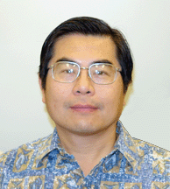
Bor Yann Liaw
Specialist
Hawaii Natural Energy Institute
School of Ocean And Earth Science And Technology
University of Hawaii at Manoa
Ph: 956-2339 / 428-4976
Fax: 956-2336
Email: bliaw@hawaii.edu

UNIVERSITY OF HAWAII
Specialist, Hawaii Natural Energy Institute, 2003 - present
Graduate Faculty, Department of Mechanical Engineering, 1990 - present
OTHER PROFESSIONAL EXPERIENCE
2008―2010 Treasurer, Battery Division, the Electrochemical Society.
2005―present Member, Executive Committee, International Battery Association.
11/05 – 12/05 Visiting Research Fellow, Kyoto University, Kyoto, Japan, under a Japan Society for the Promotion of Science (JSPS) Research Fellow award.
06/05 – 08/05 Summer Research Fellow, Naval Research Laboratory, Washington, DC, under an ASEE/ONR Summer Research Fellowship.
EDUCATION
Ph.D., Materials Science and Engineering, Stanford University, 1988
M.S., Chemistry, University of Georgia, 1982
B.S., Chemistry, National Tsing-Hua University, 1977
PATENTS
1. Liaw, B.Y. and X.G. Yang, “Pressure-Based Battery Charging,” U.S. Patent 6,437,542, August 20, 2002.
2. Liaw, B.Y. “Intelligent Prediction of Battery Service Life and Performance”, US60/634,521, December 9, 2004.
3. Scott D. and B.Y. Liaw, “Sustainable Current Generation from the Ammonia-Polypyrrole Interaction,” U.S. Provisional Pattern application, April 7, 2008.
4. Scott D. and B.Y. Liaw, “Carbohydrate anode for energy harvesting and power generation,” U.S. Provisional Pattern application, October 20, 2008.
RECENT GRANTS & AWARDS
08/07―04/08 Prognostic Battery Remaining Life Model. (UH 6-51555)
Expert Microsystems, STTR Program/NAVAIR, Phase I $16,344. (Selected for Phase II but not funded)
10/07―12/08 High Fidelity Electrochemical System Models for Powertrain Applications. (UH 6-51995)
Southwest Research Institute, $75,000.
09/07―09/09 Biofuel Cells – Electrochemistry. (UH 6-51155, PI: Richard Rocheleau)
HEET/ONR, $142,885.
01/06―09/08 Lithium Ion Battery Cell Testing. (UH 6-56142)
HCATT/HTDC & APTO/U.S. Air Force, $120,000.
09/06―12/08 Biofuel Cells – Electrochemistry. (UH 6-57558, PI: Richard Rocheleau)
HEET/ONR, $177,143.
10/05―06/07 Biofuel Cells – Electrochemistry. (UH 6-55893, PI: Richard Rocheleau)
HEET/ONR, $132,115.
09/04―04/09 Nano- and Micro-Enzymatic Power Sources. (UH 6-54154, co-PI: Michael Cooney)
Intelligence Community Postdoctoral Fellow Research Program, National Geospatial-Intelligence Agency, $360,000.
05/04―09/08 Data Collection and Analysis of Hybrid Fuel Cell Bus Operated at Hickam Air Force Base. (UH 6-53720)
HCATT/HTDC & APTO/U.S. Air Force, $171,000.
01/00―12/08 Develop VRLA Traction Battery Model. (Direct Project #006391, RCUH)
Ford Motor Company, $174,340.
RESEARCH INTERESTS
Fuel Cells:
• Bio-Fuel Cells, • Electrochemical in situ characterizations • Micro-power sources • Fundamentals and Bioengineering of Enzymatic Fuel Cells (2003-present)
• Solid Oxide Fuel Cells, NEDO International Joint Research project on “preparation of zirconia of enhanced oxygen conduction via interface processing” (1994-97)
• Solid Oxide Fuel Cells, Thin tetragonal zirconia films as solid electrolytes (1993-1995)
Battery R&D:
• Battery cycle life prediction, diagnostics, and prognostics (1999-present)
• Dynamic battery modeling and simulation and experimental validation (1996-present)
• Advanced electric vehicle battery evaluation (1995-present)
• Advanced rapid charging algorithm development (1997-2003)
Electric and Hybrid Vehicle Testing:
• EV-Ready State and Hyundai Santa Fe e-SUV demonstration, leading the task of data collection, driving cycle and battery performance analyses (2001-present)
• DARPA EHV National Data Center, collecting and managing data collected from seven national consortia on electric vehicle testing and demonstrations (1994-97)
PUBLICATIONS
1. W. Johnston, N. Maynard, B.Y. Liaw, M.J. Cooney, “In situ measurement of activity and mass transfer effects in enzyme immobilized electrodes,” Enzyme and Microbial Technology 39 (2006) 131.
2. D.M. Jenkins, B. Chami, M. Kreuzer, G. Presting, A.M. Alvarez, and B.Y. Liaw, “Hybridization probe for femtomolar quantification of selected nucleic acid sequences on a disposable electrode,” Anal. Chem. 78 (2006) 2314.
3. M. Dubarry, V. Svoboda, R. Hwu, and B.Y. Liaw, “Incremental capacity analysis and close-to-equilibrium OCV measurements to quantify capacity fade in commercial rechargeable lithium batteries,” Electrochem. Solid-State Lett., 9 (2006) A454.
4. A., Konash, M.J. Cooney, B.Y. Liaw, and D.M. Jameson, “Characterization of enzyme-polymer interaction using fluorescence,” J. Materials Chem. 16 (2006) 4107.
5. J.C. Viera, M. González, B.Y. Liaw, F.J. Ferrero, J.C. Álvarez, J.C. Campo, C. Blanco, “Characterization of 109 Ah Ni–MH batteries charging with hydrogen sensing termination,” J. Power Sources 171 (2007) 1040.
6. V. Svoboda, M.J. Cooney, C. Rippolz, and B.Y. Liaw, “In-situ characterization of electrochemical polymerization of methylene green on platinum electrodes,” J. Electrochem. Soc. 154 (2007) D113.
7. M. Dubarry, V. Svoboda, R. Hwu and B.Y. Liaw, “Capacity and power fading mechanism identification from a commercial cell evaluation,” J. Power Sources 165 (2007) 566.
8. M. Dubarry, V. Svoboda, R. Hwu and B.Y. Liaw, “Capacity loss in rechargeable lithium cells during cycle life testing: The importance of determining state-of-charge” J. Power Sources 174 (2007) 1121.
9. M. Dubarry and B.Y. Liaw, “Development of a universal modeling tool for rechargeable lithium batteries,” J. Power Sources 174 (2007) 856.
10. M. Dubarry, V. Svoboda, R. Hwu and B.Y. Liaw, “A roadmap to understand battery performance in electric and hybrid vehicle operation,” J. Power Sources 174 (2007) 366.
11. B.Y. Liaw, M. Dubarry, “From driving cycle analysis to understanding battery performance in real-life electric hybrid vehicle operation” (invited) to the Special Issue on Hybrid Electric Vehicles, J. Power Sources 174 (2007) 76.
12. S.D. Minteer, B.Y. Liaw, M.J. Cooney, “Enzyme-based biofuel cells” Current Opinion in Biotechnology (invited), 18 (2007) 228-234.
13. P. Atanassov, C. Apblett, S. Banta, S. Brozik, S. Calabrese Barton, M. Cooney, B.Y. Liaw, S. Mukerjee, S.D. Minteer, “Enzymatic biofuel cell” Interface, 16 (2007) 28-31.
14. M. Dubarry, N. Vuillaume, B.Y. Liaw, and T. Quinn, “Vehicle evaluation, battery modeling, and fleet-testing experiences in Hawaii: A roadmap to understanding evaluation data and simulation” J. Asian Electric Vehicles 5 (2007) 1033.
15. M.J. Cooney, C. Lau, M. Windmeisser, B.Y. Liaw, T. Klotzbach, and S.D. Minteer, “Design of chitosan gel pore structure: towards enzyme catalyzed flow-through electrodes” J. Mat. Chem. 18 (2008) 667.
16. D.M. Sun, D. Scott, M.J. Cooney, B.Y. Liaw, “A potential reconstitution platform for PQQ-dependent apo-enzymes” Electrochem. Solid State Lett. 11 (2008) B101.
17. V. Svoboda, M. Cooney, B.Y. Liaw, S. Minteer, E. Piles, D. Lehnert, S. Calabrese Barton, R. Rincon, and P. Atanassov, “Standardized characterization of electrocatalytic electrodes” Electroanalysis, 20 (2008) 1099.
18. V. Svoboda, B.Y. Liaw, “In-situ transient study of polymer nano-film growth via simultaneous correlation of charge, mass, and ellipsometric measurements” Pure Applied Chem., 80 (2008) 2439–2449.
19. D. Scott, M.J. Cooney, and B.Y. Liaw, “Sustainable current generation from the ammonia - polypyrrole interaction” J. Mat. Chem., 18 (2008) 3216.
20. M. Dubarry, N. Vuillaume, and B.Y. Liaw, “From single cell model to battery pack simulation for Li-ion batteries,” J. Power Sources, (2008) doi:10.1016/j.jpowsour.2008.10.051.
22. Liaw, B.Y., and D.D. Friel, “Battery management and life prediction,” in Industrial Applications of Batteries: From Electric Vehicles to Satellites, Michel Broussely and Gianfranco Pistoia, eds., Elsevier Science BV, Amsterdam, Netherlands, 2007. Chapter 13, pp - .
23. Cooney, M., and B.Y. Liaw, “In situ characterization techniques for design and evaluation of micro and nano enzyme-catalyzed power sources,” in Nano-scale Science and Technology in Biomolecular Catalysis, eds., H.S. Kim, J.B, Kim, and P. Wang, ACS Symposium Series 986, the American Chemical Soc., Cleveland, OH, 2008, Chapter 19, pp. 289-333.
24. Cugnet, M., M Dubarry, and B.Y. Liaw, “Lead-acid battery modeling,” to be published in: The Encyclopedia of Electrochemical Power Sources, Eds. J. Garche (Chief), C.K. Dyer, P. Moseley, Z. Ogumi, D. Rand, B. Scrosati, Elsevier, Oxford, UK.
Electrochemical Power Systems Lab
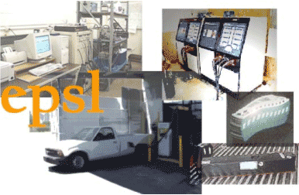
Dr. Bor Yann Liaw directs the Electrochemical Power Systems Laboratory (EPSL) at the Hawaii Natural Energy Institute of the University of Hawaii. The researchers in the laboratory have been engaging in battery and fuel cell research since 1989. The group's research activities are focused on solid-state ionics and electrochemistry. The group's strength is the ability to integrate knowledge from fundamental study of thermodynamic and kinetic properties of electrode materials used in advanced batteries, ultracapacitors and fuel cells, and effectively utilizing instrumentation together with computer simulation and modeling to facilitate research and development of electrochemical power systems for energy storage and conversion applications.
Facilities of EPSL are located at two major areas, one on the UH Manoa campus and another near downtown Honolulu.
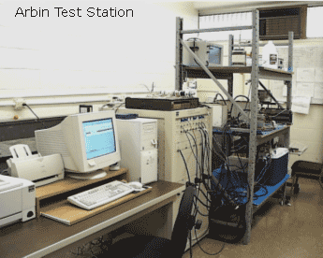
UH R&D Facility: The EPSL research facility on the UH Manoa campus is located in the Hawaii Institute of Geophysics (HIG) building and equipped with an array of sophisticated electrochemical testing equipment, including:
- An Arbin Instruments BT-2043 8-channel galvanostat/potentiostat computer-controlled battery test station. Four low-current channels are capable of delivering from 1 mA to 2 ADC and from -2 to 20 VDC per channel for high-accuracy low-capacity cell characterization. Four high-current channels can deliver up to 20 ADC per channel for high-capacity module tests. Each channel also comes with high precision temperature and pressure sensors for monitoring the cell thermal and gas evolution/recombination behaviors.
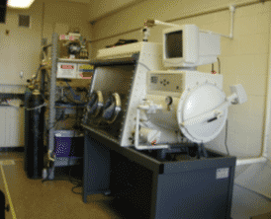
- Electrochemical impedance spectroscopy using a Solartron 1260 impedance analyzer and 1287 electrochemical interface combination. This piece of equipment can be used to conduct electrochemical impedance spectroscopic study of cell kinetics and degradation. The useful frequency range is from 1 MHz to 10 µHz. The 1287 unit has 2 ADC maximum current capability and can act as a stand alone potentiostat or galvanostat for various electrochemical measurements.
- Keithley 236 and 238 Source and Measuring units, which can provide accurate current or voltage sources and conduct high quality precise measurements of corresponding electrical response. Accuracy of the current can go down to 10 fA, and 10 µV for voltage. The 238 unit can handle current as high as 1 A.
- A Vacuum Atmosphere glove box station filled with argon to handle air-sensitive materials and cell assembly. Electrical and electronic feedthroughs are installed to provide access to cells in the glove box for electrochemical measurements.
- An assortment of furnaces, including a high temperature Micropyretics Heaters International silicon carbide unit that can operate up to 1,700
°C, to process electrode or solid electrolyte materials and for cell testing. The facility is also equipped with gas lines and mass flow controllers for gas mixing and supplying for fuel cell testing.
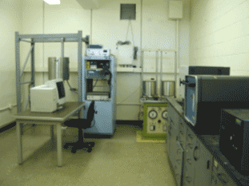
- Other high voltage and current DC power supplies from HP and Sorensen for high power electrochemical measurements.
- All instrumentation is computerized and networked with high bandwidth for on-line access and real-time control. The facility is also connected with the downtown EV test facility (described below) using a wide area network for real-time on-line access and test control.
Downtown Honolulu EV Test Facility: The EPSL also has access to an industrial type electric vehicle test facility near downtown Honolulu. The Hawaii Electric Vehicle Demonstration Project (HEVDP) EV Test Facility is located at 531 Cooke Street, in Kakaako, very close to downtown Honolulu and Waikiki. The facility occupies about 18,000 square feet of floor space and is equipped with state-of-the-art tools and test equipment for vehicle assembly, repair, and maintenance; for parts inventory; for testing electrochemical power source systems; and for rapid recharging electric vehicles.
The major pieces of equipment include:
- Two AeroVironment ABC-150 battery cyclers, rated at 120 kW, and capable of handling battery pack testing up to 470 VDC and 530 ADC. The battery cyclers are computer controlled to allow automated tests of battery packs with a SmartGuard data acquisition system which can collect sophisticated test data with detailed information including individual cell voltage and temperature. Additional data acquisition capabilities are also available. The cyclers are operated using the Remote Operation System application on NT 4 workstations that support NIDAQ interface built by National Instruments. This unique capability allows the use of NIDAQ data acquisition boards with excellent flexibility for sophisticated tests and data acquisition. The capability of the cyclers meets any advanced stringent test requirements including complex driving cycle tests, such as the Federal Urban Driving Schedule (FUDS).
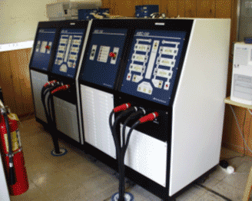
- A Mustang MD-250-l/BI chassis dynamometer, rated at 300 horsepower continuous and 500 horsepower peak. The dynamometer is computerized for automated vehicle testing and data collection. It can perform various types of dynamic tests, including FUDS cycle or other standard driving schedules defined by EPA, SAE or vehicle manufacturers. The wide roller base can accommodate vehicles up to a full-size 40-ft transit bus.

- A 28 foot x 8 foot environmental chamber with temperature control down to -10 C (14 F). The chamber is capable of testing a typical mid-sized vehicle in a controlled temperature environment to facilitate on-board battery pack testing. Up to four full-sized battery packs can be tested in the chamber simultaneously. A high bandwidth Ethernet connection is also available for high-speed data acquisition. The chamber is equipped with a flammable gas sensor, which constantly monitors the gas composition in the ambient. If the flammable gas composition exceeds a safety limit, the tests will be automatically shut down to prevent any possible disastrous consequence.
- Various conductive or inductive charging stations, including 60 kW PosiCharge (AeroVironment), for rapid charging vehicles.
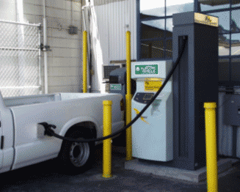
- The facility also has four fully-equipped vehicle-assembly bays, a machine shop, a battery/parts inventory storage area, offices and conference rooms.

Hawaii Natural Energy Institute, University of Hawaii, 1680 East-West Road, POST 109, Honolulu, HI 96822, US, Tel: +1 808 956 2337, ewan@hawaii.edu

