出國報告（出國類別：發表論文）

出席國際學術會議APNOMS 2009
心得報告

服務機關：國立中正大學
姓名職稱：潘仁義 助理教授
派赴國家：韓國
出國期間：2009/9/21~2009/9/27
報告日期：2009/10/16

摘要

本次出國主要是前往2009年亞太網路管理研討會(APNOMS2009)發表研究成果，主要內容如下：
由於WiMAX網路的普及，IEEE工作組織與 WiMAX 論壇不斷的將WiMAX協定推向更高的服務範圍與品質，近年來相關的研究都是考慮固定式WiMAX網路佈建，他們並沒有考慮以及討論到移動的議題。有鑑於此，本篇論文主要探討在802.16e以及Network architecture stage的定義下，針對移動網路的環境建立了WiDeMS的架構。在論文的研究方法中，我們對於移動網路中的元素模型化 (modeling)以及網路佈建的規劃。對使用者端定義了User Model來表現所有使用者使用網路的情形並且描述不同機率下使用應用程式時間，也完整經濟模型與相關假設以及制定了完整的WiMAX 核心網路，包含電信計費與移動性管理。為了實踐此架構，我們利用QualNet網路模擬軟體，將WiDeMS架構套用於模擬軟體中，分析其網路負載情形，換手延遲，封包遺失率，使用者付費情況與電信營收的結果。透過整套的方案與規劃，我們可以於本論文的模擬分析中，看出WiMAX核心網路運作的整體效能。而此架構不僅適用於WiMAX網路環境，亦可適用於其他大型電信網路佈建，如：3.5/4G/LTE 等前瞻電信網路架構。

目次
摘要 2
本文 2
目的 2
過程 2
心得及建議 5
附錄 6

本文

目的
本次出席國際會議APNOMS(The 12th Asia-Pacific Network Operations and Management Symposium)，主要是為了發表論文 “Forecasting WiMAX System Earnings: A Case Study on Mass Rapid Transit System”，並於國際學者交流。本會議是亞太地區最著名的網路管理相關會議，而台灣是下一屆(2011年)舉辦此會議的地主。

過程
由於飛機航程無法銜接，所以於9/21先行前往首爾，9/23前往濟洲島，擔任議程主席，9/25早上發表論文，並於會議結束時，獲選最佳論文獎。此獎僅有三位，分別為日本、韓國、及台灣的學者。論文接受率為23.7%，同時有被EI收錄。
APNOMS網頁：
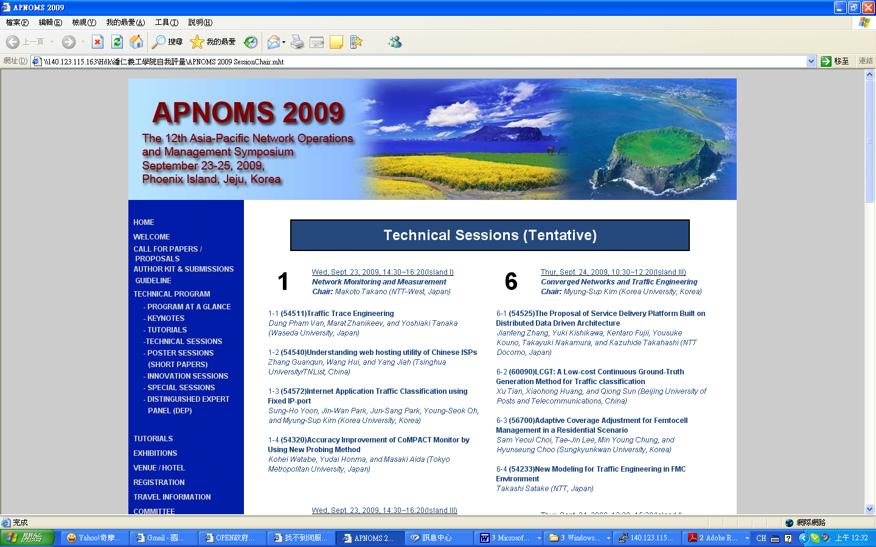
擔任議程主席：
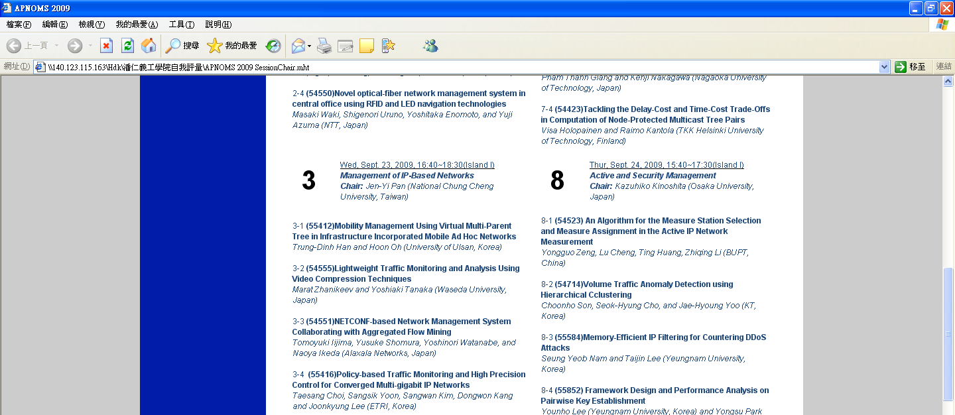
論文發表：
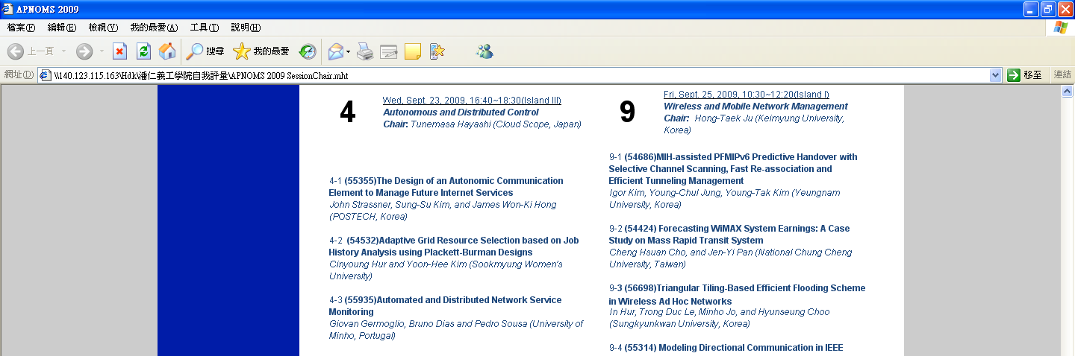
獲得最佳論文獎：
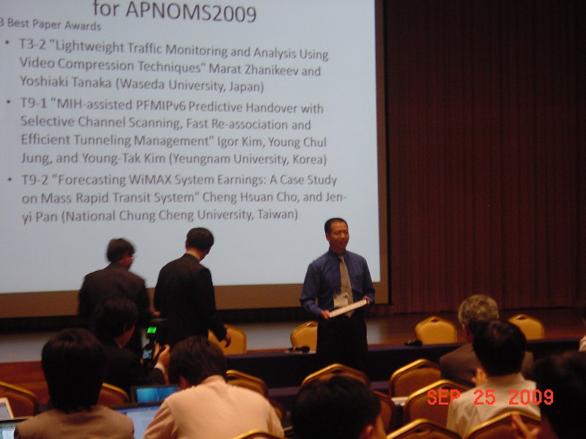

心得及建議
雖然之前已經有數次發表論文的經驗，不過這次比較特別有得到最佳論文獎。但是我自己個人覺得仍然有很大的改進空間，所以回國之後就更努力在作研究了。擔任議程主席也並不是第一次，不過這次感覺更能掌控全場的氣氛，覺得蠻有進步的。

附錄
論文本文
Forecasting WiMAX System Earnings:
A Case Study on Mass Rapid Transit System
Cheng Hsuan Cho and Jen-yi Pan,
621 Chia-Yi, Taiwan, Republic of China
Department of Communications Engineering,
National Chung Cheng University
kusojuo@gmail.com, jypan@comm.ccu.edu.tw
Abstract. The WiMAX network has been proposed as an alternative technology to provide wireless network service. This paper focuses on WiMAX system forecasting in Mass Rapid Transit (MRT) environments and describes numerous models, including a user model, application model, economic model, subscription model, and evaluation model. We simulated a WiMAX network using these models to forecast the profitability of a broadband access system in an MRT environment.
Keywords: Deployment, WiMAX, QoS, Economic, Simulation and Modeling.
1 Introduction
It is important to evaluate the overall performance of a WiMAX (worldwide interoperability for microwave access) network (based on the IEEE802.16 standard and the WiMAX forum network architecture). As compared to other telecommunication networks, a WiMAX network provides more services and applications, and it has a higher data rate. Standards for broadband wireless access (BWA) are being developed within IEEE Project 802, working group 16, also referred to as 802.16 d/e/m/j. To promote 802.16-compliant technologies, the WiMAX Forum was founded. According to the specifications proposed by the WiMAX forum, 802.16 technologies are attractive for a wide variety of applications including high-speed Internet access, WiFi hotspot backhaul, cellular backhaul, public safety services, and private networks.
In recent years, many studies have focused on WiMAX systems and their deployment. In addition, comparisons of WiMAX with different technologies such as 3G and LTE have been reported. [1][2][3] have focused on fixed WiMAX arrangements for urban, suburban, and rural environments. [1] addresses the deployment considerations for a wireless metropolitan area network based on the IEEE 802.16-2004 Air Interface Standards. [2] discusses a deployment in which some factors related to the PHY layer are considered, and the wireless link budget is calculated. [3] considers the physical performance and path loss model in a fixed WiMAX deployment. However, while all of these consider a fixed BWA scenario, they do not consider and discuss mobility issues in relation to the WiMAX standard, which is important for mobile users. Therefore, in this study, we focus on WiMAX system forecasting in a Mass Rapid Transit (MRT) environment. We examine user/network aspects and present an evaluation of the system performance in an urban environment.
However, offering a service for mobile users while roaming is a complex issue. A WiMAX operator needs to satisfy requirements such as return on investment, system performance, reliability, and so on. The operator needs to consider and balance many factors to provide optimum service. The business case and system design need to address the following questions:
In which markets should we offer end-user WiMAX service?
How should we price the service?
How do we guarantee an appropriate level of quality?
How much will the annual capital and operational expenses be?

In this paper, we propose a framework called WiMAX Deployment for Mass Rapid Transit (MRT) System (WiDeMS). It is the result of heuristic research on designing a method to demonstrate the mobility issues in WiDeMS. It describes numerous models that provide solutions to the abovementioned questions and requirements. The remainder of this paper consists of four parts. Section 2 introduces the modeling technique and research steps of the WiDeMS framework. Section 3 describes the simulation scenario of WiDeMS. The simulation results are presented in Section 4. Finally, the conclusions are presented in Section 5.
- Deployment frameworks and Model description
First, we discuss the planning and deployment of WiDeMS. There are some aspects that need to be clarified. For example, we investigate the operation and execution in an MRT system. The research involved in WiDeMS planning is divided into four steps, as shown in Fig. 1:
  - Modeling stage: A design methodology and model for deploying a network, along with pricing. This stage includes the user, application, economic, and subscription models.
  - WiMAX deployment stage: Clarifying the deployment scenario for the WiMAX deployment. The actual operating environment should be considered and investigated since it may affect the deployment strategy. For example, buildings, terrain, or tunnels in the service coverage area may affect the strategy.
  - Network simulation stage: In this stage, all the factors related to WiDeMS are determined. The input argument, scenario description, physical layer definition, MAC layer definition, and global definition should be completed in this step.
  - Evaluation stage: The evaluation stage analyzes some simulation results and predicts the performance using the evaluation model. In addition, if the simulation results are not as good as expected, stages (1), (2), or (3) should be revisited to rationalize the assumptions.
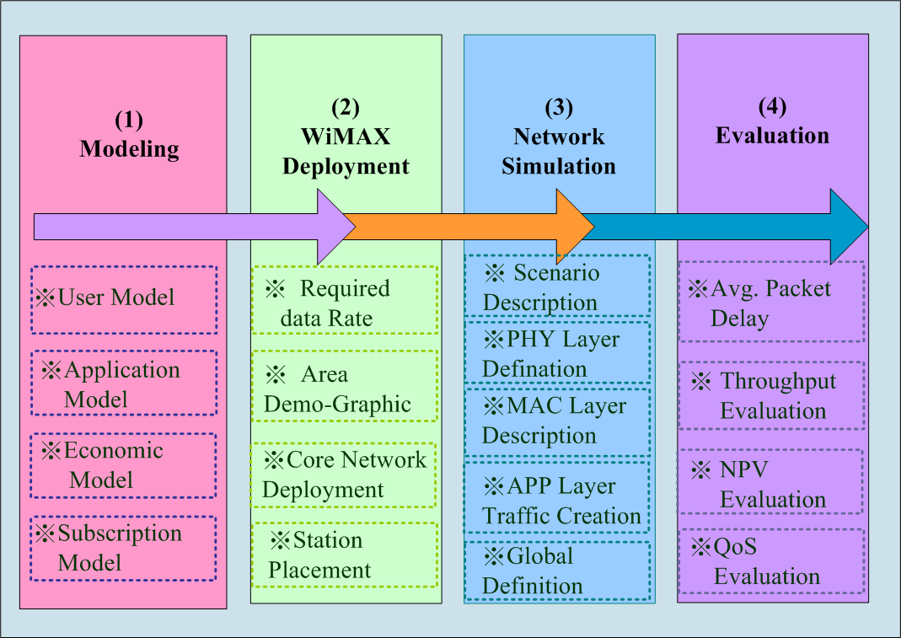
Figure 1. Research steps involved in development of WiDeMS.

The first stage describes and illustrates numerous models and basic assumptions. For our WiDeMS requirements, the station model, user model, traffic model, and economic model are well defined in this stage. In the modeling stage, a suitable mathematical or statistical technique that can be used in the simulation scenario is determined.
  - User Model
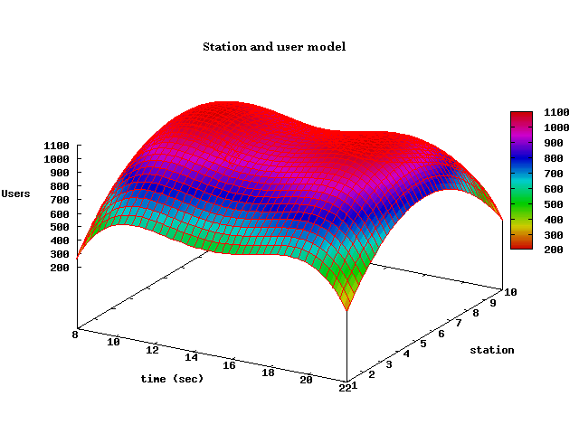
Figure 2. User model with time deviation and stations.
This model assumes the number of passengers at each station at different times. For example, if we have ten stations, the model should map each station to its correlated passengers. The model will also have its distribution (i.e., peak-rates from 1100–1300 and 1700–1900, and off-peak rates at other times). Fig. 2 shows a 3-D model for this table. The model additionally describes the passenger I/O rate during the peak rates (at 1200 and 1800), and defines the station models by using different weights from 1 to 5. The higher the weight of a station, the more passengers get on or off trains at this station (i.e., the traffic load of the station). In this model, the amount of user traffic varies from low to high from the off-peak to peak hours.
2.2 Application model
The application model shows the duration of time for which passengers use the applications on MRT-trains. Our research considered two types of applications: voice over IP (VoIP) and file transfer protocol (FTP). The parameters for these models are listed in Table 1. The distributions of the VoIP average call holding times and FTP file sizes are shown in Figs. 3 and 4 using a cumulative distribution function (CDF). Modeling methodologies for more applications can be referred from [4].

Table 1. Parameters of VoIP and FTP traffic model.
Component |  | Factors
VoIP avg. call holding time | Exponential Distribution
VoIP frame length | 20 ms
VoIP Frame size | 128 bytes
FTP File Size |  | Truncated lognormal

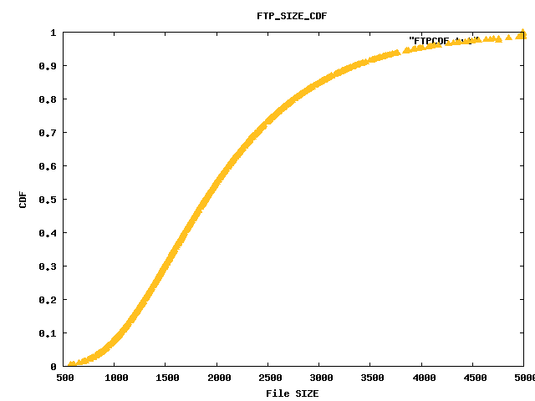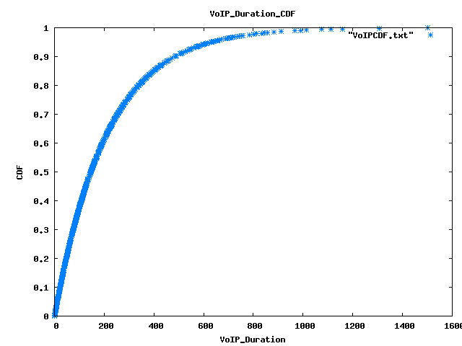
Figures 3 and 4. FTP duration model and VoIP duration model.
2.3 Economic model and assumptions
The economic model considers various equipment costs, market-related investment parameters, and other factors. However, before considering the profit, the annual capital and operational expenses need to be considered first. The investment cost is the first consideration for telecommunication/wireless communication operators.
First, we need to determine cost factors such as the capital expenditure and operation expenditure.
A. CAPEX
The capital expenditure (CAPEX) includes the costs of the end-user device, WiMAX equipment (e.g., base station (BS)/subscriber station (SS)), backhaul link equipment, and server equipment. All the costs involved in the setup of the wireless environment are included in the CAPEX. For example, the spectrum license cost is included in the CAPEX. Many WiMAX operators own different licensed bands (e.g., 2.5G/3.5G), but some operate in un-licensed bands. In licensed bands, operators need to consider the size of the bands that need to be covered and their costs in the cases of continuous or non-continuous bands. The first WiMAX-certified products operated in the licensed 3.5-GHz frequency band, followed by systems in the 2.5-GHz licensed band and the 5.8-GHz license-exempt band. It is important thing to consider all these costs in the CAPEX.
B. OPEX
The operational expenditure (OPEX) is the on-going cost of running a business. The OPEX of companies includes the salaries of workers and facility expenses such as rent and utilities.
In a WiMAX network structure, the OPEX includes costs associated with the operation and maintenance of the WiMAX and backhaul equipment. It also includes accounting expenses, advertising, office expenses, supplies, attorney fees, insurance, and property management. For network operation and maintenance, a detailed costing model should be used. We list some of the important equipment and operational expenses in Table 2. This includes factors related to deployment costs, while some investment factors were referred from [1], [2], [5], and [8] :
Table 2. Costs for MRT system.
Investment factor | Deployment cost
WiMAX BS | $15000 per BS
WiMAX BS installation cost | $2500 per BS
License fee | $15000
BS site rental | $3000 per BS per year
Backhaul link equipment | $40000
SS installation cost | $500
SS site rental in MRT stations | $10000 per SS per year
Administration cost | 10% of total investment
Maintenance cost | 10% of total investment

As a second step, the WiMAX operator needs to calculate the total revenue/income. In this step, we determined our pricing model by using a two-part tariff strategy for a WiDeMS subscriber:
$$P_{(i)}=\sum_{u=1}^{N(i)}{[B+(A∗T_{u,(i)})]}$$ | (1)
$$N(i)=\text{MSR}(i)∗\text{S, 0 }≤\text{msr}(i)≤\text{ 1}$$ | (2)
The formula (1) illustrates the profit in month i. The number of users (denoted by U) is a key factor in our framework. The B is basic service fee and A is denoted application service fee. T_{u,(i)} f is the total spent time for a user in the i month. Also, we formulate the total number of subscribers in equation (2). MSR_{(i)} is Monthly Subscription Rate (MSR) of the i month. The total passenger is represented by S. In this equation, the number of subscriber (we denote by N) is a key factor in our framework, the number of subscribers (overbooking rate) will change based on the service quality. If the quality (denoted by Q) is not good enough, some users will cancel their subscriptions. However, the monthly subscription rate (MSR) will increase constantly. The MSR can be calculated based on the most recent month’s quality:
MSR(i) = MSR(i-1) + INC - BQ(i-1) | (3)
The formula (3) illustrates the MSR in month i which is depending on last month. INC is a constant that indicates the subscription increase rate of the entering the network. The factor BQ means Bad Quality. It is the proportion of the discontent rate which depends on the experience of the user. We will discuss this factor later by using the subscription model.
2.4 Subscription Model–subscribe/cancel analysis
In this analysis, we address the problem of pricing in such a network/telecom service. There are many factors that impact the MSR: the factor BQ, service price, and competition/cooperation among service providers. The higher of BQ value, the fewer subscribers satisfy this service, the more is the number of subscribers not enjoying this service. Thus, the MSR will decrease in the next period (i.e., the next month in our scenario). In [6], a game theory analysis and Nash equilibrium are considered to find the solution to this issue. Briefly, if the service price offered by a service provider is too high, subscribers may churn to another service provider. However, if the service price is low, the total revenue of the service provider may not be maximized. For a WiDeMS service, we assume that the basic service fee (B) is 5$ and the application service fee (A) is 0.001$ per second. These fees are defined as variable so that we may adjust them to appropriate values.
In our study, we focused on the impact of service quality. Two factors were considered for the MSR: the rate of increase of subscribers entering the network and the WiDeMS service quality. In this paper, we focus on the packet delay, packet loss, and data rates. These factors are more sensitive when the link becomes congested. A previous paper [7] defined a computational model for digitized voice transmission using the E-model, R-factor, and Mean of Score (MOS). We use the method of calculating the R-factor as good-or-better (GoB) and poor-or-worse (PoW) to determine how the number of users who have had a poor experiences with WiDeMs. This number is determined as follows:
  - The WiMAX operator observes the mean inter packet delay.
  - The mean inter packet delay is mapped to the R-value by the equations (3-1), (3-27), and (3-28) given in [7].
  - Based on the R-value, the good-or-better (GoB) value and poor-or-worse (PoW) value is calculated by equations (B-1), (B-2), and (B-3) given in [7].
In this manner, the number of users who have had a poor experience because of packet delay and packet loss can be determined. We can also determine the increment or decrement of MSR for the next month. The correlations between the inter packet delay and the PoW and GoB values are shown in Fig. 5.
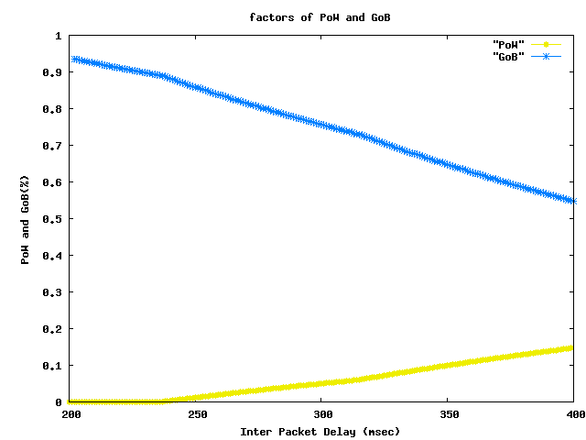
Figure 5. Correlations between the inter packet delay and the PoW and GoB.
The subscription model considers not only the packet delay but also the service blocking rate. WiMAX scheduling, including the resource allocation and admission control policies, has to be able to meet the QoS assurances for the WiMAX network. We measure the blocking rate for the overall connections. If the blocking rate is high, the BQ factor will increase. We argue that when the call blocking probability increases, subscribers will suffer from more call blockings and the level of user satisfaction will decrease. In WiDeMS, we define the leave threshold as 1%. If the block probability is higher than 2%, some subscribers will stop using WiDeMS.
The other factor impacting user satisfaction is the throughput (i.e., the data rate). In a WiMAX system, the data rate differs based on the modulation scheme and encoding rate. With higher modulation and encoding rates, the overall data rate will increase to 50–70 Mbps. The subscription model measures the average throughput of every FTP application. If subscribers suffer from lower data rates, they will leave in the next month if the data rate is insufficient. The leave probability table is shown below:
Table 3. Correlations between data rate and user experiment.
Date rate | User experiment | Leave probability
>2 Mbps | Excellent | 0%
500 Kbps~2 Mbps | Good | 0%
100 Kbps~500 Kbps | Fair | 10%
10 Kbps~100 Kbps | Poor | 50%
<10 Kbps | Bad | 90%
3 Simulation Environment of WiDeMS
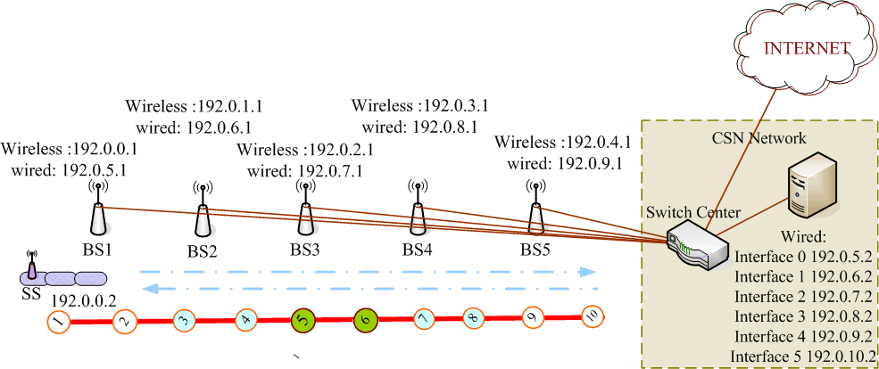
Figure 6. Simulation scenario.

In the network simulation stage, we simulated the WiDeMS framework. Our simulation tool was based on Qualnet simulation Software version 4.5 [9], which includes advanced wireless tools that support the IEEE 802.16e standard. The Qualnet platform is a PC-based software that is intended for use in the planning and designing of wired and wireless networks. The simulation arguments are based on the input criteria provided in its configuration file.
As shown in Fig. 6, BS directly connects to the wired network and manages the admission control for each MS/SS. Each MS/SS is located on an MRT train. It connects to the WiMAX-BS by the 802.16 PHY/MAC protocol. In this configuration, because the MS/SSs are situated on MRT-trains, the passengers can link with the MS/SS through a WLAN or wired interface. In the WiDeMS, we assume that the MRT trains support a WLAN network. The distance between MRT stations is approximately 1.5 km. An MRT train moves to the next MRT station and stops for a while. It then moves to the next MRT station. The drive duration of an MRT train is 140 s while the stop duration is approximately 25 s. The maximum speed of the MRT train is up to 70 km/h.
Our framework assumes that the end-user subscriber uses the WiMAX service every day. The number of passengers and MSR will also be set in the configuration file. These input parameters and the configuration file are changed for different times and different cases. For example, the number of subscribers and the duration for each application will be reset for the next period.
In the operation flow, the overall process is divided into 20n parts for one day. n describes the MRT round trip periods in one day. First, the input arguments are stored in the simulator’s configuration file (for example: the MAC/PHY setting, node placements/movements, and application descriptions). All of these input arguments will are inputted into the simulator. An MRT train starts from station 1, moves to station 10, and returns to station 1. For each round trip, an automatic function for the application model will add and remove VoIP/FTP applications in different time slots T (0 < T < 20n – 1). At the end of the simulation, the simulation results are saved in our database, which can be used for evaluation in the evaluation stage. Table 4 shows the parameters and input arguments for the Qualnet simulator.
Table 4. Simulation parameters.
Simulator parameter | Value
Channel bandwidth | 20 MHz
BS frame interval | 20 ms
BS TDD DL duration | 10 ms
BS TTG/RTG/SSTG | 10 µs/10 µs/4 µs
BS DCD broadcast interval | 5 m
Propagation path loss model | TWO-RAY
PHY802.16 TX power | 20.0
Handover RSS Trigger | –76.0 dbm
Wired link Bandwidth | 100 mb/s
Simulation time | 1400 s/per round of MRT

Supporting the QoS in a WiMAX-system is a difficult task because the characteristics of wireless links are highly variable and unpredictable. To cope with these issues, the QoS is usually managed at the medium access control (MAC) layer. In the Qualnet simulator, the QoS is supported by the bandwidth request, scheduling, traffic classifier, and UL/DL functions. However, for a researcher and designer, it is more difficult to build a system that can detect and maintain the different classifications of applications. Two different processes in our simulation were run in Qualnet. The first situation was not assigned a QoS guarantee, while the other was assigned a QoS guarantee. In the QoS-guarantee scenario, the UGS, rtPS, nrtPS, ertPS, and best effort classes were included in the WiMAX system. However, with no QoS-guarantee, all of the applications used the best effort class instead of the QoS supported classes. We called this situation the no QoS-guarantee scenario. On the other hand, the QoS-guarantee scenario considered all of the traffic types for all applications.
Simulation results:
In our simulation, WiDeMS was initialized and deployed in January 2010 with operations and management provided for 3 years (from January 2010 to December 2012). The numerical results and analyses are shown below:
  - Average delay on MRT
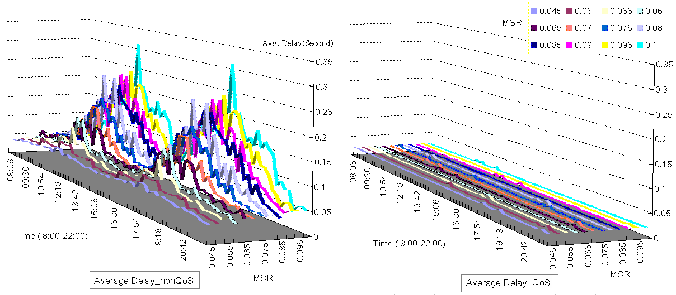
Figure 8. VoIP packets average delay on MRT.

We collected VoIP packet transmission data for different MSRs, as shown in Fig. 8. In the case of an MSR of less than 0.06 with the no QoS guarantee, the average delay was less than 0.05 s. When the MSR approaches 0.1, the average delay for each user approaches 0.1–0.2 s, and even reaches 0.3 s at the peak rate. The high average delay not only resulted in a huge number of instances where receiving data of VoIP packet transmit out of time threshold but also decreased the MSR because the users experienced low quality of service. In the QoS-guarantee scenario, every VoIP session was assigned to the UGS class. All of the VoIP sessions received their packets within the assured time delay. The average delay was close to 20 ms. This is suitable for every UGS class application.

(a)
(b)
Figure 9. Monthly income (a) and ARPU (b) for 3 years of operation.

  - Monthly income
During the initial operating period, the profit is not very good. This is because the MSR is initialized at 5% and increases by 1% every month. After one year of service, the profit reaches $40000–45000. On the other hand, the quality of the WiDeMS is not very good when the MSR is high (at about 10%–12%). So a portion of the subscribers will leave during the following month. This depends on the GoB values of the subscription model. Finally, the monthly profit reaches a stable condition.

  - Average Monthly Revenue (ARPU) for Customers
Based on Equation (1) and (2), we focused on the overall subscribers’ ARPU using formula (4).

$$\text{ARPU }=\text{ P}(i)\text{ / N}(i)$$ | (4)
The results of the ARPU for the QoS guarantee and no QoS guarantee scenarios are close to 10. These stable ARPU results occur because every subscriber’s applications are generated by the application model. The average service duration is close to the mean of the VoIP/FTP duration (i.e., VoIP call holding time and FTP transmit time). The ARPU reveals that most of the users use the WiMAX service if they agree to pay the WiMAX operator $10 every month.
(a)
(b)
Figure 10. Average throughput evaluation (a) and net present value (b) for 3 years of operation.

  - Average Throughputs
Fig. 10(b) depicts the FTPs’ average throughputs for the QoS guarantee and no QoS guarantee scenarios. The average throughputs were based on all of the FTP sessions. It shows that the average throughputs were close to 1.2 Mbps–1.8 Mbps for the QoS guarantee, which was higher than the no QoS guarantee situation. This is because, for the no QoS guarantee scenario, all of the applications use the UL/ DL bandwidth for the BE class. The efficiency of the contention based strategy is lower than the pre-allotment in the MAC-scheduling since it wastes time dealing with the bandwidth request process. The best effort class needs every application to use the time slots to acquire the UL/DL bandwidth. Moreover, collisions may occur when the same application take the same random back off number if MSs/SSs need to transmit in the same time. This is the reason for the lack of bandwidth used and the allocation for the no QoS guarantee scenario.

  - Economic analysis
The results of the economic analysis are shown in Fig. 10(b). The total investment and profit were calculated for the QoS guarantee and no QoS guarantee scenarios. In the early part of the operation, the CAPEX and OPEX are about 0.2 million dollars. After a year, the NPV will not only balance but also increase every month. After three years, the overall profit with the QoS guarantee is close to 1.7 million dollars. But in the no QoS guarantee scenario, the profit is 0.5 million dollars. Since the quality is not good in the no QoS guarantee scenario, subscribers will leave because of bad experiences. However, the OPEX is deposited at the beginning of the year. Therefore, the NPV is reduced in January of every year.

  - Sensitivity analysis
To satisfy the uncertainty inherent in our assumptions, we used a method for testing the degree of sensitivity. The sensitivity analyses in the research included the OPEX, CAPEX, and service price level. For each parameter, 50% deviations from the base assumptions were defined as the upper (maximum) and lower limits (minimum) for the sensitivity analysis. The parameters were analyzed one-by-one, changing their values between the minimum and maximum and plotting the respective NPV values, as shown in Fig. 11(a). This graph shows that the NPVs are significantly more sensitive to changes in the service price. However, changing the service price level is a service problem, because when a WiMAX operator changes the service fee, it directly impacts the ARPU. In addition, the ARPU will sometimes affect the MSR and the monthly income when it is too expensive for a subscriber.
(a)
(b)
Figure 11. Sensitivity analyses for OPEX, CAPEX, and service price level for no QoS guarantee (a) and QoS guarantee (b) scenarios.

Finally, this paper summarizes the results of the WiDeMS simulation. We calculated the figures for subscribers, avg. MSR, monthly income, ARPU, and NPV for every year. These statistics can be easily seen for every year.

Table 4. The result for the WiDeMS per year.
Scenario | Period | Avg. subscribers | Avg. MSR | Monthly income | ARPU | NPV (M$)
WiDeMS_Non-QoS | 1st year | 2522 | 0.07 | 24478.894 | 9.69 | 0.057746738
WiDeMS_Non-QoS | 2nd year | 2777 | 0.078 | 28600.691 | 10.29 | 0.307455031
 | 3rd year | 2813 | 0.079 | 29541.852 | 10.50 | 0.56845726
WiDeMS_QoS | 1st year | 3274 | 0.091 | 35594.059 | 10.27 | 0.16172277
 | 2nd year | 5067 | 0.157 | 60203.191 | 10.35 | 0.81676115
 | 3rd year | 7207 | 0.20 | 83644.936 | 10.30 | 1.715783253

- Conclusion and Future work:
It is possible that modifications for the input arguments can be seen from both the business and network perspectives. For example, if one or more factors, like the BS location, user model, application model, or MSR, were changed, different system performance and financial results might be seen. In our simulation results, the WiDeMS shows results whether the WiMAX operator supports a QoS guarantee or not.
Our deployment framework, models, and the performance of our simulation are suitable, not only for a WiMAX core network, but also for other technologies with high data rates and wide service coverage, e.g., LTE, 3.5 G, etc. The simulation results for the proposed WiDeMS show the forecast profit and the bottleneck of the network, which is the bandwidth overhead. Greater bandwidth leads to a higher data rate for subscribers. However, determining how to use a limited total bandwidth for all of the users is the critical issue for the deployment inside moving MRT trains.
The future work on the WiDeMS will focus on the following researches. The first thing is to put more than one SS/MS onto an MRT train. Each SS/MS can link to the same or a different BS(s). Every SS/MS allows a subscriber to use their cell phones or notepads by connecting to the BS. Furthermore, each SS/MS handles a different handoff threshold. This scenario may lead to load balancing/sharing effects because users simultaneously employ different BSs from the same MRT train. On the other hand, the deployment strategy should also be considered in the load balancing scenario for the WiDeMS. However, the use of a heuristic method in the research may take these factors into consideration for a future WiDeMS. In addition, by changing the basic assumptions and the station topology, other interesting simulation results will be illustrated in future work.
References
1. WiMAX forum, “WiMAX deployment considerations for Fixed Wireless Access in the 2.5 GHz and 3.5 GHz licensed Bands,” 2005/7,white paper.
2. Lannoo, B., Verbrugge, S., Ooteghem, J.V., Quinart, B.,: Business Scenarios for a WiMAX Deployment in Belgium, Mobile WiMAX Symposium, 2007.
3. Grønsund, P., Engelstad, P.E., Johnsen, T., Skeie, T.: The Physical Performance and Path Loss in a Fixed WiMAX Deployment, International Wireless Communications and Mobile Computing Conference, p.p. 439 - 444, 2007.
4. WiMAX forum, “WiMAX System evaluation methodology” version 2.1, 2008.
5. Smura, T.,: Competitive potential of WiMAX in the broadband access market: a techno-economic analysis, Helsinki University of Technology, available at: www.netlab.tkk.fi/u/tsmura/publications/Smura_ITS05.pdf
6. Niyato, D., Hossain, E.: A game theoretic analysis of service Competition and pricing in Heterogeneous wireless Access Networks, Wireless Communications, IEEE Transactions, December 2008.
7. ITU-T Recommendation G.107, “The E-Model, a computational model for use in transmission planning,” March 2005.
8. WiMAX forum: The Business Case for Fixed Wireless Access in Emerging Markets, 2005.
9. scalable network technologies: qualnet simulator 4.5, http://www.scalable- networks.com/products/developer/new_in_45.php

