出國報告（出國類別：進修）

國內引進藥事法庭/酒後駕駛專責法庭---
結合醫療與司法體系建立酒藥癮治療模式
可行性初探

服務機關：行政院衛生署草屯療養院
姓名職稱：王作仁主任醫師
派赴國家：美國
出國期間：97年5月31日至98年8月4日
報告日期：98年10月22日

摘要
如何增進藥酒癮治療及強化再犯預防成效之相關研究是相當重要的課題，現今已無法依賴各別醫療人員或司法人員的努力即可達成顯著成效，需考慮如何結合跨領域專業合作，以較低社會成本且有效率之酒藥癮治療模式協助酒藥癮個案；因此職自97年5月31日起奉派出國進修，至美國南加州大學、NIDA等研究機構進行相關研究及訪談學者；獲得法官許可後，至落杉磯及費城之藥事法庭/酒駕專責法庭實習， 深入暸解藥事法庭/酒駕專責法庭中，參與其中之司法與醫療專業人員如何分工、開庭前如何進行個案討論會議、審理流程中法官等專業人員與個案之互動、專業人員長期共同協助個案所致成效；並參加美國藥事法庭/酒駕專責法庭專業人員培訓課程，實地瞭解及評估國內未來引進藥事法庭/酒後駕駛專責法庭---結合醫療體系與司法體系建立酒藥癮治療模式可行性。
美國近年來研究顯示，毒品犯若能在藥事法庭制度完整監控下完成12-18個月的療程， 則一年內再犯率可能由60%~80%降低至4%~29%。職建議借鏡美國藥事法庭/酒後駕駛專責法庭二十年經驗， 縮減摸索過程，以司法約束力持續將藥酒癮個案連結於精神醫療系統中，並持續評估試辦藥事法庭/酒後駕駛專責法庭實施成效與改進措施，將可能逐年降低藥酒癮個案再犯率及改善旋轉門現象，進一步增進個案與家屬生活品質，促進社會及道路安全。

目次

摘要 2

本文

- 目的 4

- 過程 5

- 心得 6

- 建議 8

附錄部份10~33

碩士論文
Policy Formulation of Drug Treatment Court and DUI Court to Enforce Addiction Treatment:
From USA to Taiwan

本文

一、目的
改變的時刻到了(It’s time to Change)
如何增進藥酒癮治療及強化再犯預防成效之相關研究是相當重要的課題，現今已無法依賴各別醫療人員或司法人員的努力即可達成顯著成效，需考慮如何結合跨領域專業合作，以較低社會成本且有效率之酒藥癮治療模式協助酒藥癮個案；因此職自97年5月31日起奉派出國進修，至美國南加州大學、NIDA等研究機構進行相關研究及訪談學者；獲得法官許可後，至落杉磯及費城之藥事法庭/酒駕專責法庭實習， 深入暸解藥事法庭/酒駕專責法庭中，參與其中之司法與醫療專業人員如何分工、開庭前如何進行個案討論會議、審理流程中法官等專業人員與個案之互動、專業人員長期共同協助個案所致成效；並參加美國藥事法庭/酒駕專責法庭專業人員培訓課程， 希望瞭解及評估國內未來引進藥事法庭/酒後駕駛專責法庭---結合醫療體系與司法體系建立酒藥癮治療模式可行性。
近年來我國毒癮愛滋病患急速增加，為儘速控制疫情，參考美國、澳洲等國之減少傷害(Harm Reduction)策略，於94年12月6日通過「毒品病患愛滋減害試辦計畫」，積極推動清潔針具計畫和替代療法，採取替代性戒癮藥物，如美沙冬（Methadone）、丁基原啡因（Buprenorphine），對於海洛因施用毒品犯採取「減害計畫--美沙冬療法」、「減害計畫—針頭針筒交換」等措施；台南地檢署等單位為使海洛因施用毒品犯接受美沙冬療法，減低危害，依「執行毒品減害替代療法緩起訴處分作業要點」， 進一步試行施用毒品犯接受美沙冬療法「緩起訴」等措施， 要求其至指定之醫療機構按時服用美沙冬(METHADONE)或指定之替代藥品，至無繼續服用之必要為止，期間最長為一年。此美沙冬療法「緩起訴」等措施已在部分縣市獲初步成效，且蘊釀積極推動修法，將毒品減害替代療法法制化。
國內目前雖無藥事法庭制度，但國內針對施用海洛因毒品犯接受美沙冬療法「緩起訴」措施，即為司法體系與醫療體系初步共識， 嘗試以司法公權力要求海洛因施用毒品犯持續接受戒癮治療， 增進戒癮成效， 此可成為國內未來於原有司法體系內創立藥事法庭制度之根基，由司法體系以公權力要求施用毒品犯持續接受戒癮治療， 施以相關成癮治療(Court-Mandated Treatment )等配套措施；在司法體系與醫療體系共同合作下，共同努力防治藥物濫用問題，有效降低毒品犯再犯率。
酒癮長久以來亦為一世界性重要社會議題及精神疾病， 雖適量社交性少量飲酒是為社會所允許，但酒癮患者長期失控過量飲酒，不僅可引起病患心理及生理多種合併症狀，並造成嚴重的家庭功能障礙及社會問題，甚至導致病患死亡(Caces et al 1991；Debakley et al 1993) ，因此酒癮在國內已成為不容忽視的議題。依據法務部資料顯示 以民國95 年地方法院檢察署公共危險罪偵查終結為例（含舊受）約5 萬3 千人，其中起訴約3 萬2 千人（九成一屬違背安全駕駛），較民國94 年增加14.0％；緩起訴處分約1 萬6 千人，占29.5％。民國95 年各地方法院檢察署執行公共危險罪定罪人數2 萬9千人（男性占九成四），占全部刑案定罪人數的19.7％，高居犯罪案件之首位；其中具公共危險罪前科之再累犯人數占23.3％。
期盼如同藥事法庭一般，以司法公權力要求酒駕者必需接受完整酒癮相關治療(Court-mandated treatment for convicted drinking drivers)及相關配套措施，以獲得公共危險罪「緩起訴」，若能在酒駕專責法庭制度完整監控下完成12-18個月的療程 則可能有機會降低酒駕再犯率達20%(Mann et al., 1994) ， 進一步增進道路及社會安全。

二、過程：
（一）出國前的準備
感謝衛生署97年度「行政院衛生署所屬醫院醫事人員出國進修計畫」補助職進修計畫，取得十九個月公假及ㄧ百六十四萬元之經費補助。決定出國進修之後，職立即開始準備留學國語言考試，由於臨床業務繁忙，無暇參加托福及GRE考試補習班的加強，只能趁公餘自修，順利申請入學。
職於九十七年六月順利入學美國南加州大學公共政策管理學院之國際公共政策管理研究所（University of Southern California, School of Policy, Planning and Development , International Public Policy and Management Department），準備研讀醫療政策相關學程，以「國內引進藥事法庭/酒後駕駛專責法庭---結合醫療與司法體系建立酒藥癮治療模式可行性初探」為研究主題，以使學習進修的內容更為完整，順利完成此次進修。
感謝院長陳宏、國防醫學院學務長司徒惠康教授及國防醫學院公共衛生學院林金定教授為職撰寫推薦函，感謝家人支持、林滄耀主任出國期間代理成人精神科主任業務與科內同仁努力科內業務。

（二）研習機構及課程簡介
進修過程分為以下兩階段：
1. 第一階段自九十七年六月入學美國南加州大學公共政策管理學院之國際公共政策管理研究所（University of Southern California, School of Policy, Planning and Development , International Public Policy and Management），研讀醫療政策學程，順利提前於十三個月完成學位，完成碩士論文 (如附件一)，並取得公共政策管理碩士學位(MPPM )(如附件二)。
國際公共政策管理研究所碩士課程研習課程以統計學、流行病學及政策管理相關課程為主，至少四個學季 (semester) ，十八個月內完成系所要求必須修滿至少三十二個學分，同時完成畢業論文，通過指導教授評鑑後，方能取得學位。
2. 第二階段，為瞭解及評估國內未來引進藥事法庭/酒後駕駛專責法庭---結合醫療體系與司法體系建立酒藥癮治療模式可行性，特別拜訪請教美國華府藥癮研究專責單位NIDA(National Institute of Drug Abuse)之學者專家戴博士(Dr. Betty Tai )及李伯曼博士(Dr. Akiva M. Liberman ) ，請教臨床及研究實務經驗豐富之美國南加大洛杉磯分校UCLA佘博士(Dr. Yih-Ing Hser )、耶魯大學耶提斯教授(Dr. Fredrick Altice in Yale University) 。
另經由藥事法庭/酒後駕駛專責法庭相關領域專家馬洛威博士等(Dr. Douglas Marlowe & Dr. Davis Festinger )引薦，職於週間及假日至洛杉磯及費城藥事法庭/酒後駕駛專責法庭實習，感謝克連法官(Judge Ross M. Klein)等法律專家細心指導，了解許多法官無法接受毒犯出獄後很快即再犯被抓回到監牢，因此1989年由佛羅里達州幾位法官開始特別設立藥事法庭/酒後駕駛專責法庭，並逐步推廣至全美各州與加拿大、澳洲等國家；職並主動參加美國藥事法庭/酒駕專責法庭專業人員培訓課程， 希望深入瞭解及評估國內未來引進藥事法庭/酒後駕駛專責法庭---結合醫療體系與司法體系建立酒藥癮治療模式可行性。

三、心得：
以下為初步研究心得， 就教於精神醫療與司法前輩。
A.藥事法庭
1.旋轉門現象
近年來政府反毒政策變革中，不僅將戒治施用毒品犯定位為兼具病人與犯人特性之「病犯」，確立「有條件除刑不除罪」的政策，理念上採取「治療重於處罰」、「醫療先於司法」的原則。對於施用第一、二級毒品者，違反民國 92 年 7 月修正通過之毒 品 危 害 防 制 條 例第 10 及20 條，經檢察官聲請法院裁定令被告入勒戒處所觀察、勒戒後，檢察官則依據勒戒處所之陳報，認受觀察、勒戒人無繼續施用毒品傾向者即釋放，並為不起訴之處分或不付審理之裁定 ；若勒戒處所之陳報認受觀察、勒戒人有繼續施用毒品傾向者，檢察官則聲請法院裁定令入戒治處所強戒治，其期間為六個月以上，至無繼續強制戒治之必要為止。但最長不得逾一年。雖然司法體系採取多種方式協助，但施用毒品個案常缺乏動機持續接受治療且再犯率高，存在所謂旋轉門現象(Revolving Door)；依據法務部資料顯示，以民國 97 年執行毒品案件裁判確定有罪人數為例， 其中施用毒品再累犯即高達89.1% ，且毒犯越捉越多，偵案激增，監所人滿為患， 6萬在監受刑人中約有3萬名毒癮者， 造成司法體系及監所空間、管理人力及經費上的龐大負荷。
2.美國藥事法庭
同樣情況也發生於美國 1980年代， 許多法官無法接受毒犯出獄後很快即再犯被抓回到監牢，且監所經常人滿為患， 1989年由佛羅里達州幾位法官，於原有司法體系內首先創立藥事法庭，逐步推廣藥事法庭制度，專業人員共同成立專業協會， 積極進行推廣活動及專業人員培訓課程；藥事法庭施行成效，經近年來研究顯示，毒品犯若能在藥事法庭制度完整監控下完成12-18個月的療程， 則一年內再犯率可能由60%~80%降低至4%~29% ，此顯著成效獲得廣泛認同其為有效降低毒品犯再犯率方法之一，並於1994 年獲得國會通過法案(Biden Crime Bill) 授權，將逐年支付共十億美元無條件的支持藥事法庭補助方案(Drug Court Discretionary Grant Program) ， 迄至2009年為止， 全美已超過2,000處設立或籌設中之藥事法庭、後來衍生之酒駕專責法庭、 少年藥事法庭等類型藥事法庭。
3.美沙冬療法「緩起訴」
近年來我國毒癮愛滋病患急速增加，為儘速控制疫情，參考美國、澳洲等國之減少傷害(Harm Reduction)策略，於94年12月6日通過「毒品病患愛滋減害試辦計畫」，積極推動清潔針具計畫和替代療法，採取替代性戒癮藥物，如美沙冬（Methadone）、丁基原啡因（Buprenorphine），對於海洛因施用毒品犯採取「減害計畫--美沙冬療法」、「減害計畫—針頭針筒交換」等措施；台南地檢署等單位為使海洛因施用毒品犯接受美沙冬療法，減低危害，依「執行毒品減害替代療法緩起訴處分作業要點」， 進一步試行施用毒品犯接受美沙冬療法「緩起訴」等措施， 要求其至指定之醫療機構按時服用美沙冬(METHADONE)或指定之替代藥品，至無繼續服用之必要為止，期間最長為一年。此美沙冬療法「緩起訴」等措施已在部分縣市獲初步成效，且蘊釀積極推動修法，將毒品減害替代療法法制化。
國內目前雖無藥事法庭制度，但國內針對施用海洛因毒品犯接受美沙冬療法「緩起訴」措施，即為司法體系與醫療體系初步共識， 嘗試以司法公權力要求海洛因施用毒品犯持續接受戒癮治療， 增進戒癮成效， 此可成為國內未來於原有司法體系內創立藥事法庭制度之根基，由司法體系以公權力要求施用毒品犯持續接受戒癮治療， 施以相關成癮治療(Court-Mandated Treatment )等配套措施；在司法體系與醫療體系共同合作下，共同努力防治藥物濫用問題，有效降低毒品犯再犯率，減輕監所空間、管理人力及經費的負擔。
B.酒駕專責法庭
酒癮長久以來亦為一世界性重要社會議題及精神疾病， 雖適量社交性少量飲酒是為社會所允許，但酒癮患者長期失控過量飲酒，不僅可引起病患心理及生理多種合併症狀，並造成嚴重的家庭功能障礙及社會問題，甚至導致病患死亡(Caces et al 1991；Debakley et al 1993)。近年來針對國內酒癮盛行率的研究顯示，國人漢族在都市及鄉鎮的酒精依賴的盛行率約為1.5--3% (Hwu et al,1988; Helzer et al. 1990),而原住民酒癮盛行率更高達6.4--11.4% (Hwu et al,1990)；因此，酒癮在國內已成為不容忽視的議題。
根據交通部統計，九十五年開始，酒駕已經躍升 Ａ１類交通事故（人員當場或二十四小時死亡）發生原因第一名，其所造成的自身及他人人身安全及財物危害，甚至於影響數百個家庭生計，其對社會造成之衝擊，並不小於海洛因等其他物質濫用。雖經政府多年宣導勿酒後駕車，民國八十六年3 月道路交通管理處罰條例修正施行，加重酒後駕車處罰，民國八十八年4月起取締酒醉駕車，酒後駕車超過法定數值(駕駛人呼氣酒精含量超過0.25毫克／公升者)即取締告發，以維護駕駛人行車安全 若駕駛人呼氣酒精含量超過0.55毫克／公升，將可以刑法一百捌拾伍條之三的公共危險罪起訴；民國九十一年9 月道路交通管理處罰條例三度修正第三十五條， 酒後駕車除處罰新臺幣一萬五千元以上六萬元以下罰鍰、吊扣駕照一年外，並當場移置保管其車輛；但酒駕者常以僥倖心態為之，國內現階段酒後駕駛被判罰款、吊扣、駕照、付不出罰款而入監服刑後，仍多次犯案者並不在少數。
依據法務部資料顯示 以民國95 年地方法院檢察署公共危險罪偵查終結為例（含舊受）約5 萬3 千人，其中起訴約3 萬2 千人（九成一屬「違背安全駕駛」），較民國94 年增加14.0％；緩起訴處分約1 萬6 千人，占29.5％。民國95 年各地方法院檢察署執行「公共危險罪」定罪人數2 萬9千人（男性占九成四），占全部刑案定罪人數的19.7％，高居犯罪案件之首位；其中具公共危險罪前科之「再累犯」人數占23.3％，比例不低。
徒法不足以自行，國內目前雖無酒駕專責法庭，但可考慮於原有司法體系內設立酒駕專責法庭(Driving –under -influence court)，如同藥事法庭一般，以司法公權力要求酒駕者必需接受完整酒癮相關治療(Court-mandated treatment for convicted drinking drivers)及相關配套措施，以獲得公共危險罪「緩起訴」，若能在酒駕專責法庭制度完整監控下完成12-18個月的療程 則可能有機會降低酒駕再犯率達20%(Mann et al., 1994) ， 進一步增進道路及社會安全。
美國藥事法庭/酒後駕駛專責法庭經驗值得借鏡
美國許多法官無法接受毒犯出獄後很快即再犯被抓回到監牢，因此1989年由佛羅里達州幾位法官開始特別設立藥事法庭/酒後駕駛專責法庭後 研究發現藥事法庭/酒後駕駛專責法庭制度完整監控下，個案若完成12-18個月的療程， 則一年內再犯率可能由60%~80%降低至4%~29% ，此顯著成效獲得廣泛認同其為有效降低毒品犯再犯率方法之一，並於1994 年獲得國會通過法案(Biden Crime Bill) 授權，將逐年支付共十億美元無條件的支持藥事法庭補助方案(Drug Court Discretionary Grant Program) ，因此美國各州陸續推廣迄至2009年為止， 全美已超過2,000處設立或籌設中之藥事法庭、後來衍生之酒駕專責法庭、 少年藥事法庭等類型藥事法庭。職全程參與藥事法庭/酒後駕駛專責法庭運作過程後，深入了解美國司法與精神醫療專業人員如何分工、開庭前如何進行個案討論會議、審理流程中法官等專業人員與個案之互動、精神醫療與司法專業人員長期共同協助個案等跨領域專業團隊合作，經過將近二十年來共同摸索與努力，方致如此顯著成效。
經實地瞭解及評估美國現行藥事法庭/酒後駕駛專責法庭---結合醫療體系與司法體系建立酒藥癮治療模式可行性後，臺灣若借鏡美國藥事法庭/酒後駕駛專責法庭二十年經驗，以司法約束力持續將藥酒癮個案連結於精神醫療系統中，將可能逐年降低藥酒癮個案再犯率；期望臺灣未來亦能如美國藥事法庭近年來施行成效，毒品犯若能在藥事法庭制度完整監控下完成12-18個月的療程， 則一年內再犯率可能由60%~80%降低至4%~29%。

四、建議事項：
經職實地瞭解及評估美國現行藥事法庭/酒後駕駛專責法庭後，職思考臺灣若借鏡美國藥事法庭/酒後駕駛專責法庭二十年經驗， 縮減摸索過程， 未來經由司法系統派訓法官與檢察官、衛生署派訓精神醫療人員後，若國內經由政策評估可行後，可考慮於原有司法體系內先行 ”試辦”藥事法庭/酒後駕駛專責法庭，由已派訓藥事法庭/酒後駕駛專責法庭之法官帶領已接受派訓之精神醫療人員與司法人員團隊，以司法約束力持續將藥酒癮個案連結於精神醫療系統中，並持續評估試辦藥事法庭/酒後駕駛專責法庭實施成效與改進措施，將可能逐年降低藥酒癮個案再犯率及改善旋轉門現象。
建議經由衛生署、法務部與立法院等相關部會，審慎討論與修訂相關法令後，近年內:
1. 設立藥事專責法庭:
國內目前雖無藥事法庭制度，但國內針對施用海洛因毒品犯接受美沙冬療法「緩起訴」措施，即為司法體系與醫療體系初步共識， 嘗試以司法公權力要求海洛因施用毒品犯持續接受戒癮治療， 增進戒癮成效， 此可成為國內未來於原有司法體系內創立藥事法庭制度之根基，由司法體系以公權力要求施用毒品犯持續接受戒癮治療， 施以相關成癮治療(Court-Mandated Treatment )等配套措施；在司法體系與醫療體系共同合作下，共同努力防治藥物濫用問題，有效降低毒品犯再犯率，減輕監所空間、管理人力及經費的負擔。

- 設立酒駕專責法庭:
國內目前雖無酒駕專責法庭，但可考慮於原有司法體系內設立酒駕專責法庭(Driving –under -influence court)，如同藥事法庭一般，以司法公權力要求酒駕者必需接受完整酒癮相關治療(Court-mandated treatment for convicted drinking drivers)及相關配套措施，以獲得公共危險罪「緩起訴」，若能在酒駕專責法庭制度完整監控下完成12-18個月的療程 則可能有機會降低酒駕再犯率達20%(Mann et al., 1994) ， 進一步增進道路及社會安全。

`
Running head: POLICY FORMULATION of DRUG TREATMENT COURT and DUI COURT to ENFORCE ADDICTTION TREATMENT: from USA to TAIWAN

Policy Formulation of Drug Treatment Court and DUI Court to Enforce Addiction Treatment:
From USA to Taiwan

TSO-JEN WANG M.D.; Ph.D.; MPPM
University of Southern California
Dr. Melissa Lopez & Prof. Glenn Melnick
July 22, 2009

Policy Formulation of Drug Treatment Court and DUI Court: from USA to Taiwan Table of contents
- Cover page P 10
- Table of contents P 11
- Introduction to your topic or critical issue and description of policy or management problem
P 12
- Define the Policy Problem P 13
- Significance of Drug Treatment / DUI Court: from USA to Taiwan P 16
- Causes of the problem. P 17
- Comparative Analysis: What strategies or tactics have been used to solve the problem in your home country and other countries and what are the advantages and disadvantages of the current tactics be used.
P 18
a. focus on home country Taiwan P 18
b. focus on other comparable countries USA P 20
- Recommendations P 26
- Discussion and Conclusions P 29
- References P 32

Introduction
We Want to Make Changes in Taiwan
There are many studies show that “addiction” is a complex disorder involved with brain neurotransmitters, with biological and psycho-social attributions and behavior change. Addiction itself negatively not only affects individuals, families, but also communities, society and country(Gil Kerlikowske, May 2009).Some of addicts with drug offenses, not drug dealers, were reconsidered as “ patient-criminal” after revision of “Drug Prevention and Control Act” since 1998 in Taiwan. They had received screening, diverse individual/group treatment programs “in prisons”. These addicts are not highly motivated to receive regular treatment” in communities” after release from prisons, they are suffering from rapid relapse due to addiction itself and inconsistent motivation.
How many prisons are enough to keep them abstinence and away from drug crime? How many policemen are enough to stop drunk driving? As a matter of fact, these drug and alcohol abusers are not only charged and pay for their crimes in prison, and most importantly, they need effective treatment for addiction after release into community. Many drug abusers inmates refuse to receive appropriate medical treatment after being released into community, if without continuous monitoring with proper legal pressure. They are always lacking of persistent motivation to go on drug/alcohol rehabilitation programs in community.
Do we want to keep on fighting a continuous and exhausting war against drug abusers or to give addicts effective treatments in Taiwan? We need to think it over carefully. The prevailing drug abuse and alcohol abuse with related crimes are both endemic and international issues, which are dealt with different strategies in different developed and developing countries. We may learn how to deal with it from the previous experiences of United States of America.

Define the Policy Problem
Problem statement: The current traditional courts are not effective enough to reduce the rapidly increasing numbers of drug abusers / drunk-driving violators and inmates in Taiwan.
Rapidly increasing numbers of drug abusers and drunk driving violators
- There is a rapid increase of drug abusers charged with drug offenses and drunk-driver violators charged with against public safety (Fig. 1) in recent 10 years in Taiwan.
Fig 1.Offenders Convicted by Main Causes ---Drug Offenses vs. Against Public Safety
(1999-2008)
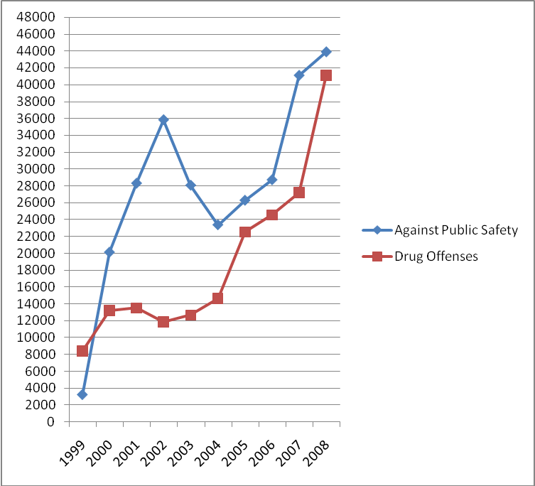
Resources: revised from Ministry of Justice, Taiwan
2.The drunk drivers violators caught by policemen was increasing rapidly in Taiwan, the numbers were 96,403, 115,785 and 137,692 in 2005, 2006 and 2007 respectively; some of them were charged with “against public safety” (see Table 1)( Yi-Ping Zeng and Ministry of Justice, Taiwan,2008).
Table 1.Drunk Drivers data (2005-2007)
Year/category/Case number | drunk drivers caught by policemen | drunk drivers charged with against public safety
2005 | 96,403 | 26,263
2006 | 115,785 | 28,696
2007 | 137,692 | 41,081
Resources: revised from Yi-Ping Zeng and Ministry of Justice, Taiwan,2008.
Rapidly increasing numbers of drug abusers and drunk driving Inmates
There is a rapid increase of drug offense inmates and against public safety inmates due to drunk-driving in prison (Fig 2) in recent 10 years in Taiwan.
- The prisons are overloaded with drug abusers, and the number of these inmates is increasing since 2003 to 2008(5988 inmates in 2003,and 14,492 inmates in 2008)
- There were 2600 new inmates per year in average charged with “against public safety “due to drunk driving during 2004 and 2006, and the number counted for 86% of new inmates charged with “against public safety “in average (Ministry of Justice, Taiwan,2009).
Fig 2. New Prisoners by Type of Crime—Drug Offenses vs. Against Public Safety (1999-2008)
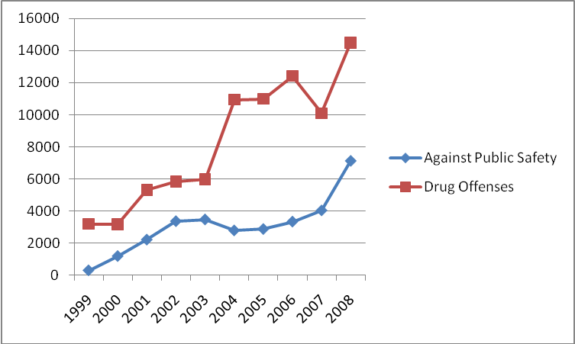
Resources: revised from Ministry of Justice, Taiwan
So it’s a good timing to evaluate the possibility of initiating policy formulation of drug treatment court and DUI court to Enforce Addiction Treatment, in order to reduce the rapidly increasing numbers of drug abusers / drunk-driving violators and inmates in Taiwan
High Recidivism Rate
- It’s estimated that 89.1% of drug abusers inmates are re-arrested (not first-timers) in 2008 (Ministry of Justice, Taiwan,2009).
- With traditional court , the one-year recidivism rate of drug addicts and reconvicted in prison is high( 64.7%-80.1%) in Taiwan(SHU-CHUAN CHIANG,2006), which is similar to the situation that 60% ～ 80% of drug abusers commit a new drug-related crime in USA(Langan & Levin ,2002).
- With Drug court/DUI court implementation in USA, one-year recidivism rate of graduates from drug courts is reduced significantly to 4 %～ 29%(Virginia Drug Treatment Court Advisory Committee, June 2008),as compared to 60% ～ 80% in traditional courts(Langan & Levin ,2002).

Significance of Drug Treatment Court and DUI Court: from USA to Taiwan
Public Health Issue: Rapid increasing of HIV infection in heroin abuser
There are 6,148 AIDS cases (35.29% of all AIDS cases) are due to heroin abusers with sharing needle injection, until May 2009 in Taiwan(CDC website, Taiwan). The rapid increasing of HIV infection in heroin abuser is a overwhelming public health and social problems in Taiwan(72 cases in 2003 to 571 cases in 2004)(website of Department of Health,Taiwan,2005). The effective means of control over drug abuse are getting more attention from the Government of Taiwan, from social and public health aspects.
Public Safety Threatening from Drunk-Drivers
In Taiwan, one of the major causes of mortality in traffic accidents was driving-under-influence of alcohol, which is accounted for 27% mortality rate in traffic accidents reported in 2005( Yi-Ping Zeng,2008). Even though the law enforcement to stop drunk drivers had been strengthening since 1999, it’s still a major public safety threatening for pedestrian and other safe drivers until now (see Table 2). With strengthened law enforcement ,the drunk drivers caught by policemen was increasing rapidly in Taiwan, the numbers were 96,403, 115,785 and 137,692 in 2005, 2006 and 2007 respectively ( Yi-Ping Zeng,2008).
Do we have fewer drunk-drivers after only strengthening the law enforcement? The answer is doubtful. We need to reconsider that some drunk drivers are not only “social drinker” but with the possibility of alcohol abuse/dependence. If we want to keep the public away from the threatening of drunk driving, we need some more effective approaches to deal with this issue.
More Prisons
The capacity for inmates had been forced to double from 26,000 in1990 to 53,000 in 2006 (Ministry of Justice, Taiwan, 2006).Without ongoing judicial oversight and team management for these addicts, the prisons are overloaded with drug abusers, and the number of these inmates is still increasing since 2006 to 2008(12,419 inmates in 2006, and 14,492 inmates in 2008). Do we want to build more prisons with much more cost? The answer is quite obviously “No”. So we need some more effective approaches to deal with this issue.
Causes of the problem
- Judges’ attitude : Patient vs. Criminal
Not every Judge regards drug addict offenders as “patient-criminal” since 1998, after revision of “Drug Prevention and Control Act”. Drug addicts need treatment more than incarceration. As for drunk drivers, they also need evaluation and treatment besides fine, suspension of driving license, or sanction with “against public safety” penalty by “Criminal Code”. As a matter of fact, Judges may assume “proactive roles” not only as a “leader in judicial system”, but also as a “leader in treatment team” to help drug addicts/drunk drivers in Drug court/DUI courts.
- Incarceration Do little on Stopping Drug Addiction
Addicts return to prison quickly as a “revolving door” pattern, they need treatment more than incarceration. Addict inmates may have the opportunities to receive some screening, diverse individual/group treatment programs “in prisons”. Are these addicts still highly motivated to receive regular treatment” in communities” after release from prisons? The answer is doubtful, and they are still suffering from vicious cycle of addiction. With traditional court, there is a high one-year recidivism rate ( 64.7%-80.1%) of drug addicts and reconvicted in prison in Taiwan(Psychiatry and Clinical Neurosciences, Aug 2006 ), although it’s similar to the fact that 60% ～ 80% of drug abusers commit a new crime in USA (typically a drug-related crime)(Langan & Levin ,2002).
- No “Mandatory” treatment “in communities” to help Drug/Alcohol Addict “Inmates” after release from Prisons
Addict inmates are suffering from rapid relapse and re-arrest, for there is “ no “ regular “mandatory” treatment” in communities” from courts after release from prisons. Furthermore, even with all efforts to give addicts treatment programs in prisons, the number of drug offense is still increasing rapidly since 2004 to 2008(14,640 in 2004 , and 41,120in 2008) ( Ministry of Justice, Taiwan,2009).There is a great need for regular “mandatory” treatment” in communities” after release from prisons.
- Few “Mandatory” treatment “in communities” to help Drug/Alcohol Addict “Probationers”
These addicts probationers are suffering from vicious cycle of “revolving door” of addiction with rapid relapse, for there is few regular “mandatory” treatment” in communities” from courts. They need court mandated continuous treatment with judicial monitoring, in order to help them get out of the vicious cycle of addiction in communities. Only some prosecutors mandate heroin-addict probationers to receive “methadone maintenance treatment” in methadone clinics since 2007 in Taiwan, instead of incarceration. Nevertheless, the Judges with great judicial power are still not involved to lead treatment teams and to mandate treatment “in communities” to help Drug/Alcohol Addict “Probationers”, as the roles of Judges in Drug courts/DUI courts.
Comparative Analysis: Literature review
- in Taiwan
For Narcotic Addicts
There was a historic event called “The First Opium War” or the “First Anglo-Chinese War “ which was fought between the British East India Company and the Qing Dynasty of China from 1839 to 1842 with the aim of forcing China to allow free trade, particularly in opium. Since then on, the drug abuse problem is not only a crime but a felony in China and in Taiwan. The heroin addicts were regarded as criminal and sentenced with incarceration in prison for years, even death penalty, not to receive any regular medical treatment for addiction in prison.
Some of these addict criminals, not drug dealers, were reconsidered as “ patient-criminal” after revision of “Drug Prevention and Control Act” since 1998 in Taiwan. Nevertheless, the rapid increase of drug abusers inmates has overloaded the prisons in recent 10 years, even with some treatment programs in prisons(Fig 3). There were some debates about this situation then, such as “Do we need more prisons and how long will it take to keep them abstinence and away from drug crime?“
Fig 3.Number of Prisoners by Type of Crime in the end of year:
Drug Offense Inmates vs. Total Inmates (1999-2008). 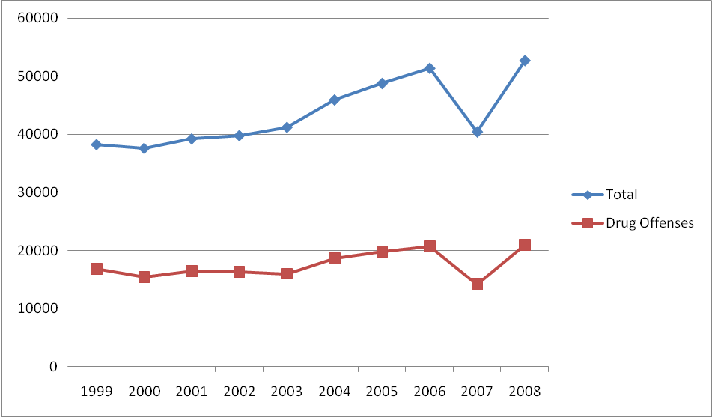
In response to the rapid increasing of HIV infection in heroin abuser, the Department of Health in Taiwan then began to launch “harm reduction” programs with clean needle exchange for heroin addicts in December 2005. Furthermore, some prosecutors in Taiwan started to mandate methadone maintenance treatment for heroin addict probationers in methadone clinics since 2007, instead of incarceration. This transition is some sort similar to the Judicial response during the initiation phase of the first “drug court” in Miami in 1989(James E. Lessenger & Glade F. Roper,2007). This transition could be a preliminary base for future implementation of drug treatment court.
As for parolee of heroin abusers, they will receive interview per month and urine test by parole officers after release into community. Many drug abusers inmates have received treatment programs in prison, but most of them insisted on the over-optimistic belief “I will quit addiction after the huge cost I paid for incarceration “ and refused to continue on medical treatment after being released into community, if without continuous monitoring with proper legal pressure.
There is a preliminary report on comparison of 3 different groups of participants of Methadone maintenance treatment (MMT) for months in Taiwan(Wei Lien-Chung ,2008):
Group1. HIV positive group (government pay treatment fee for them),
Group 2.Voluntary participant group (they pay treatment fee for themselves),
Group 3.Mandatory probationer group (Government use their probation penalty
to pay treatment fee for them)
The percentage of staying in MMT is only 78.9%, 85% in group 1 and 2,as compared to 100% in group 3.This preliminary research findings supported the “mandatory” methadone maintenance treatment for heroin addict probationers in methadone clinics.
For Drunk Drivers
Some hosts would like to show their hospitality to guests with encourage guest to “bottom up” with alcohol drinking in social drinking occasions. Some drunk drivers “insisted” on having capability to drive by themselves, even under influence of alcohol. Even more, some drunk drivers would rather “take their own chances” to drive after drinking, than taking taxi home.Therefore,the law enforcement to stop drunk drivers had been strengthening since April 1999, and penalty was increased in Sep 2002.They may be sentenced to receive fine (NT 15,000 ~60,000), suspension of driving license (1 year), and being charged with “against public safety” by “Criminal Code”, if Breath Alcohol Concentration was over 0.55mg/L or Blood Alcohol Concentration was over 0.11 % ). Most of them were not mandated to receive treatment for addiction of alcohol. Some prosecutors started to mandate alcoholism treatment for drunk-driving probationers in Taiwan. This transition could also be a preliminary base for future implementation of DUI(Driving-under-influence) drug court system in Taiwan.
- In USA
For Narcotic Addicts
The first phase of drug abuse occurred from 1885 to 1925 in United States. It’s estimated by public health officials that about 250,000 Americans were addicted to opiates, and 200,000 Americans were addicted to cocaine(James E. Lessenger & Glade F. Roper,2007). So the Congress passed the Harrison Narcotics Act in 1914,and President Taft started this effort “ a War on Drugs” (James E. Lessenger & Glade F. Roper, 2007). Even with efforts on “a War on Drugs”, by 1925, heroin had become illegal and half of the prisoners in the federal penitentiary at Leavenworth were narcotics law violators(717 of 1,482). (James E. Lessenger & Glade F. Roper, 2007).
The second phase of drug abuse occurred between 1950 to 1970 in United States. The drug use continued to grow, and experimentation in treatments also expanded. The methadone treatment for heroin addicts showed promise in some researchers. As hippie movement waned in late 1960s, the abuse of psychedelic drugs declined (James E. Lessenger & Glade F. Roper, 2007).
The third phase of drug abuse occurred around 1980s with abuse of cocaine as a fashionable recreational drug and methamphetamine abuse in United States. Legislation again increased harsh mandatory minimum sentences for addicts, although new diagnostic techniques had demonstrated that addicted brains have different physical characteristics from unaddicted brains and addiction can be regarded as a disease or disorder (James E. Lessenger & Glade F. Roper, 2007).
It is unacceptable for a Judge to sentence repeat offenders to a year in custody, and to have these offenders rearrested on new charge only a few weeks after being released(James E. Lessenger & Glade F. Roper,2007).Judges and prosecutors in Florida started to combine the coercive power of the criminal justice system with rehabilitation treatment ,instead of abandoning the value of the criminal court system in interdicting drug use .Then the first “drug court” was established in Miami in 1989 (James E. Lessenger & Glade F. Roper,2007).Since then on, the “drug courts” have gained wide acceptance and diverse development with drug courts ,DUI (Driving-under-influence) courts ,family drug courts ,juvenile drug courts , and etc. in USA and some other countries. Drug treatment court/ DUI drug court programs have given drug/ alcohol offenders a chance to receive treatment rather than incarceration.
For Drunk Drivers
DUI (Driving-under-influence) courts were developed later on for convicted drinking drivers. DUI courts are making offenders accountable for their actions in a fair and just way, thus bringing about a behavioral change that ends DUI recidivism, stopping the abuse of alcohol and protecting the public(California Courts website,2009).
What are Drug Courts / DUI Courts?
Drug treatment courts were developed in Florida in the early 1990s as an alternative to traditional criminal justice prosecution for drug-related offenses (California Courts website,2009). There are over 2,000 drug courts in existence or being planned in USA now, and there are also some other countries have implemented drug court systems, such as United Kingdom, Australia, Canada. These Drug Court / DUI Courts combine the close supervision of the judicial process with resources available through alcohol and drug treatment services (California Courts website,2009). These Drug Court / DUI Courts provide a platform for linking supervision and treatment with ongoing judicial oversight and team management(California Courts website,2009).The majority of drug courts include initial intensive treatment services with ongoing monitoring and continuing rehabilitation programs for a year or more(California Courts website,2009
The two goals of these Drug Court programs are to reduce recidivism of drug-related offenses and to create options within the criminal justice system that tailor effective and appropriate responses for offenders with drug problems (California Courts website,2009). These courts cooperated and modified traditional treatment-delivery systems, and have designed more effective interventions for this population(California Courts website,2009).
Here is a vivid and straightforward statement about drug courts made by General Barry McCaffrey, former Director of the Office of U.S. National Drug Control Policy -- "If you don't like paying for jails, if you don't like a waste of tax dollars, then you'll like the concept of drug courts. This is an initiative that's been working."
Drug Court / DUI Court Guidelines (California Courts website,2009).
The nationally accepted guidelines from the National Association of Drug Court Professionals (NADCP) include the following statement: “ 10 Key Components”
- Drug courts integrate alcohol and other drug-treatment services with justice system processing.
- Using a non-adversarial approach, prosecution and defense counsel promote public safety while protecting participants' due process rights.
- Eligible participants are identified early and promptly placed in the drug court program.
- Drug courts provide access to a continuum of alcohol, drug, and other related treatment and rehabilitation services.
- Abstinence and use of alcohol and other drugs are monitored by frequent drug testing.
- A coordinated strategy governs drug court responses to participants' compliance.
- Ongoing judicial interaction with each drug court participant is essential.
- Monitoring and evaluation measure the achievement of program goals and gauge effectiveness.
- Effective drug court operations require continuing interdisciplinary education.
- Forging partnerships among drug courts, public agencies, and community-based organizations increases the availability of treatment services, enhances drug court effectiveness, and generates local support
Drug /DUI courts Do Better to reduce Recidivism Rate than Traditional Courts
There are several studies about comparison of recidivism rate between traditional courts and drug/DUI courts, and the data supported that drug/DUI courts are more effective approaches to reduce recidivism rate of drug/alcohol addicts (Table 2).
Table 2.Recidivism Rate: Traditional Court vs. Drug Courts 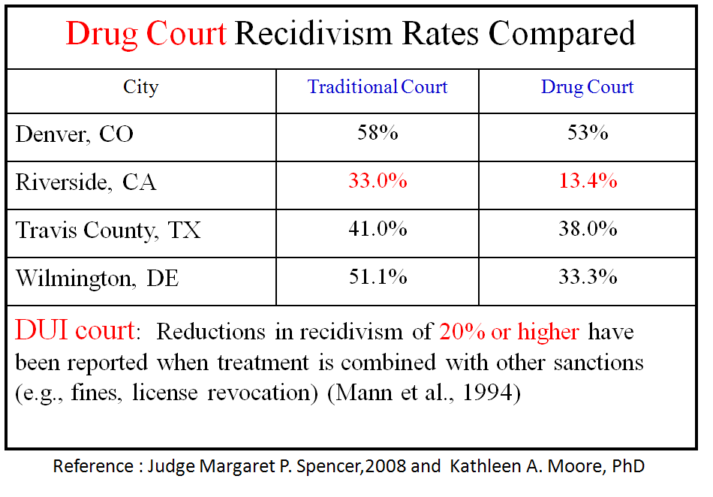
Traditional Courts Are Not as Cost Effective as Drug Court/DUI court
Furthermore, there are several recent studies showed that drug/DUI courts are also cost-effective (Table 3).

Table 3.Cost Analysis
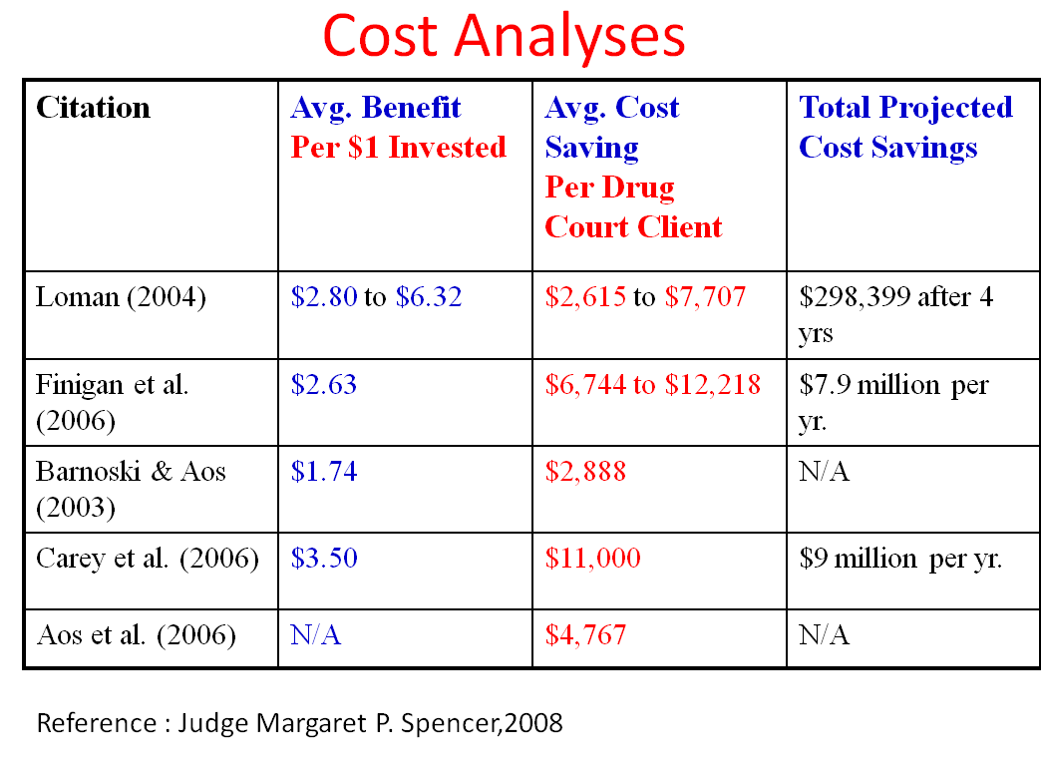

Drug Court / DUI Courts Studies
In 2001, Columbia University's National Center on Addiction and Substance Abuse (CASA) concluded an updated study of its seminal 1998 review of drug court research and evaluations. It finds that drug courts continue to provide the most comprehensive and effective control of the drug-using offenders' criminality and drug usage while under the court's jurisdiction.
After reviewing the progress of drug courts in recent two decades, researches supported that drug courts may reduce recidivism and promote other positive outcomes. Programs are influenced by a variety of factors that may be external (e.g., trends in drug use), internal (e.g., staff turnover), or policy-related (e.g., diversion versus post-disposition) (National Institute of Justice (NIJ) Special Report-- Drug Courts: The Second Decade, June 2006). However, research has not defined which court processes affect which outcomes and for what types of drug related crime offenders (NIJ Special Report-- Drug Courts: The Second Decade, June 2006).The offenders reported that “interactions with the judge are one of the most important influences on the experience they have while in the program “(NIJ Special Report-- Drug Courts: The Second Decade, June 2006). The offenders respond to the judge’s interpersonal skills and ability to resolve legal problems expeditiously and provide ready access to services. Furthermore, offenders who interact with a single drug court judge, rather than multiple judges, may be more likely to comply with program demands (NIJ Special Report-- Drug Courts: The Second Decade, June 2006).
Problems to deal with
Have we ever successfully surpassed the trend of drug/alcohol abuse problem with only laws in recent decades? These drug abuse / alcohol abuse problems can’t only be regarded as only judicial but also important public health and public safety issues. These problems are gaining more attention because of crimes, rapid increase of AIDS cases in heroin addicts and increase of casualty in drunk driving.
It’s well known that drug use increases the likelihood of criminal behaviors. Offender drug use is involved in more than half of all violent crimes, in 60-80 percent of child abuse and neglect cases, and in 75 percent of drug dealing and manufacturing cases(Nora D. Volkow, NIDA website ,2006). Moreover, illicit drug use costs USA about $180 billion a year in crime, productivity loss, health care, incarceration, and drug enforcement. (Nora D. Volkow, NIDA website ,2006).It’s estimated that two-thirds of all adult arrestees and over half of juvenile arrestees test positive for illicit drugs at arrest (NADCP website,2009).Furthermore, the recidivism rate is very high after their release from prison, it’s between 60% and 80% of drug abusers commit a new crime (typically a drug-related crime); even more, 85% to 95% of drug abusers relapse quickly to drug abuse (NADCP 2009 drug court in brief ,2009).
Gil Kerlikowske, the new Director of ONDCP(Office of National Drug Control Policy), said that “The Obama Administration understands addiction is a disease, and its treatment needs to be addressed as part of a comprehensive strategy to stop drug use” on the testimony held on May 19,2009. Over 20 million individuals aged 12 and older were diagnosed with substance dependence or abuse in USA in 2007(Gil Kerlikowske, May 2009). Drug addiction treatment is as effective as is treatment for most other similarly chronic medical conditions such as diabetes, hypertension (Gil Kerlikowske, May 2009). However, less than 10% received treatment for their disorder in USA (2007 National Survey on Drug Use and Health, 2008).
Recommendations
Transition of Recommendations “Step By Step”
- More than Status Quo
The first policy option is “more than Status Quo”-- to strengthen coordination between judicial and medical systems in Taiwan, in order to improve the drug/alcohol abuse situations. According to the current concept of “addiction is not a crime but a disease itself“, the judicial system may step further to coordinate with medical systems to help abusers , since that most abusers have fluctuating and not persistent motivation to keep abstinence. Some prosecutors in Taiwan mandate methadone maintenance treatment for heroin addict probationers in methadone clinics, instead of incarceration. We may encourage “voluntary” self-payment treatment with “conditional probation” for violators from drug offenses and drunk drivers. Furthermore, the public education for drug/alcohol addiction issues is essential to improve the support from the public.
- More methadone maintenance therapy/AA group counseling
The second policy option is to improve recent actions adopted by some prosecutors to mandate the drug/alcohol abusers to receive methadone maintenance therapy/AA group counseling, with the concept of addiction and harm reduction in Taiwan. There are some monitoring methods to enforce the process of methadone maintenance therapy. This could be implemented before completing the legislation of drug treatment court system.
- Increase the Penalty for drunk drivers
The third policy option is to enforce the penalty for drunk drivers in Taiwan, they are not only sentenced to receive higher fine(NT 30,000~100,000) , suspension of driving license (one year for first timer, and life-long suspension for second violators) , and drunk drivers might considered be mandated to receive treatment for addiction of alcohol as a “conditional probation”( even for first timer).Although it takes time to go through the legislation process, this could be implemented before completing the legislation of DUI(Driving-under-influence) drug court .
- Drug treatment courts/DUI courts
The fourth policy option is to formulate and implement the drug treatment court /DUI(Driving-under-influence) drug court ,through the process of educating the public about these two new systems in Taiwan, process of administrative coordination between judicial and medical systems , legislation process, and then implementation process , monitoring process ,.and further adjustment process to maturity ,etc .These process might take 10 to 20 years as it occurred in United States, even with the help of drug treatment court /DUI drug court professionals (e.g. from NIDA,NIAAA, NADCP & NDCI ). With comprehensive comparison of two decades experience of drug/DUI courts in USA , we may seriously consider the Drug/DUI courts as a cost- effective alternative to control for the rapidly increasing number of drug abusers and drunk driving in Taiwan.
The Ministry of Justice had noticed “Drug courts” issues while there were some professionals visiting Australia and Hong Kong for “ harm reduction” issues in September 2008.In the beginning, we may start to advocate the Drug/DUI courts in Department of Health and Ministry of Justice. Some Judges may take the lead to start the Drug court/DUI court field experiment in Taiwan, with funding from Ministry of Justice and empirical support form USA. Some psychiatric centers with excellent experiences in treating addicts may join the treatment team to collaborate with Judge, attorney, prosecutors, and probation officers. Then, we may find proper ways to integrate Drug treatment courts/DUI courts into judicial system and medical system in Taiwan.
- Possible Programs for Parolee
The fifth policy option is to have reentry drug courts for parolee. The offenders reported that “interactions with the judge are one of the most important influences on the experience they have while in the program “(NIJ Special Report-- Drug Courts: The Second Decade, June 2006). There are only now near 20 federal reentry drug courts for parolee with split sentence to recruit some parolee into rehabilitation program in USA(conference discussion with Dr. Douglas Marlowe and Dr. David Festinger, in Treatment Research Institute(TRI), on June 2 ,2009).Most parolee are monitored by parole officers ,not the Judge with treatment team. We may consider to have parole officers work with Judge and treatment team in Taiwan, to recruit more parolee with higher motivation under “conditional parole with mandated drug/alcohol treatment “ .There is some experimental research for heroin addict inmates to start methadone treatment as early as 6 months “before release” from prison, for the relapse rate is high in the first few weeks after release and the need of gradual titration of methadone dosage up to more than 80mg /day if necessary(conference discussion with Dr. Frederick L. Altice in Yale University School of Medicine, on June 2 ,2009).The Naltrexone long- acting depot is also one treatment modality for heroin addicts or repeat drunk-drivers with conditional parole.
Recommendations by Stages in Summary
In summary, we recommend transitions from more than status quo to Drug/DUI courts at different stages in Taiwan.
- Short term (1-2 years) :We recommend on-job training for Judges about the updating experiences of Drug/DUI courts from USA and other countries. It starts from “more than Status Quo”-to Improve coordination between judicial and medical systems, prepare for drug treatment court /DUI drug court(e.g. public education, advocacy, legislation ,etc.)
- Mid Term (3-5 years) :
- To improve harm reduction policy Implementation.
2. Conditional probation with mandated treatment for heroin addicts /drunk
-driving violators.
3. Conditional parole with mandated treatment for heroin addicts /drunk
-driving inmates.
- Long term (6-10 years and after): Implementation of drug treatment court /DUI drug court with continuous on job training, evaluation and updating.
Discussion and Conclusion
What are effective means to help drug/alcohol abusers in Taiwan? Beside the existing traditional court, the drug treatment court/ DUI(Driving-under-influence) drug court might be one of those cost-effective means, which are worthy to be implemented in Taiwan in the near future.
Future Researches
Drug courts have gained wide acceptance in recent 2 decades since 1989, even at the national and international level .Those Drug treatment court /DUI drug court Programs may be influenced by a variety of factors that may be external (e.g., trends in drug use), internal (e.g., staff turnover), or policy-related (e.g., diversion versus post-disposition) ; and research has not yet defined which court processes affect which outcomes and for what types of drug related crime offenders in USA (NIJ Special Report-- Drug Courts: The Second Decade, June 2006).
No single policy works for every country. In order to improve the implementation process and to define which court processes affect which outcomes in Taiwan, we may consider to incorporate researches with implementation process and to have “randomly assignment” for research groups with similar demographic characteristics in different treatment modalities(conference discussion with Dr. Betty Tai and Dr. Akiva M. Liberman, NIDA on May 27,2009). The Law systems are different between Taiwan and USA , even though most drug/DUI courts don’t need much new law enforcement in USA(conference discussion with Dr. Betty Tai and Dr. Akiva M. Liberman, NIDA on May 27,2009), it’s better to have drug/DUI courts related laws ready via legislation process before implementation in Taiwan.
“Revising” Programs for some Probationers
The Judge is the leader of Drug treatment court /DUI drug court Programs. After detailed assessment of participants, individualized and updated treatment plan was established after discussion of all case-related information (e.g urine test result and attendance in treatment) in team meeting. It is essential to have frequent scheduled team meeting (per 4-6 weeks, and even per 2 weeks for some “ high risk cases” with antisocial personality disorder or Hx of previous failure of treatment program) with summarized case progress and urine test reports from treatment providers and case manager with vital discussion and consensus among treatment team members before drug/DUI courts court(conference discussion with Dr. Douglas Marlowe and Dr. David Festinger, in Treatment Research Institute(TRI), on June 2 ,2009) .The “supportive interaction” between Judge/treatment team members and participants in supervision hearing of Drug treatment court /DUI drug court, with proper reward / punishment options and ongoing monitoring by treatment team , may be influenced by a variety of factors (e.g., participants’ motivation, staff’s experience) (observation from Philadelphia Treatment Court, discussion with Dr. David Festinger, in TRI , on June 3 ,2009)..
Conclusion
In summary, we recommend “smooth transitions” step by step from “ more than status quo” to “Drug/DUI courts “, from short-term to long-term , at different stages in Taiwan. We want to make changes, of course, better changes.

References
Betty Tai and Akiva M. Liberman, conference discussion in NIDA on May 27, 2009
Bureau of Justice Assistance , Office of Justice Programs, U.S. Department of Justice(reprint in 2004); Drug Courts Resource Series; Defining the Drug Courts: The Key Components; retrieved on May 12, 2009 from http://www.ncjrs.gov/pdffiles1/bja/205621.pdf
California Courts: What is a Drug Court? retrieved on May 12, 2008 from
http://www.courtinfo.ca.gov/programs/collab/drug.htm.
Douglas Marlowe and David Festinger, conference discussion in Treatment Research Institute(TRI), Washington DC, on June 2 ,2009
Frederick L. Altice ,M.D. ,conference discussion , on June 2 ,2009
Gil Kerlikowske(May 2009). Testimony of Gil Kerlikowske, Director of ONDCP(Office of National Drug Control Policy) on May 19,2009 ; retrieved on May 22, 2009 from http://www.whitehousedrugpolicy.gov/news/testimony09/051909_dpc_subcommittee.pdf
James E. Lessenger & Glade F. Roper(2007).Drug Courts: A New Approach to Treatment and Rehabilitation.
Jonnes J. Hep-Cats,Narcs and Pipe Dreams: A history of America’s Romance With Illegal Drugs.New York:Scribner;1996.
Ministry of Justice, Taiwan, R.O.C. retrieved on May 22, 2009 from http://www.moj.gov.tw/mp001.html
NADCP 2009 drug court in brief , retrieved on May 12, 2009 from
http://www.nadcp.org/NADCP_Drug_Court_Brief.pdf
National Institute on Drug Abuse (NIDA).retrieved on May 15, 2009 from http://www.nida.nih.gov/about/aboutnida.html
National Institute of Justice(NIJ), Office of Justice Programs, U.S. Department of Justice(June 2006);Special Report-- Drug Courts: The Second Decade
retrieved May 12, 2009 from http://www.ncjrs.gov/pdffiles1/nij/211081.pdf
National Police Agency, Ministry of Interior, Taiwan, R.O.C. retrieved on May 22, 2009 from http://www.npa.gov.tw/NPAGip/wSite/np?ctNode=11358
Results from the 2007 National Survey on Drug Use and Health: National Findings, Substance Abuse and Mental Health Services Administration (SAMHSA), 2008, retrieved on May 22, 2009 from http://www.oas.samhsa.gov/nsduhLatest.htm
Steven Belenko(2001), Integrating Research into Drug Courts, in meeting on May 30, 2001,New Orleans, LA ; retrieved May 12, 2008 from http://www.drugabuse.gov/MeetSum/DrugCourts.html
Wei Lien-Chung (2008),Poster: Prediction analysis of Patient Adherence to Methadone Maintenance Treatment, retrieved on April 27, 2008 from http://www.typc.doh.gov.tw/public/gpi/42d85c022ae855b89517978aa64abcb3.pdf
Yi-Ping Zeng(2008),Comments on Drunk Driving, Newsletter of Chinese Institute of Transportation ,Issue No.79,p3-5; retrieved on May 24, 2009 from
http://www.cit.org.tw/publish/%E9%81%8B%E8%BC%B8%E4%BA%BA%E9%80%9A%E8%A8%8A%E7%AC%AC79%E6%9C%9F.pdf

