出國報告（出國類別：進修）

2009「人為因素分析
及分類系統HFACS」專業訓練

服務機關：行政院飛航安全委員會
姓名職稱：工程師／劉震苑
工程師／鄭永安
副工程師／楊啟良
派赴國家：美國亞特蘭大
出國期間：民國98年3月15日至3月21日
報告日期：民國98年6月19日
目 次
- 目的
- 過程
2.1 人為因素與航空事故
2.2 人為因素分析及分類方法之發展（HFACS）
2.3 人為因素分析及分類系統
2.4 HFACS使用須知
2.5 人為因素改善策略之發展
2.6 HFACS於正向因素分析/分類之應用
- 心得
- 建議事項

- 目的
1.1 前言
人為因素已是所有需要高安全標準之產業（如：航空產業、核能電廠、化學工廠等）十分重視之要素，亦是安全管理系統（Safety Management System）所需涵蓋之議題之一。
然而，就產業界而言，人為因素仍停留在所謂的「知識」層級，尚未進入「應用」層級，例如：一個組織可給予其員工人為因素相關的知識（如：疲勞、睡眠管理、壓力管理、組織文化等），但卻難以具體地將其融入組織運作程序中，亦難以評估其成效或缺失。
組織在評估其人為因素計畫之需求時，亦缺乏適當之資料及方法以了解組織本身真正的需求，而僅能採用一般通用之人為因素計畫，且計畫執行後，亦難評估其成效。
本次出國訓練之課程目的，即提供一人為因素分析及分類方法，以有系統地蒐集人為因素相關資料，並有效地予以分析整理，以期找出人為疏失方面之重點改善項目；另外該課程亦提供學員運用該方法進行實際分類演練，期許能將理論與實務相互結合，使得人為疏失之改善更有效能，以進一步降低事故率。

1.2 講師介紹
  - Scott A. Shappell
該講師擁有神經科學（Neuroscience）之博士學位，目前為美國Clemson University工業工程學系終身職教授。
該講師過去長期於美國海軍航空部隊擔任有關人為因素及失事預防之專業人員，以及美國聯邦航空總署（US Federal Aviation Administration, FAA）民航研究機構（Civil Aerospace Institute）人為因素研究部門之主管，亦曾發表過50篇以上有關民航失事調查、空間迷向（spatial disorientation）、駕駛艙傷害（flight deck injuries）及飛航組員疲勞（aircrew fatigue）等之學術論文。
  - Douglas A. Wiegmann
該講師擁有實驗心理學（Experimental Psychology）之博士學位，目前於威斯康辛大學(University of Wisconsin )工業及系統工程學院之人為因素系擔任副教授。
該講師過去曾在美國海軍航空部隊擔任航空心理學研究人員，亦曾於美國國家運輸安全委員會（National Transportation Safety Board, NTSB）擔任調查員。另外，也曾因其在飛航安全（flight safety）、人為疏失（human error）及失事預防（accident prevention）等領域之成就而多次獲獎。

- 過程
2.1 人為因素與航空事故
縱使過去數十年，航空工業經歷了改革及進步期，但在人們心中仍留有一個疑問？那就是”飛機爲什麼會失事？”，早期人們可以很合理的說是飛機製造的不安全、飛機害死了飛行員，現在則出現了”飛航組員致命風險高過他們所駕駛的飛機”此一說法，依據文獻資料顯示，評估有70%-80%的飛航事故歸因於人為疏失，而人為疏失又完全歸因於飛航組員疏失，就若醫生在未經檢查確認病因前，即宣告病人罹病是一樣的。此外，多數的人將人為疏失與飛行員疏失畫上等號，所以在飛航事故調查上常是僅指出飛行員疏失，這種調查結論相當的粗糙與簡單，因此，確立事故絕非單一原因或唯一個體的觀念是很重要的。
事實上，飛航事故調查在確認主要肇因與相關的發現，而飛航組員僅是事故結果中最後一位產生不安全行為的人，對調查人員來說要如何確認事故肇因，特別是分析70%-80%與人為疏失有所關聯，是一項挑戰，因此，調查員在選擇事故原因調查的方法是很重要的，尤其是在人為疏失的確認與分析上需要專業與理論的協助，有鑒於此，這些基礎需求、安全資料導向等相關的理論架構相繼的被發展。
2.1.1 人為疏失架構介紹
在確認需求後，有關事故調查與預防之人為疏失的架構慢慢開始發展，有一些是新的研究也有是旣有的架構。
- 認知型 (Cognitive)：
想像人腦是一台訊息處理系統或電腦，當人體感覺器官由環境中接收到訊息，經由腦部的解釋並由個體作出反應行動。當疏失產生時，我們的目的即是去發現和了解哪一部份的訊息處理發生了錯誤。此方法係以類似電腦之思考方式，以每次2選1之排除法，找出更深層之人為疏失發生的原因(如圖1)。一般我們常見之錯誤樹(Fault Tree)可視為此方法之延伸。其優、缺點如下：
優點：
- 較一般簡單的分類法找出人為疏失更根本之發生原因；
- 可依據類似認知錯誤架構，分析某些表面上似乎不相關之疏失；
- 確認具體疏失之趨勢變化，有利於改善及減低疏失策略之發展。
缺點：
- 應用上，須訂定完整之分析程序，以提高分析及失事調查時之實用性；
- 未考量任務或背景等相關因素(如裝備設計等)、操作者之身體狀況(如疲勞)或督導及其他組織因素等影響操作者表現之變數；
- 通常僅將事故原因歸咎於個人的疏失。
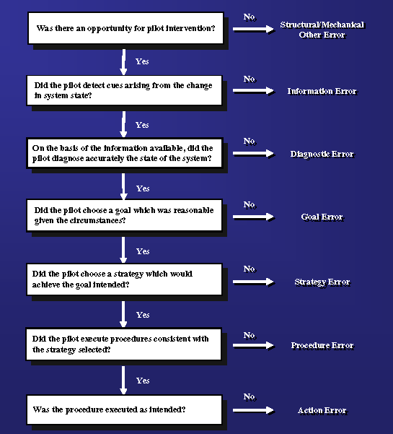
圖1認知型(Cognitive)之人為錯誤分類架構
2. 人因工程型 (Ergonomics)：
想像人是系統的一部份，而系統的每個部份都須與其他零件有效的互動，當疏失產生時，會以系統失效為討論重點，而非歸咎為個人。人因工程型如圖2所示，係以犯錯者為中心，評估系統中其他變數(如：環境、硬體、軟體、其他人員等)對該項人為疏失之影響。我們所熟悉的SHELL模式及魚骨圖即屬此類之分類架構。
優點：
- 考量影響操作者表現之任務或背景等相關變數，包括裝備設計；
- 可獲得一種多元化疏失預防的方法，包括設計疏失容忍力高的系統；
- 人因工程型之概念尤其對於未曾接受專業之航空心理或人為因素的人來說，較易理解及認同。
缺點：
- 當應用於分析人這個系統時，仍缺乏成熟的技術；
- 認知、社交、及組織因素之深度不足，容易使人覺得這些因素並不是很重要；
- 給人一種所有的錯誤皆是設計不良所造成。
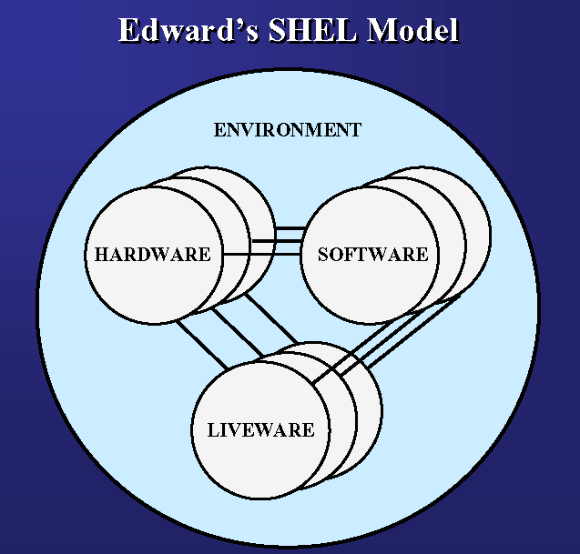
圖2人因工程型(Ergonomics)之人為疏失分類架構
3. 行為學 (Behavioral)：
行為往往是經由獎勵與處罰刺激而產生的，疏失常因不當的刺激而導致的不安全行為。行為學如圖3所示，係著重於人，強調個人執行某項任務之動機、對所獲獎勵(包含有形及無形)之滿意度及個人能力與工作經驗對其行為之影響。
優點：
- 此模式強調動機(motivation)與獎勵(reward)在影響個人表現安全行為上扮演重要的角色；
- 該模式指出，當個人缺乏動機去執行安全任務時，或在某些情況下會鼓勵不安全之作為時，此時較易發生事故；
- 近年來有較多的安全計畫是依據行為學之理論而制定的，以獎勵之方式激勵安全行為，並以規定強制員工要為其不安全的行為負責。
缺點：
- 不安全之行為往往造成致命的後果，因此很難讓人相信有人會沒有執行安全行為之動機；
- 很難想像有些行為或無心之過(inadvertent errors)會跟動機因素(motivational)聯結在一起；
- 有必要去釐清不安全之行為(Unsafe acts)是有意(motivation-driven)的行為(如違規)或是真實認知的錯誤；
- 在發展降低不安全行為及改善飛安預防措施時，釐清動機是很重要的議題。

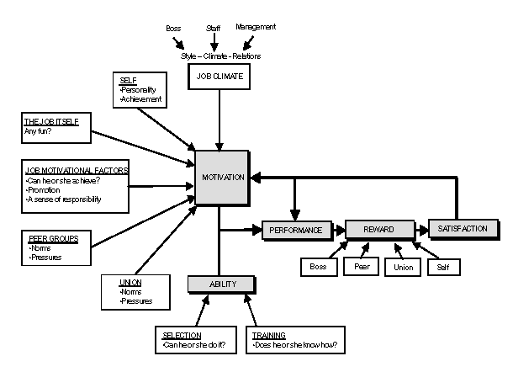
圖3 行為學(Behavioral)之人為疏失分類架構
4. 生理學 (Physiological)：
個體的生理特性常會影響在高風險系統中的表現，當疏失發生時，我們需要檢查操作者的生理狀況，而不只是檢視工作的環境或設計因素。
優點：
- 生理學強調個體的生理狀況在安全行為的表現上扮演著重要的角色；
- 生理學/航空醫學對於提升軍方及民間對於疲勞之重視，扮演極重要之角色；
- 此方法可以協助制定許多具爭議性的政策，如排班、輪班及組員休息時間等規定。
缺點：
- 在民航中，有許多生理因素看來似乎與飛航安全無關聯；
- 一般人欠缺生理因素在失事事件中具何等影響力的概念；例如飛行員的疲勞、服用成藥或迷向須達到多大的程度，才會犯下致命的飛安疏失？
- 要辨識出存在的生理因素和確定這些因素是否會導致疏失/意外事件發生，是非常困難的。
5. 社會心理學 (Psychosocial)：
人類少見獨自執行任務的，大多數的活動都是個體與團隊間溝通與互動之模式，當疏失發生時，他們必須了解社會心理系統的內涵與處置之道。社會心理型如圖4所式，係以犯錯者為核心，探討其作業過程中及其他作業人員對其造成的影響。
優點：
- 強調人際關係對人員表現的影響，也是長期以來被忽略的部份；
- 越來越多航空心理學家在檢視人類疏失時，會將社會心理方面之因素納入評估；
- 組員資源管理訓練(Crew Resource Management, CRM)及組員配對程序(crew-pairing procedure)即依此學派之概念所發展出來之訓練科目與程序，目的係為透過改進駕艙中組員之溝通與協調，降低人為疏失之發生。
缺點：
- 有關社會心理學之人為疏失模式，其實證研究仍嫌不足；
- 目前組員資源管理訓練之定義係為：駕艙組員有效的利用所有可用的資源，包括人力資源、硬體設備及資訊等；
- 若依此廣義之定義容易給人一種錯誤的認知，即「人為疏失造成之失事，若非因CRM之失效所造成，就可能是組員受到壓力或其他妨礙行為所造成」。
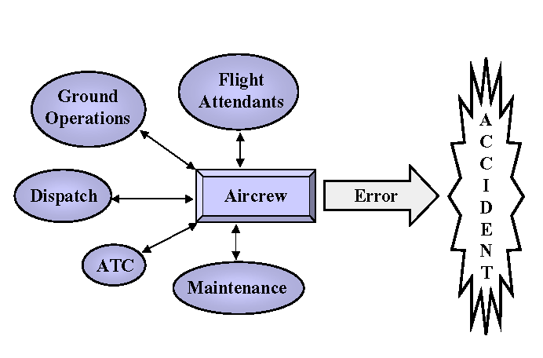
圖4 社會心理型（Psychosocial）之人為疏失分類架構
6. 組織型 (Organizational)：
個體於組織設定的範圍內運作(如規則、章程)，組織有責任確保其對操作之要求是適切的以及讓員工能擁有使其完成作業所需的資源。組織型如圖5所示，係探討組織對第一線人員之影響。
優點：
- 組織型的其中一項優點為，研究及預防人為疏失時，是以一種更廣闊的視野去瞭解問題。；
- 因此，所有先前提到有關產業及組織心理學之知識都可以與操作者疏失及事故預防之議題相連結；
  - 另一項優點為，它將所有的人為疏失都視為風險管理所需考慮的要素之一。
缺點：
- 組織肇因導致操作者犯錯，而這些因素往往都有多次的機會可以完全地或暫時地從環境中(如駕艙中)移除；
- 另外，我們並不清楚組織型態與駕艙中疏失類型間的關係；
- 組織傾向於將事故的發生歸咎於單一類型之肇因。
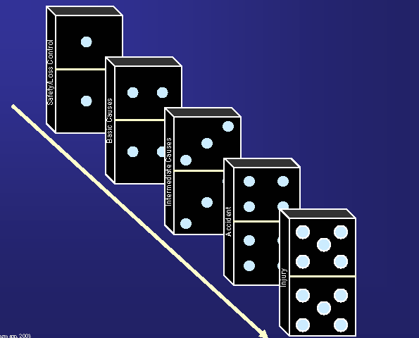
圖5 組織(Organizational)之人為疏失分類架構
2.2 人為因素分析及分類系統(HFACS)之發展
2.2.1 整合模式之概念
如前所描述，人為疏失分類方法之架構皆有其優缺點，因此，Scott A. Shappell及Douglas A. Wiegmann兩位教授嘗試發展出一綜合型之模式，以期能融合各學派之特性(如圖6)，並能廣為學術界與實務界運用之模式。
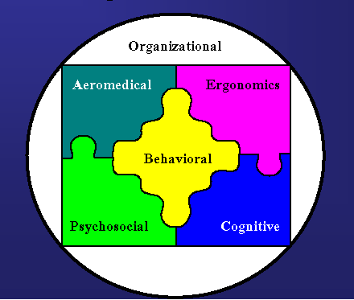
圖6 整合型模式之發展概念示意圖
2.2.2 Reason之事故肇因模式
James Reason於1990年提出人為疏失的事故肇因模式，又稱為”起司模式(Swiss Cheese Model)”，此模型描述人為疏失的四個層級(Unsafe Acts, Preconditions for Unsafe Acts, Unsafe Supervision and Organizational Factors)，上層級影響著下一層級。
1.第一層(Unsafe Acts)
回溯事故發生前的工作，第一層是描述操作者的不安全行為導致事故的發生，於航空領域此層級通常為飛航組員/駕駛員疏失，也是事故調查最關注的重點。畢竟，飛航組員行動是直接與事故連結，例如在儀器飛行的天氣條件下，飛航組員未作適當審視，而當成目視天氣條件時，可能會產生立即或潛在的風險，就如同起司上的洞，而這些行為也就是飛航組員典型所犯下最後不安全的行為。然而，為什麼起司模式用在事故調查上的幫助非常大？原因是此方法可協助調查員找出與事故肇因相關聯的潛在錯誤。
2.第二層(Preconditions for Unsafe Acts)
此層涉及飛航組員之各種狀況也影響其表現，包括精神疲勞、溝通不良以及工作上的協調，通常稱之為組員資源管理(CRM)，對於疲勞的飛航組員來說，產生溝通不良、無法與駕艙內的組員或機外的人員(如航管、機務等)協調及作出錯誤的決定等行為是不值得驚訝的。
3.第三層(Unsafe Supervision)
例如兩位較欠缺經驗(經驗或許在平均水準以下)的飛行員搭配飛行，且在一不利天氣的夜間執勤，悲劇的產生有誰會驚訝？更糟的是，若是兩位飛行員欠缺好的CRM訓練，則潛在的溝通問題以及組員的疏失將會更加嚴重。
4.第四層(Organizational Factors)
組織因素能夠影響所有層級的表現，例如組織在財務緊縮期間，經費經常遭刪減，而影響訓練及飛時也削減，因此，督導經常是在無法選擇的情況下指派不熟練的飛行員執行複雜的任務，在沒有好的CRM訓練、不良的溝通與協調下，會開始出現preconditions，這些都會影響到飛航組員的表現並肇致疏失的機會。
在許多方面，”起司模式(Swiss Cheese Model)”的事故肇因經由改革有了共同的觀念，不幸的，此模式只是一個簡單的理論，但卻未被定義清楚，而起司上的孔到底是什麼？它與實務操作的關聯？那些系統錯誤被稱為起司上的孔，在調查期間應該被確認出，最好是在事故發生前就已修正完。
Scott A. Shappell及Douglas A. Wiegmann兩位教授發展其整合型模式時，James Reason於1990年所提出的事故肇因模式（Reason’s Model of Accident Causation，以下簡稱Reason’s Model），又稱為起司模式（Swiss Cheese Model）已是當代最廣為各界所接受及使用之模式（如圖4-2）。
事實上Reason’s Models已能夠融合上述所描述之各學派。舉例來說，使用Reason’s Model時，首先可將航空運輸作業視為一複雜之生產系統(Productive System)；該模式闡述許多事故的發生可追述到高層管理者(如：總經理或航務處長層級)之決策(即模式中的Organizational Factors)，因高層之某些決策(例如：追求準點率)可能會造成現場督導人員(如：總機師層級)不安全之督導行為（即模式中的Unsafe Supervision），此即為組織學派之觀點；而這些不安全之決策及督導所造成的不良影響往往會長期潛伏於組織中，並逐漸形成不安全之作業環境(即模式中的Pre-condiction)，如：不佳之維修設備(此為人因工程學派之觀點)、疲勞(此為航空生理學派之觀點)或組員間不良之溝通(此為社會心理學派之觀點)；所有這些因素都會影響操作者或第一線人員(如：航機駕駛員)處理資訊之能力、決策能力及績效，造成人為疏失之產生(此為認知學派之觀點)，進而可能導致事故。而圖7中每一層級所產生的錯誤都可視為一片起司的洞，當每一層級的洞都被穿過後，即可能會發生失事。
Reason’s Models已能成功地融合各學派的概念，並「描述」人為疏失造成之事故，其肇因間的因果關係。然而，該模式的弱點為：未能清楚地指出及定義每一層級之人為疏失類型，因此，調查員或研究人員不易將該模式作為「分析」的工具。ICAO(1993)之人為因素事故調查手冊(Human-Factors Accident Investigation Manual）中指出，Reason’s Models對於幫助我們瞭解失事的人為肇因有極大的貢獻，然而該手冊卻建議使用SHEL Model作為調查的工具，即因Reason’s Models還只是一個「描述」事故的工具，而非「分析」事故的工作。
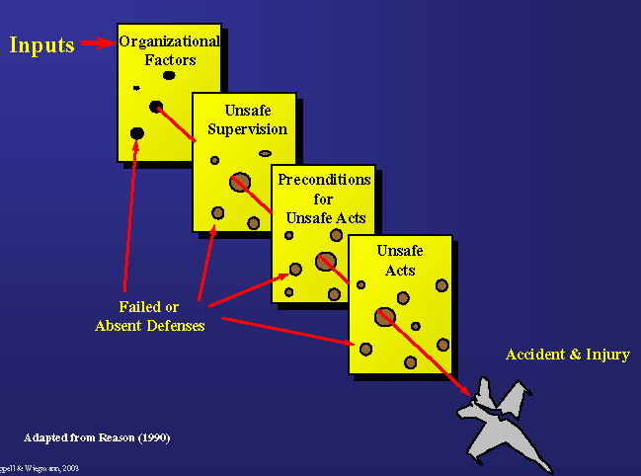
圖7 Reason之事故肇因模式
2.3人為因素分析及分類系統
人為因素分析與歸類系統(Human Factors Analysis and Classification System, 以下簡稱HFACS)係美國學者Scott A. Shappell和Douglas A. Wiegmann於2000年所提出之人為因素調查工具及資料庫分類架構。該模式係以英國學者James Reason於1990年所提出之事故肇因模式 為理論基礎，結合認知心理、人因工程、行為學、航空生理、社會心理學等模式，使用因素分析法分析數百件美國海軍軍用航空器之事故調查報告，共數千筆人為肇因資料所發展出來。
Shappell及Wiegmann將Reason所提出的組織系統中的「顯性失效（Active failures）」與「隱性失效（Latent failures）」，進化為HFACS的四個層級，共19個類別變數，詳如圖8。另外，Shappell及Wiegmann亦發展出HFACS檢查表，在每一類別變數下列有相關之人為因素檢查項目，詳見附錄1。
HFACS中每一較高層級之變數均可能會直接影響到下一層級，即第四層級「組織的影響（Organizational Influences）」中有關組織高層之不當決策，可能會造成第三層級「不安全的督導（Unsafe Supervision）」中督導者不當的規劃，進而形成第二層級「不安全行為的前置狀況（Preconditions for Unsafe Acts）」中不利於第1線作業人員的工作環境，導致第一層級「不安全的行為（Unsafe Supervision）」中第一線作業人員做出不安全的行為或決策，進而發生事故。其中HFACS第一層級即Reason所稱之第一線人員的「顯性失效」，係最容易觀察到的人為錯誤；第二至第四層級係Reason所稱之隱藏在組織系統中之「隱性失效」。
HFACS發表後亦陸續被應用在航空相關領域，多數的研究係使用HFACS對現有之事故資料庫進行統計分析，其中一類型之研究係以HFACS找出某特定類型失事之人為因素特性，例如：Shappell及Wiegmann(2001)針對美國商用航空1990-1996年間之失事、Shappell及Wiegmann(2003)針對1990-1998年美國普通航空業可操控下觸地型(Controlled flight into terrain)事故、Li, W.-C.等(2008)針對我國41件民航飛航事故等；另一類型為比較不同類型失事之人為因素特性，例如：Shappell及Wiegmann(2004)比較北美軍用及民用航空事故、Detwiler, C.等(2006)比較美國阿拉斯加地區與美國其他區域之普通航空業失事；澳洲ATSB(2007)比較美國與澳洲1993至2002年間之民航失事、Shappell等(2007)比較1990至2003年間美國商用航空Part 121及Part 135失事等。
部分研究則是針對HFACS模式本身之信度及不同國家文化背景使用者間之使用差異進行實證研究，例如：Li, W.-C.等(2005)使用我國空軍之失事資料對HFACS進行信度分析、Li, W.C.等(2007)針對不同國家文化背景之航空事故調查員使用HFACS對同一失事分析之結果進行實證研究。
另外HFACS亦被使用於實際事故調查中，例如：2003年北美地區大停電之事故調查。而美國國防部則是將HFACS作為事故調查之輔助工具，並發展出符合其任務需求之人為因素調查工具(DoD HFACS)。
HFACS依Reason’s Model將人為疏失分為四種層級，包括：1. Unsafe Act；2. Preconditions for unsafe act；3. Unsafe Supervision；及4. Organizational Influences。各層級間之關係與概念與Reason’s Model類同。另外，兩位講師已發展出HFACS之檢查表，詳見附錄1。
2.3.1 Unsafe Act
Unsafe Act are those factors that are most closely tied to the mishap (航空器運作中/航空器維修中), and can be described as active failure or actions committed by the operator(第一線操作人員) that result in human error or unsafe situation._DoD HFACS Nanocodes.
不安全的行為係指操作者錯誤的行為或會造成不安全情況之行為 (做對的事但做錯了、做了不該做、該做沒做)，其為事故發生最直接的肇因。
Error
Errors are factors in a mishap when mental or physical activities of the operator fail to achieve their intended outcome as a result of skill-based, perceptual, or judgment and decision making errors leading to an unsafe situation. Errors are unintended _DoD HFACS Nanocodes and FAA HFACS Final Report.
- Skill-based errors
Skill-based behavior is best described as routine activity that occurs without significant conscious thought. When trying to determine whether a particular error is skill-based or some other error type (e.g., decision error), ask yourself whether the individual could carry on a conversation while doing the task in question.
Highly practiced skills are particularly vulnerable to failures of attention and/or memory. In fact, attention failures have been linked to many skill-based errors such as the failure to keep your eyes on the path, task fixation, the inadvertent activation of controls, and the misordering of steps in a procedure, among others. A classic example is an individual who locks himself out of the car or misses his exit because he was either distracted, in a hurry, or daydreaming.
In contrast to attention failures, memory failures often appear as omitted items in a checklist, place losing, or forgotten intentions. Indeed, these are common everyday occurrences for most of us. It is not difficult to imagine that when under the stress or time pressure, critical steps in procedures can be missed. However, even when not particularly stressed, individuals have forgotten to pack their toothbrush or important items of clothing when traveling.
The third, and most common type of skill-based error identified in many investigations involve technique errors. That is to say, regardless of one’s training, experience, or educational background, the manner in which one carries out a specific sequence of actions may vary greatly. For example, two drivers with identical training and experience may differ significantly in the manner in which they drive their car. While one driver may always drive cautiously within the speed limit, others may drive more aggressively (yet still within the law) scaring their passengers and those around them. While both may be safe and equally adept at driving, the techniques they employ could set them (or others) up for an accident depending on the environmental or road conditions. In fact, the way we do things is as much a reflection of innate ability and aptitude as it is an overt expression of one’s own personality, making efforts at the prevention and mitigation of technique errors difficult, at best.
- Decision errors
Decision errors can be grouped into three general categories: procedural errors, poor choices, and problem-solving errors. Procedural decision errors, or rule-based mistakes as some have called them, occur during highly structured tasks/procedures. Indeed, much of what we do on the job is procedural. Even something as simple as getting ready for work is procedural as we decide what to wear, what to pack for lunch, when to leave, etc. Nevertheless, even though many of the decisions are routine, errors can, and often do, occur when a situation is either not recognized or misdiagnosed. This is particularly true when an employee is placed in a situation that requires quick decisions like an emergency or when the boss “wants it now!”
However, not all situations have corresponding procedures to deal with them. Therefore, many situations require a choice to be made among multiple response options. Consider an operator who must chose among a variety of tools or equipment available to perform a job. Based on his experience, he may choose the wrong tool for the job or choose to use the tool for a job that it was not designed for. Likewise, an employee who elects to retrieve a box from the top shelf may chose to get a step ladder and reach it easily or stand on the tip of his toes and stretch for the box, inching it out with his fingertips. While this might work for a box of cereal in a grocery store, when the box weighs 25 lbs it the potential for disaster is obvious.
Confronted with situations such as this, choice decision errors, or knowledge-based mistakes as they are otherwise known, may occur. This is particularly true when there is insufficient experience, time, or other outside pressures that may preclude correct decisions. Put simply, sometimes we chose well, and sometimes we don’t.
Finally, there are occasions when a problem is not well understood, and formal procedures and response options are not available. It is during these ill-defined situations that the invention of a novel solution is required. In a sense, employees find themselves where they have not been before, and may be forced to make a “best guess.” When placed in this situation, they must resort to slow and effortful reasoning processes where time is a luxury rarely afforded. Not surprisingly, while this type of decision-making is uncommon, the relative proportion of errors committed is markedly higher.
- Perceptual errors
Not unexpectedly, when one’s awareness of the world differs from reality, errors can, and often do, occur. Typically, these “perceptual” errors occur when sensory input is degraded or “unusual,” as is the case with visual illusions or when operators simply misjudge the height or distance between themselves and other objects. Visual illusions, for example, occur when the brain tries to “fill in the gaps” with what it feels belongs in a visually impoverished environment, like that seen at night or in the rain. The unsuspecting individual is often left to make a decision that is based on faulty information, and the potential for committing an error is elevated. It is important to note, however, that it is not the visual illusion that is classified as a perceptual error. Rather, it is the operator’s erroneous response to the illusion.
Likewise we all have been guilty of misjudging our speed, height, distance, etc. when going about our everyday life. For example, if not for the speedometer on your car do you really know how fast you are going? In fact, any police officer will tell you that the most motorists will say as they are writing out the speeding citation, “I didn’t realize I was going that fast.” Or when parking your car, how many times have you hit the curb, bumped a pole, or tapped the car next to you with your door as you got out? Employees are not immune from such everyday misjudgments just because they are getting paid or the consequences are much more severe.
Violation
Refer to the willful disregard for the rules and regulations that govern the safety of flight. Violation._FAA HFACS Final Report
Are factors in a mishap when the actions of operator represent willful disregard for rules and instructions and lead to an unsafe situation. Violation are deliberate. _DoD HFACS Nanocodes
Violation之定義為：The willful disregard for the rules and regulations that govern the safety of flight. Violation可細分為兩種類型：
- Routine
By definition, errors occur within the rules and regulations promulgated by an organization. In contrast, violations represent the willful disregard for the rules and regulations that govern safe operations. The key word here is “willful.” In other words, the individual must know the rules and have intentionally ignored them for whatever reason. From a safety perspective (not legal perspective), ignorance of the rules and regulations changes the unsafe act from a willful violation to a knowledge-based decision error. This distinction is often difficult for investigators to accept; but, keep in mind that violations in this sense represent the willful disregard for the rules which implies knowledge.
There are two types of violations. The first, routine violations, tend to be habitual by nature and often tolerated by authority. Consider, for example, the individual who drives consistently 5-10 mph faster than allowed by law. While, certainly contrary to governing regulations, many others individuals have done the same thing. Furthermore, those who drive 64 mph in a 55 mph zone, almost always drive 64 in a 55 mph zone. That is, they “routinely” violate the speed limit. The same can typically be said of the operator who routinely “cut corners” or takes shortcuts while performing a task.
What makes matters worse, these violations (commonly referred to as “bending” the rules) are often tolerated and, in effect, sanctioned by supervisory authority (i.e., you’re not likely to get a traffic citation until you exceed the posted speed limit by more than 10 mph). If, however, the local authorities started handing out traffic citations for exceeding the speed limit on the highway by 9 mph or less (as is often done on military installations), then it is less likely that individuals would violate the rules. Therefore, by definition, if a routine violation is identified, one must look further up the supervisory chain to identify those individuals in authority who are not enforcing the rules.
- Exceptional
By definition, errors occur within the rules and regulations promulgated by an organization. In contrast, violations represent the willful disregard for the rules and regulations that govern safe operations. The key word here is “willful.” In other words, the individual must know the rules and have intentionally ignored them for whatever reason. From a safety perspective (not legal perspective), ignorance of the rules and regulations changes the unsafe act from a willful violation to a knowledge-based decision error. This distinction is often difficult for investigators to accept; but, keep in mind that violations in this sense represent the willful disregard for the rules which implies knowledge.
Exceptional violations, unlike routine violations, exceptional violations appear as isolated departures from authority, not necessarily indicative of an individual’s typical behavior pattern or condoned by management. For example, an isolated instance of driving 105 mph in a 55 mph zone is considered an exceptional violation since it is highly unlikely that the individual does this all the time. However, it is important to note that, while most exceptional violations are heinous, they are not considered “exceptional” because of their extreme nature. Rather, they are considered exceptional because they are neither typical of the individual, nor condoned by authority.
Still, what makes exceptional violations particularly difficult for any organization to deal with is that they are not indicative of an individual’s behavioral repertoire and, as such, are particularly difficult to predict. In fact, when individuals are confronted with evidence of their dreadful behavior and asked to explain it, they are often left with little explanation. Indeed, those individuals who survived such excursions from the norm clearly knew that, if caught, dire consequences would follow. Nevertheless, defying all logic, many otherwise model citizens have been know to travel down this potentially tragic road.
2.3.2 Precondition for Unsafe Act
Are factors in a mishap if active and/or latent preconditions such as conditions of operators, environmental or personnel factors affect practices, conditions or actions of individuals and result in human error or an unsafe situation._DoD HFACS Nanocodes.
Precondition for Unsafe Act係指第一線人員於工作時本身之狀態 (生理/心理/限制)、所處之工作環境、工作時與其他人員之互動及為工作所作之準備等存在影響其工作表現之因素。不安全之狀態或環境容易影響人員之作業表現，增加第一線人員犯錯之機率。
Environmental Factors
Are factors in a mishap if physical or technological factors affect practice, conditions and actions of individual and result in human error or an unsafe situation. _DoD HFACS Nanocodes.
- Physical Environment
The impact that the physical environment can have on operators has long been known and much has been documented in the literature on this topic. The term physical environment refers to such factors as weather, heat, vibration, lighting, noise, etc. For example, heat can cause dehydration (adverse physiological state) that reduces an operator’s concentration level (adverse mental state), producing a subsequent slowing of decision-making processes or even the inability to the control of equipment (skill-based error). In addition, a lack of appropriate illumination can result in perceptual errors or a noisy environment can result in a breakdown in communication and produce subsequent unsafe acts.
Also included in this category are the facilities employees must work in. Are they free from clutter and debris that might prevent them from accomplishing their job or require them to modify it (e.g., having to reach over boxes or walk around them to get to a tool or equipment). Likewise, we are all familiar with the employee who slips and falls on spilled water, coffee, or worse yet oil that no one bothered to clean up. Or what about the individual who trips over an exposed tile that can’t be seen due to poor illumination? Good housekeeping isn’t just a saying, it’s central to safety.
- Technological Environment
The technological environment that operators often find themselves in can also have a tremendous impact on their performance. While the affect of some of these factors has been known for a long time, others have only recently received the attention they deserve. Within the context of HFACS, the term technological environment encompasses a variety of issues including the design of equipment and controls, display/interface characteristics, checklist layouts, task factors and automation.
For example, a lack of guards/protective devices or inadequate warning systems can set up a hazardous situation, if an operator were to become distracted (adverse mental state) and inadvertently place their hand our limb in a pinch point or other dangerous work area. Likewise, just as poor instructions have been know to send the well-intentioned father down the road to disaster as he builds his daughter’s doll house, poorly written checklists and procedures have led to many incidents/accidents in the workplace. A thorough safety investigator can ferret out these technological issues from those due to poor training or the general lack of skill and knowledge.
Condition of Operators (Substandard Condition of Operator)
Are factors in a mishap if cognitive psycho-behavioral, adverse physical state, or physical/mental limitation affect practices, conditions or actions of individuals and result in human error or an unsafe situation. _DoD HFACS Nanocodes.
- Adverse Mental State
The condition of an individual can, and often does, influence performance on the job whether it is flying a plane, operating on a patient, or working on an assembly line. Unfortunately, this critical link in the chain of events leading up to an accident often goes unnoticed by investigators who have little formal training in human factors, psychology, or aerospace medicine. Still, it does not require a degree in any of those fields to thoroughly examine these potentially dangerous factors. Sometimes, it just takes pointing investigators in the right direction and letting their natural instincts take over. That is our purpose as we briefly describe three conditions of operators that directly impact performance: adverse mental states, adverse physiological states, and physical/mental limitations.
Being prepared mentally is critical in nearly every endeavor. As such, the category of adverse mental states was created to account for those mental conditions that affect performance. Principal among these are the loss of situational awareness, task fixation, distraction, and mental fatigue due to sleep loss or other stressors. Also included in this category are personality traits and pernicious attitudes such as overconfidence, complacency, and misplaced motivation.
Predictably, if an individual is mentally tired for whatever reason, the likelihood that an error will occur increases. In a similar fashion, overconfidence and other hazardous attitudes such as arrogance and impulsivity will influence the likelihood that a violation will be committed. Clearly then, any framework of human error must account for preexisting adverse mental states in the causal chain of events.
- Adverse Physiological State
The condition of an individual can, and often does, influence performance on the job whether it is flying a plane, operating on a patient, or working on an assembly line. Unfortunately, this critical link in the chain of events leading up to an accident often goes unnoticed by investigators who have little formal training in human factors, psychology, or aerospace medicine. Still, it does not require a degree in any of those fields to thoroughly examine these potentially dangerous factors. Sometimes, it just takes pointing investigators in the right direction and letting their natural instincts take over. That is our purpose as we briefly describe three conditions of operators that directly impact performance: adverse mental states, adverse physiological states, and physical/mental limitations.
Adverse physiological states, refers to those medical or physiological conditions that preclude safe operations. Particularly important to most operations is physical fatigue, as well as the myriad of pharmacological (alcohol and drugs) and medical abnormalities known to affect performance. However, often overlooked, are the effects of simply being ill. Nearly all of us have gone to work sick, dosed with over-the-counter medications, and have generally performed well. Yet, illness can affect our mood, concentration, and reaction times, not to mention the negative effects of many medications that can make operators drowsy while on the job! Such physiological conditions can set up adverse mental states and the myriad of unsafe acts that follow.
- Physical/Mental Limitations
The third and final category involves an individual’s physical/mental limitations. Specifically, this category refers to those instances when operational requirements exceed the capabilities of the person at the controls. For example, the human visual system is severely limited at night; yet, automobile drivers do not necessarily slow down or take additional precautions.
There are also occasions when the time required to complete a task or maneuver exceeds one’s ability. That is, individuals often vary widely in their capacity to process and respond to information. But faster does not always mean better. It is well documented, that if individuals are required to respond quickly (i.e., less time is available to consider all the possibilities or choices thoroughly), the probability of making an error goes up markedly. It should come as no surprise then, that when faced with the need for rapid processing and reaction time (as is the case in most emergencies) all forms of error would be exacerbated.
Perhaps more important than these basic sensory and information processing limitations, there are at least two additional issues that need to be addressed - albeit they are often overlooked or avoided for a variety of reasons by many safety professionals. These involve individuals who simply are not compatible with a certain job, because they are either unsuited physically or do not possess the aptitude. For instance, some people simply do not have the physical strength to operate certain machinery or perform certain tasks for anthropometric reasons. Most equipment or tools have not been designed with all shapes, sizes, and physical abilities in mind. Indeed, most have been designed around the average male, making use particularly by smaller or weaker individuals.
A much more sensitive topic to address as an accident investigator is the fact that not everyone has the mental ability to perform certain tasks. Just as not all of us can be concert pianists or NFL linebackers, not everyone has the innate ability to be a crane operator, or to operate other complex machinery. The difficult task for the safety professional is identifying whether aptitude might have contributed to the accident.
Personnel Factors (Substandard Practice of Operators)
Are factors in a mishap if self imposed stressors or crew resource management affect practices, conditions or actions of individuals and result in human error or an unsafe situation. _DoD HFACS Nanocodes.
- Communication and Coordination
Good communication skills and team coordination have been the mantra of industrial/organizational and personnel psychology for years. As a result, this category was created to account for occurrences of poor communication and coordination among personnel that leads to errors. This includes coordination both within and between work teams, as well as with supervisors, maintenance, and other personnel. But team coordination does not apply only to the actual worksite. It also includes coordination before and after work activities with the pre-work brief and post-work debrief of the team.
It is not difficult to envision a scenario where a work team fails to coordinate work responsibilities related to a critical operation, which then results in a lack of communication, a loss of situation awareness (adverse mental state) and poor decisions by team member (unsafe act).
- Personal Readiness
In any occupational setting, individuals are expected to show up for work ready to perform at optimal levels. A breakdown in personal readiness can occur when individuals fail to prepare physically or mentally for duty. For instance, not getting enough rest, excessive drinking while off duty, or self-medicating while ill, can all adversely affect performance on the job.
Indeed, it is not hard to imagine that when individuals do not get enough rest, that they run the risk of suffering from mental fatigue and other adverse mental states, which ultimately lead to errors and accidents. Note however, that violations of conventional safety requirements that affect personal readiness are not considered an “unsafe act, violation” since they typically do not happen on the job, nor are they necessarily active failures with direct and immediate consequences.
    - Unsafe Supervision
Are factors in a mishap if the method, decision or policies of supervisory chain of command directly affect practices, conditions, or actions of individual and result in human error or an unsafe situation._DoD HFACS Nanocodes.
- Inadequate Supervision
The role of any supervisor is to provide their personnel the opportunity to succeed. To do this, they must provide guidance, training, leadership, oversight, incentives, or whatever it takes, to ensure that the job is done safely and efficiently. This includes providing adequate tools or personnel protective equipment for the job, conducting frequent work walk-through, and effective performance feedback. Unfortunately, this is not always easy, nor is it always done. For example, it is not difficult to conceive of a situation where adequate training was either not provided, or the opportunity to attend such training was not afforded to a particular employee.
In a similar vein, sound professional guidance and oversight are essential ingredients within any successful organization. While empowering individuals to make decisions and function independently is certainly important, this does not divorce the supervisor from accountability. The lack of guidance and oversight has proven to be a breeding ground for many of the violations that have crept into the workplace. As such, any thorough investigation of accident causal factors must consider the role supervision plays (i.e., whether the supervision was inappropriate or did not occur at all) in the genesis of human error.
- Planned Inappropriate Operations
Occasionally, the operational tempo and/or the scheduling of employees will put individuals at unacceptable risk, jeopardize crew rest, and ultimately adversely affect performance. Such operations, though arguably unavoidable during emergencies, are otherwise regarded as unacceptable. Therefore, the second category of unsafe supervision, planned inappropriate operations was created to account for these failures.
In addition, there are other times when supervisors allow or even encourage operations to be performed under conditions which safety is jeopardized. For example, assigning individuals to perform a task for which they are not qualified (inadequate matching of qualifications for job) or not clearly communicating or delegating authority to qualified individuals. Furthermore, supervisors may place improper pressure on operators to work at a pace that reduces safety margins or even reinforce taking shortcuts to complete jobs quickly. Such conditions can set up operators for a variety of pre-conditions and unsafe acts, ultimately leading to accident or injuries.
- Failed to Correct Known Problems
The third category, failed to correct a known problem, refers to those instances when deficiencies among individuals, equipment, training or other related safety areas are “known” to the supervisor, yet are allowed to continue unabated. For example, it is not uncommon for accident investigators to interview an operator’s friends, colleagues, and supervisors after a fatal accident only to find out that they “knew it would happen to him some day.” If the supervisor knew that a individual was incapable of performing the job efficiently/safely, and allowed the operation anyway, he clearly did the person no favors.
Likewise, the failure to consistently correct or discipline inappropriate behavior certainly fosters an unsafe atmosphere and promotes the violation of rules. Indeed, the failure to report these unsafe tendencies and initiate corrective actions is yet another example of the failure to correct known problems.
- Supervisory Violations
Supervisory violations, on the other hand, are reserved for those instances when existing rules and regulations are willfully disregarded by supervisors. Although arguably rare, supervisors have been known occasionally to violate the rules and doctrine when managing their assets. For instance, there have been occasions when individuals were permitted to operate an piece of machinery without current qualifications or proper training. Likewise, it can be argued that failing to enforce existing rules and regulations or flaunting authority are also violations at the supervisory level. While rare and possibly difficult to cull out, such practices are a flagrant violation of the rules and invariably set the stage for the tragic sequence of events that predictably fol
2.3.4 Organizational Influences
Are factors in a mishap if the communication, actions, omissions or policies of upper-level management directly or indirectly affect supervisory practices, conditions, or actions of the operators and result in system failure, human error or an unsafe situation._DoD HFACS Nanocodes.
Organizational influences係指組織高層管理者之不安全之決策、或不安全之組織氣候（Organizational Climate）可能會直接影響督導人員之作為、形成不安全之條件或影響第一線人員之行為表現。其又可分為3類：Resource management, Organizational Climate, Organizational process.
- Resource Management
This category encompasses the realm of corporate-level decision-making regarding the allocation and maintenance of organizational assets such as human resources (personnel), monetary assets, equipment, and facilities. Generally speaking, corporate decisions about how such resources should be managed are typically based upon two, sometimes conflicting, objectives – the goal of safety and the goal of on-time, cost-effective operations. In times of relative prosperity, both objectives can be easily balanced and satisfied in full. However, as we mentioned earlier, there may also be times of “budget crunches” that demand some give-and-take between the two. Unfortunately, history tells us that safety and training are often the losers in such battles, and as such, the first to be cut in organizations having financial difficulties.
For example, excessive cost-cutting could also result in reduced funding for new equipment, the purchase of low-cost, less effective alternatives, or worse yet, the lack of quality replacement parts for equipment. Likewise, in an effort to save money, organizations may purchase vehicles that are improper for their desired use, or choose a vendor that is “cheaper” yet unqualified to provide the proper service. As a result, a supervisor may have no choice but to assign operators to tasks with inadequate tools, which then leads to unsafe activities on the job.
- Organizational Climate
Organizational climate refers to a broad class of variables that influence worker performance. Formally, it can be defined as the “situationally based consistencies in the organization’s treatment of individuals.” While this may sound like psycho-babble to some, what it really means is that organizational climate can be viewed as the working atmosphere within the organization. One tell-tale sign of an organization’s climate is its structure, as reflected in the chain-of-command, delegation of authority, communication channels, and formal accountability for actions. Just like in the cockpit, communication and coordination are also vital within an organization. If management and staff are not communicating, or if no one knows who is in charge, organizational safety clearly suffers and accidents can and will happen.
An organization’s culture and policies are also important variables related to climate. Culture really refers to the unofficial or unspoken rules, values, attitudes, beliefs, and customs of an organization. Put simply, culture is “the way things really get done around here.” Policies, on the other hand, are official guidelines that direct management’s decisions about such things as hiring and firing, promotion, retention, sick leave, and a myriad of other issues important to the everyday business of the organization. When policies are ill-defined, adversarial, or conflicting, or when they are supplanted by unofficial rules and values, confusion abounds. Indeed, it is often the “unwritten policies” that are more interesting to accident investigators than the official ones.

- Operational Process
This category refers to corporate decisions and rules that govern the everyday activities within an organization, including the establishment and use of standard operating procedures and formal methods for maintaining checks and balances (oversight) between the workforce and management. Consider, for example a young and inexperienced mechanic right out of school tasked with changing an engine on a crane or truck. As he dutifully lays out his manual and begins changing the engine, following the procedures step-by-step, along comes the salty old mechanic with 25 years of experience in the field. During the ensuing conversation, the senior mechanic is heard to say, “Son, if you follow that book, we’ll never get this finished on time. Let me show you how it’s done.” Unfortunately, rather than follow the procedures as outlined in the manual, the old mechanic relies more on his own experiences and memory than on the actual procedures in the manual. Perhaps the procedures themselves are faulty and there is no way that an engine can be changed in the time allowed when using the manual. Nevertheless, the non-standard procedure the chief is using also introduces unwanted variability into the maintenance operation. While the latter requires a different sort of remedial action, the former implies that the procedures themselves may be flawed and points toward a failure within the organizational process.
Other organizational factors such as operational tempo, time pressures, and work schedules are all variables that can adversely affect safety. As stated earlier, there may be instances when those within the upper echelon of an organization determine that it is necessary to increase the operational tempo to a point that overextends a supervisor’s staffing capabilities. Therefore, a supervisor may have no recourse other than to utilize inadequate scheduling procedures that jeopardize operator rest or produce sub-optimal team compositions, putting operators at an increased risk of an accident. Clearly, organizations should have official procedures in place to address such contingencies, as well as oversight programs to monitor the risks. Regrettably, however, not all organizations have these procedures nor do they engage in an active process of monitoring aircrew errors and human factor problems via anonymous reporting systems and safety audits. As such, supervisors and managers are often unaware of the problems before an accident occurs.

2.4 HFACS使用須知
事故資料庫分析工具
比較型研究
- 不同飛航任務（Commercial/GA/EMS)
- 一般/特殊事故型（CFIT)；
- 不同地區（Alaska with continental US)
- 不同國家
HFACS使用者須先完全瞭解各層級、各變數之意義與差異。進行人為肇因分類時，最好有兩組（或以上）人個別作業，再比較各組之分類結果，並對差異部分進行討論，尋求共識。若遭遇專業性之議題時，則可求教於該領域之專業人士。若使用該模式作為事故調查之工具時，則可先找出Unsafe Act層級之人為疏失項目，再逐一針對各項目往上思考是否有其他層級之變數，影響該項人為疏失之發生。
事故調查工具
- 事實資料蒐集
  - 為確認Unsafe Act之屬性，調查員須蒐集更多的資料
  - 確認Unsafe Act屬性後，可使用HFACS Checklist逐層蒐集可能造成Unsafe Act產生之相關資料
- 分析及結論
  - 運用HFACS將分析結果繪製成圖，有助於分析完整性及邏輯性之檢視
  - 確認後之分析結果關係圖，亦有助於結論之決定及撰寫
- 人為因素調查員訓練及能量建立
  - HFACS作為訓練教材之綱要，再針對個別人為因素議題發展調查方法、綜整人為因素議題之文獻、及建立專家諮詢管道
  - 實際使用HFACS對過去事故之發現進行分類及繪圖，可強化調查員之調查邏輯及觀念

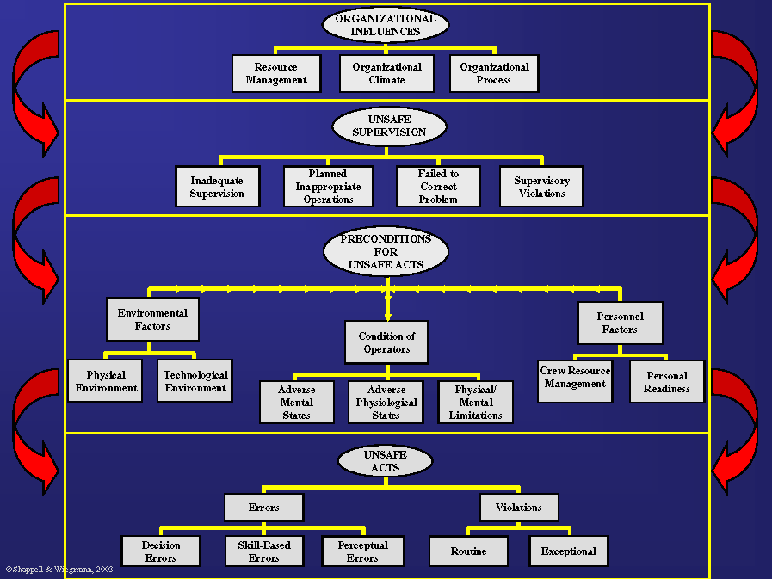
圖8 人為因素分析及分類系統（HFACS）
附錄1 HFACS檢查表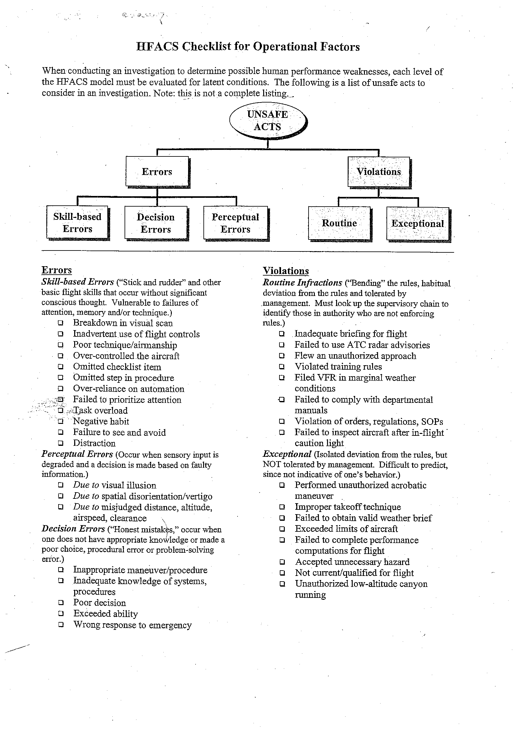
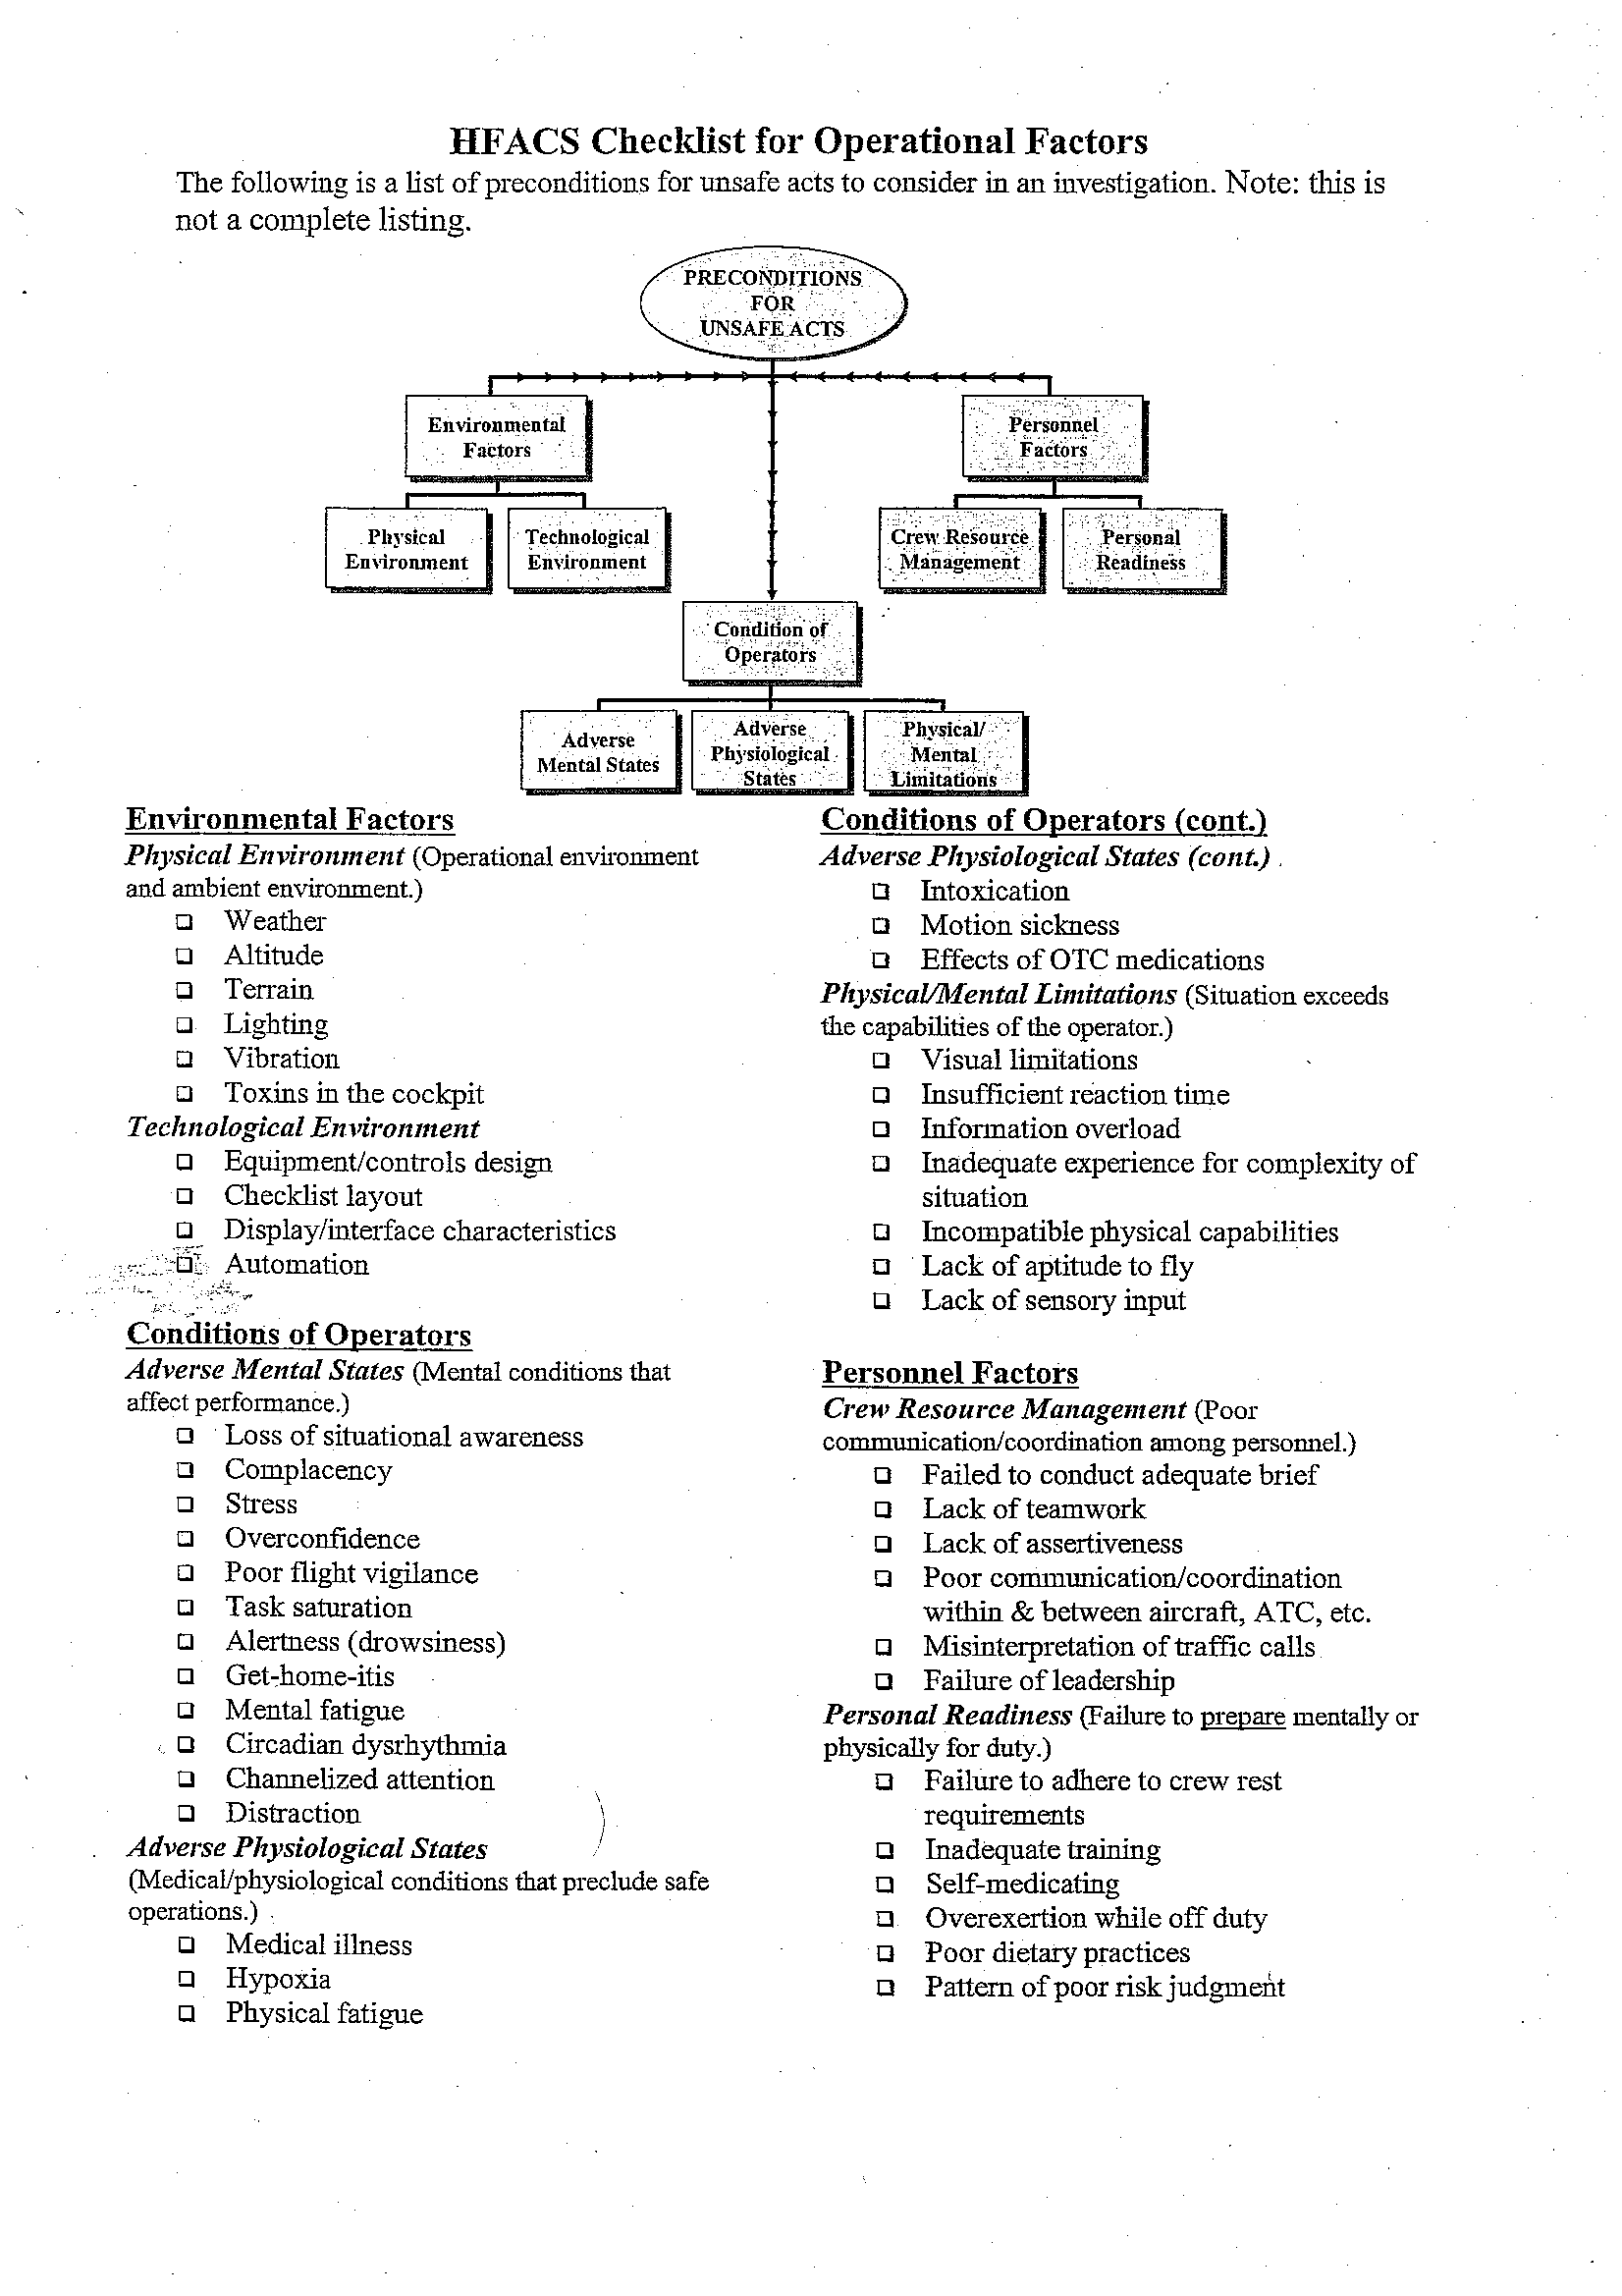
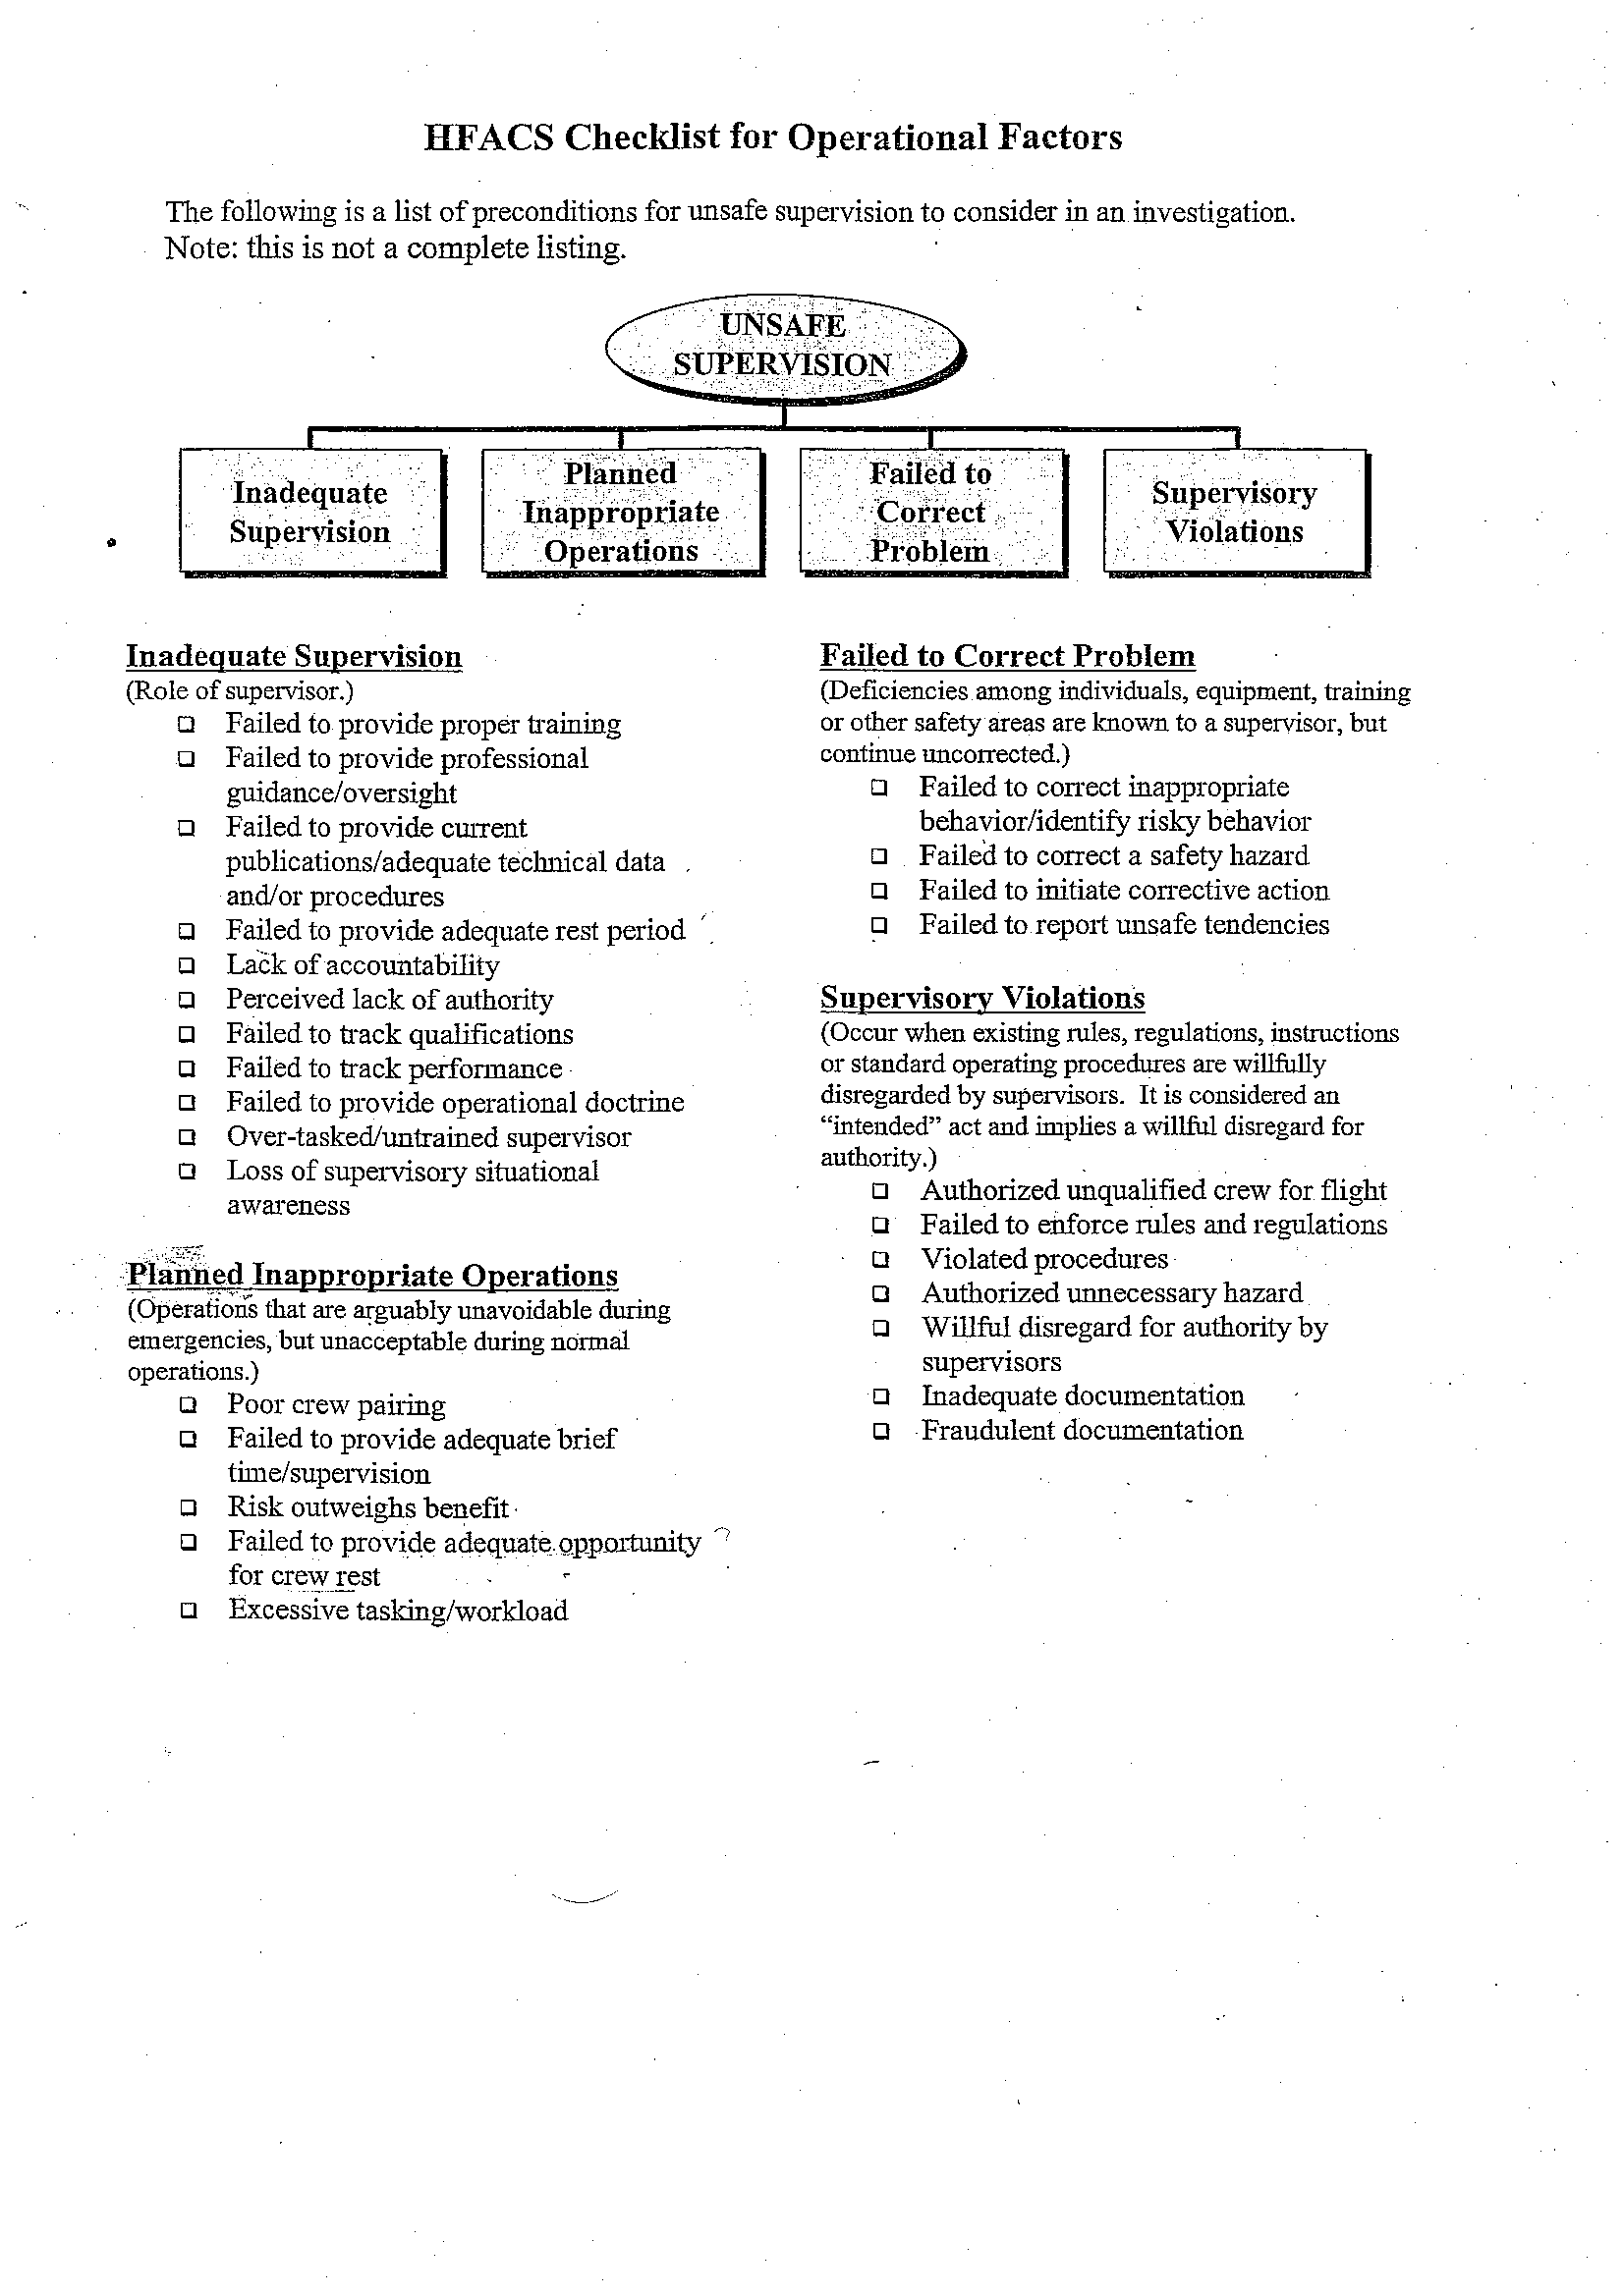
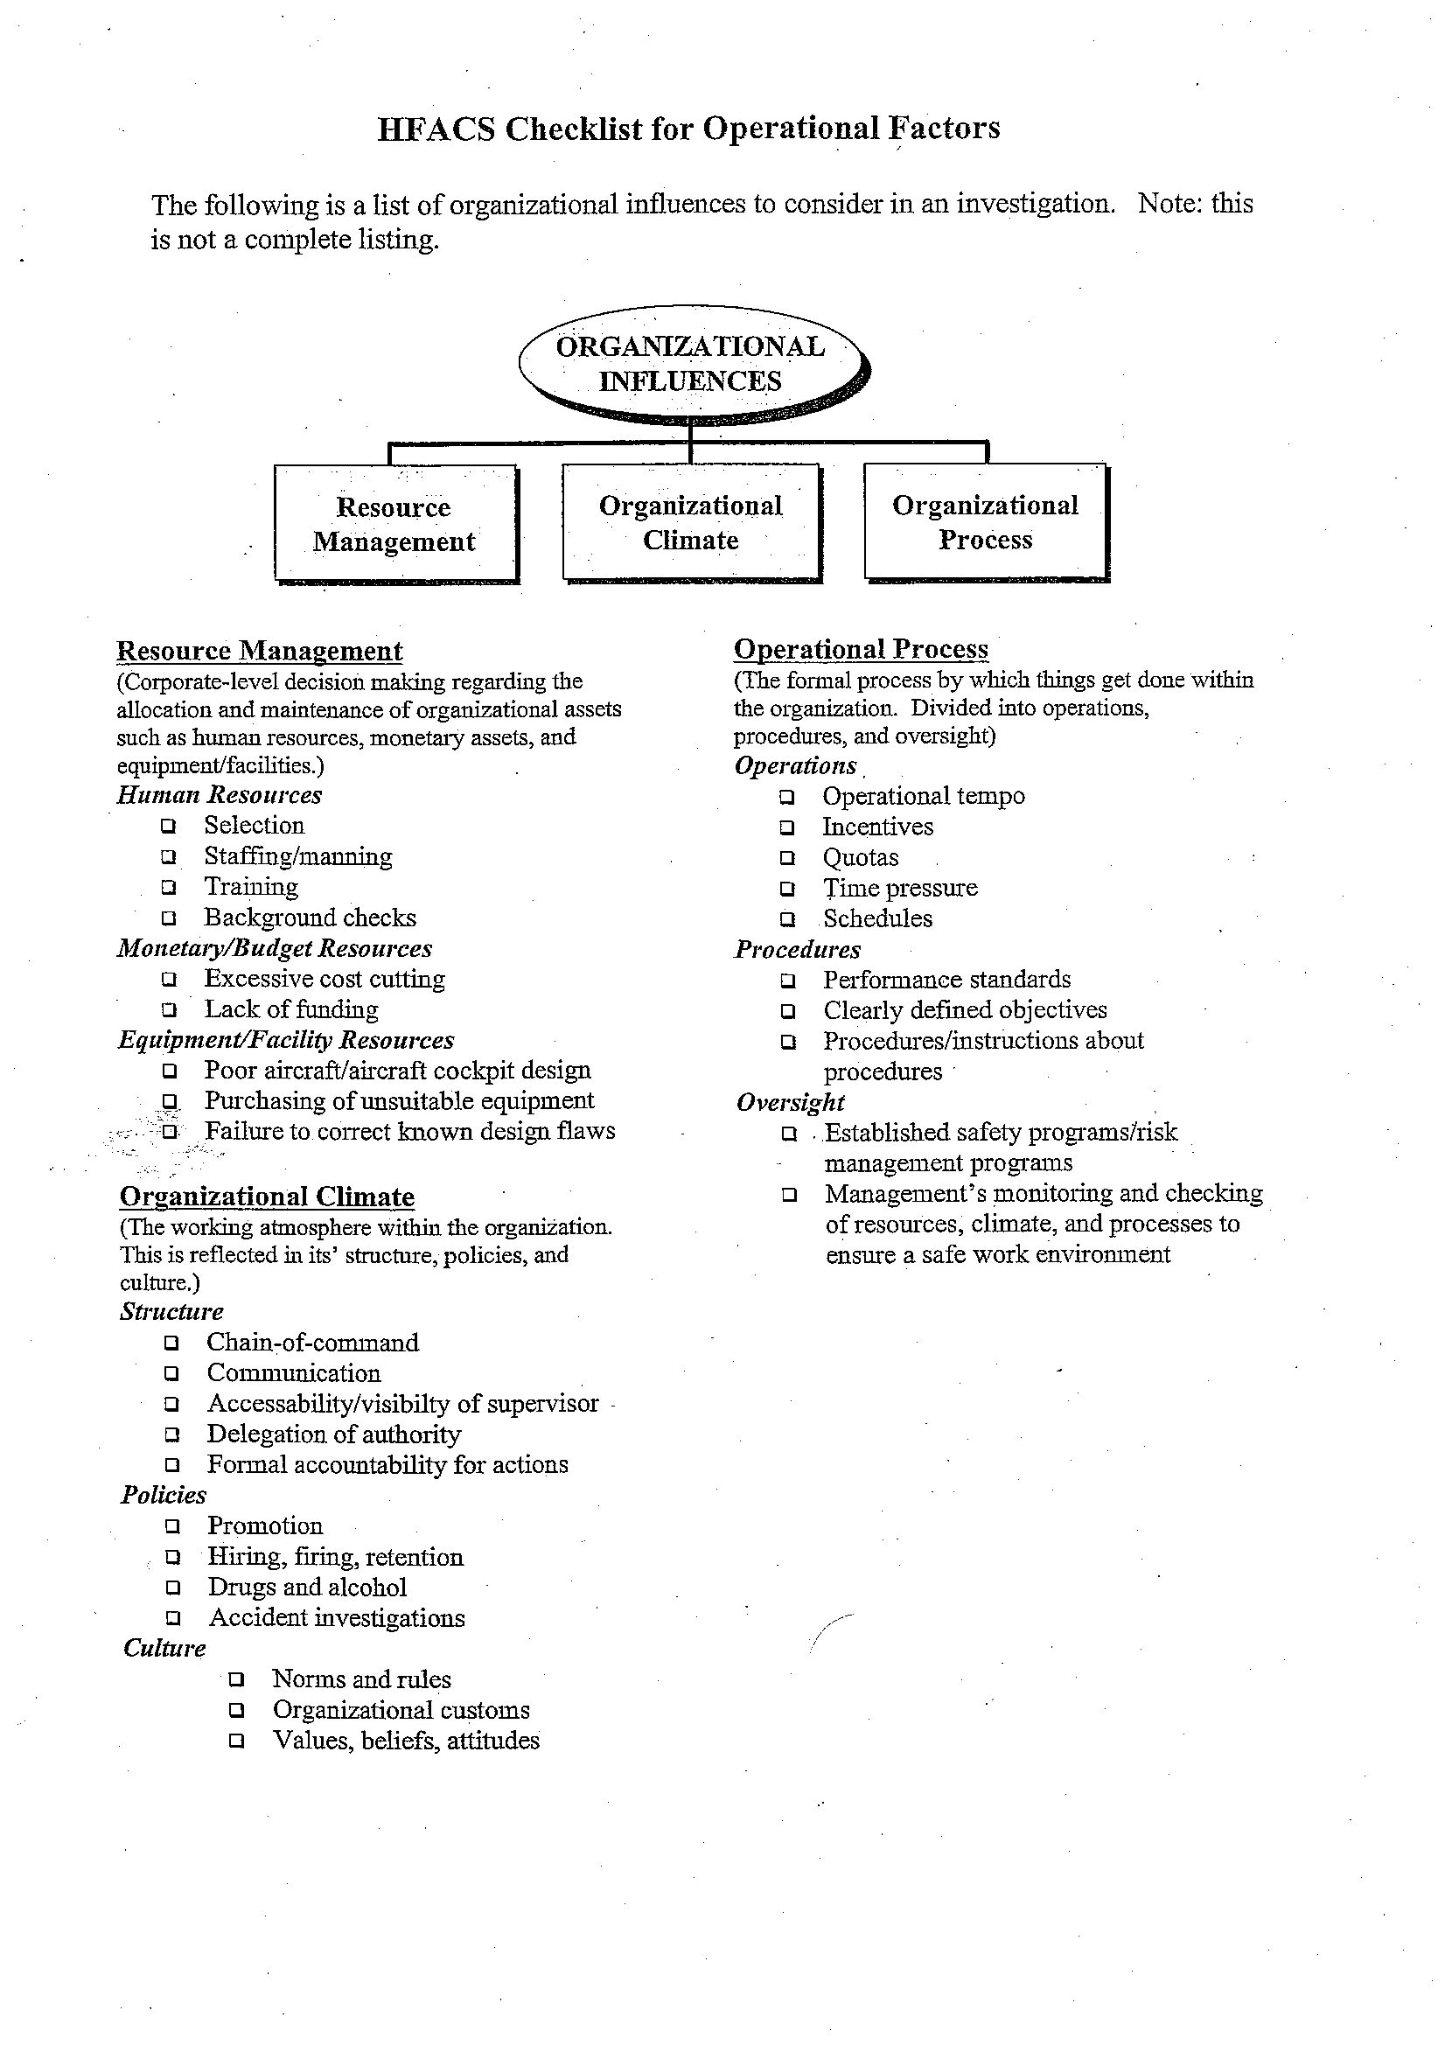
2.5 人為因素改善策略之發展
當飛航事故經過調查、肇因分類、找出關鍵肇因後，下一步驟就是改善策略（Intervention Strategies）之擬定，以改正問題或降低傷害的嚴重性。
2.5.1 人為因素改善策略發展矩陣
Scott A. Shappell及Douglas A. Wiegmann兩位講師在回顧其他學者之方法後，發展出人為因素改善策略發展矩陣（Human Factors Intervention Matrix，以下簡稱為HFIX）。HFIX之特色在於可與HFACS結合，將Unsafe Act納入模式中，另外亦納入實務考量之決策變數（Decision Criteria）及一組有關Mode之變數，詳見圖9。
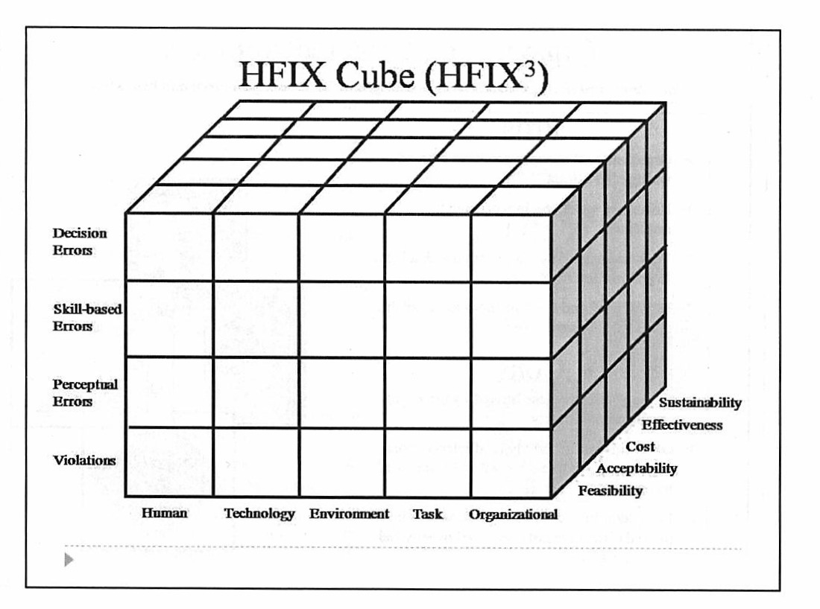
圖9 Human Factors Intervention Matrix
調查人員對於調查中發現的Decision Errors、Skill-based Errors、Perceptual Errors以及Violations等Unsafe Acts，可分別針對人(Human)、科技(Technology)、環境(Environment)、任務(Task)、組織(Organizational)等不同層面，擬定改善措施。
對於提出的每項改善措施，再分項衡量其可行性(Feasibility)、可接受度(Acceptability)、花費(Cost)、有效性(Effectiveness)、持續性(Sustainability)等，可於不同的權重，經過計算之後，再依分數高低排定執行的優先順序，並避免提出不切實際的改善建議。
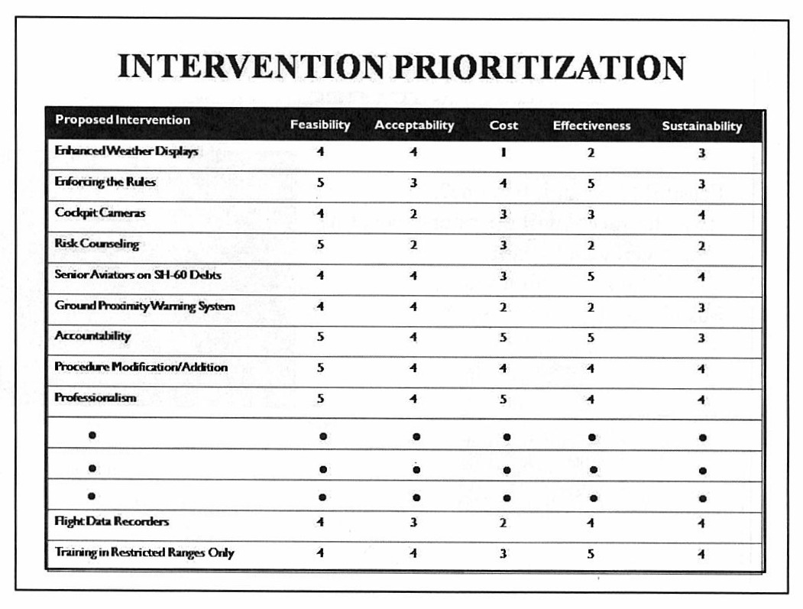
2.5.2 人為疏失認定及改善之研究架構圖
人為疏失之認定及改善策略之發展須經過圖10所列之7個步驟。而為了使整個流程更有效能，則可以採用HFACS及HFIX兩種模式，幫助我們分析危害因素（Hazard）、找出關鍵之危害因素、針對關鍵之危害因素發展所有可能之改善策略、評估各改善策略執行時之優先順序、執行改善策略、及持須監控改善策略之效益。
圖10 人為疏失認定及改善之研究架構圖
2.6 HFACS於正向因素分析/分類之應用
2.6.1正向因素分析/分類
依據Swiss Cheese理論，意外事件能避免演變為飛航事故，或飛航事故之災害能被減至最低，代表中間有一些防線發揮了功用，成功阻斷了錯誤鏈。簡而言之，就是「做對了什麼」， 這些作對的事即所謂正向因素(Positive Factors)。
傳統事故調查係以發掘事故肇因，提出改善建議，來達到避免類似事件再次發生之目的。受限於篇幅，以及報告的既定格式，報告內容均著重於「哪裡做錯了」，對於減輕事故嚴重程度或阻斷意外事件演變為失事的正向因素為何，則著墨不深。換言之，對於組員「做對」的事，均視為理所當然，然而這些正向因素對於事故預防而言助益極大，卻沒有一個共通、有效的分類標準，以致於資訊無法被分享、運用。事故組員處置得宜，不表示其他組員都能做到，事故業者在訓練、考核、手冊方面做得好，不代表其他公司皆是如此，若這些正向因素無法被分享出去，將失去許多提醒與教育之機會。
有鑑於此，由各國政府與業界共同組成之CAST (Commercial Aviation Safety Team) / ICAO Common Taxonomy Team, CICTT成立Positive Taxonomy Working Group，期望能發展出共同簡單的標準去辨識/擷取阻斷事故發生之正向因素，以便於分類與資訊整合，進而瞭解必須強化的重點。

圖11 Heinrich金字塔說明事故分類圖解
圖11說明現有的事故調查主要係著眼於金字塔頂端的失事與重大意外事件，而Positive Taxonomy Working Group之目標，在於對金字塔底部的不安全事件進行正向因素分類，藉由完整的資料庫使相關資訊能被航空界分享、運用，進而達成避免飛航事故發生之目的。
2.6.2 HFACS之應用
課程中，講師以發生於2009年1月15日之全美航空1549航班成功於海上迫降之事故為案例，讓學員嘗試從中找出該事故之正向因素。雖然目前美國官方尚未公佈事實資料，但就現有的航管錄音抄件、監視器拍攝畫面及最終的結果，仍可看出些許端倪。以第一層為例：飛航組員在決定返航、轉降以及迫降之過程置中，決策(Decision)十分明確，對於當時航機的高度、姿態、位置、地障隔離…等認知(Perceptual)十分清楚，在航機的操控、注意力分配等技能(Skill)，均表現稱職。
飛航組員優異的表現，讓我們可以向上追溯到第二層之項目，例如飛航組員之人格特質、情緒管理等精神狀態，數十年來累積的經驗、知識及熟悉度，組員之間的溝通、合作…等，都可能是使當日能有完美演出背後的關鍵因素之一。再加上事故當時為白天，天候及能見度狀況良好，這先天環境因素增加了飛航組員成功之機會。
再往上追溯，則可歸因於航空公司平日的訓練、考核做得完善，手冊、程序等相關文件符合實際需求，促使了飛航組員在事故當時，能有好的表現。
由這個實例，讓我們瞭解到，業者如何運用HFACS尋找事故當中的正向因素。當瞭解了需要加強之處後，事故預防的目標將更容易達成。

- 心得
兩位講師所介紹之HFACS模式，其理論及概念都可接受，在應用上亦較目前最常用之SHELL模式更為理想，應值得於國內推廣與使用。
HFACS使用心得如下：
- HFACS或其他人為因素模式觀念上都容易了解及接受，然而可能需要至少20件事故以上使用之經驗，甚至涵蓋不同類型之事故，才能真正熟悉該模式、了解實際應用之限制、及深化調查員人為因素之意識；
- HFACS原始設計係供航空公司或軍方內部使用，故其探討範圍為組織內部可掌控的部分，應用於飛航事故調查時，涉及更廣泛的被調查單位，如何延伸模式應用之廣度為努力方向之一；
- HFACS更具體的指出督導及管理階層應調查之方向，然相較於組織內部調查，飛航事故調查時取得相關議題資料及證實其存在之難度更高，故HFACS應用於內部調查或Near-Miss事故分享時可能有更佳之效果；
- HFACS部分構面可能涉及對事故相關人員咎責，飛航事故調查中相關資料仍須予以蒐集及分析，然於報告呈現時則須謹慎；
- HFACS模式理論上亦可應用於航管、維修、客艙安全方面之人為因素調查，然目前屬飛航操作之檢查表發展較為成熟；
- 人為因素分類的目的在於了解其特性及有助於改善策略之擬定，然任何人為因素分類模式皆有模糊空間，使用時可依改善方向之屬性為判斷的參考；
- 人為因素調查係以ICAO Human Factors Digest No. 7 Investigation of Human Factors in Accidents and Incidents為指導文件，HFACS功能在於強化該文件第2章中提及之：調查員可使用人為因素檢查表，協助檢視相關人為因素議題之完整性，及規劃相關事實資料蒐集之優先順序；
- 其他人為因素模式仍然有其價值，實際上熟悉其他模式才能幫助調查員完整地了解及使用HFACS；
- 使用HFACS整合其他人為因素檢查或許為可行之方向；
- HFACS模式及檢查表並非固定不變，調查員應參考調查之經驗及人為因素研究之成果適當地予以調整及延伸。
國內民航界目前對於人為因素，確實仍只停留在「知識」層級，可考慮使用HFACS，瞭解其本身在人為因素方面之需求；而各航空公司之人為疏失改善重點應依據本身不同之情況而有所差異，例如CRM之課程，其內容所涵蓋之議題可高達數十種，各公司應依其不同時期之需求，製作符合其本身需求之課程。

- 建議
依據本次受訓之內容，對本會調查相關事項之建議如下：
- 嘗試使用HFACS來進行人為因素之飛航事故調查，並評估其可行性。
- 嘗試使用HFIX或其他改善策略發展方法來擬定飛安改善建議，並評估各方法之可行性。
- 調查人員可嘗試應用HFACS於正向因素之分析/分類，並將結果呈現於報告之中，以彌補傳統調查報告之不足。

