附錄一 參訪機構
機構名稱 | 地址 | 網址
HOME OFFICE  Inter-Personal Violence Team  Violent Crime Unit | Peel Building, NE Quarter  2 Marsham Street  SW1P 4DF | http://www.homeoffice.gov.uk/
DVIP  （Domestic Violence Intervention Project） | 164-168 Westminster Bridge Road SE1 7RW | http://www.dvip.org/
Caada  （Co-ordinated Action Against Domestic Abuse） | CAN Mezzanine, 32-36 Loman Street, London, SE1 0EH | http://www.caada.org.uk/
Cardiff Central Police station | KING EDWARD VII AVE CATHAYS PARK CARDIFF | http://www.south-wales.police.uk/
Standing Together | Hammersmith Town Hall  King Street  Hammersmith  London W6 9JU | http://www.standingtogether.org.uk/
Advance | Hammersmith Town Hall  King Street  Hammersmith  London W6 9JU | http://www.advanceadvocacyproject.org.uk/
Refuge | Refuge, 4th Floor, International House, 1 St Katharine’s Way, London E1W 1UN | http://www.refuge.org.uk/

附錄二 參訪照片（照片提供者：林柏煌）
HOME OFFICE
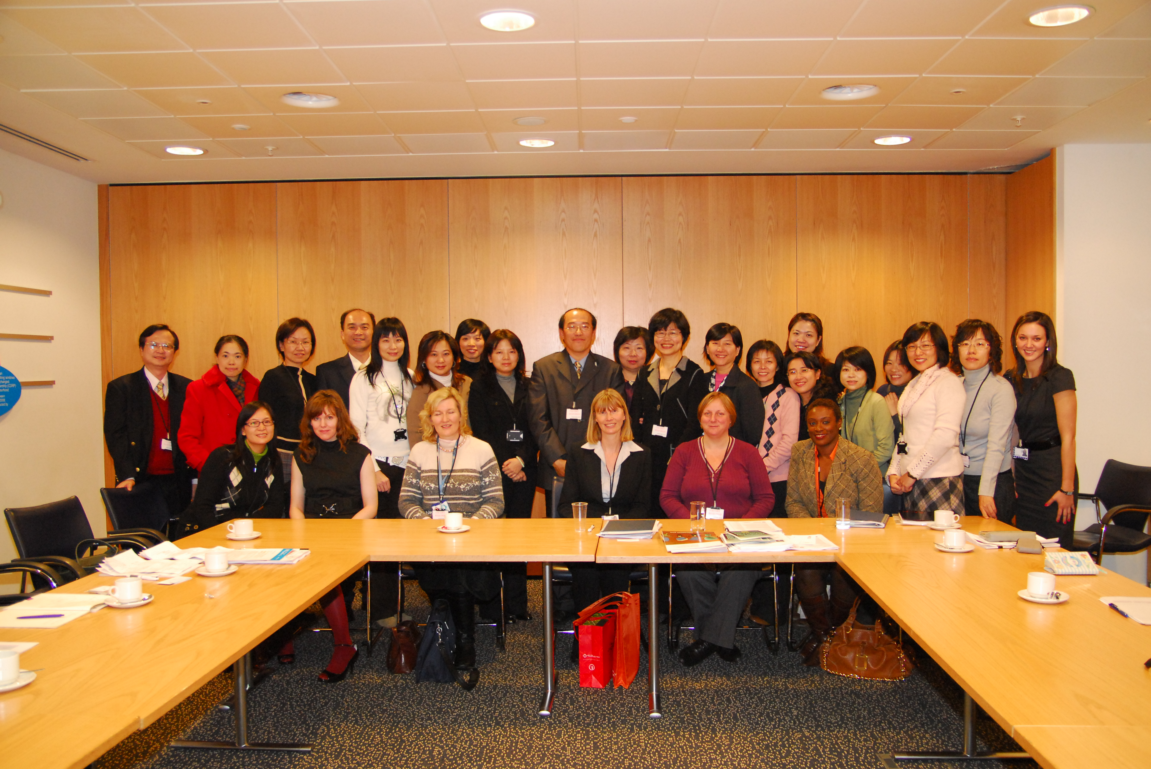

Refuge
