伍、附錄

Letter of Invitation

20 October 2008

Dear TPT-WG Colleagues,

Coming at the heels of the recently concluded 31st of the APEC Transportation Working Group (TPT-WG30) held in Lima, Peru last August 2008, it is with honor and a personal privilege to invite you to attend the First Drafting Meeting to be held in Boracay, Philippines on December 15-17, 2008.

As discussed during the last meeting of TPT-WG31, the Philippines confirmed its hosting of a Meeting of APEC Transportation Ministers on April 27-29, 2009 in Cebu City, Philippines. Prior to this, a first draft of the Joint Ministerial Statement shall be sent out by the Philippines on the 3rd week of November. Thereafter, a First Drafting Meeting to be hosted by the Philippines will be held in December followed by a Second Drafting Meeting hosted by China will be held in February next year.

In my report, I have encouraged all economies to give full consideration to the Directives from TMM5 and Leaders and continue to prioritize the implementation of the Directives set out in 2007 by APEC Transportation Ministers and Leaders. Further, that Chairs of Experts Groups shall provide suggestions on a theme for TMM6 in preparation for the Ministerial Meeting considering the need to develop a solid TMM6 Agenda. All this will be considered during the First Drafting Meeting.

As host economy for the First Drafting Meeting, we have pooled our efforts to provide all attendees the finest meeting venue. Boracay is the country’s premier resort destination offering the needed ambiance that will help the attendees come up with the best possible output while enjoying the experience of what the island resort has to offer.

Attached is the Administrative Bulletin One which includes information of contact persons for any queries and assistance needed by the attendees.

We would like to encourage you to make preparations to attend the First Drafting Meeting as soon as possible, especially relating to pre-arrival registration and hotel reservation. We look forward to seeing you in Boracay in December 2008.

Thank you very much.

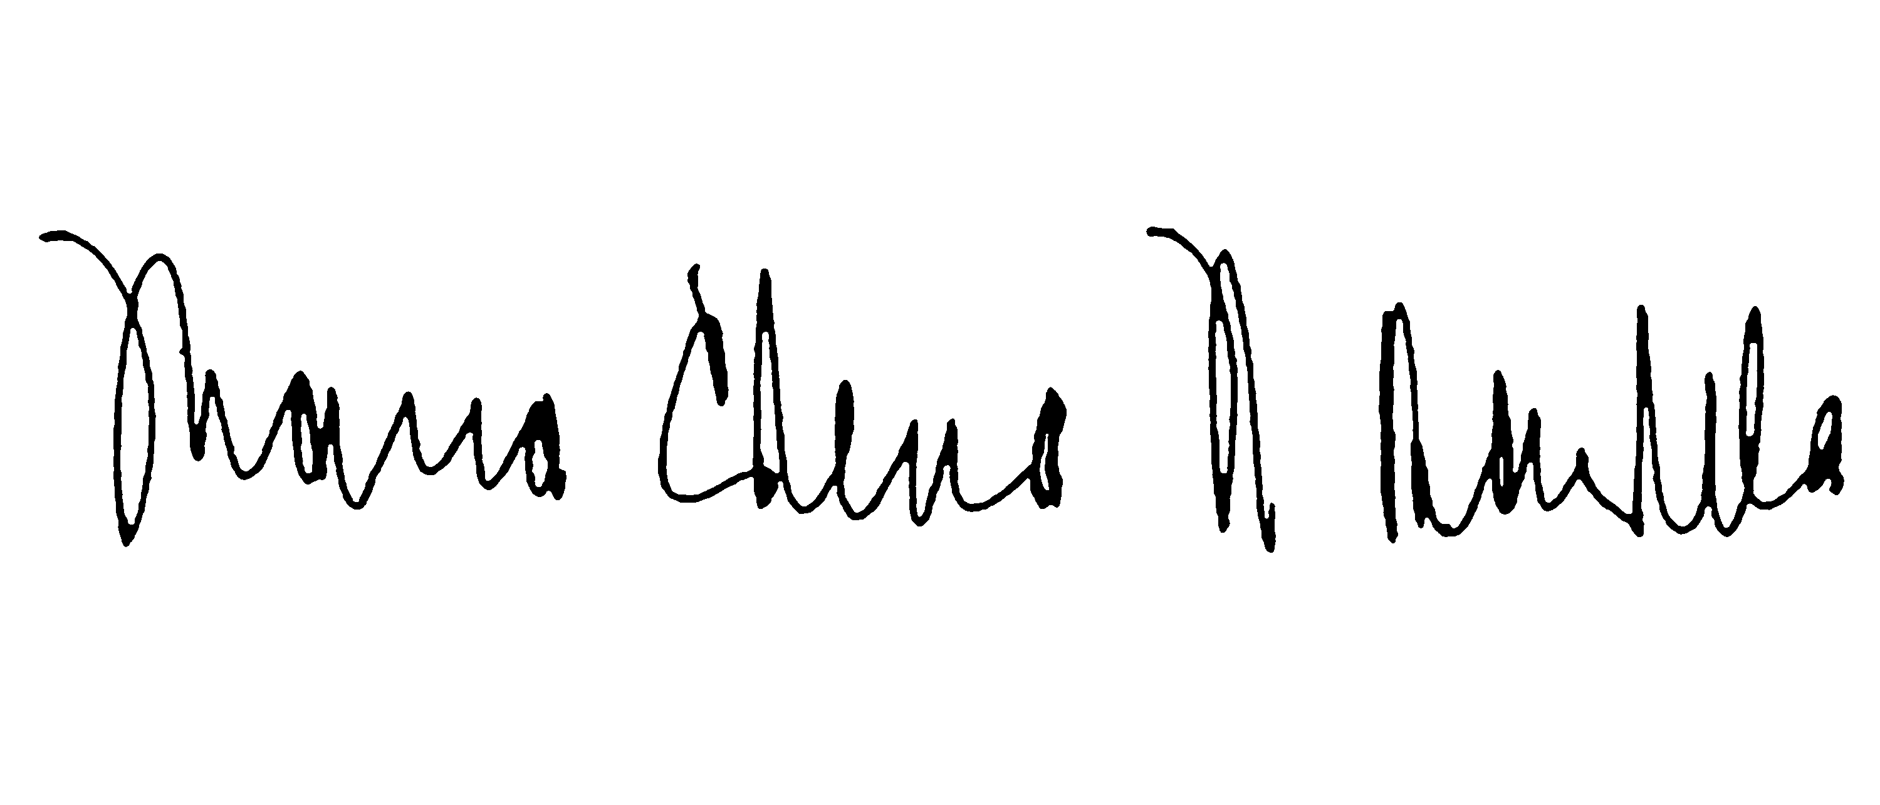
With my warmest regards,

MS. MARIA ELENA H. BAUTISTA

Undersecretary for Maritime Transport

Department of Transportation and Communications, The Philippines
APEC TPT-WG Lead Shepherd,
APEC TPT-WG First Drafting Meeting Organizing Committee Chairperson

A-1



APEC Transportation Working Group

First Drafting Meeting

Bulletin One



Department of Transportation and Communications
Philippines
A-2

TABLE OF CONTENTS

Page

- Meeting Overview 3
- Contact Information 3
- Meeting Venue and Hotel Accommodation 4
- How to Get There 5
- Meeting Registration 7
- What to Wear 7
- Social Program 7
- Documentation Reproduction and Distribution 8
- Presentations 8
- Visa Arrangements and Entry Formalities 8
- Delegate Information 9
- Medical Services 9
- General Information About the Philippines and Boracay Island 9

APPENDICES

- Letter of Invitation 12
- First Drafting Meeting Program 13
- Pre-Arrival Registration and Hotel Reservation Form 14
- Document Reproduction Request Form 16

A-1
A-1
A-1
A-3
- Meeting Overview

The Department of Transportation and Communications (DOTC) of the Republic of the Philippines welcomes all participants to the APEC Transportation Working Group (TPT-WG) First Drafting Meeting which will be held at the Sea Wind Resort, Boracay Island, Philippines from 15 to 17 December 2008. Please see Attachment A (Letter of Invitation). This Bulletin provides an overview of the administrative arrangements for the First Drafting Meeting, which we hope will facilitate your participation in this event.

The First Drafting Meeting comes at an opportune time following the successful TPT-WG31 meeting in Peru last August 2008, at which the Lead Shepherd gave guidance to the full consideration to the Directives from TMM5 and Leaders and continue to prioritize the implementation of the Directives set out in 2007 by APEC Transportation Ministers and Leaders. Further, the Chairs of Experts Groups were instructed to provide suggestions on a theme for TMM6 in preparation for the Ministerial Meeting considering the need to develop a solid TMM6 Agenda. All this will be considered during the First Drafting Meeting.

Considering the significant work to be undertaken at this meeting, delegates are invited to begin preparations to attend the First Drafting Meeting in Boracay Island, Philippines as soon as possible and to begin visa application processes, if necessary.

To enable the Host Secretariat to make the necessary arrangements to facilitate your arrival to the Philippines and to obtain special rates, please complete the Pre-Arrival Registration Form (Attachment B), detailing the delegates’ personal and organizational information, flight and accommodation information, and special requirements) and send it to:

- the First Drafting Meeting Secretariat at apec@dotc.gov.ph or fax at (+63-2) 7210800 not later than 15 November 2008.

- Contact Information

Contact information on administrative and policy matters is provided below. We have created a dedicated email address, apec@dotc.gov.ph, which can be used for any requests and document submissions, if any.

In addition, inquiries can be made to the following DOTC officials:

Undersecretary MARIA ELENA H. BAUTISTA
Lead Shepherd, and
Chairperson, Organizing Committee
Department of Transportation and Communications
Unit 169, The Columbia Tower, Ortigas Avenue, Mandaluyong City
1555 Philippines
Telephone: (+63-2) 7260204
Fax: (+63-2) 7266221

Email: usecmehb@dotc.gov.ph or ehb769@yahoo.com

Director ROWENA S. QUIOGUE
Chairperson, Working Committee
Department of Transportation and Communications
Unit 49, The Columbia Tower, Ortigas Avenue, Mandaluyong City
1555 Philippines
Telefax: (+63-2) 7210800

Email: rquiogue@dotc.gov.ph or angellika1957@yahoo.com.ph

A-4
- Meeting Venue and Hotel Accommodation
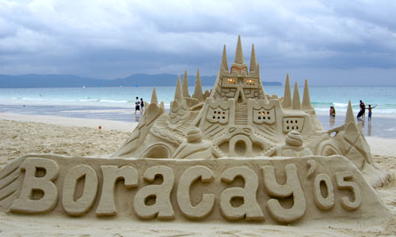
The First Drafting Meeting will be held at the Sea Wind Resort, Boracay, Philippines, which is also the official residence of the delegates. The Resort is about an hour flight from Manila and is located in Central, Philippines. The Resort provides all the amenities and meeting rooms needed by the delegates during the duration of the meeting. Further, Boracay Island offers the right ambiance to provide a pleasurable and fulfilling stay at the Philippines’ premier resort island destination.

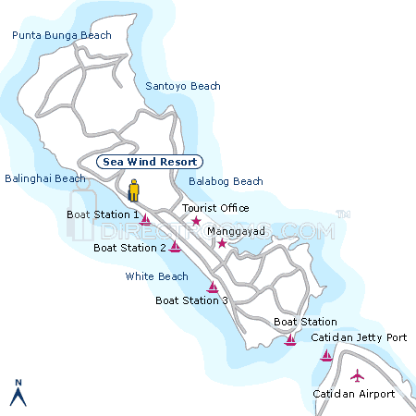
The address of the Resort is:


Sea Wind Resort
1 R&G Tirol Park, Balabag, Boracay Island
Malay, Aklan, Philippines

Website: www.seawindresort.net

Email: seawind@pacific.net.ph

Tel: (+63) (36) 2883091
Fax: (+63) (36) 2883425

Reservation Office:

Judith P. Pondevida
Reservation Officer
Sea Wind Resort
831 EDSA cor. Eugenio Lopez Street
Quezon City
Tel. No. (632) 416-4010 / 415-1285 / 924-0995
Fax No. (632) 416-4011

Email Add: seawind-rsvn@pacific.net.ph

The Department of Transportation and Communications has made arrangements with Sea Wind Resort for a special APEC rate as follows:

Type of Occupancy Price for Extra Night
3 days/2 nights package with breakfast per room per night
Single PHP 11,300.00 per person (about $235) PHP 5,200.00/$108
Twin Sharing PHP 6,100.00 per person (about $127) PHP 5,200.00/$108
Triple Sharing PHP 5,100.00 per person (about $107) PHP 6,300.00/$131
Quad Sharing PHP 4,500.00 per person (about $94) PHP 7,600.00/$158

Note: Present exchange rate is US$ 1 = PHP 48.10

In order to avail of the special APEC rate and to reserve a room early since December is a peak season month, the Resort requires that all reservations should be made not later than 15 November 2008. Since the Resort does not have an electronic reservation in their website www.seawindresort.net, you can either communicate with the Resort directly via their contact numbers as indicated above or email the reservation officer, Miss Judith Pondevida at seawind-rsvn@pacific.net.ph. While making your own reservation, indicate that you are part of the APEC so as to avail of the special APEC rates. Or you may submit the Hotel Reservation Form, including an electronic photocopy of your credit card and passport to the Working Committee contact person Director Rowena Quiogue (rquiogue@dotc.gov.ph or angellika1957@yahoo.com.ph) who will make the necessary arrangements with the Resort in your behalf.
A-55

- How to Get There
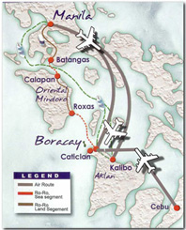
Manila is the international gateway in the Philippines which offers connecting flights to Caticlan Airport, Aklan. Guests will take a 15 minute boat ride to Boracay Island. The Ninoy Aquino International Airport (NAIA) in Manila is the premier gateway. There are three major airports/terminals, namely, NAIA Terminal 1 which serves all international flag carriers; NAIA Terminal 2 which serves Philippine Airlines (PAL) flights; and NAIA Terminal 3 which serves Cebu Pacific, Air Philippines and PAL Express flights for domestic transfers. Further, there is an old Domestic Airport which serves smaller airlines like South East Asian Airlines (SEA Air) and Asian Spirit / Zest Airlines. All these airlines have flights to Caticlan Airport, Aklan, Philippines. All these terminals provide free transportation between terminals.

Another way to get to Caticlan Airport, Aklan, Philippines is via the Mactan International Airport (MIA) in Cebu, Philippines which handles flights from Japan, Singapore and Australia.

The following domestic airlines have regular flights from Manila to Caticlan Airport, Aklan:

Philippine Airlines / PAL Express
www.philippineairlines.com

Cebu Pacific Airlines
www.cebupacificair.com

Air Philippines Airlines
www.airphils.com

Asian Spirit Airlines / Zest Air
www.asianspirit.com

South East Asian Airlines (SEA Air)
www.flyseair.com

Hereunder are the flight schedules to/from Caticlan Airport:

PAL EXPRESS (Philippine Airlines)

MANILA TO CATICLAN CATICLAN TO MANILA

Flt. No Freq. ETD ETA Flt. No Freq. ETD ETA
PR 035 Daily 05:50 07:00 PR 036 Daily 07:25 08:35
PR 037 Daily 06:30 07:40 PR 038 Daily 08:05 09:15
PR 045 Daily 09:05 10:15 PR 046 Daily 10:40 11:50
PR 047 Daily 09:45 10:55 PR 056 Daily 13:40 14:50
PR 055 Daily 12:05 13:15 PR 062 Daily 14:05 15:15
PR 061 Daily 12:30 13:40 PR 072 Daily 16:55 18:05
PR 071 Daily 15:20 16:30 PR 048 Daily 17:00 18:10
PR 077 Daily 15:45 16:55 PR 078 Daily 17:20 18:30

A-6

CEBU PACIFIC AIR

MANILA — CATICLAN CATICLAN — MANILA
Flt. No. Freq. ETD ETA Flt. No. Freq. ETD ETA
5J — 893 Daily 0630 0730 5J — 894 Daily 0750 0855
5J — 897 Daily 0930 1030 5J — 896 Daily 1050 1155
5J — 899 Daily 1210 1310 5J — 900 Daily 1330 1435
5J — 903 Daily 1510 1610 5J — 904 Daily 1630 1735

CEBU – CATICLAN CATICLAN - CEBU
Flt. No Freq. ETD ETA Flt. No. Freq. ETD ETA
5J – 136 Daily 1015 1115 5J – 135 Daily 0630 0730
5J – 588 Daily 1030 1130 5J – 589 Daily 1150 1250

SEAIR

Manila – Caticlan Caticlan - Manila
Flt. No. Freq. ETD ETA Flt. No. Freq. ETD ETA
DG 003 F 0600 0645 DG 004 F 0705 0750
DG 007 Th 0700 0745 DG008 Th 0805 0850
DG 011 MWSu 0800 0845 DG012 MWSu 0905 0950
DG 013 DAILY 0830 0915 DG014 DAILY 0935 1020
DG 017 F 0930 1015 DG206 W 0945 1055
DG 217 MWThSu 0930 1015 DG018 F 1035 1120
DG 721 ThSu 1010 1120 DG022 DAILY ex F 1135 1220
DG 745 M 1020 1130 DG222 TS 1150 1235
DG 021 DAILY ex F 1030 1115 DG722 ThSu 1150 1300
DG 725 T 1050 1200 DG024 DAILY 1205 1250
DG 219 S 1050 1200 DG218 WSu 1305 1350
DG 023 DAILY 1100 1145 DG742 F 1450 1600
DG 033 T 1340 1450 DG034 Th 1520 1630
DG 227 W 1350 1500 DG732 S 1530 1640
DG 731 S 1350 1500 DG786 MW 1540 1650
DG 785 T 1450 1600 DG782 F 1540 1650
DG 739 S 1450 1600 DG040 TWSSu 1605 1650
DG 039 TWSSu 1500 1545 DG042 DAILY 1635 1720
DG 041 DAILY 1530 1615 DG044 DAILY 1705 1750
DG 043 DAILY 1600 1645

CEBU – CATICLAN CATICLAN – CEBU

Flt. No. Freq. ETD ETA Flt. No. Freq. ETD ETA

DG 212 F 1045 1130 DG 213 F 0930 1015

DG 222 TS 1045 1130 DG 221 TS 0930 1015

DG 216 MTh 1200 1245 DG 217 MWThSu 1035 1120

DG 218 WSu 1200 1245 DG 282 Th 1310 1420

DG 782 F 1330 1415 DG 284 Su 1440 1550

DG 786 MW 1330 1415 DG 785 T 1630 1740

ZEST AIRWAYS (former Asian Spirit)

MANILA TO CATICLAN CATICLAN TO MANILA
FLT NO. FREQ ETD ETA FLT NO. FREQ ETD ETA
6K 865 DAILY 0510 0610 6K 864 DAILY 0630 0730
6K 867 DAILY 0630 0730 6K 866 DAILY 0800 0900
6K 869 DAILY 0800 0900 6K 868 DAILY 0920 1020
A-7
6K 871 DAILY 0845 0945 6K 870 DAILY 1005 1105
6K 873 DAILY 0940 1040 6K 872 DAILY 1100 1200
6K 875 DAILY 1050 1150 6K 874 DAILY 1510 1610
6K 877 DAILY 1135 1235 6K 876 DAILY 1550 1650
6K 881 DAILY 1230 1330 6K 880 DAILY 1400 1500
6K 883 DAILY 1500 1600 6K 882 DAILY 1630 1730
6K 897 DAILY 1545 1645 6K 896 DAILY 1710 1810

CEBU – CATICLAN CATICLAN - CEBU
Flt. No. Freq. ETD ETA Flt. No. Freq. ETD ETA
6K 994 TThS 1350 1450 6K 905 TThS 1220 1320

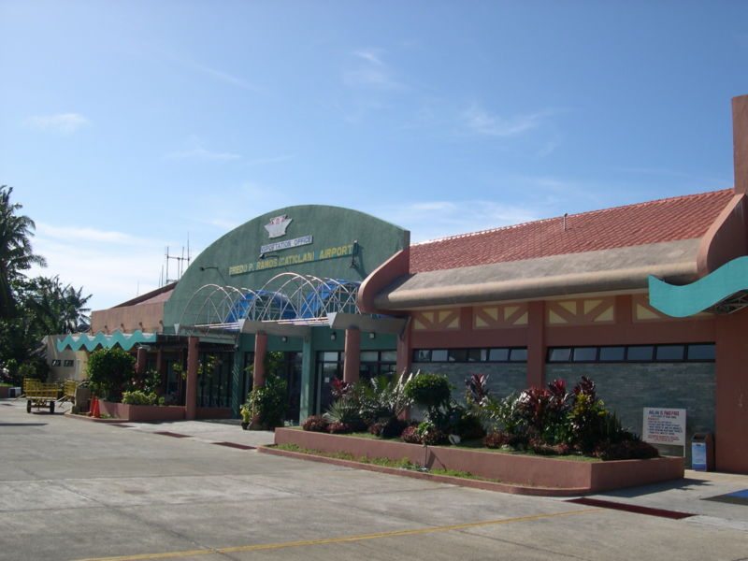
Delegates are encouraged to plan their travel, coordinate with their travel agents and purchase flight tickets not only up to Manila but also their flight onward to Caticlan Airport. By planning, it is suggested that you arrive in Manila or Cebu in the morning of December 15, 2008 at the latest (or earlier since the meeting starts after lunch as per attached program of activities), transfer to the corresponding airport terminal and take your flight to Caticlan Airport. That way, you will arrive in Caticlan before noon. If your travel agent does not offer domestic flights from Manila to Caticlan Airport, Aklan, you can also purchase your electronic ticket direct from the airline’s website.

There will be an APEC team meeting you in Manila and/or Cebu. Please consider getting flights from Manila or Cebu to Caticlan Airport, Aklan with some leeway (about at least 3 hours) for airport transfer and check in.

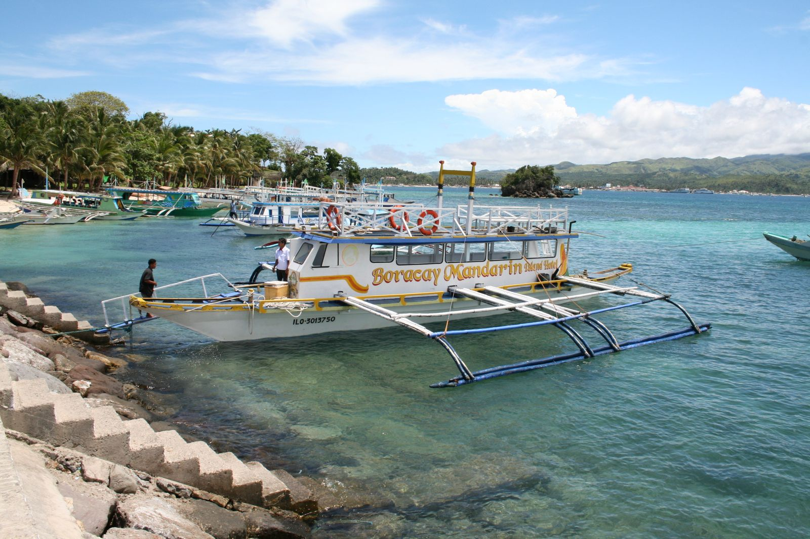
While there are flights to Kalibo Airport, which is also in Aklan, it will entail a one hour road trip to Caticlan. For your comfort, we recommend direct flights to Caticlan from Manila or Cebu.

Upon arrival at Caticlan Airport, host Secretariat will assist in transporting you to the jetty port for the 15 minute boat ride to Boracay Island. At the boat station in Boracay Island, the Secretariat will assist you for the 15 minute land transport to Sea Wind Resort.

- Meeting Registration

For better control in the registration and activity coordination, it is highly recommended that delegates fill up the Participant’s Meeting Registration Form (Appendix D), and send it to the Secretariat either through email or fax using the numbers below:

Email: apec@dotc.gov.ph; Fax: (63 2) 721-0800

Registration Forms should be received by the Secretariat not later than 15 November 2008.

A-8
- What to Wear

Visitors in Boracay Island do not wear shoes as it tends to clog up with sand. Hence, the First Drafting Meeting will be a very informal affair. Casual and loose clothing recommended.

- Social Program

Welcome Reception. Welcome Dinner will be held at the Beachfront on 15 December 2008 at 1900H. Delegates are advised to wear casual beach attire.

- Presentations, Documentation Reproduction and Distribution

Please submit papers and documents to the Lead Shepherd not later than 08 December 2008 at usecmehb@dotc.gov.ph or ehb769@yahoo.com, copy furnish the Lead Shepherd’s Secretariat, Miss Jo Ann Salamanca, at jmsalamanca@dotc.gov.ph or joann_rd02@yahoo.com. The Documentation Reproduction Request Form is at Attachment D.

Computers with internet connection will be made available at the meeting venue.

- Visa Arrangements and Entry Formalities

All participants should be in possession of a valid passport (validity not less than 6 months prior to expiration) or applicable travel documents with visas or entry permits to enter into the Philippines. Participants are responsible for obtaining their own visa, if required, and should contact the nearest Philippine diplomatic or consular office for further information. Please note that the Philippines participates in the APEC Business Travel Card System.

Nationals from the following APEC member-economies are allowed to enter the Philippines without a visa for a period of stay of 21 days or less:

Australia New Zealand
Brunei Darussalam Papua New Guinea
Canada Peru
Chile Singapore
Indonesia Thailand
Japan United States
Malaysia Vietnam
Mexico

Holders of Hong Kong Special Administrative (SAR) passports are allowed to enter the Philippines without a visa for a stay not exceeding 7 days. Nationals from China, Korea, Russia and Chinese Taipei are required to secure visa prior to entry to the Philippines. For other information regarding entry formalities and requirements, please visit http://www.dfa.gov.ph.

Airport security measures impose that all arriving passengers shall pass through certain procedures. For the convenience of all delegates, please observe the following:

- Delegates shall use the Diplomatic Lane at the Immigration Area.
- After the Immigration Area, the delegates shall proceed to get their luggage at the designated luggage carousel.
- Pass through the Customs Area, giving the Customs Declaration Form.
- Look for the Airport Transfer Desk and Host Secretariat depending on your choice of airlines for your flight from Manila to Caticlan Airport, Aklan, inquire with the Desk for transfer to the following terminals:
A-9
  - NAIA 2 – Philippine Airlines (PAL)
  - NAIA 3 – Cebu Pacific and Air Philippines (also has code sharing with PAL)
  - Domestic Airport – Asian Spirit Airlines and South East Asian Airlines (SEA Air)
- Check in at the abovementioned terminals and await your flight to Caticlan Airport.

- Delegate Information

A Registration Desk will be set up at the Sea Wind Resort lobby to assist all attendees to the First Drafting Meeting. All delegates will be provided with additional information such as venues of meetings, Welcome and Farewell Dinner, together with their identification badges and meeting kits upon registration.

For other needs, inquiries, requests or assistance required, delegates may approach Registration Desk anytime.

- Medical Services

In cases of emergency when the delegates need hospital confinement, the Meeting Secretariat will do the necessary coordination with local authorities for medical assistance and will accompany you to the hospital if required. All hospitalization bills, medicines, and professional fees, however, shall be charged to the delegates.

- General Information About the Philippines and Boracay Island

The Philippines

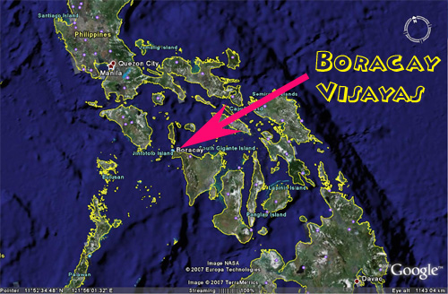
The Philippines is an archipelago composed of 7,107 islands. It is rich in natural resources, world-famous beaches, and tropical rainforests. It has a total land area of about 300,000 square kilometers (116,000 square miles). It is divided into 3 island groups: Luzon, Visayas, and Mindanao. Manila, the capital, is located in Luzon, while Boracay Island in the Province of Aklan is located in the Visayas.

Climate

The climate is hot, humid and tropical. March to May is hot and dry. June to October is rainy. November to February is cool. Average temperatures: 78F°/25C° to 90F°/32C°; humidity: 77%.

Time Zone

There is only one time zone for the entire country, which is 120 degrees East Meridian Time and eight hours in advance of the Greenwich Mean Time (GMT +0800H).

Language

Filipino is the national language. English is the business language and spoken widely. Approximately 111 languages and dialects are spoken in the country.

Electricity and Water

The Philippines uses 220V electric power. Tap water is potable; however, it is not recommended for travelers. Most establishments provide bottled water.
A-10

Currency and Credit Cards

The country’s unit of currency is the Philippine Peso (PHP). The exchange rate as of 20 October 2008 is approximately PHP 48.10 per US$ 1. For other currencies, please visit the Currency Converter at http://www.xe.net/ucc to check your currency vs. PHP. Foreign currencies can be exchanged at the airport, designated banks, malls, hotels, resorts and money changers. Major credit cards are accepted throughout the Philippines. Traveler’s cheques may be cashed at foreign-exchange banks, some tourist-oriented business establishments, and international hotels.

Banking Hours

Most banks are open from Monday to Friday from 9:00 am to 3:00 pm. Automated Teller Machines (ATMs) are available 24 hours in Boracay Island.

Airport Fees

P750 for international departure and P200 for local departure (paid in Philippine pesos only).

Traveling Tips

- Dress for the weather. Light clothing is ideal year-round.

- Casual clothing is acceptable inside churches and business offices.

- Dining establishments and hotels impose no dress code. Beach attire is absolutely acceptable in all establishments.

- No need to bring any formal or business attire during the First Drafting Meeting. Casual, loose and beach attire is encouraged.

- Prepare to hop in a jeepney, tricycle or pedicab – exotic modes of land transport – that are the most commonly available for going around.

- Always bring loose change when taking public transport.

- The Philippine Peso is generally preferred for financial transactions. Money changing shops are available in key cities and towns, including Boracay Island.

- The standard amount is 10% of the total bill. Tipping is optional on bills that include a service charge.

- When shopping in a public market, it is perfectly acceptable to haggle for the cheapest price.

- Adapt to local customs; accept local differences. The Filipinos are divided into regions, each with its own distinct traits and traditions.

- Be sure to sample the endless variety of native delicacies and local cuisine, which differ in every region. The Philippines is made up of 7,107 different flavors that you will want to take home with you.

- For more information about the Philippines, you may log on to www.gov.ph or www.tourism.gov.ph. Or view videos about the Philippines at www.visitmyphilippines.com.
A-11

Boracay Island

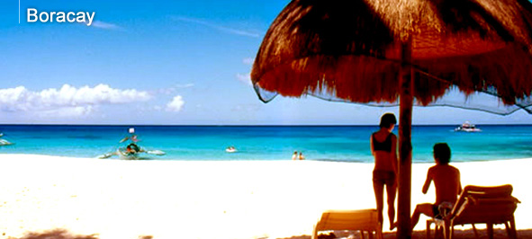
The palm-studded island of Boracay – with its white, talcum-fine beach, balmy weather, and warm, crystalline waters – is like a hypnotic magnet. In this tiny, butterfly-shaped island at the northwestern tip of Panay in Western Visayas, days can be spent simply lazing on the beach while nights are for indulging in the tropical party lifestyle.

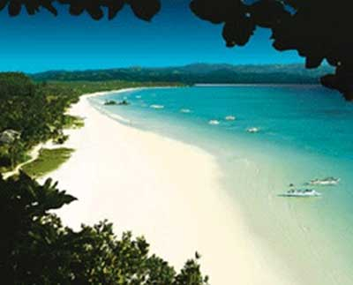
The best part of the island is the four-kilometer White Beach hailed as the “finest beach in the world.” The surrounding water is shallow and the sand is finer and brighter than most beaches in the archipelago. White Beach is so fine, it feels like treading on miles of baby powder!

The code in Boracay is strictly informal. There is an undeniably easy atmosphere in the island, where walking barefoot or in sandals is the rule rather than the exception. Even swinging discos have the beach for a floor, giving dance a new twist. There are no hang-ups here. During the day, tourists having a soothing massage under the shade of a coconut tree beside the shoreline is a common sight. And from dusk to dawn, Boracay turns into one big party place where everyone is welcome to join in.

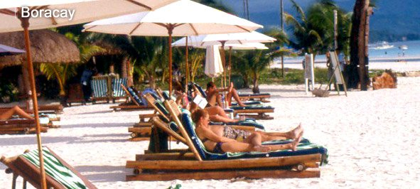
Diversions are not a problem, with leisure activities calendared throughout the year and amenities offered by some 350 tourist establishments. There is plenty to do other than beachbumming and partyhopping. For the adventure-driven, there is ""Mambo Number 5"" – a little bit of boating and wind surfing, a little bit of scuba diving, a little bit of trekking, a little bit of mountain biking, and a little bit of golf. On the eastern side of the island is Bulabog Beach, a boardsailor’s mecca that draws enthusiasts from all over the world, especially during the peak season from November to March.

Sailboating and kayaking are popular sporting activities, with Boracay playing host to the annual Paraw Regatta, an international sailboat race that makes use of the native outrigger. Dive sites surround the island and are learning venues to both novice and professional divers, guided by competent instructors of the many dive shops that operate in the area.

Trekking and mountain biking can also bring the intrepid to the island's quaint interior villages and to the edges' scenic rocky cliffs, discovering along the way many hidden coves with isolated beaches far from the tourist crowd. And for golf bugs, Fairways and Bluewater Resort Golf and Countryclub has an 18-hole championship course.

View videos about Boracay at www.visitmyphilippiines.com.

A-12

Appendix A

Letter of Invitation

20 October 2008

Dear TPT-WG Colleagues,

Coming at the heels of the recently concluded 31st of the APEC Transportation Working Group (TPT-WG30) held in Lima, Peru last August 2008, it is with honor and a personal privilege to invite you to attend the First Drafting Meeting to be held in Boracay, Philippines on December 15-17, 2008.

As discussed during the last meeting of TPT-WG31, the Philippines confirmed its hosting of a Meeting of APEC Transportation Ministers on April 27-29, 2009 in Cebu City, Philippines. Prior to this, a first draft of the Joint Ministerial Statement shall be sent out by the Philippines on the 3rd week of November. Thereafter, a First Drafting Meeting to be hosted by the Philippines will be held in December followed by a Second Drafting Meeting hosted by China will be held in February next year.

In my report, I have encouraged all economies to give full consideration to the Directives from TMM5 and Leaders and continue to prioritize the implementation of the Directives set out in 2007 by APEC Transportation Ministers and Leaders. Further, that Chairs of Experts Groups shall provide suggestions on a theme for TMM6 in preparation for the Ministerial Meeting considering the need to develop a solid TMM6 Agenda. All this will be considered during the First Drafting Meeting.

As host economy for the First Drafting Meeting, we have pooled our efforts to provide all attendees the finest meeting venue. Boracay is the country’s premier resort destination offering the needed ambiance that will help the attendees come up with the best possible output while enjoying the experience of what the island resort has to offer.

Attached is the Administrative Bulletin One which includes information of contact persons for any queries and assistance needed by the attendees.

We would like to encourage you to make preparations to attend the First Drafting Meeting as soon as possible, especially relating to pre-arrival registration and hotel reservation. We look forward to seeing you in Boracay in December 2008.

Thank you very much.

With my warmest regards,

MS. MARIA ELENA H. BAUTISTA

Undersecretary for Maritime Transport

Department of Transportation and Communications, The Philippines
APEC TPT-WG Lead Shepherd,
APEC TPT-WG First Drafting Meeting Organizing Committee Chairperson

A-13

Appendix B

First Drafting Meeting Program

15 December 2008

1600H – 1800H | Registration
1800H – 1900H | Cocktails
1900H – 2100H | Welcome Dinner

16 December 2008

0730H – 0830H | Breakfast
0830H – 0900H | Late Registration
0900H – 1030H | Housekeeping Issues  Project Updates
1030H – 1100H | Morning Tea Break
1100H – 1230H | Discussion/Outcomes of Transport Ministers from Ministers' Statement  Future Work for TPT-WG
1230H – 1330H | Lunch
1330H – 1500H | Presentation and Discussion on the draft Joint Ministerial Statement
1500H – 1530H | Afternoon Tea Break
1530H – 1700H | Discussion on the draft Joint Ministerial Statement
1700H – 1900H | Group Picture
1900H – 2200H | Dinner

17 December 2008

0730H – 0830H | Breakfast
0830H – 1030H | Finalize Programme for TMM6  Accreditation for TMM6 and Other Logistical Issues
1030H – 1100H | Morning Tea Break
1100H – 1300H | Finalize draft Joint Ministerial Statement
1300H – 1400H | Lunch
1400H – 1500H | Room Available to Continue Work, if required
1500H | Meeting Concludes

A-14

Appendix C

Pre-Arrival Registration and Hotel Reservation Form

PERSONAL INFORMATION
Economy |  |  |  |  |  |  |  |  |  |  |  |  |  | P H O T O
Title (Prof, Dr, Mr, Mrs, Ms)
Name (FN, MN, LN)
Name to appear on ID Badge
Sex |  |  |  | Male Female
Date of Birth (dd /mm /yy)
Email Address

ORGANIZATION INFORMATION
Department / Ministry
Division / Office
Position
Office Address
Phone Nos. |  |  |  | Mobile: |  |  |  |  | Office: |  |  |  |  | Fax:
Delegation Member Position |  |  |  | Head of Delegation Delegate Others (pls. specify: Observers; Guests)
No. of Accompanying Persons
Name of Accompanying Person (optional) |  |  |  |  |  |  |  |  |  |  |  | Relationship (optional)
Information on Accompanying Person (optional)

PASSPORT INFORMATION
Passport Type |  | Regular Official Diplomatic
Passport No.
Date & Place of Issue |  |  |  |  |  |  |  |  |  |  | Citizenship

FLIGHT INFORMATION
Arrival Date: |  |  |  |  |  |  | Airline: |  |  | Flight No. |  |  |  |  |  | Time:
Departure Date: |  |  |  |  |  |  | Airline: |  |  | Flight No. |  |  |  |  |  | Time:

ACCOMMODATION
Sea Wind Resort |  |  | Duration of Stay:
Room Category / Rate |  |  | Single Twin Sharing Triple Sharing Quad Sharing  A-15

CREDIT CARD INFORMATION
Card No. |  |  |  |  |  |  |  | Card Type |  | AMEX / VISA / MASTERCARD / DINERS / JCB
Cardholder’s Name on Credit Card |  |  |  |  |  |  |  |  |  |  | Expiry Date (mm-yy)

SPECIAL REQUIREMENTS
Dietary
Medical
Religious

IMPORTANT NOTES
- You may wish to submit your registration form: email to apec@dotc.gov.ph or fax: (63 2) 7210800.
- In case of non-appearance by the delegate with confirmed hotel reservation, payment for the first night of reservation shall be charged to his / her credit card.

- For any question, contact Director Rowena S. Quiogue at rquiogue@dotc.gov.ph or angellika1957@yahoo.com.ph telephone no. (632) 727-7960 local 202 or tele-fax no. (632) 721-0800.

A-16

Appendix D

Document Reproduction Request Form

Economy: ____________________________________________________________________

Contact Person: ________________________________________________________________

Date of request: ____________________ Time: ____________________

Date documents needed by: ____________________ Time: ____________________

Document Title: ________________________________________________________________

Number of Pages: ______________________________________________________________

Number of Copies: _____________________________________________________________

Distribute to: __________________________________________________________________

Other instructions: ______________________________________________________________

Requested by (name): ___________________________________________________________

Send request by December 8, 2008 to: apec@dotc.gov.ph and copy furnished Ms. Joann Salamanca (jmsalamanca@dotc.gov.ph or joann_rd02@yahoo.com).

A-17
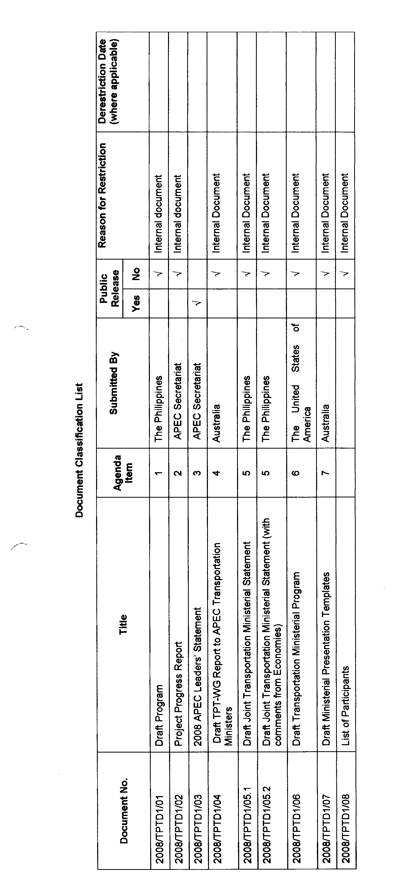
A-18

