

MASTERE SPECIALISE

AERONAUTICAL MAINTENANCE

END OF STUDIES THESIS

Return of Experience:
Improvement of FFRAS
(Flight Fault Report Analysis Software)

CHEN YING-CHANG

2009

ABSTRACT
Aircraft have embeded capacities for detection of failures. The failures are recorded and then extracted after flight.

The technical teams use the data collected:
-Immediately, for maintenance needs in order to recondition the plane before another flight.
-Later on, in order to realize a statistical analysis of the fleet behavior.

FFRAS tool briefly supports these two aspects.
The trainee will identify the evolutions of the tool for a more complete exploitation of the recorded maintenance data. He will analyze the needs of the maintenance teams, using their knowhow and their feedback to suggest:
-Assistance with the analysis of the flight,
-Capitalization of the return experience,
-Propose modification of the operating interface,

He will put forward new aircraft information to be recorded if necessary.

A hypothesized FFR database (46 aircrafts, 14582 flights, and 4 years of activities) is provided to validate the working hypothesis.

The internship had two main phases:
- Phase 1: Familiar to the operation of the system and existing data base, and try to find out inconvinient operating procedure according to the maintenance staff experience.

- Phase 2: Feedback user experience to upgrade operating procedures, interface, functions, and increase system efficiency.

Key Words: Flight Fault Report – FFRAS – Maintenance experience – efficiency – evolutions – feedback – modifications.

ACKNOWLEDGEMENTS
Thanks of highly improvements of aeronautical technology, transportation became easier and easier. Learning in abroad is not a dream far away. As a foreign student, it was a great honour to study in the Toulouse ISAE School. This engineering palace, established in the greatest aeronautical area of Europe, provided a high level teaching which enabled me to more deeply explore the profession of airframe manufacturer. I want to thanks all the professors who give me amazing aeronautical knowledge during this period.

Mr. Jean Yves BRET, who is Dassault on Site Customer Support Leader, encouraged me to major in this master course. Mr. Gilles YTIER, who is a Mirage 2000 Maintenance Officer and Technical Adviser, tought me many fleet managing skills. During their staying period in Taiwan, they inspired my wish to study in France.

Madam Marie Francoise, who was ASTAC system technical adviser in THALES, I was tought by her since 2001. Nowaday I often invited to visit their house in Neauphle le chateau. Madam Dorodee, who is my French teacher, gave me the foundation of French before entering school. She made me involved into French life quickly.

Secondly, I would like to express my gratitude to my tutor Mr. Georges CROS, supervisor Walter TURCO, manager Brahim BOUCHAIB, technical assistance Christian TERRIER, who all gave me appropriate help during my internship. They provide me helpful discussion in technical scope and design concept.

Furthermore, I would like to express my special thanks to all administration support team member in IAS and Dassault Aviation. Mr. Didier FERIOL and Mr. Marc PRIME covered all the staff in Toulouse and made me can concentrate on courses. Mr. Rachad CANELLI, Patrick CORBILLON, Patrick MADALAINE and Miss. Lisa SANTORO who assists me in Paris daily life. I have to say French people are always gental and kind.

In addition, I would like to express my special thanks to my superior Colonel Jason Lee and Stephane Chao, who helps me during application; Lt. Colonel Dominique Hsu ,Lt. Colonel Allen Chang and Major Abel Yu, who inspires me some creative ideas of improvements; Major Gian and Master sergant Wang in WDNS system who provides me O/L maintenance experience.

Finally, I am thankful to my friends Chao-Ting and Chinwen Wang, they help me to translate French manual into Chinese; my best friends Jing-Song Guo and Xian-Yi Yang who helps me to pass the difficult period in Paris; my dear wife Hsin-Yi Liu and our new baby always give me unfailing and loving support.

The thesis is for my mother in the heaven.

TABLE of contents
1. INTERNSHIP OBJECTIVES 11
1.1 Subject 11
1.2 Internship context 11
1.3 Subject description 11
1.4 Internship steps 11
1.5 Remark…………………………………………………………………………………............12
2. Abbreviations 13
3. Definitions 14
3.1 Auxiliary Unit (AU) 14
3.2 Depot Level (D/L) 14
3.3 Electrical Flight Control System (EFCS) 14
3.4 Failure Count (FC) 14
3.5 Flight Fault Report (FFR) 14
3.6 Flight Fault Report Analysis Software (FFRAS) 14
3.7 Flight Hours (FH) 15
3.8 Flight Hours Equipment (FEH) 15
3.9 Ground Status Report (GSR) 15
3.10 Head Down Display (HDD) 15
3.11 Health Usage Monitoring System (HUMS) 15
3.12 Intermediate Level (I/L) 15
3.13 Logestic Information Management System (LIMS) 15
3.14 Moyen Exportation des Compte Rendus de Vol (MECRV) 16
3.15 Mean Time Between Failure (MTBF) 16
3.16 Mean Time between Unscheduled Removal (MTBUR) 16
3.17 Maintenance Tracking Number (MTN) 16
3.18 No Fault Found (NFF) 16
3.19 Organizational Level (O/L) 16
3.20 Supply Chain Management (SCM) 17
3.21 Turn Around Time (TAT) 17
3.22 Technical investigation 17
4. Dassault Aviation 18
4.1 Group profile 18
4.2 Dassault Aviation Group 19
4.3 Site location 20
5. FLIGHT FAULT REPORT 22
5.1 Principle of generation of FFR 22
5.2 Description of FFR 22
5.2.1 Structure 22
5.2.2 Timing 22
5.2.3 Limitations 22
5.2.4 Types of failure associated with FFRTypes of failure associated with FFR 23
5.3 Definition of FFR recording phase 23
5.3.1 FFR recording phase 23
5.3.2 Takeoff time recoding 23

5.4 Principle of generation of GSR 24
5.5 Description of GSR 24
5.5.1 Structure 24
5.5.1 Types of failure associated with GSR 24
5.6 Definition of GSR generation phase 24
5.7 Generation of Maintenance Report 24
6. FFRAS STANDARD 25
6.1 FFRAS background 25
6.2 Purpose and Objectives 26
6.3 FFRAS Functions 27
6.3.1 Chapter 1 – User management (Security) 27
6.3.2 Chapter 2 – FFRAS Access (Protection) 27
6.3.3 Chapter 3 – Main menu 27
6.3.4 Chapter 4 – Flight files list 27
6.3.5 Chapter 5 – Flight analysis 28
6.3.6 Chapter 6 – Global analysis 32
6.3.7 Chapter 7 – Parameters 36
6.3.8 Chapter 8 – Utilities 36
6.4 Focus on FFRAS Chapter 5 and 6 36
6.4.1 Purpose of Chapter 5 and 6 37
6.4.2 Benefit of Chapter 5 and 6 37
6.4.3 Drawbacks of Chapter 5 and 6 37
7. Improvement of ffras 38
7.1 Purpose of the improvement 38
7.2 Improvement methods 38
7.3 Proprosed improvement details 39
7.3.1 Data transmission way improvement 39
7.3.2 Change the Date Storage time 39
7.3.3 Automatic timer conversion 39
7.3.4 Create “Failure Type” 40
7.3.5 Increase “User feedback” function 40
7.3.6 Modify data expression way by “Persentage %” 41
7.3.7 Add “Serial Number” tracking function 44
7.3.8 Give assistance to maintenance crew 45
7.3.9 Increase “Status” to display aircraft condition 45
7.3.10 Repair time estimation 45
7.3.11 False alarm judgement 46
7.3.12 Reliability Cauculation 47
7.3.13 Repeat Failure Monitoring 47
7.3.14 Spare Part Estimation Index 48

8. EXAMPLE (RDY system) 50
8.1 Analysis 50
8.2 Feedback 51
9. CONCLUSIONS 52
9.1 Conclusions related to ATA spec 2000 (chapter 11) analysis 52
9.2 Conclusions related to Data Mining 52
9.3 Conclusions related to the internship 53
10. Bibliographical references 54
11. appendices 56
11.1 APPENDIX 1 : FFRAS usage condition compare to fighters 56
11.2 APPENDIX 2 : Use of Maintenance Reports 57
11.3 APPENDIX 3 : FFR Recording Phase 59
11.4 APPENDIX 4 : Generation of Maintenance Report 60
11.5 APPENDIX 5 : ROCAF REAL EXAMPLE ORINGINAL REVERSION 61
11.6 APPENDIX 6 : ROCAF REAL EXAMPLE AFTER SORTING 70
11.7 APPENDIX 7 : SUMMARY OF ROCAF REAL EXAMPLE 79

INTERNSHIP OBJECTIVES

Purposes
The purposes of this thesis are:

-To familiar the system with the hope to improve the efficiency by the maintenance staff concept.

-To utilize ROE (Return of Experience) and to make system interface friendly.

-To shorten the maintenance time thanks of utilization of improved FFRAS.

Internship context
The trainee has been in the Dassault-Aviation plant located in Saint Cloud, France (near Paris) for six months.

Subject description
The internship will focus on the feedback of maintenance staff concept in the frame of software interface improvement. The software program design will not be discussed. The trainee will first analyze the basic data base provided by Dassault-Aviation (46 aircrafts, 14582 flights, and 4 years of activities). Compare the data with the maintenance management method used by Airforce of Taiwan, and find out the inconvenient operation of FFRAS. Those inconveniences will be modified or improved in order to match the customer requirement, constraints or benefits.

Then, the collected real ROCAF data will be introduced by the trainee, to improve the difference between document and the confirmed failure.

In the last phase, the entire operating interface will be modified to friendly for the maintenance staff’s sake. By this way, we can save the time for reading documents and discussion.

The author has been serving in the airforce over 12 years, after serving in the flight line service, the test bench workshop, the maintenance administration center and various positions, he wishes to combine fleet management and maintenance experience to improve this software from designer orientated view to user orientated angle.

Internship steps
Phase 1: Study the software.

- Familiar to the operation of the system and existing data base.
- Analyze the failure cases inside the data base.
- Develop the failure mode with profile generated by built-in function “Graphic analysis”.
- Compare the drawbacks, benefits, completion level, and applicability with real requirement from maintenance staff.
- Propose modification of software to match user’s requirements.

Phase 2: Propose recommendations.

- Introduce percentage to describe failure distribution from the data base and provide basic ideas of failure type to the maintenance staff.
- Propose “User feedback” column to collect confirmed failure data to enhance the identification between false alarm and real failure.
- Add “serials number” of equipment to track specific failure items and to calculate equipment reliabilities.
- Find examples to describe possible false alarm, and sort it by different level in various colors to increase efficiency (in trouble-shooting).
- Modify the data transmitting time avoid in case of MC failed.
- Change design concept from “passive” to “initiative”. Provide the necessary information before demand. And give the option for crew to choose instead of setting.
- Provide “recent status” to help crews know more about history to specific item. Before doing maintenance, it is better to have a global view of the item.
- Study the possibilities of merges the FFRAS with original LIMS system to get more logistic support information.
- Study the possibilities of combining multi-function parameters.
- Increase “Non interchangeability“. FFRAS is too easy to be replaced by man-made. We need to increase its additional values.
- Provide “repair time estimation” to help crew manage schedules.
- Cancel the complex procedure. Intergrate the filter setting function with system itself. Just like the excel software.
- Provide calculation of reliability, spare parts requirements, and time conversion.
- Provide a “repeat failures monitoring” function.
- Make a statistic and analysis of “Failure Types”

Remark
Since we try to improve this software, all the software modification will not consider as cost when we want to compare advantage and disadvantage. It is necessary to be done.

Abbreviations
- AU: Auxiliary Unit
- D/L: Depot Level
- EFCS: Electrical Flight Control System
- FC: Failure Count
- FFR: Flight Fault Report
- FFRAS: Flight Fault Report Analysis Software
- FH: Flight Hours flown by the aircraft
- FHE: Flight Hours flown by the Equipment
- HDD: Head Down Display
- HUMS : Health Usage Monitoring System
- I/L : Intermediate Level
- IFR : Internal Failure Report
- LIMS : Logistic Information Management System (Taiwan)
- LRU: Line Replaceable Unit
- LRURR: Line Replaceable Unit Removal Record
- MCC: Maintenance Control Center
- MMI: Man Machine Interface
- MECRV: Moyen Exportation des Compte Rendus de Vol
- MTBF: Mean Time Between Failure
- MTBUR: Mean Time Between Unscheduled Removal
- MTN: Maintenance Tracking Number
- O/L: Organizational Level
- QPA: Quantity Per Aircraft
- QCO: Quality Control Office
- ROCAF: Republic Of China Air Force
- ROE: Return of Experience
- SERPAM:
Système d'Enregistrement et de Restitution des PAramètres de Mission
- SMW: Status and Mode Word
- TAT: Turn Around Time
- URC: Unscheduled Removal Count
- WDNS: Weapon Delivery Navigation System

Definitions

Auxiliary Unit (AU)
Auxiliary Unit plays the main role in missile data-link system. In 2001, the AU failure rate increased rapidly within 6 months, manufacturer found the welding manner applied on oscillating crystal caused failure after technical investigation. Because AU installed in high vibration zone, improper welding has high probabilities to lead to failure.

Depot Level (D/L)
The Depot Level (D/L) is the maintenance level located in a factory which may belong to the Original Equipment Manufacturer or to a certified repair agent.

Electrical Flight Control System (EFCS)
The Mirage aircraft has a redundant fly-by-wire automatic flight control system, providing a high degree of agility and easier handling, together with stability and precise control in all situations. The fighter's airframe is naturally unstable, and so it is coupled with FBW commands to obtain the best agility; however, in override mode it is still possible to exceed a 270 deg/sec roll rate and allows the aircraft to reach 11 g (within the 12 g structural limit), instead of 9 g when engaged. The system is reliable with no known losses due to its failure.

Failure Count (FC)
Some failure is temporary exist and could be reset or ignored. Besides this kind of failure, all the failures which are confirmed by O/L or I/L belong to Failure Count. FC is used to separate real failure and false failure. The failure count will affect logistic support requirement.

Flight Fault Report (FFR)
Main computer will keep monitoring all the equipments which are connected to digital bus during the flight, if the dialogue between main computer and equipments become abnormal, main computer will memorize (record?) the phenomenon and transfer it into digital code according to the equipment and failure part. Twenty seconds after landing, the main computer will send all the records to mass memory. It is called Flight Fault Report. Compare with GSR, FFR is mentioning the failures which are happened during flight.

Flight Fault Report Analysis Software (FFRAS)
Developed by Dassault Aviation, which is used to collect FFR and provide stastics, global analysis, and graphic analysis functions. It helps maintenance staffs carry out trouble shooting and fleet behaviour study. It is the target that trainee tries to improve.

Flight Hours (FH)
Flight hours normally indicate the hours flown by the aircraft. If it is not special mentioned, it means the aircraft’s flight hours.

Flight Hours Equipment (FHE)
Due to fleet management or special requirement, equipment will be exchanged or switched between aircrafts. It causes flight hours of equipments to differ from aircraft. To calculate MTBR or MTBUR, we need FHE instead of FH.

Ground Status Report (GSR)
Unlike FFR, GSR displays the failure condition collected during ground test. Although the name and phase are different from each other, but the contents are similar.

Head Down Display (HDD)
Mirage 2000 equips 5 displays for pilots. They are HUD (Head Up Display), HD (Head Display), HDD (Head Down Display) and 2 LD (Lateral Display). After the aircraft lands, the FFRs will be displayed in HDD after ground maintenance staff demanded.

Health Usage Monitoring System (HUMS)
HUMS is developed for RAFALE aircraft. It can collect more parameters at the same time. Not only limited in FFRs. The multi-parameters collected by HUMS help in fleet administration and maintenance scheduled management a lot.

Intermediate Level (I/L)
The Intermediate Level (I/L) is the maintenance level located in a shop which may belong to the end user (Airline, Air Force…) or to a certified service station.

Logestic Information Management System (LIMS)
LIMS is developed by ROCAF itself. It is used to collect all the relative parameter of aircraft. Because database is huge, the system is divided into several modules. Each module is responsible for certain specific tasks. But all the data inside the module could be used in common. Even the aircraft changes its position; the maintenance officer can know that through this system. We can say almost all the maintenance jobs are included in this system. The system will give maintenance officer alarm to indicate them a scheduled maintenance is approaching. Every failure will be registered in system and be distributed to corresponding specialists. After confirmation, repairing, filling up records, the status of failure will be changed, and then be saved into database.
MCC and QCO use this system to manage unscheduled maintenance, periodical inspection and produce monthly reports.

Moyen Exportation des Compte Rendus de Vol (MECRV)
MECRV is the French words of FFRAS.

Mean Time Between Failure (MTBF)
The Mean Time Between Failure (MTBF) is the mathematical expectation of the failure times.
The general mathematical expression of the Mean Time Between Failures is:
$$\text{MTBF}=E(t)=\int_{0}^{∞}{t\text{.}d(t)\text{.}\text{dt}}=\int_{0}^{∞}{R(t)\text{.}\text{dt}}$$

Mean Time between Unscheduled Removal (MTBUR)
The Mean Time Between Unscheduled Removal is, for a given equipment type, the average of the times between equipment removals.
Unscheduled removals mean that all scheduled removals are not included. A scheduled removal is typically motivated by:
- a modification
- a planned maintenance action (visit, overhaul, verification)
- a removal to allow access to another item for any reason
- a removal from a higher assembly to equip another higher assembly which misses the corresponding equipment.

Maintenance Tracking Number (MTN)
To track equipment failure, it needs corresponding number. Normally it is a serials number. Its official name is MTN.

No Fault Found (NFF)
A No Fault Found (NFF) situation is a scenario in which a fault is found on aircraft during or after a flight and the fault is not found again at Intermediate Level maintenance or at Depot Level maintenance.

Organizational Level (O/L)
The Organizational Level (O/L) maintenance is the maintenance performed directly on aircraft.

Supply Chain Management (SCM)
The Supply Chain Management (SCM) is the process of planning, implementing, and controlling the operations of the supply chain as efficient as possible. It spans all movements and storages of raw materials, work-in-process inventory, and finished goods from point-of-origin to point-of-consumption.

Turn Around Time (TAT)
In the frame of this internship, the Turn Around Time is the time difference between:
- an equipement removal
- and the end of its repair at Depot Level shop.
Ideally the TAT should be between the date of departure to Depot Level and the date of arrival of the equipment back at the store. However those dates were not available in the data used. The missing dates were therefore approximated by the closest available dates.

Technical investigation
A technical investigation is a thorough analysis of a failure, performed at Depot Level with specialists of the equipment. The specialists include Original Equipment Manufacturer specialists, Airframer specialists, and sometimes certification authority representatives. This thorough analysis aims at finding out the root that causes for the failure.

Dassault Aviation

Group profile
Dassault Aviation is one of the major players in the global civil and military aviation industry. It is a reasonably sized and financially secure private international group, with a presence in more than 70 countries across 5 continents. Dassault Aviation has been particularly present in the US since the start of the 1970s through its subsidiary – Dassault Falcon Jet – which has four facilities: Teterboro (New Jersey), Little Rock (Arkansas), Wilmington (Delaware) and Aero Precision Inc. (Florida).

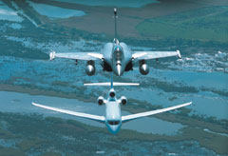

Dassault Aviation is a French group, 50.21% held by the private Groupe Industriel Marcel Dassault, which in turn is owned by the Dassault family. The other shareholders are EADS France (46.30%) and private investors (3.49%).

Dassault Aviation has been profitable ever since its creation in 1936. This secures the Company’s future through reinvestment in research and development, industrial and IT capital expenditure, the development of internal skills and commercial activities and the remuneration of shareholders and employees. The Group has sufficient cash resources available for the financing of investment activities.

Structured to adapt its production to market cycles, Dassault Aviation encompasses a rich industrial network of high-tech companies in France, Europe, the US and many countries worldwide.

Through its engineering design departments, production facilities, the skills of its employees and its product lines, Dassault Aviation offers its customers in-depth know-how, ranging from design to operations, based on strong entrepreneurial values.

Dassault Aviation Group
The Dassault Aviation Group is an international group which encompasses most of the aviation activities of Groupe Industriel Marcel Dassault.
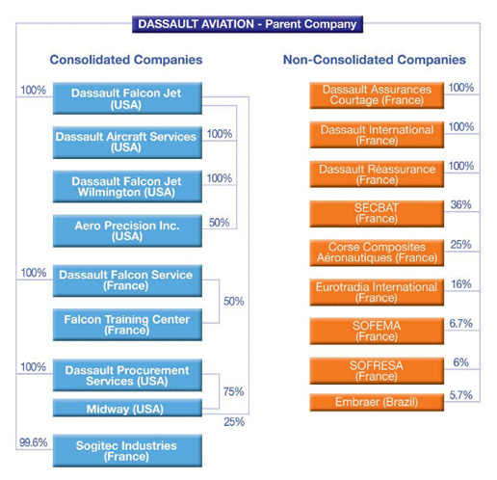

Site location

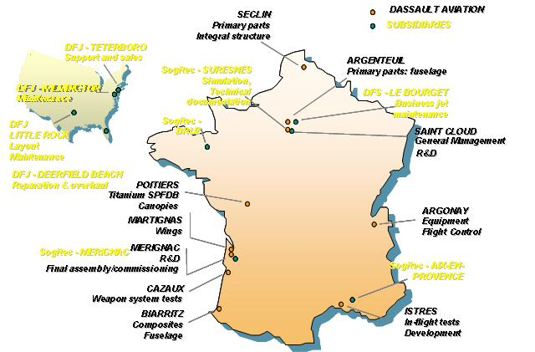

Flight fault report

Principle of generation of Flight Fault Report (FFRs)
In flight, for each equipment item, the failure bits of the SMW are permanently monitored. Any change in the stage of a failure bit (Correct→Failure, Failure→Correct) results in recording of the SMW causing this change. This record is called FFR and is timed in relation to the takeoff time.
The FFRs are stored as soon as they are generated. They are kept in storage even after the power supply is cut off and are erased only at the start of the next flight.
At the end of the mission (landing+20 seconds), a list of failed LRUs is constituted and stored.
A copy of files (FFRs + failed LRUs) is made in the mass memory.
Upon generation of the first FFR, an FFR magnetic indicator on the ground operator panel shows the failure status. Recording of the takeoff time does not cause the FFR indicator to change.
This indicator remains in this state and can only be reset by the ground operator when the mission is over.

Description of Flight Fault Report (FFRs)

Structure
An FFR consists of 4 words:
  - One word indicates the equipment number,
  - Another word indicates when the FFR was generated,
  - The other two words constitute the SMW.
(SEE Appendix 2)

Timing
The time is reset to zero at the start of the flight. The takeoff time is recorded. The FFRs are then timed in relation to the takeoff time.

Limitations
The number of FFRs which can be stored is limited to 128. For each equipment item, this number is limited to 10 (30 for the radar and the SYSTEM), regardless of the number of LRUs of the equipment item involved.

Types of failure associated with FFR
Prior to recording, the FFR is assigned a type of failure defined in accordance with the following rules:
  - If the FFR corresponds to a self-test result indicating an equipment LRU definitely isolated as faulty, it is assigned type 1. Bit D is set.
  - Otherwise, the FFR is assigned type 2 (LRU failure is not accurately isolated). Bit E is set.
  - If the FFR is resulted from the tenth failure occurrence for a given equipment item, it is assigned the saturating type (Type S). Bit D and E of SMW2 are set (these bits were kept available upon generation of the SMW).
Note: If the SMW transmits two failures, one of which is type 1 and the other will be type 2, the SMW is assigned type 1 which has priority.

Definition of FFR recording phase
(SEE Appendix 3)

FFR recording phase
The FFR recording phase corresponds to the time during the system is energized between the start and end of the flight:
  - The start of the flight: information provided by the first “U/C shock absorbers extended” signal follows the first switchover of the INU to “NAV” or “EMG” after energization of the system on the ground,
  - The end of the flight: information provided by the signal indicates “U/C shock absorbers compressed” for more than 20 seconds. This time delay allows the aircraft to remain in the flight phase during touch-and-go landing.

Takeoff time recording
Recording is made in relation to the mission start signal.

Principle of generation of ground status reports (GSRs)
The GSRs are generated to provide for display of the SMWs indicating the instantaneous status (Correct or incorrect) of each equipment item.
The GSRs are not stored, but are systematically generated on the ground as soon as the LRUs are energized.

Description of ground status reports (GSRs)

Structure
A GSR consists of 4 words:
- One word indicates the equipment,
- Another word indicates the timing set to 0. As the GSRs are not stored but used in “real time”, it is not necessary to time them,
- The other words constitute the SMW (same structure as for FFR).

Types of failure associated with GSR
The GSR is assigned a type of failure defined in accordance with the following rules:
- If a self-test assigned for which an LRU is isolated as faulty, the GSR is assigned type 1. Bit D is set,
- Otherwise, the GSR is assigned type 2. Bit E is set.

Definition of GSR generation phase
The GSRs are generated as soon as the aircraft is on the ground.

Generation of Maintenance Report (MR)
(SEE Appendix 4)

FFRAS Standard

FFRAS background
FFRAS (Flight Fault Reports Analysis Software) is the product which researched and developed by Dassault Company in 2002. Normally, Dassault Aviation will suggest the new customer to buy one set for each combat fighter squadron.

Dassault Company succeeds to sell over 600 Mirage 2000 series aircraft, and FFRAS was adopted by UAE, French Air Force, and Greece. The old type of mirage fleet is not compliable; there are still development potential and improvement space (see appendix 1).

FFRAS is good software, it equips statistic and global analysis functions. But it looks tilt to designer oriented. Therefore, the maintenance staffs prefer focus on single failure instead of studying fleet behavior. To solve this problem, the author tries to make software match users’ requirement in trouble-shooting which Includes friendly interface, obvious order, and procedures that are easy to be understood.

The problem is that it is not easy for maintenance staff to realize the design concept. The maintenance staff prefers trouble-shooting as soon as possible in order to make a study of fleet behavior. And the graphic statistics is not as attractive as locating a confirmed failure. For them, to study fleet behavior is like the duty of MCC officer.

The Dassault’s Divisional manager of design visited the French Air Force base on the spot, and discussed with the maintenance staff there. He discovered the satisfaction of the product didn’t approach the anticipation.

And the statistical analysis functions of this software have hardly been used in the behavior pattern research or during the fleet management period.

It reveals FFRAS functions are too easy to be replaced by other method, no matter manual check or software developed in local such as LIMS. In fact, most squadron did not equipped with FFRAS, and their unit still could be operated. We have to create more additional value of FFRAS.

Remark:
LIMS is logistic software which is developed by ROCAF. It collects the entire relative parameter of aircraft, Including Flight Hours, Failures, Periodical Inspection, Unscheduled maintenance…etc. The maintenance staffs also can check the aircraft’s position through the system.

Purpose and objectives
The purpose of FFRAS is to collect flight fault report, and carries out statistic analysis to obtain the expiration tendency. By analyzing this trend, it is easier to locate some specific failure equipments. By studying the tendency, we can evaluate the aircraft failure mode and the behavior pattern of the fleet.

More detailed objectives are listed here below:
- To provide flight files lists.
- To create a new FFR by manual entry or download automatically.
- To provide ground and pilot remark column to be filled in maintenance description.
- To provide flight analysis.
- To print out Flight Fault Reports.
- To show the Graphic of bit behaviour according to the time.
- To focus on certain specific aircraft, equipments, or digits with the help of “Global Analysis Function”.
- To help crews in trouble shooting by cross-check ground remarks and flight remarks.
- To provide “bits definition”.
- To show stastics of “FFRs Number per A/C”.

FFRAS functions
Flight Fault Report Analysis Software (FFRAS) is designed to collect Flight Fault Report (FFR), and try to help maintenance crew analyze the data bas easier.

For one flight, it is very easy to see what has happened. But when the time goes by, after the huge data accumulated, finding out the trend is more and more difficult. That’s why the maintenance staff needs software such as FFRAS to help them reorganize the data.

Chapter 1 – User managements (Security)
A user type forms a group of users who have the same levels of access to the FFRAS. As a result, there are three different levels to these use types that are:
- The administrators in Level 1 (High Level)
- The mechanics’ chiefs in Level 2 (Medium Level)
- The mechanics in Level 3 (Low Level)

The higher the level is and the more access permissions there are.

Chapter 2 – FFRAS Access (Protection)
  - The FFRAS is run with a protection dongle that is put on the parallel port of the computer. During the FFRAS execution, this dongle is regularly enquired.
  - The Security system form is activated each time when the FFRAS starts. It uses the security information stored in the users table.

Chapter 3 – Main menu
- After identififying of the user’s profile, the FFRAS main menu is displayed.
- If a function is not authorized for a user type, this one is grayed.

Chapter 4 – Flight files list
A flight file is composed of three distinct parts:
- A header that contains inter alia, the identity of the flight files (Number of the flight file, number of the aircraft, flight dates, the number of FFR, the flight comments…)
- The FFR that has appeared during the flight.
- The ground remarks that are attached to a piece of equipment (written down by mechanic after aircraft landed).

You can easily blank, create, and delete a FFR or use “FFR Automatic acquisition” to restore FFR into the software instead of manual entry.

If maintenance staffs have some opinions, they can write them down in “Ground remarks” column.

Chapter 5 – Flight analysis
The exploitation actually consists in analysing a flight file on any level, FFRs filters and graphs.
- Selection criteria
The multi-criteria selection enables the user to optimize the search for a flight file. Indeed, the user enters criteria that will restrict the flight files list.
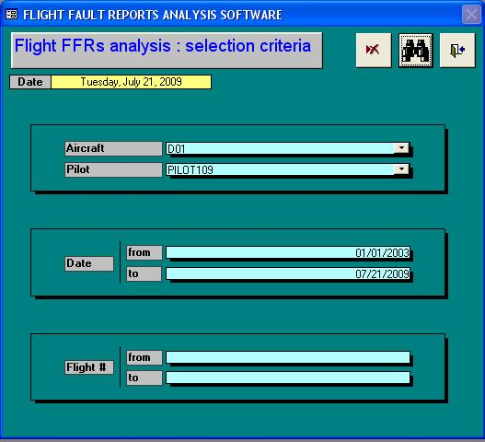

- Flight selected list
This list contains all the flights files that match the criteria given in the Flight FFRs analysis selection form. If no criterion is entered, then the list will contain all flight files of the database.
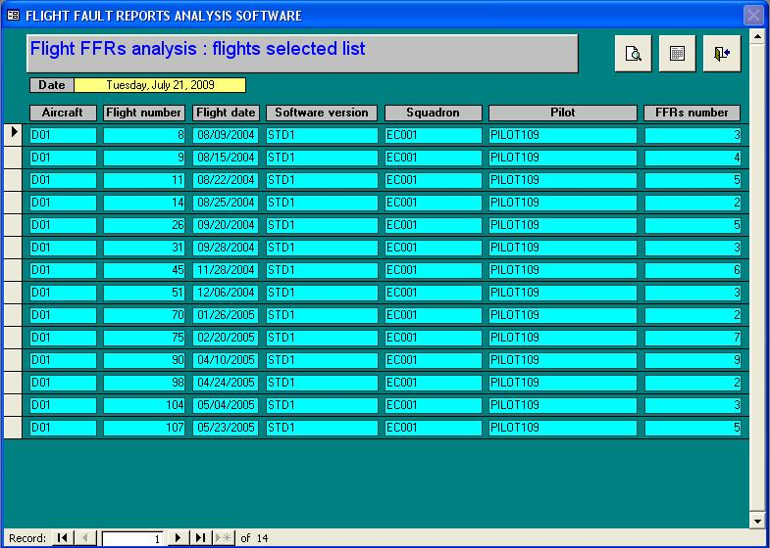
- Flight Fault Reports
This function presents the FFRs that appear during the flight. They are classified by the appearance order or by equipment. The FFRs cannot be modified.

When selecting a FFR bit, the following information concerning the FFR will appear at the bottom of the screen:
  - Failure type.
  - LRU mnemonic.
  - LRU name.
  - Bit meaning.
  - Encoding (if there is information coding on several bits)..
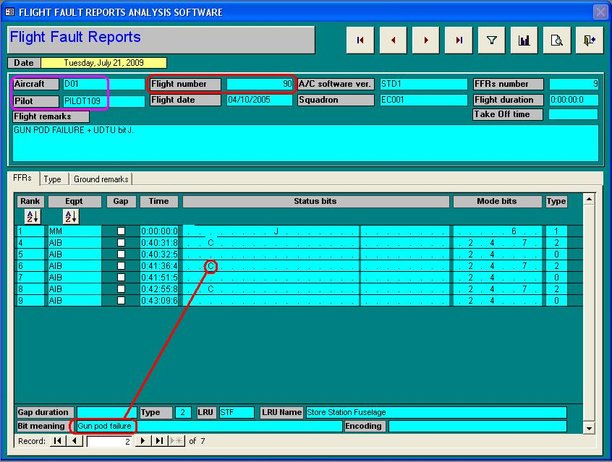

- Type of failure
The types of failure enable to display the faulty equipment according to four columns (1, 2, O, S). Types of failure are indicated in SMW 2 through bits D and E, with the following logic:
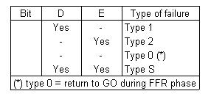

Remarks:
  - Type 1: Isolated failure.
  - Type 2: Failures except type 1.
  - Type O: Return to GO during FFR phase.
  - Type S: Saturating Type. If the FFR is resulted from the tenth failure occurrence for a given equipment item, it is assigned the saturating type (with the exception of the RADAR or the SYSTEM, for which thirty FFRs must be stored to have as type S failure status).

- Graphic selection
By choosing this function, it is possible to watch the bits behaviour according to the time.
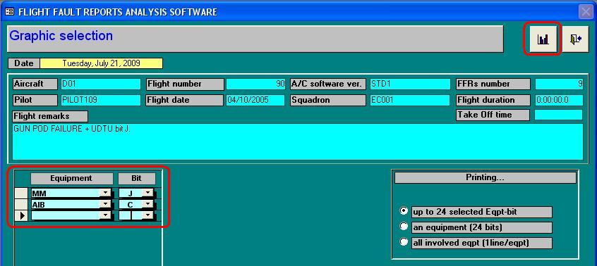

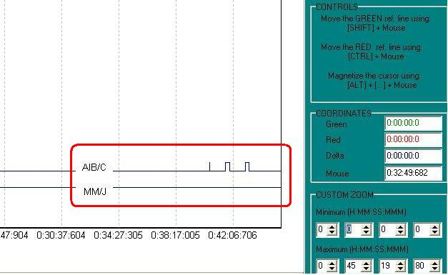

- Apply filters
Selection of a filter among those assigned to the A/C software version. This selection is done by the filter drop-down list. After choosing a filter, its criteria are recalled. But if there is no filter you need, you got to create a new filter in another module than export it to FFRAS.

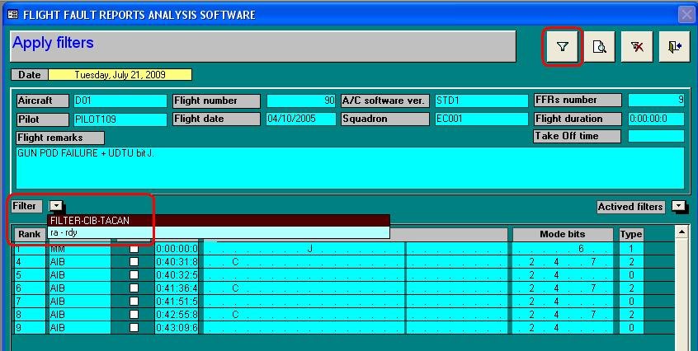

Chapter 6 – Global analysis
The analysis part enables us to deal with all the information recorded on several flight files to get back relevant information.
- Selection criteria
Criteria selection form enables us to enter the criteria that will allow us to make the wished analysis.
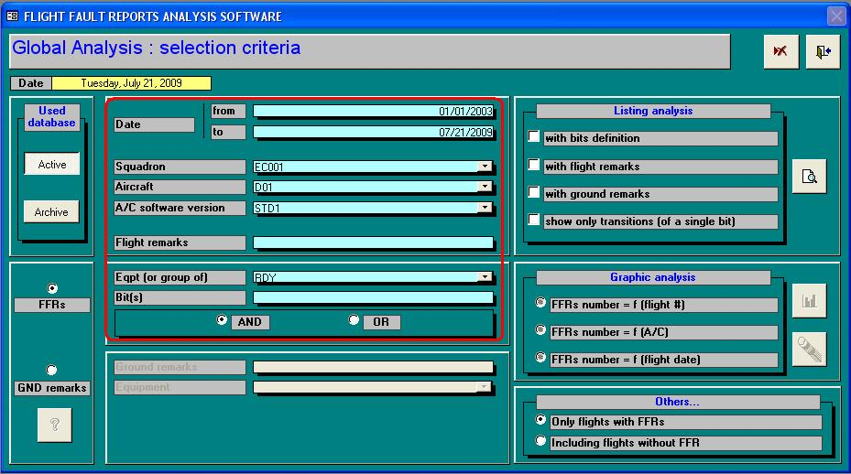

- Help in troubleshooting
It is made in the A/C software version and ground remarks parts. The “Flight remarks” and “Ground remarks” fields should be entered.

- Listing analysis
The reports are only made in the A/C software version and ground remarks parts. All analyses can be printed in following four options:
- With bits definition.
- With flight remarks.
- With ground remarks.
- To Show only transitions (of a single bit).

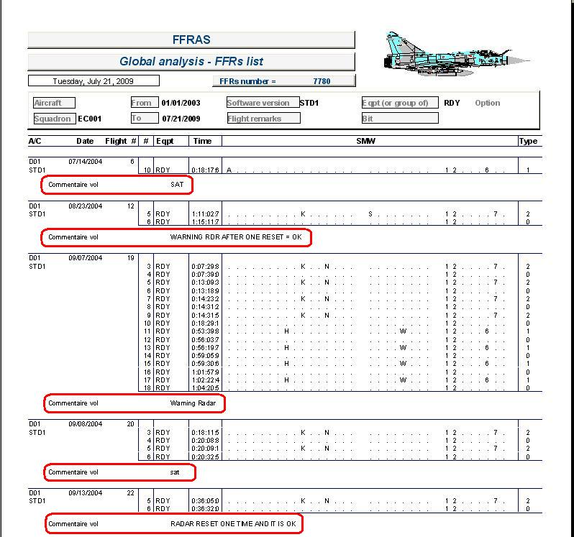

- Graphic analysis
The Graphic analysis is only made in the A/C software version and ground remarks.

The graph obtained will looks like as follows:
Graphic Setting
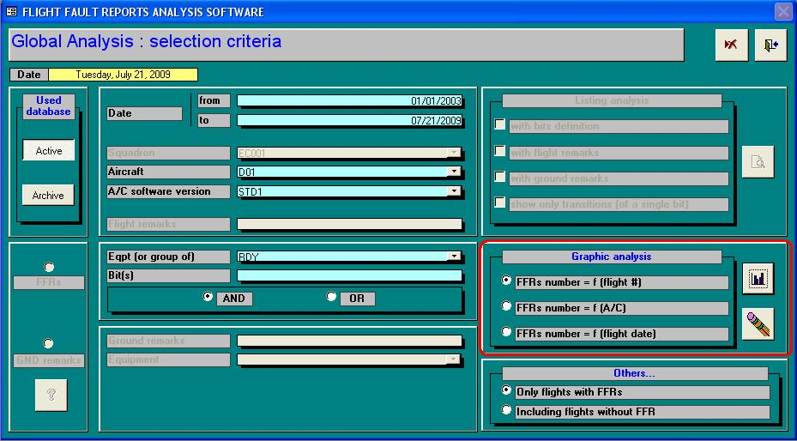

Graphic Analysis1 (by flight):
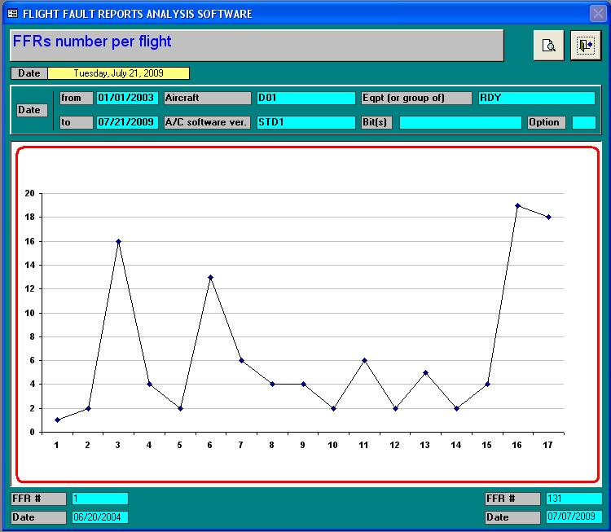
For each aircraft, display the average number of FFR per flight.
  - For one piece of equipment or one bit.
  - For a group.
  - For all the groups and all the equipments.
  - For a squadron.
  - For all the squadrons.
  - For a given duration of time.
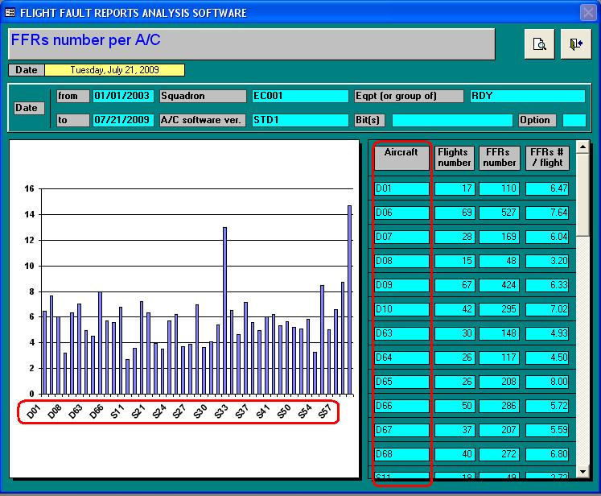
Display the average number of FFR per flight and per aircraft, grouped by weeks:
  - For one piece of equipment or one bit.
  - For a group.
  - For all the groups and all the equipments.
  - For a squadron.
  - For all the squadrons.
  - For a given duration of time.
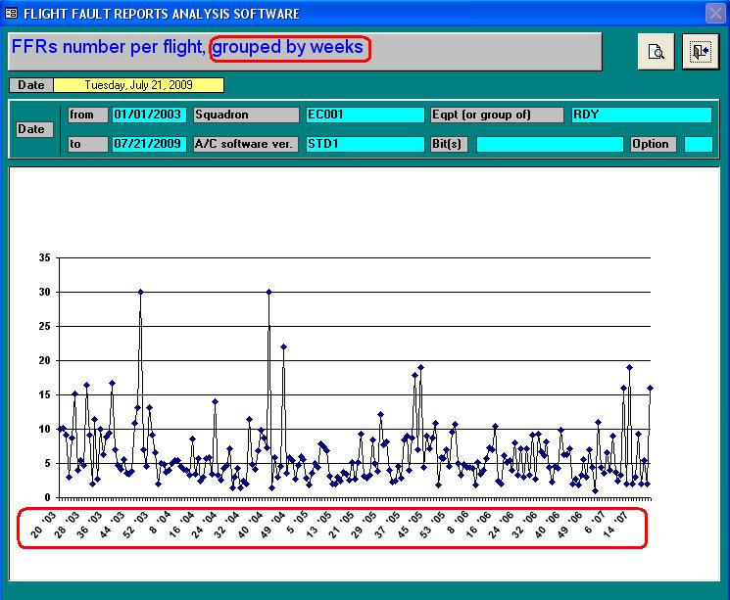

Chapter 7 – Parameters

The parameters form gathers the various parameters that are regularly used.
From this form, it is possible to:
  - Manage the squadrons.
  - Manage the aircraft.
  - Manage the pilots.
  - Import an A/C software version.
  - Consult the A/C software dictionary.
  - Import filters.
  - Assign filters to one or more A/C software versions.

Chapter 8 – Utilities

The Utilities function enables to carry out exceptional tasks.
By using the tools presented in the Utilities Form, the user will be able to carry out the following functions:
  - Database backup.
  - Database restores.
  - Flight files export.
  - Flight files import.
  - Local settings modification.
  - Flights files archive.
  - Flights files unarchive.
  - Database compaction.

Focus on FFRAS Chapter 5 and 6

Purpose of Chapter 5 and 6
Each day, thousands of flight fault report data are collected manually in the airforce base all over the world. Unfortunately, most of them were recorded on the paper only. As the time accumulated, analysis task will be more and more difficult and insufficient. FFRAS is designed to help maintenance staff to simplify the problem and decrease the wasted time. And main functions are located in chapter 5 and 6.

Benefit of Chapter 5 and 6
Thanks to data base collected from the daily flights during long period, these two modules can help user shorten the analysis time. It provides graphic profile which can easily show the failure trend and equipment behaviour mode.

Drawbacks of Chapter 5 and 6
The operating interface could be friendlier. Showing the important information without demand is always welcome. Maintenance staff is not necessary to search information again in the setting. For example, to check what the meaning of this digit is.
Failure probability could be modified to displayed in the “percentage %” way. Compared with a lot of data, it is easier for the users to understand the long story within a very short time and gives them the direction for trouble-shooting. There is no “user feedback” function for FFRAS. Each result should be a new foundation to update and enhance the database.
This software doesn’t provide “serial number” tracking function; therefore, it is not good to use the software to track some specific equipments.
“Filter” setting procedure is also complex; therefore no one is interested in using it.
FFRAS emphasize on “Flight fault report” collection function which is could be upgraded to collect more parameters.

iMPROVEMENT of FFRAS

Purpose of the Improvement
We suppose this software will be used in an Air Force organization. Maintenance staff there only concern about one thing: When can I finish the work? It means they need a powerful tool to help them to locate the failure as soon as possible. By this way, they can save the time on searching for answers and invest it on replacement and testing.

The complex statistics system which can reveal the fleet behaviour or equipment failure trend is very amazing, but will not attract their attention. In fact, this function is only used by some officers in QCO and MCC. They use this function to produce monthly analysis report. And unfortunately, many countries have similar system already. For example, ROCAF developed LIMS by themselves.

My work is focus on the modifications of chapter 5 and 6 of the FFRAS.

There are three main targets should be reached:
  - Making good use of database.
  - Helping maintenance crew to shorten the trouble-shooting time.
  - Createing a friendly operating interface.

We all know that data without being reorganized are trash. So, to make database more efficient becomes a main topic. It could be reached through a well-designed processing way and format, such as serial number and user feedback column.

The time that the maintenance staff spend on searching for answers is no longer necessary; as all the needed information will be provided beforehand.

The operating interface will be friendlier, easier to understand, easier to operate, and the setting will be less complex.

The experience of R.O.C’s Air Force will be a good example to improve:
  - Users’ feedback
  - Accuracy of documentation
  - Reliability of Data base

Improvement methods
The improvement is based on following:
  - Software users’ experience.
  - O/L maintenance requirement.
  - Fleet management experience.
  - Aeronautical knowledge learned from ISAE-SUPAERO.

Proposed Improvement details (following the time sequence)

Data transmission way improvement
There are two ways to obtain FFR after flight.
First one is read directly from HDD in the cockpit of aircraft. But the aircraft will not just stop in front of maintenance hanger every time. So, it takes time to collect people, assign task, wait for transportation, send crews go and back, energize the A/C, sign the maintenance book, etc. Normally, it takes over one hour or more.
Advantage: Without transfer.
Disadvantage: Time-consuming on preparation.

Another way is to download FFR through Mass Memory Cartridge (Greece and Abu Dahbi) or SERPAM PCMCIA card (FAF and ROCAF); it depends on the aircraft type.
Advantage: No need to prepare, directly download.
Disadvantage: Spend time to wait for cartridge. And SERPAM is classified equipment in ROCAF.

Improvement proposed: Transmit FFR by Wifi.
Advantage:
-Matured skill, it has already applied in ASTAC POD and AIRBUS A/C.
-Maintenance crew will get information before A/C landing, they can diagnosis the failure condition, even can apply for spare part in advance.
Disadvantage: Additional modification cost of whole system.

Change the Date Storage time
FFRs will be collected during the flight and transfer to Mass Memory at 20 seconds after landing (to avoid Touch-Go condition). If the MC failed before landing, all the FFRs which are saved temporary inside the MC won’t be extracted forever.

Proposed solution is changing design. Ask MC sent the FFRs to Mass Memory periodically and save it.

Advantage: Even the MC is failed, we still can extract FFRs from Mass Memory, it helps trouble-shoot and make sure maintenance tasks will not effected by MC failure.

Automatic timer conversion
Normally, the FFRs will be saved in memory inside the MC (Main Computer). But in case of MC failure, there is no more FFRs could be downloaded from it. We have to send MC into ATEC workshop in I/L to download IFR data. Unfortunately, the time in IFR is recorded in hexadecimal; it’s not easy to transfer it into decimal manually.

Each time while maintenance staffs encounter this kind of failure, it always takes time to decode the data. They have to transfer it from hexadecimal to decimal, then times 0.16 to match time cycle inside the MC, and finally divide the value by 60 to get real time. Each time while maintenance staffs happen to this failure, it always takes time to decode.

Proposed solution is adding “Automatic timer conversion” function.
Advantage: To shorten the maintenance time.

Create “Failure Types”
Without this software, maintenance crews need to check documentation to obtain the meaning of each digit of FFR.

With this software, we can even reach this requirement by moving cursor on each digit. But it is still not enough.

The system could be smarter. It should tell us the historical information.
Although there are millions of combination, but only few of them are redundant.

For example, there are 315 radar system failures in ROCAF Hsin-Chu Airforce base. But there are only 50 “types”. To create “Failure Types” can identify the failure easily without checking documentation or setting. As soon as the system catches the FFR, it can compare “Failure Types” with database, then tells what’s the solution is according to the accumulated results. It is very useful for crews to have a basic understanding for the history—such as whether there is the same failure before, how many times? What equipment has been changed to repair this failure, or is it the only one solution or we have another choice?

Proposed solution is adding “Failure Type” function.

Depends on the importance of failure, maintenance crews can decide to create a new failure type which will be added to the library in database. Basically, all the new generated failure should be added into “Failure Types” list by default to complete the database.

Advantage: To provide speedy diagnosis for first step.
Disadvantage: No.

Increase “User feedback” function
The original system can only receive date passively. It lacks of the ability to track the maintenance results. It only knows all the flight fault reports during the certain period, but it never knows what the real problems are to cause the fault. No matter it is a confirmed failure or a false alarm. So, the system becomes a purely data collector, it still needs human intelligence to locate the failed equipment.

Proposed solution: adding “User feedback” function

As soon as maintenance staffs download a “FFR”, they have to follow the maintenance until the A/C recovery. During the maintenance period, the failed equipment will be confirmed by I/L or O/L itself. Sometimes the failure is just a false alarm. No matter what the result is, maintenance staffs have the responsibility to fill the result in the “User feedback” column.

After that, the system will accumulate all the maintenance records in the database.
Next time when the FFR is downloaded, the system will automatically inform the user how many times it has happened before and what the solution to the problem was.

The “User feedback” function is composed by a drag-down list which contains all the possible equipment in certain system such as radar. Another options as below will allow database to collect more information:
-Failure confirmed by O/L
-Failure confirmed by I/L
-Non-confirmed failure
-Match failure
-Not-match failure
-Total repair time

The option confirmed / non-confirmed is used to describe doubted equipment that is confirmed or not.
The option match / not-match is used to describe doubted equipment that matches description of documentation or not.

Advantage: To Integrate maintenance results into database, and provides global concept of this FFR.
Disadvantage: No.

Modify data expression way by “Percentage %”
No matter you choose “Flight analysis” mode or “Global analysis” mode, the only thing you will get is a list of record. You have to choose one of them to go deeper to see what happened of the certain aircraft or equipment.

“Flight analysis” mode
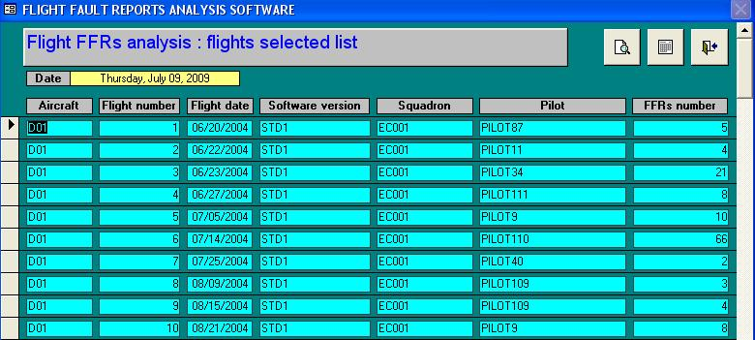

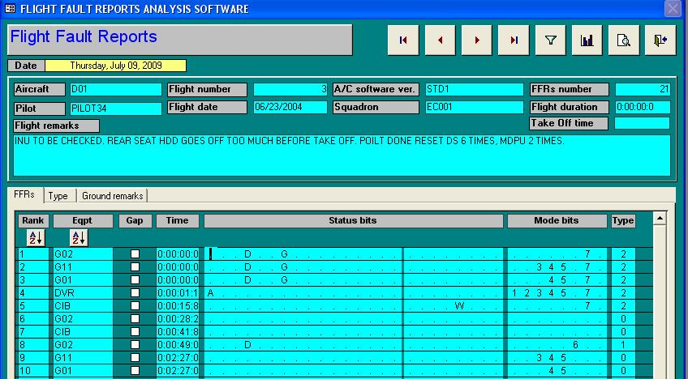

“Global analysis” mode
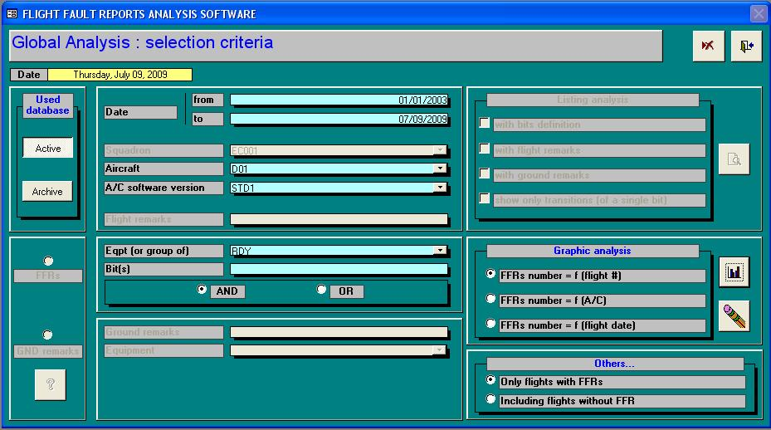

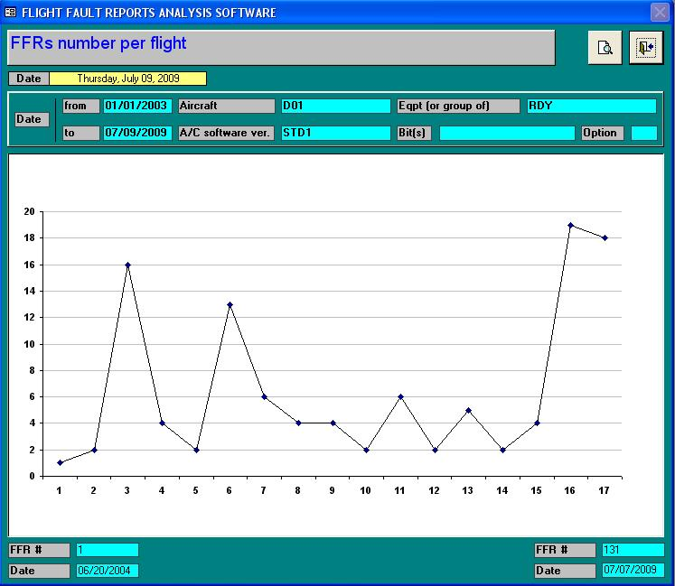

It belongs to one A/C or equipment; it shows the variation of FFR number with time. You can see how many FFRs happened during this period. But there is no relationship between this time and last time.
It can not reveal the positioning of this failure in the whole database. Maintenance staff can not realize the probability of this failure.

Proposed solution is adding “Percentage %” function.

First, we need to compare FFR with “failure type” which is introduced in 7.3.2.

Then the system will show us how many times the same case happened before according to the aircraft number, date period, and maybe pilot’s name (sometimes pilot’s control habit will effect the failure in some specific case) you choosed.

Compare the “user feedback” result which is introduced in 7.3.3 with the total failure amount, you will get probability distribution of this specific type failure.

Advantage: System database gives instruction to maintenance staff according to the user feedback. Because the user feedback is composed by failure solutions, it saves time to repeat failure diagnosis.
Disadvantage: No.

Add “Serial Number” tracking function
As the same figure with last case, we can find “FFR Number per flight” profile of A/C D01 in certain period. The problem is that these FFRs do not always be related to the same equipment. Because of spare part shortage, sometimes maintenance staff is obligated to switch or exchange equipment for higher technology. If without the serial number or MTN of the equipment, all the FFRs will be counted as the same one. You have no method to sort them out, unless introducing a “Serial number” tracking function.

Based on ROCAF maintenance experience, the author found some equipment will be failed in some specific configuration. Maybe when the specific equipment was installed in some specific aircraft or composed with specific items. In the monthly report of QC, the author and his colleagues found some special cases, even when they sent those cases into I/L workshop, the test bench still judged those cases were in good condition. Technical assistance suggested the author to do tests on the aircraft. Therefore, it is necessary to keep tracking the serial number of each equipment.

Proposed solution is adding “Serial Number” tracking function.

Advantage: Failure profile will be more precise. Some specific items which often cause strange failure will be located.
Disadvantage: No.

Give assistance to maintenance crew
Since there is the failure probability distribution, the system can give assistance to maintenance crew automatically through a well designed instruction as below:
  - Total number of same failure happened before
  - Main failure causes (displayed in percentage %)
  - Second failure causes (displayed in percentage %)
  - Other failures cause (displayed in percentage %)
  - Serial number tracking (if same item has the same failure before)
Advantage: Even an un-experienced maintenance staff will be able to follow the instruction to locate failure.
Disadvantage: No.

Increase “Status” to display aircraft condition
When maintenance staff try to repair a failure, it is good for him to realize the aircraft condition. Thanks to the improved database, it can provide following informations:
  - Total flight hours of aircraft (FH)
  - Total flight hours of equipment (FHE)
  - The numbers of take off
  - The numbers of landing (including touch-go)
  - Average flight hours
  - Failure rate
  - Failure system distribution
  - Total maintenance time
  - Average maintenance time sorted by system

Advantage: To provide a global view of whole condition of an aircraft.
Disadvantage: No.

Repair time estimation
Maintenance task is complex and involves many scopes. However, human power and supporting resources are limited. It is necessary to arrange maintenance tasks well.

Proposed solution is adding “Repair time estimation”.

Based on the information collected from users’ feedback, we can know the following:
  - Repair time for each failure
  - Total repair time for specific failure
  - Average repair time for specific failure

We will get a “repair time estimation” according “average repair time for specific failure” ±5%.

Advantage: To provide an estimated time to manage maintenance schedule. And it is a very important value to modify working hours.
Disadvantage: No.

False alarm judgement
The total FFRs number per flight is not always equal. From the statistic profile, we can easily tell that some FFRs are meaningless. For example, the average FFR number is 2; in this case FFR which happened only once could be ignored. But there is no such function in the software.

Maintenance staffs still have to download and check all the system to make sure the aircraft is in good condition.

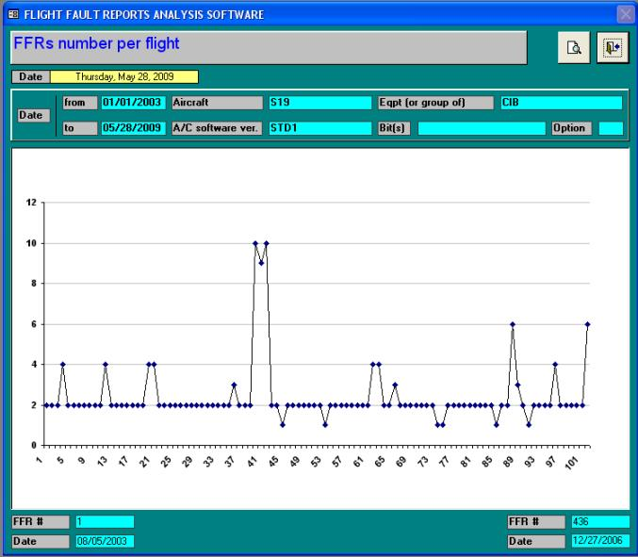

Proposed solution is adding “False alarm” detecting function.

The system can calculate the average of FFRs number per flight. Normally, the average FFRs number means a standard. If FFR is equal or less than the average, it means that the FFR could be ignored. But in order to avoid making a mistake, we proposed to flag it in amber color. Maintenance staff still to check it and determine is it belong to false alarm.

This deduction will be proved through “user feedback” function which is introduced in 7.3.3.

Maintenance staffs can focus on the FFRs number which is higher than the average when the time is limited or not sufficient.

Advantage: To downgraded the failure level..
Disadvantage: No.

Reliability Calculation
When maintaining a system, there are some reliability values provided by the manufacturer such as MTBF. But during the maintenance period, there is no tool or convenient method to verify it.

Thanks to the “Users’ Feedback” function; a database can be established. The database contains “Confirmed failure” and “Unscheduled Removals”. By this way, the system can provide the maintenance staff a function which displays some important values such as MTBF and MTBUR.

Even though, the value is not 100% accurate due to mistakes or difference. But it is a good reference for maintenance.
By comparing the values obtained from system calculation and those given by manufacturer, the maintenance staff can see the system failure is a normal phenomenon or a design defect.

When the author served in Electric Warfare Element, he found the AU failures increase rapidly within certain period. They were caused by oscillating crystal welding manner designing defect, and high vibration during flight caused the failures.
The maintenance staff noticed that a little bit late, if the system can provide this reliability calculation function, defect could be seen earlier by a comparison between these two indexes.

The Reliability Calculation will help maintenance staff to notice abnormal failure; it will also help the manufacturer to modify their design.

Advantage: To compare the reliability with the manufacturer value, we can understand the failure rate is normal or not.
Disadvantage: No.

Repeat Failure Monitoring
Some system such as RADAR has the characteristic of repeat. Same item may generate same or similar failure during short term, sometimes happen in continuously flights.
The original FFRAS can not monitoring this phenomenon, even you try to define a period to study, it is not easy to do.

Proposed solution is adding “Repeat Failure Monitoring” function.

System will look backward to compare serial number of equipment (and aircraft number) with database. Then catch out the date for definition. If same failure happened again within 5 flights after repair, then provide warning signal to crews automatically.

If the same failure happened again in next flight, it is called “Repeat 1”, flagged by yellow color.
If the same failure happened continuously twice in following flights, it is called “Repeat 2”, flagged by amber color. And so on.
If “Repeat 3” happened, failure will be flagged by red color.
Even “Repeat 4” happened; flag color will still stay in red.

Repeat failure monitoring is very important. It means the maintenance action is invalid. Even we erased the failure condition temporary, but we never find out the real failure cause. So, when the aircraft carry out mission again, the same problem will come out. Indeed, some failure has difficulity to reproduce again on ground. That’s why we must provide warning signal to crews; to remind them should check the system more precisely.

Remark:
Repeat Failure Monitoring Rules depends on each airforce base. In ROCAF, same failure is not allowed to happen again within 5 flights. But in some base, the rule is counted by “days”. User can make setting according local rules.

Advantage: To track repeat failure during a period of time.
Disadvantage: No.

Spare Part Estimation Index
Even you have maintenance crews, skill, documents and GSE, but sometimes you were obiligated to ground the aircraft when it was failed. Why?

Because of shortage of spare parts.

Average TAT of mirage 2000 serials equipments is between 12~18 months. But this is under perfect condition, sometimes delivery time will be postponded to 18~24 months due to different reasons.

So, estimate requirement of spare part precisely become very important.

Proposed solution is adding “Spare Part Estimation Index”.

Depends on failure rate during 3 months, 6 months, 12 months, and 3 years, we can provide 4 kinds of index. You can modify the index setting according to your need. These indexes indicate you the failure trend within specific duration. By this design, we can easily estimate how many spare part we have to order in next season.

Advantage: To provide a spare parts requirement index.
Disadvantage: No.

example (rdy system)

Analysis
I try to analyze all the RDY system failure which is happened during 2008 in one Airforce base.

Previously, it is only a big list of 315 failures as appendix 11.5. For maintenance crew, it is only a RDY failures record for 2008. But if we reply the concept we discussed in chapter 7 on it, it will be modified to the list as appendix 11.6 and 11.7.

After sorting, we can easily to define 50 kinds of “Failure Type”. For example, when FFR displays “N/A” is one type. And “RDY:2/0289E” is another.

Thanks of the list as appendix 11.7, we grasp the case history. Compare the result we had with the case history list, we can forcast where the failure is.

For example, if we have RDY:2/0289E, document will ask you to replace a TX (Transmitter). In this case, the chance of restore is 84.38%. But, if it is still failed after replacement, maintenance crews start to looking for answer from circuit diagram in the document, or asking help from experienced master sergeant. But if FFRAS can provide this function to them, no matter the crew is experienced or still young, they will have a clear blueprint in mind before carry out maintenance.

I think it helps them to shorten the maintenance time. In aeronautic industries, it means you save the cost. Crews will have more time to rest, and decrease the rate of mistakes.

FFRAS improvement chart (In case of FFR=N/A)
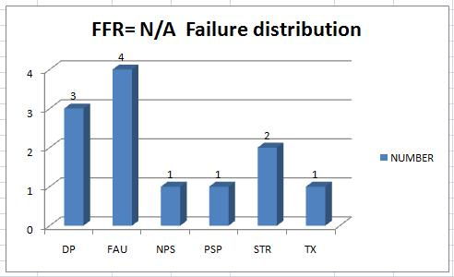
FFRAS improvement chart (In case of FFR=N/A, in %)
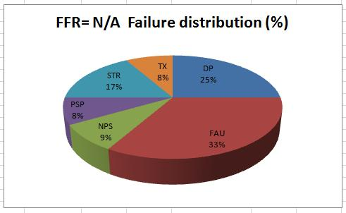

Feedback
The introduction written in the document is given by manufacturer. These datas which is collected by maintenance crews is a powerful evidence to convince manufacturer.

Manufacturer needs these datas to modify document in order to increase reliablities. And in the future, this work will be done by FFRAS. Maintenance crews no need to record each failure manually anymore.

After undating the database in FFRAS and results in document, the real failure will more and more approach the forecasting.

CONCLUSIONS
The conclusions have been split into 3 parts:
- Conclusions related to FFRAS usage.
- Conclusions related to FFRAS improvements.
- Conclusions related to the internship.

Conclusions related to FFRAS usage
FFRAS is matured software. However, to match user requirement, several adjustments should be made:
- Powerful failure diagnosis ability
- Friendlier operating interface
- Intelligent database
- Multi-function integration
- Procedure simplification
- Create additional value
- Driving-type Menu

The progress of technology nowadays is extremely quick. Customer has many options could be chosed. Product which has few functions can not attract customer. Nowaday, even mobile phone can do lot of things. The more additional function it equipped with, the higher value it has.

Compare to HUMS or LIMS, FFRAS is a kind of mini software which is only focus on FFR data collection and analysis. After customer experienced such product, they will be more strict to upgrated FFRAS. We have to finish all the improvement that we can do, and then upgrade it at once.

Conclusions related to FFRAS improvements
During studing period, we found the most difficult problem is not writing a program to perform the action you need. The valuable thing is “Creativity”. One nice idea can simplify the complex procedure, shorten working time, save resource, and increase efficiency.

Between dialogues with maintenance staffs in the airforce base, we try to listen to their voice, demand, and aspire. The age, that engineer sitting in the office then try to design good software, has past. It is time to visit your customer and listen to them. Matching customer’s requirement is the only way leads to victory.

Conclusions related to the internship
It was very interesting for me, as a maintenance officer on Mirage 2000 aircraft, to have the opportunity to practice my internship within the Military Customer Support Division of Dassault Aviation Company in France.

As a maintenance officer, it is quitely different from maintenance staffs who is specilized in one system, we have chance to learn about various knowledge and contact different people. I never know my working experience will help me in internship. But it indeed helps me to integrate design concept and user demand successfully.

Limited to internship period and identification, we don’t have chance to visit users in French Air Force Base. Otherwise, maybe we can inspire more sparks.

Dassault Company is very proud of customer service. When I asked for customer opinion after usage, manager Mr. Brahim provided me a copy of proposal in 2002 very soon, included of user opinion and answers. It is very impressive.

Bibliographical references
- http://en.wikipedia.org/wiki/Mirage_2000
- FFRAS User’s Guide 9601ECV100-02
- 1F-M2000 EI-DI MM Maintenance Documentatiions
- ROCAF LIMS documentations
- ROCAF 2008 real RDY System failure case.

appendices

APPENDIX 1 :FFRAS usage condition compare to fighters
Type | Customers
2000- | France | India | UAE | ROC | Greece | Egypt | Qatar | Peru | Brazil
B | 30 |  |  |  |  | 4 |  |  | 2
C | 124 |  |  |  |  |  |  |  | 10
D | 86 |  | 6 |  | 4 |  | 3 | 2
E |  |  | 22 |  | 36 | 16 | 9 | 10
H |  | 52
TH |  | 7
N | 75
R |  |  | 8
TOTAL | 315 | 59 | 36 |  | 40 | 20 | 12 | 12 | 12
New version suitable for FFRAS
5EI |  |  |  | 48
5DI |  |  |  | 12
5F | 37
5MK2 |  |  |  |  | 15
9 |  |  | 20
9D |  |  | 12
TOTAL | 37 | 0 | 32 | 60 | 15 | 0 | 0 | 0 | 0
FFRAS | 3 |  | 5 |  | 2

Note1: Mirage D and Mirage E types in UAE are upgraded to comply with FFRAS. And for Greece, will be upgraded in the future.
Note2: French Army has proposed upgrade requirement for Mirage 2000-D.

APPENDIX 2 : Use of Maintenance Reports

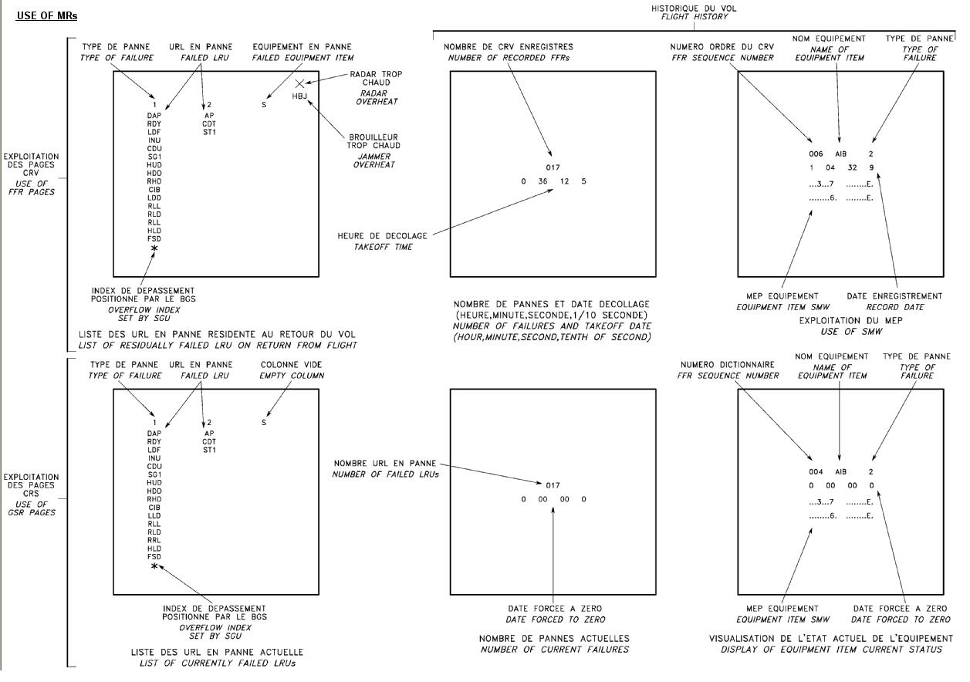

APPENDIX 2 : Use of Maintenance Reports (SMW)
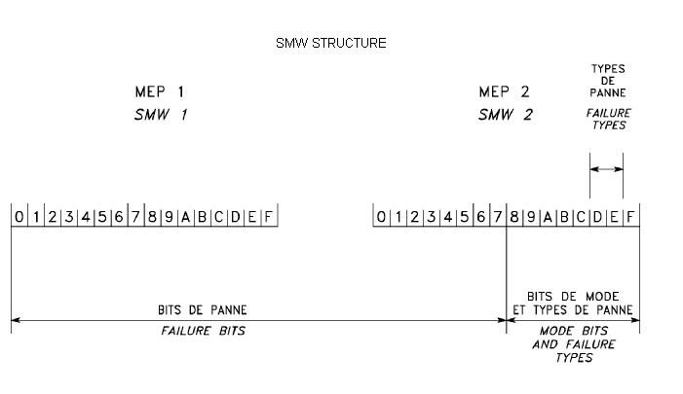

APPENDIX 3 : FFR Recording Phase
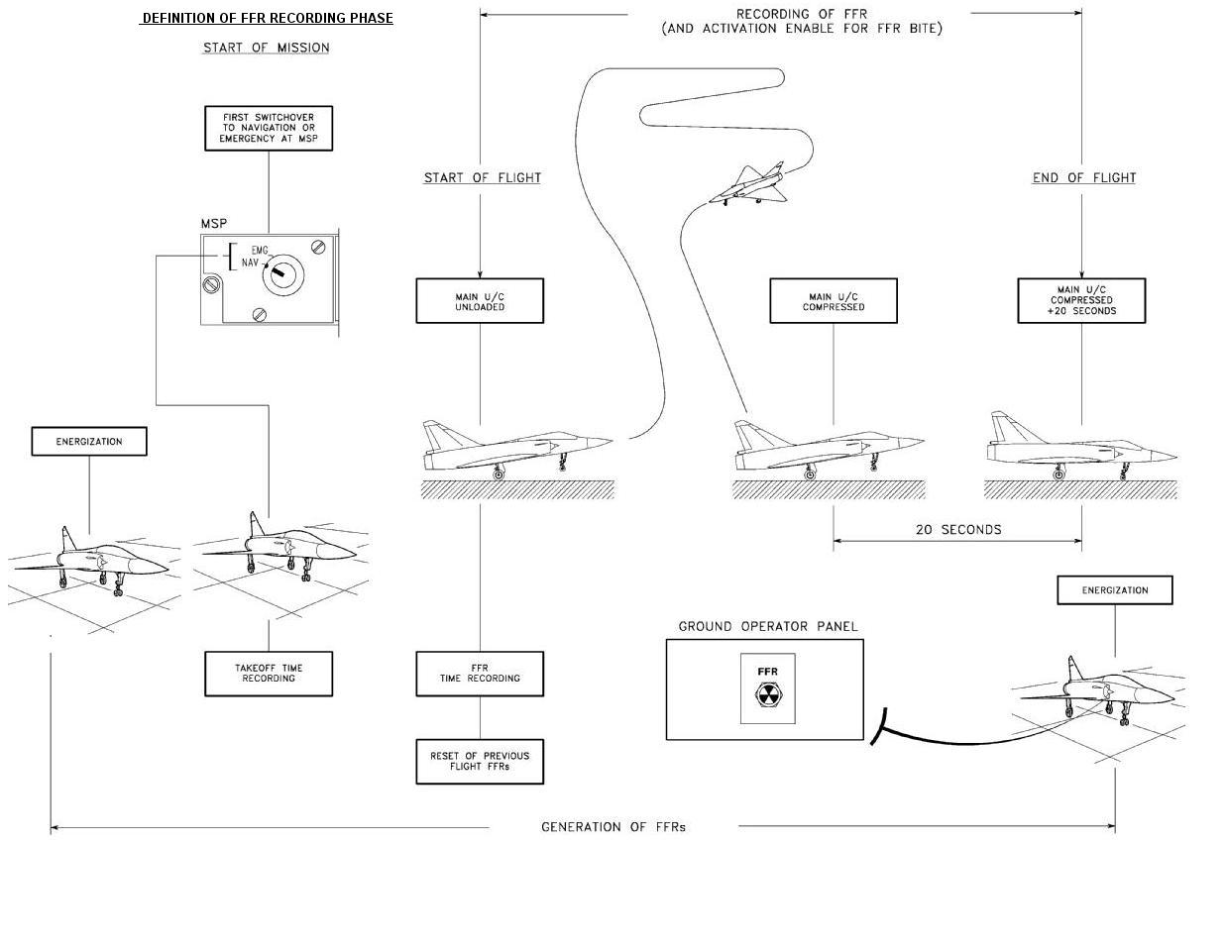

APPENDIX 4 : Generation of Maintenance Report
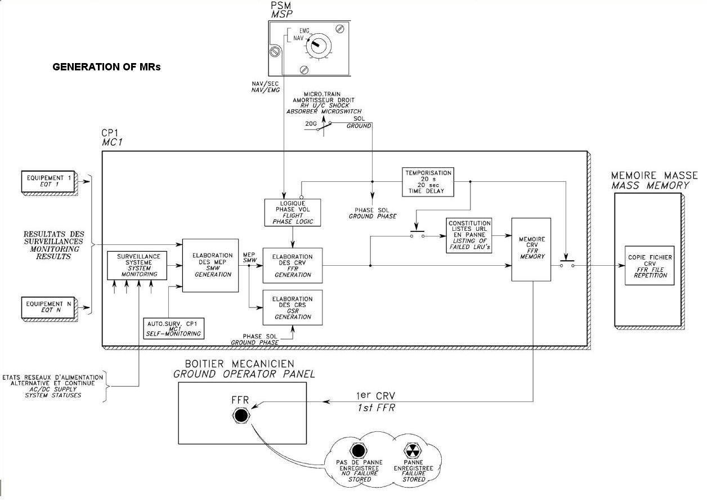

APPENDIX 5 : EXAMPLE ORINGINAL REVERSION(略)

11.6 APPENDIX 6 : EXAMPLE AFTER SORTING(略)

11.7 APPENDIX 7 : SUMMARY OF EXAMPLE
FAILURE DISTRIBUTION & CONFIRMATION WITH DOCUMENATS
TYPE | FFR/GSR | TOTAL | CONFIRM F. | NUMBER | PERCENT | DOCEMENTS
1 | NA | 12 | DP | 3 | 25.00%
1 | NA | 12 | FAU | 4 | 33.33%
1 | NA | 12 | NPS | 1 | 8.33%
1 | NA | 12 | PSP | 1 | 8.33%
1 | NA | 12 | STR | 2 | 16.67%
1 | NA | 12 | TX | 1 | 8.33%
2 | RDY:0/89D | 3 | DP | 3 | 100.00%
3 | RDY:2/0289E | 32 | FAU | 5 | 15.63%
3 | RDY:2/0289E | 32 | TX | 27 | 84.38% | Mentioned bo DOC.
4 | RDY:2/089E | 5 | FAU | 2 | 40.00%
4 | RDY:2/089E | 5 | TX | 3 | 60.00% | Mentioned bo DOC.
5 | RDY:2/289E | 2 | FAU | 1 | 50.00%
5 | RDY:2/289E | 2 | TX | 1 | 50.00% | Mentioned bo DOC.
6 | RDY:2/89D | 2 | TX | 2 | 100.00%
7 | RDY:28/89D | 1 | TX | 1 | 100.00%
8 | RDY:2C/389E | 4 | TX | 4 | 100.00%
9 | RDY:3/389E | 1 | FAU | 1 | 100.00%
10 | RDY:3/489E | 1 | FAU | 1 | 100.00%
11 | RDY:3/89D | 17 | DP | 1 | 5.88%
11 | RDY:3/89D | 17 | FAU | 16 | 94.12% | Mentioned bo DOC.
12 | RDY:3/89E | 1 | FAU | 1 | 100.00%
13 | RDY:3D/89E | 8 | FAU | 8 | 100.00%
14 | RDY:4/089E | 5 | PSP | 2 | 40.00%
14 | RDY:4/089E | 5 | RX | 3 | 60.00% | Mentioned bo DOC.
15 | RDY:4/389AE | 2 | FAU | 1 | 50.00%
15 | RDY:4/389AE | 2 | PSP | 1 | 50.00% | Mentioned bo DOC.
16 | RDY:4/389E | 18 | PSP | 16 | 88.89%
16 | RDY:4/389E | 18 | RX | 2 | 11.11% | Mentioned bo DOC.
17 | RDY:4C/89E | 5 | FAU | 1 | 20.00%
17 | RDY:4C/89E | 5 | PSP | 3 | 60.00%
17 | RDY:4C/89E | 5 | RX | 1 | 20.00% | Mentioned bo DOC.
18 | RDY:4EF/3489E | 1 | RX | 0 | 0.00% | Mentioned bo DOC.
18 | RDY:4EF/3489E | 1 | DP | 1 | 100.00%
19 | RDY:5/489D | 5 | DP | 1 | 20.00%
19 | RDY:5/489D | 5 | PSP | 3 | 60.00% | Mentioned bo DOC.
19 | RDY:5/489D | 5 | STR | 1 | 20.00%
20 | RDY:5/489E | 1 | PSP | 1 | 100.00%
21 | RDY:5/BD | 1 | PSP | 0 | 0.00% | Mentioned bo DOC.
21 | RDY:5/BD | 1 | RX | 1 | 100.00%
22 | RDY:5B/0189E | 1 | PSP | 1 | 100.00%
23 | RDY:5D/089E | 41 | PSP | 40 | 97.56% | Mentioned bo DOC.
23 | RDY:5D/089E | 41 | STR | 1 | 2.44%
24 | RDY:6/AE | 4 | FAU | 1 | 25.00%
24 | RDY:6/AE | 4 | NPS | 2 | 50.00%
24 | RDY:6/AE | 4 | RX | 1 | 25.00%
25 | RDY:6/E | 1 | DP | 1 | 100.00%
26 | RDY:6A/AE | 1 | PSP | 1 | 100.00%
27 | RDY:6DE/AE | 1 | NPS | 1 | 100.00%
28 | RDY:7/389E | 5 | DP | 4 | 80.00% | Mentioned bo DOC.
28 | RDY:7/389E | 5 | PSP | 1 | 20.00%
29 | RDY:7/89D | 6 | DP | 6 | 100.00%
30 | RDY:7C/389E | 1 | DP | 0 | 0.00% | Mentioned bo DOC.
30 | RDY:7C/389E | 1 | PSP | 1 | 100.00%
31 | RDY:7DE/89E | 2 | DP | 2 | 100.00%
32 | RDY:7E/89E | 1 | DP | 1 | 100.00%
33 |  |  | STR | 0 | 0.00% | Mentioned bo DOC.
33 | RDY:8/089E | 1 | EX | 1 | 100.00%
34 | RDY:8/89E | 1 | STR | 1 | 100.00%
35 | RDY:8A/89AE | 1 | STR | 1 | 100.00%
36 | RDY:8A/89BE | 1 | STR | 1 | 100.00%
37 | RDY:8A/89E | 10 | STR | 10 | 100.00%
38 | RDY:8AC/89E | 8 | FAU | 4 | 50.00%
38 | RDY:8AC/89E | 8 | STR | 4 | 50.00% | Mentioned bo DOC.
39 | RDY:8AEF/3489E | 1 | STR | 0 | 0.00% | Mentioned bo DOC.
39 | RDY:8AEF/3489E | 1 | FAU | 1 | 100.00%
40 | RDY:8C/89E | 1 | STR | 0 | 0.00% | Mentioned bo DOC.
40 | RDY:8C/89E | 1 | FAU | 1 | 100.00%
41 | RDY:9/089E | 70 | EX | 69 | 98.57%
41 | RDY:9/089E | 70 | PSP | 1 | 1.43%
42 | RDY:9C/089E | 4 | EX | 4 | 100.00%
43 | RDY:9C/89E | 1 | EX | 1 | 100.00%
44 | RDY:9E/089E | 2 | EX | 2 | 100.00%
45 | RDY:9E/89E | 2 | EX | 2 | 100.00%
46 | RY2:0/D | 1 | DP | 0 | 0.00% | Mentioned bo DOC.
46 | RY2:0/D | 1 | RX | 1 | 100.00%
47 | RY2:5/BD | 4 | NPS | 4 | 100.00%
48 | RY2:6/AE | 13 | BPS | 2 | 15.38%
48 | RY2:6/AE | 13 | DP | 3 | 23.08%
48 | RY2:6/AE | 13 | NPS | 3 | 23.08%
48 | RY2:6/AE | 13 | PSP | 3 | 23.08%
48 | RY2:6/AE | 13 | STR | 2 | 15.38%
49 | RY2:6/E | 2 | DP | 2 | 100.00%
50 | RY2:8A/7D | 1 | STR | 1 | 100.00%

