出國報告（出國類別：會議）

第16屆世界資訊科技大會
（16th World Congress on Information Technology）

服務機關： | 行政院研考會
出國人職稱： | 高級分析師、副研究員、助理設計師
姓 名： | 李國田、 劉彥麟、 蔡彰漢
派赴國家： | 馬來西亞
出國期間： | 97.05.18-97.05.23
報告日期： | 97.7.17
目 次
壹、目的 ----------------------------------------------- 6
貳、會議內容-------------------------------------------- 6
一、資通科技造成的影響與未來------------------------ 6
二、亞洲的機會-------------------------------------- 8
三、資訊長之角色------------------------------------ 13
四、關懷世界--------------------------------------- 15
五、台灣-國家主題館-------------------------------- 16
參、心得與建議---------------------------------------- 19
附錄：會議議程---------------------------------------- 21

壹、目的
第16屆世界資訊科技大會（WCIT 2008）於97年5月19日至22日於馬來西亞吉隆坡市之國際會議展覽中心（Kuala Lumpur Convention Center, KLCC）舉辦，台灣參訪團由中華民國軟體協會組團，工業技術研究院院長李鐘熙博士領隊，帶領工業技術研究院、資訊工業策進會及中華電信股份有限公司等單位參展，並獲得最佳國家主題館獎項。

本次大會由馬來西亞政府積極主辦，展覽空間超過10萬平方英呎，參與來賓來自90個國家，其中包含105位主講者，3,313位與會代表。大會主題在於：資訊和通訊技術的全球性影響：促進商業行為，擴大社會功能及富足經濟體系（The Global Impact of Information and Communications Technology: Enable Businesses, Empower Societies, Enrich Economies）。討論議題集中於資通科技造成的影響與未來、亞洲的機會、資訊長之角色及關懷世界等議題，並安排與會代表參訪近郊之Cyberjaya科學園區。

- 會議內容
一、資通科技造成的影響與未來
大會議程的安排每天都會有一兩位全球知名的講者上台，在第一天的議程中Intel現任董事長貝瑞特（Barrett）主講Global Impact Issue : A World of Opportunity Powered by Technology，演講內容著重在科技與教育可以帶來的影響，過程中包含了非洲電腦教育影片的播放、與巴西亞馬遜河偏遠村落醫生的遠距視訊會議、其他專家的現場心得分享等，藉由非洲的兒童可以透過電腦與Internet學習新知、接觸世界；巴西亞馬遜河旁距主要城市1500公里遠的偏遠村落醫生可藉由遠距視訊會議取得醫療支援與學習技術；協助超級馬拉松賽事的廠商Racingtheplanet創辦人Mary Gadams講述電腦在各種嚴厲環境下帶來的好處；藉由微型信貸協助孟加拉婦女脫離貧窮的鄉村銀行創辦人諾貝爾和平獎得主Yunus教授講述數位機會點可以帶來的影響，說明ICT科技可以在教育、經濟發展、醫療等領域帶來的影響。本演講的影音片段可以在http://tw.truveo.com/Dr-Craig-Barretts-Keynote-at-WCIT-2008/id/115519615觀看。
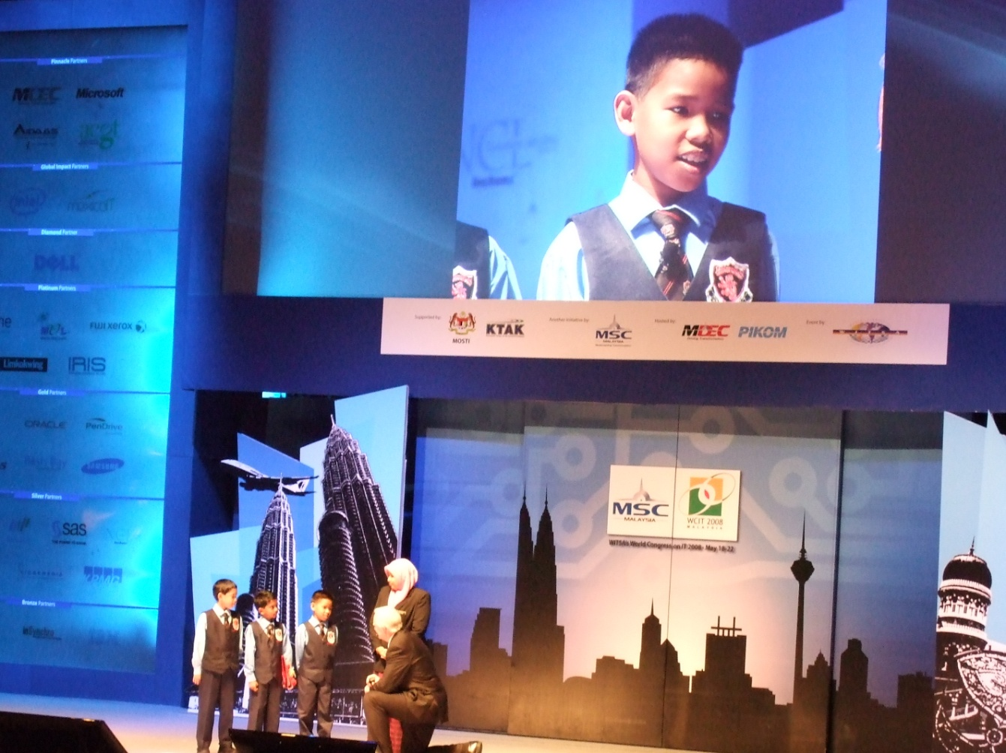
Global Impact Issue: A World of Opportunity Powered by Technology, Dr Craig Barrett, Chairman, Intel Corporation

在第一天的演講活動中第二個受矚目的場次便是由微軟創辦人比爾蓋茲以3D立體照相(holographic)預錄影像呈現的Innovation in a Connected World: Trends & Opportunities主題演講，微軟亦將其影像上傳到http://video.msn.com/video.aspx?mkt=en-us&vid=766c874c-12eb-499e-8e88-992b7aa833ad供觀看，演講內容主要在於目前科技的發展，對於未來科技與應用趨勢的預測，例如:高頻寬接取會無所不再、大型資料中心會在全世界各地出現並透過網路提供大量的儲存與運算能力、可用各式的互動介面與系統互動、高畫質顯示方式將愈趨普遍。在這樣的基礎下可以提供更多的學習新知與知識的機會，創造當地的工作機會，成為永續成長的基礎。當越來越多的人參與知識經濟，創新將使得大眾的生產力提昇，並擁有更好的人生。

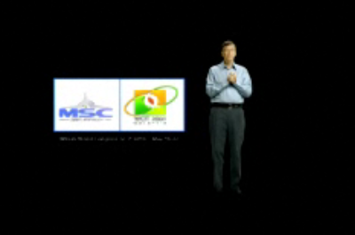
Innovation in a Connected World: Trends & Opportunities, Bill Gates, Chairman, Microsoft,

二、亞洲的機會

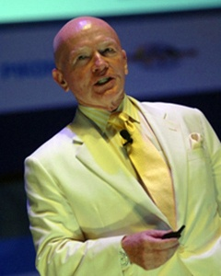
素有新興市場教父稱謂之富蘭克林坦伯頓資產管理公司執行總裁馬克墨比爾斯博士，是第二天議程中不可錯過的講者，演講主題為「Emerging markets: Where are the next hotspots particularly for ICT?」，墨比爾斯博士使用非常多的數據串起整場演說，對於當下網路使用者人數進行詳細的分析，並提供相關預測，將來網路使用者的分布狀態。其中最令人振奮的網路使用者分析莫過於下圖，目前的新興市場網路使用者人數已超越已開發市場，然而這僅僅是在滲透率15%的情況下的結果，如果將來新興市場的網路滲透率到達已開發市場的平均值60%，則可想見未來的網路使用者人數將由大量的新興市場人口組成，尤其是中國與印度這兩個國家。
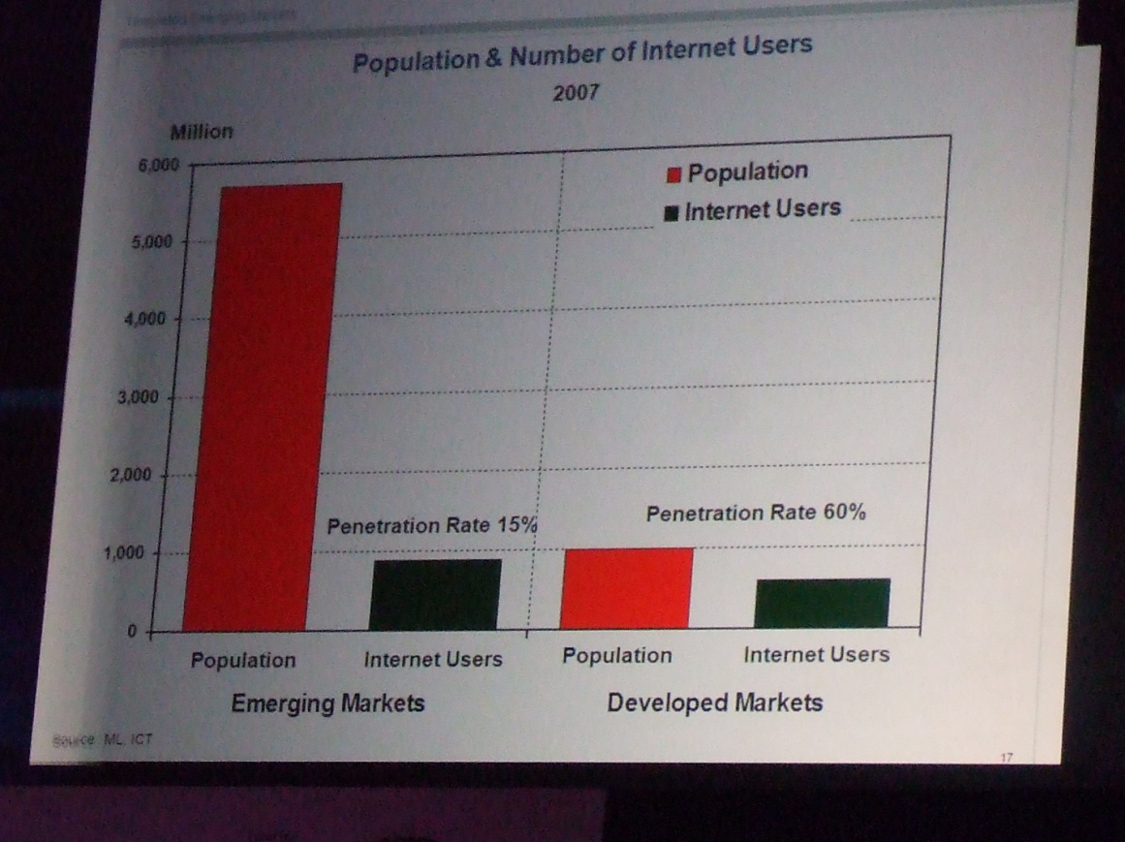
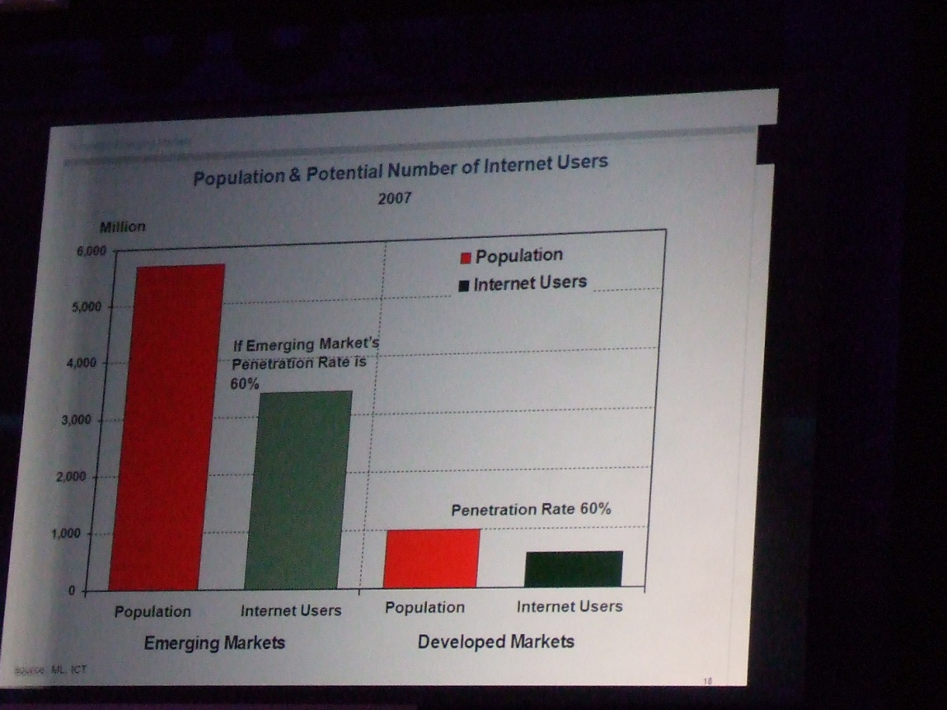
相同的分析方式，若自手機使用者人數分析，其結果將更為驚人，如下圖目前新興市場手機使用者人數已經是已開發市場的兩倍，但這僅僅是在滲透率42%下的結果，若新興市場其手機滲透率可到達已開發市場相同的92% 平均值，則其手機使用人口數將成為已開發市場的5倍多，達到50餘億支手機使用者的規模。屆時手機的網路將成為個人電腦網路另一重要的接取交換資訊管道。
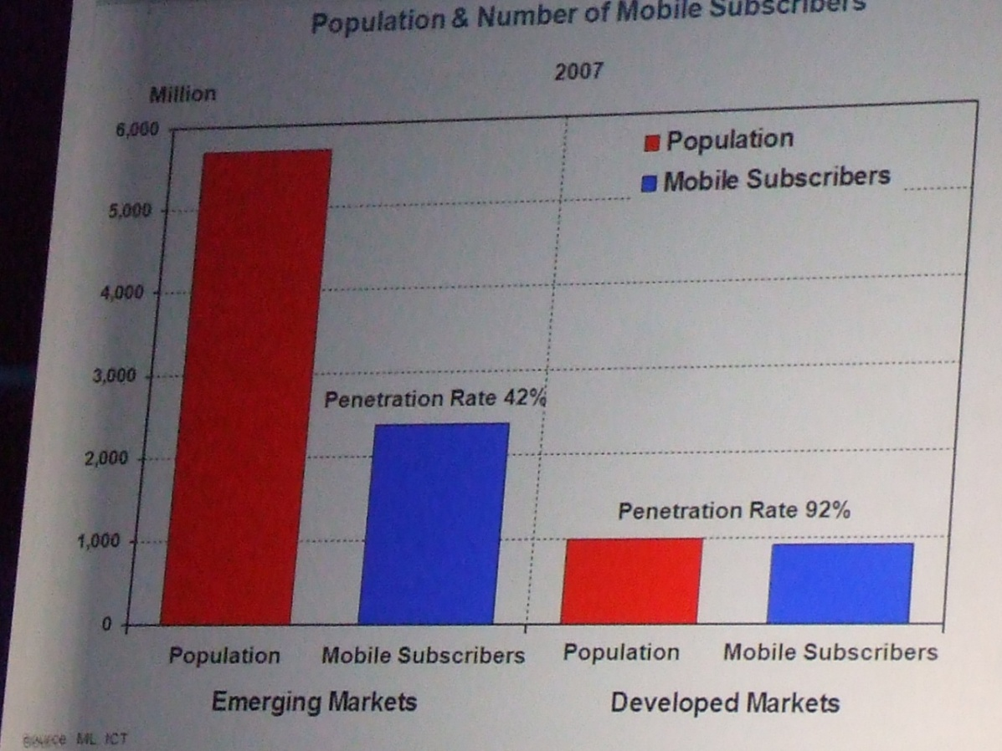
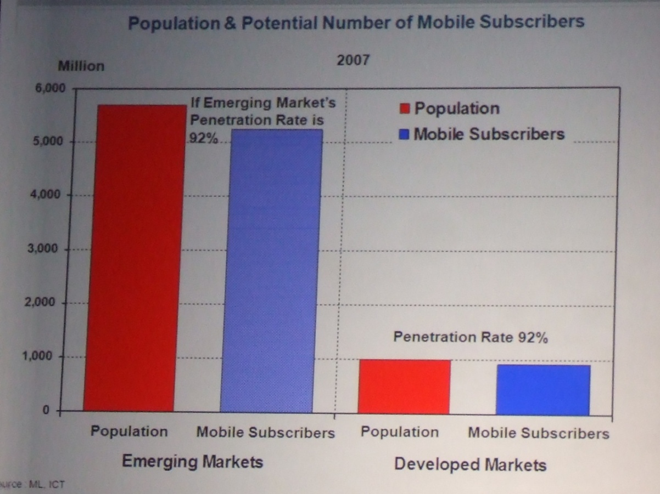
第三天的議程中由Google Chief Internet Evangelist Vinton Cerf博士主講的Internet 2035演講，同樣也提到了與馬克墨比爾斯類似的概念，目前各大洲的網路使用者人口中以亞洲的5億多人口最多，歐洲的3億多人口其次，北美的2億多人口再次之。但若比較網路滲透度，則可發現亞洲的滲透率僅僅只是13.7%，若提升到歐洲或北美洲的水準，則人數將成長3倍至5倍多，成為15億至25億餘，如下圖所示。可以想見屆時網路上的內容與人口組成都將大幅改觀，人類接取網路的方式與成本也將面臨改變與考驗。
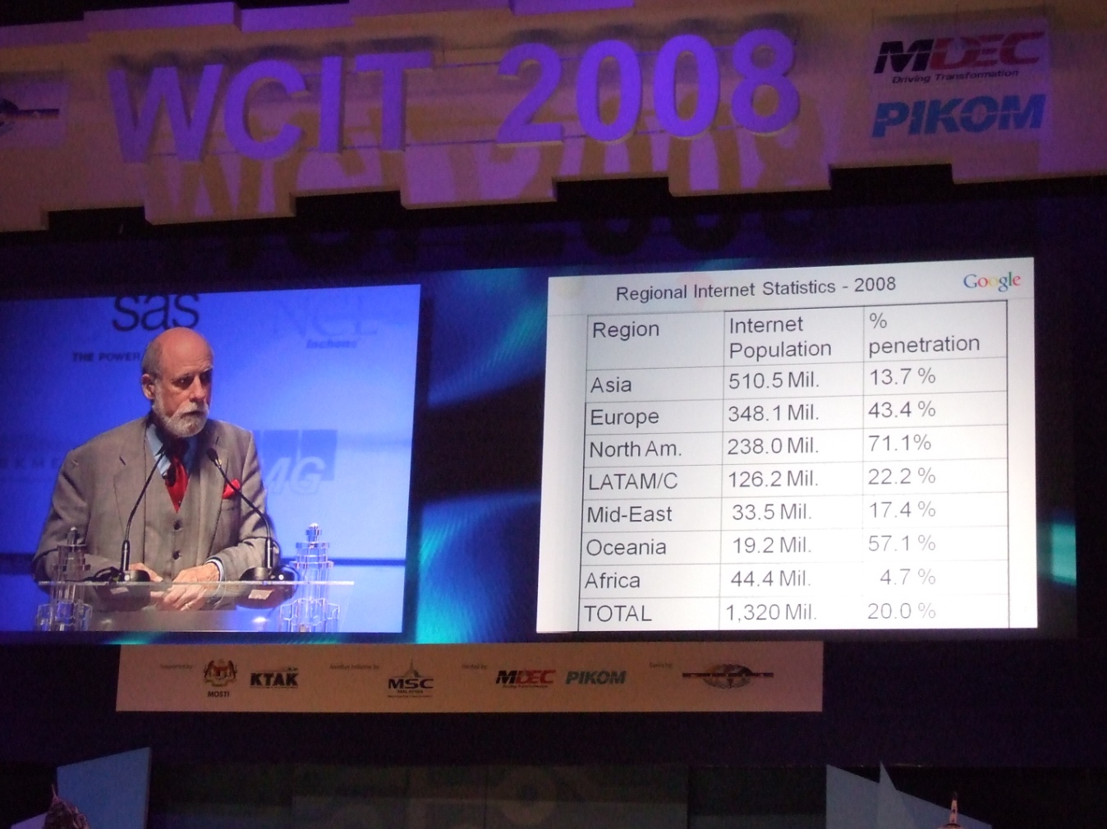

另Vinton Cerf博士根據目前的一些數據與推測，對於西元2035年的Internet概況做了一個描述，屆時網路上的電腦數目將從目前的5億餘台，成長為100億台；網路使用者人數將由目前的13億人成長為57億人，如下圖。屆時Internet已經52歲了（自1983年起算），全球的人口估計是81億人，全球的網路平均滲透率估計是70%，已開發國家的平均滲透率是100%，網路的位址標準也將完全使用IPv6。
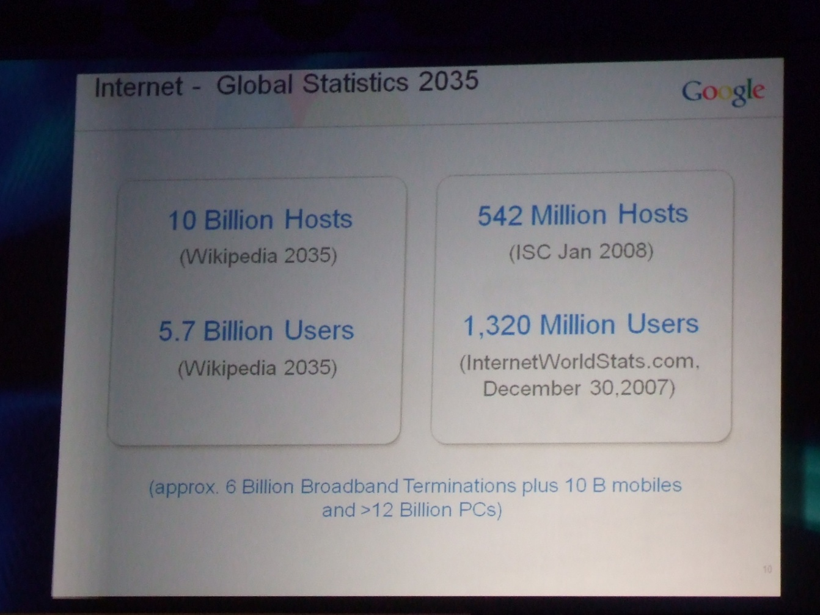

三、資訊長之角色
在本次活動的第2天及第3天議程中皆討論到資訊長的角色議題，在第2天的議程中我們有機會看到南韓首爾市針對電子化政府的架構，如下圖，切分為前台、後台、基礎設施的架構，前台包含首爾市政府的整合網站、一站式的市民請願服務及地理資訊系統入口網站；後台包含整合的管理資訊系統、交通、人力、財務資訊系統及地理資料倉儲；基礎設施包含首爾市的網路及資料中心。第2天的議程中在資訊長觀點的研討會中我們可以看到嘉納顧問公司（Gartner）針對2008年的資訊長調查中發現資訊長的3大優先工作，分別是改進作業流程、吸引保留客戶及創造新服務或流程。這樣的觀點將資訊長的角色放到公司經營策略的高度，這些看似總經理、行銷或研發單位的工作卻成為資訊長的3大優先工作項目，我們可以肯定推斷資訊長的職能將從傳統的資訊系統維護、資訊架構設計等工作演變提升至組織經營決策的核心競爭力來源。
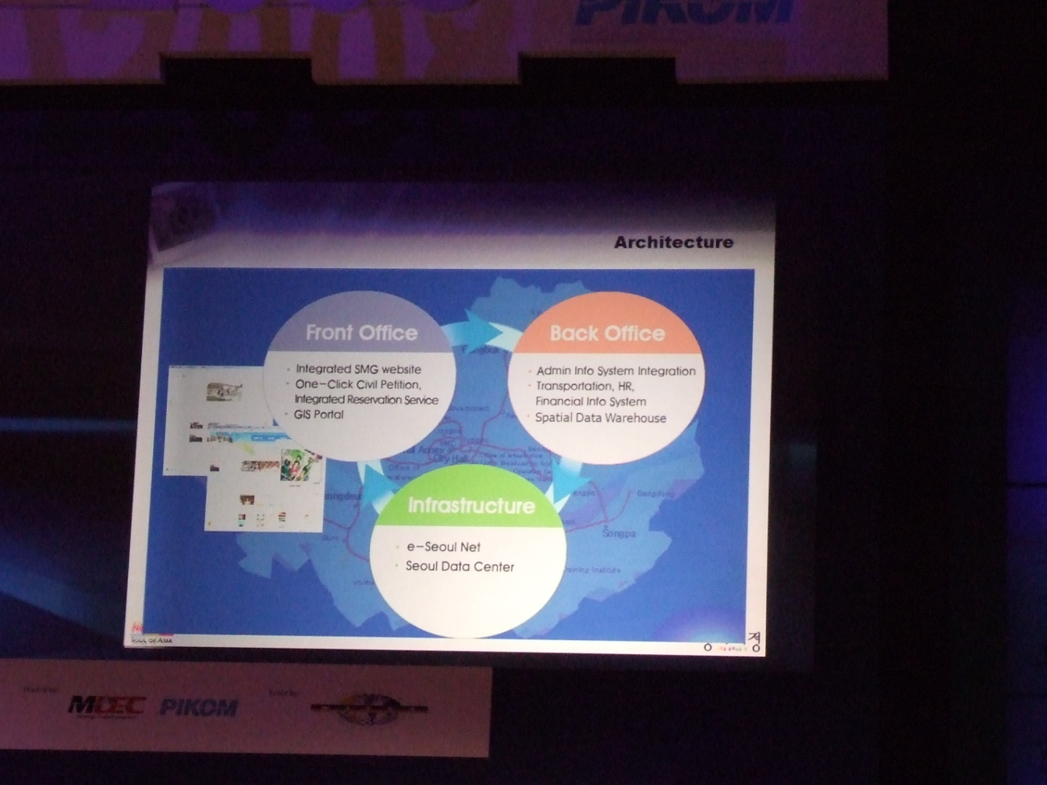
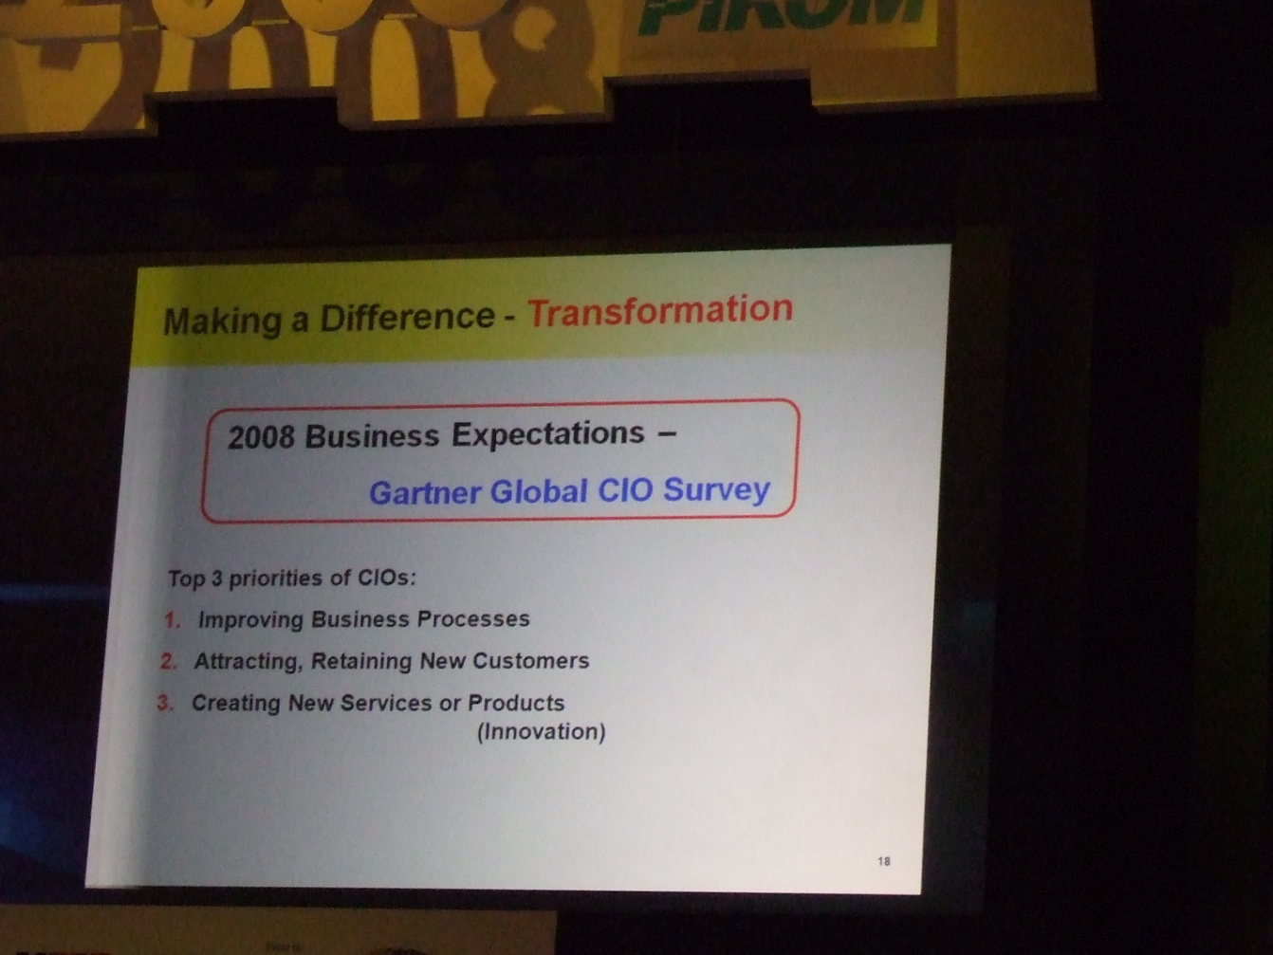
四、關懷世界
第三天的議程中由Operation Smile組織創辦人Bill Magee博士主講的Changing the Face of the World with Your Gifts，是整場活動中關心世界的高潮，Operation Smile是一個非營利組織目的在為有顏面殘障的兒童進行手術，進而讓他們能夠正常的講話、學習並融入社會。我們可以從下圖的照片中看到，原先有顏面障礙的嬰兒在經過手術後可以擁有較為正常快樂的人生。
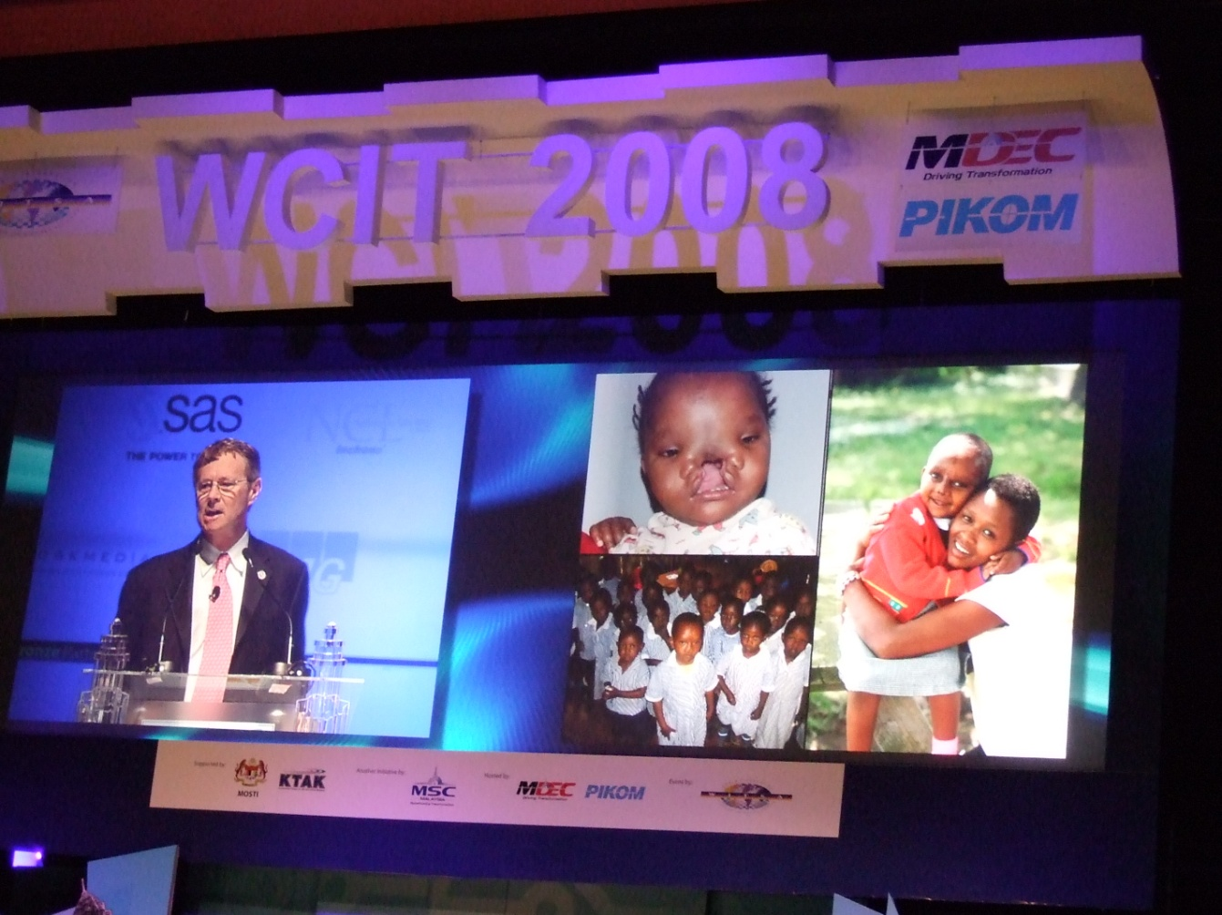

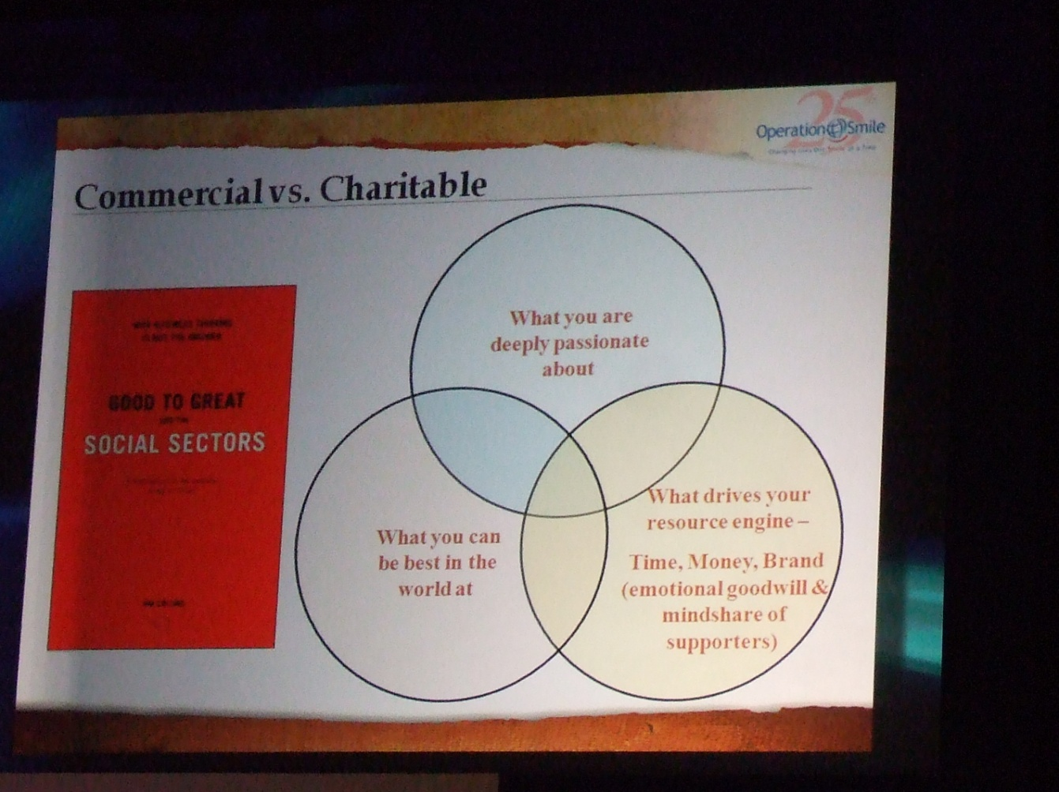

Bill Magee博士提供了一個可供大家參考的模型，來找出自己可為世界貢獻的方向，第一個要考慮的是什麼是你所深深熱愛的，再來要考慮什麼是你在這世上最擅長的，最後考慮什麼是驅動你的引擎，這三者的交集便可做為個人終身志業的參考。

五、台灣-國家主題館
台灣參展團隊包含工研院、資策會及中華電信，主題為享受聰明的數位家庭，開幕式於議程的第一天中午，由鼓陣、馬總統錄影致詞及工研院院長院長李鐘熙博士現場致詞開幕，現場來賓踴躍，並對於中華電信研發之手機晶片小額付費、資策會研發之中文學習系統及工研院研發之手機攝影傳輸平台皆深感興趣，其中馬國總理更於參訪攤位時於台灣主題館停留試用中文學習系統。台灣國家主題館並於最後獲得最佳國家主題館之殊榮。

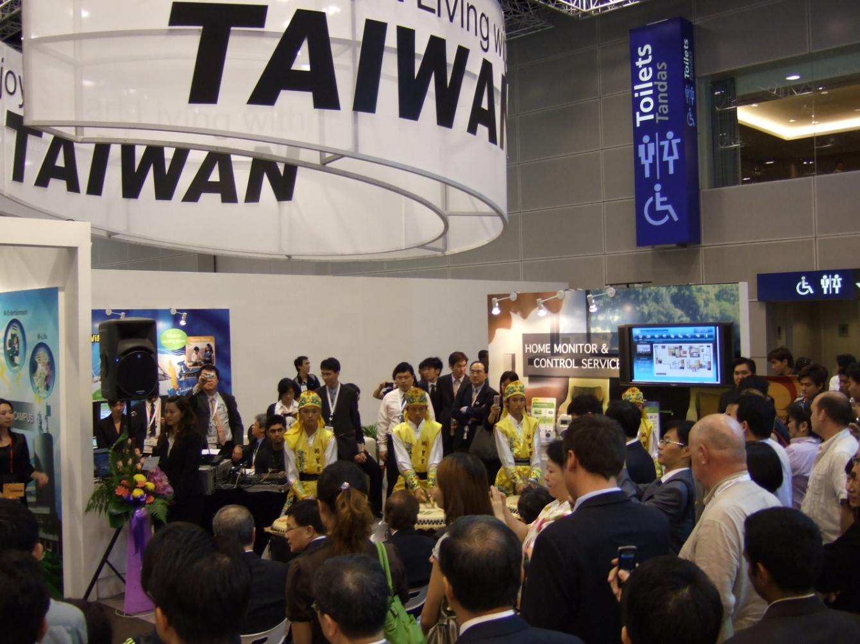

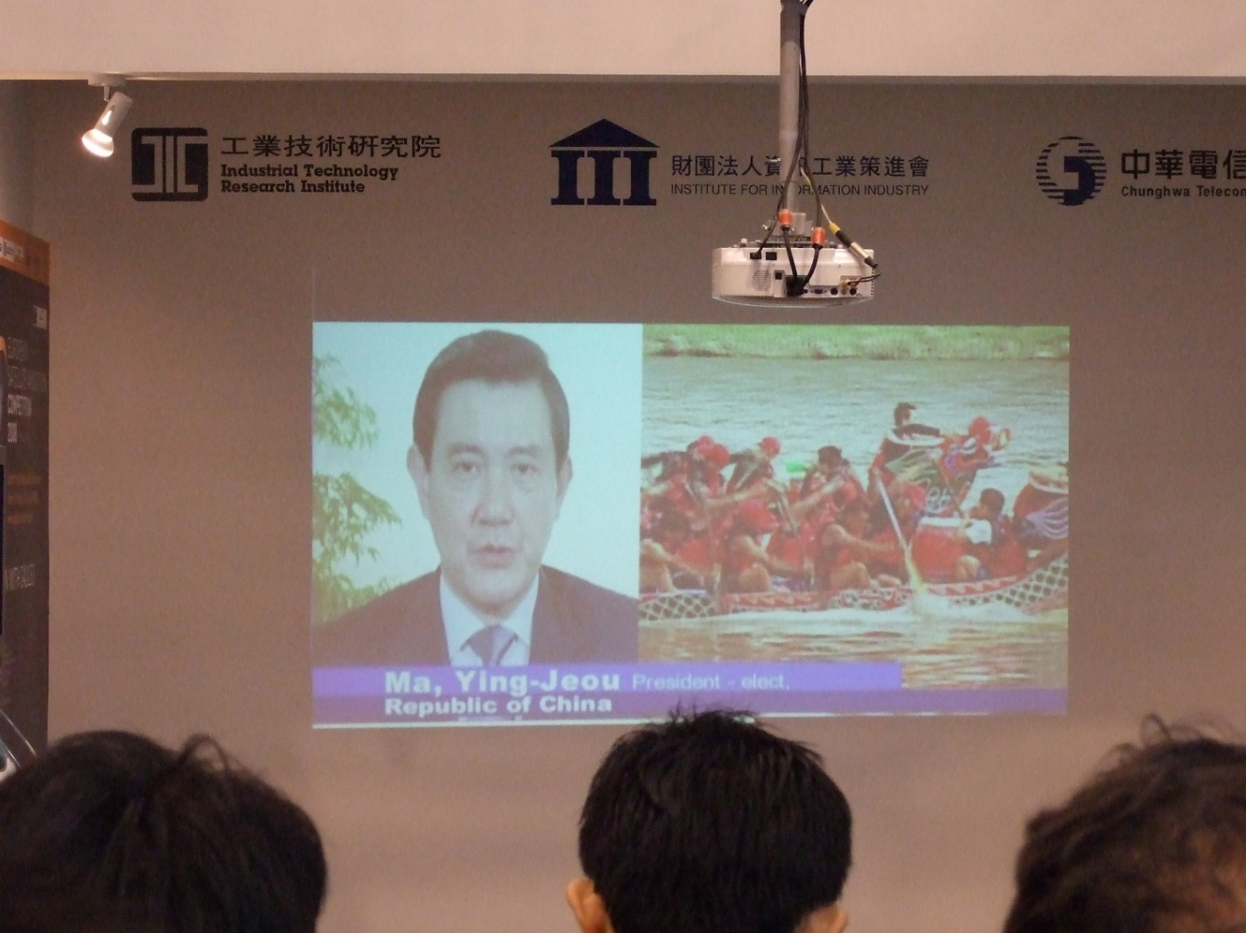

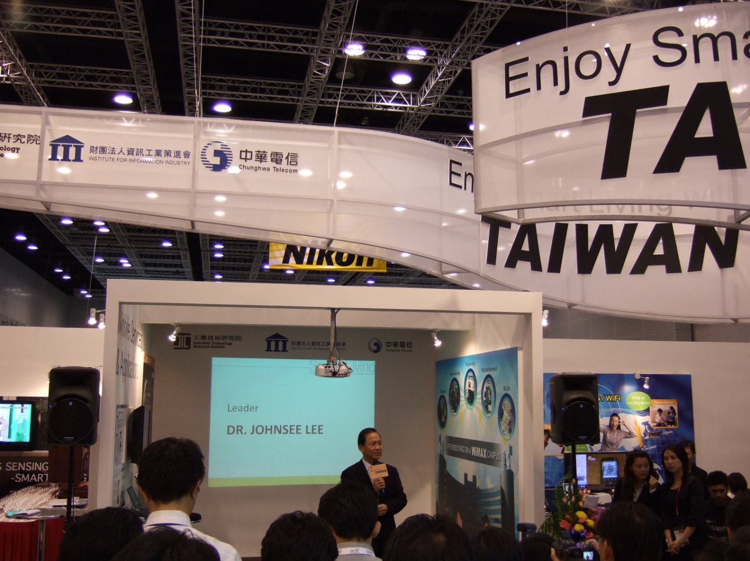

- 心得與建議
兒童是我們共同的未來，因此對於下一代的教育，或利用資訊科技加強教育的效果，都是本次世界資訊科技大會著重的部分，在第一天的開幕式中主辦單位請當地國際學校的孩童用各國語言歡迎大家，也展現出了這一層的意義。而透過科技的力量改善教育、政府服務與健康醫療相關領域的品質，正是提昇人類生活品質的有效方式之一。
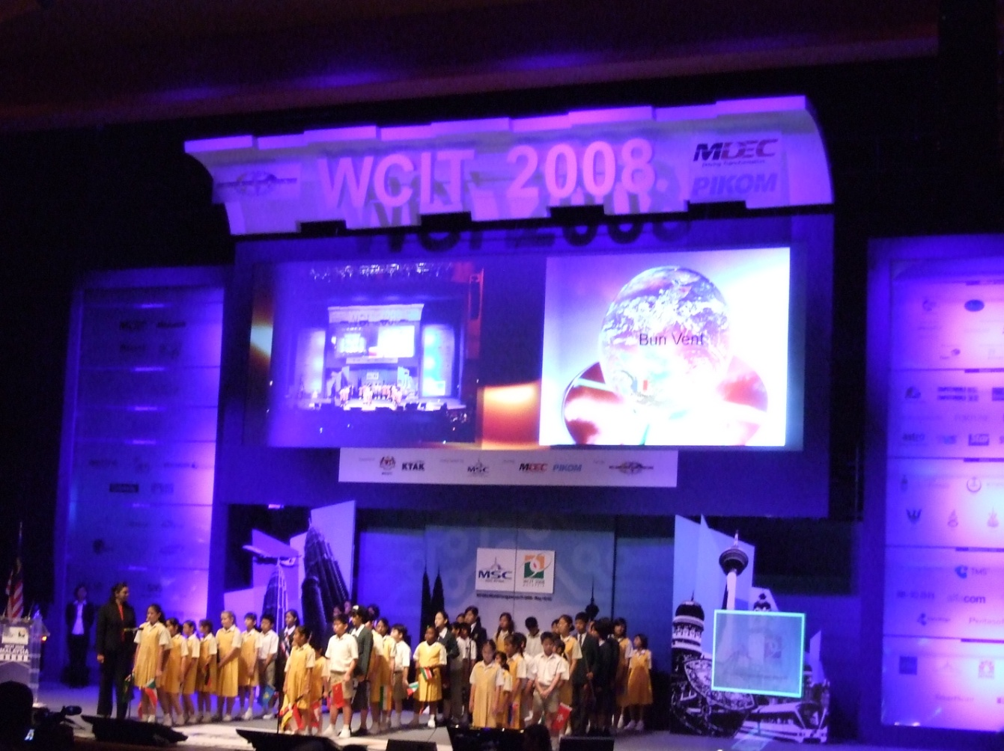

建議：
- 建議可積極爭取主辦相關國際資訊研討會
爭取主辦相關國際資訊科技研討會可增進我國電子化政府之能見度，對於提昇我國電子化政府之國際評比具有正面幫助，我國推動電子化政府之相關經驗，可提供其他國家作為電子化政府推動時之相關參考借鏡；亦可行銷本國相關資訊科技產業，協助我國產業提升全球競爭力，跨入資訊科技產業全球供應鏈，以台灣擅長之科技產業製造及服務能量，提升全人類之生活品質。
- 建議可積極研討我國於全球社會中之定位
經過本次研討會，可瞭解馬來西亞、韓國等鄰近國家政府對於提昇其國家競爭力之積極程度與決心，我國長期發展之半導體製造、個人電腦或筆記型電腦產業已在國際社會中具有舉足輕重之地位，然而許多廠商亦面臨毛利率偏低之過度競爭環境，如何走出藍海策略，發展知識經濟中取代性較低或與製造生產成本相關性較低之服務、金融等產業，是我國可積極思索之部分，對於可扮演之全球社會角色，亦必須提供適當之產業發展環境及相關租稅鼓勵等措施，以期我國可在長期經濟發展的道路上持續大步邁進，提升國家之競爭力與人民之生活品質。

附錄：會議議程
5月19日議程
時間 | 主題 | 主講者
8:30am – 9:25am | Opening Ceremony | - Dato’ Badlisham Ghazali, Chairman, WCIT 2008  - Datuk Dr Maximus Ongkili, Minister of Science, Technology and Innovation, Malaysia  - George Newstrom, Chairman, WITSA  - Dato’ Seri Abdullah Ahmad Badawi, Prime Minister, Malaysia
9:27am – 9:40am | Enabling the Renaissance of the Digital Age- A Call for Action | Dr James Poisant, Secretary-General, WITSA
9:40am – 10:40am | Global Impact Issue : A World of Opportunity Powered by Technology | Dato’ Dr Craig Barrett, Chairman, Intel Corporation
10:45am – 11:15am | Keynote: Simulation: A Tool for Global Governance? | Dr Robert Bishop, Chairman and Founder, BBWORLD Consulting Services Sarl  Introducer: John Higgins, Director-General, Intellect
11:15am – 11:35am | Keynote: The UN Challenge to the ICT Community | H.E Sha Zukang, Under-Secretary-General for Economic and Social Affairs, United Nations  Introducer: Robert Lawrence, Chairman Emeritus, WITSA
11:35am – 12:05pm | Keynote : Connecting the World – Empowering People | Dr Hamadoun Touré, Secretary-General, International Telecommunication Union  Introducer: Wei Chuan Beng, Group Managing Director, REDTone International
12:10pm – 1:35pm | Lunch : Simplifying IT to Innovate Business | Steve Felice, President, Asia-Pacific/Japan, Dell Global B.V.
1:40pm – 2:40pm | Ministerial Panel : Digital Prosperity | - Dr Robert Atkinson, President, Information Technology and Innovation Foundation – Moderator  - Datuk Dr Maximus Ongkili, Minister of Science, Technology and Innovation, Malaysia  - H.E. Liwayway Vinzons-Chato, Member of the House of Representatives, The Philippines  - H.E. Dr Lee Boon Yang, Minister for Information, Communications and the Arts, Singapore  - Sergio Carrera Rivapalacio, General Director, Digital Economy and Commerce, Ministry of Economy, Mexico
2:40pm – 3:40pm | Plenary Panel : The Wireless Broadband Revolution – “The Promise of Service – Driven Technology Infrastructure ” | - Aida Dato’ Seri Mohd Adib, Chief Executive Officer, Allied Digital Infonet Bhd  - Professor Dr Fedir Fedorovich Dubrovka, Chief Scientist, Allied Digital Infonet Bhd  - Professor Mykhailo Jurievich Omelianenko, Chief Scientist, Allied Digital Infonet Bhd  - Alexander M Faingold, Deputy Director & Chief Designer, AIDAAS  - Associate Professor Dr Othman Sidek, Director of Collaborative Micro-Electronic Design Excellence Centre (CEDEC), Malaysia
3:45pm – 4:15pm | Keynote : The changing dynamics of Telecom industry | Jari Tammisto, Chief Executive Officer, Mobile Monday  Introducer: Looi Kien Leong, Chief Executive Officer, 1001 Technologies Sdn Bhd
4:15pm – 4:35pm | Keynote: Global Financial System – Structural Reform and ICT | Dr Heizo Takenaka, Professor and Director at Global Security Research Institute, Keio University, Japan  Introducer: Mr. Tomokazu Hamaguchi, Japan Information Technology Services Industry Association Chairman and Senior Corporate Advisor of NTT Data Corp.
4:35pm – 5:35pm | Marquee : Innovation in a Connected World: Trends & Opportunities | Bill Gates, Chairman, Microsoft (Special Appearance via Holographic Technology)  Dr Ya-Qin Zhang, Corporate Vice President, Microsoft Corp
7:00pm – 7:30pm | Transfer to Dinner Venue @ Berjaya TIMES Square
7:30pm – 10:35pm | WCIT 2008 Welcome Reception | Berjaya TIMES Square

5月20日議程
時間 | 主題 | 主講者
8:30am – 9:30am | Plenary Panel - Creativity Unlimited | - Arnold Gay, Anchor, CNBC - Moderator  - Kamil Othman, Vice President, Multimedia Development Corporation  - Fritz Attaway, Executive Vice President, Motion Picture Association of America  - Terry Thoren, Chief Executive Officer, Rocket Fish Studios
9:30am – 10:30am | Plenary Panel - Doing Business in Asia | - Dato’ Azman Mokhtar, Managing Director, Khazanah Nasional  - Datuk Dr Maximus Ongkili, Minister of Science, Technology and Innovation, Malaysia  - H.E. A. Raja, Minister of Communications and Information Technology, India  - Ali Saleh Alsoma, Advisor to Minister of Communications and Information Technology and Director-General of E-Government Program, Saudi Arabia  - Dr.Liu Jiren, Chairman and Chief Executive Officer, Neusoft Group
10:35am – 11:05am | Keynote: Emerging markets: Where are the next hotspots particularly for ICT? | Dr Mark Mobius, Executive Chairman, Templeton Asset Management  Introducer: Jorge Cassino`, President, Sols Technologies
11:15am – 12:15pm | Asian Opportunity – Breakout Panel (Creating the infra and infostructure for ICT development) | - Ashank Desai, President, Asian-Oceanian Computing Industry Organization (ASOCIO) - Moderator  - Dr Ahmad Al-Yamani, Director-General of ICT Sector, Saudi Arabian General Investment Authority  - Dinesh Nair, Founder and CTO, QubeConnect  - Dr Jung-Hee Song, Assistant Mayor for Information Technology (Chief Information Officer), Seoul Metropolitan Government, South Korea  - Dato’ Zamzamzairani Mohd Isa, Group Chief Executive Officer, Telekom Malaysia Berhad
11:15am – 12:15pm | Asian Opportunity – Breakout Panel (Asian Innovation for the World) | - Harres Tan, Group Chief Executive Officer, HT Consulting – Moderator  - Dato’ Praba Thiagarajah, Chief Executive Officer, Basis Bay  - Tony Lee, Founder, IRIS Technologies  - Kelvin Lee, Senior General Manager, Green Packet International  - Dr Liu Jiren, Chairman and Chief Executive Officer, Neusoft Group
11:15am – 12:15pm | Asian Opportunity – Breakout Panel (From Start-up to Global) | - Yasmin Mahmood, Managing Director, Microsoft Malaysia - Moderator  - Dato’ Aminuddin Baki Esa, Chief Executive Officer, Scan Associates  - Wei Chuan Beng, Group Managing Director, REDTone International  - Suhaimee Abu Hassan, President and Founder, XYBASE
11:15am – 12:15pm | Asian Opportunity – Breakout Panel (Asia, the destination of choice for Shared Services and Outsourcing) | - Dato’ Narayanan Kanan, Senior Vice-President, Multimedia Development Corporation – Moderator  - Michael F. Corbett, Chairman of the International Association of Outsourcing Professionals  - Dr Ganesh Natarajan, Chairman, NASSCOM  - David Wong, Chairman, Outsourcing Malaysia  - Stephen Braim, Vice President Governmental Programs, IBM Asia Pacific
12:20pm – 1:45pm | Lunch : Working in the Mixed Reality World | Dr. Lawrence A. Rowe, President, FX Palo Alto Laboratory
1:50pm – 2:50pm | Plenary Panel: CIO Perspectives | - Don Tennant, Vice President and Editorial Director, Computerworld and Infoworld – Moderator  - Diane Jurgens, CIO, Asia-Pacific and China Group, General Motors  - Timothy Kasbe, Chief Information Officer, Reliance Retail Ltd  - Joseph Alhadeff, Chief Privacy Officer, Oracle  - Kerry Purcell, Vice President and Managing Director, EDS Asia
3:00pm – 4:00pm | CIO Perspectives – Financial Services | - Woon Tai Hai, Partner, KPMG - Moderator  - Dr Bhaskar Dasgupta, Global Head of Programme Office, HSBC Holdings plc  - Chu Hong Keong, Chief Information Officer, HSBC Malaysia  - Emanuel Katsidonis, Account Director, Computer Sciences Corporation
3:00pm – 4:00pm | CIO Perspectives – Energy | - David Crane, Award-winning Canadian Author - Moderator  - David Beaney, Executive Chairman, Beaney Enterprises Limited  - Ainuddin Jantan, General Manager, Corporate ICT Development Unit, PETRONAS  - Steve Clearwater, Executive Director and Global Desktop Services Director, Shell IT International, Malaysia  - Philip Thrush, Country Leader, IBM Global Business Service
3:00pm – 4:00pm | CIO Perspectives – Manufacturing | - Jim Davis, Senior Vice President and Chief Marketing Officer, SAS Institute - Moderator  - Dato’ Simon Wong, Vice President, Dell Asia-Pacific  - Richard Davidson, Senior Vice President & CIO, Manpower Inc  - Diane Jurgens, CIO, Asia-Pacific and China Group, General Motors
3:00pm – 4:00pm | CIO Perspectives – Retail | - Don Tennant, Vice President and Editorial Director, Computerworld and Infoworld - Moderator  - Timothy Kasbe, Chief Information Officer, Reliance Retail Ltd  - Stan Singh, Senior Vice President/Global CIO, MUI dotCom  - Robert Madge, Chief Executive Officer, FoodReg
4:10pm – 4:40pm | Keynote : How Climate Change will affect the IT industry worldwide | Dr Rajendra Kumar Pachauri, Chairman, Intergovernmental Panel on Climate Change  Introducer: Dr Aristides Patrinos, President, Synthetic Genomics, Inc.
4:45pm – 5:45pm | Marquee : Genomics: From Human Health to the Environment | Dr J. Craig Venter, Chairman, J. Craig Venter Institute  Introducer: Derrik Khoo, Chief Executive Officer, Asiatic Centre for Genome Technology
7:30pm – 8:00pm | Transfer to Dinner Venue @ PWTC
8:00pm – 11:45pm | WCIT 2008 Gala Dinner | PWTC

5月21日議程
時間 | 主題 | 主講者
9:00am – 10:00am | Technologist Panel : Future of the Internet | - Peter Dengate Thrush, Chairman, Internet Corporation for Assigned Names and Numbers - Moderator  - Ganesh Kumar Bangah, Chief Executive Officer, MOL AccessPortal  - Dan Neary, Vice-President, eBay  - Tyson Dowd, Senior Director, Malaysian Software Economy, Microsoft Malaysia
10:00am – 10:35am | Plenary Panel : Future of the Internet | - Dato’ Larry Gan, Executive Chairman, Littledrops - Moderator  - Dato’ Dr Halim Man, Secretary General, Ministry of Energy, Water and Communications, Malaysia  - H.E. Frank Heemskerk, Minister of Foreign Trade, Netherlands  - Direk Charoenphol, Advisor to the Minister of Information and Communication, Thailand  - HE Alfredo Raul Morelli, Argentinian Ambasssador to Malaysia
10:37am – 11:07am | Keynote: Building Business Relationships With The Help Of ICT | Dato’ Seri Mohd Najib Tun Abdul Razak, Deputy Prime Minister, Malaysia  Introducer: Dato’ Badlisham Ghazali, Chairman, WCIT 2008
11:11am – 11:56am | Global Impact Issue : Near-shoring | - Sergio Carrera Rivapalacio, General Director, Digital Economy and Commerce, Ministry of Economy, Mexico  - Dr Eduardo Ruiz Esparza, President, Mexican Electronics Telecommunications and Information Technologies Industries Chamber (CANIETI)  - Francisco Madina, General Director, State Council of Science and Technoloy, Jalisco
12:05pm – 1:35pm | Luncheon Event: Asiatic Centre for Genome Technology 's Milestone Announcement
1:45pm – 2:45pm | Link Forum Track 1 : State Partner 1 | - Lim Guan Eng, Chief Minister of Penang  - Datuk Seri Ir. Haji Mohammad Nizar Jamaluddin, Chief Minister of Perak  - Tan Sri Abdul Khalid Ibrahim, Chief Minister of Selangor
1:45pm – 2:45pm | Link Forum Track 2 : State Partner 2 | - Dato’ Haji Abdul Ghani bin Othman, Chief Minister of Johor  - Datuk Seri Hj Mohd Ali Rustam, Chief Minister of Malacca  - Datuk Dr Yee Moh Chai, Minister of Resource Development & IT, Sabah
1:45pm – 2:45pm | Link Forum Track 3 : State Partner 3 | - Dato’ Sri Haji Adnan bin Haji Yaakob, Chief Minister of Pahang  - Datuk Haji Mohamad Morshidi Bin Abdul Ghani, Deputy State Secretary of Sarawak
1:45pm – 2:45pm | Link Forum Track 4 : | - David Gilmour, Principal Instructor, Architecting-the-Enterprise  - Cindy Chong, Managing Director, NCL Solutions  - Michael Reyes, Director, My Money Tree  - Fazel Naghshineh, Chief Executive Officer, BriteSoft
1:45pm – 2:45pm | Link Forum Track 5 : | - Edge Zarrella, Global Partner in Charge, IT Advisory, KPMG  - Tan Ee Ern, Executive Director, FSBM  - Hasan Ganny Hanif Francis, Chief Executive Officer, Time Quantum  - Damien Leong Yiew Choong, Chief Executive Officer, Jia Yu Home Entertainment
1:45pm – 2:45pm | Link Forum Track 6 : | - Chris Chan, Chief Executive Officer, The Media Shoppe  - Verghese Kochummen, Principal Consultant, Insynchro  - Dato' Dr. Raja Mohamad Abdullah, Chief Executive Officer, OIC Today  - Md Zubir Ansori Yahaya, Chief Executive Officer, Malaysia Debt Ventures
2:55pm – 3:25pm | Keynote : Changing the Face of the World with Your Gifts | Dr Bill Magee, Co-founder and Chief Executive Officer, Operation Smile  Introducer: Phillip Bond, President, Information Technology Association of America
3:30pm – 4:30pm | The Great Debate | - Arnold Gay, Anchor, CNBC - Moderator  - Professor Howard Schmidt, Eminent Cyber-security Expert  - Dr Johnsee Lee, President, Industrial Technology Research Institute  - Dr John Gage, Chief Researcher and Director of the Science Office, Sun Microsystems
4:31pm – 5:31pm | Marquee : Tracking the Internet into the 21st Century | Dr Vinton Cerf, Vice-president & Chief Internet Evangelists, Google  Introducer: Dan E Khoo, Chief Executive Officer, WCIT 2008
5:31pm – 5:45pm | WCIT 2010 Handover Ceremony
5:45pm – 5:52pm | WCIT 2008 Closing Ceremony
7:30pm | Private parties

