行政院及所屬機關出國報告
(出國類別：參加會議)

參加第4屆
台灣－阿拉斯加經貿暨投資合作委員會
林業暨農業組報告

服務機關：行政院農業委員會林務局
姓名職稱：魏立志 副局長
出國地區：美國
出國期間：97年3月6日至3月11日
報告日期：97年4月
目 錄

壹、公務出國報告摘要
貳、會議議程與會談內容
參、建議
肆、結論
伍、附件
壹、公務出國報告摘要
頁數：34 含附件：有
報告名稱：參加第4屆「台灣－阿拉斯加經貿暨投資合作委員會」－林業暨農業組報告
主辦機關：經濟部
聯絡人∕電話：羅怡如∕02-23515441-132
出國人員：魏立志 行政院農業委員會林務局 副局長
出國類別：參加會議
派赴國家：美國
出國期間：民國97年3月6日至97年3月11日
報告日期：民國97年4月
分類號/目：F8/林業

關鍵詞：
備忘錄(MOU)、森林工業(Forestry Industry)、森林資源(Forestry Resources)、木片(Wood Chips)、林木銷售價格(Selling Prices of Timber Products)、鋸木廠(Sawmill)、原木直徑、等級及樹種、森林經營、森林火災、野生動物保育、原住民保留地林業、疏伐、森林病蟲害防治、半成品、種薯、熱帶新鮮水果、檢疫程序。
內容摘要：
第4屆台灣－阿拉斯加經貿暨投資合作委員會於2008年3月9日在美國阿拉斯加州菲爾班克市(Fairbanks) Princess Riverside Hotel旅館舉行，本次會議共分能源暨礦物組、林業暨農業組、海產組及觀光組等4組。我方出席人員包括政府官方及民間企業共28人，共同團長為行政院經建會何主任委員美玥與中華民國工商協進會黃理事長茂雄，顧問為總統府康前資政寧祥。
林業暨農業組我方主談人為本會林務局魏副局長立志，民間團體及企業界有台灣區木材輸出業同業公會孫理事長國雄、農興貿易有限公司李董事長秀真、農和企業股份有限公司趙顧問一之及舊金山台灣貿易中心李主任以安及駐洛杉磯台北經濟文化辦事處經濟組吳組長新華等5人。阿方主談代表為阿州自然資源廳林業處副處長Ms. Dean Brown及該處北方林區管理處處長Mr. Mark Eliot，另阿方參加人員有阿拉斯加大學森林系助理教授Dr. Jingjing Liang及植病系教授Dr. Jenifer Huang McBeath等人。我方提出5項議題，其中1—3項為林業議題，4—5項為農業議題，經過雙方熱烈討論，台阿雙方獲致5點結論。
本次會議原訂2007年9月中旬舉行，因阿州新任州長Mrs. Sarah Palin上任初期，忙於內政事務，致延期至今年3月初召開。另由於「台灣－阿拉斯加經貿暨投資合作委員會(TATICC)」阿方共同主席及各組召集人均換新人，原先預期雙方需要一段時間溝通，才能建立互信，惟本次會議林業暨農業組在分組討論中，雙方很快就進入情況，相互釋出善意回應，使得會議成果相當圓滿，對未來台阿在林業及農業合作方面建立了良好的基礎，令人振奮。
貳、會議議程與會談內容
一、大會會議議程
(一)97年3月6日(星期四)
林業暨農業組成員台灣區木材輸出業同業公會孫理事長國雄、農和企業股份有限公司趙顧問一之及本會林務局魏副局長立志等3人，為實地瞭解我國廠商向阿州採購木片供貨情形，上述3人提前1天到達安克拉治市，下機後立即與NPI公司(阿州木片供應商)副總經理Mr. Ron Arvin等人會談，就目前已供貨數量及未來2—3年預計供貨數量交換意見。阿州新政府林業政策將影響NPI公司林木伐採數量及日後外銷供應數量。
(二) 97年3月7日(星期五)
1.台灣代表團一行28人搭乘華航CI012班機抵達安克拉治市。
2.職等3人與代表團在機場會合後，搭乘阿拉斯加航空#183班機於當日中午11:56時分到達菲爾班克市(Fairbanks)。隨即到Princess Riverside Lodge旅館辦理Check-in手續。
康資政指示職及農興貿易有限公司李董事長秀真、阿拉斯加大學植物病理系教授Dr. Jenifer Huang McBeath等4人於下午1時30分在旅館大廳會議桌舉行會談，討論我廠商向阿州採購馬鈴薯種薯所遭遇到的問題，包括無法交貨致訂單取消、交貨期一再延誤及種薯出口前檢驗等問題。本會議至下午3時30分結束，共獲致幾點初步結論，台阿雙方將循正式行政作業管道簽報，並於3月9日的正式會議分組會議中提出討論。
3月7日晚上6時30分由何主任委員召集全體團員在旅館2樓會議室舉行我代表團會前會議，由各分組主談人報告所提討論議題，及我方希望達成的重要成果，並由何主委作成裁示，會前會於晚上9時許結束。林業及農業分組由職代表報告，並由李董事長及趙顧問補充說明。
(三) 97年3月8日(星期六)
參觀2008年阿拉斯加皮裘及冰雕展。上述展覽會開幕典禮係由阿州州長Mrs. Sarah Palin主持。我代表團全體成員受邀參加。
(四) 97年3月9日(星期日)
09:30 辦理第4屆「台灣－阿拉斯加經貿暨投資合作委員會」
會議報到手續
10:00—10:30 開幕典禮
－阿方官民代表致歡迎詞
－我方何主委、黃理事長及康前資政致詞
－雙方介紹團員
會議地點：Princess Riverside旅館Edgewater室
10:30－12:00 分組討論(海產組、能源暨礦物組、林業暨農業組及觀光組)分別假旅館Edgewater室、Marble室及River View室舉行
12:00—12:30 休息
12:30—13:00 分組報告會議結論
閉幕典禮
13:00 歡送午宴
22:23 台灣代表團搭乘阿拉斯加航空AS146班機赴安克拉治
23:16 台灣代表團抵達安克拉治
(五) 97年3月10日(星期一)
03:45 搭乘華航CI011班機由安克拉治市啟程返回台北
(六) 97年3月11日(星期二)
06:30 返抵台北
二、林業暨農業組會議議程及會談內容
(一)議程
1. 時間：2008年3月9日(星期日)
上午10:00 － 下午1:00
2. 地點：Princess Riverside旅館2樓
Marbel會議室
3. 台阿雙方共同主談人
「台方」
魏立志，行政院農業委員會林務局 副局長
「阿方」
Ms. Dean Brown，阿州州政府自然資源廳林業處 副處長
4. 簡報
(1)Mr. Mark Eliot
．Overview of Forestry in the Alaska Interior.
(2)Dr. Jingjing Liang
．“FIASKA：A Key to Study Forest Management in Alaska”
(3)Dr. Jenifer Huang McBeath
．“Alaska Seed Potatoes for Export”
5. 我方參加人員：
(1)魏立志 行政院農業委員會林務局 副局長
(2)孫國雄 台灣區木材輸出業同業公會 理事長
(3)李以安 舊金山台灣貿易中心 主任
(4)李秀真 農興貿易有限公司 董事長
(5)趙一之 農和企業股份有限公司 顧問
(6)吳新華 駐洛杉磯台北經濟文化辦事處經濟組 組長
6. 阿方參加人員：
(1)Ms. Dean Brown 阿州州政府自然資源廳林業處 副處長
(2)Mr. Mark Eliot 阿州州政府自然資源廳林業處北方林區
管理處 副處長
(3)Dr. Jingjing Liang 阿拉斯加大學森林系 助理教授
(4)Dr. Jenifer Huang McBeath 阿拉斯加大學植物病理系 教授
(5)Ms. Patricia Eckert 阿州州長辦公室 經貿專員
7. 會談內容
「林業暨農業議題、說明及建議」
議題一：台阿雙方依林業合作備忘錄內容架構，推動各項相關合作計畫，如拓展林產品貿易、轉移林業技術、促進林業投資、減少貿易障礙等。
說明：
(一)台阿雙方已於2006年9月完成林業合作備忘錄簽署，雙方均同意在備忘錄架構下，共同推動未來30年之林產貿易投資及相關技術合作，以創造雙方林產工業之雙贏。
(二)台灣在林產工業發展上有良好的技術經驗，行銷通路仍遍及全球，為解決阿州大量低品等木材利用的問題，及協助拓展海外市場，雙方如能密切合作，將能發揮互補互利的功能。
(三)自台阿委員會成立以來，台商採購阿州木材產品已超過2千萬美元，且台商進口阿州木片(Chip)製漿品質良好，正持續進貨中。惟台商進口阿州木材尚無定期船運，海運費用偏高，希透過聯合採購，協調船期，並洽談回運台灣物資如水泥、鋼鐵等，以降低運費。
建議：
(一)建請阿州政府提供鼓勵或輔導阿方林產業者拓展海外市場之政策方案，以順利推動台阿雙方的林產品經貿活動。
(二)建請阿方能夠提供較為具體在當地投資設立製材廠及薄片廠之可行性評估報告，包括建廠各項成本及木材售價等資料，作為我方林產業者決策參考。
(三)建請阿方林務局就該州州有林相關林木標售資料，及該州內陸林木資訊以直徑級及樹種別方式提供在機關網站上，提供我方林產業者參考。
Topic 1：Taiwan and Alaska parties will be working by the framework of the Memorandum of Understanding for forestry cooperation to promote the cooperative activities of Special Forestry Task Force such as expansion of trade, transfer of technology, promotion of investments and reduction of trade barriers.
Proposed by:
Forestry Bureau, Council of Agriculture, Executive Yuan
Explanation：
(1)Taiwan and Alaska parties signed the forestry cooperation of the Memorandum of Understanding in September of 2007. Both parties have agreed to promote mutual forestry trade, investment and technical cooperation in lumber/timber/forestry products over the next 30 years for creating win-win in forestry industry by the framework of the Memorandum of Understanding.
(2)Taiwan has good technical experience from its forestry industry development with marketing all over the world to solve a great deal of the inferior timber usage and assist to develop overseas markets of Alaska. Consequently, it will develop the complementary and mutually beneficial function if both parties are able to cooperate closely.
(3)Taiwan manufacturers have procured more than US$20 million of Alaskan timber since Taiwan-Alaska Trade and Investment Cooperation Council (TATICC) established. Now, Taiwan manufacturers are importing chips from Alaska for good pulp continuously. However, sea freight is quite high for Taiwan to import Alaskan timber without liner shipping. It expects to undertake the joint procurement for shipping schedule and negotiate with reshipping supply of cement and steel in Taiwan to reduce freight.
Request：
(1)Alaska party is requested to provide the policy plan for encouraging or guiding the Alaskan suppliers of forest products to develop overseas markets and promote commercial activities for both parties favoringly.
(2)Suggest Alaska party enables to provide feasibility reports including every cost of establishment, the selling price of timber for the investment of sawmill and LVL factory as the reference of Taiwan party.
(3)The Department of Natural Resources, State of Alaska is requested to provide public tenders of timbers with diameter classes and tree species on its web site for Taiwan party.
議題二：建請阿方同意協助台方尋找適當機會在阿州投資林產工業，提 供我方所需原木、合板、木片(Chip)等木材資源。
說明：
為有效提高木材資源之利用率，我方業者希望能在產地進行半成品加工，以降低生產成本，並增加木材之附加價值。

建議：
建議阿州政府同意協助台方尋找適當機會在阿州投資林產工業，及提供所需木材資源，以降低生產成本及提高產品品等，並研究雲杉、樺木、三角葉楊等樹種小徑木之開發利用，拓展木材外銷市場，提昇阿州森林資源的利用率。
Topic 2：
It is requested Alaska party agrees to seek investing opportunities of forestry industry and provide log, LVL and chip resources for Taiwan party.
Proposed by:
Forestry Bureau, Council of Agriculture, Executive Yuan
Explanation：
Taiwan’s forestry suppliers expect to proceed semi products in Alaska that is to increase utilization rate of timber resource for reducing production cost and raising added value.
Request：
Suggest Alaska party agrees to seek investing opportunities of forestry industry and provide log, LVL and chip resources for reducing production cost and raising quality for Taiwan party. In the meantime, it is to research and develop the usage for the pole crops of Spruce, Birch and Populus that enables to expand export markets and raise the utilization rate of forest resources in Alaska.
議題三：建請台阿雙方林業人員互訪，交換森林經營管理等經驗。
說明：
為因應未來全球木材供應之短缺，如何提高林木蓄積量、培育良質用材，為森林經營之重要課題。阿州由於森林環境特殊，對於森林火災防救、野生動物保育、原住民社區林業等，有良好制度績效，希望雙方能夠透過互訪交流，加強森林經營之業務推動。
建議：
(一)希阿方提出對口單位，就木材貿易、投資設廠、經營管理及人才培訓等方面加強合作。
(二)請阿方協助安排我方林業人員參訪，如森林火災防救、野生動物保育、原住民社區林業、林木疏伐作業、病蟲害管理等。
Topic 3：
Requesting Taiwan and Alaska parties are to exchange visit and experience of forest management.
Proposed by:
Forestry Bureau, Council of Agriculture, Executive Yuan
Explanation：
It is an important assignment of forest management to deal with the shortage of global timber supply some day that is how to improve growing stocks and breed superior merchantable timbers. Alaska’s forest environment is so distinctive that has enforced the good system and achievements for forest fire salvage, wildlife conservation and aboriginal preserve forestry. It prospects to strengthen promotion of forest management after the exchange visit each other.
Request：
(1)It prospects Alaska party provides the corresponding group to improve cooperation for timber trade, investment of established factory, operation management and training.
(2)Alaska party assists to arrange Taiwan’s visit such as forest fire salvage, wildlife conservation, aboriginal preserve forestry, thinning operation, diseases and pest management.
議題四：建請阿方協助台商解決採購阿州種用馬鈴薯問題。
說明：
台灣目前種植馬鈴薯面積約2,000公頃，每年需種薯約532,000磅(以1櫃4000磅計，約13櫃)，由於我方僅開放阿拉斯加州種薯進口，我方業者非常誠意希與阿方進行採購交易，惟我方業者對於阿方運送至台灣之種用馬鈴薯品質及其交貨期程未盡滿意，希阿方儘速解決問題，台商願提供必要之協助，期於每年8月至10月馬鈴薯栽培季節，阿方可準時交貨。
建議：
(一)希阿州政府自然資源廳農業部門協助解決台商採購阿州種用馬鈴薯問題，及協助提供相關業者名單資料供我方業者參考。並建請阿方安排Alaska Agricultural Development ＆Marketing. Inc. 、Alaska Seed Growers Organization 及Mr. Bill Campbell (Alaska Plant Material Center)等單位人員與會協商。
(二)另建請阿方開放進口台方蔬菜、水果等農產品，促進雙方農產品貿易交流。

Topic 4: Request that the Alaska side help to solve Taiwan’s procurement of seed potatoes from Alaska
Explanation:
Potato plantations currently cover approximately 2,000 acres in Taiwan. Taiwan’s yearly demand of seed potatoes is about 532,000 pounds (13 containers). At present, Alaska is the only import source permitted by the Taiwan government. Since the Taiwan side is not satisfied with both the quality of Alaskan seed potatoes and its unpunctual delivery, we urge the Alaska side to help us resolve these problems quickly. Taiwanese importers hope that Alaska can punctually deliver seed potatoes during the period of August-October each year to meet the local planting season.
Request::
That the Department of Agriculture, State of Alaska, help to solve current issues related to the procurement of seed potatoes and provide a list of suitable suppliers for our reference. It is suggested that Mr. Bill Campbell of the Alaska Plant Material Center as well as representatives of Alaska Agricultural Development & Marketing, Inc. and Alaska Seed Growers Organization be invited to attend the fourth TATICC meeting.

議題五：新鮮水果輸阿拉斯加州案
說明：
目前我國產熱帶水果如荔枝、楊桃及芒果鮮果實皆須經檢疫處理後始得輸往美國，輸往加拿大則無須經檢疫處理。阿拉斯加州雖屬美國之ㄧ州，惟地理位置與美國本土相距甚遠，氣候及農業型態較接近加拿大，臺灣屬亞熱帶型氣候，病蟲害種類與屬寒帶型氣候之阿拉斯加州相異，病蟲害應無法在該州立足。
建議：
請阿拉斯加州考量，我國產熱帶水果可比照輸往加拿大方式，無須經檢疫處理即可輸往該州。
Topic 5 : Fresh fruits export to Alaska.
Explanation:
At present, tropical fruits such as litchi, carambola and mango produced in Taiwan must be treated with appropriate quarantine treatments prior to export to the United States. However, these tropical fruits can be exported to Canada without any treatment. The geographical location of Alaska is away from the mainland of the United States, and its climate and the agriculture status are similar to Canada. Due to the large difference between the sub-tropical climate in Taiwan and the cold climate in Alaska, many plant pests and diseases occurring in Taiwan can not establish in Alaska.
Request:
Taiwan requests Alaska to consider that tropical fresh fruits produced in Taiwan can be exported to the State without quarantine treatments as the same as Canada’s requirements.
8.會議決議事項

Fourth Meeting of the
Taiwan-Alaska Trade & Investment Cooperation Council
Forestry and Agriculture Sector Final Report
March 9, 2008

Following is a list of items jointly concurred to by the TATICC Forestry and Agriculture Sector.

- The Taiwan and Alaska sides agree to continue to work under the framework of the Forestry MOU to promote forestry cooperation.

- Alaska will continue to explore investment opportunities in forest products. The Governor’s Office on International Trade, Ms. Shelley James, and the Office of Economic Development, Department of Commerce, Community, and Economic Development, Mr. Jack Phelps, will continue to be the points of contact.

- Both Alaska and Taiwan will look for opportunities to exchange field visits for forest management and fire management experience.

The Alaska side explained that the majority of forest harvest operations in the interior occur during the winter and, obviously, the fire season occurs during the summer period, primarily in mid-June through July/August. This scenario may require separate visits by Taiwan representatives.

- Discussion on issues concerning Alaska seed potato exports to Taiwan and Taiwan fresh fruit exports to Alaska indicated that opportunities exist, though unfortunately, so do barriers. There is a need for continued dialog in these matters as the production capacity in Alaska is far below the demand of Taiwan. There was much that could not be resolved in this session; issues will be raised to the appropriate level and to the appropriate personnel.

5. The group reviewed the 2003 Agronew/Alaska MOU for Agricultural Cooperation. Alaska side will provide Taiwan with a list of current seed potato growers. Alaska side will provide Taiwan with a copy of the Taiwan import requirements for seed potatoes, as agreed by the United States and Taiwan.

以下諸項係「台灣－阿拉斯加經貿暨投資合作委員會(TATICC)」林業暨農業組聯合一致之決議事項：

一、台阿雙方同意依林業合作備忘錄之架構持續推動林業合作。
二、 阿拉斯加將繼續探討林產品之投資機會。阿拉斯加州州長辦公室國際貿易專員Ms. Shelley James及阿拉斯加州政府商務廳經濟發展處Mr. Jack Phelps將繼續擔任聯絡人。
三、 台阿雙方將尋覓在林業管理及森林火災管理經驗之交換參訪機會。
阿方表示在該州內陸地區森林收穫作業多數發生在冬天；明顯地，森林火災季節發生在夏天，特別是6月中旬至7、8月間。這種情境也許需要台灣代表分別時間參訪。
四、討論關於阿拉斯加馬鈴薯種薯出口至台灣和台灣新鮮熱帶水果出口至阿拉斯加之議題：顯示機會是存在；雖然不幸地仍存在著障礙。這些議題有持續對話的需要，阿拉斯加種薯的產能遠低於台灣的需求量。在本屆會議上，尚無法獲得解決；該議題將被提到適當的層級和合適的人員來進行協商。
五、林業暨農業組檢視2003年農興貿易有限公司和阿拉斯加州政府簽署之農業合作備忘錄。阿方將提供台方目前馬鈴薯種薯種植者名單。阿方將提供台方1份經由台灣和美國同意之台灣馬鈴薯種薯進口需求資料。
參、建議
一、近年來，世界木材資源逐漸減少，尤以熱帶雨林最為嚴重。我國林產工業所需木材原料，98%以上必須仰賴進口。目前進口木材除價格持續上漲外，取得來源日益不易，使我國林產工業未來發展面臨重大的挑戰。
阿拉斯加州木材資源蓄積豐富，且多數森林處於未開發狀態，如能透過台阿雙邊林業合作之推動，增加該州木材輸往台灣之數量，對於我國林產工業將有很大的助益。
二、我國林產工業廠商對於在阿州中部林區投資興建中小型林產加工廠，然後將半製品運回台灣作最後的加工外銷，深感興趣，希望阿方能持續提供投資設廠相關可行性研究報告及其他資料。
三、台阿雙方林務人員互訪對於未來雙方林業合作有積極的意義。本次會議，阿方非常樂意安排我方2位林務人員於今年內訪問阿州林業經管及森林火災防救等業務，希望我方今後每年均能編列適當預算，選派人員赴阿州林業單位訪問，建立台阿雙方林業人員之互信。
四、有關阿州馬鈴薯種薯輸往台灣所遭遇到的問題，台阿雙方農業及檢疫部門將作進一步的溝通，尋找雙方可以接受的解決方案。
五、台灣熱帶水果品質優良，且為阿州所沒有生產者，外銷阿州極具潛力，目前有關進口檢疫問題，希望台阿雙方相關部門繼續磋商，以尋求適當的解決方案。
肆、結論
一、阿州新政府施政初期較偏重州內事務，對於國際經貿合作業務稍感陌生，如能透過「台灣－阿拉斯加經貿暨投資合作委員會」建立雙方林業及農業合作基礎，將可達成雙贏的目的。
二、阿州林業暨農業生產環境與台灣相差甚多，未來我方廠商如欲做進一步的投資合作，則應廣泛蒐集相關資訊，並作好投資可行性研究分析，然後採取正式的行動，以免於造成重大損失。
附件一
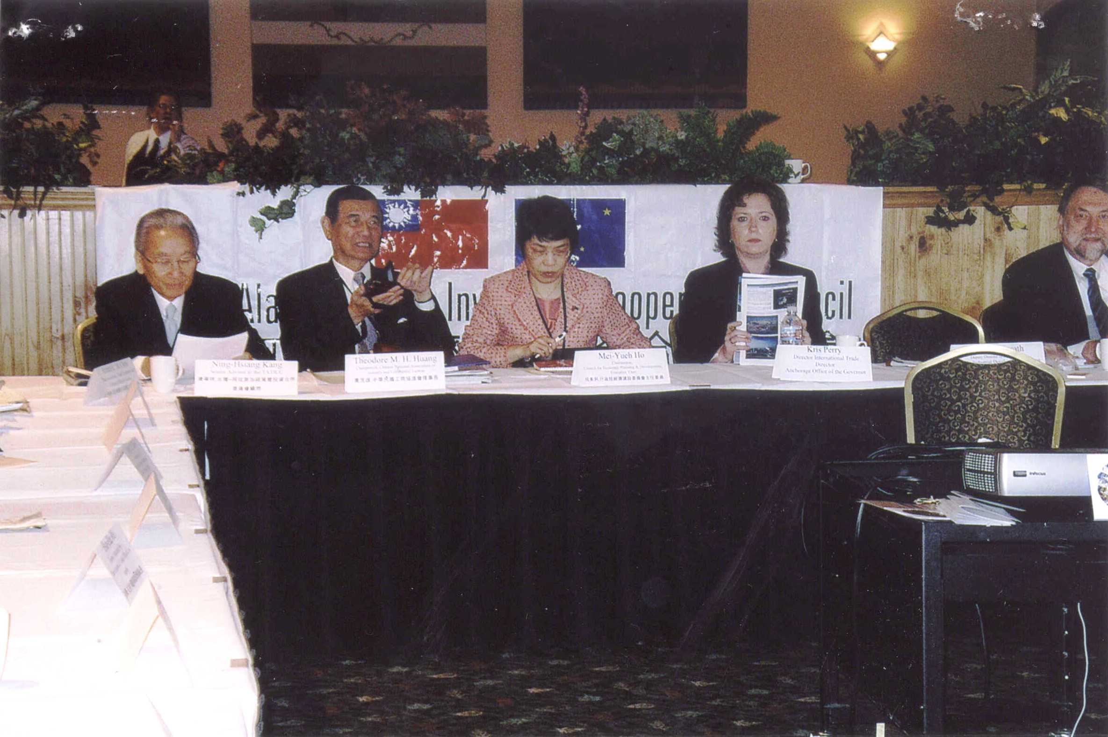

圖1，台阿雙方共同主席在開幕典禮上合照(左起康前資政寧祥、黃理事長茂雄、何主任委員美玥、Ms. Kris Perry安克拉治州長辦公室國際貿易部主任、Mr. James Hemsath，AIDEA & AEA副主任)
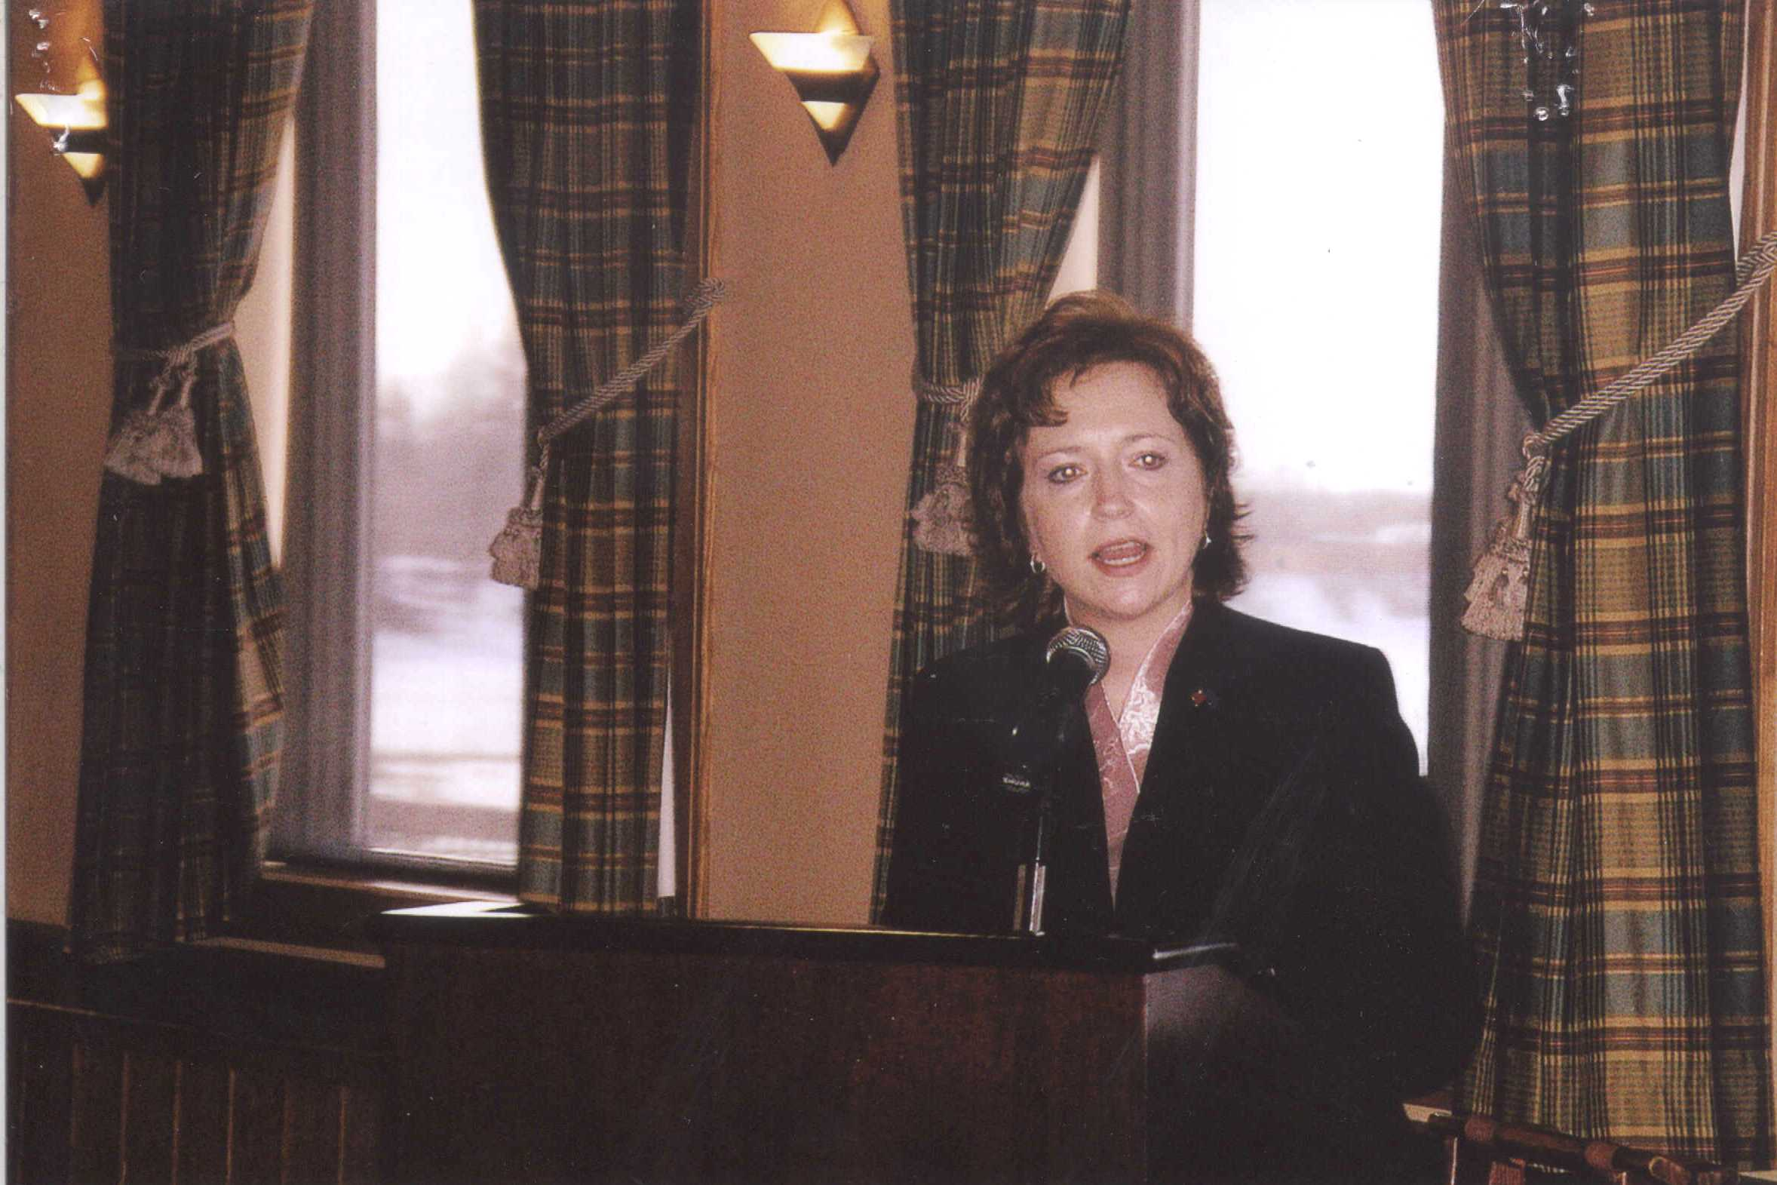
圖2，Ms. Kris Perry致歡迎詞
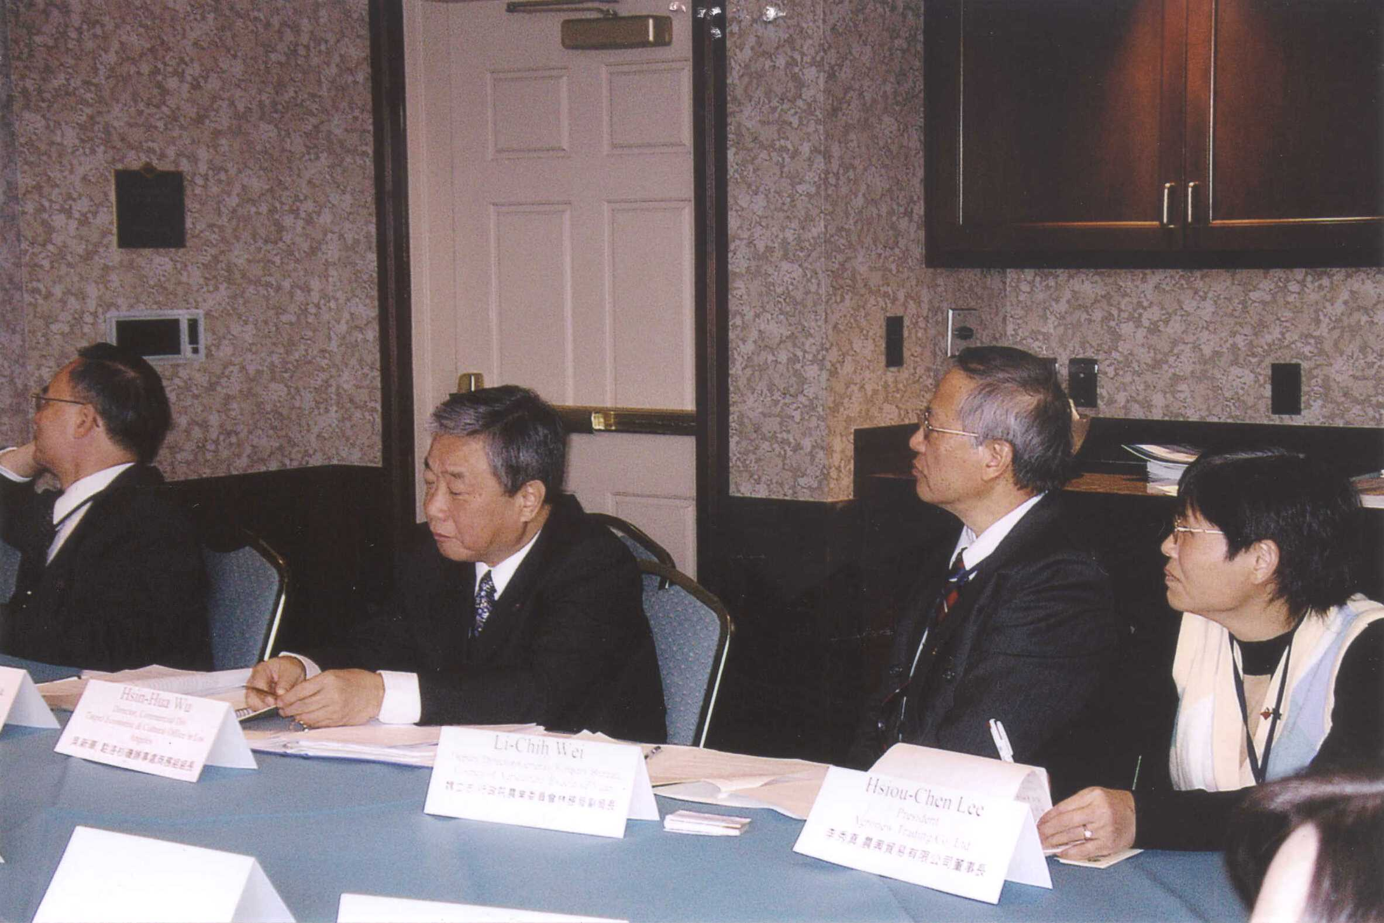
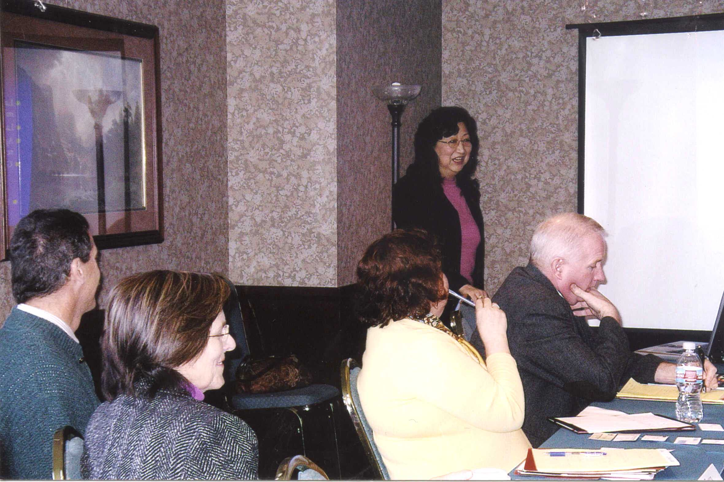
圖3，林業暨農業組分組討論情形
圖4，林業暨農業組分組討論情形
圖5，阿方代表Mr. Mark Eliot在閉幕典禮上報告林業暨農業組決議事項
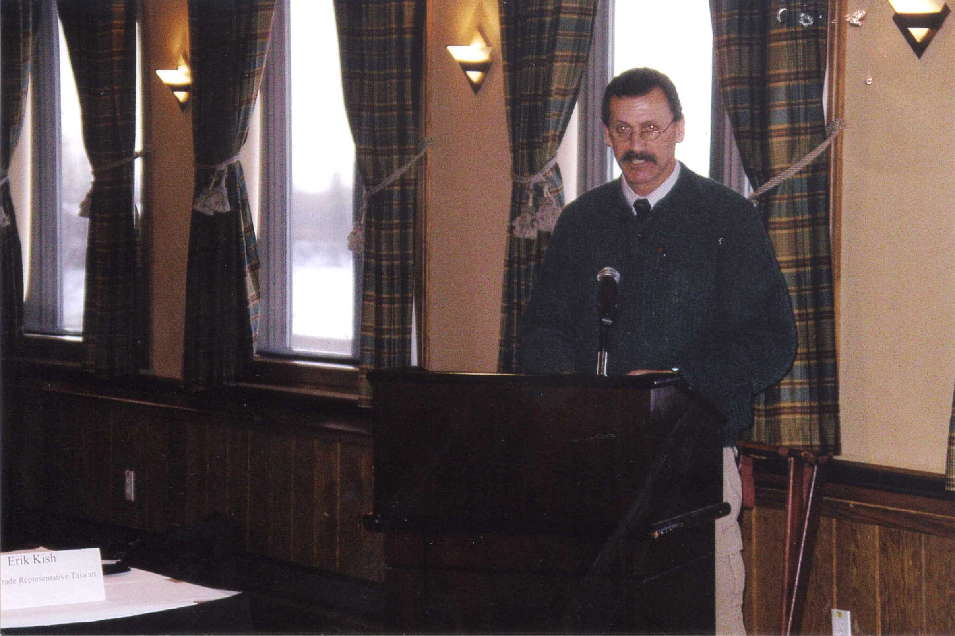
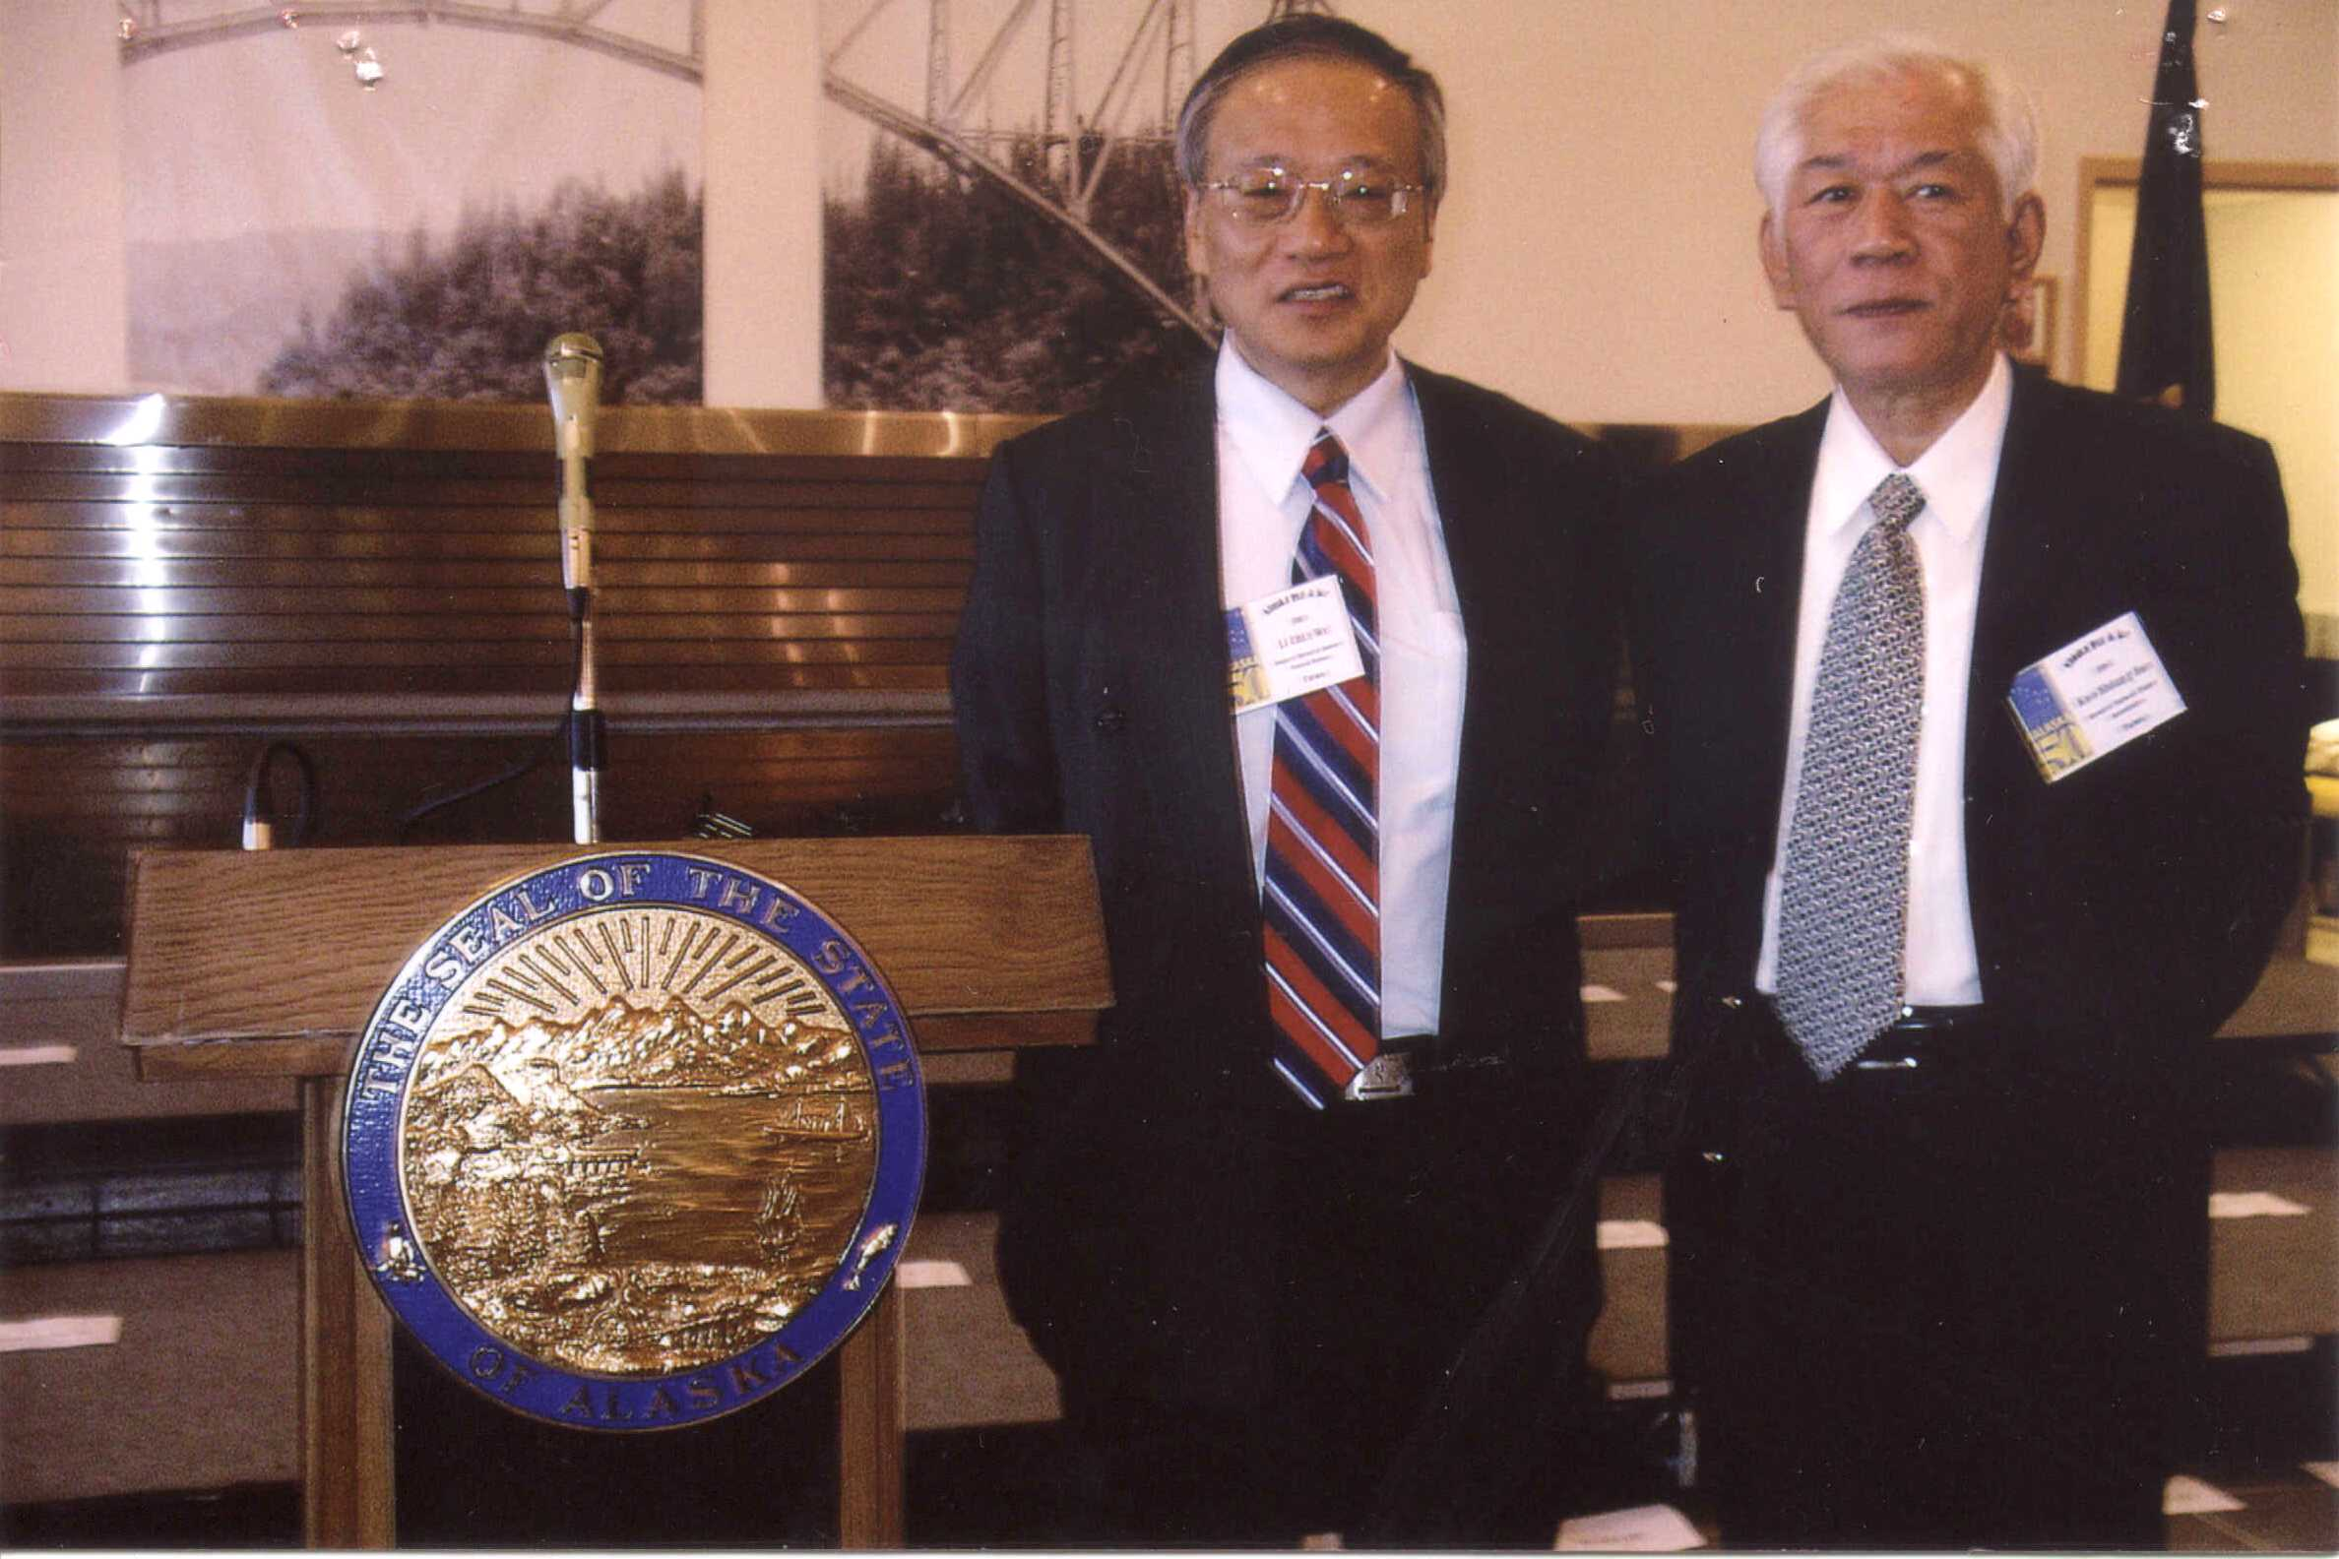
圖6，魏副局長與孫理事長合影
附件二

第4屆台灣－阿拉斯加經貿暨投資合作委員會會議
台灣代表團團務會議

時間：97年3月7日下午6時30分
地點：Princess Riverside Hotel, Copper Room

議 程

- 何共同主席美玥致詞
- 黃共同主席茂雄致詞
- 康顧問寧祥致詞
- 台方各組報告
- 秘書處周執行長報告
- 能源暨礦物組葉召集人報告
- 林業暨農業組魏召集人報告
- 海產組林召集人永德報告
- 觀光組謝召集人謂君報告
- 駐外單位報告
- 駐西雅圖陳處長報告
- 駐洛杉磯吳組長報告
- 臨時動議
附件三


Taiwan Delegation Alaska Itinerary

Friday, March 7, 2007 – Taipei/Anchorage/Fairbanks

11:56 am | Taiwan Delegation arrives Fairbanks, Alaska Airlines flight #183  - Hotel shuttle available, please telephone upon arrival.

Check-into Fairbanks Princess Riverside Lodge
4477 Pikes Landing Road, telephone (907) 455-4477

 | Evening on own

Alaska Fur and Ice 2008 is a one-day international event in Fairbanks, Alaska. The event is held in honor of the diplomatic corps and international tourism and business representatives. The hosts for the weekend include the Alaska Railroad, the Fairbanks Convention & Visitors Bureau, and the Fairbanks Chamber of Commerce.

Saturday, March 8, 2007 – Fairbanks
Ground transportation provided
7:45 am | Cold Weather Gear  If you need cold weather gear (parka, boots, hat, gloves, pants), please meet in the hotel lobby. AIE Tours will donate one day of rental to Alaska Fur & Ice participants.
9:00 am- 2:30 pm | Tour of Fairbanks  Meet in lobby of hotel.  Tour includes:  - Visit to the Trans-Alaska Pipeline  - University of Alaska Museum of the North “Ainu Ramati” exhibit  - Limited North American Championship sled dog race  - Hosted lunch at the Silver Gulch  - Dress - warm casual (parka, boots, hat, gloves)
3:20 pm | Motorcoach departs for Governor’s International Reception  Meet in lobby of hotel.
4:00 –  5:30 pm | Governor’s International Reception  The State of Alaska hosts international dignitaries and guests at a reception in the Alaska Railroad Passenger Depot  - Dress - business attire and fur.
6:00 pm | Dinner on own
7:10 pm | Motorcoach departs hotel for Ice Alaska
7:30 pm | Walking Tour of Sculptures at Ice Alaska’s Ice Park  Dramatic lighting of more than 60 ice sculptures against the night stars.  - Dress - warm casual (parka, boots, hat, gloves).

8:00 pm | World Ice Art Championship Award Ceremony  Ice Alaska presents the 2008 World Ice Art Championship awards to winners of the multi-block ice carving competition.
10:00 pm | Northern Lights Viewing  Fairbanks is one of the best spots on earth to view the beautiful northern lights.
Upon return to hotel | **Please set your watches forward one hour due to daylight savings time change at 2:00 am on Sunday**

Sunday, March 9, 2007 – Fairbanks
Ground transportation provided

10:00 am – 2:00 pm | Taiwan-Alaska Trade & Investment Cooperation Council meeting to be held in the Edgewater Room, Fairbanks Princess Lodge
2:00 – 3:00 pm | Late hotel check-out arranged for Taiwan Delegation  Please bring luggage to lobby and load all luggage and hand-carry items onto the bus. The bus will not be returning to the Fairbanks Princess Lodge.
3:00 pm | Motorcoach Departs Fairbanks Princess Riverside Lodge  Meet in lobby of hotel.  - Dress - warm casual (parka, boots, hat, gloves)  Tour includes:  - Visit to the Interior Alaska Fish Processors Plant  - Experience PAWS for Adventure dog mushing  - No host dinner at Pike’s Fine Dining Restaurant  **Mr. Joe Michel, Office of the Governor, will meet the delegation at Pike’s Restaurant to receive and return arctic gear that has been rented.
9:00 pm | Motorcoach will bring the Taiwan delegation directly to the Fairbanks International Airport for airline check-in
10:23 pm | Taiwan Delegation departs Fairbanks, Alaska Airlines flight #146
11:23 pm | Arrive Anchorage  - Delegation will check luggage straight through to Taipei.  - Airport shuttle to North (international) Terminal  - Denali VIP room, in North Terminal, will be open for Taiwan delegation
3:45 am | Depart for Taiwan, China Airlines flight #11

Shelley James (907) 351.6380 cell
Patricia Eckert (907) 632.5698 cell
Office of the Governor
附件四

Fourth Meeting of the
Taiwan-Alaska Trade & Investment Cooperation Council

1. Opening of Plenary Session
Time ： 10:00 a.m., Sunday, March 9, 2008
Venue ： The Edgewater Room, Fairbanks Princess Riverside Lodge

Agenda
10:00 am | Opening of Plenary Session  Welcome Remarks by Co-chairs of the Alaska Delegation  1. Ms. Kris Perry, Director, Anchorage Office of the  Governor, Director, International Trade  2. Mr. James Hemsath, Deputy Director of Development,  Alaska Industrial Development & Export Authority  (AIDEA) & Alaska Energy Authority (AEA)  Introductory Remarks by Co-chairs of the Taiwan  Delegation  1. Ms. Mei-Yueh Ho, Chairperson, Council for Economic  Planning & Development, Executive Yuan  2. Mr. Theodore M. H. Huang, Chairman, Chinese

National Association of Industry and Commerce
(CNAIC)

 | Remarks by H. E. Ning-Hsiang Kang, Senior Advisor to
TATICC

Proceed to Sector Meeting Rooms

10:30- | Sector Breakout Sessions
12:00 noon  12:00 noon  12:00-12:15  2. Closing  Time  Venue  Agenda  12:15 pm | - Mining and Energy (Edgewater Room)  - Fisheries Sector (Suite 201)  - Forestry and Agriculture Sector (Marble Room, 2nd fl)  - Tourism Sector (Riverview Room, 1st fl)  Adjourn  Break  of Plenary Session  ： 12:15 pm  ： The Edgewater Room  Closing of Plenary Session  Conclusion Reports  - Report by Mining and Energy Sector  - Report by Fisheries Sector  - Report by Forestry and Agriculture Sector  - Report by Tourism Sector
Remarks by Co-chairs of the Alaska Delegation
- Ms. Kris Perry, Director, Anchorage Office of the
Governor, Director, International Trade
- Mr. James Hemsath, Deputy Director of
Development, Alaska Industrial Development &
Export Authority (AIDEA) & Alaska Energy
Authority (AEA)
Remarks by Co-chairs of the Taiwan Delegation
1. Ms. Mei-Yueh Ho, Chairperson, Council for
Economic Planning & Development, Executive Yuan
2. Mr. Theodore M. H. Huang, Chairman, Chinese

National Association of Industry and Commerce
(CNAIC)
1:00 pm | Adjourn  Farewell lunch, Edgewater Room

附件五
第4屆台灣－阿拉斯加經貿暨投資合作委員會會議場所暨宴會地點
日期：97年3月9日(星期日上午10時~下午2時)

地點：Princess Alaska Lodges

會議名稱 |  | 起迄時間 | 會議室
開幕典禮 |  | 10:00~10:30 | Edgewater
分  組  討  論 | 能源暨礦物組 | 10:30~12:00 | Edgewater
分  組  討  論 | 林業暨農業組 | 10:30~12:00 | Marble
分  組  討  論 | 海產組 | 10:30~12:00 | Suite201
分  組  討  論 | 觀光組 | 10:30~12:00 | Riverview
中場休息 |  | 12:00~12:30
閉幕典禮 |  | 12:30~13:00 | Edgewater
午 宴 |  | 13:00~14:00 | Edgewater
備註：
  - 林業暨農業組及觀光組之會議室亦可能互換(迄3月7日台方團務會議前，阿方尚未正式定案)，請以現場牌示為主。
  - 各場次時間長短亦可能微調，惟請與會代表盡量嚴守原訂時間。
  - 台方各組分組討論結束後，請台方各組召集人速為何共同主席、
黃共同主席及康顧問報告分組討論重要決議事項。
附件六

The Fourth Meeting of the
Taiwan-Alaska Trade and Investment Cooperation Council
Alaska Participants

Alaska Co-Chairs
Ms. Kris Perry, Director, Anchorage Office of the Governor,
Director, International Trade
Mr. James Hemsath, Deputy Director of Development, Alaska
Industrial Development & Export Authority (AIDEA) & Alaska
Energy Authority (AEA)

Energy and Mineral Sector
Convener, Energy
Mr. James Hemsath, Deputy Director of Development, Alaska
Industrial Development & Export Authority (AIDEA) &
Alaska energy Authority (AEA)
Convener, Mining
Mr. Rick Fredericksen, Acting Mining Section Chief, Division of
Mining, Land, & Water, Department of Natural Resources

Mr. David Lepain, Geologist, Division of Oil & Gas, Department
of Natural Resources
Mr. Les Webber, Marathon Oil Corporation
Mr. Steve Borell, Executive Director, Alaska Miners’ Association
Mr. Richard Peterson, Managing Member, ANRTL, LLC
Mr. Steve Denton, Vice President of Business Development,
Usibelli coal Mine
Dr. Rajive Ganguli, Professor, University of Alaska, Fairbanks
Forestry and Agriculture Sector
Convener
Mr. Mark Eliot, Northern Regional Forester, Division of Forestry,
Department of Natural Resources
Ms. Dean Brown, Deputy Forester, Division of Forestry,
Department of Natural Resources
Mr. Ron Arvin, Chief Operation Officer, NPI
Mr. Chad Schumacher, Logistics Manager, NPI
Ms. Cassie Pinkel, Project Manager, Fairbanks Economic
Development Corporation
Dr. Jingjing Liang, Assistant Professor, UAF College of Forestry
and Agriculture Science
Mr. Tom Malone, Research Forester, UAF College of Forestry
and Agriculture Science
Ms. Patricia Eckert, Trade Specialist, Office of the Governor,
International Trade
Dr. Jennifer Huang McBeath, Researcher, University of Alaska,
Fairbanks
Seafood Sector
Convener
Mr. Ray Riutta, Executive Director, Alaska Seafood Marketing
Institute
Mr. Joe Austerman, Manager, Office of Economic Development,
Department of Commerce, community, & Economic
Development
附件七

The Fourth Meeting of the
Taiwan-Alaska Trade and Investment Cooperation Council (TATICC)
第4屆「台灣－阿拉斯加經貿暨投資合作委員會」

FORESTRY AND AGRICULTURE BREAKOUT

DRAFT AGENDA

WELCOMING AND OPENING REMARKS Dean Brown

INTRODUCTIONS Mark Eliot

PRESENTATIONS：

． Mark Eliot
    - Overview of Forestry in the Alaska Interior
． Dr. Jingjing Liang
    - “FIASKA：A Key To Study Forest Management in Alaska”
． Dr. Jenifer Huang McBeath
    - “Alaska Seed Potatoes for Export”

OPEN DISCUSSION All

