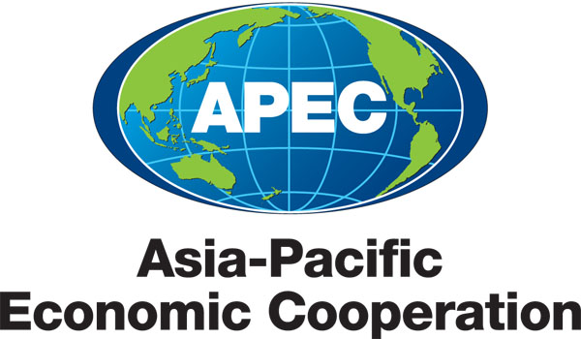
_________________________________________________________________________________
2008/ISTWG34/042
Agenda Item: P4.2

Subgroup B report

Purpose: Information

Submitted by: Chinese Taipei

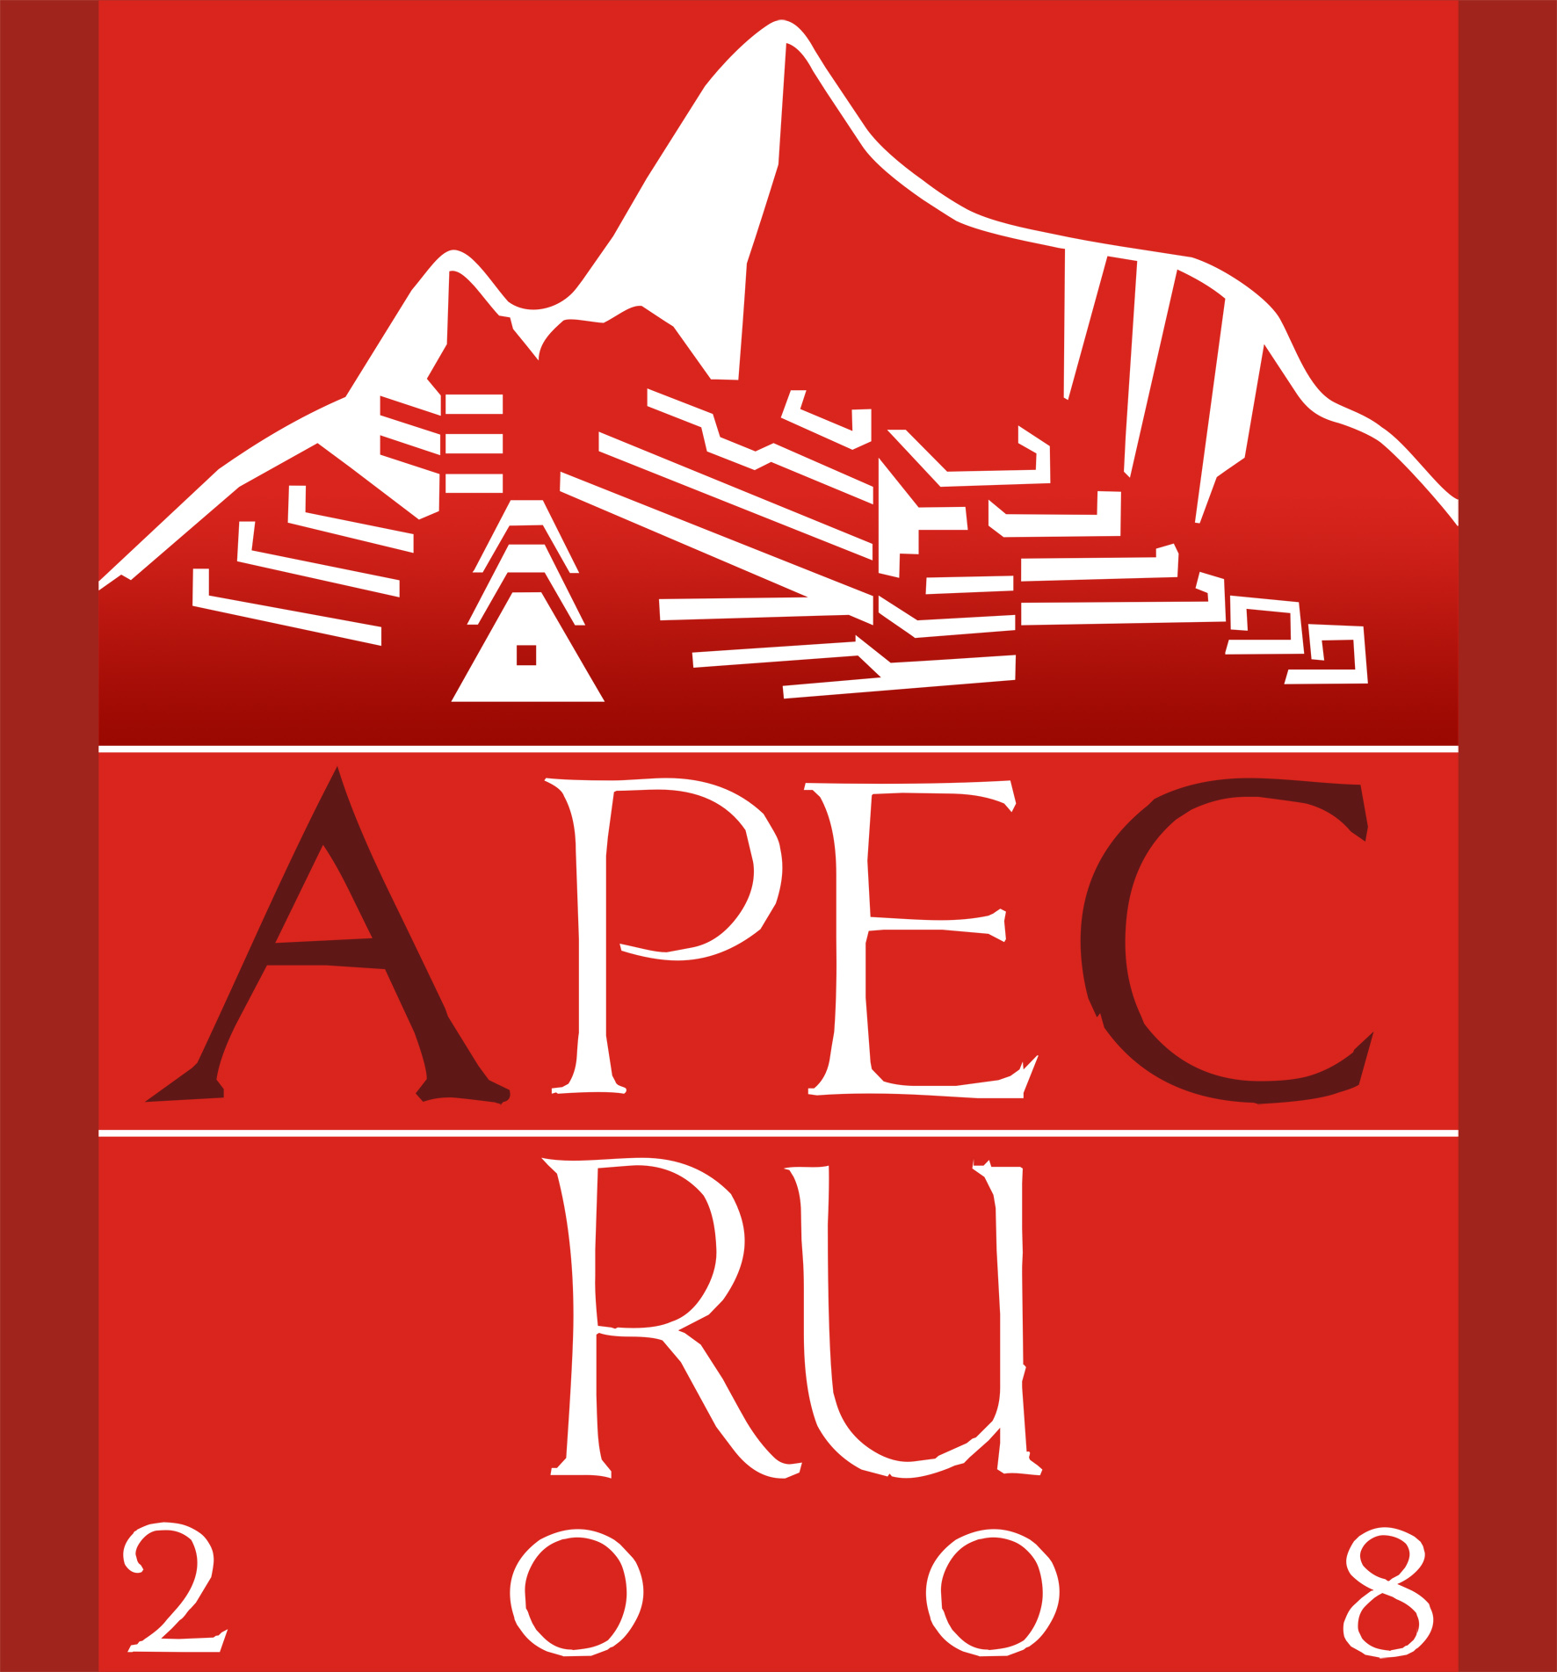 | 34th Industrial Science and Technology Working Group Meeting  Hong Kong, China  27 – 28 March 2008
Subgroup B Report
International S&T Network
34th APEC ISTWG, March 2008
Side Meeting Report

1. Background
In the ISTWG Policy Forum in 2001 it was recognized that a wealth of knowledge of success factors and best practice in developing and maintaining effective regional S&T networks exist. It was also recognized that policy issues such as IP management can present serious barriers to the development and maintenance of S&T networks. Therefore it was proposed to adopt best practices in developing international S&T networks (ISTN)
The ISTWG will facilitate the creation of S&T networks and partnerships that support the goals and priorities of APEC. In this regard, the ISTWG supports multilateral research projects using well planned and coordinated approaches that are in accordance with the intent of the APEC Joint Research Promotion Guidelines for IST including the effective dissemination of information.
The ISTWG will support the creation of networks of S&T communities in Asia Pacific region that encourage the open flow of information and researchers. It also supports the establishment of “one-stop” technology centers, such as technology parks and engineering research centers, that have a multilateral collaborative and networking dimension, and provide facilities for technology development, training and information sharing for businesses, research institutions and institutions of higher learning. It supports the creation of networks among these centers to facilitate more widespread cooperative activities.

2. Subgroup B Projects
Currently there are ten ongoing projects in Subgroup B. Two of these ten projects are completed. These two projects are: APEC Science Centre Impact Study - (Australia), and Networking of R&D Leaders and Researchers (Chinese Taipei.). The latter project was co-sponsored by Canada, China, Japan, Korea, Indonesia, Thailand, and U.S.A. There were several Fora held successfully in 1998 & 1999 (both by Chinese Taipei), 2000 (Canada), 2002 (Thailand) and 2004 (New Zealand.) In the 5th R&D Leaders’ Forum (2004), combined plenary and workshops were held and a special joint session with Science Ministers were also held.

Eight projects have given the presentations in the side meeting session last day. These eight projects include three new proposals respectively from China, Chinese Taipei, and Korea, and three projects from Japan and two projects from Chinese Taipei. These eight ongoing projects are summarized as below.

(1) Utilization and Protection of Water Resources (China) – New (APEC Funding)
China has proposed to organize a workshop on utilization and protection of water resources in may 2009 in Suzhou, which aims to set up an exchange platform for water resources experts and researchers, and build up an experts and technology database in the website of APEC Center for Technology Transfer. The project will also deliver a report to integrate the advanced technologies and information gained in the workshop and share with all member economies.
The project has attracted interests of all the member economies. Viet Nam, Thailand, Hong Kong, China and Chinese Taipei have agreed to take the role as cosponsors and Korea has also expressed his willingness to participate in the project.

(2) APEC Biotechnology Conference- Bio-Connection Construction (Chinese Taipei)
The 7th APEC Biotechnology Conference will be held in Taipei on July 21, 2008. With the theme of “Building the Value of Translation Research for Biomedicine in APEC Region”, this year’s Conference is intended to explore the best strategies and mechanisms to build a highly valued network between universities, business sector, and government in a new form of open innovation. A comprehensive series of presentations and discussions will be introduced to address two Conference focuses: (1) novel structures and models on promoting clinical and translational science in global context and (2) how APEC members could do to enhance the disciple of translational research in biomedicine. In addition, the global business opportunities and challenges in consolidating translational research will also be analyzed.

(3) Developing the Cleaner Production Approaches through Partnership Build-up for the Sustainable Development of Electronics Sector in APEC 2006-2009 (Chinese Taipei)
This project deals with the request and global trend of green electronic which has tremendous expansion of applications and brings heavy environmental loading. This report highlights the progress of the built-up of two cleaner production approaches, eco-design and green supply chain. Eco-design is developed in accordance with the “implementing measures” of the Energy Using Product Directive (EuP). Nevertheless, Assistance on the eco-design check list, LCA & Eco-profile and conformity report have been provided for some companies. Besides, a platform of green supply chain that provides integrated service is being developed. This platform provides the enterprises of system manufacturers, part suppliers, testing companies and consultants with the assistances including data evaluation, guidance of management and training.
This project also builds the links with “International Electronics Manufacturing Initiatives” (iNEMI) which is the organization that seeks to close technology gaps from overall supply chain perspectives of electronic industry.

- 2009 APEC RFID Conference - Technology Development and Best Practices (Chinese Taipei) – New (Self Funding)
The purposes of this new project proposal are: (1) to response 2007 APEC Leaders’ Declaration for improving economic efficiency and the business environment, (2) to share knowledge and experience on RFID technology and its applications involving the bi-lateral traceability system in the supply chain of the electronics industry, (3) to enhance future collaboration between APEC region economies.
This new project proposal is self funded and will analyze RFID technology and its applications involving the bi-lateral traceability system in the supply chain of the electronics industry. Chinese Taipei will also collect best practices and successful stories to share with APEC member economies by holding a conference-2009 APEC RFID Conference to gather various professionals who are highly involved in the RFID related activities to jointly examine the current technology development and to further discuss the plan for building a collaborative network within the APEC member economies. The ultimate goal of the project is to enhance the collaboration of various industries that use RFID technology and to facilitate trade and business efficiency across APEC regions where trade volumes are significant.

- Workshop on Life Cycle Assessment for APEC Member Economies (Japan)
The objective of this project is to share of knowledge and information on LCA and to discuss its application and innovation for global sustainability. This Life Cycle Initiatives has been organized every two years by AIST on the theme of the role of LCA (1998), the inventory database (2000), the development of the methods for the life cycle impact assessment (2002), the capacity building (2004) and global supply chains (2006). This initiative is the major event for the researchers and LCA experts in APEC Member Economies and countries supporting this activity. A workshop was held in March 2008 and was the 6th workshop in a series of workshops on LCA in cooperated with UNEP /SETAC Life Cycle Initiatives toward the sustainability in the Asia Pacific region.
This workshop includes 7 sessions; Life Cycle Inventory Database, LCI and LCA Studies, Life Cycle Impact Analysis, LCA for Biomass Utilization, LCA for Local Activities, Activities on MFA and Energy System, and the Application of LCA. National Institute of Advanced Industrial Science and Technology is organizing this event and it is officially cooperated with APEC.

(6) APEC Virtual Center for Environmental Technology Exchange (APEC-VC) (Japan)
The renewed 2007 activities include APEC-VC Japan website, adopting “keyword” search system using Google Custom Search Engine. Besides, a workshop in Seoul jointly with APEC-VC Korea and Korea Institute of Environmental Science Technology and a seminar for Energy-Saving and New Energy with VC China was held. As a joint project with Osaka Prefecture, Asia Environment Business Project, with the purpose of playing a role as a bridge between SMEs in Osaka and Asian countries was conducted to provide a platform for environmental business to improve the environment in Asia.
With regard to the projects in 2008, Asia Environmental Business Project will be continuously conducted. The work plan include: (1) to joining two international exhibition fairs and provide a venue for SMEs in Osaka for the exhibition of technologies and products, (2) to organize a workshop in Shanghai with VC China in November, (3) to coordinate an environment-related seminar in Osaka on Nov. 26 2008 with Osaka International Trade Fair Commission as concurrent event of New Earth 2008, International Exhibition and Symposium for Global Warming & Eco Solutions.
Through the APEC-VC network, the latest environmental information on solution technology, laws and regulations, energy saving and etc are collected and provided to companies their business operation in the APEC region.

- Disaster Reduction Hyperbase-Asian Application (DRH-Asia) (Japan)
The objective of this project is the development and dissemination of an information platform - Disaster Reduction Hyperbase-Asian Application （DRH-Asia）, which is a facility disseminating disaster reduction technology and knowledge of implementation strategies.
The Activities in 2007（April 2007–March 2008）includes: (1) Construction of the DRH-Asia production web system, (2) Generation of the DRH-Asia contents and compilation, (3) Project management / facilitation of DRH contents compilation, (4) Dissemination and publicity efforts. The progress of this project includes (1) Construction of the DRH-Asia production web system, (2) Generation of the DRH-Asia contents and compilation, (3) Project management / facilitation of DRH contents compilation, (4) Dissemination and publicity efforts. Four perspectives of this project are (1) Continued efforts, (2) Dissemination and implementation of DRH-Asia, (3) Activity sustainability and fund raising, and (4) Concluding the Phase II of DRH.

- APEC Climate Center for Climate Information Services to Society (Korea) – Ongoing and New (APEC Funding)
This new proposal seeks APEC funding and has 18 co-sponsoring economies including Australia; Canada; Chile; China; Hong Kong, China, Indonesia; Japan; Malaysia; Mexico; New Zealand; Peru; Philippines; Russia; Singapore; Chinese Taipei; Thailand; and Viet Nam.
The key objectives of the project are: (1) facilitate sharing of the latest climate information and data exchange through regional cooperation in a cost-effective way, (2) ensure all the regional scientific, industrial and stakeholder communities the comprehensive collaboration and examination over the climate issue, (3) provide member economies with training program so as to build self-generating capacity of improved climate prediction information.
This project provides optimized climate prediction information to 21 APEC members, including those members which have no capability to produce the high-cost climate information. APCC helps member economies to reduce negative economic impacts, protect lives and properties, and bring economic prosperities. This project will also build on the capacities of Meteorological Services in member economies. this project will organize the APCC Scientific Symposium in October 2009 to further facilitate the data exchange and regional cooperation for the development of early warning system of high impact climate.

Summary and Suggestions
Most of the activities of the existing projects have been in consistent with the overall focus and directions of the sub-group and appear to make good progress. There are few projects to be completed and 3 projects are proposed in 2008. Therefore, Subgroup B continues to encourage the initiation of new projects to emphasize creation of network of S&T community on broad policy, framework, and cross-cutting issues related to building community resilience and preparedness for emergencies and natural disasters, and to tackle challenges of energy security and clean development. We also would like to invite and encourage all member economies to initiate and participate in ISTN project activities to create networks among the S&T centers to facilitate more widespread cooperative activities.

