Analysis of Solar Irradiation on Greenhouse

Hsun-Heng Tsai, Jik-Chang Leong, Chien-Hsiung Tsai, Chyun-Chau Fuh

Department of Biomechatronic Engineering
National Pingtung University of Science and Technology
Taiwan, R.O.C.
Department of Vehicle Engineering
National Pingtung University of Science and Technology
Taiwan, R.O.C.
Department of Mechanical and Mechatronic Engineering,
National Taiwan Ocean University,
Taiwan, ROC
* Hsun-Heng Tsai--Voice:+886-8-7703202-7584, Email:heng@mail.npust.edu.tw

Abstract: This work was performed using computational approach to simulate the effect of solar irradiation on the greenhouse effect in a close greenhouse. The simulation results were compared with the field measurements to validate the feasibility and correctness of using the Discrete Ordinates Radiation Model in studying the heating effect in the greenhouse. Based on the comparison between the field measurements and computational results, the maximum relative error for temperature was 1.46% and was located on the floor in the greenhouse. On the hand, the minimum relative error for temperature was located on the water curtain and it was 0.06%. Also found that accumulation of heat energy obviously took place at the upper corner and the regions close to the greenhouse roof. This phenomenon could be identified for the temperatures at these regions were apparently greater than the temperatures at rest of the greenhouse interior.
Keywords: Greenhouse, CFD, Field Measurement, Solar Irradiation, Temperature Distribution

INTRODUCTON

Taiwan is located in the subtropical zone, although its climate is mild most of time, however, the agriculture in Taiwan is also suffered by typhoon and cold current, so the utility of greenhouses is also popular in Taiwan. The main constraints of crop production in the open field here are solar radiation, high rainfall, insects and diseases. Especially, solar radiation affects natural ventilation apparently which is considered one of the most important factors of greenhouse environment, and play a direct key to sensible and latent heat of the air temperature in greenhouses.

The use of Computational Fluid Dynamics (CFD) begun as early as the 1950s. With the advance in science and technology, the present computational capability has significantly increased accordingly. Finer and finer grid systems are now acceptable and the time for computation has greatly reduced. In 1974, Nelson was the first scholar applying CFD approach in studying the flow and temperature fields in a building. Since then, CFD approach has been greatly employed in the industry sector. Okushima et al. (1989) were the first who applied CFD approach to simulate the ventilation system associated to a greenhouse. Then they compared their simulation results with the wind tunnel results experimentally obtained by Sase et at. (1984). Miguel et al.(1997,1998) extended the application of CFD approach to study the effect of porosity of greenhouse screening materials and had successfully derived an empirical equation. This equation was then used by other researchers in their works that focused on the temperature distribution and flow patterns in greenhouses.

The objective of this work is to investigate the effect on the temperature field in a close greenhouse due to solar irradiation. Since the solar irradiation can be considered a non-gray radiation, this simulation employs Discrete-Ordinate (DO) Radiation model readily available in FLUENT, a highly creditable commercial CFD software package. The computational results obtained are then compared with the site measurements.

MATERISALS AND METHODS

Mathematical Formulation

The computation work presented in this paper uses FLUENT that is developed based on the control volume method. The control volume method is also known as the finite volume method. The first step in this approach is to divide the entire computational domain into a large number of control volumes and then the properties associated to each of these control volumes are solved simultaneously.

The Navier-Stokes equations are time-averaged to yield the Reynolds-Average Navier-Stokes (RANS) equations. The turbulence model employed here is the well-known standard k-ε model Launder and Spalding proposed in 1972. The heat transfer mechanism due to solar irradiation is modeled using the Discrete Ordinate (DO) Radiation Model.
The energy equation associated to the turbulent flow field is given as
(1)
where
(2)
(3)

The porous media considered in this work is modeled using the well-known Darcy’s law and Darcy-Forchheimer equation. When a fluid flows through a porous medium, the flow static pressure will decrease due to the increase in flow resistance induced by the porous medium. As a result, the local velocity at the fluid and porous medium interface is greatly influenced.
Using the DO radiation model, the radiative transfer equation for the spectral intensity can be written as
(4)

When using the DO Radiation Model, the rate of blackbody radiation, the rate of diffusivity, and absorption coefficient are required to be experimentally estimated. In this simulation, the blackbody temperature of the sun is about 5800K and the rate of blackbody radiation must be carefully adjusted to produce the reasonable desired temperature.

Field Measurement was carried out so that the setting of parameters involved in the simulation could be determined as close to the actual conditions as possible. The following describes the equipments used, the type of data collected, and the locations where the measurement was obtained.
- The temperatures and other relevant data in the greenhouse were measured using infrared thermometer, electronic anemometer , photometer, indoor/outdoor thermo-hygrometer, and caliper. The measurements are listed in Table 1.
- The subjects whose temperature was measured included the ground outside the greenhouse, the center ground inside the greenhouse, the greenhouse walls, the greenhouse roof, and water curtain. A series of temperature readings were collected from each subject and the corresponding average temperature was determined.
- The anemometer was used to measure the velocity and temperature of the air inside and outside the ventilation fan and water curtain. These readings were later used as the boundary conditions for computational simulation. It is important to recognize that experimental error was by no means completely eliminated although the measurement was performed as carefully as possible.
- Measurement discrepancies were impossible to be avoided due to the change in the solar irradiation angle, atmospheric wind conditions, and cloud conditions.

The measurements were obtained about 1:00 p.m. The environmental wind speed was measured ranging from 0.5 to 1.5 m/s while the temperature was 308 K. The length, width, and height of the greenhouse are 20 m, 6.4 m, and 3.9 m, shown in Figs. 1

Table 1. Temperature measurements at the greenhouse.
Location | Temperature (K)
Ground surface outside the greenhouse | 324.0
Ground surface inside the greenhouse | 315.0
Side glass wall | 315.0
Top glass roof | 317.0
Fan outlet | 309.0
Water curtain | 308.5
Greenhouse interior | 310.0

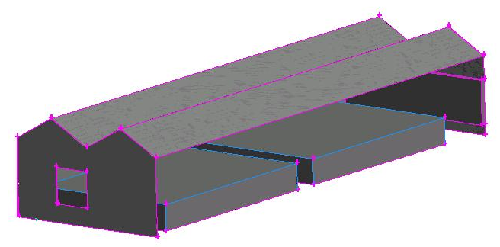
L
H
W

Figure 1. The geometry of the greenhouse.

Results and Discussion

The suitable values of the blackbody emissivity, the transparent glass diffusivity, and the glass absorptivity concluded in the preliminary study are then employed here for simulation of actual geometry and environment.
Rate of blackbody radiation is assigned 3×10⁻⁶ for simulation, the rate of diffusivity is 0.7, and the glass absorption coefficient is assigned a value of 75 m⁻¹.

The flow field in the greenhouse at X = 2.5 m is shown in Fig. 2. Air outside the greenhouse is drawn into the greenhouse from the left through the water curtain. Air blowing towards the plantation experiences an increase in flow resistance and is therefore diverted upward. This causes a large recirculation of air at the corner right above the inlet. The velocity profiles shown in Fig.3. clearly demonstrate that the variation in velocity magnitude is most dramatic at the inlet and outlet. In the greenhouse far away from both the inlet and outlet, the flow velocity has greatly been reduced. Within the plantation, the velocity is certainly lower than that above the plantation.
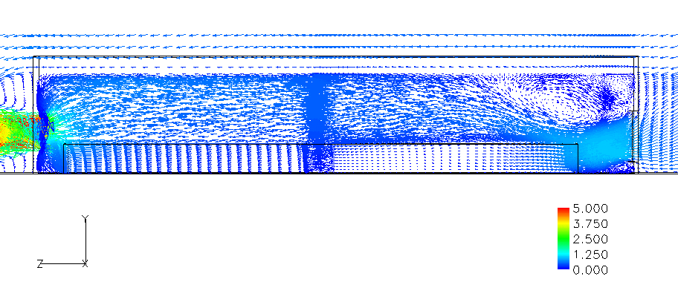
Figure 2. Vector representation of the flow field inside the greenhouse at X = 2.5 m.

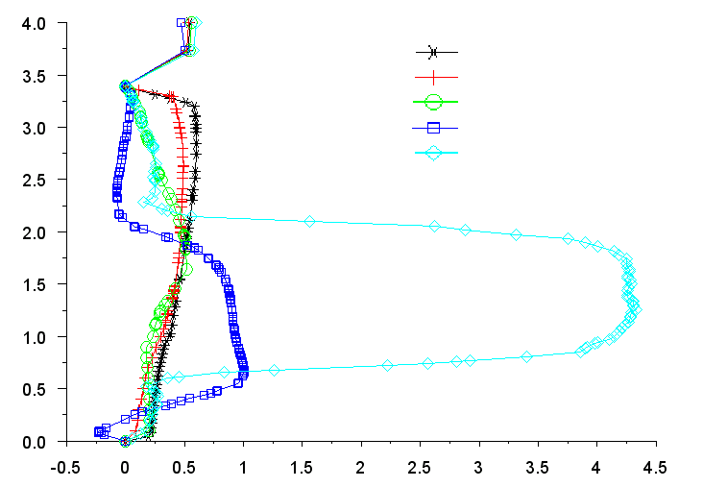
Y
(m)
Velocity (m/s)
15.0m
10.0m
5.0m
Inlet
Outlet
Figure 3. Velocity profiles in the greenhouse at X = 2.5 m but different Z locations.

By comparing the field measurements with the simulation results, as listed in Table 1, the 1.46 % maximum relative error in temperature occurred on the greenhouse interior ground surface but the minimum was 0.06 % taking place at the air inlet through the water curtain. Figs. 4 and 5 show the temperature distributions on the walls of the greenhouse and in the greenhouse interior. It was found that the maximum wall temperature was located at the corner between the roof and the wall above the water curtain. From Fig. 3 where a flow recirculation cell is obvious identified, hot air was trapped within the recirculation cell and hence led to an adverse accumulation of heat. This phenomenon can be further examined via Fig. 6. Regardless of the location, all temperature profiles prove that the air temperature in the greenhouse tended to increase close to the roof but the temperature dropped within the region next to the roof. Although a ventilation system was introduced, the system was still ineffective in cooling down the entire greenhouse. For this reason, the height of a greenhouse would have an unavoidable effect on the plantation.

Table 2. Comparison of temperatures
Location | Measure- ment  (K) | Simulation result  (K) | Relative error (%)
Exterior ground surface | 324.0 | 324.9 | 0.27 %
Interior ground surface | 315.0 | 319.6 | 1.46 %
Side wall glasses | 315.0 | 316.1 | 0.35 %
Roof surface | 317.0 | 317.5 | 0.16 %
Fan inlet | 309.0 | 310.1 | 0.29 %
Water curtain | 308.5 | 308.3 | -0.06 %
Interior | 310.0 | 309.1 | -0.29 %
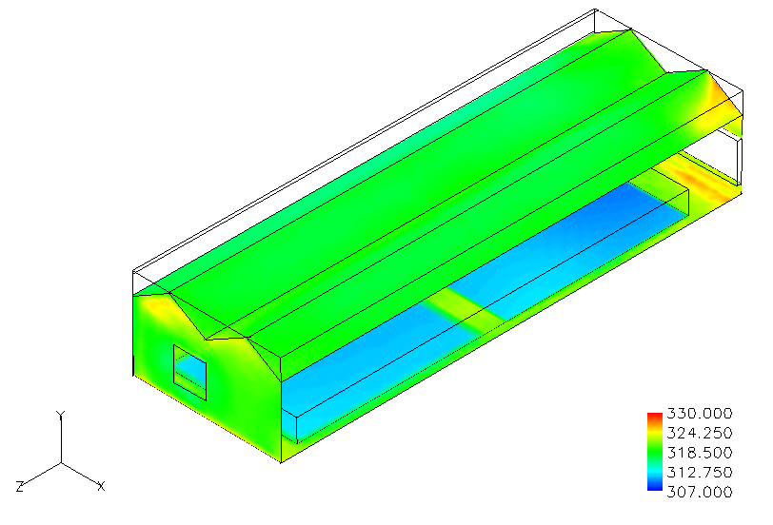
Figure 4. Temperature distribution on the walls of the greenhouse.
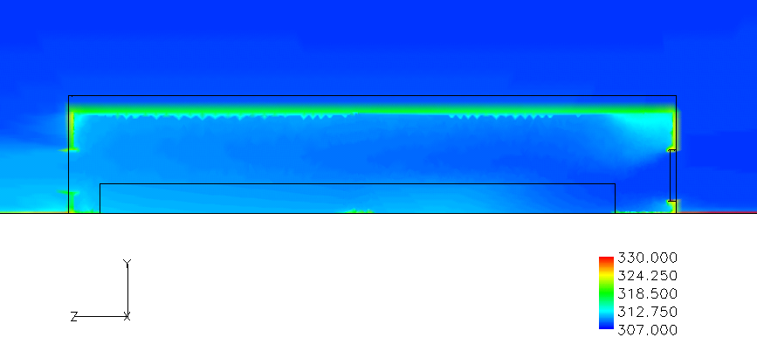
Figure 5. Greenhouse interior temperature distribution at X = 2.5 m.
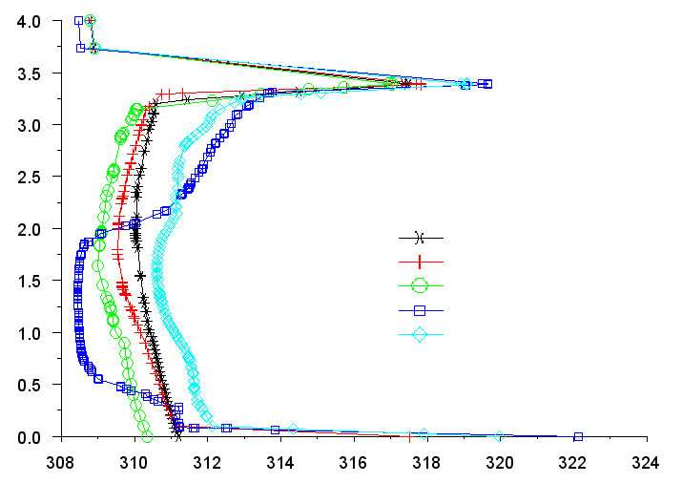
Y
(m)
Temperature (K)
15.0m
10.0m
5.0m
Inlet
Outlet
Figure 6. Temperature profiles in the greenhouse at X = 2.5 m.

Conclusions

This computational work has proven that DO heat radiation model is suitable for the simulation of greenhouse velocity and temperature fields if the conditions both interior and exterior of the greenhouse are coupled. By comparing the actual measurements and simulation results, the maximum relative error on the floor inside the greenhouse was about 1.46% while the minimum relative error about 0.06% was found located on the water curtain. Finally, based on the flow field and temperature distribution in greenhouse, it was found that the accumulation of heat energy generated within the greenhouse leads to the decrease in ventilation efficiency and eventually causes the interior temperature to raise.

ACKNOLEGEMENTS

The authors are graceful to Dr. Chien-Hsiung Tsai for his comments and suggestions that help to improve this work.

REFERENCES

Fatnassi Hicham, Thierry Boulard, and Lahcen Bouirden. 2003. Simulation of climatic conditions in full-scale greenhouse fitted with insect-proof screens. Agricultural and Forest Meteorology 118:97–111.
Francisco Domingo Molina-Aiz, Diego Luis Valera, Antonio Jesús Álvarez. 2004. Measurement and simulation of climate inside Almería-type greenhouses using computational fluid dynamics. Agricultural and Forest Meteorology 125:33–51.
Miguel A. F., N. J. Van den Braak, and G. P. A. Bot. 1997. Analysis of the air flow characteristics of greenhouse screening materials. J. Agric. Eng. Res. 67:105–112.
Miguel A. F. 1998. Airflow through porous screens: from theory to practical considerations. Energy Building 28:63–69.
Neilson P. V., A. Restivo, and J. H. Whitelaw. 1978. The Velocity Characteristics of Ventilated Rooms. Journal of Fluids and Engineering 100:291-298.
Okushima L., S. Sase, and M. Nara. 1989. A support system for natural ventilation design of greenhouses based on computational aerodynamics. Acta Hortic 248:129–136.
Sase S., T. Takakura, and M. Nara. 1984 Wind tunnel testing on airflow and temperature distribution of a naturally ventilated greenhouse. Acta Hortic 148:329–336.

