上課日期: 2006.12.11 上午
課程名稱: A-Star 之 Institute for Infocomm Research (IIR)研究所參訪
- 課程重點整理
A-Star (Agency for Science, Technology and Research)為新加坡國家級研究機構，主要從事Biomedical and Science & Engineering兩大方向研究。主題如下

Bio-medical (BMRC)
Science & Engineering (SERC)
Institute for Infocomm Research (IIR)
Materials research (IMRE)
Micro-electronics (IME)
Data storage (DSI)
Chemical engineering (ICES)
Manufacturing technology (SIMTech)

IIR研究所則為Science & Engineering下之一研究單位，專門負責Communications, Computing and Media等三大方向研究。

其研究中心有

Center for Signal Processing (CSP)
Kent Ridge Digital Labs (KRDL)
Optical Group Network Technology Research Center (NTRC)
Center for wireless communication (CWC)
R&D Group, Institute of System Science (ISS)
Information Technology Institute (ITI)

等機構。在communication方面, 研究包含Radio Systems, Embedded Systems, Wireless Communications及Network Technology。在Computing方面, 研究包含Systems & Security及Knowledge Discovery。在Media方面, 研究包含Media Processing, Media Understanding, 及Interactive Media。

IIR 並不直接從事基礎科學研究，而是運用university的產出(Blue-sky research)，經由User-Inspired Research及Development Research將基礎科學轉變應用的關鍵技術，再經由Get-UP機構做Product Development，再交予業界做Commercialization.

對業界公司而言，IIR 能提供

Research & development creating intellectual property
Technology Transfer & sharing of resources
Development of prototypes
Training & development of talent
等加值服務。
RFID為研究重點之一，主要運用於貨櫃管理。尤其配合新加坡自身每年有2400萬貨櫃的吞吐量，確實有切身的需求。由於新加坡也生產藥品，藥物生產管理/追蹤亦在計畫中。展示廳有同時介紹儲藏架及shopping cart的應用。

UWB的技術開發，同時發展 time domain 及 frequency domain技術。Time domain技術可運用於醫院病人localization的應用。解析度約30cm左右。Frequency domain技術則與Wimdia相同，著重於 Certified Wireless USB 開發。在wireless lab中，demoed了Wimedia UWB radio connection, 其中包含 UWB antenna, discrete PHY with fan for heat dissipation, FPGA base band and MAC. 雖然技術開發上落後歐美日及台灣，但值得注意的是MIMO的技術被運用其中，2x2的架構有助通訊的品質及效率。

Software Defined Radio (SDR) 及 Cognitive Radio技術為長期研究之一。其目的是建立universal 通訊平台，運用軟體運算能力，取代base band processor且能同時提供不同通訊protocol。唯目前高速ADC (analog to digital converter)技術未能成熟，發展有待突破。Cognitive Radio則能有效利用頻段、頻寬及time slot, 提高通訊品質及效率。
影音技術涵蓋了影像/聲音辨識，media understand及coding / decoding / transcoding。目前技術可辨識為 media Language & Accent Recognition, Speaker Recognition及人車。Coding/Decoding則著重於H.264及 MPEG4 –ALS/SLS開發。Transcoding則在research階段，約1~2年才有可能商品化。在MPEG4-SLS發展上，IIR是制訂標準的主要成員之一。此技術預計是下一代音樂格式主流，可同時有效支援lossless 及lossy的compression, 提高音樂品質並可依據通訊頻寬，即時改變compression rate以防止streaming 中斷。

Computing security則展示了distributed authentication server 架構。發展出電腦資訊的鎖密手法，以防此駭客入侵電腦，採取進入伺服器的鑰匙由一把分成多把，然後散佈在不同的伺服器內，駭客必須將全部的鑰持拼湊才有機會進入系統，但是困難度增加很多。亦也避免單一authentication server遭受惡意攻擊而造成系統癱瘓的缺點。若其中有server遭受迫害，backup server亦會即時取代，讓系統持續工作。
整體而言，IIR功能類似台灣的工研院之資通所，開發通訊之關鍵技術，再交予業界商品化。研發人員約350人其中博士占40%，而學生約150人。經費來源，每年約50至60萬新幣，絕大部分來自政府，或從A-Star及Industry提供專案研發經費。人員的流動也約在40%左右，主要是由於已開發的技術及關鍵人員轉移至業界。從某個角度來看，IIR也是一個人才與技術的培育中心。

資訊研究所為A-star 架構下之一研究單位，專門負責資訊關之研究，例如數位影像，聲音或是電腦資訊的判別，加密等等。該研究所細分三個部門分別為computing,communication以及media，全部研發人員約350人其中博士占40%，而學生約150人。簡報中強烈顯示出該單位的策略藍圖非常清楚，與業界的合作極為密切。在media部份對於MEPG4的訊號處理，展現其研究特色其研究特色，有多家廠商都表示相當之興趣。而自身的研究結果也有轉移至業界的成果。該組織與國內之工業院之電通所極為相似，只是今天我看到他們的策略藍圖，顯然他們來的更積極，更有謀略。他們在 rfid 方面似乎相當有斬獲，他們看到未來資料的追蹤將是一個極重要的市場，尤其配合新加坡自身每年有2400萬貨櫃的吞吐量，這種管理，難免需要一套相當有靈活且便利的管理手法， rfid 未嘗不是一種好的切入點，此外該單位也發展出電腦資訊的鎖密手法，以防此駭客入侵電腦，他們採取進入伺服器的鑰匙由一把分成多把，然後散佈在不同的伺服器內，駭客必須將全部的鑰持拼湊才有機會進入系統，但是困難度增加很多。該單位的的經費來源，每年約50至60萬新幣絕大部分來自政府，這點也跟國內織工研院極為類似。至於人員的流動也約在40%左右，從某個角度來看也是一個人才與技術的培育中心。在成果展示上，對於數位聲音的處理，著著實實給自己增廣了見聞，同時也教育了自己，原來市面上在音樂上的檔案格式有多種，其原因來自不同儀器對於音樂的播放有自己的用途考量，想原因重現，則必須考量 wma 檔，但是這種 raw data的檔案太大，在傳輸上若是頻寬不夠，則需長時間傳輸，因此 mp3 的格式出現，如此一來聲音的豐富性將會被犧牲。該單位的研發成果，似乎有機會發展獨特的音樂格式，可供消費者依自行喜好來下載，而又不失其品質，這值得加以深入討討。總之該單位的創新度有目共睹，值得再次訪問。

日期：2006年12月11日，14:00~17:00
課程名稱：研修 (南洋理工學院(Nanyang Polytechnic, NYP)
  - 其他相關資料：http://www.nyp.edu.sg/

- 課程重點整理

- 新加坡的教育制度
新加坡國民在接受過六年小學和四（或五）年的中學教育後，學生可以選擇報讀大學先修班的初級學院（二年）或高級中學（三年）或進修三年的理工學院。新加坡大學共三所：新加坡國立大學 (NUS)、南洋理工大學 (NTU)、新加坡管理大學 (SMU)。理工學校共有五所，分別為：南洋理工學院 (Nanyang Polytechnic) 、義安理工學院 (Ngee Ann Polytechnic) 、新加坡理工學院 (Singapore Polytechnic)、淡馬錫理工學院 (Temasek Polytechnic)、
共和理工學院 (Republic Polytechnic)。
相較於大學教育重視學術研究之傾向，理工學院體系強調提供與其所進修的課程相關的實踐培養訓練課程，其教學特點是將課程與校園實習訓練、海外或本地工商業作實習以及研究與發展工作緊密結合起來。

- NYP的課程設計
NYP所需經費100%由新加坡政府提供，其所收取學費與廠商合作收入則由NYP自由運用。
在NYP三年課程中，學生須在前二年中完成由教師教室授課的學科項目；在最後一年的課程中，則是以三個月專案、三個月公司實習(Industrial Attachment Programme)的方式讓學生在校所學可以與業界實務所需接軌，以提供企業不需訓練便可運用的人才為主要目標。
依據NYP自行針對畢業生畢業後之就業情形進行調查後發現，約有95%的畢業生可在畢業後六個月內順利就業。
NYP透過業界專案的導入，一方面讓在學生可以接觸到業界的實際案例，一方面也讓在校的教師可以透過專案經驗的累積，不斷提升自己本身之專業，也維繫其對產業脈動之了解。專案性質以將現有技術商業化之創新活動為主，並不進行基礎研究。

- NYP 建立教學工廠機制
NYP內之各學院與企業建立起夥伴合作，在學院內利用企業實際使用的儀器、設施，按照工廠模式進行教學環境設置和佈局，讓學生可以利用工廠裡的專案進行仿真實習。之後並使用教學工廠模仿企業生産模式，獨立地進行專案研究和專案開發，對學生提供專案實習課程，教師則須身兼專案經理和導師二種角色。
有關教師的績效評量上，以教學為最主要，專案成果次之，論文發表則不列入評量項目內，因此教師可以將教學外的時間放在專案的架構規劃、設計、與控管上，再交由學生執行。

- NYP的產學共同研發實驗室
NYP雖未將自身定位為學術導向的研究機構，但其專案導向的課程設計卻讓NYP得以承接許多公部門或是當地或外國企業之專案委託，並進一步與產業公司於NYP內設立共同研發實驗室。如：
- Embedded Technology Centre with IBM
- NYP-Cisco Interoperability Verification Test Lab
- NYP-Cisco IP Convergence Lab
- NYP-Microsoft Windows Mobility Solution Centre 等。
各實驗室之建置與管理皆採業界標準，除可確保研發成果品質外，也可協助學生適應其就業時的工作空間與環境。
NYP與產業界間的密切合作，讓NYP除ㄧ般大專教育外，也為許多企業提供訓練課程。
對於參與專案的學生之要求為應用已知技術，而非具備基礎研究能力。

- NYP的專案知識分享平台
在NYP與許多企業執行多項專案後，無論是教師或是學生在各專案中所習得的解決問題的經驗與know-how，都可以成為後進者在解決新遭遇專案問題時之參考。NYP因此建置了以留存專案經驗為主要目的知識分享平台，依據固定格式要求參與專案的教師與學生詳實記載各專案之執行過程，此專案知識分享平台並成爲學院專能開發和教職員專業培訓的重要途徑。

三、運用與心得分享
- 學習到的心得
- 新加坡教育體制設計
教育是國家的百年大計，唯有仰賴人才與創新智慧的變革，國家才能擁有有世界級的競爭力。NYP在硬體設備與人才培育上不遺餘力地和世界共同合作，致力將產業界的實務與學術界之理論架構相結合；另ㄧ方面，更明確地依據其發展應用科技、訓練立即可用就業人力的教育目標，設計出可落實該目標的三年教育學程，以及訂定出教師長期的專業能力升級規劃。NYP不以先進基礎研究突破為目標，而以應用研究為主軸的務實態度，不僅僅成功地為NYP學生之就職做好準備，在學術上的成就，事實上也決不遜於一般大學。
相較於台灣這幾年來積極地將技術學院與科技大學升格為大學之作法，在廣開大學大門同時卻也使得教育資源被稀釋、大學文憑價值發生減損的現況，新加坡如NYP等polytechnic體系所秉持的務實教育理念，或可為我國教育相關主管機關之參考。
- 成功的產學合作模式
NYP在執行其與企業之共同研發合作專案時，採取修正學校作業以配合企業作業(包括管理及預算作業等)的方式；而目前國內的產學合作，在費用編列上大多仍依循教育部規定辦理，因此在進行軟體開發或設計等較無設備投資之專案時，常需針對預算編列之明細項目進行行政上的溝通，而產生額外的行政成本，有時會降低企業進行產學合作案之意願。
對於國內進行產學合作時，參考NYP經驗而對教育單位與企業間之介面產生重新思考與設計，或可對產學合作之推廣與成效發揮ㄧ定助益。

- 印象最深刻之處
- 專案管理
NYP在提供實案專案課程時，其主要挑戰之ㄧ或許為其對研發專案管理之有效性。扮演專案經理角色的教師，必須透過管理平均每三個月流動ㄧ次的三年級生，在既定時間內完成原定專案目標。教師面對的是由學生對於專案執行之Core Knowledge之齊備、子專案之切割方式、與專案經驗之傳承上等隱含高度不確定性的專案風險，卻能在眾多不確定因素的管理中完成專案。NYP多年來所建立起的合作關係證明了其在專案管理上的成功。
- 人力資源發展
NYP認為其成功之處，建立在其優質的教師群上；NYP強調「Invest on strong teaching staff and team」的理念，透過產業委託專案的執行與產學共同研發實驗室的設立，強化教師群在專業領域上的深度與廣度。更重要的是，NYP不以教師離開學校赴業界任職的發生為人才流失，反以較正面的教師能力轉換與提升的角度視之。其對於人力資源開發的開放態度，使其不吝於在訓練資源上持續投入，而此理念所建構出的教學與研究環境，更是吸引一流人才的加入，和促成與主導企業以及一流研究機構間建立起合作關係的主要因素。

日期：2006年12月12日，星期二
課程名稱： SIMTech: 新加坡製造研究所研修

- 課程重點整理
1. ASTAR簡介
ASTAR (Agency for Science, Technology and Research，A*)
其在新加坡的研發組織中的定位及所扮演的角色，類似台灣的工研院。主要分成兩大類的研究單位，分別是BMRC(Biomedical Research Council)及SERC(Science & Engineering Research Council)。
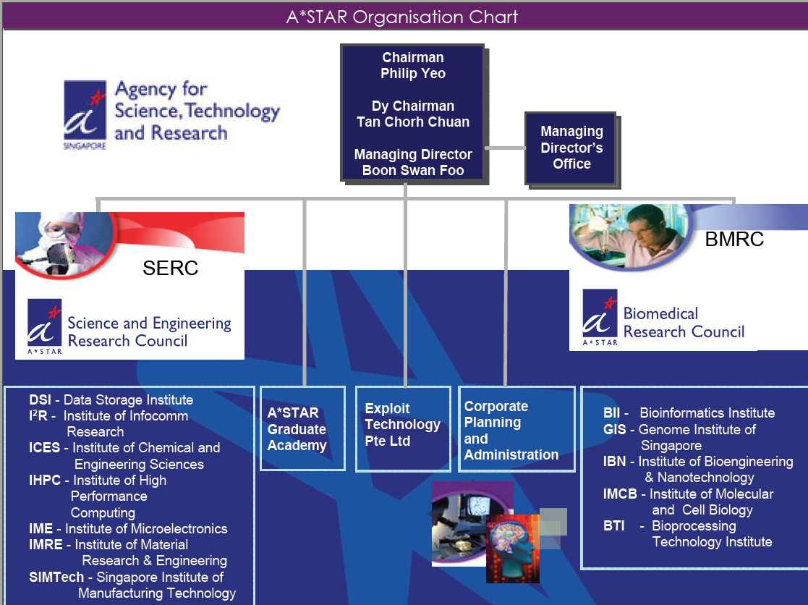
2. SIMTech簡介
SIMTeck為SERC中的一個研究所，其在功能上相當類似台灣工研院的機械所，主要任務是協助新加坡的製造業進行生產技術上的支援。該所的基礎研究技術如下:
• Surface Technology (表面技術)
• Forming Technology (成型技術)
• Micro-joining & Substrate Technology (微結合及基板技術)
• Machining Technology (加工技術)
• Mechatronics Technology (機電整合技術)
• Precision Measurements Technology (精密量測技術)
• Manufacturing Execution & Control Technology (製造及控制技術)
• Planning, Operations & Management Technolog (規劃、運作及管理技術)

SIMTech的人員約300位，其中非研究人員佔25%，研究人員佔75%(博士50%，碩士40%，學士10%)。研究計劃超過700案，合作企業為400家。
研究範圍如下:
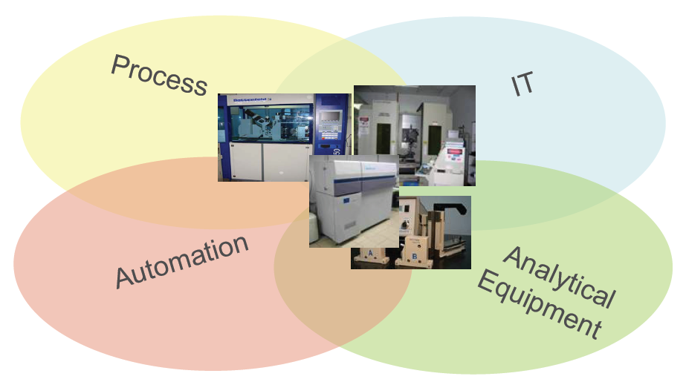
SIMTech的使命
To develop high value manufacturing technology and human capital to enhance the competitiveness of Singapore’s manufacturing industry

SIMTech對工業界所扮演的角色
Human Capital
SIMTech nurtures research scientists and engineers through manpower development initiatives, industry research collaborations and supervision of research students.

Intellectual Capital
SIMTech creates intellectual capital through the generation, application and commercialisation of advanced manufacturing science and technology.

Industrial Capital
SIMTech enriches the industrial capital in Singapore through collaborations in research and development and sharing of research expertise and infrastructure for the manufacturing industry. Our emphasis is on the transfer of research results to industry applications

強調的技術
Precision Engineerin
Single Point Diamond Turning
The single point diamond turning process uses ultrasonic vibration on the cutter during the cutting process to produce steel tools with a longer shelf life and good surface finish. The process is capable of machining steel alloys with a hardness, HRC, of 55 to a mirror-finish surface with roughness, Ra, of less than 8nm. The technology has been successfully applied to the fabrication of optical mould inserts in the industry. The process eliminates the extra step in electroless nickel plating in the fabrication of optical mould inserts resulting in a reduced production cycle time and enhanced moulding tool life.

Electronics & Semiconductor
Low Temperature Co-fired Ceramic (LTCC) Substrate Technolog
LTCC is a technology for fabricating multi-layer ceramic substrate for mounting individual integrated circuit (IC) and integrating passivpassive components (resistors, capacitors, inductors, etc). Most commonly used in mobile phone RF circuits, LTCC
technology is increasingly applied across a wider range of applications. SIMTech uses LTCC technology to seamlessly integrate key functionalities of any generic microsystem: electronic devices, sensors & interfaces and power & thermal management modules. Other multi-functional integration solutions encompass emerging applications such as wireless electronics, optoelectronics and microfluidics.

Aerospace, Marine & Automotiv
Cold Forging and Casting
This is a precision forging process for forming net and near net shape components. This process is normally performed at room temperature or below the recovery temperature of the material to realise advantages such as good surface finish, high dimensional accuracy, reduced cost and improved properties. The technology has been applied in forming precision steel components and advanced titanium and magnesium alloys with wide-range applications in the Automotive, Precision Engineeringand Aerospace Industries.
Casting is commonly used in the Precision Engineering industries. Processes developed within SIMTech have succeeded in improving the productivity and yield in castings for various industry clusters. These include thin walled castings of magnesium and castings of aluminum by suitable alloy treatment; development of advanced casting techniques such as liquid forging to generate pore free structures; precision die casting through advanced computer aided engineering and selectively reinforced composites through squeeze infiltration
Biomedica
3D Printing of Scaffolds with Predefined Architecture
The 3D printing process creates 3-dimensional solid prototypes such as bioscaffolds used in the biomedical industries. For a bioscaffold to be clinically applicable, the manufacturing process has to be able to vary the pore size to promote bone in-growth and yet retains the necessary shape and strength. In addition, the scaffold has to be able to be soluble in the body with minimal toxic effects to the tissues.
SIMTech successfully develops pre-processing and printing of biopolymers to desired shapes with suitable post processing to attain graded porosity from surface to core without compromising on the strength requirements. The technique developed allows the core of the scaffold to be solid while retaining the highly interconnected pores on the surface

Environment & Chemicals
Photocatalytic Self-cleaning Coatin
The surface coating developed combines sol-gel binding layers with photocatalytic coatings on aluminium panels, ceramic or painted surfaces, and taps on solar energy to achieve functions such as self-cleaning properties.
A kind of ceramic material, the photocatalytic coating is made up of titanium oxide (TiO2), a photosemiconductor with special crystal structure and tailored particle sizes. When sunlight beams onto such surfaces, the energy causes the generation of free radicals which acts as oxidising agents to breakdown dirt, bacteria, odour and even toxic materials.
Another property of the coating is the super-hydrophilic effect which allows water and rain to spread over the entire surfaces to wash away dirt and stains. The photocatalytic technology has applications in oxidation of toxic organic substrates for water treatment, anti-fog mirror, building surfaces and treatment of skin diseases
Infocommunication
Software System to Automate and Control Warehouse Operations
The software developed uses Radio Frequency Identification (RFID) technology, an automatic identification methodology that uses RFID tags or transponders to store and retrieve data in managing warehouse inventory operations. The system was applied successfully in a local airport services company’s cargo handling operations.
SIMTech’s system is one of the first RFID solutions in the world for automatic air-cargo tracking and is applied to containers and pallets. It eliminates the need for manual recording of container/pallet IDs and helps to improve inventory accuracy and information concurrence significantly. The state-of-the-art control system employs the latest real-time control, artificial intelligence, execution optimisation, remote diagnostic and alarm management technologies.

3. SIMTech的基礎研究能力簡介
3.1 Surface Technology Group(表面技術組)

Surface modification and coating technologies are widely used to enhance product surfaces and improve tooling performance. With recent advances in materials and processes, surface technology has been playing an important role in realising new engineering breakthroughs in various fields.
STG focuses on the development of multi-functional coatings and thin film device technologies for a wide range of applications. These include coatings with novel properties of wear resistance, corrosion prevention, anti-sticking, dry lubrication, self-cleaning, anti-reflection, as well as thin film and novel patterning processes for electronics and flat panel displays.
The Group carries out collaborative research with academic institutions, co-develops processes and products with companies and provides technology transfer and training to the manufacturing industry.
核心競爭力
- Hybrid Tribological Composite Coatings
- Superhardness/ toughness, wear resistance
- Oxidation resistance/ thermal wear
- Chemical/ corrosion resistance
- Multi-functional Coatings
- Scratch-resistance for plastics/metals
- Hydrophobic/hydrophilic coatings
- Self-cleaning, anti-bacteria, anti-fog, corrosion resistance etc
- Thin Film Devices and Systems
- Light emitting devices for flat panel displays
- Thin film transistors/Polymer electronic devices
- Photonic devices/Bio-compatible sensor

3.2 Forming Technology Group (成型技術組)
Emerging technologies are spurring new developments in manufacturing. Nanotechnology for one is driving trends towards miniaturisation and high precision in manufacturing and these have sparked new developments in forming technologies. Major industries such as the automotive, aerospace, consumer electronics, telecommunications and bioengineering are seeking to use novel materials and cost-effective process technologies in their products.
FTG focuses on developing net-shape or near net-shape metal casting, forming, polymer and powder injection moulding processes using customised or advanced materials. The emphasis is on developing new process methodologies to produce dimensionally accurate parts with superior mechanical properties at reduced manufacturing costs.
The Group carries out collaborative research with academic institutions, co-develops processes and products with companies and provides technology transfer and training to the manufacturing industry.
核心競爭力
- Metal Forming and Liquid State Processing
- Precision forming of advanced alloys
- Liquid state processing for high quality light weight materials
- Cold forging and casting
- Polymer Processing
- Micro injection & compression moulding and functional polymer processing
- Processing of biomaterials and composites
- Rapid prototyping/ tooling and process simulation
- Powder Processing
- Powder injection moulding (PIM) of high performance, dissimilar materials & components
- Processing of porous/ nano structured materials

3.3 Micro-joining & Substrate Technology Group (微結合及基板技術組)
Proliferation of wireless broadband communications, mixed-signal systems and portable electronics, as well as the emergence of organic electronics applications are the main drivers for increased functionality and product miniaturisation. To meet current and future requirements for cost-effectiveness, energy-efficiency and environmental friendliness, there is a steady shift from using purely wafer-level silicon technology towards large area electronics manufacturing techniques.
MST is developing core competencies in micro-joining, micro-patterning and multi-functional substrate technologies that play a critical role in the integration of hybrid materials and devices on a common platform.
The Group carries out collaborative research with academic institutions, co-develops processes and products with companies and provides technology transfer and training to the manufacturing industry.
核心競爭力
- Micro-joining
- Metal-to-metal and metal-to-ceramic/metal-to-polymer joining
- Wafer-level packaging for MEMS and electronics
- Lead-free assembly and reliability
- Micro-patterning
- Micro-nano imprinting
- High aspect ratio patterning
- Micro-fabrication of silicon, ceramic and polymer substrates
- Multi-functional Substrate
- Reconfigurable platform for MEMS, electrofluidics and biosensing
- Low temperature co-fired ceramic technology with composite materials
- Substrate design and fabrication

3.4 Machining Technology Group (加工技術組)
As products become more complex and the materials more exotic, a high level of competency in machining processes is needed. Product miniaturisation is a significant driving force for new research initiatives in machining technologies to achieve ever smaller feature sizes with greater accuracy.
MTG focuses on mechanical machining and laser processing technologies to enable the manufacture of products with better dimensional accuracy, greater structural intricacy and higher surface quality while increasing productivity. Technologies being developed include ultra-precision machining techniques such as ultrasonic vibration assisted diamond turning; micro-machining of minute features with high aspect ratio; laser welding, drilling and cutting.
The Group carries out collaborative research with academic institutions, co-develops processes and products with companies and provides technology transfer and training to the manufacturing industry.
核心競爭力
- Mechanical Machining
- Ultra-precision milling, cutting and grinding;
- Single point diamond turning
- Laser Processing
- Laser welding, cutting, drilling, surface hardening, cladding build-up, marking, processes for machining of microelectronics and electronics materials

3.5 Mechatronics Technology Group (機電整合技術組)
There have been growing interests in robots for a wide range of applications due to the advances in human-robot interaction technologies. Specifically for many manufacturing processes, a combination of automation systems and human operation is required in meeting the demand for efficiency and flexibility. MCH has the basic capabilities needed to enable robots to work with operators in small batch manufacturing for processes such as welding, polishing, spraying and inspection.
Parallel to the development of advanced robotic systems, MCH is also working on the key technologies and modules needed in the equipment for performing high-precision high-speed processes. Examples of such equipment are wafer inspection systems, flat panel displays and high-precision automation systems. The group plays a key role in developing the complete systems from conceptual phase up to beta version ready for use on the shop floors.
The Group carries out collaborative research with academic institutions, co-develops processes and products with companies and provides technology transfer and training to the manufacturing industry.
核心競爭力
- Precision Motion
- Precision motion system design and control
- Multi-axis motion control
- Vibration analysis and control for machine structures
- Electromechanical Module
- Electromagnetic actuators
- Force-controlled precision motion
- Flexural-based mechanisms and positioners
- Assistive Robots
- Rapid robot teaching for small batch size manufacturing
- Dynamic controlled motion for difficult-to-automate processes
- Perception for guidance and navigation of indoor/outdoor vehicles

3.6 Precision Measurements Technology Group (精密量測技術組)
Nanotechnology and miniaturisation trends are re-defining instrumentation and techniques of measurements for both the established industries and the emerging industries such as healthcare and biotechnology. Higher-resolution measurements of elements like length, time, force, mass and chemical compositions that correspond to the sub-micron and naometric scales are much needed.
PMPMG research covers optical and non-optical measurement techniques for dimensional measurements and material characterisation with a nano-scale resolution. PMG also has a strong competency in high-spread parallel image processing to address inspection problems which have no available commercial solutions.
The Group carries out collaborative research with academic institutions, co-develops processes and products with companies and provides technology transfer and training to the manufacturing industry.
核心競爭力
- Optical Measurement
- Interferometry and wavefront sensing
- Fiber optical sensors and instrumentation
- Near field optical imaging and its applications for failure analysis
- Non-optical Measurement
- Nanometric measurements
- Material characterisation and testing
- X-ray 3D computed tomography; in-situ 2D & 3D inspection
- Image Processing
- FPGA accelerated high speed imaging and processing
- 3D imaging and reconstruction
- Deep UV submicron automatic defect detection and classification

3.7 Manufacturing Execution & Control Technology Group (製造及控制技術組)
Globalisation and continuing trends towards outsourcing have great impacts on manufacturers. To remain competitive, companies need to explore opportunities to leverage advanced execution and control technologies to integrate, control and manage their operations, people and information across a distributed and networked manufacturing.
MEC focuses on research and development of networked supervisory control, intelligent performancperformance management, embedded controller, radio frequency identification (RFID), machine-to-machine, and wireless sensor network technologies to help local industries to control and manage their dynamic manufacturing systems and operations. The application of such technologies promises to bring local industries key benefits such as total operations visibility, optimal resource utilisation, maximum uptime and serviceability, and faster responses to regional economic dynamics.
The Group carries out collaborative research with academic institutions, co-develops processes and products with companies and provides technology transfer and training to the manufacturing industry.
核心競爭力
- Networked Supervisory Control
- Event-driven supervisory control of networked manufacturing systems
- Wireless sensor network data management and applications
- Networked RFID system & middleware design
- Proactive Performance Management
- Remote real-time condition monitoring
- Equipment health profiling and early detection of performance degradation
- Real-time diagnosis & on-line prognosis
- Embedded Controllers
- Rapid embedded application prototyping
- Embedded intelligence for sensor-node data processing
- Constraint-based algorithm optimisation

3.8 Planning, Operations & Management Technology Group(規劃、運作及管理技術組)
Globalisation introduces stiff challenges for manufacturers as they face shorter production times and product life cycles as well as tighter competition with more players. Organisations need to have a seamless integration of their operations with suppliers’ network and logistics infrastructure to enhance business performance. Technologies that allow simulation of manufacturing scenarios minimise downtimes and enhance decision-making. This has proved to be extremely valuable especially to a global organisation.
POM develops methodologies, technologies, and tools for operations decision support, integrated planning & optimisation and virtual enterprise integration.
The Group carries out collaborative research with academic institutions, co-develops processes and products with companies and provides technology transfer and training to the manufacturing industry.
核心競爭力
- Operations Decision Support
- ‘what if’ analysis of complex and asset-intensive hi-tech manufacturing systems
- Symbiotic real-time simulation environment for more accurate
and faster decision support
- Integrated Planning & Optimisation
- Manufacturing & supply chain planning
- Multi-site planning & scheduling
- Transportation and Inventory Network Optimisation
- Virtual Enterprise Integration
- B2B process integration & orchestration
- Defining & synthesising business processes
- Identifying and mapping services dynamically
4. 現場參觀
- 傳統的製造技術，當與其簡報資料相比較後，可發現實際的現場參觀動線的設備是屬於較一般的，技術層次較低的，會令人產生其技術並不先進的錯覺。
- RFID之應用，就其展示區來看，確實將RFID的應用面進行了相當鮮活的解說，如應用在圖書之儲存管理，貨物倉儲之管理，藥品取用之管理，招待之管理等。其RFID的識別標籤的目標價位為低於一元新加坡幣。但感測天線的費用並不低廉(約5000新幣)。感測天線的擺放位置與標籤識別角度有相當大的關聯。感測距離則與功率相關，最大的感測距離約30米左右。
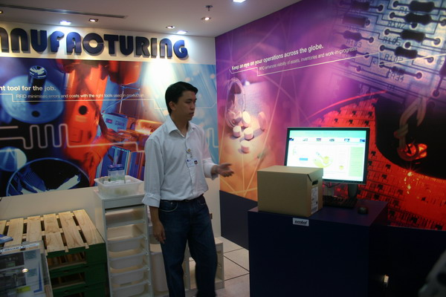 | 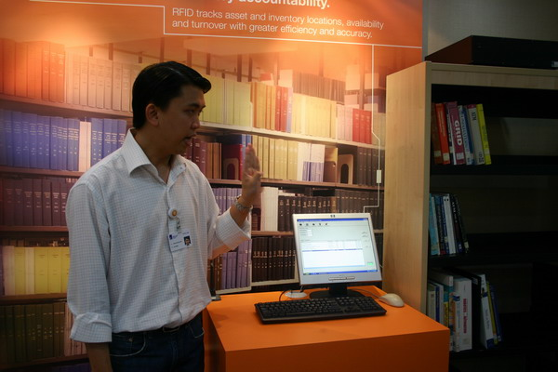

三、運用與心得分享
  - 學習到的心得
SIMTeck的定位有點類似台灣工研院的機械所，但仍有其差異，如SIMtech基本上的生產技術涵蓋機械、機電整合、半導體製程技術、IT技術、Roadmapping、生物機械等。其整合的性質較強，就單項的設備及技術來看(所開放參觀的地方)，技術上的深度仍略顯不足，不知是否是對較機密的部份有所保留?
  - 印象最深刻之處
印象最深刻的是其將Roadmapping的技術用在約40家的中小企業上，協助其利用有限的資源進行較大之綜效的發揮。
另外，物流及航運中心是新加坡政府致力發展的項目。因此特地在SIMTech內設置了RFID應用的展示中心，內容包含了倉儲、醫藥、圖書管理、居家生活之應用。展示聽的內裝佈置等加強了參觀者的感受。

日期：2006年12月13日，星期三
課程名稱：Philips Innovation Campus – Philips Design & The Learning Center

- 課程重點整理
1.Philips Design
(1) Philips Design為Philips Innovation Campus轄下的一個單位，任務為創新性產品的研究開發。其主要運作方式為整合新加坡飛利浦各事業群之產品開發部門內不同專業領域人員，激發其創意，並配合市場趨勢以設計並製造出創新並俱市場潛力的產品。
(2) 在技術運用方面 由於Philips Design將“Innovation”定義為” Something made differently, Something used differently, Something doing business differently”，因此其所開發之創新性產品，並非一定來自於嶄新的技術,反而其大部分的成果是集合及運用既存的技術所開發而成。
其主要運作概念如下圖:

2.The Learning Center
(1) The Learning Center其主要任務為針對使用其醫療設備產品之客戶提供學習相關知識及使用技術,以確保客戶能正確及有效的使用其產品以發揮產品最大的效能。而同時,於提供客戶訓練課程的同時,亦可從使用者的feedback中,瞭解客戶的實際需求及產品設計上潛在的問題,以作為日後產品改進及新產品開發的依據。
(2)在實際做法上The Learning Center提供使用者一個與在醫院使用時完全相同的環境,以獲得最正確及有效的學習成果。

三、運用與心得分享
  - 學習到的心得
就產品的創新而言,跨領域整合,常能激發出全新的想法與創意。但是如何有效的整合不同技術背景的人才,並激發其創意則是大的挑戰。人力管理與薪資管理是企業向心力的重點，太過於強調base pay不見得是最佳策略，Philips對於企業與員工共同成長也是關鍵之處，由這次的訪談發現Philips有很完整的人力管理模式，希望每位員工都可以適才適所，給予員工的不只是錢還有很多企業文化的內在收入
  - 印象最深刻之處
大型公司能整合並善用其資源,成功從生產製造轉型為研發導向,在技術及產品上不斷創新,提高產品價值。在組織運作上則保持彈性,沒有大公司的老邁僵化,使企業保持高度競爭力,令人印象深刻。而人員培訓是針對其優點加強而不在於補強缺點。

  - 未來可以運用至企業之處
跨部門領域的技術及人才的整合,創新中心的設置及營運方式,皆值得學習借鏡。人力管理不能只有大方向概念而必須結合企業文化訂定細部管理準則，給予員工除了錢以外的reward才能夠達到人力的永續經營。
日期：2006年12月14日，星期四
課程名稱：參訪新加坡經濟發展局（Economic Development Board）
- 課程重點整理
新加坡為一個天然資源缺乏的國家，為了在這全球競爭的時代中生存，憑著該國位於一個特殊航運地理位置，發展出自身一套的求生哲學，國家的經濟政策定位在以跨國企業的經營經驗，主導亞洲的經濟發展。
新加坡經濟發展局在新加坡的經濟政策扮演一個極重要的角色。它是企業（國內與國外）與新加坡政府的溝通橋樑，同時也是新加坡經濟發展推動的推手。其使命乃是持續替新加坡創造更高的生產總值，同時提供新加坡國民一個更好的工作居住環境，而遠景則是發展新加坡成為一個具有高度競爭力商業與投資的樞紐。其四個工作目標分別為 1.推動產業組的發展2.招商 3.鼓勵創業 4.優化經濟環境.。2005年新加坡的官方資料顯示新加坡國內生產總值成長6.4%而預期2006年則會有6.5% -7.5%。在2005年國內生產總值達1178億美元，其中製造業佔27%而服務業為13%。在製造業中，電子業佔37%，化學業佔31%。新加坡給了自身在2018年的成長目標，希望在2018年之前，製造業的產出將達1800億，而製造業的產出佔全國生產總值的四分之一，換言之其他的產業的比重需要提高。目前新加坡將產業發展定位在四大方向，首先電子業將持續發展，而化學業因受地利之便(中東地區的石油輸出國，在運往亞洲地區時都必須經過新加坡)已經成為全世界第三大之煉油中心，因此也將持續成長，其次則為精密工業，而最近則大力投資在生物科技，他們認定生物科技所帶來的產出，將在後來幾年大幅提昇。
由於新加坡的天然資源有限，若要在2018年完成國內生產總值遠超過目前所值，則勢必要有一套新的思維，不僅在人力的規劃上與產業的策略發展都需要新的定位。早期勞力密集的製造業在新加坡早已無法生存，因此如何維持製造業的持續生產力，勢必對於現有的製造業作更精緻的規劃與研發的投入，目前新加坡在研發經費的投入佔全國GDP的2.3%，預估在2008將會達到3%。研發經費將會有1/3放在公家機構，例如a-star而2/3將放在私人企業。這樣經費的投入將會吸引高級人力願意留在新加坡，同時也會引起跨過企業的側目，形成群聚效應。而最終結果則是將現有的製造業，帶往更高層次的境界。以上是縱方向發展策略，至於在各製造業的橫向思考則是找出各製造業的共同點或是會因技術的結合而創造出更高的經濟價值，例如精密工業，可以做出更細的針頭，改變醫療的治療方式，或是結合電子業與生醫，製造出更快速敏捷偵測疾病的醫療系統等等。這兩個方向的思維發展，將會使的新加坡在製造業的競爭力更具爆發力。新加坡在這方面的規劃，不僅提出遠景，更可貴的地方是同時提出實際的作法。
人才的引入，在於你如何提供一個絕佳的研究環境，與研究目標，然而你要達成這個目標，則必須要有資金才有可能，因此新加坡也提出方法如何吸引外地資金。首先是健全知識產權的保護，目前世界知識產權組織(WIPO)第二個辦事處設立在新加坡，這帶動了許多國際製藥大廠或是香料製造公司願意來新加坡設廠，其原因無他，乃是這些大廠知道他們的智慧財產在新加坡將受到嚴密的保護，因此商業利益可以確保無憂，其次是新加坡的移民政策，提供外商有豐沛人力資源。新加坡的移民政策非常開放，凡是外國的專業人員沒有額度的限制，目前在新加坡境內，有25%的人口是屬於境外移民，非新加坡人。這樣的政策所帶來的效應是有多元種族的文化相互融合，這對不同國家來投資的外國廠商在語言的溝通上沒有障礙，此外也因移民政策的開發，目前有35所國際學校，這更是解決移民對自己擁有文化不想放棄但又想學習他國文化的困境。最後則是在此處的稅較其他地區為低，幾個因素縱合其來，造就了新加坡成為一個亞洲最適合居住且工作之處。
在人才的吸引上，除了移民政策開發之外，新加坡政府也利用自身的教育體制吸引世界之知名學府來新加坡設立分校，包括美國的MIT，GIT，Stanford, Cornell 以及歐洲等知名大學等等，據說明年MIT將會有400名研究人員進駐新加坡，這樣的結果一旦成真，對於高級人才的湧入，有絕對的成效。
國際大廠飛利浦在新加坡設廠已有多年的歷史，勞力密集的傳統製造業，因成本的考量已經轉移至中國大陸，因此飛利浦也面臨轉型的壓力，基於新加坡特殊的地緣與多元化文化的交融，飛利浦將其研發總部放在新加坡，將原有的廠區，改為一個創新研發中心，從消費者對的觀點去看產品的需求，在現有的技術上發展出更高價值的商品出來，這種知識經濟正符合新加坡的切入點，所以飛利浦的創新中心就成了新加坡吸引外商來設廠的活廣告，而飛利浦也因更多的外商加入，因更多的挑戰者，激發了其創新的原動力，形成雙贏局面。
新加坡政府不僅以移民政策來提供豐沛人力，同時注入大量研發經費建立自身實力，吸引了外商的投資，進而啟動了正面的循環，為了使這樣的運作更具時效以及發展的更長遠，新加坡更是將政府所資助的研發中心，不管是公家或是私人公司，企圖置放在同一建築內，好讓公家與私人的研發單位互動更加頻繁，於是著手建立大的研發中心，以各製造領域為區隔，目前有關生醫的研發中心已經完成，研發區域名字稱為啟奧生物醫藥研究園 (總經費高達5億新加坡幣)，在往後幾年則電子業，精密工業等研發中心將會集中在Fusionopolis。此外為了加速全國的資訊傳遞的便捷性，新加坡也將完成全國的無線網路系統，為下一代企業或是新加坡全國國民，提供更現代化的生活環境。
心得
新加坡在築夢，而這個夢是有方法去達成的。人才，資金，政策，系統全面進行，中心思想幾乎在政府，教育單位，民間企業都達到共識，儼然就是一個超大型的公司，這種企業化的運作相當有效率，可預期的是其成功機會相當高。

日期：2006/12/15 3:00-4:30 PM
課程名稱：INSEAD企管學院參訪

- 課程重點整理
一、簡介
INSEAD創立於1957年，位於巴黎郊區之Fontainebleau，離巴黎約70公里，早期名為歐洲企業管理學院，(European Institute of Business Administration)但一直以INSEAD名之，1960年首屆MBA畢業，有52個學生，來自14個國家，早年以歐洲國家為主要市場，後來逐漸拓展至東南亞地區，於1974年開始在亞洲地區開設企管訓練課程，1980年在Fontainebleau設立歐亞(Euro-Asia)中心。1989年設立博士班課程，2000年在新加坡設立校區，並開辦MBA學程，2001年與美國Wharton School策略聯盟，Wharton MBA學生可以到INSEAD修課，INSEAD學生也可以到Wharton修課。2003年開辦EMBA學程， InnovAsia計劃於2004年第一季正式運作。其方向針對下面之領域而切入，包括IT、 Communications、 Telecom、 Media。 Engineering ：Environment EnergyChemicals Materials。Bio-Sciences： Pharma、 Life Sciences、 Food and Agriculture、 Medical等，其目標在於瞭解亞洲地區例如印度、中國研究單位動態，進而發掘地區之潛力技術，從訪談育成中心，與創業家俱樂部合作等過程中，找出新創企業發展之途徑。最後建立Knowledge Center for Entrepreneurship。在方法上則是以定期發布有關創業消息，調查分析潛力產業等。為國際企業找技術來源，為創投找投資對象，協助創業家找合作對象及協助其經營管理。因此該機構可以說是一個專門高級企業家的訓練場所。INSEAD具有極靈敏的企業嗅覺，他們看中亞洲的企業成長有極強的經濟能量在背後推動，從地域性的區域企業到跨國性的國際企業，在全球布局的趨勢下，具有國際觀國際企劃能力之經理人才，勢必供不應求，而INSEAD則是提供這樣一個解決方案。
最近數年INSEAD在企業管理學院的排名榜都保持在前3名內，不得不承認這私人經營的學院有其獨特之處。。

二、INSEAD經營理念
- 1.Mission
--推動非教條式的教育環境，融合全世界之人民、文化與創意
--以培育具責任、深思之企業領袖及創業家，能為其組織、團體創造價值
--創造及擴散最新之管理知識及實務經驗
2.VALUE
--多元化以豐富學習：不追隨優勢文化及流行教條，以開放及尊敬之態度，從創意及經驗之交流中吸收知識
--獨立性為治理原則：堅信知識之自由，以及財務、學術規劃及決策過程之自主
--嚴格與中肯之教學與研究：鼓勵多元之教學與研究方法
--接近國際企業團體：與國際知名企業合作以探討及擴散管理知識
--創業家精神：願意實驗與創新，承擔風險，並善於管理其結果
三、特色
1.國際化－學生及教授來自世界各國，而沒有任何一國具絕對多數，形成文化、語言及學習之多元化環境，學生在此不僅可學得管理知識，而且可以學習與不同文化背景的人相處，建立國際人脈，有益於其日後從事國際企業活動。
2.理論與實務之結合－融合研究、教學及與企業合作，有利於新管理知識之創造擴教。
3.獨立性－財務、決策自主，可快速反應環變遷而調整課程。
4.沒有大學部，全部是碩、博士生或短期受訓學員。
5.專業化學程－針對特定主題開辦訓練課程，例如開辦策略性研發管理學程等。

四、Q&A整理
1.INSEAD對於R&D的管理如何提出對策？
INSEAD 的課程，對於上課學員而言不是提供答案，而是給予一個思維方式，讓與課之學員相互激盪而找出答案。因此來上課的學員若是不願意發表或沒有意見者，則列入不受歡迎者。從這基本理念來回答這個問題，就是對策是由大家討論出來。
2.大家都一直討論藍海策略，但事實上當有一個藍海市場被開發之後，可預期的是該藍海市場馬上會被其他競爭著切入，不多久又成為紅海，有無一勞永逸的藍海策略？
競爭原本就是一個企業的生存的驅動力，核心技術無法永遠居領導地位，不斷的推陳出新以及源源不斷的創新，才能持續找到企業的藍海市場。。

五、感想
- INSEAD校園不大，但空間充份利用，空間設計流暢，環境優美，水池花草經過設計，利於師生間之交流互動。其中討論室相當多，每個房間可供四到六人。教室空間的內部設計，首重學員間的互動方便為原則，三角形的課桌椅排列，使的講師與所有學員幾乎都保持相同距離，同時學員間的論談也不必太費力。可評為一所六星級的學習環境。只是我在想太好的環境，真的與創新思考有對價關係嗎？
- INSEAD 最大之特色在於學院師資來自全球各地，是個標準聯合國，多國文化混合，沒有所謂主宰文化。所傳授的均是目前在商業行為最重要的課題。參與的學員也均來自世界各地，因此是個多國文化的交集平台。
- 在InnovAsia的課程中，有部份課程是針對有企業開始要進入跨國規模時，其經理人如何訓練而設計，這對一般亞洲新興國家而言，有極大的吸引力，尤其對台灣的中小企業而言，要走出國際，企業內部的經理人才，該具備何種能力？藉由該訓練課程將可以獲得準備。
- 我國已步入創新型經濟體系，科技管理的思維已逐漸成型。INSEAD的課程內容，可供國內各大學之管理學院作參考，同時也應將科技管理的理念作為通識教育。

七、參考資料
網站：http://www.insead.edu

總結：
新加坡是亞太地區一個重要的商業中心。為進一步加強新加坡作為區域中心的地位，新加坡國際企業發展局在2003年發起了建立國際企業中心。這目的在於幫助外國政府、貿易和產業機構在新加坡設立他們的區域中心。這些區域中心將為他們的企業提供及時有效的創業支援、協助和各種相關訊息，使他們能夠以最小的風險儘快融入本地商界，並縮短進入市場的時間。
例如，他們的「製造業營運中心」，其最終目標均在於利用他們的製造技術、製造體系，去吸引國際企業，將其區域營運中心設在新加坡，如此除了能幫助我們製造業提升其競爭優勢之外，也可間接帶動金融服務業、運輸服務業等其它產業的發展，真正使新加坡成為東南亞地區的重要經濟據點。
雖然新加坡是相當小國家，但目前引進超過20,000家多國籍企業公司，其中許多設有先進製造廠房、設計中心及營運總部。新加坡良好科技基礎建設及高技術人才，支撐著各項新研究活動，蓬勃發展之創投及商業環境，亦有助創新科技成果商業化；同時新加坡所擁有研發、製造、物流、金融、及多國籍人才核心競爭力，促使其有足夠優勢不斷成長與發展技術創新。
面對日益激烈的產業競爭及國際分工趨勢，新加坡的經濟發展，是以全球市場與地區分工為基礎。綜觀這次新加坡的參訪的心得如下：
第一、研究發展體系完善，積極推動科技發展專案計畫：
成立開放式研究所，讓政府部門能在此時，對民間廠商進行研
發工作方面的輔導，以及加強產學方面的合作。讓產業界與學
術界密切配合，除了提升人力素質外，也加強企業的競爭力，
讓學生在學期間預先培養以後在企業能馬上上手的技能。
一、先進製造技術
製造活動在新加坡經濟發展上扮演重要地位，產值約佔國
內生產毛額（GDP）27%，在加值及創造鏈更往上層而言，
新加坡目前是各項新世代產品之製造中心，如平面電視、
磁碟機、DVD燒錄器、以及各項精密零件如牛導體晶片、
精密電子機械、特殊化學等，均為新加坡主要製造產品；
又國際知名公司Philips及3M、Motorola、Seagate等均
在新加坡設廠，這些條件提供高科技融合於製程、零件及
成品之價值鏈之機會。
二、研發精進
新加坡之大學及研究機構，建有卓越研發能量，研究成果
並獲廣泛認可。另外，知名大學如麻省理工學院（MIT）、
Stanford Leland University、The Technical University
of Eindhoven等，均與新加坡各大學建立研究合作關係。
三、科學技術研究發展局（Agency for Science, Technology
and Research, A*STAR）
A*STAR在推廣、支持及監督新加坡公共領域之研究活動，
主要組成成員有生物科技研究委員會、科學及工程研究委
員會及科技運用公司等等。該局資助所屬12個研究所，
從事科學、工程及生物科技等之尖端研究，包括有材料及
工程研究所、生物工程及奈米科技研究所、數據儲存研究
所、新加坡製造科技研究所等，其另亦提供資金供新加坡
國立大學及南洋理工大學進行各類研究。
其中生物工程及奈米科技研究所（Institute of
Bioengineering & Nanotechnology），定位為擔任生技
及奈米科技等兩項尖端科技之介面，專注於創造知識及栽
培專才以開發科技領域，進而發展新工業。目前該所研究
內容包括藥物傳送、蛋白質和基因、組織工程、人工器官
和移植、醫藥設備、生物邏輯和生物醫學感應器、以及奈
米生物科技等。
四、新加坡製造科技研究所（Singapore Institute of
Manufacturing Technology），主要研究製造流程及技
術，該所擁有精密電子機械、產品設計開發及先進材料
製程之專家。
第二、在新興工業方面，分別提出重要產業及產品方向：例如生物科
技、光電、材料等。例如設置生物科技園（Biopolis）與新加坡高等院校毗鄰的生物科技園，以建設成為亞洲的世界級生物醫藥科技研發中心為目標。
第三、智慧財產的重視與規劃設置相關學程，以保護學界、企業及相
關的智慧財產。且商標法及專利法令，提供高價值之創新智慧
財產良好保護。
第四、完善倉儲轉運專區：以自由貿易港區功能，物流(包含人流、
商流、資訊流、金流、人流)功能齊全。其中在人流方面，不
僅涉及雇用外勞，還包括吸引高階管理人才，政府有全方位的
配套措施，包括：優良的居住環境、就醫、子女教養等，吸引
外勞及高級人才，創造自由貿易港區的人流與金流商機。
此外，為配合本地區的物流發展，他們研究單位也積極的研發
RFID的各種產品以追蹤貨物。
第五、創造一個激發信心之環境：新加坡為新創立公司提供良好環
境，政府政策內容讓企業與人民充分了解，讓民間了解政府的
推動計畫，對人民有什麼好處，有什麼利益，能積極促進政府
及民間的了解合作。此外，這種環境也足夠吸引國際化的企業
進駐，當多國籍企業進駐時，能融入這多元文化的新加坡，在
各方面都安全與舒適。
第六、歐洲著名的INSEAD企管學院的進駐：企業高階主管培訓的搖
籃，除了亞洲地區外，對世界各國已培訓120幾個國家的高階
主管，培養多元文化背景的學生，無形中這些被培訓過的高階
主管也會對新加坡印象深刻，當企業有機會外移到新加坡時，
也更能融入新加坡的文化。
此外，教授給學生的是ㄧ種哲學的思維，不直接給一個答案，
因為社會科學本身就沒有真正的答案，有的只是當下的情境，
如何運用您的思維去做判斷，找出最適解決方案。

