出國報告（出國類別：洽公）

核四廠模擬器差異訓練及轉任測驗方式

服務機關：台灣電力公司核能發電處
姓名職稱：11等主辦規劃員林鏞鶯
派赴國家：美國
出國期間：自95年10月29日至95年11月11日
報告日期：95年12月11日

出國報告審核表
出國報告名稱：核四廠模擬器差異訓練及轉任測驗方式
出國人姓名 |  | 職稱 |  | 服務單位
林鏞鶯 |  | 主辦規劃員 |  | 核能發電處
出國期間：95年10月29日至95年11月11日 |  |  | 報告繳交日期：95年12月11日
出  國  計  畫  主  辦  機  關  審  核  意  見 | □ 1.依限繳交出國報告  □ 2.格式完整（本文必須具備「目地」、「過程」、「心得」、「建議事項」）  □ 3.內容充實完備  □ 4.建議具參考價值  □ 5.送本機關參考或研辦  □ 6.送上級機關參考  □ 7.退回補正，原因：□ 不符原核定出國計畫 □ 以外文撰寫或僅以所蒐集外文資料為內容 □ 內容空洞簡略 □ 電子檔案未依格式辦理 □ 未於資訊網登錄提要資料及傳送出國報告電子檔  □ 8.本報告除上傳至出國報告資訊網外，將採行之公開發表：  □辦理本機關出國報告座談會（說明會），與同人進行知識分享。  □於本機關業務會報提出報告  □ 9.其他處理意見及方式：
層  轉  機  關  審  核  意  見 | □ 1.同意主辦機關審核意見□全部 □部分 （填寫審核意見編號）  □ 2.退回補正，原因：  □ 3.其他處理意見：
說明：
- 出國計畫主辦機關即層轉機關時，不需填寫「層轉機關審核意見」。
- 各機關可依需要自行增列審核項目內容，出國報告審核完畢本表請自行保存。
- 審核作業應於報告提出後二個月內完成。

報告人 | ： | 單位  主管 | ： |  | 主管處  主 管 | ： |  | 總 經 理  副總經理 | ：

行政院及所屬各機關出國報告提要
出國報告名稱：核四廠模擬器差異訓練及轉任測驗方式
頁數 33 含附件：☑是 □否
出國計畫主辦機關/聯絡人/電話：台灣電力公司 / 陳德隆 / (02)2366-7685
出國人員姓名/服務機關/單位/職稱/電話
林鏞鶯/台灣電力公司/核能發電處/主辦規劃員/(02)2366-7082
出國類別：□1考察□2進修□3研究□4實習☑5其他（洽公）
出國期間：95.10.29－95.11.11 出國地區：美國
報告日期：95年12月11日
分類號/目
關鍵詞：ANSI-3.5-1998、FSS、模擬器訓練
內容摘要：
- 核四廠為本公司第一座進步型反應器，依相關規定要求須於燃料填換前至少2年開始模擬器訓練，故模擬器須較控制室早設計完成，而產生差異。針對此項差異如何規劃訓練，對確保運轉安全及可靠極為重要。針對核四廠模擬器訓練有關問題與美國奇異公司龍門訓練計劃部門洽談OA&IOIM訓練計畫、模擬器差異訓練、運轉員轉任等相關議題，奇異公司除提供法規相關資訊供本公司參考辦理，並對核四廠模擬器訓練目前狀況提出建議，各項建議尚待各相關部門參考研究。
- 運轉員執照考試的模擬器應符合ANSI-3.5-1998規定，Update模擬器與FSS(full scope simulator)及實際電廠間的差異經過查証及確認後，訓練部門據以修訂模擬器硬體、軟體以與實際電廠狀況一致，並辦理差異之訓練，相關訓練計劃應提出具體之修訂方向。
- Vermont Yankee核能電廠運轉訓練計劃與國內訓練類似，整個訓練期程包括技術/理論、電廠系統、模擬器、在職訓練等，模擬器訓練著重運轉員的能力的發展，受訓學員並按訓練過程由運轉部門主管和訓練部門主管或講師等專門人員進行評鑑。
- 行政院原子能委員會最近擬修正「核子反應器運轉人員執照管理辦法」之運轉員及高級運轉員報考資格規定，本公司宜儘早整合人力、物力，並參考國內、外相關規定完成系統化訓練，建置核四廠運轉所需持照人數，以助益營運安全之管理。
本文電子檔已傳至出國報告資訊網（http：//report.nat.gov.tw）
目 錄

頁數
一、出國事由 1
二、出國行程 1
三、工作紀要 1
四、本次行程概要 2
五、心得與建議 4
六、附件 6
- 出國事由
核四廠模擬器差異項目、訓練評估及測驗方式
- 出國行程
95年10月29〜31日 往程（台北→Vermont Yankee Nuclear Power Plant）
95年10月31日〜11月2日 與Vermont Yankee核能電廠洽談電廠相關模擬器訓練法規、訓練評估及考試做法
95年11月3日〜11月9日 與美國奇異公司龍門訓練部門洽談模擬器差異訓練、轉任測試方式法及電廠OA&IOIM訓練內容
95年11月10〜11日 返程 (San Jose→台北)
- 工作紀要
- Vermont Yankee核能電廠在美國東岸Vermont城，隸屬Entergy Nuclear公司所有，其訓練中心位於電廠北方(位置詳附圖一)，該中心計分成3個部門，其中訓練部門有4位專任講師及5位職員，此次係與中心主任Michael A.Romeo Sr.洽談該廠運轉員訓練相關做法，並由其親自帶領參觀模擬中心介紹相關設施(模擬器設施詳附圖二)。
- 美國奇異公司龍門訓練計劃之經理為Bob Turkowski，其下包括6個部門(組織詳附圖三)，本次洽談係針對OA&IOIM訓練計畫、模擬器差異訓練、運轉員轉任等訓練相關規定進行討論，奇異公司除建議本公司可參考ACADEMY DOCUMENT00-003「Guidelines for Initial Training and Qualification of Licensed Operators」、 ACAD 02-004 「Guidelines for the Conduct of Training and Qualification Activities」 ACADEMY 97-014「 Guidelines for Instructor Training and Qualification 」、ACAD 90-022 「Guidelines For Simulator Training」等資料文件瞭解運轉員模擬器訓練計畫相關規定做法，並就目前核四廠模擬器訓練方面亦提出下列多項綜合性建議：
台電公司承諾原子能委員會核四廠於燃料填換前2年可開始模擬器訓練，核四廠PSAR 亦承諾以FSS 為模擬器訓練設計基準，最近奇異公司在龍門所進行之模擬器訓練係使用系統尚未完整之Update simulator，尚無法完全符合前述之承諾要求，原能會可能不同意作為持照運轉人員再考試以取得高級運轉員執照。
按INPO 訓練guidline說明，在正式訓練前訓練機關應規劃具備合格經驗資格之講師並擬訂訓練計劃，奇異公司表示本項準備(包括講師qualified及訂定計畫)需花費相當工作人日且需在舉辦模擬器訓練前要完成，故台電公司應儘早籌劃相關工作，以利後續運轉員考照訓練。另運轉員訓練除課堂之基本原理課程外，尚需有完整的系統化訓練，內容含括正常、異常及緊急等模擬訓練，整個期程亦約需14–18個月。
- 本次行程概要
- 研討OA&IOIM訓練計畫及時程
OA&IOIM訓練(The Operator Aids and Integrated Operations Information Management ) 將於initial simulator訓練結束後舉辦，預估在2007年4月辦理，奇異公司目前已著手規劃課程內容，台電公司對課程內容有任何需求可儘早向該公司提出建議，OA&IOIM訓練期程為2周。
- 研討差異訓練之規劃及做法
運轉員執照考試的模擬器應符合ANSI-3.5-1998規定，按照ANSI-3.5-1998標準，模擬器與實際電廠間的差異必須被查証及確認，然後訓練部門依此修訂模擬器硬體、軟體以與實際電廠狀況一致，在模擬器修正完成前辦理差異訓練，差異訓練計劃除由講師編擬教材及與學員檢討修訂之差異外，同時請各相關部門編提差異訓練課程或提供差異資訊請訓練部門彙整規劃訓練計畫，使模擬器訓練信度調整符合實際之最佳狀況。
- 研討類似反應器運轉員轉任(如沸水式反應器第四代BWR 4轉任進步型沸水式反應器)之規定、訓練及測驗要求
沸水式反應器與進步型沸水式反應器為類似反應器，ABWR運轉員與BWR運轉員之訓練大同小異，BWR運轉員申請ABWR運轉員資格者同樣要接受基本原理、緊急應變處理、領導管理等訓練和一些整合性的課程訓練，有關電廠特性及程序操作等必需納入訓練中，並接受ABWR所有訓練過程之各項評量測驗。
- 探討核四廠模擬器與控制室差異及訓練、考試要項
依據ANSI/ANS 3.5, 1998敘述，所謂差異訓練在於模擬器與實際電廠性能特性不同而產生之需求訓練。在此之前訓練部門必須升級模擬器到與電廠運轉狀況一致, 提供辨認偏差之差異訓練以保證運轉員獲得應有的技能以精確熟稔的進行電廠運轉操作。差異訓練時實際電廠狀況應該被描述並與模擬器做比較，尤其是對程序操作步驟及電廠相關營運管理規定做一比較，教導運轉員辨識差異，講師在模擬器訓練課程中應利用適當機會與學員對偏差不同處進行討論，以保證運轉員回到控制室擁有最新最即時之資訊能正確的判斷操作，並隨時補充蒐集偏差相關部份之特別教材或經驗回饋資料，提供給運轉人員增長其專業技能。另外訓練考試部分應該隨時更新考題因應不同之教學訓練目的。
5.探討Vermont Yankee核能電廠運轉員訓練相關做法
(1) Vermont Yankee核能電廠運轉訓練計劃期程：
運轉訓練整個期程包括審查、訓練和NCR考試測驗大約五十四個星期。
  - 技術/理論 訓練(10 個星期)
  - 電廠系統訓練(10 個星期)
  - 模擬器訓練(11 個星期)
  - 行政作業、計劃和流程(3 星期)
  - 在職訓練(15 個星期)
  - 審查評量及測驗 (4個星期)
  - NCR執照檢查(1 個星期)
(2) Vermont Yankee核能電廠計劃內容
反應器運轉員訓練計劃包括五個階段:
a. 技術和理論訓練
技術和理論訓練階段包括大約十個星期課堂訓練，課程如熱力學、熱傳和流體力學、反應器原理、保健物理學、和工廠儀控學
b.電廠系統訓練
電廠系統階段包括大約十個星期課堂訓練課程如系統和組件、運轉特徵、系統整合分析、系統操作步驟(包括正常和非正常流程),運轉暫態,和事故驗證、分析和防範措施。
c. 模擬器訓練
模擬器訓練階段約十一個星期課程，這個階段的重點期間是運轉員的能力發展如: 1) 對控制室控制和指示的用途, 2) 瞭解反應器的運轉特徵和狀態, 3) 熟稔使用相關程序書, 4) 保守安全運轉觀念的養成, 和5) 團隊訓練成為電廠運轉團隊的一分子。重視電廠暫態,異常事故判斷、分析、採取防範解決對策。在這個階段每天包括約四個小時課堂講授和四個小時模擬器訓練。在模擬器訓練階段期間, 受訓學員將按訓練過程由運轉部門主管和訓練部門主管或講師等進行評鑑。各階段授課內容及測試排程詳如附件一。
d. 行政作業、計劃和流程訓練
行政作業、計劃和流程訓練約需三個星期。
e. 運轉在職訓練
在職訓練階段約十五個星期。在這個期間, 受訓人員被分配在控制室參與運轉實習, 其工作表現並需依RO資格標準(附件二)接受評鑑。
- 心得與建議
- 模擬器訓練提供觀察團隊效率之絕佳時機，能讓學員回到控制室值班時知道如何有效處理正常、異常及緊急等狀況。
- 若模擬器軟、硬體設備與電廠運轉特性有差異，講師及運轉人員應了解模擬器的差異問題及防範解決方式，讓運轉人員對模擬器反應電廠運轉狀況有信心，使模擬器成為有效之訓練工具。
- 為確保模擬器功能更臻完善，模擬器設計基準資料來源最好直接從電廠收集到或電廠設計數據而來，但核四廠施工多次延宕時程，致基準資料來源無法獲得或發生差異，故核四廠模擬器構型管理應提出一套完整系統將模擬器和實際電廠間的差異及相關解決方法予以找出並建檔追蹤。
- 針對模擬器模擬器修改之提出、審查可設置專門有經驗之SME(Subject Matter Expert)評估各種差異參數可能對操作員採取行動的衝擊; 評估包括 (1)正常, 反常, 或緊急步驟所需人因界面(2) 執行任務在電廠控制室參考單位與模擬器區別(3)操作員不同聽覺和視覺資訊上的暗示區別,及操作員所對應做出之重要決定和行動(4) 模擬器功能應考量電廠各項安全操作需求(5)審閱以往操作的經驗回顧，增強操作員錯誤辨認的潛力或必要為技能 (6)模擬器訓練任務需求 (6)模擬器訓練成效等，以確保核能電廠運轉人員訓練用模擬器信度。
- 模擬器訓練除了按電廠操作狀況需求調整更新外，宜配合系統化訓練(SAT)規範，經由分析、設計、推動、執行、評估、回饋等聯串步驟按步就班的執行，以確保訓練成效及品質。
- 模擬器訓練講師在進行授課前必須針對各項訓練準備教材，包括：差異辨認和提供清楚的區別、進行模擬器測試、辨認和提供失敗性能試驗、情境測試、經驗回饋分享及學員訓練成績評估等，故一個稱職合格的講師的培訓計畫也非常重要。
- 行政院原子能委員會最近擬修正「核子反應器運轉人員執照管理辦法」之運轉員及高級運轉員報考資格規定，對未持有同一核子反應設施運轉員執照直接報考高級運轉員執照測驗者，除有同類型核子反應器基本原理筆試測驗合格外，要求需通過運轉員及高級運轉員兩者之個廠特性筆試，故核一、二廠持照運轉員要轉任核四廠高級運轉員，本公司宜針對執照測驗方式之改變，由相關訓練部門儘早研擬訓練計畫以建置核四廠運轉所需持照人數。
附件
- 附件一…訓練計劃授課內容及測試排程·························7
- 附件二…OJT&TPE之RO資格評鑑標準··························24
- 附圖一…Vermont Yankee核能電廠訓練中心位置·················31
- 附圖二…Vermont Yankee核能電廠模擬器設施···················32
- 附圖三…奇異公司龍門訓練計劃部門組織·······················33
附件一
PROGRAM SEGMENT | SETTING/DURATION | IG # | TOPICS
TECHNICAL/THEORY TRAINING | CLASSROOM  10 WEEKS | PROGRAM INTRODUCTION
 |  | LOT-00-000 | Course Introduction
 |  | AOI-01-020 | Learning Skills
 |  | CHEMISTRY/MATERIAL SCIENCE
 |  | LOT-00-017 | Matter and Energy
 |  | LOT-00-018 | Atomic Structure
 |  | LOT-00-019 | Atomic Mass and Weight Relationships
 |  | LOT-00-020 | The Periodic Table
 |  | LOT-00-021 | Chemical Bonding
 |  | LOT-00-022 | Chemical Equations
 |  | LOT-00-023 | Solutions
 |  | LOT-00-024 | Acids, Bases and Salts
 |  | LOT-00-025 | Electrochemistry
 |  | LOT-00-026 | Corrosion
 |  | LOT-00-027 | Reactor Chemistry
 |  | LOT-00-029 | Chart of the Nuclides
 |  | LOT-00-030 | Atomic Interactions and Order in Microstructures
 |  | LOT-00-031 | Classification of Crystalline Materials
 |  | LOT-00-032 | Structure of Metals and Ceramics
 |  | LOT-00-033 | Materials Behavior & Metallurgical Definitions
 |  | LOT-00-034 | Mechanisms of Deformation & Structure
 |  | LOT-00-035 | Testing of Toughness
 |  | LOT-00-036 | Effects of Radiation on Materials & Alloys
 |  | LOT-00-037 | Nuclear Fuel
 |  | LOT-00-038 | Fuel Cladding
 |  | REACTOR THEORY
 |  | LOT-00-122 | Neutrons
 |  | LOT-00-123 | Neutron Life Cycle
 |  | LOT-00-124 | Reactor Kinetics & Neutron Sources
 |  | LOT-00-125 | Reactivity Coefficients
TECHNICAL/THEORY TRAINING  (cont'd) | CLASSROOM  10 WEEKS (cont'd) | LOT-00-126 | Control Rods
 |  | LOT-00-127 | Fission Product Poisons
 |  | LOT-00-128 | Fuel Depletion & Burnable Poisons
 |  | LOT-00-129 | Reactor Operational Physics
 |  | HEALTH PHYSICS
 |  | LOT-00-054 | Property & Interactions of Radiation
 |  | LOT-00-055 | Equations for Use With Radioactive Material
 |  | LOT-00-060 | Detector Principles
 |  | THERMODYNAMICS
 |  | LOT-00-130 | Thermodynamic Units & Properties
 |  | LOT-00-131 | Basic Energy Concepts
 |  | LOT-00-132 | Steam
 |  | LOT-00-133 | Thermodynamic Processes
 |  | LOT-00-134 | Thermodynamic Cycles
 |  | LOT-00-135 | Fluid Statics/Dynamics
 |  | LOT-00-136 | Heat Transfer
 |  | LOT-00-137 | Thermal Hydraulics
 |  | LOT-00-138 | Core Thermal Limits
 |  | LOT-00-139 | Brittle Fracture & Vessel Thermal Stress
 |  | COMPONENTS
 |  | LOT-00-114 | Valves
 |  | LOT-00-115 | Sensors/Detectors
 |  | LOT-00-116 | Controllers & Positioners
 |  | LOT-00-117 | Pumps
 |  | LOT-00-118 | Motors & Generators
 |  | LOT-00-119 | Heat Exchangers & Condensers
 |  | LOT-00-120 | Demineralizers & Ion Exchangers
 |  | LOT-00-121 | Breakers, Relays & Disconnects
 |  | MISCELLANEOUS
 |  | LOT-00-308 | Introduction to Technical Specifications, Technical Requirements Manual, and Off-Site Dose Calculation Manual
TECHNICAL/THEORY TRAINING  (cont'd) | CLASSROOM  10 WEEKS (cont'd) | LOT-00-407 | FSAR Overview
 |  | LOT-00-062 | Blueprint Reading
 |  | LOT-00-063 | Instrumentation & Controls Fundamentals
PLANT SYSTEMS TRAINING | CLASSROOM/  SIMULATOR  10 WEEKS | NUCLEAR STEAM SUPPLY SYSTEMS
 |  | LOT-00-701 | Reactivity Management
 |  | LOT-00-290 | Reactor Vessel & Internals
 |  | LOT-00-216 | Reactor Vessel Instrumentation
 |  | LOT-01-290 | Nuclear Fuel
 |  | LOT-00-201 | Control Rod Drive Mechanisms
 |  | LOT-01-201 | Control Rod Drive Hydraulics
 |  | LOT-02-201 | Reactor Manual Control System
 |  | LOT-00-202 | Reactor Recirculation System
 |  | LOT-00-204 | Reactor Water Cleanup System
 |  | LOT-00-283 | ERFIS
NEUTRON MONITORING AND
REACTOR PROTECTION SYSTEMS
 |  | LOT-00-215 | Principles of Detector Operation
 |  | LOT-01-215 | SRM
 |  | LOT-02-215 | IRM
 |  | LOT-03-215 | LPRM
 |  | LOT-04-215 | TIP
 |  | LOT-05-215 | APRM
 |  | LOT-03-201 | RBM
 |  | LOT-00-212 | Reactor Protection System
 |  | LOT-04-201 | Rod Worth Minimizer
 |  | CONTAINMENT SYSTEMS
 |  | LOT-00-223 | Primary Containment Design
 |  | LOT-00-229 | Nitrogen Inerting & Supply
 |  | LOT-01-229 | CAD System
 |  | LOT-02-229 | CAM
PLANT SYSTEMS TRAINING (cont’d) | CLASSROOM/  SIMULATOR  10 WEEKS (cont’d) | LOT-02-224 | Secondary Containment
 |  | LOT-00-288 | Drywell HVAC
 |  | LOT-01-288 | Reactor Bldg. HVAC
 |  | LOT-00-261 | SBGT
 |  | LOT-01-223 | PCIS
 |  | EMERGENCY CORE COOLING SYSTEMS
 |  | LOT-00-207 | Introduction to Emergency Core Cooling Systems
 |  | LOT-00-217 | RCIC
 |  | LOT-00-206 | HPCI
 |  | LOT-00-218 | ADS
 |  | LOT-00-209 | Core Spray
 |  | LOT-00-205 | RHR
 |  | MAIN TURBINE & TURBINE SUPPORT SYSTEMS
 |  | LOT-00-245 | Fundamentals of Turbine Operations
 |  | LOT-01-245 | Main Turbine
 |  | LOT-00-247 | Main Turbine Lube Oil
 |  | LOT-00-249 | Mechanical Hydraulic Control System
 |  | BALANCE OF PLANT SYSTEMS
 |  | LOT-00-239 | Main Steam System
 |  | LOT-00-243 | Extraction Steam System
 |  | LOT-00-260 | Feedwater Heater, Vent & Drain System
 |  | LOT-00-255 | Condenser Air Removal
 |  | LOT-00-271 | Advanced Off-Gas System
 |  | LOT-00-256 | Condensate System
 |  | LOT-00-257 | Condensate Demineralizers
 |  | LOT-00-293 | Cond/Demin Water Transfer
 |  | LOT-00-259 | Feedwater System
 |  | LOT-01-259 | Feedwater Level Control System
PLANT SYSTEMS TRAINING (cont’d) | CLASSROOM/  SIMULATOR  10 WEEKS (cont’d) | ELECTRICAL SYSTEMS
 |  | LOT-02-245 | Main Generator
 |  | LOT-00-253 | Stator Cooling Water System
 |  | LOT-00-250 | Hydrogen Seal Oil & H2 Cooling System
 |  | LOT-00-262 | 345 KV and 115 KV Distribution System
 |  | LOT-01-262 | 4 KV Electrical Distribution System
 |  | LOT-00-264 | Emergency Diesel Generators
 |  | LOT-02-262 | 480 VAC Electrical Distribution System
 |  | LOT-03-262 | RUPS
 |  | LOT-04-262 | 120/240 Vital Electrical Distribution System
 |  | LOT-00-263 | DC Electrical Distribution System
GENERATOR SUPPORT, PLANT COOLING
AND MISCELLANEOUS SUPPORT SYSTEMS
 |  | LOT-00-275 | Circulating Water System & Cooling Towers
 |  | LOT-00-276 | Service Water
 |  | LOT-00-208 | RBCCW
 |  | LOT-00-274 | TBCCW
 |  | LOT-00-286 | Fire Protection System
 |  | LOT-01-293 | Make-up Demineralizer & Pretreatment System
 |  | LOT-00-287 | Plant Heating Boiler
 |  | LOT-00-266 | Solid & Liquid Radwaste System
 |  | LOT-00-273 | Process Radiation Monitoring
 |  | LOT-00-272 | Area Radiation Monitoring
 |  | LOT-00-222 | Allen Bradley Temperature Monitoring System
 |  | LOT-00-233 | Fuel Pool Cooling and Cleanup System
 |  | LOT-00-234 | Refueling Operations
 |  | LOT-00-211 | SBLC
 |  | LOT-02-288 | Plant HVAC
 |  | LOT-00-279 | Service & Instrument Air Systems
 |  | LOT-00-278 | Containment Instrument Air
PLANT SYSTEMS TRAINING (cont’d) | CLASSROOM/  SIMULATOR  10 WEEKS (cont’d) | LOT-00-268 | Drywell Equipment & Floor Drains System
ADMINISTRATIVE PROCEDURES, PROGRAMS, & PLANS | CLASSROOM  3 WEEKS | ADMINISTRATIVE PROCEDURES  PROGRAMS, AND PLANS
 |  | LOT-00-400 | Operations Department Administrative Procedures - 1
 |  | LOT-01-400 | Operations Department Administrative Procedures - 2
 |  | LOT-02-400 | Operations Department Administrative Procedures - 3
 |  | LOT-03-400 | Operations Department Standards DP 0166
 |  | LOT-00-401 | Vermont Yankee Safety Classification Program
 |  | LOT-00-402 | Engineering Support & Plant Administrative Procedure
 |  | LOT-00-403 | VY EQ Program
 |  | LOT-00-404 | Chemistry & Health Physics Administrative Procedure
 |  | LOT-00-405 | 10 CFR 50.59 Familiarization
 |  | LOT-00-406 | QA Procedures
 |  | HPC-01-002 | Human Performance Training
 |  | LOT-00-413 | LOT-00-413, Protective & Caution Tagging ENN-OP-102 (eSOMS)
 |  | MEC-13-003 | Electrical Safety – Level II
 |  | LOT-00-410 | Pre-Job Briefs
 |  | LOT-00-412 | Probabilistic Safety Assessment Overview
 |  | INS-01-034 | OJT Trainer Training
 |  | INS-01-035 | TPE Evaluator Training
 |  | LOT-00-900 | Introduction to Emergency Plan
 |  | LOT-00-901 | PED Off-Site Dose Assessment
 |  | INDUSTRY EVENTS
 |  | LOT-00-700 | Industry Operational Events
 |  | LOT-01-700 | Industry Shutdown/Refuel Events
 |  | SOE-08-202 | Inadvertent RPV Pressurization
ADMINISTRATIVE PROCEDURES, PROGRAMS, & PLANS | CLASSROOM  3 WEEKS (cont’d) | SOE-08-702 | Inadvertent Draining of Reactor Vessel to Torus at BWRs
 |  | SOE-09-602 | Design and Operating Considerations for Reactor Cores
 |  | SOE-02-004 | Reactor Pressure Vessel Head Degradation at Davis-Besse
SIMULATOR TRAINING | CLASSROOM/  SIMULATOR  11 WEEKS | ROUTINE PLANT OPERATIONS
 |  | LOT-00-300 | Preparation for Plant Startup
 |  | LOT-00-301 | Approach to Criticality Heatup
 |  | LOT-00-302 | Reactor Heatup and Pressurization
 |  | LOT-00-304 | Turbine Generator Operation
 |  | LOT-00-305 | Power Ascension
 |  | LOT-00-306 | Load Reduction
 |  | LOT-00-307 | Reactor Shutdown & Cooldown
TEAM TRAINING AND
COMMUNICATION SKILLS
 |  | LOT-00-800 | Diagnostic & Team Skills
ABNORMAL & EMERGENCY
PLANT OPERATIONS
 |  | LOT-00-600 | Reactor Scram Response
 |  | LOT-00-601 | Off Normal Procedures
 |  | LOT-00-602 | Operational Transiet Procedures
 |  | LOT-00-603 | Off Normal Procedures - Simulator
 |  | LOT-00-604 | Operational Transients - Simulator
 |  | LOT-00-607 | EOP-3, Primary Containment Control
 |  | LOT-00-608 | EOP-5, RPV-ED / EOP-6, RPV Flooding
 |  | LOT-00-610 | EOP-1, RPV Control / EOP-2, ATWS
 |  | LOT-00-611 | EOP-4, Secondary Containment Control / Rad Release
 |  | LOT-00-624 | Severe Accident Management Overview
SIMULATOR TRAINING | CLASSROOM/  SIMULATOR  11 WEEKS (Cont’d) | LOT-01-624 | Severe Accident Guidelines
 |  | LOT-02-624 | Technical Support Guidelines
 |  | LOT-00-622 | EOP Overview
 |  | LOT-00-626 | EOP Appendixes - Part I
 |  | LOT-01-626 | EOP Appendixes - Part II
 |  | LOT-00-625 | Primary Containment Venting
 |  | LOT-00-612 | Shutdown Using Alternate Shutdown Methods
 |  | LOT-00-613 | Operational Emergencies I
 |  | LOT-00-614 | Operational Emergencies II
 |  | LOT-00-615 | Operational Emergencies III
ACCIDENT ANALYSIS AND
MITIGATION OF CORE DAMAGE
 |  | LOT-00-616 | Accident Analysis
 |  | LOT-00-617 | Rod Drop Accident Analysis
 |  | LOT-00-618 | Loss of Coolant Accident Analysis
 |  | LOT-00-619 | Main Steam Line Break Accident Analysis
 |  | LOT-00-620 | Refueling Accident Analysis
 |  | LOT-00-621 | Mitigation of Core Damage
 |  | SEI-03-200 | Transient Analysis
ON-THE-JOB TRAINING | IN-PLANT  15 WEEKS | ROI-QS-000 | Completion of CRO QUAL STANDARD
COMPREHENSIVE WRITTEN EXAMINATIONS | CLASSROOM | CRO-01-001E | Technical/Theory Training Comprehensive Examination
 |  | CRO-02-001E | Generic Fundamentals Examination
 |  | CRO-03-001E | Plant Systems Comprehensive Examination
 |  | CRO-04-001E | Plant Procedures Comprehensive Examination
SIMULATOR PROGRESS EXAMS | SIMULATOR | CRO-05-001E | Normal Operations (OP 0105) Simulator Progress Exam
 |  | CRO-06-001E | Off Normal Procedure Simulator Progress Exam
SIMULATOR PROGRESS EXAMS | SIMULATOR  (Cont’d) | CRO-07-001E | Operational Transient Procedure Simulator Progress Exam
 |  | CRO-08-001E | Emergency Operating Procedure Simulator Progress Exam
 |  | CRO-09-001E  (Optional) | Pre-Audit Comprehensive Simulator Progress Exam (optional – as time permits based on class size & length)

附件二

VERMONT YANKEE REACTOR OPERATOR QUALIFICATION STANDARD

On-the-Job Training and Task Performance Evaluation (OJT & TPE) shall be satisfactorily completed during the course of the RO Initial Training Program through a joint effort of the Operations Department, Training Department,, and the RO candidate. RO candidates shall demonstrate proficiency and competency in the performance of tasks chosen for training from the comprehensive listing of RO tasks.

It is the responsibility of the Training Department and the Operations Department to ensure sufficient instructional support is available to each RO candidate. It is the responsibility of the RO candidate to seek instructional support and task performance evaluations to complete this Qualification Standard within applicable time constraints.

Training and evaluation of RO candidates will be under the cognizance of the Operations Training Superintendent during classroom and simulator portions of the training program. RO candidates shall be trained and evaluated under the cognizance of the Operations Shift Manager during on-shift training periods.

The RO candidate will be taught appropriate knowledge and skills (including administrative considerations) in the classroom, simulator, and on-the-job prior to independent task performance. Knowledge assimilation and skill proficiency shall be demonstrated by the RO candidate in the plant, in the Control Room, and in the Simulator.

All OJT and TPE shall be conducted in accordance with the requirements of ENN-TQ-204, “On-the-Job Training & Task Performance Evaluation”.

Knowledge items are taught and evaluated in the classroom setting. Knowledge items may be discussed and reinforced during OJT; however these items shall not be evaluated during TPE. During TPE the evaluator may ask non-scripted questions for clarifying purposes. Clarification may be sought regarding what plant or system conditions the candidate observed and what actions the candidate did or did not perform.

The applicable plant procedure(s) listed for each task in this Qualification Standard shall serve as the primary training and evaluation instrument. In addition management standards and expectations regarding proper work practices must be reinforced during OJT and followed during task performance.

During TPE sessions the RO candidate is expected to comply with all applicable procedures. The candidate is also expected to comply with all management expectations for good work practices. If at any time during TPE the candidate performs or is about to perform an unsafe act the evaluator shall immediately terminate the evaluation. For task performances that are unsatisfactory but do not involve unsafe acts the evaluator may allow the task to proceed to completion. An unsafe act is any act which jeopardizes personnel, plant, or industrial safety

The criteria for successful completion of TPE are as follows:

● Applicable task standard met
● 100% of requirements met for industrial safety, radiological work practices, and procedure use
● Satisfactory compliance with management standards and expectations

At the completion of the TPE the evaluator shall inform the candidate whether they have passed or failed the evaluation. The evaluator shall provide pertinent feedback to the candidate. If the candidate failed the TPE the evaluator shall communicate the reason for failure to the candidate and discuss areas for further study/practice. Additionally the evaluator shall take the actions specified for TPE Failures on page 9 of this standard.

Sections and/or individual items in the Qualification Standard may be waived or modified based upon an individual's background/experience. Any waivers will be completed and approved in accordance with TDD-2.6, Training Waivers and Exemptions.

The RO candidate will demonstrate proficiency during task performance evaluation using one of three methods: task PERFORMANCE (P), task SIMULATION (S), or task DISCUSSION (D). Tasks may be trained using any of the three methods; however, the "Discussion" (D) option should be used only when equipment availability precludes PERFORMANCE or SIMULATION of the task. On the other hand, task evaluation must be performed using the method specified. For example, if a task is identified as "perform" (P) then the task must be performed for evaluation (vice simulated or discussed).

While some tasks provide the evaluator with multiple methods that are acceptable for evaluating a student, it is always preferred to have a student be evaluated while the student performs the task. One or more of the three methods are specified for each task in the Qualification Standard.

If a task cannot be accomplished using the indicated action code, (i.e. “P” is the only action code and the equipment cannot be operated, or plant design has changed), the action code may be altered with prior approval of the Operations Manager and the Operations Training Superintendent. Documentation of this approved change will be annotated in the candidate’s Qualification Standard by the signature of the Program Coordinator who will annotate the new action code(s) and the basis for the change.

If a student has been evaluated on a task by SIMULATION or DISCUSSION, and actually performs it at a later date during his in-plant training time, the evaluator shall note the performance of the task at the bottom or back of the appropriate system page with the date and initials.

The Operations Training Superintendent shall determine the completion deadline for each RO Qualification Standard. The RO Program Coordinator will monitor the progress toward Qualification Standard completion during the course of the program. The Program Coordinator may monitor progress using the Performance Tracking Program described in the RO TPD. In this case performance tracking points will be assigned if progress is sub-par to the established goals.

SCOPE

The Qualification Standard is divided into three sections:
Section 1 Watchstanding Requirements
Section 2 Reactivity Control Manipulations
Section 3 Plant Systems and Operations

Each section contains explanatory information for the RO candidate, guidance for the trainer and evaluator, and signature blocks for documentation of completion.

The Program Coordinator will ensure that pages of Appendix C containing training and/or evaluation signature blocks are not distributed to the candidate until the candidate has completed the associated classroom training. This is to ensure that OJT and TPE are not initiated until after associated classroom training has been completed. Information regarding specific pre-requisite training requirements for the Reactivity Control Manipulations is provided in Section 2.

All training and evaluation for tasks in this Qualification Standard shall be conducted by personnel qualified to perform OJT and/or TPE for RO level tasks. All OJT and TPE shall be conducted in accordance with ENN-TQ-204, “On-the-Job Training & Task Performance Evaluation”.

The criteria for successful completion of TPE are as follows:

● Applicable task standard met
● 100% of requirements met for industrial safety, radiological work practices, and procedure use as specified by ENN-TQ-204 Attachment 9.2
● Satisfactory compliance with management standards and expectations as specified by ENN-TQ-204 Attachment 9.2

To aid in conducting TPE the RO Program Coordinator shall attach the latest revision of ENN-TQ-204 Attachments 9.1 and 9.2 to the candidates’ Qualification Standards when they are issued to the students. The RO Program Coordinator shall inform the students if either of these attachments is revised during the course of the training program.

Upon successful completion of OJT/TPE the qualified trainer/evaluator shall sign the appropriate Trainer or Evaluator block in the Qualification Standard. For tasks with more than one level of performance designated (e.g., P/S/D), the applicable level of performance shall be circled by the evaluator when signing and dating for satisfactory task completion.

In the event that the evaluator determines the RO candidate’s task performance to be unsatisfactory, the evaluator shall discuss the reason(s) for the failure and those areas requiring further study/practice. Additionally, the evaluator shall take the actions specified for TPE Failures listed below.

The completed Qualification Standard shall be submitted to the Operations Training Superintendent, and shall become a permanent part of the RO candidate's training record.

Note: All entries made in this Qualification Standard must be made in black or blue ink.

TPE Failures:

Any failure of a task performance evaluation shall be reported to the Program Coordinator by completing Attachment 1, “TPE Failure Reporting Form”. This form is designed to track and trend TPE failures to identify possible programmatic weaknesses. The form is designed to protect the anonymity of the trainee.

Upon failure of a Task Performance Evaluation the following shall occur:

- The evaluator for the failed TPE shall complete Attachment 1 by supplying the following information:

• Task Number and Title
• Date of Failure
• Evaluation mode (i.e. Perform, Simulate, Discuss)
• Apparent Reason for Failure (check all categories which apply)
• Any extenuating circumstances or additional information pertinent to the failure

- The evaluator shall not include the name of the trainee on the form.

- The evaluator shall forward the completed form to the RO Program Coordinator.

- The Program Coordinator shall track and trend this information as described in the RO Training Program Description.

- The evaluator shall not sign the “Evaluator” block for the task. Instead he shall cross out and initial the “Trainer” signature for the failed task in the trainee’s Qualification Standard.

- The evaluator will counsel the trainee regarding his/her performance and the reason(s) for the task failure ensuring the feedback remains specific and constructive. The evaluator shall inform the trainee the areas that should be focused upon during retraining on the task.

- The trainee shall be retrained on the failed task by either the evaluator or another qualified individual.

- When retraining is complete the OJT Trainer will sign the trainees Qualification Standard next to the original crossed-out training signature.

- The Trainee will then be re-evaluated on the failed task in accordance with ENN-TQ-204.

附圖一

附圖二
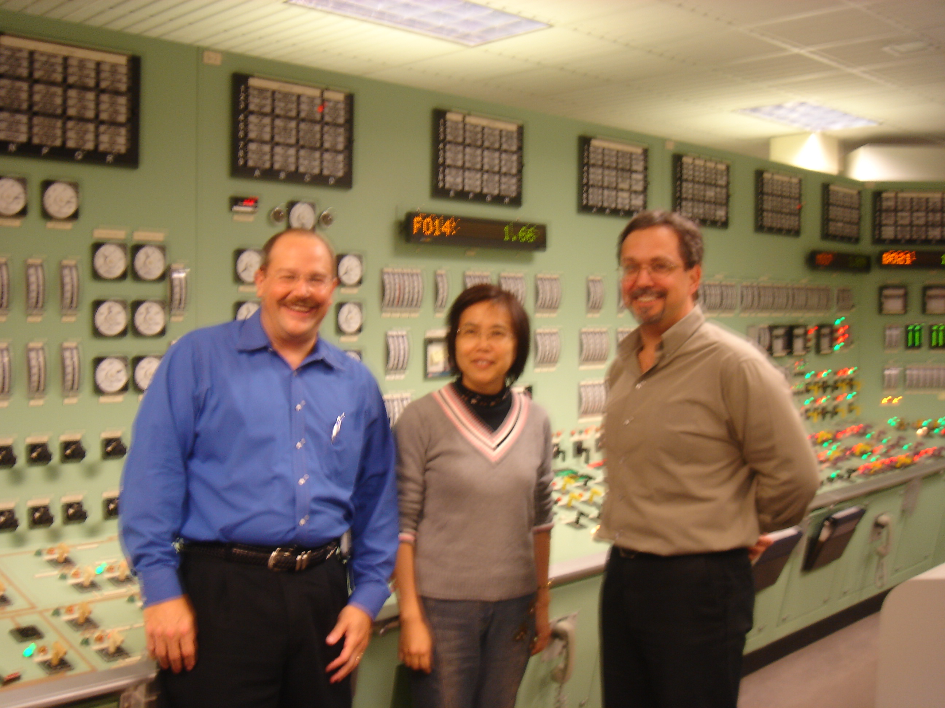

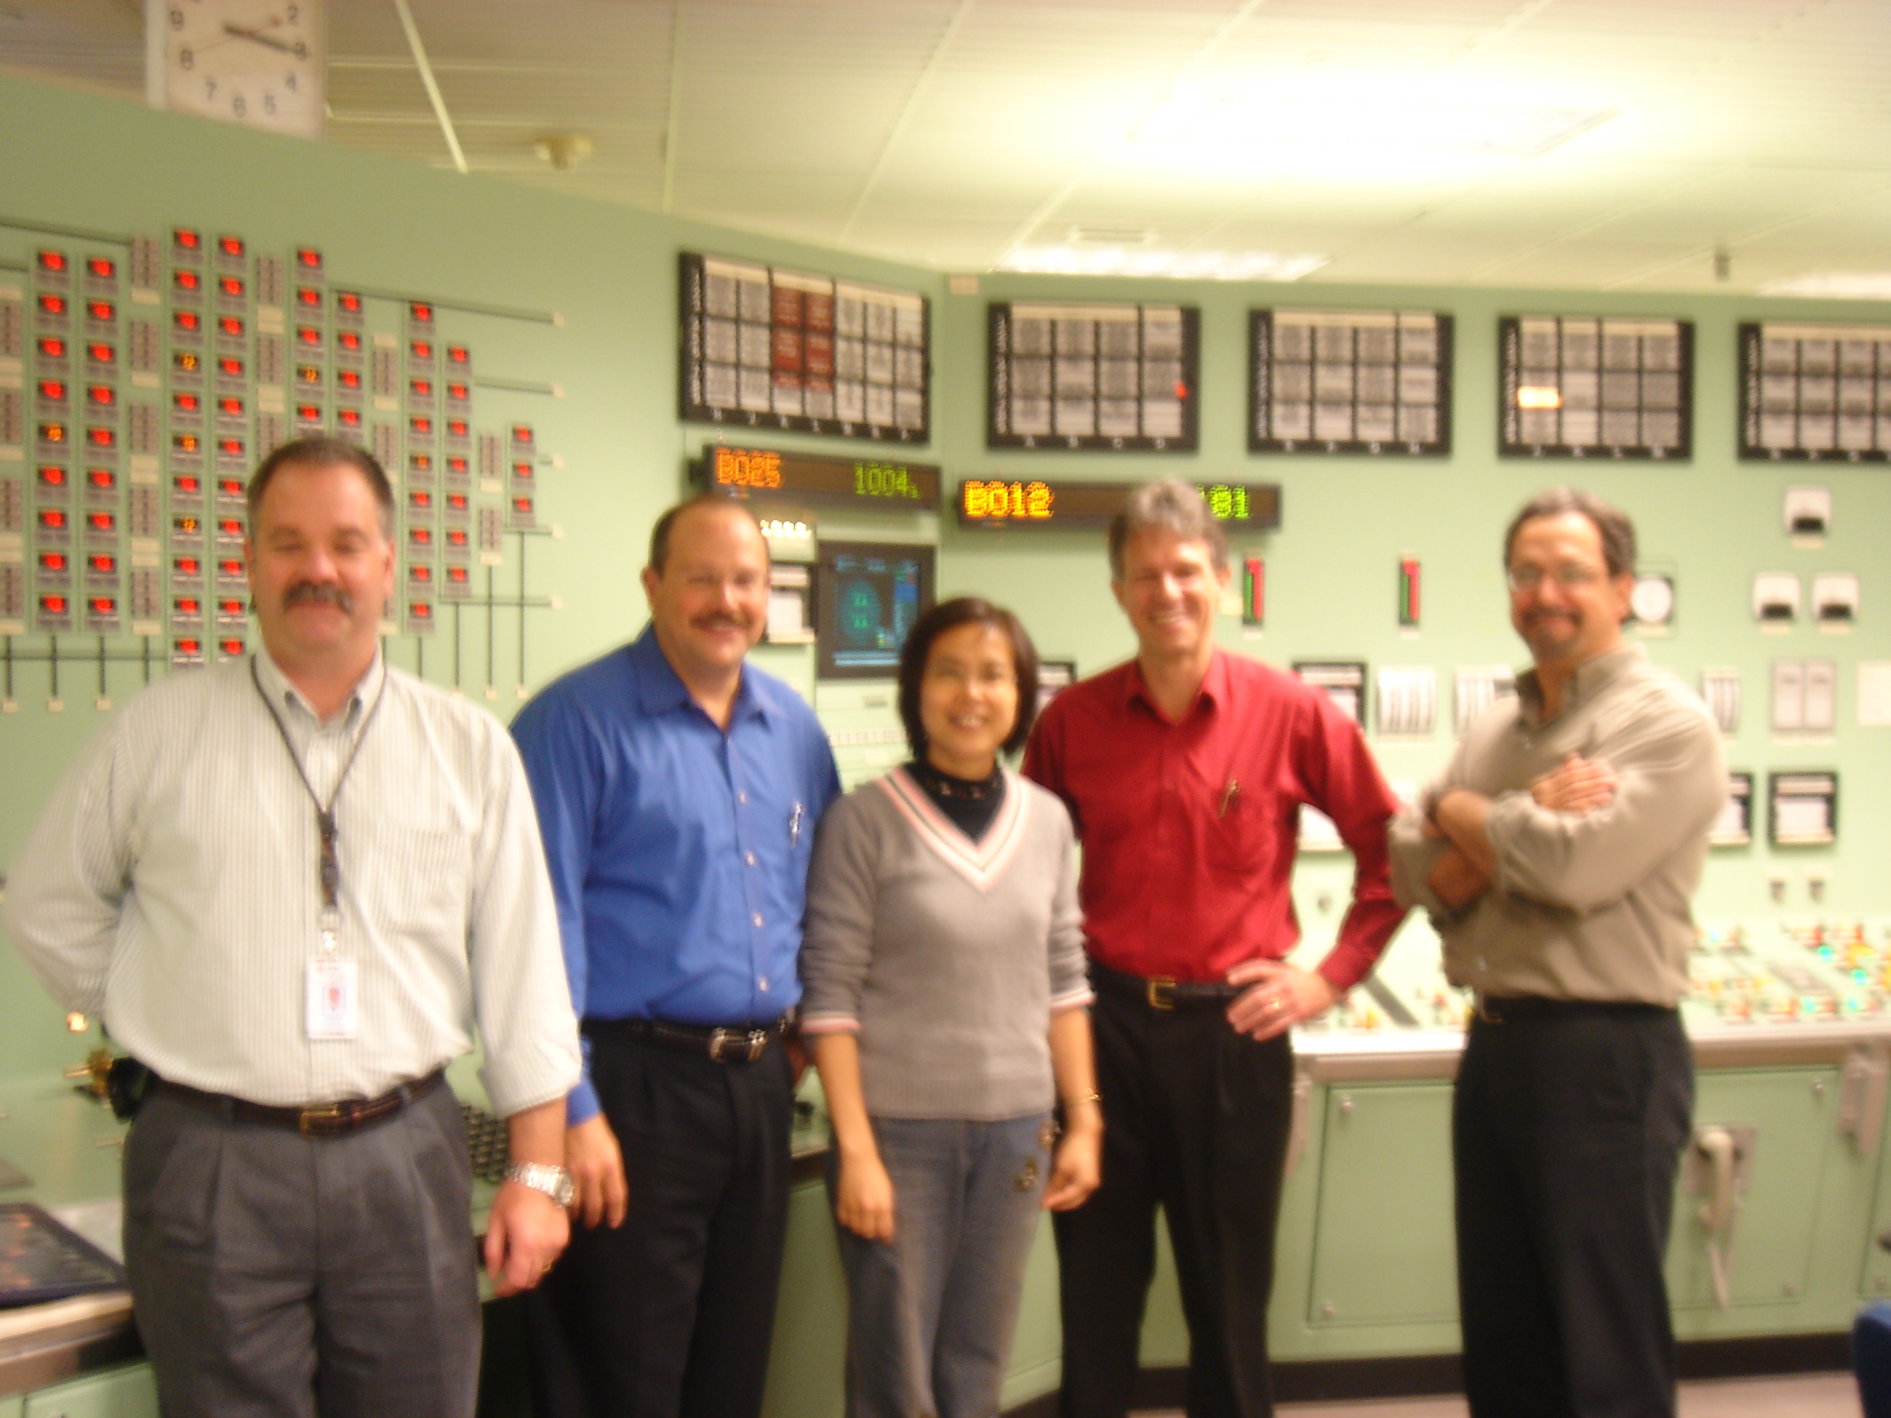

附圖三
