附錄一 日本致本局局長邀請函
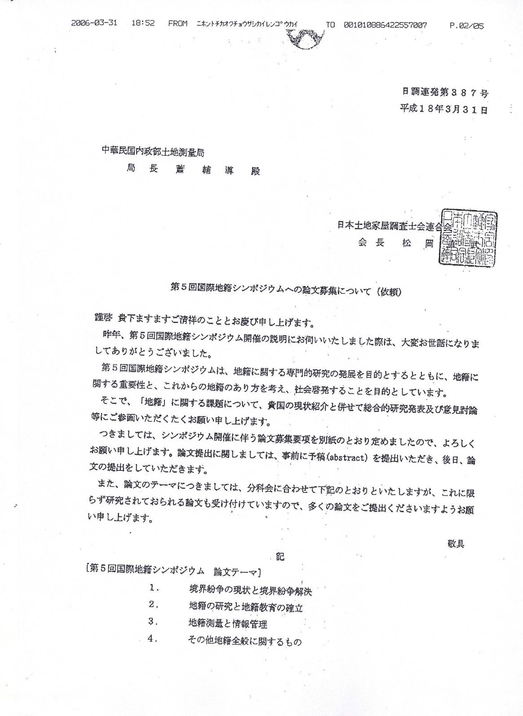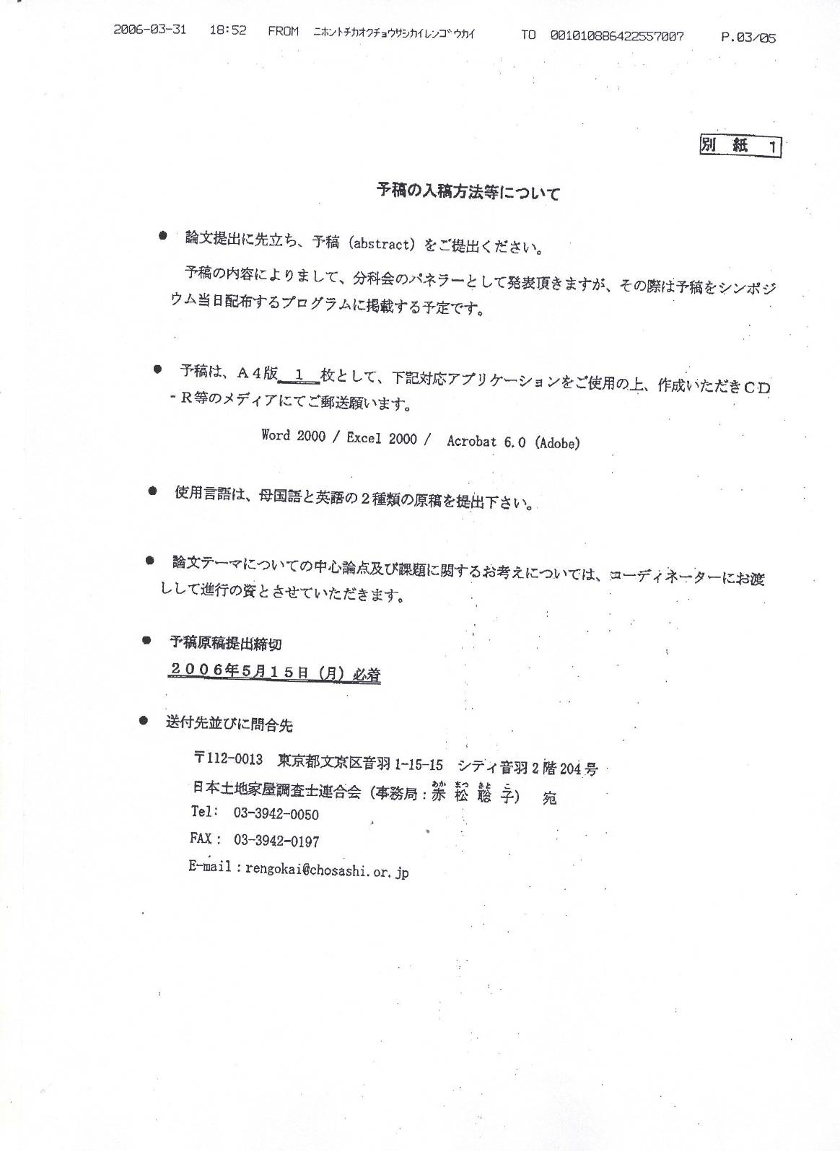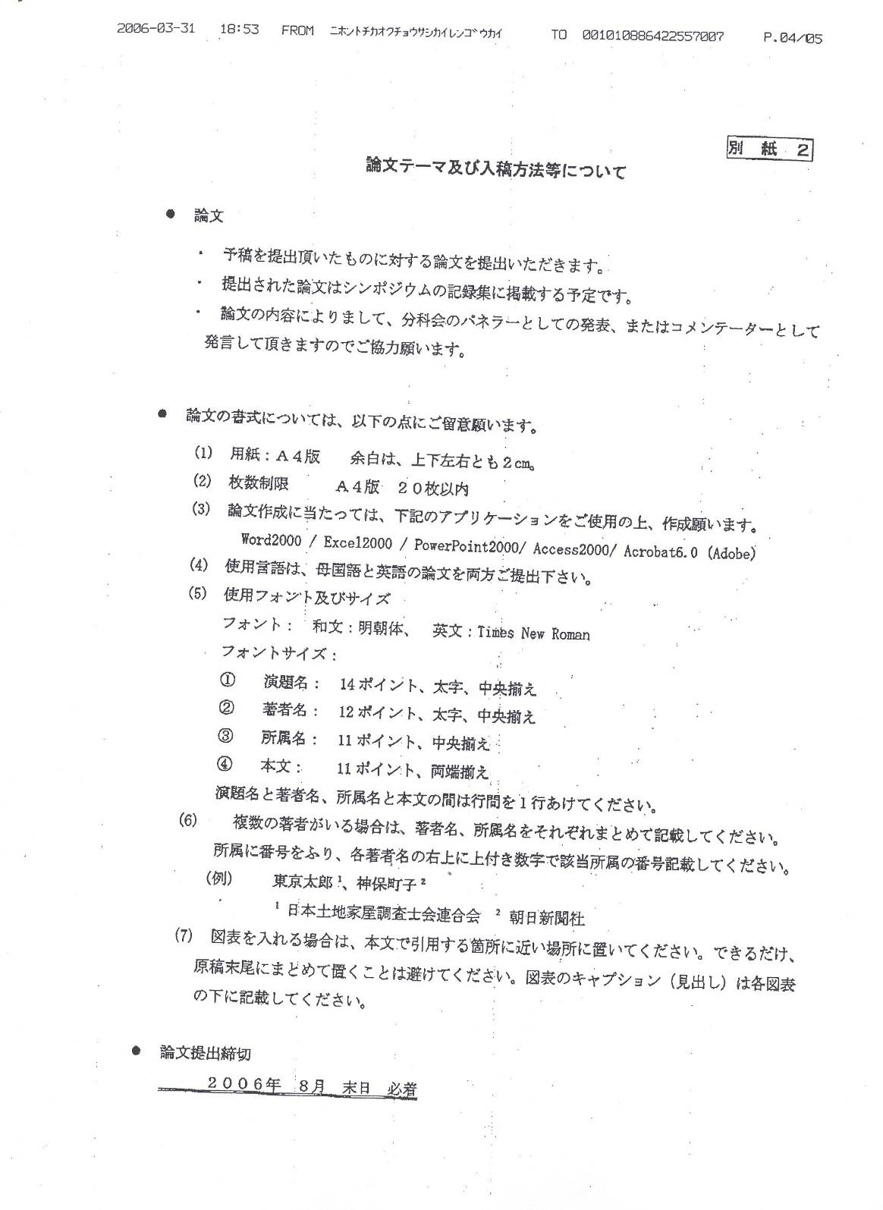
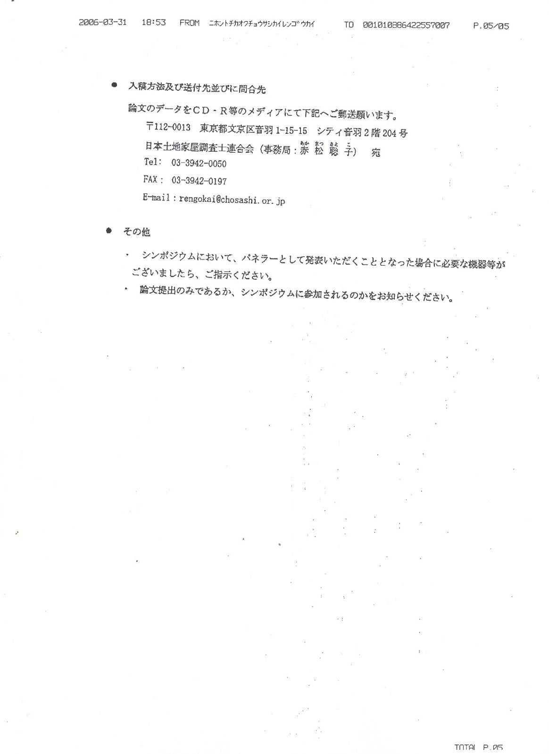

附錄二 我國研提論文名單與題目
No | Title |  | Writer
1 | 在Google虛擬地球實現三維建物套疊地籍圖與屬性資料顯示之應用 | Virtual Reality Realization of 3D Buildings Overlaid over Cadastral Map and Attribute Display on Google Earth | 劉瑞煌 | 內政部土地重劃工程局局長
1 | 在Google虛擬地球實現三維建物套疊地籍圖與屬性資料顯示之應用 |  | 溫嘉新 | 內政部土地重劃工程局正工程司
1 | 在Google虛擬地球實現三維建物套疊地籍圖與屬性資料顯示之應用 |  | 蔡裕陽 | 詮華工程顧問有限公司 副總經理
2 | 網際網路化之地籍測量資訊管理與公開─以內政部土地測量局為例 | Web-based Application Service for Managing and Publishing Cadastral Survey Information of the LSB | 游豐銘 | 內政部土地測量局測量員
2 | 網際網路化之地籍測量資訊管理與公開─以內政部土地測量局為例 |  | 蔡鴻勳 | 內政部土地測量局地圖供應課課長
2 | 網際網路化之地籍測量資訊管理與公開─以內政部土地測量局為例 |  | 蕭輔導 | 內政部土地測量局局長
3 | 台灣國土測繪資訊整合流通系統之發展經驗 | The development of territory surveying and mapping information integration and circulation system in Taiwan | 羅文珊 | 逢甲大學地理資訊系統研究中心專案經理
3 | 台灣國土測繪資訊整合流通系統之發展經驗 |  | 陳美心 | 逢甲大學地理資訊系統研究中心經理
3 | 台灣國土測繪資訊整合流通系統之發展經驗 |  | 周天穎 | 逢甲大學地理資訊系統研究中心主任
4 | 由開放格式觀點探討地籍圖形資料的應用綱要設計與網際網路應用 | The Application Schema Design and Internet Application of Cadastral Map Data from an Open Format Perspective | 洪榮宏 | 國立成功大学測量及空間資訊學系副教授
4 | 由開放格式觀點探討地籍圖形資料的應用綱要設計與網際網路應用 |  | 廖向芃 | 國立成功大学測量及空間資訊學系博士候選人
4 | 由開放格式觀點探討地籍圖形資料的應用綱要設計與網際網路應用 |  | 楊錦松 | 國立成功大学測量及空間資訊學系博士班研究生
5 | 台北市航測地形圖更新及歷史地籍圖資影像資料庫建置 | Revision of Photogrammetry-Topogaphic map of Taipei City and Establishment of the historical-Cadastral map Image Data Warehouse | 楊定國 | 中華顧問工程司地理資訊部正工程師
5 | 台北市航測地形圖更新及歷史地籍圖資影像資料庫建置 |  | 吳錫賢 | 中華顧問工程司地理資訊部工程師
6 | 日據時期澎湖地區的地籍測量 | The land measure in Penghu during the Japanese occupation era | 蔡俊哲 | 澎湖縣政府地政局局長
7 | 台灣地籍測量人員培育訓練制度之探討 | Discussion on the Training System of Taiwan Cadastral Survey Engineers | 王春治 | 內政部土地測量局課長
7 | 台灣地籍測量人員培育訓練制度之探討 |  | 黃錦桂 | 內政部土地重劃工程局主任
7 | 台灣地籍測量人員培育訓練制度之探討 |  | 蕭輔導 | 內政部土地測量局局長
8 | 知識經濟時代我國測量技師考用制度之探討 | Study of Examination and Employment Systems for Surveying Engineers In Taiwan’s Knowledge-Based Economy | 盧鄂生 | 考選部專技考試司司長
9 | 臺北市地籍圖坐標系統整合與加值運用 | Coordinate Systems Integrated and Value-Added Applications of Taipei City Cadastral Map | 施鴻冠 | 臺北市政府地政處土地開發總隊股長
9 | 臺北市地籍圖坐標系統整合與加值運用 |  | 吳智維 | 臺北市政府地政處土地開發總隊科長
9 | 臺北市地籍圖坐標系統整合與加值運用 |  | 駱旭琛 | 臺北市政府地政處土地開發總隊副總工程司
9 | 臺北市地籍圖坐標系統整合與加值運用 |  | 陳錫禎 | 臺北市政府地政處土地開發總隊總隊長
10 | 三圖合一整合實務之探討 | The Study of Three Map (Topographic, Land-use, Cadastral Map) in One From the application point of view | 鄭宏逵 | 中華顧問工程司地理資訊部 副理
10 | 三圖合一整合實務之探討 |  | 林耀宗 | 中華顧問工程司地理資訊部 組長
11 | e-GPS衛星基準站即時動態定位系統測量成果分析 | Surveying Results Analysis on Real Time Kinematic Positioning System of e-GPS Base Station | 王敏雄 | 內政部土地測量局技正
11 | e-GPS衛星基準站即時動態定位系統測量成果分析 |  | 劉至忠 | 內政部土地測量局課長
11 | e-GPS衛星基準站即時動態定位系統測量成果分析 |  | 劉正倫 | 內政部土地測量局副局長
12 | 921地震後臺灣中部地區控制點變位監測 | Monitoring Displacement of Control points in central Taiwan after the 921 Earthquake | 陳鶴欽 | 內政部土地測量局專員
12 | 921地震後臺灣中部地區控制點變位監測 |  | 曾耀賢 | 內政部土地測量局課長
12 | 921地震後臺灣中部地區控制點變位監測 |  | 劉正倫 | 內政部土地測量局副局長
12 | 921地震後臺灣中部地區控制點變位監測 |  | 蕭輔導 | 內政部土地測量局局長
13 | 台灣地藉界址問題之探討 | Current state of cadastral boundary disputes in Taiwan | 郭玉樞 | 中華民國地籍測量學會常務監事

附錄三 韓國研提論文名單與題目
No | Title |  | Writer
1 | 革新的な実施計画によるユーザ・フレンドリ三次元地籍制度の確立 | A Establishment of a User Friendly 3D Cadastre through an Innovative Implementation Action Plan | ソン・ホリョン  Song Ho-Ryong | 大韓地籍公社副社長
2 | 韓国・中国（台湾）・日本の地籍測量processの比較・分析 | Comparative Analysis of Cadastral Surveying Process in Korea, Taiwan and Japan | キム・ヨンハク  Kim, Young Hak | 大韓地籍公社地籍研究院
3 | リアルタイム地籍測量のためのNetwork RTK導入方法の研究 | The research of real time Cadastral survey in GPS Network RTK environment | カン・サング  Kang, Sang Gu | 大韓地籍公社地籍研究院
4 | 境界の正確さを確保するための地籍測量データの活用方法 (境界復元測量を中心に) | Study on utilization of cadastral survey data for accuracy improvement of cadastral boundary (Based on cadastral resurvey) | ユン・ジュンソン  Joon-Sung Yun | 大韓地籍公社地籍研究院
5 | 韓国型モバイル地籍測量システムの開発 | Development of Mobile Cadastral Surveying System in Korea | キム・ジュンシク  Kim, Joon Sik | 大韓地籍公社地籍研究院
5 | 韓国型モバイル地籍測量システムの開発 | Development of Mobile Cadastral Surveying System in Korea | カン・サング  Kang, Sang Gu | 大韓地籍公社地籍研究院
6 | 地籍測量用 GPS受信機開発のための組み込みシステムの設計及びその実現 | Deign and Implementation of Embedded System for GPS Receiver On Cadastral Surveying | パク・ソンソク  Park, Sung Seok | 大韓地籍公社地籍研究院
6 | 地籍測量用 GPS受信機開発のための組み込みシステムの設計及びその実現 |  | チャ・ヅッキ  Tcha, Dek Kie | 大韓地籍公社地籍研究院
7 | 韓国の地目制度の改善に関する研究 | A study on the improvement of the land category system in Korea | イ・ヨンムン  Lee, Yong Moon | 大韓地籍公社地籍研究院
7 | 韓国の地目制度の改善に関する研究 |  | キム・サンスウ  Kim, Sang-su | 元大韓地籍公社GPS推進団長・国際地籍学会名誉会長
8 | 韓国の墓地制度とその改善方法、および墓地管理の方法に関する研究 | A study on the Korean grave institution and improvements for grave management | キム・ジン  Kim Jin | 大韓地籍公社地籍研究院
8 | 韓国の墓地制度とその改善方法、および墓地管理の方法に関する研究 |  | ヤン・チョルス  Yang, Chul-Soo | 大韓地籍公社地籍研究院
9 | 図解地籍測量の数値登録方法に関する研究 | A Study on the Numerical Registration Plan of Graphical Cadastral Surveying | コ・ジョンソク  Ko, Jeong Seok | 大韓地籍公社地籍研究院
9 | 図解地籍測量の数値登録方法に関する研究 |  | チョン・レジョン  Jung, Rae Jung | 大韓地籍公社地籍研究院
9 | 図解地籍測量の数値登録方法に関する研究 |  | キム・スジョン  Kim, Su Jeong | 大韓地籍公社地籍研究院
10 | 韓国の地籍教育の動向分析 | The Trend Analysis of Cadastre Education in Korea | イ・ボングァン  Lee, Beom-Gwan | 慶日大学校不動産地籍学科長・社団法人韓国地籍学会副会長
10 | 韓国の地籍教育の動向分析 | The Trend Analysis of Cadastre Education in Korea | キム・ホンテク  Kim, Hong-Teak | 慶日大学校・昌原専門大学 外来(客員)教授
11 | 韓国の地籍学研究の動向分析– 韓国地籍学会を中心に – | The Trend Analysis of Cadastre Research in Korea- Oriented by the Korean Society of Cadastre - | ペク・スンチョル  Baek, Seung-Cheol | 大韓地籍公社地籍研究院教授
11 | 韓国の地籍学研究の動向分析– 韓国地籍学会を中心に – |  | イ・ボングァン  Lee, Beom-Gwan | 慶日大学校不動産地籍学科長・社団法人韓国地籍学会副会長
12 | 土地台帳情報の論理誤謬の類型に関する研究 | A Study on the Logical Error Types of Cadastral Attribute Information | イ・ソンファ  Lee, Seong-hwa | 行政自治部地籍チーム地籍事務官・行政学博士・地籍技術士

附錄四 日本評論文章或簡報名單與題目
No | Title | Writer
1 | Map Maintenance for Real Estate Registration | Shinya Hata | Assistant Official Second Division, Civil Affairs Bureau, Ministry of Justice / Assistant Official
2 | Project by the Ministry of Land,Infrastructure and Transport | Shinichi  Yokouchi | ,Land survey Division of land and water Bureau, Ministry of Land, Infrastructure and Transport  Project General Manager
3 | Cases in Toyonaka City and Expectations and issues of the “Heisei Cadastre Maintenance Project” | Shigenobu  Yanagawa | Road Management Division, Sewerage Engineering Department, Toyonaka City  Manager
4 | A New Challenge to Land and House Investigator Operations | Yukio  Yanagitai | Land and House Investigator （ Operation Japan Federation of Land House Investigators’ Associations） / Director
5 | Cadastral Survey Based on the National Land Survey Method | Kietsu  Ogasawara | All Japan Land Survey Association  Executive Director
6 | Cadaster Management “Land Tax and Profitability” and “3-D Management” | Mitsuo  Kimura | Sales, Real Estate Division, The Sumito Trust & Banking Co.,Ltd.  Director
7 | Cadaster Research and Education | Ichiro  Sakamoto | Faculty of real Estate Science, Meikai University  Professor
8 | Present Status Issues of Survey Education | Miwako  Suzuki | Survey College of Kinki  Former President
9 | ADR and Professionalism : Responding to the Japanese-type Environment | Yoshitaka  Wada | Graduate School of Law, Waseda University  Professor
10 | Lot Boundary Specification System | Kazuhiro  Umezu | Presiding Justice of the Asahikawa District and Family Court（the Osaka Legal Affairs Bureau）  Former Director
11 | Expectations and Outlook from the Perspective of Users | Yasuhiro  Orita | Lawyer（Kyoto Bar Association）  Vice Chairman
12 | Boundary Dispute Resolution and the Duties of Land and House Investigators | Masatoshi  Ibata | Member of System Measure Headquarters, Japan Federation of Land and House Investigators’Associations）  Investigator
13 | Local Custom of Kyoto | Izumi Hiratsuka | Kyoto Land and House Investigators’Association  Member
14 | Practical Study on Land Boundary and Acquisitive Prescription | Akihiro Nakahara | Sapporo Land and House Investigators’Association  Member
15 | Lot Division Application of Military Bases | Kanji Kanno | Okinawa Land and House Investigators’Association  Member
16 | Geometric Approach to creative Lot Boundary Specification | Ryichi Mabuchi | Gifu Prefecture Land and House Investigators’Association  Member
17 | Experimental Study in Variation of Supporting Structure Using Server Type RTK-GPS and its Apprication to Surveying | Masashi Sakamoto | Kagoshima Prefecture Land and House Investigators’Association / Member
18 | Cadastral Mapping Project under E-Japan Policy and Collaboration between Government and Private Sector | Tadakatsu Ueda | Shiga Prefecture Land and House Investigators’Association / Member
18 |  | Masakazu Fujiki | Shiga Prefecture Land and House Investigators’Association / Member
19 | Registration Survey from Registration Control Point | Mitsuaki Shimotomai | Iwate Prefecture Land and House Investigators’Association  Member

附錄五 京都地籍宣言原文
Kyoto Cadastral Declaration
In contributing to the clarification of the “figure and boundaries” of land which are common and invaluable property for all creation as well as the “cadastre” that determines its extents; and to protect the day-to-day lives and properties of all people; furthermore, in contributing to the establishment of foundation for a financial policy which promoting the advancement in the creation of towns, cities and nation, the untiring effort of all people is needed.
Today, researchers as well as businessmen from Japan and the overseas gathered together here in Kyoto to discuss the status and issues of cadastre in Japan from a global perspective, and prefaced the shape of the cadastre system demanded in the new age.
We will use this conference as an opportunity to declare the following action guidelines for the enhancement and development of the cadastre system of Japan and the world.
1. We will widely disseminate the importance of cadastre, map and boundaries to all social levels and contribute to the reinforcement of their maintenance.
2. Responding to a highly information and computerized society, we will contribute to establish the foundation for a financial policy by national and regional government institutes, and deepen technological and scholastic integration aiming to establish a cadastral system that will provide benefits for citizens.
3. In order to provide safe and spiritually rich lives, we will aim to prevent the occurrence of disputes concerning land boundaries, and establish a system to swiftly and appropriately resolve such disputes.
4. We will make efforts to establish organizations for scholastic and interdisciplinary research on cadastre, propose the establishment of a systematic educational system for those involved in cadastre, and make efforts for their realization.
5. All institutions, researchers, businessmen and users involved in the clarification of cadastre are to cooperate and maintain close information exchange, as well as make efforts in collaborative projects, and utilize and implement their results.
We hereby declare that we will aim to realize “Cadastral, Maps, and Boundaries of Tomorrow” beyond regions and nations.
November 14, 2006
The 5th International Cadastral Symposium in Kyoto

附錄六 總合資料館展示圖資
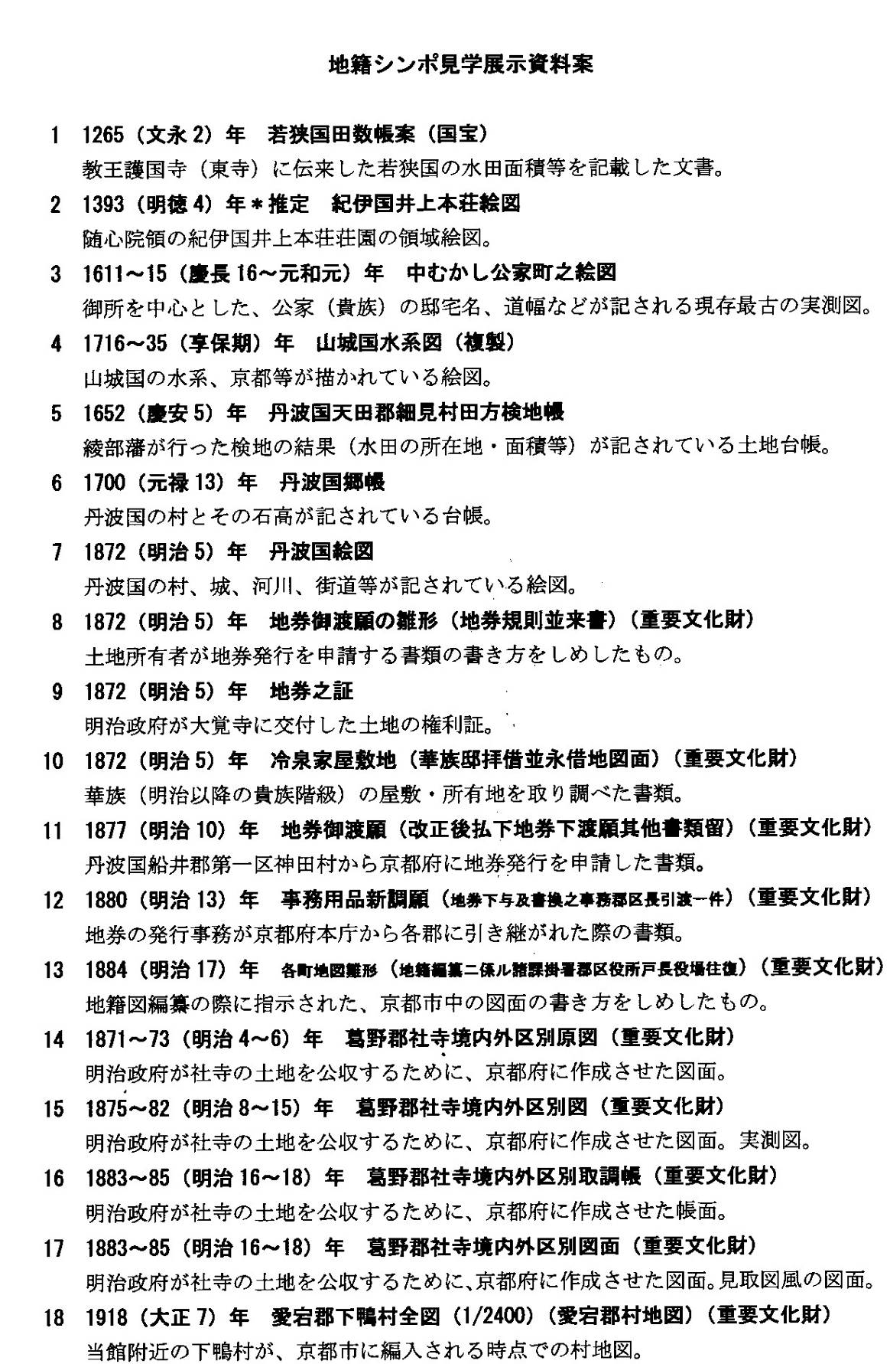

附錄七 日本京都地方法務局表單
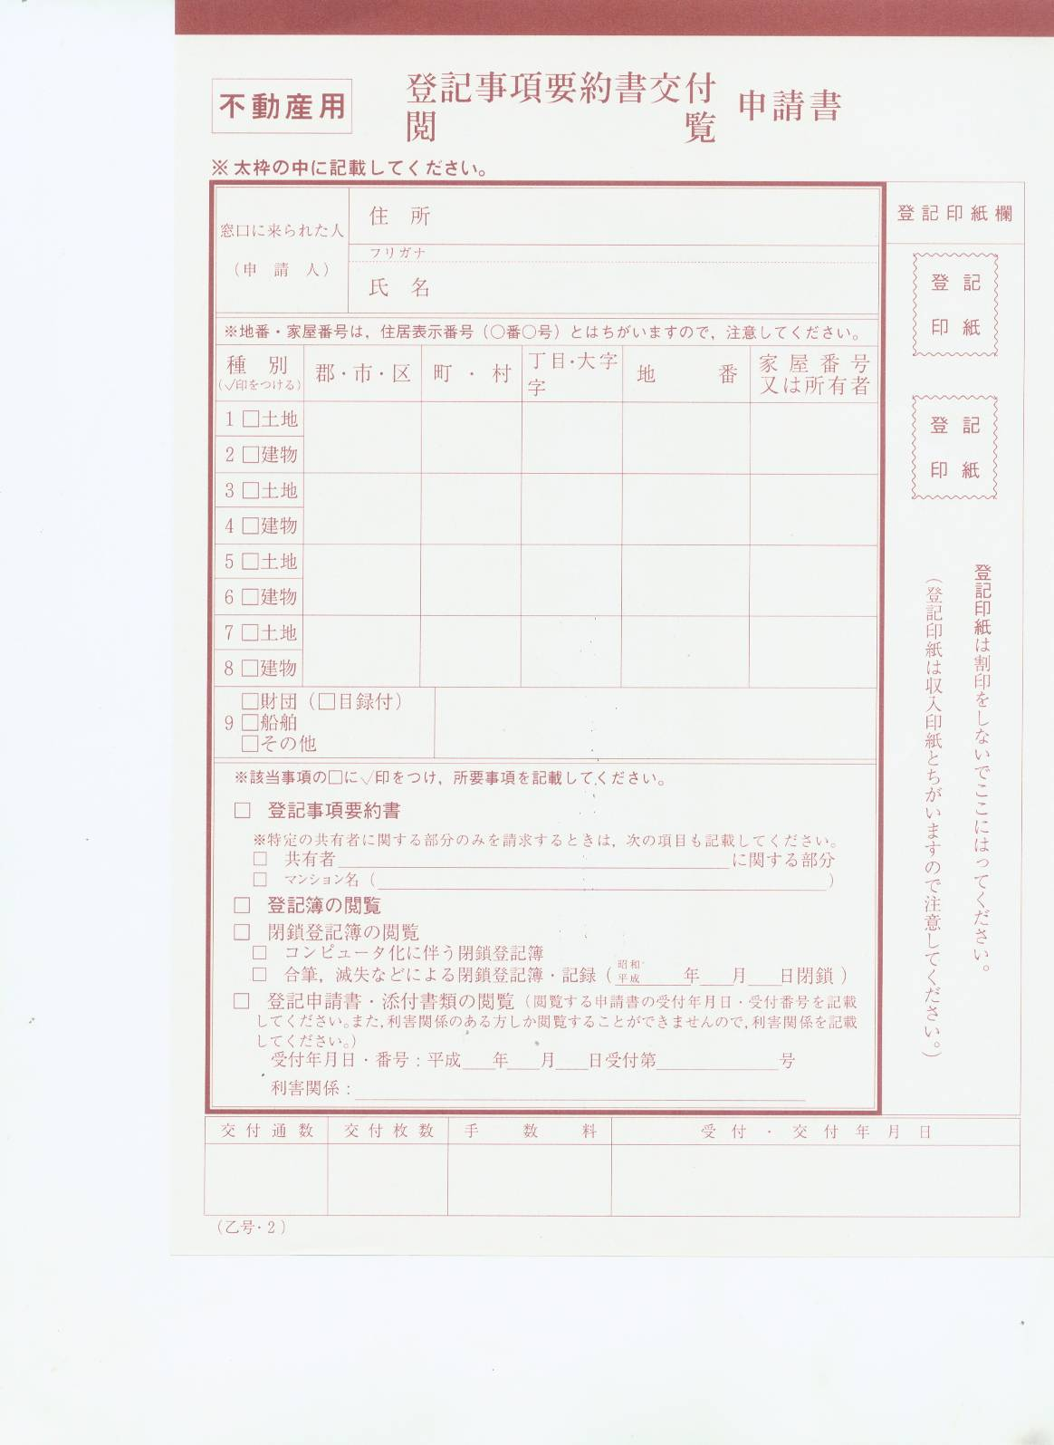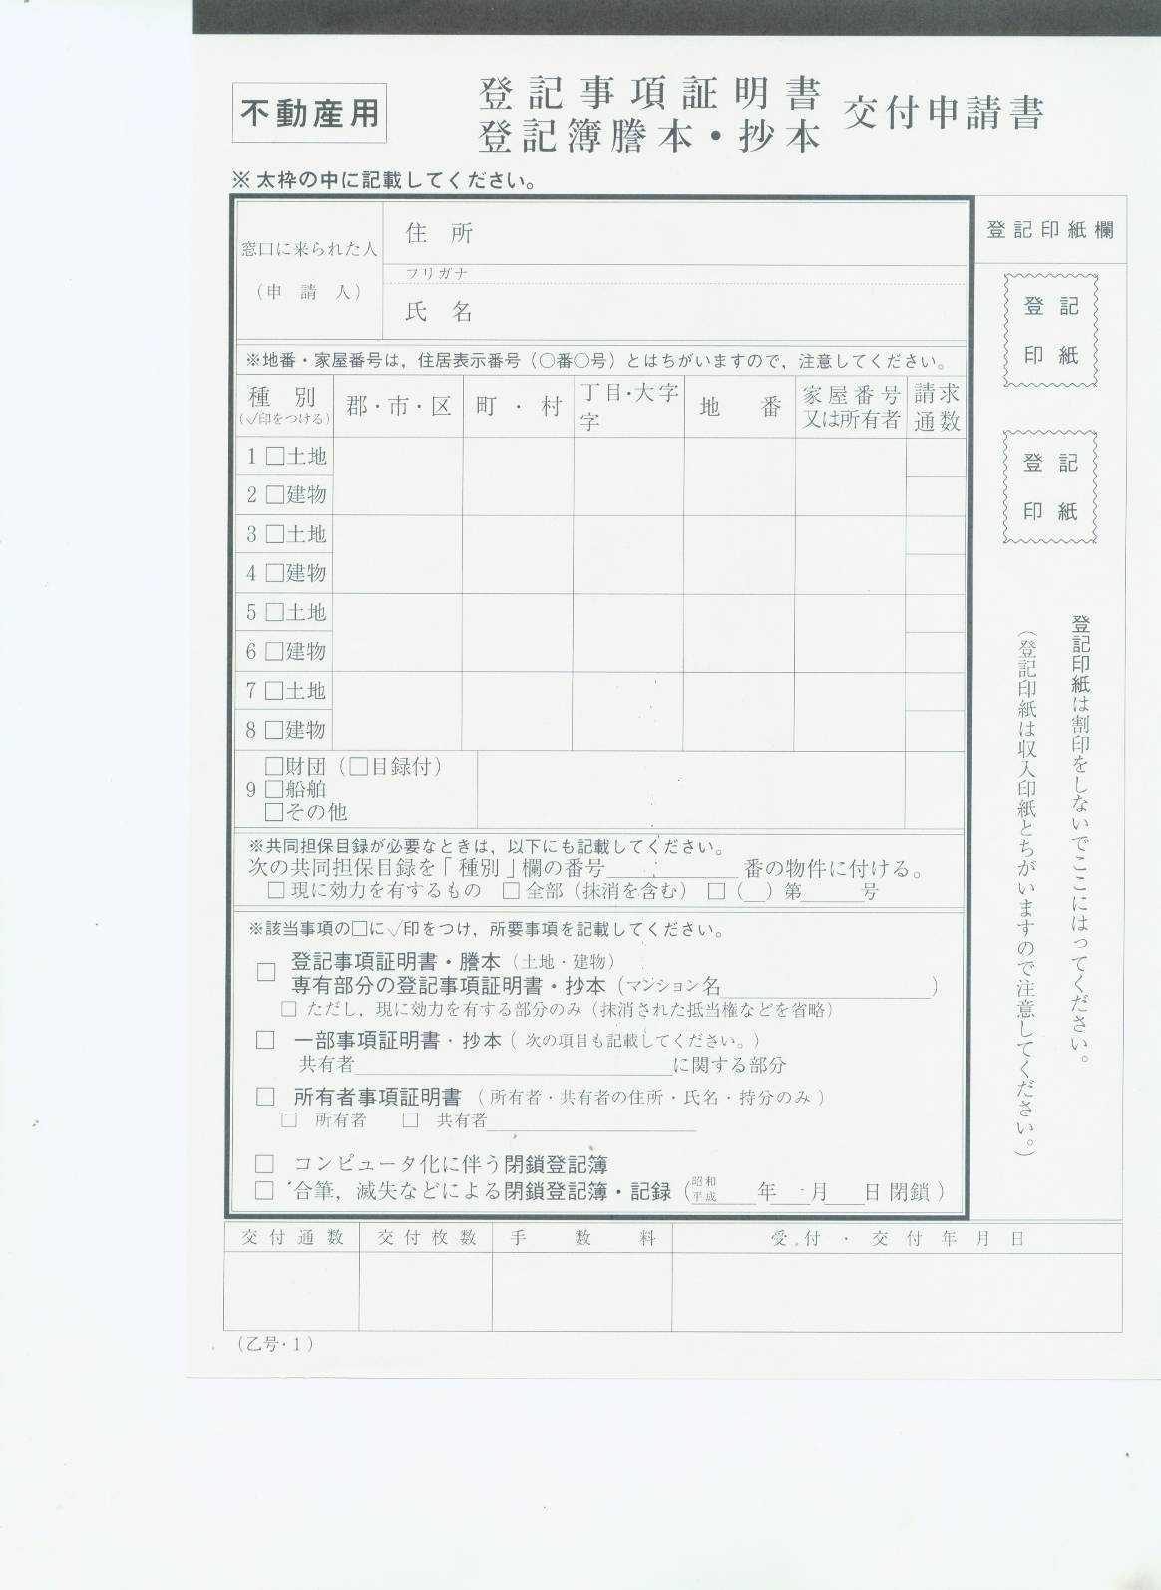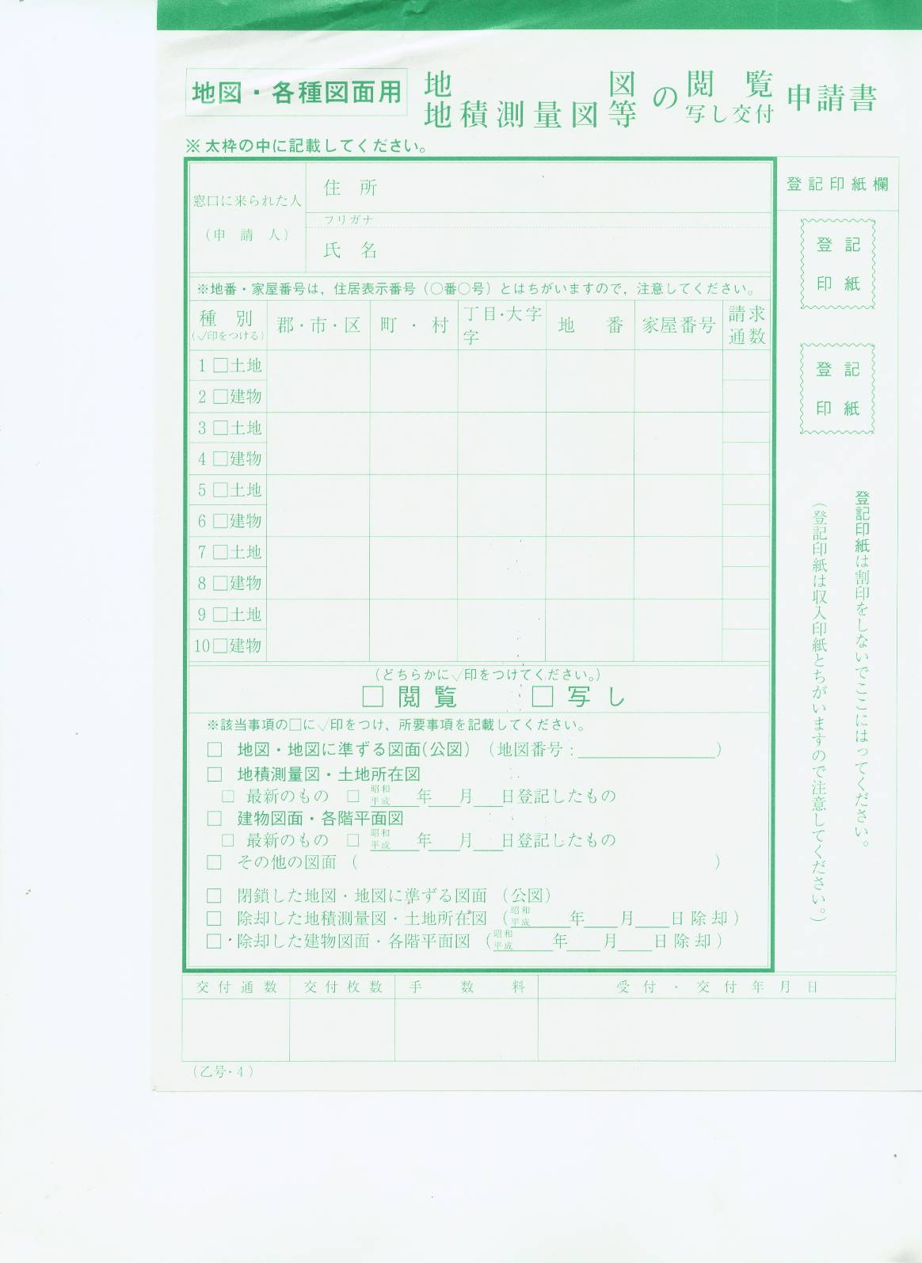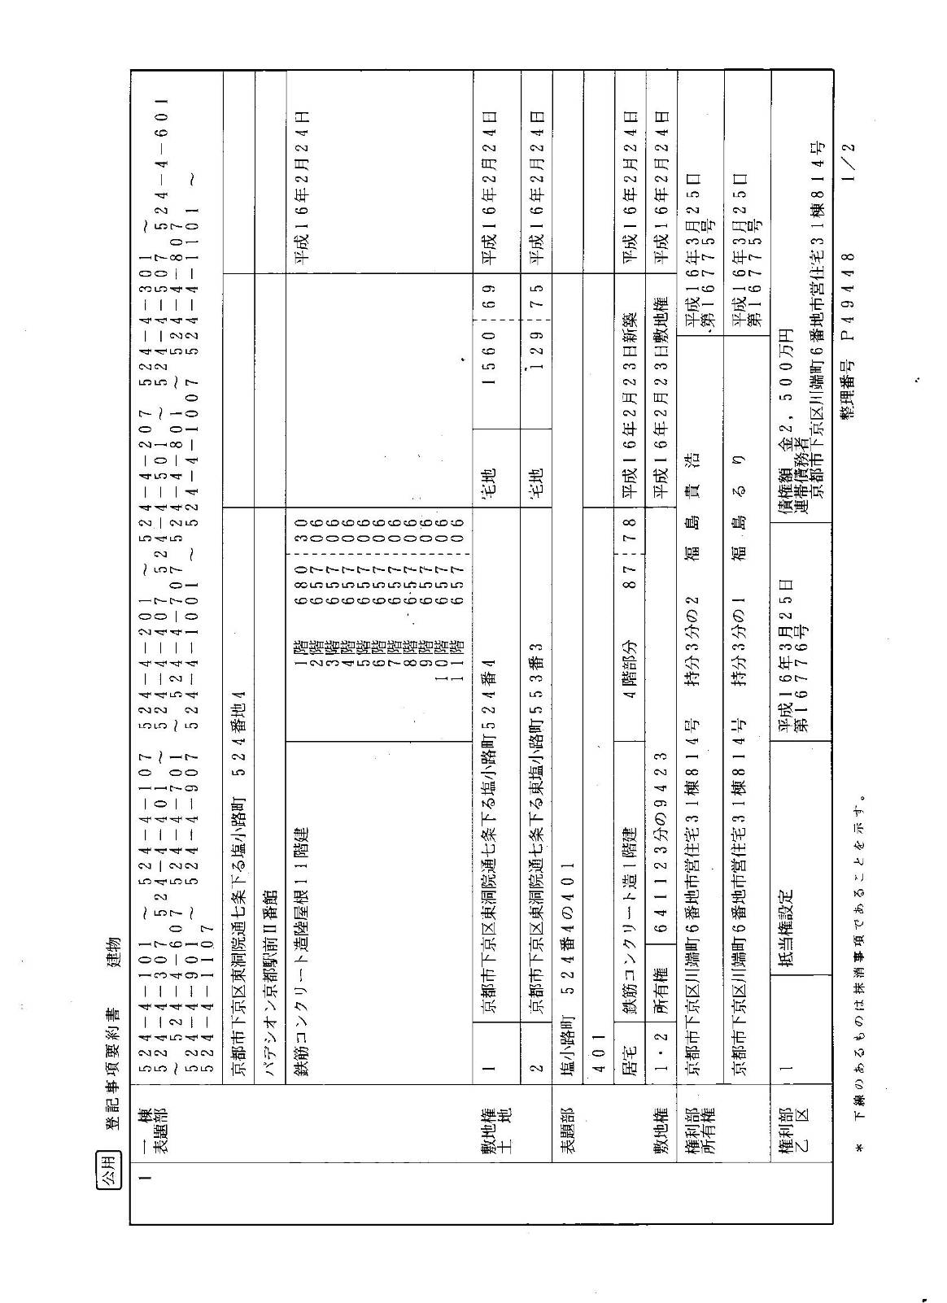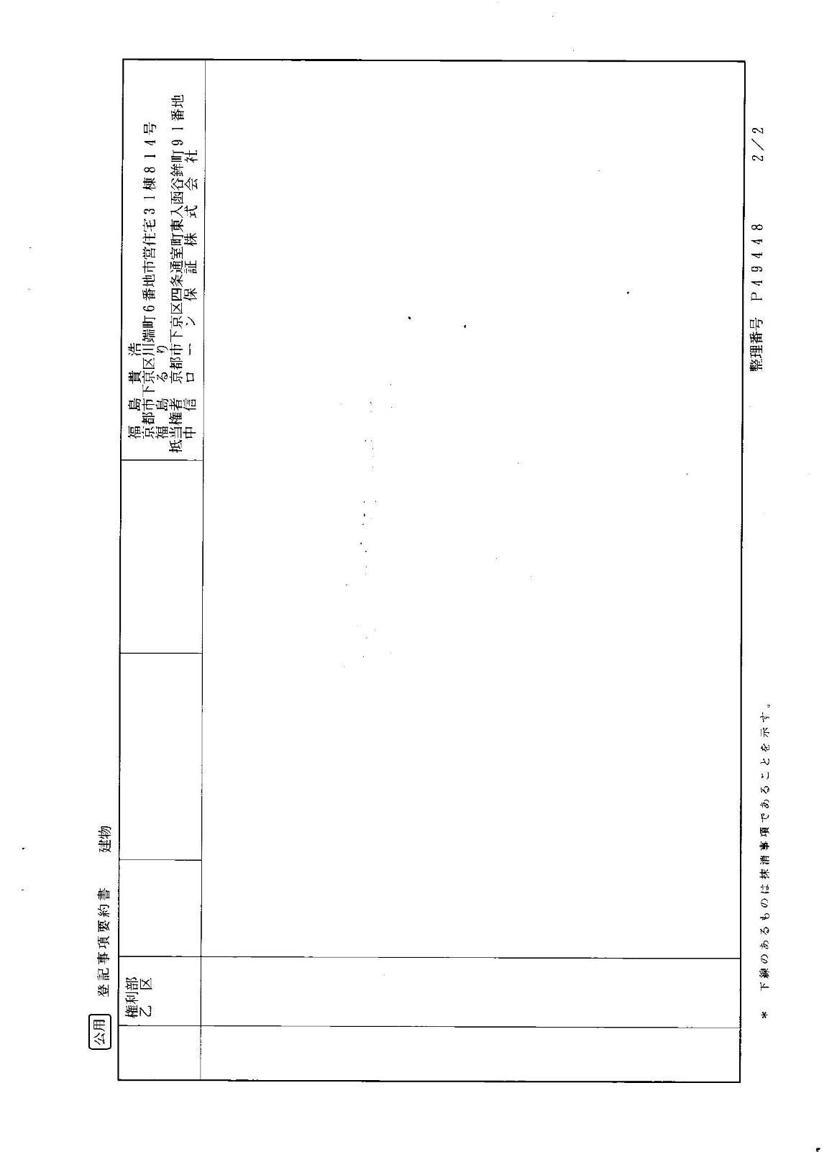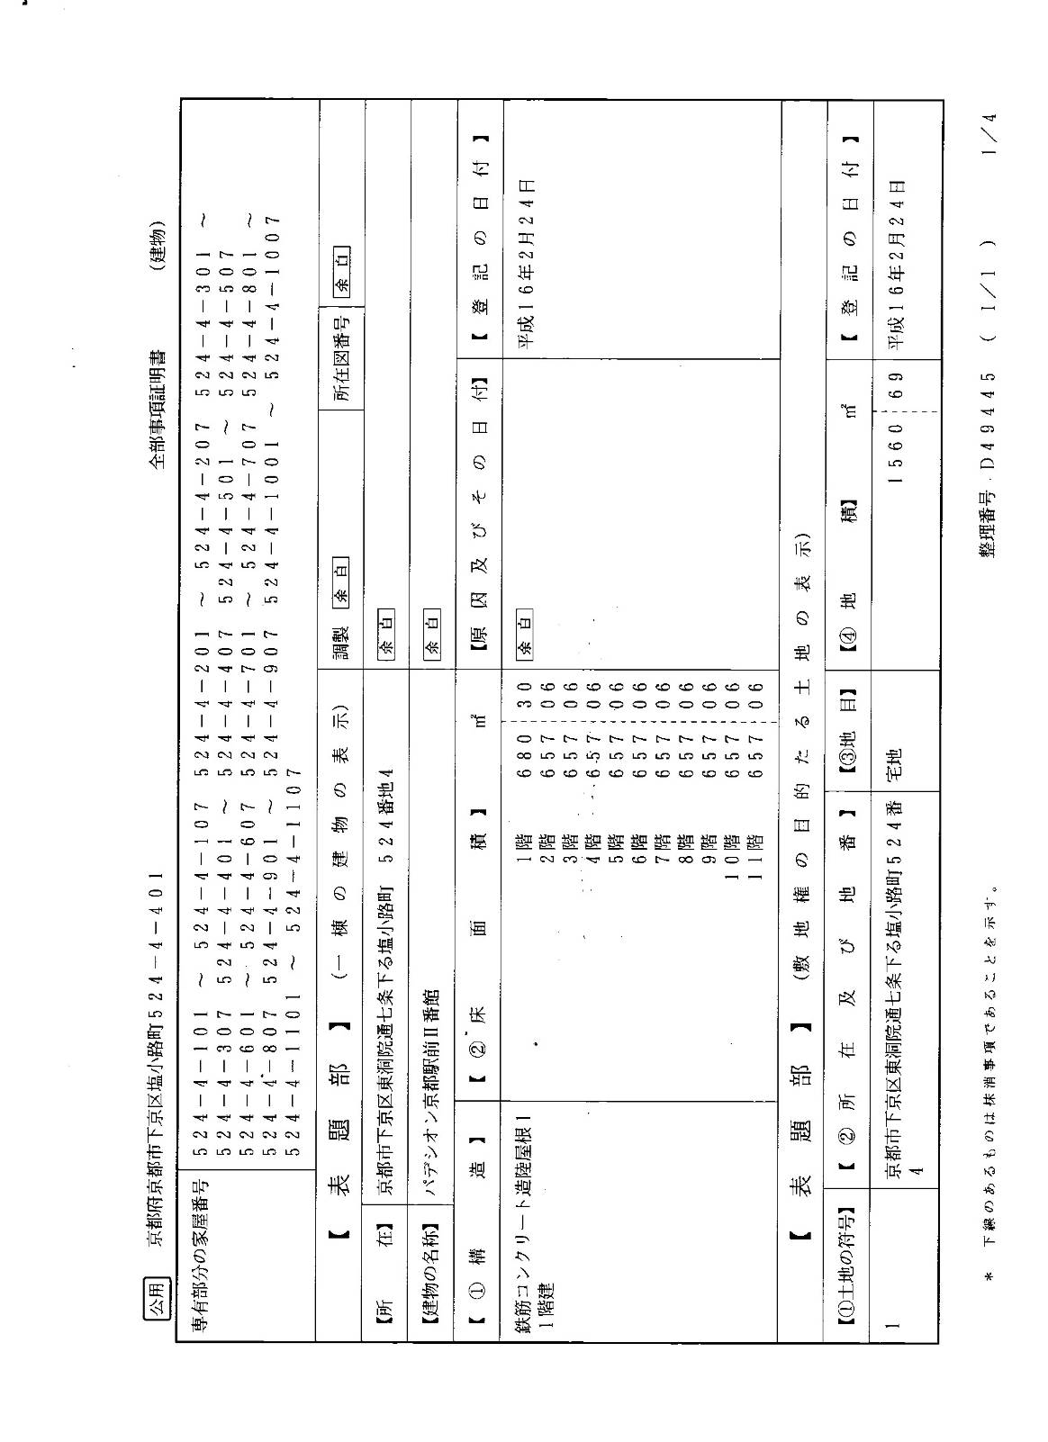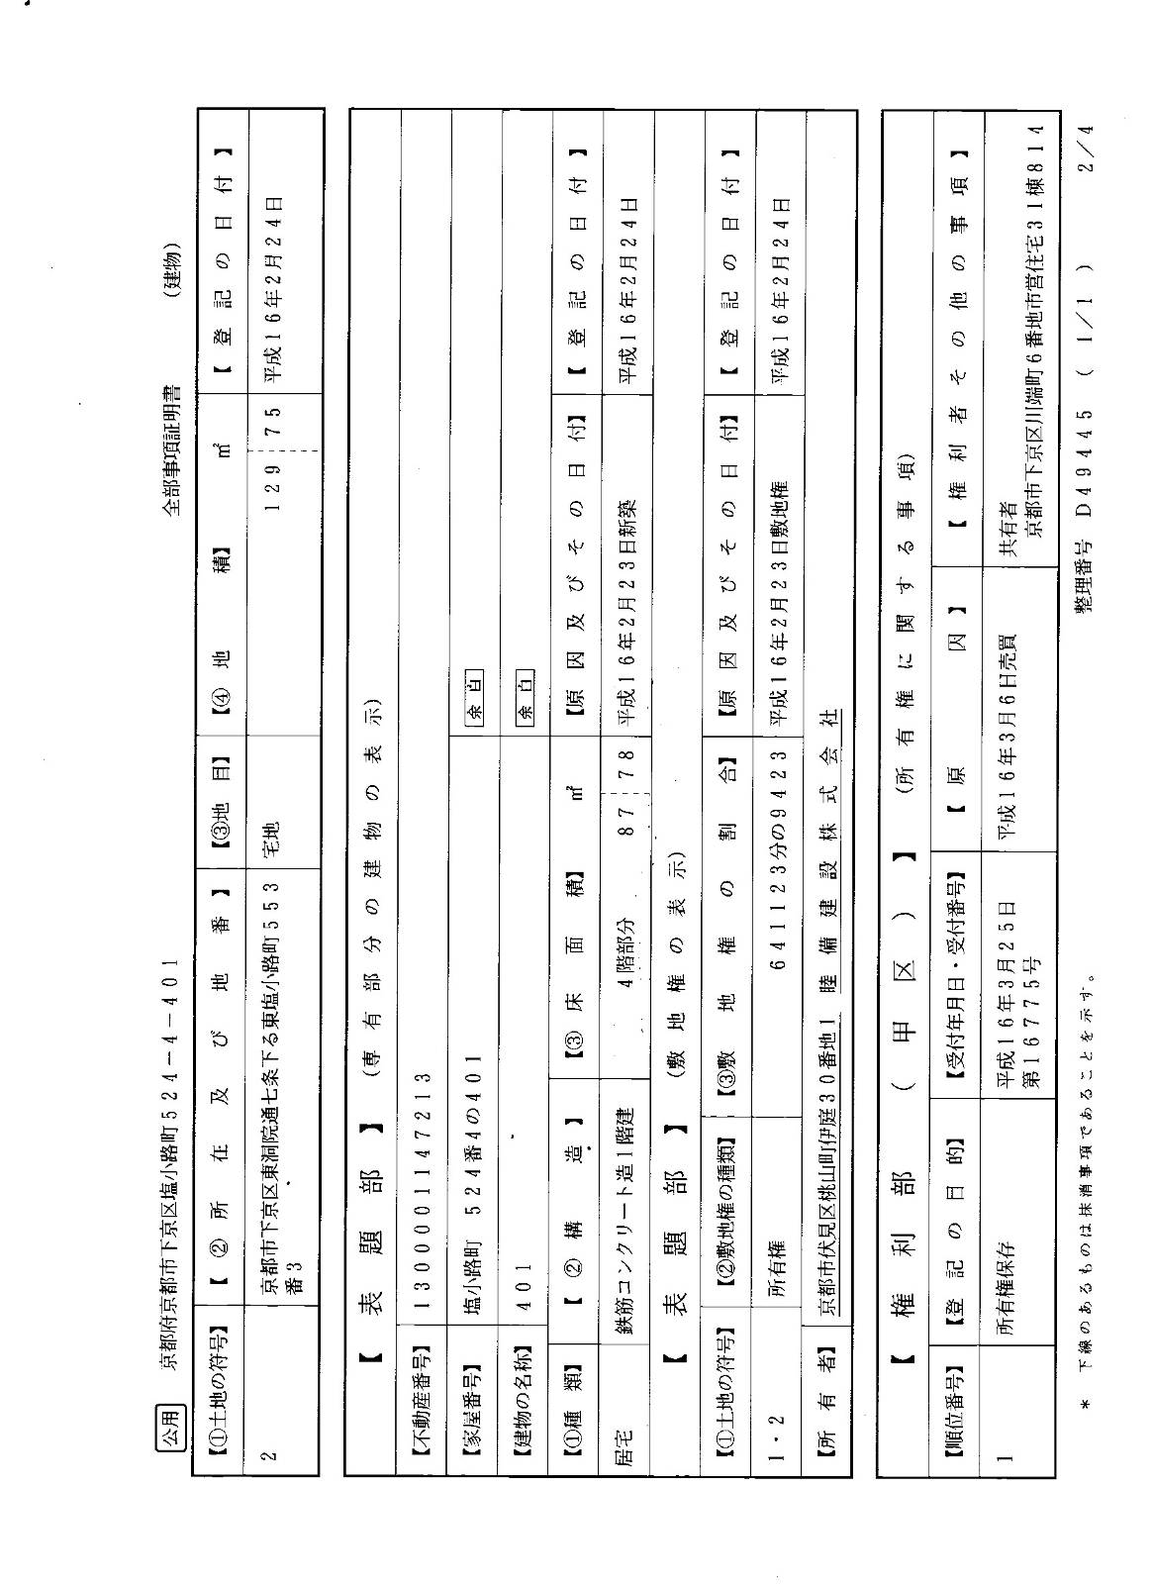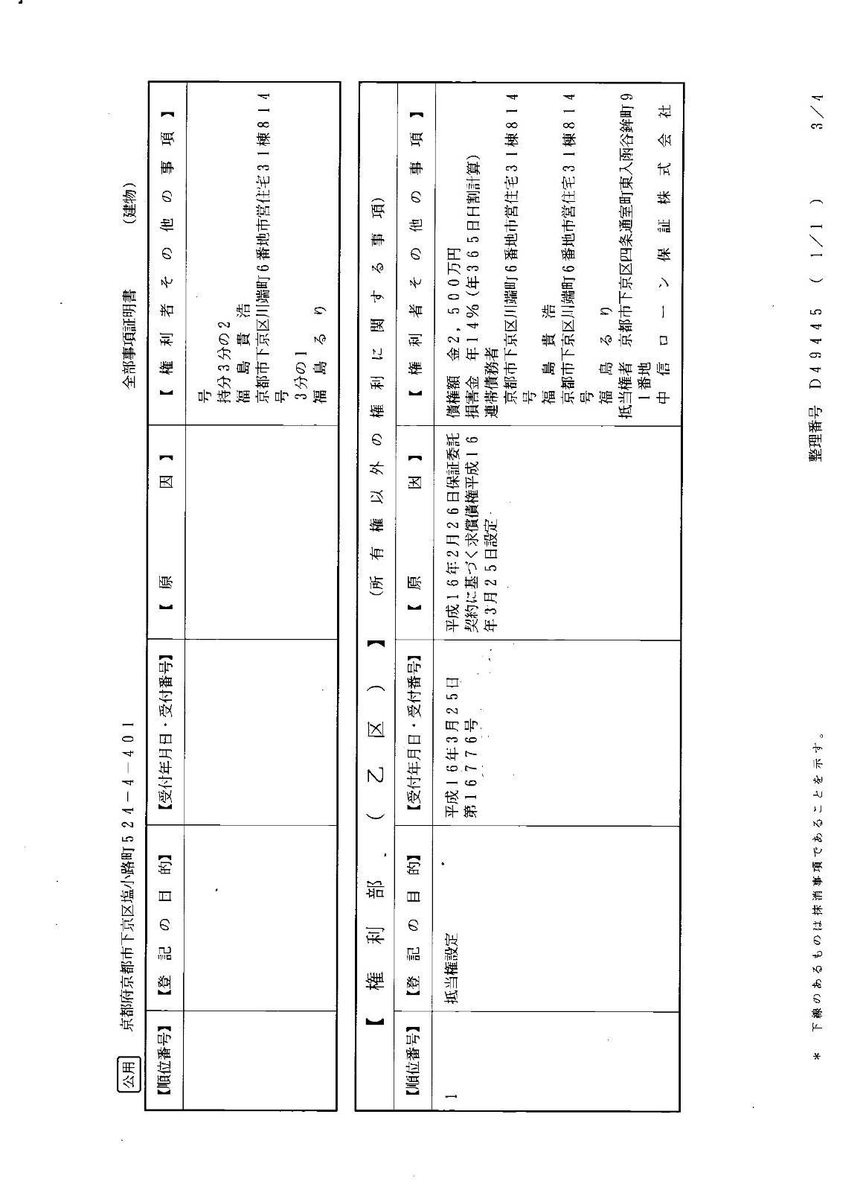
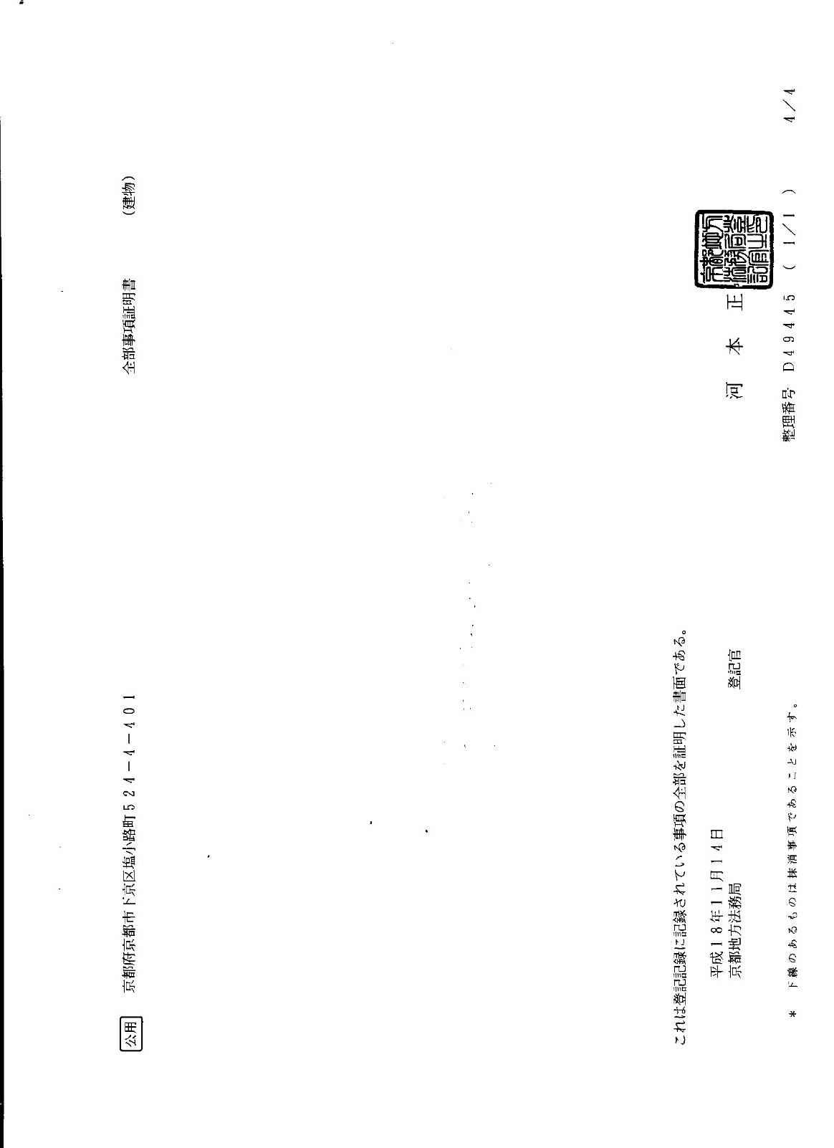

附錄八 活動照片集錦
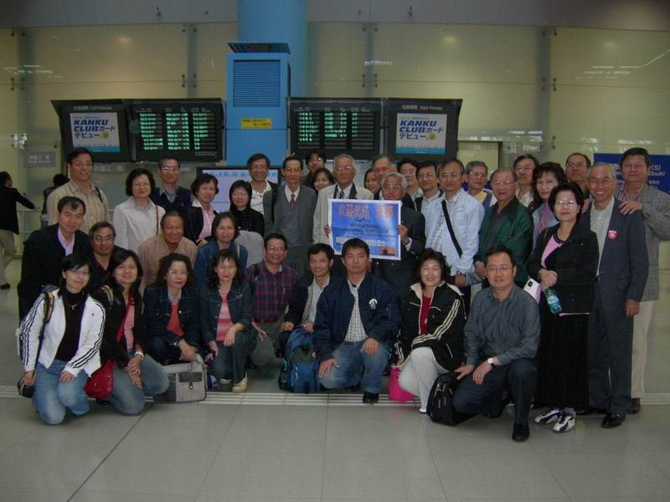
京都土地家屋調查士會浅田詔夫名譽會長至大阪機場接機
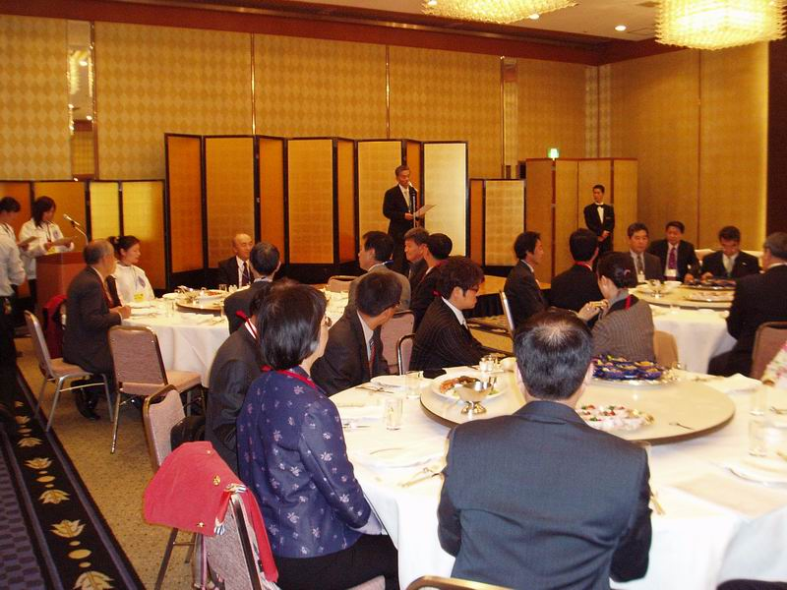
歡迎晚會─日本土地家屋調查士會連合會松岡會長直武致歡迎詞
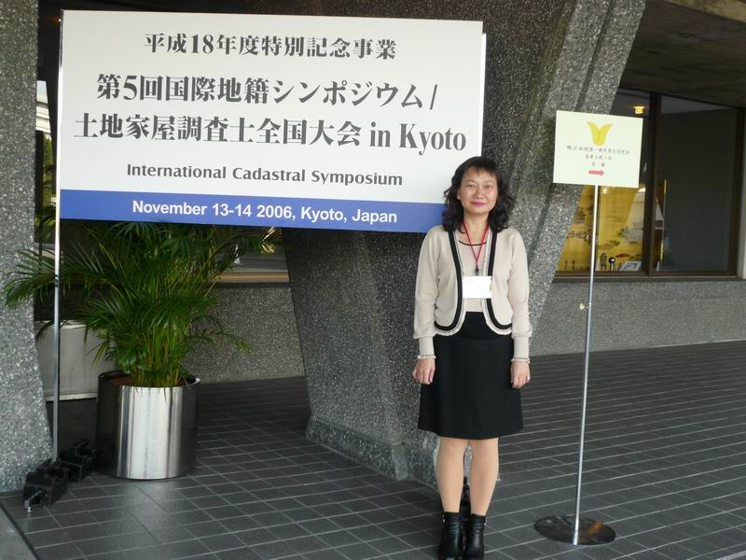
第5屆國際地籍測量學術研討會會場─國立京都國際會館
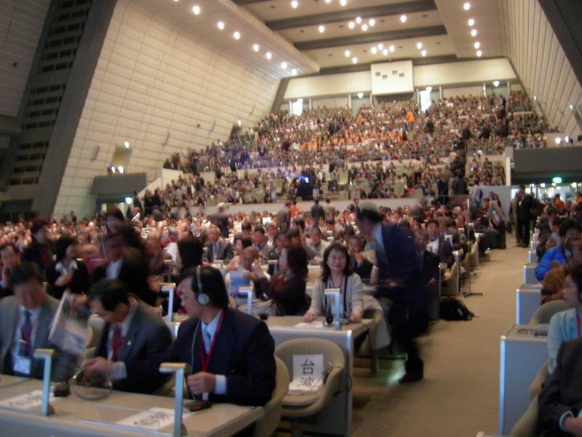
開幕式─大會會場
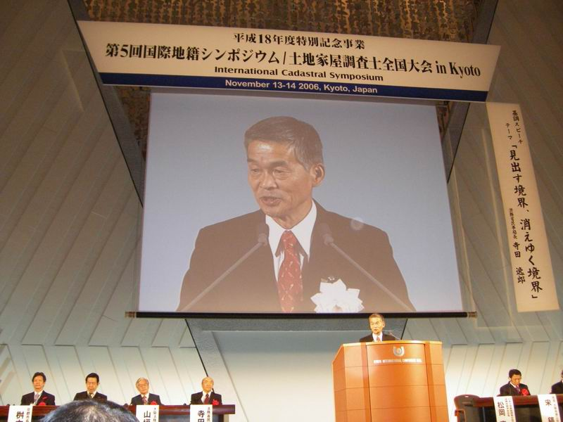
開幕式─日本土地家屋調查士會連合會松岡會長直武致詞
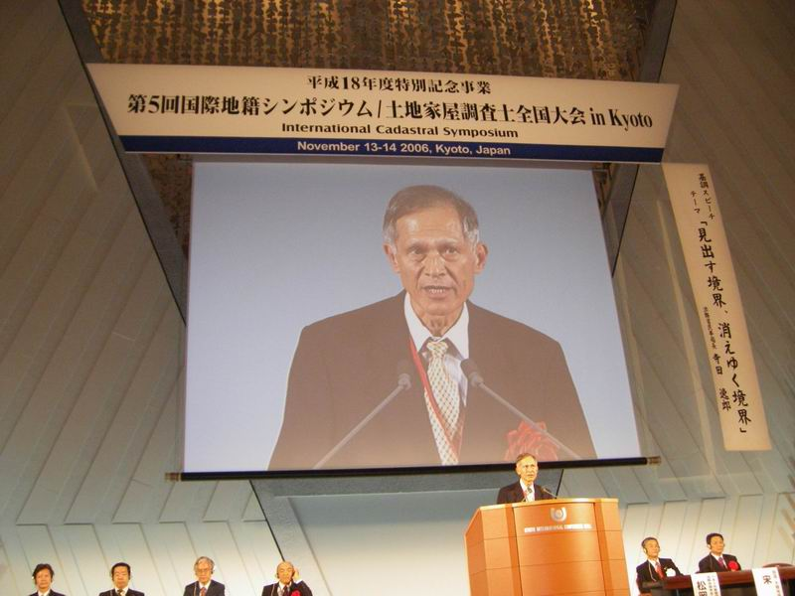
開幕式─中華民國地籍測量學會曾理事長德福致詞
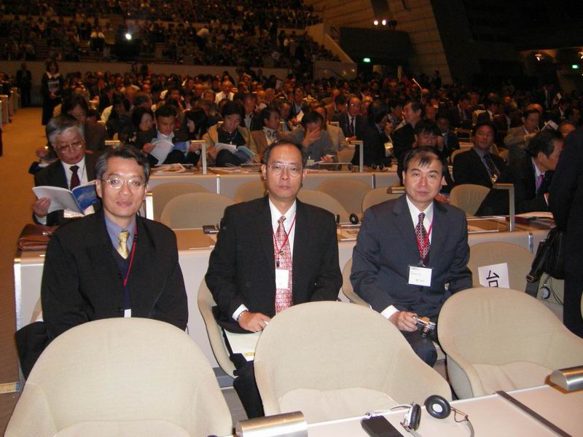
第1分組專題研討
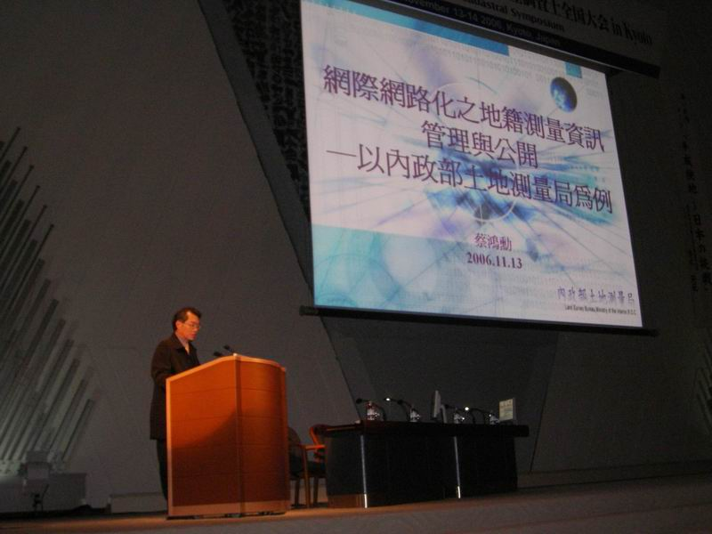
第1分組論文發表─本局蔡課長鴻勳發表論文
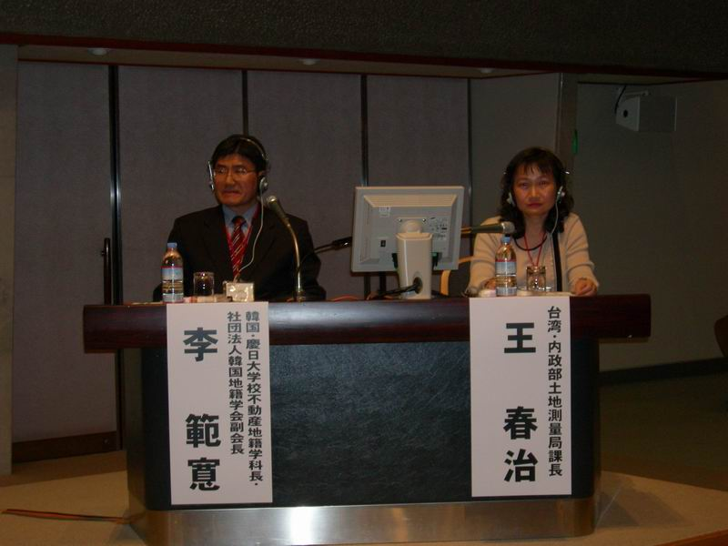
第2分組專題研討
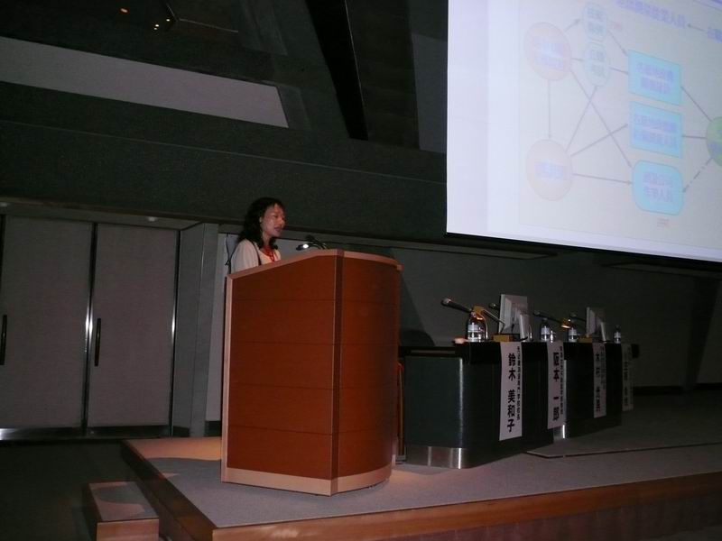
第2分組論文發表─本局王課長春治發表論文
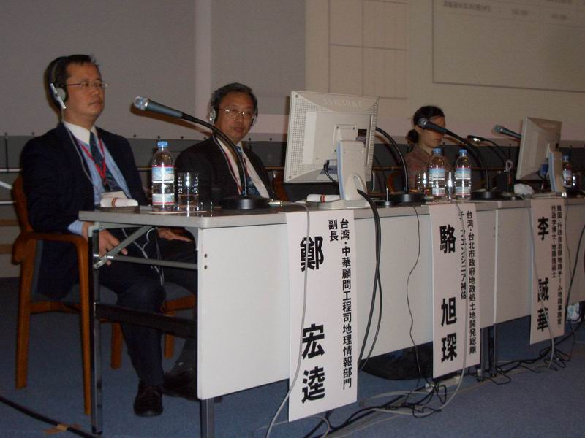
第3分組專題研討
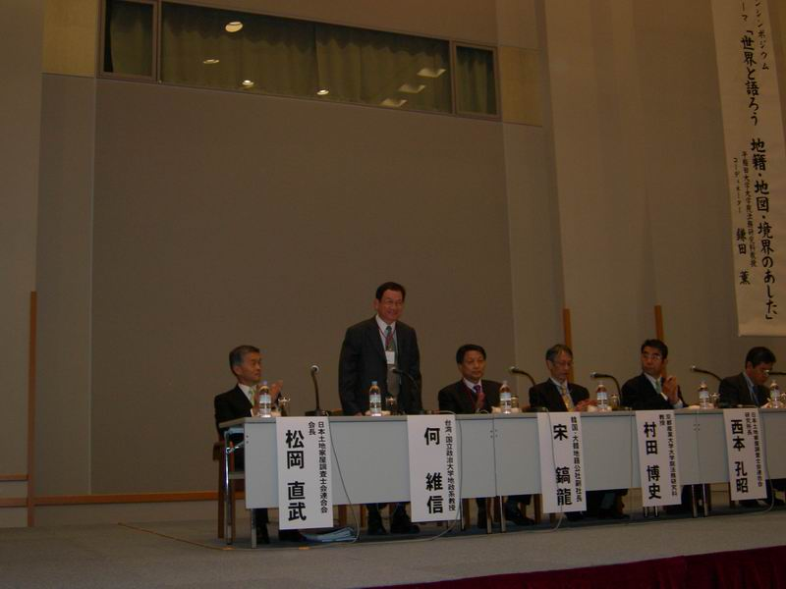
綜合討論─何教授維信協同主持
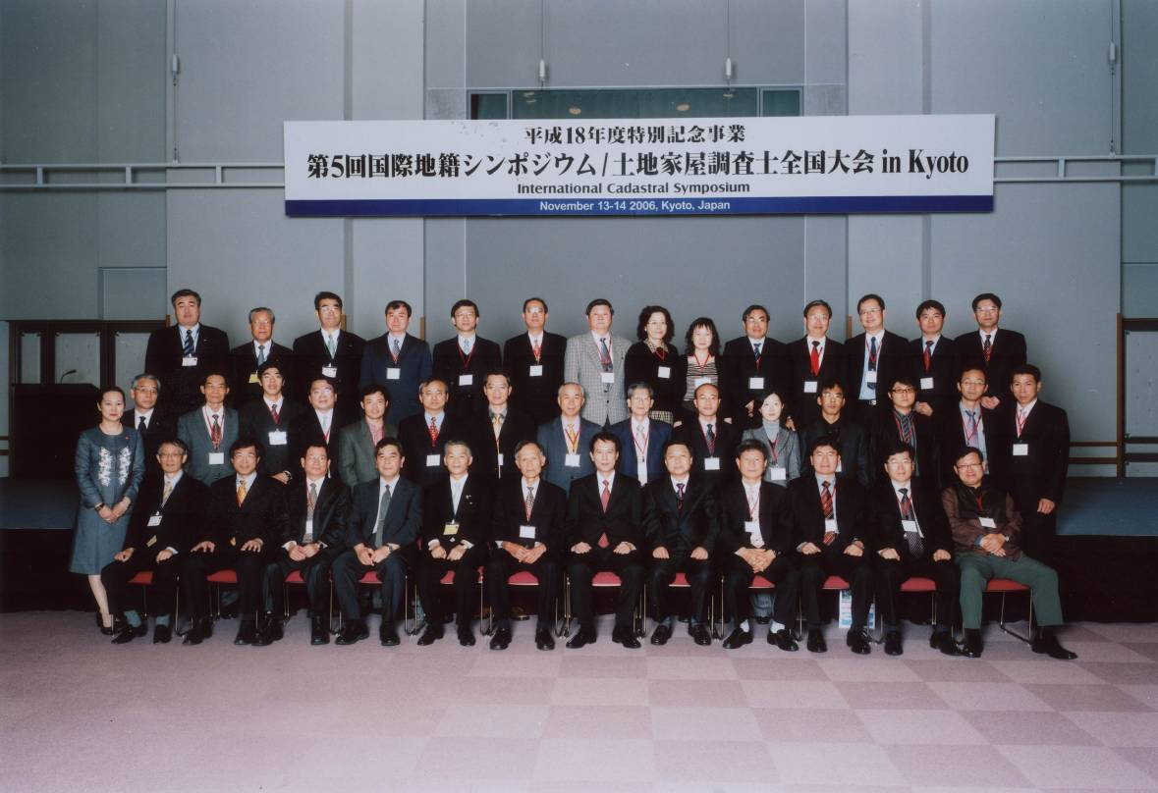
閉幕式─中日韓三國代表合影
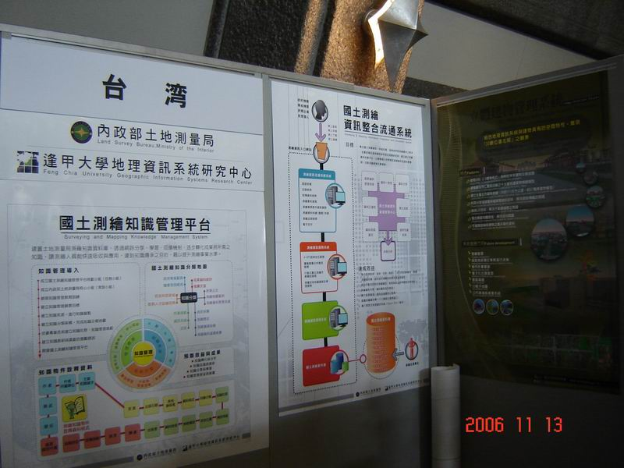
我國展示─相關單位組織及業務簡介
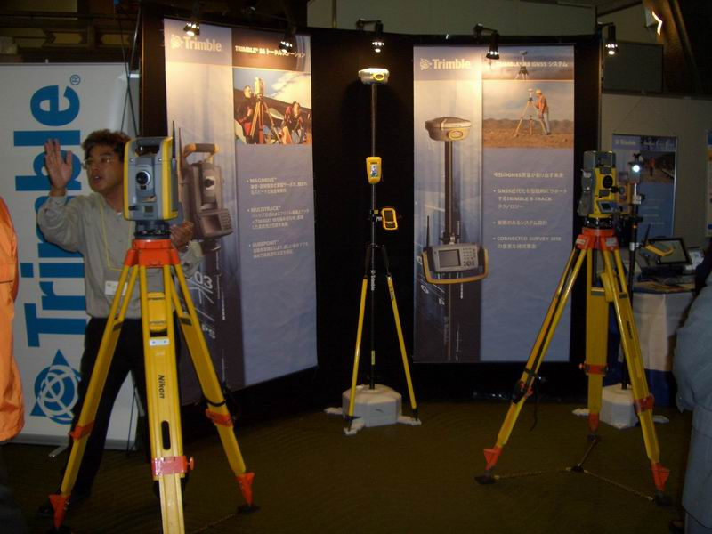
日本展示─NIKON-TRIMBLE 公司展示單人測量放樣系統
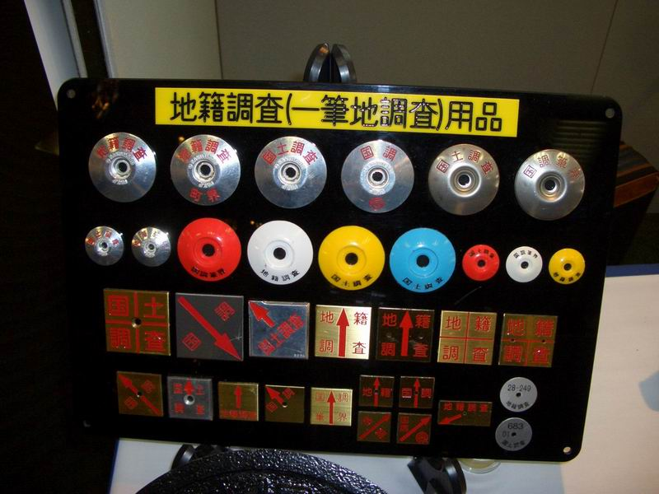
日本展示─KAKUMARU公司展示地籍調查用品
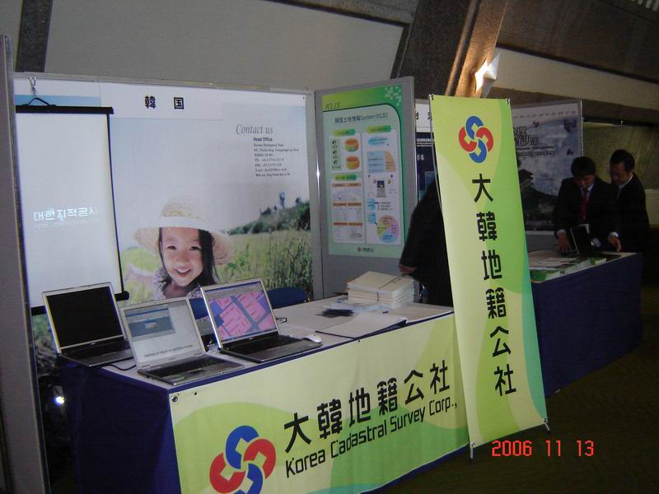
韓國展示─大韓地籍公社業務簡介
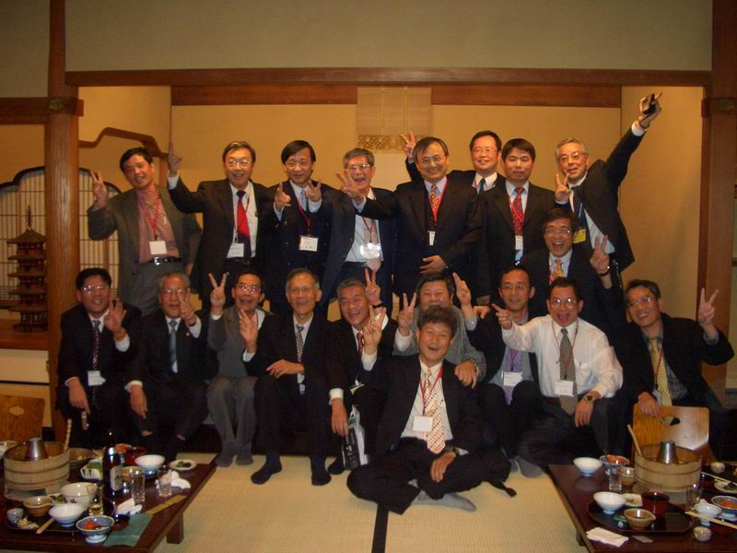
歡送晚會─中日韓三國代表熱烈交流
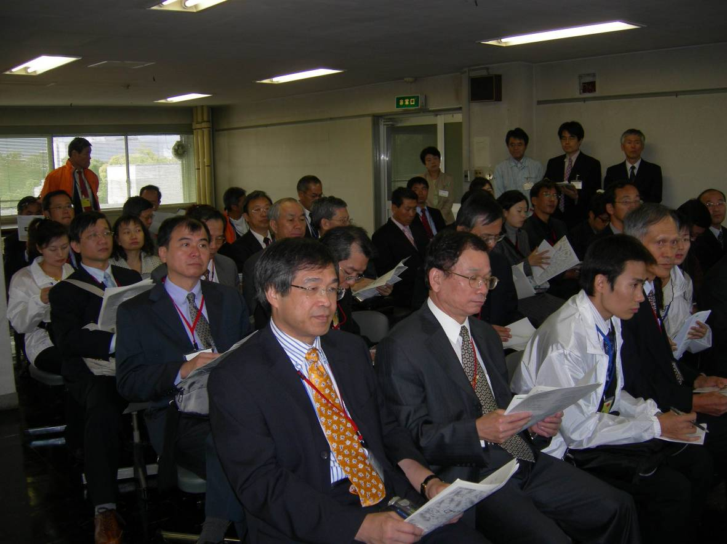
參訪京都府立總合資料館─聽取館藏業務簡報
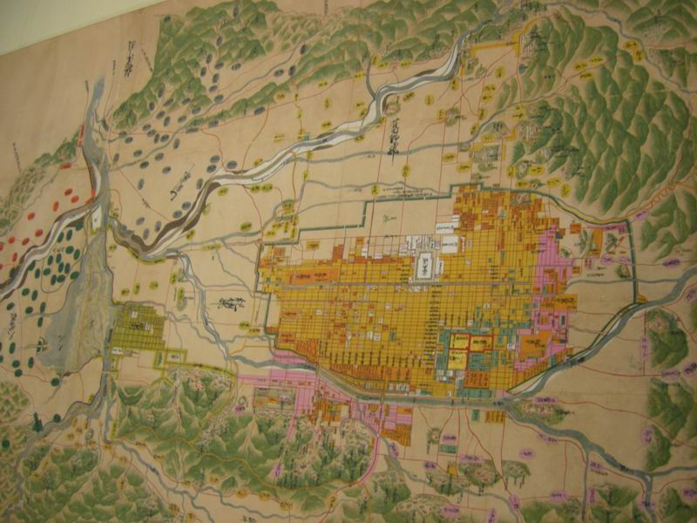
京都府立總合資料館館藏山城國水系圖
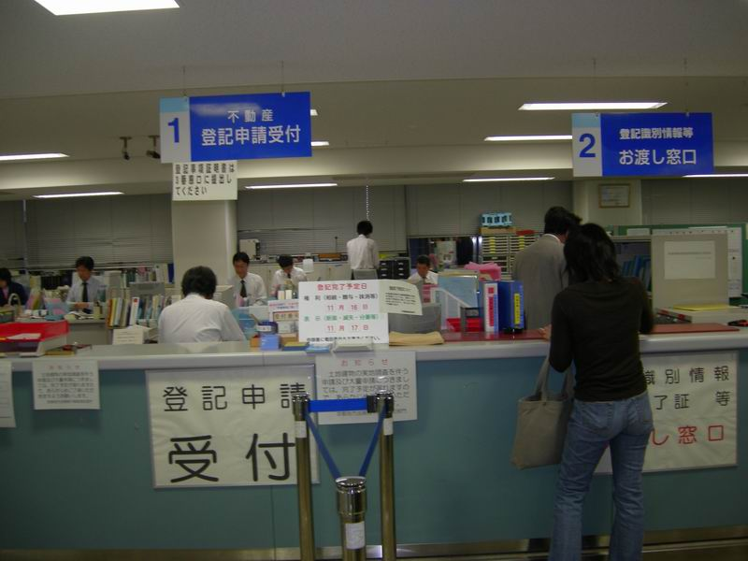
參訪京都地方法務局─登記業務處理情形
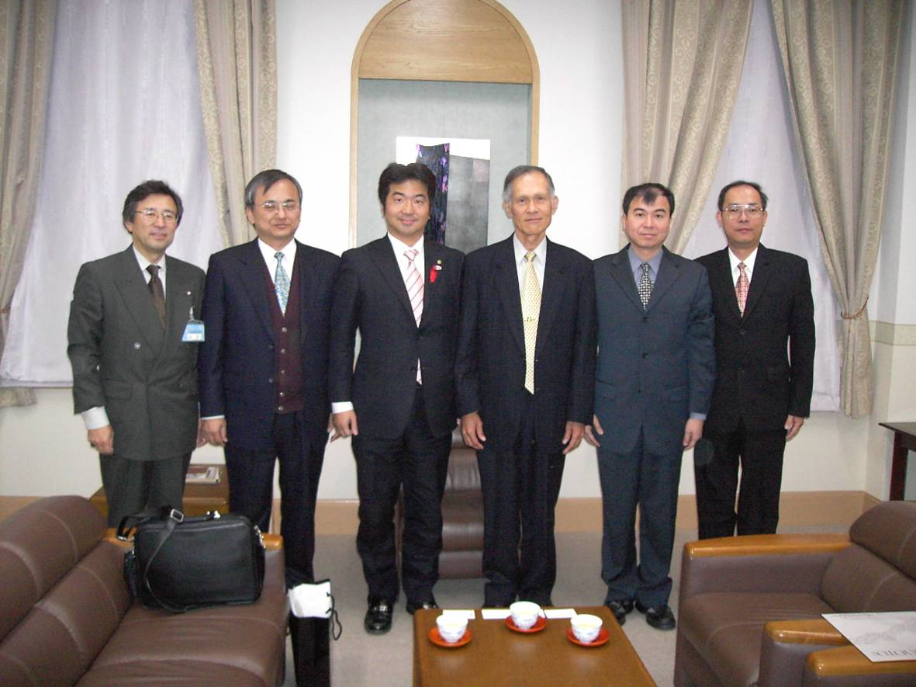
參訪京都市政府─觀摩國際化都市推動情形
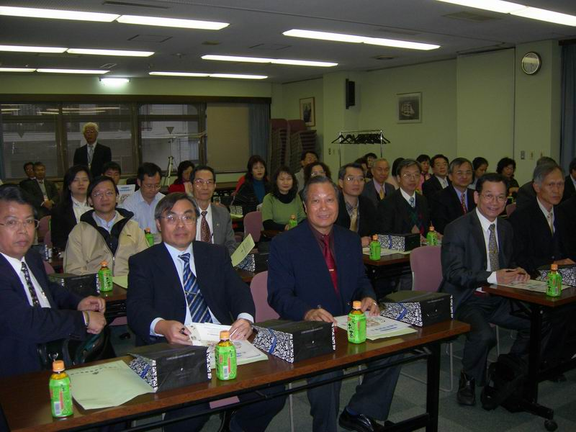
參訪大阪土地家屋調查士會─聽取調查士業務運作情形簡報
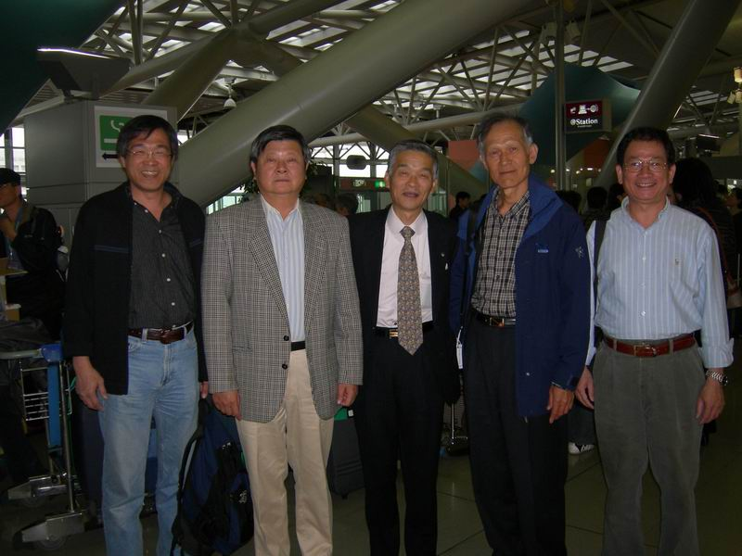
日本土地家屋調查士會連合會松岡會長直武至機場送機

