出國報告（出國類別：實習）

345/161千伏電力電纜
特性試驗及終端匣處理技術

服務機關：台灣電力公司營建處
姓名職稱：黃郁斌 變電設計員
派赴國家：德國
出國期間：95年08月21日至09日03日
報告日期：95年11月17日

摘要

核能發電廠及火力發電廠多位處海邊，濕氣大、鹽分重，屋外架空線容易受環境影響，故障率高且對景觀衝擊大。為防濕氣、鹽分腐蝕，及考量價格因素，345/161仟伏電壓系統多採用電力電纜為電力輸送之重心，負責主變壓器區與開關場間電力傳輸。為確保電纜設計製造品質，須對電力電纜實施各項試驗。而終端匣施作處理為電纜現場安裝品質關鍵之一。本次報告簡述345仟伏電力電纜特性試驗，包含了定型試驗、365天循環老化試驗、例行試驗、取樣試驗、現場交流耐壓試驗。此外亦概述所參觀廠家電纜終端匣處理技術。建議345仟伏電纜完工後現場試驗採交流耐壓試驗方式執行。

目次

一、 目的 ………… 3
二、 過程 ………… 4
三、 心得 ………… 5
1. 定型試驗 ………… 5
2. 365天循環老化試驗 ………… 9
3. 例行試驗 ………… 10
4. 取樣試驗 ………… 11
5. 現場交流耐壓試驗 ………… 13
6. 電纜終端匣安裝 ………… 14
四、 建議事項 ………… 19

一、 目的
核能發電廠及火力發電廠多位處海邊，濕氣大、鹽分重，屋外架空線容易受環境影響，故障率高且對景觀衝擊大。為防濕氣、鹽分腐蝕，及考量價格因素，345/161仟伏電壓系統多採用電力電纜為電力輸送之重心，負責主變壓器區與開關場間電力傳輸。此外，系統輸電線路對345/161kV XLPE電力電纜之應用亦日益增加。
為確保電纜設計製造品質，須對電力電纜實施各項試驗。而終端匣施作處理為電纜現場安裝品質關鍵之一。為對345/161仟伏電力電纜特性試驗及終端匣處理技術有更進一步之了解，故前往德國Suedkabel GmbH公司、獨立實驗室（IPH、FGH、IEH）及Bewag公司變電所實習相關知識技術及蒐集相關資料；藉由此次實習提升個人專業素養，進而對公司345/161仟伏電力電纜系統規劃及品管要求有所助益。

二、 過程

起始日 | 迄止日 | 前往機構名稱 | 城市名稱 | 工作內容
950821 | 950822 |  |  | 往程(台北-法蘭克福-柏林)
950823 | 950826 | Suedkabel、IPH、Bewag | 柏林 | 電力電纜試驗及實績參觀
950827 | 950827 |  |  | 行程(柏林-曼海姆)
950828 | 950901 | Suedkabel、FGH、IEH | 曼海姆（曼汗） | 電力電纜廠實習(製造、試驗)
950902 | 950903 |  |  | 回程(曼海姆-法蘭克福-台北)

三、 心得
1. 定型試驗：
Non-Electrical Type Test：

No. | Non-Electrical Type Test | Standard | Acceptance Criteria
01 | check of cable construction | IEC 62067  item 12.5.1 | *)
02 | water penetration test | IEC 62067  Annex C) | **)
03 | Test of mechanical properties of insulation before and after ageing | IEC 62067  item 12.5.2 | ***)
04 | Test of mechanical properties of oversheath before and after ageing | IEC 62067  item 12.5.3 | ****)
05 | Ageing test on piece of completed cable | IEC 62067  item 12.5.4 | ***), ****)
06 | Pressure test at high temperature on sheath | IEC 62067  item 12.5.6 | indentation < 50%
07 | Hot set test for XLPE insulation | IEC 62067  item 12.5.10 | elongation under load < 175%  permanent elongation after cooling < 15%
08 | Carbon black content of the PE sheath | IEC 62067  item 12.5.12 | 2.5±0.5 %
09 | Shrinkage test for XLPE insulation |  | < 4 %
10 | Test under fire conditions | IEC 62067  item 12.5.13 | *****)

* ) -
Deviation: Tmax/ Tmin , max. | 2
Thickness of insulation,  nominal/minimum value | 25 mm / 22.5 mm
Deviation: (Tmax – Tmin)/Tmax, max. | 0.1

**) - During the period of testing no water shall emerge from the ends of the test piece.

***) -
Without ageing (IEC 60811-1-1, sub-clause 9.1)
Minimum tensile strength | 12.5 N/mm2
Minimum elongation at break | 200 %

Variation after ageing treatment in air oven (IEC 60811-1-2, sub-clause 8.1)
Maximum variation in tensile strength | ±25 %
Maximum variation in elongation at break | ±25 %

****) -
Tests | Requirements ST 7
Without ageing (IEC 60811-1-1, sub-clause 9.1)
Minimum tensile strength | 12.5 N/mm2
Minimum elongation at break | 300 %
After ageing treatment in air oven (IEC 60811-1-2, sub-clause 8.1)
Minimum value of elongation at break | 300 %

*****) -
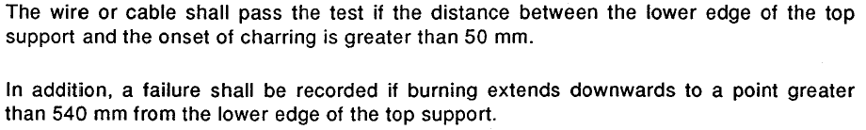
Electrical Type Test：
No. | Electrical Type Tes | Standard | Acceptance Criteria
01 | check on insulation thickness of cable | IEC 62067  item 12.4.1 | 25 mm ± 5%
02 | bending test | IEC 62067  item 12.4.2 a) | see item 04
03 | installation of cable system | IEC 62067  item 12.4.2 a) | -
04 | partial discharge test at ambient temperature  test voltage: 285 kV (1.5⋅U0) | IEC 62067  item 12.4.2 a) | < 5 pC
05 | tan delta measurement  TLeiter= 95-100°C, test voltage: 190 kV | IEC 62067  item 12.4.2 b) | < 10 x 10-4
06 | heating cycle voltage test  20 heating cycles 8/16h, Tconductor= 95-100°C,  test voltage: 380 kV (2.0⋅U0) | IEC 62067  item 12.4.2 c) | No breakdown or flashover
07 | partial discharge test at ambient temperature  test voltage: 285 kV (1.5⋅U0) | IEC 62067  item 12.4.2 d) | < 5 pC
No. | Electrical Type Tes | Standard | Acceptance Criteria
08 | partial discharge test at high temperature  test voltage: 285 kV (1.5⋅U0)  Tconductor= 95-100°C | IEC 62067  item 12.4.2 d) | < 5 pC
09 | switching impulse voltage test  10 impulses of each polarity  Tconductor= 95-100°C, test voltage: Û = 950 kV | IEC 62067  item 12.4.2 e) | no breakdown or flashover
10 | lightning impulse voltage test  10 impulses of each polarity  Tconductor= 95-100°C, test voltage: Û = 1425 kV | IEC 62067  item 12.4.2 f) / TPC Spec. | no breakdown or flashover
11 | a.c. voltage test  duration: 15 minutes,  Tconductor= ambient-100°C;  test voltage: 380 kV (2.0⋅U0) | IEC 62067  item 12.4.2 f) | no breakdown or flashover
12 | examination of cable and GIS sealing ends  type EHSVS 362 type F | IEC 62067  item 12.4.2 i) | no signs of deterioration
13 | Measurement of electrical resistivity of semi-conducting screens | IEC 62067  item 12.4.11 | Conductor screen 1000 Ohm.m Insulation screen  500 Ohm.m

2. 365天循環老化試驗：

No. | Aging Test | Standard | Acceptance Criteria
01 | check on insulation thickness of cable | IEC 62067  item 13.2.1 | 25 mm ± 5%
02 | installation of cable system | IEC 62067  item 13.2.2 | -
03 | heating cycle voltage test  180 heating cycles 8/16h, Tconductor= 90-95°C,  test voltage: 320 kV (1.7⋅U0) for 8760 hours | IEC 62067  item 13.2.3 | No breakdown or flashover
04 | lightning impulse voltage test on cable samples  10 impulses of each polarity  Tconductor= 90-95°C,  test voltage: Û = 1425 kV | IEC 62067  item 13.2.4  TPC Spec. | No breakdown or flashover
05 | examination of cable and GIS sealing ends | IEC 62067  item 13.2.5 | no signs of deterioration

3. 例行試驗：

No. | Routine Test | Test parameters | Applicable standard
01 | Partial discharge test | 330 kV,10 s  285 kV, ≤ 5 pC, (20±15)°C | IEC 60885-3,  IEC 62067, item 9.2
02 | AC voltage test | 420 kV, 60 min, (20±15)°C | IEC 62067, item 9.3
03 | DC test on oversheath | 20 kV, 1 min, (20±15)°C | IEC 60229  IEC 62067, item 9.4

4. 取樣試驗：

No. | Sample test: | Test parameters | Applicable standard
2.1 | Conductor examination
2.1.1 | Conductor diameter,  type, number of wires,  wire diameter of central part segments | 51.5 mm 6 segmental  375  2.18 mm 2.5mm | IEC 60228  IEC 62067, item 10.4
2.1.2 | Conductor resistance |  | IEC 60228  IEC 62067, item 10.5
2.2 | Thickness of insulation  shielding and bedding layers,
2.2.1 | Nominal value of insulation thickness |  | IEC 60811-1-1  IEC 62067, item10.6
2.2.2 | Minimum value of insulation thickness |  | IEC 60811-1-1  IEC 62067, item10.6
2.2.3 | Deviation:  (Tmax – Tmin) / Tmax | ≤ 0.1 | IEC 60811-1-1  IEC 62067, item10.6
2.2.4 | Minimum value of shielding layer thickness |  | IEC 60811-1-1  IEC 62067, item10.6
2.2.5 | Deviation Tmax /Tmin | ≤ 2 | IEC 60811-1-1  IEC 62067, item10.6
2.3 | Thickness of oversheath
2.3.1 | Nominal value - tn |  | IEC 60811-1-1  IEC 62067, item10.6
2.3.2 | Minimum value:  tmin = tn – (0.1 + 0.15 × tn) |  | IEC 60811-1-1  IEC 62067, item10.6
2.4 | Diameter measurement diameters conductor,  diameter insulation,  diameter cable |  | IEC 60811-1-1  IEC 62067, item10.8
2.5 | Measurement of metallic screen
2.6 | Hot set test for XLPE insulation
 | Max. elongation under load  Max. permanent elongation after cooling | 175 %  15 % | IEC 60811-2-1  IEC 62067, item10.9
2.7 | Measurement of capacitance |  | IEC 62067, item10.10
2.8 | Lightning impulse voltage test followed by power frequency voltage test | 1425 kV at 95°C  380 kV, 15 min. (app.50°C during cooling) | IEC 62067, item10.12  IEC 60230

5. 現場交流耐壓試驗：

因為電力電纜具有很大的等效電容，對於交流耐壓試驗而言需要很大的虛功率損耗，也就意味需要大額定功率的試驗設備；受制於製造技術，很難在工地現場對電纜做交流耐壓試驗。在這種情形下直流耐壓試驗或長時間系統電壓直接加壓是發現電纜絕緣缺陷的有效方法，所以以往電廠345kV XLPE電力電纜現場耐壓試驗常規定採直流試驗，或以系統電壓加壓24小時為之。
然而因為直流耐壓試驗會造成保存在電纜絕緣層中殘留電荷，當完成試驗再加入系統時殘留的電荷（電場）會與系統電場叠加可能傷害電纜。而且直流耐壓試驗會在XLPE絕緣層產生累積效應，將加速絕緣老化，縮短使用壽命。此外，直流耐壓試驗與交流耐壓試驗電壓場强特性不同，且因XLPE電纜絕緣的特殊性，較不能模擬真實運轉狀態下電纜承受的過電壓，即使XLPE電纜有缺陷亦能通過直流耐壓試驗。所以直流耐壓試驗較無法有效地發現XLPE電纜施工（包含終端匣及接續匣施作）缺失，其加壓效果不如交流耐壓試驗，且相較交流耐壓試驗亦有較亦傷害電纜之風險。
對此，IEC 62067標準也在其Introduction一節中提到：「In addition, CIGRE WG 21.09, given the task to study tests after installation on high-voltage extruded insulation cable systems, published its recommendations in Electra No 173 in August 1997. In the preparation of this International Standard, account has also been taken of these recommendations which state, among others, that d.c. tests should be avoided on the main insulation, as they are both ineffective and dangerous.」此外IEC 62067標準也明訂電纜安裝後絕緣層實施交流耐壓試驗，其規定為「The a.c. test voltage to be applied shall be subject to agreement between the purchaser and the contractor. The waveform shall be substantially sinusoidal and the frequency shall be between 20 Hz and 300 Hz. The voltage shall be applied for 1 h, either with a voltage according to table 10 or with 1,7 U0, depending on practical operational conditions. Alternatively, a voltage of U0 may be applied for 24 h.」其中對345kV級電力電纜所建議試驗電壓為U0採190kV，或採相對地(phase-to-ground)電壓250kV r.m.s.，不過就如期規定所言仍須經甲、乙雙方同意而為之。

6. 電纜終端匣安裝：

6.1. 電纜終端匣構造
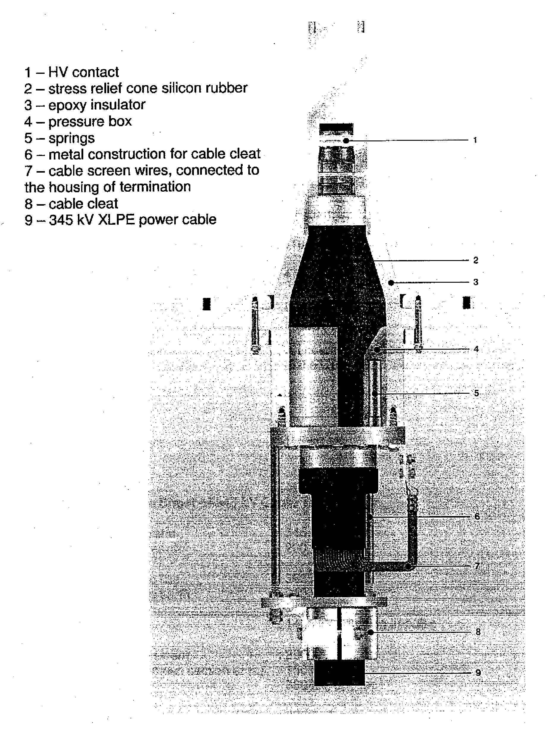

6.2 電纜終端匣安裝注意事項
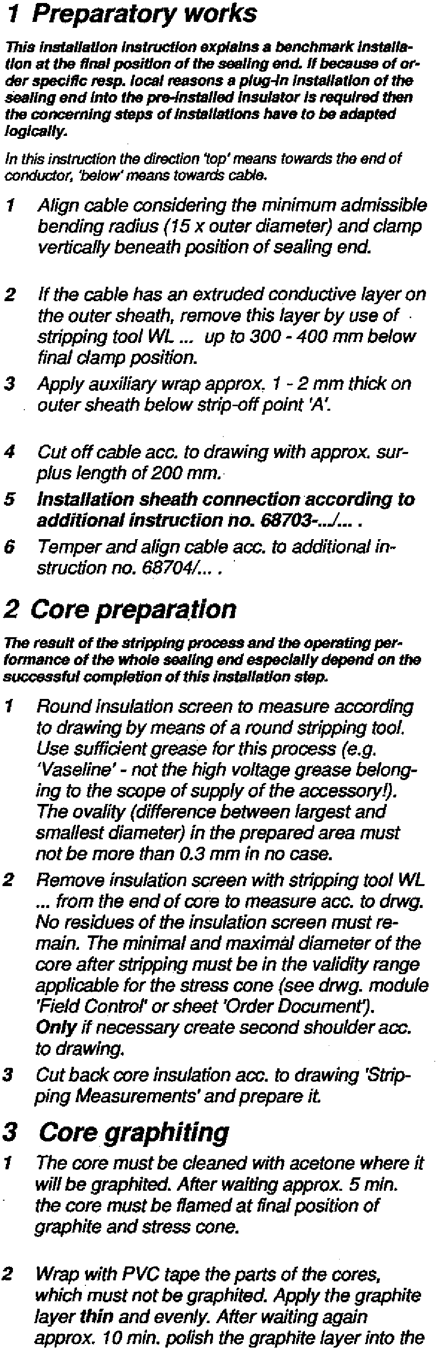

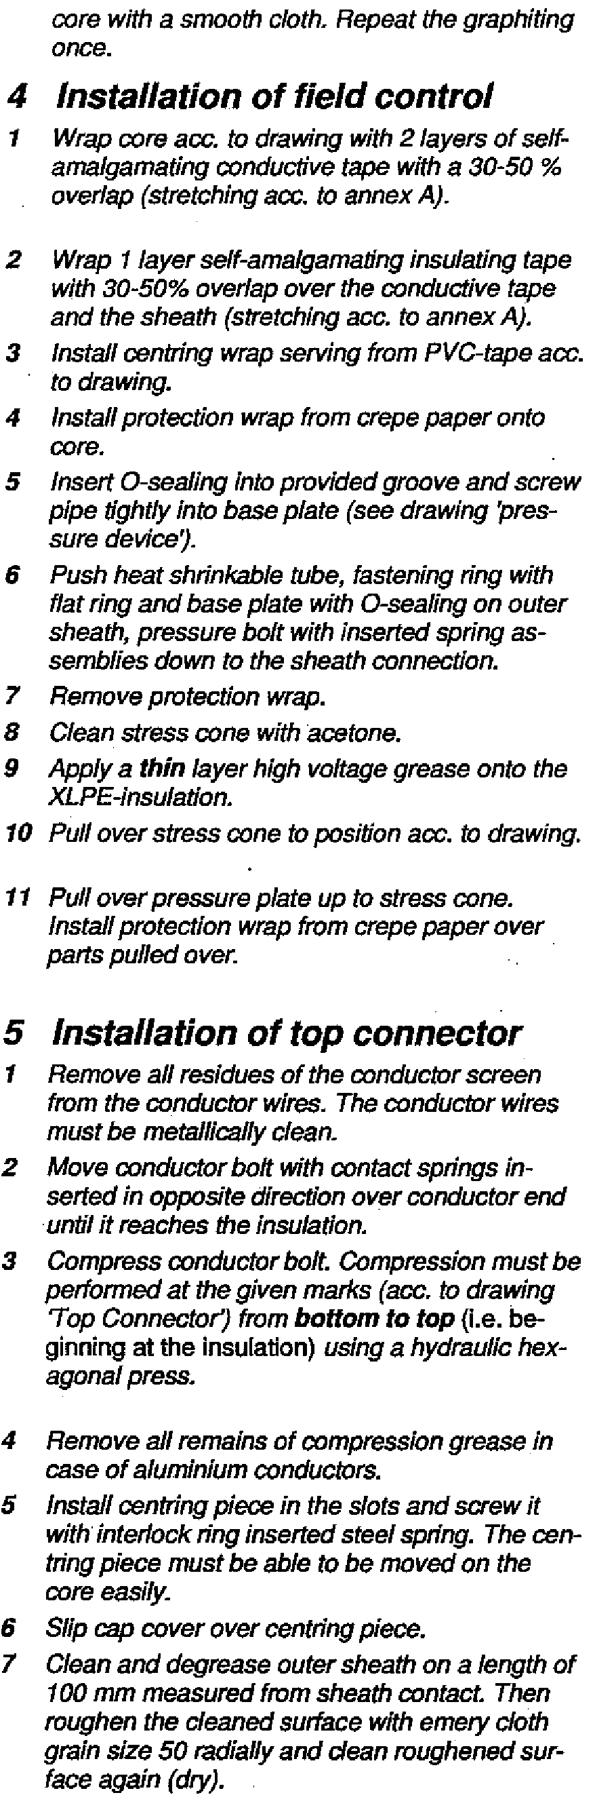
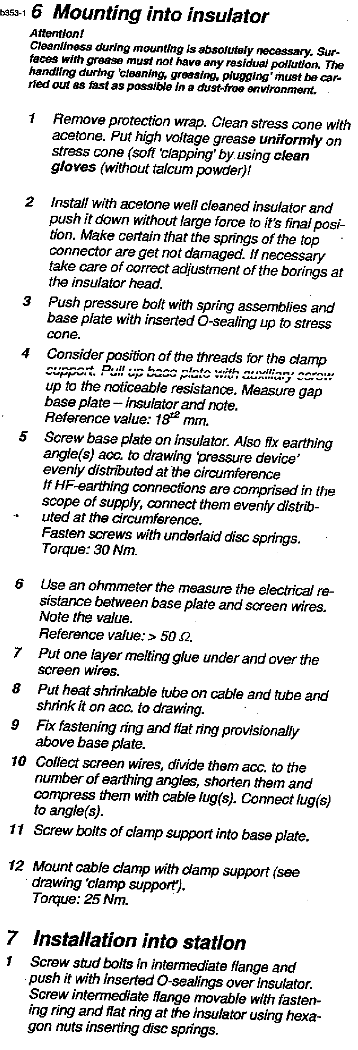
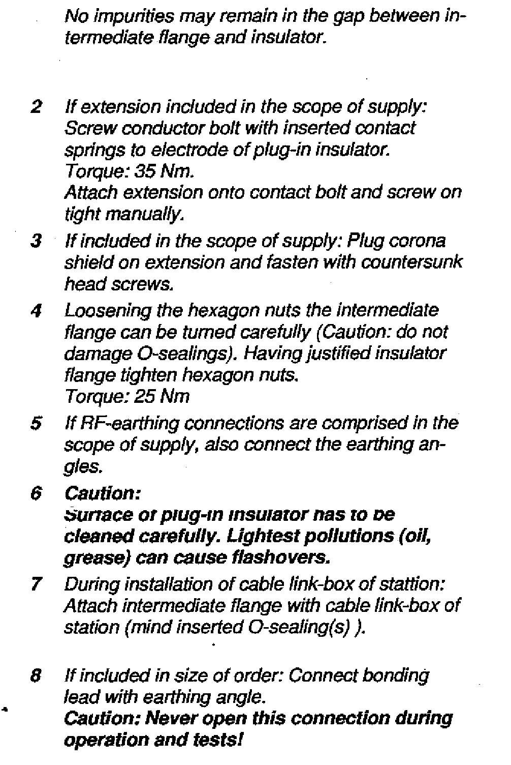

四、 建議事項
以往電廠345kV XLPE電力電纜現場耐壓試驗常規定採直流試驗，或以系統電壓加壓24小時為之。參考IEC 62067規定及國外試驗經驗，並配合綜合研究所引進試驗設備，建議爾後（如：大潭燃氣火力發電計畫345kV XLPE電力電纜現場耐壓試驗）改採交流耐壓試驗。

