Thursday, 10 August 2006
Co-Creator of First Apple Mouse Watched Me Ride in a Giant Tea Cup With a Clone Baby At San Jose City Hall
Topic: Quickies
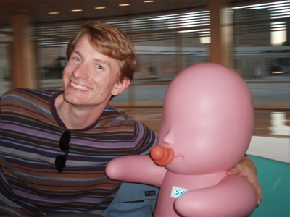

Edit: As one of my much-more-observant-than-I commenters noted, each clone baby runs off a Mac mini -- I just knew this had to be about Apple!
Original: And I mean every word in the subject line. And it's sort of Apple-related, even.
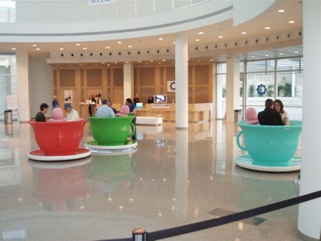
I was down at San Jose City Hall for the ZeroOne festival to hear David Kelley, founder of venerable product development house IDEO, speak about his current take on design thinking. IDEO designed the original Apple mouse, and Kelley told a hypothetical story of showing a new design to Steve Jobs ("Late as usual," Kelley noted) with a dramatic flourish and the removal of a black velvet sheet. His talk was good. Thus ends the Apple content of this post.
Now.
As I left the auditorium, I wandered over to the rotunda (which, for those who have never been to San Jose, is really more of a Tomorrowland space observatory) of the city hall where I spied not one, not two but SIX giant tea cups drifting across the floor at high speed, stopping and whirling whenever they bumped into each other.
It was all very much in keeping with the Disney feel of downtown San Jose, except for the 70 cm-tall "clone babies" who inhabited each tea cup. A strange digital read-out on their chests corresponded to another exhibit, "The Locker Baby Project," a helpful attendant noted. This, then, was BABYLOVE. I highly recommend you go to the site to read more and use the simulator to play with the tea cup. If you're interested in going, it's free and in San Jose through Sunday.
As we coasted through this seat of local government, my girlfriend and I found ourselves perpetually looped in high-speed circles -- we never did get a good handle on the controls. But in the distance -- we spotted him -- David Kelley.
This must be the place, I thought.

資料來源：http://blog.wired.com/cultofmac/index.blog?entry_id=1537383

