出國報告（出國類別：國際學術研討會）

出席2005年第六屆固體破裂與強度國際學術研討會報告

服務機關：國立屏東科技大學
姓名職稱：胡惠文 助理教授
派赴國家：印尼
出國期間：2005年4月3日至4月6日
報告日期：2005年4月18日

摘 要
由遠東與大洋洲破裂學會(Far-East and Oceanic Fracture Society, FEOFS)主辦之2005年第6屆固體破裂與強度學術研討會(The 6th International Conference on Fracture and Strength of Solids)在印尼的巴里島(Bali)舉行三天。發表之論文有254篇，研究之材料涵蓋複合材料(Composites)、金屬材料(Metallic)、智慧型材料(Smart Materials & Structures)、奈米材料(Nano-Material & Structures)、電子封裝材料(Electrical Packaging)、高分子材料(Polymers)、薄膜(Thin Films)、微機電材料(MEMS)、生醫材料(Bio-materials)、岩石與土壤(Rock & Soil)等之破壞與強度之研究；探討領域包括：介面失效(Interface Failure)、破裂力學(Fracture Mechanics)、潛變(Creep)、疲勞(Fatigue)、衝擊(Impact)、環境腐蝕(Environmental Degradation)；研究方法包括：分析模型(Modeling)、數值方法(Computing Method)、實驗方法(Experiments)、破壞容限與控制(Damage Tolerance & Control)等。本文就筆者參與該研討會過程以及發表之論文作簡短之心得摘要與建議。

目 次
一、目的 4
二、與會過程 4
三、與會心得 7
四、建議 8
五、攜回資料名稱及內容 8
六、附錄一 ：發表論文 (Damage Detection of Surface Crack in Composite Quasi-isotropic Laminate Using Modal Analysis and Strain Energy Method) 9
附錄二 ：研討會邀請函 16

一、目的
本次出國出席參加2005年第6屆固體破裂與強度學術研討會(The 6th International Conference on Fracture and Strength of Solids)主要目的是發表學術研究論文，題目為：應用模態分析與應變能法於複合材料準等項性疊層板之表面裂縫破壞偵測(Damage Detection of Surface Crack in Composite Quasi-isotropic Laminate Using Modal Analysis and Strain Energy Method)，藉由出席會議與國際相關研究領域人士學術交流，並學習材料破裂與強度分析領域之新知與發展動態，做為未來國內學術研究發展之參考。

二、與會過程
本屆固體破裂與強度學術研討會(The 6th International Conference on Fracture and Strength of Solids)在印尼的巴里島The Patra Bali舉行三天(4月4-6日)，與會專家學者有來自台灣、日本、澳洲、韓國、新加坡、馬來西亞、印尼、羅馬尼亞以及中國等地，大會除了安排之專題演講(Keynote Speeches)之外，三天分別同時進行5個場次的論文發表以及討論，研究之材料涵蓋：複合材料(Composites)、金屬材料(Metallic)、智慧型材料與結構(Smart Materials & Structures)、奈米材料與結構(Nano-Material & Structures)、電子封裝材料(Electrical Packaging)、高分子材料(Polymers)、薄膜(Thin Films)、微機電材料(MEMS)、生醫材料(Bio-materials)、岩石與土壤(Rock & Soil)等之破壞與強度之研究。探討領域包括：介面失效(Interface Failure)、破裂力學(Fracture Mechanics)、潛變破壞(Creep Rupture)、疲勞破壞與裂縫傳遞(Fatigue & Crack Propagation)、衝擊破壞(Impact)、環境腐蝕破壞與耐久(Environmental Degradation & Durability)。研究方法包括：理論分析模型(Modeling)、數值方法(Computational Method)、實驗方法(Experimental Approaches)、破壞容限與破裂控制(Damage Tolerance & Fracture Control)等。應用之範圍包括：航太工程(例如飛機結構與螺槳結構)、車輛工程(例如車體結構、引擎與焊接)、生醫工程(例如骨骼、關節與心臟)、土木工程(例如橋樑、管路與地震)、電子封裝(例如熱效應)、材料科學(例如奈米結構對材料強度的影響以及高分子鏈的模擬分析)。
本次會議發表之論文達254篇分三天每天五個會場分別進行，每一會場約有6-8篇論文發表，每一篇論文報告含討論時間有20分鐘。筆者發表之論文安排在研討會議第一天下午，論文題目為應用模態分析與應變能法於複合材料準等項性疊層板之表面裂縫破壞偵測(Damage Detection of Surface Crack in Composite Quasi-isotropic Laminate Using Modal Analysis and Strain Energy Method)，內容主要探討複合材料準等項性疊層板之表面裂縫破壞偵測。研究方法是利用複合材料疊層板破壞前後造成之模態振型差異，計算疊層板之應變能值，由破壞前後應變能比值定義出破壞指標並用來偵測疊層板之破壞位置。研究結果顯示不論實驗或電腦分析都可以成功地預測複合材料疊層板破壞的位置。與會專家學者有來自台灣、日本、韓國、新加坡、印尼以及中國等國，討論頗為熱烈並集中在表面裂縫電腦模擬方法之問題，圖一所示為表面裂縫之電腦模型，與會學者質疑為何不採用傳統橢圓模型，筆者回答結構整體動態行為(Global Dynamic Behavior)中裂縫的模型不必太過精細就可以忠實反映出其特性，經筆者解釋後與會學者多表認同。
除了發表自己的研究論文之外，筆者參與之研討會場次多集中與複合材料以及航太、車輛工程相關之研究論文。圖二、三分別為筆者於研討會場外以及發表論文過程。

圖一、複合材料疊層板表面裂縫模型
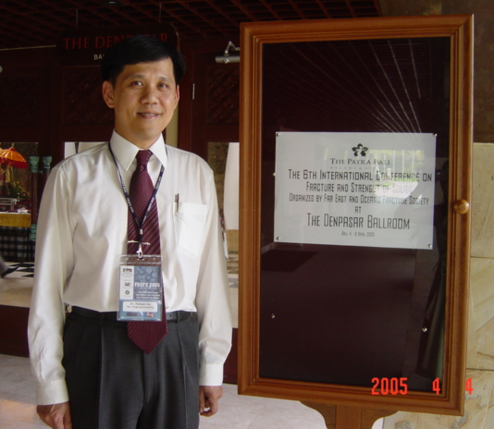
圖一、筆者於研討會場外

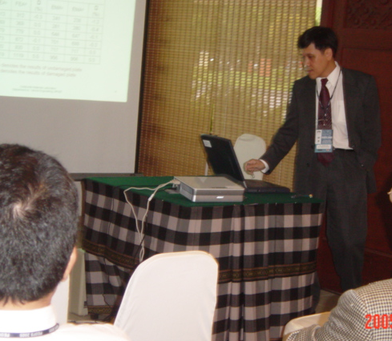
圖二、筆者發表論文過程

三、與會心得
本研討會由遠東與大洋洲破裂學會主辦，參與之專家學者主要來自遠東與大洋洲地區之國家包括台灣、日本、澳洲、韓國、新加坡、馬來西亞、印尼、羅馬尼亞以及中國，因此參與此研討會除了可以與這些地區的專家學者就固體材料的破裂行為與強度研究進行學術交流之外，亦可了解各國的學術興趣以及產業發展。以韓國為例，來自韓國的學者專家相當多，發表之論文多集中在與汽車以及半導體產業相關之領域，顯示韓國在這方面的研究投入相當多的人力與資源。中國學者的投稿數量也不少，並積極爭取主辦權，2006年第七屆FEOFS研討會已決定在中國新疆的烏魯木齊舉辦，相較之下本次研討會議發表之254篇論文中台灣僅佔13篇，數量稍嫌不足也不夠積極爭取主辦權，並且反映出台灣在固體材料的破裂行為與強度的基礎研究越來越少。這幾年由於政府的經費支持，國內學界一窩峰投入微機電以及奈米科技的研究，反而忽略了長久以來基礎產業所需的研究，例如航太、機械、土木等工程，而固體材料的破裂行為與強度正是發展以上基礎產業的重要研究。筆者認為政府除了應投注更多資源並鼓勵本國學者專家多參與國際學術研討會之外，研究主題和領域也應該多方面涉略，不應該集中某些特定主題(例如奈米科技)，反而應該鼓勵學者專家多參與產業實際問題的研究。
承辦本屆研討會的單位是印尼的Institute of Technology Bandung (ITB)。三天的研討會，都在巴里島的The Patra Bali進行，會場的佈置與設備堪稱完備，出席發表論文的專家學者均能掌控得宜，許多資深教授也都親自出席發表論文，參與討論的情形也相當熱烈，有充分討論與雙向溝通的機會，以致於有些場次的時間超過預定。晚宴部分限於經費筆者並未參加。然而ITB在事前的聯繫與論文的通知工作效率相當差，研討會的網站時常故障，與會學者專家根本無法得知研討會的籌備進度如何，研討會當天的論文發表節目表到最後一刻才出爐，筆者的論文前後共寄了四次主辦單位才收到。巴里島衛生、交通與空氣品質都不佳，另外印尼海關的索賄小動作亦令人印象惡劣，這些都是本次參與FEOFS研討會美中不足的地方。

四、建議
根據以上與會過程以及心得，筆者整理以下三點建議：
- 政府應投注更多經費改善大學的教學研究環境，訂定合理合時宜的評鑑方法與制度，但不宜過度影響或主導研究主題，並鼓勵國內學者積極投入與產業相關問題之研究。
- 補助與鼓勵國內學者積極參與國際學術研討會，並積極爭取學術研討會的主辦權，以提升台灣的學術地位。
- 此研討會每篇論文發表時間有20分鐘，同時進行5場次。出席發表論文的專家學者均能掌控得宜，許多資深教授也都親自出席發表論文，參與討論的情形也相當熱烈，有充分討論與雙向溝通的機會，以致於有些場次的時間超過預定。這是國內一般學術研討會所不及之處，如何改善國內學術研討會發表報告之品質，有待各方配合與努力。

五、攜回資料名稱及內容
2005年第6屆固體破裂與強度學術研討會論文集兩冊。

Damage Detection of Surface Crack in Composite Quasi-isotropic Laminate Using Modal Analysis and Strain Energy Method
Huiwen Hu¹, Bor-Tsuen Wang², Cheng-hsin Lee³

^{1,3} Department of Vehicle Engineering
²Department of Mechanical Engineering
National Pingtung University of Science and Technology
1 Hseuh Fu Rd., Neipu, Pingtung 91201, Taiwan
Email : huiwen@mail.npust.edu.tw
Keywords: surface crack, quasi-isotropic laminate, modal analysis, strain energy, DQM

Abstract. This paper presents a damage detection of surface crack in composite laminate. Carbon/epoxy composite AS4/PEEK was used to fabricate a quasi-isotropic laminate [0/90/±45]_{2s}. Surface crack was created by using laser cutting machine. Modal analysis was performed to obtain the mode shapes of the laminate before and after damage. The mode shapes were then adopted to compute the strain energy, which was used to define a damage index. Consequently, the damage index successfully predicted the location of surface crack in the laminate. Differential quadrature method (DQM) was introduced to calculate the partial differential terms in strain energy formula.
Introduction
Modal analysis methods have been increasingly adopted to detect the damage in composite materials due to their flexibility in measurement and relatively low cost. The basic idea of these methods is to use the information of modal parameters, such as frequency, mode shape and damping ratio, to access the structural damage.
Cawley and Adams [1] simply used the frequency shifts for different modes to detect the damage in composite structures. Tracy and Pardoen [2] found that the natural frequencies of a composite beam are affected by the size and damage location. Shen and Grady [3] indicated that local delamination does not have a noticeable effect on global mode shape of composite beams, but delamination does cause the irregularity of mode shapes. Zou et al. [4] provided a thorough review in vibration-based techniques and indicated that the above methods were unable to detect very small damage and required large data storage capacity for comparisons. Cornwell et al. [5] utilized the measured mode shapes to calculate the strain energy of a plate-like structure. Fractional strain energy was then used to define a damage index which can locate the damage in structure. The method only requires the mode shapes of the structure before and after damage. Nevertheless, the challenge of the method lies in the accuracy of measured modes. A large amount of data points are required for further analysis to locate the damage. To solve this problem, Hu et al. [6] adopted the DQM to rapidly obtain the accurate solution of strain energy and successfully located damage in a composite laminate plate. It was reported that the original DQM was first used in structural mechanics problems by Bert et al. [7]. This method is able to rapidly compute accurate solutions of partial differential equations by using only a few grid points in the respective solution domains [8].
The objective of this paper is to investigate the detection of surface crack in composite quasi-isotropic laminate using a damage index, which only requires the mode shapes obtained from modal analysis and the strain energy of the laminate before and after damage. Finite element analysis (FEA) was also performed to access this approach.
Experimental modal analysis
The prepreg of carbon/epoxy composite AS4/PEEK was used to stack up a quasi-isotropic laminate, [0/90/±45]_{2s} and then cured at a hot-press machine. After curing, the panel was cut to a test plate with dimension 210×126×2.4 mm³. Marked by 13×13 parallel grid points, the test plate was vertically hung by two cotton strings to simulate a completely free boundary condition as shown in Figure 1. Modal testing was performed by exciting the test plate throughout all grid points using an impact hammer with a force transducer. The dynamic responses were measured by an accelerometer fixing at the corner. Siglab, Model 20-40, was used to record the frequency response functions (FRFs) between measured acceleration and impact force. ME’Scope, a software for the general purpose curve fitting, was used to extract the natural frequencies and mode shapes from the FRFs. A surface crack with 24.5 mm long and 1 mm deep was created using a laser cutting machine.
0 x_{i} x_{i+1} a
b

y_{j+1}
y_{j}

0
(i,j)
(N_{x},N_{y})
x
y

Figure 1: Experimental set-up Figure 2: Grid points arrangement
Strain energy method and damage index
The test plate is subdivided into N_{x}×N_{y} sub-region and denoted the location of each point by (x_{i},y_{j}) as shown in Figure 2. For laminate plate theory, the strain energy of the plate during elastic deformation is given by
$U=\frac{1}{2}\int_{0}^{b}{\int_{0}^{a}{[D_{\text{11}}{\left(\frac{∂^{2}w}{∂x^{2}}\right)}^{2}+D_{\text{22}}{\left(\frac{∂^{2}w}{∂y^{2}}\right)}^{2}+2D_{\text{12}}\frac{∂^{2}w}{∂x^{2}}\frac{∂^{2}w}{∂y^{2}}}}+4\left(D_{\text{16}}\frac{∂^{2}w}{∂x^{2}}+D_{\text{26}}\frac{∂^{2}w}{∂y^{2}}\right)\frac{∂^{2}w}{∂x∂y}+4D_{\text{66}}{\left(\frac{∂^{2}w}{∂x∂y}\right)}^{2}]\text{dxdy}$ (1)

where w is the transverse displacement and D_{ij} are the bending stiffnesses of the laminate.
Considering a free vibration problem, for a particular normal mode, the total strain energy of the plate associated with the mode shape $φ_{k}$ can be expressed as
$U_{k}=\frac{1}{2}\int_{0}^{b}{\int_{0}^{a}{[D_{\text{11}}{\left(\frac{∂^{2}φ_{k}}{∂x^{2}}\right)}^{2}+D_{\text{22}}{\left(\frac{∂^{2}φ_{k}}{∂y^{2}}\right)}^{2}+2D_{\text{12}}\frac{∂^{2}φ_{k}}{∂x^{2}}\frac{∂^{2}φ}{∂y^{2}}+4\left(D_{\text{16}}\frac{∂^{2}φ_{k}}{∂x^{2}}+D_{\text{26}}\frac{∂^{2}φ_{k}}{∂y^{2}}\right)\frac{∂^{2}φ_{k}}{∂x∂y}+4D_{\text{66}}{\left(\frac{∂^{2}φ_{k}}{∂x∂y}\right)}^{2}]\text{dxdy}}}$ (2)
Cornwell et al. [5] suggested that if the damage is located at a single sub-region then the change of strain energy in sub-region may become significant. Thus, the energy associated with sub-region (i,j) for the k^{th} mode is given by
$U_{k,\text{ij}}=\frac{1}{2}\int_{y_{j}}^{y_{j+1}}{\int_{x_{i}}^{x_{i+1}}{[D_{\text{11}}{\left(\frac{∂^{2}φ_{k}}{∂x^{2}}\right)}^{2}+D_{\text{22}}{\left(\frac{∂^{2}φ_{k}}{∂y^{2}}\right)}^{2}+2D_{\text{12}}\left(\frac{∂^{2}φ_{k}}{∂x^{2}}\right)}}\left(\frac{∂^{2}φ_{k}}{∂y^{2}}\right)+4\left(D_{\text{16}}\frac{∂^{2}φ_{k}}{∂x^{2}}+D_{\text{26}}\frac{∂^{2}φ_{k}}{∂y^{2}}\right)\left(\frac{∂^{2}φ_{k}}{∂x∂y}\right)+4D_{\text{66}}{\left(\frac{∂^{2}φ_{k}}{∂x∂y}\right)}^{2}]\text{dxdy}$ (3)
Similarly, $U_{k}^{}$and $U_{k,\text{ij}}^{}$ represent the total strain energy and sub-regional strain energy of the k^{th} mode shape$φ_{k}^{}$for damaged plate. A fractional energy of undamaged or damage plate is given by
$F_{k,\text{ij}}=\frac{U_{k,\text{ij}}}{U_{k}}$ and $F_{k,\text{ij}}^{}=\frac{U_{k,\text{ij}}^{}}{U_{k}^{}}$ (4)
Considering all modes, m, in the calculation, damage index in sub-region (i,j) is defined as
$β_{\text{ij}}=\frac{\sum_{k=1}^{m}{F_{k,\text{ij}}^{}}}{\sum_{k=1}^{m}{F_{k,\text{ij}}}}$ (5)
Equation (5) is used to predict the damage location in composite laminate plate in this study. To obtain the partial differential terms in strain energy formula, an alternative numerical method DQM is introduced to solve the problem.
Differential quadrature method
The basic idea of DQM is to approximate the partial derivatives of a function f(x_{i},y_{j}) with respect to a spatial variable at any discrete point as the weighted linear sum of the function values at all the discrete points chosen in the solution domain of spatial variable. This can be expressed mathematically as
$f_{x}^{(n)}(x_{i},y_{j})=\sum_{r=1}^{N_{x}}{C_{\text{ir}}^{(n)}f(x_{r},y_{j})}$; $f_{y}^{(m)}(x_{i},y_{j})=\sum_{s=1}^{N_{y}}{{\overline{C}}_{\text{js}}^{(m)}f(x_{i},y_{s})}$; $f_{\text{xy}}^{(n+m)}(x_{i},y_{j})=\sum_{r=1}^{N_{x}}{C_{\text{ir}}^{(n)}}\sum_{s=1}^{N_{y}}{{\overline{C}}_{\text{js}}^{(m)}f(x_{r},y_{s})}$ (6)
where i = 1,2,…,N_{x} and j =1,2,…,N_{y} are the grid points in the solution domain having N_{x} × N_{y} discrete number of points. $C_{\text{ir}}^{(n)}$ and ${\bar{C}}_{\text{js}}^{(m)}$are the weighting coefficients associated with the n^{th} order and the m^{th} order partial derivatives of $f(x_{i},y_{j})$with respect to x and y at the discrete point (x_{i}, y_{j}) and n=1, 2,…,N_{x}-1, m=1, 2,…,N_{y}-1. The weighting coefficients can be obtained using the following recurrence formulae
$C_{\text{ir}}^{(n)}=n\left(C_{\text{ii}}^{(n−1)}C_{\text{ir}}^{(1)}−\frac{C_{\text{ir}}^{(n−1)}}{x_{i}−x_{r}}\right)$ and ${\overline{C}}_{\text{js}}^{(m)}=n\left({\overline{C}}_{\text{jj}}^{(m−1)}{\overline{C}}_{\text{js}}^{(1)}−\frac{{\overline{C}}_{\text{js}}^{(n−1)}}{y_{j}−y_{s}}\right)$ (7)
where i,r=1,2,…N_{x} but r≠i ; n= 2,3,…,N_{x}-1; also j,s = 1,2,…,N_{y} but s≠j; m= 2,3, …,N_{y}-1. The weighting coefficients when r=i and s=j are given as
$C_{\text{ii}}^{(n)}=−\sum_{r=1,r≠i}^{N_{x}}{C_{\text{ir}}^{(n)}} ； i=\text{1,2,}\text{.}\text{.}\text{.},N_{x},\text{ and }n=\text{1,2,}\text{.}\text{.}\text{.},N_{x}−1$ and ${\overline{C}}_{\text{jj}}^{(m)}=−\sum_{s=1,s≠j}^{N_{y}}{{\overline{C}}_{\text{js}}^{(m)}} ； j=\text{1,2,}\text{.}\text{.}\text{.},N_{y},\text{ and }m=\text{1,2,}\text{.}\text{.}\text{.},N_{y}−1$ (8)
$C_{\text{ir}}^{(1)}=\frac{M^{(1)}(x_{i})}{(x_{i}−x_{r})M^{(1)}(x_{r})} ； \text{i,r}=\text{1,2,}\text{.}\text{.}\text{.},N_{x},\text{ but }r≠i$ and ${\overline{C}}_{\text{js}}^{(1)}=\frac{P^{(1)}(y_{j})}{(y_{j}−y_{s})P^{(1)}(y_{s})} ； \text{j,s}=\text{1,2,}\text{.}\text{.}\text{.},N_{y},\text{ but }j≠s$ (9)
where$M^{(1)}(x_{i})=\prod_{r=1,r≠i}^{N_{x}}{(x_{i}−x_{r})}$and$P^{(1)}(y_{j})=\prod_{s=1,s≠j}^{N_{y}}{(y_{j}−y_{s})}$. The above equations are applied to compute the strain energy once the k^{th} mode shape $φ_{k,\text{ij}}=f_{k}(x_{i},y_{j})$ is obtained.
Results and discussions
The first six natural frequencies$f_{k}$and the associated mode shapes contours of the test plate are listed in Table 1. The natural frequencies in brackets denote the results of damaged plate. Both FEA and EMA results show that bending mode (3, 1) loses certain degree of the natural frequency. This implies that surface crack decreases the bending stiffness of the test plate in x-direction. However, it is not enough to preciously predict the surface crack location. Mode shape contour is also unable to locate the surface crack. In fact, the mode shapes of damage plate are almost the same to the undamaged.
A pre-study was performed using FEA software, ANSYS. Figure 3 shows the finite element model. Eight-node solid element (SOLID 46) was used to simulate the quasi-isotropic laminate plate. Mass element (MASS 21) was assigned to accelerometer. To simulate the modal testing, FE model was meshed using the same grid points to EMA. The first six mode shapes of the laminate plate were then adopted to compute the strain energy in obtaining the damage index. Figure 4 shows the damage index obtained from FEA result. The peak value successfully indicates the surface crack location. The encouraging outcome leads to the following experimental results.

Table 1: Natural frequency and mode shape of laminate plate

mode | FEA | EMA | mode | FEA | EMA
(3,1) | 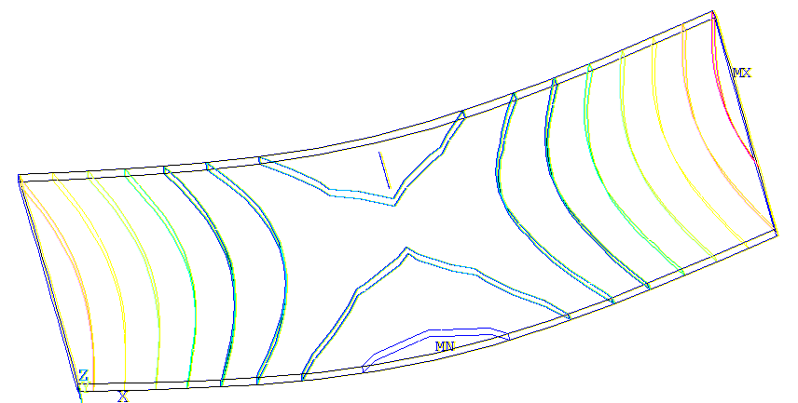  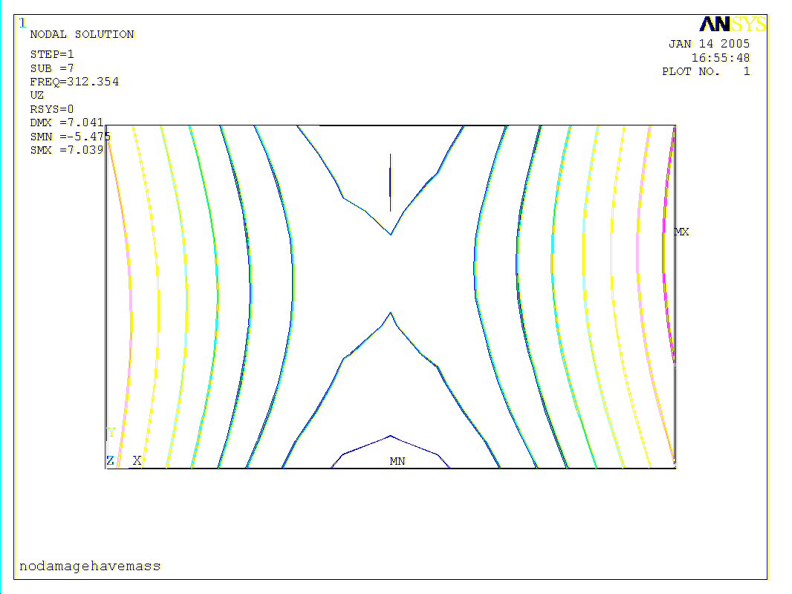  $$f_{k}=\text{313}(\text{312})\text{Hz}$$ | 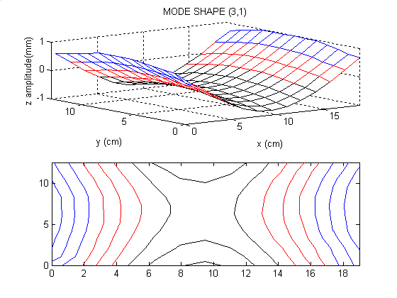$f_{k}=\text{241}(\text{238})\text{Hz}$ | (1,3) | 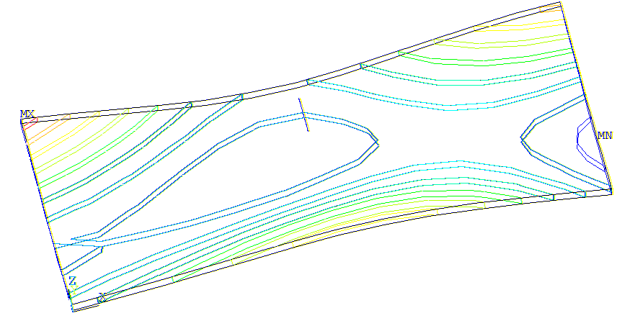  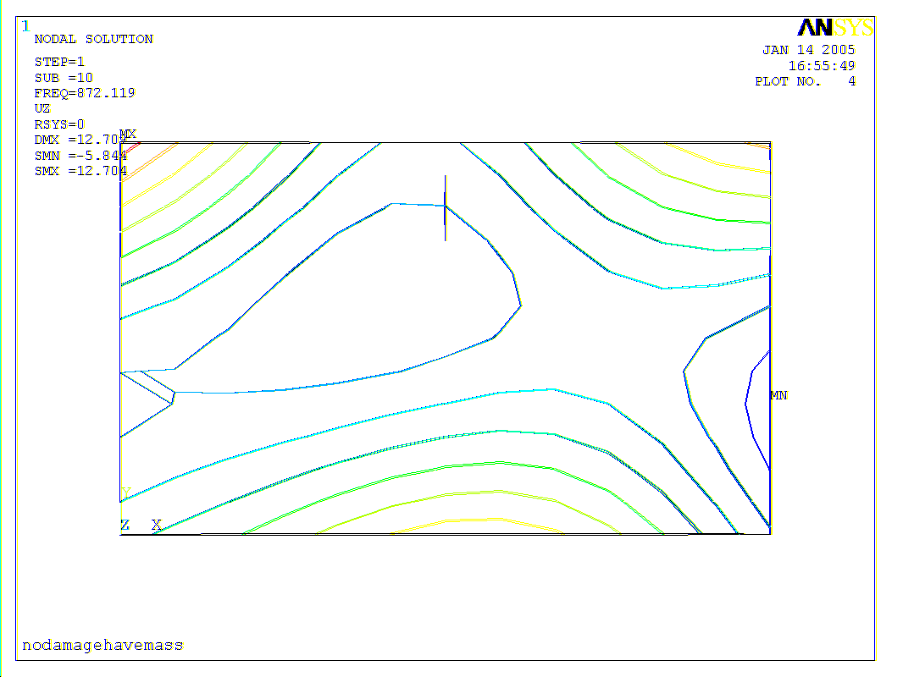  $$f_{k}=\text{873}(\text{872})\text{Hz}$$ | 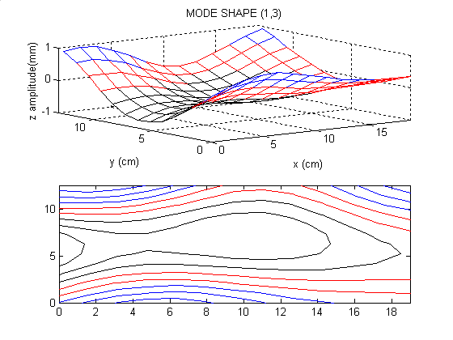$f_{k}=\text{701}(\text{699})\text{Hz}$
(2,2) | 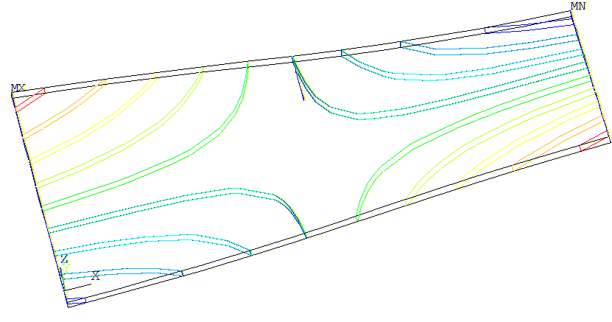  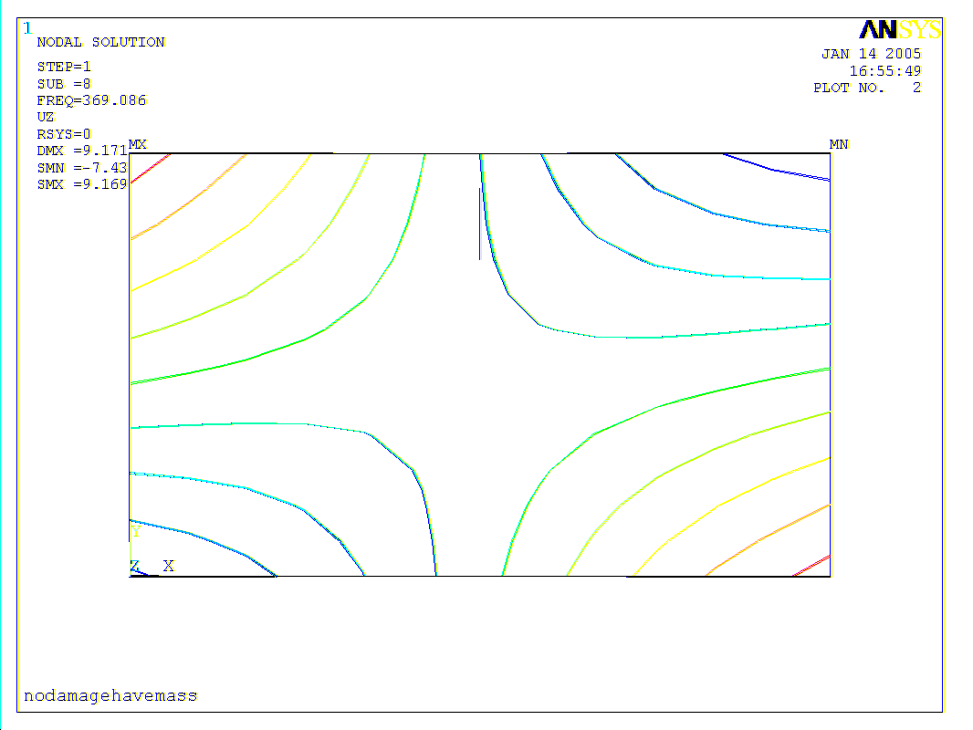  $$f_{k}=\text{369}(\text{369})\text{Hz}$$ | 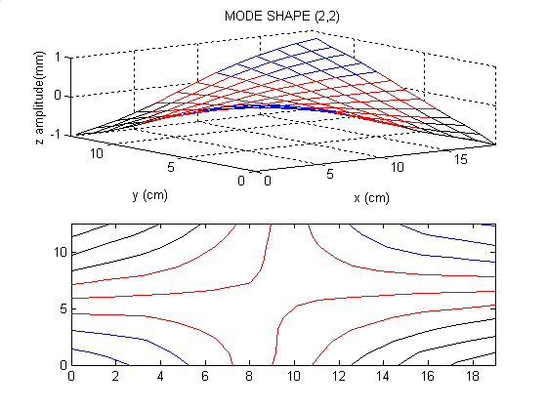$f_{k}=\text{281}(\text{280})\text{Hz}$ | (4,1) | 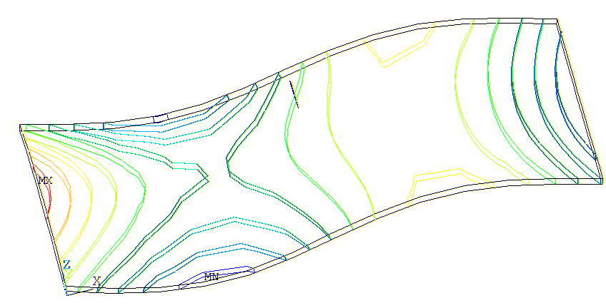  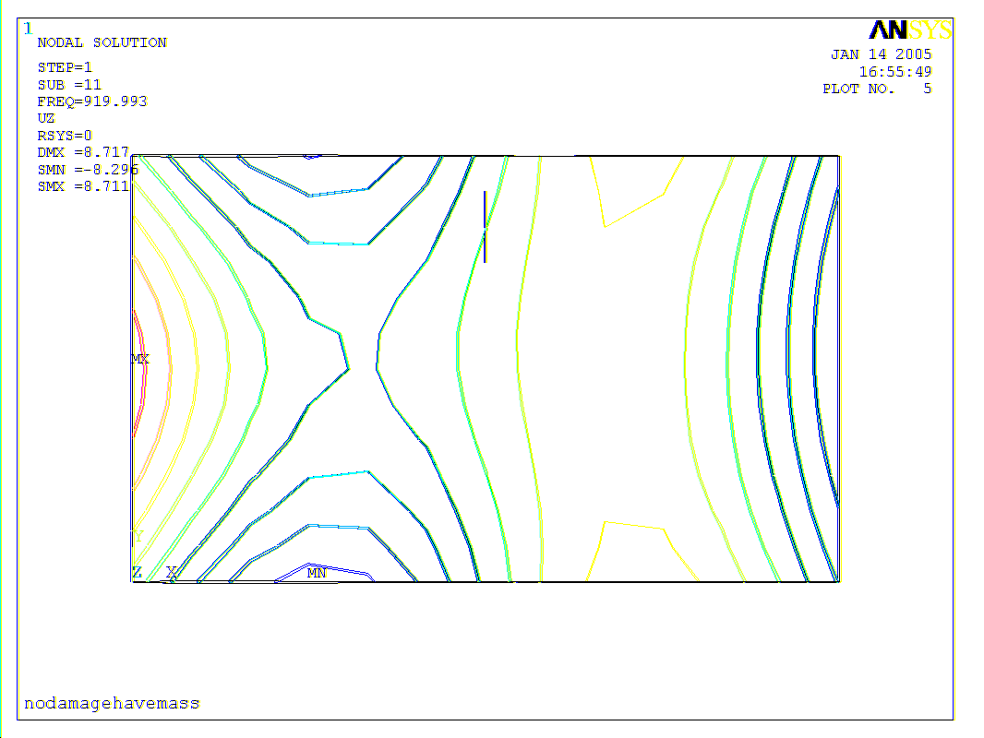  $$f_{k}=\text{920}(\text{920})\text{Hz}$$ | 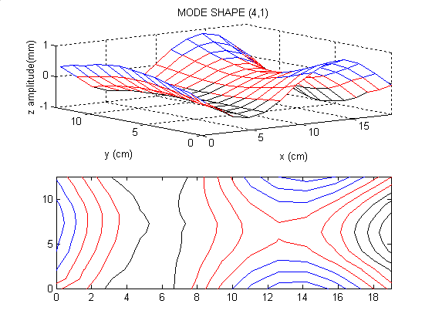$f_{k}=\text{717}(\text{717})\text{Hz}$
(3,2) | 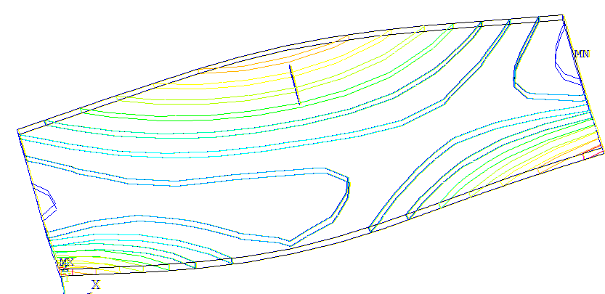  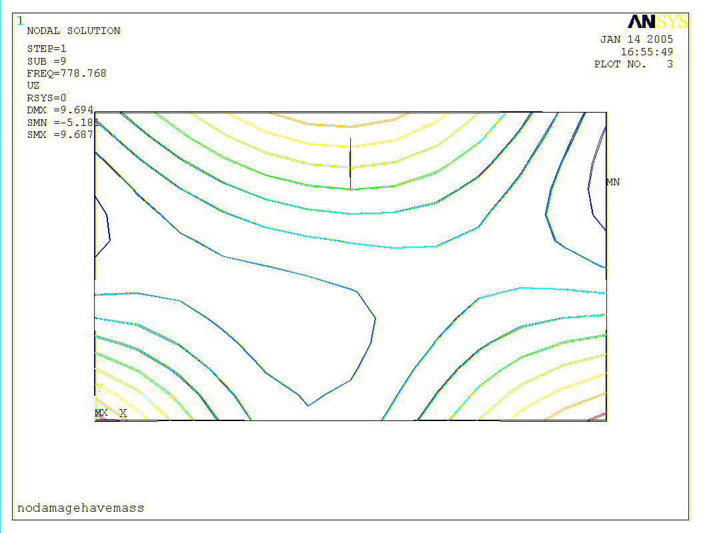  $$f_{k}=\text{779}(\text{779})\text{Hz}$$ | 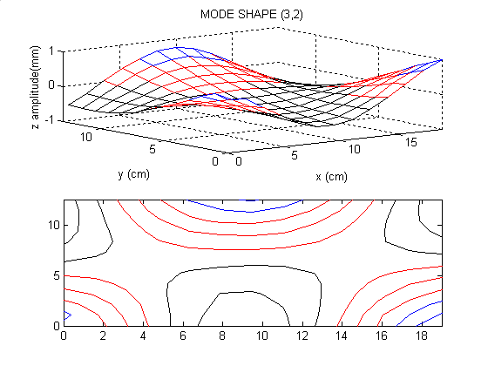$f_{k}=\text{648}(\text{647})\text{Hz}$ | (2,3) | 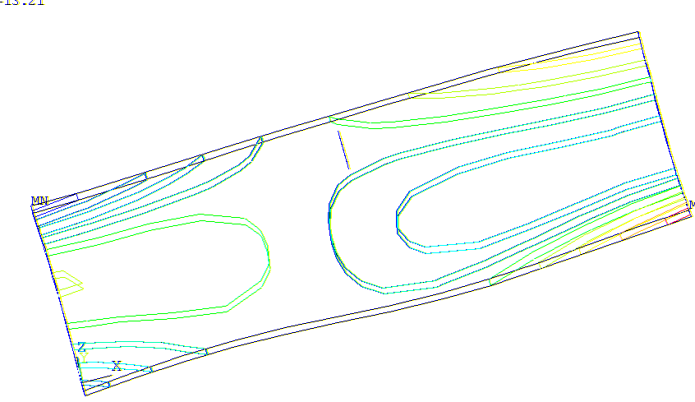  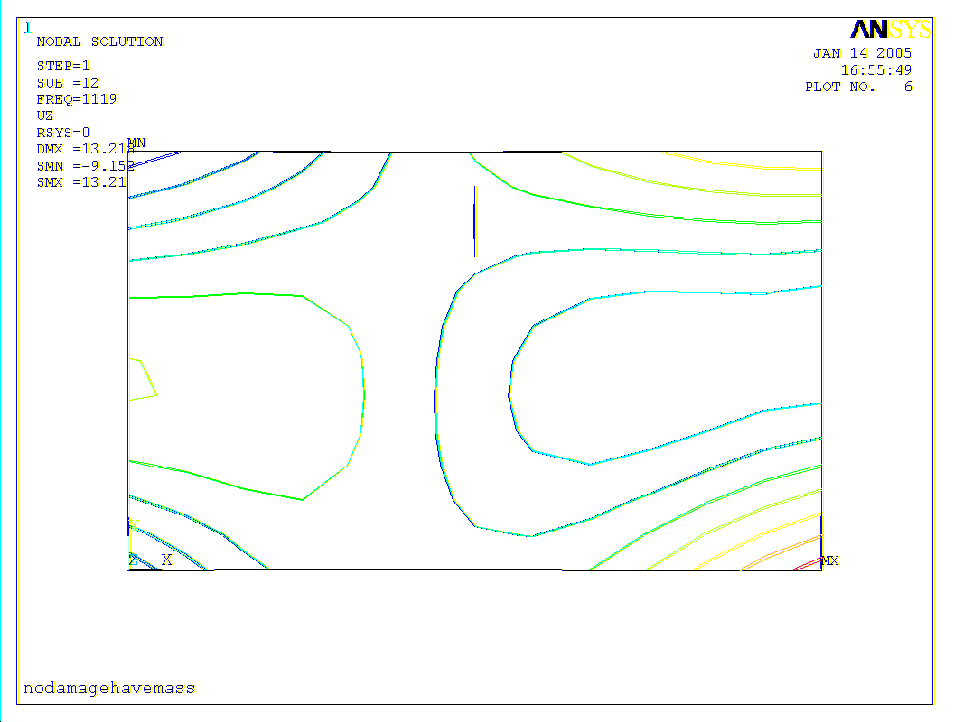  $$f_{k}=\text{1119}(\text{1119})\text{Hz}$$ | 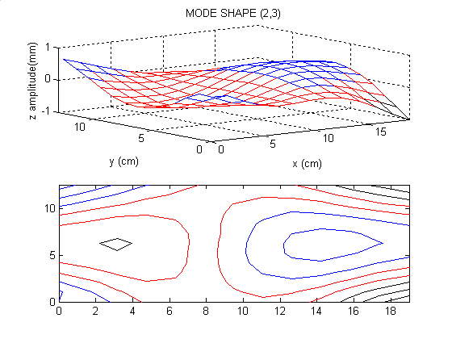$f_{k}=\text{956}(\text{956})\text{Hz}$
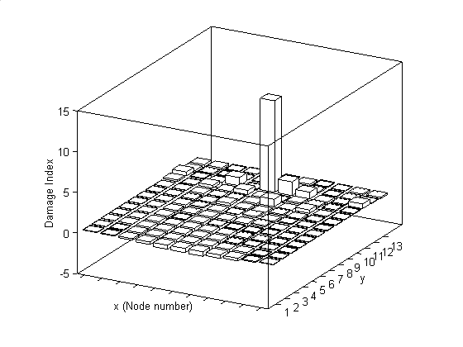
Figure 3: Finite element model Figure 4: Damage index (FEA)
Figure 5 shows the damage index obtained from EMA. Peak values occur at the location of surface crack; however, many peak values also emerged at some other undamaged areas. The deviation in measurement may attribute to these pseudomorphs. Cornwell et al. [5] suggested that damage indices with values greater than two are associated with potential damage locations. Thus, we tried to truncate the peaks of damage index less than two. The improving outcome is obtained in Figure 6. Two more EMA results are shown in Figures 7 and 9. After truncation, improving outcomes are also obtained in Figures 8 and 10. Practicably, structural damage can be long term monitored. Damage indices obtained in different times may be summed to amplify the signal of surface crack. Figure 11 shows the summation of two damage indices in first and second EMA results. The damage index by adding the third EMA result is shown in Figure 12. Both combinations clearly indicate the surface crack location in the test plate.

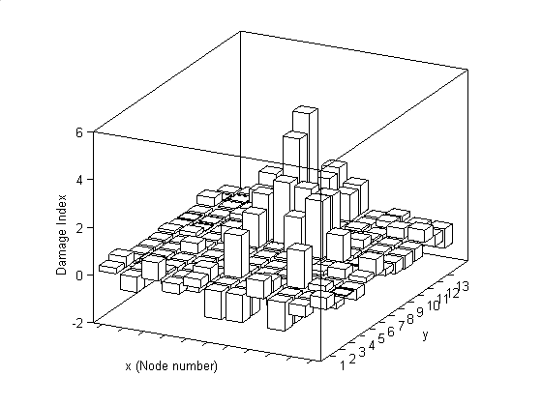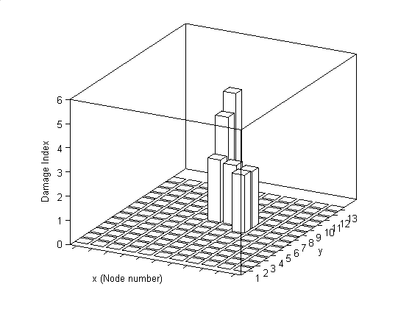
Figure 5: Damage index (1st EMA) Figure 6: After truncation (1st EMA)

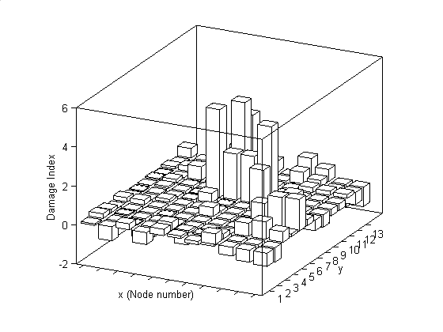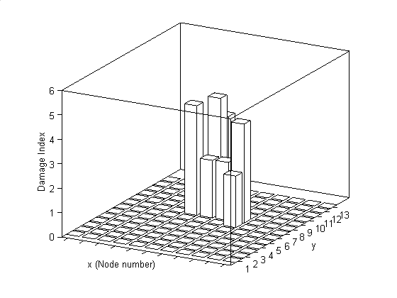
Figure 7: Damage index (2nd EMA) Figure 8: After truncation (2nd EMA)

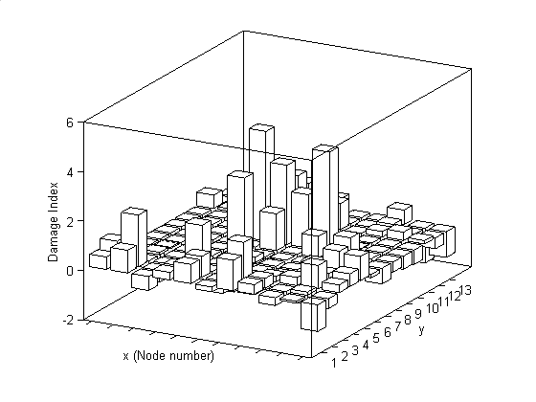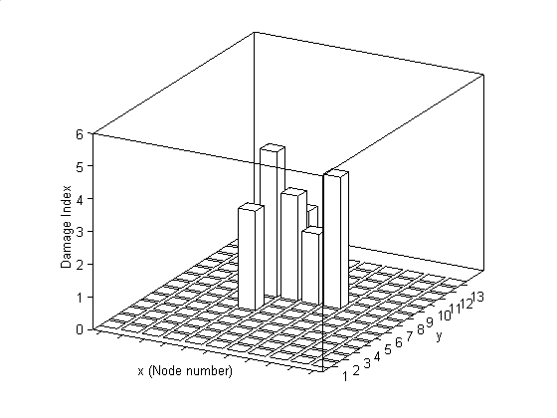
Figure 9: Damage index (3rd EMA) Figure 10: After truncation (3rd EMA)

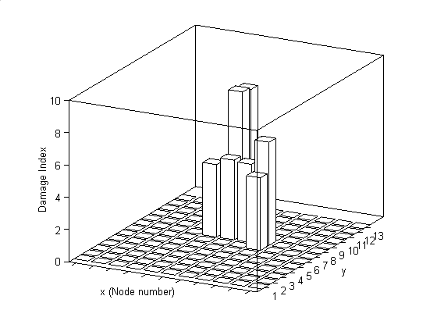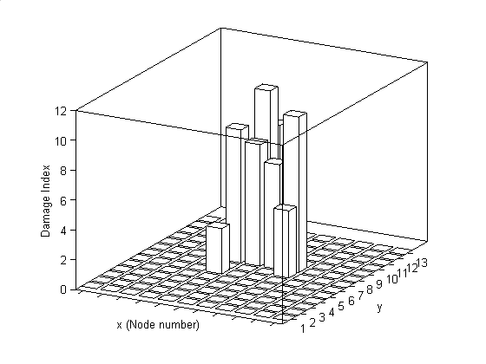
Figure 11: Damage index (1st+2nd EMA) Figure 12: Damage index (1st +2nd+3rd EMA)
Conclusions
Damage index using modal analysis and strain energy methods is developed to detect a surface crack in composite quasi-isotropic laminate in this paper. This method only requires a few mode shapes of the plate before and after damage. Both FEA and EMA results successfully locate the surface crack in test plate. DQM provides us an accurate approach to compute strain energy using only a few grid points in test plate. However, limited by grid point number, challenge still lies in the mode shape measurement. Future work will focus on the study of various types of damage.
Acknowledgment
The authors would like to acknowledge the support of Taiwan National Science Council through grant No. NSC-92-2212-E-020-010.
References
- Cawley, P., and Adams, R. D., “A Vibration Technique for Non-destructive Testing of Fiber Composite Structures,” Journal of Composite Materials, Vol. 13, pp. 161-175, (1979).
- Tracy, J. J., and Pardoen, G. C., “Effect of Delamination on the Natural Frequencies of Composite Laminates,” Journal of Composite Materials, Vol. 23, pp. 1200-1215, (1989).
- Shen, M. H. H., and Grady, J. E., “Free Vibration of Delaminated Beams,” AIAA Journal, Vol. 30, pp. 1361-1370, (1992).
- Zou, Y., Tong, L., and Steven, G.P., “Vibration-based Model-dependent Damage (Delamination) Identification and Health Monitoring for Composite Structures－A Review,” Journal of Sound and Vibration, Vol. 2, pp.357-378, (2000).
- Cornwell, P. J., Dobeling, S. W., and Farrar, C. R., “Application of the Strain Energy Damage Detection Method to Plate-like Structures,” Proceedings of the International Model Analysis Conference-IMAC, pp. 1312-1318, (1997).
- Hu, H., Wang, B. T., and Su, J. S., “Application of Modal Analysis to Damage Detection in Composite Laminates,” The 7th ASME Biennial Conference on Engineering System Design and Analysis, No. 58296, (2004).
- Bert, C. W., Jang, S. K., and Striz, A. G., “Two New Approximate Methods for Analyzing Free Vibration of Structural Components,” AIAA Journal, Vol 26, pp. 612-618, (1988).
- Bellman, R. E., Kashef, B. G., and Casti, J., “Differential Quadrature: A Technique for the Rapid Solution of Nonlinear Partial Differential Equation,” Journal of Computational Physics, Vol 10, pp. 40-52, (1972).


Bali, 4-6 April 2005
Bandung, March 22nd, 2005
Our Ref : 111/ FEOFS/ III/ 05

Dr. Huiwen Hu
National Pingtung University of Science and Technology
Taiwan

Dear Dr. Huiwen Hu,

I am pleased to inform you that the manuscript of your paper Damage Detection of Matrix Cracking in Composite Laminates Using Strain Energy Method by Huiwen Hu, Bor-Tsuen Wang and Cheng-hsin Lee has been accepted for oral presentation at the conference.

Please note that you or one of your co-authors will be expected to attend the 6th International Conference on Fracture and Strenght of Solids, FEOFS 2005 and present the paper.

I hope you have a safe and pleasant journey to the conference and look forward to seeing you in BALI.

Your Sincerely,


Dr. Ir. Ichsan Setya Putra
Chairman of Organizing Committee

