出國報告（出國類別：其他）

出席
亞洲生產力組織2005觀光行銷策略會議
報告書

服務機關：交通部觀光局
姓名職稱：劉喜臨 專門委員
派赴國家：斐濟
出國期間：94年4月2日至4月8日
報告日期：94年7月19日
系統識別號：C09401275
行政院及所屬各機關出國報告提要
頁數：160 含附件：□ˇ是□否
出國報告名稱：出席「亞洲生產力組織2005觀光行銷策略會議」報告書
出國計畫主辦機關：交通部觀光局
出國人員姓名/服務機關/單位/職稱/電話：
劉喜臨/交通部觀光局/國際組/專門委員/02-23491613
出國類別：□1.考察□2.進修□3.研究□4.實習□ ˇ5.其他：
出國期間：民國94年4月2日至4月8日
出國地區：斐濟
報告日期：民國94年7月19日
分類號/目:
關 鍵 詞：亞洲生產力組織、觀光、行銷策略、斐濟
內容摘要：
本次會議係由亞洲生產力中心（APO）岀資主辦，斐濟TPAF承辦，共有亞洲14個國家地區20位代表齊聚斐濟南地（Nadi, Fiji），共同探討全球觀光發展及亞太區域觀光行銷策略與發展。在5天的研修過程中，除透過專業人士針對專題提出討論建議外，小組作業針對斐濟觀光發展行銷的實際案例進行分析，最重要的是各國代表以該國觀光發展經驗及行銷策略投射於study case中，研討期間的交流討論也是吸取各國寶貴經驗最佳的時機。
在本篇報告中，就本會議之相關議題、教材、討論內容加以陳述，並提出以下心得與建議：1. 透過廣泛性交流，吸取各國觀光行銷經驗以為借鏡。2. 透過專業人士講授，深化對全球化與區域性觀光發展之概念。3. 台灣要發展觀光不能對中國大陸的旅遊市場驚人發展視而不見。4.為爭取國際曝光度，建議可爭取APO有關觀光產業會議或人數較多之座談會來台舉辦。以上多為個人之不成熟見解，希望能對觀光行銷策略有興趣者一些啟示，知己知彼，百戰百勝，了解鄰近競爭國之策略，以作為我國推動國際觀光行銷之借鏡。
出國報告審核表
出國報告名稱：出席「亞洲生產力組織2005觀光行銷策略會議」報告書
出國人姓名 |  | 職稱 | 服務單位
劉喜臨 |  | 專門委員 | 交通部觀光局
出國期間：94年4月2日至94年4月8日 |  |  | 報告繳交日期：94年7月19日
出  國  計  畫  主  辦  機  關  審  核  意  見 | □1.依限繳交出國報告  ˇ2.格式完整（本文必須具備「目的」、「過程」、「心得」、「建議事項」）  ˇ3.內容充實完備  ˇ4.建議具參考價值  ˇ5.送本機關參考或研辦  ˇ6.送上級機關參考  □7.退回補正，原因：□不符原核定出國計畫 □以外文撰寫或僅以所蒐集外文資料為內容 □內容空洞簡略 □電子檔案未依格式辦理 □未於資訊網登錄提要資料及傳送出國報告電子檔  □8.本報告除上傳至出國報告資訊網外，將採行之公開發表：  □辦理本機關出國報告座談會（說明會），與同仁進行知識分享。  □於本機關業務會報提出報告  □9.其他處理意見及方式：
層  轉  機  關  審  核  意  見 | □1.同意主辦機關審核意見 □全部 □部分 （填寫審核意見編號）  □2.退回補正，原因：  □3.其他處理意見：
說明：
- 出國計畫主辦機關即層轉機關時，不需填寫「層轉機關審核意見」。
- 各機關可依需要自行增列審核項目內容，出國報告審核完畢本表請自行保存。
- 審核作業應儘速完成，以不影響出國人員上傳出國報告至「出國報告資訊網」為原則。

出席「亞洲生產力組織2005觀光行銷策略會議」報告

目 錄

- 前言………………………………………… １
- 會議簡介…………………………………… ２
- 重要活動紀要……………………………… ９
- 檢討與心得…………………………………２８
- 相片集………………………………………３４
- 附件…………………………………………５７

壹、前言
斐濟是個遙遠又有點夢幻的國度，假如沒有這個機緣，這輩子也不可能踏上大洋洲的這片土地。感謝亞洲生產力中心中華民國理事辦公處提供這次機會，也感謝局內長官的提攜與容忍，讓我有幸與亞洲14個國家地區20位代表共同探討區域觀光行銷策略與發展。
在5天的研修過程中，除透過專業人士針對專題提出討論建議外，小組作業針對斐濟觀光發展行銷的實際案例進行分析，最重要的是各國代表以該國觀光發展經驗及行銷策略投射於study case中，研討期間的交流討論也是吸取各國寶貴經驗最佳的時機。
在本篇報告中，將就本會議之相關議題、教材、討論內容及參與心得與建議分別陳述，多為個人之不成熟見解，希望能對觀光行銷策略有興趣者一些啟示，知己知彼，百戰百勝，了解鄰近競爭國之策略，以作為我國推動國際觀光行銷之借鏡。
貳、會議簡介
  - 亞洲生產力組織（APO）
    - 名稱
APO（亞洲生產力組織，Asian Productivity Organization）為了亞太地區社會經濟發展有所貢獻，推行各種關於提高生產力的活動。

    - 設立目的
隨著世界快速變化，市場經濟擴大、資訊技術快速發展、環境問題深刻化、國家地域間或個人之間貧富差距擴大等都對生產力運動有很大影響，為了對應這種情況，APO在新時代提高生產力的理念中，特別標舉「提升所有人的生活品質」的想法，基於「強化競爭力」、「生產力提高與環境保護調和」、「社會公義的維持」三大視野推展活動。
1959年3月於東京舉行「第一屆亞洲生產力圓桌會議」，1960年9月於菲律賓的馬尼拉舉行「第二屆亞洲生產力圓桌會議」，根據此會中決議，基於政府間協定的「APO規約」，APO於1961年5月11日正式設立，事務局設於日本東京。
APO的目的在於發展亞太地區社會經濟，提高區域內人民生活水準，透過與加盟各國的相互合作，廣泛展開工業、農業、服務業等方面的生產力提高事業。根據「APO規約」，APO為「非政治、非營利及非差別」的組織。

    - 設立宗旨
APO的功能可簡化為以下五點：
      - 作為智庫集團，針對加盟國提高生產力的必要課題，進行調查研究。
      - 作為生產力運動的促進機關，協助加盟國生產力提高，促進區內相互合作。
      - 作為生產力問題的建言機關，對加盟國的社會經濟、開發政策提出建言。
      - 作為推進生產力運動組織的育成機關，強化各加盟國生產力本部(NPO)及支援人才培育。
      - 作為生產力的情報中心，促進亞太地區內外情資交流。

    - 加盟國家及地區
可以加盟APO者，是聯合國亞太經濟社會委員會(ESCAP)的亞太地區加盟國。設立之初有8國，如今增為20國(地區)。
表1 APO加盟國
 | 国 | 加盟年 |  | 国 | 加盟年
1. | バングラデシュ 孟加拉 | 1982年 | 11. | ラオス寮國 | 2002年
2. | カンボジア柬甫寨 | 2004年 | 12. | マレーシア馬來西亞 | 1983年
3. | 中華民国（台湾） | 原加盟 | 13. | モンゴル蒙古 | 1992年
4. | フィジー菲濟 | 1984年 | 14. | ネパール尼泊爾 | 原加盟
5. | 香港 | 1963年 | 15. | パキスタン巴基斯坦 | 原加盟
6. | インド印度 | 原加盟 | 16. | フィリピン菲律賓 | 原加盟
7. | インドネシア印尼 | 1968年 | 17. | シンガポール新加坡 | 1969年
8. | イラン伊朗 | 1965年 | 18. | スリランカ斯里蘭卡 | 1966年
9. | 日本 | 原加盟 | 19. | タイ泰國 | 原加盟
10. | 韓国 | 原加盟 | 20. | ベトナム越南 | 1996年
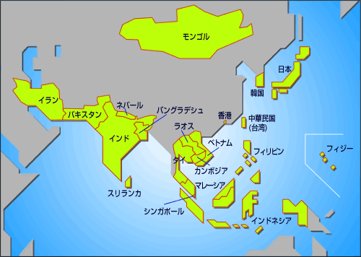
資料來源：APO官方網站
圖1 APO加盟國分布圖

  - 本次會議概述
    - 主題
※※ 觀光行銷策略 ※※
- Overview of the global tourism industry.
- Marketing and promotion strategies: Fiji and the South Pacific perspectives.
- New and emerging sectors and their potential in regional tourism.
- Challenges in marketing tourism in the Asia – Pacific region.
- Emerging trends in global tourism marketing and promotion.
- MICE (meetings, incentives, conventions and exhibitions), sports, cultural and eco tourism

    - 目標
To enable participants to understand the diverse marketing strategies employed by the tourism industry and, in particular, to learn the specific strategies used by the Fiji Islands which allowed the nation to become a global player in tourism. This will assist member countries in adopting suitable promotional strategies to meet their country-specific needs.

    - 進行方式
以演講、小組討論、參訪、專題研究及各國觀光行銷策略報告等方式進行。

  - 會議地點
名稱：Tanoa International Hotel
地址：Nadi Airport, Republic of the Fiji Islands

  - 承辦單位
名稱：Training & Productivity Authority of Fiji（TPAF）
地址：Private Mail Bag, P O Box 9203

  - 與會人員
表2 出席人員一覽表
姓名 | 加盟國籍 | 單位/職稱
Mr. Syed Tariqul Islam | 孟加拉  Bangladesh | Unit Manager (Executive Officer)  Bangladesh Parjatan Corporation National Tourism Organization of Bangladesh
Mr. Visoth Mony Tat | 柬埔寨  Cambodia | Chief of Marketing Office Marketing & Promotion Department, Ministry of Tourism
Mr. Hsi-lin Liu  劉喜臨 | 台灣  Republic of China | Senior Executive Officer Tourism Bureau, MOTC, R.O.C.  專門委員  交通部觀光局國際組
Mr. Ratu Meli Bogileka | 斐濟  Fiji | General Secretary  Tourism Resource Owners Association
Ms. Vave Fane | 斐濟  Fiji | Marketing Officer  Fiji Visitors Bureau
Mr. Ajit Singh Balhotra | 印度  India | Deputy Director General  National Productivity Council
Mr. Chandra Sekhar Mohapatra | 印度  India | Director( Tourism and Plan Coordination)  Planning Commission, Government of India
Dr. Chulwon Kim | 大韓民國  Korea, Republic of. | Secretariat General  Tourism Science Society of Korea
Mr. Bounnhang Kheuaphaphone | 寮國  Lao, PDR | Technical Staff  Vientiane Capital Tourism Administration
Mr. Jigmedsanjaa Chanrav | 蒙古  Mongolia | Executive Director  Destination Mongolia LLC
Mr. Diwakar Bickram Rana | 尼泊爾  Nepal | Manager, Tourism Marketing & Promotion  Nepal Tourism Board
Mr. Muhammad Sharif | 巴基斯坦  Pakistan | Public Relation Officer (Publicity and Promotion)  Ministry of Tourism
Mr. Waseem Mukhtar Chaudhry | 巴基斯坦Pakistan | General Manager (Operation)  The Tourism Development Corporation of Punjab
Ms. Boon Heang Chew  周文賢 | 新加坡  Singapore | Assistant Director  Singapore Tourism Board
Mr. R.M. Upali De Silva | 斯里蘭卡  Sir Lanka | Director / Corporate Services  Ceylon Tourist Board
Dr. Punthumadee Katawandee | 泰國  Thailand | Lecturer, Faculty of Commerce and Accountancy  Chulalongkorn University
Ms. Nguyen Thu Thuy | 越南  Vietnam | Lecturer, Faculty of Tourism Studies  University of Social Sciences and Humanities (USSH)Vietnam National University Hanoi (VNU)
另含斐濟當地人員3人，合計20人。
  - 講座
表3 講座簡歷一覽表
姓名 | 國籍 | 單位/職稱/經歷
Mr. Mohammed Rosly Selamat | 馬來西亞  Malaysia | Chief Executive Officer  Travel Malaysia  Graduated – Master of Science in Tourism Marketing  University of Surrey – UK  Bachelor in travel Industry management  University of Hawaii –Manoa
Ms. Cherrill Watson | 美國 | Marketing Consultant  Fiji
Mr. Josefa Tuamoto | 斐濟 | Director of Marketing Fiji Visitors Bureau

參、重要活動紀要
- 會議流程
表4 會議流程表
日期 | 內容
4月2日  4月3日 | - 出發赴斐濟(經日本東京)  - 時差調整  - 環境熟悉
第1天  4月4日 | - 報到  - 開幕式  - Welcome Address – Mr. Jone Usamate, APO Alternate Director for Fiji & Director General of TPAF.  - APO Secretary General’s Message – Mr Kamlesh Prakash, ProgramOfficer, Industry Dept, APO HQ, Japan  - Inaugural Address – The Honourable Pita Nacuva, Minister for Tourism  - 與會者及講座介紹  - 課程1：  Overview of the Global Tourism: Issues and New Marketing Perspective.  Speaker: Mohammed Rosly Selamat  - 課程2：  Marketing & Promotion Strategies: Fiji and South Pacific Perspectives  Speaker: Jo Tuamoto, Director of Marketing – Fiji Visitors Bureau  - 課程3：  New and Emerging Sector and their Potential in Regional Tourism  Speaker: Ms Cherrill Watson – Marketing Consultant, Fiji  - 課程4  Challenges in Marketing Tourism in the Asian Pacific Region.  Speaker: Mohammed Rosly Selamat  - 歡迎酒會（Welcome Cocktail）  - 歡迎晚宴(Welcome Dinner)
第2天  4月5日 | - 課程5：  Emerging Trends in the Global Tourism and Marketing Industry  Speaker: Mohammed Rosly Selamat  - 各國觀光行銷策略國家報告(Country Paper Presentation)  - 專題討論案例研究1：  Tabua Investment, Denarau Island development Site  研究主題：To study the development of Denarau Island and analysis its position in Fiji tourism development.  - 小組討論
第3天  4月6日 | - 課程6：  MICE, Sports, Cultural and Ecotourism:  Speaker: Mohammed Rosly Selamat  - 專題討論案例研究2  Treasure Island Ecotourism.  研究主題：To identify the unique preposition and strength in view of selecting a new market segment and the shape and form of development to follow.  - 小組討論
第4天  4月7日 | - 小組最終討論  - 專題討論案例研究小組報告  - 綜合講評  - 結業式  Presentation by the Minister of Labour, Industrial Relation and Productivity,  The Honourable Kenneth Zinck  - 頒發研習證書  - 惜別晚宴
4月8日 | - 回程：斐濟—仁川—台北

- 國家報告
依據參與APO活動的慣例，參與人員皆需發表國家報告乙篇，本次大會主題為「觀光行銷策略」，因此，要求與會人員就觀光發展之願景、產業發展、政策及立法架構、財務來源、遭遇的課題 （如：對區域環境、社區、文化的衝擊面）、解決策略及具體措施等提出6-8頁的報告。
我國在觀光行銷策略上，目前依循「觀光客倍增計畫」之「國際觀光宣傳推廣」執行之。因此，於報告內容上，以「觀光客倍增計畫」以公開發布之內容及2004年執行國際觀光宣傳之成果為報告重點，並搭配宣傳摺頁、影片及紀念品吸引與會及旁聽者之目光，深受好評。（簡報檔詳見附件3）
Country Paper for
Multi Country Study Mission on Marketing Strategies for Tourism Industries
4-7 April 2005, Fiji
By Liu Hsi-lin, Republic of China（Taiwan）
The International Tourism promotion strategies of Taiwan, R.O.C.
The Tourism Bureau has made a lot of effort to promote Taiwan, to achieve the Executive Yuan's goal of "Doubling the number of tourists by the year 2008." We also designated 2004 as “Visit Taiwan Year.”
1. SWOT analysis of Taiwan’s tourism development
（1）Strengths
- Abundant natural and cultural resources.
- Warm and hospitable people.
- Moderate climate for year-round tourism.
- Complete infrastructure for tourism development.
（2）Weaknesses.
- Huge gap in demand between peak and off-peak periods in domestic travel.
- High costs resulting in high product prices and weak international competitiveness.
- Taiwan is perceived as being little different from mainland China and Hong Kong.
（3）Opportunities
- Tourism has been included in Taiwan’s Six-year National Development Plan.
- Huge potential in the mainland Chinese market, room for further development in the Japanese and Korean markets.
（4）Threats
- Intense competition in the tourism industry.
- Vulnerability of tourism to external factors
2. Current tourism development policy
（1）Policy formation
- Green administration is developing Taiwan into a “green silicon island.
- Executive Yuan (Cabinet) has listed Tourism as an important strategic industry.
- Formulation of “Doubling of Tourism Arrivals Plan”.

（2）Doubling of Tourist Arrivals Plan
- Target: Five million visitor arrivals in 2008.
- Plan period: September 2002~September 2008.
- Investment: Approximately NT$75 billion
3. Strengthening International Advertising and Promotion
"Taiwan, Touch Your Heart" continued as the tourism logo on international promotions. Different promotional themes were adopted for various target markets, such as the " Taiwan beyond your expectation " advertising slogan for the America and Europe market.
The Taiwan Visitors Association was commissioned to work with domestic tour operators to form tourism promotional events in Japan, Hong Kong, Singapore, Malaysia, the U.K. and the Netherlands.
4. Hosting of Large-scale International Conferences
Attracting International Conferences and Training PCO Personnel In order to attract international conferences and exhibitions to Taiwan, the Tourism Bureau provided assistance for the holding of 26 international conferences in Taiwan and gave financial support to attract 17 international conferences, for a total of 43 events. Four basic training programs for professional conference organizers (PCOs) were offered across Taiwan. In September 2003, instructors from the International Congress and Convention Association (ICCA) gave advanced PCO courses and took part in MICE-related forums. Nearly 500 PCO seed students attended these events.
The 2004 Tourism Cup International Siouguluan River White-Water Rafting Race, Tour de Taiwan Cycling Race, World Cup Marathon, Taroko Gorge Marathon, and other major sporting events were held in 2004, attracting hundreds of top international athletes and generating significant tourism benefits.
- Taipei International Travel Fair
The 2004 Taipei International Travel Fair was held on November 15-18 at the Taipei World Trade Center Exhibition Hall. Fair exhibitors occupied 538 booths and came from 50 countries and regions. The fair consisted of tourism product presentations and travel seminars featuring presentations by tourism professionals. A record 85,744 persons visited the event during its four- day run.
5. International target market advertisement
International advertising companies were commissioned through public bidding to carry out tourism promotions through major print and electronic media channels in Japan, Hong Kong, Singapore, Malaysia, Europe and the U.S. In addition to intensifying current promotions, targeted promotional strategies for various markets were drafted as part of the Post-SARS Tourism Recovery Plan:
In Japan, post-SARS promotions emphasized the safety of travel in Taiwan under the themes "Exhausted in Japan, Rest Up in Taiwan," "Take it Easy," with the "Mr. Tea" character as the spokesperson for Taiwan tourism.
In the Hong Kong, Singapore and Malaysia markets, promotions emphasized Taiwan’s unique local culture and natural beauty under the theme, "Taiwan: Every Time is Your First Time."
In Europe and the U.S., Taiwan's unique tourism appeal was emphasized in promotions under the themes "Taiwan: Touch Your Heart" and " Taiwan beyond your expectation "
6. Promotional Activities
（1）Joint Promotions with Tourism Operators
In order to meet the special needs and changed circumstances, overseas offices of the Tourism Bureau joined hands with local airline companies and travel agencies to offer package preferential tour products with different themes. The bureau also provided advertising support to assist promotional efforts.
（2）Special Tour Programs
Several special tour packages were introduced to meet the characteristics and demands of individual markets. These include a free half-day tour for transit passengers, a 49-euro tour, charter flight service from Korea, and 10,000 yen travel coupon books awarded by a drawing to 5,000 Japanese travelers.
7. International Tourism Promotions:
（1）Malaysia and Singapore
Tourism promotion activities were held in Kuala Lumpur and Johor Baharu, Malaysia and Singapore to attract overseas Chinese visitors to Taiwan. Events included travel fairs, introductions to tourism resources in Taiwan, press conferences, and promotional banquets, all of which attracted enthusiastic participation and input from the local media.
（2）ITB Berlin
ITB Berlin is the world's biggest travel fair. The Tourism Bureau organized a delegation to attend ITB and held a promotional banquet in Paris en route to strengthen ties with tourism operators in Europe. Taiwan's uniquely designed booth was selected as the best designed booth among Asian exhibitors. There were also Chinese cooking presentations and cultural and arts presentations that attracted strong turnouts, greatly elevating the visibility of Taiwan's tourism industry.
（3）Osaka International Travel Fair
In order to strengthen promotion of Taiwan's tourism industry in western Japan, the Tourism Bureau organized a delegation to attend the Osaka International Travel Fair. The direct-to-consumer promotions emphasized tea-related tourism.
Press Conferences and Industry Seminars in Tokyo, Osaka, and Nagoya, the Tourism Bureau sent a delegation to hold promotional events in Tokyo, Osaka and Nagoya.
8. PCO Training
The Professional Training System under the Doubling Tourists Arrival Plan seeks to strengthen the training of talented international conference and exhibition organization professionals to enhance event service quality in Taiwan and attract international conferences to the island. Three basic training courses for professional conference organizers (PCOs) were held in Tainan and other areas from July to September this year.
In addition, advanced PCO courses and the Taiwan’s first professional conference and exhibition forum were held in Taipei. Leading conference and exhibition experts from various national chapters of the International Congress & Conference Association (ICCA), including the Netherlands, Australia and Malaysia were invited to speak and take part in these events along with their local counterparts in Taiwan.
In order to meet the PCO training needs of local governments in southern and eastern Taiwan, the Tourism Bureau arranged two PCO basic training courses at Taiwan Sugar Corp’s Jianshanpi Resort in southern Taiwan and the Parkview Hotel in Hualien.
Nearly 500 persons took part in the 2003 PCO training programs in 2003, far exceeding the 300 persons originally anticipated and effectively enhancing the professional ability of PCO personnel in Taiwan.
The number of foreigner tourists is 2,248,117 in 2002, and a total of 2,950,342 visitors arrived in the Republic of China in 2004, Compare to the number of 2002, it is showed a great effort been made about the International Tourism promotion strategies of Taiwan.

- 專題討論
專題討論係將與會人員區分成3組，針對斐濟2處度假區進行案例研究。該2處度假區各有其發展重點，Tabua Investment為採類似BOT形式之開發案，擬藉由引進民間投資高級度假設施（如：超5星級飯店、高爾夫球場、安養中心、獨立別墅等）來吸引國外觀光客。而Treasure Island為斐濟眾多島嶼之一，由民間購置開發成，藉由生態觀光的概念，開發島嶼成為遊憩、蜜月、休閒之島。惟2者在開發及觀光客引進之過程中，多有其文化、經濟、生態等面向的衝擊。本項討論的重點，擬藉由小組討論，以各國發展之經驗，來診斷這2處度假區之問題及研擬未來發展策略。

- 案例一
  - 地點：Tabua Investment, Denarau Island development Site
  - 研究主題：To study the development of Denarau Island and analysis its position in Fiji tourism development.
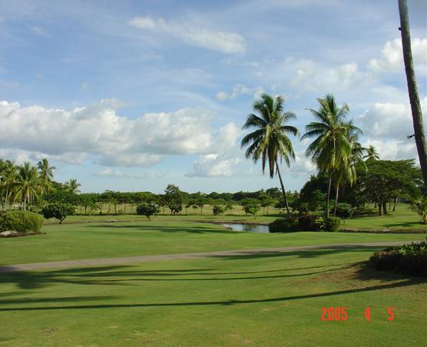
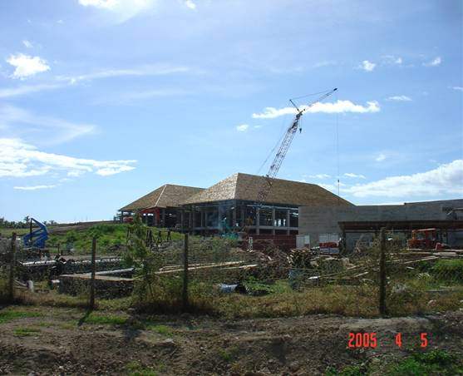

圖2 Tabua Investment, Denarau Island development Site
- 案例二
- 地點：Treasure Island Ecotourism.
- 研究主題：To identify the unique preposition and strength in view of selecting a new market segment and the shape and form of development to follow.
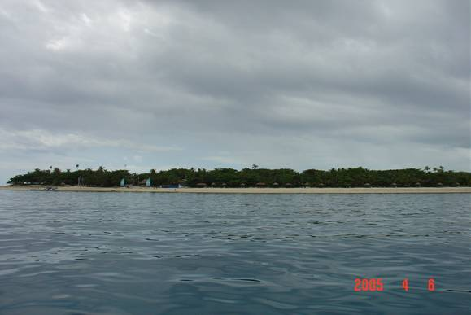
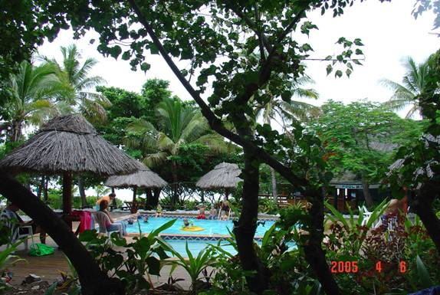

圖3 Treasure Island

- 研討內容
- To do a SWOT analysis of both tourism development and identify what new segments could be tapped.
- What new and innovative events could be planned to provide a “pull factor” for these 2 resort developments?
- If given an opportunity to re-engineer the resort development, what would be your group’s “ideal tourism development” concept?

- 小組報告
在本項作業中，我（後右1）與Mr. C S Mohapatra（印度，前右1）、Dr. Chulwon Kim（南韓，後左1）、Mr. Chaudhry（巴基斯坦，前右2）、Ms. Chew Boon Heang（新加坡，前左1）、Mr. Upali De Silva（斯里蘭卡，後中）及Ms. Senimere Salatobalevu（斐濟，前左2）等人同組。（第3組）
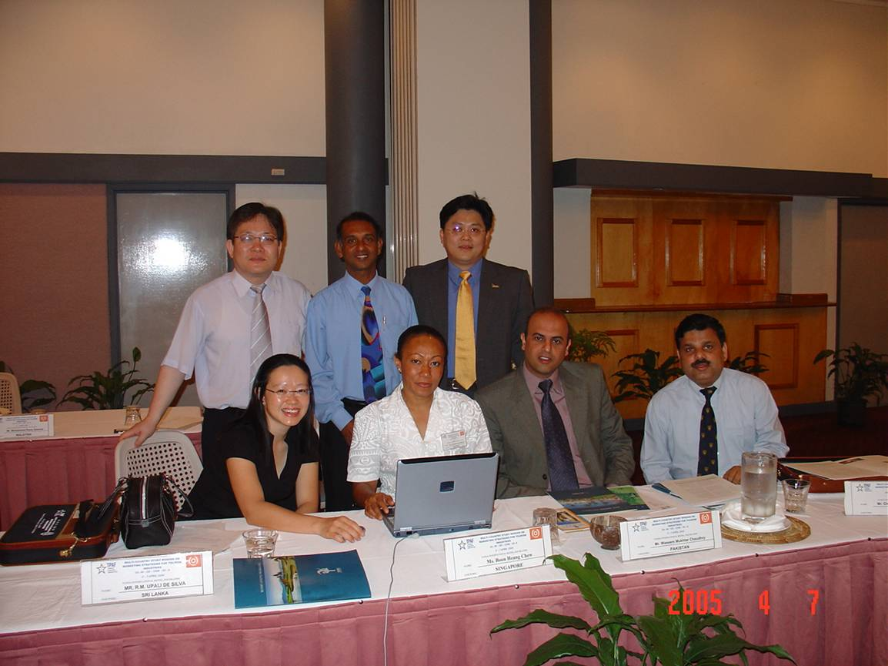
圖4 專題討論第3小組成員
研討過程中，大家絞盡腦汁希望再有限的資訊有限的時間中，完成大會所交付的任務。以下為本組報告內容摘要（簡報檔詳如附件4）
案例1：Denarau
1.SWOT分析
（1）Strengths優勢
- Hotel Management Option
- Safe area, easy to control
- Good accessibility
- Ambience
- Good branding already established
- Good coordination with govt agencies

（2）Weakness劣勢
- Insufficient Supporting Infrastructure
- Inconsistent supply of hospitality inputs
- 7,000 rooms by 2007
- Insufficient human capital
- DCL- municipality

（3）Opportunities機會
- Good weather
- Potential investment from Australia/ New Zealand close by (ready traffic)
- Near to nature – Mangrove Tour (Ecotourism)
- Good beach fronts – potential for water sports
- Good government support

（4）Threat威脅
- Local culture not assimilated – No social impact studies
- No environment impact studies

2.Denarau – New Segment
- Sport travellers
- Business travellers – MICE
- Silver segment
- North Asia, UK

3.Denarau - Events
- APGA/ special Golf events eg, with renown players, eg, Johnny Walker Classics
- Jazz events
- Rugby events
- Arts exhibition
- Gourmet food events
- Cultural events

4.Denarau – Our Vision
- A destination for international travellers in itself
- Relocate the city centre
- Arts facilities (performing, visual) within city centre
- Holistic Development (now planned by developers, not tourism planners)
- Attractions for family, eg, amusement park
- Casino for foreigners only

案例2：Treasure Island Resort
1.SWOT分析
（1）Strengths
- 1 island 1 resort
- Local culture assimilated
- Dedicated service providers
- Good participation of locals
- High % of repeat visitors
- Good facilities – deep water diving pool, gym
- Wedding Chapel facilities
- Good ancillary facilities (eg, medical etc)

（2）Weaknesses
- Tired facilities (no investment for 30 yrs) – accommodation, children facilities
- Poor image with wholesalers
- No value for money
- Improper location of generator - next to spa
- No systematic marketing research

（3）Opportunities
- Accessibility – 24 hrs seamless service
- More water activities
- Close by to Beachcomber and Bounty
- Good image of Treasure Island
- Island hopping facilities
- Marine Eco-tourism

（4）Threats
- Long term sustainability – sewage system
- Competition
- Perception of political instability
- Perception of Tsunami threat
- Inelastic Civic Amenities

2.Treasure Island Resort - Segments
- Incentive/ Corporate travellers – Teambuilding facilities needed
- North Asia Market
- Silver Market

3.Treasure Island Resort - Events
- MTV music events at Beachcomber
- Foam parties at Beachcomber
- Themed parties, weekends to attract locals, eg, Easter party, Cartoon weekend etc

4.Treasure Island Resort – Our Vision
- Holistic planning, taking into account environmental concerns
- The best family resort in Pacific Islands – best children facilities
- Better incentive package for tour operators
- World Class Spa Facilities - beach front/ on the water
- Nostalgic Tourism

肆、檢討與心得
  - 會議內容部分
- 透過廣泛性交流，吸取各國觀光行銷經驗以為借鏡。
在會議的本質成效上：本次會議集合亞太地區14個國家針對觀光行銷策略及區域整合等課題進行研討，提供各國交流機會，對各國觀光行銷作為上有正面效益。而就個人在會議中之觀察及與相關國家代表意見交換之心得如下：
  - 在會議期間，多與各國代表接觸，發現觀光企圖心強之國家，如：新加坡、韓國、馬來西亞等在觀光行銷策略的鋪陳上皆有其脈絡，其政府將觀光視為最重要發展之產業，是以在政府經費的支援上，遠超越我國。
  - 新加坡旅遊局以人員年輕化來帶動觀光創意發展，其中高階層幹部多為30-40歲，英語或其他外國語流利，對其在市場之推廣與行銷上成為利器。我國國際觀光行銷專業人才之培訓與招募（或行銷專業非公職人員之晉用、如何有效利用專業機構、如何促使委託之專業機構深入了解國際觀光行銷之課題等），皆是我國要與鄰近觀光目的地競爭之基礎工作。
  - 韓國掌握「韓流」之風潮，發展出一系列之行銷作為，並針對不同目標市場給予定位，如：日本-Extend；大陸-Diversify；東南亞-Promote；歐美-Explore。在廣告策略上以：【P】+【internet】+【Ad】+【PR】+【SP Events】整合性行銷來鋪陳韓流效應。其操作模式與我國委託廣告公司針對各市場之作為類似。但值得參考的是，其全球宣傳之”概念”一致（如泰國、馬來西亞全球一致的宣傳口號），僅在各市場依不同的目標客層施以不同的宣傳元素及公關活動。我國近年在不同市場以不同的口號來行銷，在經費有限的情形下可否達到宣傳之效益?對成熟與未成熟來台市場間有無區別?是否考慮對全球改採統一之”行銷主軸”等，將會是2006年與各國競爭之關鍵。
- 透過專業人士講授，深化對全球化與區域性觀光發展之概念。
  - 本次會議安排6場課程講座及2場專題演講，提供亞太地區觀光行銷策略及發展前景之講授，對區域性觀光發展有進一步之認識。
  - 在目前全球7億6000萬旅遊人次以每年10％的成長速率下，亞太地區更以29％成長率領先全球各區域，以數字而言，平均每年增加的6900萬旅次，亞太地區分配到3400旅次。與會各國也一致認為中國大陸以其資源面及價格面的優勢，將吸納大部分的旅次，而東南亞區域（泰國、印尼、馬來西亞、新加坡）也將吸納近33％增加的旅次。台灣如何在亞太區眾多競爭者中取得一席地位，端視如何與中國大陸間「同中求異」；與東南亞各國間「異中求同」（旅遊延伸、過境停留等）策略之展現。
  - 透過Mr. Mohammed Rosly Selamat的演講中得知，東南亞各國除了原有的觀光活動外，目前也積極發展如：郵輪旅遊、保健醫療、運動休閒、會議展覽產業觀光。因為，觀光被定義為：「旅客夢想產業」，觀光旅遊不再是走馬看花、景點旅遊，而是要享受多樣性的旅遊體驗。我國針對此些特殊旅遊活動也積極在進行產品開發及行銷階段，然在各國相繼投入龐大資源及政府主動支持下（例如：泰國政府對推動醫療觀光的投入遠超過我國醫事主管機關僅同意開放而旅遊業界不看好的「非侵入性」之「保健旅遊」），台灣應謹慎比較優劣，選擇最適宜的發展方向，以免徒勞無功。
- 台灣要發展觀光不能選擇當駝鳥視而不見中國大陸的旅遊市場驚人發展。
  - 從各國國家報告中不難發現，亞太各國之行銷策略對中國大陸旅遊市場皆寄予厚望，雖然又愛又怕，但都不會忽略其大量出國觀光的人口及吸納全球觀光市場的能力。
  - 我國雖針對大陸市場（含入出國）有相當之分析，但囿於「國家安全」及「大陸政策」之考量無法端上檯面。就以我進行國家報告為例，各國代表對我國處理各目標市場之分析與行銷策略多表肯定，唯一的疑問就是為何不提及中國大陸這個市場。當然，所有的數字及開放的步驟都在腦中，但身為官方的代表如何說明，也就僅能以特殊的兩岸關係為題又發表了一篇「兩岸觀光發展」，還好，與會人員大都了解台海兩岸關係（他們也對中國大陸未成為APO成員無法參與討論有些……）。這裡的警訊有二：
    - 其實東南亞各國明確了解大陸人們期待來台旅遊的意願威脅其行銷策略，而我國面對各國的競爭倘未能掌握時機稍縱即逝。
    - 在APO中我國會籍的保衛。（此部分不知其他會議有無類此情形，雖於會中大力說明台灣的努力與各國交流之用心，也積極表現企圖心，惟總覺得有意無意地被忽略或”誤植”為China。）
  - 我國觀光發展當然不能僅”寄望”中國大陸市場，台灣觀光的特色為何?如何突破夾擊的重圍才是致勝的關鍵。但也不要忽略中國大陸開始發展觀光及對台灣國際觀光行銷上的擠壓。
  - 此部分為出席會議之切身感受，以上建議僅代表個人言論。
- 參與人員層次不一，討論難聚焦。
  - 依大會建議應為各國從事觀光行銷相關業務主管人員，惟出席人員雖仍屬相關，但亦有產業界、學界等人員，在討論行銷策略上，有人抱著學習的態度、有人則以蒐集各國情報為主，以致在國家報告中，部分國家對其觀光行銷策略簡略帶過，深怕”機密”外流，無法開誠佈公，交流目的未能100％達成。
  - 但就會議安排上，仍可見APO的用心，透過專題演講及教學課程來建構與會者的共識及對觀光行銷策略的智能。
  - 與部分與會者溝通發現，部分課程屬基礎概念傳達，對各國觀光行銷主管人員而言稍有不足，或許在經費許可下，可邀請不同地區觀光行銷的主事者或專業機構人員（本會議僅1場）來授課，或增加各國報告及交流時間，會許更能達成會議之目的。倘就以提升會員國對觀光行銷之認識，則本會議已達成目標。
  - 因此，個人在會議過程中除主動與主要競爭國增加互動外，並將小組討論作為學習的重點。

  - 會議安排部分
- 感謝亞洲生產力組織及中華民國理事辦公處之安排，在行程規劃上提供最完善的協助。斐濟TPAF人員的熱情與溫暖也讓人感受到南太平洋的活力與熱情。
- 本次會議於斐濟舉行，讓參與各國人員對斐濟有更深一層認識。惟因受會議時間及行程限制關係，除了南地（Nadi）地區外，對斐濟仍一無所悉。斐濟雖與台灣無邦交，但對我國相當友好，其也為南太平洋島嶼國家之中心，地位重要，外國觀光客人數雖有待提升，但到該地區旅遊者屬「有錢有閒」的頂級消費者及「沒錢有閒」的自助旅遊者，我國亦可把握此市場，目標針對到斐濟之國際觀光客（非斐濟住民）透過代表處提供文宣以「下次旅遊去台灣」來吸引國際觀光客。
- 斐濟觀光局等相關單位亦把握此機會，邀請觀光各業與各國人員進行交流。
- 為爭取國際曝光度，並使台灣觀光推動有其正面效益，建議可爭取APO有關觀光產業會議或人數較多之座談會來台舉辦。

