行政院及所屬各機關出國報告
（出國類別：會議）

約旦資訊通訊科技部訪問團

服務機關：行政院研考會
出國人 職 稱：主任委員、處長、分析師
姓 名：林嘉誠、施宗英、張偉郎

行政院研考會
編號欄
出國地點：約旦
出國期間：93年4月10日至14日
報告日期：93年5月3日
行政院及所屬各機關出國報告提要

出國報告名稱：約旦資訊通訊科技部訪問團
頁數：33 含附件：是
出國計畫主辦機關/聯絡人/電話：
行政院研考會/張偉郎/02-23419066轉811
出國人員姓名/服務機關/單位/職稱/電話：
林嘉誠/行政院研考會/主任委員/02-23419066轉200
施宗英/行政院研考會/資管處/處長/02-23419066轉801
張偉郎/行政院研考會/資管處/分析師/02-23419066轉811
出國類別：其他（出席會議）
出國期間：93年4月10日至14日 出國地區：約旦
報告日期：93年5月3日
分類號/目：
關鍵詞：電子化政府 資訊通訊科技部
內容摘要：本案出國人員由行政院研考會林主任委員嘉誠領隊，並邀請國內資訊業民間企業負責人組成，於本（九十三）年四月十日至十四日參訪，主題為約旦資訊通訊科技部參訪，並與部長Dr. Fawaz H. Zu'bi就兩國電子化政府交流合作交換意見，另參訪約旦電信管理委員會（Telecommunications Regulatory Commission - Jordan）及約旦資訊科技協會（Information Technology Association - Jordan）等。

目 次
壹、前言 1
一、緣起 1
二、目的 1
三、參訪內容 1
貳、主要行程 3
參、考察重點與發現 4
一、約旦資訊通訊科技部 4
二、約旦電信管理委員會 7
三、約旦資訊科技協會 9
肆、建議事項 10
伍、附錄 13
一、約旦資訊通訊科技部部長簡介 13
二、資訊通訊科技部簡介 13
三、約旦e_Government計畫 16
四、約旦電信管理委員會 20
五、約旦資訊科技協會 27
六、照片集 29

壹、前言
一、緣起
- 約旦資訊通訊科技部（Ministry of Information and Communications Technology）部長Dr. Fawaz H. Zu'bi接受外交部邀請，曾於九十年十二月初訪問本會，聽取我國電子化政府簡報，對我國電子化政府的推動成效表示稱許，並表達進一步發展雙方合作關係的意願。
- 本會派員參與經濟部於九十二年三月組團赴約旦洽談台約資訊科技合作計畫事宜，會後本會負責就雙方電子化政府合作事宜持續推動。
二、目的
- 促成我國與約旦電子化政府之實際合作發展，促進邦誼。
- 協助約國普及資訊應用，縮減國際數位落差。
- 帶動我國資訊產業在中東地區之發展機會。
三、參訪內容
本案出國人員由行政院研考會林主任委員嘉誠領隊，並邀請國內資訊業民間企業負責人組成，於本（九十三）年四月十日至十四日參訪，主題為約旦資訊通訊科技部參訪，與部長Dr. Fawaz H. Zu'bi就兩國電子化政府交流合作交換意見，部長主動表達樂意與我方簽署政府與政府間合作備忘錄，以具體落實雙方交流合作事宜，在拜會部長前由施處長宗英等人並與約國電子化政府專案辦公室主任Mahmoud Ali Khasawneh (Director of e-Government Programme / Chief Information Officer)進行工作會議，先由我方簡報電子化政府建置成果與最新發展趨勢，嗣就約方當前工作進度、目標與需求予以分析檢討，得知約旦刻正積極規劃國家級電子化政府策略發展計畫，已尋求新加坡之協助，對於台灣有關專業與成果深感興趣，深盼早日有機會前來進行觀摩學習。
另參訪約旦電信管理委員會（Telecommunications Regulatory Commission - Jordan）、約旦資訊科技協會（Information Technology Association - Jordan）等。參訪內容對於促進中約兩國電子化政府、資訊產業交流與合作商機有相當之助益。
貳、主要行程
Date | 地點 | 內容
4/10(六) | 台北-安曼 | 搭機出境
4/11(日) | 安曼 | 13:00~15:00拜會約旦電信管理委員會Dr. Mamoun Balqar, Vice Chairman / Commissioner of Telecommunications Regulatory Commission-Jordan
4/11(日) | 安曼 | 16:30~17:30 拜會約旦資訊科技協會Mr. Ra’ed Bilbessi, CEO, Information Technology Association-Jordan (INT@J)
4/12(一) | 安曼 | 參訪資料與心得彙整
4/13(二) | 安曼 | 10:00~12:00拜會約旦資訊通訊科技部Ministry of Information & Communications Technology (MOICT)，雙方就電子化政府計畫進行工作會談。
4/13(二) | 安曼 | 12:00~13:00拜會約旦資訊通訊科技部部長H.E. Dr. Fawaz Zu’bi, Minister of MOICT, Jordan
4/14(三) | 安曼-台北 | 抵達台北

參、考察重點與發現
一、約旦資訊通訊科技部
約旦正積極草擬如何推動電子化政府，針對跨部會合作之創新e化應用極有興趣，尤其對如何規劃e化政府計劃的形成及計畫管理辦公室的制度，以達成對各部會的互動、溝通、合作、任務分配等，是目前當即要務。
約旦資訊通訊科技部部長H.E. Dr. Fawaz Zu’bi對我國推動電子化政府之發展與成效，至感興趣與贊佩，希望能儘快深入瞭解並與我國詳洽電子化政府計畫之合作事宜，以提升約國電子化政府之水準。部長對我國表示將派員來台參訪，俾與本會洽商簽訂台約兩國政府間合作之備忘錄。
此外，在參訪之前數天，約旦資訊通訊科技部部長及其CIO剛造訪新加坡並簽署一項合作協定，新加坡將由提供電子化政府策略規劃之協助，未來並由新加坡NSC (National Service Corporation)提供電子化政府建置服務。新加坡一向非常積極，從事電子化政府國際合作業務，台灣必需要有相同的效率與速度，即對事情的敬業熱誠，多管道進行，才能與其他國家競爭，以爭取國際外交與合作的商機。
從過去幾次約旦與我方洽談議題，不外乎以下幾項，但是提供台灣資訊廠商的商機必需要密集性的互動，才能提出較為具體的方案與做法。
(一)計畫管理辦公室(PMO)品管制度
協助計畫管理辦公室針對電子化政府規劃、溝通、建置、品管、營運系統，實施品管制度，以及如何作專案與效益評估等。
(二)電子化政府整合服務
- 訂定推動優先序 (如 e-Procurement, e-Trade, e-Tourism, etc.)。
- 發展各項整合服務的營運模式。
- 訂定各項整合服務的高階技術架構。
- 設計及建置階段所需的業務、技術建議書徵求文件。
(三)政府網路災難復原作業中心之策略及建置
提供政府網路災難復原作業中心全般策略規劃、發展與建置相關知識技能的協助。
(四)電子化政府資訊安全
- 參與資訊安全政策擬定。
- 提供下列事項的知識技能協助：網路入侵偵測、電子認證、安全稽核。
(五)電子化政府客服中心
- 評估電子化政府計畫相關部會的現行客服作業狀況。
- 有關提升部會機關服務效能的顧問諮詢。
- 提供相關裝備、訓練、軟體及作業程序。
(六)電子化政府網路與電子郵遞基礎建設及安全機制
- 提高PC及電子郵件的普及率。
- 提供參與政府安全網路的6個部會系統管理人員相關訓練。
- 提供政府安全網路作業中心工程師的相關訓練。
(七)電子化政府效益評估
- 關於推行電子化政府成熟度評估制度，實施範圍界定與相關事項的諮詢顧問。
- 計畫管理辦公室電子化政府人員的訓練。
- 發展與提供所需作業程序、工具、配備與軟體。
二、約旦電信管理委員會
約旦電信管理委員會於1995年成立，為一個財務與管理權獨立的半官方色彩法人組織，功能類似我國的交通部電信總局，組織的任務在於確保提供給所有使用者一個合理的、可負擔的價格之資訊通訊服務，並與所有的業者共同在一個獨立、開放、透明的風格中，建立一個提倡公平、競爭與投資的規範環境，以符合約旦王國在資訊通訊科技方面長期需求。
委員會下設十一個部門，包括內部審計單位（Internal Audit Unit）、營運部門（Operations Department）、管理事務部門（Regulatory Affairs Department）、廣播頻率管理部門（Radio Spectrum Management Department）、法律部門（Legal Department）、外部及消費者事務部門（External & Consumer Affairs Department）、資訊科技部門（Information Technology Department）、管理與支援服務部門（Management & Support Services Department）、技術部門（Technical Department）、財務部門（Finance Department）及經濟部門（Economics Department）。
委員會主要提供的服務有下列幾項：
- 依據政府政策核發電信服務與網路許可。
- 核定業者的服務收費與價格表。
- 設定費。
- 仲裁業者爭端。
- 抱怨處理。
- 核准業者內部聯網協定。
- 設定經營者服務目標品質。
- 監控經營者績效。
- 門號管理。
- 頻率管理。
- 採納電信設備規格。
- 核准電信設備類型。
三、約旦資訊科技協會
約旦資訊科技協會是一個非營利的民間組織，其任務在於有效率的推動與促進約旦軟體與資訊科技服務產業進入全球市場，其組識類似我國資訊軟體協會及台北市電腦商業同業工會等。
協會主要工作可分為以下八點：
- 提倡產業相關事務。
- 促進約旦產業投資機會。
- 提供產業研究與市場資訊。
- 促進IT產業標準化、認證與品質管理。
- 支援人力資源發展。
- 推動產業智慧財產權。
- 組成國際IT產業聯盟。
- 管理產業股東關係與解決產業衝突事件。
肆、建議事項
從近年來相關民間國際組織與團體所完成對我國電子化政府之評比顯示，我國電子化政府之推動成果獲得國際肯定，甚至居於相對領先的位置，如何善用我國電子化政府與資訊產業的成果與優勢，在當前艱難的外交處境下協助推動ｅ化外交，對本會而言係一項新興業務，亦是一項挑戰，本次本會與約旦資訊通訊科技部之交流，已累積及建立相關的經驗與模式，相關建議分述如次：
一、聯繋管道建立：我國與約旦經過數次互訪，對於兩國電子化政府之經驗及交流已初步建立聯繫之管道，鑒於初期互動及達成共識不易，後續交流如何進行是兩國關係能否持續維持的關鍵因素，正式公文書的處理往往曠日費時，建議應充分運用電子郵件，透過即時的資訊傳播，建立非正式的溝通管道，本次出訪即運用電子郵件，與約方洽詢相關細節敲定此次出訪行程，後續之交流亦應利用已建立之人脈，與約方不定時連繫，適時提供經驗分享與交流，以建立良好的關係。
二、促進雙方簽署合作備忘錄：本次參訪，約方釋出將與我簽署合作備忘錄，以加強雙邊合作關係，係此行最大收獲，此亦意味後續將有更多的交流活動，建議應建立ｅ化政府外交專案，規劃適當經費，作為持續開拓與約旦關係建立之專用，以達成合作效率並能與國際競爭。
三、善用約旦發展資訊產業優勢，引進民間投資：約旦正積極推動電子化政府以及數位學習、線上遊戲等內容發展，自許將成為阿拉伯世界的數位內容源頭，以及中東地區的區域發展中心，且該國本身具有豐碩的資訊管理與技術高等教育人才，亦有英語嫻熟之優勢，而我國資訊軟體產業在約方刻正亟思發展之項目有許多經驗、專業能力及貫穿上、中、下游先進的產業聚落，透過政府的引導或補助的方式，協助約旦電子化政府建設並發展適宜的軟體及服務產業，不僅有助於國內資訊軟體廠商與約方形成互補夥伴關係，拓展國際市場之商機，對於雙方友好關係建立亦是一項助益。
四、加強協助約方訓練電子化政府計畫相關專業人才，台灣具有豐碩經驗及專業累積，得以與約方人員分享，本次參訪期間Khasawneh主任表達派員至台觀摩學習之意願，案經返台後雙方協調，約方業指派Khasawneh，協同所屬兩位組長Candide Kirk及Khaled Hudhud，已於九十三年五月四至十四日來台訪問，訪問期間，將依據本會所提供電子化政府整體簡介、政府網際服務網、政府電子認證服務體系及重要大型行政資系統等項目研習。基於專業訓練及經驗交流，對約方專案策略規劃具有關鍵影響力，允宜持續推動，並適時協請我方資訊業界參與，以增進雙方合作實質關係。
伍、附錄
一、約旦資訊通訊科技部部長簡介
HE Dr. Fawaz H. Zu'bi
Minister of Information and Communications Technology
Minister of Administrative Develpoment

Dr. Fawaz H. Zu'bi serves as the Minister of Information and Communications Technology and Minister of Administrative Development in the government of Jordan. Assigned to the post of Minister of Post and Communications in June 17, 2000, Dr. Zu'bi successfully migrated that institution into Jordan's 1st e-Ministry on April 7, 2002, known today as the Ministry of Information & Communications Technology. He was recently also designated the responsibility of the Ministry of Administrative Development, effectively broadening his government modernization philosophy across to all public institutions.

Dr. Zu'bi is also as a member of the Economic Consultative Council (ECC), having been appointed by His Majesty King Abdullah II in 1999. On the council, he served on the task forces related to the integrated development of the Aqaba Special Economic Zone (ASEZ), Irrigated Agriculture, Water, and Culture. He is also a founder of the Young Entrepreneurs Association, the Jordan Trade Association and the Jordan Quality Association.

Born in Amman in 1956, Dr. Zu'bi is married with two children. He graduated from International College in Beirut in 1975 and completed his undergraduate, Masters and Doctoral degrees in Mechanical Engineering and Physics from Duke University in the United States in 1982. Before joining government, Dr. Zu'bi worked in the private sector and co-founded Adritec Group International, the largest regional manufacturer of modern drip irrigation systems and provider of technical irrigation know-how and services. The company operates in nine countries and exports to more than 25 markets.
（資料來源http://www.moict.gov.jo）
二、資訊通訊科技部簡介
Established in April 2002, the Ministry of Information and Communications Technology [MoICT] is the governmental entity responsible for articulating policy in the areas of information technology, telecommunications, and post in the Hashemite Kingdom of Jordan.

In addition to developing, incubating, and supporting ICT initiatives at a national level, the Ministry’s mandate includes stimulating local and foreign technology investments as well as promoting awareness and adoption of ICT by all segments by all segments of the population, in an all-inclusive approach.

The Ministry, through a dynamic public-private partnership process, works to create, promote, and drive new ICT opportunities in Jordan, which will facilitate the positioning of the Kingdom as a regional player in technology adoption and development, a key step to creating a knowledge-based economy.

The Ministry is currently articulating Jordan’s policies and strategies for liberalization of the telecommunications sector in both mobile and fixed line telephony, overseeing the creation of a more independent regulator and the formation of a combined national spectrum unit. These, as well as the formulation of national IT policies, are within its mandate of charting a strategic plan for the development of the ICT sector in Jordan.

Structured as a “think tank”, the Ministry’s work plan reflects its objective of creating the enabling legal, commercial, and regulatory environment receptive for technology introduction as a catalyst towards the larger socio-economic development of Jordan.
（資料來源http://www.moict.gov.jo）
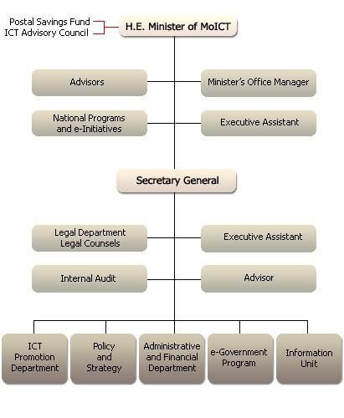
三、約旦e_Government計畫
1. Background

e-Government is a National Program initiated by his Majesty King Abdullah II. The purpose of this program is to enhance the performance of the traditional government in terms of service provision, efficiency, accuracy, time and cost effectiveness, transparency, high level of customer satisfaction, cross-Governmental integration, and much more of elements related to the style the Government of Jordan works and perception of others to the Government.

Key emphasis of the e-Government Program starts with managing the changes entailed to the new transformation to the e-Government. This includes Business Process Re-engineering towards better and more efficient processes, human performance development, organizations re-structuring to have more efficiency and map the required functions to the human resources and competencies needed for each area, deployment of best practices and latest technologies as a tool to enable Government stakeholders implement the new processes, and changing the culture towards creating a knowledge-based community.

So, e-Government will drive the Government transformation and will use communications and Information and Communications Technology to achieve the ultimate goals. This transformation process requires a focal point of contact to coordinate the efforts between Government entities and support them with best practices and subject matter experts, so that Government entities have integrated efforts and maximize the success of their transformation. Therefore, the Ministry of Information and Communications Technology (MoICT) was assigned to take the lead in coordinating efforts of implementing the e-Government Program, facilitating and providing support whenever needed to Government entities participating in the e-Government Program implementation. For this purpose, MoICT has established a Program Management Office (PMO) and staffed it with subject matter experts in the areas of project management, change management, technical management and support services, risk management, quality management and other competencies, to enable MoICT achieve the required success in its mission while implementing the e-Government Program.

2. Vision and Mission

The e-government vision is to be a major contributor to Jordan's economic and social development by providing access to Government e-Services and information for everyone in the kingdom irrespective of location, economic status, IT ability and education.

The MoICT's mission towards e-government is to provide support and capability to coordinate the management, implementation, interoperability and benefits of the National e-Government Initiative for the Government of Jordan.

3.Goals and Objectives

• Develop and support the e-Government strategy to be implemented across government entities.
• To participate in the planning and coordination of a sustainable national portfolio of e-Government initiatives.
• To maintain technological integration and interoperability of e-Gov initiatives, and encourage the re-usability of application components, to achieve consistency among Ministries / Departments for technical solutions.
• To plan and implement security policies and a secure network environment for e-Government initiatives.
• To promote and monitor a systematic method of planning, developing and implementing e-Government initiatives.
• To promote and monitor organisational transformation (Change Management) at the Ministry/Department/Organisational level necessary to establish effective e-Government.
• Educate GoJ employees and transfer the knowledge in order to have consistency in the level of skills and competencies among the GoJ employees.
• To create awareness among the GoJ entities on the e-Government Program and establish a common understanding of e-Government Program.
• To enhance the management of projects to maximize the success of e-Gov initiatives.
• To successfully deliver e-Government initiatives and projects that are managed by Project Managers at the PMO.
• To provide analysis and information on the status of e-Government initiatives and projects to sponsors and major stakeholders.
• To achieve the quality sufficient to be a model Programme Management Office in a government entity.
• Develop and support e-Government operations and management.
• Promote/Develop National Information Technology Center.

4.Scope

The Scope of the PMO Mission, Objectives, Functions, and Services covers all e-Government initiatives and projects in the Government of Jordan, and specifically includes:

• Planning of the e-Government Portfolio.
• Guiding and instigating Change Management related to e-Government initiatives.
• Determining technological standards for products and services integrated with the national e-Government Infrastructure (Portal, Secure Government Network).
• Managing projects assigned to the PMO by the e-Government Director.
• Establishing the Technical Standards, Programme and Project Management methods, procedures and tools, and reporting requirements for e-Government Projects across the Government.
• Developing and supporting the e-Government strategy and provide support to e-Government operations.

The scope of the PMO does NOT include:
• Supporting, funding or overseeing automation and/or IT projects throughout the Government of Jordan (non e-Government initiatives and projects).
• Acting as a funding source for e-Government.

5.Services

1. Provide expertise in the form of:
• Subject Matter Experts (SMEs)
• Methodologies
• Tools
• Templates
2. Provide standards on management and technical levels.
3. Provide training on the methodologies, tools, templates and processes of the PMO to relevant stakeholders.
4. Support, maintain and explain the National e-Government Architecture.
6.Functions

• Identifying potential e-Government initiatives.
• Managing the selection process of e-Gov initiatives.
• Monitoring e-Gov initiatives.
• Mitigating risks to the programme.
• Maintaining, implementing and ensuring security policies and standards for IT components of e-Government initiatives .
• Performing technical reviews to ensure systems integration, reusability, interoperability.
• Performing continuous development, maintenance and promulgation of the National e-Government Infrastructure Architecture.
• Capturing benefits of implemented e-Gov initiatives.
• Defining technical standards and guidelines.
• Ensuring that projects focus not only on the application of IT, but also address the need for improved processes, organisational culture change, and improved service.
• Validating the definition of e-Government initiatives and endorsing related RFPs.
• Developing Change Management guidelines and overseeing Change Management activities so that they are properly structured at the initiative level.
• Communicating key messages of e-Government Programme.
• Implementing and maintaining project management standards and tools, and ensure their use at the project level.
• Enabling information sharing between e-Government projects to improve project implementation and service provision.
• Implementing and maintaining training management standards and tools, and ensure their use at the project level.
• Maintaining a Quality Management system within the PMO.
• Performing Project Quality Health Checks.
• Providing skilled Project Managers to manage those initiatives and projects. assigned to the PMO by the e-Government Director.
• Developing skilled IT and e-Government experts within the PMO.
• Manage and provide support to e-government operations.

7.Resources and Organization

Currently the PMO is staffed with 18 employees that range between project management expertise to information technology, quality and change management.
(資料來源http://www.moict.gov.jo)
四、約旦電信管理委員會(TRC)
The Telecommunication Regulatory Commission (TRC) was established in the Kingdom in the year 1995 answerable to the Prime Minister. It enjoys legal personality and financial and administrative independence; the TRC is entitled to own and dispose of those movable and immovable property that are needed to achieve its goals, to contract with third parties, to undertake any legal activity, including the right to go to court, and to be represented in the legal proceedings by the Advocate General for Civil Matters or by any other lawyer.

TRC Duties and Responsibilities

The Commission under take of the following duties and responsibilities:

a. To regulate telecommunications and information technology services in the Kingdom in accordance with the established general policy so as to ensure the provision of high quality telecommunications and information technology services to users at just, reasonable and affordable prices; and, by so doing, to make possible the optimal performance of the telecommunications and information technology sectors.

b. To establish the basis for regulation of the telecommunications and information technology sectors, in accordance with the approved general policy, in such a way that services meet the comprehensive developmental needs of the Kingdom; in accordance with rules and instructions issued by the Board for this purpose.

c. To specify the minimum level of service quality which must be offered by licensees to meet the needs of Users; this shall be done in consultation with Licensees and shall be without the imposition of any specific technology.

d. To protect the interests of users and oversee the actions of persons and Licensees to ensure that the conditions of Licenses are observed, including specified service standards, service quality, and prices; and to take the necessary steps in this regard to provide for the punishment of those who violate these conditions.

e. To stimulate competition in the telecommunications and information technology sectors, relying on market forces, and so regulating them as to ensure the effective provision of telecommunications and information technology services and to ensure that its regulations is effective and efficient; to forbid anti-competitive behavior or practices; to forbid actions by any person to abuse a dominant position in the sector, and to take all necessary actions in this regard.

f. To participate in the representation of the Kingdom in meetings, conferences, delegations, workshops and other international gatherings having to do with telecommunications and information technology.

g. To encourage self-regulation by the telecommunications and information technology sectors.

h. To prepare and adopt the terms and conditions and criteria for the granting of Licenses for networks and telecommunications services, and for the use of the radio frequency spectrum

i. To manage the use of the Radio Frequency Spectrum, whether terrestrial, maritime, aviation, or satellite-based, including:

1. Preparing and maintaining the “National Table of Frequency Allocations.”

2. Preparing the “National Plan for Frequency Assignment” and "National Register of Frequencies," in coordination with Armed Forces and Security Agencies.

3. Maintaining the civilian portion of the “National Plan for Frequency Assignment” and the “National Register of Frequencies,” and making it publicly available.

j. To regulate access to telecommunications networks and conditions of interconnection therewith in accordance with instructions issued by the Commission for this purpose, and to approve the interconnection agreements mentioned in paragraph (e) of Article 29 of this Law; and to ensure that there are no infringement in these agreements, and to ensure that there are no infringement between these agreements and the above instructions, taking into consideration the terms and conditions of any License previously granted by the Commission or any agreement with the Government entered into prior to the effective date of this Law.

k. To establish technical rules and standards for the interconnection of wire line or wireless equipment, including Telecom Terminal Equipment, with the Public Telecommunications Network, and to set the regulation procedures for importing such equipment into the Kingdom with regard to principles prescribed in the effective Standards and Metrology Law..

l. To grant the necessary type approvals and regulate the import and usages of Telecom Terminal Equipment for individual and private uses, or use in special zones, and to monitor such usage.

m. To gather information related to the telecommunications and information technology sectors in order to prepare and publish reports, pamphlets, and instructions for users, as well as to prepare media programs to increase the public's awareness of the importance of these sectors and their positive impact on the economic and social development of the Kingdom.

n. To prepare and publish an annual report describing the Commission’s activities, achievements, technical development, and any changes in the general policy relating to telecommunications services, and the future plans of the Commission.

o. To assess the need for the adjustment of the level of, regulation of any telecommunication service, or specific type or group thereof, with regard to competition or any other factor that may require such adjustment or forbearance, and to recommend the same to the Board for approval.

p. To propose draft laws dealing with the telecommunications and information technology sectors, to present them to the Ministry, and to prepare the bylaws and issue the instructions related thereto.

q. To perform any other task entrusted to it in accordance with any other legislation in force.

The Commission consist of:

a. The Board of Commissioners.

b. The Executive Body.
Board powers and duties:

a. The Board shall exercise all the necessary powers to carry out the duties entrusted to the Commission by virtue of this Law, including the following:

1. To study plans and proposals concerning the implementation of the general policy in the telecommunications sector, as approved by the Council of Ministers,

2. To prepare programs and issue instructions and decisions, and to take the necessary actions in this regard.

3. To grant licenses for the following:

- To build, operate, and manage public telecommunications networks and to offer telecommunications services to users, or

- To build, operate, and manage public telecommunications networks, or

- To offer telecommunications services to users

The above does not include the power to grant licenses for the operation, management, or supervision of any business related to Broadcasting Services, nor does it include the power to regulate content conveyed via Broadcast facilities.

4. To renew, modify, or cancel any of the licenses mentioned in Paragraph (3) of this Article in accordance with this Law and regulations issued pursuant thereto; to oversee the performance of their terms, and to announce the grant of these licenses by appropriate means.

5. To grant the necessary licenses for the use of the allocated and assigned radio frequencies.

6. To pass resolutions concerning the Commission’s policies, particularly those related to competition, the prevention of monopolies, and the allocation and assignment of radio frequency spectrum and the provision of services.

7. To establish the bases for determining rates and tariffs for telecommunications services offered to Users by Licensees, in line with the state of competition in offering of services and service levels, and to monitor the compliance of Licensees as may be necessary.

8. To set the rates and tariffs of telecommunications services offered to Users in the case where competition is absent or imperfect because of the dominance of any Licensee.

9. To follow up the imposition of penalties on those violating license conditions or the provisions of this Law.

10. To prepare recommendations concerning the appropriation of land for the use of Licensees, pursuant to this Law and governing legislation.

11. To consider complaints submitted to the Board by the users against Licensees, as well as inter-Licensee disputes, and to take the necessary action concerning them; this with the exception of disputes having to do with financial obligations resulted from the implementation of a valid agreements.

12. To appoint such consultative committees as may be necessary to assist the Commission in the discharge of its duties.

13. To establish the technical specifications and standards for connecting Telecom Terminal Equipment and other telecommunications equipment, either wireline or wireless, to public telecommunications networks, as well as the procedures for bringing into and using such equipment in the Kingdom, and to publish these specifications and standards in the official Gazette and other media.

14. To approve a national numbering plan for Public Telecommunications Services, to assign numbers for these services, and offer them on the basis of objectivity, transparency, and impartiality.

15. To define the technical terms used in the telecommunications sector and the meanings assigned to them in the Kingdom, and to publish these in the Official Gazette and other media.

16. To propose regulations and issue the instructions necessary to implement the Universal Service policy with regard to telecommunications and information technology services.

17. To set the returns the Commission shall receive for licenses and permits.

18. To set the returns or charges the Commission shall receive for any services it may render.

19. To approve the Commission’s yearly budget and to submit it through the Minister to the Council of Ministers for approval.

20. To approve the Annual Report issued by the Commission, the annual budget, balance sheet; and the evaluation review report mentioned in Paragraph (o) of Article (6) of this Law; and to submit them through the Minister to the Council of Ministers.

21. To approve the organization chart and job descriptions of the Executive Board of the Commission.

b. The Board may delegate in writing any authority granted to it by this Law and bylaws issued pursuant thereto, to the Chairperson or any Member of the Commission.

Chairperson powers and duties:

The Chairperson of the Board of Commissioners shall have the following powers and duties:

1. To execute the Board's decisions.

2. To supervise the executive body of the Commission, follow up the financial and administrative affairs of the Commission, and to coordinate the work between the Commission and other concerned parties.

3. To propose the organization chart of the executive body of the Commission and to make available the human and technical resources necessary for Commission to perform its duties.

4. To sign contracts and agreements approved by the Board.

5. To prepare and submit the Commission's annual estimated budget to the Board.

6. To prepare and submit to the Board the Annual Report of the activities of the Commission, its Balance Sheet Operating Statement for the previous financial year.

7. To follow up the implementation of the recommendations issued in accordance with Paragraph (o) of Article (6) of this Law.

8. To exercise any other powers accorded to him by this Law, bylaws issued pursuant to this Law, or delegated to him in writing by the Board.

b. The Chairperson may delegate any of the powers stipulated in this Law and the bylaws issued pursuant thereto to the Deputy Chairperson, or any Board Member or any employee of the Commission, provided that such delegation shall be specific and in writing.

Financial Resources

The Commission's financial resources consist of the following sources:

a. The returns of the issuance and renewals of licenses and permits.

b. The fees and revenues charged by the Commission for the services provided by it.

c. The proceeds of fines imposed pursuant to the provisions of this Law.

d. The grants received by the Commission with the approval of the Council of Ministers.

e. The funds assigned for it in the general budget of the State.

f. Any other resources approved by the Council of Ministers.

The Commission shall have its independent budget, which, with its final accounts, shall be approved by the Board, subject to approval by the Council of Ministers.
(資料來源HTTP://www.trc.gov.jo)
五、約旦資訊科技協會簡介（INTAJ）
1.Mission

The mission of int@j (the Information Technology Association of Jordan), a voluntary non-profit, private organization is to effectively represent, promote, and advance the Jordanian software and IT services industry in the global market.

2.Objectives

The new IT Association is the focal point for all Jordanian IT industry-related activities.

The Association is open to all value added IT related, software development and support enterprises. It proposes to fulfill its mission through the following objectives:

Advocate industry issues - represent IT industry interests and lobby with government and international groups; propose national initiatives and conduct public relations efforts.

Promote industry investment opportunities in Jordan - promote Venture Capital (VC) and Initial Public Offerings (IPOs); form relationships with local export-oriented groups; represent the industry at conferences and trade shows; set up databases and publicize membership through websites, newsletters, hyperlinks, promotional materials and advertising.

Provide industry research and market information- conduct market studies; disseminate local, regional and international opportunities; provide market trends.

Effect standardization, certification and quality control in the IT industry -promote certification bodies and their value addition; enforce an IT industry code of ethics; standardize employment contracts and benefit packages.

Support human resource development - work with educational institutions to focus on critical skills; strengthen ties with local universities and collaborate with overseas universities; and initiate industry programs to benefit university students.

Advance industry intellectual property rights - certify IPR compliance; update members in IPR law changes; and work towards local IPR regulations conducive to IT industry growth.

Form international IT industry alliances - actively seek alliances with global players; develop and attract venture capital funds; and disseminate success stories.

Manage industry stakeholder relations and resolve industry conflicts - build and reinforce bridges among association Members; and between association Members and government, media, universities, NGOs and donors.
（資料來源http://www.intaj.net）
六、照片集
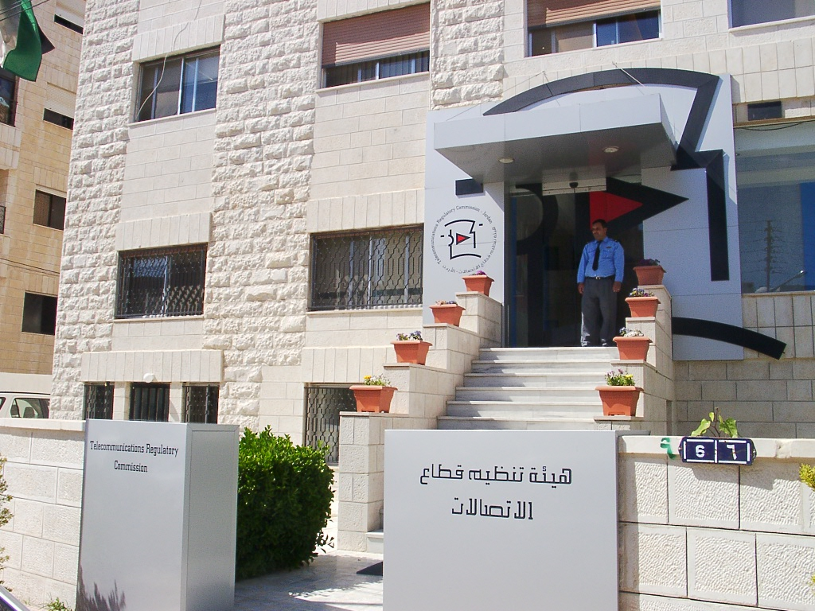
圖1.約旦電信管理委員會
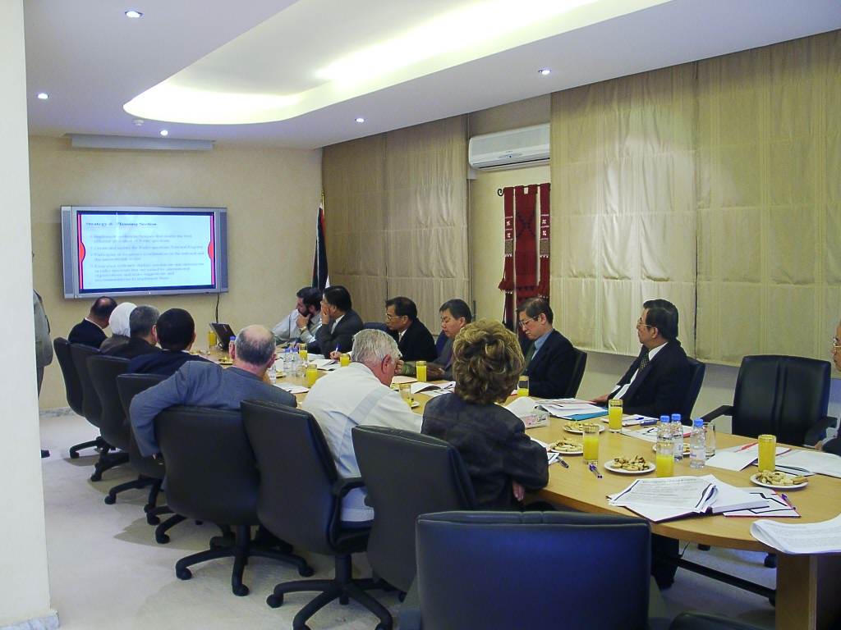
圖2.約旦電信管理委員會簡報
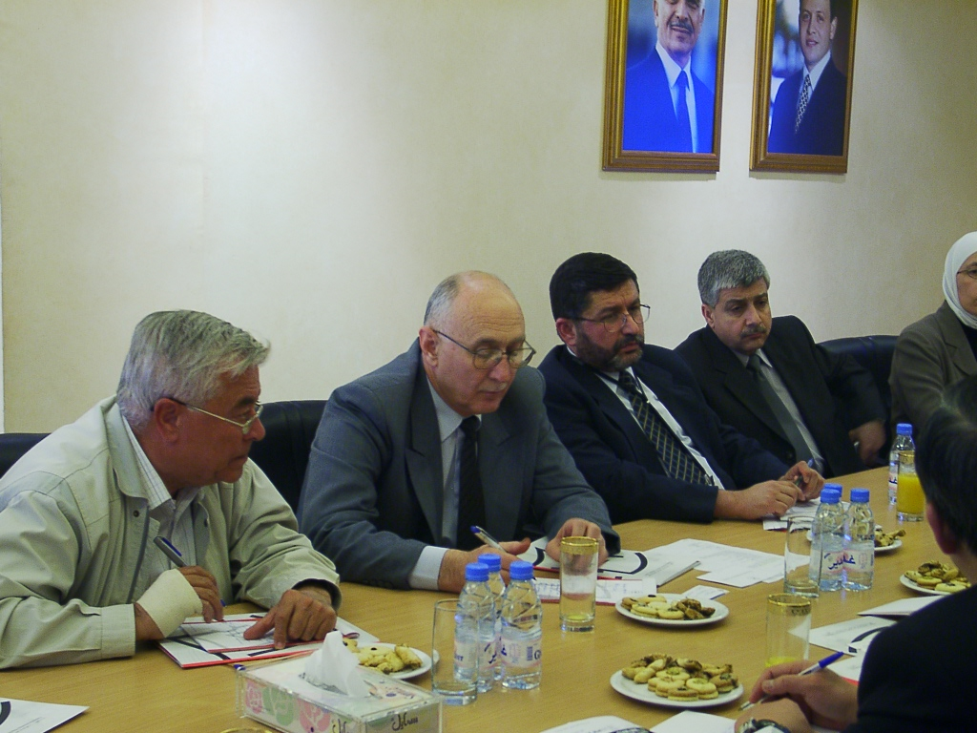
圖3.約旦電信管理委員會副主任委員Dr. Mamoun Balqar（左2）
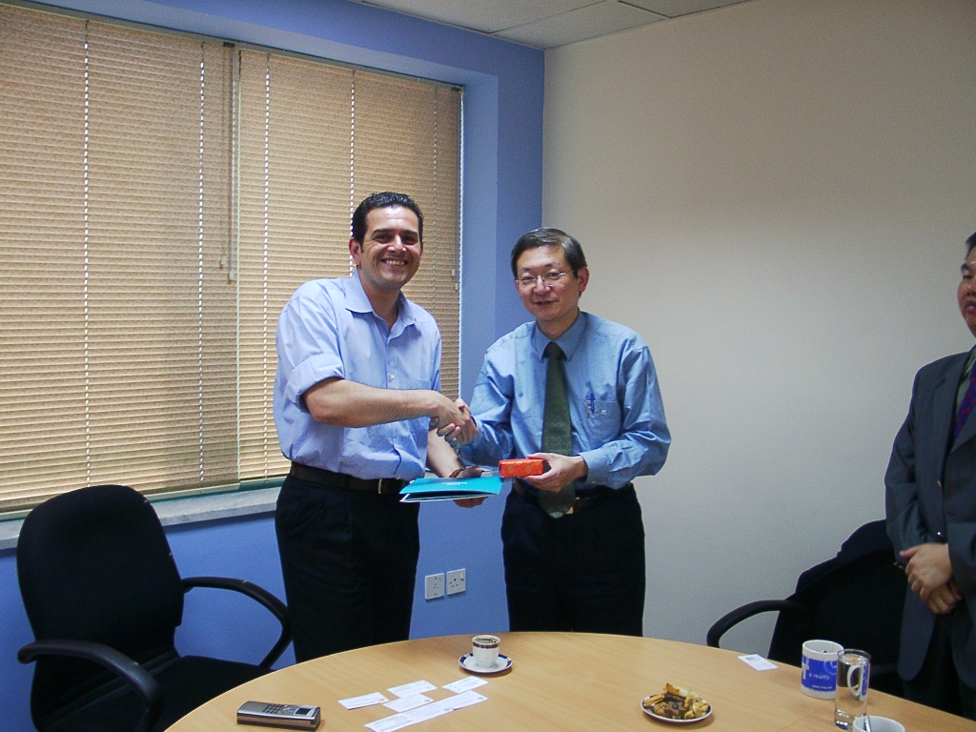
圖4.林主委與INTAJ CEO Ra'ed Bilbessi合影

圖5.團員與資訊通訊科技部CIO合影

圖6.與約旦資訊通訊科技部部長Dr. Fawaz Zu'bi會談-1
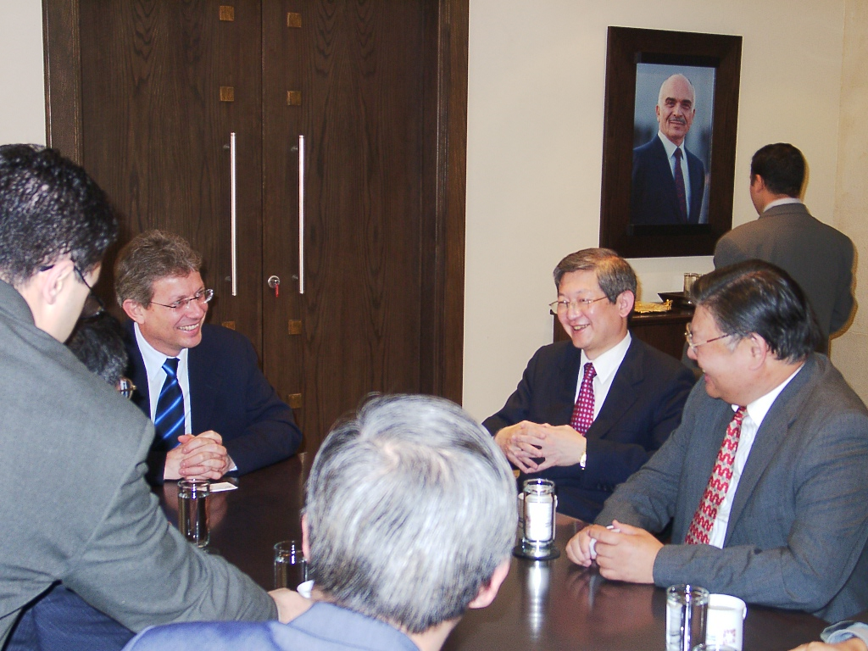
圖7.與約旦資訊通訊科技部部長Dr. Fawaz Zu'bi會談-2

圖8.林主委與約旦資訊通訊科技部部長Dr. Fawaz Zu'bi合影
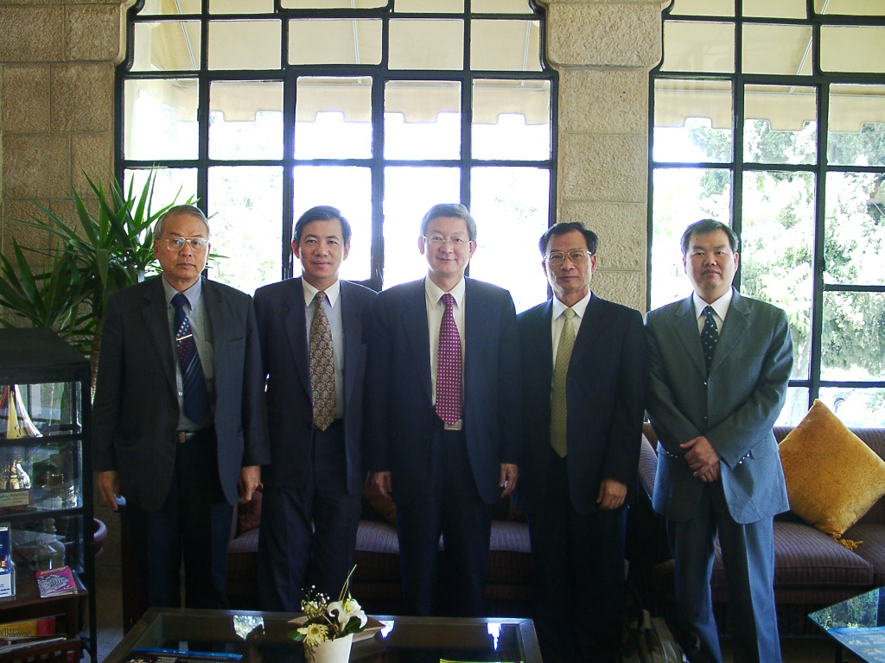
圖9.林主委及團員與駐約旦代表處魏秘書、李組長合影

