行政院及所屬各機關出國報告
(出國類別：出席國際會議 )

參加
The 2nd Asian Particle Technology Symposium 會議
出國報告書

服務機關：國立屏東科技大學
出 國 人 職 稱：教授
姓 名：周春禧
出國地區：馬來西亞檳城(Malaysia pinang)
出國期間：92年12月15日至92年12月19日
報告日期：92年12月17日
摘 要
本次會議在馬來西亞檳城(Penang)的Park Royal Hotel舉行。研討會的口頭報告論文共有30個場次，每一場次平均發表6~10篇文章，全部發表論文超過250篇。此外，大會邀請8位世界知名學者為大會的Keynote Speakers，以及安排研討會之短期課程。同時，大會安排最先進的儀器設備展出。
APT2003研討會之主題涵蓋：Particle and Bulk Powder Characterization; Particle Design, New Technologies & Industrial Applicaltions; Powder Handiling & Multiphase Flow; Solid-Liquid Separation Process。本人的口頭報告論文被安排於(12/17/2003)上午11：30AM至1：00PM的場次。論文題目：The study of static and dynamic wall stresses in a symmetric louvered-wall moving granular filter bed。會議中，部分的論文提出最新的數學模式，應用理論與數值分析的方法探討多相流體的流動行為，波的傳遞，熱傳與質傳。部分的論文提出最新的實驗方法，量測與探討顆粉粒體之特性以及非牛頓性流體的流動行為。部分的論文提出最新的電腦模式，分析與探討氣／固流體的流動行為。
每一位論文宣讀者共有十五分鐘(包括十二分鐘的口頭報告與三分鐘的討論)，因此讓與會者能對於每一篇論文都有相當深入地了解與討論，而且使報告者得以回答較深入的問題。時間控制得宜加上熟練的主持會議技巧，整體而言，會議過程十分圓滿且順利。本人也經由此次會議獲得有關顆粉粒體研究的最近發展及資訊，受益匪淺。不僅交換專業領知識，而且吸收各地風土人情與政治經濟之資訊。參加國際研討會不僅可以獲得相關研究最近發展的資訊，而且可以認識與結交相關領域的學者專家，彼此交換研究心得，獲益良多。

目 次

目的………………………………………………………………….3
過程………………………………………………………………….3
心得………………………………………………………………….4
建議………………………………………………………………….5
附錄………………………………………………………………….6
一、所發表論文

- 目的
參加本次會議的目的為發表研究結果，與世界各國的學者交流，學習新的技術及知識。
- 過程
本次會議在馬來西亞檳城(Penang)的Park Royal Hotel舉行。位於馬來西亞西海岸的檳城州，坐擁最佳的居住環境(即無颱風，無地震以及無火山)，居住在檳城州的華人佔該州人口的60％。
研討會的口頭報告論文共有30個場次，每一場次平均發表6~10篇文章，全部發表論文超過250篇。此外，大會邀請8位世界知名學者為大會的Keynote Speakers，以及安排研討會之短期課程。同時，大會安排最先進的儀器設備展出。APT2003研討會之主題涵蓋：
- Particle and Bulk Powder Characterization
Particle
Characterization
Particle Mechanics &
Tribology
Bulk Powder
Mechanics
Soft Solids Characterization
Online & Inline
Measurements
Particle-Particle
Interaction
Slurry Rheology
- Particle Design, New Technologies & Industrial Applicaltions
Crystallization & Precipitation
Agglomeration & Granulation
Aerosol Process
New Products & Technologies
Flocculation

Comminution, Attrition & Erosion
Nanoparticle Technology
Biological Aspect of Particle Tech.

- Powder Handiling & Multiphase Flow
Fluidization & CFB’s

Bulk Solids
Fluid-Particle Reaction
Modeling of Fluid-Particle Systems
Multiphase Flow
Dynamics of Granular Flow
- Solid-Liquid Separation Process
Membrane Separation
Centrifugal Separation
Gravity Settling
Filtration
Flotation
本人的口頭報告論文被安排於(12/17/2003)上午11：30AM至1：00PM的場次。論文題目：The study of static and dynamic wall stresses in a symmetric louvered-wall moving granular filter bed。會議中，部分的論文提出最新的數學模式，應用理論與數值分析的方法探討多相流體的流動行為，波的傳遞，熱傳與質傳。部分的論文提出最新的實驗方法，量測與探討顆粉粒體之特性以及非牛頓性流體的流動行為。部分的論文提出最新的電腦模式，分析與探討氣／固流體的流動行為。
總之，此次會議的議程非常緊湊，由於每一位論文宣讀者共有十五分鐘(包括十二分鐘的口頭報告與三分鐘的討論)，因此讓與會者能對於每一篇論文都有相當深入地了解與討論，而且使報告者得以回答較深入的問題。時間控制得宜加上熟練的主持會議技巧，整體而言，會議過程十分圓滿且順利。本人也經由此次會議獲得有關顆粉粒體研究的最近發展及資訊，受益匪淺。與會人員來自亞太地區14個國家，宛如置身於國際村。
- 心得
此次會議(APT2003)是由馬來西亞國立大學主辦。研究領域涵蓋顆粒粉體之專業學術領域，參與這樣的會議宛如進入浩瀚的顆粒粉體之學術殿堂，應有盡有，受益良多。
在大會的晚宴中，有機會與來自不同國度的知名學者專家認識(例如：Powder Technology 的主編Professor J. Seville, Advanced Powder Technology的主編Professor K. Higashitani等)。不僅交換專業領知識，而且吸收各地風土人情與政治經濟之資訊。同時，品嚐道地精美的馬來亞西餐點。晚宴進行中，大會準備傳統及精彩的馬來西亞歌舞表演。總而言之，此次會議成功地結合學術與藝術。
- 建 議
參加國際研討會不僅可以獲得相關研究最近發展的資訊，而且可以認識與結交相關領域的學者專家，彼此交換研究心得，獲益良多。行政院相關單位應多協助學者，參與大型的國際研討會。藉此提高國人的研究水準，進行培育未來發展國家科技的人力資源。
- 攜回資料名稱及內容
- 第二屆亞洲顆粉粒體技術研討會議議程及論文摘要。
- 第二屆亞洲顆粉粒體技術研討會議之短期課程講義。

THE STUDY OF STATIC AND DYNAMIC WALL STRESSES
IN A SYMMETRIC LOUVERED-WALL MOVING
GRANULAR FILTER BED

C.S. Chou, J.M. Hu

Department of Mechanical Engineering
National Pingtung University of Science and Technology
Pingtung, Taiwan 912, R.O.C.

Keywords: Louvered-Wall Moving Granular Filter Bed, and Pressure Pulsation.

ABSTRACT

The static and dynamic wall stresses in a symmetric two-dimensional louvered-wall moving granular filter bed were investigated. The static wall stress distribution produced by the granular solids were measured and compared with the theoretical prediction using the differential slice and Runge-kutta (order four) methods. The variations in the dynamic wall stresses with time in a moving granular filter bed were obtained. In addition, the effect of the louver angle upon the wall stresses was investigated. Employing the results obtained using stress measurements, the pressure pulsation phenomenon in a symmetric two-dimensional louvered-wall moving granular filter bed may be further understood. In addition, the research results reported here provide fundamental information for designing a moving granular filter bed for high-temperature flue gas cleanup filter.

INTRODUCTION

Particulate removal from a hot gas stream can be accomplished using cyclones, barrier filters, electrostatic precipitators, granular bed filters or scrubbers (Kuo et al. 1998). The choice of which filter to use is a complicated optimization problem involving emissions, reliability and costs. The most promising alternatives seem to be granular bed filters and barrier filters.
In the moving bed cross flow operations, the filter bed is a vertical layer of granular material, held in place by retaining grids or louvered walls. The gas passes horizontally through the granular layer while filter granules move downwards and are removed from the bottom of the moving filter bed. Apparently, the shape and configuration of the louvers are design features that need special attention. Properly designed louvers can prevent a dense cake from forming on the panel face that may cause plugging, arching and filter media flow stoppage. These plugging and arching problems could cause excessive pressure drops and hamper continuous filter operation. Consequently, moving granular bed filtration requires a filter design that puts no restrictions on the flow of the filter media between the louvered walls.
The flow patterns of filter granules and velocity fields in a granular moving bed with various wall designs were experimentally studied in (Hsiau et al. 1999; Kuo et al. 1998) and numerically studied in (Chou et al. 2000a & b). The main finding of these studies was that stagnant and quasi-stagnant zones could exist in the regions adjacent to the louvers. The influences of the louver angles upon the velocity profiles were also discussed.
Although, in the past, many theoretical, numerical and experimental methods were conducted to explore the stress and flow behaviour of bulk solids in storage silos, less attention has been paid to the pulsating wall stresses in a moving granular filter bed. This research studied the wall stresses in three kinds of 2-D symmetrical filter beds and is the partial work of Chou et al. (2003).

EXPERIMENTAL APPARATUS AND PROCEDURES

A two-dimensional moving granular filter bed was set up to observe the flow patterns of 6 mm plastic spheres and to measure the wall stress during centric discharge. This granular bed consisted of a layer of particulate material sandwiched between two transparent Acrylic panels with louver-like side walls. The granules were fed into a vertical channel from a hopper at the top that had a rectangular discharge slot with the same cross-sectional dimensions as the vertical channel. A granular solid flow was induced and controlled by a moving belt underneath the discharge slot.
The height of the granular bed was 1500mm, the width was 455mm and the depth was 124mm. The granular bed width to depth ratio was kept above 3:1 to promote two-dimensional behaviour. The louver’s angle could be adjusted by placing a wedge shape steel plate between the louver and the vertical section of the side wall. Each of the side walls had six circular holes, reserved for installing pressure gauges. The layout of the pressure gauges and detailed dimensions of the granular filter bed for three tests are shown in Fig. 1.
The pressure gauges, which could measure normal wall pressures and tangential wall shear stresses simultaneously, were calibrated before installation on the side walls. The cylindrical pressure gauges installed on the vertical section of the left side wall are marked L1 to L3 and the hexahedron pressure gauges installed on the convergent section of the left side wall are marked LS1 to LS3 (see Fig. 1). The cylindrical pressure gauges installed on the vertical section of the right side wall are marked R1 to R3 and the hexahedron pressure gauges installed on the convergent section of the right side wall are marked RS1 to RS3 (see Fig. 1).
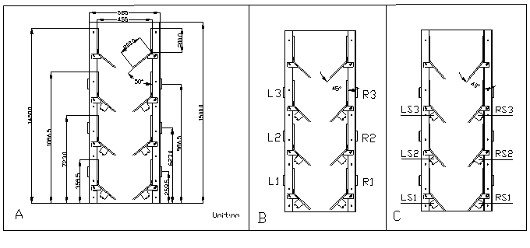
A granular material (6 mm diameter PE spheres with density of 964 kg/m³) was employed in these experiments. The friction angles for the above-mentioned granular material were obtained using a Jenike shear tester and are listed in Table
Fig. 1 The layout of the pressure gauges and detailed dimensions of the granular filter bed for three tests. (a) For Test 1; (b) for Test 2; (c) for Test 3.

TABLE 1 Friction Angles
Granular Particle- Particle- Particle-
Material Particle Side Steel Wall Transparent Acrylic Wall
PE Spheres 26。 8。 12。

Before pouring the granular material into the granular filter bed, the initial voltage for each pressure gauge mounted on the side wall was recorded. After filling the bed with granular material, the static normal and tangential stresses of the granular bed acting on each pressure gauge were measured. The flow rate was controlled and the dynamic normal and tangential stresses acting on each pressure gauge were measured during material withdrawal. The mass flow rate for three tests was controlled and maintained at 0.09-0.1 kg/s during all experiments.

results and discussion

Static Normal Wall Stress Distribution in the Granular Filter Bed
Figures 2 (a)-(b) show the static normal wall stress distribution in the granular filter bed under Tests 1 (louver angle:${\text{50}}^{∘}$) and Test 3 (louver angle:${\text{40}}^{∘}$), respectively. In each frame, the solid line and dashed line represent the theoretical static normal stress distributions with surcharge and under zero surcharge, respectively (Chou et al. 2003). In addition, cross, diamond, square, circle, asterisk and saltire represent the static normal stress measured by pressure gauges L3, LS3, L2, LS2, L1 and LS1, respectively.
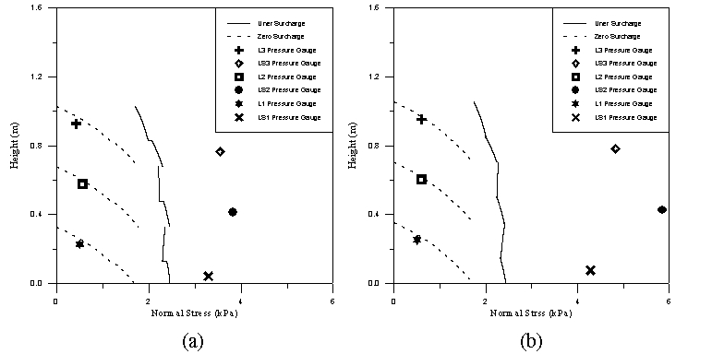
Fig. 2a-b The static normal wall stress distribution in the granular filter bed.
(a)For Tests 1 (louver angle:${\text{50}}^{∘}$); (b) for Test 3 (louver angle:${\text{40}}^{∘}$).

In general, at the vertical section of the louvered-wall, the static normal stress measured by the pressure gauge agreed well with theoretical prediction obtained using the differential slice method under zero surcharge (see Fig. 2). For example, at the vertical section of the third stage, the theoretical and experimental static normal stresses under Test 3 (louver angle:${\text{40}}^{∘}$) were 0.68 and 0.6 kPa, respectively.
In contrast, at the convergent section of the louvered-wall, the static normal stress measured by the pressure gauge was closer to the theoretical prediction obtained using differential slice method with surcharge. For example, at the convergent section of the first stage, the theoretical and experimental static normal stresses under Test 1 (louver angle:${\text{50}}^{∘}$) were 2.44 and 3.29 kPa, respectively. The magnitude of the static normal stress acting on the convergent section is approximately ten times as large as that acting on the vertical section.

Dynamic Response of Stresses on the Wall
Figure 3 demonstrates the dynamic response of normal and shear wall stresses acting on the convergent section of the right-side wall for Test 1 (louver angle:${\text{50}}^{∘}$). Two horizontal dotted lines in each panel in Fig. 3 represent the static normal and shear stresses, respectively. In general, for pressure gauges RS1, RS2 and RS3, the dynamic responses of the normal stress and shear stress have the same trend. In addition, the shear stress value is always smaller than the normal stress value.
When the normal stress measured by pressure gauge installed on the upper stage (e.g. RS3) decreases to zero, the normal wall stress measured by pressure gauge installed on the adjacent lower stage (e.g. RS2) begins to descend and fluctuate under the static normal wall stress (see fig. 3). This stress pulsation is explained as due to the existence of the flowing core and quasi-stagnant zone. The boundary between them is a shear plane where periodical shear failures take place. The shear failure causes a stress pulse that is transmitted through the quasi-stagnant zone to the side wall of the filter bed
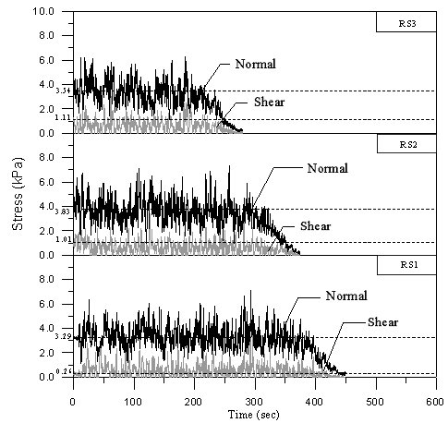
Fig. 3 The variations in dynamic normal and shear stresses with time for Test 1 (louver angle:${\text{50}}^{∘}$). The top panel is for pressure gauge RS3; the center panel is for pressure gauge RS2; the bottom panel is for pressure gauge RS1.

CONCLUSION

The static and dynamic stresses on the wall in a two-dimensional moving granular filter bed were investigated. Filter granules were moved between the two vertical louvered walls of the filter with no interstitial fluid flow relative to the solids. A pulsation phenomenon, which is partially associated with instantaneous and intermittent shear localization, was observed during material withdrawal. The filling method effect on the stress variation and the effect of the insert shape and placement on the stress variation, as well as the flow pattern in a steady flow, are subjects worthy of future study.

ACKNOWLEGEMENT

The authors gratefully acknowledge the financial support from the National Science Council of the R.O.C. for this work through projects NSC 90-2211-E-020-006

REFERENCES

Chou, C.S., Tseng, C.Y., Smid, J., Kuo, J.T., Hsiau, S.S. 2000a. Numerical Simulation of Flow Patterns of Disks in the Symmetric Louvered-Wall Moving Granular Filter Bed, Advanced Powder Technology, 11(3): 279-296.
Chou, C.S., Tseng, C.Y., Smid, J., Kuo, J.T., Hsiau, S.S. 2000b. Numerical Simulation of Flow Patterns of Disks in the Asymmetric Louvered-Wall Moving Granular Filter Bed, Powder Technology, 110: 239-245.
Chou, C.S., Lo, W.F., Smid, J., Kuo, J.T., Hsiau, S.S. 2003. The Flow Patterns and Stresses on the Wall in a Symmetric Louvered-Wall Moving Granular Filter Bed, Powder Technology, 131: 166-184.
Hsiau, S.S., Smid, J., Wang, C.Y., Kuo, J.T., Chou, C.S. 1999. Velocity Profiles of Granules in Moving Bed Filters, Chemical Engineering Science, 54(3): 293- 301.
Kuo, J.T., Smid, J., Hsiau, S.S., Chou, C.S. 1998. Granular Bed Filtration Technology, Proc. Natl. Sci. Counc. ROC(A), 22(1): 17-34.
Kuo, J.T., Smid, J., Hsiau, S.S., Wang, C.Y., Chou, C.S. 1998. Stagnant Zone in Granular Moving Bed Filter for Flue Gas Cleanup, Filtration and Separation, 35(6): 529-534.

