行政院及所屬各機關出國報告提要
出國報告名稱 ：迴轉機振動分析及模式研究
頁數 17 含附件：▓是口否
出國計畫主辦機關/聯絡人/電話

出國類別：口1考察口2進修口3研究▓4實習口5口其他
出國期間：92/10/03- 92/10/16 出國地區：意大利
報告日期：92/12/8
分類/號目
關鍵詞：振動
內容摘要：（二百至三百字）
因只針對迴轉機振動專門議題，得以清楚地了解義國之CESI 公司對於此項議題的研究成果。解決目前振動問題，該國有較先進的做法值得我們學習。簡單描述這次所接觸到之五個主要程式，首先其運用網路將所有運轉所需系統資料及振動值傳遞至監控中心，此程式名稱為SMAV，然後進行診斷。在診斷的部分，有連結SMAV程式所取得振動及運轉相關參數之程式，其名稱為EVA，功能為比較參數之變異性，然後整理成變異相關函數，由此變異可追查振動問題的主因。另一個診斷程式為我們熟悉之模式計算程式，名稱為DYNARO，其功能較之目前市面上程式多了一個，即非軸對稱之計算功能。在轉子平衡方面，當然也秀了一個專門處理平衡問題的程式ABACO。除此之外，還有一個值得一提的程式，即 ADNANT，主要功能為做系統判別，將DYNARO 所計算之結果，以ID 方法獲得最佳系統參數，自動逼真現場實際振動系統。以上五個程式強大的組合，解決很多困難的振動問題。雖部分需使用人工結合及判斷，已經是目前最完整的程式了。如果以目前我們的判斷條件，其成功之處值得我們虛心學習。

本文電子檔已傳至出國報告資訊網（http//report.gsn.gov.tw）

目錄：
- 緣起
- 行程
- 實習心得
- 簡述轉子振動分析方法
- 有關本次研習之相關問題
- 有關本次研習問題－CESI 之答覆
- 結論
- Reference Paper

一、緣起:

此次出國研習中，因只針對迴轉機振動專門議題，得以清楚地了解義國之CESI 公司對於此項議題的研究成果。解決目前振動問題，該國有較先進的做法值得我們學習，也值得與其交流。簡單描述這次所接觸到之五個主要程式，首先其運用網路將所有運轉所需系統資料及振動值傳遞至監控中心，此程式名稱為SMAV，然後進行診斷。在診斷的部分，有連結SMAV程式所取得振動及運轉相關參數之程式，其名稱為EVA，功能為比較參數之變異性，然後整理成變異相關函數，由此變異可追查振動問題的主因。另一個診斷程式為我們熟悉之模式計算程式，名稱為DYNARO，其功能較之目前市面上程式多了一個，即非軸對稱之計算功能。在轉子平衡方面，當然也秀了一個專門處理平衡問題的程式ABACO。除此之外，還有一個值得一提的程式，即 ADNANT，主要功能為做系統判別，將DYNARO 所計算之結果，以ID 方法獲得最佳系統參數，自動逼真現場實際振動系統。以上五個程式強大的組合，解決很多困難的振動問題。雖部分需使用人工結合及判斷，已經是目前最完整的程式了。如果以目前我們的判斷條件，其成功之處值得我們虛心學習。

二、行程
此次出國行程中只針對迴轉機研究，因此僅選擇CESI 公司。其原本是意大利國營電力公司ENEL 公司之研究部門，於近年獨立為處理電廠問題以及各種應用之研究型公司。參訪實習之單位為為發電研究部門，其中所接觸之主管為 Dr. Cario De Michelis, 儀器設備之 Gianluca Lapini 經理，Generation Process 之Luca Gregori 經理、Angelo Schiappacasse經理，以及振動專家Dr. Zenta。

三、實習心得
整個轉子振動分析是一個複雜的過程，因為埋藏在信號裡的內容需要訊號知識、轉子動力學知識、運轉參數等之配合，其量大而繁複，尤其須處理多種設備多種問題。在現今的條件下，使用以往方法如試誤法、人工蒐集、計算將被淘汰。唯有豐富知識配合功能完備的軟體，方可完成此項艱鉅之任務。以下幾個軟體為信號擷取到完成振因分析之一系列完整程式，部分內容在簡介中有略述，下列為訊號擷取之SMAV內容：
The use of computer systems for vibration monitoring of large rotating machinery in power plants has become for many years a common practice and, by now, the new plants are almost always equipped with complete instrumentation sets and new vibration monitoring systems. These systems were mainly born for diagnostic purposes and have been traditionally used to continuously collect data, so as to provide the vibration specialist with a reliable and comprehensive set of information whenever a major problem was pointed out by the plant staff.
In the last few years, there has been an increasing request to use vibration analysis as an integrating tool in order to implement predictive maintenance policies. This last result would constitute a definite pay-off for the introduction of monitoring systems.
At the same time, it has become increasingly easier and cheaper to transfer huge quantities of data from different plant stations to a central location, so as to concentrate analysis capabilities and requirements for specialised resources. That calls for the need of dealing with very large amounts of incoming data, that should be appropriately and timely analysed as a routine operation. Therefore, full exploitation of the potential benefits of monitoring systems in such an organization calls for an early, reliable and automatic detection of deviations from the normal vibrational behaviour. However it can be recognized that this is not yet a consolidated result, in spite of the many claims to this purpose.
A number of approaches to this problem have been proposed, with different criteria and levels of complexity. Whatever is the chosen solution, all of them require the definition of a reference model for the vibration response of the machine. Most times, this process has to be repeated from time to time in order to adapt to the inherent changes of the machine behaviour.
For the remote monitoring of a number of machines, this can become a repeated and tedious task, with possibly unreliable results.
The present paper is mainly devoted to illustrate some criteria and procedures that allow for the automatic definition and validation of the reference model, with particular attention to the data collected during on-load conditions. Another key point for the effective application of the monitoring systems is to avoid the generation of too many false alarms, while preserving the timeliness of true alarms. The comparison of the output provided by different indicators can be a valuable tool for qualifying the generated alarms. In the paper different approaches for the early detection of faulty conditions are discussed and the application to large data sets obtained from real machines is illustrated.

以下為模式計算之DYNARO程式、整合之ADVANT程式、以及訊號判別之EVA程式。

A. DYNARO程式為模擬電廠中轉動元件之動態行為。其為有限元素法分析軟體，用以模擬轉動機械之振動情形，不僅適用於氣渦輪機，亦可用在飼水幫浦、馬達以及風扇。DYNARO可針對轉子與軸線之同步化、以及軸與軸間的耦合做以下運算：
- 靜態同軸性 (Static alignment)
- 穩定性分析 (Stability analysis)
- 穩態時之受力反應 (Steady state forced response)
- 水平振動之敏感度分析 (Sensitivity analysis for lateral vibration)
- 扭力之特徵頻率 (torsional eigenfrequencies)
- 瞬間激發時的扭力反應 (Torsional response to transient excitations)
瞬間速度所導致的振動、新設計機組之評估，可做為診斷工具，模擬各種不同的故障情形。其功能可計算一連串的設定，以及軸承的靜態負載，也可根據設計參數，計算出臨界速度並針對轉子、軸承以及支撐系統進行敏感度分析，計算左右之特徵向量具有資料庫，可模擬多種不同形式的撓曲、變形，包括不平衡(unbalanced)、圓盤傾斜(disk skew)、耦合錯誤(coupling errors)、不同軸(misalignment)等；此為導致轉動元件發生故障最常見的原因。

B. ADVANT（Automatic Diagnosis by Vibration Analysis of Turbogenerator rotor
）程式將模式計算DYNARO程式結果及實測訊號SMAV程式自動調和，下圖為其關係運作圖。

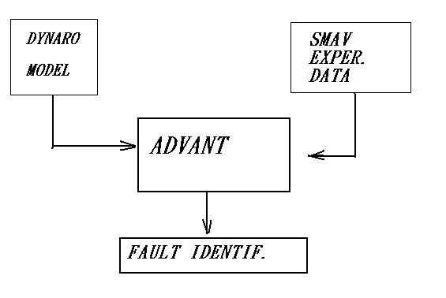

下圖為 ADVANT 作unbalance identification 之過程，在模擬結果與實際訊號所隱藏之振動模式之間，使用人工調和將費時費力，此程式可解決此問題。

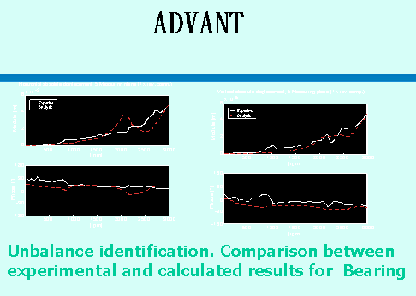
C. EVA（Automatic Vibration Evaluation
）
此程式實際運作如下圖，運用Fuzzy control 觀念來決定下圖圓圈部份之正常及異常問題。

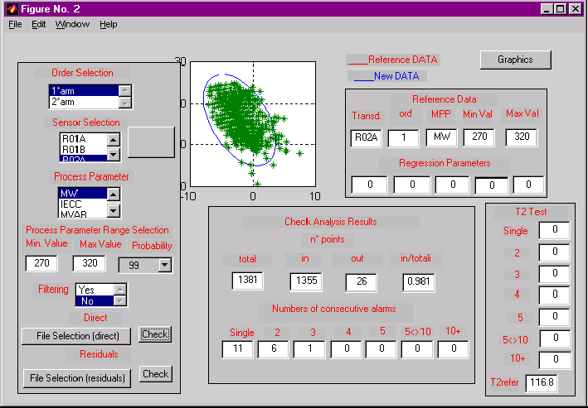

Typical graphic output for visual inspection of results with acceptance regions
and T2 tests. No faults in the data examined.

下圖為EVA程式處理所列之問題

EVA程式可以認知主訊號組成成分，以三種方法－ Acceptance、Modified-T2 test 及Deformation shape 之 model 完成判別。

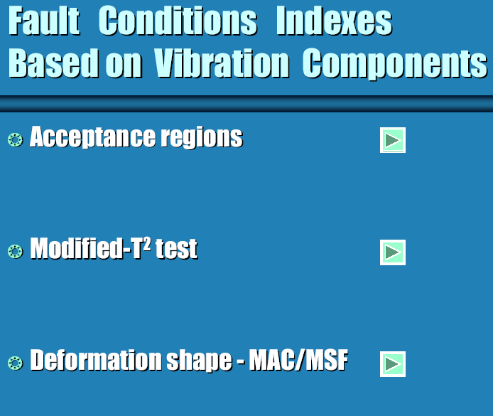

除主訊號外，以 Residual signal 來做分析及預測

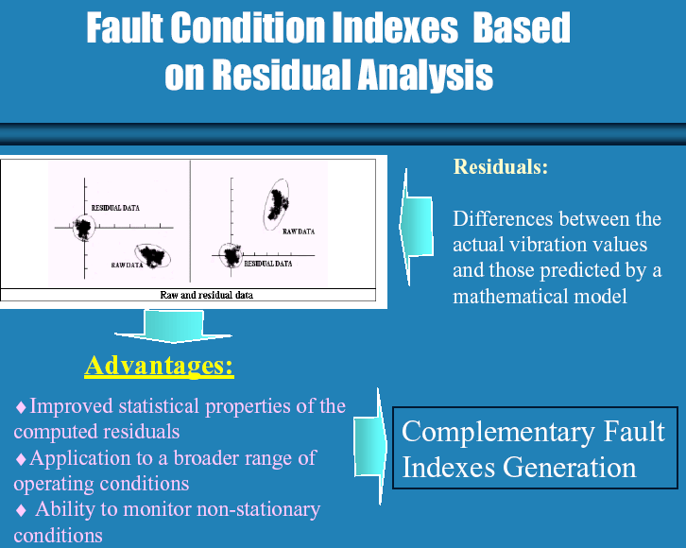

四、簡述轉子振動分析方法
有關振動基本原因分析方法有很多，如 R. ISERMANN【1】所提出，用各種分析模式或參數判別，但能運用在轉子振動研判則僅有以下兩種方式。其一為定性之訊號分析方法，以經驗知識為基礎，對振動問題解析而獲得結果，此乃所謂之專家系統。其發展歷史已經很久，但一直沒有很好使用，近年更多研究成果及結合電腦網路的運用後，先進國家競相發展，有些以模糊控制理論及神經網路功能之結合【2】而後有很好的結果。 此次出國所看到的CESI 作法為處理振因特徵 （Fault-Symptom）為矩陣式，以樹狀結構及模糊邏輯（Fuzzy logic）判斷及分類何種振因特徵，也使用神經網路（ Artificial Neural Networks）複製振因之結合上述判斷結果。
另一種為定量之模式分析方法，此法為運用可靠之模型計算，模擬其振因
結果，然後運用系統判別方法鑑別輸入輸出。
本所目前之虛擬轉子計畫所預定達成的目標大致與CESI 相同，Aesop 程式功能與Dynaro 類似，而虛擬轉子計畫未來目標與處理方法 與ADVANT 相同，其他如EVA 程式不在目前規劃範圍。CESI 在這方面已研究20餘年，且花費大量人力物力，才有今天的結果。看看別人想想自己，為迎頭趕上或並駕齊驅，值得與其合作併學習其長處。

五、有關本次研習之相關問題
除上述相關之各種程式資料研習外，提出問題尋求解答也助益匪淺。從中獲得建構理想程式的做法、如何模化軸裂、如何模化軸承及機座….等，以下是所提之問題：
- How to model the blades/ bladed disk in the modeling of rotor systems?
- About the program of DYNARO and SMAV, how to match the unbalance response of computation and measurement. (Response of transient and steady state?)
- About the program of DYNARO, how to model Gyroscopic effect and alignment?
- About the program of DYNARO, can instability problem be modeled ?- oil whirl, steam whirl, …
- Model of Bearing, Coupling, and Foundation.
- How to do balancing by using measured response data of one or two run up/coast down only?
- How to model coupling misalignment and rubbing in the DYNARO program?
- How to predict/calculate the fluid interaction forces between the turbine blades/impeller and casing?
- How to predict/calculate the electromagnetic interaction forces between the rotor and stator of the generator?
- In the modeling of breathing cracks, users supply the absolute minimum (fully open) and maximum (fully closed) stiffness values. How does DYNARO interpolate/obtain the stiffness for partially open cracks? By assuming the stiffness change is in the form of a sinusoidal curve?
- How to obtain/prepare the input data for disk skew and initial bend/kink? And how to distinguish the responses due to unbalance and initial bend?
- In the static alignment calculation, the rotor is assumed to be subject to rigid offsets of the pedestals, Does that mean the stiffness of the pedestals is set to be infinitive? What does the “rigid offsets of the pedestals” mean?
- In the static alignment calculation, the static deflection of the shaft-line and bearing loads are calculated based on the rotor modeling with the bearing coefficients supplied by the baring database or the journal bearing analysis programs. But the bearing coefficients depend on the bearing loads. Does DYNARO use iteration procedures to update the bearing loads and coefficients until convergence?
- Can DYNARO uses updated bearing coefficients in the catenary line calculation, instead of using rigid supports?
- Is that possible that we can obtain a Demo version or trial version of DYNARO in order to see the capability of DYNARO and how to interactively change the input data?
- Requested paper：

- R. Isermann, “Fault Detection and Diagnosis-Methods and Application”, 2nd International Symposium on Acoustical and Vibratory Surveillance Methods and Diagnostic Techniques, 10-12 October 1995 Senlis, France.
- R.Markert, R. Platz and M. Siedler, “Model Based Fault Identification in Rotor Systems by Least Squares Fitting”, ISROMAC-8 Conference, 26-30 March 2000, Honolulu, Hawaii, 901-905
- R. Platz, R. Markert and M. Seidler, “ Validation of Online Diagnostics of Malfunctions in Rotor Systems,” IMechE-7th Int. Conf. on Vibrations in Rotating Machinery, 12-14 September 2000, University of Nottingham, UK, 581-590
- R. J. Patton, S. Simani, S. Daley and A. Pike, “Identification and Model-based Fault Diagnosis of a Gas Turbine System,” Surveillance 4-Acoustical and Vibratory Surveillance Methods and Diagnosis Techniques, 16-18 October 2001, Compiegne, France, 27-48
- N. Bachschmid and P. Pennacchi, “Model Based Malfunction Identification from Bearing Measurements,” IMechE-7th Int. Conf. on Vibrations in Rotating Machinery, 12-14 September 2000, University of Nottingham, UK, 571-580
- N. Bachschmid, A. Vania, E. Tanzi and P. Pennacchi, “Identification and Simulation of Faults in Rotor Systems: Experimental Results,” EURO DINAME 99-Dynamic Problems in Mechanics and Mechatronics, Wissenschaftszentrum Schloss Reisenburg der Universitat Ulm, 11-16 July 1999, Gunzburg, Germany, 3-11
- N. Bachschmid, P. Pennacchi, E. Tanzi and A. Vania, “Accuracy of Modeling and Identification of Malfunctions in Rotor Systems: Experimental Results,” Journal of the Brazilian Society of Mechanical Sciences, XXII, 3, 423-442
- N. Bachschmid, P. Pennacchi, E. Tanzi and S. Audebert, “Identification of Transverse Cracks in Rotor Systems,”, ISROMAC-8 Conference, 26-30 March 2000, Honolulu, Hawaii, 1065-1072
- N. Bachschmid, P. Pennacchi and S. Audebert, “Some Results in Model Based Transverse Crack Identification in Rotor Systems,” CONEM 2000-Congreso Nacional de Engenharia Mecanica, August 7-11, 2000, Natal, Rio Grande do Norte, Brasil.
- N. Bachschmid, P. Pennacchi, E. Tanzi and A. Vania, “Identification of Transverse Crack Position and Depth in Rotor systems,” Meccanica, International Journal of the Italian Association of Theoretical and Applied Mechanics, Vol. 35, n. 6, 2000, 563-582.
- A. Vania, N. Bachschmid and P. Pennacchi, “Analysis of Light Rotor-to-Stator Contacts in Large Turbine-Generator Units,” Surveillance 4-Acoustical and Vibratory Surveillance Methods and Diagnosis Techniques, 16-18 October 2001, Compiegne, France, 27-48
- N. Bachschmid, P. Pennacchi and A. Vania, “Identification of Multiple Faults in Rotor Systems,” Journal of Sound and Vibration.
- R. Platz and R. Markert, “Fault Models for On-Line Identification of Malfunctions in Rotor Systems,” Surveillance 4-Acoustical and Vibratory Surveillance Methods and Diagnosis Techniques, 16-18 October 2001, Compiegne, France, 435-446
- R. Liebich, ”Rub Induced Non-Linear Vibrations Considering the Thermo-elastic Effects,” IFToMM 5th International Conference on Rotor Dynamics, September 1998, Darmstadf, Germany.
- N. Bachschmid, P. Pennacchi and A. Vania, “Spiral Vibrations Due to Rub: Numerical Analysis and Field Experiences,” Schwingungen in Rotierenden Maschinen V, Vieweg Verlag, Braunschweig/Weisbaden, Germany, 2001, 61-74.

六、有關本次研習問題－CESI 之答覆
  - How to model the blades/ bladed disk in the modeling of rotor systems? >> The blades contribute to the rotordynamics essentially as an added mass to the relevant rotor section. Therefore bladed disks are modeled by increasing the equivalent mass diameter. Whenever the rigid part of the disk and the blades themselves are judged to have a remarkable gyroscopic contribution (it is sometimes the case for the last bladed disks of LP steam turbines), DYNARO provides the possibility to attach rigid disks with mass and polar moments of inertia to the appropriate section.
  - About the program of DYNARO and SMAV, how to match the unbalance response of computation and measurement. (Response of transient and steady state?) >> Experimental data acquired by SMAV during speed transient responses are used to tune the rotordynamic model of DYNARO, by trial and error process, in order to obtain the best fitting of critical speed and modal damping values. Both steady state and transient responses obtained by SMAV are subsequently used in the diagnostic process, by obtaining the best curve fitting with different hypothesis about the fault type, location, dimension and phase. The diagnostic process is performed to a large extent automatically in the ADVANT code, which uses both SMAV data and the DYNARO model.
  - About the program of DYNARO, how to model Gyroscopic effect and alignment? >> Gyroscopic effects are modeled by the addition of rigid disks, to which the gyroscopic effects can be associated. The effects of misalignments can be modeled by the pedestal positions that determines the static loads on the bearings; the last ones in turns determine a variation in the stiffness and damping properties of the oil-film bearings.
  - About the program of DYNARO, can instability problem be modeled ?- oil whirl, steam whirl, >> The damped critical speed computation option and the associated Campbel diagram show the possibility of occurrence of instability problems. Oil-whirl and oil-whip are consequent to oil-film bearing properties only. If steam whirl is suspected, a dummy bearing should be added in the appropriate shaft section with stiffness and damping matrices appropriate to describe steam whirl effects; consequently the instability can be studied again by means of the modal damping associated to the critical speeds.
  - Model of Bearing, Coupling, and Foundation. >> For the bearing schematization there are three possible options : A) a built-in model of DYNARO that computes the bearing properties starting from geometry, oil temperature and thermodynamic properties and bearing load; in this case only cylindrical bearings are accounted for. B) tabular values in a database as a function of the Sommerfeld number; the most common type of bearing are already included (cylindrical, partial arc, tilting pad, multilobe), but the database can be expanded by the user at any time with additional bearings. C) Stiffness and damping matrices can be directly assigned, as a function of speed. +++ Couplings are always rigid; flexible couplings can be modeled by appropriately acting on the section properties at the flexible coupling location; skew and eccentricity coupling faults can be considred among the forces acting on the rotor. +++ The foundation is accounted for by means of 2x2 mass and stiffness matrices at each bearing, with the possibility of coupling the vertical and horizontal directions. Proportional damping can be introduced. The matrices can be variable with speed.
  - How to do balancing by using measured response data of one or two run up/coast down only? >> Question to be clarified.
  - How to model coupling misalignment and rubbing in the DYNARO program? >> Both skew coupling misalignments and rubs can be modeled by DYNARO as local bends; the coupling eccentricity can explicitly be modeled as well. All these faults can be combined in whatever configuration you want.
  - How to predict/calculate the fluid interaction forces between the turbine blades/impeller and casing? >> Once again these effects can be introduced by the addition of dummy bearings at the appropriate shaft sections, by use the assigned matrix option for describing the equivalent bearings. The correct values for the matrices must be obtained from the literature or other sources.
  - How to predict/calculate the electromagnetic interaction forces between the rotor and stator of the generator? >> Interaction forces between generator and stator can be simply represented by means of radial forces on the generator. The values for these forces must be obtained from the literature or other sources. In our experience and in practical cases this effect is very seldom of some importance on large generator rotors.
  - In the modeling of breathing cracks, users supply the absolute minimum (fully open) and maximum (fully closed) stiffness values. How does DYNARO interpolate/obtain the stiffness for partially open cracks? By assuming the stiffness change is in the form of a sinusoidal curve? >> The breathing crack is modeled by assigning the equivalent stiffness diameters in the weak and stiff directions, together with the relevant angles, for both the instant of maximum and minimum crack opening. Then DYNARO performs a Fourier transform of the equivalent stiffness function and computes up to the four harmonic component of the Fourier development. Details are given in the DYNARO user’s manual.
  - How to obtain/prepare the input data for disk skew and initial bend/kink? And how to distinguish the responses due to unbalance and initial bend? All the forcing functions are very easily described, even with different options, in the “*.dfr” input files. Unbalnce and bend can be separately described in the input. In practice, the unbalance is a function of the square of the speed and at low speed does not show any residual eccentricity at low speed; bends and kinks produce an equivalent constant force versus speed and produce low speed eccentricity.
  - In the static alignment calculation, the rotor is assumed to be subject to rigid offsets of the pedestals, Does that mean the stiffness of the pedestals is set to be infinitive? What does the “rigid offsets of the pedestals” mean? >> No, in the alignment calculation pedestal receptances are accounted for. Rigid offsets of pedestals only means that the static loads at bearings are computed considering different elevations at the pedestals, the last ones being either directly assigned by the user, or computed in the catenary option by DYNARO. In this last cases the pedestal stiffness is set to an infinite value.
  - In the static alignment calculation, the static deflection of the shaft-line and bearing loads are calculated based on the rotor modeling with the bearing coefficients supplied by the bearing database or the journal bearing analysis programs. But the bearing coefficients depend on the bearing loads. Does DYNARO use iteration procedures to update the bearing loads and coefficients until convergence? >> Yes, exactly. For this computation DYNARO uses its own built-in model for the oil-film properties, which only allows for cylindrical bearings. This is the only assumption made in this computation.
  - Can DYNARO uses updated bearing coefficients in the catenary line calculation, instead of using rigid supports? >> The catenary line is computed assuming that both pedestals and oil-film bearings are rigid. This is to fully simulate the actual coupling sequence during the installation and maintenance operations on the plant. The “catenary” option has not to be confused with the “static alignment” option; it is in the second case (“static alignment computation”) that the true pedestal and oil-film stiffness are introduced for any speed of interest.

七、結論
- 好的轉子動力分析技術需靠學理及經驗。
- 完整而實用的分析程式可快速獲得分析的結果並彌補人力之不足。
- 建構完整實用的分析程式則需有龐大人力物力。
- 先進技術的取得可縮短研發並強化解決問題的能力。
- 建立一個診斷中心，除訊號技術外，需要好的振動模式

八、Reference Paper
（1）R. Isermann, “Fault Detection and Diagnosis-Methods and Application”, 2nd International Symposium on Acoustical and Vibratory Surveillance Methods and Diagnostic Techniques, 10-12 October 1995 Senlis, France.
（2）R. J. Patton, S. Simani, S. Daley and A. Pike, “Identification and Model-based Fault Diagnosis of a Gas Turbine System,” Surveillance 4-Acoustical and Vibratory Surveillance Methods and Diagnosis Techniques, 16-18 October 2001, Compiegne, France, 27-48

