行政院及所屬各機關出國報告
(出國類別：實習)

研習「市場情報蒐集分析研判及策略研擬方法」
(Studying the Research Methodology for Analyzing Telecom Markets)

服務機關：中華電信研究所
出國人 職 稱：研究員
姓 名：洪志成
出國地點：新加坡
出國期間：90年10月21日至90年10月27日
報告日期：91年1月15日
摘要

依據公司經營方針：『市場、行銷作前導，網路、技術作後盾』，為有效進行新業務與新服務的市場開發，有必要研習國外市場顧問公司之市場分析方法，一則可有效收集市場分析所需資訊項目，二則可更精準地擬定市場行銷及相關經營策略。依據市場研究顧問公司Frost & Sullivan邀請函，參與「市場情報蒐集分析研判及策略研擬方法」為期七天(含行程二天)之海外研習 (Studying the Research Methodology for Analyzing Telecom Markets)，包括市場分析方法、及重要業務之市場概況，有助於提昇本公司人員，在企業客戶市場之研究及行銷策略擬定之能量。

1. 出國研習行程及項目

90.10.21 桃園國際機場09:00 CI 660 ~ 新加坡樟宜機場 14:00
90.10.22 ~ 10.26 研習(09:00 ~ 17:30)
90.10.22 Introduction & Backgroung

90.10.23 ~ 24
Market Analysis Methodology
- StrateCast Market Analysis Methodology
- Frost & Sullivan Market Analysis Methodology

90.10.25 Frost & Sullivan’s View of Key Services Markets
- IDC & ASP
- IP-VPN
- WLAN

90.10.26 Conclusion & Recommendations for Reference
- Frost & Sullivan Point of View

90.10.27 新加坡樟宜機場09:00 CI 661 ~ 桃園國際機場15:00

2. Stratecast Market Analysis Methodology

Business Domains of the New Public Network :

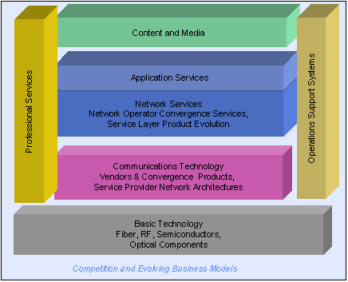

Stratecast

This is a division of Frost & Sullivan, which focuses on a very high level of strategic consulting for the telecommunications industry. The positioning of Stratecast Partners is best illustrated through the following graph:
Stratecast Focus on Strategic Analysis :

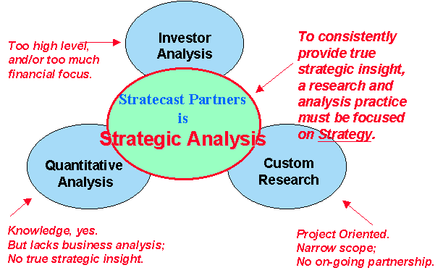

Stratecast Partners focuses on five major research areas and this is best illustrated through the following diagram:

The specific subscriptions available from Stratecast are as follows:
- COS: Competitive Operator Strategies
- COS II: Focus on Tier II Competitive Operator Strategies
- CSNA: Convergence Strategies & Network Architectures
- OSSCS: Operations Support Systems Competitive Strategies
- DSGS: Data/Internet Growth Strategies
- HOSTS: Application Hosting Strategies and Technologies
- SPIE: Strategic Partners Insights for Executives, a weekly deliverable with strategic insights into the major developments in the telecommunications industry.

Stratecast Research Methodology

Stratecast has a team of analysts which have over a century of applied strategic and domain specific expertise. Stratecast uses a collaborative research and collaborative analysis approach to develop its products. A team of two to four domain specific strategists will conduct interviews with senior management of the market participants. Subsequently this team will discuss and form opinions which will is provided in the subscription service.

Methodology

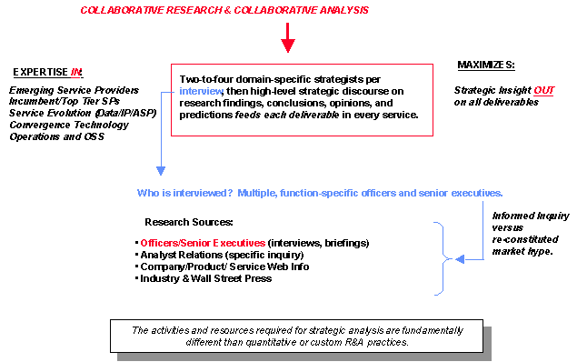

3. Frost & Sullivan Market Analysis Methodology

Frost & Sullivan Research Methodology

Market Engineering Research methodology can be summarized as follows:

1. Define Market Challenges and Opportunities. At this stage, the project team identifies the business issues, which require investigation.

2. Determine Project Objectives and the Consulting Approach. The team determines the Consulting methodology, which must be implemented to address the client’s research objectives.

3. Create Optimal Project Team. Each project’s success is based on a well-developed, diverse team.

4. Launch Data Collection Phase. During this phase, the project team designs and implements the data collection process.

5. Design Interview Strategy. Skilled interview design analysts construct effective survey instruments to optimize information flow and quality.

6. Test Survey Design. The research team tests interview surveys extensively for clarity and accuracy before they are implemented on a large scale.

7. Conduct Primary Research. The core of every study is the primary data coming directly from industry participants.

8. Analyze Research and Determine Market Position. The research team now begins to identify the most important part of any consulting project: Where is the market today?

9. Perform Market Analysis and Forecasting. At this stage, the project team analyses the market in relation to technical trends, market dynamics and future directions.

10. Develop Strategic Recommendations. Experience and analytical insight combine to drive action-oriented recommendations.

11. Confirm Results with Quality Control. All text and figures are verified for accuracy.

12. Implement Market Monitoring and Customer Feedback. Analysts review results with clients and continue to track the market.

How Frost & Sullivan Helps Its Clients
Frost and Sullivan applies its market consulting expertise to a range of business applications. Given the central role of market measurements in our methodology, our consulting services are aimed in particular at the outward, or market, facing functions of an organization. These functions as well as the business issues faced by each of them are summarized below.

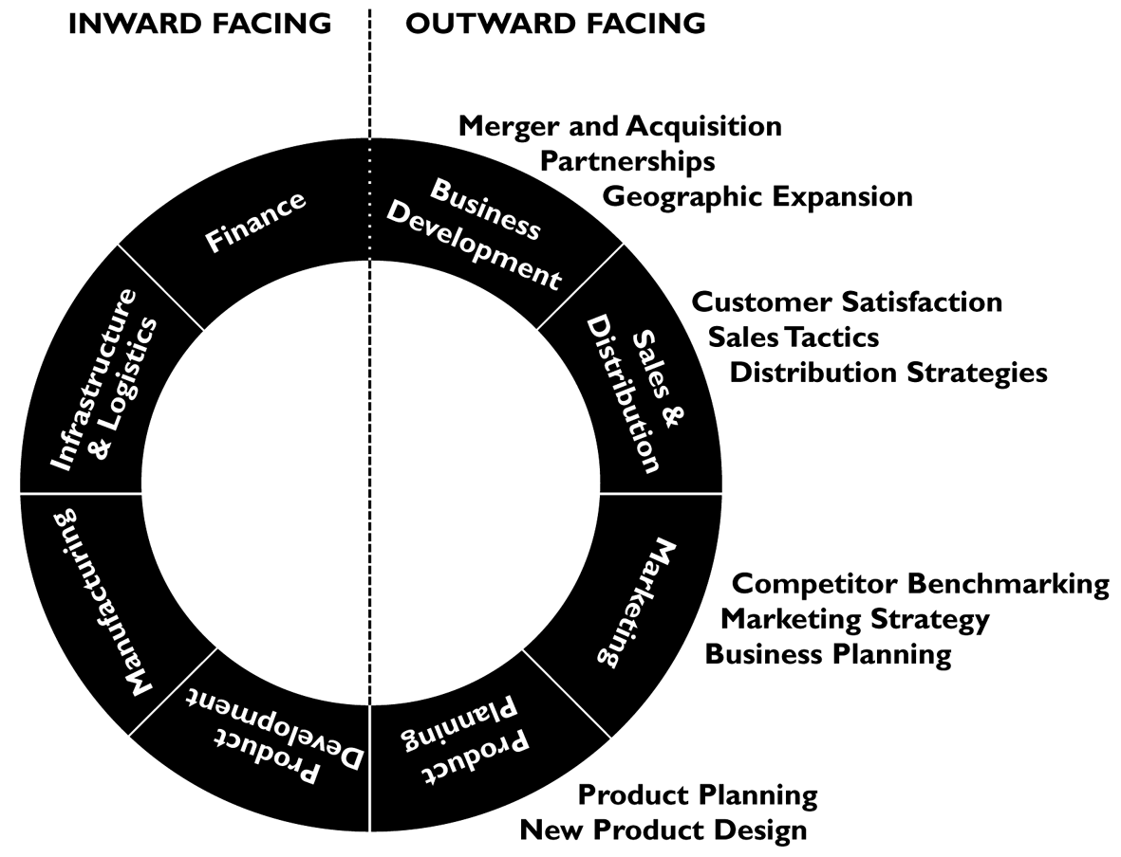

Frost and Sullivan has a range of consulting products with which it can address the information needs of its clients. These range from a simple review of secondary information sources to an international primary research and strategic analysis program. Generally speaking, the more significant the business challenge or opportunity faced by our clients, the greater the strategic consulting element of our services. This is illustrated below.

Frost & Sullivan Consulting Capabilities

Frost & Sullivan provided a good overview of its capabilities in Consulting. It basically works on three major types of consulting projects:

- Market Engineering Projects
- Customer Engineering Projects
- Competitor Engineering Projects

Frost & Sullivan provided a case study for each of these three types of consulting projects which the company has recently done in Asia Pacific. The third case study on competitive intelligence is interesting as it also involves scenario planning and analysis. The slides of this presentation are available in file consulting.ppt.

4. Key Services Markets

ASP and Data Centers

Frost & Sullivan made a presentation on the ASP and Data Centers market in Asia Pacific. We discussed the key challenges facing the Data Center service providers, namely the over supply situation in the market. This has happened as the demand for this was heavily dependent on the basis of a rapid growth of e-commerce and the dot com companies. With the burst of the internet bubble, so also the demand for the hosting solutions have gone down. This has resulted in intense price competition in the market.

Frost & Sullivan’s recommendation to Chungwa Telecom was that, there will be a consolidation trend in the Data Center market. Only long term players will be able to sustain themselves in the market. As a result, Chunghwa Telecom should keep an eye on the major competitors and focus on winning away key customers who are likely to emerge as big competitors in the e-market place. Frost & Sullivan also anticipates that brick and mortar companies are likely to emerge as dominant players in the new internet economy and Chunghwa should focus on getting these customers.

Presentation slides are attached in file asp-datacenter.ppt.

IP VPN

Frost & Sullivan had a discussion on the preliminary findings of the ongoing IP VPN market study in Asia Pacific. Frost & Sullivan emphasized that it relies heavily on primary research to meet the research objectives. It is estimated that close to 60 percent of the analysts time on any project is usually allocated for extensive primary research on the subject.

Other issues on IP VPN which were discussed:
- Almost all major carriers in Asia Pacific are offering IP VPN services to their customers. In addition there are the global players like MCI Worldcom, Equant and Infonet which are also offering these services to the customers.
- Benefits of IP VPN: We discussed why companies are adopting IP VPN as against traditional services such as frame relay, etc. The benefits of IP VPN and the security issues relating to the same.
- How service providers are introducing IP VPN while at the same time trying to minimize the impact on their traditional service offerings such as frame relay.
- The market segmentation and the adoption trends of IP VPN. The initial findings have suggested that it has been the SMEs which have the best value proposition to opt for an IP VPN service offering.

Wireless LAN in Public Hotspots

The Frost & Sullivan team made a presentation on some of the key findings from its recent research on Wireless LAN in Asia Pacific. It also drew on some of its findings from another research focusing on Wireless LAN in Public Hotspots- a recent study done on the emerging business models in Europe.

The discussion focused on the following:
- There is tremendous opportunities for Wireless LAN service especially among business executives in hot spot locations such as airports, coffee houses, 5 star hotels, etc.
- This service could be bundled along with an existing cellular subscription at an additional fixed cost per month. Alternatively it could be bundled along with the high speed broadband service offering such as DSL.
- Frost & Sullivan discussed the possibility of introducing this service for gaming applications targeted at the teenagers. Additional research will need to be undertaken to see if there is an opportunity. The only issue of concern is the ownership of Notebook PCs among the teenagers.
- No matter the exact business opportunity, Frost & Sullivan is of the opinion that Chunghwa should experiment WLAN service offering as it stands to learn tremendously by gaining an understanding of the wireless internet market.

5. Conclusion & Recommendations for Reference - Frost & Sullivan Point of View

Strategies for Chunghwa

Frost & Sullivan and Chunghwa Telecom had a discussion on Chunghwa’s long term strategy.

Overseas Investment Strategy:

Chunghwa Telecom was looking at expanding its presence in North America and China especially for new services such as IP VPN. We discussed the challenges facing companies entering the United States market. An ideal entry strategy would be to acquire a competitive strategy or have an alliance with another local company in United States. That would give Chunghwa the initial customer base.

Frost & Sullivan indicated that not many Asian companies are looking at aggressively developing their business in United States as it’s a very competitive market. Frost & Sullivan is of the opinion is that Chunghwa Telecom should also look at its neighboring markets for opportunities. Countries like India and Philippines are very fast growing telecom markets and have lot of potential for long term growth.

Frost & Sullivan indicated that it was particularly impressed with Singapore Telecom’s strategy. The company has adopted a two pronged strategy:
- Investment in overseas ventures especially in high growth developing countries. Its investments include: AIS (cellular operator in Thailand), Globe Telecom (fixed and cellular operator in Philippines), Bharti (fixed and cellular operator in India), Optus (fixed and cellular operator in Australia), Telekomsel (close to finalizing its investment in Indonesia’s largest cellular operator), New Century Infocomm Tech (Taiwan). Majority of the company’s investments are in high growth markets and this will help offset any losses in the domestic market.
- Aim to become a regional carrier’s carrier with investments in sub-sea cable network C2C, Network i2i; co-owns ST-1 satellite with Chunghwa Telecom;
- Growing its Data Business domestically to offset declines in international voice. Data is expected to overtake voice as the single largest revenue contributor in the current financial year 2001-2002.

Domestic Growth Strategy

Frost & Sullivan also recommends that Chunghwa Telecom could leverage its strong customer base within Taiwan by entering areas other than just telecommunications. Frost & Sullivan used the example of Virgin Mobile and how they have grown their business by leveraging the customer base and building a very strong brand across its different businesses such as Mobile, Travel and Music.

6. 出國觀感與建議

- 依據Frost & Sullivan顧問公司之觀點，著名國外電信顧問公司之市場研究範疇與焦點，均有所區隔，水平軸向表示：有些注重技術情報、有些注重市場規模、有些注重市場策略；而垂直軸向表示：注重傳統網路或整合網路。電信市場評估參考之顧問報告，按此原則，似較精確。

- Stratecast顧問公司之市場分析及研究方法強調：競爭業者分析、服務提供之演進分析、網路技術之整合分析、維運帳務支援系統能力分析。

- Frost & Sullivan顧問公司之市場分析及研究方法重視：市場挑戰
與機會之識別與監控、市場分析與策略研擬、市場規劃與施行。

(4) 參酌國外市場分析及研究顧問公司之研究方法，其所需搭配之相
關資料巨細靡遺，如競爭者資訊包括：創投對該公司之投資評
等、統計公司對如前100大公司評價，公司營運說明會資訊，
證券單位資訊、重大建設或投資訊息、策略聯盟訊息、公司組織與人事，經營者人脈與決策風格等。

- 關於ASP & Data Center市場：深受企業e化需求度、網路公司興衰榮枯之影響，而這又受制於景氣面所左右。存活下來的才會是贏家，因此應著眼於未來相關加服務之開拓與獲利，重視有潛力之企業，培養具潛力之明星企業客戶，並與之一齊成長。

- 關於IP-VPN市場：目標市場應鎖定中小企業，但應思考如何在大規模甚至小規模業者均提供IP- VPN之市場中獲得自己之利基及一席之地；如何與既有Frame Relay、ATM Based之VPN有所區隔，即便是單純IP-VPN與MPLS Based IP-VPN之市場區隔與產品定位等，亦應理清。

- 關於 WLAN市場：隨著上網人口增加與知識經濟的來臨，機場、車站、咖啡Shop、展覽會場等，將會是具潛力之場所；WLAN應視為搭配網路服務之一環(無線接取)，重點仍在於行銷寬頻DSL接取與服務、因此產品定義應考量Bundle寬頻服務。甚至當VoIP成熟時，考慮以GSM手機Bundle提供語音方案，亦無不可。

- 本公司國外市場策略：美國市場已高度成熟與飽和，品牌眾多，光依賴高科技代工之通訊市場、台灣移民、觀光客或留學生等，能否獲得維繫公司生存之足夠市場，仍有待思考與籌劃；但顧及投資風險，以美國作為投資他國之第三地，亦為可行之思考模式。中國大陸雖然市場商機誘人，但即使短期可獲利亦無法匯出益注母公司，以目前及最近之將來，市場仍為幾家國營電信公司所把持下，一般而言，國營公司之經營效率、價格彈性與客戶服務較弱，或許這方面是機會，因此如何經由策略聯盟進軍中國市場，獲得一席之地，需有相當的智慧。往郊區開闢電信市場或許是不錯的想法之一，另外，包裝既有維運管理與帳務系統，以技術與經驗作價，開拓並切入相關市場，亦不失為好的思考模式；積極參與國際海纜，作為區域型跨國電信頻寬主要提供者，如在台灣與美國、台灣與中國間建構超高頻寬，供自給己、其他業者、或區域國家使用，形成Regional Hub，進而參與開發中國家之電信投資，亦可作為學習成為跨國電信公司經營之參考方式之一。

- 本公司國內市場策略：發展電信及網路服務之Content，除此之外，可思考以電信網路及服務作為核心，進入週邊領域，鞏固既有市場及品牌，開拓新業務，如：與提供電子商務金流發卡交易代收帳款服務等相關之銀行、與提供行動電話及無線數據服務相關之手機代理與通路、與提供寬頻接取及新式IP服務相關之設備代理與施工承攬、與提供各式電信與網路服務相關之Content公司等。

7. 附錄
簡報資料一：
Stratecast Partners - Business & Technology Strategy Analysis in Communications

簡報資料二：
Frost & Sullivan – Consulting Services Capabilities in the Technology Practice Group

簡報資料三：
Frost & Sullivan – ASP & IDC Space : A Big (???) Opportunity

