行政院及所屬各機關出國報告
(出國類別：實習）

第三代行動通信加值服務技術實習 出國報告

服務機關：中華電信長途及行動通信分公司
出國人 職 稱：助理工程師 助理工程師
姓 名： 黃制宜 周清烈
出國地點：芬蘭赫爾辛基
出國期間：90年8月12日至90年8月25日
報告日期：91年02月25日

摘 要
國內自行動通信業務開放以來， 短短三年多時間內， 行動電話的用戶數即迅速突破千萬大關，其數量已超越有線電話數，說明了行動電話的方便性已成為現代人不可或缺的生活工具。原設計主要用來提供語音服務之第二代無線通信(2G)技術已無法滿足現代人的通信需求，無線數據通信的迫切需求已強烈驅使行動通信產業加速投入第三代無線通信(3G)技術發研與建設。且已成為世界性的潮流，其中最重要的是如何開發廣為客戶接受的行動加值服務，以確保行動電話經營業者營收持續成長，本份出國報告乃為研習期間之研習過程與研究心得， 並提出研習之感想與建議供公司未來建設方向之參考。

目 錄
1. 目的 4
2. 行程 4
3. 實習心得 4
3.1 實習課程 4
3.1.1 3G Overview 4
3.1.1.1 3GPP Reference Architecture 4
3.1.1.2 Core Neytwork 6
3.2 Multimedia Messaging Service 8
3.2.1 Introduction to Multimedia Messaging 8
3.2.2 Multimedia Messaging Service 8
3.3 Multimedia Messaging Service Centre System Features 10
3.3.1 Overview 10
3.3.2 Features - Present 11
3.3.2.1 Message Delivery to Mobile Terminal 11
3.3.2.2 Message Delivery to Internet Destination 12
3.3.2.3 Message Deposit 12
3.3.2.4 Message Store and Forward 12
3.3.2.5 Addressing 12
3.3.2.6 Multiple Address Destinations 13
3.3.2.7 Copy Multimedia Message 13
3.3.2.8 Forward Multimedia Message 13
3.3.2.9 Future Delivery 13
3.3.2.10 Message Delivery Notification 13
3.3.2.11 Notification Retry Queue 13
3.3.2.12 Read Reply 13
3.3.2.13 Media Types 14
3.3.2.14 Charging 15
3.3.2.15 Subscriber Database 16
3.3.2.16 Operation and Maintenance 16
3.3.3 Features – Future 16
3.3.3.1 Black List/White List 16
3.3.3.2 Operator Distribution List 17
3.3.3.3 Personal Distribution List 17
3.3.3.4 Video / Audio / Image / Multi Image Signature 17
3.4 Network Configuration 17
3.4.1 MMS Server 18
3.4.2 Message Store 18
3.4.3 User Database 18
3.4.4 Operator Database 18
3.4.5 MMS Relay 19
3.5 Interfaces 19
3.5.1 Multimedia Message Interfaces 19
3.5.1.1 Simple Message Transfer Protocol (SMTP) 19
3.5.1.2 Hyper Text Transfer Protocol (HTTP) 19
3.5.1.3 Short Message Peer to Peer (SMPP) (future) 19
3.5.2 WAP Interfaces 19
3.5.2.1 Push Access Protocol (PAP) 19
3.5.2.2 Hyper Text Transfer Protocol (HTTP) 20
3.5.3 Network Physical Interfaces 20
3.5.4 Operation and Maintenance Interfaces 20
3.5.4.1 Light-Weight Directory Access Protocol (LDAP) 20
3.5.4.2 Simple Network Management Protocol (SNMP) 20
3.6 System Performance and Planned Capacity 20
3.6.1 Throughput 20
3.6.1.1 Processing Throughput 21
3.6.2 Subscribers 21
3.6.3 Storage 21
3.7 Standards and Specifications 21
3.7.1 MMS Standards and Specifications 21
3.7.2 Physical Specifications 22
3.8 Benefits 22
3.8.1 Network Operator Benefits 22
3.8.2 End User Benefits 23
3.9 參觀Nokia NRC 23
3.9.1 第三代行動通信技術 24
3.9.2 寬頻接取技術 24
3.9.3 Nokia研發中心(NRC) 26
4. 感想與建議 28

目的
本實習課程包含: (1) RF System ; (2) Network Architecture; (3) Core Network and (4)Service application等， 其實習目的分述如下:
- RF System:
- 實習RF系統工程技術
- 研討3GPP、cdma2000相關技術
- Network Architecture:
- 研習加值網路架構
- 研討GSM演進至UMTS之Core Network架構與技術發展
- Core Network:
- 研究CDMA Network技術
- 實習Network Capacity Methodology
- 研習cdma2000 Core Network技術發展與架構
- Service application:
  - 研習3G Service application
  - 研討MMS 相關技術及應用

行程
去程： 90年8月12日由台北啟程赴芬蘭首都赫爾辛基
研習期間：90年8月14日至90年8月23日
回程：89年8月24日由赫爾辛基返回台北

實習心得

實習課程

3G Overview
      - 3GPP Reference Architecture
3G Characteristics如圖一所示。
圖一 3GPP Reference Architecture for Release 2000

3G Network分成Radio Access Network (RAN)及Core Network兩大部份。 RAN包含現有BTS、BSC及部分MSC功能，CN則包含現有MSC/VLR、HLR及PDSN、HA、FA、AAA等功能，負責將語音話務及數據訊務銜接至PSTN/ ISDN/PLMN及Internet/Intranet等外界網路。RAN主要提供User Equipment(UE)與交換核心網路銜接的無線接取平台。
系統在無線電介面是採用寬頻劃碼多重接取(Wideband Code Division Multiple Access；WCDMA)技術，因此比第二代的GSM系統具有更大的頻寬，可以提供較高的傳輸速率，承受更多的用戶訊務量，通信品質也會更好。未來RAN將純粹為無線用戶的接取點，無線資源的管理也會由現有MSC漸漸移至RAN，當數據服務遠超過語音服務時，語音服務將被視為是數據服務中的一個service option，而CN將漸漸由IP Network所架構，傳統的circuit domain將被packet domain所取代，如此可以讓行動電話公司自行研發和提供應用服務伺服器，在最短的時間內提供給用戶各種新的服務，及時滿足用戶將來的需求。
無線網路是整個Telecommunication網路的一環，未來也將隨著Telecommunication網路的演進將Access、Service和Transport分開，Access Network包含有線和無線RAN，Transport Network將是以IP based的骨幹網路，而Service將由各類不同功能Gateway和Server所提供。

      - Core Neytwork
3G Network雖然分成北美CDMA， TDMA及歐洲UMTS三大系統， 但其主要的Core Network都是採Packet based core network為主， 皆符合ITU IMT-2000 Network Goals:
- Low speed voice & data to high speed packet & circuit data
- Global roaming & service interoperability
- Location services
- Multimedia QoS management capabilities
- Interworking with IP
- Backward compatibility with 2G
- Independence of radio access technology and network technology evolution
就3G Network 理想版本應為:
- Single network architecture and single radio interface used in all networks of the world
- Same set of devices with same BEHAVIOR anywhere in the world
- Realize global roaming
但由於北美及歐洲各堅持自己的系統標準， 短期內要達到以上之ideal vision似乎不容易， 因而妥協後出現了”IMT-2000 Solution – Family of Systems” 。 允許不同的系統共存， 而訂定完整的Interworking標準， 使各系統能互相interconnect於IMT-2000 Network Framework。

IMT-2000在ITU’s Q.1701對此一Framework提供了一些基本的定義讓各系統(如CDMA 2000， W-CDMA， UWC-136等)來遵循，其詳細的內容可參考該標準。 而3G之發展並非一踀可成， 仍然存在許多問題待克服，茲將 3G networks未來發展之挑戰概述如下:
- Standards:
- Unified set of global standards is required to achieve many of the 3G qoals.
- Incompatibility among technologies may derail 3G vision
- W-CDMA vs. CDMA 2000/5/23
- GSM-MAP vs. IS-41
- Challenges
- Commonality and interworking among several standards
- Timely development to introduce new services
(2) Diversity of Radio Spectrum Allocation
- Spectrum requirement for 3G services
- 300 to 500 MHz
- Common Spectrum for 3G
- Spectrum allocated by WRC for 3G may not be in most countries
- Is a must for global roaming
(3) Investments in 2G Networks
- 2G networks have only been deployed in 1990’s
- Enormous investments:
- To acquire spectrum
- To deploy network
- Return on investments not realized yet
- Challenges
- Backward compatility is key to protect investments， but it may “dilute” 3G vision
- Evolution vs. Revolution
(4) Implementation Challenges
- Seamless roaming
- Interpreting service definitions in different networks
- Different operational interfaces
- Handoffs
- Between different core networks
- Between 3G and 2G networks
- Interfacing with multitude of data networks
- Internet， Private LANs
(5) Other Challenges
- Existing subscriber base
- Reluctance to move to 3G
- Support may be required for both 2G and 3G networks
- Demand
- Demand for 3G services is not known yet
- Cost
- To acquire new spectrum
- To attract new/existing customers
- To deploy new networks
- New terminals to subscribers

Multimedia Messaging Service

Introduction to Multimedia Messaging
The marriage of the Internet and mobile markets is bringing about revolutionary innovations on the mobile market, changing the behavior of the mobile subscriber. The mobile subscription, which used to be a complement to the standard telephony and telecommunication services, enabling anywhere-anytime reachability, now represents an access point to a person’s total communication, information and transaction services needs.
Messaging services are rapidly becoming a vehicle for information and transaction services as well as personal productivity tools. In this scenario, mobile phones become advanced terminals and take mobile telephony into a new application era.
Multimedia messaging is the next step in the evolution of messaging services. Multimedia messaging service (MMS) will be a key application within mobile messaging and networks with improved bandwidth, such as GPRS and UMTS. The multimedia messaging service will allow users to send and receive messages by exploiting the wide array of media types that are available today; e.g. text, image, audio, email, video; while making it possible to support new media types as they become available and grow in popularity.
Multimedia messaging builds on the success of SMS-like messaging paradigm. Users that are both familiar and comfortable with SMS will eagerly adopt multimedia messaging as an enhancement to SMS that they are presently using on a day-to-day basis. In as multimedia messaging provides a stimulating and simple-to-use interface a greater quantity of message traffic and message users can be expected over present-day SMS usage.

Multimedia Messaging Service
The Multimedia Messaging Service (MMS) makes it possible for mobile users to send multimedia messages from MMS enabled handsets to other mobile users with MMS enabled handsets and to email users. It also makes it possible for mobile users to receive multimedia messages from email users and from multimedia enabled applications. As such MMS builds on the success of SMS and enhances the communication possibilities for mobile users. As with SMS; multimedia messages are addressed using the MSISDN, allowing re-use of existing phone book entries.
A multimedia messages consists of one or more media elements (text, picture, photo, video, animation, speech, audio, etc…), which can be combined and synchronized as to context and time.Multimedia messages can for example be a photo or picture post card annotated with text and/or an audio clip, a synchronized playback of audio, text, photo and video emulating a free-running presentation or a video clip. It can also simply be a drawing combined with text. MMS is not constrained for usage within a 3G network. MMS has the capability to operate with a variety of bearers (e.g. – GPRS, CSD, and HSCSD) within the standard 2G network; GPRS based network and UMTS 3G network. The network transport is transparently handled by WAP. The user experience will vary depending on the bandwidth of the used mobile network. MMS represents the total solution, which consists of the MMS enabled handsets, and the Multimedia Messaging Service Centre (MMS-C), plus possibly additional MMS applications.
Figure 1 below describes the relationship between the entities involved in the multimedia messaging service.
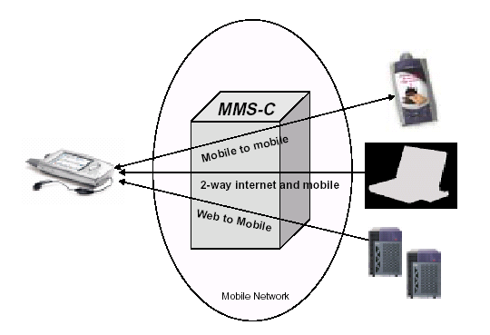
Figure 1 Multimedia messaging service usage

The mobile terminal may be a MMS enabled mobile telephone, Communicator, Personal Digital Assistant, etc. connected to the mobile network.
The MMS-C implements the network side of MMS, and makes it possible for an operator to offer MMS to its mobile subscribers. The main features of the MMS-C includes:
• Submission of multimedia messages from mobile users, email users and Internet based application servers.
• Delivery of multimedia messages to mobile users and Internet destinations. Delivery to the destination terminal is initiated via WAP push.
• Perform limited conversion of the message to match the capability of the destination terminal.
Multimedia messaging service functionality paves the way for numerous creative applications and content that can be pushed to the users mobile terminal.

Multimedia Messaging Service Centre System Features

Overview
The Multimedia Messaging Service Centre (MMS-C) implements the network side of
MMS, and makes it possible for an operator to offer MMS to its mobile subscribers. The MMS-C is a highly flexible system, which can be adapted to the needs of the operator and the particular end users involved. The MMS-C manages different sources to/from mobile terminals, supporting a wide range of standard interfaces. The use of open standards and protocols such as SMTP, and HTTP allows the operator to build other value-added services to compete in the ever-changing telecom world of tomorrow.

The main features of the MMS-C includes:
• Submission of multimedia messages from mobile users, email users and Internet based application servers.
• Delivery of multimedia messages to mobile users and Internet destinations. Delivery to the destination terminal is initiated via WAP push.
• Perform limited conversion of the message to match the capability of the destination terminal. This reduces the network, air and processing necessary for unsupported formats. From an operator point of view, the unsupported information is a non-billable event that utilizes network resources and, therefore, a wasted use of resources.
The MMS-C also offers functionality such as store and forward capabilities, guaranteed delivery, subscriber preferences, operator constraints, billing information. The MMS-C features are further described below.
All components of the messaging network are designed to run on commercial off-the-shelf hardware. This means that equipment can be selected to meet the unique performance requirements of the operator. It also means that the operator has the opportunity to take advantage of the fast price/performance evolution in the Information Technology (IT) industry. As the number of end users grows, the MMS-C can be easily expanded to meet the need for higher capacity. An optimum combination of built-in hardware redundancy, distributed architecture, Simple Network Management Protocol monitoring and safe-message storage software design ensures that the MMS-C will meet the demands of the operator.
New releases of the MMS-C will follow the latest WAP and 3GPP Forum standards as well as they will include new market requirements.

Features - Present
      - Message Delivery to Mobile Terminal
Multimedia messages are delivered to the MMS enabled mobile terminal using the following process. The purpose of these events is to reduce the required processing and air interactions of the mobile terminal. These events and the sequence in which they occur are summarized below.
• The service notifies the mobile terminal of an incoming message
• The service determines if the mobile terminal is multimedia capable
• The mobile terminal determines whether it can accept the message based upon message size, available memory, etc
• The mobile terminal sends a request to the service to send the multimedia message • The service sends the multimedia message to the mobile terminal
In case the first delivery attempt of a message fails, the message is placed in a retry queue where subsequent delivery attempts are made according to a configurable retry schedule. This process ensures safe, secure and guaranteed delivery of the multimedia messages to the recipient.
      - Message Delivery to Internet Destination
Messages to Internet destinations are delivered using the SMTP protocol. In this case the multimedia message is addressed using an email address.
      - Message Deposit
The MMS-C supports message deposit from various sources: mobile users, email users, and Internet-based multimedia applications.
Upon receipt of the message the MMS-C checks the validity of the message. If the multimedia message passes these tests, the message is queued for delivery. Otherwise a reject notification is sent to the originator of the message.
      - Message Store and Forward
A key feature in the MMS-C is the Store and Forward mechanism. It ensures that no message is lost. When a message is submitted, the MMS-C stores it on the mirrored hard disk array before confirming to the submitter that the message has been received. Depending on the conditions set up for the message and media type, an attempt can now be made to deliver it. Not until the MMSC has received a confirmation from the recipient does the MMS-C consider the message successfully delivered.
In combination with fault tolerant components, such as power supplies and mirrored hard disks, the Store and Forward method secures messages in fault situations, including loss of power and hard disk crash.
      - Addressing
The MMS-C supports different addressing formats to identify the sender and recipient. MMS-C will support the use of e-mail addresses or MSISDN to address the recipient of a multimedia message. In the case of e-mail addresses, standard Internet message routing will be used.
The usage of MSISDN for addressing a recipient in a different MMS-C service provider’s domain is possible. For that, the need for MSISDN translation to a routable address has been identified. The mapping for the MSISDN to the correct recipient’s MMS-C Relay or Server is under development.
      - Multiple Address Destinations
Enables the subscriber to submit one message to multiple addresses. Analogous to addressing an email, the multimedia service contains address fields specifying: To, Carbon Copy (CC:), Blind Carbon Copy (BCC:). This allows the subscriber to utilize their time efficiently rather then forcing the subscriber into sending the same message on a one-message-at-a-time basis.
      - Copy Multimedia Message
“Copy” allows the mobile subscriber to receive every multimedia message sent to the mobile terminal, and send a copy of the message to a UMS or an E-mail address. This allows the subscriber to store the message on a “long term” basis for future reference.
      - Forward Multimedia Message
“Forward” allows the mobile subscriber re-route every multimedia message targeted to a mobile terminal to a UMS or an E-mail address. This is very convenient for subscribers who travel to areas where multimedia messaging service is not available. One of the main differences between a “copy” and a “forward” is that a “forward” deletes the multimedia message from the MMS-C message store upon successful delivery to the UMS or E-mail address.
      - Future Delivery
Provides the subscriber with the ability to send a message at a future date and time. This is convenient for holiday greetings and the like.
      - Message Delivery Notification
When submitting a message, the message submitter will be notified when the message has been delivered to the recipient mobile terminal.
      - Notification Retry Queue
In case the first delivery attempt of a message notification fails, the message notification can be placed in a retry queue where subsequent delivery attempts are made according to a configurable retry schedule.
      - Read Reply
A programmable parameter, which allows the message originator to automatically receive a reply indicating that the message was read by the recipient. This feature is only applicable to mobile-to mobile multimedia messaging.
      - Media Types
Multimedia messages consists of one or more media types. The MMS-C is transparent to the media types and formats in the multimedia message. In mobile terminated scenarios, the MMS-C will only send media types/formats supported by the targeted terminal. Multimedia messaging service capable terminals may support SMIL to control the display of message content. In addition, the MMS-C will support SMIL format re-layout if the receiving terminal does not support the layout specified by the multimedia message originator.
The MMS-C supports all character sets widely used on the Internet. Character set transcoding will take place if the terminal does not support the received character set.
Supported character sets include:
• Arabic (ASMO 708) ASMO-708
• Arabic (ISO) iso-8859-6
• Baltic(ISO) iso-8859-4
• Central European(ISO) iso-8859-2
• Chinese Simplified(EUC) EUC-CN
• Chinese Simplified(GB2312) gb2312
• Chinese Simplified(HZ) hz-gb-2312
• Chinese Traditional(Big5) big5
• Chinese Traditional(CNS) x-Chinese-CNS
• Chinese Traditional(Eten) x-Chinese-Eten
• Cyrillic(ISO) iso-8859-5
• Cyrillic(KOI8-R) koi8-r
• Cyrillic(KOI8-U) koi8-u
• Europa x-Europa
• German(IA5) x-IA5-German
• Greek(ISO) iso-8859-7
• Hebrew(ISO-Logical) iso-8859-8-i
• Hebrew(ISO-Visual) iso-8859-8
• Japanese(EUC) euc-jp
• Japanese(JIS) iso-2022-jp
• Japanese(JIS-Allow 1 byte Kana - SO/SI) iso-2022-jp
• Japanese(Shift-JIS) shift_jis
• Japanese(JIS-Allow 1 byte Kana) csISO2022JP
• Korean(Johab) Johab
• Korean ks_c_5601-1987
• Korean(EUC) euc-kr
• Korean(ISO) iso-2022-kr
• Latin 3(ISO) iso-8859-3
• Latin 9(ISO) iso-8859-15
• Norwegian(IA5) x-IA5-Norwegian
• Swedish(IA5) x-IA5-Swedish
• Turkish(ISO) iso-8859-9
• Unicode unicode, utf-16
• Unicode(Big-Endian) unicodeFFFE
• Unicode(UTF-7) utf-7
• Unicode(UTF-8) utf-8
• US-ASCII us-ascii
• Western European(ISO) iso-8859-1
• Western European(IA5) x-IA5

      - Charging
The MMS-C supplies a wealth of charging information to the Operator. This provides the Operator with the flexibility to tariff and market multimedia messaging services in a variety of methods.
The MMS-C will generate charging data records in the following situations:
• Receiving multimedia message from MMS client (MO)
• Receiving multimedia message from another MMS Relay
• Receiving multimedia message from email system
• Sending multimedia message to another MMS Relay
• Deliver multimedia message to MMS client (MT)
• Multimedia message notification
• Multimedia message delivery
• Multimedia message read report
• Sending multimedia message to email system
• Copy/forward on receipt of message to subscriber in this MMS-C
• Multimedia message is rejected, undeliverable or expired The MMS-C charging data records will include the following:
• Date/Time stamp
• CDR id
• MMS-C id
• Originator MSISDN/email address/SMTP port number
• Receiving MSISDN(s)/email address(es)
• Message content types
• Message size
• CDR type
• Message class
• Message status
      - Subscriber Database
The Subscriber Database contains profiles of each of the subscribers. Subscriber profiles consist of information controlling the features and functionality of the multimedia messaging subscription. An interface to the database allows the operator and/or the subscriber to perform provisioning of the subscriber profile.
      - Operation and Maintenance
MMS-C includes different Management Information Bases (MIBs), and provides Simple Network Management Protocol including accesses traps, monitoring (read-only), and configuration (readonly or read-write variables). The O&M application correlates the traps to minimize the number of alarms and to display the root cause. In addition, the O&M application monitors different parameters such as disk utilization, traffic activity and application status.
The SNMP interface is available for an external network management system. For more detailed O&M activities a WWW interface and/or console may be utilized.

Features – Future
      - Black List/White List
System-wide black and white lists enable the operator to exclude/include subscribers from sending or receiving MMS messages. The fields of the black/white lists include the mobile terminal addresses of the recipient or originator. Two separate black or white lists can be created: one for Mobile Originated and one for Mobile Terminated messages.

      - Operator Distribution List
The operator distribution list enables the system operator to send a message to multiple recipients designated in the distribution lists. Operator Distribution Lists may be used for system maintenance notices, marketing purposes, etc. Operator distribution list management can be done either directly from the administrator terminal or via a WWW interface.
      - Personal Distribution List
Personal Distribution Lists allow a mobile subscriber to send a message to a list containing one or more mobile subscribers. Each mobile subscriber will be able to create 10 lists, each containing up to 100 entries. The lists can be used for both Mobile Originated and Mobile Terminated applications. Operators and/or subscribers are able to create, modify and delete the personal distribution lists via a WWW interface.
      - Video / Audio / Image / Multi Image Signature
The multimedia messaging service will support video signature, audio signature, image signature and a set of images as a signature. An interesting feature is the Message Originator Identification feature (MOI). This feature will enable the user to identify the sender of an image by his photo and not only by his/her telephone number.

Network Configuration
The MMS-C can be deployed in any mobile network. Figure 2 shows an example of the MMS-C as connected to a mobile network.
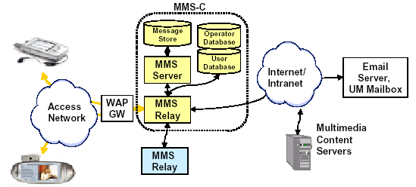
Figure 2 MMS-C in a Mobile Network
The components of the MMS-C described in the figure are logical entities and are further described below.

MMS Server
The MMS server provides the MMS-C processing engine and the multimedia service application.

Message Store
The message store stores all the multimedia messages prior to delivering the message to the recipient.

User Database
The User Database contains the profiles of all subscribers. Operators may provision subscriber profile parameters and have the option to allow subscriber self-provisioning.

Operator Database
The Operator Database provides the MMS-C operator with an easy to use Graphical User Interface (GUI) for system-level parameter configuration.

MMS Relay
The MMS relay is the front-end of the MMS-C system. The subsystem provides an interface to the various IP network connections and protocols, allowing subscriber access for the purposes of the storage and forwarding of multimedia messages.

Interfaces
The MMS-C connects the Internet environment with the mobile environment providing different interface protocols to do so. The interfaces of the MMS-C are described in the following paragraphs.

Multimedia Message Interfaces
      - Simple Message Transfer Protocol (SMTP)
Simple Message Transfer Protocol (SMTP) enables users to send or receive multimedia messages to/from mobile terminals via an Internet e-mail system.
      - Hyper Text Transfer Protocol (HTTP)
The Hyper Text Transfer Protocol (HTTP) enables the MMS-C to interconnect with Internet-based multimedia application for deposit and delivery of multimedia messages via TCP/IP over the Internet.
      - Short Message Peer to Peer (SMPP) (future)
SMPP (Short Message Peer to Peer) is a widely accepted protocol for communication between computer applications, legacy messaging systems, and Short Message Service Centres. The MMSC acts in the role of a client. Version 3.4 of SMPP will be supported.

WAP Interfaces
      - Push Access Protocol (PAP)
The Push Access Protocol (PAP) is used between the MMS-C and the WAP gateway/proxy for sending the notifications regarding new messages to mobile users.
      - Hyper Text Transfer Protocol (HTTP)
The Hyper Text Transfer Protocol is used for the depositing and delivering messages to mobile users between the MMS-C and the WAP gateway/proxy.

Network Physical Interfaces
The MMS-C interfaces to all message submission/retrieval computers and applications via a 10/100 BaseT TCP/IP Ethernet LAN, providing simple and seamless integration.

Operation and Maintenance Interfaces
      - Light-Weight Directory Access Protocol (LDAP)
Lightweight Directory Access Protocol (LDAP) is an Internet protocol that reads and writes to a directory server. The LDAP protocol can be used to access information in directory servers outside of the system, as well as to allow for external directory inquiries in the system. LDAP provides compatibility with Messaging-over-IP family of products allowing it’s common elements such as event registers, license managers, etc. to be utilized by the MMS-C.
      - Simple Network Management Protocol (SNMP)
SNMP integration provides compatibility with a wealth of Operation and Maintenance computer applications. This allows the service provider to administrate and maintain all elements of the mobile network, including the MMS-C, from a central location. In addition, this capability allows the MMS-C to be administrated and maintained by the Central O&M element of the Messaging-over-IP products.

System Performance and Planned Capacity

Throughput
Throughput rate is measured in messages per second (mps), where messages are defined as multimedia messages successfully stored and delivered, upon initial attempt, by a single multimedia message service centre.
      - Processing Throughput
Based on conditions indicated below, the maximum throughput of a one-node system at its busiest hour is 360,000 messages per hour or 50 messages per second (50 messages per second inbound and 50 messages per second outbound, simultaneously).
• Messages were originated from a mobile user anddelivered to a mobile terminal
• All messages were successfully delivered on the initial attempt, no network re-tries were initiated
• The quantity of messages inbound to the MMS-C and outbound from the MMS-C were equal (balanced load)

Subscribers
The current MMS-C release can support approximately 1 million subscribers dependent upon traffic model.

Storage
The maximum message store is 850,000 messages dependent upon traffic model.

Standards and Specifications

MMS Standards and Specifications
MMS is specified by 3GPP and WAP Forum. The main standards and specification employed are:
• 3G TS 22.140, version 1.2.0, (1999-11); 3rd Generation Partnership Project; Technical Specification Group Services and System Aspect, Service Aspects; Stage 1, Multimedia Messaging Service.
• 3G TS 23.140, version 1.3.0; 3rd Generation Partnership Project; Technical Specification Group Terminal; Multimedia Messaging Service (MMS); Functional description; Stage 2. • WAP-205-MMS Architecture Overview; Wireless Application Protocol; MMS Architecture Overview.
• WAP-206-MMS Messaging Service; Wireless Application Protocol; MMS Messaging Service Specification.
• WAP-207-MMS Interworking with Internet; Wireless Application Protocol; MMS Interworking with Internet email Specification.
• WAP-209-MMS Encapsulation; Wireless Application Protocol; WAP Multimedia Messaging Service; Message Encapsulation;

Physical Specifications
The MMS-C is based on commercial off-the-shelf hardware. Reference MMS-C Technical Product Description, Release 1.0 for further details.

Benefits

Network Operator Benefits
• A full-featured multimedia messaging service can be used for service differentiation to gain a competitive advantage, and to generate additional revenue streams from new services.
• Multimedia message service increases subscriber loyalty and reduces churn by providing the perception that the network is continually enhanced to incorporate cutting edge technology
• MMS-C offers a modular solution allowing incremental upgrades of hardware and software which ensures quick addition of capacity, redundancy and expansion of the network. It also allows investing in only the applications and features the operator wants.
• MMS-C architecture has been created with “platform independence” in mind. The open
architecture allows the operator to virtually select the availability and quality of service
required to meet their business model and market approach. This means that the operator has multiple choices when choosing a platform for the system, which can be based on any
commercial hardware certified for use with the software application. Existing resources can be re-used minimizing the investment cost.
• MMS-C takes full advantage of the expanded bandwidth of third generation mobile networks. When launched in concert with the third generation network, multimedia messaging services may be marketed as an enticement for 3G mobile subscriptions.
• Typically, operator revenue models have been based on charging subscribers for services, multimedia messaging services now provides the operator with the opportunity for additional revenue streams by charging business’ to push their multimedia advertisements to subscribers
• In as multimedia messaging service is “SMS like” in nature, subscribers will accept similar if not greater tariff rates applied by the operator

End User Benefits
• MMS-C provides an API for developing WWW/WAP interfaces for subscriber profile settings. End users are able to change their own service profile at their convenience. • End users can now send and receive a wealth of information from their mobile terminal, in various media types. Music/audio, image, animation, video and text become accessible anytime, anywhere.

參觀Nokia NRC
Nokia是目前全世界最大的行動電話手機製造商，其市場佔有率約28%，現有約有五萬多名員工，產品在11個國家製造而在全世界130個以上的國家銷售。Nokia於1988年時行動電話手機及電信設備的業務僅各佔公司營收的5%，其後該公司全力在行動電話手機及電信基礎網路(Infrastructure)兩大方向發展，1998年時上述兩項業務各佔公司營收的60%及33%，轉型甚為成功。此次除實習外，亦訪問其研發單位Nokia Research Center(簡稱NRC)，了解其前之研究方向及成果。

第三代行動通信技術
ITU制定的第三代行動通信系統標準IMT-2000在無線進接技術方面計有IMT-DS(WCDMA)、IMT-MC(cdma2000)、IMT-TC(TD-CDMA)、IMT-SC(UWC-136)、IMT-FT(DECT)等五種技術，其中以屬於寬頻CDMA技術的三種無線進接標準IMT-DS、IMT-MC及IMT-TC最受到重視，而對現階段行動電話業者而言，現有網路的演進規劃及如何引進第三代系統則是最為關心的議題。
由於歐洲各國3G頻譜拍賣之標金普遍驚人，使得3G營運執照的合理價格受到極大的關注，但以如此高成本取得3G營運執照之效益與在現有900/1800MHz頻譜擴充GSM/GPRS、引進EDGE等方案之間實有好好考慮的必要。Nokia認為就單位面積的成本而言，WCDMA較適合於高話務量之區域，其次為EDGE900，再則為EDGE1800。而對於一般的服務與應用而言，128Kbps的數據傳送速度多可滿足，因此在歐洲許多GSM業者均已規劃引進EDGE於其現有GSM頻段，而WCDMA則在IMT-2000的2GHz頻譜。由於在2002~2003年時，EDGE能提供的功能與能力將與當時的WCDMA系統相當，因此在建設上應可有先建EDGE再逐步建設WCDMA的考量，因為如此在成本上較經濟，而是否全區建設WCDMA則應是較後期的議題，初期以建設於都會區為主要考量，並與GSM/GPRS/EDGE系統Roaming及互補，視市場反應及功能需求再決定後續建設的時程。
此外，Nokia認為TD-CDMA模式並非好的解決方案，因為就室內服務而言，WLAN可提供更大的頻寬，就室外高話務地區可使用WCDMA+EDGE的解決方案，而TD-CDMA的發展時程又較慢，標準尚未完全確定，應用範圍較有限，且提供手機的廠商又甚少，因此Nokia目前未計畫大規模發展此項技術，仍處於觀察階段。

寬頻接取技術
由於Internet與行動通信服務的快速成長，而Internet理論上可提供無限的內容(Content)及接取無限的應用，且年輕族群的消費能力驚人，因此結合行動通信服務與Internet之行動加值服務型態將是未來主流， Mobile Internet將有極大市場，因此新一代的行動通信技術朝向提供高速率數據服務的方向發展，而業者亦必須加速開發藉由Internet提供於行動接取之加值服務(如生活資訊、Multimedia on Demand， Video， download及網路遊戲等)以配合新一代通信型態的來臨。此外，除了行動通信服務頻寬的提升外，有線寬頻接取(ADSL， VDSL， Cable modem)技術與Unlicensed技術(WLAN， Bluetooth)在室內環境應用之未來發展等亦是非常值得注意。
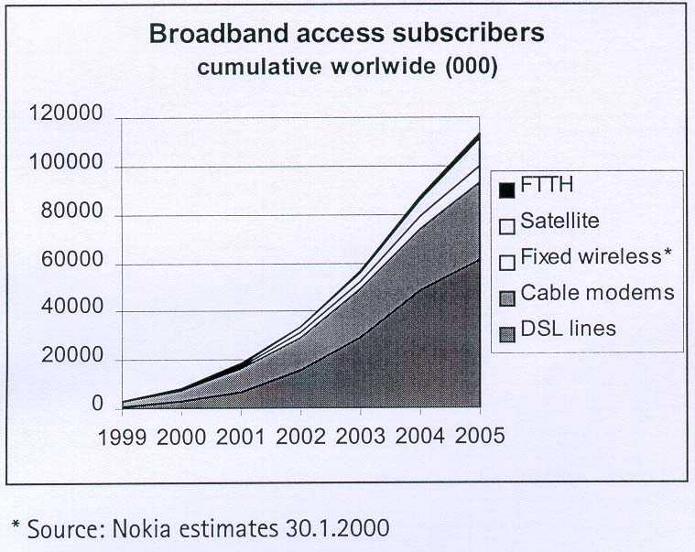
Figure 3. Nokia對寬頻接取技術發展趨勢的預測

就有線寬頻接取技術之發展而言，Nokia預測DSL相較於Cable modem會是主流，其市場趨勢預測見Figure 3，全世界xDSL之市場將於2001年至2002年間超過Cable modem，主因是cable網路並不夠普及且雙向傳輸品質仍有待加強，而全世界現有的電信業者應會在其既有的網路上選擇xDSL的解決方案，因此Nokia特別針對xDSL提供寬頻IP進接網路的方案進行討論，其中對於ADSL結合WLAN技術提供在機場、旅館及家庭等室內環境之用戶寬頻無線進接的服務更是現階段最佳的可行方案。
雖然未來寬頻接取是趨勢，但重要的商機應是所能提供的應用服務，如電子商務、在家購物、多媒體下載、網路遊戲等，公司營運的利基將轉向內容(Content)及應用(Applications)，因此本公司除提供寬頻接取服務外，亦應同步發展Content服務。未來家中室內的服務環境，Nokia的看法是結合雙向的寬頻Internet接取及單向的數位視訊廣播並發展以icon隨選的家庭入口網站(Home Portal)，提供家中整合及便利的寬頻IP無線接取環境。目前Nokia已發展ADSL/WLAN之IP Gateway，未來將持續整合外端的有線/無線技術(如xDSL， ISDN， PSTN， GSM， UMTS， DVB， …)與應用於室內的有線/無線技術(如WLAN/Bluetooth/HomeRF/10BaseT/..)等技術，發展用於家庭或室內環境使用的Service servers。家庭寬頻接取服務環境如Figure 4所示。
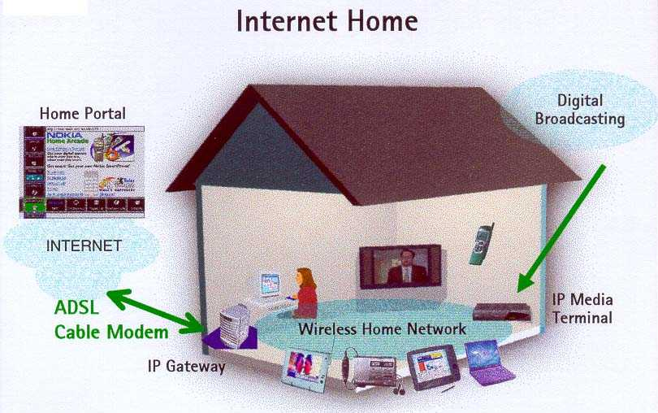
Figure 4. Nokia對家庭寬頻接取服務環境的看法

Nokia研發中心(NRC)
NRC為該公司研究計畫的執行單位，現約有1100人，人員與辦公室分布在歐洲、美國、日本及中國大陸，研究範圍涵蓋電子技術、射頻(Radio)通信技術、軟體技術、行動通信技術、視訊(Visual)通信技術、通信系統技術及語音與聲音(Audio)通信技術等領域，其研發領域示意圖如Figure 5所示。NRC人力素質甚佳，1999年底時其人力的70%具有碩士學位，且16%具有碩士以上學位，水準相當高。
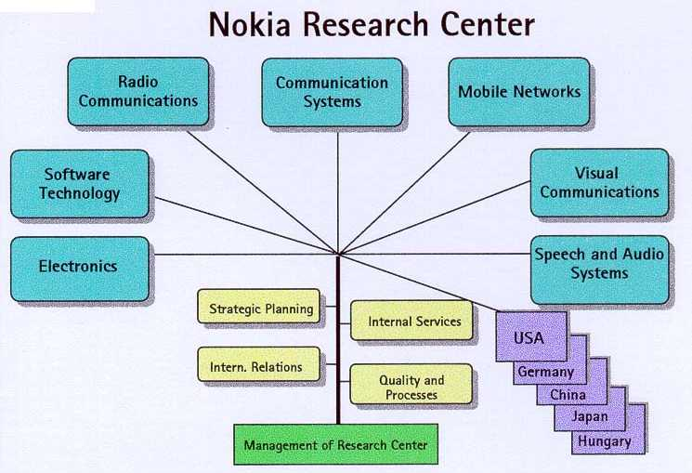
Figure 5. Nokia研發中心(NRC)研發領域示意圖

NRC經費的來源分為三部份：總經費的70%由公司的Business部門提供，用以進行Business部門所需之R&D計畫，總經費的24%由總公司提供，用以做為長期(Long-term)研究計畫(一般而言在三年以上)，而其餘的6%經費來自於政府或外界，用以接受委託研究或進行共同研究計畫。NRC的員工中女性現約佔10%，NRC人力的概略配置是25%的人力進行長期研究、50%進行中期研發(一般而言在一至三年之間)及另25%與Business部門合作進行研發，故其每年平均有約10%人力與Business部門交流。
NRC目前正進行WCDMA模擬系統(Simulator)的研發，該系統運作於PC及Window NT工作平台，可提供WCDMA無線網路規劃、參數調整驗證與優化、網路效能之模擬與評估等功能。此次參訪本所亦就行動通信相關技術領域與NRC進行研習(Internship)計畫等技術交流之可行性進行初步討論，初步結論可行方向為WCDMA無線網路規劃、模擬及優化技術、Packet/IP核心網路設計技術與演進研究及國際技術標準發展趨勢之研究等項目。

感想與建議
行動通信系統技術將朝向CDMA及寬頻化發展，網路端的發展趨勢則朝向封包(Packet)與IP傳送，服務的提供則朝向整合與共通化。因此，整體而言有線與無線通信服務之網路將逐漸整合。結合Mobile Telephone及Internet的Mobile Internet可以發展人們通信所需要的語音、數據及多媒體的多樣化型態資訊服務，3G網路將可提供一個合適的服務平台。尋找3G的killer Application是所有行動通信業者有志一同的目標，展望未來，MMS或將是值得期待的Killer Application，建議公司儘早展開相關建置作業，俾於競爭日益劇烈之行動通信市場中，立於不敗之地。

